International Journal of Production Economics

**Lean eco-efficient innovation in operations through the maintenance organisation**

**Peter Ball, University of York**

**Peter Lunt, Airbus Operations Ltd**

**Abstract**

Lean production systems dominate supply chain operations and are being enhanced through eco-efficient practices to further reduce waste and work towards sustainability. There have been advances in eco-efficiency through the reduction in energy, water and other resource consumption. Thus, wider sustainability programmes have improved the social and eco-efficiency performance in previously lean operations. Whilst eco-efficiency programmes have enhanced lean supply chains, they have usually been separate rather than integral to day-to-day innovation. Operational metrics deployed typically favour cost, quality and delivery with eco-efficiency being progressed as separate projects. In contrast, the organisation of maintenance to contribute to the sustainability dimension of innovation in supply chain operations is absent in theory and practice despite its inherently complementary role to maintain and enhance the performance of assets. Introducing innovation-led lean activity through maintenance to enhance eco-efficiency offers opportunities for new practices and technology. This paper considers current literature and presents the evolution of an energy efficiency programme into a programme across 11 sites in a lean supply chain supported by maintenance. The novelty is a framework showing how to embed eco-efficiency innovativeness into innovation-led lean operations through maintenance, overcome barriers to implementation and support others through a community of experts.

**Keywords**

Lean operations, eco-efficiency, innovation-led lean, maintenance, environmental sustainability

IJPE special issue: Achieving sustainability through innovation-led lean approaches to manufacturing supply chains, 2018

Available online: 6-JUL-2018

DOI information: 10.1016/j.ijpe.2018.07.007

*Corresponding author:*

Prof Peter Ball, The York Management School, University of York, York, YO10 5GD, UK

peter.ball@york.ac.uk, +44 1904 325302

**1. Introduction**

The drive for lean operations in manufacturing has shown significant advance over the decades. Lean thinking (Womack & Jones, 2005) has led to sustained improvements in cost, quality, delivery and other operational metrics (Lewis, 2000). Lean has reduced wastes and aided smoother, faster flow through sustained incremental innovation. Some environmental improvement has come as a secondary effect of lean (Martínez-Jurado & Moyano-Fuentes, 2014), however, significant reductions in energy, water and other resource consumption (Esty & Winston, 2009; Dopplet, 2003) now result from process innovation programmes for eco-efficiency. Companies expect to improve competitiveness through eco-innovations in process, organisation as well as product (Jabbour et al., 2015) that reduce carbon and climate change impacts. Driving innovation in lean programmes offers opportunities to add value beyond immediate production activity (Yang et al., 2010). The challenge is how to extend innovation-led lean operations to include day-to-day innovation-led eco-efficiency.

At supply chain level, eco-efficiency practices improve financial performance (Subramanian & Gunasekaran, 2015). Leaders in lean have significantly improved resource efficiency using waste reduction skills and knowledge with Florida (1996) arguing that innovation-led lean companies are more likely to innovate to address environmental performance. Prior lean development aids transition towards sustainability (King and Lenox, 2001) but a lack of toolkits can hamper progress (Piercy & Rich, 2015). Despite work on lean tools for environmental impact reduction, there is a lack of insight into innovation through embedding eco-efficiency into lean operations. Guidance to integrate the environmental sustainability dimension into organisational structures is needed.

Lean and eco-efficiency are implicitly linked; both seek to promote the efficient flow of resources, minimise waste and maximise value. For example, maximising the efficiency of steam generation and reducing fluctuations in steam use can minimise quality fluctuations in production. Works link lean and eco-efficiency agendas demonstrating their compatibility. Firstly, companies following an eco-efficiency agenda are more productive and profitable (Rotherberg et al., 2001). Secondly, at a micro level, following both lean and eco-efficiency demonstrates practice improvements with better production and environmental performance (Kurdve et al., 2014). Thirdly, organisation integration can be strengthened by an innovation-orientation to impact competitiveness (Lii & Kuo, 2016). Fourthly, there is a two-way relationship between lean and eco-efficiency in driving innovation (Piercy & Rich, 2015). For example, higher product flows through a facility result in greater eco-efficiency (Ball, 2015) and improvements in eco-efficiency enhance the work environment and product quality (Thanki et al., 2016). Fifthly, greater process innovation leads to greater environmental sustainability engagement (Moyano-Fuentes et al., 2018). Finally, at a wider level, eco-innovations at supply chain level demonstrate advance beyond a single operation (Jabbour et al., 2015). These endeavours are often pursued independently by different functions with different skill sets leaving a combinative gap in sustainability, lean and process innovation. Given evidence of lean and eco-efficiency compatibility (Ferroq et al., 2016) and trade-offs (Ball, 2015), aligning lean and eco-efficiency into the same organisational activity could be beneficial.

Maintenance is an intrinsic part of lean operations providing the service to keep equipment in good condition to permit output quantity and quality (Ahuja 2008; Thanki et al., 2016). Energy efficiency initiatives have often been coordinated by the facilities function that supplies energy to production. Economic savings for energy, water and other supplies can be obtained through purchasing contracts and new capital investment, however, significant savings can be achieved by improving existing processes and equipment (Esty & Winston, 2009). Whilst some authors have referred to the potential of contribution of maintenance to the sustainability imperative (Garetti & Taisch, 2012; Tousley, 2010; De Minicis et al., 2012) there is little evidence of this taking place. Further, there is little evidence of how practices are shared across companies as is typical for lean.

This paper reviews the lean and maintenance fields to establish the body of knowledge and infer current practice. The paper then considers process innovation in environmental efficiency (green) and how maintenance can support lean and eco-efficiency. The significant gap in knowledge in extending process innovation in lean operations to include environmental innovativeness is investigated through case research in a European company. Focus is given to energy reduction and how this knowledge is shared across its internal supply chain operations. The discussion reviews the organisational roles, reviews how barriers were avoided and captures learning for further development. The framework presented integrates the findings on how to organisationally embed eco-efficiency in innovation-led lean operations. Here eco-efficiency is positioned as a stepping stone towards sustainability. The conclusions provide new knowledge on innovation-led lean for eco-efficient operations through maintenance. The industrial utility is brought out through the case data and captured in the framework: it provides factors to overcome barriers, it provides guidance on integration within existing organisational structures and it aligns eco-efficiency with lean innovation.

**2. Theoretical background**

The field of maintenance is broad stretching from discrete production systems (Mostafa, et al., 2015), to oil and gas (Liyanage & Kumar, 2003), to service provision through products in the field (Holgado, 2014). Maintenance influences company performance (Mostafa, et al., 2015), closely relates to lean manufacturing (Thanki et al., 2016) and influences eco-efficiency (Sénéchal, 2017). Despite the compatibilities of maintenance with the lean and eco-efficiency fields, there is a lack of knowledge of innovation-led activity to prevent and reduce environmental impacts (De Minicis et al., 2012). This literature review considers maintenance and its links with lean, green (eco-efficiency) and innovation. It shows that literature is confined to tools and techniques exposing a gap in knowledge on organisational integration and sharing across the supply chain. Addressing this gap has potential to extend innovation-led lean to eco-efficiency. Lean maintenance is first addressed to establish a foundation before gaps in knowledge are identified.

*2.1 Lean maintenance*

Given the investment in capital equipment (Ahuja, 2008), maintenance has an important role to play in operations. Maintenance has moved from being a reactive operation to one with long term vision (Liyanage & Kumar, 2003), with a strategic role (Muchiri et al., 2011) in revenue generation (Mostafa et al., 2015) and wider value creation (Holgado, 2014). Lean is pervasive with significant work on the development of lean tools through to lean thinking. The links with Total Productive Maintenance (TPM) are well established.

Shah & Ward (2003) detail four lean “practice bundles” of just-in-time (JIT), total quality management (TQM), TPM, and human resource management (HRM). Such bundles group specific practices that allow the provision of, for example, maintenance to support lean objectives. Lean as an overarching philosophy in which TPM sits is exemplified by Bortolotti et al. (2015) where TPM is a foundation practice for fitness on which other lean bundles build to address performance goals.

Ahuja (2008) sees TPM as a cornerstone for lean with underlying philosophies and associated tools. Ahuja (2008) describes TPM as a structured improvement process with clear links to production efficiency, people and operational hierarchy. Ireland & Dale (2001) list standard TPM pillars (Autonomous Maintenance; Focused Maintenance; Planned Maintenance; Quality Maintenance; Education and Training; Development Management; Safety, Health and Environment) noting their adoption can be case specific. For the pillars, Chan et al. (2005) capture the accepted standards, refer to the aims of capacity, efficiency and quality and go on to define Overall Equipment Effectiveness (OEE) metrics. Eco-efficiency innovation could be considered only within the pillar referring to environment but this would be equivalent to confining quality to the quality pillar.

OEE combining availability, performance and quality metrics supports the breadth of the TPM pillars and in turn the lean focus on flow and waste. Thanki et al. (2016) identifies TPM as the most influential lean practice bundle through its highest contribution to the availability and quality production metrics that will “increase productivity of plant and equipment in such a way as to achieve maximum productivity with only a modest investment in maintenance” (Kaur et al., 2012). Problems such as delays due to poor reliability (availability rate) or defects (quality rate) can be identified with OEE thereby integrating metrics across maintenance and operations. Thus, TPM removes potential wastes (waiting, defects, etc) and enables focus on value flow to customer.

Beyond tools, the TPM pillars guide operator ownership of machines and bring production and maintenance together through team work (Ahuja, 2008). This is echoed by Kaur et al. (2012) on the importance of employee involvement and cross-functional approaches. Despite this, Mostafa et al. (2015) challenge the evidence for linking lean into the organisation of maintenance citing insufficient applications and no integrated structure of lean thinking. This knowledge gap supports the rationale for this research, which in turn can contribute to standards and metrics.

*2.2 Innovation-led lean and eco-efficiency*

Florida (1996) argued that innovation-led lean will drive environmental performance. Later Rotherberg et al. (2001) and King and Lenox (2001) established positive correlations between lean and green; companies who improve their inventory, work systems, etc. improve their environmental performance. Linking lean with sustainability is the “new frontier” (Martínez-Jurado & Moyano-Fuentes, 2014) in which green is a natural progression of lean (Dhingra et al., 2014) with evidence of better performance when lean is complemented by green (Dües et al., 2013). Models can extend innovation driven through lean to incorporate environmental innovation (Aguado et al., 2013) given that driving process innovation leads to greater sustainability engagement (Moyano-Fuentes et al., 2018). Performance improvements extend to the supply chain with the spread of environmental practices and innovation amongst its members (Martínez-Jurado & Moyano-Fuentes, 2014). Returning to ownership and involvement, Jabbour et al. (2015) promote a people-centric approach to link innovation and eco-efficiency.

The thinking around lean practice bundles has been extended to eco-efficiency with authors (e.g. Yang et al., 2011; Thanki et al., 2016), arguing that lean alone is insufficient to improve environmental performance. Citing ISO14001 as one of the most influential practice bundles, it is asserted that the practices must be combined to achieve greatest advance. There are many examples of tools, techniques and frameworks to support practice bundles: Cherrafi et al. (2016) examine the relationship between lean, six sigma and sustainability with particular emphasis on waste and soft skills, including training; Fercoq et al. (2016) develop a check-list to integrate lean and green practice through common waste reduction focus; Martínez-Jurado & Moyano-Fuentes (2014) take a waste, process and people view of lean and eco-efficiency to detail critical factors including holistic thinking, leadership, tools, continuous improvement, metrics, training and communication; Lunt et al. (2014) detail their waste hierarchy (STRE3TCH) steps to reduce energy consumption; Kurdve et al. (2014) integrate green activities through companies’ production systems by aligning values, principles, tools, metrics, organisation and audit. Current lean tools have strengths in ease of use, improvement thinking, waste reduction, problem structuring and data analysis. They concentrate on production efficiency but complementary tools and methods are needed for resource efficiency as well. The focus on tools and techniques and the training in them in turn leaves a gap in the wider organisational structure to support innovation.

There are challenges of working at the breadth and depth of lean and eco-efficiency. Ng et al. (2015) argue for methodologies to provide guidance and avoid practitioners being overwhelmed. Building on human resources aspects, Jabbour et al. (2015) argue for more work on performance and rewards to drive eco-innovation. Hartini & Ciptomulyono (2015) call for greater integration through methodological approaches and Kurdve et al. (2014) identify the need to extend roles and responsibilities to include sustainability beyond HSE (health, safety and environment) functions. Piercy & Rich (2015) question automatic progression from lean to innovation in sustainability and identify the organisation management as key. Rodriguez & Wiengarten (2017) assert that process innovativeness is a pre-cursor to environmental innovativeness. Yang et al. (2011) call for more case research, especially longitudinal. There is a gap in detailed empirical evidence linking lean and eco-efficiency despite the universal acknowledgement of it (Fercoq et al., 2016). Further, Cherrafi et al. (2016) and Kurdve et al. (2014) cite barriers of, amongst others, lack of environmental awareness, lack of metrics, perceived higher cost, organisational separation and organisational responsibility. In summary, there is a gap in how to drive innovation within organisational structures beyond the focus on tools and techniques. In addressing this innovation gap, beyond metrics, practices and tools and methodologies to integrate lean and eco-efficiency, advances are needed in the organisational support, potentially with a people-centric perspective.

*2.3 Linking lean, eco-efficiency and maintenance*

Lean and maintenance as well as lean and eco-efficiency relationships have been introduced thus far. Liyanage & Kumar (2003) separate out sustainability aspects to examine the role of maintenance to support environmentally benign operations. Additionally, Tousley (2010) seeks to operate equipment at peak efficiency and uses maintenance to reduce energy and other resource consumption. For specific techniques, Crespo-Marquez & Benoit (2007) use modelling to improve control policies in energy generation, Dalle Carbonare et al. (2014) propose a methodology (based on Quality Function Deployment) to merge TPM with the waste hierarchy, Yan et al. (2012) consider reliability in pursuit of sustainable manufacturing and, finally, Holgado (2014) identifies the wastes, tools and metrics associated with maintenance and their strategic alignment. Whilst the standard pillars and metrics of TPM and other lean tools have potential to extend to eco-efficiency, there is a gap in how these are formalised.

Works link eco-efficiency and maintenance with little or no emphasis on the role that maintenance has in driving environmental performance in innovation-led lean production systems, whether at a single site or across the supply chain. Few authors cover all three areas. The TPM work of Chiarini (2014) considers improvements (e.g. autonomy to put idle machines to standby to save energy) rather than considering the responsibility for environmental impact reduction within a lean environment. Jasiulewicz-Kaczmarek (2013) extend maintenance from reactive/preventative to integration with lean and environmental progress and notably incorporate the social aspect. Interestingly they view maintenance as the bridge between lean (to reduce waste through techniques such as Kaizen, 5S, Value Stream Mapping (VSM)) and green (to reduce environmental impact through process redesign, lifecycle analysis, waste segregation) to achieve more predictable, lower cost, lower waste, lower energy, lower health risk, etc. production systems. There is emphasis on guidelines and sharing resources by operating as a single system. The perspective is consistently tools and techniques and a gap remains for organisational practice.

Organisational factors for innovation are addressed by Jabbour et al. (2015) but not specifically for lean whilst Piercy & Rich (2015) address lean and sustainability transitions without addressing functional responsibility. Further, Rodriguez & Wiengarten (2017) argue that environmental innovation studies focus on drivers and necessary resources leaving how resources are deployed insufficiently explored. There is a gap in how an organisation leads lean eco-efficiency innovation. In addressing the innovation-led lean gap, guidance is needed beyond the extension of lean tools (e.g. TPM, Kaizen, 5S and VSM) to emphasise how to share and deploy.

*2.4 Research gaps*

The theoretical background has identified gaps in how lean and maintenance integrate with the sustainability dimension, specifically eco-efficiency. How an organisation can drive innovation-led lean for eco-efficiency is poorly addressed. Much of the reported eco-efficiency literature focuses on the site-level process, tools and performance neglecting the functional set up of organisations. Eco-efficiency should be about embedding and sustaining greater efficiency through better routines and, as appropriate, technology. The earlier sections have drawn out a number of factors to drive innovation in this area including: metrics; people-centric approach; sharing; training; practices; tools, methods and guidelines; lean tool extension and organisational support.

The role of maintenance function in innovation-led lean companies and their supply chains has potential given its understanding of and responsibility for the main resource consumers in factories. Relating back to the standards discussion, Sénéchal (2017) calls for a balanced set of sustainable metrics, addressing breadth of lubricant use through to skills development given that most manufacturing systems have been designed for optimum performance at maximum rate. De Minicis et al. (2012) consider the “maintenance contribution to prevent and reduce manufacturing environmental impacts seems to be poorly investigated” and argue for a holistic framework of tools to guide decision making. Van Horenbeek et al. (2014) support this holistic call, stating that there are no publications on the complete integration of ecological aspects in maintenance management. Aguado et al. (2013) argue for better integration of innovation processes for lean and eco-efficiency that can facilitate innovation along the lean supply chain (Martínez-Jurado & Moyano-Fuentes, 2014). Finally, Garetti & Taisch (2012) propose tools are needed for better decision making, greater use of prediction and monitoring and fostering daily shopfloor practice. The standard pillars of TPM have potential for innovation but there is a gap in formalisation. Guidance is needed on how to integrate lean and TPM tools with eco-efficiency and how these can be managed. Tools can be deployed to deliver eco-efficiency innovation, however, organisational aspects need to be developed to foster environmental innovativeness.

Whilst there has been progress made (e.g. on reducing overt material and energy wastes), there are challenges with making further progress as metrics (driven by organisational structures) typically do not drive resource reduction in discrete manufacturing as the consumer is not the owner. Addressing engagement can drive innovation (Moyano-Fuentes et al., 2018; Jabbour et al. (2015) but there remains a gap in how to drive innovation within organisational structures beyond tools. In the absence of available literature, the following research question is therefore posed: “What role can the maintenance organisation have in leading eco-efficiency improvement of operations?”

**3. Methodology**

*3.1 Context*

Conceptually, maintenance is inherently suited to the pursuit of lean, eco-efficient operations; it is typically closely linked to production operations in the organisational hierarchy and it has a role in improving the efficiency of equipment which in turn controls resource consumption. Despite this, literature is sparse with no common model to frame industry-wide investigation. Available models are technical and narrow. Therefore, the research builds theory to conceptualise the role of maintenance through case research. An exploratory case approach allows new insights into how maintenance supports innovation in eco-efficient (green) operations across a supply network.

*3.2 Approach*

A large European aerospace manufacturer was selected for this study. The manufacturer had a mature lean production system that encompassed the lean philosophy, metrics, structure and tools for everyday activities in operations. Whilst this system drove innovation in lean production, it had the challenge identified by Piercy & Rich (2015) of how to progress towards sustainability. The focus was on the eco-efficiency rather than the readiness of individual sites to accept innovation-led lean programmes, enterprise-wide initiatives or national cultural differences. Additionally, an energy reduction programme had been set up as part of the eco-efficiency agenda and the wider sustainability ambitions. Importantly detailed and longitudinal data had been collected across the sites on what was a sustained programme, not a short-term initiative.

The data was collected through the case company’s industrial energy efficiency network that spanned the internal supply chain of 11 sites. Figure 1 illustrates the company’s internal supply chain (right) and the data collection sources (left). For confidentiality, the configuration of the supply chain is representative rather than actual. The unit of analysis is an improvement project and the links to the team members’ organisational functions and network. Data from around 100 projects was collected between 2013-2015. The research was grounded in observation, review and document analysis.

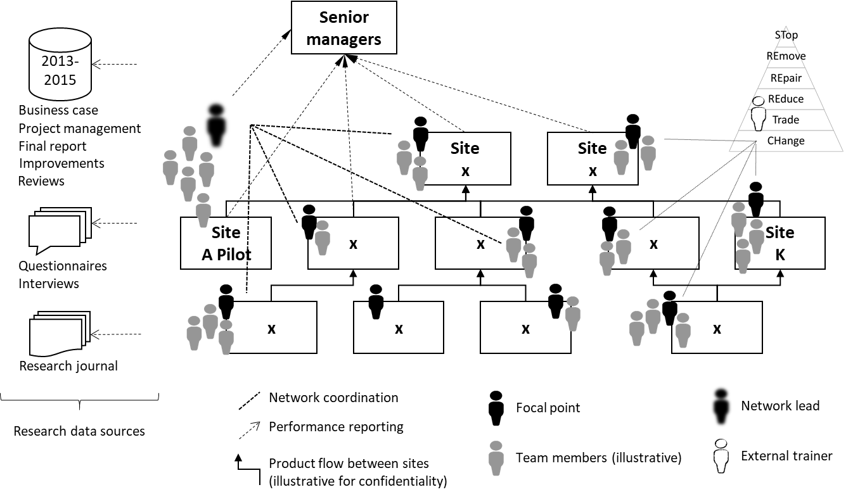

**Figure 1: Research data collection and illustrative site relationships in the internal supply chain**

*3.3 Tools*

The research used the company’s lean system including TPM, OEE, team working and visual reporting. This was complemented by an eco-efficiency improvement process, STRE3TCH (Lunt et al., 2014), adapted from best practice from Toyota’s “six attitudes” (Despeisse et al., 2013). It was tailored to the language and process requirements of the case company, combining the lean principles of waste reduction with the principle of the waste hierarchy from the environmental field. Although the adaptation did not originate in the same supply chain, it is an illustration of the innovation-orientation (Lii & Kuo, 2016) through absorption of new technology and knowledge. STRE3TCH had already been adopted by the company and whilst other tools and methods could have been considered, the prior acceptance of this particular one, its complementarity with the established lean tools and its guidance on eco-efficiency made it suitable against the literature findings.

The STRE3TCH acronym defines six steps that align to the waste hierarchy: STop, REmove, REpair, REduce, Trade, CHange as shown in Figure 2 with the improvement cycle on the left. The six steps respectively: prevent the use of resources, remove unnecessary use, maintain operating conditions to design specification, reduce the consumption through change to specification, reuse wastes elsewhere and finally change a process to a more efficient one. It is complementary to the standard innovation-led lean operating system. The steps trigger incremental innovations on behaviour and procedure through to radical changes to process technology. Against the factors highlighted at the end of the literature review, STRE3TCH extends existing lean tools to guide eco-efficiency practice through eco-efficiency metrics. Beyond the STRE3TCH method, the aforementioned network addresses the sharing factor and the remaining training, people-centric and support factors are tackled later.

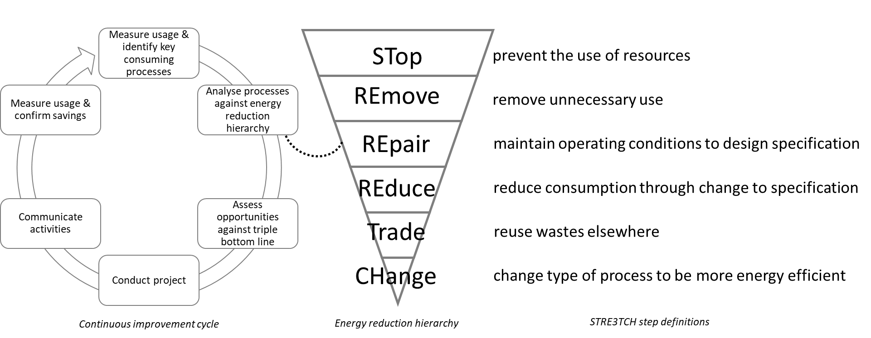

**Figure 2: The STRE3TCH eco-efficiency improvement method**

*3.4 Instruments*

Data collected (shown top left in Figure 1) included project activities and organisational interventions. For the pilot, Site A used questionnaires and interviews to capture initial data. For the network, company standard documents authored by the teams were used (initial business case; project management inc. methods, project plan, progress; final report) and improvements achieved (changes made, changes in performance). One instance of each document existed for each project. Secondly, information not tracked by the standard documentation was captured in the network lead’s company journal which contained ongoing project specific and general network information (telephone and email support; individual network focal points; individual site project reviews).

*3.5 Data analysis approach*

Analysis frames the data within established work on lean, maintenance and barriers to address the lack of models for framing maintenance eco-efficiency activity. It captures the processes and progress. The outcome is a framework that brings together lean, eco-efficiency and maintenance that fosters innovation in practice and equipment. Given the standard reporting, data could be consistently extracted from the project documents that included: year, site, performance (target and actual saving), team lead, team member functions, energy reduction hierarchy principle deployed, lean tools used, engineering tools used, data used. Savings were resource (specifically energy) reduction claimed for each project. Savings information is traceable to the target in each business case document and the savings achievement from the performance improvement passed on for management reporting and traceable back to the final report. Table 1 shows the relationships between the data source (from Figure 1) and the type of data extracted for the network data collection. The ‘enabling factors’ in the last column shows the traceability of the factors detailed later in the results and discussion.

|  |  |  |  |  |
| --- | --- | --- | --- | --- |
| Source \ Data type | Targets &  savings | Leadership & team | Method, tools & data | Enabling factors |
| Business case | x |  |  | x |
| Project management |  | x | x | x |
| Final reports | x | x | x | x |
| Improvements | x |  | x |  |
| Management reporting | x |  |  |  |
| Network reviews |  | x | x | x |
| Journal |  | x | x | x |

Table 1 Data Sources and Data Type Extracted

The network review meetings were documented and implicitly shared practice through site presentations. The process innovations were documented within the reports and covered the energy reduction hierarchy from simple behavioural changes (e.g. stopping resource use by switching equipment off) to capital investments (e.g. trading waste resource for use elsewhere). The improvements had documented ownership (e.g. visual management for the operator to switch off a machine or leak survey procedure by maintenance prior to shutdown) which can be verified, e.g. by factory walk or inspection of standard procedures. Using standard company reporting avoided the need for separate data collection or transcription. The project journal contained entries that could trigger reference to standard documentation, e.g. an entry noting a change in team leadership from one function to the maintenance function could be verified by subsequent project report authorship.

3.6 Validity

The network consisted of a network lead and ‘focal points’ (improvement champions) and associated teams at each of the sites (illustrated as people icons in Figure 1). The network was formed following successful pilot activities in 2012. An external training provider trained teams in 10 sites on the standard improvement method following development in the pilot site. This pilot then network and training approach meant leadership of improvement and the team achievements were independent of the network lead who is a co-author.

The standard, independent training supported consistency, further aided by the use of standard project documentation. Teams reported absolute kWh savings against the energy reduction hierarchy which, for confidentiality reasons, are shown here relative to Site A. The use of the pilot, standard source documents and network review meetings contributed to the research reliability. The use of multiple teams, multiple projects and multiple sources contributed to the validity of the findings. Further, claimed improvements were verified by senior managers through standard company reporting which assures accuracy.

**4. Results**

The results are presented in three parts. The first part describes which lean tools were used and how these were employed to support eco-efficiency innovation with a specific energy focus. The second part presents four examples of eco-efficiency projects that were carried out supported by the improvement method. The final part presents the multi-site context and global results.

*4.1 Lean, eco-efficient tools*

A mature lean programme existed across all sites. Its lean operating system contains uniformly cascaded “bricks” of tools and guidance, the two most relevant here are OEE and TPM, both owned by Maintenance[1]. This section draws on concepts from the theoretical review.

The company’s OEE describes the availability of manufacturing assets by identifying and categorising the non-effective usage of the assets, e.g. time on breakdown or time spent changing tools. These activities correspond to *muda* or non-value-add. From a resource point of view, any non-value-adding activity is waste hence OEE can identify waste energy and other resources. Emphasis is on schedule loss (the difference between total time available and planned production time) and run time (after accounting for planned and unplanned stops). Performance and quality losses are not addressed directly but examples exist where the focus on eco-efficiency has led to quality improvements or greater equipment life. Comparing production OEE schedule loss with resource use such as energy highlights muda and leads to innovation to stop or reduce resource consumption outside of planned production. Comparing OEE run time loss with energy consumption highlights the need for reduce or repair activities to make more effective use of resources. Finally, comparing productive time with energy consumption prompts innovation to either identify capital upgrades or capture waste energy output for use elsewhere. By exception, energy consumption outside of production may be necessary. Three examples of this are: cleaning a paint booth may require air handling at production levels therefore reduction is focused on cleaning time, not energy use; powering down machines may lead to later quality problems; stopping air compressors may lead to long and problematic start-ups.

TPM not only ensures availability (and improves OEE) but also increases productivity of the assets so they perform as close as possible to the ideal conditions. TPM here spans activities of the functions of Operations (e.g. autonomous maintenance) and Maintenance (e.g. planned maintenance). This leads to resource consumption benefits, e.g. motors managed by good TPM are controlled to the optimum speed, minimising energy consumption, increasing availability and promoting longevity.

On top of typical lean tools, the complementary STRE3TCH (Lunt et al., 2014) method shown in Figure 2 was deployed to identify resource efficiency opportunities in the sites. Hence lean tools such as TPM and OEE are still required to provide data, however, guidance for targeting eco-efficiency is provided by the complementary STRE3TCH tool.

*4.2 Project examples*

This section details four projects as examples of the application of the energy reduction hierarchy, lean tools, the role of maintenance and links to the internal supply chain community. The innovations vary from what could be considered incremental to more radical and technology-based. All projects used multi-functional teams including representatives from Operations, Manufacturing Engineering and Maintenance with leadership of each team at site level.

In the first example, one site used a combination of OEE and energy consumption data to identify opportunities. The STop step of STRE3TCH is the most straightforward tactic to prompt how to prevent resource consumption, e.g. by switching off manufacturing assets not in use. However, given the complexity of some systems, it is not obvious what can and what cannot be powered down. Switching off equipment temporarily could impact on asset life, production schedule or product quality. Machines should only consume energy when adding value which can be monitored through OEE. Any activity which does not add value is referred to as “non-OEE” in the company’s operating system. Thus identifying when machines consume energy during non-OEE activities leads to innovation opportunities as illustrated in Figure 3. Power consumers were identified and these assets were shut down. The procedures for how to do this without compromising performance and availability were then added to the TPM process to embed the shutdown into normal working. This was reinforced by visual management; machines that could be powered down were clearly labelled, as were those which could not. The team used the experience of the network community across the internal supply chain and had the ability to revert to previous operating procedures to avoid the fear of impacting on product quality. Relating to the TPM pillars, the innovation opportunity was effectively discovered during focused maintenance and realised through autonomous maintenance, hence demonstrating value obtained beyond standard TPM activity and the organisational preparedness to change.

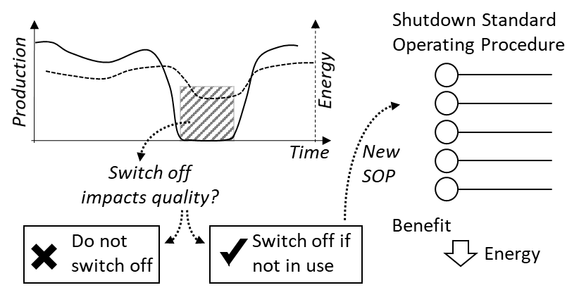

**Figure 3: STRE3TCH application: STop step considering non-value add energy use**

The REpair step prompts engineers to ensure assets are working efficiently. The second example relates to using compressed air for powering production assets. As the age of these systems increased leaks developed. At one site the reliability of some compressed air tooling was found to be low. Root cause analysis from the lean toolset was used by Maintenance. One contributor was found to be the system pressure. Investigations of leaks through root cause analysis illustrated in Figure 4 found that the compressed air system was operating adequately but with significant losses. A third party carried out a leak survey, recording the leak location and size using ultrasonic detection equipment. Where possible, leaks were repaired in situ. Otherwise the leaks were tagged for repair during planned maintenance. This innovation was then embedded in the normal maintenance routine of the site with leak detection occurring before shutdowns and any new leaks repaired during this time. Again, this is an illustration of the remit of Maintenance beyond the lean production focus and embedding of resource efficiency actions within the standard processes so that the activity becomes routine. Relating to the TPM pillars, the opportunity was discovered during focused and planned maintenance and realised through planned maintenance. As with the first example, the innovation here is incremental and illustrates the organisational orientation to continuous improvement.

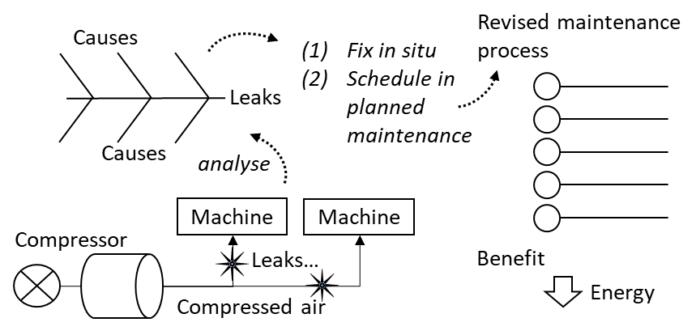

**Figure 4: STRE3TCH application: Repair step addressing compressed air energy consumption**

The REduce step is illustrated through the third example of a paint shop. All sites have painting activities which are high electricity and gas consumers due to temperature and air flow requirements. Through TPM planned maintenance, one site identified a fan motor in one of its paint shops which had a speed controller fitted which had run at 100% load since installation. A maintenance function does not generally have authority for altering the current configuration or set points of manufacturing equipment. It is the responsibility of Manufacturing Engineering to ensure equipment produces products in line with quality standards. Through the support of Manufacturing Engineering it was found that the air flow was higher than required hence fan speed was reduced. This in turn increased the life of the motors as well as the service interval. Figure 5 illustrates the joint working of the two functions and the subsequent reduction in consumption. This could be considered an obvious innovation but the traditional lean focus does not prompt “asking why” for such reduction types and therefore they are likely to be missed opportunities without the wider remit of Maintenance. Again, this learning was shared across the sites through the network. Relating to the TPM pillars, the opportunity was discovered and realised during planned maintenance and checked through autonomous maintenance. This example further demonstrates the lean-led thinking to waste reduction in the widest sense and introduces inter-function orientation to innovation.

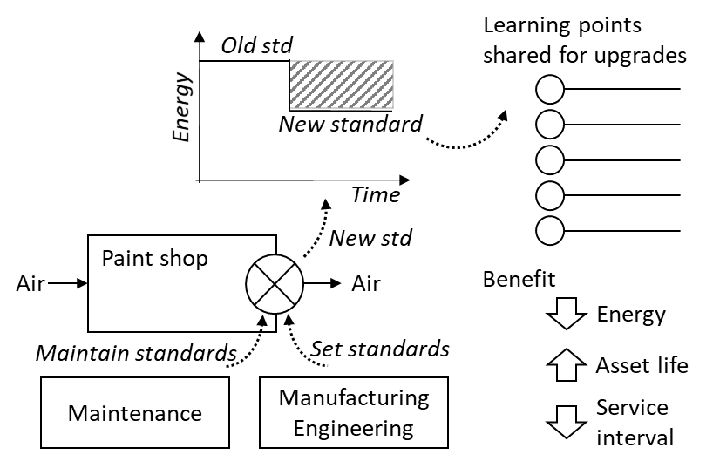

**Figure 5: STRE3TCH application: Reduce step through revised standard process**

The fourth Trade example concerns resource reuse. Given the quality, health and safety requirements of paint spraying, most paint shops operate a total loss system; all the air is ejected and not recirculated. This is wasteful since a considerable amount of energy is required to bring the air to process specification. One site retrofitted a rotary heat and humidity exchanger known as an enthalpic wheel to return some of the energy from the exhaust to the inlet. Figure 6 illustrates the energy recovery and revision to procedures. This significantly improves the process efficiency and reduces the load on the heating and cooling elements. Again, the innovation goes beyond the production scope of lean and maintaining the site to standard working conditions. Generally, innovations such as this would be included in the original specification, which is the responsibility of Manufacturing Engineering, so they would usually specify a retrofit. However, in one site Maintenance led this activity because they were carrying out retrofits (upgrading heat exchangers and motors etc.) and knew that decreasing the load on the heating system would increase the system reliability, and could lead to retrofitting a smaller, easier to maintain system. Relating to the TPM pillars, development management / early equipment maintenance activity improved the design and this was later managed through planned maintenance. Again, this work is beyond the quality and output focus and brings in wider resource management innovation.

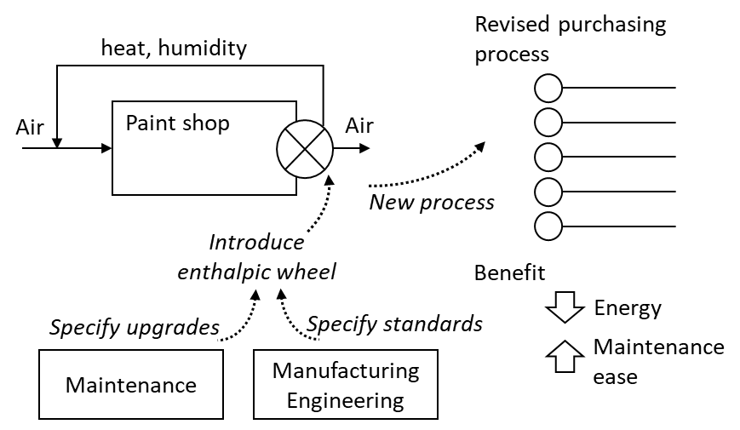

**Figure 6: STRE3TCH application: Trade step to reuse ‘waste’ resources from a process**

The examples demonstrate the level of involvement of Maintenance. The first shows Maintenance responsibility for enabling the operation of an asset, even if they are not responsible for, in this case, switching off the asset themselves. The second demonstrates proactive maintenance for improving eco-efficiency. The third shows how eco-efficiency necessitates a collaboration between functions but that ultimately Maintenance are the mostly likely to identify innovations and are most likely to be responsible for their implementation. In the fourth, the improvement typically would come from Manufacturing Engineering, however, Maintenance needed to be involved in the specification and commissioning to ensure availability and efficiency in service. Maintenance engaged in these different eco-efficiency steps with varying levels of responsibility depending on whether the domain of the activity was operation, maintenance or acquisition. Against the TPM pillars, as the knowledge in the organisation builds, the education and training will be updated and more direct links to quality may arise (quality improvements did arise for some projects but these cannot be claimed as planned outcomes).

*4.3 Results Across the Internal Supply Chain*

The above examples are typical of the type and range of projects across multiple sites in the supply chain. This cascade of innovation is facilitated by a centrally sponsored Industrial Energy Efficiency Network through a community of ‘focal’ points. This set up is beyond the lean organisational structure and fosters innovations in eco-efficiency. Table 2 lists circa 100 projects tracked through the network by site by year.

|  |  |  |  |
| --- | --- | --- | --- |
|  | 2013 | 2014 | 2015 |
| Site A | 8 | 4 | 7 |
| Site B | 1 | 8 | 3 |
| Site C | 0 | 1 | 1 |
| Site D | 1 | 5 | 2 |
| Site E | 2 | 0 | 1 |
| Site F | 3 | 2 | 2 |
| Site G | 3 | 3 | 9 |
| Site H | 9 | 4 | 7 |
| Site I | 1 | 1 | 0 |
| Site J | 0 | 0 | 2 |
| Site K | 1 | 4 | 3 |
| Total | 29 | 32 | 37 |

Table 2 Network Projects by Site by Year

The impact can be seen in the results from the first three years of implementation. Table 3 shows the savings achieved across the internal supply chain against the target at each site. Figures have been normalised against the 2013 target for Site A and are based on Megawatt-hours (MWh) savings, with electricity and gas savings having equal weighting. Distinguishing between environmental innovations and environmental innovativeness (Rodriguez & Wiengarten, 2017), the improvement approach aligns to the former whilst the cases and savings evidence the latter. Sites D, G and K are the only sites which had a focal point in Maintenance throughout the initiative. They performed consistently well throughout this period. It was noted that Site D progress was initially low due to resource delays. The relative performance of these three sites compared to the other sites could suggest that where a maintenance function is responsible for eco-efficiency within a lean environment, the sustained impact could be higher. Research would be required across many companies to test such a hypothesis.

|  |  |  |  |  |  |  |  |  |  |
| --- | --- | --- | --- | --- | --- | --- | --- | --- | --- |
|  | **2013** | | | **2014** | | | **2015** | | |
| **Site** | **Savings Target** | **Savings Actual** | **Savings to Target** | **Savings Target** | **Savings Actual** | **Savings to Target** | **Savings Target** | **Savings Actual** | **Savings to Target** |
| **Site A** | 1.000 | 1.712 | 171% | 1.667 | 1.133 | 68% | 1.033 | 0.691 | 67% |
| **Site B** | 0.001 | 0.006 | 500% | 0.542 | 0.121 | 22% | 0.050 | 0.050 | 100% |
| **Site C** | - | - | - | 0.104 | 0.104 | 100% | 0.026 | 0.026 | 100% |
| **Site D** | 0.375 | 0.083 | 22% | 0.200 | 0.290 | 145% | 0.375 | 0.588 | 157% |
| **Site E** | 0.125 | 0.122 | 98% | 0.347 | 0.000 | 0% | 0.347 | 0.000 | 0% |
| **Site F** | 0.208 | 0.208 | 100% | 0.683 | 0.891 | 131% | 0.833 | 0.653 | 78% |
| **Site G** | 0.167 | 0.392 | 235% | 0.833 | 1.383 | 166% | 1.500 | 2.568 | 171% |
| **Site H** | 0.286 | 0.224 | 78% | 0.208 | 0.292 | 140% | 0.146 | 0.109 | 75% |
| **Site I** | 0.108 | 0.108 | 100% | 0.167 | 0.242 | 145% | 0.083 | 0.083 | 100% |
| **Site J** | - | - | - | 1.600 | 0.000 | 0% | 2.500 | 1.292 | 52% |
| **Site K** | 2.917 | 4.167 | 143% | 2.000 | 5.317 | 266% | 0.138 | 0.138 | 100% |
| **Average** |  |  | 161% |  |  | 131% |  |  | 91% |

**Table 3: Energy Savings per Site per Year.**

**5. Discussion**

The results show the repeated success across multiple sites of an enterprise. The role of Maintenance varied across the different sites, from supporting other teams’ innovation-led lean activities to leading the activity themselves.

*5.1 Knowledge domain*

The network allowed practices and innovation to spread amongst the supply chain members in line with Martínez-Jurado & Moyano-Fuentes (2014). For the network launch, each site nominated a focal point. This resulted in multiple functions in the network, including Operations, Maintenance and Manufacturing Engineering. The nomination was linked to the type of projects planned for each site. The focal point was generally in Manufacturing Engineering for sites focusing on new asset acquisition and generally in Maintenance where the focus was on improving existing assets. Over time emphasis shifted towards focal points in Maintenance which reflected the type of projects being carried out. More than half the network was based in Maintenance by the third year (and the expectation that eventually all will be) with innovation the recognised function responsibility. The finding here is that the existing innovation-led lean organisation can successfully lead eco-efficiency objectives in tandem with lean objectives and not run as a separate programme. This addresses De Minicis et al. (2012) assertion about the lack of knowledge of the role of maintenance in pursuing eco-efficiency, the organisation gap identified by (Mostafa et al., 2015) and the higher levels of maturity in lean green strategies (Verrier et al., 2016).

Cherrafi et al. (2016) and Kurdve et al. (2014) identified barriers to eco-efficiency including awareness and organisational separation. Maintenance historically had a close relationship with Operations and Manufacturing Engineering hence existing structures and communication channels within the organisation were used. Process knowledge could have been a barrier to innovation. This was avoided by ensuring improvements are driven by the people with the greatest degree of understanding of the processes which aligns with the people-centric position of Jabbour et al. (2015).

Whilst Manufacturing Engineering with method and process knowledge or Operations with equipment knowledge would seem the obvious knowledge-owning functions, it is Maintenance which has the most practical knowledge of the processes as-installed. Although Maintenance may not understand *why* a process is controlled in a certain way, they know *how* it is controlled. The leadership of Maintenance still requires close working with Operations to innovate lean shop-floor practice and Manufacturing Engineering to enhance the practices in specifying standards and capital acquisition. The finding here is how Maintenance can bridge the domains of knowledge in lean manufacturing to fulfil the role of leading innovation for eco-efficiency.

*5.2 Eco-efficiency improvement steps*

The improvements described may appear obvious and not radically innovative. The non-trivial savings achieved may suggest that the enterprise was obviously wasteful. The situation has parallels with lean implementations; in hindsight, wasteful activity can be considered easy to spot and an operation poorly run. The learning mirrors Smith & Ball (2012) who found a resource efficiency approach deployed to complement the lean toolsets prompts staff to view a system with a different mindset.

The STRE3TCH (Lunt et al., 2014) eco-efficiency improvement method directed those using TPM to think beyond typical production metrics to include wider eco-efficiency considerations. By assigning responsibility appropriately and providing appropriate tools, eco-efficiency, and energy efficiency in particular, can be embedded into day-to-day innovation. This aligns metal parts production study from Ng et al. (2015) who adapt lean tools and metrics beyond narrow production efficiency and assign responsibility to particular roles. The finding here is that methods from other fields (in this case the waste hierarchy concept) can be used to broaden lean innovation .

*5.3 Lean tools*

Maintenance used the OEE and TPM ‘bricks’ to pursue both production and eco-efficiency objectives when complemented by an eco-efficiency method, STRE3TCH. This aligns with Rodriguez & Wiengarten (2017) assertion that process innovativeness is a pre-cursor to environmental innovativeness. The company study here supports the aerospace sector study of Ruiz-Benitez et al. (2017) which found that lean process improvements drive environmental improvements. Through the complementary toolset, the organisation changed its behaviours to uncover previously unseen waste and value. This extends the automotive empirical study of Chiarini (2014) by using an eco-efficiency tool to complement lean tools for environmental impact. Whilst targets for savings in energy are separate from other metrics (such as OEE availability) the activities and their outcomes are complementary as demonstrated by the example of reducing speed to save energy and reducing planned (and potentially unplanned) downtime. Finally, the activities of eco-efficiency and lean improvement are not separately conducted as demonstrated by the update of the TPM toolset as the enterprise learnt.

The lean standardisation tools such as visual management link to operations for stopping and removing wasteful activities through equipment knowledge. Case 1 of Stop is an illustration of visual management to reinforce a standard operating procedure of switching off machines through autonomy. OEE and TPM’s preventative maintenance were used to reduce consumption and to change standards. Cases 3 & 4 are illustrations of innovations through TPM to improve eco-efficiency where greater process knowledge was needed. Alternatives to STRE3TCH from the literature could have been deployed and the efficacy of different approaches is worthy of further research. The tool used here shares the emphasis on waste of many other authors (e.g. Cherrafi et al., 2016 Martínez-Jurado & Moyano-Fuentes, 2014; Kurdve et al. 2014) with hierarchy aligning with Fercoq et al. (2016). Noting Abreu et al. (2017) criticised published models not being available for prompt use, whilst STRE3TCH triggers specific eco-efficiency actions, of greater importance is the attribute of all tools to prompt thinking beyond narrow production innovation.

*5.4 Maintenance factors*

A number of enabling factors have been brought out by this study. These are illustrated here in *italics*. With the exception of community, the factors align to those highlighted in the literature review.

Cherrafi et al. (2016) and Kurdve et al. (2014) cited barriers to integrating eco-efficiency within existing lean structures. The lack of *metrics* barrier was addressed by establishing eco-efficiency metrics within each site with clear organisational *responsibility*, in many cases owned by Maintenance. The delegation of responsibility to an existing function overcame the organisational barriers that can exist when separate eco-efficiency teams are set up. The company deployed multi-site standard *training* to address the barrier of lack of environmental awareness. The perception of higher cost was addressed, initially, by communication of the outcome of activities in the pilot site and, later, by publishing savings by site annually. Comparing with the innovation work of Jabbour et al. (2015), there is alignment with the metrics, responsibility and training needs. Against the innovation work of Bossle et al. (2016), there is complementarity of training and need for coordination capability that, in part, contribute to measurable performance change.

Sharing innovations across the (internal) supply chain has been possible through a *community* of ‘focal points’. The creation of a pan-supply chain network enabled sharing to overcome any misconceptions of benefits. This aligns to the call by Martínez-Jurado & Moyano-Fuentes (2014) for a more people-centric approach and the need to exchange knowledge across sites (Gavronski et al., 2012). Further, the case-based work here complements the work of Zhu & Sarkis (2004), Graham & Potter (2015) and others who have examined multiple sites through survey. The network created allowed staff to work with a wider community in which sharing was mutually beneficial.

Maintenance ownership of innovation demonstrated the alignment of the eco-efficiency agenda within the *organisational structure*. The growth in the maintenance function’s responsibility for leading the development in collaboration with the operations and manufacturing engineering functions to provide *process knowledge* reinforces this. This addresses Piercy & Rich’s (2015) concern for organisation management for progression from lean to innovation in sustainability and meets the environmental innovativeness of Rodriguez & Wiengarten (2017) and general innovation-orientation of Lii & Kuo (2016).

To achieve the target metrics, a new standard *eco-efficiency method* (STRE3TCH) was embedded into standard operating procedures (SOPs) within existing tool sets. Whilst the method is not a certified standard, it aligns with Bossle et al. (2016) on the need for a guiding system to drive innovation. Over time, *revised lean procedures* were shared between sites. The innovations spanned standardisation (stopping and removing waste as well as repair) as well as acquisition (for example, challenging Manufacturing Engineering to consider total cost of ownership when changing equipment).

*5.5 A framework for eco-efficiency in lean manufacturing*

This work led to the formation of a framework for lean eco-efficiency supported by the maintenance organisation shown in Figure 7. The framework draws from the findings on knowledge domains, eco-efficiency improvement method, lean tools and enabling factors that counter the challenges identified in the literature earlier. It captures how an innovation-led lean organisation can incorporate sustainability into production efficiency.

Referring to Figure 7, the eco-efficiency steps of STRE3TCH are shown to the right with the lean tools. The standardisation tools align to the higher STRE3TCH steps and the improvement tools align to the later steps. The higher steps focus on identifying non-value-add activities, whilst the later steps focus on improving the value-add. Referring to the left-hand side of the Figure 7 framework, the broad leading role of maintenance is illustrated with the overlap of Operations and Manufacturing Engineering activities. The enabling factors derived earlier are listed as the attributes needed to ensure that STRE3TCH sustains innovation in eco-efficiency. The eco-efficiency steps and prior improvement cycle support innovation projects in lean operations whilst the factors support innovativeness. Finally, the framework aligns knowledge of equipment (operations) and knowledge of method and process (engineering) with the position of maintenance established in this research. The framework guides eco-efficiency in innovation-led lean operations through ownership by the maintenance function.

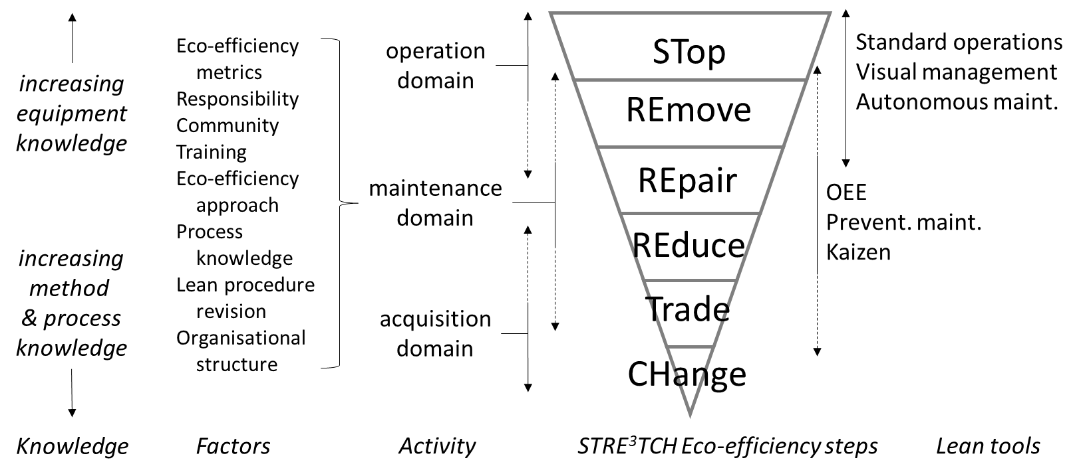

**Figure 7: A framework for lean eco-efficiency through maintenance organisation**

*5.6 Future research*

Mostafa et al. (2015) challenged the evidence of linking lean and maintenance organisationally. The eco-efficiency framework (Figure 7) shows how maintenance can integrate eco-efficiency with lean innovative activity. There are opportunities to address shortcomings of this research. Firstly, the research was conducted in a single large enterprise with an internal supply chain, hence work to understand whether the implementations at other sites can be adopted by smaller companies and supply chains made up of different companies would be valuable. There are potential trade-offs for maintenance to balance greater eco-efficiency and greater lean product flow. How maintenance can make decisions technically to achieve savings warrants further investigation. The trade-offs within lean production alone are well known but between lean and eco-efficiency are seldom reported. Also, it would be valuable to uncover if manufacturers that lead their eco-efficiency through their maintenance function perform better through greater innovation than those who use other organisational arrangements. Further, it would be fruitful to contrast the types of innovation (incremental and radical) that maintenance drives with other organisational functions. Finally, the role that maintenance has in specifying the design of future production systems and organisational metrics to support eco-efficient, lean production has potential for the discovery of new knowledge to support future manufacturing.

**6. Conclusions**

The connection between maintenance and eco-efficiency in manufacturing is largely absent from the literature and yet conceptually maintenance has the potential to link eco-efficiency into day-to-day lean operations. This paper has explored maintenance and eco-efficiency (green) literature in the context of innovation-led lean to uncover work to date before using case research to ground how maintenance has supported eco-efficiency practice change to less unsustainable operations. The research novelty is the role maintenance could have in supporting eco-efficiency in innovation-led lean organisations. The research highlights the role of community, training, tools and organisational structure in ensuring that eco-efficiency targets are pursued.

Maintenance is a potential conduit for sustaining eco-efficiency advances within innovation-led lean operations. Both eco-efficiency and lean strive to innovate to maximise value and minimise waste, hence improving eco-efficiency will typically improve lean performance and vice versa. The metrics and subsequent activity of maintenance operations are compatible with innovation processes for both lean and eco-efficiency. The ability of maintenance to work simultaneously on both and therefore balance trade-offs in performance offers a means by which companies can bring eco-efficiency into innovation-led lean operations improvement and sustainment.

This paper contributes to theory by addressing the gap in how to embed eco-efficiency in an organisation. The paper argues that the maintenance function is well placed to lead innovation in eco-efficiency in existing lean operations. The work demonstrates incentivising performance improvement through maintenance is appropriate as maintenance has the skills and production equipment responsibility to improve eco-efficiency as well as lean efficiency. A novel eco-efficiency framework for the maintenance organisation is presented to extend innovation-led lean through an eco-efficiency improvement method and enabling organisational factors. The method enables environmental process innovations whilst the organisational factors are foundations for environmental innovativeness. Placing responsibility on maintenance for day-to-day activity can align eco-efficiency innovation with production efficiency innovation. The work shows how barriers from the literature can be overcome to support eco-efficient lean operations in practice.

For practice, the paper contributes through the factors in the framework that supports the role of the maintenance organisation in eco-efficiency. The work details how factors including community, eco-efficiency improvement method, training and embedding learning in new standard operating procedures can support eco-efficiency as part of the wider sustainability agenda. The work demonstrates that it is possible to pursue eco-efficiency within existing lean organisational structures by re-defining the role of maintenance. Requirements can be built into new capital purchase and the activities can complement the existing production innovation process. Additionally, the work demonstrates how benefits can be realised across multiple tiers of an internal supply chain through a network community. Examples show that eco-efficiency improvements can serve both the resource efficiency as well as the lean imperatives. Industrially, the framework can usefully guide companies who are challenged with sustaining eco-efficiency innovation. Finally, the framework utility extends to how to align with existing functional responsibilities and how to position against the application of existing lean tools.

**Funding**

This research did not receive any specific grant from funding agencies in the public, commercial, or not-for-profit sectors.

**References**

Abreu, M.F., Alves, A.C., Moreira, F. 2017. Lean-Green models for eco-efficient and sustainable production. Energy, 137, 846-853.

Aguado, S., Alvarez, R., Domingo, R. 2013. Model of efficient and sustainable improvements in a lean production system through processes of environmental innovation. Journal of Cleaner Production, 47, 141-148.

Ahuja, I.P.S., Khamba, J.S. 2008. Assessment of contributions of successful TPM initiatives towards competitive manufacturing. Journal of Quality in Maintenance Engineering, 14(4), 356-374.

Ball, P.D. 2015. Low energy production impact on lean flow. Journal of Manufacturing Technology Management, 26(3), 412-428.

Bortolotti, T., Danese, P., Flynn, B.B., Romano, P. 2015. Leveraging fitness and lean bundles to build the cumulative performance sand cone model, International Journal of Production Economics, 162, 227-241.

Bossle, M.B., Barcellos, M.D., Vieira, L.M., Sauvée, L. 2016. The drivers for adoption of eco-innovation. Journal of Cleaner Production, 113, 861-872.

Chan, F.T.S., Lau, H.C.W., Ip, R.W.L., Chan, H.K., Kong, S. 2005. Implementation of total productive maintenance: A case study. International Journal of Production Economics, 95, 71-94.

Cherrafi, A., Elfezazi, S., Chiarini, A., Mokhlis, A., Benhida, K. 2016. The integration of lean manufacturing, Six Sigma and sustainability: A literature review and future research directions for developing a specific model. Journal of Cleaner Production, 139, 828-846.

Chiarini, A. 2014. Sustainable manufacturing-greening processes using specific Lean Production tools: an empirical observation from European motorcycle component manufacturers, Journal of Cleaner Production, 85, 226-233.

Crespo Marquez, A., Benoit, I. 2007. A structured approach for the assessment of system availability and reliability using Monte Carlo simulation. Journal of Quality in Maintenance Engineering, 13(2), 125-136.

Dalle Carbonare, A., Ball, P., Macchi, M., Holgado, M. 2014. Improving environmental performance through maintenance: A proposed QFD-based methodology. Proceedings of the 12th International Conference on Manufacturing Research, 259-264.

De Minicis, M., Tronci, M., Fargnoli, M. 2012. Eco-Maintenance: The Improvement of Environmental Sustainability by Means of Maintenance. International Conference on Industrial Engineering and Operations Management, Istanbul, Turkey, 570-579.

Despeisse, M., Oates, M.R., Ball, P.D. 2013. Sustainable manufacturing tactics and cross-functional factory modelling, Journal Cleaner Production, 42, 31-41.

Dhingra, R., Kress, R., Upreti, G. 2014. Does lean mean green? Journal of Cleaner Production, 85, 1-7.

Dües, C.M., Tan, K.H., Lim, M. 2013 Green as the new Lean: how to use Lean practices as a catalyst to greening your supply chain. Journal of Cleaner Production, 40, 93-100.

Doppelt, B. 2003. Leading change towards sustainability: A change-management guide for business, government and civil society, Greenleaf Publishing, Sheffield, UK.

Esty, D.C., Winston A.S. 2009. Green to Gold: How Smart Companies Use Environmental Strategy to Innovate, Create Value, and Build Competitive Advantage,John Wiley.

Fercoq, A., Lamouri, S., Carbone, V. 2016. Lean/Green integration focused on waste reduction techniques. Journal of Cleaner Production, 137, 567-578.

Florida, R. 1996. Lean and green: The move to environmentally conscious manufacturing. California Management Review, 39(1): 80-105.

Garetti, M., Taisch, M. 2012. Sustainable manufacturing: trends and research challenges. Production Planning & Control, 23(2-3), 83-104.

Gavronski, I., Klassen, R.D., Vachon, S., Machado do Nascimento, L.F. 2012. A learning and knowledge approach to sustainable operations. International Journal of Production Economics, 140(1), 183-192.

Graham, S., Potter, A., 2015. Environmental operations management and its links with proactivity and performance: A study of the UK food industry. International Journal of Production Engineering, 170(A), 146-159.

Hartini, S., Ciptomulyono, U. 2015. The relationship between lean and sustainable manufacturing on performance: literature review. Procedia Manufacturing, 4, 38-45.

Holgado, M. 2014. Sustainable value creation in manufacturing through maintenance services, doctoral thesis, Politecnico Di Milano, Italy.

Ireland, F. & Dale, B.G. 2001. A study of total productive maintenance implementation, Journal of Quality in Maintenance Engineering, 7(3), 183-191.

Jabbour, C.J.C., Neto, A.S., Gobbo Jr., J.A., Ribeiro, M.S., Jabbour, A.B.L.S. 2015. Eco-innovations in more sustainable supply chains for a low-carbon economy: A multiple case study of human critical success factors in Brazilian leading companies. International Journal of Production Economics, 164, 245-257.

Jasiulewicz-Kaczmarek, M. 2014. Integrating Lean and Green Paradigms in Maintenance Management, 19th World Congress: Int Federation of Automatic Control, 4471-4476.

Kaur, M., Singh, K., Ahuja, I.S. 2012. An evaluation of the synergic implementation of TQM and TPM paradigms on business performance, International Journal of Productivity and Performance Management, 62(1), 66-84.

King A.A., Lenox, M.J. 2001. Lean and Green? An empirical examination of the relationship between lean production and environmental performance, Production and Operations Management, 10(3), 244-256.

Kurdve, M., Zackrisson, M., Wiktorsson, M., Harlin, U. 2014. Lean and green integration into production system models – experiences from Swedish industry. Journal of Cleaner Production, 85, 180-190.

Lewis, M.A. 2000. Lean production and sustainable competitive advantage. International Journal of Operations & Production Management, 20(8), 959-978.

Lii, P., Kuo, F.I. 2016. Innovation-oriented supply chain integration for combined competitiveness and firm performance. International Journal of Production Economics, 174, 142-155.

Liyanage, J.P., Kumar, U. 2003. Towards a value-based view on operations and maintenance performance management. Journal of Quality in Maintenance Engineering, 9(4), 333-350.

Lunt, P.A.V., Ball, P.D., Kaladgew, S. 2014. Integrating energy efficiency into industrial strategy - a case study from the European aerospace sector. Procedia CIRP 26, 241-246.

Martínez-Jurado, P.J., Moyano-Fuentes, J. 2014. Lean Management, Supply Chain Management and Sustainability: A Literature Review. Journal of Cleaner Production, 85, 134-150.

Mostafa, S., Dumrak, J., Soltan, H. 2015. Lean maintenance roadmap. Procedia Manufacturing, 2, 434-444.

Moyano-Fuentes, J., Maqueira-Marín, J.M., Bruque-Cámara, S. 2018. Process innovation and environmental sustainability engagement: An application on technological firms Journal of Cleaner Production, 171, 844-856.

Muchiri, P., Pintelon, L., Gelders, L., Martin, H. 2011. Development of maintenance function performance measurement framework and indicators. International Journal of Production Economics, 131, 285-302.

Ng, R., Low, J.S.C., Song, B. 2015. Integrating and implementing Lean and Green practices based on proposition of Carbon-Value Efficiency metric. Journal of Cleaner Production, 95, 242-255.

Piercy, N., Rich, N. 2015. The relationship between lean operations and sustainable operations. International Journal of Operations & Production Management, 35(2), 282-315.

Rodriguez, J.A., Wiengarten, F. 2017. The role of process innovativeness in the development of environmental innovativeness capability. Journal of Cleaner Production, 142, 2423-2434.

Rothenberg, S., Pil, F.K., Maxwell, J. 2001. Lean, green and the quest for superior environmental performance. Production and Operations Management, 10(3), 228-243.

Ruiz-Benitez, R., López, C., Real, J.C. 2017. Environmental benefits of lean, green and resilient supply chain management: The case of the aerospace sector. Journal of Cleaner Production, 167, 850-862.

Sénéchal, O. 2017. Research directions for integrating the triple bottom line in maintenance dashboards. Journal of Cleaner Production, 142, 331-342.

Shah, R., Ward, P.T. 2003. Lean manufacturing: context, practice bundles, and performance. Journal of Operations Management, 21, 129-149.

Smith, L., Ball, P.D. 2012. Steps towards sustainable manufacturing through modelling material, energy and waste flows. International Journal of Production Economics, 140(1), 227-238.

Subramanian, N., Gunasekaran, A., 2015. Cleaner supply-chain management practices for twenty-first-century organizational competitiveness: Practice-performance framework and research propositions. International Journal of Production Economics, 164, 216-233.

Thanki, S., Govindan, K., Thakkar, J. 2016. An investigation on lean-green implementation practices in Indian SMEs using analytical hierarchy process (AHP) approach. Journal of Cleaner Production, 135, 284-298.

Tousley, P.C. 2010. Maintain it and save - Why We Need Maintenance Management Programs. Energy Engineering, 107(5), 64-75.

Verrier, B., Rose, B., Caillaud, E. 2016. Lean and Green strategy: the Lean and Green House and maturity deployment model, Journal of Cleaner Production, 116: 150-156.

Van Horenbeek, A., Kellens, K., Pintelon, L., Duflou, J.R. 2014. Economic and environmental aware maintenance optimization. Procedia CIRP 15, 343-348.

Womack, J.P., Jones, D.T. 2005. Lean solutions: how companies and customers can create value and wealth together. Simon & Schuster, London, UK.

Yan, J., Hua, D., Wang, X., Xin Li, X. 2012. Sustainable Manufacturing Oriented Prognosis for Facility Reuse Combining ANN and Reliability. Quality and Reliability Engineering International, 28, 265–277.

Yang, C.-L., Lin, S.-P., Chan, Y.-h., Sheu, C. 2010. Mediated effect of environmental management on manufacturing competitiveness: An empirical study. International Journal of Production Economics, 123, 210-220.

Yang, M.G.M., Hong, P., Modi, S.B. 2011. Impact of lean manufacturing and environmental management on business performance: An empirical study of manufacturing firms. International Journal of Production Economics, 129, 251-261.

Zhu, Q., Sarkis, J. 2004. Relationships between operational practices and performance among early adopters of green supply chain management practices in Chinese manufacturing enterprises. Journal of Operations Management, 22(3), 265-289.

1. First letter capitalisation denotes specific functional group in case company