Cost-utility analysis using EQ-5D-5L data: does how the utilities are derived matter?

Fan Yang PhD¹, Nancy Devlin PhD², Nan Luo PhD³

¹Centre for Health Economics, University of York, York, UK
²Office of Health Economics, London, UK
³Saw Swee Hock School of Public Health, National University of Singapore, Singapore, Singapore

Abstract

Objectives: To explore how the use of EQ-5D-5L value set and crosswalk from EQ-5D-5L to EQ-5D-3L (and use of 3L value set) would affect cost-effectiveness analysis results for England and six other countries (Canada, the Netherlands, China, Japan, South Korea and Singapore).

Methods: Individual-level utilities derived from primary 5L data using both value set (5L) and crosswalk (c5L) approaches were applied to three Markov models assessing the cost-effectiveness of hemodialysis (HD) and peritoneal dialysis (PD) for end-stage renal disease (ESRD) patients to estimate incremental quality-adjusted life years (QALYs). The mathematic functions between incremental QALY and utility were derived.

Results: 5L- and c5L-based incremental QALYs were similar in the model for non-diabetic patients (range: 1.910-2.149, 1.922-2.121). 5L tends to generate more incremental QALYs than c5L in the model for diabetic patients (range: 1.454-1.633, 1.365-1.568) but less incremental QALYs in the model for all ESRD patients (range: 0.290-0.480, 0.315-0.493).
In all models, 5L (c5L) generated more incremental QALYs when Chinese (South Korean) value sets were used. The largest and smallest differences in 5L- and c5L-based incremental QALYs were observed when Chinese and Dutch value sets were used. Incremental QALYs was a positive linear function of both utility of PD and difference in utilities of HD and PD.

Conclusions: The value set and crosswalk approaches may not be used interchangeably in economic evaluation when EQ-5D-5L data are used to estimate utilities. Results of cost-effectiveness analysis using Markov models may be affected by both absolute utilities and their differences.

Key words: cost-utility analysis, EQ-5D-5L, EQ-5D-3L, value set, crosswalk

Highlights

i. What is already known about the topic?
- Some evidence suggests that the English EQ-5D-5L value set may generate fewer incremental QALYs than the UK EQ-5D-3L value set in cost-utility analysis (CUA).
- Currently, NICE recommends using van Hout et al’s 5L to 3L crosswalk algorithm and the UK 3L value set to generate utilities from 5L data.

ii. What does the paper add to existing knowledge?
- For the first time, we show that the English 5L value set will, in some cases, yield higher estimates of incremental QALYs than the UK 3L value set; and that the Dutch 5L value set and crosswalk may generate very similar QALYs when they applied to patients’ EQ-5D data.
- Also for the first time, we demonstrated that incremental QALY can be a function of both absolute utilities and their differences in Markov model based cost-effectiveness analysis.

iii. What insights does the paper provide for informing health care-related decision making?
- It would be more sensible to use utility values derived from both crosswalk and the English 5L value set before it is entirely clear which approach should be adopted as the reference case in England.
- Switching from 3L to 5L may not affect consistency in reimbursement decision making in the Netherlands.
- The relative performance of the 5L value set and crosswalk in cost-effectiveness analysis from any one country may not be transferable to other countries.

Introduction

Cost-utility analysis (CUA) has been widely used to guide healthcare resource allocation. In such analyses, quality-adjusted life year (QALY) is used to quantify health outcomes [1]. The 3-level EQ-5D (EQ-5D-3L or, in short, 3L) [2] has been the preferred instrument of National Institute for Health and Care Excellence (NICE) in England for QALY estimation in economic evaluation [3] and it is also being recommended or accepted by health technology assessment agencies of many other countries [4-6]. 3L uses a health-state classification system for collecting quality of life data directly from patients and a value set, which reflects the general public’s health preferences, for generating the quality of life weights (‘utilities’) required to estimate QALYs [7]. The classification system defines health with 5 dimensions (mobility, self-care, usual activities, pain/discomfort, and anxiety/depression) [8] and 3 descriptive levels (broadly corresponding to no problems, some problems, and extreme problems) for each dimension.

Recently, a new, 5-level EQ-5D (EQ-5D-5L or 5L) was developed by the EuroQol Group [9]. It measures health in the same five dimensions as 3L but with 5 descriptive levels including no problems, slight problems, moderate problems, severe problems, and extreme problems. Many studies have demonstrated the superiority of 5L versus 3L in measurement properties such as ceiling effects, reliability, and sensitivity [10-12]. Using a standardized study protocol and data collection instrument [13], many countries have developed their own 5L value sets, e.g., Canada, England and the Netherlands [14], and more are underway. Moreover, a 5L to 3L crosswalk algorithm was developed by van Hout et al as an interim solution for countries where only a 3L value set is available [15].

Whilst the 5L was developed with the intention to supersede the 3L, little is known about the impact of this switch on outcomes of economic evaluation. Nevertheless, a recent study by Hernandez et al [16] found that the English 5L value set is very likely to generate fewer QALYs and higher incremental cost-effectiveness ratios (ICERs) than the UK 3L value set in cost-effectiveness analysis of health technologies, raising concerns about consistency in decision making if 3L is replaced with 5L in decisions affecting the National Health Service. As a result, NICE recently stated its position of continuing to recommend EQ-5D-3L and recommended using van Hout et al’s crosswalk algorithm, as opposed to the English 5L value set, to estimate QALYs when 5L data is available [17]; health technology assessment agencies in other countries have not formally stated a position on use of the 5L, either because they have less formalized ‘reference case’ requirements than NICE, or because no 5L value set studies have been undertaken in their jurisdictions yet.

NICE’s position is partly based on the assumption that the 5L value set and the crosswalk approaches would lead to different conclusions in cost-effectiveness analysis [18]. This assumption, however, has not adequately been tested empirically. Hernandez et al ’s study [16] used mapping functions to generate 5L data from 3L data. It has been well documented that mapping or crosswalk generally produces biased estimates [19].

Therefore, in the present study, we aimed to examine whether the use of 5L value set and crosswalk approaches would affect cost-effectiveness analysis results by incorporating primary 5L data collected in patients with end-stage renal disease (ESRD) into three Markov models for assessing the cost-effectiveness of dialysis treatments with utilities derived from applying the two approaches to primary 5L data. We used the 3L and 5L value sets of England and six other countries in order to evaluate the transferability of the issue across countries. We also aimed to explore the reasons for the different cost-effectiveness analysis results if such variations exist.

Methods

Decision analytic models
Three decision analytic models used in two recently published cost-utility analysis studies of hemodialysis (HD) and peritoneal dialysis (PD) for ESRD patients conducted in Singapore [20] and Norway [21] were used in the present study. In the Singaporean study, two Markov models were constructed for non-diabetic and diabetic patients separately using different parameter values. Those two models were re-run in this study as model 1 (non-diabetic patients) and model 2 (diabetic patients). In the Norwegian study, an overall Markov model was estimated. It was used as model 3 (all ESRD patients) in this study. Models 1 and 2 assume patients start in either HD or PD state, and remain in this state or moved to transplantation or death state in a subsequent cycle (1 cycle = 1 year). The structure of model 3 is identical to that of models 1 and 2 except that transition between HD and PD is allowed (Figure 1).

Transition probabilities of models 1 and 2 were estimated using a cohort of dialysis patients followed up by a tertiary hospital in Singapore [22] and the national renal registry of Singapore [23] (see Supplementary Table 1 for details) and a 10-year time horizon was assumed. In model 3, the time horizon (5-year) and transition probabilities were estimated using Norwegian renal registry data and the relative risk for mortality (PD vs. HD) was based on a systematic review and meta-analysis of ten published effectiveness and cost-effectiveness studies comparing HD and PD (see Supplementary Table 1 for details).

Quality of life data
In a cross-sectional survey, a consecutive sample of 150 ESRD patients undergoing dialysis (HD: 75, PD: 75) for at least 3 months was interviewed by a trained interviewer using the EQ-5D-5L questionnaire and questions assessing socio-demographic characteristics [24].

Estimation of utilities
Individual-level utilities were generated using both 5L value sets and 3L value sets from seven countries via a ‘crosswalk’ between the 5L and 3L descriptive systems. The main characteristics of the value sets are summarized in Table 1.

First, utilities were calculated using seven recently developed country-specific 5L value sets: England [25], Canada [26], Japan [27], the Netherlands [28], South Korea [29], China [30], and Singapore (unpublished data, see Supplementary Table 2). These value sets were developed using time trade-off (TTO) data alone or both TTO and discrete choice experiment (DCE) data collected from the general public using a standardized protocol and survey tool [13].

Second, utilities were calculated using van Hout et al’s crosswalk algorithm [15] and 3L value sets available for the UK [31], Canada [32], Japan [33], the Netherlands [34], South Korea [35], China [36], and Singapore [37]. The algorithm was developed using a large dataset containing responses of individuals in varied health status to both 3L and 5L items. It maps each 5L state to one or more 3L states with corresponding probabilities [15]. The utilities were calculated as the weighted sums of the 3L values by the probabilities. The crosswalk-derived utilities are hereafter referred to as “c5L” values.

After individual-level EQ-5D utilities were calculated, multivariate OLS regression models were used to predict the mean utility values for HD and PD treated non-diabetic and diabetic ESRD patients and used in model 1 and 2, respectively. And then using the proportion of diabetic patients in Norway, the mean utility values for all ESRD patients were calculated and used in model 3. The analysis was done for each set of country-specific 5L and c5L values. The predicted health utilities for HD and PD were used in cost-utility models. The health utilities for transplantation were obtained from a published meta-analysis [38].

Analysis of Markov models
For each set of the utilities, a hypothetical cohort of 10,000 patients was modeled to estimate the incremental QALYs gained from HD and PD for an average patient in the three models. Discounting at an annual rate of 3% was applied. Direction and magnitude of the difference in 5L and c5L based incremental QALYs estimated from the models were examined for each country. The mathematic functions based on the Markov processes for estimating incremental QALYs were used to examine the relationship between utility and incremental QALY. All the Markov models were analyzed using Microsoft Excel 2016 (Microsoft Corporation, Redmond, WA).

Results

All EQ-5D utilities showed that patients on HD had better quality of life than those on PD (Table 2). For all three models, the mean absolute utilities for HD and PD and the differences between the two dialysis treatments varied with the approach used to generate the utilities. All countries considered, the 5L values were generally higher and exhibited slightly smaller differences than the c5L values (Table 2).

The estimated incremental QALYs are summarized in Table 2. In the model for non-diabetic ESRD patients, incremental QALYs based on 5L and c5L estimated using value sets of the seven countries ranged from 1.910 to 2.149 and 1.922 to 2.121, respectively. In the model for diabetic ESRD patients, incremental QALYs based on 5L (range: 1.454 to 1.633) were generally higher than those based on their corresponding c5L values (range: 1.365 to 1.568). In the model for all ESRD patients, incremental QALYs based on 5L (range: 0.290 to 0.480) were lower than those based on their corresponding c5L values (range: 0.315 to 0.493).

In all three models, 5L (c5L) generated more incremental QALYs when value sets of China (South Korea) were used. Such patterns were not observed for other counties. The magnitude of the differences in 5L and c5L based incremental QALYs estimated in the models varied with the value sets used (Figure 2). The largest and smallest differences were observed when value sets of China (range: 0.086 to 0.202) and the Netherlands (range: -0.009 to 0.023) were used, respectively. In all models, incremental QALY was a positive linear function of both utility of PD and difference in utilities of PD and HD (see Supplementary Table 3 for details).

Discussion

To the best of our knowledge, this is the second study aiming to assess the impact of switching from 3L to 5L on economic evaluation. There are two important differences between our study and the earlier work by Hernandez et al [16]. First, we used 5L data where Hernandez et al used 3L data. Second, we examined multiple models for assessing the same health technologies and Hernandez et al studied multiple models each assessing a different health technology. Our finding is consistent with that of Hernandez et al ’s analysis [16] in one respect: that estimated incremental QALYs derived from the English 5L value set and the crosswalk approach differ, supporting the concern that concurrent use of 3L and 5L value sets in England could lead to inconsistent decisions. However, in contrast to Hernandez et al ’s [16], we observed that the English 5L value set has a fairly reasonable chance (1 in 3 models) of exhibiting higher incremental QALYs than the UK 3L value set when applied to primary EQ-5D-5L data. This is in contrast to Hernandez et al ’s finding that in eight of nine cost-effectiveness case studies, the UK 3L value set led to higher estimates of incremental QALYs compared to the English 5L value set [16]. This inconsistent finding is not surprising because both studies are based on convenient CUAs; generalizability of both studies is limited. Nevertheless, our study shows that certain cost-effective health technologies may be erroneously rejected by the National Health Service if only crosswalk-based QALY estimates are used in CUA when 5L data is available. This suggests it may be important to use both utility values derived from the crosswalk and the English 5L value set, and to check the sensitivity of results, before either approach is adopted as the reference case.

We found that the incremental QALYs derived from the Dutch 5L value set and the crosswalk approach were very similar, suggesting that the two approaches may be used interchangeably for economic evaluation in the Netherlands. This may be because that Dutch 5L and 3L value sets are similar in terms of minimum value, value range and shape of distribution [28] while there are great differences between English 5L and UK 3L values sets [39]. This finding in turn suggests that switching from 3L to 5L may not cause any inconsistency in reimbursement decision making and therefore unlike England, Dutch 3L and 5L value may be used concurrently in health technology assessment since EQ-5D is the preferred utility instrument in the Netherlands. The finding that the magnitude of differences between the two approaches varied across the seven countries suggests that experience from any one country may not be transferrable to other countries, in line with previous findings that country-specific EQ-5D value sets would generate different CUA results [40, 41]. This result also suggests that switching from 3L to 5L could lead to more favourable or unfavourable cost-effectiveness outcomes in Canada, China, Japan, South Korea, and Singapore. This is not an immediate issue for the health technology assessment agencies in those countries because a reference case has not been implemented. However, it would be wise to designate a utility instrument within each jurisdiction, at least for the five countries studied, if both the 3L and 5L are candidates. Which version of the EQ-5D should be used is a complex question, involving both the measurement properties of the two versions in describing patient health, and the characteristics of the value sets used to preference weight them. Addressing this as an issue arguably supersedes other considerations such as continuity and consistency in decision making of health authorities.

The finding that incremental QALYs were a function of both utility of PD and difference in utilities of PD and HD suggests that the effect of heath-state utility on cost-effectiveness outcomes is not solely through the difference in utilities of the alternatives. Absolute utilities of the alternatives also matter and may have a greater effect than the difference in the utilities of the alternatives. This was clearly demonstrated by results of models 1 and 2 – for example, when the English 5L value set was used to estimate utilities for model 2, more incremental QALYs were estimated even though the difference in 5L-based utilities of HD and PD was smaller than that based on c5L-based utilities. Thus, this finding invalidated the naïve notion that magnitude of the difference in utilities of alternatives alone determines incremental QALYs in CUA, an implicit assumption used by many studies of utility instruments [24, 42, 43].

The main limitation of the study is the use of conveniently available EQ-5D data and models for assessing dialysis treatments, which undoubtedly limits the generalizability of its findings. A systematic investigation of the issue of concern for health technologies in all main therapeutic areas with models and EQ-5D primary data from all main populations would be ideal. However, such a study would be very costly and therefore is not feasible. Tapping on the issue in the manner of case studies is a more pragmatic approach. Therefore, we call for more studies into the issue to further our knowledge about it. It would be particularly useful to make head-to-head comparison of 3L and 5L value sets using primary 3L and 5L data respectively [18]. Both Hernandez et al and us used only one type of EQ-5D data and generated the other type of data through crosswalk. Since the crosswalk is bound to suffer from biases, such studies cannot accurately assess the impact of switching from 3L to 5L on CUA results.

Conclusions

The value set and crosswalk approaches may not be used interchangeably in economic evaluation when EQ-5D-5L data are used to estimate utilities. Results of cost-effectiveness analysis may be affected by both absolute utilities and their differences. More research is needed to inform how the two versions of EQ-5D should be used in health technology assessment.

References

1. Weinstein MC, Torrance G, McGuire A. QALYs: the basics. Value in health : the journal of the International Society for Pharmacoeconomics and Outcomes Research. 2009;12 Suppl 1:S5-9.
2. Rabin R, de Charro F. EQ-5D: a measure of health status from the EuroQol Group. Ann Med. 2001;33(5):337-343.
3. NICE. NICE Guide to the methods of technology appraisal 2013. 2013; https://www.nice.org.uk/process/pmg9/chapter/the-reference-case#measuring-and-valuing-health-effects. [Accessed August 15, 2017, 2017].
4. CADTH. Guidelines for the Economic Evaluation of Health Technologies: Canada. https://www.cadth.ca/about-cadth/how-we-do-it/methods-and-guidelines/guidelines-for-the-economic-evaluation-of-health-technologies-canada. [Accessed December 12, 2017, 2017].
5. PBS. Guidelines for preparing submissions to the Pharmaceutical Benefits Advisory Committee (Version 4.2). 2017; http://www.pbs.gov.au/info/industry/listing/procedure-guidance/4-presubmission-requirements/4-2-guidelines-for-preparing-submissions. [Accessed December 12, 2017, 2017].
6. SMC. Guidance to manufacturers for completion of New Product Assessment Form (NPAF) (November 2017). https://www.scottishmedicines.org.uk/files/submissionprocess/Guidance_on_NPAF_Final_May2017.doc. [Accessed December 12, 2017, 2017].
7. Devlin NJ, Brooks R. EQ-5D and the EuroQol Group: Past, Present and Future. Applied health economics and health policy. 2017;15(2):127-137.
8. Rabin R, de Charro F. EQ-5D: a measure of health status from the EuroQol Group. Ann Med. 2001;33(5):337-343.
9. EuroQol. EQ-5D-5L user guide: basic information on how to use the EQ-5D-5L instrument. 2014; https://euroqol.org/wp-content/uploads/2016/09/EQ-5D-5L_UserGuide_2015.pdf. [Accessed June 20, 2017, 2017].
10. Scalone L, Ciampichini R, Fagiuoli S, et al. Comparing the performance of the standard EQ-5D 3L with the new version EQ-5D 5L in patients with chronic hepatic diseases. Qual Life Res. 2013;22(7):1707-1716.
11. Janssen MF, Pickard AS, Golicki D, et al. Measurement properties of the EQ-5D-5L compared to the EQ-5D-3L across eight patient groups: a multi-country study. Qual Life Res. 2013;22(7):1717-1727.
12. Agborsangaya CB, Lahtinen M, Cooke T, Johnson JA. Comparing the EQ-5D 3L and 5L: measurement properties and association with chronic conditions and multimorbidity in the general population. Health and quality of life outcomes. 2014;12:74.
13. Oppe M, Devlin NJ, van Hout B, Krabbe PF, de Charro F. A program of methodological research to arrive at the new international EQ-5D-5L valuation protocol. Value in health : the journal of the International Society for Pharmacoeconomics and Outcomes Research. 2014;17(4):445-453.
14. EuroQol. EQ-5D-5L: valuation. 2017; https://euroqol.org/eq-5d-instruments/eq-5d-5l-about/valuation/. [Accessed August 15, 2017].
15. van Hout B, Janssen MF, Feng YS, et al. Interim scoring for the EQ-5D-5L: mapping the EQ-5D-5L to EQ-5D-3L value sets. Value Health. 2012;15(5):708-715.
16. Hernandez Alava M, Wailoo A, Grimm S, et al. EQ-5D-5L versus EQ-5D-3L: The Impact on Cost Effectiveness in the United Kingdom. Value Health. 2018;21(1):49-56.
17. NICE. NICE Position statement on use of the EQ-5D-5L valuation set. 2017; https://www.nice.org.uk/Media/Default/About/what-we-do/NICE-guidance/NICE-technology-appraisal-guidance/eq5d5l_nice_position_statement.pdf. [Accessed August 11, 2017].
18. Lloyd A. EQ-5D: Moving from Three Levels to Five. Value Health. 2018;21(1):57-58.
19. Longworth L, Rowen D. Mapping to obtain EQ-5D utility values for use in NICE health technology assessments. Value in health : the journal of the International Society for Pharmacoeconomics and Outcomes Research. 2013;16(1):202-210.
20. Yang F, Lau T, Luo N. Cost-effectiveness of haemodialysis and peritoneal dialysis for patients with end-stage renal disease in Singapore. Nephrology. 2016;21(8):669-677.
21. Pike E, Hamidi V, Ringerike T, Wisloff T, Klemp M. More Use of Peritoneal Dialysis Gives Significant Savings: A Systematic Review and Health Economic Decision Model. J Clin Med Res. 2017;9(2):104-116.
22. Yang F, Khin LW, Lau T, et al. Hemodialysis versus Peritoneal Dialysis: A Comparison of Survival Outcomes in South-East Asian Patients with End-Stage Renal Disease. PLoS One. 2015;10(10):e0140195.
23. Choong HL. Eighth report of the Singapore renal registry 2009. 2012.
24. Yang F, Lau T, Lee E, Vathsala A, Chia KS, Luo N. Comparison of the preference-based EQ-5D-5L and SF-6D in patients with end-stage renal disease (ESRD). The European journal of health economics : HEPAC : health economics in prevention and care. 2015;16(9):1019-1026.
25. Devlin NJ, Shah KK, Feng Y, Mulhern B, van Hout B. Valuing health-related quality of life: An EQ-5D-5L value set for England. Health economics. 2017.
26. Xie F, Pullenayegum E, Gaebel K, et al. A Time Trade-off-derived Value Set of the EQ-5D-5L for Canada. Med Care. 2016;54(1):98-105.
27. Shiroiwa T, Ikeda S, Noto S, et al. Comparison of Value Set Based on DCE and/or TTO Data: Scoring for EQ-5D-5L Health States in Japan. Value in health : the journal of the International Society for Pharmacoeconomics and Outcomes Research. 2016;19(5):648-654.
28. M MV, K MV, S MAAE, de Wit GA, Prenger R, E AS. Dutch Tariff for the Five-Level Version of EQ-5D. Value in health : the journal of the International Society for Pharmacoeconomics and Outcomes Research. 2016;19(4):343-352.
29. Kim SH, Ahn J, Ock M, et al. The EQ-5D-5L valuation study in Korea. Quality of life research : an international journal of quality of life aspects of treatment, care and rehabilitation. 2016;25(7):1845-1852.
30. Luo N, Liu G, Li M, Guan H, Jin X, Rand-Hendriksen K. Estimating an EQ-5D-5L Value Set for China. Value in health : the journal of the International Society for Pharmacoeconomics and Outcomes Research. 2017;20(4):662-669.
31. Dolan P. Modeling valuations for EuroQol health states. Med Care. 1997;35(11):1095-1108.
32. Bansback N, Tsuchiya A, Brazier J, Anis A. Canadian valuation of EQ-5D health states: preliminary value set and considerations for future valuation studies. PLoS One. 2012;7(2):e31115.
33. Ikeda S IN. The Japanese EuroQol Tariff Project Health status in Japanese population: results from Japanese EuroQol study. J Health Care Soc. 1999;9(3):83-92.
34. Lamers LM, McDonnell J, Stalmeier PF, Krabbe PF, Busschbach JJ. The Dutch tariff: results and arguments for an effective design for national EQ-5D valuation studies. Health economics. 2006;15(10):1121-1132.
35. Lee YK, Nam HS, Chuang LH, et al. South Korean time trade-off values for EQ-5D health states: modeling with observed values for 101 health states. Value Health. 2009;12(8):1187-1193.
36. Liu GG, Wu H, Li M, Gao C, Luo N. Chinese time trade-off values for EQ-5D health states. Value Health. 2014;17(5):597-604.
37. Luo N, Wang P, Thumboo J, Lim YW, Vrijhoef HJ. Valuation of EQ-5D-3L health states in Singapore: modeling of time trade-off values for 80 empirically observed health states. Pharmacoeconomics. 2014;32(5):495-507.
38. Wyld M, Morton RL, Hayen A, Howard K, Webster AC. A systematic review and meta-analysis of utility-based quality of life in chronic kidney disease treatments. PLoS medicine. 2012;9(9):e1001307.
39. Mulhern B, Feng Y, Shah K, et al. Comparing the UK EQ-5D-3L and the English EQ-5D-5L Value Sets. Office of Health Economics Research Paper. 2017.
40. Lien K, Tam VC, Ko YJ, Mittmann N, Cheung MC, Chan KK. Impact of country-specific EQ-5D-3L tariffs on the economic value of systemic therapies used in the treatment of metastatic pancreatic cancer. Curr Oncol. 2015;22(6):e443-452.
41. Versteegh M. Impact on the Incremental Cost-Effectiveness Ratio of Using Alternatives to EQ-5D in a Markov Model for Multiple Sclerosis. Pharmacoeconomics. 2016;34(11):1133-1144.
42. Xie F, Li SC, Luo N, et al. Comparison of the EuroQol and short form 6D in Singapore multiethnic Asian knee osteoarthritis patients scheduled for total knee replacement. Arthritis Rheum. 2007;57(6):1043-1049.
43. Grutters JP, Joore MA, van der Horst F, Verschuure H, Dreschler WA, Anteunis LJ. Choosing between measures: comparison of EQ-5D, HUI2 and HUI3 in persons with hearing complaints. Qual Life Res. 2007;16(8):1439-1449.
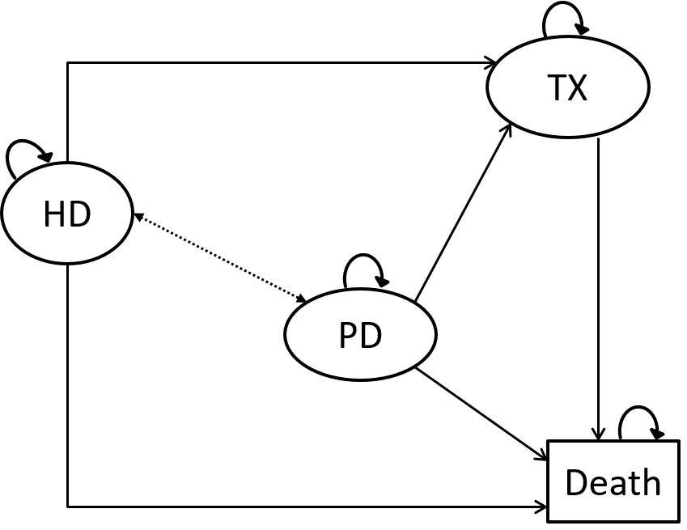
Figure 1. Markov diagram for the cost-effectiveness model of HD and PD for patients with end-stage renal disease. Arrows indicate allowed transitions. Dashed arrow indicates transitions between HD and PD that were only allowed in model 3.
HD-hemodialysis, PD-peritoneal dialysis, TX-transplantation
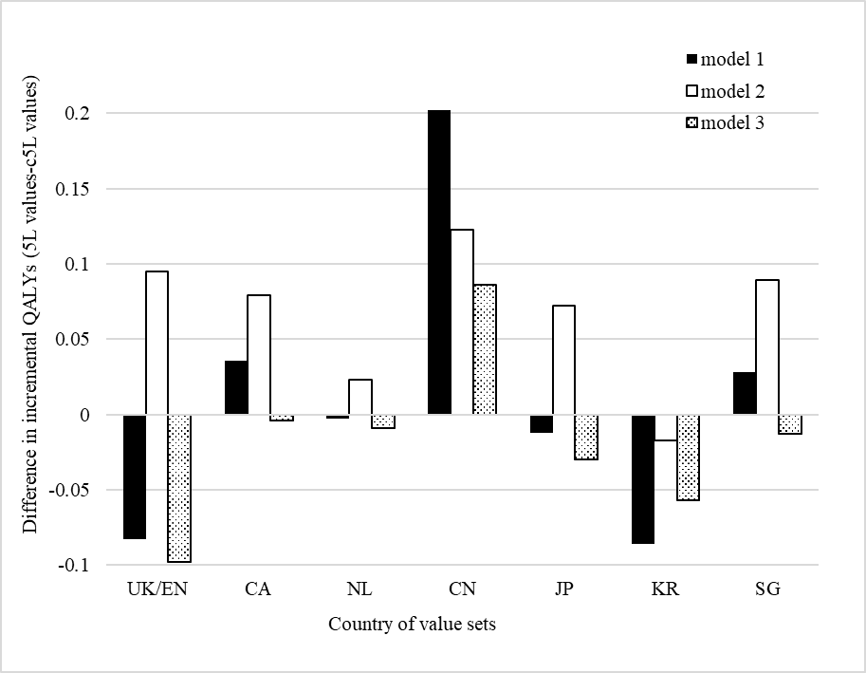
Figure 2. Difference in 5L and c5L based incremental QALYs by country of value sets.
CA-Canada, CN-China, EN-England, JP-Japan, KR-South Korea, NL-the Netherlands, SG-Singapore, UK-United Kingdom

Table 1. Methods to generating health utilities from EQ-5D-5L
Calculation methods | Author | Value set country | Sample size | Valuation method | Value range
5L value set | Devlin et al. | England | 912 | Composite TTO & DCE | (-0.285,1)
 | Xie et al. | Canada | 1073 | Composite TTO | (-0.148, 0.949)
 | Versteegh et al. | Netherlands | 979 | Composite TTO | (-0.446, 1)
 | Luo et al. | China | 1271 | Composite TTO | (-0.391, 1)
 | Shiroiwa et al. | Japan | 1026 | Composite TTO | (-0.025, 1)
 | Kim et al. | South Korea | 1080 | Composite TTO | (-0.066, 1)
 | Luo et al. | Singapore | 1000 | Composite TTO | (-0.984, 1)
3L value set | Dolan et al. | UK | 3395 | Conventional TTO | (-0.594, 1)
 | Bansback et al. | Canada | 1145 | Conventional TTO | (-0.340, 1)
 | Lamers et al. | Netherlands | 309 | Conventional TTO | (-0.329, 1)
 | Liu et al. | China | 1147 | Conventional TTO | (-0.149, 1)
 | Tsuchiya et al. | Japan | 621 | Conventional TTO | (-0.111, 1)
 | Lee et al. | South Korea | 1264 | Conventional TTO | (-0.171, 1)
 | Luo et al. | Singapore | 456 | Composite TTO | (-0.769, 1)
DCE-discrete choice experiment, TTO-time trade-off

Table 2. Utilities and incremental QALYs estimated using two approaches of seven countries
Value set country | Value | Utilities |  |  |  |  |  |  |  |  |  |  |  | Incremental QALYs
 |  | Model 1 |  |  |  | Model 2 |  |  |  | Model 3
 |  | HD | PD | Difference  (HD-PD) |  | HD | PD | Difference  (HD-PD) |  | HD | PD | Difference  (HD-PD) |  | Model 1 | Model 2 | Model 3
England/UK | 5L | 0.882 | 0.803 | 0.079 |  | 0.739 | 0.677 | 0.062 |  | 0.833 | 0.760 | 0.073 |  | 2.011 | 1.603 | 0.318
 | c5L | 0.828 | 0.714 | 0.114 |  | 0.631 | 0.544 | 0.087 |  | 0.761 | 0.656 | 0.105 |  | 2.094 | 1.508 | 0.416
Canada | 5L | 0.873 | 0.789 | 0.084 |  | 0.743 | 0.675 | 0.068 |  | 0.829 | 0.750 | 0.079 |  | 2.021 | 1.633 | 0.337
 | c5L | 0.838 | 0.749 | 0.089 |  | 0.705 | 0.640 | 0.065 |  | 0.793 | 0.712 | 0.081 |  | 1.985 | 1.554 | 0.341
Netherlands | 5L | 0.849 | 0.773 | 0.076 |  | 0.708 | 0.650 | 0.058 |  | 0.801 | 0.731 | 0.070 |  | 1.939 | 1.533 | 0.306
 | c5L | 0.845 | 0.767 | 0.078 |  | 0.693 | 0.634 | 0.059 |  | 0.794 | 0.721 | 0.073 |  | 1.942 | 1.510 | 0.315
China | 5L | 0.874 | 0.768 | 0.106 |  | 0.704 | 0.618 | 0.086 |  | 0.816 | 0.717 | 0.099 |  | 2.134 | 1.633 | 0.401
 | c5L | 0.831 | 0.750 | 0.081 |  | 0.695 | 0.637 | 0.058 |  | 0.785 | 0.712 | 0.073 |  | 1.932 | 1.510 | 0.315
Japan | 5L | 0.850 | 0.780 | 0.070 |  | 0.721 | 0.668 | 0.053 |  | 0.807 | 0.742 | 0.065 |  | 1.910 | 1.536 | 0.290
 | c5L | 0.819 | 0.736 | 0.083 |  | 0.669 | 0.611 | 0.058 |  | 0.768 | 0.693 | 0.075 |  | 1.922 | 1.464 | 0.320
South Korea | 5L | 0.858 | 0.782 | 0.076 |  | 0.725 | 0.670 | 0.055 |  | 0.813 | 0.744 | 0.069 |  | 1.954 | 1.551 | 0.304
 | c5L | 0.852 | 0.757 | 0.095 |  | 0.702 | 0.632 | 0.070 |  | 0.801 | 0.714 | 0.087 |  | 2.040 | 1.568 | 0.361
Singapore | 5L | 0.796 | 0.660 | 0.136 |  | 0.555 | 0.447 | 0.108 |  | 0.714 | 0.588 | 0.126 |  | 2.149 | 1.454 | 0.480
 | c5L | 0.765 | 0.624 | 0.141 |  | 0.498 | 0.387 | 0.111 |  | 0.674 | 0.543 | 0.131 |  | 2.121 | 1.365 | 0.493
Bold value indicates the higher estimated incremental QALY.
ESRD-end-stage renal disease, HD-hemodialysis, PD-peritoneal dialysis, QALY-quality-adjusted life year

Supplementary Table 1. Summary of transition probabilities used in three Markov models
 |  | Definition |  | Value | Source | Assumption
Model 1 (non-diabetic patients): |  | HD-death | Year 1 | 0.031 | [1] | Transition probabilities were constant from the 5th year onwards
 |  |  | Year 2 | 0.033
 |  |  | Year 3 | 0.028
 |  |  | Year 4 | 0.020
 |  |  | Year 5 | 0.040
 |  | PD-death | Year 1 | 0.076
 |  |  | Year 2 | 0.093
 |  |  | Year 3 | 0.147
 |  |  | Year 4 | 0.082
 |  |  | Year 5 | 0.111
 |  | HD/PD-transplant |  | 0.018 | Singapore Renal Registry 2009 [2]
 |  | Transplant-death |  | 0.021
 |  | HD-PD |  | 0 |  | No transition between HD and PD
Model 2 (diabetic patients): |  | HD-death | Year 1 | 0.067 | [1]
 |  |  | Year 2 | 0.083
 |  |  | Year 3 | 0.079
 |  |  | Year 4 | 0.040
 |  |  | Year 5 | 0.086
 |  | PD-death | Year 1 | 0.088
 |  |  | Year 2 | 0.136
 |  |  | Year 3 | 0.204
 |  |  | Year 4 | 0.187
 |  |  | Year 5 | 0.252
 |  | HD/PD-transplant |  | 0.018 | Singapore Renal Registry 2009 [2]
 |  | Transplant-death |  | 0.021
 |  | HD-PD |  | 0 |  | No transition between HD and PD
Model 3 (all ESRD patients): |  | HD-death |  | 0.08 | Norwegian Renal Registry [3]
 |  | PD-death |  | 0.08*1.11 | Relative risk (PD vs HD)=1.11 [4]
 |  | HD/PD-transplant |  | 0.018 | 0.07-0.13 (range of 5 years) [4] | Assume 5 years=0.07, yearly=0.018
 |  | HD-PD |  | 0.005 | 0.01-0.03 (range of 5 years) [4] | Assume 5 years=0.02, yearly=0.005
 |  | PD-HD |  | 0.02 | 0.05-0.14 (range of 5 years) [4] | Assume 5 years=0.08, yearly=0.02
[1] Yang F, Khin LW, Lau T, et al. Hemodialysis versus Peritoneal Dialysis: A Comparison of Survival Outcomes in South-East Asian Patients with End-Stage Renal Disease. PLoS One. 2015;10(10):e0140195.
[2] Choong HL. Eighth report of the Singapore renal registry 2009. 2012.
[3] The Norwegian Renal Registry Annual reports 2013. Available from: http://www.nephro.no/nnr/AARSM2013.pdf. [Accessed December 12, 2017]
[4] Pike E, Hamidi V, Ringerike T, Wisloff T, Klemp M. More Use of Peritoneal Dialysis Gives Significant Savings: A Systematic Review and Health Economic Decision Model. J Clin Med Res. 2017;9(2):104-116.

Supplementary Table 2. Singapore EQ-5D-5L value set
 |  | Coefficient of linear parameter | Value for health state 23245
Constant |  | 1.000
Mobility | slight | 0.101 | 0.101
 | moderate | 0.191
 | severe | 0.372
 | unable | 0.411
Self-care | slight | 0.093
 | moderate | 0.176 | 0.176
 | severe | 0.342
 | unable | 0.378
Usual activities | slight | 0.074 | 0.074
 | moderate | 0.140
 | severe | 0.272
 | unable | 0.300
Pain/discomfort | slight | 0.110
 | moderate | 0.209
 | severe | 0.406 | 0.406
 | extreme | 0.448
Anxiety/depression | slight | 0.110
 | moderate | 0.208
 | severe | 0.404
 | extreme | 0.447 | 0.447
The value for health state 23245 |  |  | 1-0.101-0.176-0.074-0.406-0.447  = -0.204

Supplementary Table 3. Relationship between incremental QALYs and utility of PD and difference in utilities
 | Incremental QALYs=
Model 1 (non-diabetic patients): | utility of PD*1.746+difference*6.802+0.072
Model 2 (diabetic patients): | utility of PD*1.766+difference*5.599+0.060
Model 3 (all ESRD patients): | utility of PD*0.073+difference*3.296+0.022
*coefficients were rounded to 3 decimal places. Difference=utility of HD-utility of PD

