**Effect of humidity on photoinduced radicals in human hair**

**Authors**: Philip Grovesa, Jennifer M Marshb, Yiping Sunb, Tanuja Chaudharyb, Victor Chechikb

1. Department of Chemistry, University of York, Heslington, York YO10 5DD, UK
2. The Procter & Gamble Company, Mason Business Center, 8700 Mason-Montgomery Road, Mason, 45040, USA

**Correspondence** should be addressed to:

Jennifer Marsh, The Procter & Gamble Company, Mason Business Center, 8700 Mason-Montgomery Road, Mason, 45040, USA.

Phone: 513-622-0445. Email: [marsh.jm@pg.com](mailto:xxxxx.xx@pg.com).

**Highlights**:

* UV irradiation results in the formation of keratin free radicals in hair
* At high humidity, free radicals decay faster due to higher molecular mobility
* This is supported by increased protein damage in hair at high humidity

**Keywords**: Hair, Free Radicals, Electron Paramagnetic Resonance, UV Damage

**Graphical Abstract:**

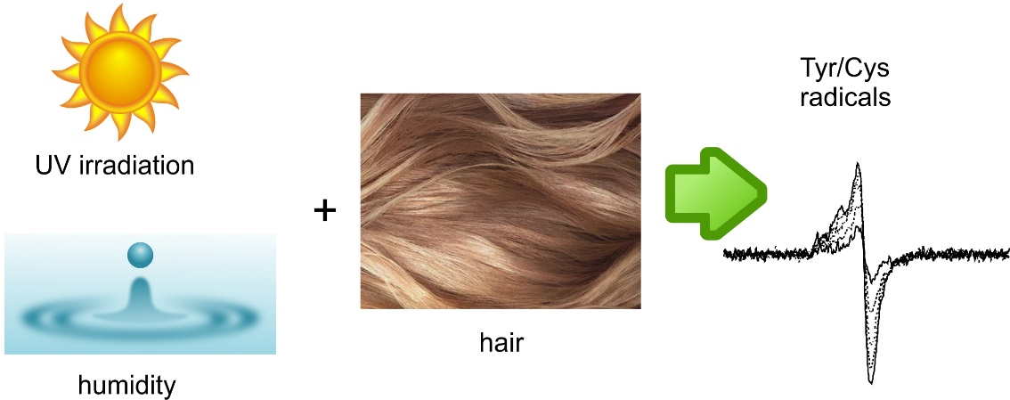

**ABSTRACT:**

EPR spectroscopy was used to monitor formation of free radicals in human hair upon UV irradiation. While the EPR spectra of brown hair were dominated by melanin signal, those of white hair were keratin-derived. Formation of keratin radicals was somewhat suppressed, and their decay was enhanced at increased ambient humidity. We argue that at higher humidity the swollen hair provide more liquid-like environment, and higher molecular mobility in this environment leads to faster radical reactions. This interpretation is consistent with the increased UV-triggered protein damage in hair at high humidity as demonstrated by the protein loss, MALDI-TOF and FT-IR data.

**INTRODUCTION:**

UV damage to hair and its consequences to the structural components of hair including proteins[1], lipids[2] and melanin[3] have been well documented in the literature. Several reports on the oxidation of tryptophan to different kynurenines[4] are found in the literature but there have been few studies that investigate specific radical pathways that lead to the measured fiber integrity changes such as tensile strength. Here, we use electron paramagnetic resonance (EPR) to detect and quantify radicals formed in hair on exposure to UV as a function of relative humidity. EPR studies into paramagnetic species present in hair fibers have been carried out previously, with most published research focused on either the strong intrinsic melanin signal[5] or paramagnetic metal centers such as copper which are present in the fibers[6]. Keratin-derived free radicals have also been observed in white hair by EPR[7]. However, the effect of ambient humidity on the hair chemistry has been largely overlooked. Hair has a reasonably high moisture content of around 14% by weight at 20 °C and 65% relative humidity[8]. The moisture content can vary significantly with changing relative humidity, as hair is quite hygroscopic[9]. This leads to changes in tensile strength and stretching ability, a property exploited by hair hygrometers. We reasoned that on molecular level, humidity should affect local viscosity and molecular dynamics, and hence the chemistry of reactive intermediates. Existing studies into the effects of sunlight upon hair proteins at different humidity have relied on indirect analysis of properties such as tensile strength and fiber swelling. The cleavage of polypeptides and disulfides within the keratin decreases the rigidity of the fiber. Results in literature are contradictory, with swelling measurements indicating highest damage at intermediate humidity[10] and tensile strength measurements showing higher degradation at high humidity[11]. This investigation aims to build upon and clarify existing literature studies and to correlate changes in radical formation and decay with direct measurements of protein degradation using protein loss, protein biomarker and cysteic acid measurement.

**METHODS:**

**Hair Source**

4 g, 8 inch Caucasian-source untreated (i.e. no chemical treatment) light brown and white hair was purchased from International Hair Importers & Products Inc. (Glendale, NY).

**Electron Paramagnetic Resonance Measurements**

Samples of natural white hair were cut into 4 cm lengths, and placed into a Suprasil® quartz EPR tube with an outer diameter of 5 mm. The mass of hair sample loaded was measured, and was 130 ± 3 mg for each sample. The hair samples were then loaded into JEOL JES RE-1X EPR spectrometer (Peabody, MA, USA) and EPR spectra were recorded. Sequential scans were run on hair samples at an interval of 48 s upon exposure to a 100 W Hg lamp. The lamp shutter was opened after the first scan. 150 scans were carried out over a 2-hour period. EPR parameters (150 sequential scans, room temperature): Power = 10 mW; Scan Time = 30 s; Sweep Width = ± 10 mT; Modulation Width = 0.1 mT, Time Constant = 0.03s. Following this prolonged exposure period, the lamp was shut off, and subsequent EPR spectra were recorded every 30 minutes over a 24-hour period. These scans used a slower scan time, improving signal/noise ratio. EPR parameters (48 sequential scans (one every 30 min), room temperature): Power = 10 mW; Scan Time = 300 s; Sweep Width = ± 10 mT; Modulation Width = 0.1 mT, Time Constant = 0.3 s.

Humidity environments in the 50-70% RH range were achieved via daily variation; outside this range values created by using a polyethylene glove bag (Aldrich AtmosBag). Hair samples were placed in an open EPR tube in the bag, and equilibrated to a controlled humidity level. This was achieved by using a combination of dry compressed air blown into the bag, warm water reservoirs placed within the bag, and bubbling inlet gas through a solution of saturated salt solutions. 25% RH was achieved with a saturated CH3COOK bubbler, 80% RH with a saturated (NH4)2SO4 bubbler and 100% RH with hot water. Dry air samples were prepared by blowing dry air directly into the bag from the lab compressed air supply. Hair samples were equilibrated for 2 hours at all humidity levels (monitored with humidity meter placed in the glove bag), before sealing into the EPR tube within the glove bag. Samples in an inert atmosphere were prepared by placing them in the bag, alternately evacuating the bag under vacuum and refilling with N2 gas 3 times before sealing the sample.

**Protein Loss Measurements**

0.2-0.3 g hair samples (2 inch length) were collected from each hair tress and were added to glass scintillation vials.  Distilled water was added at a ratio of 10:1 (ml water to g hair).  Samples were shaken for 1 h at 2500 rpm on a DVX-2500 Multi-tube Vortexer platform (VWR International, Radnor, PA, USA).  Following direct measurement of total protein, samples were subjected to centrifugation at 16100 g to separate into soluble/insoluble fractions.  Pelleted material (insoluble) was solubilized in 3 M urea, 1 M NaOH, 0.06% CHAPS (3-[(3-cholamidopropyl)dimethylammonio]-1-propanesulfonate) followed by sonication for 30 min in a Branson B300 sonicating water bath (34 kHz).  Protein concentration was determined using the Modified Lowry assay against a porcine gelatin standard (Modified Lowry Protein Assay kit supplied by Pierce, Rockford, IL, <http://www.piercenet.com>)

**MALDI-TOF Mass Spectrometric Analyses of Water Extracts of UV Damaged Hair and MALDI-Imaging of Damage Biomarkers Directly on Single Hair Fibers**

Matrix-Assisted Laser Desorption Ionization Time-Of-Flight (MALDI-TOF) Mass Spectrometry was used for fast detection of peptide marker ions specific to UV damaged hair. Briefly, 5 μl of each water extract from virgin and LLS hair was mixed with 5 μl of MALDI matrix α-cyano-4-hydroxycinnamic acid (CHCA at 10 mg/ml in 80% acetonitrile/water/0.1% trifluroacetic acid). 0.7μl of this mixture was spotted on a target plate and allowed to air dry at room temperature before MALDI analysis. A MALDI TOF/TOF 4800 Plus Mass Analyzer (AB-Sciex, Framingham, MA, USA) was used in the positive ion reflection mode. The mass spectrometer uses a 200 Hz frequency Nd:YAG laser, operating at a wavelength of 355 nm. Ions generated by the MALDI ionization process were accelerated at 20 kV. MALDI-TOF mass spectra were typically generated in the mass range 800 to 4000 Da. Data were collected in an automated fashion using random sampling over the sample spot with 50 shots per sub-spectrum and a total of 1000 shots per spectrum. The intensity of peptide marker peaks for each extract was measured. For the peptide biomarker sequencing, hair water extracts were analyzed by online NanoLC (Waters, NanoAcquity, Milford, MA)-high resolution Orbitrap Elite mass spectrometry (Thermo Fisher, Schaumburg, IL). The NanoLC used 5-60%B over 60 min with a 75 μm × 15 cm C18 column and Easyspray interface (Thermo Fisher). The LC solvent A was water with 0.1% formic acid and solvent B was acetonitrile with 0.1% formic acid. The Orbitrap system provides a mass measurement accuracy better than 10 ppm. Mascot software (Matrix Science Corporation, London UK)was used to search Swiss-Prot protein database (Swiss Institute of Bioinformatics, Switzerland)*)* to identify the peptide sequence of the biomarker. Protein database search of the NanoLC-Orbitrap data was done with some common modifications, e.g., N-terminal acetylation, methionine oxidation, amidation, etc.

**FT-IR Measurements**

A Perkin Elmer Spectrum® 1 Fourier Transform Infrared (FTIR) system equipped with a diamond Attenuated Total Internal Reflection (ATR) cell was used to measure the surface cysteic acid concentration in human hair. The swatches were braided (~1 plait per cm) to minimize variations in surface area of contact between readings and four readings per tress were taken. The second derivative of the absorbance at 1040 cm-1 was taken as the relative concentration of cysteic acid after normalization of the spectra to the 1450 cm-1 protein CH2 stretch peak.

**Exposure to Artificial Radiation**

Sun exposure was simulated by irradiation with an Atlas Ci3000+ weather-o-meter (Atlas, Chicago, Illinois, US). An internal and outer quartz filter was used to simulate broad-spectrum, outdoor daylight with a specific irradiance of 1.48 W/m2 at 420 nm. During the irradiation process, temperature and relative humidity (RH) were kept constant at 35 °C and 80% RH, respectively.

**RESULTS AND DISCUSSION**

**Melanin and keratin radical contributions to the hair EPR signal**

Initial studies investigated the intrinsic EPR signals from brown and white hair and their change on irradiation with UV. Brown hair has a strong EPR signal that increases as a function of melanin concentration where the radical centers are likely to arise from the redox equilibrium between hydroquinone/quinone and semiquinone radical forms of the main melanin polymer repeat unit as shown in Figure 1[12]. White hair, which contains very little or no melanin, has a very weak intrinsic EPR signal which is likely a combination of tyrosyl species and small amounts of tryptophan, lipid or melanin radical species[13].

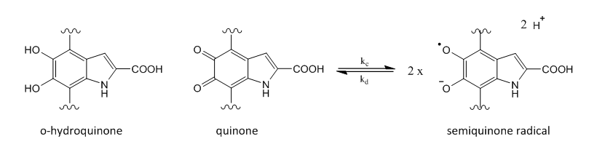

*Figure 1: Redox equilibrium between hydroquinone/quinone and semiquinone radical forms within melanin*

As the intrinsic signals observed for brown and white hair arise from different species, they are likely to respond differently to UV. Brown hair, with high melanin content, would be expected to reflect the photochemical response of melanin, whereas white hair would show the response of protein based radical species. Upon exposure to the full spectrum of a 100 W Hg lamp coupled to an X-band EPR cavity, the intensity of the radical signal from both natural white and mid-brown hair samples increased significantly over time. The intensity of the EPR signal (measured by 2nd integral intensity of the spectrum) was monitored by recording a spectrum every 0.8 minutes over a 2-hour exposure period. Figure 2 shows the change in peak area relative to the initial measurement. The datasets have been normalized to an initial signal intensity of 1 (the initial EPR signal area for the brown hair is 2.82 times greater than white hair).

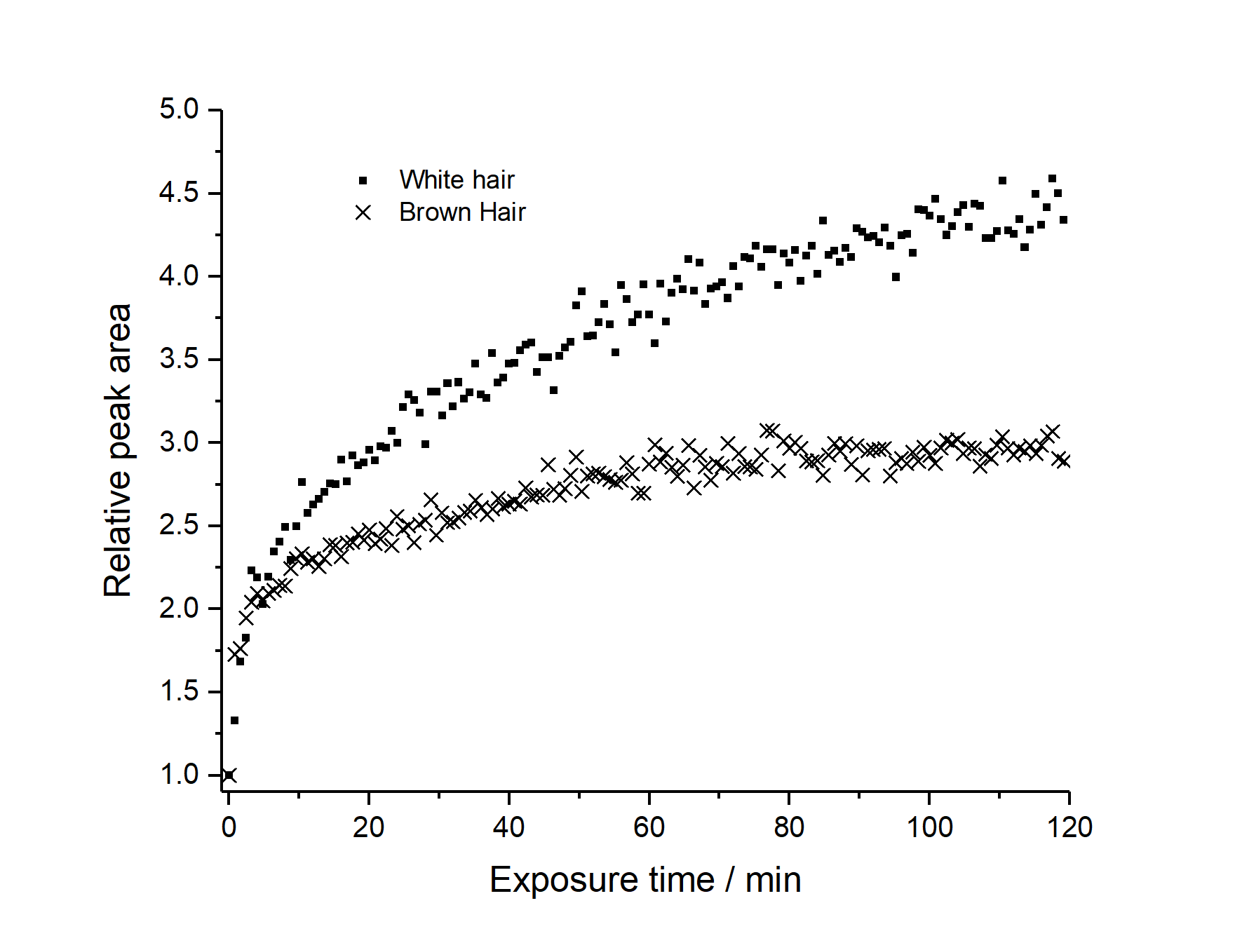

Figure 2: Comparison of EPR signal growth upon exposure of mid-brown and natural white hair samples to the full spectrum of a 100 W Hg lamp

Notably, the rate of increase in radical signal is different for white and brown hair. This different response to UV highlights the different identities and chemical environments of the radical species in the two hair samples. For white hair, the change appears to be a gradual increase over time (4.5 times the initial intensity over 2 hours) and it is proposed this is due to formation of tyrosyl and tryptophan radicals that are in a restrictive environment and thus build-up over time with radical quenching, recombination or onward reactions likely to be slow. In comparison, brown hair shows a much more rapid change initially, with an increase of 73% in the first 0.8-minute measurement interval, compared to only 33% for white hair. However, after this initial rapid increase, the intensity change plateaus, so that after 2 hours, the intensity is only 2.9 times the initial intensity (average of the last three data points taken). The very rapid initial change is consistent with the comproportionation/disproportionation equilibrium of melanin semiquinone radicals in Figure 1. UV exposure provides an additional quinone/hydroquinone comproportionation route[14] and thus shifts the equilibrium to the radical form and consequently increases the observed radical signal. Over a longer irradiation time, the signal continues to increase gradually and it is likely that this slower increase corresponds to the formation of different radical species. This could be a build-up of keratin-based radicals as seen in white hair, or the formation of longer-lived melanin radical species. These experiments are thus consistent with the assignment of EPR signals of brown and white hair to melanin and keratin radicals. Subsequent EPR experiments focused on white hair to study the UV impact with humidity as interest was in induced changes to the protein structure.

**Identity of keratin radicals**

The shape of EPR spectra reveals information about identity of primary and secondary radical species, which can be used to compare radical transfer processes. Rates of radical formation and degradation therefore reflect the overall rate of photodamage in hair proteins. These results have been correlated with fiber protein changes measurements including formation of cysteic acid via FT-IR, protein loss and formation of a protein fragment biomarker of UV damage.

Figure 3 shows EPR signals for the intrinsic signal for white hair and after UV irradiation with a Hg lamp for 2 hours at 0% and 100% RH. Both have a large signal at ~3360 G (g = 2.0060) which matches what would be expected for a tyrosine-based phenoxyl radical, based on g-values and the broad symmetric line-shape[15]. These are likely primary radicals formed directly through oxidation of photo-excited tyrosine species. After UV exposure, a shoulder appears at ~3340 G (g = 2.0164) which matches the signal seen in UV irradiated cysteine in the literature[16] (confirmed in this work) and is likely a sulfur-based radical[17]. This is a secondary radical formed via radical transfer from tyrosyl species leading to disulfide cleavage as tentatively shown in Figure 4. It is possible that there is also some contribution from other heteroatom-centered radicals (e.g., peroxyl radicals).

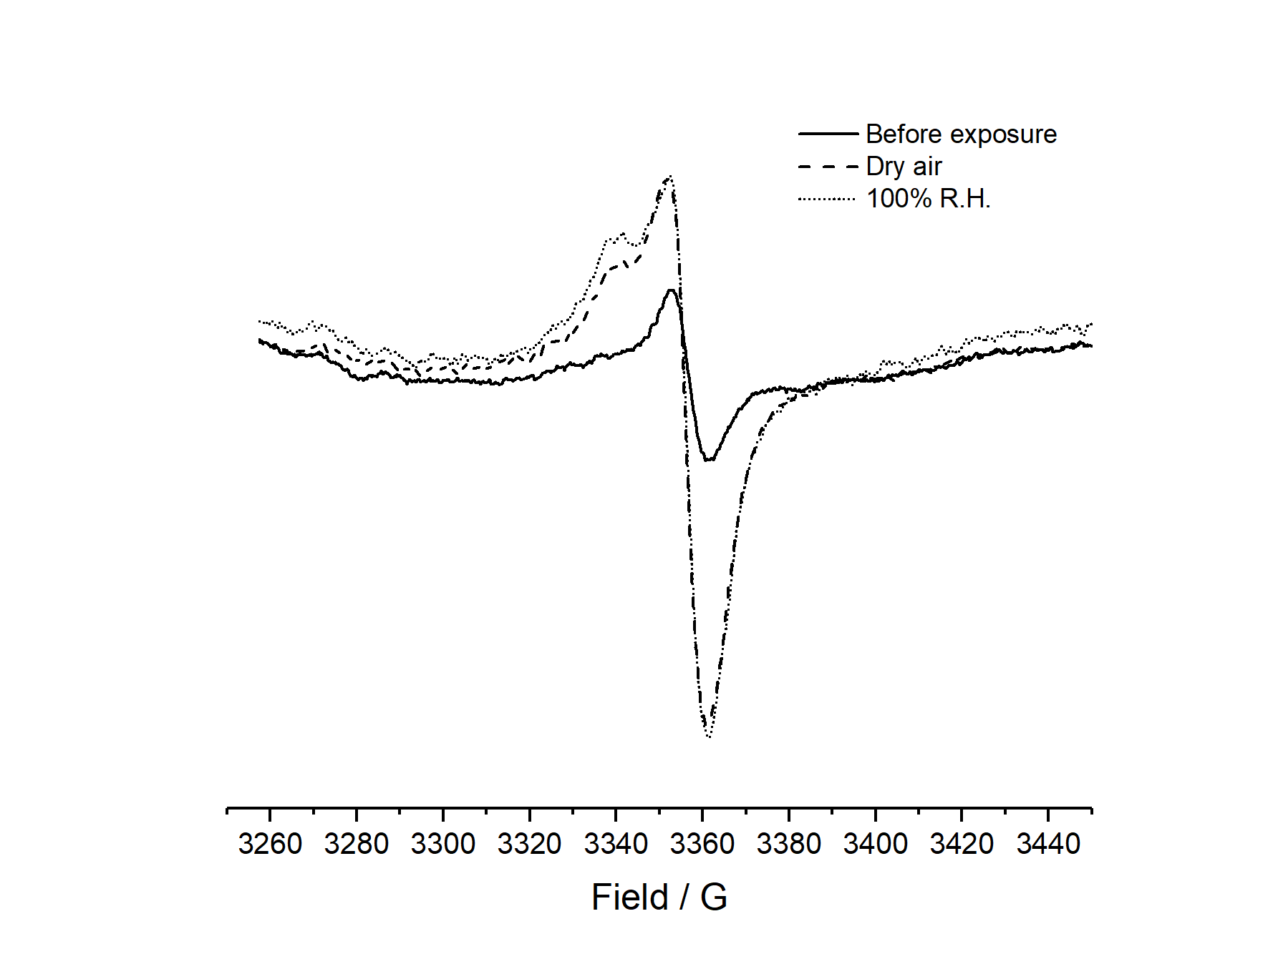

*Figure 3: Comparison of EPR line-shape for hair samples initially and after 2 h UV exposure in dry air and 100% relative humidity*



*Figure 4: Formation of tyrosyl primary radical and sulfur-based secondary radical*

The sulfur radical shoulder peak at 3340 G is significantly larger (relative to the central peak) at higher humidity, corresponding to a greater proportion of sulfur-based radicals. These are formed indirectly through electron transfer from excited Tyr/Trp, interaction with hydroxyl radicals and superoxide indicating that electron transfer processes and diffusion of reactive oxygen species are enhanced at higher humidity.

**Effect of humidity on hair EPR signal**

Radical reactivity was monitored by looking at formation of photochemically generated radical species under controlled humidity over 2 hours exposure to a 100 W Hg lamp and then subsequent lifetime by monitoring decay over 12 hours after the lamp is switched off. Figure 4 and Figure 5 show the formation and decay of these radical species, respectively.

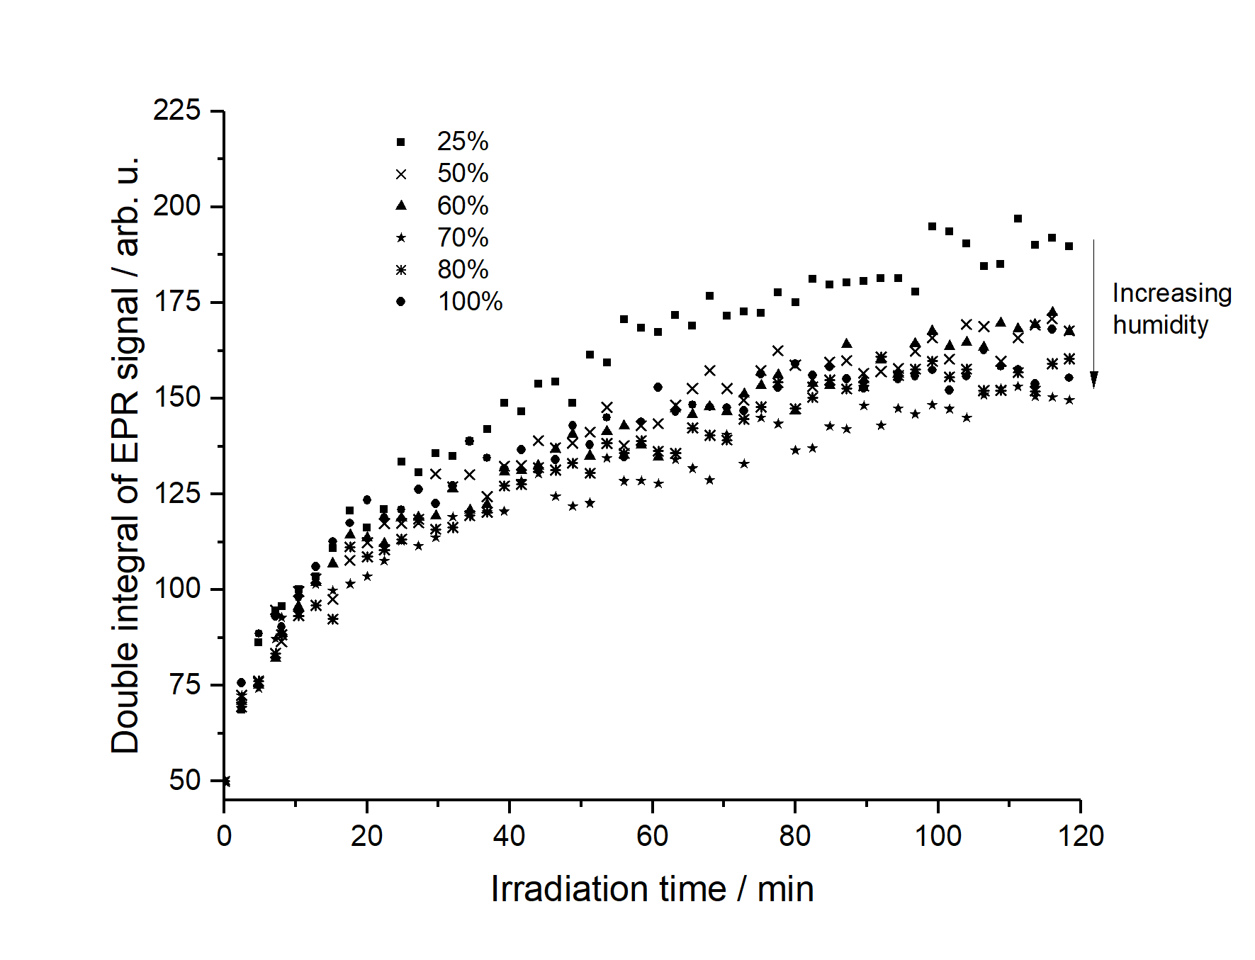

Figure 4: Comparison of signal growth over 2 h UV exposure at different humidity.  
Corrected for mass differences, normalised to starting peak area

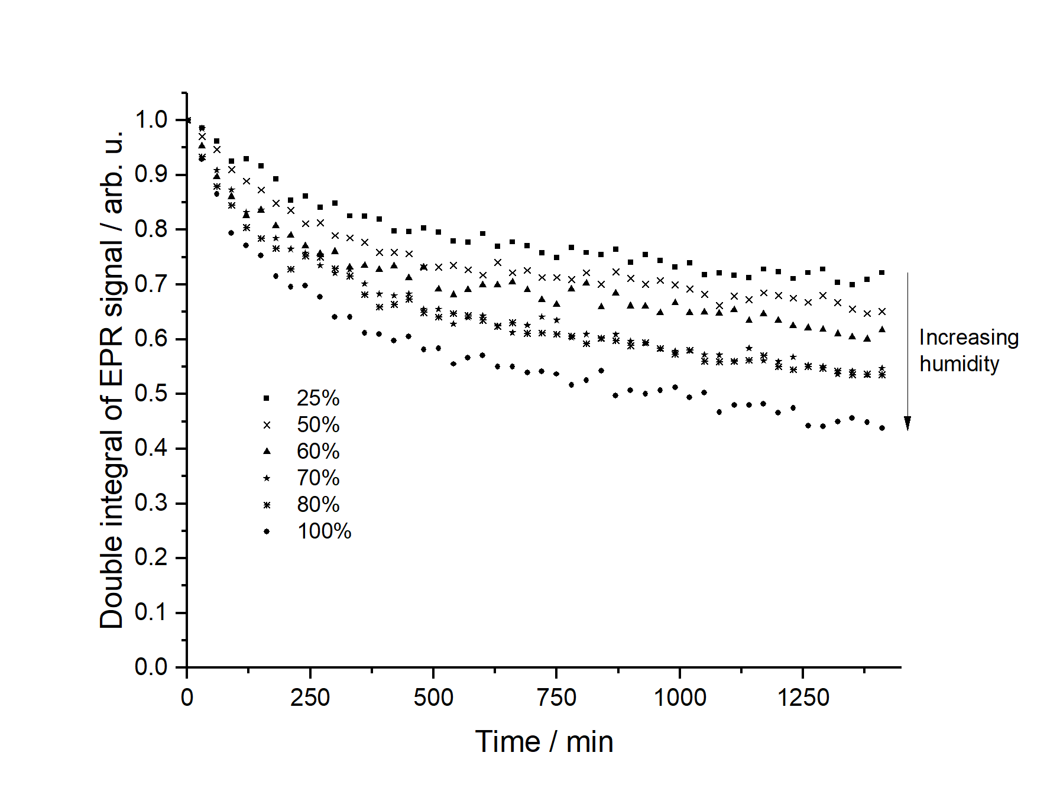

Figure 5: Comparison of radical decay in hair samples at different humidity after lamp switch off

All samples show a significant increase in radical concentration over the exposure period, and changing humidity does influence radical growth. The extent of radical growth decreases with humidity but data analysis assuming first order kinetics showed relative humidity did not have a significant impact on rate of radical formation. However, increasing humidity is leading to a lower stable radical population in hair samples upon UV exposure. At higher humidity, photoinduced radical species within hair proteins can react faster and are consequently shorter-lived, limiting build-up of radicals within hair. This is confirmed in the decay data in Figure 5 where increased decay is seen at higher humidity levels. This more labile, reactive tyrosine environment in hair keratin at high humidity can be attributed to water uptake into keratin proteins, providing greater solvation and a mechanism for the diffusion of oxygen and reactive oxygen species.

The effect of oxygen on the keratin radical reactivity was assessed by performing the same experiments in an oxygen-free environment with the EPR tubes filled with nitrogen. Figure 6 shows of radical formation in air vs nitrogen and clearly in the absence of oxygen the rate of radical formation is dramatically slowed. In addition, a qualitative decrease in sulfur-based radicals was observed.

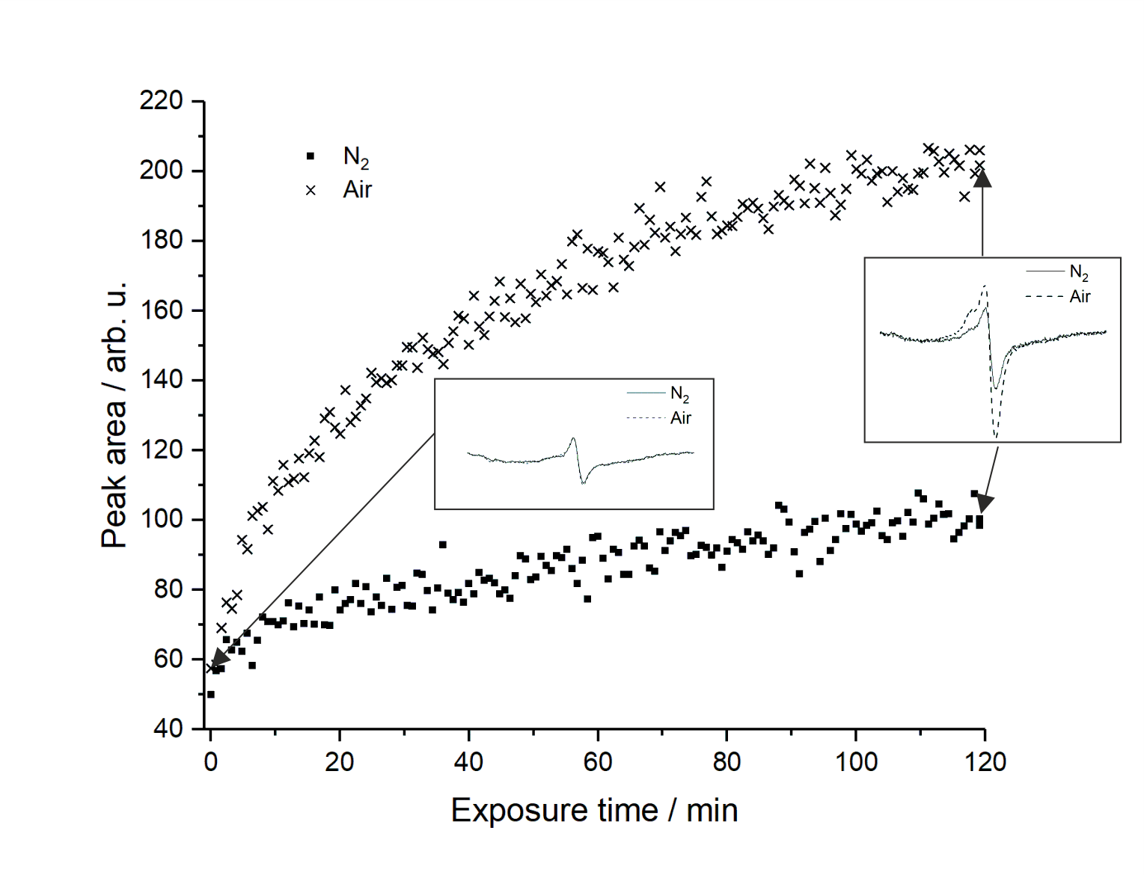

*Figure 6: Comparison of spectra over 2 h UV exposure at low humidity on hair in air and under nitrogen*

Oxygen is important in two crucial processes of keratin photodegradation: the formation of radical species on aromatic amino acids after photoexcitation and the transfer of radical center via reactive oxygen species to other parts of the protein such as disulfides. Formation of radical species on aromatic amino acid residues is facilitated through interactions between excited states and oxygen, leading to the formation of reactive oxygen species. Reactive oxygen species facilitate transfer of radical centers, leading to increased cleavage of disulfides and polypeptide backbone. Oxygen can also interact with radical species, leading to the formation of peroxyl radicals. Auto-oxidation cycles lead to degradation of amino acid side chains, disulfide bonds and the polypeptide backbone. These processes are shown in Figure 7.



*Figure 7: Summary of light-induced autoxidation processes leading to polypeptide cleavage, disulfide cleavage and side chain degradation in proteins. R = amino acid side chain or α-carbon of amino acid in polypeptide.*

The presence of oxygen also increases the rate of radical decay as in the absence of oxygen, radicals likely simply revert to full shell molecules through recombination or hydrogen abstraction. In the presence of oxygen, further degradation pathways are available, some of which lead to hydroperoxide formation and autoxidation[18]. These processes are likely to contribute significantly to the observed radical decay in the presence of oxygen.

**Effect of humidity on UV-triggered protein degradation in hair**

The EPR data have demonstrated that radical decay is enhanced at high humidity and that this involves formation of reactive oxygen species that should lead to increased protein degradation and disulfide cleavage. Experiments were performed to measure protein loss and cysteic acid formation as hair is exposed to UV to confirm the link between radical decay and protein changes. An Atlas Weatherometer was used to irradiate either light brown or white hair with light that simulates broad-spectrum, outdoor daylight with a specific irradiance of 1.48 W/m2 at 420 nm. During irradiation temperature was kept at a constant 35 °C and relative humidity was set at either 25% or 85% RH. After irradiation, hair was sonicated for 1 hour in distilled water to elute any protein fragments formed during UV exposure and the level of protein measured via a modified Lowry Assay for total protein. In addition, the eluted protein was used for MALDI-TOF to investigate the specific fragments formed.

Figure 8 shows the protein loss data for light brown hair; similar data was generated for white hair. The data shows increased protein loss at 40 vs 20 hours as expected and significantly higher protein loss at 85% RH vs 25% RH for both 20 and 40 hour exposure. The MALDI-TOF data showed a prominent peak at m/z = 1278 that was only present at low levels in the control hair. Previous work has shown this peak is due to a fragment of the S100A3 protein and that its intensity increases as a function of UV exposure[19]. The S100A3 protein is a calcium binding protein found in the cuticle and is thought to play a role in cuticle adhesion[20]. A radical pathway has been proposed for its breakdown via formation of ROS generated via UV absorption by the hair proteins, predominantly tryptophan and tyrosine. Figure 8 shows this m/z = 1278 biomarker concentration as a function of UV exposure and relative humidity for brown hair. As for protein loss, the same result was found for white hair. The biomarker concentration increases with both UV exposure and relative humidity, again indicating that the greater radical mobility measured via EPR correlates with increased protein degradation.



*Figure 8: Protein loss for hair exposed to UV at 25% and 85% RH*



*Figure 9: m/z = 1278 protein fragment concentration for hair exposed to UV at 25% and 85% RH*

The EPR data indicated higher formation of sulfur-based radicals at higher humidity and it is anticipated that this will lead to increased disulfide bond cleavage. This was measured for both white and light brown hair (Table 1) using FT-IR to measure the cysteic acid S=O stretch at 1040 cm-1 normalized to the protein CH2 stretch (1450cm-1)[21]. In both hair types a significant increase in cysteic acid formation is observed after 40 hour UV exposure for 85% RH vs 25% RH and for brown hair this is also significant at 20 hour UV exposure.

|  |  |  |
| --- | --- | --- |
| **UV Exposure Details** | **Hair Type** | **FT-IR Cysteic acid (1040 cm-1)**  **Std dev in parenthesis** |
| Control (no UV) | Light Brown | 21.32 (3.13) |
| 20 h UV, 25% RH | Light Brown | 22.40 (3.76) |
| 20 h UV, 85% RH | Light Brown | 25.48 (4.93) |
| 40 h UV, 25% RH | Light Brown | 23.77 (3.66) |
| 40 h UV, 85% RH | Light Brown | 32.03 (5.23) |
|  |  |  |
| Control (no UV) | White | 30.34 (4.65) |
| 20 h UV, 25% RH | White | 28.75 (3.97) |
| 20 h UV, 85% RH | White | 30.36 (3.10) |
| 40 h UV, 25% RH | White | 28.92 (4.71) |
| 40 h UV, 85% RH | White | 33.12 (4.87) |

Table 1 – FT-IR cysteic acid results after UV exposure

**CONCLUSION:**

There are a variety of different components within hair fibers which respond to light. Melanin, present in brown hair samples, exhibits a rapid EPR response to irradiation as light influences the equilibrium between non-radical quinone/hydroquinone and semiquinone radicals. White hair samples (with little or no melanin pigment) also show an intrinsic radical EPR signal which increases upon irradiation and is relatively stable following exposure. The signal is consistent with tyrosine based radicals on keratin proteins, based on spectral line-shape and g-values. The response (signal growth and decay) of protein based radicals in white hair is significantly different from melanin in brown hair.

Following exposure of white hair, the features of the EPR signal matched those of phenoxyl radicals (from tyrosine) and sulfur centered radicals formed by disulfide cleavage. This suggests the formation of ROS such as singlet oxygen and hydroxyl radicals by photoexcited tyrosine, which diffuse and interact with disulfides, leading to protein damage. This process was accelerated at higher humidity.

Radical lifetimes in hair samples decrease with increasing humidity, suggesting a more labile and reactive system when more water is present in hair. The movement of reactive oxygen species and electrons between different parts of the protein is facilitated by water layers present at higher humidity between protein fibers. This accelerates radical transfer and degradation reactions, resulting in increased protein degradation and disulfide cleavage at higher humidity. These findings agree with literature tensile strength measurements.

**ACKNOWLEDGEMENTS**

The authors would like to thank The Procter & Gamble Company for support of this work and Jinky Fejer for help with protein loss measurements.

**REFERENCES**

1. [] A.C.S Nogueira, L.E. Dicelio, I. Joekes, About photodamage of human hair, Photochem. Photobiol. Sci. 5 (2006) 165–169.
2. [] E. Hoting, M. Zimmerman, Photochemical alteration in human hair. Part III: investigation of internal lipids. J. Soc. Cosmet. Chem. 47 (1996) 201–211.
3. [] W. Korytowski, B. Pilas, T. Sarna, B. Kalanaraman. Photoinduced generation of hydrogen peroxide and hydroxyl radicals in melanins. Photochem. Photobiol. 45 (1987) 185-190.
4. [] C.M. Pande, J. Jachowicz, Hair photodamage – measurement and prevention. J. Soc. Cosmet. Chem. 44 (1993) 109-122; E. Palma, D. Gomez, E. Galicia, V. Stolc, Y. Griko, Changes in human hair induced by UV- and gamma radiation, Adv. Biosci. Biotechnol. 7 (2016) 19-27.
5. [] M.S. Jahan, T.R. Drouin, R.M. Sayre, Effect of humidity on photoinduced ESR signal from human hair, Photochem. Photobiol. 45 (1987) 543-546.
6. [] N. Worasith, B.A. Goodman, Determination of the coordination environment of Cu(II) in human hair and its possible relevance to health and hair care treatments, Int. J. Cosmet. Sci. 35 (2013) 424-429.
7. [] R. Arnaud, G. Perbet, A. Deflandre, G, Lang, ESR study of hair and melanin–keratin mixtures – the effects of temperature and light, Int. J. Cosmet. Sci. 6 (1984) 71-83.
8. [] E.H. Mercer, A.G. Matolsty, Keratin, In: Adv. Biol. Skin, Vol. 9: hair grown, W. Montagna, R.L.Dobson, Eds., Pergamon Press, 1967, pp. 559-569.
9. [] L.R.G. Treloar, The absorption of water by hair, and its dependence on applied stress, Trans. Faraday Soc. 48 (1952) 567-576.
10. [] S. Ratnapandian, S.B. Warner, Y.K. Kamath, Photodegradation of human hair, J. Soc. Cosmet. Chem. 49 (1998) 309-320.
11. [] C. Dubief, Experiments with hair photodegradation, Cosmet. Toiletries 107 (1992) 95-102.
12. [] T. Sarna, P.M. Plonka, Biophysical studies of melanin: paramagnetic, ion-exchange and redox properties of melanin pigments and their photoreactivity, in: Biomedical EPR, part A: free radicals, metals, medicine, and physiology, S.R. Eaton, G.R. Eaton, L.J. Berliner, Eds., Springer, 2005, pp. 125-146.
13. [] L.J. Kirschenbaum, X. Qu, E.T. Borish, Oxygen radicals from photoirradiated human hair: An ESR and fluorescence study, J. Soc. Cosmet. Chem. 51 (2000) 169-182.
14. [] A.J. Elliot, J.K.S. Wan, [A CIDEP study of the photoreduction of quinones in the presence of phenols and 2-propanol](http://pubs.acs.org/doi/10.1021/j100493a015), J. Phys. Chem. 82 (1978) 444-452; X. Qu, L.J. Kirschenbaum, E.T. Borish, Hydroxyterephthalate as a fluorescent probe for hydroxyl radicals: application to hair melanin, Photochem. Photobiol. 71 (2000), 307-313.
15. [] S. Un, P. Dorlet, A.W. Rutherford, A high-field EPR tour of radicals in photosystems I and II, Appl. Magn. Reson. 21 (2001) 341-361.
16. [] E.E. Smissman, J.R.J. Sorenson, The electron spin resonance spectra of disulfides irradiated with ultraviolet light, J. Org. Chem. 30 (1965) 4008-4010.
17. [] G. Strzelczak, M. Sterniczuk, J. Sadło, M. Kowalska, J. Michalik, EPR study of γ-irradiated feather keratin and human fingernails concerning retrospective dose assessment. Nukleonika 58 (2013) 505-509.
18. [] D.I. Pattison, A.S. Rahmanto, M.J. Davies, Photooxidation of proteins, Photochem. Photobiol. Sci. 11 (2012) 38-53.
19. [] J.M. Marsh, M.G. Davis, M.J. Flagler, Y. Sun, T. Chaudhary, M. Mamak, D.W. McComb, R. Williams, K.D. Greiss, L. Rubio, L. Coderch, Advanced hair damage model from ultra-violet radiation in the presence of copper, Int J Cosmet Sci, 37 (2015) 532-541.
20. [] K. Kizawa, H. Uchiwa, U. Murakami, Highly-expressed S100A3, a calcium-binding protein in human hair cuticle, Biochim. Biophys. Acta, 1312 (1996) 94-98.
21. [] V. Signori, D.M. Lewis, FT-IR investigation of the damage produced on human hair by weathering and bleaching processes: implementation of different sampling techniques and data processing, Int J Cosmet Sci, 19 (1997) 1-14.