New Imine Reducing Enzymes from β-Hydroxyacid Dehydrogenases by Single Amino Acid Substitutions
Maike Lenz^{[a]}, Silvia Fademrecht^{[a]}, Mahima Sharma^{[b]}, Jürgen Pleiss^{[a]}, Gideon Grogan^{[b]} and Bettina M. Nestl*^{[a]}
[a] Institute of Biochemistry and Technical Biochemistry, Universitaet Stuttgart, Allmandring 31, 70569 Stuttgart, Germany, * Correspondence: bettina.nestl@itb.uni-stuttgart.de
[b] York Structural Biology Laboratory, Department of Chemistry, University of York, Heslington, York, YO10 5DD UK
ABSTRACT
We report the exploration of the evolutionary relationship between imine reductases (IREDs) and other dehydrogenases. This approach is informed by the sequence similarity between these enzyme families and the recently described promiscuous activity of IREDs for the highly reactive carbonyl compound 2,2,2-trifluoroacetophenone. Using the structure of the R-selective IRED from Streptosporangium roseum (R-IRED-Sr) as a model, β-hydroxyacid dehydrogenases (βHADs) were identified as the dehydrogenases most similar to IREDs. To understand how active site differences in IREDs and βHADs enable the reduction of predominantly C=N or C=O bonds respectively, we substituted amino acid residues in βHADs with the corresponding residues from the R-IRED-Sr and were able to increase the promiscuous activity of βHADs for C=N functions by a single amino acid substitution. Variants βHADAt_K170D and βHADAt_K170F lost mainly their keto acid reduction activity and gained the ability to catalyze the reduction of imines. Moreover, the product enantiomeric purity for a bulky imine substrate could be increased from 23% ee (R-IRED-Sr) to 97% ee (βHADAt_K170D/F_F231A) outcompeting already described imine reductase selectivity.

KEYWORDS
imine reductases, β-hydroxyacid dehydrogenases, promiscuity, active site mutation, 3D- crystal structure
INTRODUCTION
The stereocontrolled addition of hydrogen from NAD(P)H to aldehydes/ketones or α,β-unsaturated carbonyl compounds by reductase enzymes is one of the most important and best-studied reactions in biocatalysis.[1] Compared to C=O and activated C=C bonds, the C=N bond of imines presents a considerable challenge for enzymatic reductions due to its aqueous lability.[2] Mitsukura et al. described the first member of the novel enzyme family of NADPH-dependent imine reductases (IREDs) for the reduction of 2-methylpyrroline (see also Figure 1 A).[3,4] In recent years, various IREDs were characterized that catalyze the asymmetric reduction of different cyclic as well as exocyclic imines and reductive amination reactions.[2,5,6]
On account of the essential cofactor NADPH, an imine reduction mechanism closely related to the mechanism of dehydrogenases containing hydride and proton transfer[7] is assumed (Figure 1 B). While NADPH clearly serves as hydride donor, a proton-donating residue in IREDs is still ambiguous. For most IREDs an aspartic acid or tyrosine residue at position 187 in the active site has been suggested to be the proton donor.[8–10] However, the observation of non-protic alanine, phenylalanine or asparagine residues at this position questions the requirement for proton donating amino acid in IREDs.[11–13] This is further supported by the asymmetric reduction of iminium ions[10,14] and the protonation of imines by a water-molecule, being similar to the well-studied imine-reducing enzyme dihydrofolate reductase (DHFR).[15] In this context the function of IREDs would be in positioning of the iminium ions in a favourable orientation for hydride transfer.[16] The first insights into the role of amino acid residues in terms of substrate binding were recently obtained by the groups of Turner and Grogan, who co-crystallized the IRED from Amycolatopsis orientalis with NADPH and the amine product 1-methyl-1,2,3,4-tetrahydroisoquinoline.[13] Furthermore, the annotation of most IREDs as dehydrogenases using sequence similarity [9], supports the idea of an evolutionary relationship between IREDs and other dehydrogenases. Although no activity of IREDs from Streptosporangium roseum and Paenibacillus elgii for their annotated substrates glycerol-3-phosphate and 6-phosphogluconate could be detected[9], both enzymes were able to reduce the highly reactive 2,2,2-trifluoroacetophenone carbonyl compound[17] to the corresponding alcohol with high selectivities of 96% ee and 87% ee, respectively. The 600-fold decreased catalytic efficiency (k_{cat}/K_{M}) for the carbonyl compound compared to 2-methylpyrroline, one of the IRED model substrates, indicate that IREDs have evolved in nature for the reduction of C=N bonds.[17] Similar observations were made by Müller and co-workers that reported on the promiscuous activity of glucose dehydrogenases from different organisms for the asymmetric reduction of iminium salts.[18]
In addition to sequence similarities Pleiss and co-workers gained more information about the structural relationship between IREDs and the wider dehydrogenase superfamily by superimposing the structure of the R-selective IRED-Sk from Streptomyces kanamyceticus on a β-hydroxyacid dehydrogenase (βHAD) from Lactococcus lactis.[16] βHADs are a highly diverse protein family exhibiting a low substrate specificity converting C₂ up to C₆, as well as phosphate group containing keto and hydroxy acids.[19–22] A common feature of βHADs, with the exception of 6-phosphogluconate dehydrogenases, is the preference for a 3-carbon substrate core, however, these enzymes also catalyze the oxidation of substrates with a 2- and 4-carbon substrate core. X-ray crystal structures and mechanism studies showed that IREDs and βHADs differ in at least three ways. First, while IREDs display domain swapping with the active site located at the interface of the N-terminal domain of one subunit and the C-terminal bundle of the other[2,8], βHADs bind their substrates between the domains of one monomer.[16] Second, mainly nucleophilic and electrophilic active site residues are described for substrate binding in βHADs.[16,19,20,23] In contrast to βHADs, IREDs mostly contain hydrophobic residues like methionine and leucine at these respective positions.[9,16] Third, a positively charged lysine residue in βHADs, not present in IREDs, acts as proton donor and is thought to stabilize the formation of the negative charge on the carbonyl group in the transition state. Starting from these closely-related dehydrogenases containing similarl oriented active site residues, we hypothesized a switch in activity from carbonyl to imine reduction by applying enzyme engineering in the active site. In this paper the assumption was confirmed by achieving imine reduction catalyzed by βHAD enzymes after substituting only one active site residue.
MATERIALS AND METHODS
Bioinformatics analysis
A new version of the Imine Reductase Engineering Database was created using two characterized IREDs with solved structure as seed sequences: S-IRED-Ss (GI: 460838082) and R-IRED-Sk (GI: 524933133)[16]. Proteins with a global sequence identity of at least 49% were assigned to the same superfamily. The superfamilies were further subdivided into homologous families using a sequence similarity network of all sequences generated with Cytoscape version 3.1.0[24] and sequence identities calculated by the Needleman-Wunsch algorithm.[25] Available structures were downloaded from the Protein Data Bank[26] and stored in the respective protein entry. Functionally and structurally relevant positions were extracted from literature and annotated in the respective proteins. To further validate the superfamily assignment, bootstrap analyses were performed by RAxML version 8.2[27] (100 bootstraps, protein distance calculated by BLOSUM62).
A standard numbering scheme was established using R-IRED-Sk as reference that has been the first IRED with a solved structure. A multiple sequence alignment was performed including two representative sequences from nine homologous families that contain ten or more sequences (18 sequences in total) by using Clustal Omega.[28] On the basis of this alignment, a profile Hidden Markov Model (HMM) was generated with HMMER version 3.1.[29] Subsequently, each sequence of the database was aligned against the profile HMM and the residue numbers of the reference sequence were transferred.[30] The superposition of the active sites of βHADs and IREDs showed their high overall similarity, whereas structurally equivalent active site residues differed: S121, K170, and N174 in βHADAt, M137, D187, and L191 in R-IRED-Sr (Figure 4).
Materials
Except otherwise noted, all solvents, buffer components and chemicals were obtained from Sigma-Aldrich and Fluka (Steinheim, Germany), Carl Roth GmbH (Karlsruhe, Germany), Acros Organics (Geel, Belgium), VWR (Darmstadt, Germany) or Alfa Aesar (Karlsruhe, Germany). Human Plasma Thrombin was purchased from Calbiochem (San Diego, USA). Imine substrates 6-methyl-2,3,4,5,-tetrahydropyridine (6MTHP) and 6-phenyl-2,3,4,5-tetrahydropyridine were kindly provided by Prof. Dr. Nicholas Turner and Dr. Shahed Hussain from the University of Manchester.
Crystallization of R-IRED-Sr
Performance of gene expression and protein purification was done as described in the supporting information (section 1). Initial screening of crystallization conditions was conducted using commercially available INDEX (Hampton Research), PACT premier and CSSI/II (Molecular Dimensions) screens in 96-well sitting drop trays. Further optimization was carried out in a 24-well hanging-drop format to obtain optimal crystals for X-ray diffraction. For co-crystallization experiments, 150 mM stock solutions of cofactor NADP⁺ was prepared in water and 1 M stock solution of 2,2,2-trifluoroacetophenone was prepared in DMSO. A crystal of R-IRED-Sr was grown using a 40 mg/mL His₆-tag free cleaved protein solution in 50 mM TRIS buffer pH 7.5 containing 300 mM NaCl, by co-crystallization with 1.5 mM NADP⁺ and 5 mM 2,2,2-trifluoroacetophenone in sitting drops mixed 1:1 with 0.2 M MgCl₂.6H₂O, 0.1 M TRIS pH 8.0 containing 20% (w/v) PEG 6000 using the commercial PACT premier screen. The crystals were flash-cooled in liquid nitrogen using nylon CryoLoopsTM (Hampton Research) without any cryoprotectant.The complete dataset described in this report was collected at Diamond Light Source, Didcot, Oxfordshire, U.K. on beamline I04. The data were processed and integrated using XDS[31] and scaled using SCALA[32] included in the Xia2 processing system[33]. Data collection statistics are given in Table S1. The crystals of the R-IRED-Sr ternary complex were in the space group C222₁. The structure was solved with MOLREP[34] using the N-terminal domains of the monomer of the IRED from Streptomyces kanamyceticus (Q1EQE0; PDB code 3ZHB[8]) as initial search model. The solution contained six monomers in the asymmetric unit, representing three dimers (Figure S3). The solvent content was 50.3%. The structure was built and refined using iterative cycles applying Coot[35] and REFMAC[36], the latter employing local NCS restraints. Following building and refinement of the protein and water molecules, clear residual density was observed in the omit maps at the subunit dimer interfaces. This was modelled and refined as NADP⁺. Following refinement of NADP⁺, further density was observed adjacent to the nicotinamide ring of the cofactor. This was modelled and refined as the hydrate of substrate 2,2,2-trifluoroacetophenone, for which the coordinate and refinement library files were prepared using ACEDRG [37]. The final structure gave Rcryst and Rfree values of 15.0% and 18.4%. Refinement statistics for the structures are presented in Table S1. The Ramachandran plot for ternary complex showed 97.1% of residues in allowed regions and 2.9% in preferred regions, with no outliers. The coordinate files and structure factors have been deposited in the Protein DataBank (PDB) with the coordinate accession number 5OCM.
Plasmid construction
Gibson assembly was applied for cloning of the expression constructs. The synthetic DNA with the target genes (already containing homology regions to the pBAD33 plasmid, see supporting information section 2) and the pBAD33 backbone were amplified by PCR. After purification using the DNA Clean & ConcentratorTM-5 kit from Zymo Research (Irvine, USA), the PCR products of vector backbone and target gene were mixed in a ratio of 1:3. Isothermal Gibson assembly was performed according to literature using 15 µL Gibson-Mix (containing T5 exonuclease (10 U/µL), Phusion HF DNA polymerase (2 U/µL), Taq DNA ligase (40 U/µL) and ISO reaction buffer) and 5 µL of the 1:3 ration of DNA fragments for 1 h in a PCR machine at 50°C.[38] After cooling to 8°C, 5 µL of the assembly products were transformed in chemically competent E. coli DH5α cells (competent cells were prepared according to the RbCl method[39]). Cells were plated on LB agar with 34 µg/mL chloramphenicol and grown overnight at 37°C. The analyzed mutants were constructed by site-directed mutagenesis according to the QuikChangeTM procedure of the commercial available kit from Agilent[40]. Therefore the PfuUltra II Fusion HS polymerase with the corresponding buffer was used (Thermo Fisher Scientific, Schwerte, Germany). Appropriate primers were purchased from Metabion (Metabion GmbH, Planegg, Germany). All used primers are listed in Table S2.2. To confirm the correct plasmid assembly and amino acid substitutions DNA sequencing was performed by GATC Biotech (Konstanz, Germany).
Expression and cell lysis
The pBAD33 based expression constructs were transformed via heat shock (42°C, 30 sec) into chemically competent E. coli JW5510 cells (competent cells were prepared according to the RbCl method[39]). Cells were plated on LB agar supplemented with 34 µg/mL chloramphenicol and were grown overnight. As preculture 5 mL LB media with 34 µg/mL chloramphenicol was inoculated with a single colony and incubated at 37°C and 180 rpm overnight. Cultivation conditions in shake flask cultures were as follows: 200 mL TB medium (12 g/L tryptone, 24 g/L yeast extract, 5 g/L glycerol, 2.13 g/L KH₂PO₄, 12.54 g/L K₂HPO₄, pH 7.2) in 2-L baffled flasks supplemented with antibiotic (34 µg/mL chloramphenicol). The culture was inoculated with 1% (v/v) preculture (2 mL) and incubated on a rotary shaker (InforsHT, Bottmingen, Switzerland) at 37°C and 180 rpm. For inducible expression of the enzymes, cells were grown to an OD_{600nm} of 0.6-0.8 followed by the induction with 0.02% (1.33 mM) arabinose. Cells were incubated at 25°C and 180 rpm for 20 h and harvested by centrifugation at 4°C, 9800 x g for 30 min (centrifuge Avanti J 26S XP, Beckmann Coulter, Krefeld, Germany). The cell pellet was suspended in 1.5 mL/g working buffer (50 mM sodium phosphate buffer pH 7.0 for imine reductase; 50 mM TRIS-HCl pH 8.0 for β-hydroxyacid dehydrogenases) containing 1 µL/mL DNase (5 mg/mL stock solution). Cell disruption was performed by high-pressure homogenization (3 cycles, 750-1000 bar) with an EmulsiFlex C-5 (Avestin, Canada). The lysate was cleared by centrifugation for 45 min at 4°C and 8000 x g (centrifuge Avanti J-26S XP, Beckmann Coulter, Krefeld, Germany). Validation of enzyme expression and solubility was done by SDS-PAGE using 4-20% gradient gels (ExpressPlus™ PAGE, GenScript, Hölzel Diagnostika, Cologne, Germany).
Protein purification
The lysates were purified by His₆-tag affinity chromatography using His GraviTrapTM TALON® columns according to the instruction manual (GE Healthcare, Freiburg, Germany). After sample loading the columns were washed twice with working buffer (50 mM sodium phosphate buffer pH 7.0 for imine reductase; 50 mM TRIS-HCl pH 8.0 for β-hydroxyacid dehydrogenases) containing 10 mM imidazole. Elution was carried out with 300 mM imidazole in the according working buffer. The eluted enzyme solution was desalted and concentrated in 50 mM sodium phosphate buffer pH 7.0 (imine reductase) or 50 mM TRIS-HCl pH 8.0 (β-hydroxyacid dehydrogenases) using ultrafiltration spin columns (Vivaspin, MWCO: 10 kDa, PES membrane, Sartorius, Göttingen, Germany). Analysis of enzyme purity was done by SDS-PAGE using 4-20% gradient gels (ExpressPlus™ PAGE, GenScript, Hölzel Diagnostika, Cologne, Germany). Protein concentrations were measured using the BCA Protein Assay Kit (Thermo Scientific, Rockford, USA) according to the manufacturer’s instructions[41] with bovine serum albumin (BSA) as protein standard in concentrations of 25 to 2000 µg/mL. The enzymes were stored at -80°C until further use.
Activity assay and kinetic parameters
To check the activity of the generated βHAD variants for their natural substrates (glyoxylic acid or 6-phosphogluconate), NADPH depletion assays were performed by monitoring the change in absorbance for NADPH at 340 nm. The same assay was used to determine kinetic parameters and therefore compare the affinity of the imine reductase and the generated βHAD variants for the imine substrate 2-methylpyrroline (2MPN). Reactions contained 0.5 µM or 5 µM enzyme depending on the substrate, 300 μM nicotinamide cofactor and 10 mM of the substrate (dissolved in H₂O). Reactions were performed in 300 μL scale in a 96-well plate (Greiner Bio-One GmbH, Frickenhausen, Germany) at 30°C and started by the addition of the cofactor. One unit of enzyme activity was defined as the amount of protein that oxidizes 1 μmol NADPH per minute. For the determination of kinetic parameters different concentrations of 2MPN were used: 0 mM, 0.1 mM, 0.2 mM, 0.3 mM, 0.4 mM, 0.5 mM, 0.6 mM, 0.7 mM, 0.8 mM, 0.9 mM, 1 mM, 1.5 mM, 2.0 mM, 2.5 mM, 5 mM, 10 mM, 15 mM, 30 mM. Due to lower activities at higher substrate concentrations, the Michaelis-Menten equation was adapted to substrate inhibition kinetics using the following formula: v=(v_{max}×[S])/(K_{M}+[S]×(1+([S]/K_{I}))). Kinetic parameters were calculated using Microsoft excel.
Biotransformation setup
Biotransformations were performed with purified protein at a final concentration of 0.5 mg/mL, 10 mM substrate (all dissolved in methanol) and 2.5 mM of NADPH cofactor. For cofactor regeneration 25 mM glucose-6-phosphate and 5 U/mL glucose-6-phosphate dehydrogenase (lyophilized powder from Leuconostoc mesenteroides, Alfa Aesar, Karlsruhe, Germany) were added. Reactions were performed in 50 mM TRIS-HCl buffer at pH 8.0 with a final MeOH concentration of 5% (v/v) in all samples. Samples were incubated in 5 ml screwed capped glass vials at 25°C and 180 rpm. 150 µL samples were taken over time (0 h, 0.5 h, 1 h, 2 h, 3 h, 5h, 24 h and 48h). Control reactions with heat-inactivated IRED or βHAD enzyme (10 min at 95°C) were performed. The other relevant components of the control reactions were identical to the ones with active enzyme. Dependending on the applied substrate, GC- or HPLC-analysis was performed for quantification of the biotransformations. Sample preparation and conditions used for analysis are listed in the supporting information (section 8).
RESULTS
Determination of the crystal structure of the R-selective IRED from Streptosporangium roseum in complex with NADP⁺ and 2,2,2-trifluoroacetophenone hydrate
The N-terminal His₆-tagged imine reductase from Streptosporangium roseum (R-IRED-Sr) was purified by nickel affinity and size exclusion chromatography (SEC) and 11 mg purified enzyme per litre culture broth was isolated after the two-step purification (Figure S1). Following unsuccessful attempts to crystallize the intact tagged protein, cleavage of the His₆-tag was achieved using high-grade human plasma thrombin (Figure S2). After the cleavage reaction, the protein was passed through a Ni-NTA column to separate the cleaved His-tag, followed by further purification of the cleaved protein by gel filtration. The cleaved protein was crystallized successfully in the presence of both NADP⁺ and 2,2,2-trifluoroacetophenone and the best crystals diffracted to 1.8 Å. The structure of R-IRED-Sr was solved using a monomer of the IRED Q1EQE0 from Streptomyces kanamyceticus [PDB code 3ZHB;[8]] as a model. Six molecules were found in the asymmetric unit, constituting three dimers (Figure S3). A search on the DALI server[42] revealed that R-IRED-Sr was structurally most similar to 3ZHB, with which it shared 65% amino acid sequence identity, with a root-mean-square deviation (rmsd) of 2.1 Å over 284 Cα atoms. The monomer comprised an N-terminal Rossmann domain and a C-terminal helical bundle connected by a long interdomain helix (Figure 2A).
The R-IRED-Sr dimer was of an organisation similar to that of IREDs determined previously[8,13,43–45], in which intimate domain sharing results in the formation of an active site at the interface between the N-terminal domain of one monomer, and the C-terminal helical bundle of its partner. One notable feature was that the R-IRED-Sr dimer structure had been trapped in a ‘closed’ conformation, previously achieved with the IRED from Amycolatopsis orientalis[13] and the related reductive aminase from Aspergillus oryzae[45], and which permits observation of the active site residues what is assumed to be more reflective of their catalytic conformation than is observed in ‘open’ IRED dimer structures.[8,43,44] Within the active site, clear electron density was observed in the omit maps for both NADP⁺ and another ligand adjacent to the nicotinamide ring of the cofactor. This was modelled as the hydrate of the ligand 2,2,2-trifluoroacetophenone (Figure S4). The ligand is situated in the active site with its aromatic ring stacked between the nicotinamide ring of NADP⁺ and the side chain of Met177, with additional hydrophobic environment provided by Ile122, Trp208 and Phe215 of the partner subunit at the distal region of the active site as shown (Figure 2B). The positioning of the ligand reveals that the (re)-face of the ketone would be presented to the nicotinamide ring, which would result in the formation of the (S)-alcohol product reported (Lenz et al., 2017). Protonation would be accomplished by the side chain of Thr241. The ligand makes further contacts through the trifluoromethyl group with the backbone carbonyl of Thr237 and also the 2’ hydroxyl of the ribose sugar of the cofactor, each at distances of approximately 3 Å. The interaction between the trifluoromethyl group and the ribose 1-hydroxyl, which brings the ligand into closer proximity with the nicotinamide ring of the cofactor, coupled with the greater electrophilicity of the carbonyl carbon, may help to explain the promiscuous reductive activity of R-IRED-Sr towards this ketone.
Selection of β-hydroxyacid dehydrogenases based on sequence and structure similarity
In recent work, Fademrecht et al. explored the sequence similarity of IREDs by collecting 20,832 similar sequences using a BLAST search in the non-redundant protein database at NCBI.[16] Using cluster analysis, a connection between the subgroups of IREDs and βHADs at a sequence identity threshold of 35% was identified, indicating a high sequence similarity between both protein families. To analyze the imine reducing capability of βHADs, three enzymes of this family were chosen for further characterization based on homology and crystal structure availability. The glyoxylate reductase from Arabidopsis thaliana (βHADAt, PDB code 3DOJ) and the γ-hydroxybutyrate dehydrogenase from Geobacter metallireducens (βHADGm, PDB code 3PEF) were chosen showing both a sequence similarity of 22% compared to R-IRED-Sr, which was set as benchmark. Additionally, the less related 6-phosphogluconate dehydrogenase from Lactococcus lactis (βHADLal, PDB code 2IYP, only 14% sequence identity compared to R-IRED-Sr) was selected.
Structure comparison of the selected enzymes
The crystal structure of R-IRED-Sr (PDB code 5OCM) was superimposed with structures of βHADAt (PDB code 3DOJ), βHADGm (PDB code 3PEF) and βHADLal (PDB code 2IYP). Comparing the structures using the DALI Server (http://ekhidna2.biocenter.helsinki.fi), rmsd values of 2.3 Å (292 Cα atoms), 2.2 Å (287 Cα atoms) and 3.4 Å (469 Cα atoms) were shown, respectively (Z-scores 25.9, 26.3, and 20.8). These results support the structural relationship of IREDs to the βHAD family (Figure 3, Figure S4). Major structural differences between these two enzyme families are the formation of the substrate binding pocket and the mode of dimer assembly.[16] While in IREDs the pocket is built by both monomers of the homodimer, the active site of βHADs is formed by only one monomer (Figure 3). Interstingly, βHADLal possesses an additional C-terminal domain (Figure S4, green), which is described as a tail domain and is responsible for dimerization by extending through the helical domain of the partner subunit.[21] This leads to an overall different structure when comparing the dimers (Figure 3C).
Active site comparison of β-hydroxyacid dehydrogenases and imine reductases – predicted variants
Despite their sequence and structural similarities, IREDs and βHADs catalyze the asymmetric reduction of related C=N and C=O functionalities. These differences in function appear to arise from only a few residues that differ in the active site.[16] Several residues are reported in βHADs to contribute to substrate binding and catalysis.[20,21] Superposition of the active sites of R-IRED-Sr with the βHADAt shows a close alignment of main chain atoms. However, a comparison of the four described residues in βHADs with corresponding positions in IREDs reveals significant differences (Figure 4): First, the substrate binding pocket of R-IRED-Sr is considerably more hydrophobic than that of the three selected βHADs. Second, for βHADAt a serine (S121) and a phenylalanine (F231) residue are described to be important for recognition, orientation and docking of the substrate.[23] S121 is described to interact with the carboxyl group of the natural substrate.[21,23] R-IRED-Sr has a methionine at the position corresponding to S121 in βHADAt. Furthermore, R-IRED-Sr lacks the phenylalanine residue (F231) that is essential for substrate binding in βHADs. Third, in βHADs a lysine, acting as the proton donor, and an asparagine, within hydrogen bonding distance to the lysine residue, are described to be essential for catalysis.[23] In IREDs the proton donating source, if required, has been suggested to be an aspartic acid, or a tyrosine at position 187 according to the IRED standard numbering (Imine Reductase Engineering Database: www.ired.unistuttgart.de[16]). The residue corresponding to these, e.g. D187 in R-IRED-Sr, is K170 in βHADAt[16]. At position N174 in βHADAt, IREDs have mainly leucine (81%) or methionine (6%) residues.[16] Based on this active site comparison, we replaced K170, N174, S121 and F231 in βHADAt with the corresponding residues most prominent in IREDs. By site-directed mutagenesis the following combinations of these four residues were generated: K170D, K170F, K170Y, N174L, S121M and F231A. The same methodology has been applied for R-IRED-Sr resulting in three further variants: D187K, L191N and M137S. In addition to the individual mutations, combinations yielded in double and triple amino acid substitutions.
Imine reductase activity of β-hydroxyacid dehydrogenase variants
In order to understand the role of the selected residues in imine reduction, we first introduced all suggested mutations in the glyoxylate reductase from Arabidopsis thaliana (βHADAt) possessing highest sequence identity and similiarity with R-IRED-Sr. While gene synthesis yielded the wild-type enzyme βHADAt, the desired single, double and triple mutants were introduced using site-directed mutagenesis. All variants were overexpressed in Escherichia coli and purified via affinity chromatography exploiting the N-terminal inserted His₆-Tag. Substitution of N174 with leucine resulted in insoluble protein (Figure 5 and Figure S5), confirming the need of the high conservation at position 174 in βHADs (always asparagine or glutamine). Due to the formation of insoluble protein, no further experimental evaluation of the functional significance of this residue has been undertaken. All other variants gave good expression of soluble protein, exhibited by a band on SDS-PAGE at ~35 kDa (Figure 5).
Imine reducing activity was determined using 2-methylpyrroline (2MPN) as substrate. Cyclic imines such as 2MPN or 6-methyl-2,3,4,5,-tetrahydropyridine (6MTHP) are among the best accepted substrates.[10,46] Biotransformations with the set of solubly expressed variants revealed that substitution of K170 with an aspartic acid or a phenylalanine, the most prominent amino acids in R-selective imine reductases at this position, caused a significant increase (up to 12-fold) in reduction activity towards 2MPN (Figure 5). Substituting residue S121 did not impact the imine reducing activity of βHADs. After substituting the serine at this position with methionine, an activity comparable to βHADAt wild-type was detected (Figure 5). Moreover, no influence on the imine reducing activity of βHADs was observed by replacing the phenylalanine F231 located at the entrance to the active site with alanine (Figure 5).
To demonstrate the significance for catalysis, the best mutations in βHADAt were transferred to the enzymes from Geobacter metallireducens (βHADGm) and Lactococcus lactis (βHADLal). Although the substitution of N174 in βHADAt showed a clear influence on active folding and stability, this mutation was inserted into βHADs from Geobacter metallireducens (βHADGm) and Lactococcus lactis (βHADLal), particularly in respect of the different quarternary structure of βHADLal. Again gene synthesis yielded the wild-type enzymes βHADGm and βHADLal, while site-directed mutagenesis gave the desired single and double mutants. Expression and purification was performed as described in the method section. As previously observed for βHADAt, mutation N175L in βHADGm resulted in insoluble protein (Figure S6). No influence on solubility was observed for this mutation in βHADLal (Figure S7). Despite a good expression of gene product analyzed by SDS-PAGE (Figure S7), no increase in enzymatic activity for the imine substrate could be detected for the amino acid substitution N188L in βHADLal compared to the wild-type enzyme (Table 2). Irrespective of how close the sequence and structure similarities are, all selected βHADs showed an increase in imine reducing activity after substituting the catalytic base lysine with aspartic acid or phenylalanine (Table 2). The highest product formations (>50%) were detected for the variants from βHADAt. The dehydrogenase activity of the best variants βHADAt_K170D and βHADAt_K170F decreased 885- and 685-fold (Table 1), while imine reducing activity increased 8- and 12-fold, respectively compared to wildtype (Table 2). Summarizing these results an up to 8200-fold shift in catalytic activity could be obtained by a single amino acid substitution.
To compare the imine reducing activity of the two best variants βHADAt_K170D and βHADAt_K170F with the activity of the wild-type imine reductase from Streptosporangium roseum (R-IRED-Sr), kinetic parameters with 2MPN as substrate were determined. The results showed that the catalytic efficiency of the variants is modest compared with the natural enzymes (Table 3). The turnover number, k_{cat}, was 0.42 min⁻¹ and 0.27 min⁻¹ respectively, which is up to 217-fold lower than for R-IRED-Sr. The K_{M} value of 1.29 mM and 0.85 mM, respectively, is in the same range or slightly better than for R-IRED-Sr (1.31 mM), implying a good binding affinity of βHADs for imines.
β-Hydroxyacid dehydrogenase activity of β-hydroxyacid dehydrogenase variants
β-Hydroxyacid dehydrogenase (βHAD) activity was detected by monitoring the change in absorbance of NADPH at 340 nm. As anticipated, βHAD variants engineered to increase imine reducing activity showed a significant decrease in the reduction of their natural hydroxyacid substrates (Table 1). Glyoxylic acid and 6-phosphogluconate were chosen as natural substrates.[19–21] The rate of keto reduction decreases for glyoxylic acid and 6-phosphogluconate with the mutation of lysine by aspartic acid, tyrosine or phenylalanine, which has the most deleterious impact on the βHAD activity. We found further that replacement of S121 with methionine did not affect the keto reducing activity of βHADAt. These results suggest, that serine plays a role in substrate binding but not catalysis. To ascertain whether the alterations in activity of lysine variants in βHADAt were due to changes in substrate binding affinity or catalytic activity, the Michaelis-Menten parameters were obtained for wild-type and variants βHADAt_K170F and βHADAt_K170D with the natural substrate glyoxylic acid. The data in Table 3 indicate that both variants showed up to 100-fold decreases in catalytic efficiencies (k_{cat}/K_{M}). In comparison with wild-type, variant βHADAt_K170F showed a 6.5-fold and 5800-fold decrease in K_{M} and k_{cat}, respectively, against glyoxylic acid. Similiarly, for variant βHADAt_K170D the activity against the natural substrate was severly reduced (3.7-fold and 3700-fold decrease in K_{M} and k_{cat}).
Substrate specificity and enantioselectivity of βHAD variants
To further confirm that βHAD variants can catalyze the reduction of C=N bonds and to explore the substrate scope and selectivity of these new imine reducing enzymes, biotransformations with a small set of imine substrates of different size and degree of substitution were performed. In addition to the model substrate 2-methylpyrroline (2MPN), 6-methyl-2,3,4,5,-tetrahydropyridine (6MTHP), 3,4-dihydroisoquinoline (DHQ) and the sterically more challenging 6-phenyl-2,3,4,5-tetrahydropyridine (6PTHP) were selected. Purified enzyme in a final concentration of 0.5 mg/mL was used in biotransformations and product formations were determined by GC or HPLC analysis.
The panel of imine compounds was converted up to 15% by the βHAD wild-type enzyme from Arabidopsis thaliana (Table 3). Variants βHADAt_K170D and βHADAt_K170F demonstrated increased activity towards the selected imine substrates as observed for 2MPN (Table 3). However, 6PTHP was a poor substrate. By increasing the ring size from the 5-membered 2MPN to the 6-membered 6MTHP, product formations strongly increased and even the wild-type enzyme showed full conversion after 24 h biotransformation. In control experiments with inactivated variants (95°C, 10 min), no amine products were detected. Due to the observed low activity for 6PTHP an additional substitution at the entrance of the active site was introduced, replacing F231 with an alanine (Figure 4). In order to elucidate the role of phenylalanine as a ‘gate-keeper’ or as a residue required for substrate recognition, we performed biotransformations using 6PTHP and 2MPN as substrates. Applying the variant βHADAt_K170D_F231A around 60% product was formed after 24 h biotransformation with 2MPN, which is in the same range than for the variant βHADAt_K170D implying no catalytically important role for the phenylalanine. Product formations of approximately 40% were monitored in biotransformations using 6PTHP and variants βHADAt_K170D_F231A and βHADAt_K170F_F231A. The introduction of an alanine resulted in 14-fold increased activity compared to the variants βHADAt_K170D and βHADAt_K170F (Table 3). We assume that replacement of F231 by alanine permits substrates larger such as 6PTHP to enter the active site.
Enantiomeric excesses were determined for all substrates by chiral GC analysis, resulting in very good to excellent enantioselectivites of the new imine-reducing enzymes (Table 3). For the amine products of the substrates 2MPN and 6MTHP enantioselectivities of 92-99% ee (R), respectively, were determined. Moderate enantioselectivities of 26-34% ee (S) were observed for βHADAt_K170D and βHADAt_K170F in the reduction of 6PTHP, similarly to R-IRED-Sr showing an enantiomeric excess of 23% (S).[46] Remarkably, the introduction of mutation F231A increased activity and enantioselectivity (97% ee (S)) for 6PTHP. The inversion of enantioselectivity, compared to the other tested substrates, does not originate from a change in 3-D structure, but is rather explicable by the difference in the prioritization of the benzene substituent, according to the Cahn-Ingold-Prelog rules.[46]
Reduction activity of R-IRED-Sr variants
In order to demonstrate proof-of-concept of switching between imine and keto acid reducing mechanism, we replaced selected active site residues of R-IRED-Sr with the corresponding residues from βHADs. We examined the reduction of both 2MPN and glyoxylic acid using R-IRED-Sr wild-type and variants (Figure 6). In contrast to βHAD wild-type enzymes, no promiscuous activity of wild-type R-IRED-Sr towards glyoxylic acid could be detected, consistent with the lack of catalytically active residues needed for keto acid binding and activation. Single variants M137S, D187K and L191N of R-IRED-Sr catalyzed the reduction of glyoxylic acid more efficiently than the wild-type with up to 36.8 ± 2.0 % of glycolic acid product formed. While variant R-IRED-Sr_M137S gave the highest formation of amine product in the reduction of the imine substrate 2MPN, only little imine reduction activity with variant R-IRED-Sr_D187K could be observed. Various double and triple substitutions yielded only slight improvements. The best was the double substitution R-IRED-Sr_D187K_L191N, which showed the highest glycolic acid product formation (80.2 ± 3.5 %). Comparison of k_{cat}/K_{M} values of wild-type βHADAt with both IRED variants showed that up to 1300-fold reduced specificity constants in keto acid reduction were obtained with the variants (see supporting information section 7). The K_{M} for variants R-IRED-Sr_D187K and R-IRED-Sr_D187K_L191N towards glyoxylic acid were low: 0.75 and 0.80 mM in comparison with 2.59 for wild-type βHADAt. The specificity constant (k_{cat}/K_{M}) for R-IRED-Sr_D187K_L191N was 1.25 min⁻¹ mM⁻¹, which is higher than for R-IRED-Sr_D187K (0.67 min⁻¹ mM⁻¹) and is an approximate 2-fold increase over the single variant.
DISCUSSION
Chiral amines have an important role in a variety of industrial sectors, illustrated by the fact that about 40% of all pharmaceuticals comprise at least one chiral amine building block.[47] Motivated by the identification of new enzyme catalysts for effective amine synthesis and a deeper understanding of the imine reductase (IRED) catalysis as well as evolution of this enzyme family, we examined the potential of the closely related β-hydroxyacid dehydrogenases (βHADs) to reduce imines. The possibility to design functional promiscuity of enzymes is one of the most attractive challenges in biocatalysis. Recent work suggests that many enzymes possess promiscuous activities facilitating multiple, chemically distinct reactions within the same active site.[48,49] Several examples for the evolution of new catalytic activities out of promiscuous activities by the incorporation of new catalytic groups within the active site are described.[50–52] Today’s highly specialized enzymes presumably evolved by natural duplication combined with mutation and selection from a common ancestor protein.[53] This reflects a common evolutionary origin between an enzyme showing a certain promiscuous activity and another one showing the same reaction as its natural one.[53,54]
Enzyme superfamily members evolved from a common progenitor share a common catalytic strategy and the same protein fold, however, they differ in substrate and reaction scope due to mechanistically diverse partial reactions.[50,55] Babbit, Gerlt and colleagues contributed greatly to the understanding of enzyme superfamilies[56,57], which have served as model systems for enhancing our understanding of promiscuity. In previous work, we identified that IREDs and βHADs are members of the same superfamily.[16] βHADs are a large group of functionally diverse enzymes, whose homologous members catalyze different NAD(P)H-dependent oxidation/reduction reactions, but share a conserved structure and common catalytic machinery. Members of this group include 3-hydroxyisobutyrate dehydrogenases, tartronate semialdehyde reductases, 6-phosphogluconate dehydrogenases and others.[22,23] We presumed that IRED activities may be modern activities that gradually evolved from the βHAD activity through divergent evolution. Comparative bioinformatics analysis of IREDs and βHADs was used to identify differences in organization of corresponding active sites with imine and keto acid reduction activities. The sequence cluster used for selecting βHAD enzymes is connected to the IRED sequence cluster at a sequence identity threshold of 35%. Furthermore, in addition to high sequence identities both enzyme families are homologous demonstrating similar strucutural elements. These structural elements comprise a homodimeric structure, a N-terminal Rossmann-fold and an interdomain helix that connects the N- and C-terminus.[16] Tawfik and co-workers showed that Rossmann-fold enzymes possess a unique interaction geometry that indicate a common ancestor, independent from their used cofactors (SAM, NAD or FAD) and their catalytic chemistries.[58] In this context, the existence of a Rossmann-fold domain required for NAD(P)H cofactor binding in the IRED/βHAD superfamily supports and promotes the idea of a common evolutionary origin. Subfamily-specific positions – conserved within IREDs and βHADs but different between them – were supposed to be responsible for functional discrimination between homologs. The major difference between IREDs and βHADs can be found in the active site of these enzymes. Therefore, we mainly focused our studies on the identification of active site residues used as hot-spots to improve imine reduction activity of βHADs from Arabidopsis thaliana (βHADAt), Geobacter metallireducens (βHADGm) and Lactococcus lactis (βHADLal). These comprise, for example positions K170, N174, S121 and F231 that are positioned within hydrogen bonding distance of each other and are part of the substrate binding and catalysis site of βHADAt. Further, these hydrogen-bond interactions could act as a proton relay from active site water to K170 via the N174 residue and then to glyoxylic acid. Substitution of these in βHADAt would affect the proton relay and decrease keto acid reduction activity in these variants. The comparison of active site residues of IREDs and βHADs demonstrated that based on the chemistry these differ in the nature of the proton donor /acid base catalysts. The protonating lysine essential for dehydrogenases is absent in IREDs. In the most straightforward extrapolation of the potential mechanism of reduction of imines involves the hydride transfer from the NADPH cofactor onto the protonated imine (most likely iminium species at neutral pH) to generate the amine product. This differs from the reduction mechanism of βHADs, in which after binding of the substrate to the active site the hydride will be delivered to the keto group of the substrate followed by proton transfer from the acid/base catalyst. The features of the IRED-catalyzed reaction in common with that of the βHAD are substrate binding, NAD(P)H cofactor-binding and hydride transfer.
In this light , we assessed the imine reducing activity of purified recombinant wild-type βHADs and variants thereof containing single mutations. Surprinsingly, all tested βHAD wild-type enzymes showed a low level of promiscuous C=N reducing activity for different imine substrates. The activity of βHADs towards imine substrates has not been reported yet. This activity could be highly improved by substituting the catalytically important lysine by aspartic acid or phenylalanine, at the cost of a large drop in activity against the natural substrate glyoxylic acid (690-fold reduced specific activity compared to βHADAt wild-type). The most active variant βHADAt_K170D had a catalytic efficiency of 0.32 min⁻¹ mM⁻¹, 140-fold reduced to native R-IRED-Sr enzyme. However, single variants had higher k_{cat}/K_{M} values for 2MPN than the βHADAt wild-type, indicating that these residues are crucial participants in catalysis. Overall, our data support the assignment of K170 as a general proton donor in the acid/base catalytic mechanism of βHADAt. With this in mind, we can speculate on the impact of the K170 mutations on imine reduction. The K170 mutation would eliminate the side chain of the lysine residue and therefore any possibility of proton donor. Furthermore, reduction activity with lysine would be lower because it likely has a higher pKa value in the enzyme environment and is therefore a weaker acid. A systematic analysis of differences in IRED sequences indicated that aspartic acid or tyrosine side chains are most abundant at the position of K170.[16] Mutations of these to alanine resulted in high decrease in activity or even inactivation.[9] The improvement of activity of K170D substitution against 2MPN might be explained by potential hydrogen-bonding interactions of βHADAt_K170D with 2MPN imine substrate. Due to the fact that the imine substrate is probably protonated at the pH value used for reduction, a proton donor may not be necessary. However, the role of the amino acid at this position is to act as an anchor for binding and fixation of substrate for reduction. The side chain of aspartic acid in βHADAt_K170D would be less likely to accept a proton from the active site water, probably due to its lower pK and shorter side chain compared to lysine. Further studies on the elucidation of the catalytic mechanism for imine reduction are needed to establish the role of aspartic acid in R-IRED-Sr. In the case of variant βHADAt_K170F, we assume that a bulky residue is probably required at this position in order to form van der Waal´s contact with the imine substrate molecule. Interestingly, only little improvement in imine reduction activity could be observed with variant βHADAt_K170Y. The tyrosine would be capable of accepting a proton from water and therefore, could function as proton donor to the developing product. The catalytic activity in imine reduction with βHADAt_K170Y is similar to that of the βHADAt wild-type (Figure 5). This is not unexpected as the pKs of tyrosine and lysine are in the same range, however, the lower imine reduction activity is most likely due to the result of steric interference by the tyrosine side chain. Adjacent to K170 is the side chain of N174 that is believed to play a role in the catalytic process. Variant βHADAt_N174L expressed as insoluble inclusion body. We assume that the loss of expression might be due to improper formation/folding of the dimer. Additional mutations βHADAt_S121M and βHADAt_F231A resulted in little imine reducing activity compared to wild-type. Collectively, these findings show that side chains of S121 and F231 are in position to form hydrogen bonds and van der Waal´s contacts with the keto acid substrates and are more critical for substrate binding. The double and triple variants were also prepared by site-directed mutagenesis to see the effect of combination of these mutations. It is interesting to note that while βHADAt single variants were in general more promiscuous than the native enzymes. A 3- to 10-fold decrease in activity towards the model imine substrate with double and triple variants could be detected, albeit with one exception. The substrate scope with the double variant βHADAt_K170D_F231A is extended to more bulky imine substrates while maintaining K170D variant-like levels of acticity. The additional replacement of F231 with alanine resulted in good activity (42% product formed) with a simultaneous increase in selecitivity towards 6PTHP by about 4-fold (97% ee (S)). In previous investigations using IREDs, we and others could demonstrate the reduction of 6PTHP in moderate to excellent conversions (up to 98%) but only moderate enantiomeric excess (up to 37% ee (S)) [10,46]. Remarkably, variant βHADAt_K170D_F231A shows even higher selectivity in the reduction of 6PTHP than the IRED wild-type enzymes applied so far. The structural comparison data suggest that the accessibility of natural keto acids to the binding site of βHADs is controlled by F231 as specific ‘gatekeeper’ residue positioned in the entrance of the active site. We reasoned that F231 may partially block the entrance tunnel of βHADAt, thus making it difficult for more bulky substrates to enter. Therefore, the conversion of more bulky imine substrates required the replacement of ‘gatekeeping’ side chain of F231 by a smaller alanine. Furthermore, an improved fit of 6PTHP may be the reason for improved selectivity with βHADAt variants. These initial findings showed that a single mutation in βHADs generated a selective promiscuous enzyme capable of acting on a range of imine substrates. Combination of mutations identified also a double variant βHADAt_K170D_F231A with enhanced selectivity. The 12-fold increase in imine reducing activity after substituting lysine with aspartic acid, strengthen the role of this position in imine recognition and orientation, closely associated with substrate activation. Moreover, the kinetic studies reveal a slightly better binding affinity of the generated βHAD variants for the imine substrate 2-methylpyrroline than the imine reductase R-IRED-Sr, underlining the evolutionary relatedness of these enzyme families.
This approach was also successful in introducing βHAD activity into R-IRED-Sr. By combining sequence comparison with structure analysis, three different residues were defined as potentially significant for protonation and substrate binding. In contrast to βHADs, R-IRED-Sr did not exhibit promiscuous activity towards keto acids. However, we hypothesized that promiscuous keto acid reducing activity will be gained by fine-tuning of the three identified active site residues. By incorporating the respective amino acid side chains of βHADs, IRED variants with increased keto acid reducting activity could be obtained (Figure 6). Among the three active variants, R-IRED-Sr_M137S exhibited the highest keto acid reduction with glyoxylic acid as substrate, although maintaining a high level of imine reducing activity. Surprisingly, the replacement of D187 with lysine caused almost inactive imine reduction using 2MPN as substrate, while keto acid reduction similar to R-IRED-Sr_M137S could be observed. This effect can most likely be explained by the substitution of the aspartic acid that is involved in IRED catalysis. Despite the lack of understanding of the catalytic mechanism and the hypothesis that the imine is protonated at reaction pH, the requirement of a proton-donating residue in IREDs still has to be researched. Since the effect of mutations is often additive, the combination of the mutations of M137S, D187K, and L191N in R-IRED-Sr was examined for further improvement of glyoxylic acid reduction. Double and triple variants were prepared and were assayed for the imine and carbonyl reducing activities. The combination of D187K_L191N was additive and increased the reduction of glyoxylic acid by 2-fold compared with that for each single mutation D187K and L191N, respectively. When we replaced D187 of R-IRED-Sr with lysine, the single as well as the double variant R-IRED-Sr_D187K_L191N completely lost imine reducing activity, while R-IRED-Sr_L191N retained activity at a lower rate for the 2MPN imine substrate. These results are consistent with the different protonation mechanisms assumed for IREDs and βHADs. This also suggests that the interaction of the catalytic lysine with adjacent amino acid side chains might be important for maintaining proper orientation and/or unprotonated state of lysine. The double variant R-IRED-Sr_D187K_L191N ist able to reduce glyoxylic acid with the respectable formation of 80% glycolic acid product after 24 h biotransformation. This suggests that an important feature to facilitate promiscuous keto acid reducing function is the presence of amino acids to act as proton donors and to stabilize binding of non-native keto acid substrates. The addition of the third mutation (M137S) to give the triple variant resulted in decrease of reducing activity by 50% using glyoxylic acid.
Previous studies indicate that in many promiscuous enzymes, there is a trade-off between acquired and original activities.[54,55,59,60] In this study, the trade-off relationship between imine and keto reducing activities was also observed. Mutations have a great impact on the enzyme, leading to a sharp decline in original activities. In our research, the K170 site in βHADAt and homologs is crucial because a single point mutation at this site turns βHADAt into an evolutionary intermediate of this enzyme superfamily. βHADs variants with simultaneous imine and keto reducing activities were obtained within acceptable/reasonable limits. It is worth noting that βHADs display a higher activity towards their natural substrates than the R-IRED-Sr, whose role in nature remains unknown. Taking this in consideration, also single variants R-IRED-Sr_M137S and R-IRED-Sr_L191N showed both adequate activity in the reduction of 2MPN and glyoxylic acid. Additionally, we obtained variants with promiscuous activity through mutagenesis at the proton donor site (lysine for βHADs and aspartic acid in R-IRED-Sr). Our results indicate that the lysine/aspartic acid site has a universal significance for determing the catalytic activities in this βHAD/IRED superfamily. As proven by our study, single activites are expected to be easily separated through site-directed mutagenesis of this site.
In the present study, we demonstrate that engineering of the active site is an effective strategy to regulate catalytic activities and substrate specificities. By exchanging structurally equivalent active site residues in R-IRED-Sr and βHADs we created two effective novel keto acid and imine reductases, R-IRED-Sr_D187K_L191N and βHADAt_K170D/F. Our data unambiguously confirm that imine and keto acid reduction take place at the same active centre and are influenced by the same active site residues. This work demonstrates that only one active site amino acid substitution can dramatically change the reaction type. The imine reducing activity of βHADs was shown to improve up to 10-fold after replacing one residue in the active site. This approach was also successful in introducing keto acid reduction activity into IREDs. This study lays the basis for further improvement of imine reduction activity of βHADs that could give rise to novel biocatalysis for amine synthesis. Enzyme promiscuity plays an important role in evolving new catalytic activities, and fine-tuning of protein engineering might influence enzyme performance. In the future, further engineering may expand the reaction range of these enzymes to include a variety of challenging imine substrates.

ACCESSION NUMBERS: Coordinates and structure factors have been deposited in the Protein Data Bank with accession number 5OCM.
ACKNOWLEDGMENTS
We express our cordial thanks to Prof. Dr. Bernhard Hauer for the fruitful discussions about the project. This work was supported by the European Union and the EFPIA companies’ in kind contribution for the Innovative Medicine Initiative under Grant Agreement No. 115360 (Chemical manufacturing methods for the 21st century pharmaceuticals industries, CHEM21).
REFERENCES
[1] K. Drauz, H. Gröger, O. May, eds., Enzyme Catalysis in Organic Synthesis: A Comprehensive Handbook, 3rd ed., Wiley-VHC Verlag GmbH, 2012.
[2] G. Grogan, N.J. Turner, InspIRED by Nature: NADPH-Dependent Imine Reductases (IREDs) as Catalysts for the Preparation of Chiral Amines, Chem. - A Eur. J. 21 (2015) 1–9.
[3] K. Mitsukura, M. Suzuki, K. Tada, T. Yoshida, T. Nagasawa, Asymmetric synthesis of chiral cyclic amine from cyclic imine by bacterial whole-cell catalyst of enantioselective imine reductase., Org. Biomol. Chem. 8 (2010) 4533–4535.
[4] K. Mitsukura, M. Suzuki, S. Shinoda, T. Kuramoto, T. Yoshida, T. Nagasawa, Purification and characterization of a novel (R)-imine reductase from Streptomyces sp. GF3587., Biosci. Biotechnol. Biochem. 75 (2011) 1778–1782..
[5] J.H. Schrittwieser, S. Velikogne, W. Kroutil, Biocatalytic Imine Reduction and Reductive Amination of Ketones, Adv. Synth. Catal. 357 (2015) 1655–1685.
[6] M. Sharma, J. Mangas-Sanchez, N.J. Turner, G. Grogan, NAD(P)H-Dependent Dehydrogenases for the Asymmetric Reductive Amination of Ketones: Structure, Mechanism, Evolution and Application, Adv. Synth. Catal. 359 (2017) 2011–2025..
[7] B.P. Schlegel, J.M. Jez, T.M. Penning, Mutagenesis of 3 alpha-hydroxysteroid dehydrogenase reveals a “push-pull” mechanism for proton transfer in aldo-keto reductases, Biochemistry. 37 (1998) 3538–3548.
[8] M. Rodríguez-Mata, A. Frank, E. Wells, F. Leipold, N.J. Turner, S. Hart, J.P. Turkenburg, G. Grogan, Structure and activity of NADPH-dependent reductase Q1EQE0 from Streptomyces kanamyceticus, which catalyses the R-selective reduction of an imine substrate., ChemBioChem. 14 (2013) 1372–1379.
[9] P.N. Scheller, S. Fademrecht, S. Hofelzer, J. Pleiss, F. Leipold, N.J. Turner, B.M. Nestl, B. Hauer, Enzyme Toolbox: Novel Enantiocomplementary Imine Reductases, ChemBioChem. 15 (2014) 2201–2204.
[10] S. Hussain, F. Leipold, H. Man, E. Wells, S.P. France, K.R. Mulholland, G. Grogan, N.J. Turner, An (R)-Imine Reductase Biocatalyst for the Asymmetric Reduction of Cyclic Imines, ChemCatChem. 7 (2015) 579–583.
[11] M. Gand, H. Müller, R. Wardenga, M. Höhne, Characterization of three novel enzymes with imine reductase activity, J. Mol. Catal. B Enzym. 110 (2014) 126–132.
[12] D. Wetzl, M. Berrera, N. Sandon, D. Fishlock, M. Ebeling, M. Müller, S.P. Hanlon, B. Wirz, H. Iding, Expanding the imine reductase toolbox by exploring the bacterial protein sequence space, ChemBioChem. 16 (2015) 1749–1756.
[13] G.A. Aleku, H. Man, S.P. France, F. Leipold, S. Hussain, L. Toca-, R. Marchington, S. Hart, J.P. Turkenburg, G. Grogan, N.J. Turner, Stereoselectivity and Structural Characterization of an Imine Reductase ( IRED ) from Amycolatopsis orientalis, ACS Cata. 6 (2016) 3880–3889.
[14] H. Li, Z.-J. Luan, G.-W. Zheng, J.-H. Xu, Efficient Synthesis of Chiral Indolines using an Imine Reductase from Paenibacillus lactis, Adv. Synth. Catal. 357 (2015) 1692–1696.
[15] C.M. Czekster, A. Vandemeulebroucke, J.S. Blanchard, Kinetic and chemical mechanism of the dihydrofolate reductase from Mycobacterium tuberculosis, Biochemistry. 50 (2011) 367–375.
[16] S. Fademrecht, P.N. Scheller, B.M. Nestl, B. Hauer, J. Pleiss, Identification of imine reductase-specific sequence motifs, Proteins Struct. Funct. Bioinforma. 84 (2016) 600–610.
[17] M. Lenz, J. Meisner, L. Quertinmont, S. Lutz, J. Kästner, B. Nestl, Asymmetric Ketone Reduction by Imine Reductases, ChemBioChem. 18 (2017) 253–256.
[18] S. Roth, A. Präg, C. Wechsler, M. Marolt, S. Ferlaino, S. Lüdeke, N. Sandon, D. Wetzl, H. Iding, B. Wirz, M. Müller, Extended Catalytic Scope of a Well-Known Enzyme: Asymmetric Reduction of Iminium Substrates by Glucose Dehydrogenase, ChemBioChem 18 (2017) 1703-1706.
[19] G.J. Hoover, O.R. Van Cauwenberghe, K.E. Breitkreuz, S.M. Clark, a. R. Merrill, B.J. Shelp, Characteristics of an Arabidopsis glyoxylate reductase: general biochemical properties and substrate specificity for the recombinant protein, and developmental expression and implications for glyoxylate and succinic semialdehyde metabolism in planta, Can. J. Bot. 85 (2007) 883–895.
[20] Y. Zhang, Y. Zheng, L. Qin, S. Wang, G.W. Buchko, R.M. Garavito, Structural characterization of a ß-hydroxyacid dehydrogenase from Geobacter sulfurreducens and Geobacter metallireducens with succinic semialdehyde reductase activity, Biochimie. 104 (2014) 61–69.
[21] R. Sundaramoorthy, J. Iulek, M.P. Barrett, O. Bidet, G.F. Ruda, I.H. Gilbert, W.N. Hunter, Crystal structures of a bacterial 6-phosphogluconate dehydrogenase reveal aspects of specificity, mechanism and mode of inhibition by analogues of high-energy reaction intermediates, FEBS J. 274 (2007) 275–286.
[22] R.K. Njau, C.A. Herndon, J.W. Hawes, New developments in our understanding of the b -hydroxyacid dehydrogenases, Chem. Biol. Interact. 132 (2001) 785–791.
[23] G.J. Hoover, R. Jørgensen, A. Rochon, V.S. Bajwa, A.R. Merrill, B.J. Shelp, Identification of catalytically important amino acid residues for enzymatic reduction of glyoxylate in plants, Biochim. Biophys. Acta - Proteins Proteomics. 1834 (2013) 2663–2671.
[24] P. Shannon, A. Markiel, 2 Owen Ozier, N.S. Baliga, J.T. Wang, D. Ramage, N. Amin, B. Schwikowski, T. Ideker, Cytoscape: a software environment for integrated models of biomolecular interaction networks, Genome Res. (2003) 2498–2504.
[25] S.B. Needleman, C.D. Wunsch, A general method applicable to the search for similiarities in the amino acid sequence of two proteins, J. Mol. Biol. 48 (1970) 443–453.
[26] H.M. Berman, J. Westbrook, C. Zardecki, P.E. Bourne, The Protein Data Bank, Nucleic Acid Res. 28 (2000) 235–242.
[27] A. Stamatakis, RAxML version 8: A tool for phylogenetic analysis and post-analysis of large phylogenies, Bioinformatics. 30 (2014) 1312–1313.
[28] F. Sievers, A. Wilm, D. Dineen, T.J. Gibson, K. Karplus, W. Li, R. Lopez, H. McWilliam, M. Remmert, J. Söding, J.D. Thompson, D.G. Higgins, Fast, scalable generation of high-quality protein multiple sequence alignments using Clustal Omega, Mol. Syst. Biol. 7 (2011) 1–6.
[29] J. Mistry, R.D. Finn, S.R. Eddy, A. Bateman, M. Punta, Challenges in homology search: HMMER3 and convergent evolution of coiled-coil regions, Nucleic Acids Res. 41 (2013) 1–10.
[30] C. Vogel, M. Widmann, M. Pohl, J. Pleiss, A standard numbering scheme for thiamine diphosphate-dependent decarboxylases, BMC Biochem. 13 (2012) 1–10.
[31] W. Kabsch, Xds, Acta Crystallogr. Sect. D Biol. Crystallogr. 66 (2010) 125–132.
[32] P. Evans, Scaling and assessment of data quality, Acta Crystallogr. Sect. D Biol. Crystallogr. 62 (2006) 72–82.
[33] G. Winter, Xia2: An expert system for macromolecular crystallography data reduction, J. Appl. Crystallogr. 43 (2010) 186–190.
[34] A. Vagin, A. Teplyakov, MOLREP : an Automated Program for Molecular Replacement, J. Appl. Crystallogr. 30 (1997) 1022–1025.
[35] P. Emsley, K. Cowtan, Coot: Model-building tools for molecular graphics, Acta Crystallogr. Sect. D Biol. Crystallogr. 60 (2004) 2126–2132.
[36] G.N. Murshudov, A.A. Vagin, E.J. Dodson, Refinement of macromolecular structures by the maximum-likelihood method, Acta Crystallogr. Sect. D Biol. Crystallogr. 53 (1997) 240–255.
[37] F. Long, R.A. Nicholls, P. Emsley, S. Gražulis, A. Merkys, A. Vaitkus, G.N. Murshudov, Validation and extraction of molecular-geometry information from small-molecule databases, Acta Crystallogr. Sect. D Struct. Biol. 73 (2017) 103–111.
[38] D.G. Gibson, L. Young, R. Chuang, J.C. Venter, C.A. Hutchison, H.O. Smith, Enzymatic assembly of DNA molecules up to several hundred kilobases., Nat. Methods. 6 (2009) 343–345.
[39] D. Hanahan, Studies on transformation of Escherichia coli with plasmids., J. Mol. Biol. 166 (1983) 557–580.
[40] J. Braman, C. Papworth, A. Greener, Site-Directed Mutagenesis Using Double-Stranded Plasmid DNA Templates, in: Methods Mol. Biol. (1996) 31–44.
[41] R.J. Randall, A. Lewis, Protein Measurement with the Folin Phenol Reagent, J. Biol. Chem. 193 (1951) 265–275.
[42] L. Holm, C. Sander, Mapping the Protein Universe, Science 273 (1996) 595–602.
[43] T. Huber, L. Schneider, A. Präg, S. Gerhardt, O. Einsle, M. Müller, Direct Reductive Amination of Ketones: Structure and Activity of S -Selective Imine Reductases from Streptomyces, ChemCatChem 6 (2014) 2248–2252.
[44] H. Man, E. Wells, S. Hussain, F. Leipold, S. Hart, J.P. Turkenburg, N.J. Turner, G. Grogan, Structure, Activity and Stereoselectivity of NADPH-Dependent Oxidoreductases Catalysing the S-Selective Reduction of the Imine Substrate 2-Methylpyrroline., ChemBioChem 16 (2015) 1052–1059.
[45] G.A. Aleku, S.P. France, H. Man, J. Mangas-Sanchez, S.L. Montgomery, M. Sharma, F. Leipold, S. Hussain, G. Grogan, N.J. Turner, A reductive aminase from Aspergillus oryzae, Nat. Chem. (2017) 1-9.
[46] P.N. Scheller, B.M. Nestl, The biochemical characterization of three imine-reducing enzymes from Streptosporangium roseum DSM43021, Streptomyces turgidiscabies and Paenibacillus elgii, Appl. Microbiol. Biotechnol. 100 (2016) 10509–10520.
[47] L.M. Jarvis, The Year in New Drugs, Chem. Eng. News. 94 (2016) 12–17.
[48] S.D. Copley, Shining a light on enzyme promiscuity, Curr. Opin. Struct. Biol. 47 (2017) 167–175.
[49] M.S. Newton, V.L. Arcus, M.L. Gerth, W.M. Patrick, Enzyme evolution: innovation is easy, optimization is complicated, Curr. Opin. Struct. Biol. 48 (2018) 110–116.
[50] D.M.Z. Schmidt, E.C. Mundorff, M. Dojka, E. Bermudez, J.E. Ness, S. Govindarajan, P.C. Babbitt, J. Minshull, J.A. Gerlt, Evolutionary potential of (ß/α)₈-barrels: Functional promiscuity produced by single substitutions in the enolase superfamily, Biochemistry. 42 (2003) 8387–8393.
[51] J.D. Bloom, P.A. Romero, Z. Lu, F.H. Arnold, Neutral genetic drift can aid functional protein evolution, Biol. Direct. 2 (2007) 7–10.
[52] S.C. Hammer, A. Marjanovic, J.M. Dominicus, B.M. Nestl, B. Hauer, Squalene hopene cyclases are protonases for stereoselective Brønsted acid catalysis, Nat. Chem. Biol. 11 (2014) 121–126.
[53] R.A. Jensen, Enzyme recruitment in evolution of new function, Annu. Rev. Microbiol. 30 (1976) 409–425.
[54] O. Khersonsky, C. Roodveldt, D.S. Tawfik, Enzyme promiscuity: evolutionary and mechanistic aspects, Curr. Opin. Chem. Biol. 10 (2006) 498–508.
[55] O. Khersonsky, D.S. Tawfik, Enzyme promiscuity: a mechanistic and evolutionary perspective., Annu. Rev. Biochem. 79 (2010) 471–505.
[56] P.C. Babbitt, M.S. Hasson, J.E. Wedekind, D.R.J. Palmer, W.C. Barrett, G.H. Reed, I. Rayment, D. Ringe, G.L. Kenyon, J.A. Gerlt, The enolase superfamily: A general strategy for enzyme-catalyzed abstraction of the α-protons of carboxylic acids, Biochemistry. 35 (1996) 16489–16501.
[57] P.C. Babbitt, J. Gerlt, Understanding enzyme superfamilies, J. Biol. Chem. 272 (1997) 30591–30594.
[58] P. Laurino, Á. Tóth-Petróczy, R. Meana-Pañeda, W. Li, D.G. Truhlar, D.S. Tawfik, An ancient fingerprint indicates the common ancestry of Rossmann fold enzymes utilizing different ribose based cofactors, PLOS Biol. (2016) 1–23.
[59] R.J. Kazlauskas, Enhancing catalytic promiscuity for biocatalysis, Curr. Opin. Chem. Biol. 9 (2005) 195–201.
[60] M. Monincová, Z. Prokop, J. Vévodová, Y. Nagata, J. Damborský, Weak activity of haloalkane dehalogenase LinB with 1,2,3-trichloropropane revealed by X-ray crystallography and microcalorimetry, Appl. Environ. Microbiol. 73 (2007) 2005–2008.

FIGURES/TABLES

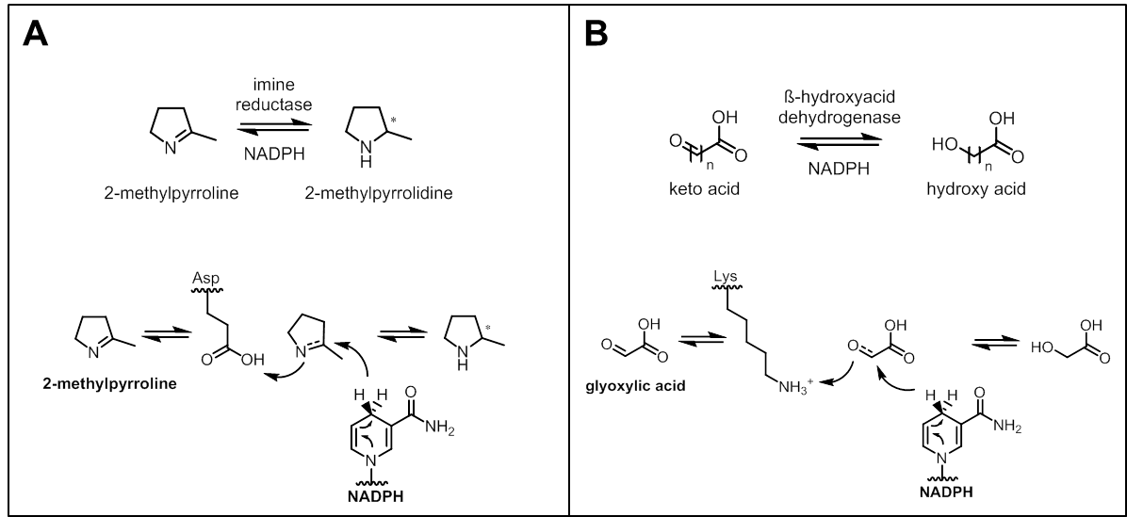
Figure 1: Asymmetric reductions catalyzed by imine reductases (IREDs) and β-hydroxyacid dehydrogenases (βHADs) A. Prosposed catalytic mechanism of IREDs with aspartic acid as proton source. B. Described acid-base catalysis of βHADs showing lysine as proton donating amino acid. For both enzyme families NADPH is known as hydride donor.

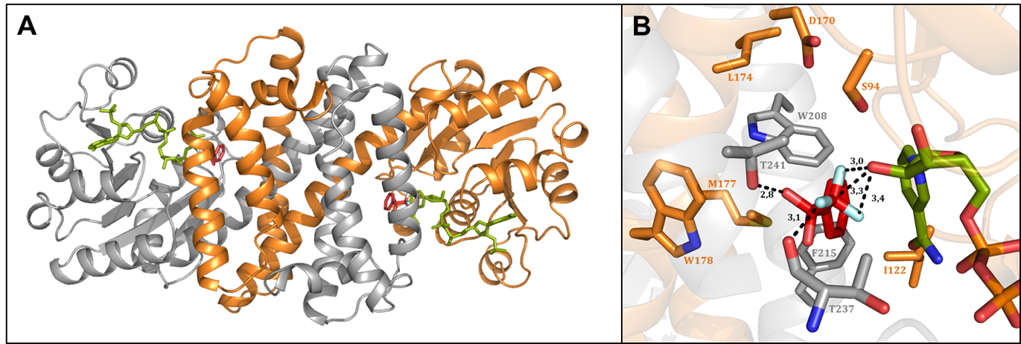
Figure 2: A. Structure of R-IRED-Sr dimer in ribbon format with subunits ‘A’ and ‘B’ in orange and grey respectively. Ligands NADP⁺ and 2,2,2-trifluoroacetophenone hydrate are shown in cylinder format at the active sites with carbon atoms in green and red, respectively. B. Structure of R-IRED-Sr active site with residue side chains of subunits ‘A’ and ‘B’ in cylinder format in orange and grey, respectively. Ligands NADP⁺ and 2,2,2-trifluoroacetophenone hydrate are shown in cylinder format at the active sites with carbon atoms in green and red, respectively.

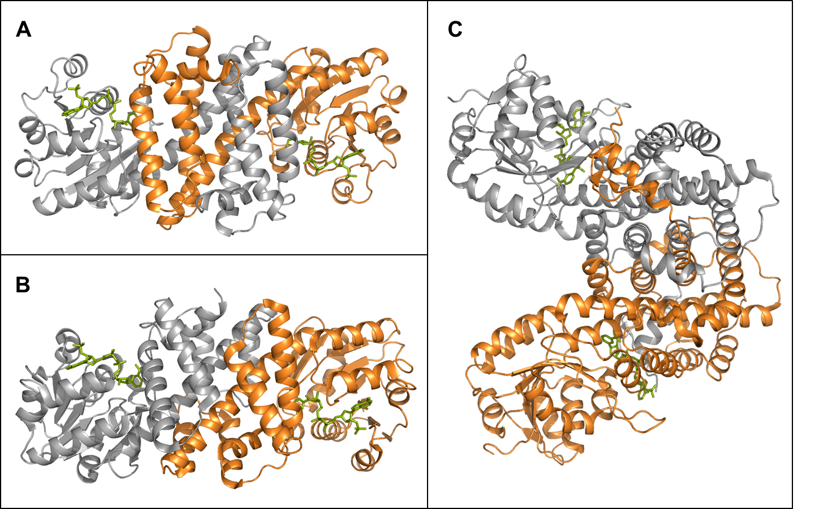
Figure 3: Comparison of the dimerization of R-IRED-Sr (A), βHADGm (B, PDB code 3PEF) and βHADLal (C,PDB code 2IYP) showing monomeric subunits in orange and grey, respectively. Ligand NADP⁺ is docked to the active sites and shown as green sticks. In R-IRED-Sr the active site is formed by two different monomers, while in all known βHADs only one domain interacts with the substrate. The overall structure of the βHADLal dimer differs significantly from the R-IRED-Sr and βHADGm, due to orientation of the dimers resulting from the third domain.

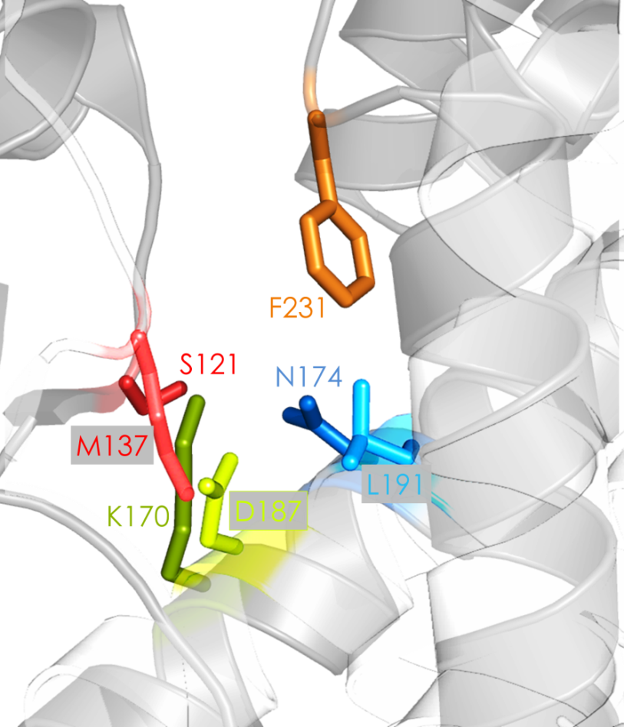
Figure 4: View on the superimposed active sites of R-IRED-Sr and βHADAt. R-IRED-Sr active site residues are coloured in coloured in light red, green and blue (grey labels) and residues from βHADAt are coloured in dark red, green, blue and orange.

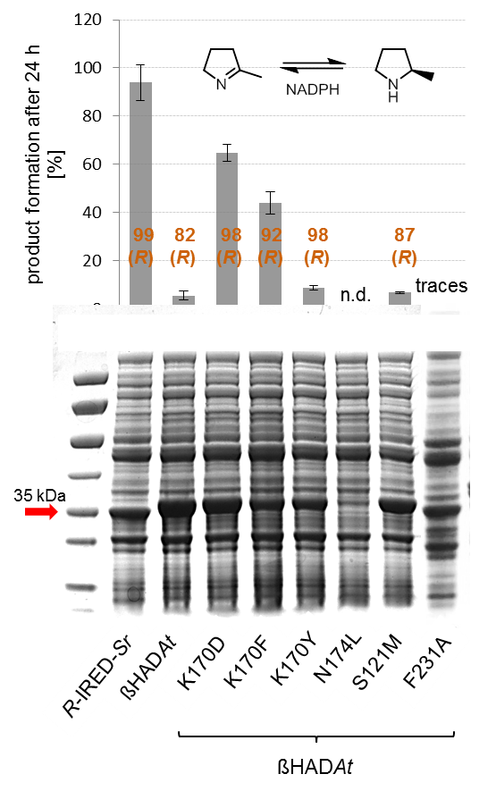
Figure 5: Expression levels and biotransformation results of βHADAt variants in comparison to R-IRED-Sr and βHADAt wild-type enzymes. Biotransformations were performed applying 10 mM 2-methylpyrroline as substrate. Product enantiomeric purities (ee [%]) are shown in orange. Both enzymes show a size of approximately 33 kDa (R-IRED-Sr: 32.6 kDa, βHADAt: 33 kDa), marked with the red arrow on SDS PAGE. n.d.: not determined due to insoluble variant. Traces: < 0.1 % product formation. Experiments were performed as triplicates and data are represented as mean ± SD.

Figure 6: Product formations in percent after 24 h biotransformation with R-IRED-Sr wild-type and variants using imine substrate 2-methylpyrroline and glyoxylic acid. Experiments were performed as triplicates and data are represented as mean ± SD.

Table 1: Specific activities of the examined βHAD wild-type enzymes and variants thereof for their natural substrates.
 | specific activity [U/mg]
 | βHADAt* | βHADGm* | βHADLal**
mutation
wild type | 69.90 ± 2.07 | 4.38 ± 1.77 | 12.83 ± 1.10
K D | 0.10 ± 0.01 | 0.04 ± 0.01 | 0.17 ± 0.01
K F | 0.08 ± 0.01 | 0.02 ± 0.00 | 1.6*10⁻³ ± 0.00
K Y | 0.15 ± 0.01 | n.d. | n.d.
N L | 0.13 ± 0.03 | 0.09 ± 0.01 | 0.02 ± 0.00
S M | 70.3 ± 0.63 | n.d. | n.d.
Respective positions mutated in βHADAt: K170, N174, S121; βHADGm: K171, N175 and βHADLal: K184, N188; *Glyoxylic acid was chosen as natural substrate for βHADAt and βHADGm; **6-Phosphogluconate was chosen as natural substrate for βHADLal; n.d. not determined due to the fact that these variants were not generated for βHADGm and βHADLal.

Table 2: Reduction of 2-methylpyrroline using βHAD wild-type enzymes and variants thereof.
 | product formation after 24 h [%]
organism | Arabidopsis  thaliana | Geobacter  metallireducens | Lactococcus  Lactis
mutation
wild-type | 5.6 ± 1.8 | 1.1 ± 0.4 | 10.6 ± 1.1
K D | 64.6 ± 3.5 | 8.9 ± 2.3 | 35.6 ± 3.2
K F | 44.1 ± 4.7 | 3.6 ± 0.5 | 13.3 ± 2.5
N L | n.d. | n.d. | 4.4 ± 0.0
K D, N L | n.d. | n.d. | 2.3 ± 0.3
K F, N L | n.d. | n.d. | 1.2 ± 0.0
n.d. not determined; Respective positions mutated in βHADAt: K170, N174; βHADGm: K171, N175 and βHADLal: K184, N188.
Table 3: Reducing activities of wild-type enzymes R-IRED-Sr and βHADAt and selected βHADAt variants towards 2-methylpyrroline (2MPN) and glyoxylic acid substrates.
variant | substrate | K_{M}  [mM] | v_{max}  [U mg⁻¹] | k_{cat}  [min⁻¹] | k_{cat}/K_{M}  [min⁻¹ mM⁻¹] | K_{I}  [mM]
R-IRED-Sr | glyoxylic acid | - | - | - | - | -
 | 2MPN | 1.31 | 1.91 | 58.56 | 44.84 | 19.11
βHADAt | glyoxylic acid | 2.59 | 72.82 | 2206.70 | 849.60 | 2.10
 | 2MPN | 0.26 | 1.6*10⁻³ | 47.1*10⁻³ | 0.18 | 29.87
βHADAt_ K170D | glyoxylic acid | 0.70 | 19.6*10⁻³ | 0.59 | 0.84 | 23.86
 | 2MPN | 1.29 | 13.7*10⁻³ | 0.41 | 0.32 | 28.96
βHADAt_ K170F | glyoxylic acid | 0.40 | 12.4*10⁻³ | 0.38 | 0.94 | 27.34
 | 2MPN | 0.85 | 8.8*10⁻³ | 0.27 | 0.31 | 72.93
All experiments were performed as triplicates. Fitting of the kinetic data was done with excel based on the mean of the raw data (no standard deviations were listed).

Table 4: Product formations [%] and selectivities of βHADAt variants compared to wild-type enzyme testing different imine substrates.
 | product formation after 24 h [%] / enantiomeric excess ee [%]
substrates
enzyme variant
βHADAt | 5.6 ± 1.8/ 82 (R) | 15.1^{[a]} ± 0.4/ 97 (R) | 14.4 ± 0.1 | 5.0 ± 0.5/ n.d.
βHADAt_K170D | 64.6 ± 3.5/ 98 (R) | 88.8^{[a]} ± 10.6/ >99 (R) | 19.6 ± 0.6 | 2.9 ± 0.2/ 34 (S)
βHADAt_K170F | 44.1 ± 4.7/ 92 (R) | 94.2^{[a]} ± 9.3/ 98 (R) | 16.5 ± 0.3 | 2.2 ± 0.1/ 26 (S)
βHADAt_K170D_F231A | 55.2 ± 8.7/ >99 (R) | n.d. | n.d. | 40.6 ± 0.9/ 97 (S)
βHADAt_K170F_F231A | 54.8 ± 1.2/ >99 (R) | n.d. | n.d. | 42.0 ± 2.2/ 97 (S)
^{[a]} Total conversion after 24 h. In other cases, product formation results after 5 h biotransformation are listed to clarify the differences in enzyme activity of the variants compared to the wild-type enzyme; n.d. not determined.

