McKechnie and Amar (2018) suggest that my recent review of trends and themes in African ornithology (Beale 2018) “paints a picture of ornithology in this continent that that does not even come close to being a true reflection of reality”. They reach this conclusion after identifying three issues: first, that the selection of literature is too narrow; second, that the research themes identified are incomplete and third, that the tone is patronising.

With regards to the first point, McKechnie and Amar firstly dismiss the full text search of the PubMed literature as papers limited in scope to human and animal health. This is an incorrect characterisation of PubMed Central, which characterises itself as “a free full-text archive of biomedical and life sciences journal literature” (https://www.ncbi.nlm.nih.gov/pmc/), drawing on full text archives of many ecological journals. Secondly, they overlook the “ecological full-text search” that used only PubMed papers from ecological journals (listed in Appendix 2 of Beale 2018). This includes complete recent sets of full text articles from many of the journals they suggest I should have examined. Finally, they argue that the “ornithological abstract search” I undertook was incomplete. This is something I acknowledged clearly, noting both that much valuable ornithological literature is published in regional journals that are not readily searched and more is in general ecological journals elsewhere; indeed, the work of one of the individuals mentioned is the exact example of this I gave in the review. I argue only that it is a valid sample of the ornithological literature for assessing trends and themes. For their criticism to be valid, McKechnie and Amar would need to demonstrate that the literature I sampled is systematically biased. But they have not attempted to demonstrate this themselves, and rejected an offer to work together to undertake this analysis. Consequently, I downloaded the 7283 records that resulted from a search of the additional journals they suggest by name for the years 1990 - 2017 (search: PUBLICATION NAME: ('Journal of Avian Biology' OR 'Journal of Ornithology' OR Condor). From this I identified only a further 243 papers (an additional 11%) that had titles, abstracts of key words containing either ‘Africa’ or an African country name and the name of an African bird species (checking for synonyms as in the original paper). Unsurprisingly, such few additional papers makes no qualitative difference to they key results (e.g. compare Fig 1 with Beale 2018 Fig 4, and Fig 2 with Beale 2018 Fig 5). Based on these new analyses, it seems unlikely that additional trawls of the general literature will substantially change my original findings.

Their second criticism is that the broad classifications of themes exclude important areas of ornithology. The two examples given are behavioural ecology and ecological physiology, and they they further argue that the words I used to identify papers in these areas are insufficient. In fact, both physiology and animal behaviour are topics I included. To determine whether the search terms I used are sufficient to identify a representative sample requires empirical research: in the absence of concrete suggestions for search terms in their response or a willingness to work together to identify some, I posit that those I have used are the best currently available.

Thirdly, if my tone was indeed patronising to Africa's ornithologists, I apologise unreservedly. That was not my intention: indeed I was trying to give voice to some of the discussions I have had with many African ornithologists at the PAOC and elsewhere. That said, I hope readers can overlook the tone of voice and assess the substance. Two assertions of McKechnie and Amar in this area require correction: first, that the journals chosen are themselves somehow patronising, second that I am calling for more researchers to come to Africa where researchers need mentoring. As detailed above, I believe the journals chosen so identify a cross section of the ornithological literature. Second, they misunderstand my call for those overseas researchers already working in Africa to undertake better mentoring and training. I do not think all African researchers need continued mentoring, but I do think that the normal mentoring of scientists in the Europe and North America through PhD, postdoc and fellowship positions is largely unavailable away from southern Africa, and I personally find myself in regular receipt of mentoring requests that I cannot hope to meet. It is the moral reasonability of all overseas researchers to assist in this role more fully to avoid scientific colonialism. This should not be read as a patronising labelling of all African scientists as in need more mentoring, but rather a positive call to action by those working regularly in Africa to do more locally.

References:
Beale CM. 2018. Trends and themes in African ornithology. Ostrich http://dx.doi.org/10.2989/00306525.2017.1407834.

McKechnie AE & Amar A. 2018. Missing the bigger picture: a response to Beale (2018) Ostrich XXXXXXX

Figure legends:
Figure 1: Taxonomic trends in the expanded ornithological literature search of Africa (equivalent to Figure 4 in beale 2018). (a) Histogram of the numbers of papers per species, for all species where at least one paper has been published. (b) Histogram of the numbers of papers per family, where at least one paper has been published on members of the family. (c) The relationship between the number of species in a family and the number of papers published on them for all families where at least one paper has been published. (d) The ratio of papers to number of species by IUCN red list category. CR = Critically Endangered, EN = Endangered, VU = Vulnerable, NT = Near Threatened, LC = Least Concern. Note that patterns are essentially identical to the original paper.

Figure 2: Geographical patterns in the expanded ornithological literature search of Africa (equivalent to Figure 5a in Beale 2018). Note the continued heavy geographical bias remains.

Figure 1:
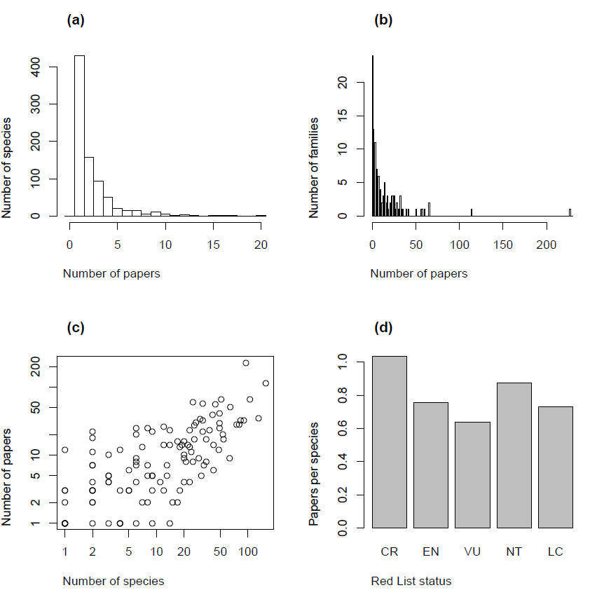

Figure 2:
