Nanohelicoidal Nematic Liquid Crystal Formed by a Non-Linear Duplexed Hexamer
Richard J. Mandle and John W. Goodby

The twist-bend modulated nematic liquid crystal phase exhibits phenomena of fundamental importance to science; the formation of a helical pitch of nanometre scale in a fluid and the spontaneous breaking of mirror symmetry leading to a quasi-fluid state composed of chiral domains despite being composed of an achiral material. We note that this phase has only been observed for materials with two or more mesogenic units, the manner of attachment between which is always linear. In this communication we report on non-linear oligomers, with a H-shaped hexamesogen found to exhibit both nematic and twist-bend modulated nematic phases. This shatters the widely held assumption that a linear sequence of mesogenic units is a prerequisite for this phase, and points to this state of matter being exhibited by a much wider range of self-assembling structures than was previously envisaged. The present results support the double helix model of the TB phase as opposed to the simple heliconical model. This new class of materials has the potential to act as low molecular weight surrogates for cross linked liquid-crystalline elastomers.
Keywords: Liquid Crystals, Oligomers, Modulated Nematics

The phenomenon of spontaneous breaking of mirror symmetry manifests in a wide range of scientific disciplines and ongoing problems; from subatomic physics to autocatalysis to biological homochirality. ^{[1]} The twist-bend modulated nematic phase (TB), predicted by Dozov, ^{[2]} possesses a helical structure with a pitch length of approximately 10 nm; ^{[3]} this phase is chiral despite being typically formed by achiral molecules and is the first example of spontaneous symmetry breaking in a liquid system without accompanying positional order. The TB phase was first identified in liquid crystalline dimers, ^{[4]} and the relationship between molecular structure and the incidence of this phase has been an active area of research, with the majority of explored structural variations presented in Figure 1a. ^{[5]} In addition to being found in low molecular weight dimers the generation of the TB phase has been demonstrated in oligomers ^{[6]} and polymers. ^{[7]} The TB phase exhibits a fast (microsecond) electrooptic response, ^{[8]} and also provides a simple route to materials with defined nanostructures via in situ photopolymerisation ^{[9]} which may find use in photonics. ^{[10]}
Without exception, all examples of the TB phase are found in materials in which the rigid ‘mesogenic units’ are mutually attached via a linear manner akin to a main chain polymer, thereby inducing dimers to behave like polymers. We had suggested that the TB phase may have a double helix structure, ^{[11]} and this idea has been revisited in some detail by others recently. ^{[12]} Such a phase structure, if it exists, should be stabilised by duplexed oligomers in which two (or more) linear oligomers are laterally linked (shown in Figure 1d), whereas a single helix would be destabilised (Figure 1b). We devised the novel trimer D11₃ and related duplexed hexamer D11₃(2) as a test of this idea.
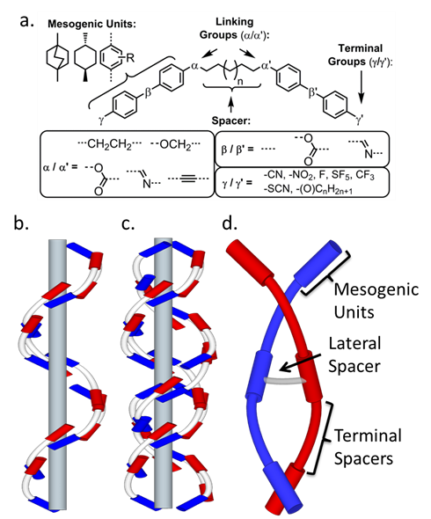
Figure 1: (a) general overview of the molecular structures explored within the context of the TB phase; (b) heliconical model proposed by Dozov; (c) double twist model suggested by Goodby et al ^{[11]} and developed by Tuchband et al; ^{[12]} (d) Depiction of a duplexed hexamer formed from two laterally appended trimers, with key subdivisions indicated.

Suzuki cross-coupling of i1, reported in ^{[13]}, with 2,5-dibromophenol afforded the trimer D11₃. Dimerisation of the trimer to afford the hexamer D11₃(2) was achieved by heating D11₃ with dibromoheptane and caesium carbonate to 200 °C (sand bath, external temperature) in acetone in a sealed tube. The structure of D11₃(2) was confirmed by NMR spectroscopy (¹H and ¹³C{¹H}) and APCI mass spectrometry, with purity of both the trimer and hexamer assayed by reverse phase HPLC. Computational chemistry was performed in Gaussian G16; ^{[14]} conformer libraries were built via the MODREDUNDANT keyword with geometries and energies extracted via Matlab scripts as described ^{[15]}. Selected output files were visualised using Qutemol. ^{[16]} Full synthetic and instrumental details are given in the SI to this communication.

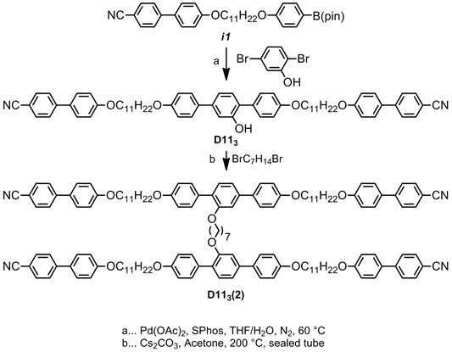
Scheme 1
The trimer D11₃ and the hexamer D11₃(2) were studied by polarised optical microscopy (POM) differential scanning calorimetry (DSC) and simultaneous small- and wide-angle X-ray scattering (SWAXS) to determine transition temperatures and phase types. Tabulated transition temperatures and enthalpies of transition are given in Table 1.
No. |  | MP | TB-N | N-Iso
D11₃ | T | 125.9 | 86.3* | 172.8
 | ΔH | 32.4 | 0.6 | 5.5
D11₃(2) | T | 123.7 | 117.2* | 172.9
 | ΔH | 93.0 | 0.5 | 4.2
Table 1: Transition temperatures (T, °C) and associated enthalpies of transition (ΔH, kJ mol⁻¹) for the trimer D11₃ and derived hexamer D11₃(2). Values were obtained by DSC at a heat/cool rate of 10 °C min⁻¹ and are the average of 5 cycles. * monotropic phase transition, observed only on cooling below the melting point.
Phase identification was made by a combination of microscopy and SWAXS experiments, whereas transition temperatures and enthalpies were determined from DSC. The nematic phase exhibits a distinctive schlieren texture (Figure 2a) which transforms into the blocky texture immediately following the TB-N transition (Figure 2b, 2c) which evolves into the rope-like texture with further cooling (Figure 2d). We confirm these phase assignments for D11₃(2) by way of miscibility with CB9CB, ^{[3a]} a contact preparation shows the two materials are be mutually miscible in both mesophases and therefore our assignment of both phases is correct; photomicrographs are presented in the ESI to this communication (Figure SI-1). Previous results indicate that lateral groups, both polar ^{[5b, 6a]} and non-polar, ^{[11]} tend to depress the thermal stability of the TB phase; yet dimerisation of the trimer D11₃ into the duplex trimer D11₃(2) unexpectedly increases the TB-N transition temperature by over 30 °C. The enthalpy associated with the TB-N transition in both materials is comparable to prior (linear) oligomeric examples, and the transition is first order. ^{[6]} During SWAXS study no scattering is observed from the TB helix during non-resonant SWAXS study (Figure 2f) as has been noted previously, ^{[3a]} although the lack of Bragg scattering supports our assignment as a nematic-like phase. The intensity of the wide-angle scattering peak is significantly greater than that at small-angles, indicating both nematic and TB phases lack significant lamellar fluctuations (cybotaxis). The d-spacing value of the small angle peak is temperature invariant and has a value of 22.1 Å, this is shorter than the molecular length as will be discussed shortly. The wide-angle scattering peak has a value of 5 Å, which corresponds to the average lateral molecular separation. We do not observe any further scattering from the sample of D11₃(2) at smaller angles (2θ ≥ 0.7 °, q ≥ 0.5 Å⁻¹, d ≤ 125 Å); this excludes the possibility of lamellar twist-bend phases with large layer spacings ^{[17]} and hypothetical splay-bend modulated nematic phases which should exhibit Bragg scattering at $Q= \frac{2π}{P_{SB}}$, where P_{SB} is the splay bend modulation period. ^{[3a]}

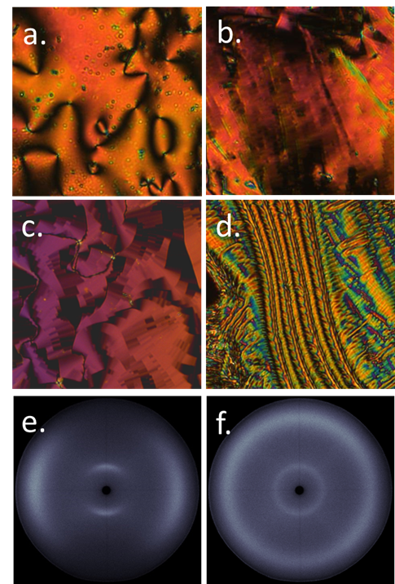
Figure 2: Photomicrographs (x100) of: (a) the schlieren texture of the nematic phase of D11₃(2) at 155 °C; (b) the blocky texture of the TB phase of D11₃(2) at 115 °C; (b) the blocky texture of the TB phase of D11₃ at 82 °C; (d) the rope texture of the TB phase of D11₃(2) at 110 °C.; 2D SWAXS patterns of (e) the magnetically aligned nematic phase of D11₃(2) at 160 °C; (f) the unaligned TB phase of D11₃(2) at 112 °C, note that the loss of alignment is spontaneous at the phase transition.
To rationalise SWAXS data we first obtained an optimised, fully extended all trans structure of D11₃(2)_{a} at the B3LYP/6-31G(d) level of DFT (Figure 3b). The molecular length of this conformer is 62 Å; taken in conjunction with the d-spacing of the small angle peak in SWAXS experiments (22.1 Å) this indicates the nematic and TB phases are both extensively intercalated, with no segregation of the different mesogenic units into layers (or pseudo layers) which would lead to Bragg (or quasi Bragg) scattering. The single broad SWAXS peak at small angles is most likely the centre-to-centre separation between mesogenic units; ^{[7]} although we do not observe differing scattering peaks for terminally (~24 Å) and laterally (18 Å) appended segments of the molecule. This result is consistent with prior studies on TB forming oligomers, which exhibit small angle scattering at 1/n times the molecular length, ^{[6b, 6c]} where n is the generation of oligomer (n = 3, trimer, n = 4 tetramer etc.)
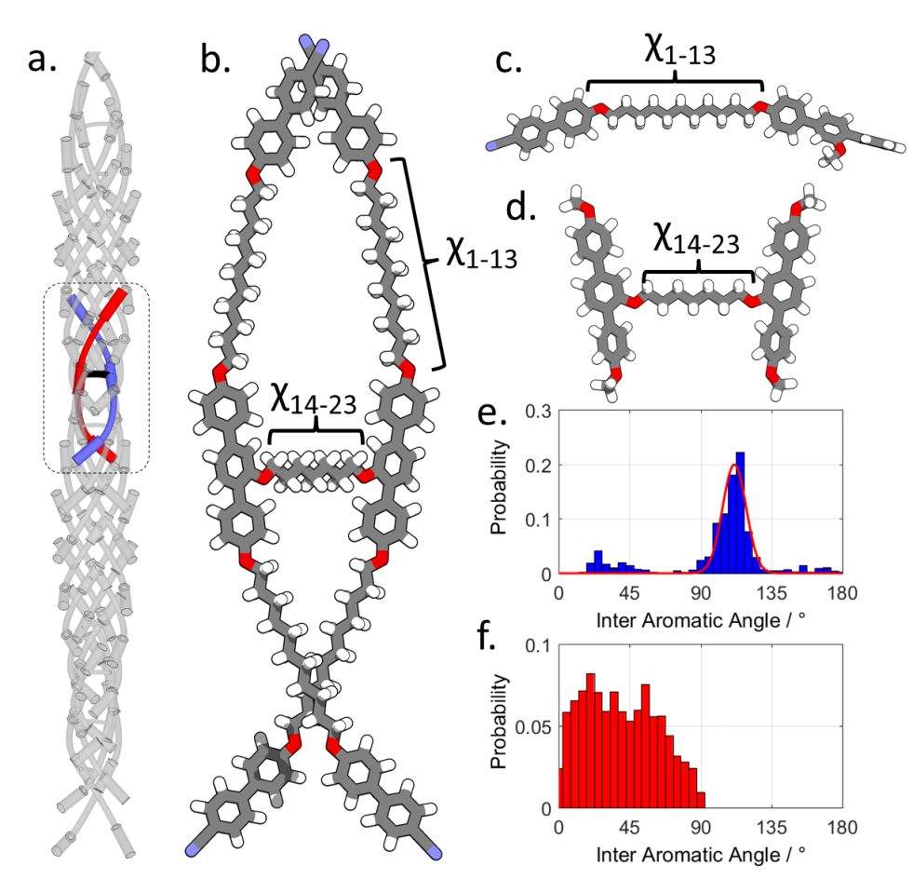
Figure 3: (a) Proposed double-helical structure of the TB phase formed by duplexed hexamers; (b) Geometry of D11₃(2) optimised at the B3LYP/6-31G(d) level of DFT, the dihedrals χ₁₋₁₃ and χ₁₄₋₂₃ were used to build conformer libraries of the fragments shown in (c) and (d) at using fully relaxed scans at the B3LYP/6-31G(d) level of DFT. Plots of the probability of a given interaromatic bend angle from fragment c (e) and fragment d (f). The solid line in (e) is a Gaussian fit to the major peak.
A single geometry neglects the flexibility of this molecule; assuming threefold rotation about each dihedral in the spacer gives an imposing number of conformers (4*(3^13)*3^9) which is too expensive to study computationally. We therefore subdivided D11₃(2) into two fragments, shown in Figure 3c and d. On each fragment we performed fully relaxed scans at the B3LYP/6-31G(d) level of DFT, allowing each flexible bond to adopt either trans or gauche states, giving a library of conformers. Clearly this method ignores intermolecular interactions which could be important in the condensed LC phase, but it provides a useful approximation in this instance. For each conformer we calculate the angle between the two mesogenic units in question and a Boltzmann probability allowing us to present the probability weighted angles given in Figure 3. Within each linear segment the probability of a given bend angle is skewed towards being bent due to the odd parity of the spacer (Figure 3e). The major distribution of bend angles is approximately Gaussian, centred at 108 ° with a FWHM of ~25 °. Minor populations of linear (bend > 150 °) and hairpin (bend < 30 °) conformers exist.
A broad range of angles are adopted between the two central terphenyl mesogenic units (Figure 3f); provided these two units are a way off perpendicular (i.e. <75 °) the formation of a double helical structure is favourable and we note that there is a decrease in the probability of bend angles over about approximately 60 °. If the two central units are (close to) perpendicular then the resulting gross molecular shape would be globular, with the outer nitriles forming the apex of a tetrahedron, rather than a double helix. Presently it is not clear how flexibility - or lack thereof – of this part of the molecule impacts upon TB phase formation.
This conformational study indicates that D11₃(2) is likely to adopt a wide range of conformations, with many of these will being helical or double-helical structures. If we consider now the parent trimer D11₃, the conformational landscape of this material is effectively defined by the biphenyl-terphenyl bend indicated in Figure 3d. The formation of a double helix structure by D11₃ relies on non-covalent interactions whereas D11₃(2) forms this structure to covalent bonding of two trimers. The observed enhancement in the thermal stability of the TB phase in D11₃(2) relative to D11₃ suggests the double helix structure not only warrants further experimental study, but also suggests that entirely new classes of materials could exhibit this state of matter. We also note the possibility of incorporating stimuli- or chemo- responsive groups (e.g. azo, ^{[18]} crown ether) into the lateral spacer to give functional, tuneable or switchable twist-bend materials. Just as linear LC dimers and oligomers are considered as good model systems for main-chain LC polymers ^{[19]} we consider that the nematic phases of materials such as D11₃(2) could be considered as low molecular weight surrogates for crosslinked nematic LC elastomers, which have attracted attention as actuators, sensors and artificial muscle. ^{[20]} Furthermore, one should not lose sight of the possibility of that the double twisted structure could form a cable- or rope-like arrangement, and lead to entirely new forms of matter.

Conclusions
We observe a remarkable stabilisation of the nanohelical TB phase by covalently bonding two trimers together, affording a duplexed hexamer. Previous studies show that lateral substitution at the mesogenic units leads to diminished TB phase stability; however in the present case the linking of two trimers together actually affords an increase. Rather than forming a single helix the duplexed hexamer is conformationally biased towards double helix formation, and computational studies on the conformational landscape support this idea. We consider that the present results support the double helix model of the TB phase which we had previously proposed, ^{[11]} and has been revisited in more detail by others recently. ^{[12]} There is a need for development of theoretical models of this phase that account for such a helical structure. The observation of the TB phase in a non-linear oligomer prompts a re-evaluation of previously held beliefs about the type of molecular structure required to exhibit this nanohelical phase of matter.

Acknowledgements
We thank the EPSRC (UK) for funding via grants EP/M020584/1 and EP/K039660/1.

References
[1] aA. J. Bissette, S. P. Fletcher, Angew Chem Int Edit 2013, 52, 12800-12826; bY. Nambu, Rev Mod Phys 2010, 82; cJ. A. R. Rodrigues, Quim Nova 2010, 33, 1175-1185.
[2] I. Dozov, Europhys Lett 2001, 56, 247-253.
[3] aC. Zhu, M. R. Tuchband, A. Young, M. Shuai, A. Scarbrough, D. M. Walba, J. E. Maclennan, C. Wang, A. Hexemer, N. A. Clark, Phys Rev Lett 2016, 116, 147803; bD. Chen, J. H. Porada, J. B. Hooper, A. Klittnick, Y. Shen, M. R. Tuchband, E. Korblova, D. Bedrov, D. M. Walba, M. A. Glaser, J. E. Maclennan, N. A. Clark, Proc Natl Acad Sci U S A 2013, 110, 15931-15936; cV. Borshch, Y. K. Kim, J. Xiang, M. Gao, A. Jakli, V. P. Panov, J. K. Vij, C. T. Imrie, M. G. Tamba, G. H. Mehl, O. D. Lavrentovich, Nat Commun 2013, 4, 2635.
[4] aP. J. Barnes, A. G. Douglass, S. K. Heeks, G. R. Luckhurst, Liq Cryst 1993, 13, 603-613; bM. Cestari, S. Diez-Berart, D. A. Dunmur, A. Ferrarini, M. R. de la Fuente, D. J. Jackson, D. O. Lopez, G. R. Luckhurst, M. A. Perez-Jubindo, R. M. Richardson, J. Salud, B. A. Timimi, H. Zimmermann, Phys Rev E Stat Nonlin Soft Matter Phys 2011, 84, 031704; cM. Sepelj, A. Lesac, U. Baumeister, S. Diele, H. L. Nguyen, D. W. Bruce, J Mater Chem 2007, 17, 1154-1165.
[5] aR. J. Mandle, Soft Matter 2016, 12, 7883-7901; bR. J. Mandle, E. J. Davis, C. C. A. Voll, C. T. Archbold, J. W. Goodby, S. J. Cowling, Liq Cryst 2015, 42, 688-703; cT. Ivsic, M. Vinkovic, U. Baumeister, A. Mikleusevic, A. Lesac, Rsc Adv 2016, 6, 5000-5007; dD. A. Paterson, M. Gao, Y. K. Kim, A. Jamali, K. L. Finley, B. Robles-Hernandez, S. Diez-Berart, J. Salud, M. R. de la Fuente, B. A. Timimi, H. Zimmermann, C. Greco, A. Ferrarini, J. M. D. Storey, D. O. Lopez, O. D. Lavrentovich, G. R. Luckhurst, C. T. Imrie, Soft Matter 2016, 12, 6827-6840; eA. A. Dawood, M. C. Grossel, G. R. Luckhurst, R. M. Richardson, B. A. Timimi, N. J. Wells, Y. Z. Yousif, Liq Cryst 2016, 43, 2-12; fR. J. Mandle, C. T. Archbold, J. P. Sarju, J. L. Andrews, J. W. Goodby, Sci Rep-Uk 2016, 6.
[6] aR. J. Mandle, J. W. Goodby, Rsc Adv 2016, 6, 34885-34893; bR. J. Mandle, J. W. Goodby, Chemphyschem 2016, 17, 967-970; cF. P. Simpson, R. J. Mandle, J. N. Moore, J. W. Goodby, J Mater Chem C 2017, 5, 5102-5110; dA. Al-Janabi, R. J. Mandle, J. Goodby, Rsc Adv 2017, 7, 47235-47242.
[7] W. D. Stevenson, J. An, X. Zeng, M. Xue, H.-x. Zou, Y. Liu, G. Ungar, Soft Matter 2018.
[8] V. P. Panov, R. Balachandran, M. Nagaraj, J. K. Vij, M. G. Tamba, A. Kohlmeier, G. H. Mehl, Appl Phys Lett 2011, 99, 261903.
[9] V. P. Panov, S. P. Sreenilayam, Y. P. Panarin, J. K. Vij, C. J. Welch, G. H. Mehl, Nano Lett 2017, 17, 7515-7519.
[10] aJ. Xiang, Y. Li, Q. Li, D. A. Paterson, J. M. D. Storey, C. T. Imrie, O. D. Lavrentovich, Adv Mater 2015, 27, 3014-3018; bY. Wang, Z.-g. Zheng, H. K. Bisoyi, K. G. Gutierrez-Cuevas, L. Wang, R. S. Zola, Q. Li, Materials Horizons 2016, 3, 442-446; cH. K. Bisoyi, Q. Li, Accounts of Chemical Research 2014, 47, 3184-3195; dL. Wang, Q. Li, Adv Funct Mater 2016, 26, 10-28.
[11] R. J. Mandle, E. J. Davis, C. T. Archbold, C. C. Voll, J. L. Andrews, S. J. Cowling, J. W. Goodby, Chem. Eur. J 2015, 21, 8158-8167.
[12] M. R. Tuchband, M. Shuai, K. A. Graber, D. Chen, C. Zhu, L. Radzihovsky, A. Klittnick, L. M. Foley, A. Scarbrough, J. H. Porada, M. Moran, J. Yelk, D. Bedrov, E. Korblova, D. M. Walba, A. Hexemer, J. E. Maclennan, M. A. Glaser, N. A. Clark, in ArXiv e-prints, Vol. 1703, 2017.
[13] R. J. Mandle, M. P. Stevens, J. W. Goodby, Liq Cryst 2017, 44, 2046-2059.
[14] M. J. Frisch, G. W. Trucks, H. B. Schlegel, G. E. Scuseria, M. A. Robb, J. R. Cheeseman, G. Scalmani, V. Barone, G. A. Petersson, H. Nakatsuji, X. Li, M. Caricato, A. V. Marenich, J. Bloino, B. G. Janesko, R. Gomperts, B. Mennucci, H. P. Hratchian, J. V. Ortiz, A. F. Izmaylov, J. L. Sonnenberg, Williams, F. Ding, F. Lipparini, F. Egidi, J. Goings, B. Peng, A. Petrone, T. Henderson, D. Ranasinghe, V. G. Zakrzewski, J. Gao, N. Rega, G. Zheng, W. Liang, M. Hada, M. Ehara, K. Toyota, R. Fukuda, J. Hasegawa, M. Ishida, T. Nakajima, Y. Honda, O. Kitao, H. Nakai, T. Vreven, K. Throssell, J. A. Montgomery Jr., J. E. Peralta, F. Ogliaro, M. J. Bearpark, J. J. Heyd, E. N. Brothers, K. N. Kudin, V. N. Staroverov, T. A. Keith, R. Kobayashi, J. Normand, K. Raghavachari, A. P. Rendell, J. C. Burant, S. S. Iyengar, J. Tomasi, M. Cossi, J. M. Millam, M. Klene, C. Adamo, R. Cammi, J. W. Ochterski, R. L. Martin, K. Morokuma, O. Farkas, J. B. Foresman, D. J. Fox, Wallingford, CT, 2016.
[15] C. T. Archbold, R. J. Mandle, J. L. Andrews, S. J. Cowling, J. W. Goodby, Liq Cryst 2017, 44, 2079-2088.
[16] M. Tarini, P. Cignoni, C. Montani, Ieee T Vis Comput Gr 2006, 12, 1237-1244.
[17] J. P. Abberley, R. Killah, R. Walker, J. M. D. Storey, C. T. Imrie, M. Salamonczyk, C. H. Zhu, E. Gorecka, D. Pociecha, Nat Commun 2018, 9.
[18] D. A. Paterson, J. Xiang, G. Singh, R. Walker, D. M. Agra-Kooijman, A. Martinez-Felipe, M. Gan, J. M. D. Storey, S. Kumar, O. D. Lavrentovich, C. T. Imrie, J Am Chem Soc 2016, 138, 5283-5289.
[19] G. R. Luckhurst, Macromol Symp 1995, 96, 1-26.
[20] aT. Ikeda, J. i. Mamiya, Y. Yu, Angewandte Chemie International Edition 2007, 46, 506-528; bC. Ohm, M. Brehmer, R. Zentel, Adv Mater 2010, 22, 3366-3387.

TOC Entry:
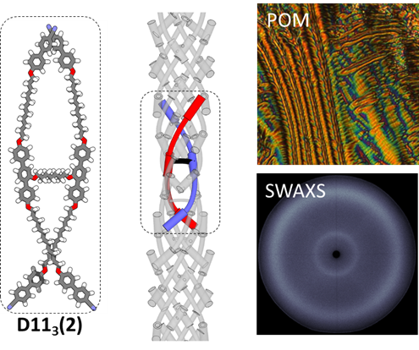
Double Helix: The first example of a non-linear duplexed hexamer to exhibit the twist-bend modulated nematic liquid crystal phase suggests the emergence of these spontaneously chiral fluid phases may occur in a far wider class of materials than had previously been envisaged

