**Geometric aspects influencing N-NTB transition - implication of intramolecular torsion**

Andreja Lesac1*,Ute Baumeister2,Irena Dokli1, Zdenko Hameršak1, Trpimir Ivšić1, Darko Kontrec1, Marko Viskić1,Anamarija Knežević1, Richard J. Mandle3

1Ruđer Bošković Institute, Bijenička cesta 54, 10000 Zagreb, Croatia.

2Institute of Chemistry, Physical Chemistry, Martin Luther University Halle-Wittenberg, von-Danckelmann-Platz 4, 06120 Halle, Germany.

3Department of Chemistry, University of York, York, YO10 5DD, UK

*e-mail: [andreja.lesac@irb.hr](mailto:andreja.lesac@irb.hr)

**Abstract**

Herein we report a comprehensive study on novel carbonyl- and ethenyl- linked symmetric dimers that combine synthesis, mesomorphic properties and molecular modelling. The study has been focused on the impact of geometry imposed by the linkage group on the incidence of the twist-bend nematic (NTB) phase. Comparison of the mesomorphic properties of these two series complemented with computational studies of conformational space around the linkage group points molecular curvature and intramolecular torsion plays important role in the appearance of the NTB phase and can be regarded as the basic structural requirements for design of new twist-bend nematogen materials.

Keywords: bent-shape dimers, structure-property correlation, linking group conformations, NTB phase

**1. Introduction**

For many years liquid crystalline dimers have been studied because of their rich and unusual smectic and columnar mesomorphism, which differs from that of the corresponding monomers.[1]The recent discovery of additional low temperature nematic phase found in odd-membered dimers has vivified interest in this class of materials. In 2001 a twist-bend nematic phase (NTB) was predicted[2] for bent-shaped molecules. In the NTB phase, the molecules form a conical helix: the director n is tilted with respect to the helix axis and is precessing around it. This chiral structure is obtained even when the molecules are achiral. Its chirality is doubly degenerated – the left- and right-handed domains have the same energy. Ten years after its prediction, Cestari et al.[3] identified the lower temperature nematic mesophase exhibited by 1,7-bis-4-(4'-cyanobiphenyl) heptane (CB7CB) as being a twist-bend nematic phase. Later on, a series of studies reported the evidence of chiral molecular organization within the twist-bend nematic phase, which is consistent with an oblique helicoidal structure.[4–13] In addition to fundamental studies aiming to understand the structural characteristics and macroscopic properties of the NTB phase, there is significant interest in the molecular features that give rise to this unique phase of matter. In the last few years the number of compounds displaying the NTB phase has increased. Although predominantly exhibited by liquid crystal dimers possessing odd-membered spacers,[14] the NTB phase has also been reported for trimers and tetramers[14–17] including a semi-flexible bent core liquid crystal.[18] The relationship between the chemical structure and formation of the NTB phase has been investigated largely on dimers with methylene linkage group[3,14,16,19–24] but also a significant number of ether[14,24–28] and imino-linked[29–32] dimers have been examined. Despite an effort to determine how variations in molecular structure, such as the linkage group, the length of the spacer, the structures of the mesogenic units and the terminal groups attached to them affect incidence of the NTB phase, a general and comprehensive relationship between molecular structure and the formation of the NTB phase is still in early stage of development. Currently, it is generally accepted that the NTB phase is associated with a bent molecular shape. A molecular field theory based on symmetric V-shaped molecules predicts a strong sensitivity of the NTB phase formation to the molecular bending defined as the angle between the two mesogenic arms.[33]. Combined experimental and computational studies showed that a bend angle in the region of 125° is the optimum for a material to exhibit the twist-bend nematic phase.[34] Several recent reports implied that the value of TNTBN does not depend simply on the bending angle, but also other factors must be taken into account, such as conformational distribution,[35,36] the bend angle fluctuation,[37] effect of free volume[20,38,39] and intramolecular torsion[12,29,40] .

(b)

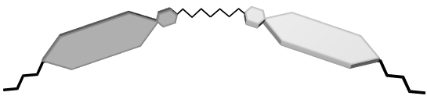

Twisted geometry

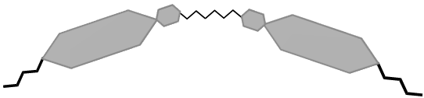

Planar geometry

(a)

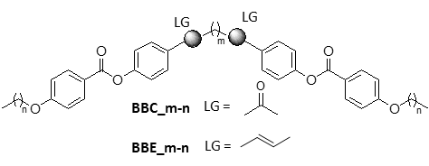

Figure 1. Schematic presentation of symmetric ethenyl **BBE_m-n** and carbonyl linked **BBC_m-n** dimers. (a) The molecular structure where m represents the number of methylene units in the spacer, n the number of methylene units in the terminal chain and LG the linkage group. (b) Schematic presentation of the plausible twisted and planar geometries

To investigate the implication of the intramolecular twist in design of twist-bend nematogen materials generally, we prepared two new families of symmetric carbonyl-linked and ethenyl-linked dimers as schematically presented in Fig. 1a. The new sets of dimers primary differ in the nature of the linkage group. Due to the sp2 character of the carbon atoms in the linking groups and π-conjugation, the plane of the linkage group is aligned with the plane of the mesogen. Conformational analysis showed that the most stable conformation of 1-butene adopts a *skew* whereas 2-butanone *eclipsed* geometry.[41,42] Based on these results it is reasonable to assume that ethenyl-linked dimers will adopt twisted geometry, whereas carbonyl-linked materials will adopt a planar geometry as shown in Fig.1b. Thus, comparison of mesogenic properties of these two sets will provide information about the implication of intramolecular torsion on the incidence of the NTB phase. Since the effective bending of the dimer increases with decreasing number of methylene units in the spacer,[43] altering the length of the spacer allowed for examination of small variation in bending angle in conjunction with different torsion geometry. The experimental data complemented with conformational analysis will demonstrate that molecular curvature and intramolecular torsion plays important role in the appearance of the NTB phase and can be regarded as the basic structural requirements for design of new twist-bend nematogen material.

**2. Experimental**

**2.1. General Information**

All the solvents were either *puriss p.a.* quality or distilled over appropriate drying reagents. Reagents were used directly as supplied by Aldrich, Alfa Aesar or Acros. NMR spectra were recorded on Bruker AV 600 MHz and 300 MHz spectrometers, operating at 150.92 or 75.47 MHz for 13C and 600.13 or 300.13 MHz for 1H nuclei. CHN analyses were done on Perkin Elmer 2400 Series II CHNS analyser. Melting points were determined using an Electrothermal 9100 apparatus in open capillaries and are uncorrected. Phase transition temperatures and textures were determined using an Olympus BX51 polarizing microscope equipped with a Linkam TH600 hot stage and PR600 temperature controller. Enthalpies of transition were determined from thermograms recorded on Perkin-Elmer Diamond DSC, operated at scanning rates of 5 °C min–1. Powder X-ray patterns were obtained with a Guinier film camera (HUBER Diffraktionstechnik, Germany) using quartz-monochromatized CuKα radiation from samples in glass capillaries (diameter 1 mm) mounted in a temperature-controlled heating stage. Two-dimensional patterns of aligned samples (surface aligned on a glass plate on a temperature-controlled heating stage or aligned in the capillary in a magnetic field in a temperature controlled oven) were obtained using Ni filtered CuKα radiation recorded by an area detector (HISTAR, Siemens/Bruker). Computational chemistry was performed using density functional theory with the B3LYP functional and the 6-31G basis set within Gaussian 09 program package.[44] Full experimental details, including synthetic procedures and chemical characterisation, are given in the accompanying Supporting Information.

All data generated or analysed during this study are included in this published article (and its Supplementary Information files) and also available from the corresponding author on reasonable request.

***2.1. Synthesis***

Synthesis of target molecules as outlined in Fig.2 started with Grignard reaction of 4-[(tert-butyldimethylsilyl)oxy]benzaldehyde and suitable 1, *k*-dibromoalkane (*k* = 5, 7, 9). The product diols **1**-**3** were obtained in 76-78% yield; these were then used as precursors for both carbonyl-and ethenyl- series of compounds. Jones oxidation of diols **1**-**3** gave diketones **4**-**6** in 70-88%; subsequent desilylation using tetra-n-butylammonium fluoride (TBAF) afforded the phenols **7** – **9** in quantitative yield. Dehydration reaction of diols **1**-**3** with *p*-toluenesulfonic acid in benzene gave the dienes **10**-**11** in 70-80 % yield. Again, deprotection of the TBS groups with TBAF afforded products **12**-**13**in 90-100% yield. Esterification of **7**-**9** and **12**-**13** with appropriate benzoyl chlorides using 4-dimethylaminopyridine (DMAP) and triethylamine (Et3N) provided for target molecules in 50-87% yield. Full experimental details, including synthetic procedures and chemical characterisation, are given in the accompanying Supporting Information



Figure 2. Synthesis of target carbonyl- and ethenyl-linked dimers; (i) Mg, Et2O, reflux, 2h, (ii) 4-OTBS-benzaldehyde, Et2O, -70 °C, 5 min, (iii) Jones reagent, acetone, rt, 1h, (iv) TBAF, THF, H2O, rt, (v) p-TsOH·H2O, benzene, 10 min, (vi) DMAP, Et3N, CH2Cl2, 24 h, 0°C to rt.

**3. Results and discussion**

The liquid-crystalline behaviour of the new compounds was investigated by polarising optical microscopy, differential scanning calorimetry and X-ray diffraction. The phase transition temperatures and the corresponding enthalpy and entropy changes are collected in Tables 1 and 2.

Table 1. Transition temperatures (°C), enthalpies (kJ mol-1) in italics and the dimensionless value of Δ*S*/R in [] for the homologues of the series **BBE**

|  |  |  |  |  |  |  |  |  |  |
| --- | --- | --- | --- | --- | --- | --- | --- | --- | --- |
| Dimer | Cr |  | SmCA |  | NTB |  | N |  | Iso |
| **BBE_5-2** | • | 127  *37.45*[11.26] |  |  | • | 143  *0.08*[0.02] | • | 170  *0.72*[0.19] | • |
| **BBE_5-3** | • | 128  *46.78*[14.02] |  |  | (• | 120)  *0.28*[0,08] | • | 140  *0.23*[0.06] | • |
| **BBE_5-4** | • | 130  *51.52*[15.37] |  |  | (• | 125  *0.47*[0.14] | • | 142  *0.30*[0.09] | • |
| **BBE_7-2** | • | 104  *48.49*[14.47] |  |  | • | 145  *0.02*[0.01] | • | 183  *1.15*[0.30] | • |
| **BBE_7-3** | • | 123  *42.35*[a][12.57] |  |  | • | 124  *0.06*[b][0.02] | • | 155  *0.62*[0.17] | • |
| **BBE_7-4** | • | 121  *44.34*[a][13.53] |  |  | • | 123  *0.10*[b][0.03] | • | 151  *0.68*[0.19] | • |
| **BBE_7-5** | • | 112  *43.00*[a][13.12] |  |  | • | 114  *0.14*[b][0.04] | • | 142  *0.57*[0.16] | • |
| **BBE_7-6** | • | 110  *41.81*[13.12] | • | 114  *4.63*[1.44] | • | 121  *0.28*[0.08] | • | 140  *0.61*[0.18] | • |

[a] combined enthalpies; [b]obtained on cooling; Cr, crystalline phases; SmCA, anticlinic smectic C phase; NTB, twist-bend nematic phase; N, nematic phase; Iso: isotropic liquid; (): monotropic phase.

Transition properties for ethenyl-linked dimers presented in Table 1 show that all compounds display both, the uniaxial nematic and the twist-bend nematic phase. The uniaxial nematic phase was identified according to its typical schlieren and marbled textures (Fig. 3a). On cooling transition from N to NTB showed characteristic blocky texture (Fig. 3b) from which polygon and rope texture developed (Fig. 3c). When studied by X-ray scattering both the nematic and NTB mesophases exhibit only diffuse scattering at both small and wide angles, as is typical for these phases. Whilst the nematic mesophases were well aligned by the external magnetic field the NTB phase was generally unaligned. Representative two dimensional diffraction patterns are given in Fig.3d.

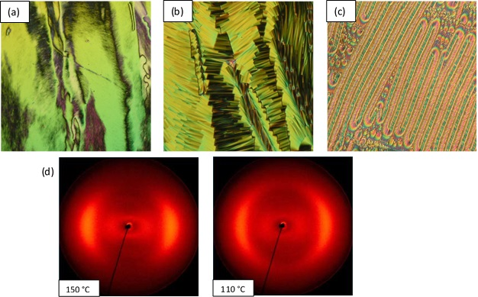

Figure 3. POM textures obtained on cooling. a) The marbled textures of the N phase of **BBE_5-4**at 130 °C. b) The blocky texture with parabolic defects of the NTB phase of **BBE_5-4**at125 °C. c) The rope texture of the NTB phase of **BBE_7-2**at98 °C. d) 2D XRD patterns for a sample of **BBE_7-2** aligned in the magnetic field obtained on cooling from the isotropic liquid at 150 °C and 110 °C

It is interesting to note that the NTB phase persists even in homologues with comparable lengths of chain and spacer. Although the NTB phase was mainly observed for dimers having a chain length significantly smaller than the spacer,[19,21] a similar behaviour was reported for imino-linked dimers comprising salicyl mesogenic unit.[29,45] Among ethenyl series only the highest homologue **BBE_7-6** display smectic phase. On cooling, from the NTB to smectic phase a very small focal-conic texture developed (Fig.4a). Shearing the sample led to a schlieren-like texture with two and four brushes (Fig.4b) which have also been observed in intercalated SmC phases of mesogenic twins[1,21,46]

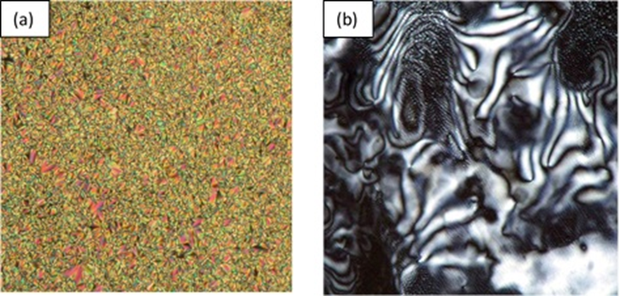

Figure 4. Photomicrographs of the intercalated smectic phase of **BBE_7-6**. a) A small focal-conic texture at 112 °C. b) The schlieren texture after shearing the sample at 111°C.

Due to the lack of alignment it was not possible to determine tilt angles for **BBE_7-6** from X-ray scattering experiments, however the lack of sharp scattering at wide-angles indicates the mesophase lacks long-range positional organisation within the layers and is therefore indicative of a SmA or SmC type mesophase (see Fig. S1, Tables S1 and S2). The layer spacing was found to have values of 22.56 Å and 22.48 Å at temperatures of 110 °C and 100°C respectively. When expressed as a d/l ratio, *i.e.* the ratio between the layer spacing and the molecular length obtained at the B3LYP/6-31G level of DFT, the values are 0.50 and 0.49 at these temperatures. These are ½ of the dimer length, indicating that the smectic mesophase is intercalated, while optical microscopy supports the identification as a tilted, anticlinic smectic phase. Thus we can conclude the mesophase is a SmCA.

Mesomorphic behaviour of carbonyl series presented in Table 2 show that all the compounds display enantiotropic nematic phase.

Table 2. Transition temperatures (°C), enthalpies (kJ mol-1) in italics and the dimensionless value of Δ*S*/R in [] for the homologues of the series **BBC**.

|  |  |  |  |  |  |  |  |  |  |
| --- | --- | --- | --- | --- | --- | --- | --- | --- | --- |
| Dimer | Cr |  | SmCA |  | NTB |  | N |  | Iso |
| **BBC_5-2** | • | 152  *45.83*[12.96] |  |  | (• | 132)  *<0.01* | • | 169  *1.06*[0.29] | • |
| **BBC_5-3** | • | 152  *58.87[*a][16.54] |  |  |  |  | • | 153  *1.02[*b][0.28] | • |
| **BBC_7-2** | • | 130  *42.55*[12.69] |  |  | • | 132  *<0.01* | • | 174  *1.42*[0.38] | • |
| **BBC_7-3** | • | 130  *48.49*[14.47] |  |  | (• | 116)  *<0.01* | • | 154  *1.11*[0.31] | • |
| **BBC_7-4** | • | 132  *42.35*[12.57] | (• | 130)  *6.28*[1.87] |  |  | • | 155  *1.50*[0.42] | • |
| **BBC_9-2** | • | 136  *54.57*[16.04] |  |  | (• | 127)  *<0.01* | • | 169  *1.88*[0.51] | • |
| **BBC_9-3**[c] | • | 139  *6.52*[1.90] |  |  |  |  | • | 147  *1.53*[0.43] | • |
| **BBC_9-4** | • | 136  *53.12[*a][15.62] | • | 138  *5.51[*b][1.61] |  |  | • | 155  *2.23*[0.63] | • |

[a] combined enthalpies; [b]obtained on cooling; [c] Cr-Cr transition at 134 °C (ΔH = 56.86 kJmol-1);

Cr, crystalline phases; SmCA, anticlinic smectic C phase; NTB, twist-bend nematic phase; N, nematic phase; Iso: isotropic liquid; (): monotropic phase.

In contrast to ethenyl series, the NTB phase was observed only in the homologues with the shortest terminal chains. Both nematic phases were determined according to their characteristic textures (Figure S3). The tiny nematic to NTB transition enthalpies indicate that the extent of change in local structure is quite small at the N-NTB transition. Indeed, the X-ray investigation showed that the pattern of the NTB phase differs from that of the N phase mainly by a certain loss of orientation as frequently found at the N – NTB transition (Figure S4).[9,11,31]

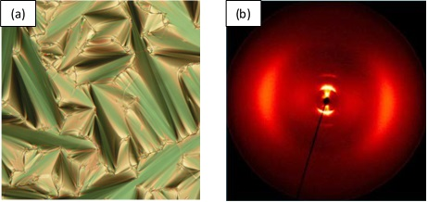Elongation of the terminal chains to C4 facilitates smectic organization. On cooling, from the nematic to smectic phase a fan-shaped texture developed (Fig.5a). The smectic mesophase exhibited by **BBC_9-4** was studied by X-ray scattering. Due to the direct N-Sm phase transition the smectic mesophase is well aligned by the external field (Fig.5b) The layer spacing was found to have values of 21.56 Å, 21.50 Å and 21.41 Å at temperatures of 130 °C, 125 °C, and 120°C respectively. Expressed as a d/l ratio the layer spacings remain the same, taking values of 0.51 at these temperatures. As shown in Figure 5b there is sharp Bragg scattering at small angles, which corresponds to the layer periodicity, whilst at wider angles the scattering is only diffuse (see Tables S3 and S4). This indicates that there is no long-range positional ordering within the layers, and thus restricts the Sm mesophase exhibited by **BBC_9-4** to being either SmA or SmC type. Given that the mesophase exhibits a schlieren texture with both 2- and 4- brush defects it is concluded that it is an anticlinic smectic C phase (SmCA).

Figure 5. a) A fan-shaped texture of the smectic phase of **BBC_9-4** at 131 °C. b) 2D XRD patterns for a sample of **BBC_9-4** aligned in the magnetic field obtained on cooling from the isotropic liquid at 125 °C.

It is broadly accepted that molecular curvature is essential for the formation of the twist-bend nematic phase and its stabilization has been predicted to increase with decreasing molecular bending angle.[33,34] Thermodynamic data listed in Table 1 and 2 show a small value of the isotropization entropies in accordance with their overall bent shape. However, the extent of molecular curvature can be affected not only by the linkage group but also by the parity of the terminal chains[47] and by the length of the spacer.[43] All the compounds of BBE series exhibit the NTB phase. This suggests that fluctuation in molecular curvature caused by the parity of the terminal chains or by the length of the spacer has little effect on the formation of the NTB phase. The highest value of TN-NTB (143 °C for **BBE_5-2** and 145 °C for **BBE_7-2**) and the widest temperature range (16 °C for **BBE_5-2** and 41 °C for **BBE_7-2**) were observed for the ethoxy terminated materials. From these results, it appears that stabilization of the NTB phase in the BBE series is mainly determined by geometry imposed by ethenyl linkage group which dictates the extent of bending and makes molecule inherently twisted.

Replacement of ethenyl by more polar carbonyl linkage group resulted in surprisingly similar clearing temperatures. Slightly higher isotropization entropies of the carbonyl dimers suggest their more pronounced molecular anisotropy. The similar differences were observed for methylene and ether-linked odd dimers.[24,48] It has been attributed to a change in the molecular geometry.[47,49] The odd-membered ether-linked dimer, being less bent, show higher isotropization entropies than that the corresponding methylene linked dimers. The presence of the NTB phase in methylene- but not in ether-linked dimers, was attributed to the more pronounced molecular bending[48,50] and intramolecular twist.[29]

Although considered planar, a limited number carbonyl-linked dimers unexpectedly exhibit the NTB phase. All ethoxy terminated dimers exhibit the NTB phase. Both, the Iso-N and N-NTB transition temperatures for three ethoxy terminated materials show very small variation suggesting similar gross molecular geometry. In addition to ethoxy terminated dimers, the monotropic NTB phase was observed for **BBC_7-3**. The TNTBN for **BBC_7-3** is significantly lower than those observed for ethoxy terminated materials resembling the trend reported for methylene linked phenyl-(4-alkoxybenzoate) dimers.[19]

In an attempt to explain these results, we examined how these two different linking groups might affect molecular curvature and overall shape of the dimeric molecule. Investigation of the conformational distribution of the achiral symmetric dimers in the nematic and NTB phases revealed high probability of all-*trans* conformation of the alkylene spacer.[51] Some recent studies demonstrated the wider conformational distribution of the alkyl spacer.[37,52–54] For comparative study, we chose compounds containing the same number of methylene units **BBE_7-4** and **BBC_7-4**. The contribution of conformational diversity of the alkylene spacer to molecular curvature and overall molecular shape is expected to be similar for both compounds. It is reasonable to assume that the main difference in mesomorphic properties of two series rises from different geometry imposed by the linking group. Thus, we focused our computational study on conformational space around the linkage group defined by a dihedral angle (τ) between the first methylene carbon in the spacer and corresponding functional group (Fig.6).

The *eclipsed* conformation defined by C1=C2-C3-C4 torsion angle τ of approximately 0° corresponds to the geometry in which the plane of the mesogenic unit is in the plane common to the carbon atoms in the spacer. The symmetry of ethenyl group provides for a conformational degeneracy in the molecule and gives rise to the skew conformation in which the torsional angle may adopt two distinct values of the same magnitude (±120°), but opposite sign. According to the energy content the *skew* conformation was found to be more stable than the *eclipsed* what is in accord with data reported for 1-butene.[41] The torsional scan of the carbonyl moiety resulted also in three minima characterized by the O1=C2-C3-C4 dihedral angle of approximately 0° and ±90° and can be attributed to *eclipsed* and *skew* conformations, respectively.

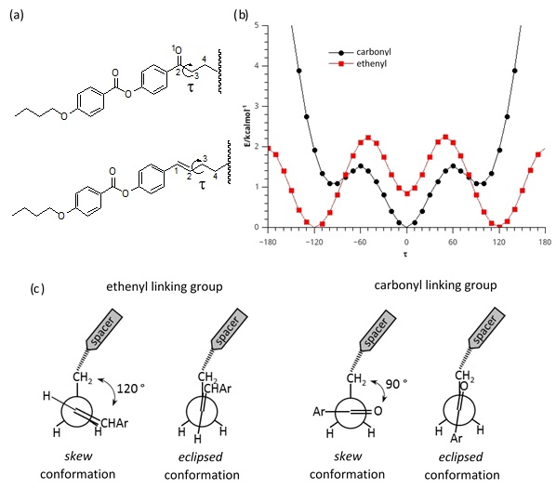

Figure 6. a) Definition of dihedral rotation (τ).b) Torsional energy profile for single ethenyl and carbonyl linking group. c) Newman projection structures of the corresponding stable conformations.

In contrast to ethenyl derivative, *eclipsed* conformation of carbonyl material represents the lowest energy conformational state. Rotation around C2-C3 bond resulted in energetically flat region between 90.0° and 100° which was found to be 1.1 kcal mol-1 higher in energy than the *eclipsed* geometry. The energy difference between the *eclipsed* and *skew* forms and the preference of the *eclipsed* conformation are in good agreement with computational results for 2-butanone.[41,42]

The effect of stable linking group conformations on molecular shape is examined on the conformer in which methylene units adopt the *anti* position. The most stable conformer of ethenyl dimer involves two *skew* forms which resulted in the mutual twisted arrangement of mesogenic cores (Fig.7a) and the overall shape can be described as bent-propeller. The small values of Δ*S*NI*/*R implicate high population of highly bent conformer what is accord with the geometry of the most stable conformer. In contrast to ethenyl, conformational states around carbonyl group led to the conformers of various shape, with the rather small difference in energy; the planar, the twisted hockey-stick, the bent-propeller and the hair-pin conformers (Fig.7b). It has been demonstrated that orientational order influences conformational probability, favouring more extended conformation despite energetic preference in the gaseous phase.[36,53] Among four identified conformations the largest inter-mesogen angle was estimated for the higher energy bent-propeller conformer. Comparison of the bent-propeller conformers of ethenyl and carbonyl dimers revealed smaller molecular curvature and greater intramolecular torsion for the later. The Vanakaras theory predicts second order phase transition from nematic to NTB phase for relatively small curvature and large torsion.[40] According to the peak shape observed for ethoxy carbonyl compounds the nematic to NTB transition is pseudo second-order what can be attributed to rather large intramolecular torsion. Unlike ethenyl materials which possess inherently twisted geometry and all of them exhibit the NTB phase, the intramolecular torsion is feasible only for carbonyl dimers with very short terminal chains. This is in agreement with the recently developed model proposed by Stevenson *et al*. the molecules adopt a high energy conformation in which the arms are less bent but twisted about the spacer axis.[12] Elongation of the terminal chains in carbonyl series disrupts reorientation of the promesogenic phenyl benzoate moiety promoting planar conformation and destabilizes the NTB phase.

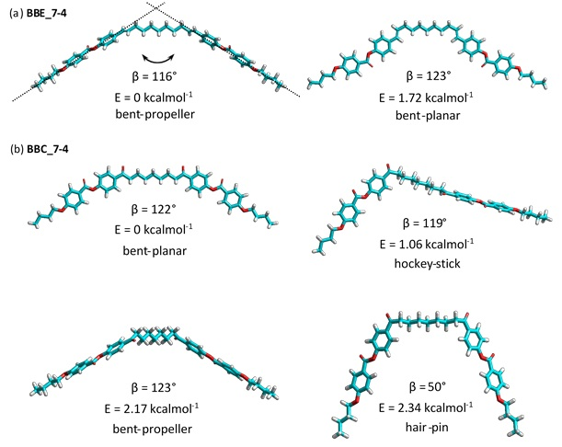

Figure 7. Geometries and selected geometry parameters at the DTF(B3LYP/6-31G) level for low energy conformers of a) **BBE_7-4**and b)**BBC_7-4** obtained by merging *skew* and *eclipsed* conformations of particular linking group.

**4. Conclusion**

In conclusion, two new families of symmetric carbonyl- and ethenyl-linked dimers were prepared in order to expand the knowledge on geometric aspects imposed by the linkage group influencing the stability of the NTB phase. Investigation of mesomorphic properties showed that all the members of ethenyl series and only the shortest homologues of the carbonyl-linked dimers exhibit the NTB phase. Computational study of conformational space around the linkage group revealed bent-propeller geometry for the most stable ethenyl and bent-planar for the most stable carbonyl conformer. The appearance of the NTB phase in the carbonyl materials with ethoxy chains is attributed to their ability to adopt higher energy bent-propeller conformation. This highlights a profound effect of intramolecular torsion but also that conformational diversity has to be included in the assessment of the geometric factors influencing formation of the NTB phase. Overall our studies demonstrate that intramolecular torsion in conjunction with molecular curvature plays essential role in stabilization of the NTB phase. Consequently, both can be regarded as the basic structural requirements for design of new twist-bend nematogen material.

**Acknowledgements**

The authors thank the Croatian Science Foundation [grant ref. IP-2014-09-1525] for financial support.

**Funding**

Croatian Science Foundation, grant ref. IP-2014-09-1525

**Supplemental data**

Supplemental data for this article can be accessed

**References**

[1] Imrie CT, Henderson PA. Liquid crystal dimers and higher oligomers: between monomers and polymers. Chem. Soc. Rev. 2007;36:2096.

[2] Dozov I. On the spontaneous symmetry breaking in the mesophases of achiral banana-shaped molecules. Europhys. Lett. EPL. 2001;56:247–253.

[3] Cestari M, Diez-Berart S, Dunmur DA, et al. Phase behavior and properties of the liquid-crystal dimer 1′′, 7′′-bis (4-cyanobiphenyl-4′-yl) heptane: A twist-bend nematic liquid crystal. Phys. Rev. E. 2011;84:031704.

[4] Beguin L, Emsley JW, Lelli M, et al. The Chirality of a Twist–Bend Nematic Phase Identified by NMR Spectroscopy. J. Phys. Chem. B. 2012;116:7940–7951.

[5] Emsley JW, Lesot P, Luckhurst GR, et al. Chiral solutes can seed the formation of enantiomorphic domains in a twist-bend nematic liquid crystal. Phys. Rev. E. 2013;87:040501.

[6] Greco C, Luckhurst GR, Ferrarini A. Enantiotopic discrimination and director organization in the twist-bend nematic phase. Phys. Chem. Chem. Phys. 2013;15:14961.

[7] Mandle RJ, Davis EJ, Archbold CT, et al. Microscopy studies of the nematic N TB phase of 1,11-di-(1′′-cyanobiphenyl-4-yl)undecane. J Mater Chem C. 2014;2:556–566.

[8] Meyer C, Luckhurst GR, Dozov I. Flexoelectrically driven electroclinic effect in the twist-bend nematic phase of achiral molecules with bent shapes. Phys. Rev. Lett. 2013;111:067801.

[9] Gorecka E, Salamonczyk M, Zep A, et al. Do the short helices exist in the nematic TB phase? Liq. Cryst. 2015;42:1–7.

[10] Cestari M, Frezza E, Ferrarini A, et al. Crucial role of molecular curvature for the bend elastic and flexoelectric properties of liquid crystals: mesogenic dimers as a case study. J. Mater. Chem. 2011;21:12303.

[11] Borshch V, Kim Y-K, Xiang J, et al. Nematic twist-bend phase with nanoscale modulation of molecular orientation. Nat. Commun. 2013;4:2635.

[12] Stevenson WD, Ahmed Z, Zeng XB, et al. Molecular organization in the twist–bend nematic phase by resonant X-ray scattering at the Se K-edge and by SAXS, WAXS and GIXRD. Phys. Chem. Chem. Phys. 2017;19:13449–13454.

[13] Zhu C, Tuchband MR, Young A, et al. Resonant Carbon $K$-Edge Soft X-Ray Scattering from Lattice-Free Heliconical Molecular Ordering: Soft Dilative Elasticity of the Twist-Bend Liquid Crystal Phase. Phys. Rev. Lett. 2016;116:147803.

[14] Mandle RJ. The dependency of twist-bend nematic liquid crystals on molecular structure: a progression from dimers to trimers, oligomers and polymers. Soft Matter. 2016;12:7883–7901.

[15] Wang Y, Singh G, Agra-Kooijman DM, et al. Room temperature heliconical twist-bend nematic liquid crystal. CrystEngComm. 2015;17:2778–2782.

[16] Mandle RJ, Goodby JW. Progression from nano to macro science in soft matter systems: dimers to trimers and oligomers in twist-bend liquid crystals. RSC Adv. 2016;6:34885–34893.

[17] Jansze SM, Martínez-Felipe A, Storey JMD, et al. A Twist-Bend Nematic Phase Driven by Hydrogen Bonding. Angew. Chem. Int. Ed. 2015;54:643–646.

[18] Chen D, Nakata M, Shao R, et al. Twist-bend heliconical chiral nematic liquid crystal phase of an achiral rigid bent-core mesogen. Phys. Rev. E. 2014;89:022506.

[19] Mandle RJ, Davis EJ, Archbold CT, et al. Apolar Bimesogens and the Incidence of the Twist–Bend Nematic Phase. Chem. Eur. J. 2015;21:8158–8167.

[20] Mandle RJ, Goodby JW. A twist-bend nematic to an intercalated, anticlinic, biaxial phase transition in liquid crystal bimesogens. Soft Matter. 2016;12:1436–1443.

[21] Mandle RJ, Goodby JW. Dependence of Mesomorphic Behaviour of Methylene-Linked Dimers and the Stability of the NTB/NX Phase upon Choice of Mesogenic Units and Terminal Chain Length. Chem. – Eur. J. 2016;22:9366–9374.

[22] Henderson PA, Imrie CT. Methylene-linked liquid crystal dimers and the twist-bend nematic phase. Liq. Cryst. 2011;38:1407–1414.

[23] Mandle RJ, Goodby JW. Does Topology Dictate the Incidence of the Twist-Bend Phase? Insights Gained from Novel Unsymmetrical Bimesogens. Chem. – Eur. J. 2016;22:18456–18464.

[24] Archbold CT, Andrews JL, Mandle RJ, et al. Effect of the linking unit on the twist-bend nematic phase in liquid crystal dimers: a comparative study of two homologous series of methylene- and ether-linked dimers. Liq. Cryst. 2017;44:84–92.

[25] Mandle RJ, Davis EJ, Lobato SA, et al. Synthesis and characterisation of an unsymmetrical, ether-linked, fluorinated bimesogen exhibiting a new polymorphism containing the NTB or ‘twist-bend’ phase. Phys. Chem. Chem. Phys. 2014;16:6907.

[26] Sebastián N, López DO, Robles-Hernández B, et al. Dielectric, calorimetric and mesophase properties of 1′′-(2′,4-difluorobiphenyl-4′-yloxy)-9′′-(4-cyanobiphenyl-4′-yloxy) nonane: an odd liquid crystal dimer with a monotropic mesophase having the characteristics of a twist-bend nematic phase. Phys Chem Chem Phys. 2014;16:21391–21406.

[27] López DO, Robles-Hernández B, Salud J, et al. Miscibility studies of two twist-bend nematic liquid crystal dimers with different average molecular curvatures. A comparison between experimental data and predictions of a Landau mean-field theory for the N TB –N phase transition. Phys Chem Chem Phys. 2016;18:4394–4404.

[28] Mandle RJ, Voll CCA, Lewis DJ, et al. Etheric bimesogens and the twist-bend nematic phase. Liq. Cryst. 2016;43:13–21.

[29] Ivšić T, Vinković M, Baumeister U, et al. Towards understanding the N TB phase: a combined experimental, computational and spectroscopic study. RSC Adv. 2016;6:5000–5007.

[30] Dawood AA, Grossel MC, Luckhurst GR, et al. On the twist-bend nematic phase formed directly from the isotropic phase. Liq. Cryst. 2016;43:2–12.

[31] Ivšić T, Baumeister U, Dokli I, et al. Sensitivity of the NTB phase formation to the molecular structure of imino-linked dimers. Liq. Cryst. 2017;44:93–105.

[32] Dawood AA, Grossel MC, Luckhurst GR, et al. Twist-bend nematics, liquid crystal dimers, structure–property relations. Liq. Cryst. 2017;44:106–126.

[33] Greco C, Luckhurst GR, Ferrarini A. Molecular geometry, twist-bend nematic phase and unconventional elasticity: a generalised Maier–Saupe theory. Soft Matter. 2014;10:9318–9323.

[34] Mandle RJ, Archbold CT, Sarju JP, et al. The Dependency of Nematic and Twist-bend Mesophase Formation on Bend Angle. Sci. Rep. 2016;6:36682.

[35] Paterson DA, Abberley JP, Harrison WT, et al. Cyanobiphenyl-based liquid crystal dimers and the twist-bend nematic phase. Liq. Cryst. 2017;44:127–146.

[36] Sebastián N, Robles-Hernández B, Diez-Berart S, et al. Distinctive dielectric properties of nematic liquid crystal dimers. Liq. Cryst. 2017;44:177–190.

[37] Ferrarini A. The twist-bend nematic phase: molecular insights from a generalised Maier–Saupe theory. Liq. Cryst. 2017;44:45–57.

[38] Goodby JW, Mandle RJ, Davis EJ, et al. What makes a liquid crystal? The effect of free volume on soft matter. Liq. Cryst. 2015;42:593–622.

[39] Abberley JP, Jansze SM, Walker R, et al. Structure–property relationships in twist-bend nematogens: the influence of terminal groups. Liq. Cryst. 2017;44:68–83.

[40] Vanakaras AG, Photinos DJ. A molecular theory of nematic–nematic phase transitions in mesogenic dimers. Soft Matter. 2016;12:2208–2220.

[41] Wiberg KB, Martin E. Barriers to rotation adjacent to double bonds. J. Am. Chem. Soc. 1985;107:5035–5041.

[42] Zhong H, Stewart EL, Kontoyianni M, et al. Ab Initio and DFT Conformational Studies of Propanal, 2-Butanone, and Analogous Imines and Enamines. J. Chem. Theory Comput. 2005;1:230–238.

[43] Luckhurst GR. Liquid crystals: a chemical physicist’s view. Liq. Cryst. 2005;32:1335–1364.

[44] M. J. Frisch. Gaussian 09 Citation | Gaussian.com [Internet]. [cited 2017 Jan 20]. Available from: http://gaussian.com/g09citation/.

[45] Šepelj M, Baumeister U, Ivšić T, et al. Effects of Geometry and Electronic Structure on the Molecular Self-Assembly of Naphthyl-Based Dimers. J. Phys. Chem. B. 2013;117:8918–8929.

[46] Šepelj M, Lesac A, Baumeister U, et al. Intercalated liquid-crystalline phases formed by symmetric dimers with an α,ω-diiminoalkylene spacer. J Mater Chem. 2007;17:1154–1165.

[47] Ferrarini A, Luckhurst GR, Nordio PL, et al. Understanding the dependence of the transitional properties of liquid crystal dimers on their molecular geometry. Liq. Cryst. 1996;21:373–382.

[48] Henderson PA, Seddon JM, Imrie CT. Methylene‐ and ether‐linked liquid crystal dimers II. Effects of mesogenic linking unit and terminal chain length. Liq. Cryst. 2005;32:1499–1513.

[49] Ferrarini A, Luckhurst GR, Nordio PL, et al. Understanding the unusual transitional behaviour of liquid crystal dimers. Chem. Phys. Lett. 1993;214:409–417.

[50] Panov VP, Nagaraj M, Vij JK, et al. Spontaneous periodic deformations in nonchiral planar-aligned bimesogens with a nematic-nematic transition and a negative elastic constant. Phys. Rev. Lett. 2010;105:167801.

[51] Emsley JW, Lelli M, Lesage A, et al. A Comparison of the Conformational Distributions of the Achiral Symmetric Liquid Crystal Dimer CB7CB in the Achiral Nematic and Chiral Twist-Bend Nematic Phases. J. Phys. Chem. B. 2013;117:6547–6557.

[52] Emsley JW, Lelli M, Luckhurst GR, et al. 13C NMR study of the director distribution adopted by the modulated nematic phases formed by liquid-crystal dimers with odd numbers of atoms in their spacers. Phys. Rev. E. 2017;96:062702.

[53] Paterson DA, Gao M, Kim Y-K, et al. Understanding the twist-bend nematic phase: the characterisation of 1-(4-cyanobiphenyl-4′-yloxy)-6-(4-cyanobiphenyl-4′-yl)hexane (CB6OCB) and comparison with CB7CB. Soft Matter. 2016;12:6827–6840.

[54] Imrie CT, Walker R, Pociecha D, et al. Spontaneous chirality through mixing achiral components: A twist-bend nematic phase driven by hydrogen-bonding between unlike components. Chem. Commun. [Internet]. 2018 [cited 2018 Mar 12]; Available from: http://pubs.rsc.org/en/content/articlelanding/2018/cc/c8cc00525g.