Designing Liquid-Crystalline Oligomers to Exhibit Twist-Bend Modulated Nematic Phases
Richard J. Mandle *
* richard.mandle@york.ac.uk, Department of Chemistry, University of York, York, UK

Abstract
Arguably the most active area in liquid crystal research presently, the twist-bend modulated nematic phase (TB) exhibits a nanoscale helical structure and therefore exhibits bulk chirality despite being formed of typically achiral materials. After a short introduction we address the structure-property relationship that exists for this unique mesophase before introducing recent advances in strategies employed to prepare oligomeric materials that exhibit this state of matter. These methods afford fine control over the molecular substructure and potentially over the nanostructure of the exhibited mesophases.

1.1 Introduction
The term liquid crystal (LC) refers to a group of phases of matter with some degree of positional or orientational order. In addition to being widely exploited in display devices, LC phases are also formed by DNA,¹⁻⁶ carbohydrates and lipids, ⁷⁻⁹ and peptides, ¹⁰⁻¹² as well as suspensions of viral ¹³⁻¹⁶ and inorganic particles. ¹⁷⁻¹⁹ The nematic LC phase possesses an average orientational order of its constituent molecules along a vector termed the director lacks positional order (Figure 1a). The addition of a chiral additive to a nematic LC leads to a chiral nematic (cholesteric, N*) phase in which the director rotates through space to give a periodic, helical structure (Figure 1b).

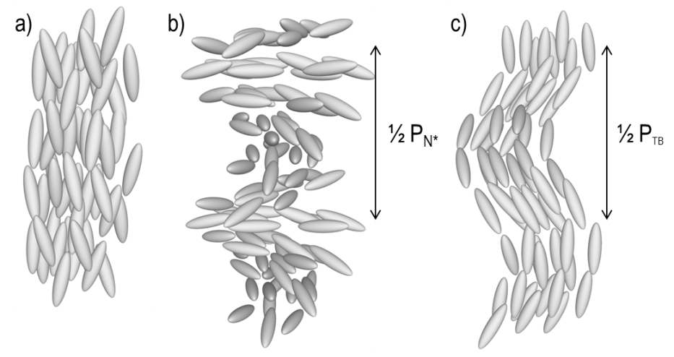
Figure 1: Cartoon depictions of the local structures and director arrangement in (a) the uniaxial nematic phase, (b) the chiral nematic (cholesteric, N*) phase, and (c) the helicoidal twist-bend (TB) phase. Note that the pitch depicted in (c) is much smaller than that of (b); the former being ~10 nm while the latter can be over 1 μm and even into the millimetre to meter range.

The twist-bend modulated nematic phase (TB, Figure 1c) was predicted by Dozov and is a type of nematic phase with a modulated structure. ²⁰ The TB phase possesses a short helical pitch and is therefore locally chiral, even when formed from achiral materials; this is therefore an example of spontaneous breaking of mirror symmetry in soft matter. The molecules are tilted away from the helix axis but lack positional ordering and thus the TB phase is ‘nematic’. ²⁰ Similarly, other nematic-like mesophases have been predicted to occur (splay-bend nematic (N_{SB}), ²¹⁻²² and screw nematic (N_{S}*) ²³⁻²⁴ as well as polar ‘nematic’ phases with transverse (N_{TP}) and longitudinal (N_{LP}) polarisation), ²⁵ while other nematic or nematic-like phases whose structure is presently unknown have also recently been reported. ²⁶⁻²⁸ In the twist-bend modulated phase the helical pitch length (P_{TB}) has been measured by freeze-fracture transmission electron microscopy, ²⁹⁻³¹ by resonant small angle X-ray scattering at the carbon ³² ³³ and selenium K-edges. ³⁴ All three methods give quantitative measurement of the pitch length, which is of the order of several nanometers. In situ ²H NMR spectroscopy conducted on samples doped with a suitable spin probe has also been interpreted as supporting the presence of a local helix with a nanoscale pitch (i.e. several molecular lengths), ³⁵ although other models have been used to interpret these results. ³⁶⁻³⁷ Order parameters for the twist-bend modulated nematic phase have been determined by ²H NMR, ³⁸ polarised Raman spectroscopy (PRS) ³⁹ and wide-angle X-ray scattering (WAXS), ⁴⁰ the values being of a similar magnitude to the nematic phase suggesting that the TB phase itself is structurally very similar to the nematic.
In terms of applications, the twist bend modulated nematic phase exhibits a fast electrooptic response. ⁴¹ Photopolymerisation of the TB phase ⁴² preserves the local nanohelical structure and potentially gives nanoscale materials which may find use in photonics. ⁴³⁻⁴⁶

2.1. Outline of Structure Property Relations
The twist-bend modulated nematic phase is commonly observed in liquid crystalline dimers, two rigid units joined with a flexible spacer. ⁴⁷⁻⁴⁹ The phase is exclusively observed for materials with odd- parity spacer; the resulting bent shape appears to be a prerequisite for TB phase formation. The optical textures of the twist-bend modulated nematic phase are somewhat reminiscent of smectic phases, ⁵⁰ it is unsurprising that many materials that were reported to exhibit lamellar phases of unknown structure (SmX) have subsequently been demonstrated to exhibit the TB phase, ^{38, 51} or are suspected of doing so. ⁵²⁻⁵⁴ LC dimers can be subdivided into several distinct units: terminal groups, mesogenic units, linking groups and the central spacer (Figure 2). For example, the CBnCB materials have nitrile terminal groups, biphenyl mesogenic units, methylene linking groups and alkyl spacers (structure shown in Figure 3), and were the first materials in which the TB phase was definitively identified. ⁵⁵

Figure 2: Generalised structure of an LC dimer, showing the different subdivisions used in this account and examples of the chemical composition of each

Our initial foray into work on the TB phase was to synthesise the CBnCB materials as shown in Figure 3, and at the time one of only a handful of materials known to exhibit the TB phase. ⁵⁵ The bis (4-hydroxyphenyl)alkanes can also be used to construct dimers containing ester groups such as the PCBnPCB compounds; given the large number of commercially available benzoic/carboxylic acids, we envisaged a large number of materials could be prepared, allowing the elucidation of a structure-property relationship. Initially we screened a number of polar terminal groups (CN, NO₂, F, CF₃, SF₅), ⁵⁶ followed by apolar terminal groups (H, H_{2n+1}C_{n}, H_{2n+1}C_{n}O) ⁵⁷ and mixed polar/apolar materials. ⁵⁸⁻⁵⁹ Materials with long (>C8) terminal chains have a tendency to exhibit tilted smectic C phases directly from the nematic phase, although a few examples of TB-SmC phase transitions exist. ^{57, 60-61} Replacing one phenyl ring with cyclohexyl usually leads to retention of the TB phase; however incorporation of a bicyclohexyl leads to smectic B phases. ⁶² Ahmed et al. demonstrated that a phenyl ring can be replaced with thiophene without loss of the twist-bend modulated nematic phase, ⁶³ similarly selenophene can be incorporated whilst retaining the TB phase, ⁵⁸ permitting measurement of P_{TB} by resonant X-ray at the Se K-edge. ³⁴

Figure 3: Synthesis of the ‘CBnCB’ materials via bis (4-hydroxyphenyl)alkanes, and the related PCBnPCB materials.

After much synthetic effort we concluded that the TB phase was not especially sensitive to the composition of the mesogenic units, ⁵⁶⁻⁵⁷ similar conclusions also being reached by others, ⁶⁴⁻⁶⁵ although the use of non-linear mesogenic groups such as cyclophanes can render the resulting materials non-mesogenic. ⁶⁶ We next considered the role of the linking groups and the spacer. Adlem et al. demonstrated the first material with ether-linking groups to exhibit the TB phase, ⁶⁷ albeit in a multicomponent mixture. Separately to this we had prepared a large number of fluorinated, ether-linked dimers, finding many of them to exhibit the twist-bend phase. ⁶⁸⁻⁷⁰ Many materials with imine linking groups have been reported to exhibit the twist-bend modulated nematic phase, ⁵³⁻⁵⁴ ^{61, 71-72} including materials that exhibit direct isotropic to TB phase transitions without an intervening nematic phase. ⁷³⁻⁷⁴ Most recently the role of torsion in the central spacer has been studied by Lesac et al. ⁷⁵

2.2. Dependency on Molecular Bend, Flexibility and Shape
Theoretical treatments had suggested the TB phase should display some dependency upon the gross molecular bend-angle. ⁷⁶ As an experimental study we synthesised several new materials with cyanobiphenyl mesogenic units, various linking groups and nonamethylene (or equivalent) spacers. ⁷⁷ The change in linking group leads to a change in bend-angle which we estimated from DFT calculations and 1D ¹H NOESY NMR. ⁷⁷ The use of a single conformer to describe flexible systems such as LC dimers is an obvious weakness; we later improved upon this earlier study by using large libraries of conformers for each material, allowing us to obtain Boltzmann weighted average bending angles as well as to quantify how broad the distribution of bend angles is for each material. ⁷⁸ This computational approach is in good, albeit not perfect, agreement with experimental conformational data obtained in situ in the twist-bend phase ⁷⁹ and that inferred from dielectric measurements. ⁸⁰ Results from our two studies strongly imply a link between the gross molecular bend angle and the incidence of the twist-bend phase. In particular bend angle in the region of 105-115 ° appears to confer a large increase in the TB transition temperature, as shown in Figure 4. Simply taking an average bend neglects molecular flexibility, a point that will be returned to shortly.

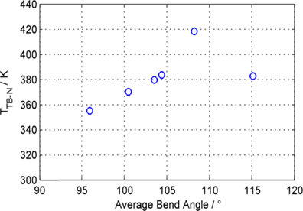
Figure 4: Plot of the TB-N transition temperature as a function of the average molecular bend angle as reported by Archbold et al ⁷⁸

We observed that for methylene-linked dimers the TB-N transition temperature (T_{TB-N}) and clearing point (T_{N-Iso}) exhibit a linear relationship. ^{58, 81} This linear relationship is obeyed the oligomeric materials ⁸² and polymers that exhibit twist-bend modulated nematic phases. ⁵¹ Similar relationships are found for materials with mixed ether/methylene linking groups, ⁸³ and unpublished results point to a similar relationship for other linking group combinations. The fact that the two transition temperatures are interdependent on one another, irrespective of the chemical makeup of the material, indicates that the TB phase is driven by steric factors, i.e. the gross molecular shape. This outcome was first described in a theory work by Greco et al. ⁷⁶ and later Vaupotic et al. proposed that “…the internal structure of the TB is driven mainly by steric interactions.” ⁸⁴ A plot of T_{TB-N} versus T_{N-Iso} for materials with nonamethylene and octamethyleneoxy spacers is given in Figure 5a. This plot includes materials with extremely polar terminal groups (NO₂, SF₅, CN), apolar terminal groups (H_{2n+1}C_{n}, H_{2n+1}C_{n}O), lateral groups (F, CH₃, OH), hydrogen bond donors/acceptors (CN, OH, COOH, NO₂); the lack of deviation from linearity - despite the range of functional groups included – is remarkable and as far as is known, not observed for any other combination of phase transitions. Different linking groups give near identical slopes, only the intercept values vary.

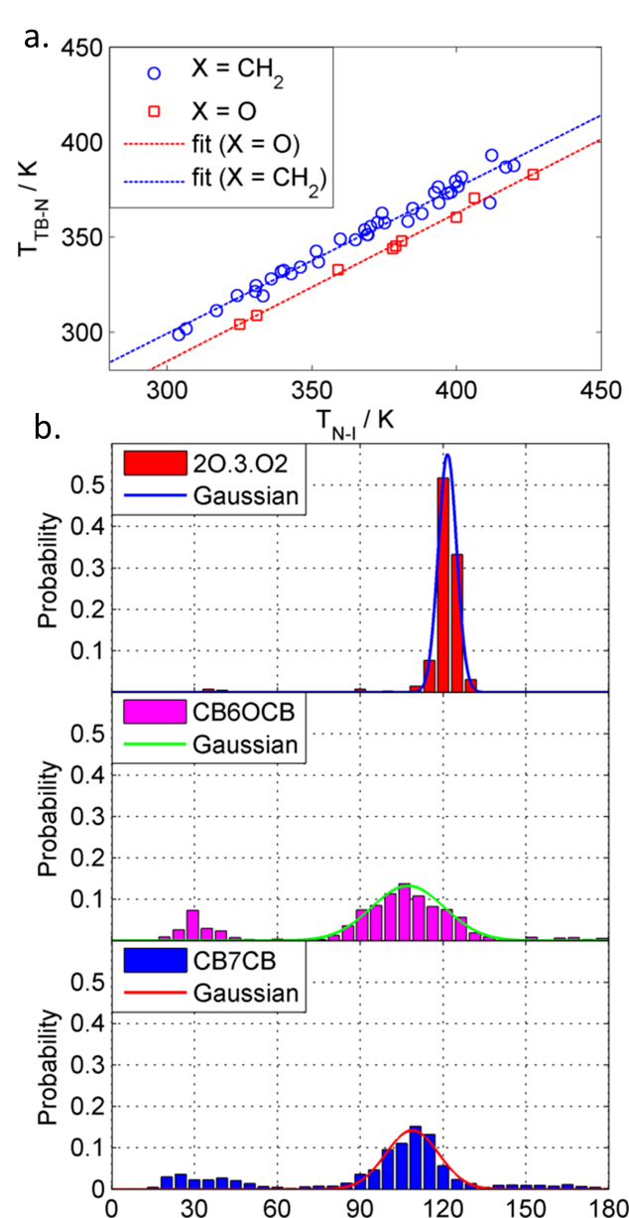
Figure 5: (a) Plot of T_{TB-N} / T_{N-Iso} (K) for dimers with two methylene linking groups (circles) and dimers with mixed ether/methylene linking units (squares). Linear fits take the form y = 0.766x + 69.67 for X = O and y = 0.7788x + 51.27 for X = -CH₂-. Data was taken from ref ^{81, 83} (b) Histogram plot of bend angle probabilities for the dimers 2O.3.O2, CB7CB and CB6OCB along with Gaussian fits (solid lines).

Recent results suggest that the TB phase is promoted by a narrow distribution of bend angles centred at ~ 110 °, when this is sufficiently tight direct isotropic to TB transitions can occur (i.e. the intercept of the linear fit is >1). In the case where the distribution is broadened, the intercept value reduces; swapping one methylene for an ether leads to a wider distribution and a lower intercept value (Figure 5b). ⁸³ The dimer 2O.3.O2 exhibits a direct TB to isotropic phase transition, and is therefore a suitable case study for this hypothesis. ⁷³⁻⁷⁴ Using the conformational analysis technique described by Archbold et al, ⁷⁸ a libraries of conformers for the dimers CB7CB, CB6OCB and 2O.3.O2 were constructed by allowing rotation about each dihedral of the spacer of both compounds using the AM1 semi empirical method as implemented in Gaussian G16. ⁸⁵ The Boltzmann weighted average bending angles are 119 ° for 2O.3.O2, 108 ° for CB6OCB and 107 ° for CB7CB. We determine the breadth of the bend-angle distribution by fitting a histogram plot of probability versus bend-angle with a Gaussian centred at the average bend angle; the FWHM for CB7CB is 21.7 °, for CB6OCB it is 32.7 ° and for 2O.3.O2 it is 11.1 °. These FWHM values correlate well with TB phase stability, and suggest this hypothesis has some validity. The incidence of the TB phase in bimesogens and dimers is therefore a product not only of the molecular bend, but also the flexibility and distribution of bend angles. It is unclear how flexibility and bend influence the pitch length (and other properties) of the TB phase as there is a real lack of experimental data for both pitch length and conformer distribution. It seems a reasonable hypothesis that the most flexible molecules would have the longest pitch, whereas those with a relatively tight distribution of bend-angles would have relatively short pitches. The pitch of CB7CB (7.8 Å) ³² is shorter than that of the more flexible CB6OCB (8.9 Å), ⁸⁶ and this is consistent with the presented hypothesis.

3. Beyond Dimers: n-mers and Polymeric Systems
If a dimer is composed on two mesogenic units then more broadly we can define liquid-crystalline n-mers are composed of n interconnected mesogenic units, e.g. n = 3 trimer, n = 4 tetramer and so on. The individual units need not be the same and the manner of linking need not be linear; the amount of chemical space occupied by such structures is incalculable. ⁴⁸ Whereas polymers typically have a degree of polydispersity, liquid crystalline n-mers are monodisperse by definition. The hydrogen-bonded trimer formed spontaneously by CB6OBA (Figure 6) was the first quasi n-mer reported to exhibit the TB phase. ⁸⁷ The analogous material with even spacer parity, CB5OBA, does not exhibit the twist-bend phase due to its linearity. ⁸⁷ Wang et al also reported the TB phase to be exhibited by a trimer containing a 2,5-disubstituted 1,3,4-oxadiazole. ⁸⁸

Figure 6: Transition temperatures (°C) of the hydrogen-bonded trimers (CB5OCB, linear) and (CB6OBA, bent). ⁸⁷

We considered that if the helical structure of the twist-bend phase is correct then this phase should be readily formed by n-mers as well as simple dimers/bimesogens as the phases formed by these two materials structurally differing materials are basically degenerate. During the synthesis of the dimer T2₉ small quantities of the monoesterified product were isolated; following optimisation of this reaction we could isolate multigram quantities and we used these to prepare the trimer (T3₉) and the tetramer (T4₉) as shown in Figure 7. ^{59, 89}
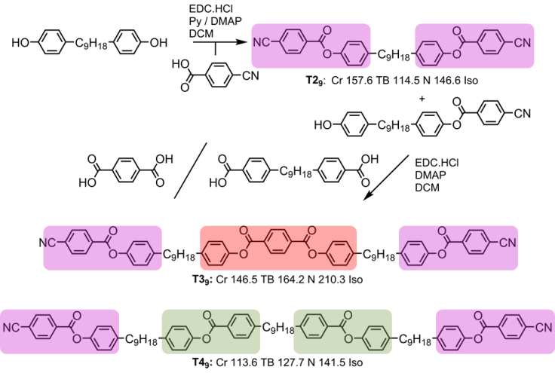
Figure 7: Chemical synthesis of the dimer T2₉, ⁵⁶ the trimer T3₉, ⁵⁹ and the tetramer T4₉. ⁸⁹ Transition temperatures are given in °C

While T3₉ and T4₉ demonstrated conclusively that the TB phase could be observed systems beyond simple dimers, the synthetic route to these materials is not well suited to the preparation of higher n-mers. We devised the ‘N+1’ synthetic strategy to overcome this; this is loosely defined as a synthesis of a liquid crystal incorporating n number mesogenic units which are installed sequentially, giving a high degree of control over the molecular sub structure. In principle this allows the synthesis of perfectly monodisperse materials incorporating any number of similar/dissimilar mesogenic units (Figure 8a). This concept was applied in the synthesis of the second generation of n-mers designed to exhibit the TB phase. We devised a chemical intermediate containing two ‘half’ mesogenic units, one bearing a phenol and the other a protected carboxylic acid; this allows complete mesogenic units to be formed by successive esterification/deprotection, in principle allowing any number of mesogenic units to be incorporated. This method was used to afford the tetramer O4₇ and the hexamer O6₇, ⁸² with both materials found exhibit nematic and TB phases. Comparing the transition temperatures of the tetramer and hexamer to the analogous dimer (O2₇) we find the linear relationship described in Figure 5a is obeyed. Molecular structures and transition temperatures are given in Figure 8b.
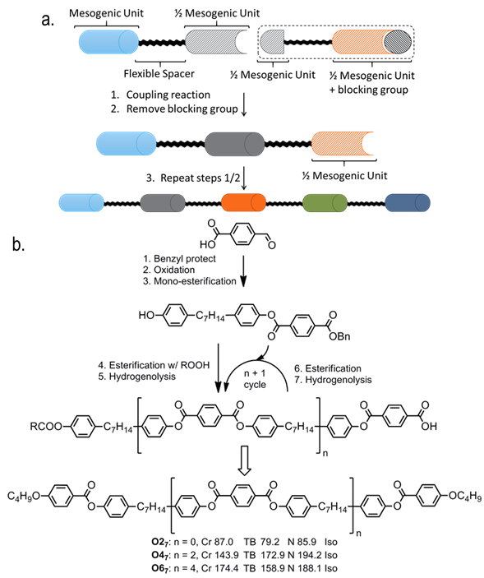
Figure 8: (a) conceptual route to n-mers via stepwise insertion of mesogenic units, the ‘N+1’ approach; (b) a truncated synthesis of O2₇, O4₇ and O6₇, transition temperatures are given in °C.

The synthetic route employed to synthesise the On₇ materials is poorly suited to higher generation n-mers due to low yields resulting from transesterification and the resulting difficulties in chromatographic separation of the desired material from reaction side products. Replacement of the phenyl benzoate mesogenic units present in the Tn₉ and On₇ n-mers with biphenyls should improve chemical stability, whilst substituting one methylene linking group with an ether group simplifies the preparation of these materials. The ‘N+1’ in this synthetic approach is a two-step deprotection/etherification, allowing each mesogenic unit to be installed in turn. As shown in Figure 9 the target of this synthetic approach is the A6_{n} materials, where n is the number of mesogenic units in the n-mer, these being homologous in structure to the well-known dimer CB6OCB. ⁸⁶The key intermediate in this approach is derived from 1-bromo-4-iodobenzene in 3 steps and incorporates a free phenol and a benzyl protected primary alcohol; the ‘n+1’ cycle in these materials encompasses etherification via the Mitsunobu protocol followed by hydrogenolysis of the benzyl ether to afford a free alcohol. ⁹⁰ Unfortunately despite screening a range of different catalysts and poisons we were unable to affect hydrogenolysis of the benzyl group without accompanying nitrile reduction, although we were able to obtain quantitative reduction of the alkyne without reduction of the nitrile using palladium on carbon poisoned with diaminoethane (Figure 9). ⁹⁰⁻⁹¹ Nevertheless, the obtained material exhibits the twist-bend phase despite possessing a terminal benzyl ether (Cr 93.1 TB 48.3 N 67.1 Iso). ⁹⁰
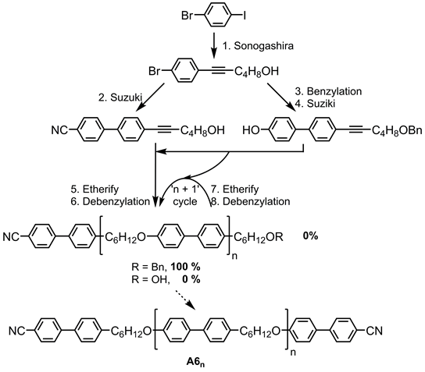
Figure 9: Attempted synthesis of the A6_{n} materials. ⁹⁰

As workaround to the problem of debenzylation in the presence of a nitrile we replaced the benzyl ether protecting group with tert butyldimethylsilyl ether (TBDMSO), which is cleavable using tetrabutylammoniumfluoride (TBAF). This enabled us to synthesise the two isomeric trimesogens A6₃ and B6₃ as a proof of concept to this approach. The trimer A6₃ exhibits the TB phase whilst its isomer B6₃ displays a phase of matter that we could not be definitively identified as being the TB. ⁹² In a later paper, Tuchband et al reported resonant X-ray studies on this material and find it has a nanoscale periodicity of 66 Å which, unlike normal TB materials, is temperature invariant. ⁹³ The synthetic route devised for the preparation of A6₃ and B6₃ can also afford higher n-mers such as A6₄, demonstrating the power of our synthetic approach shown in Figure 10a. Replacing one of the nitriles of A6₃ with a hexyloxy chain (6OA6₃, Figure 10b) prevents the resulting material from exhibiting the TB phase, instead forming a highly ordered smectic phase of unknown structure. ⁹⁰
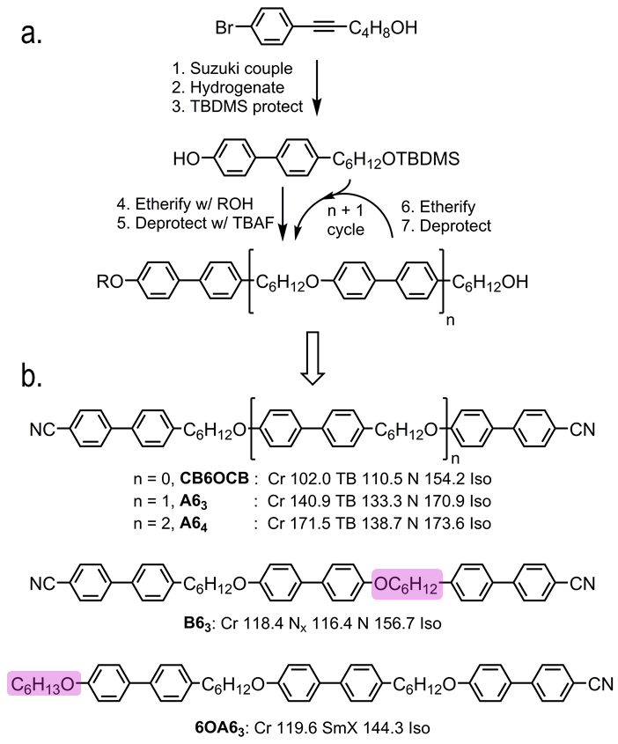
Figure 10: (a) Truncated synthetic route incorporating an ‘N+1’ cycle used in the synthesis of the A6_{n} n-mers; (b) molecular structure and transition temperatures (°C) of the dimer CB6OCB, ⁸⁶ the trimer A6₃, ⁹² the tetramer A6₄, the trimer B6₃ ⁹² and the trimer 6OA6₃. ⁹⁰ For B6₃ and 6OA6₃ the structural differences with A6₃ are highlighted.

A previously unreported trimer from the York group, C6/8₃, can be considered homologous in structure to A6₃ except with an alkyne inserted into one methylene spacer. This structural modification has minimal impact on transition temperatures (A6₃: Cr 140.9 TB 133.3 N 170.9 Iso), and this result can be taken to support the idea of the TB phase being a shape driven phase. However, materials such 6OA₆ suggest that the formation of the TB modulated phase in n-mers exhibits sensitivity to molecular structure that is not observed for simple dimers/bimesogens. The increased molecular complexity of n-mers over dimers necessitates longer synthetic routes; therefore the delineation of a structure property relationship for n-mers exhibiting the twist-bend phase poses a greater difficulty than for dimers, which are trivial to synthesise by comparison. The fine control over molecular substructure afforded by using the ‘n+1’ cycle allows oligomers of any length, any composition and any repeating sequence of mesogenic units to be constructed, simplifying the synthesis of higher oligomers.

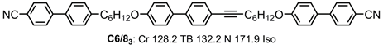
Figure 11: The molecular structure and transition temperatures (°C) of the trimer C6/8₃. Synthesis and characterisation details are given in the SI.
Summary and Outlook
When our studies on structure-property relationships began only 7 materials were known to exhibit the TB phase; at the time of writing this is figure now over 250. The understanding of the molecular factors that influence the occurrence of this phase is not quite complete; however present results imply that the molecular shape (gross bend angle, flexibility) dictates this phase of matter and not any particular combination of functional groups. The number of structures that satisfy the shape requirements, and therefore might be considered possible candidates for exhibiting the TB phase, is probably inestimable.
Oligomeric materials that exhibit the TB phase are the next frontier in this area. Already there is some evidence to suggest that the structure-property relationships in these systems are more complex than in dimers. Our ‘N+1’ concept, in which individual mesogenic units are installed in turn, allows the synthesis of large materials (the hexamer O6₇) as well as unsymmetrical materials (the trimers A6₃, 6OA6₃, and C6/8₃). The observation of TB phases in polymer systems ⁵¹ and – potentially - lyotropic suspensions of micron sized particles ⁹⁴ - indicate this phase of matter is not confined to any one length scale, and it is probable that higher oligomers (decamers, dodecamers etc.) will be found to exhibit the TB phase. Provided the bend and flexibility requirements are satisfied, it may be possible to incorporate branched sections, either Y-shaped or λ-shaped, into an n-mer whilst retaining the heliconical TB phase. Tuchband et al recently expanded on the earlier idea of Goodby et al, ⁵⁷ suggesting that the structure of the TB phase is a more complex than a single helix, instead having a duplex double-helical chain; ⁹⁵ it is possible to envisage therefore that two n-mers, laterally appended to give an elongated ‘H’ shaped or ‘X’ shaped material, as candidates for exhibiting this unusual state of matter.

Acknowledgements
I thank Professor John Goodby FRS for mentorship, encouragement to write of this personal account and for innumerable discussions concerning the TB phase. I also thank former students Dr. Craig Archbold, Constantin Voll, Sam Lobato, Philip Foeller, Jessica Andrews, Frank Simpson, Matthew Stevens, Adam Al-Janabi, Megan Havers and Emily Pocock for their work on dimers, oligomers and n-mers and polymers, and I thank the University of York for funding some these projects. Lastly I thank the EPSRC for funding the small angle X-ray scattering equipment that has been employed much of this work via grant code EP/K039660/1.

Biographical Sketch
Richard J. Mandle is currently a postdoctoral researcher in the Department of Chemistry at the University of York, UK. He completed BSc (2007) and MSc degrees (2008) in Chemistry at the University of Hull UK, before completing a PhD (2012) in Chemistry at the University of York under the supervision of Professor John W. Goodby FRS. Some of Dr. Mandle’s current research interests include liquid crystal and OLED materials for optoelectronic devices, soft matter, mesophases with modulated structure, as well as novel dyes and dye-doped liquid crystals. To date he has published over 50 peer reviewed works, and was the winner of the 2017 BLCS Young Scientist Award.

TOC Entry
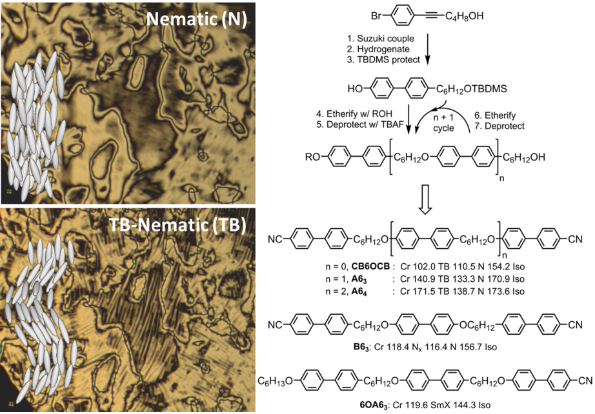
Arguably the most active area in liquid crystal research presently, the twist-bend modulated nematic phase (TB) exhibits a nanoscale helical structure and therefore exhibits bulk chirality despite being formed of typically achiral materials. Recent advances and developments in strategies employed to prepare oligomeric materials that exhibit this state of matter afford fine control over the molecular substructure and potentially over the nanostructure of the exhibited mesophases.

References
1. Neville, A. C.; Luke, B. M., Biological System Producing a Self-Assembling Cholesteric Protein Liquid Crystal. J Cell Sci 1971, 8 (1), 93-&.
2. Yevdokimov, Y. M.; Skuridin, S. G.; Salyanov, V. I., The Liquid-Crystalline Phases of Double-Stranded Nucleic-Acids Invitro and Invivo. Liq Cryst 1988, 3 (11), 1443-1459.
3. Livolant, F.; Levelut, A. M.; Doucet, J.; Benoit, J. P., The Highly Concentrated Liquid-Crystalline Phase of DNA Is Columnar Hexagonal. Nature 1989, 339 (6227), 724-726.
4. Booy, F. P.; Newcomb, W. W.; Trus, B. L.; Brown, J. C.; Baker, T. S.; Steven, A. C., Liquid-Crystalline, Phage-Like Packing of Encapsidated DNA in Herpes-Simplex Virus. Cell 1991, 64 (5), 1007-1015.
5. Reich, Z.; Wachtel, E. J.; Minsky, A., Liquid-Crystalline Mesophases of Plasmid DNA in Bacteria. Science 1994, 264 (5164), 1460-1463.
6. Mangenot, S.; Leforestier, A.; Durand, D.; Livolant, F., Phase diagram of nucleosome core particles. J Mol Biol 2003, 333 (5), 907-916.
7. Bault, P.; Gode, P.; Goethals, G.; Goodby, J. W.; Haley, J. A.; Kelly, S. M.; Mehl, G. H.; Ronco, G.; Villa, P., Liquid crystalline derivatives of galactose and galactitol: dependence of thermotropic mesomorphism on carbohydrate form. Liq Cryst 1998, 25 (1), 31-45.
8. Goodby, J. W., Liquid-crystalline glycolipids: towards understanding the roles of liquid crystals in biological and life processes. Liq Cryst 2006, 33 (11-12), 1229-1237.
9. Xu, R.; Ali-Rachedi, F.; Xavier, N. M.; Chambert, S.; Ferkous, F.; Queneau, Y.; Cowling, S. J.; Davis, E. J.; Goodby, J. W., Self-organizing behaviour of glycosteroidal bolaphiles: insights into lipidic microsegregation. Org Biomol Chem 2015, 13 (3), 783-792.
10. Watanabe, J.; Fukuda, Y.; Gehani, R.; Uematsu, I., Thermotropic Polypeptides .1. Investigation of Cholesteric Mesophase Properties of Poly(Gamma-Methyl D-Glutamate-Co-Gamma-Hexyl D-Glutamate)S. Macromolecules 1984, 17 (5), 1004-1009.
11. Watanabe, J.; Ono, H.; Uematsu, I.; Abe, A., Thermotropic Polypeptides .2. Molecular Packing and Thermotropic Behavior of Poly(L-Glutamates) with Long Normal-Alkyl Side-Chains. Macromolecules 1985, 18 (11), 2141-2148.
12. Iizuka, E.; Inoue, S.; Hanabusa, K.; Shirai, H., Interaction between Thermotropic Liquid-Crystalline Polypeptides Having Long Alkyl Side-Chains and Normal-Alkanes. Mol Cryst Liq Cryst 1987, 149, 61-77.
13. Fraden, S.; Maret, G.; Caspar, D. L. D.; Meyer, R. B., Isotropic-Nematic Phase-Transition and Angular-Correlations in Isotropic Suspensions of Tobacco Mosaic-Virus. Phys Rev Lett 1989, 63 (19), 2068-2071.
14. Fraden, S.; Maret, G.; Caspar, D. L. D., Angular-Correlations and the Isotropic-Nematic Phase-Transition in Suspensions of Tobacco Mosaic-Virus. Phys Rev E 1993, 48 (4), 2816-2837.
15. Zhou, S.; Sokolov, A.; Lavrentovich, O. D.; Aranson, I. S., Living liquid crystals. P Natl Acad Sci USA 2014, 111 (4), 1265-1270.
16. Barry, E.; Hensel, Z.; Dogic, Z.; Shribak, M.; Oldenbourg, R., Entropy-driven formation of a chiral liquid-crystalline phase of helical filaments. Phys Rev Lett 2006, 96 (1), 018305.
17. Paineau, E.; Philippe, A. M.; Antonova, K.; Bihannic, I.; Davidson, P.; Dozov, I.; Gabriel, J. C. P.; Imperor-Clerc, M.; Levitz, P.; Meneau, F.; Michot, L. J., Liquid-crystalline properties of aqueous suspensions of natural clay nanosheets. Liq Cryst Rev 2013, 1 (2), 110-126.
18. Paineau, E.; Antonova, K.; Baravian, C.; Bihannic, I.; Davidson, P.; Dozov, I.; Imperor-Clerc, M.; Levitz, P.; Madsen, A.; Meneau, F.; Michot, L. J., Liquid-Crystalline Nematic Phase in Aqueous Suspensions of a Disk-Shaped Natural Beidellite Clay. J Phys Chem B 2009, 113 (48), 15858-15869.
19. Michot, L. J.; Bihannic, I.; Maddi, S.; Funari, S. S.; Baravian, C.; Levitz, P.; Davidson, P., Liquid-crystalline aqueous clay suspensions. P Natl Acad Sci USA 2006, 103 (44), 16101-16104.
20. Dozov, I., On the spontaneous symmetry breaking in the mesophases of achiral banana-shaped molecules. Europhys Lett 2001, 56 (2), 247-253.
21. Shamid, S. M.; Allender, D. W.; Selinger, J. V., Theory of Polar Blue Phases. ArXiv e-prints 2014, 1405.
22. Trojanowski, K.; Cieśla, M.; Longa, L., Modulated nematic structures and chiral symmetry breaking in 2D. Liq Cryst 2016, 1-11.
23. Kolli, H. B.; Frezza, E.; Cinacchi, G.; Ferrarini, A.; Giacometti, A.; Hudson, T. S.; De Michele, C.; Sciortino, F., Self-assembly of hard helices: a rich and unconventional polymorphism. Soft Matter 2014, 10 (41), 8171-8187.
24. Kolli, H. B.; Frezza, E.; Cinacchi, G.; Ferrarini, A.; Giacometti, A.; Hudson, T. S., Communication: From rods to helices: Evidence of a screw-like nematic phase. J Chem Phys 2014, 140 (8).
25. Longa, L.; Pajak, G., Modulated nematic structures induced by chirality and steric polarization. Phys Rev E 2016, 93 (4).
26. Mandle, R. J.; Cowling, S. J.; Goodby, J. W., Rational Design of Rod-Like Liquid Crystals Exhibiting Two Nematic Phases. Chem-Eur J 2017, 23 (58), 14554-14562.
27. Mandle, R. J.; Cowling, S. J.; Goodby, J. W., A nematic to nematic transformation exhibited by a rod-like liquid crystal. Phys Chem Chem Phys 2017, 19 (18), 11429-11435.
28. Archbold, C. T.; Davis, E. J.; Mandle, R. J.; Cowling, S. J.; Goodby, J. W., Chiral dopants and the twist-bend nematic phase--induction of novel mesomorphic behaviour in an apolar bimesogen. Soft Matter 2015, 11 (38), 7547-7557.
29. Chen, D.; Porada, J. H.; Hooper, J. B.; Klittnick, A.; Shen, Y.; Tuchband, M. R.; Korblova, E.; Bedrov, D.; Walba, D. M.; Glaser, M. A.; Maclennan, J. E.; Clark, N. A., Chiral heliconical ground state of nanoscale pitch in a nematic liquid crystal of achiral molecular dimers. Proc Natl Acad Sci U S A 2013, 110 (40), 15931-15936.
30. Borshch, V.; Kim, Y. K.; Xiang, J.; Gao, M.; Jakli, A.; Panov, V. P.; Vij, J. K.; Imrie, C. T.; Tamba, M. G.; Mehl, G. H.; Lavrentovich, O. D., Nematic twist-bend phase with nanoscale modulation of molecular orientation. Nat Commun 2013, 4, 2635.
31. Chen, D.; Nakata, M.; Shao, R.; Tuchband, M. R.; Shuai, M.; Baumeister, U.; Weissflog, W.; Walba, D. M.; Glaser, M. A.; Maclennan, J. E.; Clark, N. A., Twist-bend heliconical chiral nematic liquid crystal phase of an achiral rigid bent-core mesogen. Phys Rev E Stat Nonlin Soft Matter Phys 2014, 89 (2), 022506.
32. Zhu, C. H.; Tuchband, M. R.; Young, A.; Shuai, M.; Scarbrough, A.; Walba, D. M.; Maclennan, J. E.; Wang, C.; Hexemer, A.; Clark, N. A., Resonant Carbon K-Edge Soft X-Ray Scattering from Lattice-Free Heliconical Molecular Ordering: Soft Dilative Elasticity of the Twist-Bend Liquid Crystal Phase. Phys Rev Lett 2016, 116 (14).
33. Salamonczyk, M.; Vaupotic, N.; Pociecha, D.; Wang, C.; Zhu, C. H.; Gorecka, E., Structure of nanoscale-pitch helical phases: blue phase and twist-bend nematic phase resolved by resonant soft X-ray scattering. Soft Matter 2017, 13 (38), 6694-6699.
34. Stevenson, W. D.; Ahmed, Z.; Zeng, X. B.; Welch, C.; Ungar, G.; Mehl, G. H., Molecular organization in the twist-bend nematic phase by resonant X-ray scattering at the Se K-edge and by SAXS,WAXS and GIXRD. Phys Chem Chem Phys 2017, 19 (21), 13449-13454.
35. Beguin, L.; Emsley, J. W.; Lelli, M.; Lesage, A.; Luckhurst, G. R.; Timimi, B. A.; Zimmermann, H., The Chirality of a Twist-Bend Nematic Phase Identified by NMR Spectroscopy (vol 116, pg 7940, 2012). J Phys Chem B 2012, 116 (34), 10407-10407.
36. Gorecka, E.; Salamonczyk, M.; Zep, A.; Pociecha, D.; Welch, C.; Ahmed, Z.; Mehl, G. H., Do the short helices exist in the nematic TB phase? Liq Cryst 2015, 42 (1), 1-7.
37. Hoffmann, A.; Vanakaras, A. G.; Kohlmeier, A.; Mehl, G. H.; Photinos, D. J., On the structure of the Nx phase of symmetric dimers: inferences from NMR. Soft Matter 2015, 11 (5), 850-855.
38. Barnes, P. J.; Douglass, A. G.; Heeks, S. K.; Luckhurst, G. R., An Enhanced Odd Even Effect of Liquid-Crystal Dimers Orientational Order in the Alpha,Omega-Bis(4'-Cyanobiphenyl-4-Yl)Alkanes. Liq Cryst 1993, 13 (4), 603-613.
39. Zhang, Z. P.; Panov, V. P.; Nagaraj, M.; Mandle, R. J.; Goodby, J. W.; Luckhurst, G. R.; Jones, J. C.; Gleeson, H. F., Raman scattering studies of order parameters in liquid crystalline dimers exhibiting the nematic and twist-bend nematic phases. J Mater Chem C 2015, 3 (38), 10007-10016.
40. Singh, G.; Fu, J. X.; Agra-Kooijman, D. M.; Song, J. K.; Vengatesan, M. R.; Srinivasarao, M.; Fisch, M. R.; Kumar, S., X-ray and Raman scattering study of orientational order in nematic and heliconical nematic liquid crystals. Phys Rev E 2016, 92 (6).
41. Panov, V. P.; Balachandran, R.; Nagaraj, M.; Vij, J. K.; Tamba, M. G.; Kohlmeier, A.; Mehl, G. H., Microsecond linear optical response in the unusual nematic phase of achiral bimesogens. Appl Phys Lett 2011, 99 (26), 261903.
42. Panov, V. P.; Sreenilayam, S. P.; Panarin, Y. P.; Vij, J. K.; Welch, C. J.; Mehl, G. H., Characterization of the Submicrometer Hierarchy Levels in the Twist-Bend Nematic Phase with Nanometric Helices via Photopolymerization. Explanation for the Sign Reversal in the Polar Response. Nano Lett 2017, 17 (12), 7515-7519.
43. Xiang, J.; Li, Y.; Li, Q.; Paterson, D. A.; Storey, J. M. D.; Imrie, C. T.; Lavrentovich, O. D., Electrically Tunable Selective Reflection of Light from Ultraviolet to Visible and Infrared by Heliconical Cholesterics. Adv Mater 2015, 27 (19), 3014-3018.
44. Wang, Y.; Zheng, Z.-g.; Bisoyi, H. K.; Gutierrez-Cuevas, K. G.; Wang, L.; Zola, R. S.; Li, Q., Thermally reversible full color selective reflection in a self-organized helical superstructure enabled by a bent-core oligomesogen exhibiting a twist-bend nematic phase. Materials Horizons 2016, 3 (5), 442-446.
45. Bisoyi, H. K.; Li, Q., Light-Directing Chiral Liquid Crystal Nanostructures: From 1D to 3D. Accounts of Chemical Research 2014, 47 (10), 3184-3195.
46. Wang, L.; Li, Q., Stimuli-Directing Self-Organized 3D Liquid-Crystalline Nanostructures: From Materials Design to Photonic Applications. Adv Funct Mater 2016, 26 (1), 10-28.
47. Henderson, P. A.; Imrie, C. T., Methylene-linked liquid crystal dimers and the twist-bend nematic phase. Liq Cryst 2011, 38 (11-12), 1407-1414.
48. Imrie, C. T.; Henderson, P. A., Liquid crystal dimers and higher oligomers: Between monomers and polymers. Chem Soc Rev 2007, 36 (12), 2096-2124.
49. Attard, G. S.; Date, R. W.; Imrie, C. T.; Luckhurst, G. R.; Roskilly, S. J.; Seddon, J. M.; Taylor, L., Non-symmetric dimeric liquid crystals - The preparation and properties of the alpha-(4-cyanobiphenyl-4 '-yloxy)-omega-(4-n-alkylanilinebenzylidene-4 '-oxy) alkanes. Liq Cryst 2006, 33 (11-12), 1455-1485.
50. Mandle, R. J.; Davis, E. J.; Archbold, C. T.; Cowling, S. J.; Goodby, J. W., Microscopy studies of the nematic NTBphase of 1,11-di-(1′′-cyanobiphenyl-4-yl)undecane. J. Mater. Chem. C 2014, 2 (3), 556-566.
51. Ungar, G.; Percec, V.; Zuber, M., Liquid crystalline polyethers based on conformational isomerism. 20. Nematic-nematic transition in polyethers and copolyethers based on 1-(4-hydroxyphenyl)2-(2-R-4-hydroxyphenyl)ethane with R = fluoro, chloro and methyl and flexible spacers containing an odd number of methylene units. Macromolecules 1992, 25 (1), 75-80.
52. Henderson, P. A.; Niemeyer, O.; Imrie, C. T., Methylene-linked liquid crystal dimers. Liq Cryst 2001, 28 (3), 463-472.
53. Sepelj, M.; Lesac, A.; Baumeister, U.; Diele, S.; Nguyen, H. L.; Bruce, D. W., Intercalated liquid-crystalline phases formed by symmetric dimers with an alpha,omega-diiminoalkylene spacer. J Mater Chem 2007, 17 (12), 1154-1165.
54. Sepelj, M.; Lesac, A.; Baumeister, U.; Diele, S.; Bruce, D. W.; Hamersak, Z., Dimeric salicylaldimine-based mesogens with flexible spacers: Parity-dependent mesomorphism. Chem Mater 2006, 18 (8), 2050-2058.
55. Cestari, M.; Diez-Berart, S.; Dunmur, D. A.; Ferrarini, A.; de la Fuente, M. R.; Jackson, D. J.; Lopez, D. O.; Luckhurst, G. R.; Perez-Jubindo, M. A.; Richardson, R. M.; Salud, J.; Timimi, B. A.; Zimmermann, H., Phase behavior and properties of the liquid-crystal dimer 1'',7''-bis(4-cyanobiphenyl-4'-yl) heptane: a twist-bend nematic liquid crystal. Phys Rev E Stat Nonlin Soft Matter Phys 2011, 84 (3 Pt 1), 031704.
56. Mandle, R. J.; Davis, E. J.; Voll, C. C. A.; Archbold, C. T.; Goodby, J. W.; Cowling, S. J., The relationship between molecular structure and the incidence of the N-TB phase. Liq Cryst 2015, 42 (5-6), 688-703.
57. Mandle, R. J.; Davis, E. J.; Archbold, C. T.; Voll, C. C.; Andrews, J. L.; Cowling, S. J.; Goodby, J. W., Apolar bimesogens and the incidence of the twist-bend nematic phase. Chem. Eur. J 2015, 21 (22), 8158-8167.
58. Mandle, R. J.; Goodby, J. W., Does Topology Dictate the Incidence of the Twist-Bend Phase? Insights Gained from Novel Unsymmetrical Bimesogens. Chemistry 2016, 22 (51), 18456-18464.
59. Mandle, R. J.; Goodby, J. W., Progression from nano to macro science in soft matter systems: dimers to trimers and oligomers in twist-bend liquid crystals. Rsc Adv 2016, 6 (41), 34885-34893.
60. Mandle, R. J.; Goodby, J. W., A twist-bend nematic to an intercalated, anticlinic, biaxial phase transition in liquid crystal bimesogens. Soft Matter 2016, 12 (5), 1436-1443.
61. Ivšić, T.; Baumeister, U.; Dokli, I.; Mikleušević, A.; Lesac, A., Sensitivity of the NTB phase formation to the molecular structure of imino-linked dimers. Liq Cryst 2017, 44 (1), 93-105.
62. Mandle, R. J.; Goodby, J. W., Dependence of Mesomorphic Behaviour of Methylene-Linked Dimers and the Stability of the NTB /NX Phase upon Choice of Mesogenic Units and Terminal Chain Length. Chemistry 2016, 22 (27), 9366-9374.
63. Ahmed, Z.; Welch, C.; Mehl, G. H., The design and investigation of the self-assembly of dimers with two nematic phases. Rsc Adv 2015, 5 (113), 93513-93521.
64. Abberley, J. P.; Jansze, S. M.; Walker, R.; Paterson, D. A.; Henderson, P. A.; Marcelis, A. T. M.; Storey, J. M. D.; Imrie, C. T., Structure–property relationships in twist-bend nematogens: the influence of terminal groups. Liq Cryst 2017, 1-16.
65. Paterson, D. A.; Abberley, J. P.; Harrison, W. T.; Storey, J. M.; Imrie, C. T., Cyanobiphenyl-based liquid crystal dimers and the twist-bend nematic phase. Liq Cryst 2017, 44 (1), 127-146.
66. Mandle, R. J.; Goodby, J. W., An experimental and computational study of calamitic and bimesogenic liquid crystals incorporating an optically active [2,2]-paracyclophane. Liq Cryst 2018, 1-7.
67. Adlem, K.; Copic, M.; Luckhurst, G. R.; Mertelj, A.; Parri, O.; Richardson, R. M.; Snow, B. D.; Timimi, B. A.; Tuffin, R. P.; Wilkes, D., Chemically induced twist-bend nematic liquid crystals, liquid crystal dimers, and negative elastic constants. Phys Rev E Stat Nonlin Soft Matter Phys 2013, 88 (2), 022503.
68. Mandle, R. J.; Voll, C. C. A.; Lewis, D. J.; Goodby, J. W., Etheric bimesogens and the twist-bend nematic phase. Liq Cryst 2016, 43 (1), 13-21.
69. Mandle, R. J.; Cowling, S. J.; Goodby, J. W., Combined Microscopy, Calorimetry and X-ray Scattering Study of Fluorinated Dimesogens. Sci Rep-Uk 2017, 7,13323.
70. Mandle, R. J.; Davis, E. J.; Lobato, S. A.; Vol, C. C.; Cowling, S. J.; Goodby, J. W., Synthesis and characterisation of an unsymmetrical, ether-linked, fluorinated bimesogen exhibiting a new polymorphism containing the N(TB) or 'twist-bend' phase. Phys Chem Chem Phys 2014, 16 (15), 6907-6915.
71. Ivsic, T.; Vinkovic, M.; Baumeister, U.; Mikleusevic, A.; Lesac, A., Towards understanding the N-TB phase: a combined experimental, computational and spectroscopic study. Rsc Adv 2016, 6 (6), 5000-5007.
72. Ivsic, T.; Vinkovic, M.; Baumeister, U.; Mikleusevic, A.; Lesac, A., Retraction. Milestone in the NTB phase investigation and beyond: direct insight into molecular self-assembly. Soft Matter 2015, 11 (33), 6716.
73. Dawood, A. A.; Grossel, M. C.; Luckhurst, G. R.; Richardson, R. M.; Timimi, B. A.; Wells, N. J.; Yousif, Y. Z., Twist-bend nematics, liquid crystal dimers, structure-property relations. Liq Cryst 2017, 44 (1), 106-126.
74. Dawood, A. A.; Grossel, M. C.; Luckhurst, G. R.; Richardson, R. M.; Timimi, B. A.; Wells, N. J.; Yousif, Y. Z., On the twist-bend nematic phase formed directly from the isotropic phase. Liq Cryst 2016, 43 (1), 2-12.
75. Lesac, A.; Baumeister, U.; Dokli, I.; Hameršak, Z.; Ivšić, T.; Kontrec, D.; Viskić, M.; Knežević, A.; Mandle, R. J., Geometric aspects influencing N-NTB transition - implication of intramolecular torsion. Liq Cryst 2018, 1-10.
76. Greco, C.; Luckhurst, G. R.; Ferrarini, A., Molecular geometry, twist-bend nematic phase and unconventional elasticity: a generalised Maier-Saupe theory. Soft Matter 2014, 10 (46), 9318-9323.
77. Mandle, R. J.; Archbold, C. T.; Sarju, J. P.; Andrews, J. L.; Goodby, J. W., The Dependency of Nematic and Twist-bend Mesophase Formation on Bend Angle. Sci Rep 2016, 6, 36682.
78. Archbold, C. T.; Mandle, R. J.; Andrews, J. L.; Cowling, S. J.; Goodby, J. W., Conformational landscapes of bimesogenic compounds and their implications for the formation of modulated nematic phases. Liq Cryst 2017, 1-10.
79. Emsley, J. W.; Lelli, M.; Lesage, A.; Luckhurst, G. R., A Comparison of the Conformational Distributions of the Achiral Symmetric Liquid Crystal Dimer CB7CB in the Achiral Nematic and Chiral Twist-Bend Nematic Phases. J Phys Chem B 2013, 117 (21), 6547-6557.
80. Sebastian, N.; Lopez, D. O.; Robles-Hernandez, B.; de la Fuente, M. R.; Salud, J.; Perez-Jubindo, M. A.; Dunmur, D. A.; Luckhurst, G. R.; Jackson, D. J. B., Dielectric, calorimetric and mesophase properties of 1 ''-(2 ',4-difluorobiphenyl-4 '-yloxy)-9 ''-(4-cyano-biphenyl-4 '-yloxy) nonane: an odd liquid crystal dimer with a monotropic mesophase having the characteristics of a twist-bend nematic phase. Phys Chem Chem Phys 2014, 16 (39), 21391-21406.
81. Mandle, R. J., The dependency of twist-bend nematic liquid crystals on molecular structure: a progression from dimers to trimers, oligomers and polymers. Soft Matter 2016, 12 (38), 7883-7901.
82. Simpson, F. P.; Mandle, R. J.; Moore, J. N.; Goodby, J. W., Investigating the Cusp between the nano-and macro-sciences in supermolecular liquid-crystalline twist-bend nematogens. J Mater Chem C 2017, 5 (21), 5102-5110.
83. Pocock, E. E.; Mandle, R. J.; Goodby, J. W., Molecular shape as a means to control the incidence of the nanostructured twist bend phase. Soft Matter 2018, 14, 2508-2514.
84. Vaupotic, N.; Curk, S.; Osipov, M. A.; Cepic, M.; Takezoe, H.; Gorecka, E., Short-range smectic fluctuations and the flexoelectric model of modulated nematic liquid crystals. Phys Rev E 2016, 93 (2).
85. Frisch, M. J.; Trucks, G. W.; Schlegel, H. B.; Scuseria, G. E.; Robb, M. A.; Cheeseman, J. R.; Scalmani, G.; Barone, V.; Petersson, G. A.; Nakatsuji, H.; Li, X.; Caricato, M.; Marenich, A. V.; Bloino, J.; Janesko, B. G.; Gomperts, R.; Mennucci, B.; Hratchian, H. P.; Ortiz, J. V.; Izmaylov, A. F.; Sonnenberg, J. L.; Williams; Ding, F.; Lipparini, F.; Egidi, F.; Goings, J.; Peng, B.; Petrone, A.; Henderson, T.; Ranasinghe, D.; Zakrzewski, V. G.; Gao, J.; Rega, N.; Zheng, G.; Liang, W.; Hada, M.; Ehara, M.; Toyota, K.; Fukuda, R.; Hasegawa, J.; Ishida, M.; Nakajima, T.; Honda, Y.; Kitao, O.; Nakai, H.; Vreven, T.; Throssell, K.; Montgomery Jr., J. A.; Peralta, J. E.; Ogliaro, F.; Bearpark, M. J.; Heyd, J. J.; Brothers, E. N.; Kudin, K. N.; Staroverov, V. N.; Keith, T. A.; Kobayashi, R.; Normand, J.; Raghavachari, K.; Rendell, A. P.; Burant, J. C.; Iyengar, S. S.; Tomasi, J.; Cossi, M.; Millam, J. M.; Klene, M.; Adamo, C.; Cammi, R.; Ochterski, J. W.; Martin, R. L.; Morokuma, K.; Farkas, O.; Foresman, J. B.; Fox, D. J. Gaussian 16, Wallingford, CT, 2016.
86. Paterson, D. A.; Gao, M.; Kim, Y. K.; Jamali, A.; Finley, K. L.; Robles-Hernandez, B.; Diez-Berart, S.; Salud, J.; de la Fuente, M. R.; Timimi, B. A.; Zimmermann, H.; Greco, C.; Ferrarini, A.; Storey, J. M. D.; Lopez, D. O.; Lavrentovich, O. D.; Luckhurst, G. R.; Imrie, C. T., Understanding the twist-bend nematic phase: the characterisation of 1-(4-cyanobiphenyl-4 '-yloxy)-6-(4-cyanobiphenyl-4 '-yl)hexane (CB6OCB) and comparison with CB7CB. Soft Matter 2016, 12 (32), 6827-6840.
87. Jansze, S. M.; Martinez-Felipe, A.; Storey, J. M. D.; Marcelis, A. T. M.; Imrie, C. T., A Twist-Bend Nematic Phase Driven by Hydrogen Bonding. Angew Chem Int Edit 2015, 54 (2), 643-646.
88. Wang, Y.; Singh, G.; Agra-Kooijman, D. M.; Gao, M.; Bisoyi, H. K.; Xue, C. M.; Fisch, M. R.; Kumar, S.; Li, Q., Room temperature heliconical twist-bend nematic liquid crystal. Crystengcomm 2015, 17 (14), 2778-2782.
89. Mandle, R. J.; Goodby, J. W., A Liquid Crystalline Oligomer Exhibiting Nematic and Twist-Bend Nematic Mesophases. Chemphyschem 2016, 17 (7), 967-970.
90. Mandle, R. J.; Stevens, M. P.; Goodby, J. W., Developments in liquid-crystalline dimers and oligomers. Liq Cryst 2017, 44 (12-13), 2046-2059.
91. Sajiki, H.; Hattori, K.; Hirota, K., The formation of a novel Pd/C-ethylenediamine complex catalyst: Chemoselective hydrogenation without deprotection of the O-benzyl and N-Cbz groups. J Org Chem 1998, 63 (22), 7990-7992.
92. Al-Janabi, A.; Mandle, R. J.; Goodby, J., Isomeric trimesogens exhibiting modulated nematic mesophases. Rsc Adv 2017, 7 (75), 47235-47242.
93. Tuchband, M. R.; Paterson, D. A.; Salamończyk, M.; Norman, V. A.; Scarbrough, A.; Garcia, E.; Wang, C.; Storey, J. M. D.; Walba, D. M.; Sprunt, S.; Jákli, A.; Zhu, C.; Imrie, C. T.; Clark, N. A., Unique nanoscale behavior in the twist-bend liquid crystal phase of a flexible linear trimer. arXiv:1710.00922 2017.
94. Barry, E.; Hensel, Z.; Dogic, Z.; Shribak, M.; Oldenbourg, R., Entropy-driven formation of a chiral liquid-crystalline phase of helical filaments. Phys Rev Lett 2006, 96 (1).
95. Tuchband, M. R.; Shuai, M.; Graber, K. A.; Chen, D.; Zhu, C.; Radzihovsky, L.; Klittnick, A.; Foley, L. M.; Scarbrough, A.; Porada, J. H.; Moran, M.; Yelk, J.; Bedrov, D.; Korblova, E.; Walba, D. M.; Hexemer, A.; Maclennan, J. E.; Glaser, M. A.; Clark, N. A., Double-Helical Tiled Chain Structure of the Twist-Bend Liquid Crystal phase in CB7CB. arXiv:1703.10787 2017.

