TITLE: The ecology of tree reproduction in an African medium altitude rainforest

Fred Babweteera^{1,2}, Andrew J. Plumptre^{1,3,4*}, Gabriela S. Adamescu⁵, Luke P. Shoo⁶, Colin M. Beale⁵, Vernon Reynolds⁷, Philip Nyeko², and Geoffrey Muhanguzi¹

- Budongo Conservation Field Station, P.O. Box 362, Masindi, Uganda
- Department of Forestry, Biodiversity and Tourism, Makerere University, P.O. Box 7062, Kampala, Uganda
- Wildlife Conservation Society, 2300 Southern Boulevard, Bronx, NY 10460, USA
- Conservation Science Group, Department of Zoology, Cambridge University, Pembroke Rd, Cambridge, United Kingdom
- Department of Biology, University of York, Wentworth Way, York, YO10 5DD, UK
- School of Biological Sciences, The University of Queensland, Brisbane, Queensland, Australia
- Department of Biological Anthropology, University of Oxford, Banbury Rd, Oxford, United Kingdom

*Correspondence author: aplumptre@wcs.org

Abstract
The occurrence of flowering and fruiting in tropical trees will be affected by a variety of factors, linked to availability of resources and suitable climatic triggers, that may be affected by increasing global temperatures. Community-wide flowering and fruiting of 2,526 trees in 206 plots were monitored over 24 years in the Budongo Forest Reserve (BFR), Uganda. Factors that were assessed included: the size of the tree, access to light, the impacts of liana load, effects of tree growth and variation between guilds of trees. Most flowering occurs at the end of the long dry season from February to April. Trees that had access to more light flowered and fruited more frequently. Pioneer and non-pioneer light demanding species tended to reproduce more frequently than shade-bearing species. Trees that grew faster between 1993-2011 also fruited more frequently. When examining all factors, growth rate, tree size, and crown position were all important for fruiting, while liana load but not growth rate was important in reducing flowering. Trees in BFR show a large decline in fruiting over 24 years, particularly in non-pioneer light demanders, shade-bearers, and species that produce fleshy fruits eaten by primates. The decline in fruit production is of concern and is having impacts on primate diets and potential recruitment of mahogany trees. Whether climate change is responsible is unclear but flowering of the guilds/dispersal types which show declines is correlated with months with the coolest maximum temperatures and we show temperature has been increasing in BFR since the early 1990s.

Key Words: Budongo Forest Reserve, crown position, climate impacts, guild, phenology, tree size, tropical forest
Word Count: 5015 words
Tweetable abstract: Flowering and fruiting of trees, providing fruit for primates, declines dramatically in tropical forest - warming temperatures may be to blame
A complex set of factors potentially affect flowering and fruiting of tropical trees but these are poorly understood. Factors such as climatic cues have been suggested to trigger flowering but whether a tree flowers and then subsequently produces fruit will also be affected by available resources which in turn will be affected by competition with neighbouring trees or with factors that affect the availability of light and of nutrients from the soil. To date, much research of the impact of climate change on flowering and fruiting has focused on the timing during the seasons of phenology of temperate/boreal zone plants (Root et al. 2005; Parmesan, 2006) with relatively few studies heralding from the tropics (e.g. Corlett & LaFrankie, 1998; Wright & Calderón, 2006). Further, there is a paucity of knowledge on how ecological processes operating at local scales might confound or obscure phenological responses of tropical trees to global climate change.

Tropical trees may be sensitive to increasing temperatures; exhibiting lower growth rates (Feeley et al. 2007; Clark et al. 2003), photosynthesising over a narrower range of temperatures compared to temperate species (Cunningham and Reid 2002; 2003), and changing allocations of root and above-ground biomass (Reichart and Borchert, 1984; Körner, 1991). Climate changes are expected to affect a number of proximate cues for tropical tree phenologies such as: onset of rain in seasonal climates (Sakai et al. 2006), drought in aseasonal climates (Ashton et al. 1998), cold snaps (van Schaik et al. 1993), increasing temperature (Wright and van Schaik, 1994; Thomas and Vince-Prue 1997), and soil moisture (Wright and Calderón, 2006). In addition, invariant cues that will not be affected directly by climate change such as seasonal changes in solar irradiance (Borchert et al. 2005; Kinnaird, 1992), changes in day length (Cleland et al. 2007), and changes in timing of sunrise and sunset (Kinnaird and O’Brien, 2007) have been shown to affect phenology, but their impacts may be affected if climate change increases cloud cover for instance, and thereby reduces light level or duration.

Ecological factors that might also affect flowering and fruiting of tropical trees include species level differences in life-history (e.g. guilds and dispersal mechanisms), availability of light, age or size of tree, and competition from lianas (Wright et al. 2015). The role of these factors in determining phenology in tropical forests has rarely been studied, partly because most sites monitor large trees and often a subset of trees such as those important as food for primates. These designs preclude community-wide analyses of flowering and fruiting. In one of the rare studies that looked at community-wide phenology in Africa, Sun et al. (1996) measured the flowering and fruiting of trees in the Nyungwe Forest in Rwanda and extrapolated the results to community wide phenology patterns using plot data on the abundance of trees. They showed that larger seeded species tended to have more aggregated fruiting patterns but did not assess guilds of tree fruit types. However, they selected the 15-20 cm diameter at breast height (DBH) as a measure of an ‘adult’ tree and only sampled trees bearing fleshy fruits, because of their interest in frugivores. Plumptre (1996) showed that several species will not fruit until at a much larger DBH than 20 cm so that it is important to factor in DBH in any analysis of phenology data. Studies of tropical tree phenology have usually assessed the times of the year when flowering and fruit production occur (Chapman et al. 2005a; 2005b; 2012) or the frequency of flowering and fruiting over the years (Bush et al. 2017; Bush et al. 2018; Adamescu et al. 2018). This paper makes a community-wide ecological assessment of phenology of trees in plots from the Budongo Forest Reserve (BFR) in western Uganda, monitoring all species of trees larger than 10 cm DBH in plots, because community-level effects may be more closely aligned to functional change in the ecosystem than detailed mechanistic analyses of individual species where usually ‘mature’ individuals are selected for monitoring.

The BFR is one of the larger Forest Reserves in Uganda, situated on the escarpment above Lake Albert in the Western Rift Valley, a medium altitude semi-deciduous moist tropical forest dominated by Cynometra alexandri, Celtis mildbraedii, Celtis zenkeri and four mahogany species (Khaya and Entandrophragma species). It has been one of the main sources of hardwood for the country since 1925. Early management aimed to undertake selective logging after cycles of 60-80 years (Plumptre, 1996). In 1991, the Budongo Forest Project, which subsequently became the Budongo Conservation Field Station (BCFS), was established to monitor the impacts of the selective logging and to better understand the ecology of the forest including the role of frugivores in seed dispersal and forest regeneration (Plumptre, 2006; Plumptre and Reynolds, 1994; 1996). Unlike many sites where tree phenology is monitored in tropical forests, a plot-based approach to phenology was employed, monitoring all trees larger than 10 cm DBH in 7 m radius plots across two compartments in the forest. This provides a unique opportunity to assess how community-wide fruiting and flowering in the forest varies by tree size (Plumptre, 1995; Wright et al. 2005), its position in the canopy, with guild of tree, and with its growth rate to better understand the causes of variation in tree phenology within and between species. A decline in fruiting has been reported from the forest (Babweteera et al. 2012; Plumptre, 2012) but the causes are not known and the decline is described in more detail here.
Analyses focused on four main questions:
- What are the annual patterns in community-wide flower and fruit availability in Budongo Forest Reserve? This is important to understand the ecology of the forest and the feeding ecology of dependant species.
- What are the differences in phenology between guilds of trees and their seed dispersal mechanisms? Guilds of species are more likely to show a similar functional response to changes in the environment.
- How does phenology vary with respect to the size of a tree, its position in the forest and what impacts can lianas have on the phenophases? It is important to understand what ecological factors may be hindering reproduction in trees separately from changes in climate.
- How has community-wide fruit and flower production varied over time? Understanding the long term trends in flower and fruit availability in the forest and how trends have varied over time is important for understanding broader ecological impacts, and possible impacts of climate change.

Methods
Design of study - Phenology data collection was initiated in the BFR in 1993 by BCFS. Five line transects were established in each of eight logging compartments in the forest (Plumptre, 1996) which were used for surveying primates (Plumptre & Reynolds, 1994; 1996) using a stratified random sampling method (Plumptre & Reynolds, 1994). At 100-metre intervals, seven-metre radius plots were established to measure the abundance of trees within the compartments. Phenology data were collected monthly in 206 plots in two compartments, N15 (100 plots) and N3 (106 plots), which have been monitored almost continuously from January 1993 to December 2016. A total of 2,526 trees were monitored from 125 species in 35 families. Initially 1,509 trees were marked for monitoring in January 1993. New trees which had reached 10 cm DBH were added for monitoring in 1997 (202 trees) and again in 2011 (812 trees) as individuals in the plots died and were replaced. Effectively, all trees greater than 10 cm DBH were monitored within an area of 3.17 hectares across both sites, allowing us to estimate flower and fruit availability per unit area. Trees were monitored visually rather than collecting fruit in traps because it provides a more direct assessment of the phenology and has been found to be more accurate (Morellato et al. 2010).

Data collected from monitored trees - Each tree selected for phenology monitoring was visited once each month and the presence of flowers, unripe and ripe fruit were recorded on a 0-4 abundance scale. In the analyses, these scores were recoded to 1 or 0 for the presence or absence of the phenophase. Although unripe fruit data were recorded, we only analyse here the results of ripe fruit and flowering. From January 1998 observers also estimated the number of fruits by eye by counting a portion of the canopy and multiplying this by similar areas to estimate the total number in the canopy. All trees were marked for growth measurements by painting a line around the trunk at the point of measurement. DBH was recorded in 1992, 1997 and 2011 and used to calculate an average annual growth rate (GROWTH) between the earliest measurement and the re-measurement in 2011.
Tree Size Class: Tree species exhibit differences in their range of stem diameters. Understorey trees such as Rinorea angustifolia, and Lasiodiscus mildbraedii rarely reach 40 cm DBH, while large canopy species such as Khaya anthotheca and Cynometra alexandrii can exceed 200 cm DBH. In order to assess whether larger sized individuals tend to flower or fruit more frequently than small sized individuals (Plumptre, 1995) it was therefore necessary to standardise across the range of DBH values. Tree species where at least 30 individuals were monitored over the years were grouped into 5 classes of DBH based on relative sizes of the trees from the minimum sizes (10 cm) to the largest sizes for that species. This classified each species from small to large individuals on a 5-class scale (DBH.GROUP) and each individual was assigned to the size class 1-5 based on the cut-off values for its species. We also computed a binary class of DBH with classes 1-3 in one group and 4-5 in a second group (DBH2) to separate the largest trees from other trees.
Crown Position: We assessed the location of individual tree canopies with respect to the forest canopy using a Crown Position Score (CP), or Crown Exposure Index, in 1993, and 1997 (for trees added at that time): 1 = no direct light; 2 = side light from a gap; 3 = vertical overhead light but tree canopy below forest canopy level, 4 = tree canopy at forest canopy level; 5 = emergent tree above canopy (Dawkins, 1958; Alder & Synnott, 1992). Crown position is a proxy measure for light availability. We also grouped the CP classes into a binary group with classes 1-3 in one set and 4-5 in a second set (CP.GROUP) to separate trees at canopy level from other trees. A Fourier analysis (Bush et al. 2017) of the frequencies of flowering and fruiting by individual trees was made for the trees in the two CP.GROUP classes.
Liana impacts (LIANA): Similarly we recorded the position of lianas on the tree using a Liana Score (LIANA): 1 = no lianas on tree; 2 = lianas on bole of tree; 3 = lianas in branches and parts of tree crown; 4 = lianas covering crown of tree (Plumptre, 1996). Lianas will compete with a tree’s ability to photosynthesise and we expected to find a reduction in phenophase with higher liana scores.
Data from 1997, 2001, 2002, 2003 and 2008 were not included in the analysis because of concerns about accuracy. So in all analyses these years were omitted. Occasional months (Dec 95, Nov 96, Oct 98, Jan & Feb 99, Sep, Oct & Dec 2000) were also not included because funding or illness had prevented data collection. A total of 18.5 years of data were therefore available for analysis.

Dispersal type and tree guild – Tree species were categorised by seed dispersal methods: Wind dispersal, Ballistic dispersal (fruits that tend to explode open), Auto dispersal (tend to fall from the tree – e.g. Beans in pods), and Animal dispersal. Animal dispersal was classified into three further groups: Large Fleshy fruits (larger than 2-cm long), Small Fleshy fruits (less than 2-cm) and Zoo-Capsules (hard berries that birds tend to disperse). Tree guilds were assigned using the classification of Hawthorne (1995) and Sheil (1996): 1 = pioneer; 2 = non-pioneer light demander (NPLD); and 3 = shade-bearers. A few other species that could not be confidently assigned to a guild were omitted from the analyses. A Fourier analysis using the methods of Bush et al. (2017) was used to estimate the cycle length of flowering and fruiting by individual trees. The dominant cycle length was also analysed for each fruit dispersal category and guild (Adamescu et al. 2018). Fourier analysis was only made on trees with at least 50 months of continuous data. This is below the recommended six years duration but the data precluded longer periods: short cycle lengths (but not necessarily cycles longer than 24 months) should be accurately identifiable from this time series.

Climate data – Rainfall was measured at BCFS in a plastic rain gauge read at 8 am and recorded to the nearest millimetre. Maximum and minimum temperatures were recorded at the same time. These climate data were analysed to obtain average values for each month, average values for a seven day running mean and average values for each day across years. ENSO El Niño 4 (NINO4) Sea Surface Temperature (SST) values from 1993-2017 (https://climatedataguide.ucar.edu/climate-data/nino-sst-indices-nino-12-3-34-4-oni-and-tni) and Indian Ocean Dipole (IOD) SST values from 1993-2010 (http://www.jamstec.go.jp/frcgc/research/d1/iod/HTML/Dipole%20Mode%20Index.html) were compiled as they have been shown to influence African climate (Nicholson and Kim, 1997; Williams and Hanan, 2011). NINO4 measures the central-western Pacific Ocean temperatures and IOD measures the Indian Ocean temperatures, both known to affect climate and primary productivity in East Africa (Williams and Hanan, 2011).
Analyses were made in R version 3.4.3 (R Core Team, 2017) and focused on the following:

Monthly phenophase patterns across the year – Community-wide patterns in annual flowering and fruiting of trees in Budongo were assessed by calculating the proportion of years for each month that individual trees flowered/fruited in that month between January 1993-December 2016. We selected trees that had at least 4 years of data using all the data for each individual estimate of proportion of years for each month that the tree flowered/fruited. Trees that died between 1993-2016 were removed from the analysis in case they were diseased when monitored and might have affected the analyses. These proportions were then summed and grouped by fruit dispersal type to assess the average number of trees of each dispersal type flowering and fruiting in each month of the year per hectare.

Effect of tree size, crown position, rate of growth and lianas on phenology – To assess the combined impacts of tree size, crown position, liana cover, guild, dispersal type and rate of growth on phenology we fitted a generalised linear mixed model (GLMM) to predict the proportion of years each individual tree fruited/flowered from the above factors using species as a random factor. We opted to use the proportion of years when each phenophase was shown because of the long time period of data (as opposed to predicting a 1/0 score for whether an individual tree flowered/fruited over the full time period). Effectively the GLMM assesses which factors predict more frequent flowering/fruiting across years and assumes that trees that are young or stressed will flower or fruit less frequently than those that are mature and less stressed.

P _{phenophase} ~ Dispersal type + Growth+ DBH2 + CP + LIANA +GUILD +(1|Species)
where P _{phenophase} = Proportion of years with phenophase

A binomial GLMM was made in the lme4 package (Bates et al. 2015) using the glmer function, weighted by the number of years of data for an individual tree and using a Logit link function. Anova tests were made between models selectively dropping variables to test for significant differences between models. Over-dispersion was assessed by calculating the sum of squared Pearson residuals/ (sample size – number of parameters) (Zuur et al. 2009). No over-dispersion was found for flowering (Ø = 0.71) and fruiting (Ø = 0.49) and we proceeded with the binomial model.

Inter-annual variation in phenophase patterns – The number of trees flowering or fruiting each year was calculated for trees which had been monitored between 1993 and 2016. Anomaly values were calculated for the forest as a whole comparing the value in each month with the mean value of that month across all years to assess if any general patterns could be detected for the forest as a whole. Anomaly scores were calculated for all trees, the three most common guilds and different dispersal types. In order to assess whether climate may be affecting flowering and fruiting, anomaly scores were correlated with the rainfall, maximum and minimum temperatures and the NINO4 and IOD SST values (Wright and Calderón, 2006) with up to a 12 month lag using Pearson correlations.

Results
Monthly phenophase patterns across the year – On average 13.3 trees flowered each month per hectare of forest but only 5.2 trees/ha produced ripe fruit each month. However variation in monthly flowering was large: flowering peaked in March (Fig. 1) with high numbers of trees also flowering in February and April. This occurs at the end of the long dry season from December to early March (Fig. 1) when many trees lose their leaves and produce a flush of new leaves. Fruiting was more consistent across the year although it declines in the June-August short dry season when temperatures were lower (Fig. 1). On average fewer trees per hectare produced ripe fruit than flowered over the year indicating that many flowering events do not set fruit or that unripe fruit may be aborted before reaching maturity. Maximum temperature peaks in the long dry season (Dec-Feb) and is coolest in July-August while minimum temperatures show the opposite pattern (Fig. 1). Rainfall is bi-modal when analysed at monthly intervals but varies significantly within months of the year and these fluctuations (calculated using a running 7-day mean) are consistent between years (Fig. 1). To what extent these regular fluctuations within months of the year may act as triggers for flowering and fruiting is unknown.

Dispersal type and tree guild –Fourier analysis of the frequency of phenophase for individual trees showed major variation between trees with different dispersal methods. Wind dispersed species had very consistent flowering times at annual intervals, while auto, and animal (capsules and small fleshy fruits) dispersed species flowered at both 12 and 18 month intervals (Fig. 2). Although flowering annually, fruiting of trees with wind dispersal occurred over a large range of intervals. This may be partly due to the fact that their fruits can stay on a tree for several months slowly dispersing the seeds so that no clear dominant cycles are identified despite the fact that flowering has a dominant 12 month cycle. Large fleshy-fruit producing trees tended to fruit at 18 month intervals. Fruits with ballistic dispersal methods tended to fruit at a sub-annual frequency (6 months).
Box plots of the frequency of flowering and fruiting across fruit dispersal type and guild show large variations between these functional types (Fig. S1. Supplementary Material). A Fourier analysis of flowering and fruiting frequencies by guild type did not produce any clear patterns between species (Fig. S2. Supplementary Material).

Effect of tree size, crown position and lianas on phenology –
Tree size: Larger individuals within species flowered more frequently with higher proportions of trees flowering in group 4 and 5 classes compared with classes 1-3 (Table 1). Large trees also fruited more frequently (Table 1). This pattern was also found when comparing the average estimated number of fruits per fruiting event per tree (Fig. S3 Supplementary material), indicating that both the frequency of fruiting and the numbers of individual fruits increases as DBH increases across species. Analysing the most abundant tree species separately, we found an increase in the proportion of trees fruiting and in the average number of fruits per tree in a fruiting event with increasing DBH size class (Table 2).

Crown Position: The proportion of trees flowering or fruiting increased with larger crown position scores (Table 1). Trees at canopy level (score 4/5) fruited more frequently also. A Fourier analysis of the variation in flowering and fruiting cycles for trees in CP.GROUP score 1 or 2 did not show any clear patterns with crown position (Fig. S4 Supplementary material).

Liana score: There was no clear difference in the proportion of years in which a tree flowered with increasing liana load but there was a trend for decreasing fruiting with liana score (Table 1).

Factors predicting phenology: The GLMM for flowering identified DBH.GROUP, CP, and LIANA as significant factors predicting the proportion of years in which trees flowered but GROWTH, Dispersal type and GUILD were not significant at any level. The results show that the larger DBH (within a species range of DBH values), and the presence of the tree crown in the canopy or above were good predictors of increased flowering frequency but lianas covering the crown (score 4) could decrease flowering frequency (Table 3).
The GLMM for fruiting identified GROWTH, DBH.GROUP, and CP as being significant variables explaining increasing proportion of years in which trees fruited but that Dispersal type, GUILD and LIANA were not significant (Table 3). Larger DBH sizes (relative to the spread for a species), crown presence in the canopy, and increasing rates of growth were significant predictors of increased frequency of fruiting per year (Table 3).

Inter-annual variation in phenophase patterns – Anomaly scores for both number of individuals flowering (Fig. 3) and fruiting (Fig. 4), as well as number of species flowering and fruiting each month, show that there has been a general decline in individuals fruiting across years but less so with flowering individuals (Fig. 3). There has been a decline in flowering of shade-bearer species but not of the other two guilds (Fig. 3) and NPLD and shade-bearer species have shown more of a decline in fruiting over time than pioneer species (Fig. 4). Further analyses of anomaly scores between dispersal types and across guilds for only large trees of each species show that it is the decline in flowering (Fig. S5 Supplementary Material) and fruiting (Fig. S6) of trees producing fleshy fruits (large or small) that is contributing to the overall decline and this holds if only large trees are considered (Fig. S7 & S8 Supplementary Material).
Analysis of the rainfall in BFR shows that when comparing the first six years of data with the last six years of data that rainfall has become more strongly seasonal. Rainfall has increased in the wet seasons and dry periods have become longer in the dry seasons (Fig. 5). Rainfall also has increased in the later parts of each wet season recently but decreased in the December-February dry season. There is some indication that temperature has increased when comparing the same time periods but unfortunately the thermometer location was moved in the late 1990s so we cannot be sure whether the change is due to the move or real increases. Comparison of the period between 2000-2005 with 2011-2016 shows warmer maximum and minimum temperatures in recent times, particularly at the coolest time of year, although the December and early January maximum temperatures have been cooler (Fig. 5).
There were few significant correlations between NINO4/IOD values and numbers of individuals or species flowering in the three main guilds (only using data from large trees). There were significant correlations with actual climate variables at site, particularly maximum temperature or the difference between maximum and minimum temperature (Table 4). Making the same correlations with seed dispersal type also indicated that maximum temperature and temperature range in the day are important and correlate with no time lag for wind dispersed and fleshy fruiting species (Table 4). Wind dispersed species flowered when maximum temperature or temperature difference was large while small and large fleshy fruiting species flowered when maximum temperature or daily temperature differences were low (Table 4).

Discussion
The flowering patterns of the BFR are very seasonal, linked to the semi-deciduous nature of the forest. Following the long dry season from December to February flowering peaks in March, which is slightly later than the January flowering peaks in the Nyungwe Forest to the south of Budongo. Here, though flowering peaks during the short dry season between December to February and not after the main dry season between June-August (Sun et al. 1996). The Nyungwe Forest study though only included trees producing fleshy fruits and in Budongo the flowering of large fleshy-fruit and zoo-capsule producing species, but not small fleshy-fruit producing trees, tends to occur when it is wetter also (Table 4). Fruiting of trees tends to peak in the wet seasons (March-May and September-November) but certain species do not follow this pattern. For example, wind dispersed species fruit at the end of the long dry season when many of the trees have lost their leaves so that the seeds have more chance of being dispersed far by the wind (Fig. 1). This confirms the broad patterns observed in the diets of primates studied at Budongo with more seed and pods eaten in the long dry season and fleshy fruits more commonly eaten in the wet seasons (Plumptre, 2006).
We have assessed various ecological factors that could potentially affect flowering and fruiting of trees in BFR and which could influence results of phenology studies elsewhere in the tropics. The position of a tree with respect to the canopy (and hence its ability to receive light) was an important factor and once trees reach the canopy they flower and fruit more frequently. This is also related to the size of the tree (which may be linked to age although, since some trees in Budongo have not grown in 24 years, DBH and age do not correlate perfectly). Other studies have found that the size of the tree and the crown position affect flowering and fruiting with both increased size and increased light leading to greater reproduction (Plumptre 1996; Wright et al. 2005; Ouédrago et al. 2017). We had expected differences between tree guilds with pioneer species tending to grow fast, reproduce quickly, and invest less in wood density (Enquist et al. 1999) because they will die at a younger age than NPLD and shade-bearing species (Obeso 2002). Understorey species (shade-bearer) are presumably adapted to an environment below the canopy though, and would be expected to flower and fruit in such conditions and would not be so affected by crown position or size. However, guild type was not a significant predictor of the frequency of flowering or fruiting.
The growth rate of a tree also had a significant effect on fruiting frequency. Trees that grow faster will likely have more resources available for this growth and hence can also invest in fruit production once pollination has occurred. We had wondered if we would find a trade-off between growth and reproduction in individual trees (Obeso 2002) with those trees reproducing more frequently growing less fast but this was not the case for BFR. Where lianas covered the crown of a tree flowering frequency was reduced but liana load did not affect fruiting frequency significantly. The studies of Wright et al. (2005; 2015) found strong effects of lianas for some species with higher proportions of reproductive individuals with lighter liana loads. In BFR we know that trees with lianas in the crown grow more slowly and are more likely to die (unpublished data), and so expected a reduction in flowering and fruiting with increasing liana load.
We showed a marked decline in the fruiting of trees in BFR from the early 1990s with a decline but then recovery in flowering over the same time (Fig. 3). There was a peak in 2012 when considering all species but the causes of this is unknown. This decline is mostly found in the slower growing NPLD and shade-bearer species (Fig 3) and mostly those trees that produce fleshy fruit (Fig. S6). Chapman et al. (2012) documented decreasing fruit production between 1970 and 1984 from one dataset followed by increasing production between 1990 and 2002 from another set of trees measured in the same part of Kibale National Park in western Uganda, but it is unclear why there are these long term trends and differences between these two periods. Climate is likely to be an important factor in triggering flowering (Chapman et al. 2005b; Wright et al. 1999; Wright & Calderón 2006). We have shown that climate is changing in BFR with a trend of warming maximum and minimum temperatures and a greater seasonality in rainfall (Fig. 5), which follows predictions that have been made for climate change in the Albertine Rift (Seimon & Plumptre, 2012). Pioneer, NPLD and Wind dispersed species tended to flower when maximum temperatures were high while fleshy fruiting trees (Small and Large) and shade-bearers flowered in months when maximum temperatures were coolest (Table 4). More detailed experimentation is needed at a species level to assess what triggers flowering and fruiting but there is some evidence that the decline in fruiting of fleshy fruiting and shade-bearer species may be being affected by the warming temperatures at BFR.
We cannot be sure yet whether climate change is affecting the phenology of BFR but the large decline in fruiting is a concern as it is having impacts on the ability of primates to secure fruit in their diets. Studies of diets of monkeys have shown reduced fruit intake in 2012-2014 compared with 1993-1995 (Plumptre, 2006). Nyombi (2015) showed that fruit intake had markedly declined from 63% to 32% in blue monkeys (Cercopithecus mitis) and from 67% to 33% in red-tailed monkeys (C. ascanius). The diet of the monkeys is now predominantly leaves and other plant parts such as shoots and the bark. Recruitment of trees in the forest is therefore likely to be affected over time. Plumptre (1995) showed that mahoganies did not fruit until they attained large size (at least 50 cm DBH) and Khaya anthotheca, the most common mahogany species in BFR, fruited frequently between 1993 and 1997. However, of the 62 Khaya trees that have been monitored since 1997, only ten have fruited once in the past 20 years and none more than once. For the future production of timber in the forest this is of great concern. We need a better understanding of what causes trees to flower and fruit and hope this paper encourages further research on the trigger mechanisms.

Acknowledgements
The phenology data collection established in 1993 was initially funded by an ODA grant from the UK Government. Subsequently it has been supported by National Geographic Society, Royal Zoological Society of Scotland, NORAD, START and EARTHWATCH Institute. Field Assistants Geresomu Muhumuza, Gophine Ericson, Nelson Orijabo and Moses Businge have been mostly involved in data collection and we are grateful to all Ugandan field assistants who have collected the phenology data over the years at BCFS. The paper also benefited from the comments of two anonymous reviewers.

Data Availability Statement
The data from this study will be made available on Dryad once published.

LITERATURE CITED
Adamescu, G. S., Plumptre, A. J., Abernethy, K. A., Polansky, L., Bush, E. R., Chapman, C. A., Shoo, L. P., Fayolle, A., Janmaat, K. R. L., Robbins, M. M., Ndangalasi, H. J., Cordeiro, N.J., Gilby, I. C., Wittig, R. M., Breuer, T., Breuer, M., Sanz, C. M., Morgan, D. B., Pusey, A. E., Gilagiza, B., Tutin, C., Ewango, C. E. N., Dimoto, E., Baya, F., Bujo, F, Mulindahabi, F., Dikangadissi, J. T., Jeffery, K., Valenta, K., White, L. J. T, Masozera, M., Wilson, M.L., Ndolo Ebika, S. T., Gourlet-Fleury, S., Hart, T., Bitariho, R., Mugerwa, B., Sheil, D. Ssali, F., and Beale, C. M. 2018. Annual cycles dominate reproductive phenology of African tropical trees. Biotropica, this volume

Alder, D. and Synnott, T. J. 1992. Permanent Sample Plot Techniques for Mixed Tropical Forest. Tropical Forestry Papers, No 25: 124 pp. Oxford Forestry Institute, University of Oxford.

Ashton, P. S., Givnish, T. J. & Appanah, S. 1998. Staggered flowering in the Dipterocarpaceae: New insights into floral induction and the evolution of mast fruiting in the aseasonal tropics. Am. Nat. 132: 44-66.

Babweteera, F., Shiel, D., Reynolds, V., Plumptre, A.J., Zuberbuhler, K., Hill, C.M., Webber, A., and Tweheyo, M. 2012. Environmental and Anthropogenic changes in and around Budongo Forest Reserve. In: Plumptre, A.J. (ed). The Ecological Impact of Long-Term Changes in Africa’s Rift Valley. Nova Science Publishers, New York. Pp 31-53.

Bates, D., Maechler, M., Bolker, B., & Walker, S. (2015). Fitting Linear Mixed-Effects Models Using lme4. J Stat Softw, 67, 1-48. doi:10.18637/jss.v067.i01.

Borchert, R., Renner, S.S., Calle, Z., Navarrete, D., Tye, A., Gautier, L., Spichiger, R., and von Hildebrand, P. 2005. Photoperiodic induction of synchronous flowering near the Equator. Nature 433: 627-629.

Bush, E. R., Abernethy, K. A., Jeffery, K., Tutin, C., White, L., Dimoto, E. and Bunnefeld, N. 2017. Fourier analysis to detect phenological cycles using long-term tropical field data and simulations. Methods Ecol. Evol. 8: 530-540

Bush, E. R., Bunnefeld, N., Dimoto, E., Dikangadissi, J.T., Jeffery, K., Tutin, C., White, L., and Abernethy, K. A. 2018. Towards effective monitoring of tropical phenology: Maximising returns and reducing uncertainty in long-term studies. Biotropica (This volume)

Chapman, C.A., Chapman, L.A., Zanne, A.E., Poulsen, J.R., and Clark, C.J. 2005a. A 12-year phenological record of fruiting: Implications for frugivore populations and indicators of climate change. Pp. 75-92 in Tropical Fruits and Frugivores: The Search for Strong Interactors. Dew, L. and Boubli J.P. (eds) Springer, Netherlands.

Chapman, C.A., Chapman, L.A., Struhsaker, T.T., Zanne, A.E., Clark, C.J. & Poulson, J.R. 2005b. A long-term evaluation of fruiting phenology: importance of climate change. J. Trop. Ecol. 12:31-45.

Chapman, C.A., Chapman, L.J., Ghai, R., Hartter, J., Jacob, A.L., Lwanga, J.S., Omeja, P., Rothman, J.M., and Twinomugisha, D. 2012. Complex Responses to Climate and Anthropogenic Changes: an Evaluation based on Long-Term Data from Kibale National Park. In: Plumptre, A.J. (ed). The Ecological Impact of Long-Term Changes in Africa’s Rift Valley. Nova Science Publishers, New York. Pp 73-94.

Clark, D. A., Piper, S. C., Keeling, C. D. and Clark, D. B. 2003. Tropical rain forest tree growth and atmospheric carbon dynamics linked to interannual temperature variation during 1984–2000. Proc Natl Acad Sci USA 100: 5852-5857

Cleland, E. E., Chuine, I., Menzel, A., Mooney, H. A. & Schwartz, M. D. 2007. Shifting plant phenology in response to global change. Trends Ecol Evol 22: 357-

Corlett, R. T. and Lafrankie, J. V. 1998. Potential impacts of climate change on tropical Asian forests through an influence on phenology. Climate Change 39: 439-453

Cunningham, S. & Read, J. 2002. Comparison of temperate and tropical rainforest tree species: photosynthetic responses to growth temperature. Oecol. 133: 112-119

Cunningham, S. & Read, J. 2003. Comparison of temperate and tropical rainforest tree species: growth responses to temperature. J. Biogeog. 30: 143-153

Dawkins, C. 1958. The management of natural tropical high forest with special reference to Uganda. Institute Paper, Imperial Forestry Institute, University of Oxford, No. 34: 155 PP.

Enquist, B. J., West, G. B., Charnov, E. L., and Brown, J. H. 1999. Allometric scaling of production and life history variation in vascular plants. Nature 401, 907-911

Feeley, K. J., Wright, S.J., Nur Supardi, M. N., Kassim, A. R. and Davies, S. J. 2007. Decelerating growth in tropical forest trees. Ecol Lett 10: 461-469

Hawthorne, W. D. 1995. Ecological profiles of Ghanaian forest trees. Tropical Forestry Paper 29, Oxford Forestry Institute, Oxford University.

Kinnaird, M. F. 1992. Phenology of flowering and fruiting of an East African riverine forest ecosystem. Biotropica 24: 187-194

Kinnaird, M. F. and O’Brien, T. G. 2007. The Ecology and Conservation of Asian Hornbills: Farmers of the Forest. University of Chicago Press, Chicago.

Körner, C. 1991. Some often overlooked plant characteristics as determinants of plant growth: a reconsideration. Funct Ecol 5: 162-173

Morellato, L. P. C.,Camargo, M. G. G., Neves, F. D.,Luize, B. G., Mantovani, A. and Hudson, I. L. 2010. The influence of sampling method, sample size, and frequency of observations on plant phenological patterns and interpretation in tropical forest trees. In: I.L. Hudson & M.R. Keatley (eds). Phenological Research: Methods for environmental and climate change analysis. Springer, London.

Nicholson, S.E. and Kim, J. 1997.The relationship between the El-Niño-Southern Oscillation to African Rainfall. Int J Climatol, 17, 117-135

Nyombi, H. 2015. Tree fruiting phenology: Implications on primate foraging patterns in and around Budongo Forest Reserve, Uganda. Unpublished MSc Thesis, Makerere University. 106 pp.

Obeso J. R. 2002. The costs of reproduction in plants. New Phytol. 155: 321–348.
Ouédrago, D. Y., Doucet, J. L., Dainou, K., Baya, F., Biwole, A. B., Bourland, N., Feteke, F., Gillet, J.F., Kouadio, Y. L., and Fayolle, A. 2018. The size at reproduction of canopy tree species in central Africa. Biotropica (this volume)

Parmesan, C. 2006. Ecological and evolutionary responses to recent climate change. Annual Revue Ecology Evolutionary Systems 37: 637-669

Plumptre, A. J. 1995. The importance of “seed trees” for the natural regeneration of selectively logged tropical forest. Commonwealth Forestry Review 74: 253-258.

Plumptre, A. J. 1996. Changes following 60 years of selective timber harvesting in the Budongo Forest Reserve, Uganda. For Ecol Manage 89: 101-113

Plumptre, A.J. 2006. The Diets, Preferences and Overlap of the Primate Community in the Budongo Forest Reserve, Uganda. Pp. 345-371 In: Primates of Western Uganda. Eds. N.E. Newton-Fisher, H. Notman, J.D.Paterson and V.Reynolds. Springer, New York.

Plumptre, A. J. 2012. The Ecological Impact of Long-Term Changes in Africa’s Rift Valley. 308 pp. Nova Science Publishers.

Plumptre, A. J. and Reynolds, V. 1994. The impact of selective logging on the primate populations in the Budongo Forest Reserve, Uganda. J Appl Ecol 31: 631-641

Plumptre, A. J. and Reynolds, V. 1996. Censusing chimpanzees in the Budongo forest. Int J Primatol 17: 85-99

R Core Team 2017. R 3.1.2: A language and environment for statistical computing. R Foundation for Statistical Computing, Vienna, Austria. URL http://www.R-project.org/.

Reich, P. B. and Borchert, R. 1984. Water stress and tree phenology in a tropical dry forest in the lowlands of Costa Rica. J Ecol 72: 61-74

Root, T. L., MacMynowski, D. P., Mastrandrea, M. D. and Schneider, S. H. 2005. Human-modified temperatures induce species changes. Proc Natl Acad Sci USA. 102: 7465-7469

Sakai, S. Harrison R. D., Momose, K., Kuraji, K., Nagamasu, H., Yusanari, T., Chong, L. and Nakashizuka, T.. 2006. Irregular droughts trigger mass flowering in aseasonal tropical forests in asia. Am J Bot 93: 1134-1139.

Seimon, A., and Plumptre, A.J. 2012. Albertine Rift, Africa. Pp 33-44. In: J. Hilty, C.C. Chester and M.S.Cross (eds). Climate and Conservation. Landscape and seascape science, planning and action. Island Press, Washington. 373 pp.

Sheil, D. 1996. The Ecology of Long Term Change in a Ugandan Rain Forest. Unpublished PhD. Thesis, Oxford Forestry Institute, University of Oxford. 229 pp.

Sun, C., Kaplin, B.A., Kristensen, K.A., Munyaligoga, V., Mvukiyumwami, J., Kajondo, K.K., Moermond, T.C. 1996. Tree phenology in a tropical montane forest in Rwanda. Biotropica 28: 668–681.

Thomas, B. & Vince-Prue, D. 1997. Photoperiodism in Plants. Academic Press, New York.

van Schaik, C. P., Terborgh, J. W. & Wright, S. J. 1993. The phenology of tropical forests: adaptive significance and consequences for primary consumers. Annu Rev Ecol Syst 24: 353-377

Williams, C. A. and Hanan, N. P. 2011. ENSO and IOD teleconnections for African ecosystems: evidence of destructive interference between climate oscillations. Biogeosciences 8: 27-40

Wright, S. J. & van Schaik, C. P. 1994. Light and the phenology of tropical trees. AmNat 143: 192-199

Wright, S.J., Jaramillo, M., Pavon, J., Condit, R., Hubbell, S., and Foster, R. 2005. Reproductive size thresholds in tropical trees: Variation among individuals, species and forests. J Trop Ecol, 21: 307-315.

Wright, S.J., and Calderón, O. 2006. Seasonal, El Niño and longer term changes in flower and seed production in a moist tropical forest. Ecol Lett 9: 35-44

Wright, S. J., Sun, I. F., Pickering, M., Fletcher, C. D. And Chen, Y.-Y. 2015. Long-term changes in liana loads and tree dynamics in a Malaysian forest. Ecol 96: 2748-2757

Wright, S.J., Carrasco, C., Calderón, O. & Paton, S. 1999. The El Niño southern oscillation, variable fruit production, and famine in a tropical forest. Ecol 80: 1632-1647.

Zuur, A. F., Ieno, E. N., Walker, N. J., Saveliev, A. A, and Smith, G. M. 2009. Mixed Effects Models and Extensions in Ecology with R. Springer, New York 574 pp.

TABLES

TABLE 1. The average proportion of years that trees flowered or fruited in each of the five diameter classes, five crown position classes and four liana score classes*. Superscripts with different letters were significantly different in binomial GLMM with species as a random factor, those with no letters were not significantly different.
 |  | Categories
Measure | Phenophase | 1 | 2 | 3 | 4 | 5
Tree Diameter | Flower | 0.128ª | 0.173 ^{b} | 0.150 ^{b} | 0.260^{c} | 0.334^{d}
 | Ripe Fruit | 0.024 ª | 0.037 ª | 0.053 ^{b} | 0.101 ^{c} | 0.154 ^{c}
Crown Position | Flower | 0.133 ª | 0.130 ª | 0.182 ^{b} | 0.244 ^{c} | 0.334 ^{d}
 | Ripe Fruit | 0.040 ª | 0.046ª | 0.082ª | 0.126 ^{b} | 0.178 ^{c}
Liana Score | Flower | 0.139 ª | 0.157 | 0.107 | 0.105 ^{b}
 | Ripe Fruit | 0.049 | 0.059 | 0.040 | 0.036

*Diameter classes: 1 = Smallest; 2 = small; 3 = medium; 4 = large; 5 = largest
Crown Position: 1 = no overhead light; 2 = side light; 3 = overhead light; 4 = at crown level; 5 = emergent
Liana score: 1 = no lianas; 2 = lianas on stem; 3 = lianas in branches but not all of crown; 4 = lianas covering crown

TABLE 2. The ten most abundant species in BFR with the number of trees monitored (N), the percentage of trees fruiting per year (top line) and the average number of fruits on a tree (second line in parentheses) for each of the five DBH classes. In some years the numbers of fruits per tree were not recorded and where there were no values the cell is left blank. These ten species form 71% of tree stems in the forest and 54% of the basal area of trees in the forest.

 |  | DBH Class
Species | N | 1 | 2 | 3 | 4 | 5
Celtis mildbraedii | 450 | 0.43 | 1.50 | 2.50 | 3.20 | 5.97
 |  | (5) | (74) |  | (136) | (317)
Lasiodiscus mildbraedii | 369 | 1.76 | 1.78 | 1.53 | 1.43 | 2.98
 |  | (70) |  | (100)
Funtumia elastica | 281 | 6.46 | 8.52 | 10.75 | 14.50 | 27.87
 |  | (5) | (5) | (7) | (8) | (9)
Rinorea angustifolia | 164 | 3.48 | 3.36 | 8.04 | 6.04 | 9.05
 |  | (186) | (35) | (229) | (595) | (450)
Trichilia rubescens | 130 | 0.96 | 2.69 | 1.24 | 2.68 | 2.62
 |  | (21) | (111) | (28) | (330)
Cynometra alexandri | 96 | 0.55 | 1.13 | 7.88 | 16.03 | 21.79
 |  |  | (203) | (47) | (85) | (180)
Celtis zenkeri | 95 | 1.72 | 3.57 | 9.46 | 13.35 | 17.22
 |  | (30) | (111) | (201) | (673) | (433)
Celtis gomphophylla | 82 | 18.62 | 13.69 | 18.63 | 32.47 | 31.83
 |  | (150) | (199) | (168) | (336) | (243)
Belonophora coffeoides | 34 | 3.09 | 3.57 | 2.04 | 3.57
 |  | (43) |  | (231) | (24)
Tapura fischeri | 32 | 0.00 | 3.06 | 16.33 | 6.35
 |  |  |  | (2) | (237)

TABLE 3. Comparison of binomial GLMM results: GLMM 1 assessing the effects of Dispersal type, crown position (CP), tree size (DBH.GROUP), rate of growth of the trees (GROWTH), lianas score (LIANA) and GUILD on the proportion of years in which a tree flowered or fruited. Species were entered as a random factor in the GLMM.
Flowering models |  |  |  |  |  |  | Fruiting models
Model selected: | Growth+ DBH2 + CP + LIANA +(1|Species) |  |  |  |  | Growth+ DBH2 + CP +(1|Species)
Coefficients of final model | Coefficient | Standard Error | Z-value | P |  | Coefficient |  | Standard Error | Z-value | P
Intercept | -2.29 | 0.20 | -11.47 | <0.001 |  | -3.89 |  | 0.29 | -13.32 | <0.001
GROWTH | 0.15 | 0.09 | 1.60 | 0.11 |  | 0.31 |  | 0.13 | 2.38 | 0.019
DBH.GROUP 2 | 0.15 | 0.07 | 1.99 | 0.04 |  | 0.25 |  | 0.14 | 1.86 | 0.062
DBH.GROUP 3 | 0.20 | 0.09 | 2.22 | 0.03 |  | 0.65 |  | 0.15 | 4.65 | <0.001
DBH.GROUP 4 | 0.59 | 0.09 | 6.49 | <0.001 |  | 1.00 |  | 0.14 | 7.06 | <0.001
DBH.GROUP 5 | 0.91 | 0.11 | 8.02 | <0.001 |  | 1.12 |  | 0.17 | 6.51 | <0.001
CP score 2 | 0.03 | 0.07 | 0.39 | 0.695 |  | 0.20 |  | 0.13 | 1.51 | 0.13
CP score 3 | 0.13 | 0.08 | 1.58 | 0.11 |  | 0.22 |  | 0.15 | 1.47 | 0.14
CP score 4 | 0.37 | 0.12 | 3.19 | 0.001 |  | 0.56 |  | 0.18 | 3.09 | 0.002
CP score 5 | 0.52 | 0.24 | 2.18 | 0.029 |  | 0.66 |  | 0.36 | 1.84 | 0.07
LIANA score 2 | 0.06 | 0.08 | 0.85 | 0.39
LIANA score 3 | 0.08 | 0.12 | 0.69 | 0.48
LIANA score 4 | -1.58 | 0.53 | -2.99 | 0.002

TABLE 4. Correlations between number of individuals and number of species flowering and various measures of climate. Only trees with DBH scores 4 or 5 were included in the analysis. No significant correlations were found where there are no data.
Climate variable | Number Individuals |  |  |  | Number of Species
 | r value | Prob | Lag (month) |  | r value | Prob | Lag (month)
Pioneer Trees
IOD SST |  |  |  |  | -0.212 | 0.023 | 4
Maximum Temperature | 0.183 | 0.021 | 0 |  | 0.186 | 0.018 | 0
Minimum Temperature | -0.173 | 0.029 | 0
Daily Temp. difference | 0.211 | 0.008 | 0 |  | 0.188 | 0.018 | 0
Non-pioneer Light Demander
IOD SST | 0.244 | 0.018 | 5
Rainfall |  |  |  |  | 0.205 | 0.007 | 7
Maximum Temperature | 0.326 | <0.001 | 0 |  | 0.230 | 0.003 | 0
Minimum Temperature | 0.187 | 0.017 | 6 |  | 0.250 | 0.001 | 7
Daily Temp difference | 0.248 | 0.002 | 0 |  | 0.161 | 0.041 | 2
Shade-bearer
IOD SST |  |  |  |  | 0.209 | 0.028 | 0
Rainfall | 0.180 | 0.018 | 4 |  | 0.158 | 0.039 | 4
Maximum Temperature |  |  |  |  | -0.353 | <0.001 | 0
Minimum Temperature |  |  |  |  | -0.194 | 0.013 | 4
Daily Temp difference |  |  |  |  | -0.327 | <0.001 | 0
Auto dispersal (fall from tree)
ENSO NINO4 SST | 0.179 | 0.029 | 2 |  | 0.201 | 0.009 | 2
Ballistic Dispersal
ENSO NINO4 SST | -0.193 | 0.019 | 6
IOD SST | 0.268 | 0.011 | 0 |  | 0.196 | 0.039 | 0
Rainfall | 0.204 | 0.008 | 0
Large Fleshy fruit
Rainfall | 0.177 | 0.021 | 2 |  | 0.247 | 0.001 | 2
Maximum Temperature | -0.295 | <0.001 | 0 |  | -0.422 | <0.001 | 0
Minimum Temperature |  |  |  |  | 0.159 | 0.046 | 0
Daily Temp difference | -0.290 | <0.001 | 0 |  | -0.391 | <0.001 | 0
Small Fleshy Fruit
ENSO NINO4 SST | -0.202 | 0.014 | 4 |  | -0.229 | 0.003 | 2
Maximum Temperature | -0.209 | 0.008 | 3 |  | -0.242 | 0.002 | 2
Daily Temp difference | -0.241 | 0.001 | 7 |  | -0.212 | 0.002 | 0
Wind dispersed
ENSO NINO4 SST | 0.173 | 0.034 | 0
IOD SST | 0.236 | 0.022 | 4 |  | 0.184 | 0.049 | 4
Rainfall | 0.194 | 0.011 | 5 |  | 0.169 | 0.027 | 5
Maximum Temperature | 0.283 | <0.001 | 0
Minimum Temperature | 0.238 | 0.002 | 5
Daily Temp difference | 0.245 | 0.011 | 0
Capsules dispersed by birds
Rainfall | 0.249 | 0.011 | 4
Minimum Temperature |  |  |  |  | -0.174 | 0.027 | 3
Daily Temp difference |  |  |  |  | 0.207 | 0.008 | 3

figures
FIGURE1. The number of trees flowering (A) and fruiting (B) per hectare in each month of the year averaged between 1993-2016. Trees are plotted by their seed dispersal methods. Note the y-axis scale is different between the plots. Rainfall (C) and maximum and minimum temperature (D) values for each day, weekly running mean and monthly average are plotted showing the seasons of the year in BFR and inter- and intra-month variation in climate that occurs consistently between years.
FIGURE 2. Violin plots of the density of flowering (A) and fruiting (B) frequency of all individual trees in each dispersal type category.
FIGURE 3. Anomaly scores comparing the monthly number of individuals (left) and species (right) flowering with the average monthly number across the 24 years. The dotted horizontal line gives the mean across all months. A 13-month running mean (black line) is plotted for the average value of the six months prior to and after each specific month.

FIGURE 4. Anomaly scores comparing the monthly number of individuals (left) and species (right) fruiting with the average monthly number across the 24 years. The dotted horizontal line gives the mean across all months. A 13-month running mean (black line) is plotted for the average value of the six months prior to and after each specific month.

FIGURE 5. Differences in A) rainfall, B) maximum temperature and C) minimum temperature between 1993-1998 and 2011-2016. The black areas of the chart show where average rainfall between 1993-1998 was higher than the average rainfall between 2011-2016 and grey areas show where the average rainfall was greater between 2011-2016. A 15-day running mean was used to smooth some of the variation but provide more detail than monthly averages.

FIGURE 1.
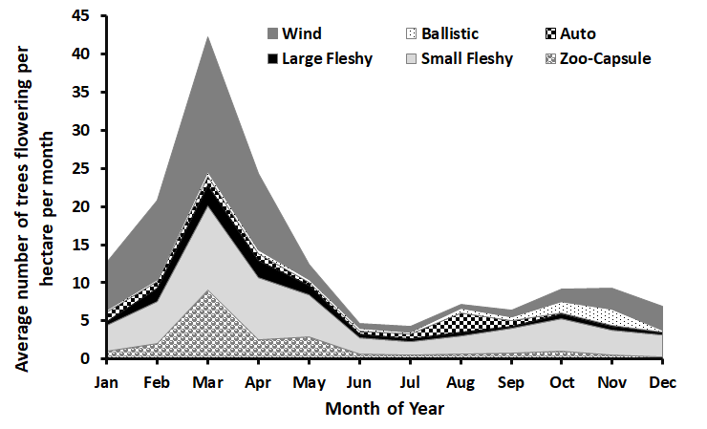
A
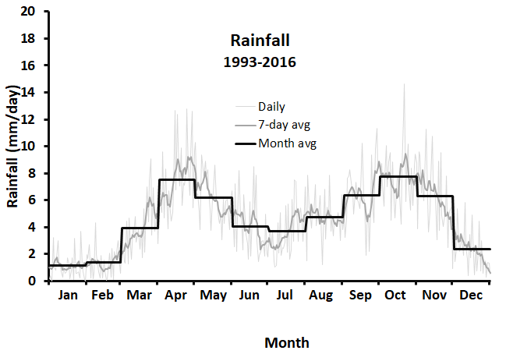
C

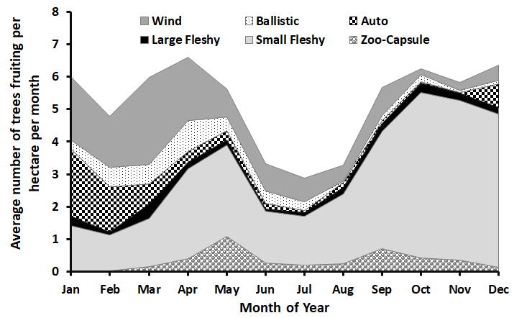
B
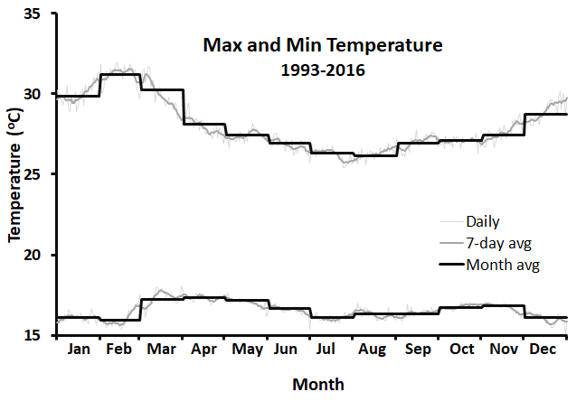
D

FIGURE 2.
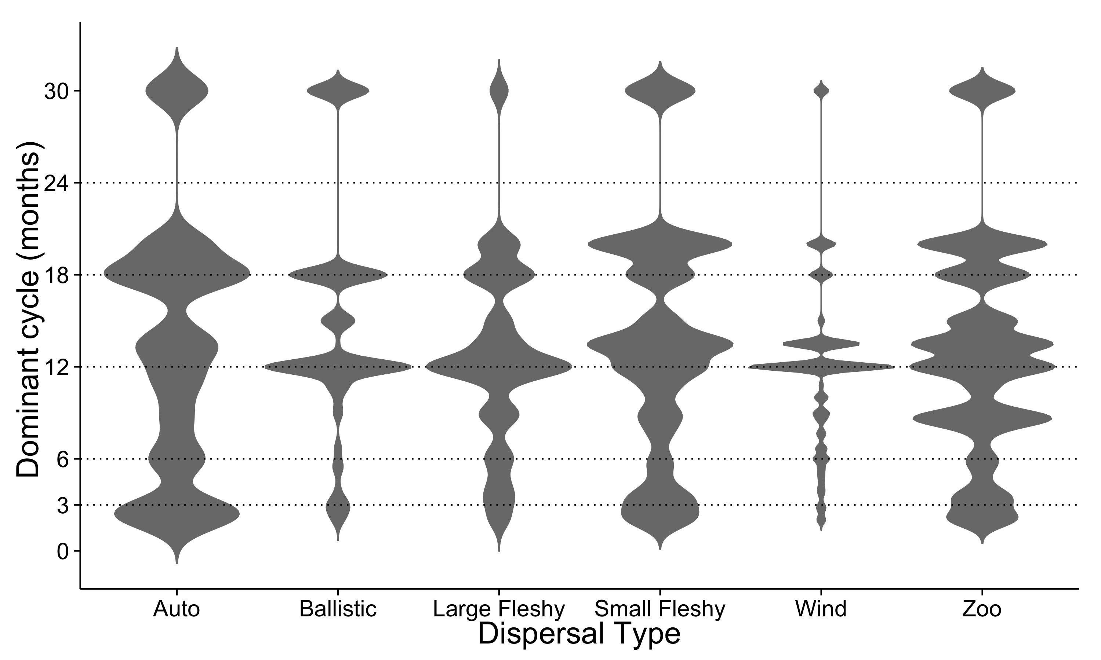
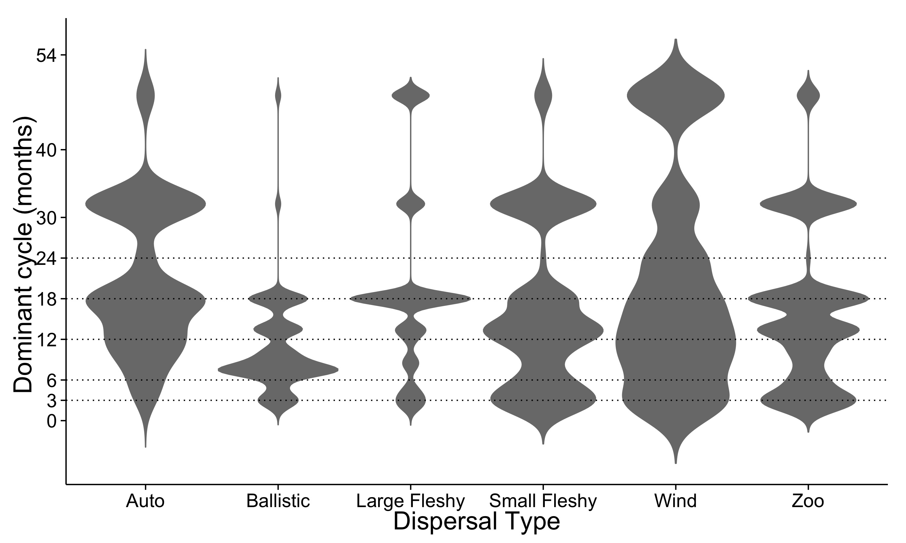
FIGURE 3.
- All trees
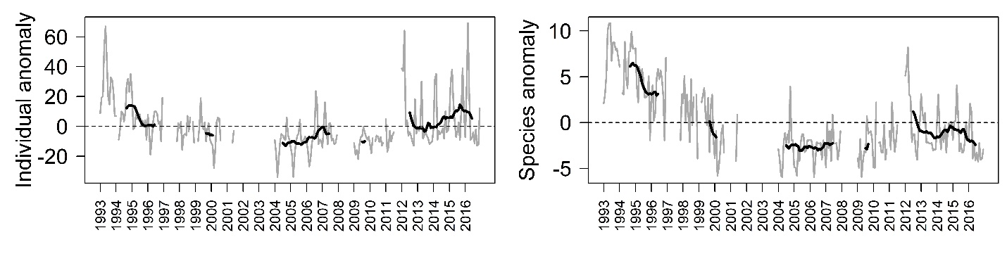
- Pioneer trees
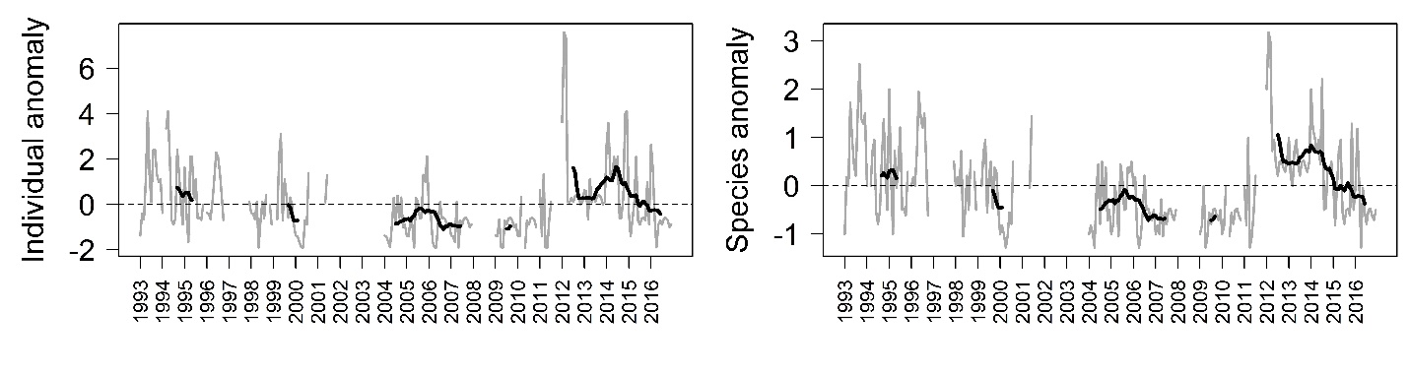
- Non-pioneer Light Demander
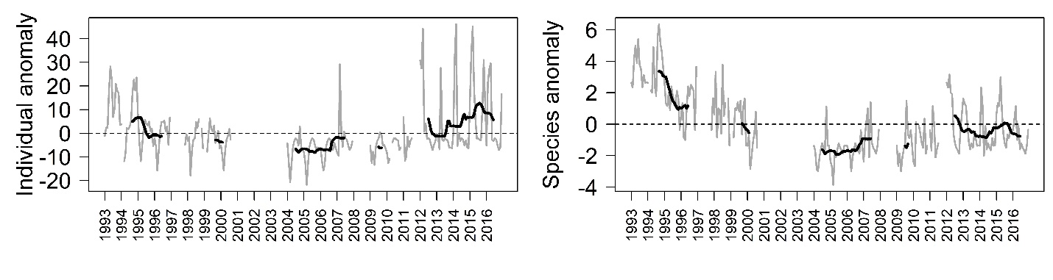
- Shade-bearer
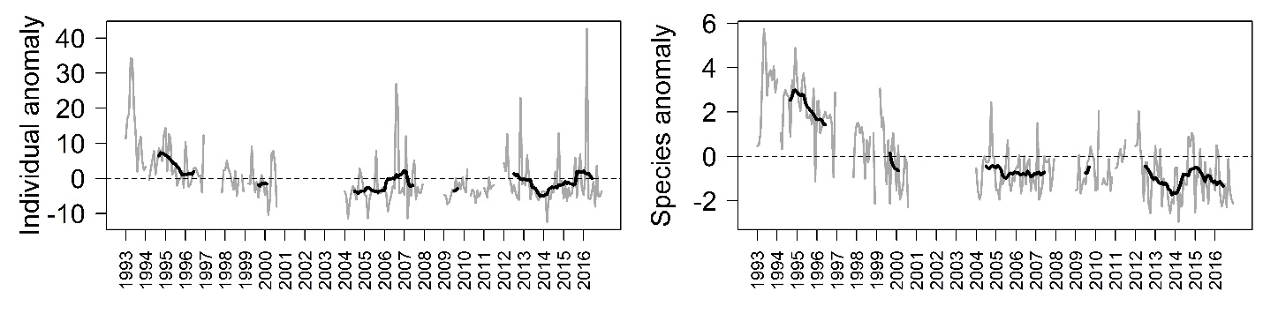

FIGURE 4.
- All trees
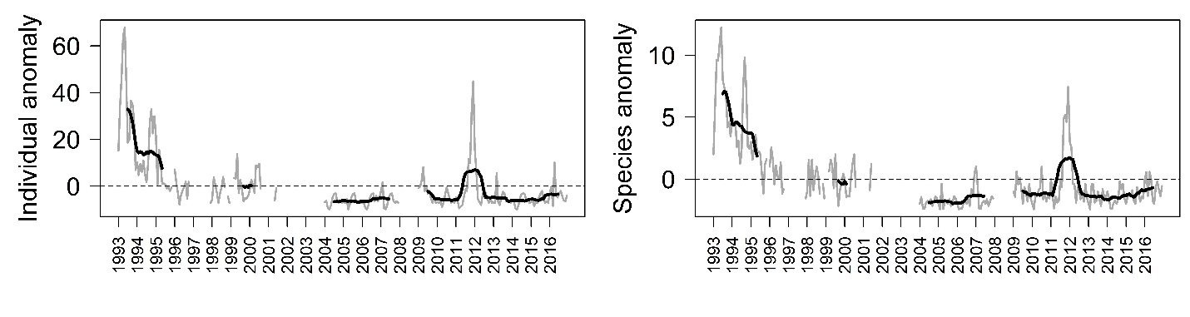
- Pioneer trees
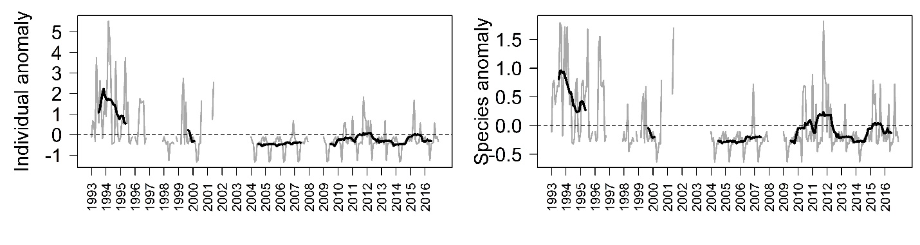
- Non-pioneer Light Demander
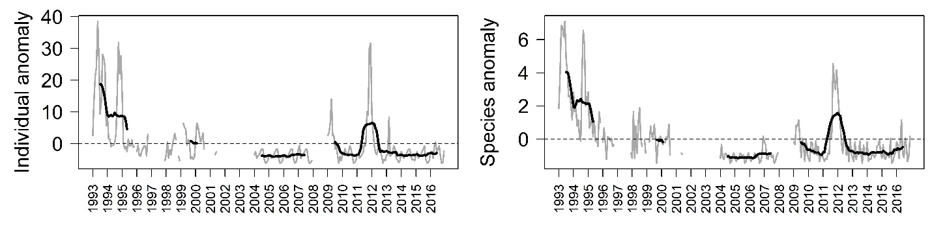
- Shade-bearer
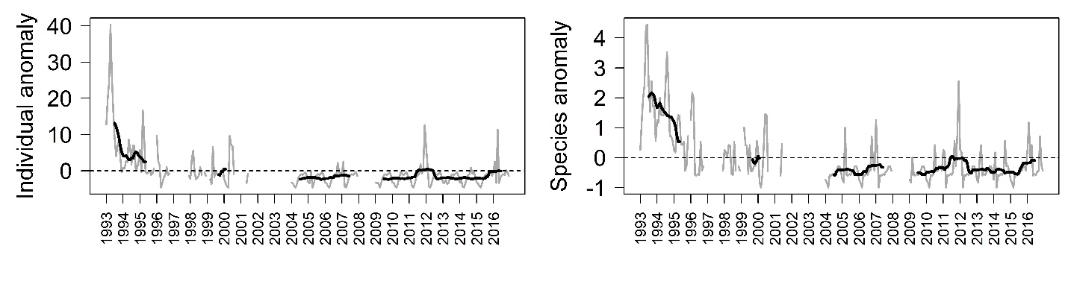

FIGURE 5.
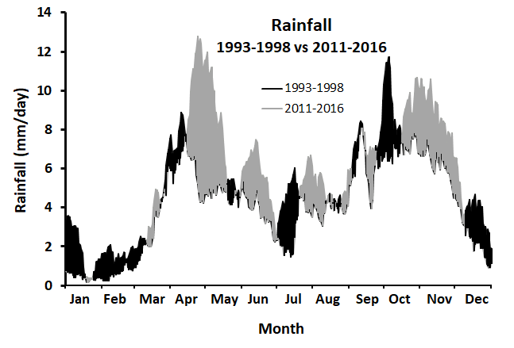
A

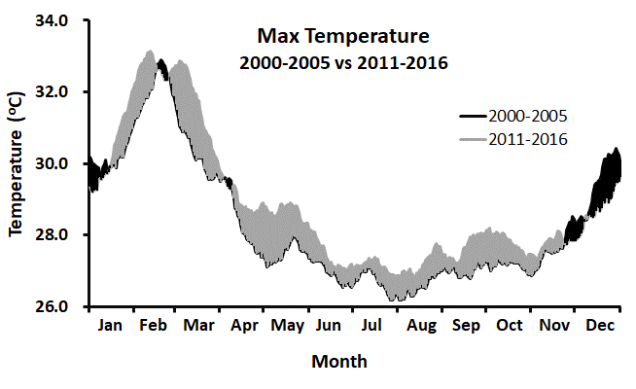
B

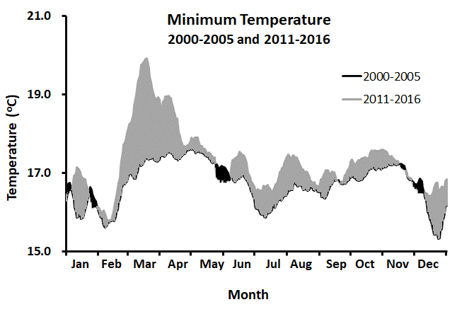
C

SUPPLEMENTARY MATERIAL

FIGURE S1.

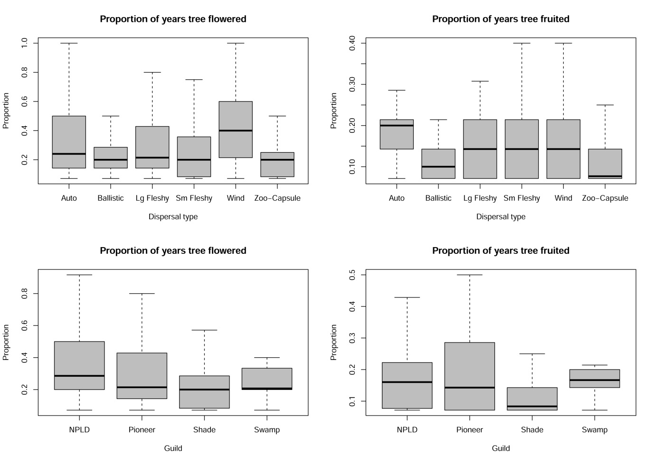

FIGURE S2. Violin plots of the density of flowering (top) and fruiting (bottom) frequency of all individual trees in each guild type.
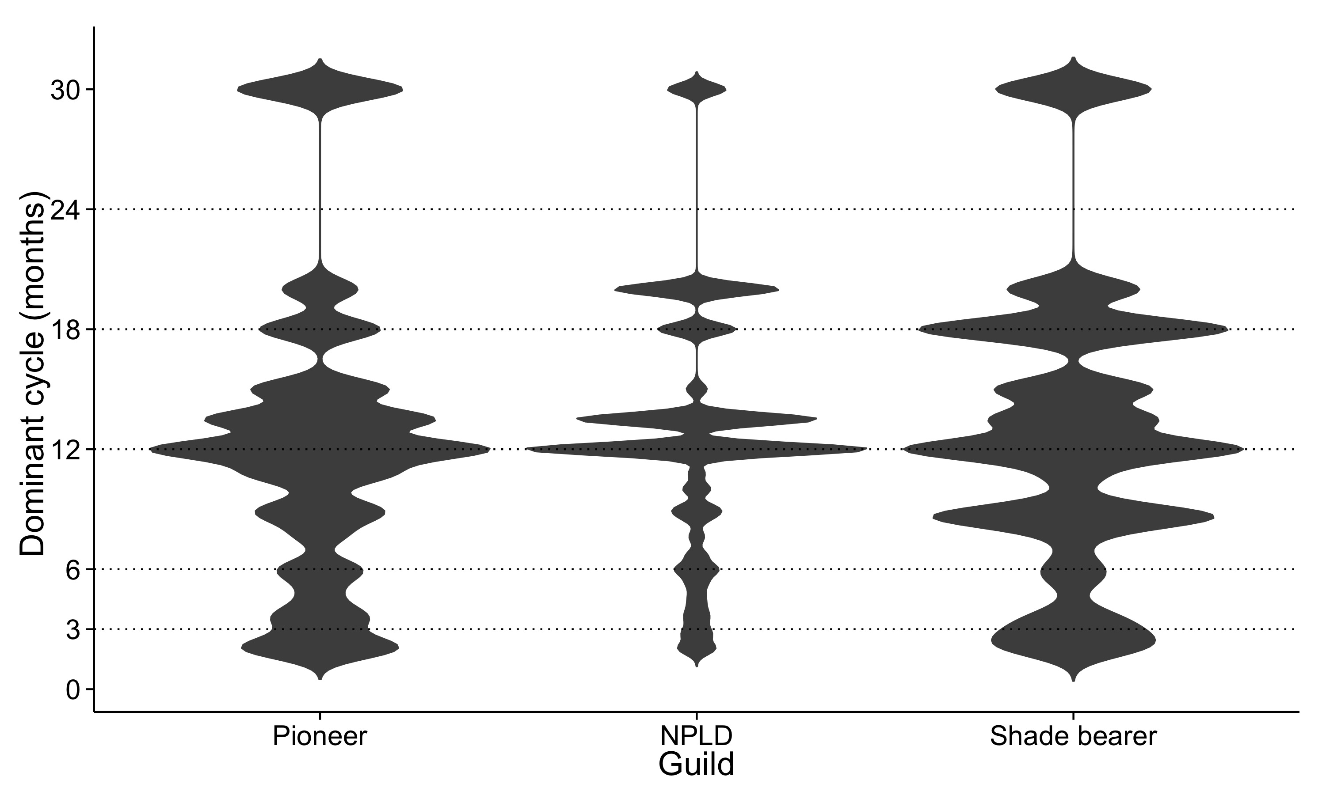
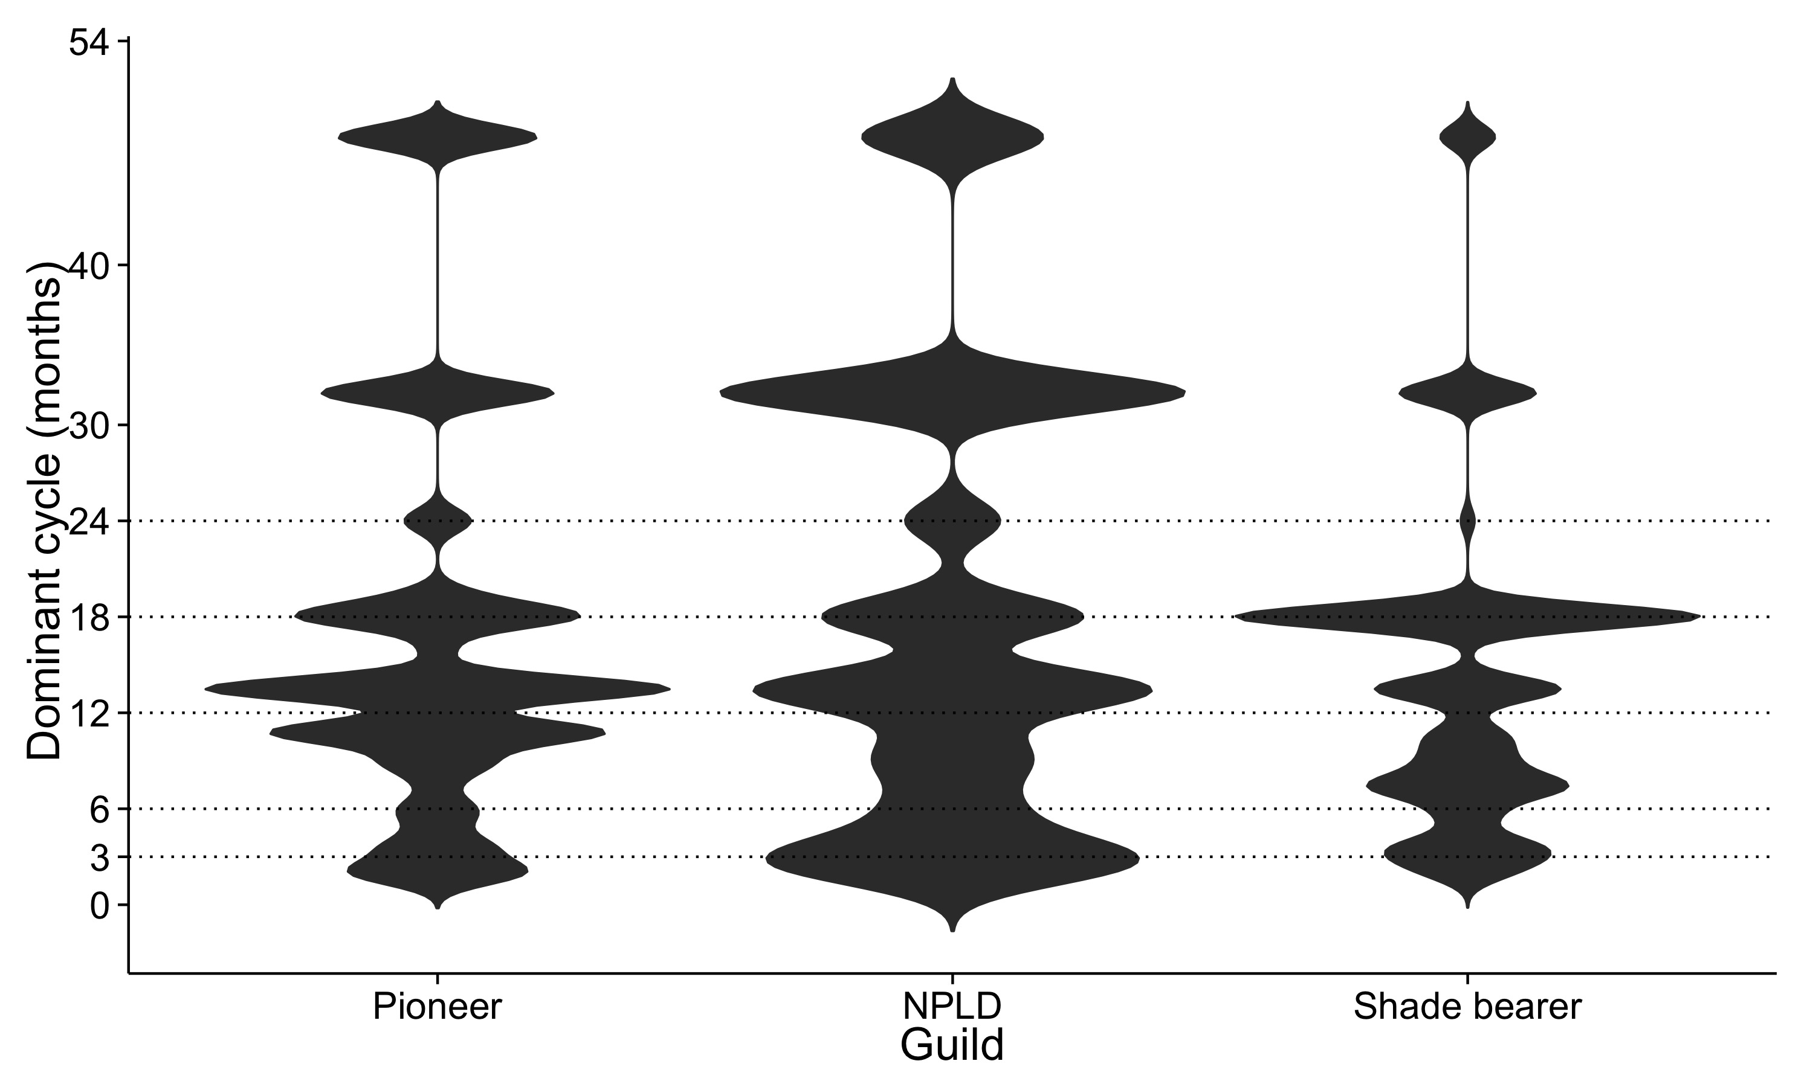
Figure S3. Boxplot of the average number of ripe fruit produced by a fruiting tree plotted by DBH group for all trees that fruited at least once. A quasi-poisson GLM indicated where significant differences occurred between tree size groups and these are flagged with different letters.

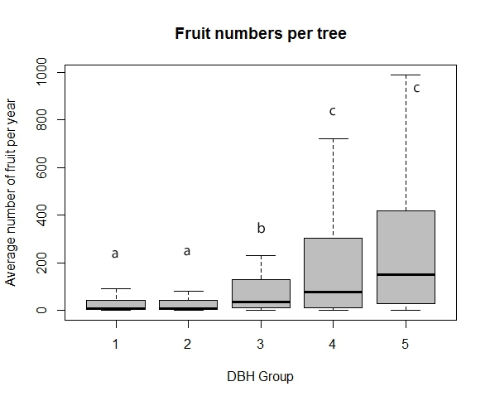

FIGURE S4 Violin plots of the density of flowering (left pair) and fruiting (right pair) frequency of all individual trees in CP.GROUP type (1 = trees below the canopy; 2 = trees at or above the canopy).
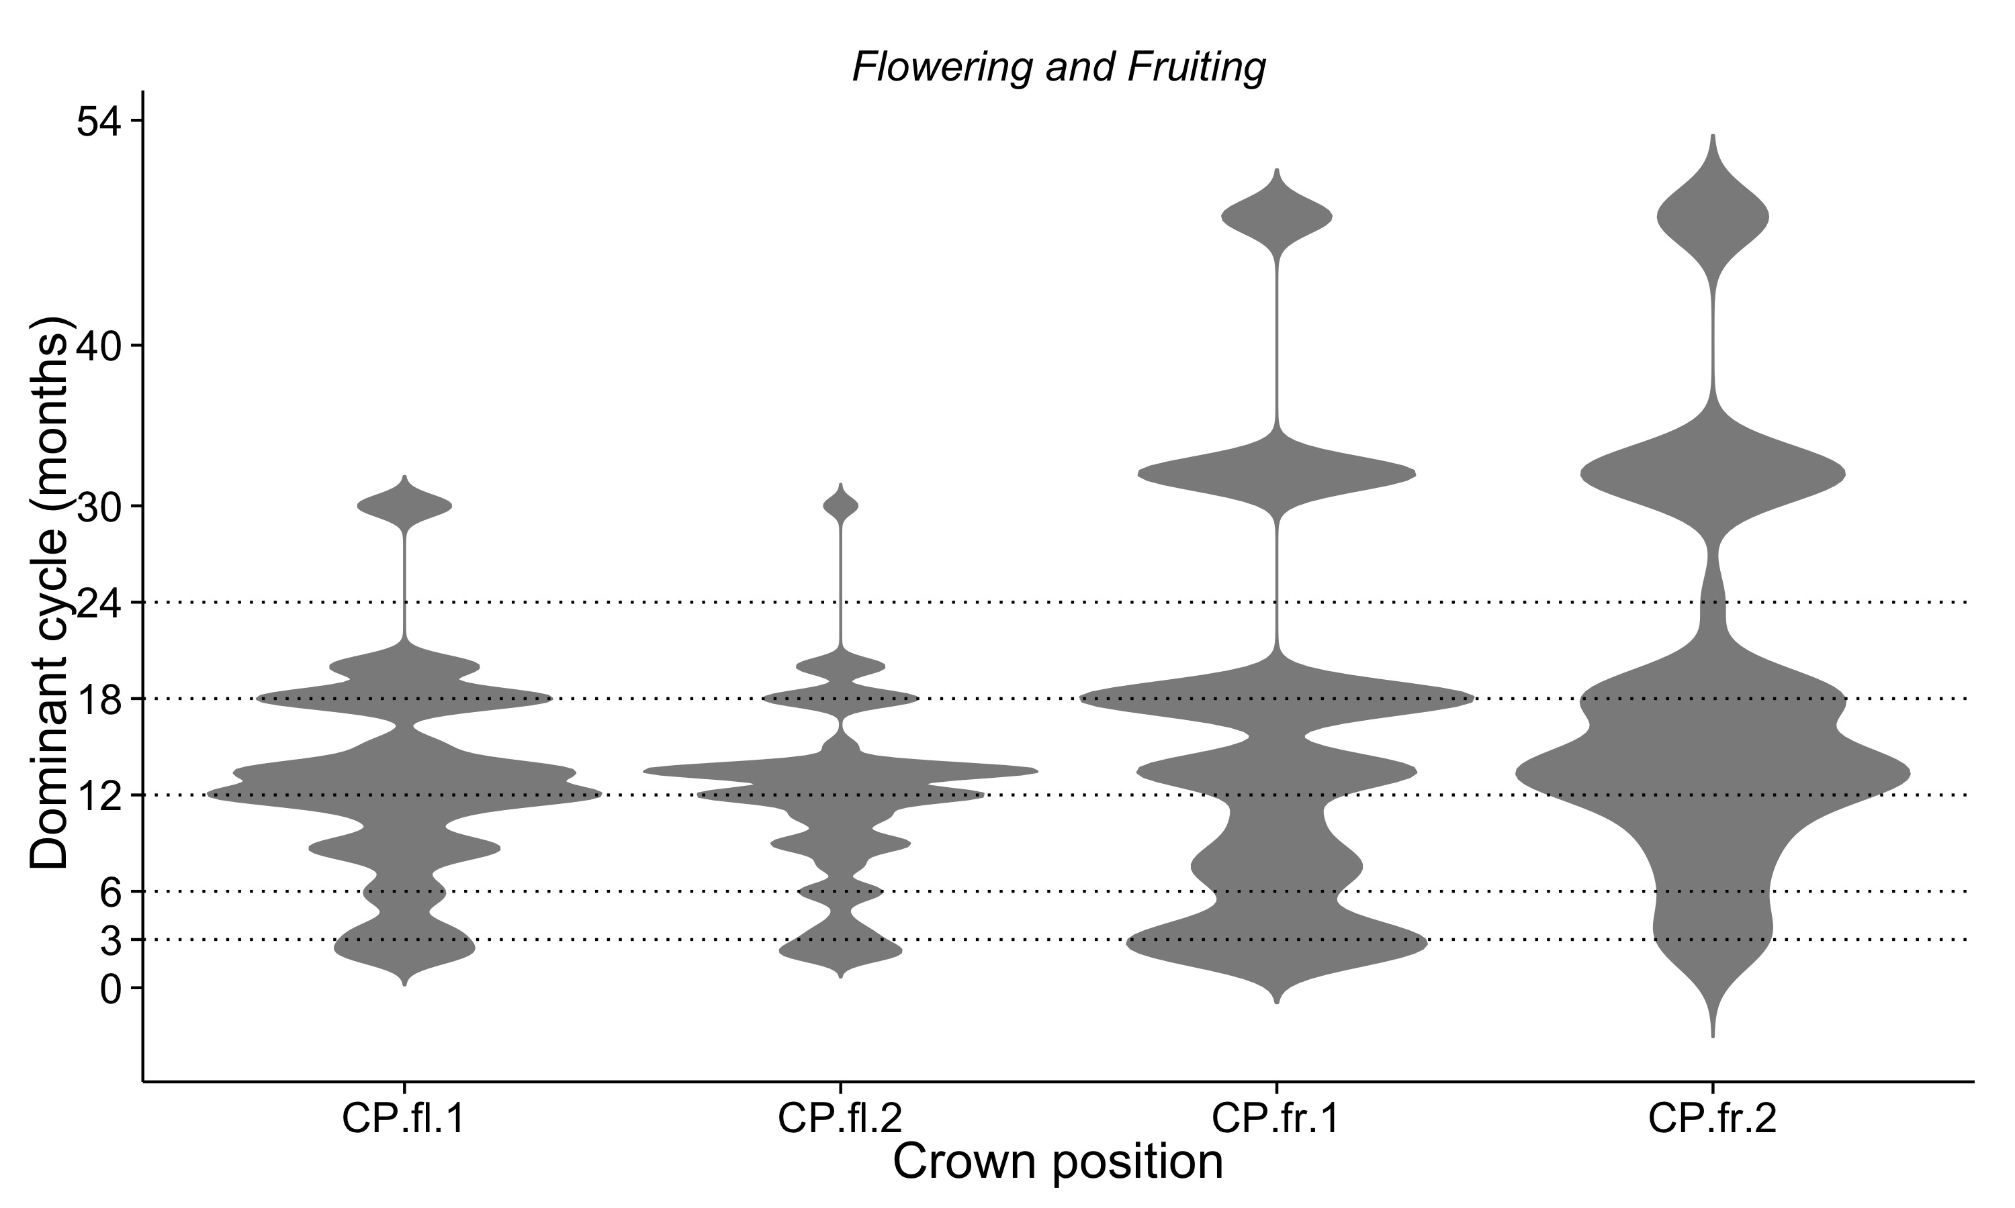
Figure S5 Anomaly scores comparing the monthly number of individuals (left) and species (right) flowering with the average monthly number across the 24 years (dotted horizontal line). A 13-month running mean (black line) is plotted for the average value of the six months prior to and after each specific month.

- Auto dispersal trees
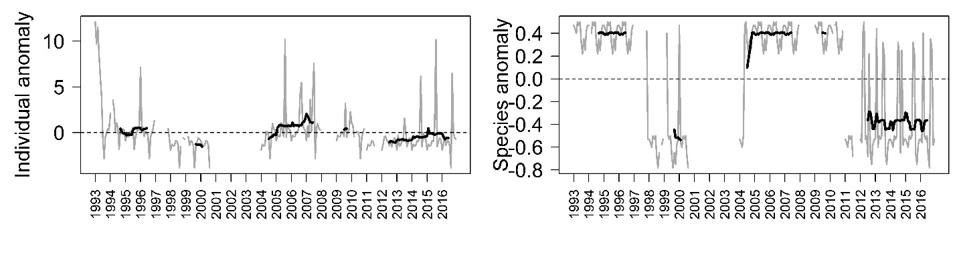
- Ballistic dispersal
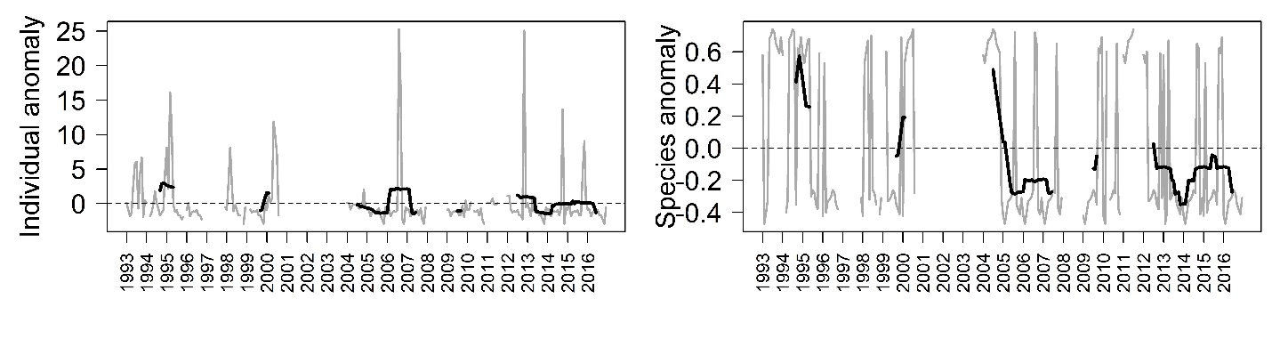
- Small fleshy fruits
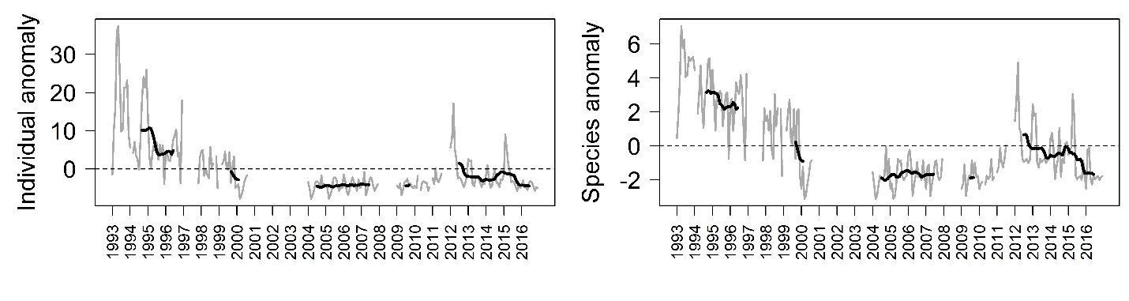

- Large fleshy fruits
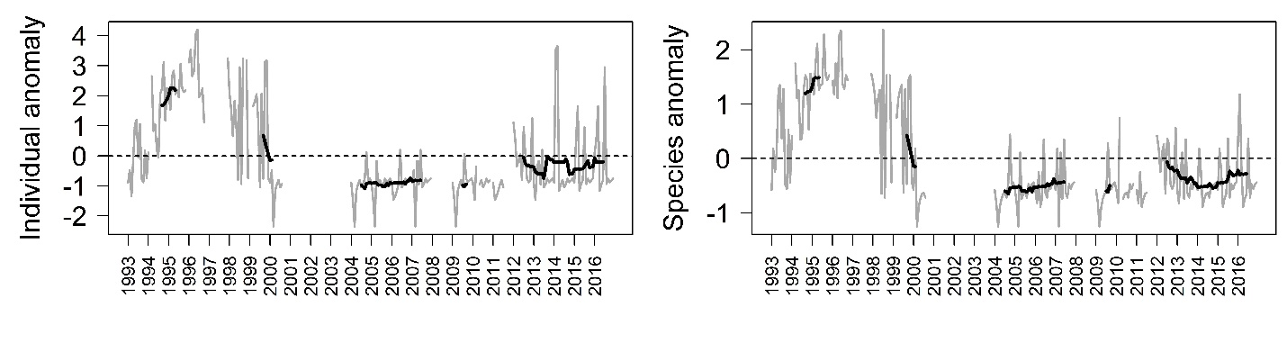
- Wind dispersal
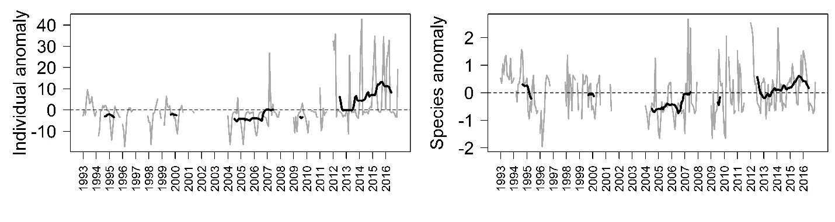
- Capsules dispersed by birds
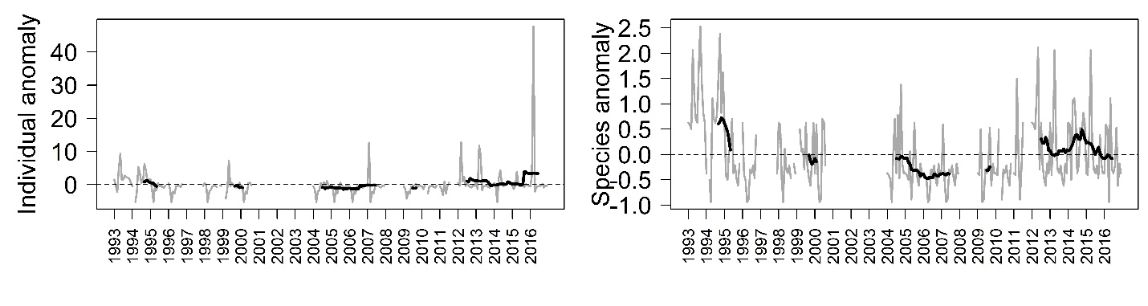

Figure S6 Anomaly scores comparing the monthly number of individuals (left) and species (right) with ripe fruit with the average monthly number across the 24 years (dotted horizontal line). A 13-month running mean (black line) is plotted for the average value of the six months prior to and after each specific month.

- Auto dispersal trees
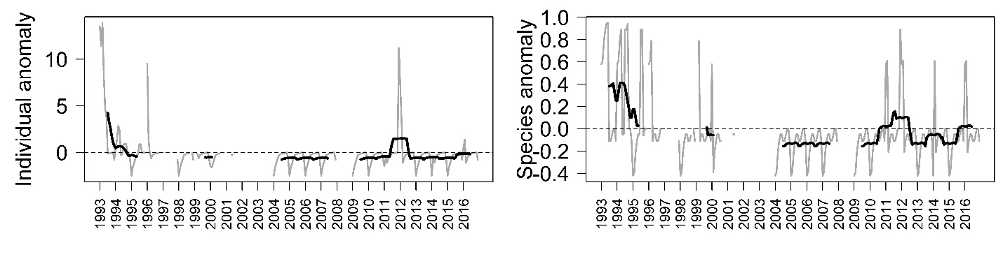
- Ballistic dispersal
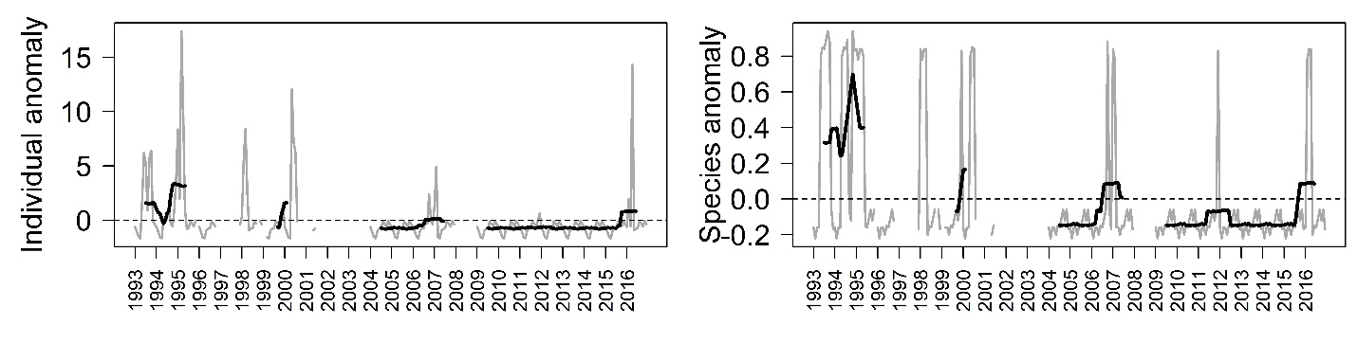
- Small fleshy fruits
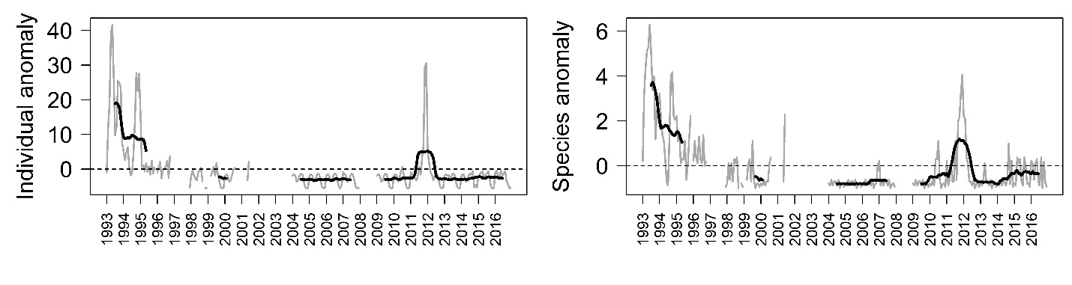

- Large fleshy fruits
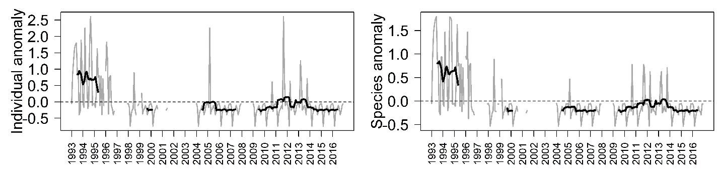
- Wind dispersal
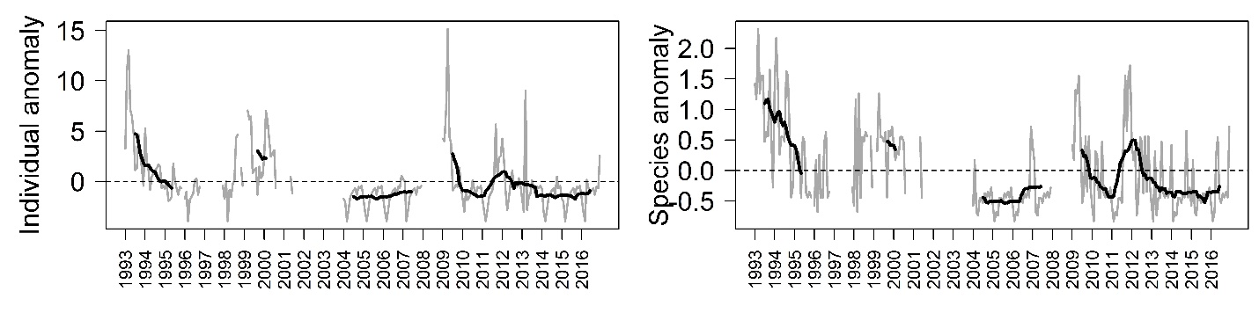
- Capsules dispersed by birds
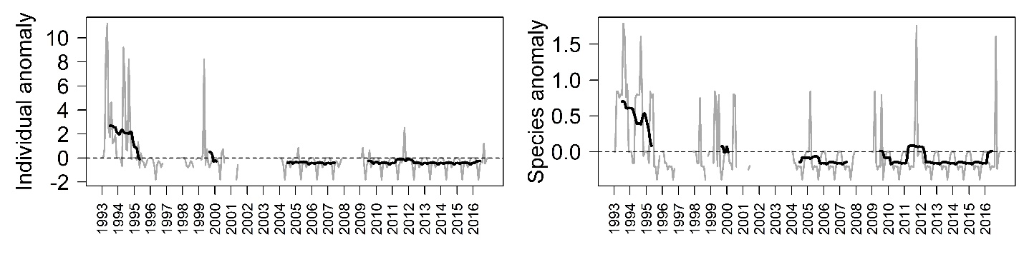

FIGURE S7. Anomaly scores from trees with DBH score 4 or 5 (largest trees), comparing the monthly number of individuals (left) and species (right) with flowers with the average monthly number across the 24 years (dotted horizontal line). A 13-month running mean (black line) is plotted for the average value of the six months prior to and after each specific month.

- Pioneer trees
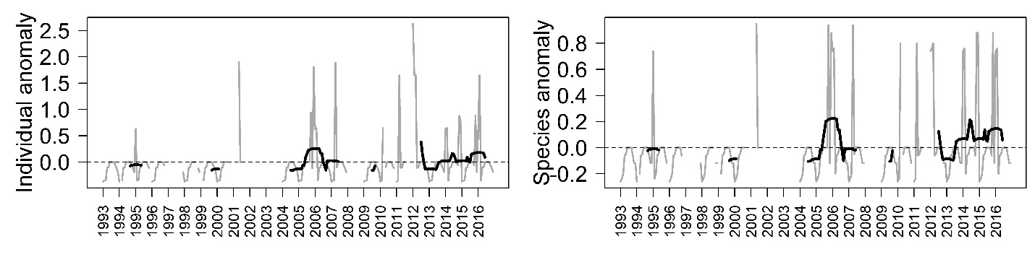
- Non-pioneer Light Demander
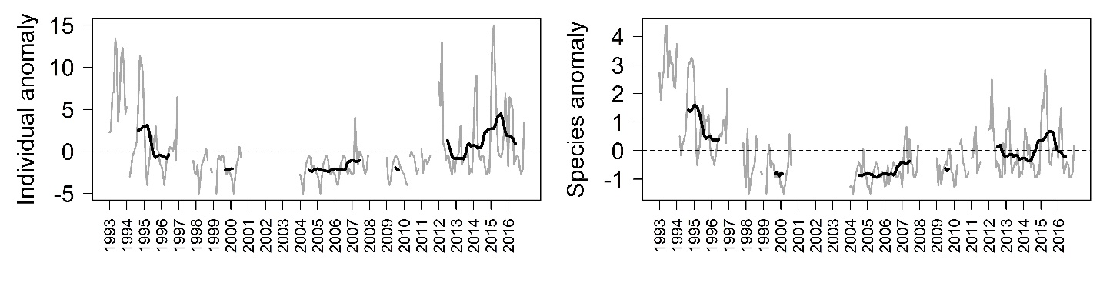
- Shade-bearer
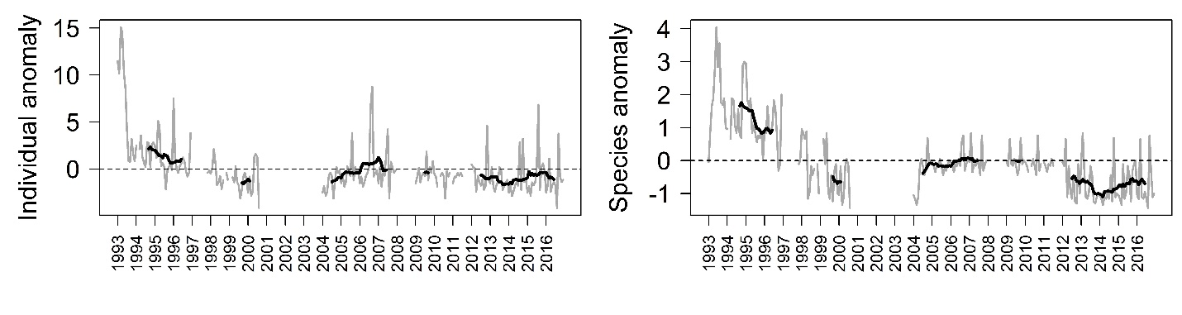

FIGURE S8. Anomaly scores from trees with DBH score 4 or 5 (largest trees), comparing the monthly number of individuals (left) and species (right) with ripe fruit with the average monthly number across the 24 years (dotted horizontal line). A 13-month running mean (black line) is plotted for the average value of the six months prior to and after each specific month.

- Pioneer trees
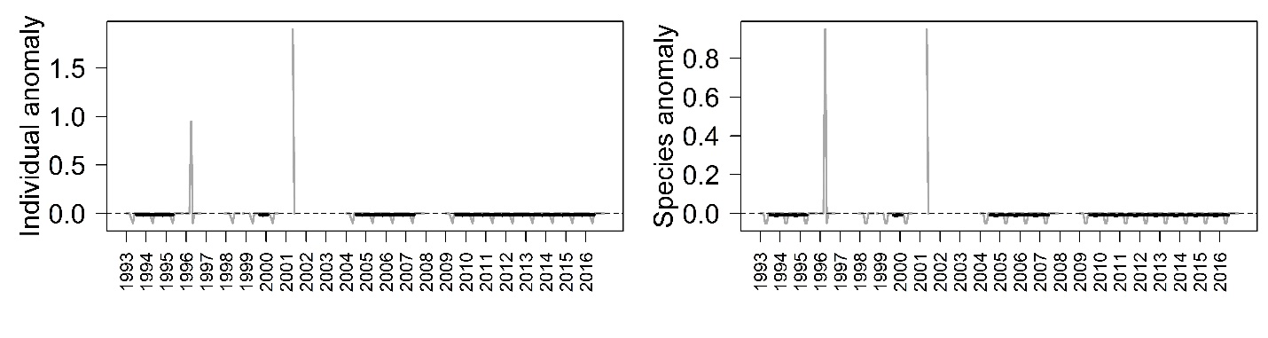
- Non-pioneer Light Demander
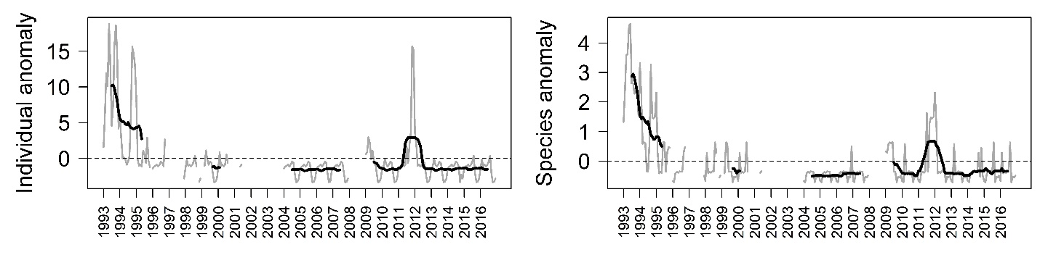
- Shade-bearer
