Mechanical Performance of Steel Fibre Reinforced Rubberised Concrete for Flexible Concrete Pavements

**Abdulaziz Alsaif,a*, Lampros Koutasa , Susan A. Bernala, Maurizio Guadagninia**

**Kypros Pilakoutasa**

Department of Civil and Structural Engineering, The University of Sheffield, Sir Frederick Mappin Building, Mappin Street, Sheffield, S1 3JD, UK.

* Corresponding author: email: [asaalsaif1@sheffield.ac.uk](mailto:L.Koutas@sheffield.ac.uk); Tel: +44 (0) 114 222 5729,

Fax: +44 (0) 114 2225700

# Abstract

This work aims to develop materials for flexible concrete pavements as an alternative to asphalt concrete or polymer-bound rubber surfaces and presents a study on steel fibre reinforced rubberised concrete (SFRRuC). The main objective of this study is to investigate the effect of steel fibres (manufactured and/or recycled fibres) on the fresh and mechanical properties of rubberised concrete (RuC) comprising waste tyre rubber (WTR). Free shrinkage is also examined. The main parameters investigated through ten different mixes are WTR and fibre contents. The results show that the addition of fibres in RuC mixes with WTR replacement substantially mitigates the loss in flexural strength due to the rubber content (from 50% to 9.6% loss, compared to conventional concrete). The use of fibres in RuC can also enable the development of sufficient flexural strength and enhance strain capacity and post-peak energy absorption behaviour, thus making SFRRuC an ideal alternative construction material for flexible pavements.

**Keywords**: *Recycled fibres; Rubberised concrete; Steel fibre concrete; Rubberised steel fibre concrete; Hybrid reinforcement; Flexible concrete; Flexible pavements.*

# Introduction and Background

Road pavements and slabs on grade are constructed either with flexible asphalt or rigid concrete. Flexible pavements can better accommodate local deformations, but lack the durability of concrete which is by nature much stiffer. A flexible concrete pavement could combine the advantages of both types of pavements, however, requires a radical change in how it is constructed. Rubberised concrete which can be design to have stiffness values similar to that of asphalt, can be used as an alternative construction material for flexible pavements. It is well known, however, that the use of rubber in substantial enough quantities can also adversely affect all of the other mechanical properties of Portland-based concrete. Furthermore, virgin rubber aggregates are significantly more expensive than natural aggregates. To address these issues, this study aims to use recycled materials derived from waste tyre rubber (WTR) not only to provide economically and structurally sound alternatives, but also to enable the development of a sustainable flexible concrete pavement solution.

## Waste tyre materials

According to The European Tyre Recycling Association [1], approximately 1.5 billion tyres are produced worldwide each year and a quarter of this amount is arisen in EU countries. It is also estimated that for every tyre brought to the market, another tyre reaches its service life and becomes waste. The European Directive 1991/31/EC [2] introduced a set of strict regulations to prevent the disposal of waste tyres in landfills as a means of preventing environmental pollution and mitigating health and fire hazard [3-5]. As a result, in the EU any type of waste tyre disposal in the natural environment has been banned since 2006. The European Directive 2008/98/EC [6] has also established a disposal hierarchy leading to a serious effort for effective waste tyre management, minimising energy consumption.

Typical car or truck tyres comprise 75-90% rubber, 5-15% high-strength corded steel wire and 5-20% polymer textile. WTR is currently used as fuel, in particular in cement kilns. It is also used in applications, such as synthetic turf fields, artificial reefs, sound proof panels, playground surfaces and protective lining systems for underground infrastructure [7, 8]. While these applications make a positive contribution to recycling WTR, demand with respect to the volume of waste tyres is still small. Since cement-based materials constitute the largest portion of construction materials worldwide, recycling WTR in concrete is a positive way to respond to the environmental challenge and to the significant redundant volumes of waste materials.

## Rubberised concrete

In the past two decades, several studies have investigated the addition of WTR in concrete, but only recently for structural applications [9-12]. Concretes containing rubber particles present high ductility and strain capacity, increased toughness and energy dissipation [11, 13, 14]. These properties, along with the material’s high impact and skid resistance, sound absorption, thermal and electrical insulation [5, 15-17] make rubberised concretes (RuC) a very attractive building material for non-structural applications.

Despite the good mechanical properties of rubber, production of RuC has several important drawbacks: (a) reduction in workability associated with the surface texture of the rubber particles [3, 11, 18, 19], (b) increased air content as the rough and non-polar surface of rubber particles tend to repel water and increase the amount of entrapped air [20-22], and (c) reduction in the compressive strength (up to approximately 90% reduction with 100% replacement of natural aggregates), tensile strength and stiffness [11, 23]. The reduction in mechanical properties is mainly attributed to the lower stiffness and higher Poisson’s ratio of rubber (nearly 0.5) compared to the other materials in the mixture, and the weak bond between cement paste and rubber particles [21, 24, 25]. One of the potential alternatives to enhance the mechanical performance of RuC is the addition of fibres.

## Steel fibre reinforced concrete using recycled fibres

The steel cord used as tyre reinforcement is a very high strength cord of fine wires (0.1- 0.3 mm). The same cord is currently being used in limited volumes to reinforce concrete in high value security applications, such as vaults and safe rooms. At the same time when extracted from tyres, the cord is either discarded or at best re-melted. Commercially available steel fibre reinforcement for concrete comprises thin fibres with a diameter ranging from 0.3 to 1 mm and has a sizable market mainly in tunnel and slabs on grade applications. Hence, it is natural to consider tyre wire for concrete applications [26], as using recycled tyre steel fibres (RTSF) from waste tyres, instead of manufactured steel fibres (MSF), can reduce costs and positively contribute to sustainability by reducing the emissions of CO2 generated from manufacturing steel fibres [27, 28]. Recently, many studies have examined the use of recycled steel fibres in concrete [27, 29-32]. By assessing mechanical properties, most of these studies confirm the ability of classified RTSF to reinforce concrete.

## Steel fibre reinforced rubberised concrete

Despite the fact that there are many studies on RuC and SFRC, there are very few studies examining the effect of using steel fibres and rubber particles together in concrete, and most of these focus on cement-based mortars or self-compacted concrete (SCC) [33-37]. Turatsinze et al. [33] investigated the synergistic effect of MSF and rubber particles, in particular replacing sand in cement-mortars. They observed that the addition of steel fibres improved the flexural post-cracking behaviour, while the addition of rubber (up to 30% by volume of sand) significantly increased the deflection at peak load. Ganesan et al. [35] studied the influence of incorporating crumb rubber and MSF in SCC. Compared to conventional SCC, they reported a 35% increase in flexural strength when 15% of sand (by volume) was replaced with crumb rubber and 0.75% (by volume) fraction of steel fibres was added. Xie et al. [36] conducted an experimental study on the compressive and flexural behaviour of MSF reinforced recycled aggregate concrete with crumb rubber. They found that as the amount of rubber content was increased, the reduction in the compressive strength was smaller compared to other studies, and they attributed this behaviour to the inclusion of steel fibres. They also concluded that steel fibres played a significant role in enhancing the residual flexural strength, which was slightly affected by the increase in rubber content. Finally, Medina et al. [37] examined the mechanical properties of concrete incorporating crumb rubber and steel or plastic fibres coated with rubber. They observed that concrete with rubber and fibres presents better compressive and flexural behaviour as well as impact energy absorption than plain rubberised concrete.

To the best of the authors' knowledge only limited information is available on the mechanical behaviour of steel fibre reinforced rubberised concrete (SFRRuC) where both fine and coarse aggregates are replaced with rubber particles in significant volumes (exceeding 20% by volume of total aggregates) and further studies are needed to understand its performance where much larger rubber volumes are used. Large volumes of rubber are necessary to achieve more flexible concrete pavements. In addition, the behaviour of SFRRuC in which RTSF are used alone or in a blend with MSF, has not been studied yet.

This study investigates the fresh properties as well as the compressive and flexural behaviour of several SFRRuC mixes with the aim of developing optimized mixes suitable for pavement applications. Coarse and fine aggregates are partially replaced by different sizes and percentages of tyre rubber particles and various dosages and blends of steel fibres, MSF and/or RTSF, are used as fibre reinforcement. Details of the experimental programme and the main experimental results are presented and discussed in the following sections. This study contributes to the objectives of the EU-funded collaborative project Anagennisi (http://www.anagennisi.org/) that aims to develop innovative solutions to reuse all waste tyre components.

# Experimental Programme

## Parameters under investigation

The parameters assessed in this study were: (i) the rubber content used as partial replacement of both fine and coarse aggregates (0%, 20%, 40% or 60% replacement by volume), and (ii) steel fibre content (0 or 20 kg/m3 MSF + 20 kg/m3 RTSF, or 40 kg/m3 RTSF). A total of 10 different mixes were prepared. For each mix, three cubes (150 mm-size), three cylinders (100 mm-diameter and 200 mm-length), and three prisms (100x100 mm-cross section and 500 mm-length) were cast. The cubes and cylinders were used to obtain the uniaxial compressive strength and the compressive stress-strain curve, respectively, whereas the prisms were cured in different conditions to evaluate free shrinkage strain (autogenous and drying) and then subjected to three-point bending. Table 1 summarises the different mix characteristics and the ID assigned to the mixes. The mix ID follows the format NX, where N denotes the amount of rubber content used as partial replacement of both fine and coarse aggregates (0, 20, 40 or 60%), while X represents the type of steel fibre reinforcement and can be either P, BF or RF (Plain, Blend of Fibres or Recycled Fibres, respectively**)**. For instance, 60BF is the rubberised concrete mix that contains 60% of rubber particles as conventional aggregate replacement and consists of blend fibres (20 kg/m3 MSF and 20 kg/m3 RTSF).

Table 1. Concrete mix ID, and quantities of rubber and steel fibres added in each mix

|  |  |  |  |  |  |  |  |
| --- | --- | --- | --- | --- | --- | --- | --- |
| Mix  No. | Mix ID | % Rubber replacing aggregates by volume | | Fine rubber (kg/m3) | Coarse rubber (kg/m3) | MSF (kg/m3) | RTSF (kg/m3) |
| Fine | Coarse |  |  |
| 1 | *0P* | 0 | 0 | 0 | 0 | 0 | 0 |
| 2 | *0BF* | 0 | 0 | 0 | 0 | 20 | 20 |
| 3 | *0RF* | 0 | 0 | 0 | 0 | 0 | 40 |
| 4 | *20P* | 20 | 20 | 49.5 | 60.4 | 0 | 0 |
| 5 | *20BF* | 20 | 20 | 49.5 | 60.4 | 20 | 20 |
| 6 | *40P* | 40 | 40 | 99 | 120.9 | 0 | 0 |
| 7 | *40BF* | 40 | 40 | 99 | 120.9 | 20 | 20 |
| 8 | *60P* | 60 | 60 | 148.5 | 181.3 | 0 | 0 |
| 9 | *60BF* | 60 | 60 | 148.5 | 181.3 | 20 | 20 |
| 10 | *60RF* | 60 | 60 | 148.5 | 181.3 | 0 | 40 |

## Materials and mix preparation

### Materials

* + - 1. *Rubberised concrete*

A high strength commercial Portland Lime Cement CEM II-52.5 N containing around 10–15% Limestone in compliance with BS EN 197-1 [38] was used as binder. The coarse aggregates used comprised natural round river washed gravel with particle sizes of 5-10 mm and 10-20 mm [specific gravity (SG)=2.65, absorption (A) =1.2%]. The fine aggregates used comprised medium grade river washed sand with particle sizes of 0-5 mm (SG=2.65, A=0.5%). Pulverised fuel ash (PFA) and silica fume (SF) were used as partial replacement of cement (10% by weight for each) to enhance the fresh and mechanical properties of the mixes. Plasticiser and superplasticiser were also added to improve cohesion and mechanical properties (mix details are given in Section 2.2.2).

The rubber particles used in this study were recovered through the shredding process of waste tyres at ambient temperature and where obtained from two different sources. As depicted in Figure 1a, the fine rubber particles were provided in the ranges of 0-0.5 mm, 0.5-0.8 mm, 1-2.5 mm and 2-4 mm and were used in the concrete mix in the ratio 12:12:32:44 of the total added fine rubber content, while the course rubber particles were supplied in the ranges of 4-10 mm and 10-20 mm and were utilized in the concrete mix in the ratio 50:50 of the total added course rubber content. Figure 2 presents the particle size distribution of the natural aggregates (NA) and rubber particles used, obtained according to ASTM-C136 [39]. To limit the influence of rubber size on concrete particle packing, conventional aggregates were replaced with rubber particles of roughly similar size distribution to minimise the impact on the packing of the concrete mix constituents. A relative density of 0.8 was used to calculate the mass of rubber replacing natural aggregates, as determined using a large rubber sample that was accurately cut and measured.



**Figure. 1** a)Rubber particles, b) MSF and RTSF used in this study and c) length distribution analysis of RTSF



**Figure. 2** Particle size distribution for conventional aggregates and rubber

Table 2 reports the physical properties of the coarse aggregates (5-20 mm) and the coarse rubber particles (4-20 mm), obtained through a series of tests: (a) particle density and water absorption according to EN 1097-6 [40], (b) loose bulk density according to EN 1097-3 [41], and (c) particle shape-flakiness index according to EN 933-3 [42]. The physical properties of the fine aggregates and fine rubber particles were not evaluated due to difficulties in performing the tests on fine rubber particles as they floated when submerged in water.

As it was not possible to complete the flakiness tests for all particle sizes, in the end this information was not used directly in the mix design. It should be noted though that the higher flakiness influenced the optimisation of the mix design and more fines and supplementary materials were necessary, as reported in [11].

**Table 2.** Physical properties of coarse aggregates and coarse rubber particles

|  |  |  |  |  |
| --- | --- | --- | --- | --- |
| Physical properties/Type of rubber | Rubber - Source 1  4-10 mm | Rubber -Source 2  10-20 mm | Natural aggregates 5-10 mm | Natural aggregates  10-20 mm |
| Apparent particle density, kg/m3 | 1136 | 1103 | 2685 | 2685 |
| Oven-dried density, kg/m3 | 1032 | 1090 | 2599 | 2599 |
| Saturated and surface-dried particle density, kg/m3 | 1123 | 1101 | 2631 | 2631 |
| Water absorption after 24h, % | 5.3-8.8 | 0.8-1.3 | 1.2 | 1.2 |
| Bulk specific gravity | 1.1 | 1.1 | 2.6 | 2.6 |
| Bulk density, kg/m3 | 454 | 485 | 1511 | 1583 |
| Flakiness index | 6.64 | 17.48 | 7.05 | 9.7 |

* + - 1. *Steel Fibres*

The MSF were crimped type steel fibres with a length of 55 mm, diameter of 0.8 mm and tensile strength of 1100 MPa. The RTSF were cleaned and screened fibres (typically containing < 2% of residual rubber) and had lengths in the range of 15-45 mm (at least 60% by mass), diameters <0.3 mm and tensile strength of 2000 MPa. Figure 1b presents both types of fibres (MSF and RTSF) used in this study and Figure 1c illustrates the length distribution of the RTSF based on a digital optical correlation method that combines photogrammetry and advanced pattern recognition to determine the length of individual fibre from high speed image of free falling dispersed fibres [43].

### Mix design

The mix design used in this experimental study (adopted from Raffoul et al. [11]) was optimised to be used for typical concrete bridge piers targeting a compressive strength of 60 MPa (cylinder), and suited the replacement of 0%, 20%, 40% and 60% of WTR without excessive degradation in fresh and mechanical properties. The optimised mix proportions for 0% rubber content (conventional concrete), are shown in Table 3.

**Table 3.** Concrete mix proportions (without rubber content)

|  |  |
| --- | --- |
| Material | Quantity |
| CEM II – 52.5 MPa | 340 kg/m3 |
| Silica fume (SF) | 42.5 kg/m3 |
| Pulverised fuel ash (PFA) | 42.5 kg/m3 |
| Natural fine aggregates 0-5 mm | 820 kg/m3 |
| Natural coarse aggregates 5-10 mm | 364 kg/m3 |
| Natural coarse aggregates 10-20 mm | 637 kg/m3 |
| Water | 150 l/m3 |
| Plasticiser | 2.5 l/m3* |
| Superplasticiser | 5.1 l/m3 |

*It was increased at higher amounts of rubber and fibres were added to the concrete (2.5-4.75 l/m3)

### Mixing, casting and curing procedure

A 200 litre pan mixer was used for all mixes. The procedure used for mixing the concrete started with conventional aggregates dry mixed for 30 seconds together with the rubber particles. Subsequently, half of the total amount of water was added and mixed for about 1 minute. The mix was allowed to rest for 3 minutes allowing the conventional aggregates to get saturated. After that, the cementitious materials (Portland cement, silica fume and fly ash) were added, followed by the remaining water and the chemical admixtures. The fresh concrete was finally mixed for another 3 minutes. For those concrete mixes with steel fibres, fibres were manually integrated into the concrete during mixing at the last mixing stage.

The concrete fresh properties, including slump, air content and fresh density, were then assessed for each mix according to the standardised methods described in EN 12350‐2 [44], EN 12350‐7 [45], and EN 12350‐6 [46], respectively. The concrete specimens were cast in plastic cube (150 mm) and cylinder moulds (100x200 mm), and prismatic steel moulds (100x100x500 mm) according to EN 12390-2 [47] and EN 14651 [48]. The specimens were cast in two layers and vibrated (25s per layer) on a vibrating table. After casting, specimens were covered with plastic sheets to prevent moisture loss, and left under standard laboratory conditions for 48h until demoulding. The specimens were then kept in a mist room (21 °C $±$ 2 and 95 $±$ 5% relative humidity (RH)) for 28 days, except for the prisms used for shrinkage measurements that were left in the mist room for 7 days and then stored in a control room (24 °C $±$ 2 and 42 $±$ 5 RH) for 50 days. After the curing period, the specimens were kept under standard laboratory conditions (20 °C $±$ 2 and 50 $±$ 5 RH) until testing.

# Test set-up and procedure

## 3.1 Compression testing

Prior to testing, the top faces of the cylinders were cut and ground according to EN 12390-3 [49]. For the RuC cylinders, extra measures were taken to prevent local failure during testing by confining their two ends with high-ductility post-tensioned straps, as proposed by Garcia et al. [50]. Axial compression tests were performed on concrete cubes and cylinders according to EN 12390‐3 [49] under monotonic loading until failure. For all tested cylinders, the compression tests were performed using a servo-hydraulic universal testing machine with a load capacity of 1000 kN. The load was applied on the cylinders at a displacement rate of 0.3 mm/min. The local axial strain was measured using two diagonally opposite strain gauges at mid-height. The global axial strain was measured using three laser sensors, with an accuracy of 40µɛ, placed radially around the specimens (120o apart) using two metallic rings. The metallic rings were attached to the specimens using four clamp screws, covering the middle zone of the cylinder and resulting in 100 mm gauge length. The tests on cubes were carried out using a standard compression machine with a load capacity of 3000 kN at a loading rate of 0.4 MPa/s.

## 3.2 Three-point bending tests

The flexural behaviour of the concrete specimens was assessed by performing three-point bending tests using an electromagnetic universal testing machine with a load capacity of 300 kN. A detailed schematic of the test setup is provided in Figure 3. The loading point allowed for both the in-plane and out-of-plane rotation of the prism. Two LVDTs were mounted at the middle of a yoke (one on each side) as suggested by the JCI [51] to measure the net deflection at mid-span.



**Figure. 3** Schematic representation of the flexural test set-up

A clip gauge of 12.5 mm-length was fixed at the middle of the bottom side of the prism, where a 5 mm-wide and 15 mm-deep notch had been sawn. The clip gauge measurement (crack mouth opening displacement -CMOD) was used to control the loading rate as suggested by RILEM [52]. All tests were performed under a rate of 50 μm/min for CMOD ranging from 0 to 0.1 mm, 200 μm/min for CMOD ranging from 0.1 to 4 mm, and 8000 μm/min for CMOD higher than 4 mm.

## 3.3 Free-shrinkage

The autogenous and drying shrinkage tests were performed according to EN-126174 [53]. However, to avoid issues of fibre alignment along the mould boundaries, the size of the prismatic specimens was increased from 40x40x160 mm (as suggested by the standard) to 100x100x500 mm. Specimens were demoulded two days after casting and fitted with steel “Demec” points (locating discs) using plastic padding. Two Demec points were fixed 300 mm apart on each of the vertical (as cast) sides of the prism.

The first strain measurement was recorded after 30 minutes to allow for the hardening of the adhesive. For autogenous shrinkage, the specimens were kept in a mist room with controlled temperature and humidity conditions (21 oC 2 and 95 $±$ 5% RH) and measurements were taken at the ages of 1, 2, 3 and 7 days after demoulding. For drying shrinkage, specimens were stored in a chamber with controlled temperature and humidity conditions (24 oC 2 and 40 $±$ 5 RH) and measurements were taken at the ages of 10, 14, and 28 and 56 days after demoulding.

# Experimental Results and Discussion

## Fresh state properties

### 4.1.1 Workability

To assess the workability of rubberised concrete, most researchers (including the authors of this paper) use the slump test which appears to be a consistent and easy-to-apply method in practice [3, 7, 10, 11, 19]. Table 4 shows the slump results of all mixes as well as their corresponding slump classes, all of which fulfil the consistency requirements as described in pavement design standard BS EN 13877-1[54] and the normative reference BS EN 206-1 [55] either for fixed-form or slip-form (class S1) paving . The desired slump class was targeted to be at least S3 (slump ≥ 90 mm), by modifying the plasticiser dosage which was increased proportionally to the amount of rubber and steel fibres in each mix. All mixes achieved the targeted slump, however, the workability for mixes *60BF* and *60RF* was quite low (40 and 35 mm, respectively) although high amounts of plasticiser and superplasticiser were added (4 per m3 and 5.1 per m3 of concrete, respectively). Nevertheless, this low workability did not raise any issues during handling, placing or finishing of the mixes due to the high rubber dosage (60%). No signs of segregation, bleeding or excessive “balling” were observed in any of the mixes.

**Table 4.** Fresh concrete properties for all concrete mixes

|  |  |  |  |  |  |  |  |
| --- | --- | --- | --- | --- | --- | --- | --- |
| Mix  No. | Mix ID | Extra plasticiser  added  L/m3 | Slump (mm) | Slump  class | Air content % | Bulk  density  (kg/m3) | Theoretical density  (kg/m3) |
| 1 | *0P* | 0 | 240 | S5 | 1.35 | 2406 | 2426 |
| 2 | *0BF* | 0 | 195 | S4 | 1.5 | 2452 | 2454 |
| 3 | *0RF* | 0 | 195 | S4 | 1.15 | 2447 | 2454 |
| 4 | *20P* | 0.25 | 200 | S4 | 1.9 | 2258 | 2211 |
| 5 | *20BF* | 0.5 | 170 | S4 | 3 | 2269 | 2239 |
| 6 | *40P* | 0.5 | 170 | S4 | 3.15 | 2046 | 1996 |
| 7 | *40BF* | 1 | 130 | S3 | 3.35 | 2086 | 2025 |
| 8 | *60P* | 1 | 150 | S3 | 2.35 | 1869 | 1780 |
| 9 | *60BF* | 1.5 | 40 | S1 | 3.35 | 1889 | 1811 |
| 10 | *60RF* | 1.5 | 35 | S1 | 4.15 | 1884 | 1811 |

The results show that slump decreases with the addition of steel fibres, and further decreases with the inclusion of rubber, even though the amount of plasticiser was increased proportionally. By comparing the slump values of the control mix with the SFRC mixes without rubber (*0BF* and *0RF*), it can be seen that fibres caused a slump drop of 18.8% for both SFRC mixes. This decrease may be caused by increased friction between the RTSF, which have a large specific surface area, and the concrete constituents during mixing. Additionally, the tendency of steel fibres to agglomerate also has an adverse effect on workability.

The slump of the RuC mixes without steel fibres, *20P, 40P* and *60P*, also decreased by 16.6%, 29.1% and 37.5%, respectively, in comparison to the control mix. The surface shape and texture of rubber appear to have increased friction compared to conventional aggregates. Furthermore, fine impurities (i.e. rubber dust and fluff) on the rubber particles may also have reduced the free water in the fresh concrete mix.

The combined effects of both steel fibres and rubber on reducing the workability can be clearly seen from the slump values of SFRRuC mixes, *20BF, 40BF, 60BF* and *60RF,* where the slump significantly dropped by 29.1%, 45.8%, 83.3% and 85.4%, respectively, in comparison to the control mix.

### 4.1.2 Air content and unit weight

Air content has been shown to increase with the addition of fibres and/or rubber in concrete [56, 57] and a similar trend is observed in this study. As indicated in Table 4, the air content (entrapped air) in the concrete in general rises when increasing the rubber content, and further increases with the addition of fibres (except for mixes *0RF* and *60P* which can be considered outliers). The increase in the air content is possibly due to the rough and non-polar surface of rubber particles which tend to repel water and increase the amount of entrapped air in the mix. The large specific surface area of the fibres and their tendency to occasionally agglomerate can also contribute to increase air entrapment.

It was expected that the air content of the concrete mix with a blend of fibres (MSF and RTSF) would be less than the air content of the concrete mix with RTSF alone as the blend fibres mix has lower amount of fibres, hence lower specific surface area of fibres. However, as shown in Table 4, there is no clear trend in this respect and more work is needed before firm conclusions can be made.

From Table 4, it is clear that, as expected, the measured density of the concretes assessed significantly decreases with increasing rubber content. Although this was mainly due to the lower specific gravity of rubber particles (0.8) compared to the specific gravity of fine and coarse aggregates (2.65), density was also slightly affected by the increase in air content. On the other hand, the addition of steel fibres resulted in a marginal increase in the density (in both conventional and RuC) due to the higher specific gravity of steel fibres (7.8). The last column in Table 4 presents the theoretical density of each mix, assuming that there is no air content. A good correlation between the theoretical and experimental values is observed. The measured density values dropped by 148-215 kg/m3 for each 20% addition of rubber replacement, whereas the theoretical decline was 215 kg/m3. The difference between these two is attributed to air content and the assumed specific gravity value used for rubber (0.8), which might not be accurate for all rubber particles used, as tyres arise from various sources.

## 4.2 Compressive behaviour

The mean (average from three cubes and three cylinders, respectively) compressive strength and elastic modulus values are shown in Table 5. The modulus of elasticity values were obtained by using the secant modulus of the stress-strain curves (from 0 to 30% of the peak stress) similar to fib 2010 model code [58]. Standard deviation values are given in brackets below the mean values.

**Table 5.** Mechanical properties of all concrete mixes tested under compression

|  |  |  |  |  |  |  |  |  |  |  |
| --- | --- | --- | --- | --- | --- | --- | --- | --- | --- | --- |
| Mix ID | *0P* | *0BF* | *0RF* | *20P* | *20BF* | *40P* | *40BF* | *60P* | *60BF* | *60RF* |
| Age of testing  (days) | 30 | 30 | 31 | 31 | 32 | 32 | 33 | 33 | 34 | 34 |
| Cube strength  (MPa) | 78.2 (4.5) | 93.7 (3.5) | 101.5 (2.9) | 51.1 (1.5) | 52.0 (3.0) | 23.3 (0.2) | 25.1 (1.6) | 10.6 (0.5) | 11.7 (1.4) | 11.9 (0.2) |
| Cylinder strength  (MPa) | 68.9 (20.7) | 94.8 (7.0) | 78.8 (5.0) | 33.1 (5.1) | 33.9 (4.4) | 10.8 (0.4) | 16.5 (1.4) | 7.6 (1.0) | 8.2 (1.4) | 7.8 (0.3) |
| Modulus of elasticity  (GPa) | 44.3 (4.0) | 43.0 (1.2) | 45.7 (1.2) | 30.7 (5.1) | 20.0 (0.0) | 22.0 (5.3) | 17.3 (1.5) | 8.0 (0.0) | 8.3 (1.5) | 4.7 (1.2) |

### 4.2.1 Cube strength

It can be observed that the addition of steel fibres in conventional concrete increases the compressive strength by 20% when a blend of MSF and RTSF (20 kg/m3 and 20 kg/m3) is used, and by 30% when only RTSF is used (40 kg/m3). Steel fibres enhanced the compressive strength by controlling the tensile transverse strains developed, due to the Poisson effect during axial loading, thus delaying micro-crack coalescence and eventually unstable propagation that causes compression failure. RTSF are particularly effective in this respect, possibly due to their random geometry and better distribution in the mix due to their small diameters.

The replacement of fine and coarse aggregates with rubber particles had, as expected, a significant adverse effect on the compressive strength. The drop in the compressive strength, with respect to the control mix, was around 35%, 70% and 86% for mixes with 20%, 40% and 60% aggregate replacement, respectively. The reduction in compressive strength can be mainly attributed to the lower stiffness and higher Poisson ratio of rubber compared to conventional aggregates, and the weak bond between cement paste and rubber [20, 21]. Under axial load, rubber particles develop large lateral deformations (due to Poisson effect) which cause lateral tensile stresses and micro-cracks in the cement paste, thus accelerating the unstable propagation of cracks and causing failure at a lower load compared to conventional concrete. The differences in elastic characteristics and possibly poor bonding conditions between cement paste and rubber particles may also lead to uneven stress distribution in the concrete.

The addition of fibres into the RuC mixes did not have a significant effect on the compressive strength. Compared to the RuC mixes that had the same amount of rubber and did not contain fibres, the increase in the compressive strength as a result of the addition of MSF and/or RTSF was 1.7% for *20BF*, 7.6% for *40BF*,10% for *60BF* and 12% for *60RF*. This indicates that the compressive strength of the SFRRuC is dominated by the amount of rubber, while sensitivity to steel fibre content is very low.

### 4.2.2 Stress-strain characteristics

Figure 4 shows representative axial stress-strain curves (up to the peak stress) for selected tested cylinders. As there are considerable local strain variations and global bending issues, the cylinders that displayed better agreement between global and local axial strains and lower level of bending during loading were chosen. As pointed out by other researchers [11, 25], there is a very high variability in the recorded results, mainly due to large accidental bending, resulting from uneven bearing surfaces and/or due to the non-uniform distribution of the rubber particles in the concrete mass.

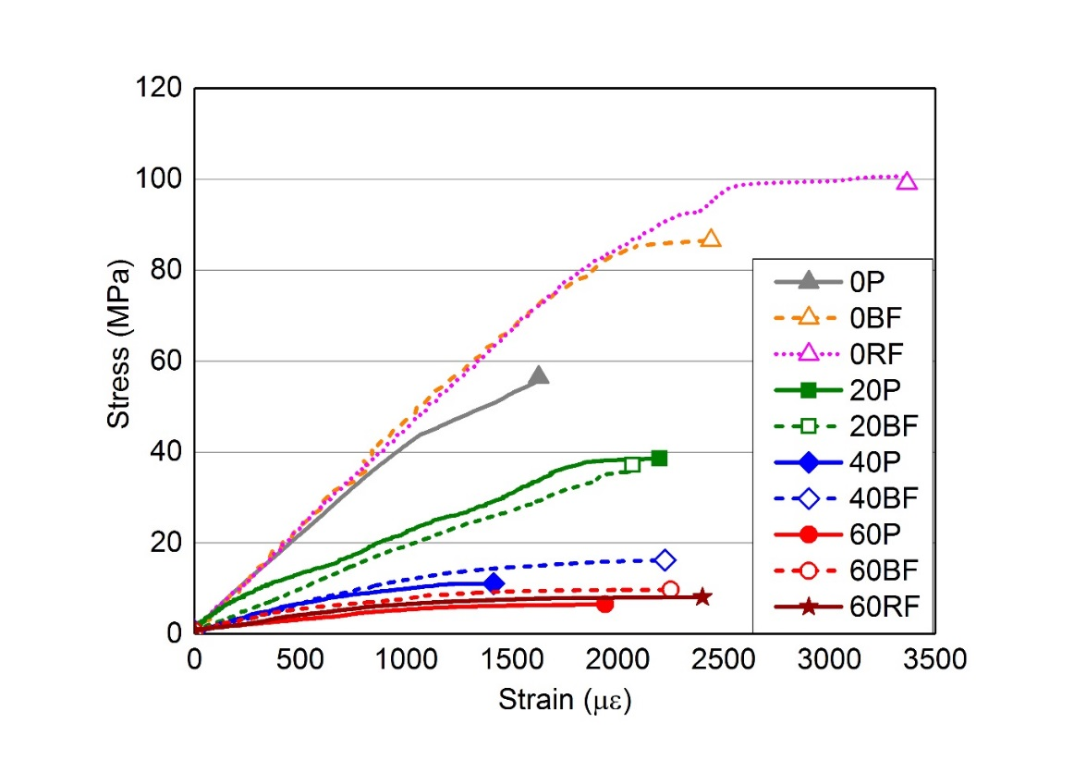

**Figure. 4** Stress-strain curves of the concrete assessed

It can be seen from Table 5 and Figure 4 that as the rubber content increases, the peak stress and the initial slope of the stress-strain curves substantially decreases. For the applications considered in this study (i.e. concrete pavements and slabs on grade), the loss in compression strength is not as important as the increase in deformability, provided that sufficient flexural strength is maintained.

Figure 5 shows that the modulus of elasticity of rubberised concretes (ERuC) without fibre addition, normalised with respect to the control concrete mix (Econtrol), reduces with an increased rubber content. Such reduction in stiffness can be attributed to the lower stiffness of rubber particles (compared to conventional aggregates) and to the higher air content, as confirmed in section 4.1.2. An exponential curve is also shown to provide an equation for the estimation of modulus of elasticity. The reduction in elastic stiffness may be undesirable in some structural applications, but it can help develop new structural solutions, in particular at the soil structure interaction level.

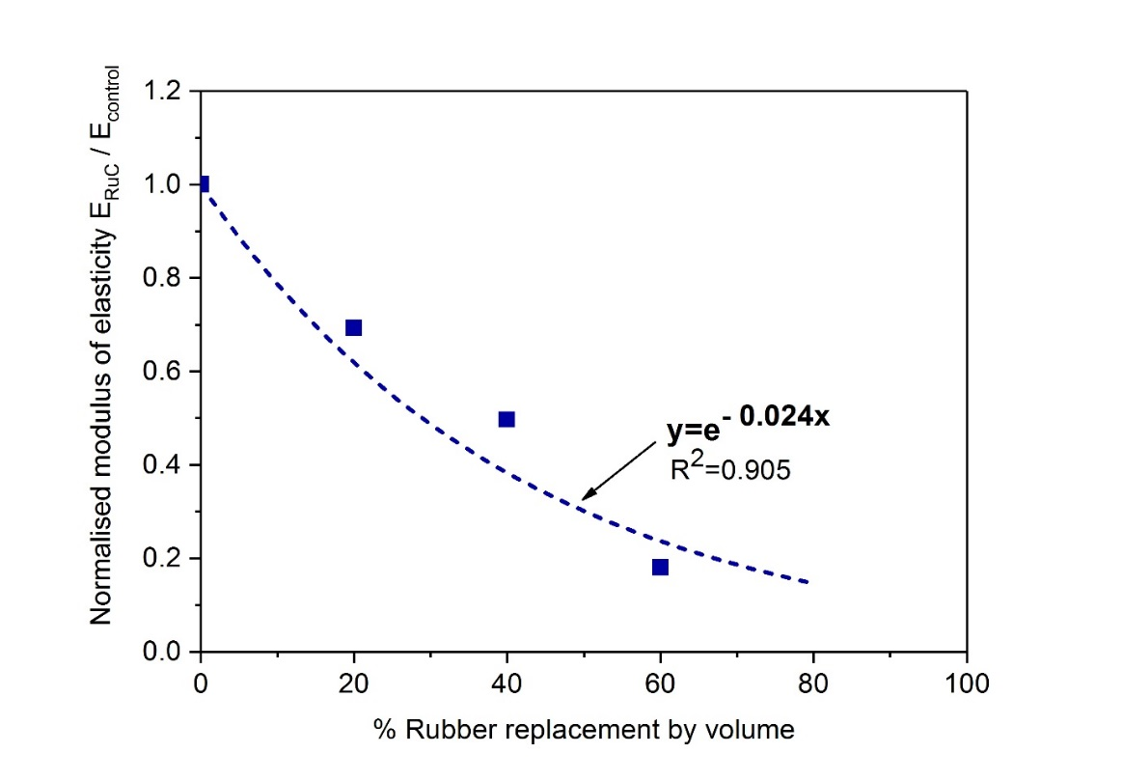

**Figure 5.** Correlation between the normalized modulus of elasticity of rubberised concretes as a function of rubber aggregate content

As shown in Table 5, the effect of steel fibres on compressive stiffness is not conclusive. However, steel fibres overall tend to increase the peak stress and corresponding strain (apart from mix *20BF*). This enhancement is expected due to the steel fibre ability to control the development of transverse deformations.

The addition of rubber and steel fibres had a more significant effect on the failure mode (Figure 6). Whilst the plain concrete specimens failed in a sudden and brittle manner, the RuC specimens failed in a much more ductile manner. This can be attributed to the relatively low elastic modulus of the rubber particles, which increases the deformation capacity before cracking, but also to the tensile resistance of rubber aggregates. The RuC specimens with steel fibres exhibited more (and thinner) vertical cracks at failure, compared to the ones without fibres. This suggests that ductility was also improved somewhat by adding fibres.

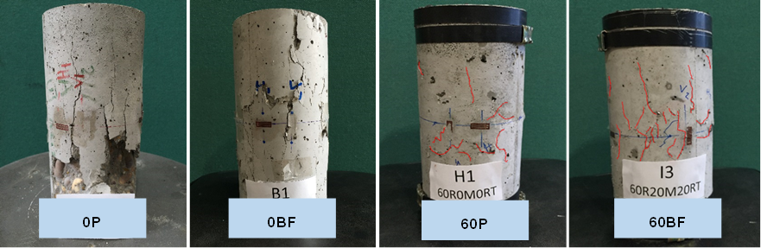

**Figure 6.** Typical compression failure of tested concrete cylinders

## Flexural behaviour

The failure mode was the same for all specimens and a typical example is shown in Figure 7; a single crack initiated at the notch of the mid-span section and propagated vertically towards the compression zone.



**Figure 7.** Photograph showing a typical flexural failure of the tested concrete prisms

The mean values (average of three prisms) of strain capacity, flexural strength and elastic modulus are shown in Table 6. The elastic theory was used to determine the flexural modulus of elasticity by using the secant modulus of the load-deflection curves (from 0 to 30% of the peak load).

**Table 6.** Mechanical properties of all concrete mixes tested in flexural

|  |  |  |  |  |  |  |  |  |  |  |
| --- | --- | --- | --- | --- | --- | --- | --- | --- | --- | --- |
| Mix ID | *0P* | *0BF* | *0RF* | *20P* | *20BF* | *40P* | *40BF* | *60P* | *60BF* | *60RF* |
| Age of testing  (days) | 60 | 60 | 61 | 61 | 62 | 62 | 63 | 63 | 64 | 64 |
| Flexural strength (MPa) | 7.3 (0.2) | 9.2 (0.8) | 9.5 (0.7) | 5.6 (0.1) | 6.9 (0.9) | 3.7 (0.4) | 6.6 (0.4) | 2.6 (0.2) | 5.5 (0.1) | 4.2 (0.3) |
| Modulus of elasticity  (GPa) | 46.8 (2.1) | 47.5 (1.0) | 48.3 (3.34) | 29.3 (2.31) | 34.0 (3.1) | 18.3 (2.6) | 23.5 (5.9) | 8.1 (1.6) | 8.3 (1.1) | 10.1 (2.5) |
| Strain capacity, δfmax  (mm) | 0.04  (0.01) | 0.06 (0.02) | 0.22 (0.07) | 0.05 (0.01) | 0.26 (0.32) | 0.06 (0.01) | 1.34 (0.21) | 0.14 (0.03) | 1.32 (0.74) | 0.55 (0.36) |

### 4.3.1 Flexural Strength

Flexural strength values are compared in Figure 8. The addition ofsteelfibres enhanced the flexural strength by 26% for *0BF* and 30% for *0RF*, with respect to the control mix. This improvement was anticipated as the steel fibres act as flexural reinforcement.

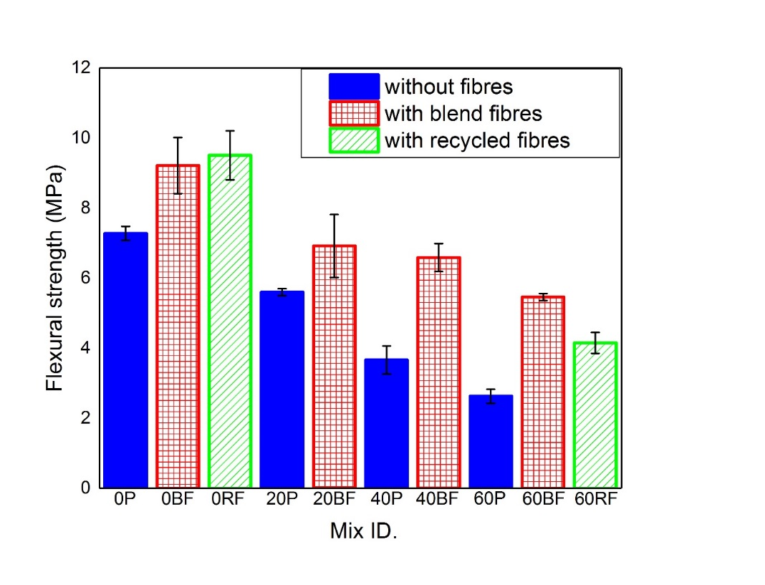

**Figure 8.** Flexural strength of the tested concrete mixes

Consistent with the reported by other authors [25, 36, 59], replacing the fine and coarse aggregates with rubber particles had an adverse effect on flexural strength. The flexural strength of the RuC mixes without fibres, *20P, 40P* and *60P,* was 23%, 49% and 64% lower than that of the conventional concrete, respectively. As for the compressive strength, the reduction in flexural strength may be attributed to the lack of good bonding conditions between the rubber particles and the cement paste, as well as the low stiffness and higher Poisson’s ratio of rubber (nearly 0.5) compared to conventional aggregates [20, 21]. The high Poisson’s ratio means that the rubber once in tension will contract faster than concrete in the lateral direction, facilitating loss of bond. The low stiffness also means that the rubber contributes very little in tension at the low strain at which the cement matrix cracks.

The addition of steel fibres in the RuC resulted in a substantial enhancement of its flexural strength, therefore mitigating the adverse effect of partially replaced natural aggregates by recycled rubber particles. By comparing the flexural strength of the SFRRuC mixes, *20BF, 40BF, 60BF* and *60RF,* with the flexural strength of the RuC mixes without fibres, *20P, 40P* and *60P*,it is noted that the flexural strength was increased by 23%, 78%, 111.5% and 61.5%, respectively. Although the flexural strength gain of the *60RF* mix is not as high as the *60BF* mix, it still provides sufficient flexural strength for SFRRuC pavements and slabs on grade and can potentially lead to more sustainable solutions by eliminating the need for virgin materials.

Figure 9 shows the normalised compressive and flexural strength for all mixes, with respect to the control mix (concrete without fibres and/or rubber). It is clear that the loss in compressive strength as a result of the addition of rubber is more pronounced than the flexural strength loss. Even without the fibres, the loss in flexural resistance of the RuC is less than the loss in compressive strength; this indicates that the rubber is making a modest contribution to the tensile capacity of the concrete in tension. When fibres are added, the tensile resistance is further enhanced and hence, considerable flexural resistance is developed even when large volumes of rubber are present.

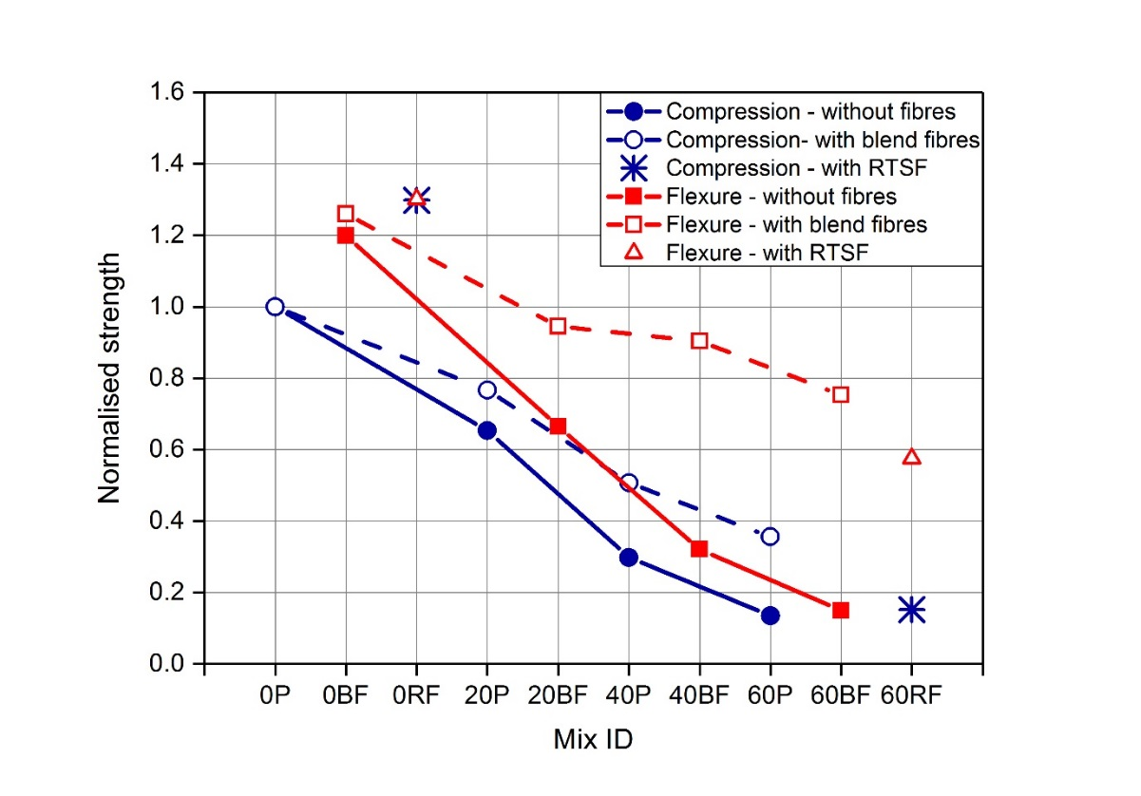

**Figure. 9** Normalised strength as a function of rubber volume in the concrete

### 4.3.2 Modulus of elasticity

The values obtained from the flexural tests are in general similar to those from the compressive tests. As expected, there is a small increase (up to 3%) in the elastic modulus when fibres are added. A significant reduction in the elastic modulus is also found for the RuC mixes, with the decrease being almost proportional to the amount of rubber content. In particular, the modulus of elasticity of the RuC mixes without fibres, *20P, 40P* and *60P*, was 37.4%, 60.9% and 82.7% lower than that of the control mix, respectively. The addition of steel fibres into RuC mixes recovered only marginally part of the modulus of elasticity loss. This confirms that, within the elastic domain, the inclusion of rubber particles plays a dominant role on flexural stiffness, whereas the steel fibres make a minimal contribution.

### 4.3.3 Strain capacity

The flexural strain capacity was assessed by examining the stress-deflection curves. The deflection δfmax corresponding to the peak stress, fmax, is taken as a relevant indicator of strain capacity [33]. It is evident from table 6 that the strain capacity is enhanced by the addition of fibres. For instance, the δfmax valuefor the control mix, *0P*, was 0.04 mm, while the δfmax values for *0BF* and *0RF* mixes were 0.06 and 0.22 mm, respectively. This enhancement can be explained by the bridging action of the fibres. The strain capacity of the RTSF mix, *0RF*,was higher than that of the blend fibres mix, *0BF*, possibly due to the larger number of RTSF fibres bridging the cracks.

The strain capacity also increases with higher rubber contents in the concrete. Compared to the control mix, *0P*, the δfmax of the RuC mixeswas increased by 25%, 50% and 250% for *20P, 40P* and *60P*, respectively. Turatsinze et al. [33] explained such behaviour by the ability of rubber particles to reduce stress concentration at the crack tip, thus delaying the coalescence and propagation of micro-cracks. Mixes with steel fibres and rubber developed the highest strain capacity values, indicating a synergy between rubber and steel fibres in enhancing strain capacity.

### 4.3.4 Residual flexural strength and energy absorption behaviour

The load versus deflection curves shown in Figure 10 confirm that the post-peak branches of the SFRC prisms without rubber were significantly enhanced as a result of the inclusion of fibres. The fibres continue bridging the cracks and resisting their opening even after the peak load, dissipating energy through the pull-out mechanism.

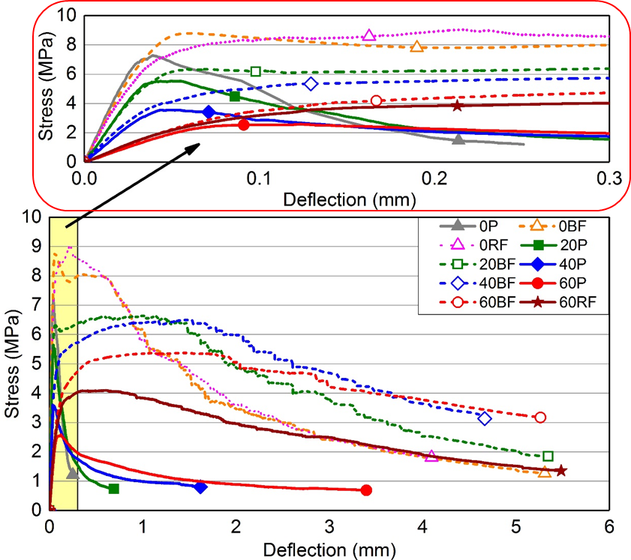

**Figure. 10** Average stress versus deflection curves for all concrete mixes studied

Although rubber particles had an adverse effect on the flexural strength of the concrete prisms, they improved slightly the post-peak energy absorption. This enhancement can be explained by the ability of the rubber particles to undergo large deformation in tension and promote high energy absorption. As a result of the interlocking and friction at fibre–matrix and fibre-rubber interfaces, steel fibres substantially enhanced the post-peak energy absorption and dissipation of RuC mixes, which at large displacements show higher flexural capacity than the specimens without rubber.

As expected, concrete prisms with a blend of fibres (MSF and RTSF) show superior post-peak energy absorption behaviour than those with RTSF alone. RTSF are overall better distributed and in general help control micro-cracks, while MSF are better at controlling cracks once they open and develop. Though the difference in performance is not obvious for normal concrete in Figure 10, this is well demonstrated at 60% rubber content when the 60BF controls the cracks much better than 60RF. In another study [43], the mixes with blend fibres are shown to outperform both the RTSF and MSF only mixes.

To further examine the post-peak energy absorption behaviour of the mixes, the residual flexural strength (fRi) and the characteristic residual flexural strength values (fRi,c) were obtained (see Table 7) at given intervals of CMOD (0.5, 1.5, 2.5, 3.5) according to RILEM recommendation [52]. The residual flexural strength can be considered a measure of toughness or even ductility of the SFRC mixes. Higher values of fR,i mean higher post-cracking load carrying capacity and higher ductility. The characteristic residual flexural strength fRi,c accounts for the variability of the residual flexural strength results. SFRRuC mixes showed a lower rate of reduction in residual strength than FRC mixes. This may be attributed to the presence of rubber particles that prolong the crack path and increase the contact area of the failure surface with the rubber particles, which make some contribution to the tensile strength, but also enable the steel fibres to engage better across the crack.

**Table 7.** Residual and characteristic flexural strength values of concrete assessed

|  |  |  |  |  |  |  |  |  |  |  |  |
| --- | --- | --- | --- | --- | --- | --- | --- | --- | --- | --- | --- |
| Mix  No. | Mix ID | fRi (MPa) | | | | fRi, c (MPa) | | | | fib (2010) classification | |
| fR1 | fR2 | fR3 | fR4 | fR1,c | fR2,c | fR3,c | fR4,c | fR3,c/fR1,c | Class |
| 1 | *0P* | - | - | - | - | - | - | - | - | - | - |
| 2 | *0BF* | 8.1 | 5.3 | 3.5 | 2.7 | 6.1 | 3.5 | 2.4 | 1.2 | 0.39 | - (< 0.5) |
| 3 | *0RF* | 8.4 | 5.2 | 3.7 | 2.8 | 8.3 | 4.7 | 2.9 | 1.8 | 0.35 | - (< 0.5) |
| 4 | *20P* | - | - | - | - | - | - | - | - | - | - |
| 5 | *20BF* | 6.5 | 6.6 | 5.4 | 4.3 | 4.4 | 4.9 | 3.3 | 2.3 | 0.75 | 4.4***b*** |
| 6 | *40P* | - | - | - | - | - | - | - | - | - | - |
| 7 | *40BF* | 5.9 | 6.4 | 6.4 | 5.4 | 4.9 | 5.8 | 5.6 | 4.6 | 1.14 | 4.9***d*** |
| 8 | *60P* | - | - | - | - | - | - | - | - | - | - |
| 9 | *60BF* | 5.1 | 5.4 | 5.3 | 4.7 | 4.4 | 5.2 | 5.1 | 3.8 | 1.16 | 4.4***d*** |
| 10 | *60RF* | 4.1 | 3.7 | 3.1 | 2.6 | 3.6 | 3.2 | 2.8 | 2.6 | 0.78 | 3.6***b*** |

*\** ***a***if 0.5  *fR3,c/fR1,c*  0.7*;* ***b***if 0.7 ≤  *fR3,c/fR1,c* ≤ 0.9; ***c***if 0.9 ≤  *fR3,c/fR1,c* ≤1.1;***d***if 1.1 ≤ *fR3,c/fR1,c* ≤ 3;e if ≤ *fR3,c/fR1,c*

According to fib model code [58] for structural applications with normal and high-strength concrete, SFRC can be classified according to the post-cracking residual strength (considering the value of fR1,c), and the ratio fR3,c/fR1,c. The higher the value of fR1,c and/or the ratio fR3,c/fR1,c, the higher the class. As observed in Table 7, mixes *40BF* and *60BF* show the best overall performance among all mixes, whereas SFRC mixes (without rubber) can not be classified as their fR3,c/fR1,c ratio is less than 0.5. Nevertheless, all SFRC mixes (conventional and rubberised) fulfilled the requirements of EN 14889-1 [60] – 1.5 MPa at 0.5 mm CMOD and 1.0 MPa at 3.5 mm CMOD – and could be used for practical applications.

The aim of this study is to develop a more flexible Portland cement concrete pavement. However, as flexible pavement standards/specifications relate to asphalt concrete, it is not possible to use them for a direct comparison, though the flexural performance of SFRRuC is far superior to that of asphalt concrete. Hence, SFRRuC pavements, though flexible, should comply with standards/specifications for rigid pavements. The major issue here is that the rigid pavement standards relay on the compressive and flexural strengths. Though all SFRRuC mixes studied here meet the flexural strength characteristics, as described in pavement design standard BS EN 13877-1[54], not all of them can meet the compressive requirements. However, provided that durability requirements are met, this should not be a big issue but would require modification on the standard.

## 4.4 Free shrinkage behaviour

Typical curves of total shrinkage versus time are shown in Figure 11. The vertical dotted line shown at 8 days indicates the start of drying shrinkage. The values predicted according to Eurocode 2 [61] for conventional concrete (accounting for temperature and humidity) are also included for comparison.

Both conventional concrete and SFRC mixes show lower autogenous and drying shrinkage strains than those predicted by Eurocode 2 (EC2). The difference between predicted and actual values for these mixes can be attributed to the presence of high quantities of silica fume and fly ash, not accounted for in the Eurocode 2 equation. It is also clear that the addition of rubber increases the overall shrinkage strains at 57 days by 15.5% for *20P*, 59% for *40P* and 127% for *60P*. This increase in free shrinkage strain with increasing rubber content is due to the lower stiffness of rubber particles compared to conventional aggregates, which reduces the overall internal restrain. The higher porosity and diffusivity of rubberised concrete prims can also contribute to increasing the rate of moisture loss and accelerating drying shrinkage.

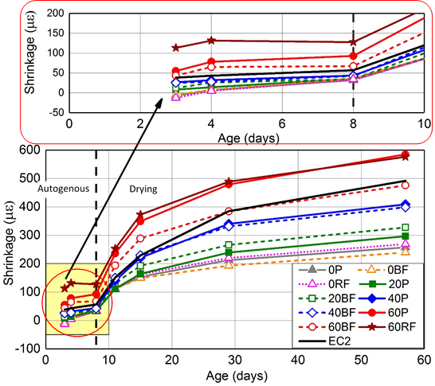

**Figure. 11** Total free shrinkage for all concrete mixes

# Conclusions

This study assessed the fresh state and mechanical properties of steel-fibre reinforced rubberised concretes (SFRRuC), in which waste tyre rubber partially replaced aggregates, and blends of manufactured and recycled tyre steel fibres were used as reinforcement. Based on the experimental results, the following conclusions can be drawn:

* The replacement of conventional aggregates with rubber particles reduces workability and unit weight, and increases air content of the fresh concrete mixes. Steel fibres further lower workability and increase air content, whilst marginally increasing unit weight.
* The mechanical properties (compressive and flexural strength, as well as the modulus of elasticity) decrease with increasing rubber content. Steel fibres in appropriate amounts (up to 40 kg/m3) enhance the mechanical properties of conventional concrete (up to 30% compressive strength) and provide modest increases in the modulus of elasticity.
* Free shrinkage strain increases with increasing rubber content as a result of the lower stiffness of rubber particles.
* In rubberised concrete, the addition of steel fibre reinforcement mitigates the loss in flexural strength (from 50% to 9.6% loss, compared to conventional concrete) and slightly improves compressive strength and modulus of elasticity (up to 12.5% and 28.4%, respectively), hence, they are an important component when RuC is to be used for structural purposes.
* Concrete strain capacity and post-peak energy absorption behaviour are enhanced by the addition of fibres and are further improved by the inclusion of rubber, completely transforming the flexural performance of RuC and enabling it to resist structural loads.
* A high performance (class d according to fib 2010 model code [58]) and highly flexible steel fibre reinforce rubberised concrete can be produced with 60% rubber content and blended fibres (20 kg/m3 of MSF and 20 kg/m3 of RTSF), suitable for pavement applications.

It is concluded that SFRRuC is a promising candidate material for use in structural concrete applications with increased toughness and flexibility requirements, such as road pavements and slabs on grade. Future work should be directed towards investigating the long-term performance of this innovative concrete in aggressive environments.

# Acknowledgements

The research leading to these results has received funding from the European 393 Union Seventh Framework 394 Programme [FP7/2007- 2013] under grant agreement n° 603722. The authors would also like to thank all of the material suppliers and companies for their in-kind contribution of materials for this research study: Tarmac UK, Sika, Aggregate Industries UK Ltd and Twincon Ltd. The first author PhD studies are sponsored by King Saud University and Ministry of Education in the Kingdom of Saudi Arabia.

# References

# [1] ETRA, The European Tyre Recycling Association. 2016, Available at: <http://www.etra-eu.org> [Last accessed: 02/01/2018].

# [2] Council of the European Union, Council Directive 1999/31/EC of 26 April 1999 on the landfill of waste. 1999.

# [3] Eldin, N.N. and A.B. Senouci. Measurement and prediction of the strength of rubberized concrete. Cement and Concrete Composites 1994;16(4):287-298.

# [4] Benazzouk, A., et al. Thermal conductivity of cement composites containing rubber waste particles: Experimental study and modelling. Construction and Building Materials 2008;22(4):573-579.

# [5] Mohammed, B.S., et al. Properties of crumb rubber hollow concrete block. Journal of Cleaner Production 2012;23(1):57-67.

# [6] Council of the European Union, Council Directive 2008/98/EC on waste (Waste Framework Directive). 2008.

# [7] Bravo, M. and J. de Brito. Concrete made with used tyre aggregate: durability-related performance. Journal of Cleaner Production 2012;25:42-50.

# [8] Thomas, B.S. and R.C. Gupta. A comprehensive review on the applications of waste tire rubber in cement concrete. Renewable and Sustainable Energy Reviews 2016;54:1323-1333.

# [9] Son, K.S., I. Hajirasouliha, and K. Pilakoutas. Strength and deformability of waste tyre rubber-filled reinforced concrete columns. Construction and Building Mateials. 2011;25(1):218-226.

# [10] Youssf, O., et al. An experimental investigation of crumb rubber concrete confined by fibre reinforced polymer tubes. Construction and Building Materials 2014;53:522-532.

# [11] Raffoul, S., et al. Optimisation of rubberised concrete with high rubber content: An experimental investigation. Construction and Building Materials 2016;124:391-404.

# [12] Bompa, D., et al. Experimental assessment and constitutive modelling of rubberised concrete materials. Construction and Building Materials 2017;137:246-260.

# [13] Grinys, A., et al. Fracture of concrete containing crumb rubber. Journal of Civil Engineering and Management 2013;19(3):447-455.

# [14] Liu, F., et al. Mechanical and fatigue performance of rubber concrete. Construction and Building Materials 2013;47:711-719.

# [15] Sukontasukkul, P. and C. Chaikaew. Properties of concrete pedestrian block mixed with crumb rubber. Construction and Building Materials 2006;20(7):450-457.

# [16] Ling, T.C., H.M. Nor, and S.K. Lim. Using recycled waste tyres in concrete paving blocks. Proceedings of the ICE - Waste and Resource Management 2010;163(1):37-45.

# [17] Issa, C.A. and G. Salem. Utilization of recycled crumb rubber as fine aggregates in concrete mix design. Construction and Building Materials 2013;42:48-52.

# [18] Güneyisi, E., et al. Evaluation of the rheological behavior of fresh self-compacting rubberized concrete by using the Herschel–Bulkley and modified Bingham models. Archives of Civil and Mechanical Engineering 2016;16(1):9-19.

# [19] Flores-Medina, D., N.F. Medina, and F. Hernández-Olivares. Static mechanical properties of waste rests of recycled rubber and high quality recycled rubber from crumbed tyres used as aggregate in dry consistency concretes. Materials and Structures 2014;47(7):1185-1193.

# [20] Khatib, Z. and F. Bayomy. Rubberized portland cement concrete. Journal of Materials in Civil Engineering 1999;11(3):206-213.

# [21] Khaloo, A.R., M. Dehestani, and P. Rahmatabadi. Mechanical properties of concrete containing a high volume of tire–rubber particles. Waste Management 2008;28(12):2472-2482.

# [22] Richardson, A.E., K. Coventry, and G. Ward. Freeze/thaw protection of concrete with optimum rubber crumb content. Journal of Cleaner Production 2012;23(1):96-103.

# [23] Batayneh, M., I. Marie, and I. Asi. Promoting the use of crumb rubber concrete in developing countries. Waste Management 2008;28(11):2171-2176.

# [24] Bignozzi, M.C. and F. Sandrolini. Tyre rubber waste recycling in self-compacting concrete. Cement and Concrete Research 2006;36(4):735-739.

# [25] Ganjian, E., M. Khorami, and A.A. Maghsoudi. Scrap-tyre-rubber replacement for aggregate and filler in concrete. Construction and Building Materials 2009;23(5):1828-1836.

# [26] USFD, Thin wire reinforcement for concrete’. B.P. Application, Editor. 2001: UK.

# [27] Pilakoutas, K., K. Neocleous, and H. Tlemat. Reuse of tyre steel fibres as concrete reinforcement. Proceedings of the ICE-Engineering Sustainability 2004;157(3):131-138. ISSN 1478-4629.

# [28] Neocleous, K., et al. Fibre-reinforced roller-compacted concrete transport pavements. Proceedings of the ICE-Transport 2011;164(TR2):97-109.

# [29] Tlemat, H., K. Pilakoutas, and K. Neocleous. Stress-strain characteristic of SFRC using recycled fibres. Materials and structures 2006;39(3):365-377.

# [30] Angelakopoulos, H., K. Neocleous, and K. Pilakoutas. Steel fibre reinforced roller compacted concrete pavements. Challenges for Civil Construction 2008:16-18.

# [31] Aiello, M.A., et al. Use of steel fibres recovered from waste tyres as reinforcement in concrete: Pull-out behaviour, compressive and flexural strength. Waste management 2009;29(6):1960-1970.

# [32] Graeff, A.G., et al. Fatigue resistance and cracking mechanism of concrete pavements reinforced with recycled steel fibres recovered from post-consumer tyres. Engineering Structures 2012;45:385-395.

# [33] Turatsinze, A., J.L. Granju, and S. Bonnet. Positive synergy between steel-fibres and rubber aggregates: Effect on the resistance of cement-based mortars to shrinkage cracking. Cement and Concrete Research 2006;36(9):1692-1697.

# [34] Nguyen, T., A. Toumi, and A. Turatsinze. Mechanical properties of steel fibre reinforced and rubberised cement-based mortars. Materials & Design 2010;31(1):641-647.

# [35] Ganesan, N., J.B. Raj, and A. Shashikala. Flexural fatigue behavior of self compacting rubberized concrete. Construction and Building Materials 2013;44:7-14.

# [36] Xie, J.-h., et al. Compressive and flexural behaviours of a new steel-fibre-reinforced recycled aggregate concrete with crumb rubber. Construction and Building Materials 2015;79:263-272.

# [37] Medina, N.F., et al. Mechanical and thermal properties of concrete incorporating rubber and fibres from tyre recycling. Construction and Building Materials 2017;144:563-573.

# [38] BSI, EN 197-1: Cement — Part 1: Composition, specifications and conformity criteria for common cements. BSI 389 Chiswick High Road, London W4 4AL, UK. 2011.

# [39] ASTM, C136: Standard test method for sieve analysis of fine and coarse aggregates. ASTM International, West Conshohocken, PA. doi:10.1520/C0136-06. 2006.

# [40] BSI, EN 1097-6: Tests for mechanical and physical properties of aggregates, Determination of particle density and water absorption. BSI 389 Chiswick High Road, London W4 4AL, UK. 2013.

# [41] BSI, EN 1097-3: Tests for mechanical and physical properties of aggregates, Determination of loose bulk density and voids. BSI 389 Chiswick High Road, London W4 4AL, UK. 1998.

# [42] BSI, EN 933-3: Tests for geometrical properties of aggregates, Determination of particle shape – Flakiness index. BSI 389 Chiswick High Road, London W4 4AL, UK. 2012.

# [43] Hu, H., et al. Mechanical properties of SFRC using blended manufactured and recycled tyre steel fibres. Construction and Building Materials 2018;163:376-389.

# [44] BSI, EN 12350-2: Testing fresh concrete, Part 2: Slump-test. BSI 389 Chiswick High Road, London W4 4AL, UK. 2009.

# [45] BSI, EN 12350-7: Testing fresh concrete, Part 7: Air content — Pressure. BSI 389 Chiswick High Road, London, W4 4AL, UK. 2009.

# [46] BSI, EN 12350-6: Testing fresh concrete Part 6: Density. BSI 389 Chiswick High Road, London, W4 4AL, UK. 2009.

# [47] BSI, EN 12390-2: Testing hardened concrete, Part 2: Making and curing specimens for strength tests. BSI 389 Chiswick High Road, London W4 4AL, UK. 2009.

# [48] BSI, EN 14651:+A1:2007: Test method for metallic fibre concrete — Measuring the flexural tensile strength (limit of proportionality (LOP), residual) ICS 91.100.30. BSI 389 Chiswick High Road, London W4 4AL, UK. 2005.

# [49] BSI, EN 12390-3: Testing hardened concrete, Part3: Compressive strength of test specimens. BSI 389 Chiswick High Road, London W4 4AL, UK. 2009.

# [50] Garcia, R., et al. Seismic retrofitting of RC buildings using CFRP and post-tensioned metal straps: shake table tests. Bulletin of Earthquake Engineering 2015:1-27.

# [51] JCI. SF-4: Method of test for flexural strength and flexural toughness of steel fiber reinforced concrete. Japan Concrete Institute, Tokio, Japan. 1984.

# [52] RILEM, TC 162-TDF: Test and design methods for steel fibre reinforced concrete, Bending test, Final Reccomendation. Materials and Structures: 35, 579-582. 2002.

# [53] BSI, EN 12617-4: Products and systems for the protection and repair of concrete structures — Test methods —Part 4: Determination of shrinkage and expansion. BSI 389 Chiswick High Road, London W4 4AL, UK. 2002.

# [54] BSI. EN 13877-1. Concrete pavements Part 1: Materials. BSI 389 Chiswick High Road London W4 4AL UK. 2013.

# [55] BSI, BS EN 206-1. Concrete —Part 1: Specification, performance,production and conformity. BSI 389 Chiswick High Road London W4 4AL. 2000.

# [56] Siddique, R. and T.R. Naik. Properties of concrete containing scrap-tire rubber–an overview. Waste Management 2004;24(6):563-569.

# [57] Abaza, O.A. and Z.S. Hussein. Flexural Behavior of Steel Fiber-Reinforced Rubberized Concrete. Journal Of Materials In Civil Engineering 2015;28(1):04015076.

# [58] fib, Model Code for Concrete Structures 2010. Federal Institute of Technology Lausanne–EPFL, Section Génie Civil, Swizerland. 2010. p. 978-3.

# [59] Aiello, M.A. and F. Leuzzi. Waste tyre rubberized concrete: properties at fresh and hardened state. Waste Manag 2010;30(8-9):1696-704.

# [60] BSI, EN 14889-1: Fibres for concrete — Part 1: Steel fibres — Definitions, specifications and conformity. BSI 389 Chiswick High Road, London W4 4AL, UK. 2006.

# [61] BSI, EN1992-1-1. Eurocode 2: Design of concrete structures — Part 1-1: General rules and rules for buildings. BSI 389 Chiswick High Road, London W4 4AL, UK. 2004.