**Supplementary Online Content**

Aude Nicolas, Alan E. Renton, Faraz Faghri, et al. Large-scale meta-analysis of genome-wide association data identifies new loci for amyotrophic lateral sclerosis

This supplementary material has been provided by the authors to give readers additional information about their work.

Table of contents (needs reordering)

Supplementary Note 3

Supplementary Figure 1. Power curves 7

Supplementary Figure 2. Multi-dimensional scaling plot 8

Supplementary Figure 3. QQ plot of logistic regression analysis *P*-values 9

Supplementary Figure 4. QQ plot of mixed model analysis *P*-values 10

Supplementary Figure 5. QQ plot of gene burden exome analysis *P*-values 11

Supplementary Figure 6. Regional association plots 12

Supplementary Figure S7. Forest plots 24

Supplementary Figure S7. Chromatograms 25

Supplementary Table 1. Demographics of samples included in analysis 27

Supplementary Table 2. DbGaP studies contributing to analysis 28

Supplementary Table 3. Additional information on associated SNPs 29

Supplementary Table 4. Additional information on associated SNPs 30

Supplementary Table 5. Phenotype of *KIF5A* mutation carriers 31

Supplementary Table 6. Conditional association analyses 32

Supplementary Table 6. *P*-values for previously reported loci. 33

References 34

# Supplementary Note

**Part 1. Additional Acknowledgments and Funding**

We thank the patients and research subjects who contributed samples for this study.

This study utilized the high-performance computational capabilities of the Biowulf Linux cluster at the National Institutes of Health, Bethesda, Maryland (http://biowulf.nih.gov).

The Genotype-Tissue Expression (GTEx) Project was supported by the Common Fund of the Office of the Director of the National Institutes of Health, and by NCI, NHGRI, NHLBI, NIDA, NIMH, and NINDS. The data used for the analyses described in this manuscript were obtained from the GTEx Portal on 07/30/2017.

This study makes use of data generated by the Wellcome Trust Case-Control Consortium. A full list of the investigators who contributed to the generation of the data is available from www.wtccc.org.uk. Funding for the project was provided by the Wellcome Trust under award 076113, 085475 and 090355.

This work was supported by the HYPERGENES project (European Network for Genetic-Epidemiological Studies: building a method to dissect complex genetic traits, using essential hypertension as a disease model), grant HEALTH-2007-201550, funded by the European Union within the seventh Framework Programme.

DNA samples were obtained from the NINDS Repository at Coriell, Camden, NJ; and from the North-East ALS (NEALS) Consortium Sample Repository, Boston, MA.

Brain tissue was obtained from the Baltimore Longitudinal Study on Aging at the Johns Hopkins School of Medicine, Baltimore, MD; from the NICHD Brain and Tissue Bank for Developmental Disorders at the University of Maryland, Baltimore, MD; from the University of Pennsylvania Brain Bank, Philadelphia, PA; from the New York Brain Bank-The Taub Institute, Columbia University, New York, NY; and, from the Department of Veterans Affairs Biorepository, Boston, MA.

**Part 2. Consortium Members**

ITALSGEN consortium members and affiliations:

Francesco O. Logullo1; Isabella Simone2; Giancarlo Logroscino2,3; Fabrizio Salvi4; Ilaria Bartolomei4; Giuseppe Borghero5; Maria Rita Murru5; Emanuela Costantino5; Carla Pani5; Roberta Puddu5; Carla Caredda5; Valeria Piras5; Stefania Tranquilli; 5 Stefania Cuccu5; Daniela Corongiu5; Maurizio Melis5; Antonio Milia5; Francesco Marrosu5; Maria Giovanna Marrosu5; Gianluca Floris5; Antonino Cannas5; Stefania Tranquilli5; Margherita Capasso6; Claudia Caponnetto7; Gianluigi Mancardi7; Paola Origone7; Paola Mandich7; Francesca L. Conforti8; Gabriele Mora9; Kalliopi Marinou9; Riccardo Sideri9; Silvana Penco10; Lorena Mosca10; Christian Lunetta11; Giuseppe Lauria Pinter12; Massimo Corbo13; Nilo Riva14; Paola Carrera14; Paolo Volanti15; Jessica Mandrioli16; Nicola Fini16; Antonio Fasano16; Lucio Tremolizzo17; Alessandro Arosio17; Carlo Ferrarese17; Francesca Trojsi18; Gioacchino Tedeschi18; Maria Rosaria Monsurrò18; Giovanni Piccirillo18; Cinzia Femiano18; Anna Ticca19; Enzo Ortu20; Vincenzo La Bella21; Rossella Spataro21; Tiziana Colletti21; Mario Sabatelli22; Marcella Zollino22; Amelia Conte22; Marco Luigetti22; Serena Lattante22; Giuseppe Marangi22; Marialuisa Santarelli23; Antonio Petrucci24; Maura Pugliatti25; Angelo Pirisi25; Leslie D. Parish25; Patrizia Occhineri25; Fabio Giannini26; Stefania Battistini26; Claudia Ricci26; Michele Benigni26; Tea B. Cau27; Daniela Loi27; Andrea Calvo28; Cristina Moglia28; Maura Brunetti29; Marco Barberis28; Gabriella Restagno29; Federico Casale28; Giuseppe Marrali28; Giuseppe Fuda28; Irene Ossola28; Stefania Cammarosano28; Antonio Canosa28; Antonio Ilardi28; Umberto Manera28; Davide Bertuzzo28; Raffaella Tanel30; Fabrizio Pisano31

1. Neurological Clinic, Marche Polytechnic University, Ancona, Italy
2. Department of Basic Medical Sciences, Neurosciences and Sense Organs, University of Bari, Bari, Italy
3. Department of Clinical and Research Neurology, “Pia Fondazione Cardinal G. Panico” Hospital, Tricase (LE), Bari, Italy
4. Center for Diagnosis and Cure of Rare Diseases, Department of Neurology, IRCCS Institute of Neurological Sciences, Bologna, Italy
5. Department of Neurology, Azienda Universitario Ospedaliera di Cagliari and University of Cagliari, Cagliari, Italy
6. Department of Neurology, University of Chieti, Chieti, Italy
7. Department of Neurosciences, Ophthalmology, Genetics, Rehabilitation, Maternal and Child Health, IRCCS Azienda Ospedaliero-Universitaria San Martino IST, Genoa, Italy
8. Institute of Neurological Sciences, National Research Council, Mangone, Cosenza, Italy
9. Department of Neurological Rehabilitation, Fondazione Salvatore Maugeri, IRCCS, Istituto Scientifico di Milano, Milano, Italy
10. Department of Laboratory Medicine, Medical Genetics, Niguarda Ca' Granda Hospital, Milan, Italy
11. NEuroMuscular Omnicenter, Serena Onlus Foundation, Milan, Italy
12. Neuroalgology and Headache Unit, IRCCS Fondazione Istituto Neurologico "Carlo Besta”, Milano, Italy
13. Department of Neurorehabilitation Sciences (P.T., M.C.), Casa Cura Policlinico, Milan, Italy
14. Department of Neurology and Institute of Experimental Neurology (INSPE), IRCCS San Raffaele Scientific Institute, Milan, Italy
15. Neurorehabilitation Unit/ALS Center, Scientific Clinical Institutes (ICS) Maugeri, IRCCS, Mistretta, Messina, Italy
16. Department of Neuroscience, S. Agostino-Estense Hospital, University of Modena and Reggio Emilia, Modena, Italy
17. Neurology Unit, School of Medicine and Surgery and NeuroMI, University of Milano-Bicocca, Monza, Italy
18. Department of Medical, Surgical Neurological Metabolic and Aging Sciences, Second University of Naples, Naples, Italy
19. Department of Neurology, Azienda Ospedaliera San Francesco, Nuoro, Italy.
20. Division of Neurology, "A. Segni" Hospital, Ozieri, Italy
21. ALS Clinical Research Center, Bio. Ne. C., University of Palermo, Palermo, Italy.
22. Centro Clinico NEMO-Roma. Neurological Institute, Catholic University and I.C.O.M.M. Association for ALS Research, Rome, Italy
23. Department of Medicine, Azienda Complesso Ospedaliero, San Filippo Neri, Rome, Italy
24. Neurology Department, San Camillo Hospital, Rome, Italy
25. Department of Biomedical and Surgical Sciences, Section of Neurological, Psychiatric and Psychological Sciences, University of Ferrara, Ferrara, Italy
26. Department of Medical, Surgical and Neurological Sciences, University of Siena, Siena, Italy
27. Azienda Sanitaria Locale n. 2, Olbia-Tempio, Olbia, Italy
28. "Rita Levi Montalcini" Department of Neuroscience, Amyotrophic Lateral Sclerosis Center, University of Turin, Turin, Italy; Azienda Ospedaliero Universitaria Città della Salute e della Scienza, Turin, Italy
29. Molecular Genetics Unit, Department of Clinical Pathology, A.S.O. O.I.R.M.-S. Anna, 10126 Turin, Italy
30. Department of Neurology, Santa Chiara Hospital, Trento, Italy
31. Department of Neurological Rehabilitation, "Salvatore Maugeri" Clinical-Scientific Institute, Istituto di Ricovero e Cura a Carattere Scientifico, Veruno, Italy

**AALS**

**Create**

**Project Mine**

**NYGC**

**GTAC**

# Supplementary Figure 1. Multi-dimensional scaling plot of the 44,558 genotyped samples included in analysis compared to the HapMap populations

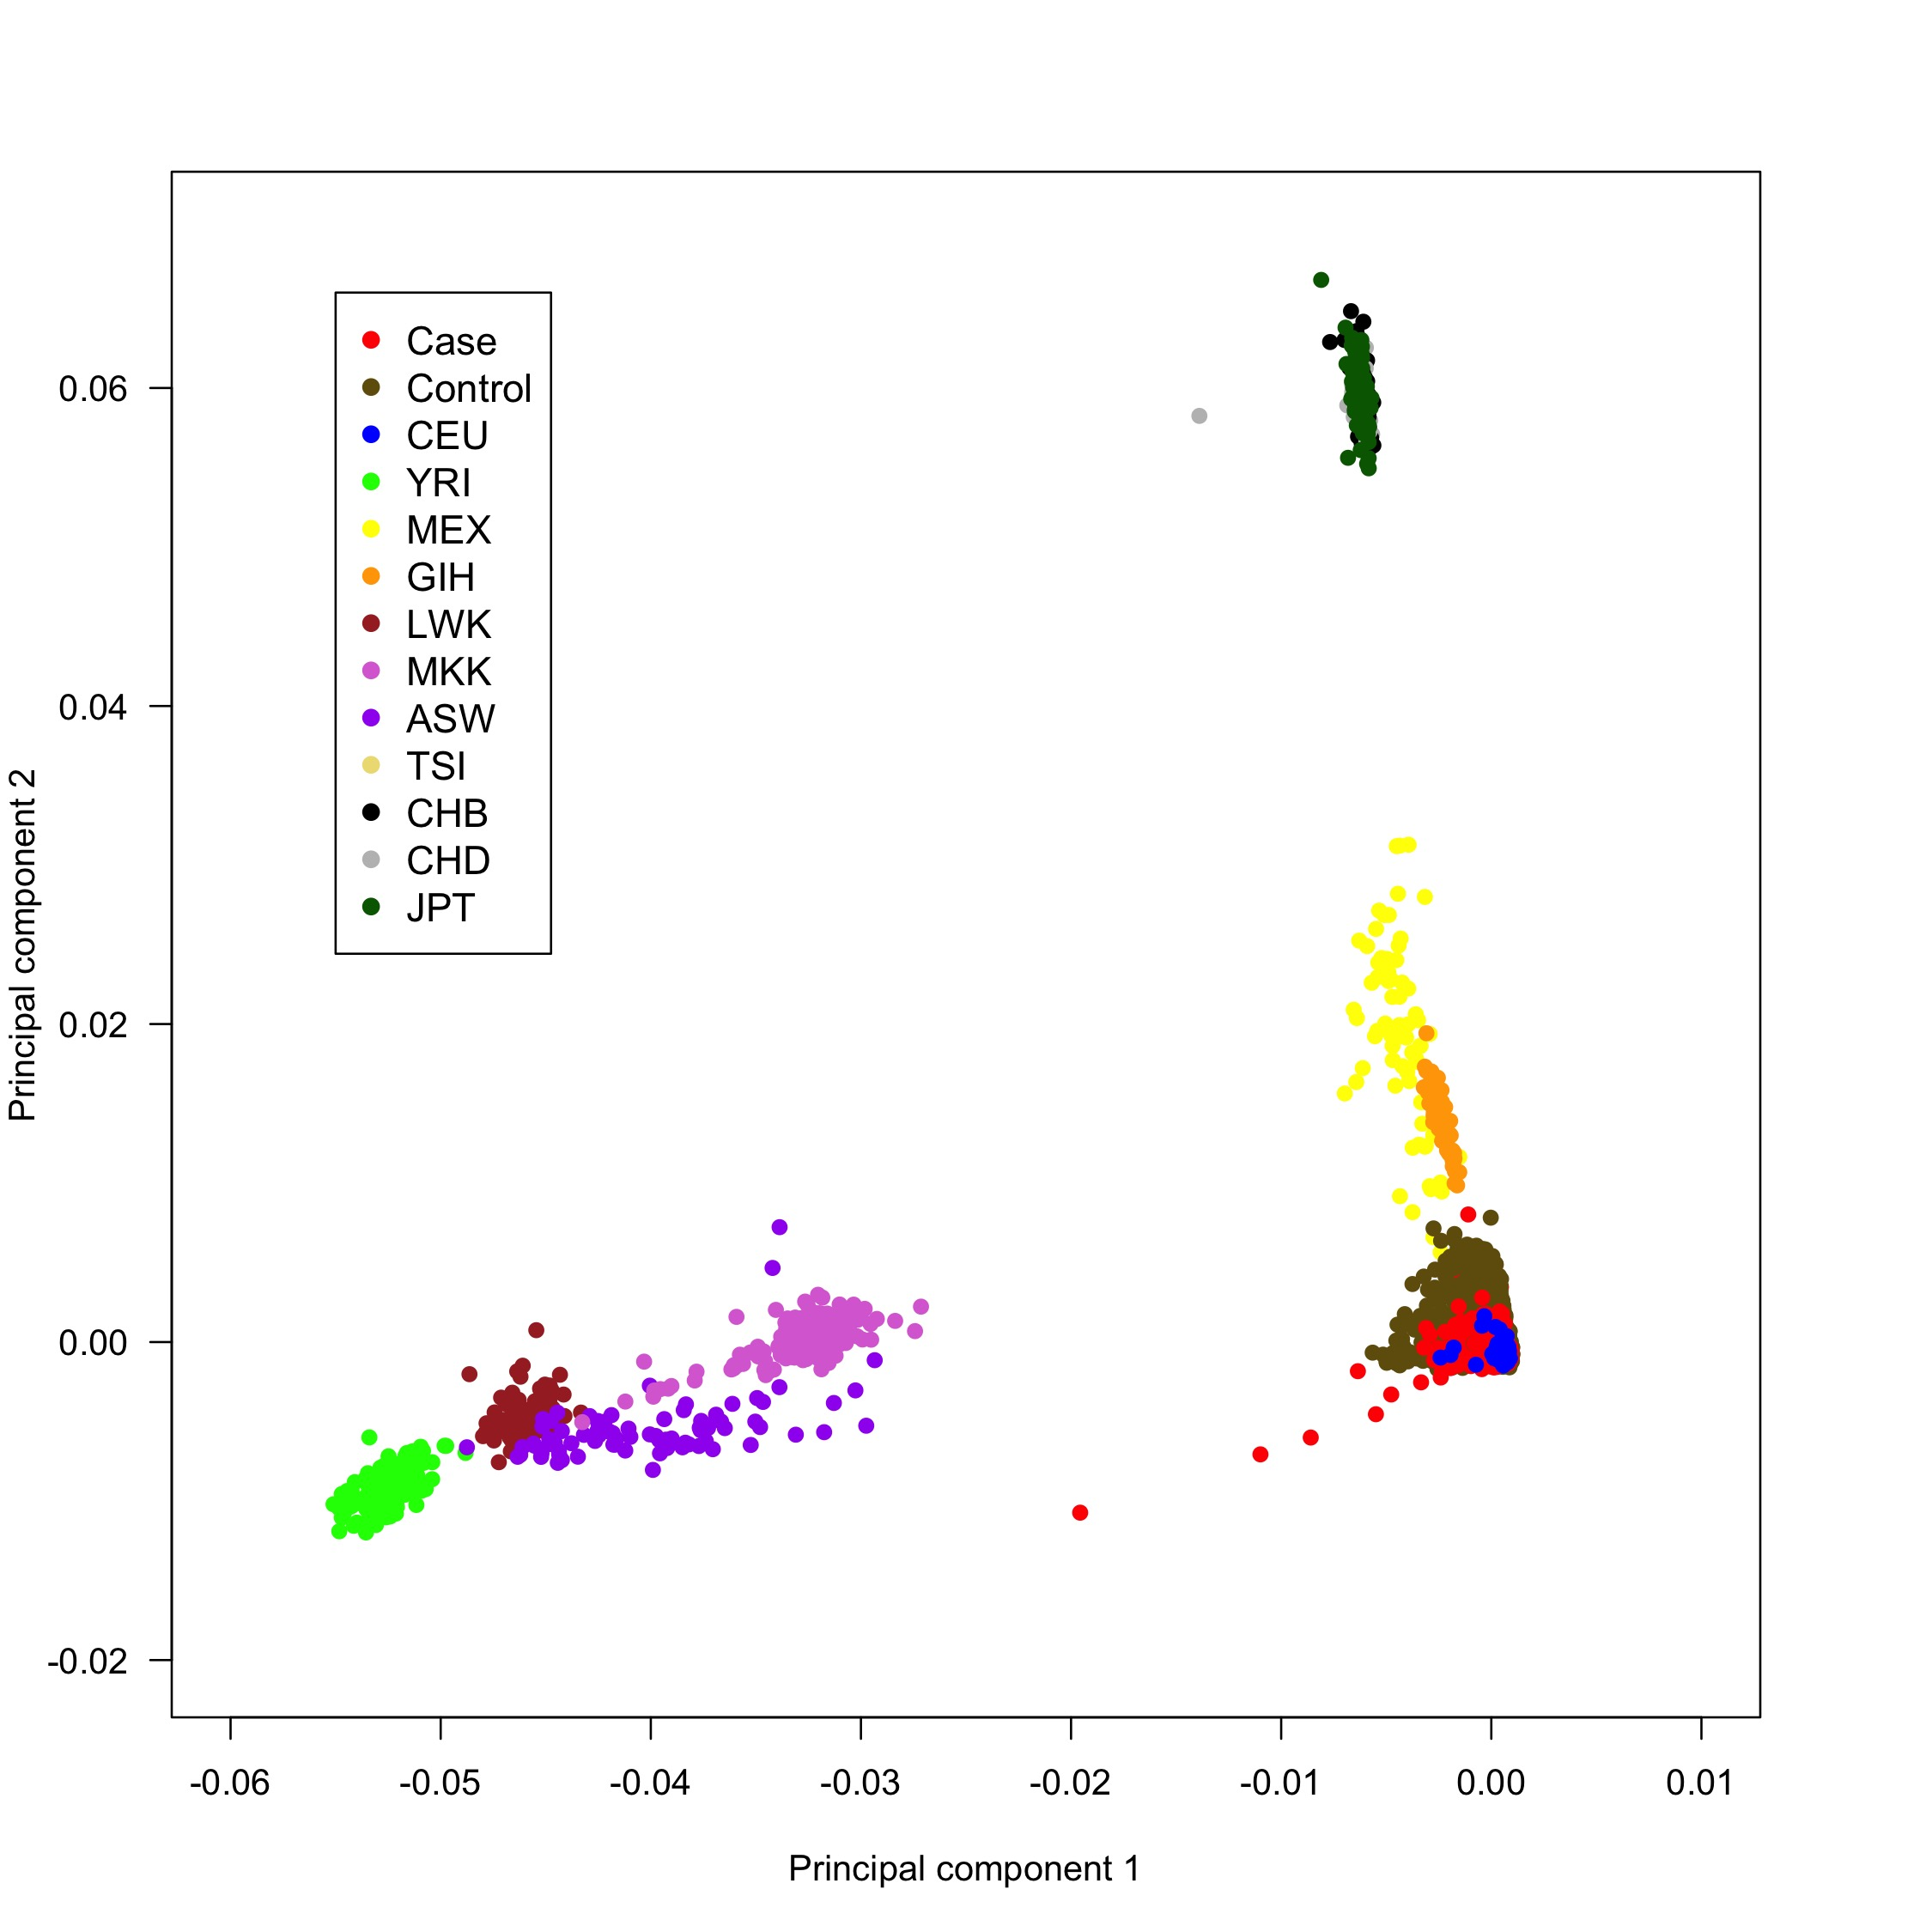

# Supplementary Figure 2. QQ plot of *P*-values from the meta-analysis based on logistic regression analysis. The black curve represents all SNPs, and the red curve represent SNPs after excluding variants within +/- 200 kilobases of C9orf72 and UNC13a loci. Raw lambda = 1.042 and adjusted lambda scaled to 1,000 cases and 1,000 controls = 1.001 based on the entire SNP dataset.

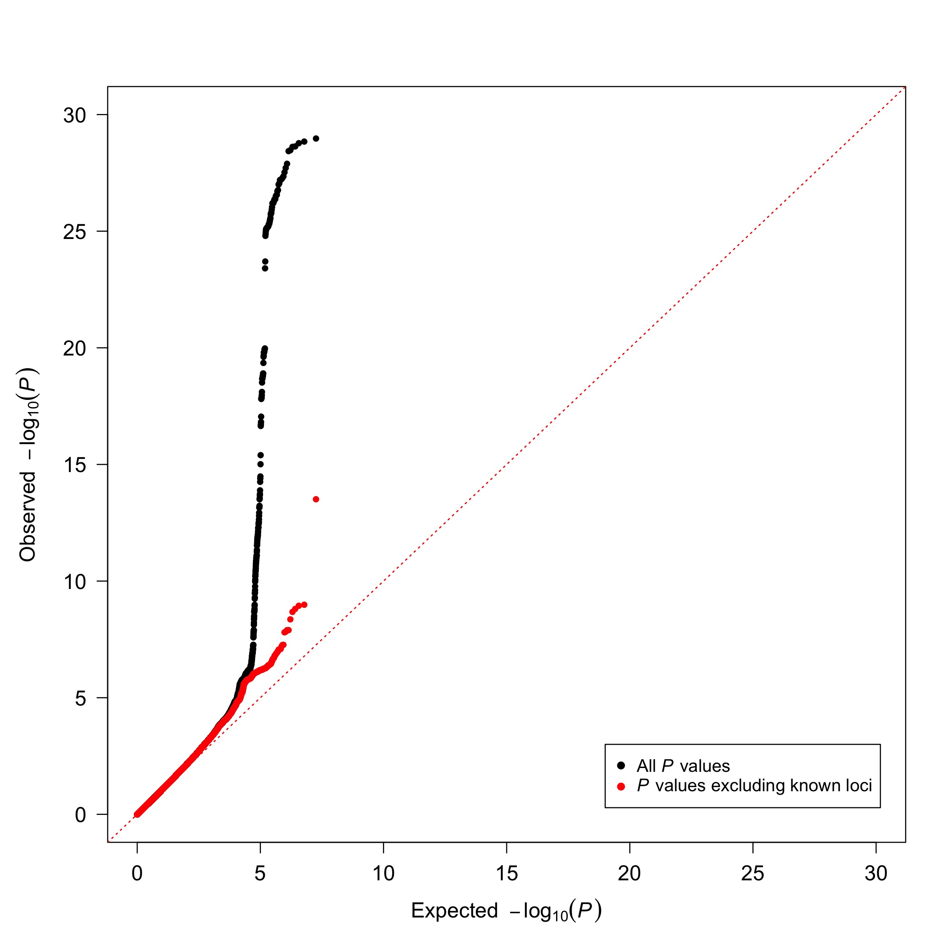

# Supplementary Figure 3. Power to detect associate loci for a cohort of 20,806 cases and 59,804 control subjectsa

Power calculations were performed using the QUANTO software program (version 1.2.4, available from: http://hydra.usc.edu/gxe) under an additive model assuming two-tailed *P* value of 5.0x10-8 (threshold *P* value for significance after Bonferroni correction for multiple testing), population risk of 0.0001 and complete linkage equilibrium between the genotyped SNP and the causative allele. Based on our findings for rs142321490 in the KIF5A locus on chromosome 12 (see **Table 1** in the main paper), a cohort of 20,806 cases and 59,804 controls has ~99.5% power to detect an associated SNP with a minor allele frequency of 0.018 and an odds ratio of 1.37 under the additive model.



**Supplementary Figure 4. QC of FALS discovery cohort.**

Starting cohort included sequencing data for 1,463 FALS and 41,410 control samples. Samples were then excluded in the event of outlying ancestry (>3SD from mean along PC1-4 in PCA analyses, see Supplementary Figure 5), exome-wide call rate<70%, outlying heterozygosity (F<-0.1 or F>0.1), SNP predicted and reported gender discrepancy or detectable relatedness to another retained sample (Kinship coefficient>0.0442; >3rd degree relationship).

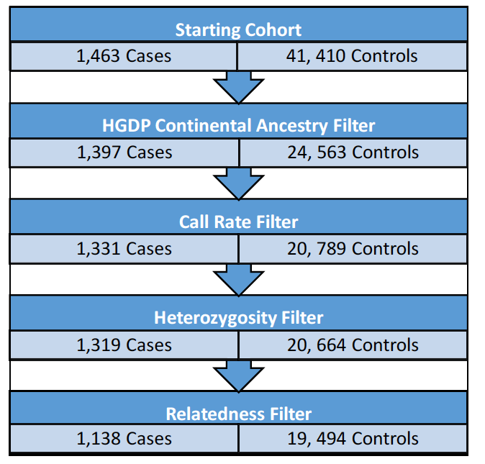

# Supplementary Figure 5. Multi-dimensional scaling plot of samples included in RVB analysis compared to the Human Diversity Panel

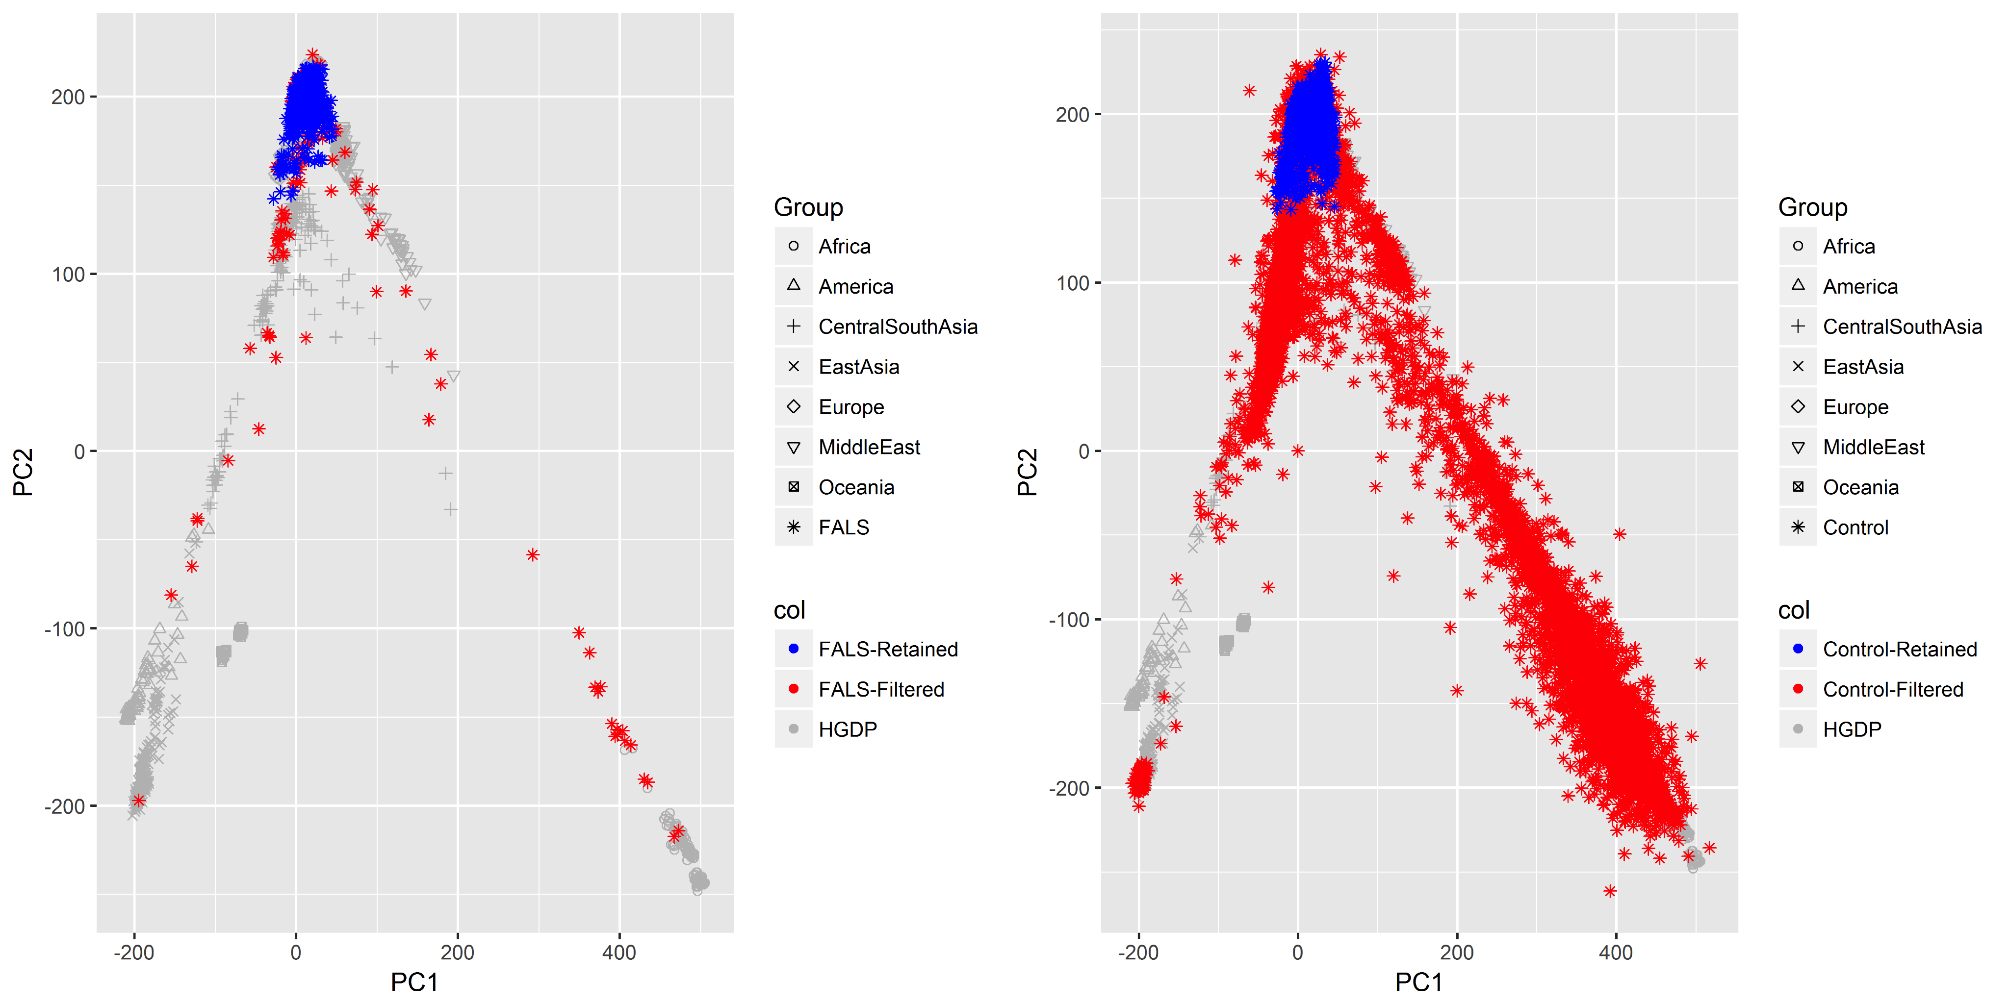

# Supplementary Figure 6. QQ plot of *P*-values from the meta-analysis based on gene burden analysis of exome data. The black curve represents all genes. Raw lambda = 0.460 (we calculated 0.93) and adjusted lambda scaled to 1,000 cases and 1,000 controls = 0.749 based on the entire SNP dataset.

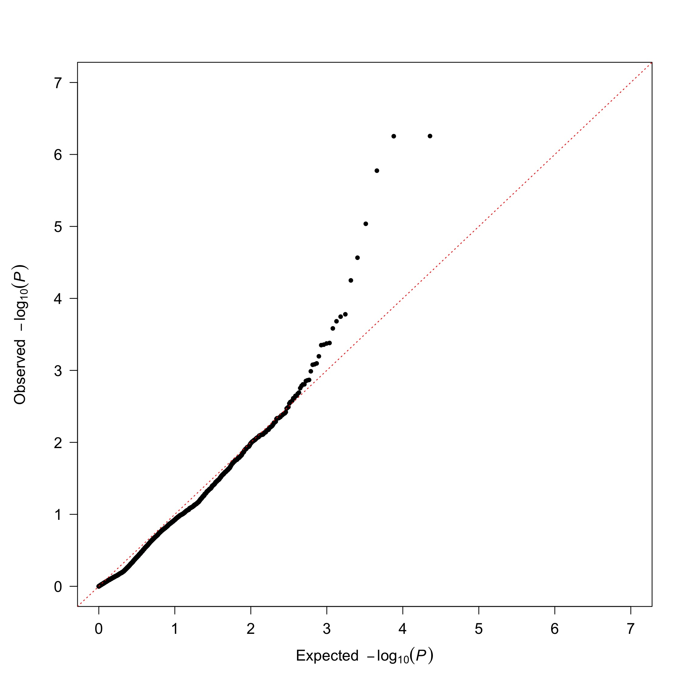

**Supplementary Figure 7. Control-control Analyses.**



# Supplementary Figure 8. Plot of variant call rate across the KIF5A protein-coding region in FALS versus controls analyzed by RVB.

# 

# Supplementary Figure 9. Regional association plots for most associated SNPs in each locus from Table 1. The R2 pattern is based on most significant SNP per locus using 379 European ancestry samples from the November 2010 release of the 1000 genomes project dataset. Recombination rates are from HapMap phase 2 European ancestry samples. *P*-values in the first six loci are based on the logistic regression analysis, whereas *P*-values in the last six loci are based on the mixed model analysis.

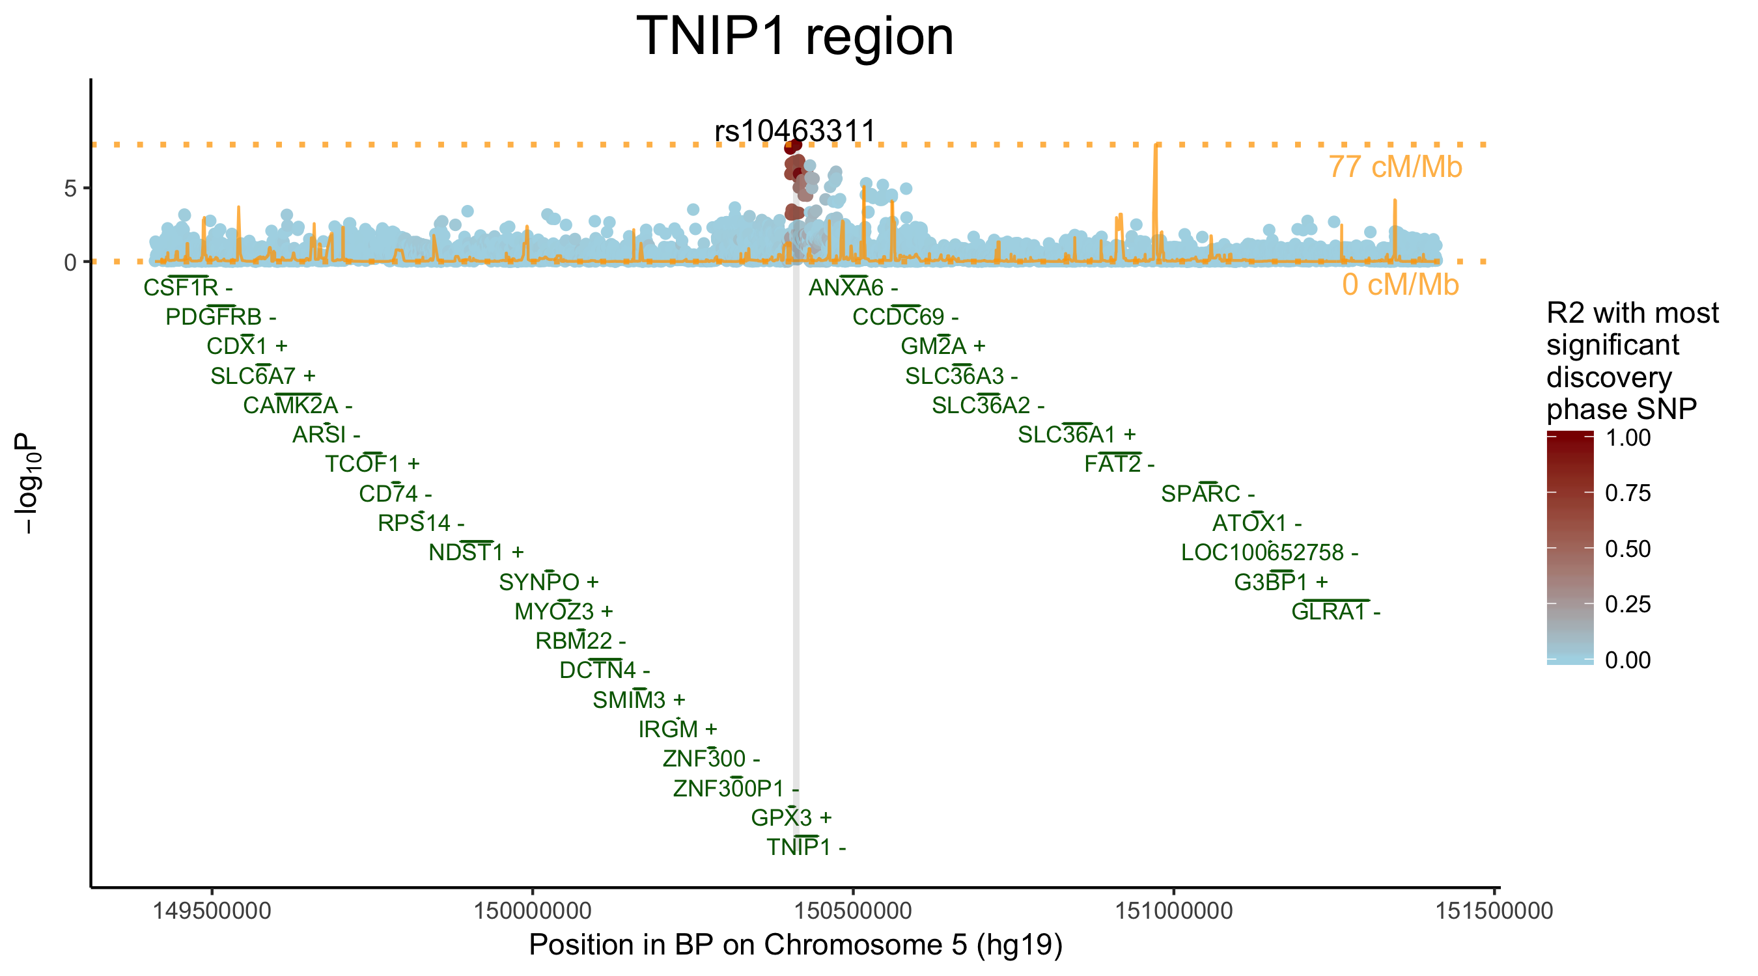

*P* values are based on cohort without cases carrying the *C9orf72* repeat expansion

Need *ACSL5- maybe zoom in closer*

# Supplementary Table 1. Demographics and baseline characteristics of patients diagnosed with ALS and control individuals included in analysis

|  |  |  |  |  |  |  |  |  |  |  |  |  |  |  |
| --- | --- | --- | --- | --- | --- | --- | --- | --- | --- | --- | --- | --- | --- | --- |
|  | **US** | |  | **Italian** | |  | **UK** | |  | **French &**  **Belgian** | |  | **Total cohort** | |
|  | cases | controls |  | cases | controls |  | cases | controls |  | cases | controls |  | cases | controls |
| **Sample number** | 3,777 | 33,365 |  | 2,853 | 2,143 |  | 449 | 226 |  | 1,150 | 595 |  | 8,229 | 36,329 |
|  |  |  |  |  |  |  |  |  |  |  |  |  |  |  |
| **Female**  **(%)** | 1,515  (40.1) | 23,870  (71.5) |  | 1,239  (43.4) | 896  (41.8) |  | 193  (43.0) | 109  (48.2) |  | 486  (42.3) | 422  (70.9) |  | 3,433  (41.7) | 25,297  (69.6) |
|  |  |  |  |  |  |  |  |  |  |  |  |  |  |  |
| **Age**  **(SD)** | 58.1  (12.3) | 64.2  (13.3) |  | 61.8  (11.8) | 50.6  (17.4) |  | 60.3  (12.8) | 57.0  (0.0) |  | 60.5  (12.6) | 66.9  (16.8) |  | 59.8  (12.3) | 63.4  (13.9) |
|  |  |  |  |  |  |  |  |  |  |  |  |  |  |  |
| **Bulbar-onset\***  **(%)** | 963  (25.5) | - |  | 741  (26.0) | - |  | 141  (31.4) | - |  | 357  (31) | - |  | 2,202  (26.8) | - |
|  |  |  |  |  |  |  |  |  |  |  |  |  |  |  |
| **Family history†**  **(%)** | 458  (12.1) | - |  | 248  (8.7) | - |  | 54  (12.0) | - |  | 195  (17.0) | - |  | 955  (11.6) | - |

SD, standard deviation. *Data not available for site of symptom onset for 199 patients. †Data not available for familial history of 154 patients.

# Supplementary Table 2. DbGaP studies contributing to analysis

|  |  |  |  |  |  |  |
| --- | --- | --- | --- | --- | --- | --- |
| **Accession Number** | **Study** | **Sample number** | **Females (%)** | **Average age (SD)** | **Genotyping platform** | **Ascertainment criteria** |
| **phs000001** | NEI Age-Related Eye Disease Study (AREDS) | 1,644 | 959 (58.3) | 68.2 (4.8) | HumanOmni2.5 | Population controls |
| **phs000007** | Framingham Cohort | 1,298 | 718 (55.3) | 75.7 (8.6) | HumanOmni5 | Population controls |
| **phs000187** | High Density SNP Association Analysis of Melanoma | 1,027 | 414 (40.3) | 51.3 (12.6) | HumanOmniExpress | Population controls |
| **phs000196** | CIDR: The NeuroGenetics Research Consortium Parkinson's Disease Study | 10 | 6 (60) | 74.3 (18.6) | HumanOmni1 | Population controls |
| **phs000292** | GENEVA Genetics of Early Onset Stroke (GEOS) Study | 89 | 0 (0) | 41.5 (6.4) | HumanOmni1 | Population controls |
| **phs000304** | Genes and Blood Clotting Study (GABC) | 403 | 259 (64.3) | 21.6 (3.3) | HumanOmni1 | Population controls |
| **phs000315** | Woman's Health Initiative (WHI GARNET) | 4,206 | 4206 (100) | 65.7 (6.9) | HumanOmni1 | Population controls |
| **phs000368** | Polycystic Ovary Syndrome Genetics (POLYGEN) | 2,974 | 2973 (100) | 46.8 (15.2) | HumanOmniExpress | Population controls |
| **phs000372** | Alzheimer's Disease Genetics Consortium Genome Wide Association Study | 533 | 335 (62.9) | 75.8 (9) | HumanOmniExpress | Population controls |
| **phs000394** | Autopsy-Confirmed Parkinson Disease GWAS Consortium (APDGC) | 299 | 152 (50.8) | 82.1 (12.6) | HumanOmni1 | Population controls |
| **phs000397** | NIA Long Life Family Study (LLFS) | 1,804 | 957 (53) | 65.9 (12.3) | HumanOmni2.5 | Population controls |
| **phs000404** | The Genetic Architecture of Smoking and Smoking Cessation | 81 | 50 (61.7) | 36.6 (5.9) | HumanOmni2.5 | Population controls |
| **phs000421** | A Genome-Wide Association Study of Fuchs' Endothelial Corneal Dystrophy | 497 | 294 (59.2) | 70.4 (10.2) | HumanOmni2.5 | Population controls |
| **phs000428** | Health and Retirement Study (HRS) | 9,394 | 5437 (57.9) | 68.4 (9.4) | HumanOmni2.5 | Population controls |
| **phs000615** | NINDS Stroke Genetics Network (SiGN) | 743 | 416 (56) | 56 (16.1) | HumanOmni5 | Population controls |
| **phs000675** | GWAS on Selected WHI Hormone Trial European Americans | 5,626 | 5626 (100) | 68 (5.9) | HumanOmni1 | Population controls |
| **phs000801** | NCI Non-Hodgkin Lymphoma GWAS | 1,544 | 790 (51.2) | 58.4 (11.6) | HumanOmniExpress | Population controls |
| **phs000869** | Barrett's and Esophageal Adenocarcinoma Genetic Susceptibility Study (BEAGESS) | 1,174 | 271 (23.1) | 61.3 (10.9) | HumanOmni1 | Population controls |

# Supplementary Table 3. SNPs achieving genome-wide significance based on logistic regression analyses

|  |  |  |  |  |  |  |  |  |  |  |  |  |  |  |  |  |  |  |  |  |  |  |  |
| --- | --- | --- | --- | --- | --- | --- | --- | --- | --- | --- | --- | --- | --- | --- | --- | --- | --- | --- | --- | --- | --- | --- | --- |
| **SNP Information** | | | | | |  | |  | |  | |  | **Current study**  **(8,229 cases &**  **36,329 controls)** | | |  | **Van Rheenen**  **(12,577 cases &**  **23,475 controls)** | | |  | **Meta-analysis**  **(20,806 cases &**  **59,804 controls)** | | |
| SNP | | C. | Position (bp) | Gene | Effect  allele | | Alt.  allele | | Effect allele freq. | |  | | I2 | Beta | Std.  error |  | I2 | Beta | Std.  error |  | I2 | Beta | Std.  error |
| rs10463311a | 5 | | 150,410,835 | *TNIP1* | T | | C | | 0.744 | |  | |  |  |  |  | 0.6 | -0.0995 | 0.0202 |  | 0.0 | -0.0899 | 0.0158 |
| rs3849943 | | 9 | 27,543,382 | *C9orf72* | T | | C | | 0.752 | |  | | 8.1 | -0.1690 | 0.0244 |  | 65.9 | -0.1808 | 0.0202 |  | 0.9 | -0.1760 | 0.0155 |
| rs142321490 | | 12 | 58,676,132 | *KIF5A* | C | | G | | 0.018 | |  | | 4.5 | 0.3522 | 0.0838 |  | 0.0 | 0.2923 | 0.0655 |  | 0.0 | 0.3150 | 0.0516 |
| rs74654358 | | 12 | 64,881,967 | *TBK1* | A | | G | | 0.047 | |  | | 0.0 | 0.1982 | 0.0587 |  | 17.6 | 0.2058 | 0.0416 |  | 0.0 | 0.2033 | 0.0339 |
| rs12973192 | | 19 | 17,753,239 | *UNC13A* | C | | G | | 0.675 | |  | | 40.9 | -0.1535 | 0.0267 |  | 0.0 | -0.1057 | 0.0189 |  | 42.2 | -0.1216 | 0.0154 |
| rs75087725 | | 21 | 45,753,117 | *C21orf2* | A | | C | | 0.015 | |  | | 36.5 | 0.6742 | 0.1647 |  | 0.0 | 0.4787 | 0.0738 |  | 35.2 | 0.5114 | 0.0673 |

Note, position is in Human Genome Assembly build 37. Nearest gene or previously published gene names are included. C., chromosome; Alt. allele, alternate allele; Effect allele freq., effect allele frequency; I2, heterogeneity statistic; Std. error, standard error. avalues presented for the Current study and for the Meta-analysis are after removing 690 cases carrying the *C9orf72* repeat expansion.

# Supplementary Table 4. Clinical information of probands and relatives carrying KIF5A LOF Variants

|  |  |  |  |  |  |  |  |  |  |  |  |
| --- | --- | --- | --- | --- | --- | --- | --- | --- | --- | --- | --- |
| **Position** | **Variant** | **Relation to Proband** | **DNA Available** | **Exon** | **cDNA** | **Description** | **Gender** | **Age of Onset (years)** | **Site of Onset** | **Survival (months)** | **Alive** |
| 57,975,729 | GA>A | Proband | Y | 26 | c.2987delA | p.Asp996fs | M | 45 | n/a | n/a | n/a |
| 57,976,382 | C>T | Proband | Y | 27 | c.2993-3C>T | 5' Splice Junction | M | 29 | L | >264 | Y |
| 57,976,382 | C>T | Sister | Y | 27 | c.2993-3C>T | 5' Splice Junction | F | 52 | L | 84 | N |
| 57,976,382 | C>T | Brother | Y | 27 | c.2993-3C>T | 5' Splice Junction | M | 18 | L | 324 | N |
|  |  | Brother | N |  |  |  | M | n/a | L | n/a | N |
| 57,975,731 | CA>C | Sporadic | Y | 26 | c.2989delA | p.Asn997fs | F | 50 | L | >96 | Y |
| 57,976,384 | G>A | Sporadic |  | 27 | c.2993-1G>A | 5' Splice Junction |  |  |  |  |  |
| 57,976,385 | GA>G | Proband | Y | 27 | c.2996delA | p.Asn999fs | M | 42 | L | >12 | Y |
|  |  | Brother | N |  |  |  | M | 38 | n/a | 24 | N |
| 57,976,411 | A>G | Proband | Y | 27 | c.3019A>G | p.Arg1007Gly | F | 53 | L | 45 | N |
| 57,976,412 | G>A | Proband | Y | 27 | c.3020G>A | p.Arg1007Lys | M | 50 | L | >108 | Y |
| 57,976,413 | G>A | Proband | Y | 27 | c.3020+1G>A | 3' Splice Junction | M | 45 | B | >220 | Y |
|  |  | Parent | N |  |  |  | n/a | 47 | n/a | 156 | N |
|  |  | Uncle/Aunt | N |  |  |  | n/a | 57 | n/a | 144 | N |
|  |  | Uncle/Aunt | N |  |  |  | n/a | 55 | n/a | 121 | N |
|  |  | Uncle/Aunt | N |  |  |  | n/a | 46 | n/a | 24 | N |
| 57,976,414 | T>A | Proband | Y | 27 | c.3020+2T>A | 3' Splice Junction | M | 46 | B | 124 | N |
| 57,976,414 | T>A | Brother | Y | 27 | c.3020+2T>A | 3' Splice Junction | M | 48 | L | 117 | N |
|  |  | Mother | N |  |  |  | F | 35 | L | 144 | N |
| 57,976,415 | A>G | Proband | Y | 27 | c.3020+3A>G | 3' Splice Junction | M | 50 | B | 54 | N |

All mutations were heterozygous; Genomic coordinates in NCBI build 37; Protein change based on transcript NM_004984.3;

# Supplementary Table 5. Demographic and clinical information of probands and relatives carrying KIF5A LOF Variants

|  |  |  |  |  |
| --- | --- | --- | --- | --- |
| **Analysis** | **FALS** | **Control** | **OR** | **P** |
| Missense - Full CDS | 9 (0.79%) | 80 (0.41%) | 1.93(0.915-3.60) | 8.09x10-2 |
| Missense - Motor Domain | 3 (0.26%) | 18 (0.09%) | 3.27(0.86-9.25) | 7.74x10-2 |
| Missense - Microtubule Binding Domain | 2 (0.18%) | 8 (0.04%) | 5.07(0.95-18.52) | 5.57x10-2 |
| Missense - Coiled-Coil Domain | 3 (0.26%) | 55 (0.28%) | 1.01(0.28-2.60) | 9.83x10-1 |
| Missense - C-Terminal Domain | 3 (0.26%) | 7 (0.04%) | 7.23(1.74-24.55) | 9.41x10-3 |
| Loss of Function | 6 (0.53%) | 3 (0.02%) | 32.07(9.05-135.27) | 5.55x10-7 |
| Loss of Function (Including Frameshift) | 9 (0.79%) | 3 (0.02%) | 46.29(14.61-186.00) | 2.62x10-10 |

# References