Abstract
A common argument in the violent video game (VVG) literature is that the greater the realism of a game, the more it activates aggressive concepts, and the greater antisocial effects it will have on its players.
Several experiments have therefore looked into whether the graphical realism of VVGs might influence their effects. These experiments have returned mixed results. However, there are other ways that a VVG can be realistic besides looking like the real world. More specifically, things in VVGs can not only look realistic, they can also behave realistically. It may be the case that this kind of realism leads to increases in the activation of aggressive concepts, rather than increases in graphical realism.
In this paper, we therefore present two large-scale online experiments (n=898 and n=1880) which investigate the effects of two different manipulations of behavioural realism on the activation of aggressive concepts in VVGs. In neither experiment did increasing realism increase the activation of aggressive concepts.
Realism is often described as increasing the effects of VVGs. These results contradict this perspective, and instead suggest that realism may not lead to increases in aggression-related variables.

Introduction
Realism is a game’s ability “to mimic things that exist, or events that have happened in real life” (Malliet, 2006). Since the early 1970s, researchers have argued that the more ‘real’ on-screen violence in television and film seems, the more aggressive viewers themselves are likely to become (e.g. (Geen, 1975)). This link between realism and aggressive behaviour has extended into accounts of the potential effects of VVGs. For instance, (C. Barlett et al., 2008) links the increased realism of modern VVGs to potentially increased effects, writing that “theoretically, violent video game graphics quality could be related to aggression-related variables, as they are more graphically enhanced to depict violent acts and blood in great detail and quality.”. This view, that greater realism may lead to more aggressive behaviour, is echoed throughout the VVG literature (e.g. (Krcmar et al., 2011)).
Despite this theoretical rationale, experimental evidence for a link between realism and VVG effects has thus far proved weak. Several experiments have attempted to clarify the effects of realism on the players of VVGs. These experiments have produced mixed or otherwise inconclusive results. However, it is important to note that previous research has largely focused on the effects of graphical realism in VVGs (e.g. (Jeong et al., 2012; Zendle et al., 2015)). Graphical realism refers to the ability of video games to visually resemble real people, places and things. This is not the only way that video games can be realistic. By contrast, behavioural realism refers to the ability of things in a video game to behave like things in the real world (Cheng and Cairns, 2005). The effects of behavioural realism on aggression-related variables have not yet been investigated in an experimental context. The experiments presented here address this important gap in the literature.
Experiment 1 investigated whether making in-game enemies behave realistically via the use of ragdoll physics increased the activation of aggressive concepts in players. A bespoke first-person shooter (FPS) game was made, and then manipulated so that it formed two different experimental conditions. In one of these conditions, the implementation of ragdoll physics gave enemies dynamic and physically realistic death behaviours. In the other condition, these deaths were instead animated via less realistic (and non-dynamic) pre-recorded animation sequences. The results of a large online experiment (n=898) indicated that the use of ragdoll physics did not increase the activation of aggressive concepts.
Experiment 2 investigated the effects of a different form of behavioural realism. This experiment looked at the effects of realistic non-player character (NPC) tactics on the activation of aggressive concepts in VVGs. In this game, two versions of a bespoke FPS game were again created. In one condition NPC enemies behaved according to realistic squad-based tactics, whilst in the other condition they used less realistic, simpler behaviours. Results of a large online experiment (n=1880) indicated that more realistic NPC tactics may lead to marginally less activation of aggressive concepts in VVGs, but they certainly do not lead to more.
When taken together, these experiments suggest that greater behavioural realism does not necessarily lead to greater amounts of the activation of aggressive concepts in VVGs. This provides further evidence that increases to the realism of VVGs may not necessarily lead to similar increases in their antisocial effects.

Background

Graphical realism and behavioural realism
Realism refers to a game’s ability to imitate the real world. This term is often used to describe the quality of a game’s graphics. A variety of technological innovations in modern VVGs can be used to make these games look more like their real world counterparts. For instance, the increasing processing power of modern computers allows them to render 3D models which use ever larger numbers of polygons. This has allowed the transition of objects in VVGs from simple geometric shapes to “more realistic or organic” (Tavinor, 2009) forms.
However, it is important to note that changes in the dimensions of texture maps and the number of polygons in 3D models are not the only factors which are relevant to the realism of video games. When discussing the realism of a game, it does not “suffice to observe what is visible on the computer or television screen”, but “in addition, one must look at the program rules that govern the pace of the game” (Malliet, 2006) as well. In other words, when it comes to realism in video games the way things behave as well as how they look matters. This idea that a game’s realism is also to do with how closely its “objects and characters act in comparison to the same object in the real world” (Cheng and Cairns, 2005) is sometimes referred to as that game’s ‘behavioural realism’ or ‘simulational realism’ (Ribbens and Malliet, 2010) as opposed to its ‘graphical realism’.
Ragdoll Physics
Just as there are a variety of ways that VVGs can be made more graphically realistic, there are several different methods that can be used to make them more behaviourally realistic. One key way that behavioural realism can be increased is through the use of ragdoll physics. Physics is thought to play an important role in “conveying realistic fictional worlds” (Tavinor, 2009) in video games. Therefore, a common way to make in-game characters “realistically interact” (Schell, 2014) with each other is through the use of ragdoll physics. In this approach, game developers build a physical simulation of each of a game’s characters as a collection of jointed bodies joined together into a skeleton. They then simulate the reaction of this ‘ragdoll’ to whatever force killed them, and animate the character accordingly. When ragdoll physics is used, in-game characters therefore react to collisions in a way which is in keeping with how they would behave the real world. This technique is commonly used in VVGs to animate the deaths of in-game characters in physically realistic ways (Hertzmann and Zordan, 2011).
NPC Tactics
By contrast, a very different way to add behavioural realism to a VVG is through the tactics which non-player characters (NPC) use. VVGs such as Far Cry feature NPC characters who are deliberately programmed to act in ways which realistically reflect how combatants behave in real-life combat situations. For instance, in 1998’s Half Life, one early reviewer noted that “the infantry squads will split up, trying to hit you from several sides while one guy keeps you pinned or lobs grenades” (Bates, 1998).
Similarly, in the recent VVG The Last of Us, enemy characters used ‘flanking’ tactics on the player (Rabin, 2015). In this tactic, one group of NPCs ‘pins down’ the player with bursts of continuous fire, whilst a second group “maneuvers around to their flank and then cuts across from the side to finish them off” (Rabin, 2015).
This is not the only way that NPC tactics in VVGs can mimic the way that real-world combatants fight. As game designer Ernest Adams points out in (Adams and Rollings, 2007), there are a plethora of tactics which can influence the behavioural realism of a VVG:
“Depending on the degree of realism offered, tactics can include flanking maneuvers, sneak attacks, creating diversions, cutting off enemy supply lines, killing the superior officers to leave the troops without leadership, taking advantage of the effects of bad weather, and so on. “

The effects of playing VVGs
A fierce debate rages over the potential effects of violent video games (VVGs). Some academics passionately argue that these games lead to antisocial behaviour (e.g. (Anderson and Bushman, 2001)). By contrast, others claim that the proposed effects of VVGs are unsupported by empirical evidence (e.g. (Elson and Ferguson, 2014; Kneer et al., 2016)).
The most prominent explanation of why playing VVGs might lead to antisocial behaviour is the GAM, or General Aggression Model. As its name suggests, the General Aggression Model (GAM) specifies how a variety of factors lead to “relatively automatic”(Anderson and Carnagey, 2004) aggressive behaviour, both in the short-term and also over longer periods of time. The idea of “priming effects” (Bushman and Anderson, 2001) are integral to this model. Under the GAM, when players are exposed to depictions of aggression in video games, concepts which are related to aggression are activated in players’ memories. This activation also spreads to associated violence-related “knowledge structures” (Anderson and Carnagey, 2004) such as scripts, schema, and beliefs. This leads to players being temporarily more likely to commit acts of violence themselves (Anderson and Bushman, 2002).
Additionally, the authors of the GAM argue that activation of aggressive concepts can lead to long-term changes in personality through processes of reinforcement. Reinforcement refers to the idea that repeatedly activating a concept or knowledge structure will lead to that same concept or knowledge structure becoming easier to activate again, not over short periods of time, but over long periods of time. In fact, the GAM predicts that this effect will occur to the point where these knowledge structures “eventually become part of the person’s personality” (Anderson et al., 2010). Knowledge structures which may become reinforced under the GAM include aggressive beliefs and attitudes, perceptual and expectation schemata, and behavioural scripts (Anderson and Bushman, 2002).

Debate over the validity of VVG effects
Numerous studies have seemingly demonstrated that playing VVGs, indeed, leads to the activation of aggression-related concepts. For instance, in (Anderson et al., 2004) participants were exposed to either a violent game or a non-violent game. Players of non-violent games completed a subsequent word fragment completion task with significantly fewer aggression-related words. Similarly, in (Bösche, 2010), participants who had played a violent video game recognised aggression-related words more quickly in a LDT than those who had played a non-violent video game.
However, recent scholarship has challenged both the validity of experiments like these and the generalizability of the effects which they demonstrate. As noted in (Adachi and Willoughby, 2011), experimental research into the effects of VVGs is often conducted using a setup in which each experimental condition is represented by a different commercial off the shelf (COTS) video game, without any attempt to “equate the violent and non-violent games on other dimensions that may be related to aggression”. An issue with this methodology, in which experiments are conducted “between video games” (Barlett et al., 2007), is that it may lead to false positives. As (Valadez and Ferguson, 2012) put it, “the first limitation with experimental research [into the effects of VVGs] is the failure of many studies to adequately equate video game conditions on confounding variables such as competitiveness, difficulty, and pace of action”.
Recent findings seem to support the severity of this issue. In recent years, null results have repeatedly been found by researchers seeking to test the theory that playing VVGs leads to aggressive behaviour using more controlled experimental settings than the ones outlined above (e.g. (Kneer et al., 2016; Przybylski et al., 2014; Zendle et al., 2018)). This has led to dispute over the size, the significance, and the importance of the effects of playing VVGs. This picture is further muddied by the results of recent meta-analyses. Some meta-analyses estimate the size of the effect of playing VVGs on aggression as a size which “warrant[s] serious concern”(Bushman and Huesmann, 2014) at around r₊=0.20 (e.g. (Greitemeyer and Mügge, 2014): r₊=0.18; (Anderson et al., 2010): r₊=0.21; (Anderson et al., 2004): r₊=0.20). However, critics of these effects claim that the literature is subject to widespread publication bias in which null results are suppressed (Ferguson, 2007). They claim that when this bias is taken into account, effect sizes sink as low as r₊=0.04, with a 95% confidence interval which crosses 0 - in other words, an insignificant effect (Ferguson, 2007). Similarly, the meta-analysis contained within (Ferguson, 2015) places the effects of VVGs on aggression at r₊=0.06, whilst the analysis present in (Furuya-Kanamori and Doi, 2016) places the effect’s size at r₊=0.055. Indeed, a recent re-analysis of the database used in Anderson’s 2010 meta-analysis has suggested both that the literature is subject to extensive publication bias, and that effect sizes associated with VVG play may be smaller than initially estimated (Hilgard et al., 2017).
It is also worthwhile to point out that in additional to the problems with the VVG literature outlined above, there may also be deeper-rooted issues with the GAM itself. Whilst fiercely defended by its proponents, researchers have begun to question the validity of several of the assumptions that underlie this model. For instance, under the GAM, “violent video games, by their nature, require the activation of aggressive thoughts, whereas nonviolent games do not require it”(Anderson et al., 2010), which in turn leads to aggressive behaviour on the behalf of gamers. However, as noted in (Elson and Ferguson, 2014), the link between a player’s aggressive concepts being activated and that player committing an actual act of violence is far from clear. Criticisms of the GAM are diverse, and range from concerns such as the one outlined above, to the model’s focus on the idea that aggression is mainly cognitive and automatic, to its implicit assumption that ‘the human brain does not distinguish reality from fiction’ (Ferguson and Dyck, 2012).

Realism and the effects of VVGs
As described above, a complex debate is currently taking place over whether playing violent video games leads to antisocial outcomes. However, in recent years a rich body of literature has emerged which does not just investigate whether VVGs lead to antisocial outcomes – but also investigates how the features of VVGs play a role in determining the antisocial outcomes of playing these games (or lack thereof). Features whose effects have been tested are diverse. They range from in-game profanity (Ivory and Kaestle, 2013), to the gender of the player’s avatar (Eastin, 2006), to even the kind of rewards which players are given in a VVG (Carnagey and Anderson, 2005). However, one feature of violent video games which frequently tested when discussing their potential effects is realism.
For instance, (Ivory and Kalyanaraman, 2007) tested the hypothesis increasing the “realism of character images and sounds” in a VVG leads to similar increases in aggression-related effects. In order to investigate this idea, experimenters had participants play one of two different commercial off-the-shelf games: 1995’s Zombie Raid and 2001’s The House of the Dead 2. These games were selected as they featured similar gameplay and content, but the newer game’s graphics were more realistic. However, experimental results indicated that there was no significant difference between these conditions when it came to either the activation of aggressive concepts or increases in aggression-related affect. Indeed, greater realism seemed to lead to slightly less activation of aggressive concepts rather than more.
Krcmar et al. (2011) similarly investigated whether increasing the realism of a VVG leads to greater aggression-related effects on players. In this experiment, some participants played the less realistic Doom, whilst others played the newer and more realistic Doom 3. Results indicated that playing a more realistic game led to no significant changes in retaliatory aggression, but that players of the more realistic game (Doom 3) scored significantly higher on a measure of physically aggressive intentions than players of the less realistic Doom.
However, as with much of the VVG literature in general, there may be serious problems with the validity of many of these experiments. More specifically, as mentioned above, these experiments commonly use a ‘between games’ approach to experimentation in which different COTS games are used to form different experimental conditions. This may lead to confounding. For instance, (Krcmar et al., 2011) investigated realism by having some participants play Doom, whilst others played Doom 3; (Ivory and Kalyanaraman, 2007) tested the effects of the ‘realism of character images and sounds’ by having some participants play Zombie Raid whilst others played House of the Dead 2. It is difficult to say whether the results of these studies may be due to several factors besides realism, such as difficulty, varying between these games.
However, it is equally important to note that this ‘between games’ approach is not universally used in the realism literature. By contrast, Zendle et al. (2015) investigated whether graphical realism increased the effects of VVGs through custom-building bespoke games. In this experiment, participants played one of two specially-made games. In one condition, participants played a violent driving game in which they ran over as many pedestrians as possible. This game featured detailed 3D graphics. In another condition, participants played the same game, with the same gameplay, but less detailed, unrealistic 3D graphics. Results indicated that greater graphical realism in a VVG led to less activation of aggressive concepts, rather than more.
Finally, it is important to note that whilst some experiments in the literature test the specific effects of graphical realism (e.g. (Jeong et al., 2012; Zendle et al., 2015)) and others test the effects of realism in a more general sense (e.g. (Krcmar et al., 2011)), no experiment in the literature currently investigates the specific effects of behavioural realism in a VVG. Therefore, whilst the effects of realism on the effects of VVGs may be somewhat unclear in general, the effects of behavioural realism in specific are even less clear.

Experiment 1: Ragdoll Physics

Introduction
VVGs incorporate behaviours and physical processes which are becoming increasingly similar to those found in the real world. A prime example of these increases in behavioural realism is the use of ragdoll physics. Whilst enemies in early VVGs showed that they had died through the use of unrealistic and predetermined animation sequences, games now commonly incorporate dynamic simulations of the movement of dead bodies.
This experiment investigates the effects of this kind of realism. In order to do this, it looks at how the presence of ragdoll physics in a VVG influences the activation of aggressive concepts. In this experiment, participants played a bespoke first-person shooter (FPS) game. This game was manipulated so that it formed two different conditions. In one condition, enemies had death animations which dynamically mimicked how the real world behaves through the use of procedurally animated ragdolls. In the other condition, enemy deaths were shown via pre-defined animations. After play, participants had their activation of aggressive concepts measured.

Method
Aim
This online experiment aimed to investigate whether behavioural realism via ragdoll physics leads to greater activation of aggressive concepts in VVGs.
Hypothesis
H1: The use of realistic ragdoll physics will lead to greater activation of aggressive concepts. Therefore, participants will complete more fragments with aggressive meanings on the Anderson word fragment completion task when ragdoll physics is present.
Design
The experiment had a between-participants design. Participants played a first person shooter game. However, in one condition enemy deaths were shown using ragdoll physics. In the other condition they were shown using predefined death animations.
Measures
The Anderson word fragment completion task (Anderson et al., 2004) was used to measure the activation of aggressive concepts. This task is commonly used to measure the activation of aggressive concepts (e.g. (Anderson et al., 2003; C. P. Barlett et al., 2008)). In this task, a participant is given a series of 98 word fragments (e.g. K I _ _) which can be completed to form a variety of full words. For instance, K I _ _ can be completed to form both ‘KISS’, ‘KING’, ‘KILT’ and ‘KILL’. The overall proportion of word fragments which a participant completes as aggression-related words (e.g. ‘KILL’) rather than aggression-unrelated words (e.g. ‘KILT’) is used to measure the activation of their aggressive concepts.
It is important to note that, unlike with questionnaires, there is no widely-used method by which word fragment tasks are created. Whilst (Koopman et al., 2013) lays out a cohesive methodology for developing word fragment completion tasks involving iterative steps of item creation, piloting, item reduction, and reliability and validity analyses, this methodology does not yet enjoy wide uptake. Instead, the creators of word-fragment completion tasks typically work in an ad-hoc manner. In many cases, authors do not mention how their word fragments are generated (e.g. (Choi et al., 2013; Kim et al., 2014)). This is the case with the Anderson word fragment completion task.
Games
In this experiment, participants play an FPS. This genre of games revolves around the action of a player shooting at enemy characters from a first person perspective. Examples of games from this genre are Call of Duty, Doom, and Halo.
A custom first-person shooter game was built in Unity3D for this experiment so that we could ensure that we were changing only our planned manipulation of ragdoll physics between experimental conditions. In this game the player took on the role of a character with an assault rifle. The player was placed in a rooftop scene, and was under continual attack from waves of enemy soldiers. (See Figure 3-1). This game was played by each participant for 4 minutes. The player’s task was to kill as many enemies as possible before the time ran out. In order to do this, the player moved their character with the keyboard and aimed and shot their weapon with the mouse.
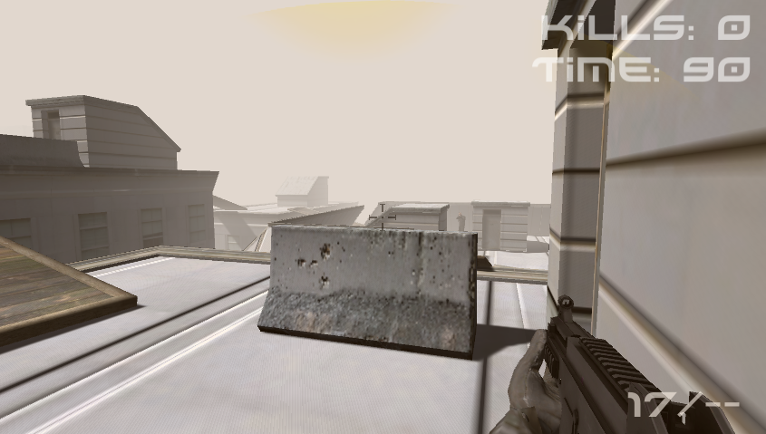
Figure 3-1: Gameplay in the FPS game
The number of player kills was displayed in the corner of the screen, as was the amount of time left in the game. If a player was hit too many times by enemies, they would ‘die’, the screen would fade to white, and after a brief pause the player would respawn. Conversely, if the player hit an enemy twice or more, that enemy character would die. If ragdoll physics was present in the game that was being played, this would cause the enemy’s body to ‘crumple’ realistically, given the location and direction of the kill-shot which the player had made. Conversely, if ragdoll physics was absent in the game, this would cause a pre-defined animation sequence to play in which the enemy character fell over.
Participants and Setting
This experiment took place online. The game was placed online on popular video game portal websites (e.g. kongregate.com, newgrounds.com). Participants were recruited both through these portals and via social media.
898 participants took part in the experiment. 642 participants were aged 18-24, 201 were 25-29 years old, 43 were 30-34 years old, 12 were 35 or older. 444 described themselves as playing games at least once a day, 216 played up to once a week, 49 played up to once a month, and 151 preferred not to answer the question.
Participants were randomly assigned to experimental conditions, with 446 playing a game where ragdoll physics was absent and 452 playing a game where it was present. Participant IP addresses were recorded at the beginning of the experiment and only the first set of data from each unique IP was used in this experiment.
Procedure
Players first completed an informed consent and demographics screen, and indicated that they were ready to begin the experiment. Following this, they played the game outlined above for four minutes. After this, they completed the Anderson word fragment completion task. They were then debriefed via a short video.

Results
Means and standard deviations for each treatment are presented below.
Ragdoll Physics | Proportion of fragments completed with aggression-related meanings | Number of kills | N.
Absent | 0.24 (SD = 0.14) | 14.99 (SD = 7.62) | 446
Present | 0.24 (SD = 0.15) | 15.39 (SD = 7.97) | 452
Total | 0.24 (SD = 0.15) | 15.19 (SD = 7.80) | 898
Table 3-1: Summary statistics for players of the first person shooter
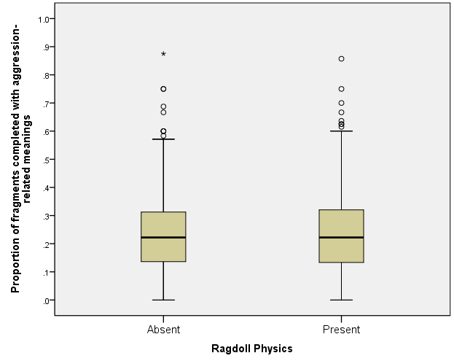
Figure 3-2: Box-plot showing responses to the Anderson word fragment completion task, split by presence or absence of ragdoll physics
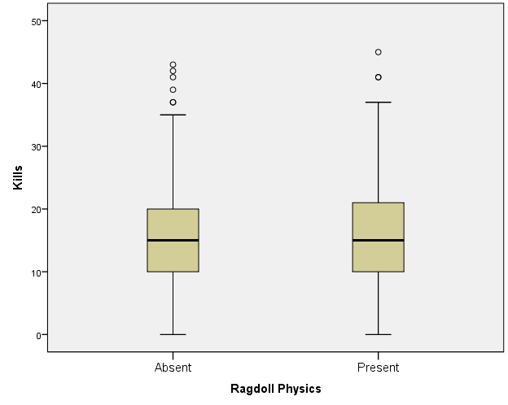
Figure 3-3: Box-plot showing number of kills, split by presence or absence of ragdoll physics
The effects of ragdoll physics on the activation of aggressive concepts was tested via an ANOVA, with ragdoll physics (absent, present) as a between-subjects factor. There was no significant effect, F(1,896) = 0.312, p=0.577, η² = 0.0003.
The data was further explored to see if playing the game with more realistic death animations might lead to players killing fewer enemies, and the null result reported above might be a product of this change in behaviour between conditions. Therefore, the effects of ragdoll physics on the number of kills which players made was also tested via ANOVA. This analysis revealed no significant effect of ragdoll physics on number of kills, F(1,896) = 0.593, p=0.441, η² = 0.0006.

Discussion
This experiment suggests that the presence of ragdoll physics in a VVG has little effect on the activation of aggression-related concepts. A large sample size was used here (n=898). However, the effect size between conditions was so small (η² = 0.0003) that no significant difference between people who played the game with ragdoll physics and people who played the game without ragdoll physics was detectable.
There are several possible explanations for this result. Firstly, it might simply be the case that behavioural realism in general has little effect on the activation of aggression-related concepts in VVGs. On the one hand, this perspective clashes strongly with theoretical explanations of how realism might help to determine the effects of VVGs. On the other hand, this explanation is in keeping with at least some of the literature. After all, even though it is widely hypothesised that increased realism might lead to greater effects in VVGs, results in the literature testing this hypothesis have frequently returned null results themselves.
Another explanation for this null result might be that players were not exposed to sufficiently different conditions in each version of the game. More specifically, it may be the case here that the presence of either ragdoll physics or pre-defined animations has an effect on the activation of aggressive concepts, but as this feature of the game was not on screen for very long, there was not enough exposure to this manipulation for the effect to be measured. However, this explanation of the results does not seem likely. In this game, players were exposed to the manipulation not once, but each time they killed an enemy. Since players killed, on average, 15.2 enemies it seems likely that the manipulation was shown enough times to players for it to have an impact. Furthermore, it also seems unlikely that this null result is the product of players in one condition being exposed to the manipulation more than in the other, as players killed very similar numbers of enemies in each condition. Indeed, a follow-up ANOVA showed that there was no significant difference in number of kills between conditions.
One final explanation for the null effect observed here relates to the specific manipulation which was used in this experiment. Just as there are several ways that the graphical realism of a game may be altered and increased, so too are there several different ways that behavioural realism may be boosted. Adding realistic ragdoll physics to a game is only one of these. It may therefore be premature to draw strong conclusions about the general influence of behavioural realism on the activation of aggressive concepts from this experiment alone.

Experiment 2: Realistic NPC Tactics

Introduction
The previous experiment suggests that ragdoll physics has little effect on the activation of aggressive concepts in VVGs. However, using ragdoll physics is not the only way that a VVG’s behavioural realism can be increased. In this experiment we therefore investigated whether a different manipulation of behavioural realism might have an effect on the activation of aggressive concepts in VVGs. We looked into this by manipulating the realism of the tactics which in-game NPCs used.
In this experiment, participants played an FPS game for 3 minutes. This game was manipulated so that it formed two different conditions. In one condition, participants played against a group of AI-controlled soldiers who did not behave like ‘real’ soldiers. In the other condition, participants played against a group of AI-controlled soldiers who used realistic squad-based behaviours, such as flanking and laying down suppressing fire. Following play, activation of aggressive concepts was again tested via the word fragment completion task.
There is a key difference between the manipulation of behavioural realism used in this experiment, and the manipulation used in the previous experiment. In Experiment 1, the difference between conditions was how enemies’ deaths were animated. There was therefore no possible difference between conditions in gameplay-related factors such as challenge, frustration, and difficulty. However, this is not the case here. The behaviours which enemies’ exhibit in one condition may not just be more realistic than the behaviours which enemies in the other condition use. They may also be more challenging. Because the difficulty of gameplay may differ between conditions, players may also feel less competent in one condition than another. Feeling incompetent has been linked in the VVG literature to aggression-related effects (e.g. (Przybylski et al., 2014)). In order to be as rigorous as possible, statistical analysis of the results of this experiment took into account players’ feelings of incompetence. More specifically, players’ perceptions of their own incompetence was measured using the Player Experience of Need Satisfaction (PENS) questionnaire (Ryan et al., 2006). This variable was then entered into a mediation analysis as a potential mediator of the effect of realistic NPC tactics on the activation of aggressive concepts. Mediation analysis was conducted according to (Hayes, 2013).

Method
Aim
This online experiment aimed to investigate whether increasing behavioural realism via realistic NPC tactics leads to greater activation of aggressive concepts in VVGs
Hypothesis
H1: Realistic tactics will lead to greater activation of aggressive concepts. Therefore, participants will complete more fragments with aggressive meanings on the Anderson word fragment completion task when realistic tactics are used by NPCs.
H2: The effect of realistic NPC tactics will be mediated by player perceptions of competence, with perceptions of lower competence leading to greater activation of aggressive concepts.
Design
The experiment had a between-participants design. Participants played either a first person shooter (FPS) which featured realistic NPC tactics, or the same game but with less realistic NPC tactics. In addition to this, competence was measured as a potential mediating variable.
Measures
The Anderson word fragment completion task was again used to measure the activation of aggressive concepts.
In addition to this, competence was measured via the corresponding subscale of the Player Experience of Need Satisfaction (PENS) scale (Ryan et al., 2006). This instrument is designed specifically to measure player feelings of competence.
Games
The FPS game used in the previous experiment was again used here. However, instead of manipulating this game so that there were two conditions with different death animations, it was instead manipulated so that there were different levels of realism for the tactics of the NPCs in the game.
In one condition, the tactics used by NPC soldiers were more representative of the behaviours of actual soldiers. Instead of moving along the shortest path towards the player, NPCs would attempt to ‘flank’ them by finding the shortest path through blind spots in the player’s field of vision. If an NPC needed to reload their weapon, they would use cover and move to a location where they were safe from the player’s line of sight when doing so. NPCs would also attempt to use cover when attacking the player, instead of standing in the open. Additionally, NPCs collaborated with other members of their squad by picking behaviours which were likely to work well together. For instance, if one NPC was flanking the player, another would lay down suppressing fire from cover in order to distract them. All of these features of NPC behaviour mirror common enemy AI implementations which are designed to mimic the way real soldiers act.
In the other condition, the tactics used by NPCs were less representative of the behaviours of actual soldiers. They did not use cover, either when reloading or when attacking the player. They did not use squad-based tactics, and they did not take advantage of the player’s line of sight in order to flank them. Instead, these enemies were programmed to either advance towards the player along the shortest available path whilst firing continuous bursts from their assault rifles, or stay at a distance and fire less frequently but more accurately at the player. This behaviour is representative of less realistic NPC tactics used in some FPS games.
Participants and Setting
As with the previous experiment, this experiment took place online. The game was placed online on popular video game portal websites (e.g. kongregate.com, newgrounds.com). Participants were recruited both through these portals and via social media.
1880 participants took part in the experiment. 1497 participants were aged 18-24, 366 were 25-29 years old, 3 were 30-34 years old, 10 were 35 or older. 747 described themselves as playing games at least once a day, 419 played between this amount and once a week, 315 played between this amount and once a month, and 399 preferred not to answer the question.
Participants were randomly assigned to experimental conditions, with 919 playing a game where the realism of NPC tactics was high and 961 playing a game where the realism of NPC tactics was low. Participant IP addresses were recorded at the beginning of the experiment and only the first set of data from each unique IP was used in this experiment.
Procedure
Players first completed an informed consent and demographics screen, and indicated that they were ready to begin the experiment. Following this, they played the game outlined above for 3 minutes. After this, they completed the Anderson word fragment completion task and the PENS competence sub-scale. They were then debriefed via a short video.

Results
Means and standard deviations for each treatment are presented below.
Realism of NPC Tactics | Proportion of fragments completed with aggression-related meanings | Competence | Number of kills | N.
Low | 0.23 (SD = 0.135) | 3.68 (SD = 1.54) | 20.12 (SD = 10.59) | 961
High | 0.22 (SD = 0.124) | 3.53 (SD = 1.55) | 14.47 (SD = 9.13) | 919
Total | 0.23 (SD = 0.130) | 3.61 (SD = 1.55) | 17.36 (SD = 9.87) | 1880
Table 4-1: Summary statistics for players of the first person shooter
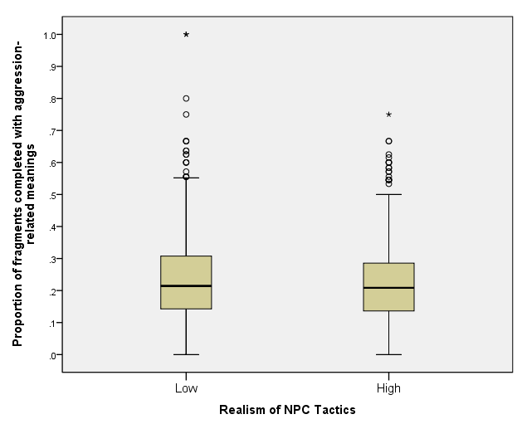
Figure 4-1: Box-plot showing responses to the Anderson word fragment completion task, split by realism of NPC tactics
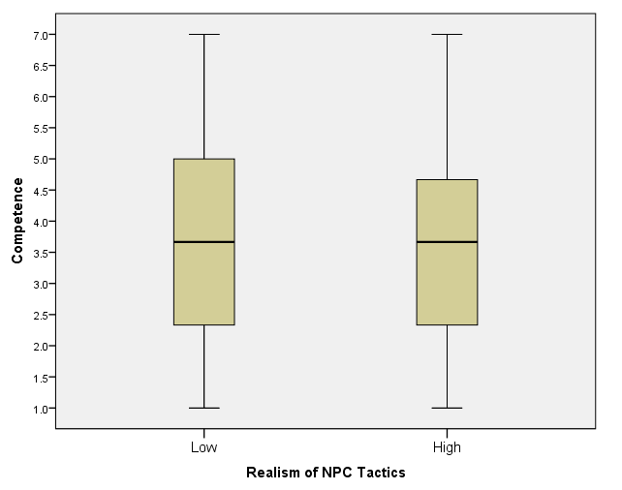
Figure 4-2: Box-plot showing player competence, split by realism of NPC tactics
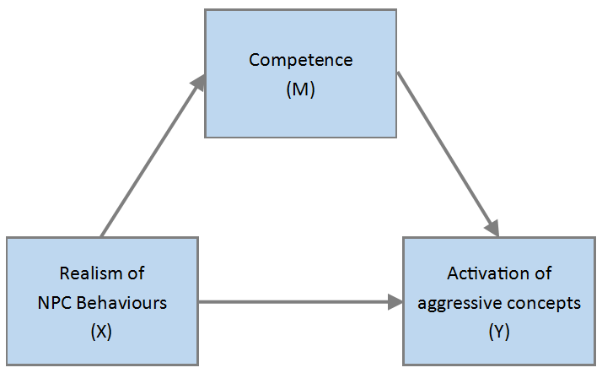
Figure 4-3: conceptual mediation model for the NPC realism experiment

The effects of the realism of NPC behaviours on the activation of aggressive concepts were tested for following the regression-based approach described in (Hayes, 2013). The conceptual mediation model for this analysis is shown above. Initial simple linear regression revealed that realism of NPC behaviours had a marginally significant total effect on the activation of aggressive concepts, t(1878) = -1.934, p=0.053, β = -0.089, r² = 0.002, with greater realism of NPC behaviours leading to the lessened activation of aggressive concepts.
The indirect effects of the realism of NPC behaviours on the activation of aggressive concepts were tested using simple linear regression. Greater realism of NPC behaviours led to lessened feelings of competence, t(1878) = -2.041, p=0.041, β = -0.09, r² = 0.002. Greater feelings of competence led to greater activation of aggressive concepts, t(1878) = 2.092, p=0.036, β = 0.048, r² = 0.003. Bootstrap confidence intervals were calculated for the indirect effect of the realism of NPC behaviours on the activation of aggressive concepts via competence. Under (Hayes, 2013) the indirect effect was calculated in this case by taking the product of the effect of realism on competence, and competence on activation. Based on 10,000 bootstrap samples, the confidence interval for this effect was entirely below zero (-0.0018 to -0.0001), indicating that greater realism of NPC behaviours indirectly led to significantly lessened activation of aggressive concepts. However, this indirect effect appears to be very small. The effect size of the indirect effect was calculated as R²_{med} = 0.0002. This statistic is conceptually similar to the η² statistic used in the previous experiment, and represents the proportion of variance in the activation of aggressive concepts explained by the indirect effect (Fairchild et al., 2009).
When indirect effects of realism of NPC behaviours on the activation of aggressive concepts via competence were taken into account, the direct effect of the realism of NPC behaviours on the activation of aggressive concepts remained marginally significant, t(1878) = -1.83, p=0.066, β = -0.084, r² = 0.002.
Following this analysis, the data was further explored by calculating the correlation between the number of kills that a player made and their competence. These variables had a moderate positive correlation when participants were pooled between conditions, r(1878)=0.52, p<0.0001. This relationship remained the same when participants were split between conditions, with moderate positive correlations occurring both for participants in the high realism condition, r(919)=0.54, p<0.0001 and participants in the low realism condition, r(961)=0.528, p<0.0001.

General Discussion
The results of both experiments described above strongly conflict with the idea that increasing the behavioural realism of VVGs leads to similar increases in their aggression-related effects.
In Experiment 1, increasing the behavioural realism of a VVG through ragdoll physics had little effect on the activation of aggressive concepts. A large sample size was used here (n=898). However, the effect of behavioural realism between conditions was so small (η² = 0.0003) that no significant difference between participants who played the game with ragdoll physics and people who played the game without ragdoll physics was detectable.
Similarly, the results of Experiment 2 also do not fit well with the idea that greater behavioural realism in a VVG leads to greater activation of aggressive concepts. Overall, the manipulation of behavioural realism in this experiment led to marginally significant differences in the activation of aggressive concepts. However, this marginal direct effect ran in the opposite direction to the experimental hypothesis. Participants who played the FPS with realistic NPC tactics showed less activation of aggressive concepts (M=0.216) than those who played the game without realistic NPC behaviours (M=0.228).
The counter-intuitive result of Experiment 2 might initially seem to reflect the indirect effect of a difference in competence between experimental conditions. After all, feeling incompetent is thought to increase the activation of aggressive concepts. However, mediation analysis strongly suggests that this is not the case. Whilst part of the marginally significant total effect of realism on the activation of aggressive concepts was due to a significant indirect effect via competence, this indirect effect was very small (R²_{med} = 0.0002). Because of its small size, even when the effect of competence on activation was taken into account the direct effect of behavioural realism on activation described above remained marginally significant (p=0.066). It therefore seems unlikely that the effect observed here is due to changes in competence between conditions.
When taken together, the results of these two experiments seem to suggest that greater behavioural realism simply does not seem to lead to greater activation of aggressive concepts in VVGs. The strength of this conclusion is further bolstered by the methodology used in these experiments. Bespoke games were used in each of the experiments in this chapter. This process ensured that only the specific kind of realism which was under test varied between conditions, and thereby minimised the risk of confounds caused by multiple features varying between experimental conditions. Furthermore, not only were these experiments conducted online, and therefore involved video game players in an ecologically valid environment, but they were also conducted across samples of an unprecedented size for the VVG effects literature. A total of 2778 participants took part in these experiments, and the majority of these participants (n=1826) played video games at least once a week. This use of a large and representative sample suggests that if behavioural realism really did lead to effects amongst the players of VVGs, it would be reflected by a measurable positive effect in at least one of these experiments. This, however, was not the case.
These results are consonant with other recent findings related to the effects of VVGs. Whilst early studies in this field may have suggested a strong relationship between VVG play and antisocial effects, recent scholarship seems to imply that this effect is in fact a phantom. Similarly, early research into the effects of realism in VVGs predicted the presence of an important link between realism and VVG effects. This effect, too, now appears to be failing to materialise – both in this study and elsewhere in the literature.
Despite the points outlined above, general inferences about the effects of behavioural realism that are drawn from these experiments must be tempered with caution. The experiments outlined above test the effects of behavioural realism in two different ways. Furthermore, the specific manipulations made in these experiments are diverse. However, the fact remains that they do only test two specific ways that VVGs can have their realism increased. Therefore, it may well be the case that another way of making VVGs ‘behave like’ the real world does lead to increases in their aggression-related effects. For instance, it may be the case that the inclusion of bystander characters who behave like their real-world counterparts (as in Grand Theft Auto V) leads to increases in these games effects. Contrastingly, the detailed the simulation of how bullets affect different internal organs (as in Sniper Elite 3) may lead to changes in aggression-related variables. Similarly, there may be other kinds of realism present in modern VVGs aside from behavioural realism which drastically change their effects – one notable potential example being VR.
These experiments provide a useful initial investigation of the role of behavioural realism in determining the effects of VVGs. They also provide initial evidence that the behavioural realism of VVGs may not lead to important changes in these games effects. However, much further work is needed to determine whether this lack of an effect holds across a broad variety of manipulations of realism.

Bibliography
Adachi, P.J., Willoughby, T., 2011. The effect of violent video games on aggression: Is it more than just the violence? Aggress. Violent Behav. 16, 55–62.
Adams, E., Rollings, A., 2007. Fundamentals of Game Design. Pearson Prentice Hall.
Anderson, C.A., Bushman, B.J., 2002. Human aggression. Psychology 53, 27.
Anderson, C.A., Bushman, B.J., 2001. Effects of violent video games on aggressive behavior, aggressive cognition, aggressive affect, physiological arousal, and prosocial behavior: A meta-analytic review of the scientific literature. Psychol. Sci. 12, 353–359.
Anderson, C.A., Carnagey, N.L., 2004. Violent evil and the general aggression model. Soc. Psychol. Good Evil 168–192.
Anderson, C.A., Carnagey, N.L., Eubanks, J., 2003. Exposure to violent media: the effects of songs with violent lyrics on aggressive thoughts and feelings. J. Pers. Soc. Psychol. 84, 960.
Anderson, C.A., Carnagey, N.L., Flanagan, M., Benjamin, A.J., Eubanks, J., Valentine, J.C., 2004. Violent video games: Specific effects of violent content on aggressive thoughts and behavior. Adv. Exp. Soc. Psychol. 36, 199–249.
Anderson, C.A., Shibuya, A., Ihori, N., Swing, E.L., Bushman, B.J., Sakamoto, A., Rothstein, H.R., Saleem, M., 2010. Violent video game effects on aggression, empathy, and prosocial behavior in eastern and western countries: a meta-analytic review. Psychol. Bull. 136, 151.
Barlett, C., Rodeheffer, C.D., Baldassaro, R., Hinkin, M.P., Harris, R.J., 2008. The effect of advances in video game technology and content on aggressive cognitions, hostility, and heart rate. Media Psychol. 11, 540–565.
Barlett, C.P., Harris, R.J., Baldassaro, R., 2007. Longer you play, the more hostile you feel: Examination of first person shooter video games and aggression during video game play. Aggress. Behav. 33, 486–497.
Barlett, C.P., Harris, R.J., Bruey, C., 2008. The effect of the amount of blood in a violent video game on aggression, hostility, and arousal. J. Exp. Soc. Psychol. 44, 539–546.
Bates, J., 1998. Half-Life Review - IGN [WWW Document]. URL http://uk.ign.com/articles/1998/11/26/half-life-5 (accessed 8.30.16).
Bösche, W., 2010. Violent video games prime both aggressive and positive cognitions. J. Media Psychol.
Bushman, B.J., Anderson, C.A., 2001. Is it time to pull the plug on hostile versus instrumental aggression dichotomy? Psychol. Rev. 108, 273.
Bushman, B.J., Huesmann, L.R., 2014. Twenty-Five Years of Research on Violence in Digital Games and Aggression Revisited: A Reply to Elson and Ferguson (2013). Eur. Psychol. 19, 47–55. doi:10.1027/1016-9040/a000164
Carnagey, N.L., Anderson, C.A., 2005. The Effects of Reward and Punishment in Violent Video Games on Aggressive Affect, Cognition, and Behavior. Psychol. Sci. 16, 882–889. doi:10.1111/j.1467-9280.2005.01632.x
Cheng, K., Cairns, P.A., 2005. Behaviour, Realism and Immersion in Games, in: CHI ’05 Extended Abstracts on Human Factors in Computing Systems, CHI EA ’05. ACM, New York, NY, USA, pp. 1272–1275. doi:10.1145/1056808.1056894
Choi, Y.K., Lee, S. mi, Li, H., 2013. Audio and Visual Distractions and Implicit Brand Memory: A Study of Video Game Players. J. Advert. 42, 219–227. doi:10.1080/00913367.2013.775798
Eastin, M.S., 2006. Video game violence and the female game player: self-and opponent gender effects on presence and aggressive thoughts. Hum. Commun. Res. 32, 351–372.
Elson, M., Ferguson, C.J., 2014. Twenty-five years of research on violence in digital games and aggression. Eur. Psychol.
Fairchild, A.J., MacKinnon, D.P., Taborga, M.P., Taylor, A.B., 2009. R 2 effect-size measures for mediation analysis. Behav. Res. Methods 41, 486–498.
Ferguson, C.J., 2015. Do Angry Birds Make for Angry Children? A Meta-Analysis of Video Game Influences on Children’s and Adolescents’ Aggression, Mental Health, Prosocial Behavior, and Academic Performance. Perspect. Psychol. Sci. 10, 646–666. doi:10.1177/1745691615592234
Ferguson, C.J., 2007. Evidence for publication bias in video game violence effects literature: A meta-analytic review. Aggress. Violent Behav. 12, 470–482.
Ferguson, C.J., Dyck, D., 2012. Paradigm change in aggression research: The time has come to retire the General Aggression Model. Aggress. Violent Behav. 17, 220–228.
Furuya-Kanamori, L., Doi, S.A.R., 2016. Angry Birds, Angry Children, and Angry Meta-Analysts: A Reanalysis. Perspect. Psychol. Sci. 11, 408–414. doi:10.1177/1745691616635599
Geen, R.G., 1975. The meaning of observed violence: Real vs. fictional violence and consequent effects on aggression and emotional arousal. J. Res. Personal. 9, 270–281.
Greitemeyer, T., Mügge, D.O., 2014. Video Games Do Affect Social Outcomes A Meta-Analytic Review of the Effects of Violent and Prosocial Video Game Play. Pers. Soc. Psychol. Bull. 40, 578–589. doi:10.1177/0146167213520459
Hayes, A.F., 2013. Introduction to mediation, moderation, and conditional process analysis: A regression-based approach. Guilford Press.
Hertzmann, A., Zordan, V., 2011. Physics-based characters. IEEE Comput. Graph. Appl. 31, 20–21.
Hilgard, J., Engelhardt, C.R., Rouder, J.N., 2017. Overstated evidence for short-term effects of violent games on affect and behavior: A reanalysis of Anderson et al. (2010). Psychol. Bull. 143, 757–774. doi:10.1037/bul0000074
Ivory, A.H., Kaestle, C.E., 2013. The Effects of Profanity in Violent Video Games on Players’ Hostile Expectations, Aggressive Thoughts and Feelings, and Other Responses. J. Broadcast. Electron. Media 57, 224–241. doi:10.1080/08838151.2013.787078
Ivory, J.D., Kalyanaraman, S., 2007. The effects of technological advancement and violent content in video games on players’ feelings of presence, involvement, physiological arousal, and aggression. J. Commun. 57, 532–555.
Jeong, E.J., Biocca, F.A., Bohil, C.J., 2012. Sensory realism and mediated aggression in video games. Comput. Hum. Behav. 28, 1840–1848.
Kim, K., Lee, M., Macias, W., 2014. An alcohol message beneath the surface of ER: How implicit memory influences viewers’ health attitudes and intentions using entertainment-education. J. Health Commun. 19, 876–892.
Kneer, J., Elson, M., Knapp, F., 2016. Fight fire with rainbows: The effects of displayed violence, difficulty, and performance in digital games on affect, aggression, and physiological arousal. Comput. Hum. Behav. 54, 142–148.
Koopman, J., Howe, M., Johnson, R.E., Tan, J.A., Chang, C.-H., 2013. A framework for developing word fragment completion tasks. Hum. Resour. Manag. Rev. 23, 242–253.
Krcmar, M., Farrar, K., McGloin, R., 2011. The effects of video game realism on attention, retention and aggressive outcomes. Comput. Hum. Behav. 27, 432–439.
Malliet, S., 2006. An exploration of adolescents’ perceptions of videogame realism. Learn. Media Technol. 31, 377–394.
Przybylski, A.K., Deci, E.L., Rigby, C.S., Ryan, R.M., 2014. Competence-impeding electronic games and players’ aggressive feelings, thoughts, and behaviors. J. Pers. Soc. Psychol. 106, 441.
Rabin, S., 2015. Game AI Pro 2: Collected Wisdom of Game AI Professionals. CRC Press.
Ribbens, W., Malliet, S., 2010. Perceived digital game realism: A quantitative exploration of its structure. Presence Teleoperators Virtual Environ. 19, 585–600.
Ryan, R.M., Rigby, C.S., Przybylski, A., 2006. The motivational pull of video games: A self-determination theory approach. Motiv. Emot. 30, 344–360.
Schell, J., 2014. The Art of Game Design: A Book of Lenses, Second Edition. CRC Press.
Tavinor, G., 2009. The Art of Videogames. John Wiley & Sons.
Valadez, J.J., Ferguson, C.J., 2012. Just a game after all: Violent video game exposure and time spent playing effects on hostile feelings, depression, and visuospatial cognition. Comput. Hum. Behav. 28, 608–616.
Zendle, D., Cairns, P., Kudenko, D., 2018. No priming in video games. Comput. Hum. Behav. 78, 113–125. doi:10.1016/j.chb.2017.09.021
Zendle, D., Cairns, P., Kudenko, D., 2015. Higher Graphical Fidelity Decreases Players’ Access to Aggressive Concepts in Violent Video Games, in: Proceedings of the 2015 Annual Symposium on Computer-Human Interaction in Play. ACM, pp. 241–251.

