**Sorption, plant uptake and metabolism of benzodiazepines**

***Abstract***

Reuse of treated wastewater for irrigation of crops is growing in arid and semi-arid regions, while increasing amounts of biosolids are being applied to fields to improve agricultural outputs. Due to incomplete removal in the wastewater treatment processes, pharmaceuticals present in treated wastewater and biosolids can contaminate soil systems. Benzodiazepines are a widely used class of pharmaceuticals that are released following wastewater treatment. Benzodiazepines are represented by a class of compounds with a range of physicochemical properties and this study was therefore designed to evaluate the influence of soil properties on the sorption behaviour and subsequent uptake of seven benzodiazepines (chlordiazepoxide, clonazepam, diazepam, flurazepam, oxazepam, temazepam and triazolam) in two plant species. The sorption and desorption behaviour of benzodiazepines was strongly influenced by soil type and hydrophobicity of the chemical. The partitioning behaviour of these chemicals in soil was a key controller of the uptake and accumulation of benzodiazepines by radish (*Raphanus sativus*) and silverbeet (*Beta vulgaris).* Benzodiazepines such as oxazepam that were neutral, had low sorption coefficients (Kd) or had pH-adjusted log octanol-water partition coefficients (log *Dow*, pH 6.3) values close to 2 had the greatest extent of uptake. Conversely, benzodiazepines such as flurazepam that had an ionised functional groups and greater Kd values had comparatively limited accumulation in the selected plant species. Results also revealed active in-plant metabolism of benzodiazepines, potentially analogous to the known metabolic transformation pathway of benzodiazepines in humans. Along with this observed biological transformation of benzodiazepines in exposed plants, previously work has established the widespread presence of the plant signalling molecule -amino butyric acid (GABA), which is specifically modulated by benzodiazepines in humans. This highlights the need for further assessment of the potential for biological activity of benzodiazepines following their plant uptake.

***Keywords***

Soil, pharmaceutical, metabolism, radish, silverbeet

***Introduction***

Benzodiazepines are a class of pharmaceuticals which are among the most highly prescribed psychoactive pharmaceuticals worldwide. One of the most well-known benzodiazepines is diazepam (Valium®) which was in the top 10 psychiatric medicines prescribed in the U.S. in 2011 at 14.6 million prescriptions (Lindsley 2012). In addition to diazepam, lorazepam, clonazepam, alprazolam and temazepam were also amongst the top 200 dispensed prescriptions in the U.S. according to IMS Health 2012 (RxList 2012).

As a class of compounds, benzodiazepines share a common ring structure (Figure S1) with individual benzodiazepines having variations in the ring substitution, which affects their respective physicochemical properties and pharmacokinetic profile (Charney et al. 2001). Benzodiazepines generally display weak basic properties although their physico-chemical properties such as log *Kow* values, vary greatly (Figure S1; Table S1), which will ultimately influence their fate in the environment.

The widespread use of benzodiazepines has led to their recent detection in the environment, where they have been measured at ng/L to low g/L concentrations in wastewater effluents (Calisto et al. 2011; Fick et al. 2017; Jelic et al. 2011; Kosjek et al. 2012; Kummerer 2009; Loffler et al. 2005; Mendoza et al. 2014; Nunes et al. 2015; Stein et al. 2008). Even at these relatively low concentrations, there have been reports that have indicated benzodiazepines are also bioactive in aquatic organisms (Brodin et al. 2013; Gagne et al. 2010). A number of benzodiazepines have been reported to be resistant to removal in the environment, as well as interacting weakly with solids (Calisto et al. 2011; Jelic et al. 2011; Loffler et al. 2005; Stein et al. 2008), there is a potential for them to be released into the terrestrial environment through wastewater irrigation which has become an increasingly important means of water recycling (Asano et al. 2007). The fate and effects of these bioactive pharmaceuticals in the terrestrial environment, however, has received little attention. Plant uptake of pharmaceuticals have been reported in a range of vegetable crops including radish, tomato, lettuce, and soybean (Carter et al. 2014; Goldstein et al. 2014; Malchi et al. 2014; Wu et al. 2010; Wu et al. 2014), depending on the physicochemical properties of the compound (Briggs et al. 1982; Carter et al. 2014). Based on the physicochemical properties of benzodiazepines, including having a moderate log *Kow* and existing as unionised compounds, there is a high potential for them to taken up by plants (e.g. (Briggs et al. 1982; Carter et al. 2014).

In humans, benzodiazepines interact with -amino butyric acid (GABA) receptors (GABAA and GABAB) by potentiating the effects of endogenous GABA already bound to the receptor through increasing the efficiency of the intracellular flow of chloride (Cl-) ions (Haefely 1984; Olsen and Sieghart 2008). This has the effect of decreasing neuronal activity, making benzodiazepines effective anxiolytics and anticonvulsants. Recent physiological and genetic evidence indicates that plants may possess GABA like receptors that have features in common with animal receptors (Kinnersley and Lin 2000; Kinnersley and Turano 2000). Indeed it has recently been demonstrated that GABA signalling modulates plant growth by directly regulating the activity of plant-specific anion transporters (Ramesh et al. 2015). Given the importance of GABA signalling in plants it is important to establish the plant uptake of GABA modulating benzodiazepines from soils.

The human metabolic pathway of benzodiazepines has been extensively characterised where a multiphase transformation pathway can result in the formation of active metabolites, including temazepam and oxazepam, which are prescription pharmaceuticals in their own right (Figure S2). Knowledge relating to the fate and transport of pharmaceutical metabolites, in general, within the terrestrial environment is particularly limited as such studies have primarily focussed on the parent compound. Plant metabolism of pharmaceuticals has not been extensively characterised, although this is an important consideration where biologically active transformation products in plant organs have a similar potency to that of the parent compound (Malchi et al. 2014).

Along with their potential for bioactivity in plants, the various substitutions of the benzodiazepine ring structure also modify the physicochemical properties of this class of pharmaceuticals which are likely to affect their fate in soil systems. This study was therefore designed to evaluate the influence of soil properties on the sorption behaviour and subsequent uptake of a range of benzodiazepines with variable physicochemical properties into two common vegetable crops, radish (*Raphanus sativus*) and silverbeet (*Beta vulgaris)*. Analysis was also carried out to consider any potential in-plant metabolism of the benzodiazepine parent compounds. The soil was spiked directly with benzodiazepines, as opposed to a continuous exposure reflecting wastewater irrigation, to ensure maximum uptake by the plant and for findings from the sorption studies to be related to plant uptake behaviour.

***Materials and Methods***

Primary standards of chlordiazepoxide, chlordiazepoxide-D5, clonazepam, clonazepam-D4, diazepam, diazepam-D5, flurazepam, oxazepam, oxazepam-D5, nordiazepam, nordiazepam-D5, temazepam, temazepam-D5, triazolam and triazolam-D4 (≥ 98% purity) were obtained from Novachem (Melbourne, Australia). Hoaglands No. 2 Basal Salt Mixture was purchased from Sigma-Aldrich (Sydney, Australia). HPLC grade solvents were used for all extractions and Optima LC/MS grade methanol was used (Thermo Fisher Scientific; Sydney, Australia) for LC-MS/MS analysis.

Two soil types with contrasting properties were used for this experiment. Soil was obtained from the Tepko agricultural region (pH 6.3, EC 0.09 dS/m, OC 1%, CEC 5.2 cmol (+)/kg, 8% clay, 3% silt and 89% sand), as well as the Inman Valley region in southern Australia (pH 6.3, EC 0.21 dS/m, OC 5.2%, CEC 23.4 cmol (+)/kg, clay 52%, silt 29%, sand 19%). The soils were not cropped and had not previously received biosolids or wastewater applications. Prior to experimental use the soil was air-dried and then sieved to 2 mm to ensure homogeneity. Radish (*Raphanus sativus*, Cherry Belle variety) and silverbeet (*Beta vulgaris*, Fordhook Giant variety) were obtained from Mr Fothergills (Sydney, Australia).

*Sorption:* Thesorption of chlordiazepoxide, clonazepam, diazepam, flurazepam, nordiazepam, oxazepam, temazepam and triazolam was studied in the two soils using an adaption of the batch equilibrium method based on the Organisation for Economic Co-operation and Development (OECD) guideline 106 (OECD 2000) (see Supporting Information for a detailed method description). Briefly, benzodiazepines were spiked individually into glass tubes containing soils at a 1:5 w:w ratio with 0.01 M HgCl2 solution (to prevent biodegradation of the benzodiazepines) to achieve a final soil concentration of 0.8 mg/kg. Tubes were shaken on a rotating shaker for 16 h, centrifuged at 650 *g* for 45 minutes and the supernatant was analysed by LC-MS/MS. Sorption coefficients (Kd) were determined as a ratio of between the measured soil and water concentration in the test tubes. Measured soil and pore water concentrations obtained from the plant uptake experiment (see below) were also used to determine ‘in pot’ sorption coefficients (field Kd).

*Plant uptake experiment:* Theuptake and potential metabolism of chlordiazepoxide, clonazepam, diazepam, flurazepam, oxazepam, temazepam and triazolam was studied in two test soils (Inman Valley and Tepko). For each benzodiazepine treatment, plastic pots containing 500 ± 5 and 750 ± 5 g soil were prepared in triplicate for the radish and silverbeet exposure respectively. A portion of sand (1% of soil weight) was placed in a culture tube and spiked with 400 µL (radish) or 600 µL (silverbeet) of benzodiazepine stock solution (1 mg/mL in methanol) for each of the benzodiazepine treatments. In addition to an unspiked negative control, soil was also spiked with the maximum solvent volume used for the solvent control. The solvent was evaporated under a stream of nitrogen, after which the sand was placed in the respective pots and mixed by hand to thoroughly homogenise the spiked sand to create a final nominal concentration of 0.5 mg/kg of each benzodiazepine. The moisture content was adjusted to 60% of the maximum water holding capacity (MWHC) by addition of ultrapure water (18.2 Mcm; Milli-Q, Millipore) and pots were left to equilibrate under controlled conditions for 48 h (65% relative humidity, 12 h light (23⁰C)/ 12 h dark (15⁰C). Before seeds were sown, 2 ± 0.2 g of soil, fresh weight (FW) was removed from each pot to confirm nominal start concentrations (Table S4). Three seeds were then sown per pot which was thinned down to one seedling after germination in excess of 80% in all treatments was reached. Pots were incubated under the same controlled conditions as the equilibrium period (see above), arranged in a completely randomised design (Microsoft Excel) and re-randomised on a weekly basis. Moisture content adjustments were made on a daily basis using ultrapure water to ensure the MWHC remained at 60% until harvest (4 weeks). To ensure the plants received an adequate amount of nutrients, a 25% dilution Hoaglands solution in ultrapure water was applied to the soil twice a week (5 mL per 250 g soil) instead of water.

At harvest loose soil was removed from around the roots to allow for the intact removal of the plants. Each plant was then thoroughly rinsed in ultrapure water to remove any soil residues, patted dry with paper towel, weighed and divided up into above and below ground biomass, and these were reweighed individually. The leaf material was detached from the above ground biomass, reweighed separately and cut into smaller pieces. To determine benzodiazepine residues, 1 ± 0.1 g of radish leaf, radish bulb or silverbeet leaf (FW) from each replicate was placed in a glass culture tube to which 0.1 µg of deuterated internal standard (1 µg/mL in methanol) was added to each sample to account for recoveries and matrix interference. In addition, soil was sampled from each pot to confirm benzodiazepine residues remaining at the end of the experiment (2 ± 0.2 g of soil (FW)) and 0.1 µg of deuterated internal standard was added to each sample. Prior to extraction, soil and plant samples were spiked with respective deuterated internal standard for the parent compound spiked into the soil at the start of the exposure, as well as associated internal standards for suspected metabolites (Table S7). All samples were then freeze dried and stored at -20⁰C until extraction.

*Benzodiazepine extraction:* Pore water was extracted from the soil for each replicate by centrifugation, following methods previously described in Carter et al., 2014. After addition of internal standard (0.1 µg/mL) to each 1 mL sample of collected pore water, the samples were ready for direct injection on LC-MS/MS to determine the concentration of benzodiazepine residues in the matrix.

Extraction of soil and leaf material was achieved by liquid-solid extraction using ultra-sonication. To determine chlordiazepoxide, clonazepam, oxazepam and temazepam residues in soil and oxazepam, temazepam and triazolam samples in leaf material 5 mL of methanol was added to the culture tube containing the soil and plant material. The tubes were vortexed for 30 seconds, placed in an ultrasonication bath for 15 minutes and then centrifuged at 650 *g* for 30 mins. The resulting supernatant was removed and stored in a separate vessel, after which the same extraction steps were followed with an additional 5 mL of methanol and 5 mL of acetone for each sample. For the remaining benzodiazepines the previous extraction steps were followed but a solution of 70:30 acetonitrile/ultrapure water was used as the extraction solvent as this generated better extraction recoveries (Table S3).

The combined supernatants from the extraction were diluted with ultrapure water to ensure the maximum solvent concentration did not exceed 10% and then applied to a preconditioned (ultrapure water and methanol) Oasis HLB (Waters Corporation) 6 mL 200 mg solid phase extraction (SPE) cartridge at a rate of 1 mL per minute. The SPE cartridges were dried under a vacuum and washed with 10 % methanol to remove any unwanted eluants then eluted using 2 x methanol (3 mL) and 1 x methylene chloride (3 mL). The collected solvent was dried under a gentle stream of nitrogen followed by reconstitution in 1 mL methanol after which they were sonicated for 5 minutes and transferred to HPLC vials ready for analysis using LC-MS/MS.

Extracts were analysed for benzodiazepine residues by LC-MS/MS using a ThermoFinnigan TSQ Quantum Discovery Max (Thermo Electron Corporation) and concentrations determined using the isotope dilution method. Further details of the LC-MS/MS analytical method for the detection of benzodiazepines in soil, plant and pore water matrices are provided in Supporting Information.

***Results***

*Sorption:* The sorption kinetics of a wide suite of benzodiazepines in the two soil types, were determined in this study. Sorption coefficients (Kd) for eight benzodiazepines ranged between 4.5 – 95 L/kg in Tepko soil (Table 1). Larger sorption coefficients were measured for Inman Valley soil, with Kd values ranging between 21–252 L/kg (Table 1). For both soils, the eight benzodiazepines showed similar partitioning tendencies with temazepam, oxazepam and nordiazepam typically having the smallest sorption coefficients whereas flurazepam and triazolam were more strongly sorbed in both soils. The field Kd values of the benzodiazepines, determined from the measured soil and soil porewater concentrations, were comparable with the measured batch sorption Kd values, although triazolam had relatively smaller field Kd values in the Tepko soil than would be expected from its Kd value (Table 1). The field Kd values of triazolam in the Inman Valley soil, however, could not be determined due to the porewater concentrations being below its limit of quantification. This was also the case for flurazepam in both soils and clonazepam in Inman Valley soil, which would be at least partially explained by a high degree of association with the soil.

*Plant uptake*: All seven of the spiked benzodiazepines were detected in the radish and silverbeet leaf material grown in Tepko soil. Exposure to oxazepam resulted in the highest benzodiazepine concentration in both plant species, reaching a maximum concentration of 14.2 µg/g and 5.0 µg/g in radish and silverbeet respectively (Figures 1 and 2). Silverbeet plants in the Inman Valley control soils (no benzodiazepines spiked to soil) did not meet minimum viability standards (<90% survival) and so the results from the silverbeet exposure in Inman Valley soil were discounted (OECD 2006) . Detectable concentrations of benzodiazepines were also measured in the radish leaf after exposure in Inman Valley soil although accumulation occurred to a lesser extent, with maximum reported concentrations of 0.9 µg/g in the oxazepam exposure (Figure 1). Whilst oxazepam accumulated to the greatest extent in the leaf material, flurazepam was detected at the lowest concentration in the radish leaf (0.2 µg/g) and diazepam in the silverbeet leaf (0.03 µg/g) (Figures 1 and 2). This resulted in radish leaf uptake factors (UF) ranging between 0.94 – 45.56 and 0.14 – 7.14 in the Tepko and Inman Valley soil respectively (Table S6). The enhanced UF in Tepko soil also corresponded with greater benzodiazepine pore water concentrations, relative to Inman Valley soil (Figures 1 and 2, Table S6).

In both soil types, higher concentrations of all benzodiazepines were measured in the radish leaf material in comparison to the radish bulb, with concentrations in the bulb ranging from below the analytical limit of quantification (LOQ; Table S2) to 0.7 µg/g and 0.06 µg/g in Tepko and Inman Valley soil, respectively. The associated UFs for the radish bulb ranged between 0.42 – 3.44 and 0.02 – 0.52 for the Tepko and Inman Valley soil, respectively (Table S6).

Analysis of the leaf and bulb samples also revealed the formation of metabolites in the plant material (silverbeet and radish) (Figure 3). A number of the metabolites detected in the diazepam, temazepam and chlordiazepoxide treatments were benzodiazepine parent compounds in their own right (Figure 3). These metabolites were however not detected in the soil or soil pore water at concentrations above the LOQ, except for nordiazepam which was detected at 56±9  g/kg in Tepko soil chlordiazepoxide treatment for silverbeet only (Figure 3, Table S5). Significant concentrations of nordiazepam were detected in the diazepam exposed plants, in both soil types, which were in excess of the concentration reported for the parent compound (Figure 3). Nordiazepam was also detected in the chlordiazepoxide exposed plants ( <11.5 µg/g). In a similar trend to the diazepam exposure, the formation of nordiazepam within the plant tissues was also in excess of the measured concentrations of the parent compound, approximately three times that of chlordiazepoxide in the Tepko soil treatments (Figure 3). Oxazepam was detected in the leaf material from the diazepam, chlordiazepoxide and temazepam exposures in Tepko soil and for temazepam exposures in the Inman Valley soil, (Figure 3). For all exposures, nordiazepam was detected in higher concentrations in the plant material than the putative, ultimate metabolic product, oxazepam.

The measured concentrations at the beginning of the experiment were less than the nominal start concentration of 0.8 mg/kg. In the Tepko soil, apart from the chlordiazepoxide and temazepam treatments in the silverbeet exposure, there was generally little difference in the measured initial and final soil concentrations of benzodiazepines, suggesting minimal transformation of the benzodiazepines occurred within the soil compartment (Table S4). There were however larger differences in benzodiazepine concentrations measured at the beginning and the end of the experiment in the Inman Valley soil with < 60 % unaccounted for according to the mass balance (Figure S3).

***Discussion***

*Plant uptake and fate of benzodiazepines in soil:* There are relatively few studies relating to the fate of benzodiazepines in soils or sediments. Previous studies that have done so demonstrate that benzodiazepines can be highly persistent in the solid phase. For example, high persistence and significant sorption has been reported for diazepam in water-sediment systems, with 60% of the initial aqueous concentration accounted for via sediment sorption and less than 2% mineralisation of the parent compound (Loffler et al. 2005). This related to the time for 90% degradation (DT90) of diazepam being estimated at >365 d.

A similar resistance to degradation has also been demonstrated for diazepam and temazepam added to bacterial cultures grown from soils for a period of 60 days (Redshaw et al. 2008). Under the same conditions, however, oxazepam was found to undergo biotic and abiotic degradation where only 20% of the initial amount remained. The degradation of a number of benzodiazepines was also noted following exposure to a purified soil fungi enzyme, with oxazepam and diazepam both degrading by ~20% after 60 h incubation (Ostadhadi-Dehkordi et al. 2012). Chlordiazepoxide, however, was found to be highly resistant to degradation under these conditions. Our results suggest that this was not the case in both the Tepko and Inman Valley soil, as chlordiazepoxide was the only benzodiazepine found to be labile in both soils (Table S4). In the Inman Valley soil, clonazepam, flurazepam and oxazepam also had reduced soil concentrations compared with that measured initially. This unaccounted for fraction of benzodiazepines could not be explained by uptake into the plant (Figure S3). This may be related to the higher %OC, and therefore increased microbial community size and diversity (Bending et al. 2002), in the Inman Valley soil compared with the Tepko soil which could enhance the biodegradation of benzodiazepines. It has previously been reported in literature that the persistence of pharmaceuticals can vary between different soil types (Thiele-Bruhn 2003). This highlights the need to undertake further fate assessments reflecting scenarios where benzodiazepines are present in a range of agricultural soils with different properties. Furthermore, such fate assessments should take into account the nature of wastewater irrigation, where ongoing addition of wastewater can not only affect the overall load of benzodiazepines added to the soil but also the ability of degrading microorganisms to adapt to these loads.

Sorption coefficients for diazepam in the present study ranged from 13.66 – 59.83 L/kg, which are around the typical Kd values previously reported for diazepam sorption in soils. For example, Kreuzig et al. (2003) observed stronger diazepam sorption to a silty sand soil (Kd 20 ± 4 L/kg, 0.8% OC) than a clayey silt soil (Kd 13 ± 1 L/kg, 1.4% OC). Our results show stronger diazepam sorption in Inman Valley soil (59.83 L/kg) which had a higher organic carbon content compared with Tepko soil (Table 1). Although diazepam is a weak base (pKa 3.4), it would be found predominantly in its non-ionised form (> 98 %) in both the soils from the (Kreuzig et al. 2003) study and test soils used in this analysis. Due to a lack of protonation at test soil pH, electrostatic interactions between diazepam and soil would therefore be minimal and non-ionic interactions are expected to govern diazepam sorption. As such, this supports the similar Kd values reported across the two studies and the relationship with soil organic carbon content as hydrophobic partitioning to organic soil constituents are expected to dominate the sorption process (Della Site 2001).

Oxazepam, one of the major metabolites of diazepam in humans, has a slightly higher polarity than diazepam, and is known to partition to sediments to a lesser extent than diazepam (19 - 29%) (Loffler et al. 2005). In the present study, smaller Kd values were calculated for oxazepam in Tepko and Inman Valley soil types than diazepam, which fits with this trend. Additional data on benzodiazepine sorption in soils is limited and therefore it is challenging to put these results in further context. On the whole, the sorption of benzodiazepines in this study appears to be driven by hydrophobicity with increasing sorption coefficients corresponding to chemicals increasing in log *Kow*. This relationship with log *Kow* is typically observed with non-ionised organic chemicals. Similarly to diazepam, the remaining benzodiazepines used in this experiment also have ionisable functional groups with clonazepam, oxazepam and temazepam possessing both acidic and basic functional groups (Table S1). The pH of the two experimental soils, however, would mean that most of the benzodiazepines would have been predominantly in the neutral form (> 98 % non-ionised) and therefore hydrophobic partitioning to organic soil constituents is expected to have been the dominant sorption mechanism (Della Site 2001; DePaolis and Kukkonen 1997). Triazolam and chlordiazepoxide, with their pKa values within 2 pH units of the soil pH, would have been partially ionised but this only consisting of a minor proportion of the molecules with an insignificant effect on their overall charge (Table S1). In the case of flurazepam, the tertiary amine functional group would lead to the presence of a cationic form of this compound at the pH of both soils, which would make cationic exchange sorption mechanisms important (Della Site 2001; Lee et al. 1997). The higher cationic exchange capacity, along with increased %OC, of Inman Valley soil would have contributed to the observed enhanced sorption of flurazepam relative to the other benzodiazepines.

The sorption behaviour of benzodiazepines in Tepko and Inman Valley soils can explain, to some extent, the differences in plant uptake observed between the different chemicals. The lesser uptake and accumulation of benzodiazepines in Inman Valley soil was expected based on the results from the sorption experiments as the benzodiazepines were more strongly sorbed in this soil type in comparison to Tepko soil. On a chemical specific basis, strongly sorbing chemicals will typically result in lower porewater concentrations and reduced bioavailability for plant uptake which is expected to result in lower UFs (Carter et al. 2014). In the present study, the smallest UFsoil for radish and silverbeet leaf were calculated for flurazepam which had the highest sorption coefficients in the test soils (Table 1). Oxazepam was comparatively less strongly sorbed to the soils and the exposure resulted in the largest UFsoil for radish and silverbeet leaf (Table S6). The relationship between soil sorption and plant uptake becomes less clear for the benzodiazepines not at the extremes of plant uptake (i.e. highest and lowest UFs) suggesting that there are other contributing factors in addition to soil sorption that are driving the uptake and accumulation of benzodiazepines.

While the benzodiazepines share a common structure the different side chains give benzodiazepines their unique pharmacological and physiochemical properties, including chemical hydrophobicity, which has previously been suggested to influence the uptake and accumulation of pharmaceuticals in plants. High concentrations of benzodiazepines in the leaf material, in comparison to the measured concentrations in the radish bulb (Figure 1), is consistent with previous work which has suggested maximum plant uptake and translocation occurs for organic chemicals with a log *Kow* of approximately 2 (Briggs et al. 1982; Carter et al. 2014). Despite having ionisable functional groups (Figure S1), the majority of the benzodiazepines in this study would be in their unionised form in the two soils (pH 6.3) due to the weakly acidic or basic nature of these functional groups. Whilst having the greatest log *Kow* value of the benzodiazepines, flurazepam would have been fully ionised at the pH of the two soils, which would serve to decrease its overall hydrophobicity and lead to it having the lowest soil pH-adjusted log *Kow* (log *Dow*) value of all the benzodiazepines (Table S1). Based on a log *Kow* of 2 being optimal for the uptake of organic chemicals, the relative hydrophobicity of the benzodiazpeines may have been an important factor in the relative UFs measured in the plants. Specifically, the highest measured concentrations in the radish and silverbeet leaf material and highest UFs of all benzodiazepines were calculated for oxazepam which has a log *Kow* of 2.04 (Table S6). The higher log *Kow* values of the remaining benzodiazepines supports this relationship with hydrophobicity as these chemicals accumulated to a lesser extent in the radish and silverbeet leaf material, with the lowest uptake observed for flurazepam. Based on these results, hydrophobicity is also a key driving factor in the accumulation of benzodiazepines in plants, and should be considered in addition to soil-water partitioning behaviour in order to explain benzodiazepine uptake by plants.

*In-plant metabolism of benzodiazepines:* In humans, pharmaceuticals can undergo biotransformation resulting in the breakdown of the parent compound via processes such as oxidation, N-dealkylation or aliphatic hydroxylation and glucuronide conjugation (Mandrioli et al. 2008). The metabolism of pharmaceuticals converts lipophilic organic molecules to more water-soluble compounds to facilitate drug elimination (Celiz et al. 2009). If similar pathways of transformation are present in plants then there is also the potential for metabolic products to be formed during pharmaceutical accumulation.

The presence of metabolites in the leaf tissue that were undetectable in the soil compartment suggests that the formation of these metabolites in the plants was the most likely scenario (i.e. in-plant metabolism). In the chlordiazepoxide exposure the presence of nordiazepam cannot be solely attributed to in plant metabolism as our results show the presence of this metabolite in both the soil and the plant (Figure 3). Therefore nordiazepam may have been present in the plant tissue either through uptake from soil or due to metabolism of chlordiazepoxide within the plant. Additional uptake experiments with nordiazepam spiked within a soil are required to confirm this.

As well as being a benzodiazepine parent compound in its own right, oxazepam is the final metabolic product of the two primary metabolites, nordiazepam and temazepam, and therefore can be thought of as the end product of diazepam metabolism (Figure S2). In humans, the rates of the second phase of metabolism (i.e. oxazepam from nordiazepam) are much slower than the first stage such that an appreciable accumulation of hydroxylated products does not occur (Charney et al. 2001).The findings observed in this study would suggest that a similar transformation pathway occurs in plants exposed to diazepam. Whilst all three metabolites were detected in the radish leaf, concentrations of nordiazepam (106.6 µg/g) were in excess of measured concentrations for temazepam (0.31 µg/g) and oxazepam (0.73 µg/g) after exposure to diazepam spiked soil (Figure 3). In the silverbeet experiment spiked with diazepam, oxazepam remained undetected in the leaf whereas temazepam (0.18 µg/g) and nordiazepam (19.84 µg/g) were measured at concentrations above the LOQ albeit at concentrations less than those measured in the radish leaf (Figure 3). These findings support the idea that plants, like humans, have a slower second stage of metabolism as nordiazepam concentrations were in excess of the final transformation product, oxazepam. As oxazepam is the final metabolic product of the biotransformation pathway this may explain why exposure to oxazepam resulted in the highest measured plant concentration as the other benzodiazepines were undergoing transformation to active metabolites (e.g. temazepam and nordiazepam) leading to a reduced parent compound concentration.

To date, most studies have focussed on assessing the uptake and accumulation of pharmaceutical parent compounds with little research investigating the potential for pharmaceutical metabolism in plants (Carter et al. 2014; Tanoue et al. 2012; Williams et al. 2015). Research has so far identified the presence of carbamazepine metabolites, 10,11- epoxycarbamazepine and 10,11-dihydroxycarbamazepine in tomato, cucumber, sweet potato and carrot (Goldstein et al. 2014; Malchi et al. 2014). Carbamazepine was dominant in the soil (~ 90 %) and roots (~ 90 %) whereas concentrations of the metabolites were significantly higher in the leaf material with the parent compound only accounting for 11 - 28 % of all carbamazepine species in the leaves of sweet potato and carrot (Malchi et al. 2014). This would suggest significant in-plant metabolism of carbamazepine and is analogous to the findings of this study, as measured soil concentrations of the benzodiazepine metabolites were typically below the LOQ but at detectable levels in the plant material, often in excess of the parent compound (Figure 3).Furthermore, our findings showed similarities to benzodiazepine metabolism in humans (Charney et al. 2001; Mandrioli et al. 2008) occurring within plant tissue, in terms of the benzodiazepines that were formed from the respectively spiked parent benzodiazepines.

Our analysis was targeted to analyse the specific treatments for known metabolites based on our understanding of the metabolism of benzodiazepines in humans and the metabolites formed during this process. Supplementary experiments where sampling at a number of time intervals during uptake to establish changes in levels of different metabolites would be necessary to confirm the particular metabolic pathways occurring within plant tissue. Furthermore, analysis using a non-targeted screening approach and high resolution mass-spectrometry techniques would be able to quantify if oxazepam is end product of benzodiazepine metabolism in plants or any additional transformation products formed during the exposure (Riemenschneider et al. 2017). Longer uptake studies would also be able to investigate if the formation of 3-hydroxylated compounds (i.e. oxazepam) increase over time in response to a decrease in in nordiazepam concentrations, with the potential for ultimate detoxification or removal from of the active compounds via glucuronidation.

The cytochrome P450 family of enzymes (CYPs), which are responsible for the human biotransformation of benzodiazepines, have also been identified in various plant species and have been linked to the metabolism of other trace organic pollutants (Siminszky 2006; Thies et al. 1996). CYPs are the major enzymes involved in human drug metabolism, accounting for 75% of the total metabolism (Guengerich 2008; Pan et al. 2016) and thus their presence in plants would suggest that pharmaceuticals, in addition to benzodiazepines, can potentially undergo in-plant metabolism if they are taken up from the soil. Similarities in pharmaceutical metabolism in plants offers potential read-across from mammalian pharmacokinetic studies. The read-across hypothesis was first proposed by Huggett et al. (2003) in the context of calculating fish plasma concentrations of pharmaceuticals. Further work has since focussed on biological read-across approaches that can reveal insights into the toxicology of pharmaceuticals in the aquatic environment (Rand-Weaver et al. 2013) however this approach in the context of plant uptake has yet to be investigated. If read-across approaches can be explored further in relation to in-plant metabolism of pharmaceuticals this could help elucidate potential detoxification pathways or formation of bioactive transformation products.

*GABA signalling in plants:* Benzodiazepines are a class of chemicals known to elicit sub-lethal effects in non-target organisms in the environment. Specifically, research has demonstrated that European perch (*Perca fluviatilis*) developed a higher feeding rate and exhibited increased activity and reduced sociality after exposure to oxazepam at environmentally relevant concentrations (1.8 µg/L) (Brodin et al. 2013). These behavioural modifications can be explained by the fact that pharmaceuticals remain biochemically active following post-therapeutic discharge into the environment. Recent research has also demonstrated that environmentally relevant concentrations of pharmaceuticals in the soil environment can also result in sub-lethal impacts on plant growth and development. In this case, plant uptake of the anti-epileptic carbamazepine induced changes in phytohormone and nutrient homeostasis which may have wider implications for plant disease survival and agricultural productivity (Carter et al. 2015). There is, therefore, the potential that the accumulation of other bioactive pharmaceuticals, such as benzodiazepines, may also result in sub-lethal changes in plant growth and development.

The potential for benzodiazepines to induce sub-lethal effects in plants is further supported by the therapeutic mode of action of benzodiazepines in humans, namely to increase the effect of GABA at the GABA receptor (Olsen and Sieghart 2008). GABA has been identified as an important signalling molecule in plants, with several roles being suggested regarding the ubiquitous presence of GABA in plants including regulation of cytosolic pH, protection against oxidative stress, defence against insects and contribution to the C:N balance (Bouche and Fromm 2004). Physiological and genetic evidence has also indicated that plants may possess GABA like receptors that have features in common with animal receptors (Kinnersley and Lin 2000; Kinnersley and Turano 2000). Until recently, however, evidence has been lacking to support the idea that GABA signalling occurs in plants, as it does in mammals. Confirmation that GABA acts as a signalling molecule in both the plant and animal kingdoms has since been published by Ramesh et al. (2015) who were able to demonstrate that anion flux through plant aluminium-activated malate transporter (ALMT) proteins is activated by anions and negatively regulated by GABA. This novel-signaling pathway has the potential to translate changes in the concentration of GABA into physiological effects throughout the plant, via ALMT, including regulation of pollen tube, altered root growth and altered tolerance to alkaline pH, acid pH and aluminium ions (Ramesh et al. 2015).

Based on the known mechanism of action of benzodiazepines together with the identification of GABA as a key signalling pathway in plants; the uptake and accumulation of benzodiazepines has the potential to result in effects on plant functioning, growth and development via changes in GABA activity. Additional studies are therefore urgently required to further explore the effect of benzodiazepines on GABA signalling and the associated physiological effects in plants.

***Conclusion***

This research demonstrates that the benzodiazepine class of pharmaceuticals can persist in soils long enough and have physicochemical properties that mean they can be taken up by plant species, including radish and silverbeet. Relationships between the fate of benzodiazepines in soil and their accumulation and distribution in plants have also been established. For example, uptake of benzodiazepines by plants appears to be driven by a combination of factors including the soil sorption potential and hydrophobicity of the chemical. This study was also able to elucidate in-plant metabolism of pharmaceuticals and demonstrated that similar metabolites of benzodiazepines in humans can also be formed in plant tissue. This highlights the need for further studies to definitively elucidate metabolic pathways of benzodiazepines (and other pharmaceuticals) in plant species and to determine whether the uptake and metabolism of pharmaceuticals within plants can have negative consequences for plant health.

***Acknowledgements***

The authors would like to acknowledge the financial support by CSIRO to the project and especially to Laura Carter for the award of post-doctoral fellowship. Sara Kamaludeen is thankful to the Australian Government for the Endeavour Fellowship. The analytical support by Jun Du (CSIRO) is also gratefully acknowledged.

***Table***

**Table 1.** Average (n=3 ± standard deviation) soil sorption coefficients (Kd, L/kg) of the benzodiazepines measured during batch sorption experiments, compared with field Kd values obtained from soil and soil porewater concentrations measured during the plant exposures.

|  |  |  |  |  |  |  |  |  |  |  |  |
| --- | --- | --- | --- | --- | --- | --- | --- | --- | --- | --- | --- |
|  | **Tepko** | |  |  |  |  |  | **Inman Valley** |  |  |  |
| **Benzodiazepine** | **Kd (L/kg)** | **Porewater (g/L) - radish** | **Soil (mg/kg)** | **Field Kd (L/kg)** | **Porewater (g/L) - silverbeet** | **Soil (mg/kg)** | **Field Kd (L/kg)** | **Kd (L/kg)** | **Porewater (g/L)**  **radish** | **Soil (mg/kg)** | **Field Kd (L/kg)** |
| Chlordiazepoxide | 18.5 ± 0.8 | 33±9 | 0.41±0.03 | 12.4±6.4 | 30±2 | 0.22±0.03 | 7.4±2.4 | 109± 2 | 5±0.4 | 0.18±0.08 | 37±3 |
| Clonazepam | 8.2 ± 0.8 | 9±1 | 0.17±0.01 | 20±4.6 | 13±4 | 0.43±0.02 | 34±10 | 70.7 ± 11.2 | <LOQ | 0.16±0.06 | NA |
| Diazepam | 13.7 ± 0.5 | 26±4 | 0.22±0.004 | 8.3±1.3 | 34±6 | 0.32±0.07 | 9.3±2.3 | 59.8 ± 5.2 | 9.5±1.1 | 0.21±0.06 | 22±10 |
| Flurazepam | 94.5 ± 5.3 | <LOQ | 0.19±0.01 | NA | <LOQ | 0.16±0.02 | NA | 252± 17 | <LOQ | 0.07±0.03 | NA |
| Nordiazepam | 5.6 ± 0.4 | NA | NA | NA | NA | NA | NA | 41.5 ± 8.8 | NA | NA | NA |
| Oxazepam | 5.4 ± 0.1 | 33±3 | 0.31±0.01 | 9.9±0.7 | 26±5 | 0.37±0.01 | 14±4 | 25.1 ± 5.9 | 12±4 | 0.15±0.06 | 12±15 |
| Temazepam | 4.5 ± 0.4 | 42±7 | 0.39±0.03 | 9.3±0.5 | 35±1 | 0.53±0.06 | 15±1.2 | 20.8 ± 0. 7 | 7.5 | 0.37±0.09 | 49 |
| Triazolam | 31.4 ± 1.3 | 24±5 | 0.14±0.01 | 5.8±3 | 21±5 | 0.34±0.03 | 16±3 | 84.3 ± 7.3 | <LOQ | 0.09±0.04 | NA |

<LOQ = limit of quantification; NA = not available

**Figure 1.** Measured radish leaf and bulb concentrations after exposure to diazepam, flurazepam, oxazepam, triazolam, clonazepam, temazepam and chlordiazepoxide spiked in (A) Tepko and (B) Inman Valley soil. Measured concentrations of benzodiazepines in soil and pore water at the end of the exposure are also provided. All values are mean concentrations (dry weight, n=3) ± standard deviation.





**Figure 2.** Measured silverbeet leaf concentrations after exposure to diazepam, flurazepam, oxazepam, triazolam, clonazepam, temazepam and chlordiazepoxide spiked Tepko soil. Measured concentrations of benzodiazepines in soil and pore water at the end of the exposure are also provided. All values are mean concentrations (dry weight, n=3) ± standard deviation.



**Figure 3.** Benzodiazepine metabolites detected in radish leaf and bulb after exposure in diazepam, temazepam, and chlordiazepoxide spiked Tepko (column A) and Inman Valley (column B) soil and benzodiazepine metabolites detected in silverbeet leaf after exposure in Tepko soil (column C). Values are mean soil and plant concentrations (dry weight) ± standard deviation.

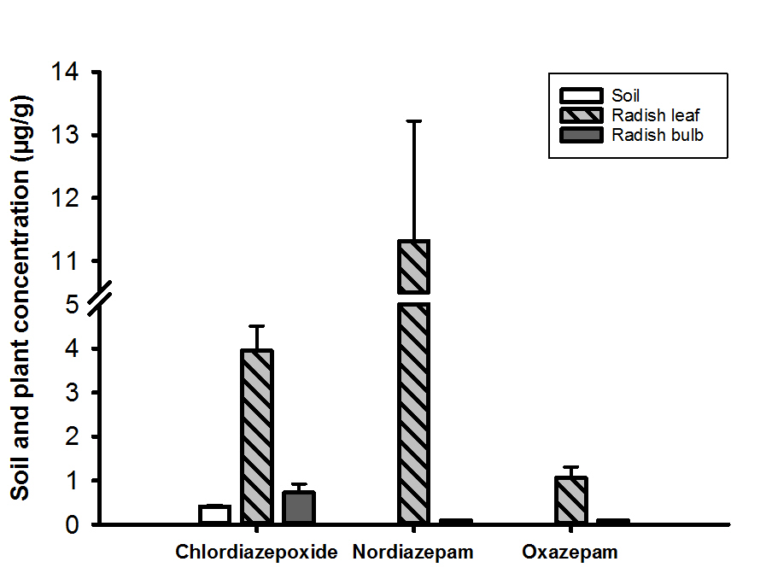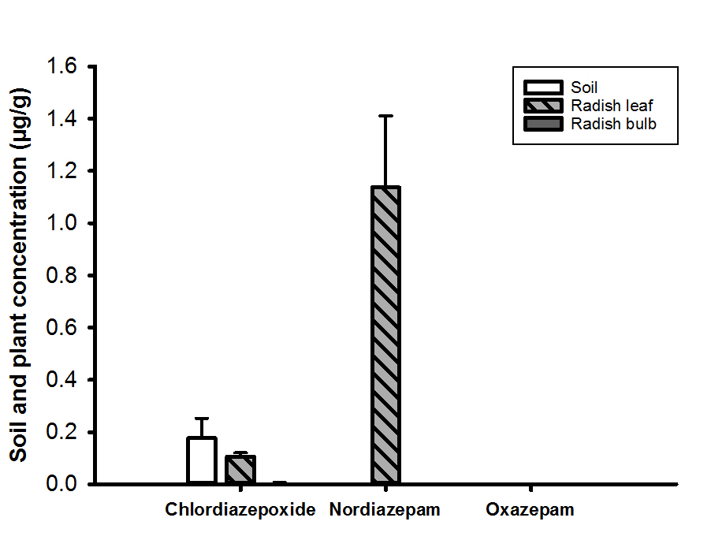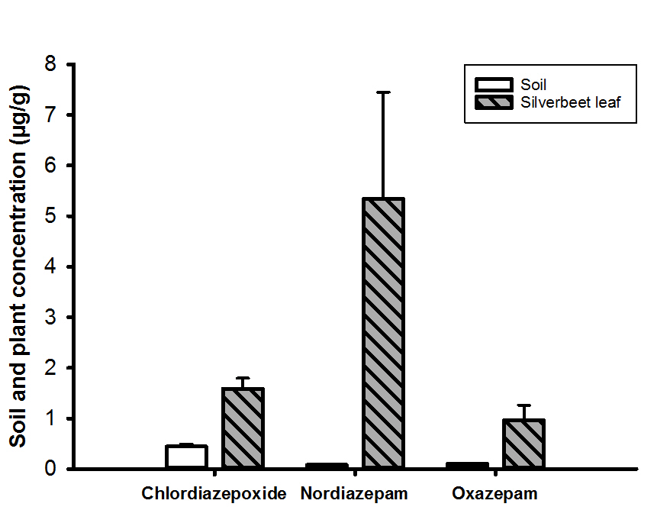

**(C)**

**(B)**

**(A)**

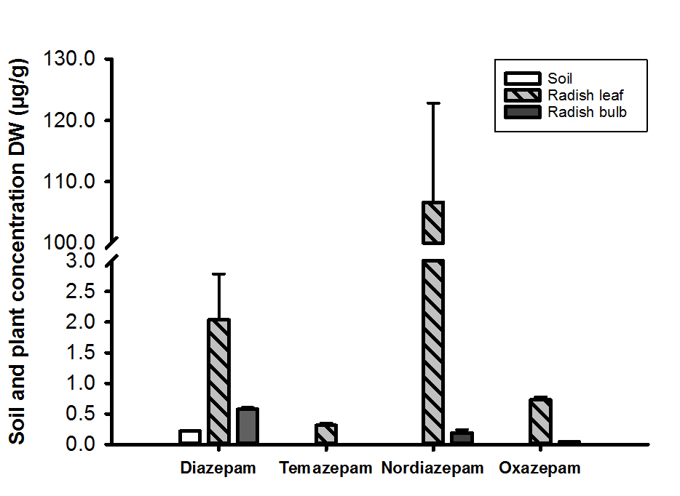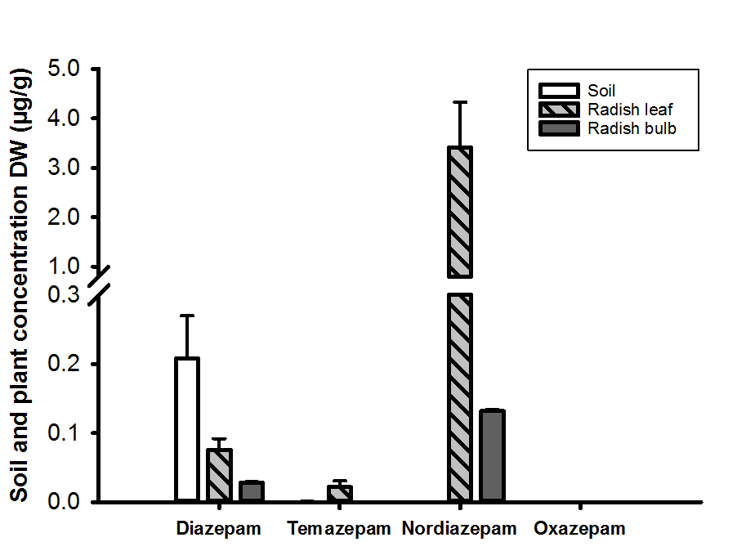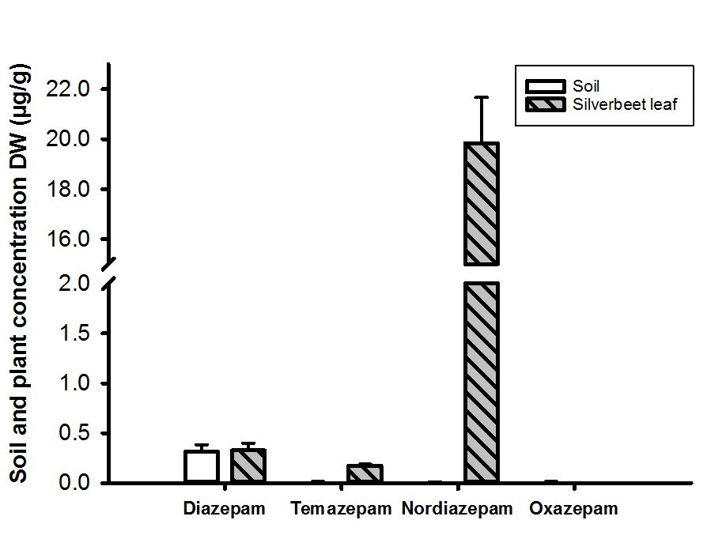

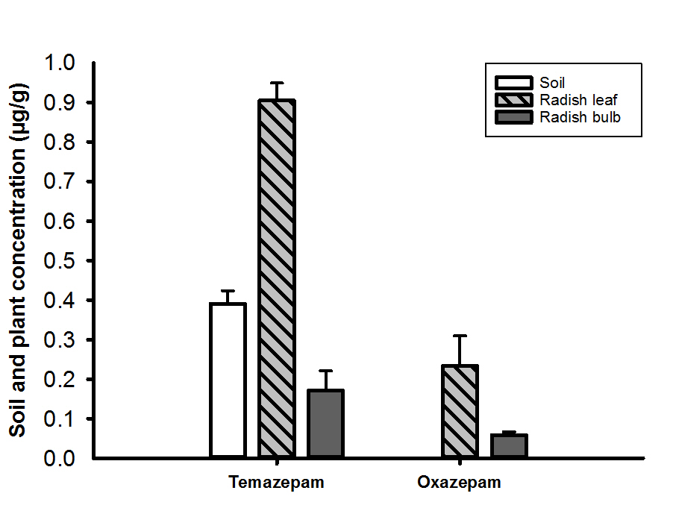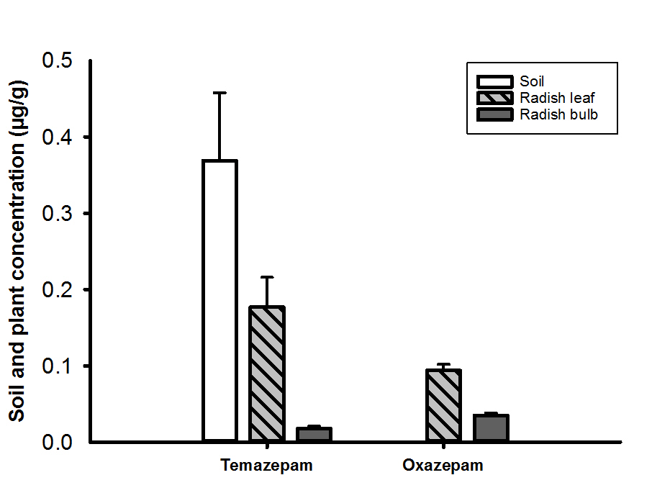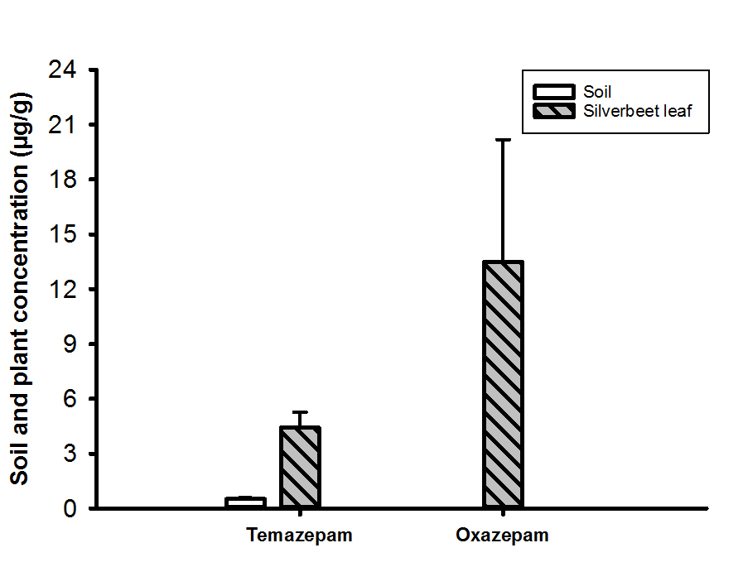

**REFERENCES**

Asano, T.; Burton, F.L.; Leverenz, H.; Tsuchihashi, R.; Tchobanoglous, G. Water Reuse: Issues, Technologies, and Applications. New York: McGraw-Hill Professional; 2007

Bending, G.D.; Turner, M.K.; Jones, J.E. Interactions between crop residue and soil organic matter quality and the functional diversity of soil microbial communities. Soil Biology & Biochemistry. 34:1073-1082; 2002

Bouche, N.; Fromm, H. GABA in plants: just a metabolite? Trends in Plant Science. 9:110-115; 2004

Briggs, G.G.; Bromilow, R.H.; Evans, A.A. Relationships between lipophilicity and root uptake and translocation of non-ionized chemicals by barley. Pesticide Science. 13:495-504; 1982

Brodin, T.; Fick, J.; Jonsson, M.; Klaminder, J. Dilute concentrations of a psychiatric drug alter behavior of fish from natural populations. Science. 339:814-815; 2013

Calisto, V.; Domingues, M.R.M.; Esteves, V.I. Photodegradation of psychiatric pharmaceuticals in aquatic environments - Kinetics and photodegradation products. Water Res. 45:6097-6106; 2011

Carter, L.J.; Harris, E.; Williams, M.; Ryan, J.J.; Kookana, R.S.; Boxall, A.B.A. Fate and Uptake of Pharmaceuticals in Soil-Plant Systems. J Agric Food Chem. 62:816-825; 2014

Carter, L.J.; Williams, M.; Bottcher, C.; Kookana, R.S. Uptake of Pharmaceuticals Influences Plant Development and Affects Nutrient and Hormone Homeostases. Environ Sci Technol. 49:12509-12518; 2015

Celiz, M.D.; Tso, J.; Aga, D.S. Pharmaceutical metabolites in the environment: Analytical challenges and ecological risks. Environ Toxicol Chem. 28:2473-2484; 2009

Charney, D.S.; Mihic, S.J.; Harris, R.A. Chapter 17 Hypnotics and Sedatives. in: Hardman J.G., Limbird L.E., Goodman Gilman A., eds. Goodman and Gilman's The Pharmacological Basis of Therapeutics. United States of America: McGraw-Hill; 2001

Della Site, A. Factors affecting sorption of organic compounds in natural sorbent/water systems and sorption coefficients for selected pollutants. A review. Journal of Physical Chemical Reference Data. 30:187-390; 2001

DePaolis, F.; Kukkonen, J. Binding of organic pollutants to humic and fulvic acids: Influence of pH and the structure of humic material. Chemosphere. 34:1693-1704; 1997

Fick, J.; Brodin, T.; Heynen, M.; Klaminder, J.; Jonsson, M.; Grabicova, K.; Randak, T.; Grabic, R.; Kodes, V.; Slobodnik, J.; Sweetman, A.; Earnshaw, M.; Barra Caracciolo, A.; Lettieri, T.; Loos, R. Screening of benzodiazepines in thirty European rivers. Chemosphere. 176:324-332; 2017

Gagne, F.; Andre, C.; Gelinas, M. Neurochemical effects of benzodiazepine and morphine on freshwater mussels. Comp Biochem Physiol C-Toxicol Pharmacol. 152:207-214; 2010

Goldstein, M.; Shenker, M.; Chefetz, B. Insights into the Uptake Processes of Wastewater-Borne Pharmaceuticals by Vegetables. Environ Sci Technol. 48:5593-5600; 2014

Guengerich, F.P. Cytochrome P450 and chemical toxicology. Chemical Research in Toxicology. 21:70-83; 2008

Haefely, W. BENZODIAZEPINE INTERACTIONS WITH GABA RECEPTORS. Neuroscience Letters. 47:201-206; 1984

Jelic, A.; Gros, M.; Ginebreda, A.; Cespedes-Sanchez, R.; Ventura, F.; Petrovic, M.; Barcelo, D. Occurrence, partition and removal of pharmaceuticals in sewage water and sludge during wastewater treatment. Water Res. 45:1165-1176; 2011

Kinnersley, A.M.; Lin, F. Receptor modifiers indicate that 4-aminobutyric acid (GABA) is a potential modulator of ion transport in plants. Plant Growth Regulation. 32:65-76; 2000

Kinnersley, A.M.; Turano, F.J. Gamma aminobutyric acid (GABA) and plant responses to stress. Critical Reviews in Plant Sciences. 19:479-509; 2000

Kosjek, T.; Perko, S.; Zupanc, M.; Hren, M.Z.; Dragicevic, T.L.; Zigon, D.; Kompare, B.; Heath, E. Environmental occurrence, fate and transformation of benzodiazepines in water treatment. Water Res. 46:355-368; 2012

Kreuzig, R.; Kullmer, C.; Matthies, B.; Holtge, S.; Dieckmann, H. Fate and behaviour of pharmaceutical residues in soils. Fresenius Environmental Bulletin. 12:550-558; 2003

Kummerer, K. The presence of pharmaceuticals in the environment due to human use – present knowledge and future challenges. Journal of Environmental Management. 90:2354-2366; 2009

Lee, L.S.; Nyman, A.K.; Li, H.; Nyman, M.C.; Jafvert, C. Initial sorption of aromatic amines to surface soils. Environ Toxicol Chem. 16:1575-1582; 1997

Lindsley, C.W. The Top Prescription Drugs of 2011 in the United States: Antipsychotics and Antidepressants Once Again Lead CNS Therapeutics. ACS Chem Neurosci. 3:630-631; 2012

Loffler, D.; Rombke, J.; Meller, M.; Ternes, T.A. Environmental fate of pharmaceuticals in water/sediment systems. Environ Sci Technol. 39:5209-5218; 2005

Malchi, T.; Maor, Y.; Tadmor, G.; Shenker, M.; Chefetz, B. Irrigation of Root Vegetables with Treated Wastewater: Evaluating Uptake of Pharmaceuticals and the Associated Human Health Risks. Environ Sci Technol. 48:9325-9333; 2014

Mandrioli, R.; Mercolini, L.; Raggi, M.A. Benzodiazepine Metabolism: An Analytical Perspective. Curr Drug Metab. 9:827-844; 2008

Mendoza, A.; de Alda, M.L.; Gonzalez-Alonso, S.; Mastroianni, N.; Barcelo, D.; Valcarcel, Y. Occurrence of drugs of abuse and benzodiazepines in river waters from the Madrid Region (Central Spain). Chemosphere. 95:247-255; 2014

Nunes, C.N.; Pauluk, L.E.; dos Anjos, V.E.; Lopes, M.C.; Quinaia, S.P. New approach to the determination of contaminants of emerging concern in natural water: study of alprazolam employing adsorptive cathodic stripping voltammetry. Analytical and Bioanalytical Chemistry. 407:6171-6179; 2015

OECD. Test No. 208: Terrestrial Plant Test: Seedling Emergence and Seedling Growth Test: OECD Publishing

OECD. Adsorption-desorption using a batch equilibrium method (Guideline 106). OECD guideline for the testing of chemicals. Paris; 2000

OECD. Test No. 208: Terrestrial Plant Test: Seedling Emergence and Seedling Growth Test: OECD Publishing; 2006

Olsen, R.W.; Sieghart, W. International union of pharmacology. LXX. Subtypes of gamma-aminobutyric Acid(A) receptors: Classification on the basis of subunit composition, pharmacology, and function. Update. Pharmacol Rev. 60:243-260; 2008

Ostadhadi-Dehkordi, S.; Tabatabaei-Sameni, M.; Forootanfar, H.; Kolahdouz, S.; Ghazi-Khansari, M.; Faramarzi, M.A. Degradation of some benzodiazepines by a laccase-mediated system in aqueous solution. Bioresour Technol. 125:344-347; 2012

Pan, S.T.; Xue, D.; Li, Z.L.; Zhou, Z.W.; He, Z.X.; Yang, Y.; Yang, T.; Qiu, J.X.; Zhou, S.F. Computational Identification of the Paralogs and Orthologs of Human Cytochrome P450 Superfamily and the Implication in Drug Discovery. Int J Mol Sci. 17; 2016

Ramesh, S.A.; Tyerman, S.D.; Xu, B.; Bose, J.; Kaur, S.; Conn, V.; Domingos, P.; Ullah, S.; Wege, S.; Shabala, S.; Feijo, J.A.; Ryan, P.R.; Gilliham, M. GABA signalling modulates plant growth by directly regulating the activity of plant-specific anion transporters. Nature communications. 6:7879; 2015

Rand-Weaver, M.; Margiotta-Casaluci, L.; Patel, A.; Panter, G.H.; Owen, S.F.; Sumpter, J.P. The Read-Across Hypothesis and Environmental Risk Assessment of Pharmaceuticals. Environ Sci Technol. 47:11384-11395; 2013

Redshaw, C.H.; Cooke, M.P.; Talbot, H.M.; McGrath, S.; Rowland, S.J. Low biodegradability of fluoxetine HCl, diazepam and their human metabolites in sewage sludge-amended soil. Journal of Soils and Sediments. 8:217-230; 2008

RxList. The Top 200 Prescriptions for 2012 by Number of US Prescriptions Dispensed. NDC Health: <http://www.rxlist.com/script/main/hp.asp>; 2012

Siminszky, B. Plant cytochrome P450-mediated herbicide metabolism. Phytochemistry Reviews. 5:445-458; 2006

Stein, K.; Ramil, M.; Fink, G.; Sander, M.; Ternes, T.A. Analysis and sorption of psychoactive drugs onto sediment. Environ Sci Technol. 42:6415-6423; 2008

Tanoue, R.; Sato, Y.; Motoyama, M.; Nakagawa, S.; Shinohara, R.; Nomiyama, K. Plant Uptake of Pharmaceutical Chemicals Detected in Recycled Organic Manure and Reclaimed Wastewater. J Agric Food Chem. 60:10203-10211; 2012

Thiele-Bruhn, S. Pharmaceutical antibiotic compounds,in soils - A review (vol 166, pg 145, 2003). Journal of Plant Nutrition and Soil Science-Zeitschrift Fur Pflanzenernahrung Und Bodenkunde. 166:546-546; 2003

Thies, F.; Backhaus, T.; Bossmann, B.; Grimme, L.H. Xenobiotic biotransformation in unicellular green algae - Involvement of cytochrome P450 in the activation and selectivity of the pyridazinone pro-herbicide metflurazon. Plant Physiology. 112:361-370; 1996

Williams, M.; Martin, S.; Kookana, R.S. Sorption and plant uptake of pharmaceuticals from an artificially contaminated soil amended with biochars. Plant and Soil. 395:75-86; 2015

Wu, C.X.; Spongberg, A.L.; Witter, J.D.; Fang, M.; Czajkowski, K.P. Uptake of Pharmaceutical and Personal Care Products by Soybean Plants from Soils Applied with Biosolids and Irrigated with Contaminated Water. Environ Sci Technol. 44:6157-6161; 2010

Wu, X.Q.; Conkle, J.L.; Ernst, F.; Gan, J. Treated Wastewater Irrigation: Uptake of Pharmaceutical and Personal Care Products by Common Vegetables under Field Conditions. Environ Sci Technol. 48:11286-11293; 2014