POISONING HISTORIES IN THE ITALIAN RENAISSANCE: THE CASE OF PICO DELLA MIRANDOLA AND ANGELO POLIZIANO

Gianni Gallello^{*a}, Elisabetta Cilli^{b}, Fulvio Bartoli^{c}, Massimo Andretta^{e}, Lucio Calcagnile^{d}, Agustin Pastor^{i}, Miguel de la Guardia^{i}, Patrizia Serventi^{b,f}, Alberto Marino^{g}, Stefano Benazzi^{b,h}, Giorgio Gruppioni^{b}

ª Department of Archaeology, University of York, King’s Manor, Exhibition Square YO1 7EP, York, UK
^{b} Department of Cultural Heritage, Alma Mater Studiorum University of Bologna,1 Ariani Street, 48121 Ravenna, Italy
^{c} Department of Biology University of Pisa, 13 Luca Ghini street, 56126 Pisa, Italy
^{d} Department of Mathematics and Physics “Ennio De Giorgi”, University of Salento, Via per Arnesano Street, 73100 Lecce, Italy
^{e} School of Engineering and Architecture, Alma Mater Studiorum University of Bologna, CIRSA, 163 S. Alberto street, 40123 Ravenna, Italy
^{f} Department of Biological, Geological & Environmental Sciences, Alma Mater Studiorum University of Bologna, 3 Selmi street, Bologna, Italy.
^{g} Reparto Investigazioni Scientifiche (RIS) – Arma dei Carabinieri – Parma
^{h}Department of Human Evolution, Max Planck Institute for Evolutionary Anthropology, Deutscher Platz 6, 04103 Leipzig, Germany
^{i} Department of Analytical Chemistry University of Valencia, 50 Dr. Moliner Street, 46100 Burjassot, Valencia, Spain

*Corresponding author: Gianni Gallello
Tel.+447949999321

Email: gianni.gallello@york.ac.uk

ORCID ID: 0000-0003-3641-8815

Abstract
Giovanni Pico della Mirandola and Angelo Poliziano were two of the most important humanists of the Italian Reinassance. They died suddenly in 1494 and their deaths have been for centuries a subject of debate. The exhumation of their remains offered the opportunity to study the cause of their death through a multidisciplinary research project.
Anthropological analyses, together with documentary evidences, radiocarbon dating and ancient DNA analysis supported the identification of the remains attributed to Pico. Macroscopic examination did not reveal paleopathological lesions or signs related to syphilis. Heavy metals analysis, carried out on bones and mummified tissues, showed that in Pico’s remains there were potentially lethal levels of arsenic, supporting the philosopher's poisoning theory reported by documentary sources. The arsenic concentrations obtained from analysis of Poliziano’s remains, are probably more related to an As chronic exposure or diagenetic processes rather than poisoning.

Keywords: Arsenic poisoning; ancient DNA; radiocarbon dating; Pico della Mirandola; Angelo Poliziano; Girolamo Benivieni.

- Introduction
Several studies have been carried out on human remains belonging to important personalities of the past, in order to establish their authenticity, to reveal unknown aspects or to clarify mysteries correlated to their life and death [1,2,3,4]. In some cases, the aim of the studies was to investigate the cause of death of individuals who died in mysterious circumstances, often being related to poisoning [5,6,7]. Since ancient times many deaths, including those of famous personalities, have been associated with arsenic poisoning [8,9] particularly during the Italian Renaissance [10]. Some of these studied have employed multidisciplinary analysis to develop a proper approach that could help with the interpretation of ancient documents [4] and physician’s data [5,6] related to the death scene of historical figures. Following this approach our work seeks to investigate the sudden deaths of Giovanni Pico della Mirandola and Angelo Poliziano, members of the humanist circle at the court of Lorenzo the Magnificent, Lord of Florence, and test the hypothesis that both personalities were murdered.
A man of acute intellect, Pico della Mirandola was one of the greatest philosophers and intellectuals of the Renaissance Humanism, universally known for his prodigious memory. He was a member of the noble Italian family of the Counts of Mirandola and Concordia, near Modena (Emilia Romagna) and was born in Mirandola the 24th February 1463 [11,12,13]. Pico della Mirandola wrote important texts, such as “De hominis dignitate” (1486), and is recognised as one of the greatest humanists of the Renaissance. On the 17th November 1494, when he was just 31 years old, Pico died in the Florentine convent of San Marco, after thirteen days of mysterious fevers [14]. The nature of his death is still debated, but there are numerous voices who argue that the great philosopher from Mirandola was murdered with poison, as reported by a rumour that began to spread soon after his death [15,16].
Angelo (Agnolo o Angiolo) Ambrogini, also known as Poliziano from Mons Politianus, the Latin name of the town where he was born (Montepulciano - Siena - Tuscany) on the 14th July 1454. He is considered to be the most important Italian poet of the 15th century. During the night of the 28th and 29th September 1494, at the age of 40, Poliziano also died suddenly in Florence after suffering symptoms of violent fevers, delirium, and hallucinations that lasted for two weeks [17].
Since the death of Pico and Poliziano occurred within two months and the symptoms suffered before passing away were quite similar, it has also been suggested that they died from syphilis, in particular the fulminating form which at that time was spreading epidemically throughout all Europe [18,19]. After all, the symptoms of this disease (fever and delusional manifestations) not only corresponded to those described by Antonio Spannocchi about the death of Poliziano, but were the same that, a couple of weeks before, led to the death of an individual who was maintaining intimate relations with the poet, supporting the hypothesis of a possible transmission of the infection [17].
However, according to some documents the possibility that Pico and Poliziano were murdered by poison must be considered [15]. A script found in the diaries of the Venetian Doge, Dandolo, mentions how Cristoforo and Martino da Casalmaggiore suppressed Giovanni Pico della Mirandola [16]. A further note appears in the work of Giovanni Veronesi titled “Quadro storico della Mirandola e della Concordia”, where it is reported that Pico lent a significant amount of money to a businessman from Florence to buy some provisions. Rather than repaying the money the man decided instead to poison Pico [20]. Other sources talk about a member of the Medici family condemning and trying to capture Pico for his love affair with Margherita, Mariotto’s wife, but the philosopher was protected by Lorenzo the Magnificent [21]. Moreover, Pico`s family, especially his brother Anton Maria and the sister in law Bianca Maria D’Este, did not accept the transfer of an important part of his inheritance to his nephew Giovanni Francesco Pico della Mirandola [22,23]. In summary, there are a number of documents suggesting that there were people with a motive to get rid of Pico della Mirandola [15].
Without excluding other potential causes of death, in this and also in the Poliziano case, the poisoning hypothesis cannot be omitted. In fact, according to some documents, it seems that he could had been targeted by someone who, for some reason, was interested in killing him [15,16,24].
Thanks to an Italian organization so called “National Committee for the Enhancement of Historical Heritage, Culture and Environment”, the remains of Pico della Mirandola and Angelo Poliziano were exhumed and studied.
Their tombs were placed in the small cloister adjacent to the church of San Marco in Florence. The investigation also included the skeletal remains of another, less famous, Florentine poet, Girolamo Benivieni, who was buried in the same coffin as Pico. Benivieni was also a member of the circle of Lorenzo the Magnificent, and a close friend of Pico who died in 1542, aged 89.
This study aims to find scientific evidence about the authenticity of the specimens attributed to Pico della Mirandola and Angelo Poliziano, and to provide data which can ascertain the hypothesis proposing that the two humanists were murdered by poisoning by carrying out toxic heavy metals analysis. Furthermore, the same analyses were also performed on Benivieni’s remains as a coeval sample control.

2. Materials and methods
2.1 The anthropological survey and sampling
The remains attributed to Pico della Mirandola were buried together with those of Girolamo Benivieni, inside an ancient coffin made by wooden tables and enclosed in a larger modern coffin. On the cover, a metal plate was fastened, the inscription said: "Bones of Pico della Mirandola and Girolamo Benivieni". The remains of the two humanists were placed side by side. One of them was lying supine with the skeletal segments maintained in anatomical connection by mummified soft tissues. The body was covered by clothing, the head by a headdress in red tissue. The masculine features of the skeleton, the pronounced tooth wear, and the advanced alveolar atrophy suggest that he was a man of advanced age. The remains are therefore compatible with Girolamo Benivieni, who died in 1542, at the age of 89. The skeletal remains attributed to Pico della Mirandola were located along the left side of Benivieni, entirely recomposed, following a rough order. It is likely, therefore, that at the moment of Benivieni’s death, 48 years after the death of Pico, the remains of this latter were introduced into the coffin of his Florentine friend. The skeleton almost completely and exceptionally well-preserved (just some bones of the hands and feet were missing, while the remaining skeleton was partially covered by mummified tissue) was attributed to Pico della Mirandola.
Within the coffin, there was a lead case containing a parchment reporting the outcome of the remains survey carried out in 1940 and mentioning the previous surveys (1590, 1699 and 1800).
The remains of Poliziano were poorly preserved and found inside a small modern coffin with the inscription: "Poliziano bones". Also in this case, a parchment was contained in a lead case placed into the coffin during the survey carried out in 1940 confirming the successful identification of the poet’s remains. The remains were extremely incomplete and in a poor state of conservation. Only a scarce number of fragments of the neural and facial skull and of the postcranial skeleton were preserved. A possible past integrative restoration and consolidation treatment were also evident in some bone fragments.
In order to perform the analyses, samples from mummified tissues, bones, wood and textiles, belonging to the three humanists and their coffins, were collected. A very good state of conservation was evident in the remains of Pico and Benivieni, where bones, nails, soft tissues and also Benivieni clothes were still preserved. On the contrary, as already mentioned Polizano remains were just represented by fragile fragments, which in the past have already been restored as could be observed thanks to the presence of a glossy film covering the surface of the bones.
The sampling was carried out avoiding parts that could heavily affect the remains preservation, whilst at the same time trying to develop a strategy that allowed us to obtain meaningful chemical-physical analyses. From Pico, rib, soft tissue from the heel, foot skin and a toenail were sampled; Poliziano samples were taken from rib, radius and vertebrae; in Benivieni a toenail, a rib, soft tissues from the knee and from the heel, a piece of muscle and skin from the femur, from the hand and the left temple, and as well clothes from the pelvis area together with a piece of headgear from the temple, were sampled. Furthermore, fragments of wood of the coffin of Pico and Benivieni were collected. For genetic analyses a tooth and a fragment of femur were sampled from Pico, while for Poliziano, considering the poor preservation of the bones and the scarce availability of skeletal elements, a fragment of phalanx was taken. Radiocarbon dating was performed on fragments of long bones and coffin.
Sampling was carried out using a cutting tool and a micro spoon spatula made of stainless steel. Instruments were cleaned with ultra-pure water for each sampling and samples were deposited in plastic tubes. Woods were extracted employing a thin blade, the textiles were collected using laboratory tweezers and the mummified tissues were sampled by a scalpel.

2.2 Overview of the employed techniques
Before performing laboratory analyses, the remains of Pico and Poliziano were scanned by X-ray Computer Tomography (CT) to observe structural and pathological features and also to create digital models of bones.
To confirm the identity of the studied remains, samples collected from the bones of the three individuals, the Benivieni headgear and the ancient coffin have been dated using radiocarbon.
Ancient DNA analysis has been applied in order to test the preservation of the genetic material and to confirm the molecular sex of the individuals.
To observe arsenic poisoning traces in Pico della Mirandola soft tissues and nails, Scanning Electron Microscopy (SEM) and Optical Microscopy (OM) have been employed. Inductively Coupled Plasma Mass-Spectrometry (ICP-MS) analysis of arsenic and mercury has been carried out to measure As and Hg concentrations. In order to accurately determine the concentration of mercury in the samples, Pyrolysis cold vapour atomic absorption spectrometry (PCVAAS) was also utilized, while to determine arsenic levels it has been used as well Hydride Generation Atomic Fluorescence Spectrometry (HG-AFS).
The analytical techniques applied in this study were adequately calibrated and validated in order to obtain accurate and precise results. These techniques are described in the next sections.

2.3 Radiocarbon dating by Accelerator Mass Spectrometry (AMS)
Several samples were collected for radiocarbon dating: Pico della Mirandola rib and skin, Benivieni humerus, headgear and garment, and also a sample from the coffin of Pico and Benivieni was analysed.
The samples were chemically prepared and measured by Accelerator Mass Spectrometry (AMS) by using a 3MV Tandetron accelerator at CEDAD-CEnter for Dating and Diagnostics, in order to determine the absolute chronology by using the radiocarbon 14C method.
The samples were mechanically cleaned and crushed to remove surface contamination before chemical treatments. Then, the Longin method was used to extract collagen from the osteological samples. Samples from the three individuals were demineralized by using HCl at room temperature, gelatinized at 85 °C and filtered by using 0.45 mm pore silver filter until the collagen was extracted.
The purified collagen gelatine has been combusted to CO₂ in sealed quartz tube, and reduced to graphite using Fe powders as catalyst and H₂ as reducing medium at 600°C. Finally, the graphite obtained from the reduction process was pressed into Al target and measured by AMS.
The radiocarbon ages of the three samples were determined by measuring the 12C, 13C, 14C isotopes, corrected for the fractionation effects and normalize by using the IAEA C6 Sucrose standards. The OXcal v.3.10 software was used to calibrate the radiocarbon ages into calendar ages. The results of calendar ages are reported at one or two standard deviations (1σ and 2σ) corresponding respectively to 68.2% and 95.4% confidence levels.

2.4 Ancient DNA analysis
DNA analysis was carried out in specific equipped facilities under the strictest criteria of analysis recommended in this research field, such as: independent DNA extractions, negative controls, genotyping of all operators and the use of disposable gloves, masks and body suits. To confirm the authenticity of the obtained data, when it was feasible, the analyses were replicated on multiple samples. In fact, sampling for DNA analysis has concerned a tooth (first molar) and a fragment of femur for Pico della Mirandola, whereas for Poliziano only a phalanx. The samples were decontaminated by bleach washing, UV light exposure (40 minutes for each side) and with the physical removing of the outer surface (2-3 mm). First, the samples were powdered in a freezer mill with liquid nitrogen, then, 1 gr of samples were decalcified employing EDTA 0.5 M pH8 for 24 hours in a rotor at room temperature. At the end of this process, DNA was extracted with a phenol - chloroform protocol [25]. DNA quantification was performed by Plexor HY kit (Promega) following the manufacturer recommendations.

2.5 SEM and OM
SEM and OM have been employed to observe arsenic poisoning traces in soft tissues and nails of Pico della Mirandola and Benivieni. Samples were analysed, without any further preparation, by an Environmental Scanning Electron Microscope (Philips, ESEM Xl40) equipped with an energy-dispersive X-ray-system (EDAX Sapphire) and using an Optical microscope SMZ (NIKON).

2.6 Inductively coupled plasma mass spectrometry (ICP-MS)
ICP-MS analysis of arsenic and mercury has been carried out avoiding complete ashing of samples to be able to measure As and Hg.
For the ICP-MS analyses, 0.5 g of sample was digested into 1.5 ml HCl and 1.5 ml HNO₃ . Then, we heated the solution in a thermal bath at 100 ºC for 40 minutes and we brought it to a volume of 15 ml with the addition of ultrapure water. For the determination of the calibration curve of the ICP-MS spectrometer, we used a standard solution of 100 mg/l of As and Hg. Samples solution were filtered employing filter paper (WhatmanTM N.1 of 70mm), in order to avoid the obstruction of the nebulizer system, and analyzed by ICP-MS with a Perkin Elmer Elan DRCII©. Bone ash NIST 1400 has been used as standard reference materials for evaluating the analytical method.

2.7 Pyrolysis cold vapour atomic absorption spectrometry (PCVAAS)
In order to accurately determine the concentration of mercury in the studied samples, we have used a cold vapour Mercury Analyzer DMA-80 Milestone, based on atomic absorption determination after thermal decomposition of the samples. For liquid sample analysis, we employed quartz containers of 1.5 ml capacity, while for solid samples we used aluminium containers of 0.5 g to weight 0.1 g of wood, mummified tissue, human bones and textiles. For standards preparation, a solution of 1000 mg/l of Hg has been employed to prepare a solution of 10 µg/l in HCl medium. Then, 100 µl of each standard solution was directly pipetted in the quartz container. To evaluate the accuracy of the analytical method, we employed Coal Fly Ash NIST 1633C as certificate sample.

2.8 Hydride generation atomic fluorescence spectrometry (HG-AFS)
The analysis through HG-AFS PS-Analytical Excalibur Millenium 10,005 was employed to determine with greater accuracy the arsenic levels. 2.5 ml of Mg (NO3) 2 • 6H2O 20% (m / v) + MgO 2% (m / v) were added to 1 g of sample. Samples were covered with watch glasses and dried in a sand bath at 50 °C. Once the desired level of dryness was reached, samples were mineralized in a muffle with the following heating program treatment steps: 30min at 150 ºC; I) increasing one degree per minute to 450 ºC; II). After this, the ashes were weighted using 1ml of purified water and dissolved with 9 ml of concentrated HCl 10%. For HG-AFG measurements 9 ml of concentrated HCl and 600 mu.l of a mixture of KI-ascorbic acid, containing KI 50% (m/v) + ascorbic acid 10% (m/v), were added. After 30 minutes, the solution has been brought to 30 ml volume with ultrapure water. For the standards preparation, 1000 μg/ml of As from Merck has been diluted using hydrochloric acid, KI (1% m/v) and ascorbic acid (2% m/v) at 2 µg/l. To assess the accuracy of the analytical method, bone ash NIST 1400 was employed as certified sample.

3. Results and discussion
3.1 The human remains
The inscriptions on the gravestone placed on the wall, the metal plate outside the coffins as well as the scrolls within the coffins, report the names of the three important Humanists. The human remains contained in the coffins were analysed following anthropological protocols to identify sex and age, collect anthropometric data and evaluate potential trauma and/or pathological conditions. Therefore important data about the reconstruction of the individual biological profile and, when possible, the assessment regarding the cause of death, were obtained.
The skeletal remains of the alleged Pico and Benivieni are compatible with the physical characteristics of the two individuals, i.e. males died at ca. 30 (for Pico) and 89 (for Benivieni) years old.
Concerning Pico, ancient DNA analysis has revealed a good conservation of genetic material and has confirmed the sex of the sample as a male. Unfortunately, at the moment, without a direct descendent or a coeval relative, it is not possible to have a reference DNA to perform a personal identification of Pico remains. However, the good state of preservation of the genetic material paves the way for following future genomic DNA analyses. The paleopathological analysis of the human remains, supported by computer tomographic (CT) image data, has not revealed the presence of any pathological condition, including syphilis, which leave traces on the skeleton, generally only at the terminal stage (3rd stage) of the disease.
Concerning Poliziano, the fragmentary condition and poor preservation of the skeleton remains undermined both the anthropological study and ancient DNA analysis, finally failing to reconstruct a reliable biological profile of the individual. In general, pathological conditions related to syphilis were not observed. From the fragments of the skull it was possible, employing virtual technology, to reconstruct the cranium [26] and consequently the poet face was reproduced [27].

3.2 AMS radiocarbon dating
The radiocarbon (¹⁴C) dating of the three humanists has been confirmed by the consilience of multiple samples analysed. The dating of the remains attributed to Pico della Mirandola and Angelo Poliziano are 1430-1520 calibrated (cal) AD and 1440-1530 cal AD, respectively, which are in agreement with the date of death of the two humanists. The dating of the remains of Benivieni, as well as his headgear and garment, provided a data comprised between 1490 and 1660 cal AD, which is also compatible with his date of death. Concerning the coffin containing the remains of Pico and Benivieni, it was found to be dated between 1540 and 1640, thus temporally compatible with Benivieni remains, but more recent than those of Pico. Consecuently this should be the coffin originally used to place the body of the Florentine poet where, according with his wish, the remains of Pico were placed.

3.3 Toxic heavy metals analysis
High levels of arsenic were detected in all the samples collected from Pico, with values that increase from the rib to soft tissues, reaching the maximum value in the toenail (over 29 µg/g) (Table 1). Such high arsenic values (obtained average value: 14+ 11 µg/g) are almost twice the amount considered normal in the population of the Renaissance period (5-7 µg/g) [28]. It is worthwhile noting that the pattern of arsenic values observed in Pico samples is compatible with a form of acute arsenic exposure, as the poison accumulates, at first, especially in hair and in nails and, to a lesser extent, in the skin, and even less in the bones [10]. In addition, some bands in the nails of Pico, may due to transverse true leukonychia, were identified by Scanning Electron Microscopy (SEM) and Optical Microscopy (OM) analyses (Figures 1 and 2 respectively), and could further suggest toxic arsenic exposure [29,30]. Unfortunately, the historical information that we have about the symptoms manifested by Pico before death are very poor. Giovanni Francesco Pico in the biography of his uncle wrote that Pico was suffering an insidious fever, which penetrated in the humor and viscera of his body so furiously that the treatments provided were not working [14]. So, a second hypothesis about the philosopher death could be related tothe important amount of arsenic that was given to him as "drug". For example Pico's biographer mentioned that nothing was working against the "insidious fever".
Hg was relatively high in Pico’s tissues (10 ± 5 μg/g) (Table 1), but such values are not considered toxic [31] and were found in Medieval and Renaissance individuals under medical treatments (about 10 μg/g) [30,32].
As and Hg values observed in the Benivieni samples were generally low, except for the rib (As: 5.5 μg/g), the “left temple hat” sample (As: 3.97 μg/g; Hg: 4.25 μg/g) and the “left temple soft tissue” (As: 2.45 μg/g; Hg: 1.97 μg/g), a sample directly in contact with the hat (Table 1). The As values observed in Benivieni rib are similar to those observed in Pico and Poliziano ribs (Table 1), may due to the environmental arsenic exposure during their life. However transverse true leukonychia, were not detected in the toenail microscopic analysis of Girolamo Benivieni (Figure 3).
Similar As and Hg values were obtained for “left temple hat” and “left temple soft tissue” samples may due to the use of some substances during postmortem body treatments [33,34].
Although as mentioned above the poor condition of Poliziano skeleton remains makes it very difficult to discuss As and Hg results, some hypothesis could be developed. Hg values in the poet’s remains are lower than those obtained from Medieval individuals with visible disease signs (like those associated with leprosy or syphilis), that probably were treated with mercury [32]. On the other hand As values were high compared to the average levels for human bones [35], especially in the analysed vertebra (24.14 μg/g) and, at lower extent, in the radius (6.51 μg/g) and rib (4.02 μg/g) (Table 1). Those differences probably depend on the bone remodelling processes, but at the moment there are not data available showing As values measured in unlike bones.
The high levels of As recorded in the bones of Poliziano suggest that the poet may suffered prolonged exposure to arsenic. However, although some historical documents claim that Poliziano was poisoned [15], other hypotheses concerning environmental factors or, more likely, prolonged medical cares based on arsenic must be taken in to account. However, Poliziano died due to "violent fevers, paranoid delusions, hallucinations and delirium which lasted two weeks," symptoms consistent with those now recognised in cases of arsenic poisoning [36,37].
About syphilis, at the time of Poliziano, mercury was one of the most employed drugs to cure this disease [32,38], while arsenic was used more frequently as a therapy for syphilis later, in 18th century [39]. Nevertheless, in general, arsenic has been used as drug throughout history, with documented cases reported before 2000 BCE [40,41,42]. Many scholars state that syphilis was imported from America into Spain by Cristoforo Colombo and then spread out through Europe thanks to the French army of Charles VIII [24]. However, both Pico and Poliziano got sick before the entry into Florence of the French King’s troops. In particular, Pico died the same day the troops arrived in Florence, while Poliziano two months earlier [24]. This evidence undermines the hypothesis of the death caused by syphilis.
Finally, considering the preservation state of Poliziano’s remains, the action of diagenetic processes, that could affect the bones post-mortem modifying their original elemental composition, cannot be excluded [43,44,45]. However the remains were found in a modern coffin having been transferred at some point from the original burial where probably the body decomposition processes began. Therefore, without studying the unknown original deposition is not possible to confirm this last hypothesis through interpretation of the obtained results.

4. Conclusions
In this study we tried to find scientific evidences to support the hypothesis of death by poisoning of the two famous humanists of the Italian Renaissance.
To achieve our aims, a consistent and coordinated multidisciplinary approach was developed. X-ray Computer Tomography allowed the observation of structural and pathological features that excluded the presence of syphilis in Pico’s and Poliziano’s remains, radiocarbon results confirmed that the studied remains belong to the period in which those humanists died and ancient DNA analysis confirmed the molecular sex of the remains attributed to Pico.
SEM and OM allowed us to observe arsenic poisoning traces in the toenail of Pico della Mirandola. Finally, ICP-MS, PCVAAS and HG-AFS analyses were successfully employed to measure As and Hg concentrations, and poisoning levels of arsenic in Pico’s soft tissues were found.
Following the ancient documents, Giovanni Pico della Mirandola passed away on the 17th November 1494, when he was just 31 years old, after thirteen days of mysterious fevers [14]. The results of the analysis may support the hypothesis that Pico died from acute arsenic poisoning. It is, as yet, difficult to prove that this was an intentional poisoning , but such assumption is consistent with several documentary and historical sources [15,16, 20,21,22,23].
The obtained results have not confirmed that the poet Angelo Poliziano died from an acute arsenic poisoning. The historical sources confirm that the poet died between the 28th and 29th September 1494, after violent fevers, deliriums, and hallucinations, which lasted two weeks [17]. Our data may suggest a possible arsenic chronic exposure caused by environmental factors or medical treatments. However the diagnosis of chronic arsenic poisoning remains a difficult task [46] and more analyses should be performed to support it (e.g. analysis of internal organs should be carried out, but unfortunately they are not preserved). Furthermore because of the poor preservation of Poliziano’s remains, the action of diagenetic processes modifying post-mortem the bone original elemental composition cannot be excluded.
Further analyses are necessary to confirm or propose new hypotheses about the cause of death of the famous Florentine literates.
With regard to Girolamo Benivieni, given that palaeopathological and toxic heavy metals analyses do not show particular evidence of diseases or poisoning, we can assume that he died from natural causes.
This work represents a significant addition to our knowledge of these three important individuals of the Italian Renaissance, and casts some new light on the intrigue surrounding their mysterious deaths. Moreover, the knowledge of aspects concerning arsenic poisoning, such as the preservation of this element in toenail, could be an interesting methodological issue for forensic anthropologists that need to be developed in further studies.

References

- Fornaciari G, Vitiello A, Giusiani S, Villari N. The Medici Project first anthropological and paleopathological results of the exploration of the Medici tombs in Florence. Journal of History of Medicine 2007; 19: 521-44.

- Fornaciari G, Bartolozzi P, Bartolozzi C, Rossi B, Menchi I, Piccioli A. A great enigma of the Italian Renaissance: paleopathological study on the death of Giovanni dalle Bande Nere (1498–1526) and historical relevance of a leg amputation. BMC Musculoskelet. Disord. 2014; 15: 301. doi: 10.1186/1471-2474-15-301

- Fornaciari G, Giuffra V, Bortolotti F, Tagliaro F. A medieval case of digitalis poisoning: the sudden death of Cangrande della Scala, lord of Verona (1291–1329). Journal of Archaeological Science 2015; 54: 62–7. doi: 10.1016/j.jas.2014.12.005.

- Haeusler M, Haas C, Lösch S, Moghaddam N, Villa I M, Walsh S, et al. Multidisciplinary Identification of the Controversial Freedom Fighter Jörg Jenatsch, Assassinated 1639 in Chur, Switzerland. PLoS One 2016; 11: e0168014. doi:/10.1371/journal.pone.0168014

- Cox TM, Jack N, Lofthouse S, Watling J, Haines J, Warren M J. King George III and porphyria: an elemental hypothesis and investigation. Lancet 2005; 366: 332-5. doi: 10.1016/S0140-6736(05)66991-7.

- Kintz P, Ginet M, Marques N, Cirimele V. Arsenic speciation of two specimens of Napoleon’s hair. Forensic Science International 2007; 170: 204-6. doi:10.1016/j.forsciint.2007.02.035.

- Lewin P K, Hancock R G, Voynovich P. Napoleon Bonaparte--no evidence of chronic arsenic poisoning. Nature 1982; 299: 627–8. doi:10.1038/299627a0.

- Parascandola J. King of Poisons. A History of Arsenic. Washington: Potomac Books, 2012.

- Sánchez, Jose B. From Forensic Toxicology to Biological Chemistry: Normal Arsenic and the Hazards of Sensitivity during the Nineteenth Century. Endeavour, 2016; 40 (2): 82-92 doi: 10.1016/j.endeavour.2016.03.007.

- Mari F, Polettini A, Lippi D, Bertol E. The mysterious death of Francesco I de’ Medici and Bianca Cappello: an arsenic murder? BMJ 2006; 333: 1299–301. doi: 10.1136/bmj.38996.682234.AE.

- Garin E. Ritratti di umanisti. Firenze: Sansoni, 1967.

- Viti P. Pico, Poliziano e l’Umanesimo di fine Quattrocento. Firenze: Olschki, 1994.

- Fumagalli M., Brocchieri B., Pico della Mirandola. Casale Monferrato: Piemme, 1999.

- Pico della Mirandola GF. Vita di Giovanni Pico della Mirandola scritta dal nipote Giovan Francesco Pico. Modena: Aedes Muratoriana, 1994.

- Andreolli B., Gruppioni G. Peripateticus miles : vita, fattezze e morte di Giovanni Pico della Mirandola. Mirandola: Centro internazionale di cultura Giovanni Pico della Mirandola, 2009.

- Poletti S. Del modo tenuto da Cristoforo a Martino da Casalmaggiore nel sopprimere Giovanni Pico della Mirandola. Mirandola: Redolfi, 1987.

- Del Lungo I. Florentia : uomini e cose del Quattrocento. Firenze: Barberà, 1897.

- Collard F. Pouvoir et poison. Histoire d’un crime politique de l’Antiquité à nos jours. Paris: Seuil, 2007.

- Pastore, A.Veleno. Credenze, Crimini, Saperi Nell'Italia Moderna. Bologna: Il Mulino, 2010.

- Veronesi G. Quadro Storico della Mirandola e della Concordia. Modena:Minghetti, 1847.

- Piazzo M Del. Nuovi documenti sull’incidente aretino del Pico della Mirandola. Rass. degli Arch. di Stato 1963; 23.

- Ceretti F. Il Conte Antonmaria Pico della Mirandola : memorie e documenti raccolti. Atti e Memorie delle rr Deputazioni di storia patria per le province dell’Emilia. Modena: Vincenzi, 1878.

- Wilmo C. Nuovo contributo alla iconografia di Giovanni Pico.Mirandola: Bozzoli, 1970.

- Tognotti E. L’altra faccia di Venere : la sifilide dalla prima età moderna all’avvento dell’AIDS, XV-XX sec. Milano: Angeli, 2006..

- Barnett R, Larson G, A phenol-chloroform protocol for extracting DNA from ancient samples..Methods Mol Biol. 2012; 840:13-9. doi: 10.1007/978-1-61779-516-9_2.

- Benazzi S, Stansfield E, Milani C, Gruppioni G. Geometric morphometric methods for three-dimensional virtual reconstruction of a fragmented cranium: the case of Angelo Poliziano. International Journal of Legal Medicine 2009; 123: 333–44. doi: 10.1007/s00414-009-0339-6.

- Milani C, Capussotto V, Guaschino M, Mombello D, Cocuzza M, Pirri C F, et al. A hyper-realistic method for facial approximation: the case of the Italian humanist Angelo Poliziano. Anthropologischer Anzeiger 2015; 72: 235–44. doi: 10.1127/anthranz/2015/0493.

- Andretta M. Risultanze delle analisi sulle concentrazioni di mercurio, cianuro ed arsenico nei resti ossei di Arrigo VII In: Archivio per l'Antropologia. Le spoglie dell'Alto Arrigo. Firenze: Società Italiana di Antropologia e Etnologia. 2015.

- Daniel C R, Piraccini B M, Tosti A. The nail and hair in forensic science. Journal of the American Academy of Dermatology 2004; 50: 258–61. doi:10.1016/j.jaad.2003.06.00810.

- Seavolt M B, Sarro R A, Levin K, Camisa C. Mees’ lines in a patient following acute arsenic intoxication. International Journal of Dermatology 2002; 41: 399–401. doi: 10.1046/j.1365-4362.2002.01535_2.x.

- Rasmussen K L, Kučer J, Skytte L, Kameník J, Havránek V, Smolík J. Was He Murdered Or Was He Not?-Part I: Analyses of Mercury in the Remains of Tycho Brahe. Archaeometry 2013; 55: 1187–195. doi: 10.1111/j.1475-4754.2012.00729.x.

- Rasmussen K L, Boldsen J L, Kristensen H K, Skytte L, Hansen K L, Mølholm L, et al. Mercury levels in Danish Medieval human bones. Journal of Archaeological Science 2008; 35: 2295–306. doi:10.1016/j.jas.2008.03.003

- Marinozzi S, Fornaciari G. Le mummie e l’arte medica nell’evo moderno. Medicina nei Secoli 2005; 1: p.344.

- Rasmussen K L, Torino M, Glastrup J, Ramseyer N T, Bjerregaard P. On the emblematic of S. Francesco Caracciolo. Archaeometry 2012; 54: 1100–113. doi: 10.1111/j.1475-4754.2012.00659.x.

- Yoo YC, Lee S K, Yang J Y, In S W, Kim K W, Chung K H, et al. Organ Distribution of Heavy Metals in Autopsy Material from Normal Korean. Journal of Health Science 2002; 48:186–194. doi: 10.1248/jhs.48.186

- Pecile A. Nota del Professor Antonio Percile sulle caratteristiche tossicologiche dell’anidride arseniosa in: Levi M.A., ed. Alessandro Magno. Santarcangelo di Romagna: Rusconi, 1994.

- Saha, J C, Dikshit A K, Bandyopadhyay M, Saha K C. A Review of Arsenic Poisoning and its Effects on Human Health. Critical Reviews in Environmental Science and Technology 1999; 29: 281–313. doi:10.1080/10643389991259227.

- Fornaciari G, Marinozzi S, Gazzaniga V, Giuffra V, Picchi M S, Giusiani M, et al. The use of mercury against pediculosis in the Renaissance: the case of Ferdinand II of Aragon, King of Naples, 1467-96. Medical History 2011; 55: 109–15. https://doi.org/10.1017/S0025727300006074.

- Hughes M F, Beck B D, Chen Y, Lewis A S, Thomas D J. Arsenic Exposure and Toxicology: A Historical Perspective. Toxicological Science 2011; 123: 305–332. doi.org/10.1093/toxsci/kfr184

- Antman K H. Introduction: the history of arsenic trioxide in cancer therapy. Oncologist 2001; 6: 1–2.

- Hyson J M. A history of arsenic in dentistry. Journal of the California Dental Association 2007; 35: 135–9.

- Jolliffe D M. A history of the use of arsenicals in man. Journal of the Royal Sociecty of Medicine 1993; 86:287–9.

- Cascant MM, Rubio S, Gallello G, Pastor A, Garriegues S, de la Guardia M. Prediction of alkaline earth elements in bone remains by near infrared spectroscopy. Talanta 2017; 162: 428-298. doi: 10.1016/j.talanta.2016.10.071.

- Gallello G, Kuligowski J, Pastor A, Diez A, Bernabeu J. Chemical elements levels as a methodological tool in forensic science. Journal of Forensic Research 2015; 6: 264-273. doi: 10.4172/2157-7145.1000264.

- Gallello, G Kuligowski, J Pastor, A Diez, A Bernabeu, J. Biological mineral content in iberian skeletal cremains for control of diagenetic factors employing multivariate statistics. Journal of Archaeological Science 2013; 40: 2477-2484. doi:10.1016/j.jas.2013.01.022.

- Hindmarsh J T. Caveats in hair analysis in chronic arsenic poisoning. Clinical Biochemistry 2002; 35: 1–11.

TABLE

Individual/material | Sample | As | Hg | Method
Pico della Mirandola | bone (rib) | 4.94 | 3.89 | ICP-MS
 | soft tissue (heel) | 7.02 | 10.4 | ICP-MS
 | skin (foot) | 15.6 | 14.7 | ICP-MS
 | toenail | 29.0 | 13.4 | ICP-MS; SEM; OM
Angelo Poliziano | bone (rib) | 4.02 | 1.71 | ICP-MS
 | bone (vertebra) | 24.2 | 5.2 | ICP-MS
 | bone (radius) | 6.51 | 0.18 | HG-AFG; PCVAAS
Gerolamo Benivieni | bone (rib) | 5.5 | 0.12 | ICP-MS; PCVAAS
 | soft tissue (heel) | 0.99 | 0.76 | HG-AFG; PCVAAS
 | soft tissue (muscle) | 0.75 | 0.65 | HG-AFG; PCVAAS
 | soft tissue (knee) | 0.23 | 1.04 | HG-AFG; PCVAAS
 | skin (femur area) | 0.59 | 0.12 | HG-AFG; PCVAAS
 | skin (left temple area) | 2.45 | 1.93 | HG-AFG; PCVAAS
 | skin (hand area) | LOQ | 0.39 | HG-AFG; PCVAAS
 | toenail | 0.34 | 0.09 | HG-AFG; PCVAAS; OM
 | hat (left temple area) | 3.97 | 4.25 | HG-AFG; PCVAAS
 | cloth (pelvis area) | 0.76 | 0.94 | HG-AFG; PCVAAS
Coffin wood Benivieni side | old coffin (bottom feet area) | 0.06 | 0.04 | HG-AFG; PCVAAS
 | old coffin (bottom head area) | 2.61 | 0.06 | HG-AFG; PCVAAS
 | old coffin (high part of bottom feet area) | 3.84 | 0.98 | HG-AFG; PCVAAS
 | old coffin (headboard wall area) | 1.63 | 0.06 | HG-AFG; PCVAAS
 | new coffin (internal cover of left head area) | LOQ | 0.03 | HG-AFG; PCVAAS
 | new coffin (external cover of left head area) | 0.02 | 0.04 | HG-AFG; PCVAAS

Table 1. Inductively coupled plasma mass spectrometry (ICP-MS), Hydride generation atomic fluorescence spectrometry (HG-AFS) and Pyrolysis cold vapour atomic absorption spectrometry (PCVAAS) analysis results. As and Hg absolute concentrations (espressed in µg/g) in Giovanni Pico Della Mirandola, Girolamo Benivieni, Angelo Poliziano and the Coffin wood Benivieni side samples.

FIGURES
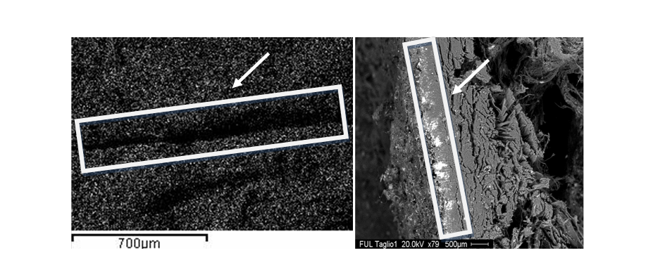

Figure 1. SEM images indicating the presence of band in Pico Della Mirandola left foot toenail of transverse true leukonychia due to a toxic arsenic exposure.
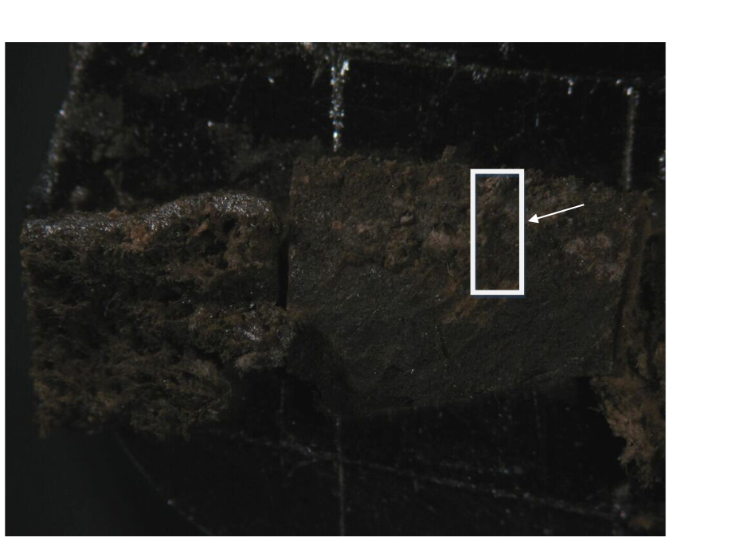
Figure 2. OM image (5 mm) of Pico Della Mirandola left foot toenail internal (on the left) and external (on the right) part.

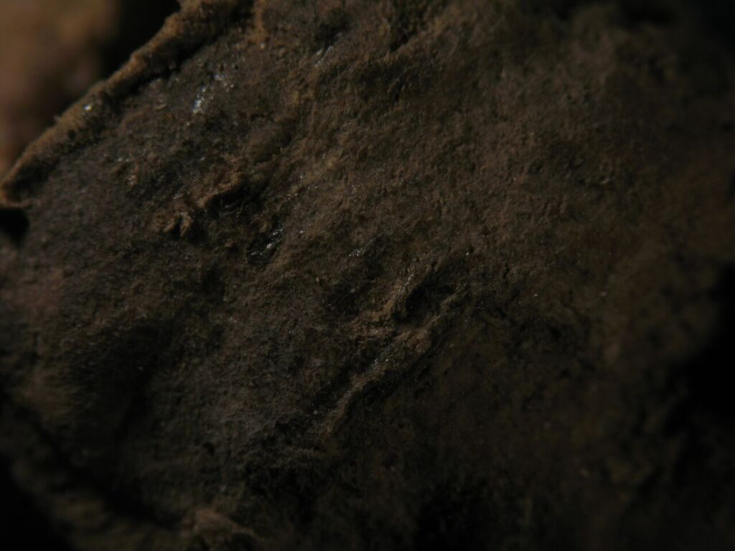

Figure 3. OM image (1 mm) of Girolamo Benivieni right foot toenail.

