Utilisation of supercritical fluids for the effective extraction of waxes and Cannabidiol (CBD) from hemp wastes
Thomas M. Attardª, Camille Bainierª, Marine Reinaudª, Alexandra Lanot^{b}, Simon J. McQueen-Mason^{b} and Andrew J. Huntª*
ª*(Corresponding author) Green Chemistry Centre of Excellence, Department of Chemistry, University of York, Heslington, York, UK. YO10 5DD, email: andrew.hunt@york.ac.uk. Tel. +44(0)1904324456
^{b} Centre for Novel Agricultural Products, Department of Biology, University of York, Wentworth Way, York, UK. YO10 5DD

Abstract
Up to 33% of hemp by mass can be lost in the form of dust during processing for fibre production. Heptane Soxhlet extractions and supercritical carbon dioxide extractions (scCO₂) of hemp dust samples yielded significant quantities of high value lipophilic molecules including fatty acids, policosanols (fatty alcohols), fatty aldehydes, hydrocarbons, sterols, triterpenoids and cannabinoids (Cannabidiol (CBD)). Dust collected from different stages of the mechanical process of hemp fibres gave rise to lipophilic extractives with varying compositions, thus making the isolation and purification of these compounds easier. Of particular interest is CBD (5832.5 ±118.9 μg/g of dust) which has attracted much attention for clinical-level studies on its therapeutic efficacy in the treatment of a variety of central nervous system (CNS) disorders. Factorial experimental design was carried out to optimise the scCO₂ extraction, with 350 bar and 50 ºC yielding the selective extraction of higher value components.

Introduction
Hemp (Cannabis sativa L.) is a C₃ plant that has its origins in Central North-East Asia.^{1, 2} It is one of the oldest cultivated non-food crops known dating back to around 5000 years ago.¹ Industrial hemp and marijuana (known for its psychotropic properties) originate from the same species (Cannabis sativa L.), however, while the latter is bred for its ∆⁹-tetrahydrocannabinol (∆⁹-THC) content in the female flowers, industrial hemp has been bred for high fibre content in the stem or for seeds.¹ The industrial hemp accumulate minimal amounts of ∆⁹-THC (0.2% w/v), which displays the psychotropic properties – approximately 50 times less than that found in marijuana.¹
In the last 2 decades, as a result of a number of developments, there has been renewed interest in hemp cultivation in several European countries (Italy, Spain, Germany, the Netherlands, United Kingdom and France) as well as other parts of the world.^{2, 3} Certain agricultural commodities have been overproduced within the EU which has led to the search for alternative uses for agricultural land.³ Hemp offers a number of agricultural benefits, namely, pest and disease resistance, weed control and improvement of soil properties due to crop rotation.² Hemp generates very high yields under very low input, with around 15 – 25 tonnes of dry matter per hectare. Its large plasticity allows it to be cultivated under a wide range of agro-ecological conditions.²⁻⁴
Hemp stems consist of two main parts – the bast fibres (35%) having a high cellulose content (57 – 77%) and low lignin content (5 – 9%) and the woody core (65%) (or shiv), which has lower amounts of cellulose (40 – 48%) and a higher lignin content (21 – 24%).⁵ Hemp fibres have always been known to be of very high quality and can be used in a number of industries such as paper-manufacturing, textiles industries, automotive industries and bio-building industries.^{1, 4} It has also been used as a biofuel in certain countries such as Sweden.⁴
In hemp fibre extraction, the fibres are separated out from the shiv. The latter is normally used for animal bedding. During fibre extraction, large amounts of hemp dust are generated, which could be a potential source of valuable chemicals. The exploitation of hemp dust for natural product extraction could potentially add value to this otherwise waste residue. A number of non-psychotropic cannabinoids are found in the hemp plant such as cannabidiol (CBD). CBD has been given considerable attention over the past few years due to its plethora of therapeutic properties and pharmacological activities.⁶⁻⁸ Unlike ∆⁹-THC, it is a non-psychotropic compound and is well-tolerated, enabling it to be used to treat numerous disorders. CBD has low toxicity which has allowed for clinical-level studies on its therapeutic efficacy (alone or combined with various cannabinoids) in the treatment of a variety of central nervous system (CNS) and peripheral disorders (such as Alzheimer’s).⁷ CBD exhibits high anti-inflammatory properties which could be used to treat neuro-inflammatory disorders. In fact, in 2011, the first phytocannabinoid drug Savitex® was approved in the UK (CBD combined with ∆⁹-THC) for the treatment of multiple sclerosis muscle spasms.⁹ Lipids and waxes are also an important and valuable class of compounds that can be extracted from agricultural residues.¹⁰⁻¹⁶
Traditional solvents such as hexane are typically utilised for wax extraction from biomass, however, these are increasingly being restricted due to toxicological and environmental issues. Supercritical carbon dioxide (scCO₂) is a non-flammable, non-toxic, widely available alternative and easily recyclable alternative to traditional extraction solvent.^{11, 12}
In this study lipid extraction was carried out on a variety of different hemp dust samples, obtained from different parts of an industrial hemp processing plant. Heptane soxhlet extractions, as well as scCO₂ extractions were carried out on dust samples collected from various parts of the plant to identify value added products and highlight potential uses for such waste streams.

Experimental

Hemp (cannabis sativa .) dust residue samples
The hemp dust residues were obtained from different dust plants situated in various points along the processing facility (as shown in Figure 1) situated in Tadcaster, North Yorkshire, UK. The hemp dust samples that were obtained are labelled in Table 7-1. Originally ten samples were collected from the processing facility, however the first two samples (sample 1 and sample 2) were found to contain too many impurities and these were therefore discarded. The original hemp plants are grown on 80-acres of arable land, in North Yorkshire. The variety was santhica, were harvested on the September 2013, and processed in April 2014.
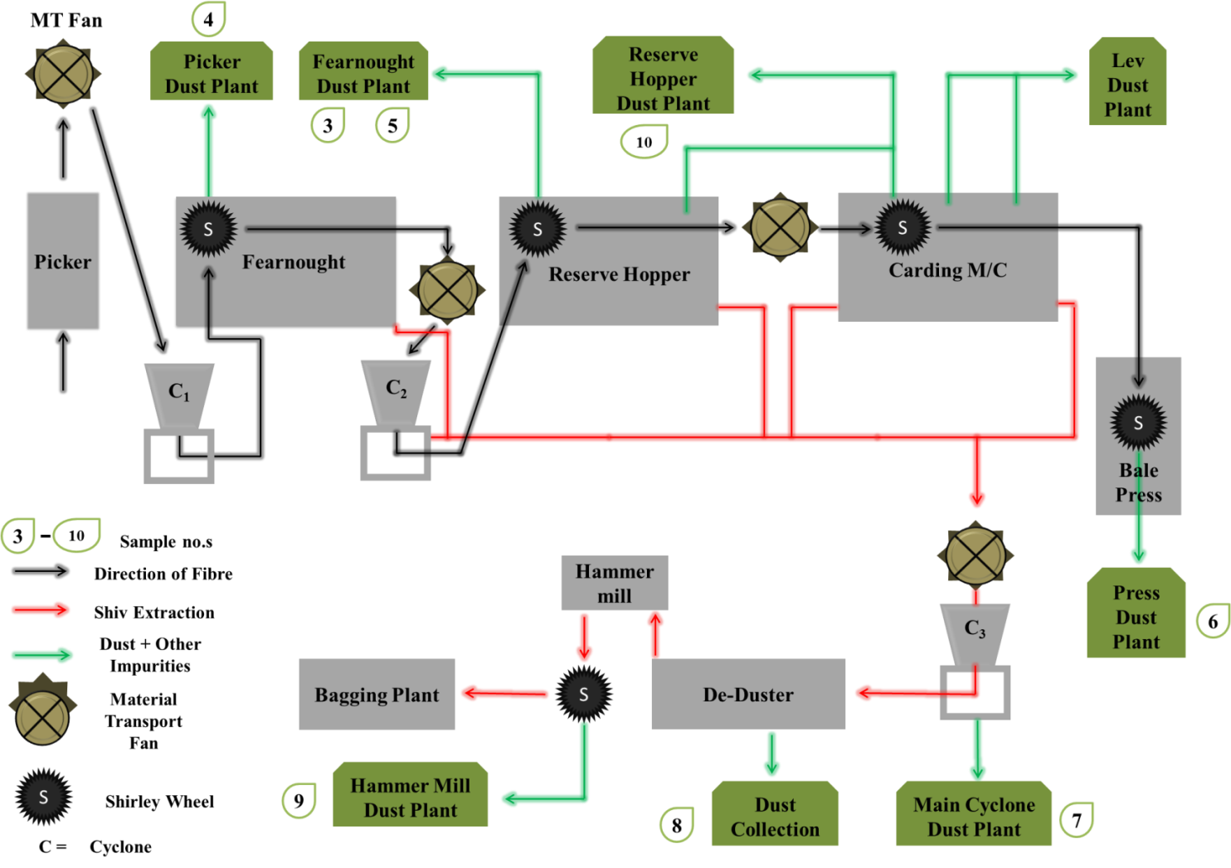
Figure 1 Schematic of the hemp processing plant and the paths taken by the fibre, shiv and dust
The process involves the use of various types of machinery which aim to separate the fibres from the rest of the stem and a considerable amount of dust is generated at each step. These are collected in dust plants that are found across the facility. In this hemp processing facility, approximately five tonnes of hemp is currently processed every week by the processing facility and around 18 – 33% of the total is hemp dust, thus generating approximately 900 – 1650 kg of hemp dust weekly.
*Table 1 Dust samples and their origins from the hemp processing facility.
Dust sample no. | Dust plant
3 | Fearnought dust plant (1st sample)
4 | Picker dust plant
5 | Fearnought dust plant (2nd sample)
6 | Press dust plant
7 | Main cyclone dust plant
8 | Dust collection (from rotary screen of de duster)
9 | Hammer mill dust plant
10 | Reserve hopper dust plant
*Samples 1 and 2 were the dust collected at the beginning of the processing facility and were found to be contaminated and were therefore discarded.
Dust samples were dried in a vacuum oven at 30 ºC for several days to constant weight.

Soxhlet extraction of the hemp dust residue
11g of hemp dust residue was placed in a Soxhlet thimble which was inserted into the Soxhlet apparatus. This was fitted to a 250 ml round bottom flask containing heptane (200 ml). A Radleys Discovery Technologies 2006T thermocouple was used to monitor the temperature during the extraction. The solution was allowed to reflux for 4 hours. The resulting solution was filtered (to remove any biomass present in the product) and the solvent was removed in vacuo. The samples were further dried at room temperature for 24 hours before weighing to ensure the removal of traces of residual solvent. The crude wax product was weighed and the % yield calculated. Three extractions were carried out and an average % yield calculated.

Supercritical carbon dioxide (scCO₂) extraction of the hemp dust residue
The scCO₂ extractions were carried out using a SFE-500 provided by Thar technologies. Supercritical fluid grade carbon dioxide (99.99%) was used to conduct the extractions. ≈100 g of milled hemp dust residue was placed into the 500 cm³ extraction vessel and connected to the extraction system. Liquid CO₂ was passed through a pre-heater set at the required temperature. The extractor was heated to the required temperature (range of extractions from 35 ºC – 65 ºC) and 5 minutes were allowed for it to equilibrate. An internal pump was used in order to obtain the required pressure (range of extractions from 80 bar – 400 bar). An automated back pressure regulator (ABPR) maintained the pressure throughout the system. The system was run in dynamic mode, in which the carbon dioxide which contained the epicuticular lipids, was allowed to flow into the collection vessel. A flow rate of 35 g min⁻¹ of liquid CO₂ was applied. The extraction was carried out for 4 hours.
When the extraction was terminated, depressurisation of the system was carried out over a period of 15 mins – 75 mins (depending on the pressure applied). The wax was collected by rinsing the collection vessel twice with approximately 100 ml of DCM. Anhydrous magnesium sulphate was added to any product samples that contained water (small amounts of water could be extracted by scCO₂ during the extraction process). The solution was subsequently filtered and DCM was passed through the filter paper to re-dissolve any wax found on the filter paper. The solvent was removed in vacuo. The crude wax product was weighed and the % yield was calculated.

Derivitisation prior to HT-GC (High temperature-gas chromatography) analysis
30 mg of crude wax extract was silylated by adding 200 μL N,O-bis-(trimethylsilyl)-trifluoro-acetamide and 100 μL toluene. The solution was heated in an oven for 45 minutes at 75 ºC.

High temperature- gas chromatography (HT-GC) method for analysis of waxes
HT-GC analysis was performed on an Agilent Technologies 6890N Network GC System. A ZB-5HT capillary column (30m x 250 μm x 0.25 μm nominal) was fitted at constant pressure of 22.35 psi. The carrier gas used was helium. The injector temperature and the flame ionisation detector temperature were maintained at 300 ºC. The samples were injected by automated injection (1 μl injection volume) with a split ratio of 5:1. An initial oven temperature of 60 ºC was maintained for 1 minute. The temperature was increased at a ramp rate of 8 ºC min⁻¹ until 360 ºC and held at this temperature for 30 minutes.
Quantification of the lipid components was carried out by means of internal standard calibration and response factors (R_{f}). Six point linear calibration graphs were produced using external standards for the quantification of hydrophobic compounds (fatty acids, alcohols, aldehydes, alkanes, wax esters, sterols and triterpenoids); whereby the mass ratios of the six samples were plotted against the area ratios. The R_{f} values for each external standard was obtained using the following equation:
$$\frac{{Mass}_{product}}{{Mass}_{standard}} = R_{f}× \frac{{Area}_{Product}}{{Area}_{Standard}}$$
The standards that were used were octadecanoic acid, linoleic acid, 1-octacosanol, dodecanal, hentriacontane, hexadecanoic acid octadecyl ester (Palmitic acid stearyl ester), stigmasterol and cannabidiol. Silylated calibration curves were also produced for the groups of compounds that were silylated (fatty acids, alcohols, sterols and cannabinoids).
HT-GC-MS (High temperature-gas chromatography mass spectrometry) procedure for analysis of wax
HT-GC-MS was performed on a Perkin Elmer Clarus 500 GC coupled with a Clarus 500 quadrupole mass spectrometer. This was fitted with a DB5HT capillary column (30 m x 250 μm x 0.25 μm nominal) at constant pressure of 22.35 psi. The carrier gas used was helium. The temperature of the injector was 300 ºC and the flow rate was set to 1.2 ml/min. The initial oven temperature was maintained at 60 ºC for 1 minute. The temperature was then ramped at a rate of 8 ºC min⁻¹ until 360 ºC and held for 10 minutes. The Clarus 500 quadrupole mass spectra was operated in the electron ionisation mode (EI) at 70 eV, a source temperature of 300 ºC, quadrupole at in the scan range of 30 - 1200 amu per second.
Another method was developed for the analysis of wax esters. The temperature of the injector was 380 ºC and the flow rate was set to 1.2 ml/min. The initial oven temperature was maintained at 100 ºC for 1 minute. The temperature was then ramped at a rate of 10 ºC min⁻¹ until 380 ºC and held for 20 minutes. The Clarus 500 quadrupole mass spectra was operated in the electron ionisation mode (EI) at 70 eV, a source temperature of 300 ºC, quadrupole at in the scan range of 30 - 1200 amu per second.
The data was collected with the PerkinElmer enhanced TurboMass (Ver5.4.2) chemical software and compounds were identified by analysing the mass fragmentation patterns, comparison of mass fragmentation patterns with spectra contained in the NIST library (v. 2.2) and by direct comparison with standard compounds.

Results and Discussion
Eight hemp dust samples (shown in Table 1) were obtained from different dust plants found in the processing facility (labelled in Figure 1) and subjected to Soxhlet extractions with heptane. The extractives obtained were characterised and compared in order to see whether different parts of the processing facility generated dust samples having different extractive compositions (and hence see whether different stages of the mechanical processing of hemp results in dust samples of varying composition). Supercritical carbon dioxide (scCO₂) extraction was subsequently carried out on one selected sample and an optimisation of the extraction process was carried out.

Figure 2 Concentration of compounds found in the heptane extractives from the various dust samples.
Lipophilic extractives from the various hemp dust samples were extracted by means of Soxhlet extractions using heptane. Figure 2 shows the distribution of the major families of lipophilic compounds found in the extracts from the hemp fibre processing plant in μg/g of dust. Samples 3-6 and sample 10 were dust residues generated during the fibre extraction process (fibre separation from the shiv) while samples 7-9 are dust residues generated solely from shiv processing (all of the fibre would have been removed at this stage), as shown in Figure 1 above. It can be seen that there is a similarity in lipophilic composition between sample 3, sample 5 and sample 6, the latter two of which are almost identical. Interestingly, sample 3 and sample 5 are waste residues collected from different parts of the same dust plant (referred to as Fearnought dust plant) and this therefore indicates that the type of machinery leads to the generation of waste residues having specific types and quantities of compounds.
Long-chain fatty acids were the most abundant compounds found in each sample with the exception of sample 8 (which is dominated by cannabinoids). The highest amount of fatty acids were found in sample 7 (4386.6 ±65.7 μg/g of dust) and sample 8 (4341.1 ±173.7 μg/g of dust). Saturated fatty acids having chain lengths of C₆ – C₂₅ were identified in all heptane extracts with C₁₆ predominating. Marques et al. investigated the composition of lipophilic extractives in hemp raw material and hemp cellulose pulps to investigate the effects that pulping has on the lipophilic constituents.¹⁷ These lipophilic extracts were obtained by Soxhlet extraction with acetone on the raw material and various cellulose pulps for 8 hours. Chain lengths of C₁₆ – C₂₆ were identified (with trace amounts of C₂₈ acid detected in certain pulp samples).¹⁷ Gutiérrez et al. also looked at acetone-extracted lipophilic extracts from hemp raw material in order to compare them with pitch deposits.¹⁸ They found chain lengths of C₁₆ – C₃₀ and stated that C₁₆, C₁₈ and C₂₀ acids predominated (though no quantification data was given).¹⁸
Four unsaturated fatty acids were identified in the lipophilic extracts: palmitoleic acid, oleic acid, linoleic acid and linolenic acid (Figure S1 – Supplementary information). The unsaturated fatty acids constituted a large portion of the total fatty acid composition in sample 4, sample 7, sample 8 and sample 10 (approximately 40% of the total fatty acid composition) while relatively small amounts were found in sample 3 (approximately 7% of the total fatty acid composition). The largest amounts of unsaturated fatty acids were found in sample 7 (1698 ±39.9 μg/g of dust), sample 8 (1637.7 ±57.5 μg/g of dust) and sample 4 (1498.3 ±194.9 μg/g of dust). However, when looking at the composition of unsaturated fatty acids in the lipophilic extracts (mg/g of wax), sample 10 has a higher amount of unsaturated fatty acids in the lipophilic extracts (72 ±5 mg/g of wax) (Figure S2- supplementary information). Only linoleic acid and oleic acid were found in the lipophilic extractives from hemp and cellulose pulps in the study carried out by Marques et al. and there was a decrease in the total composition of unsaturated fatty acids during the pulping process.¹⁷ Gutiérrez et al. also found oleic acid and linoleic acid in hemp biomass.¹⁸
n-Policosanols having chain lengths from C₂₂ to C₃₂ were detected in all samples. Sample 7 had the largest amount of n-policosanols (2040.2 ±101.7 μg/g of dust) followed by sample 4 (1209.8 μg/g of dust) and sample 10 (893 ±9 μg/g of dust). Interestingly, there was a difference in the dominant alcohol chain length between sample 7 and the other samples (Figure S3 – supplementary information). 1-octacosanol was the dominant alcohol chain length in sample 7 (comprising 46% of the total fatty alcohol composition) while 1-triacontanol was found to predominate in the remaining samples. This suggests that there is a drastic change in the n-policosanol composition of the hemp waste residues generated when the hemp fibres passes through the main cyclone. It is only in this sample that 1-octacosanol is obtained in such significant quantities (939.9 ±46.9 μg/g of dust or 38.2 ±1.9 mg/g of wax). Similar chain lengths have been reported in the literature of alcohol composition in hemp and cellulose pulps, with 1-octacosanol predominating.¹⁷ 1-docosanol, 1-octacosanol and 1-triacontanol were said to be the major alcohol chain lengths in another study on alcohol composition in hemp.¹⁸
A large abundance of fatty aldehydes were found in sample 7 (4071.9 ±71.6 μg/g of dust). Significantly lower amounts of aldehydes were found in the other samples, with sample 4 having the second highest amount of fatty aldehydes (2284 ±445.1 μg/g of dust). Chain lengths of C₂₆ to C₃₀ were identified. Once again, there was a difference in the dominant aldehyde chain length between sample 7 (octacosanal predominating) and the other samples (triacontanal predominating) (Figure S4 – Supplementary information). The same chain lengths were detected in previous studies on hemp and hemp cellulose pulps, with triacontanal predominating.^{17, 18} There was a significant reduction in aldehyde content after the pulping process.¹⁷
Hydrocarbons having chain lengths ranging from C₂₅ – C₃₁ were detected, with nonacosane (C₂₉) predominating (83% of the total alkane composition). Similar amounts of C₂₇ and C₃₁ were found in all the extracts. Sample 4 demonstrates the largest amount of alkanes (2357.3 ±81.5 μg/g of dust) followed by sample 7 (1514.8 ±30.5 μg/g of dust) (Figure S5 – supplementary information). The alkane composition is consistent with that reported in literature, where a predominance of C₂₉ alkane was found in acetone-extracted waxes from hemp.^{17, 18} Furthermore, relatively equal amounts of C₂₇ and C₃₁ were detected, which is consistent with the results of this study.¹⁷
Wax esters having chain lengths of C₃₈ to C₅₈ were present in all samples but, were most abundant in sample 7 (3076.6 ±129.9 μg/g of dust) followed by sample 4 (2189.7 μg/g of dust). There was a variation in the dominant wax ester chain length amongst the different samples (Figure S6 in supplementary information), with C₄₄ wax ester predominating in sample 4 and sample 8 (22.2% and 22% of total wax ester composition respectively), while C₄₆ wax ester was the most abundant chain length in the remaining samples (34.6% of total wax ester composition in sample 7). A smaller distribution of wax esters were highlighted in previous studies on wax ester composition in hemp during the pulping process for paper production (C₄₀ to C_{50,} Marques et al.; C₄₀ to C₅₄, Gutiérrez et al.) and it is interesting to note that all the wax esters were lost during the pulping process.^{17, 18}
All seven hemp lipophilic samples investigated show three sterols (β-sitosterol, stigmasterol and campesterol), one steroid ketone (stigma-4-en-3-one) and the triterpenoid friedelin was detected in trace amounts. Sample 8 demonstrated the largest amount of sterols (2503.7 ±142.5 μg/g of dust). In previous studies, there was a reduction in steroid ketones during the pulping process while only a small amount of free sterols were present in certain cellulose pulps (no free sterols were present in the cellulose pulps that had undergone elemental chlorine free bleaching).¹⁷
Cannabinoids were also detected in the lipophilic extracts. It was expected that low amounts of cannabinoids would be detected in the dust samples as these are normally found in the hemp flowers and not in the fibre. However, surprisingly, considerable amounts of the non-psychotropic CBD were detected in sample no. 8 (5832.5 ±118.9 μg/g of dust). Considerably lower amounts of CBD were found in the other dust samples (sample 4 had the second highest quantities, with 1125.4 ±117.8 μg/g of dust) which indicates that during the mechanical extraction and separation of the fibre from the woody core, there is accumulation of CBD at one stage of the process. Trace amounts of cannabinol and ∆⁹-THC were also detected in the extract. This could be of considerable significance since CBD is highly sought after as an important pharmaceutical agent for treatment of CNS diseases and other peripheral disorders.

Figure 3- CBD content in the heptane extracts from the various dust samples.
Interestingly, phytol was detected in significant quantities in sample 10 (3008.3 ±205.7 μg/g of dust), while it was only found in minute quantities in all the other samples. Furthermore, phytol was found to be the most abundant compound in the lipophilic extractives in sample 10 (Figure S7- supplementary information). Phytol has not previously been found in the lipophilic extractives of hemp.^{17, 18}
These results are promising as for the first time it has been demonstrated that hemp fibre waste residues from different parts of an industrial processing facility generate lipophilic extractives having different constituents (even though they originate from the sample hemp fibre plant). Hemp dust residues obtained from the main cyclone dust plant (sample 7) provide large amounts of long-chain saturated and unsaturated fatty acids, fatty aldehydes and wax esters. In this part of the process, the main cyclone separates off the lighter dust which ends up in the dust plant and lets the heavier shiv (woody core) pass on to the rotary screen de-duster which in turn further separates the dust out (sample 8) leaving only the shiv to be processed through the hammer mill. Waste residues from the picker dust plant (sample 4) are rich in hydrocarbons, which can be used in semiochemical applications, while lipophilic extracts from the rotary screen duster (sample 8) provide a steady source of high-value cannabinoids as well as phytosterols which are of medicinal and nutraceutical interest.^{6, 8, 19-21} The residues generated from the reserve hopper dust plant (sample 10) provide lipophilic extractives having considerable quantities of phytol which is of commercial interest for the fragrance industry.²²
Previously in literature, it was found that the manufacturing of cellulose pulps from hemp resulted in a significant decrease in certain groups of lipophilic compounds that are present in the raw material hemp lipophilic extractives namely aldehydes, wax esters, steroid ketones, sterol esters and alkylferulates.¹⁷ Free sterols have been shown to decrease in certain pulping processes.¹⁷ In the hemp dust residues collected from the extraction of hemp fibre (for incorporation into bedding), this should not occur as the hemp biomass did not undergo any chemical pre-treatment. Furthermore, an advantage of extracting from hemp dust as opposed to the entire plant is that the woody core rich in lignin and the fibre rich in cellulose have been separated enriching the sample with the epidermal part of the stem (which is where the waxy content is situated). Sample 8 was selected in order to carry out scCO₂ extraction and optimisation of lipophilic extractives as a result of the high concentrations of CBD and phytosterols present in the heptane extractives (when compared to the other samples). A 2x2 factorial experimental design was carried out; whereby the pressure and temperature were varied as follows: 80 bar 35 ºC, 80 bar 65 ºC, 240 bar 50 ºC, 350 bar 50 ºC, 400 bar 35 ºC and 400 bar 65 ºC. The results are summarised in Figure 11.
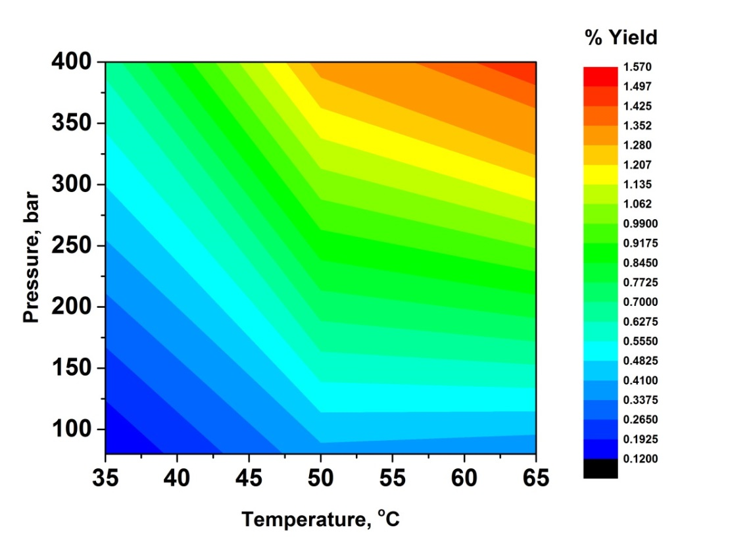

Figure 4 Contour plot showing % yield as a function of pressure and temperature.
Figure 4 shows that the highest extraction crude yields were obtained when the highest pressure and temperature were implemented (400 bar and 65 ºC). However, it is interesting to see whether these conditions also give rise to the highest amounts of the compounds of interest (namely CBD and phytosterols). Therefore, different families of compounds obtained for each scCO₂ extraction were quantified and compared in order to see what effect varying the conditions (temperature and pressure) had on the composition of lipophilic extractives.
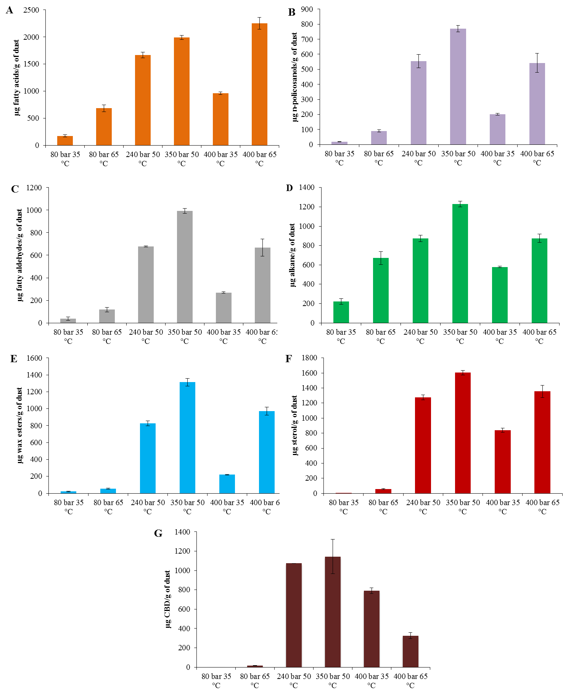
Figure 5 Quantities of A) Fatty acids B) n-Policosanols C) Fatty aldehydes D) n-Alkanes E) Wax esters F) Sterols and G) CBD in scCO₂ extracts with various conditions (temperature and pressure), in μg/g of dust.

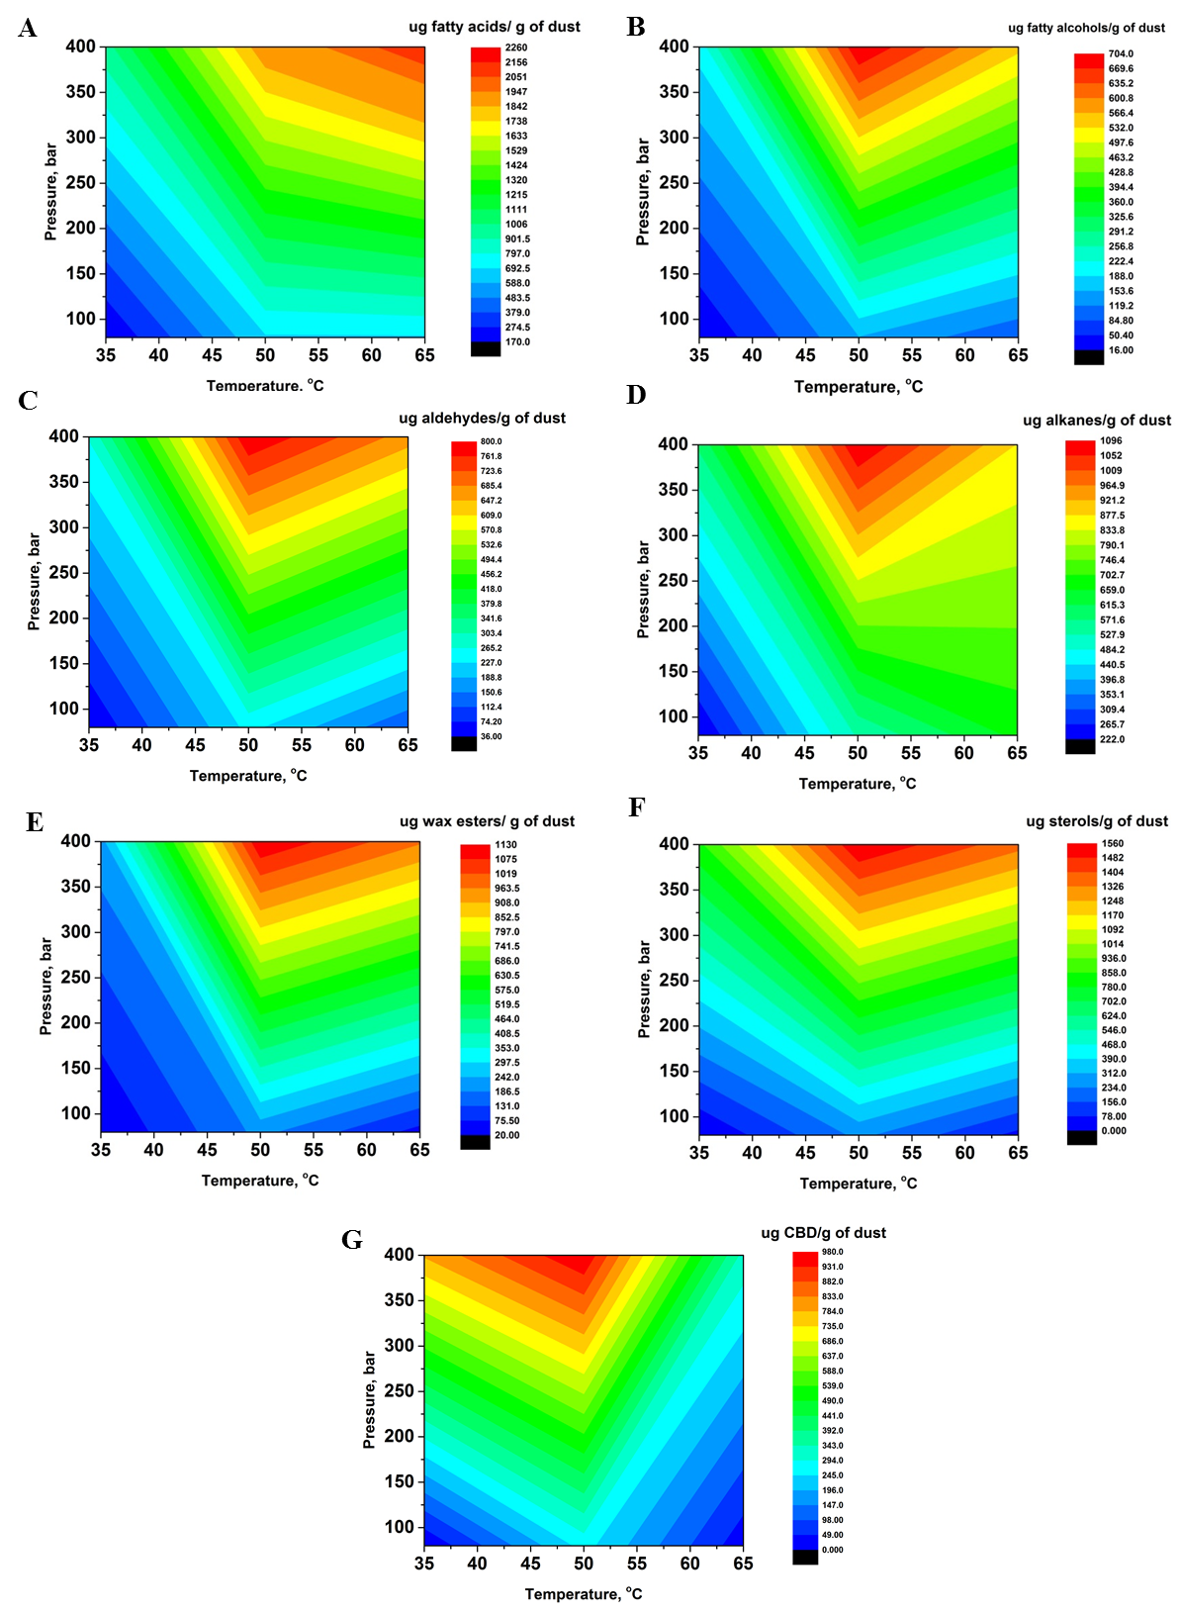
Figure 6 2D-contour plots showing the variation of A) Fatty acid concentration B) n-Policosanol concentration C) Fatty aldehyde concentration D) n-Alkane concentration E) Wax ester concentration F) Sterol concentration and G) CBD concentration with temperature and pressure.
Results (Figure 5) indicate that the highest yields of fatty acids were obtained with 400 bar and 65 ºC (2252.8 ±108.5 μg/g of dust). The solubility of fatty acids with scCO₂ at various pressures and temperatures was modelled using the Chrastil equation.²³ It was found that with fatty acids having chain lengths of C₁₂, C₁₄ and C₁₆, increasing the pressure and temperatue led to an increase in the solubility of fatty acids in scCO₂ and it was speculated that the increase in solubility occurred as a result of a phase change from solid fatty acid to liquid.²³ This data correlates with what was observed in this study, where higher yields of saturated fatty acids were obtained at higher pressures and temperatures and it is speculated that the higher temperatures (65 ºC) increase the solubility of fatty acids due to phase transitions (melting of the fatty acids) from solid to liquid (the melting point of hexadecanoic acid and octadecanoic acid are 62.9 ºC and 69.3 ºC respectively).
However, in the case of the other families of compounds, i.e. the long-chain fatty alcohols, aldehydes, n-alkanes, wax esters sterols and cannabinoids, the highest yields were achieved when conditions of 350 bar and 50 ºC were utilised (771.2 ±21.7 μg/g of dust, 992.4 ±22.7 μg/g of dust, 1229.9 ±29.5 μg/g of dust, 1313 ±43.2 μg/g of dust, 1606 ±30.8 μg/g of dust and 1143.4 ±117.8 μg/g of dust respectively). It is not clear as to why these conditions yielded the highest concentrations of these groups of compounds. Besides the solubilities of the individual components in scCO₂, other factors have to be taken into consideration such as the interactions between the different components making up the epicuticular waxes as well as entrainer effects by the solute molecules in scCO₂.²⁴
Figure 13 shows a number of 2-D contour plots, which try to model the yields of compounds extracted (in μg/g of dust) with varying pressure and temperature. Interestingly, for all groups of compounds, there seems to be a specific temperature (≈50 ºC) at which the influence of pressure on yield changes. Once this temperature is reached the yield of compounds extracted drastically increases with increasing pressure.
It is interesting to note that, in the case of CBD (Figure 13 G), there seems to be a negative effect with temperature on the yield of CBD extracted. This contrasts to what was observed with the other groups of compounds, where temperature seems to aid in the extraction. However, higher yields were obtained at 400 bar and 35 ºC than 400 bar and 65 ºC and 50 ºC seems to be the ideal temperature for the extraction of CBD. Solubility studies of CBD in scCO₂ have been carried out and seem to be in agreement with the data obtained in this current study.²⁵ It has been shown that there is a higher CBD solubility at lower temperatures and it was concluded that liquid cannabinoids (such as CBD and cannabigerol (CBG)) display a decreased solubility in scCO₂ compared to solid cannabinoids. It was also concluded that the highest CBD solubilities were obtained at moderate temperatures (50 ºC).²⁵ The melting point of CBD is 66 ºC and the highest temperature utilised in the current optimisation study was 65 ºC. Therefore, at this temperature the majority of CBD would be found in the liquid phase which would explain the decreased concentrations of CBD obtained when this extraction temperature was utilised (decrease in solubility of CBD). The solubility behaviour of CBD in scCO₂ is different to the psychoactive cannabinoids (∆⁹-THC and cannabinol), which show higher solubilities with higher temperatures. Therefore, the separation of CBD from the psychoactive cannabinoids as well as other lipophilic extractives by scCO₂ fractionation should be relatively straightforward, obtaining a relatively pure CBD oil.²⁵ This is therefore an advantage of utilising scCO₂ over conventional solvent extraction.
In the extraction conducted at low pressure and temperature (80 bar and 35 ºC), the extract primarily constitutes n-alkanes (217.3 ±29.7 mg/g of wax) followed by long-chain fatty acids (129.7 ±16.2 mg/g of wax). The remaining groups of compounds are only found in minute quantities (Figure S8 – supplementary information). It is known that certain groups of compounds such as sterols and cannabinoids show limited solubility at the supercritical point which explains the low abundance of these groups of compounds.²⁵⁻²⁷ Therefore, at low extraction conditions, there is selectivity towards specific groups of lipophilic compounds. However, in the scCO₂ extracts obtained at 350 bar and 50 ºC, there is a much wider variation in the groups of compounds obtained with long-chain fatty acids the most abundant compounds. There is a significant increase in the concentrations of sterols, wax esters and CBD.
Therefore, it can be concluded that even though conditions of 400 and 65 ºC gave rise to the highest % yield of crude wax, the factorial experimental design shows that, with the exception of the long-chain fatty acids, conditions of 350 bar and 50 ºC gave rise to the highest quantities of n-policosanols, fatty aldehydes, n-alkanes, wax esters, sterols and cannabidiol. Furthermore, the variation in CBD solubility in scCO₂ makes it possible to fractionate this cannabinoid from the rest of the lipophilic molecules, which cannot be done with conventional organic solvents. It has recently been demonstrated that scCO₂ extraction can be a cost effective method for wax extraction and can lead to easier downstream processing of the remaining biomass residues for the production of second generation biofuels. ¹⁰ As such, scCO₂ extraction is not only an effective solvent for the extraction of CBD from waste hemp residues but could potentially open doors for hemp based biorefineries.

Conclusion
It has been demonstrated that the processing of hemp for fibre extraction and shiv separation generates significant amount of dust residues which contain large groups of valuable chemicals that could potentially be exploited. Interestingly, dust collected from different stages of the mechanical process gave rise to lipophilic extractives that have significantly different amounts of hydrophobic components. Dust sample 7 (collected from the main cyclone dust plant) gave rise to considerable quantities of long-chain saturated and unsaturated fatty acids, fatty aldehydes and wax esters, while dust from the picker dust plant (sample 4) was found to contain significant amounts of hydrocarbons. Dust sample 8 (obtained from the de-duster) was the only sample to contain significant quantities of cannabinoids (mainly CBD), while significant amounts of phytol were only found in the dust collected from the reserve hopper dust plant (sample 10). This is interesting as it shows that the mechanical processing of hemp leads to the fractionation of lipophilic constituents, which should make the isolation and purification of these compounds easier.
ScCO₂ extraction was conducted on dust sample 8 (dust from the de-duster) and optimisation of the process was carried out using the factorial experimental design. Interestingly, it was found that, although conditions of 400 bar and 65 ºC gave rise to the highest % yield of crude wax, in-depth analysis on the concentrations of each family of compounds showed that 350 bar and 50 ºC gave rise to the highest yields of the majority of compounds (with the exception of fatty acids). The use of scCO₂ fractionation of CBD from the psychoactive cannabinoids and other components could generate opportunities for the production of higher value compounds from these hemp based waste streams. This study has highlighted that this should be relatively straightforward as CBD is more soluble at lower temperatures in scCO₂, thus enabling such fractionations.

Acknowledgments
The authors would like to thank Harrison Spinks for kindly supplying hemp dust residues. We gratefully acknowledge funding through the European Commission’s Directorate-General for Research within the 7th Framework Program (FP7/2007–2013) under the grant agreement no. 311849(MultiHemp).
1. L. Nissen, A. Zatta, I. Stefanini, S. Grandi, B. Sgorbati, B. Biavati and A. Monti, Fitoterapia, 2010, 81, 413-419.
2. P. Ranalli and G. Venturi, Euphytica, 2004, 140, 1-6.
3. P. C. Struik, S. Amaducci, M. J. Bullard, N. C. Stutterheim, G. Venturi and H. T. H. Cromack, Industrial Crops and Products, 2000, 11, 107-118.
4. E. Kreuger, T. Prade, F. Escobar, S. E. Svensson, J. E. Englund and L. Björnsson, Biomass and Bioenergy, 2011, 35, 893-900.
5. M. S. U. Rehman, N. Rashid, A. Saif, T. Mahmood and J.-I. Han, Renewable and Sustainable Energy Reviews, 2013, 18, 154-164.
6. J. Fernández-Ruiz, O. Sagredo, M. R. Pazos, C. García, R. Pertwee, R. Mechoulam and J. Martínez-Orgado, British Journal of Clinical Pharmacology, 2013, 75, 323-333.
7. R. Mechoulam, M. Peters, E. Murillo-Rodriguez and L. O. Hanuš, Chemistry & Biodiversity, 2007, 4, 1678-1692.
8. R. Mechoulam, L. A. Parker and R. Gallily, The Journal of Clinical Pharmacology, 2002, 42, 11S-19S.
9. J. Sastre-Garriga, C. Vila, S. Clissold and X. Montalban, Expert Review of Neurotherapeutics, 2011, 11, 627-637.
10. T. M. Attard, E. Theeuwes, L. D. Gomez, E. Johansson, I. Dimitriou, P. C. Wright, J. H. Clark, S. J. McQueen-Mason and A. J. Hunt, RSC Advances, 2015, 5, 43831-43838.
11. T. M. Attard, C. R. McElroy, C. A. Rezende, I. Polikarpov, J. H. Clark and A. J. Hunt, Industrial Crops and Products, 2015, 76, 95-103.
12. E. H. K. Sin, R. Marriott, A. J. Hunt and J. H. Clark, Comptes Rendus Chimie, 2014, 17, 293-300.
13. M. Arshadi, A. J. Hunt and J. H. Clark, RSC Advances, 2012, 2, 1806.
14. F. E. I. Deswarte, J. H. Clark, J. J. E. Hardy and P. M. Rose, Green Chemistry, 2006, 8, 39-42.
15. Y. Athukorala and G. Mazza, Industrial Crops and Products, 2010, 31, 550-556.
16. F. E. I. Deswarte, J. H. Clark, A. J. Wilson, J. J. E. Hardy, R. Marriott, S. P. Chahal, C. Jackson, G. Heslop, M. Birkett, T. J. Bruce and G. Whiteley, Biofuels, Bioproducts and Biorefining, 2007, 1, 245-254.
17. G. Marques, J. C. del Río and A. Gutiérrez, Bioresource Technology, 2010, 101, 260-267.
18. A. Gutiérrez and J. C. del Río, Bioresource Technology, 2005, 96, 1445-1450.
19. M. H. Moghadasian and J. J. Frohlich, The American Journal of Medicine, 1999, 107, 588-594.
20. P. G. Bradford and A. B. Awad, Molecular Nutrition & Food Research, 2007, 51, 161-170.
21. F. P. Schiestl, M. Ayasse, H. F. Paulus, C. Löfstedt, B. S. Hansson, F. Ibarra and W. Francke, Nature, 1999, 399, 421-421.
22. D. McGinty, C. S. Letizia and A. M. Api, Food and Chemical Toxicology, 2010, 48, Supplement 3, S59-S63.
23. P. Maheshwari, Z. L. Nikolov, T. M. White and R. Hartel, Journal of the American Oil Chemists’ Society, 1992, 69, 1069-1076.
24. J. M. Dobbs and K. P. Johnston, Industrial & Engineering Chemistry Research, 1987, 26, 1476-1482.
25. H. Perrotin-Brunel, M. C. Kroon, M. J. E. van Roosmalen, J. van Spronsen, C. J. Peters and G.-J. Witkamp, The Journal of Supercritical Fluids, 2010, 55, 603-608.
26. Ö. Güçlü-Üstündağ and F. Temelli, The Journal of supercritical fluids, 2004, 31, 235-253.
27. E. Stahl and A. Glatz, Fette, Seifen, Anstrichmittel, 1984, 86, 346-348.

