Alien Futures: What is on the horizon for biological invasions?

Running title: Alien Futures

Katharina Dehnen-Schmutz^{1*}, Thomas Boivin², Franz Essl³, Quentin J Groom⁴, Laura Harrison^{5,} Julia M Touza⁵, Helen Bayliss⁶

¹ Centre for Agroecology, Water and Resilience, Coventry University, Ryton Gardens, Coventry, CV8 3LG, UK
² Ecology of Mediterranean Forests, URFM, INRA, 84914, Avignon, France
³ Department of Botany and Biodiversity Research, University Vienna, Rennweg 14, 1030 Vienna
⁴ Botanic Garden Meise, Bouchout Domain, Nieuwelaan 38, 1860 Meise, Belgium
⁵ Environment Department, University of York, Wentworth Way, Heslington, YO10 5NG, York, UK
⁶ London, UK

*Corresponding author, email: ab6340@coventry.ac.uk

Abstract

Aim
To collect and identify the issues that may affect the future global and local management of biological invasions in the next 20 to 50 years and provide guidance for the prioritisation of actions and policies responding to the management challenges of the future.
Location
Global
Methods
We used an open online survey to poll specialists and stakeholders from around the world as to their opinion on the three most important future issues both globally and at their respective local working level.
Results
The 240 respondents identified 629 global issues that we categorised into topics. We summarised the highest rated topics into five broad thematic areas: (1) environmental change, particularly climate change, (2) the spread of species through trade, (3) public awareness, (4) the development of new technologies to enhance management, and (5) the need to strengthen policies. The respondents also identified 596 issues at their respective local working levels. Management, early detection, prevention and funding-related issues all ranked higher than at the global level. Our global audience of practitioners, policy makers and researchers also elicited topics not identified in horizon scanning exercises led by scientists including potential human health impacts, the need for better risk assessments and legislation, the role of human migration and water management.
Main conclusions
The topic areas identified in this horizon scan provide guidance where future policy priorities for invasive alien species should be set. First, to reduce the magnitude and speed of environmental change and its impacts on biological invasions; second, to restrict the movement of potentially invasive alien species via trade; third, to raise awareness with the general public and empower them to act; and finally, to invest in innovative technologies that can detect and mitigate adverse impacts of introduced species.

Keywords: biological invasions, future direction, global survey, horizon scanning, invasive alien species, management, prioritisation

- Introduction
The substantial and rising impacts of biological invasions on the environment and on human-wellbeing are now widely recognized (Millennium Ecosystem Assessment, 2005; Paini et al., 2016; Vilà & Hulme, 2017). This is reflected in international agreements with some of the most influential ones being the International Plant Protection Convention (IPPC) in 1952 and the Convention on Biological Diversity (CBD) in 1992 (Shine, 2007). Globally, the number of policies dealing with invasive alien species (IAS) has increased in particular in recent history (Butchart et al., 2010; Turbelin, Malamud, & Francis, 2017). Nevertheless, analyses of national response capacities have revealed that large areas of the global land surface remain highly vulnerable due to limited proactive capacities (Early et al., 2016; Turbelin et al., 2017), and while comparable assessments for marine environments have not been conducted, the situation is likely to be similar (Hewitt, Everett, & Parker, 2009). As a result, there is yet no saturation in the accumulation of alien species worldwide (Seebens et al., 2017), implying an urgent need for more proactive policies that respond to existing and well-known problems and future challenges.
Horizon scanning is a systematic process to identify and prioritize future threats and opportunities in order to inform strategy and policy (Sutherland, Fleishman, Mascia, Pretty, & Rudd, 2011; Sutherland & Woodroof, 2009). Horizon scanning has been used to identify potential IAS at different geographic scales (e.g. Roy et al., 2014). More recently, Ricciardi et al. (2017) used this approach to identify “emerging scientific, technological and socio-political issues likely to affect how biological invasions are studied and managed over the next two decades”. A key criterion of this study was the novelty of the issues, which the team of 17 leading scientists in the field had identified and ranked, to select their top 14 priority topics from a total list of 52. Although well placed to identify emerging scientific and technological issues, scientists are not necessarily representative of the wider community concerned with IAS, and therefore offer a specific perspective (see also Zenni, Ziller, Pauchard, Rodriguez-Cabal, & Nuñez, 2017). In other fields, similar horizon scanning studies have tried to address this by opening up the process to much larger groups of participants. For example Sutherland et al. (2008) involved representatives from governmental organizations, charities, businesses as well as academics in a horizon scanning project to identify future novel threats and opportunities facing UK biodiversity.
Here, we aimed to identify the issues relating to the future management of IAS that a more diverse audience would propose, while focusing on a longer projected time range of 20 to 50 years. We present results from a global horizon scan of an audience of practitioners, policy makers and researchers working across five continents. We investigate the issues of highest importance to the global IAS community rather than those of greatest potential novelty. Our work uses a contrasting but complementary scanning approach to Ricciardi et al. (2017), and provides decisive contributions to the current debate on how to shape and prioritise IAS management for the future.

- Methods
We invited participation in our survey over a period of five months starting from November 2015 using email distribution lists (e.g. IUCN Aliens-L, ESA ECOLOG-L), social media (Twitter), blogs, and by contacting relevant organisations and networks. The survey was available online in English, French, and Spanish, with a Russian version circulated by email (https://alienfutures.org/). We encouraged recipients to redistribute the survey further using their own networks. The survey asked participants to name, in priority order, up to three environmental, social or technological issues “important for the management of biological invasions at the global level over the next 20 to 50 years”, which could have “positive or negative implications”. The same question was asked for three issues at their working level, i.e. the geographical scale of their work, which usually ranges from local to national. The open questions could be answered in a 250 character space available for each issue. The survey also included questions about where participants are working (i.e. on which continent), the scale of their work (local to global), the focus of their work in relation to the invasion pathway (e.g. prevention, management), their professional sector, and their experience working with the main taxonomic groups, habitats and land-use systems. These questions were framed as multiple choice and respondents allowed to choose several answers. This enabled us to characterise the diversity of participants, and distinguish those involved in research from those that are not. Responses of the non-English surveys were translated into English. The qualitative analysis of the submitted issues was conducted using a thematic analysis approach to identify and analyse patterns (topics) within the issues submitted (Braun & Clarke, 2006; Weber, 1990). Two members of the team used an inductive approach to open code the issues, which was reviewed and redefined by the team until a final set of codes was agreed. The issues were then re-evaluated based on the agreed codes, and organised into topics. Some topics included a small number of issues, but were retained due to their distinctive characteristics. The total number of respondents who submitted issues within a topic was then used to identify and rank the top ten global and local working level topics. We also compared our results with those of Ricciardi et al. (2017) by applying our categorisations to the full list of issues in their supplementary material and used a Mann-Whitney-Wilcoxon test to compare the distributions of number of issues within each topic.

- Results

Two hundred and forty people participated in our survey (158 in the English version, 37 French, 36 Spanish, 9 Russian). The categorisation of the issues submitted resulted in the identification of 39 topics with a total of 629 global and 596 working level unique responses, respectively (Table 1). While this represents a large number of respondents, we acknowledge that our sampling approach did not succeed in a fully balanced representation of participants in terms of where their main work focus is based geographically and the professional sectors they are working in . For instance, respondents were working in all continents, except Antarctica, but there was a strong bias towards European participation (Table2/ Figure S1b). About half of the participants are working in academia and accordingly research scored highest in response to the question about the main areas of interests of participants (Figure S1c). However, management, communication and policy making also scored highly demonstrating both the participation of representatives of the non-academic sector as well as high interest in these topics by researchers. In terms of expertise, the broad taxonomic groups of animals and plants are well covered, while over 20 percent of participants have expertise in microorganisms. Terrestrial habitats are best covered by participants’ experience, followed by freshwater, while less than 20% of participant have experience in marine habitats. Respondents mainly work at the local and regional to national levels (Figure S1f).

3.1 The top global topics for invasive alien species management in the future
We identified the top-ten global topics (Figure 1) from the sum of all scores they received, and we summarise them here in the following five main broad content areas.
3.1.1 Environmental change
The two highest ranked topics both relate to environmental change: the first-ranked “climate change” (64 respondents) and the second-ranked “biodiversity and ecosystem change” (56 respondents). Submitted issues predominantly related to facilitating impacts of climate change on biological invasions and the ensuing consequences for biodiversity, the impacts of land-use changes, and global human-induced changes of the biophysical environment (e.g. eutrophication and pollutants). Respondents predicted climate change to increase the likelihood of occurrence, abundance, and spread of IAS resulting in an increase in threats to biodiversity and ecosystem services. The respondents identified that the potential for synergistic effects of changes in both climate and land use (e.g. habitat degradation and fragmentation) will amplify anticipated climate-driven future IAS impacts, with potentially increasing risks for protected areas specifically. From a policy perspective, there is a common thread in the responses on the need to consider IAS in the context of rapid environmental change such as climate and land use, as well as to implement global mitigation policies.

3.1.2 International Trade
International trade was the third highest ranked topic put forward by 56 respondents. The majority of the issues submitted dealt with the raising volume of trade, greater global connectivity, changes in direction and speed of trade routes, greater human global mobility, and new ways of trading online. On the latter, a respondent stated: “Trade in the online domain is largely unsupervised and can move invasive species internationally but also domestically with speed and little oversight”. Mitigating the risk of invasion with increasing trade is recognised to be complex, due to the challenges of regulating existing and future trade partnerships and the need for cooperation and coordinated global responses to address issues such as the risks associated with countries with porous borders with insufficient biosecurity regulations; the difficulty of labelling so that the origin, route and vector of an organism’s spread can be traced; illegal trading issues; and unsupervised e-commerce that can bypass biosecurity protocols. Three respondents mentioned IAS risks could decline with decreasing trade volumes and shorter routes associated with increasing fossil fuel costs and ‘societies choosing to source products locally rather than globally’.

3.1.3 Awareness and communication
The fourth highest rated topic, awareness, values and attitudes towards IAS (52 respondents), is closely related to another topic from the top ten, communication and information on IAS (27 respondents). Most issues submitted focused on the lack of awareness in the general public of the negative impacts of IAS and insufficient understanding of their control. Respondents also mentioned trading companies and governments who may either ignore national and international regulations or are unaware of them. They are worried that increased rates of invasions with global change will lead to fatalism and ignorance towards the topic. However, one respondent also mentioned that it ‘perhaps makes little sense to focus too heavily or exclusively on species assemblages and ecosystems of the past as calibration points for the future’. All this explains the high number of issues related to the need for better communication and information not just for the general public but also to specific target groups. For example, pet owners and the horticultural trade are specifically mentioned, as is the need for scientists to talk to policy makers directly. A positive thread in this theme is that awareness of global ecological problems will overall strengthen environmental behaviour and support for management actions.

3.1.4 Management: New technologies, innovation and resources
The management of IAS features highly in the responses submitted, with 30 responses on the development of new technology to detect and manage IAS. Several issues relate to the use of genetic tools including next generation DNA sequencing of environmental samples (eDNA), that could be useful to detect even small IAS populations in the environment as well as in pathways. Techniques involving genetic modifications such as gene drive (i.e. genome editing of target organisms to alter their populations) are reported as possible advances for IAS control while respondents are also aware of their possible environmental risks. Further progress is expected for example in remote operating machinery for detection and control, selective pesticide development, non-toxic biofouling solutions, fertility control and smartphone applications. In relation to the topic of management and control (28 respondents), participants strongly emphasise the need for increased stakeholder collaboration, in particular among politicians, regulators and local citizens. Despite these positive ideas about how management could become more efficient, the outlook is far less optimistic regarding the necessary resources for implementation. Most of the 28 issues within this topic concerned the lack of, or future decline in, resources.

3.1.5 IAS regulations, policy and implementation, and research
Advancing legislation on IAS and improving its implementation was mentioned by 36 respondents and thus ranked in fifth place. For reducing future invasions , the majority of respondents explicitly mentioned the importance of establishing legally binding global agreements that focus on the role of trade in general, or high-risk pathways in particular. The call for strengthening global IAS policies was expressed by respondents that worked in a wide range of applied fields (biodiversity conservation, agriculture, forestry, aquaculture), but much less so by respondents interested primarily in basic science (Figure 2a).
The topic of research on IAS includes 22 issues submitted by respondents. Issues mentioned to be addressed by scientific inquiry cover a broad range of themes including interaction with other features of environmental change, progress achievements on impacts and risks of IAS, and exploration of the role of new approaches such as citizen science.

3.2 Topics at respondents’ working level
While the submitted issues at the working level are broadly similar to the global level, there are several conspicuous differences (Figure 1) and the list and order of the top ten-topics vary. Most notable is that the two top global topics, “climate change” and “biodiversity and ecosystem change”, disappear from the top ten. Instead, awareness comes top with 60 respondents and topics related to management (47) and funding (41) get higher ranks, as do issues on early detection/prevention (36) and risk assessment (22) that did not feature in the top ten at the global level. At the working level, international trade is considered less relevant (12) whereas international and national cooperation and coordination (28) is considered more important. However, some global topics of local relevance may not have been mentioned at the working level separately, because respondents considered them when asked about the global issues, which could partially underestimate their representation. Taking into account the geographical focus of the respondents’ work (Table 2) reveals further differences, although some respondents may work in more than one continent.

3.3 Are researchers suggesting different topics than non-researchers?
Comparing respondents working in research to respondents who are not working in research does not reveal notable differences at the global level (Figure 2a). However, at the working level non-researchers more often identify research issues than researchers, whereas researchers more often mention IAS management and control issues (Figure 2b).
Our respondents identified the highest ranked topics identified by Ricciardi et al. (2017), for example gene drive. Both studies recognise the importance of awareness raising, values and attitudes towards IAS. However, we find a significant divergence in the numbers of issues raised within each topic (W = 329, P = <0.001), in particular within the topic areas of international trade and climate change (Figure 3).
Further, more than 40% of issues submitted in our survey could not been allocated to any of the Ricciardi et al. (2017) topics, including some topics that ranked highly, for example, the need for advancing legislation and improving its implementation, human health impacts (22), and the need for better risk assessments (19) (Table 1). This list of additional topics includes also topics with few responses that may nevertheless turn out to be highly important for future IAS management, for example human migration (4), pesticide resistance in IAS (5), and water management (7).

- Discussion
Our global survey revealed a wide range of topics with potentially high impacts on the management of biological invasions in the next 20 to 50 years. While several of the issues submitted are also well known current problems in IAS management, for example, biodiversity and ecosystem changes or international trade, the survey makes clear that these will persist in the future. Climate change is, perhaps unsurprisingly, the topic which the highest number of respondents considered would have substantial future impacts. Our diverse panel of specialists acknowledge that little can be done without the support of the general public and commercial and administrative sectors to raise awareness and improve legislation. International trade ranked highly and is also one of the issues that policy makers have most direct control over, but the concerns of our respondents are consistent with increasing evidence that past efforts to mitigate invasions have been unable to deal successfully with increasing globalisation (Seebens et al., 2017). While our sampling approach was successful in getting responses at a global scale, the number of European responses far outweighed responses from other continents. Similar horizon scanning projects conducted at continental scales could therefore be useful to involve more participants based in the respective areas and also to raise awareness of IAS at these scale. Notably, our results show that awareness raising scored in the top three global topics for Africa, Asia, South America and Oceania whereas this was not the case for Australia, Europe and North America (Table 2).
Our survey found considerable differences in the topics elicited as top priorities in comparison to the novel issues identified by Ricciardi et al. (2017). This underlines the complementarity and usefulness of our approach for policy makers that need to propose management strategies for the future. Involving a wider audience in eliciting the top priorities is also likely to strengthen the acceptance of policy actions taken, and minimize conflicts in IAS management (Crowley, Hinchliffe, & McDonald, 2017; Novoa et al., 2018).
As with many other environmental problems biological invasions do not respect national borders, and their management depends on the actions taken by societies in response to climate change, globalisation and environmental degradation. The topic areas identified in this horizon scan provide guidance where future priorities should be set by public authorities and stakeholders. Firstly, act to reduce the magnitude and speed of environmental change; secondly, look for opportunities to restrict the movement of potential IAS via trade and human mobility; thirdly, raise awareness of the problem with the general public and empower them to act; and finally, invest in innovative technologies that can detect and mitigate adverse impacts of introduced species. While raising awareness could be a good starting point, the scale of the problems calls for the implementation of all these actions concurrently.

Acknowledgements
We are very grateful to all participants in our survey, the people that helped with the distribution of the survey link, and to Dr Nikolaï Shalovenkov for the Russian translation and dissemination of the survey. Quentin Groom would like to acknowledge funding from the Belgian Science Policy Office under the Tracking Alien Invasive Species (TrIAS) project (BR/165/A1/TrIAS).

Data accessibility

Data with the survey results as well as the questionnaire are available from Zenodo

(https://doi.org/10.5281/zenodo.1195928 )

References
Braun, V., & Clarke, V. (2006). Using thematic analysis in psychology. Qualitative Research in Psychology, 3(2), 77-101. doi:10.1191/1478088706qp063oa
Butchart, S. H., Walpole, M., Collen, B., van Strien, A., Scharlemann, J. P., Almond, R. E., . . . Watson, R. (2010). Global biodiversity: indicators of recent declines. Science, 328(5982), 1164-1168. doi:10.1126/science.1187512
Crowley, S. L., Hinchliffe, S., & McDonald, R. A. (2017). Conflict in invasive species management. Frontiers in Ecology and the Environment, 15(3), 133-141. doi:10.1002/fee.1471
Early, R., Bradley, B. A., Dukes, J. S., Lawler, J. J., Olden, J. D., Blumenthal, D. M., . . . Tatem, A. J. (2016). Global threats from invasive alien species in the twenty-first century and national response capacities. Nature Communications, 7, 12485. doi:10.1038/ncomms12485
Hewitt, C. L., Everett, R. A., & Parker, N. (2009). Examples of Current International, Regional and National Regulatory Frameworks for Preventing and Managing Marine Bioinvasions. In G. Rilov & J. A. Crooks (Eds.), Biological Invasions in Marine Ecosystems: Ecological, Management, and Geographic Perspectives (pp. 335-352). Berlin, Heidelberg: Springer Berlin Heidelberg.
Millennium Ecosystem Assessment. (2005). Ecosystems and Human Well-being: Biodiversity Synthesis. Washington, DC: World Resources Institute.
Novoa, A., Shackleton, R., Canavan, S., Cybèle, C., Davies, S. J., Dehnen-Schmutz, K., . . . Wilson, J. R. U. (2018). A framework for engaging stakeholders on the management of alien species. Journal of Environmental Management, 205, 286-297. doi:https://doi.org/10.1016/j.jenvman.2017.09.059
Paini, D. R., Sheppard, A. W., Cook, D. C., De Barro, P. J., Worner, S. P., & Thomas, M. B. (2016). Global threat to agriculture from invasive species. Proceedings of the National Academy of Sciences, 113(27), 7575-7579. doi:10.1073/pnas.1602205113
Ricciardi, A., Blackburn, T. M., Carlton, J. T., Dick, J. T. A., Hulme, P. E., Iacarella, J. C., . . . Aldridge, D. C. (2017). Invasion Science: A Horizon Scan of Emerging Challenges and Opportunities. Trends in Ecology & Evolution, 32(6), 464-474. doi:/10.1016/j.tree.2017.03.007
Roy, H. E., Peyton, J., Aldridge, D. C., Bantock, T., Blackburn, T. M., Britton, R., . . . Walker, K. J. (2014). Horizon scanning for invasive alien species with the potential to threaten biodiversity in Great Britain. Global Change Biology, 20(12), 3859-3871. doi:10.1111/gcb.12603
Seebens, H., Blackburn, T. M., Dyer, E. E., Genovesi, P., Hulme, P. E., Jeschke, J. M., . . . Essl, F. (2017). No saturation in the accumulation of alien species worldwide. 8, 14435. doi:10.1038/ncomms14435
Shine, C. (2007). Invasive species in an international context: IPPC, CBD, European Strategy on Invasive Alien Species and other legal instruments*. EPPO Bulletin, 37(1), 103-113. doi:10.1111/j.1365-2338.2007.01087.x
Sutherland, W. J., Bailey, M. J., Bainbridge, I. P., Brereton, T., Dick, J. T. A., Drewitt, J., . . . Woodroof, H. J. (2008). Future novel threats and opportunities facing UK biodiversity identified by horizon scanning. Journal of Applied Ecology, 45(3), 821-833. doi:10.1111/j.1365-2664.2008.01474.x
Sutherland, W. J., Fleishman, E., Mascia, M. B., Pretty, J., & Rudd, M. A. (2011). Methods for collaboratively identifying research priorities and emerging issues in science and policy. Methods in Ecology and Evolution, 2(3), 238-247. doi:10.1111/j.2041-210X.2010.00083.x
Sutherland, W. J., & Woodroof, H. J. (2009). The need for environmental horizon scanning. Trends in Ecology & Evolution, 24(10), 523-527. doi:10.1016/j.tree.2009.04.008
Turbelin, A. J., Malamud, B. D., & Francis, R. A. (2017). Mapping the global state of invasive alien species: patterns of invasion and policy responses. Global Ecology and Biogeography, 26(1), 78-92. doi:10.1111/geb.12517
Vilà, M., & Hulme, P. E. (Eds.). (2017). Impact of Biological Invasions on Ecosystem Services. Cham: Springer.
Weber, R. P. (1990). Basic content analysis. Sage university papers series on quantitative applications in the social sciences. UK: Sage.
Zenni, R. D., Ziller, S. R., Pauchard, A., Rodriguez-Cabal, M., & Nuñez, M. A. (2017). Invasion Science in the Developing World: A Response to Ricciardi et al. . Trends in Ecology & Evolution. doi:10.1016/j.tree.2017.08.006

Biosketch

The Alien Futures Core Team initially met through the British Ecological Society specialist interest group on invasive species (https://alienfutures.org). It involves invasion ecologists and economists with a deep interest into the human dimension of biological invasions. The lead author, Katharina Dehnen-Schmutz, is particularly interested in the role of ornamental trade and horticulture as driver of plant invasions.

Author contributions: HB, TB, KDS, LH and JT developed and conducted the survey. All authors contributed to the data analysis and writing of the drafts.

Table 1: Global and working level topics including the number of respondents that submitted issues in each topic. Grey shaded topics were not identified in the Ricciardi et al. (2017) study.
Global topics | Issues | Working level topics | Issues
Climate change | 64 | Awareness, values and attitudes towards IAS | 60
Biodiversity and ecosystem change | 56 | Management and control | 47
International trade | 56 | Lack of resources | 41
Awareness, values and attitudes towards IAS | 52 | Communication and information on IAS | 39
IAS regulations, policy and implementation | 36 | IAS regulations, policy and implementation | 38
Management technology and innovation | 30 | Early detection and prevention | 36
Lack of resources | 28 | Research on IAS | 35
Management and control | 28 | Management technology and innovation | 33
Communication and information on IAS | 27 | (Inter)national cooperation and coordination | 28
Research on IAS | 22 | Risk assessment | 22
Early detection and prevention | 21 | Climate change | 20
Environmental impacts | 20 | Changes in pathways | 19
Human health impacts | 20 | Environmental impacts | 18
Risk assessment | 19 | Knowledge transfer and capacity building | 16
Socio-economic impacts | 18 | Monitoring | 16
(Inter)national cooperation & coordination | 16 | Economic interests and benefits | 13
Economic interests and benefits | 15 | Biodiversity and ecosystem change | 12
Human population growth | 9 | International trade | 12
Biosecurity | 8 | Human health impacts | 10
Changes in pathways | 7 | Local land management | 10
Technology and innovation | 7 | IAS expertise and knowledge | 8
Water management | 7 | Socio-economic impacts | 8
Environmental and socio-economic impacts | 6 | Technology and innovation | 8
Internet trade | 6 | Biological control | 7
Lack of societal political stability and conflict | 5 | Biosecurity | 6
Mitigation and adaptation to climate change | 5 | Local biodiversity conservation | 5
Pesticide resistance of IAS | 5 | Global environmental change in general | 4
Cost benefit analyses | 4 | Lack of societal political stability and conflict | 4
Evolutionary adaptive changes | 4 | Land-use change | 4
Global environmental change in general | 4 | Cost benefit analyses | 3
Human migration | 4 | Establishment and spread of new aliens | 3
Knowledge transfer and capacity building | 4 | Assisted migration | 2
Land-use change | 4 | Environmental and socio-economic impacts | 2
Biological control | 3 | Global biophysical changes | 2
Assisted migration | 2 | Pesticide resistance of IAS | 2
IAS expertise and knowledge | 2 | Socio-economic growth | 2
Monitoring | 2 | Human migration | 1
Socio-economic growth | 2
Global biophysical changes | 1
Total | 629 |  | 596

Table 2: The top global and working level topics by continents respondents are working on. Only the respondent’s highest rated topics were considered. (*excluding coastal marine areas). Note that some respondents work in more than one continent.
Continent | Africa | Asia | Australia | Europe | North America | South America | Oceania*
Respondents | 20 | 22 | 31 | 141 | 37 | 12 | 13
Highest rated topic
Global | climate change | awareness, values and attitudes | climate change | biodiversity and ecosystem change | climate change | communication and information | international trade
Working level | (inter)national cooperation | awareness, values and attitudes | climate change | awareness, values and attitudes | management and control | awareness, values and attitudes | communication and information
Second highest rated topic
Global | awareness, values and attitudes | environmental impacts | international trade | international trade | international trade | awareness, values and attitudes | awareness, values and attitudes
Working level | management control | communication and information | management control | early detection prevention | communication and information | (inter)national cooperation | management technology and innovation
Third highest rated topic
Global | biodiversity and ecosystem change | climate change | human population growth | climate change | biodiversity and ecosystem change | regulations, policy and implementation | communication and information
Working level | awareness, values and attitudes | management control | changes in pathways | regulations, policy and implementation | research | communication and information | biosecurity

Figures

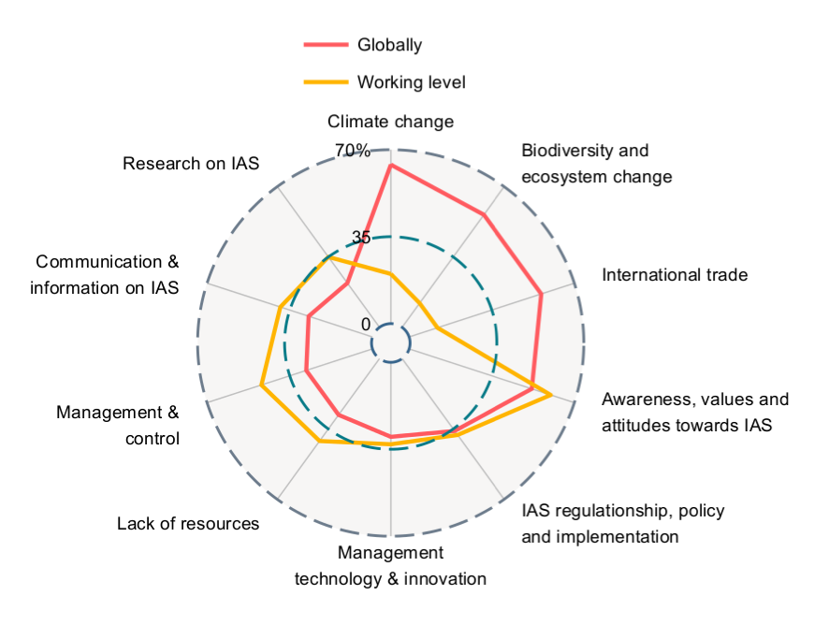
Figure 1: The number of respondents that submitted issues within each of the top ten global topics globally and at the respondents’ working level.

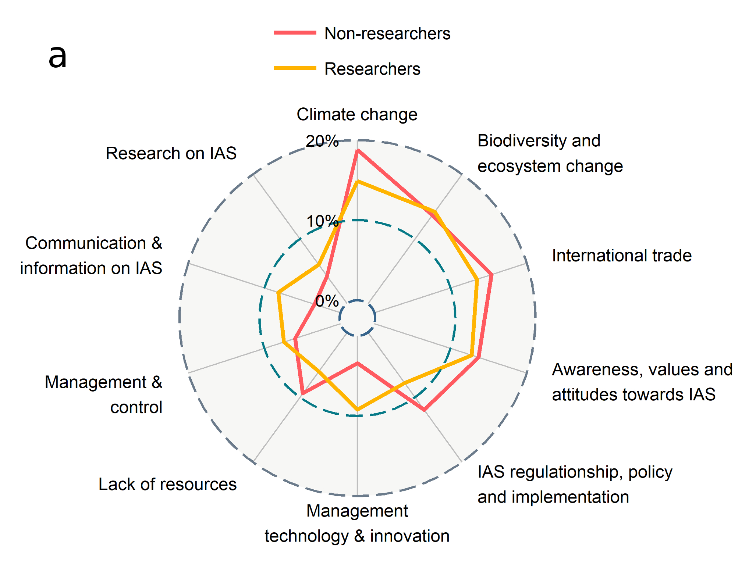
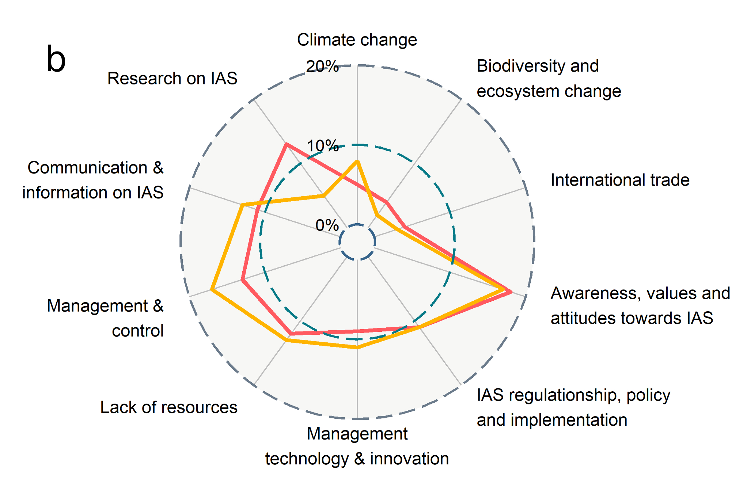
Figure 2: The percentage of the number of participants that submitted issues within the top ten global topics (a) and working level topics (b) received from respondents split by those that worked in research versus those that did not. Of a total of 399 issues included in the top ten global issues 282 were from researchers and 117 from non-researchers.

Figure 3: Comparison of the allocation of issues to the 20 topics identified by Ricciardi et al. (2017) and in the Alien Futures horizon scanning survey. Bars indicate the percentage of issues within each topic for the 52 issues in the Ricciardi et al. (2017) study (grey bars) and the 362 global issues submitted by respondents in the Alien Futures survey (black bars). A further 267 issues submitted in the Alien Futures survey were summarised in 19 topics with no overlapping with the Ricciardi et al. (2017) study and not included in the calculation of percentages.

Figure S1 (supplementary material)
Summaries of the participant's demography with regard to their taxonomic interest (a); continent they are working on (b); main interest when dealing with IAS (c, Comm. = communication); working sector (d); land use system in which they are dealing with IAS (e, Agric. = agriculture, Aquacult.= aquaculture); working scale (f); habitat (g); focus of their work within the invasion pathway (h).
Note that the percentages always add up to more than 100% because many people belong to more than one group.

