**Regional variation and predictors of over-registration in English Primary Care in 2014: a spatial analysis**

Patrick Burch, *In-Practice Fellow*1*,* Tim Doran, *professor2*, Evangelos Kontopantelis, *reader*1 3

1 NIHR School for Primary Care Research, Centre for Primary Care, Institute of Population Health, University of Manchester

2 Department of Health Sciences, University of York

3 Centre for Health Informatics, Faculty of Biology Medicine and Health, University of Manchester

Correspondence to:

Patrick Burch

e-mail: [patrick.burch@manchester.ac.uk](mailto:e.kontopantelis@manchester.ac.uk)

**Abstract**

**Background**

There are more people registered with a general practice in England than are estimated to be resident in the country. The reasons behind this are not fully understood.

**Aim**

We investigated the levels of over-registration (or under-registration) in English primary care, their regional variability and their association with population and geographical characteristics.

**Design** **and setting**

Cross-sectional study using mid-year population estimates for 2014 and general practice populations for the same year. 32,844 Lower Super Output Areas (LSOAs, 2011 census derived geographical areas of 1500 people on average), covering the whole population of England.

**Method**

We calculated levels of patient registration with English primary care, in relation to census derived population estimates, at various geographical levels of interest: regions, Clinical Commissioning Groups and LSOAs. We used linear regressions to investigate the relationship between levels of registration and area deprivation, urbanicity, ethnicity, age, sex, and mean distance to practice.

**Results**

The total over-registration rate for England was 3.9% (2,097,101 people) but there was wide regional variability. London had significantly higher levels of over-registration (6.0% and 515,063 people) than other areas in England. Higher levels of over-registration at the LSOA level were associated with greater proportions of non-White British residents, females, and elderly people and higher levels of social deprivation.

**Conclusion**

Our findings indicate that high mobility and health need may be the underlying causes of over-registrations. The regional variation in over-registration, with London being an outlier, points towards potential inequalities in resourcing of primary care, and the ability of the NHS to adequately match funding to population need.

**Keywords**

primary care, public health, general practice, health policy

# What this paper adds

**What is already known on the subject**

* There are more people registered with a General Practice in England than are estimated to be resident in the country.
* There are people within England who are not registered with a General Practice.
* The majority of funding in primary care in England is dependent of the number of patients registered at a practice and the inequitable distribution of money within primary care can lead to health inequalities.

**What this study adds**

* Over-registration was calculated at 3.9% of the estimated English population for 2014 (over 2 million people), with large regional variation and the highest levels observed in London (6%)
* At a low geographical level, over-registration of patients is associated with greater proportions of non-White British residents, females, and elderly people and higher levels of social deprivation.
* Procedures for the registration and deregistration of patients, and funding formulas, need to be reviewed.

# Introduction

In order to access most non-emergency National Health Service (NHS) healthcare and health screening in the UK, a patient needs to be registered with a General Practice. In England there are currently 7,613 practices, which provide first level contact with people seeking healthcare in the community.(1) Patients can directly access Accident and Emergency (A&E) departments, walk in centres, treatment for some infectious diseases and some psychiatric illness, but all other NHS care requires registration with a General Practitioner (GP). Non-registration therefore limits what services a patient can access, especially non-emergency treatment and health promotion. Delayed access to primary care can result in unnecessary hospital admissions and potentially greater overall expense to the NHS.(2, 3) Most GP service provision in the UK is state-funded - only an estimated 3% of General Practice consultations are with private GPs.(4) The number of UK based patients that self-pay for private hospital treatment is very small, (4) and less than 10% of the population have comprehensive private health insurance (and most of these policies require the patient to see a GP before they can be referred to secondary care). With the exception of a few mostly wealthy individuals, patients must therefore be registered with a NHS GP in order to access non-emergency medical care.

There are patients in England who are not registered with a GP. Obtaining precise estimates of the number of unregistered patients is difficult, as studies tend to use local surveys and to focus on specific populations, such as immigrants and A&E attenders.(5-7) For example, up to 67% of recent migrants are not registered.(6) Not registering with a GP may be a personal choice (for example, short or medium-term economic immigrants or people who have relocated who are younger and healthier may defer registration until they need to see a GP) or due to systematic barriers (for example, homeless patients or refugees have difficulty accessing NHS services because they have no permanent address). There is therefore an expectation that practice registration counts would be lower than population estimates, but combining patient registration data with population demographic data from the decennial census reveals that more people are registered with a General Practice in England than are estimated to be resident in the country (57 million and 54 million respectively).(8, 9) There are several possible explanations for this, including over-counting in GP practice registers, under-counting in population estimates, and the use of different definitions for residency.(10, 11)

Several attempts have been made to combat over-registration (‘list inflation’), including periodic data cleaning exercises by the Audit Commission to remove ineligible patients from practice registers. In the 2009/10 exercise 95,000 records were removed, which included deceased persons (34%), duplicate records (31%), multiple occupancy (ten or more at an address - 21%), removed asylum seekers (10%) and patients with a high likelihood of being deceased due to old age (4%). (12) Although this provides an insight into likely sources of data inaccuracy, the numbers of inaccurate records identified account for less than 4% of the estimated total of over registered patients.

Identification of the factors driving over-registration could help answer why the NHS Patient list contains more people than the national census, and this will have implications for health policy and primary care funding. Identifying factors driving under-registration could inform interventions to increase registration for certain areas or patient groups, ultimately improving health outcomes and reducing the burden on secondary care services. In this study, we used existing routine data to identify patterns in, and predictors of, over-registration and under-registration. We examined spatial patterns of low registration counts at different levels of geography and identified predictors of under-registration from a pool of available locality and population characteristics, including area deprivation, urbanicity, ethnicity, age, sex, language, religion and mean distance to practice.

METHODS

## Data

In England, the lowest geographical area of practical use, i.e. the level at which most national datasets are collected, is the Lower Layer Super Output Area (LSOA). These areas are revised after each decennial census to ensure they contain around 1500 inhabitants, on average. After the 2011 census, there were 32,844 LSOAs in England. We collated information from various sources at the LSOA level. The mid-year population in each LSOA and the age and sex distribution was obtained from ONS estimates for 2014.(13) Ethnicity was available from the 2011 census. Urbanicity data were available after the 2011 census, and for simplicity we used a dichotomy with towns or cities with 10,000 inhabitants or more classed as urban.(14) As a proxy for overall deprivation levels in the locality we used the 2015 Index of Multiple Deprivation or IMD.(15) Practice data were obtained from the April 2014 NHS Attribution Dataset, which links practice populations to LSOAs.(16) From this we were able to generate information at the LSOA level on the number of people on English practice registers. We also calculated the number of practices and the total list-size of practices serving each LSOA. Combining the attribution dataset information with geographical data from the ONS geoportal we also estimated the mean distance to attending a practice, for each LSOA (using the population weighted LSOA centroids).(17) ONS geoportal data were also used to create spatial maps at the LSOA and 2016 Clinical Commissioning Group level, the latter being a low-level administrative organisation for English primary care.

## Statistical Analyses

Descriptive statistics and spatial maps were used to describe regional variability of under- and over-registration with primary care in England. Spatial autocorrelation for registration (over or under) at the LSOA level, was assessed and quantified using Moran’s I(18) which ranges between values of -1 (negative spatial autocorrelation, i.e. dissimilar values cluster together) and +1 (positive spatial autocorrelation, i.e. similar values cluster together). For example, a high value on this metric would imply that areas with over-registration cluster together. We calculated Moran’s I for each region, to allow for within-England comparisons, and the whole of England for completeness.

At the LSOA level (with 32,844 data points), we used regression models to quantify the strength of association between under- and over-registration and: region, demographic characteristics (age, sex and ethnicity), urbanicity, the number of practices and their list sizes serving a LSOA, the mean distance to attending practice, the ONS population estimate, and the IMD. We decided to use linear models, in which the outcome was modelled as a percentage of over- or under-registration (i.e. (attribution-ONS)/ONS), with the ONS populations used as analytic weights). We did not use Poisson or other count-outcome models since we wished to reliably capture under-registration as well as over-registration and these models do not allow for negative values. Since the characteristics for London are very different to all other regions, we ran sensitivity analyses in which London was excluded.

Analyses were executed with Stata v14.1 and R v3.3.1. Due of the size of the dataset (effectively the whole of England) statistical significance is largely irrelevant; most comparisons would be statistically significant and thus we focus on effect sizes where possible. All variables we used were complete and hence we did not have to consider approaches for dealing with missing data.(19)

# Results

A total of 56,413,719 patients were registered with a general practice in April 2014 when the mid-year 2014 population estimate for England was 54,316,618. The over-registration rate for England was 3.9% (2,097,101 people) but there was wide regional variability. Over-registration rates ranged from 2.8% (129,598 people) in the South East to 6.0% (515,063 people) in London. The median over-registration at the LSOA level was 57 people (25th centile: 9; 75th centile: 112), when the median population at the LSOA level was 1589 people (25th centile: 1446; 75th centile: 1783). The median number of practices serving a LSOA was 19 for England, ranging from 12 in the South Central and the South West, up to 40 in London. The mean population-weighted LSOA centroid distance to the LSOA centroid of attending practice was a median 0.87 miles (25th centile: 0.62; 75th centile: 1.26).

There was very wide variation in registration rates at the LSOA level (Figures 1 and 2) and the CCG level (Figures 3 and 4). Spatial autocorrelation was found to be low for all regions, although there was regional variability with the lowest values for Moran’s I obtained for the North East and the North West, and the highest for the West Midlands and the East of England (Figure 5).

The results from the linear regression indicated that higher rates of over-reporting were associated with LSOAs with larger percentages of people aged 60 or over, larger percentages of females, smaller percentages of White British, higher deprivation levels and smaller distances to practices (Table 2). However, the model only explained 18% of the observed variance in percentage of over-registration within LSOAs. Using the size of the t-value as an indicator of the strength of the association, which is more informative for large data sets, the strongest predictor was ethnicity. For every 1% increase in the proportion of residents who are White British within an LSOA, there was a decrease of 0.18% (95% CI: 0.17, 0.18) in over-registration. For example, a decrease from 91% (50th centile) of White British residents to 81% (31st centile) would be associated with a 1.8% increase in over-registration under the model. The second strongest association was observed for percentage of female residents; a 1% increase in female population was associated with a 0.94% (95% CI: 0.90, 0.98) increase in over-registration. Therefore an increase from 51% in female population (50th centile) to 53% (89th centile) would imply a 1.88% increase in over-registrations. The third strongest association was for IMD with an increase of 10 points (e.g. from the 50th centile or 17.4 to the 71st centile or 27.4) linked to a 0.74% (95% CI: 0.67, 0.81) increase in over-registration.

# **discussion**

## Summary

The total over-registration rate for England was 3.9% (2,097,101 people) but there was wide regional variability. London had significantly higher levels of over-registration (6.0% and 515,063 people) than other areas in England, with the lowest observed for the South East (2.8% and 129,598 people). Levels of spatial clustering were low, overall and within each region. Higher levels of over-registration at the LSOA level were associated with greater proportions of non-White British residents, females, and elderly people and higher levels of social deprivation.

Within each region, levels of over-registration clustering (auto-correlation) were low, implying that auto-correlation is generally uniformly allocated across space and relevant to all general practices and geographies (although variation exists). Spatial clustering in the drivers of over-registration will of course affect the spatial distribution of over-registration and the low levels of auto-correlation we observe are driven by this.

## Strengths and limitations

To the best of the authors’ knowledge, this is the only study that has looked at demographic factors associated with over-registration at the lowest geographic level for which data is available (LSOAs). The data is cross-sectional so it is not possible to draw definitive conclusions about causation based on the data.

This study examined spatial patterns in mismatches between population estimates and practice registrations at the small area level across the whole of England, and the associations of under- and over-registration with a range of population characteristics. However, in explaining the reasons for the observed mismatches, we have to acknowledge the limitations of the data. In particular, we cannot assume that population estimates provide the gold standard, and that mismatches are entirely attributable to errors with registration data. The ONS acknowledges that population estimates and characteristics derived from census data, updated using administrative datasets, are imperfect. It does, however, go to great lengths to account for over and under counting.(20)

Some of the discrepancy between practice registers and population estimates can be explained by patients who are eligible for primary care services but who are not eligible to be counted on the census, which is a record of all persons who intend to stay in the UK for 12 months or more. Practice registers work to shorter timescales, with patients permitted to register with a GP if they are intending to stay in the UK for 3 months or more. At the time of the 2011 census the Office for National Statistics estimated there to be 195,000 of these short-term residents,(21) which could account for up to 7% of the over-registered patients.

Patients who remain on a practice list but who no longer live in the UK will account for some of the over-registration. There are an estimated 4.5 to 5.5 million Britons living abroad.(22) Unless a person leaving the UK specifically informs their GP or hands in their NHS health card they would not normally be removed from the GP register, and it is not unusual for practices to treat British ex-patriots temporarily returning home to use NHS GP services. Urban and non-white populations tend to be more transient and more likely to move abroad, and this is supported by our results finding higher levels of over-registration in urban areas and in populations with a higher proportion of non-white ethnicity. Temporary residents (i.e. patients in the UK who intend to stay less than 3 months) will likely account for a proportion of patients that do not appear on the census but do appear on the GP register. This is supported by our finding of non-white ethnicity (which can be taken as a surrogate marker of number of foreign residents) being the strongest independent predictor of over-registration. Within that group there will exist patients accessing GP services when they are not legally entitled to, but quantifying the numbers involved is difficult.

The increased likelihood of over-registration in populations with higher proportions of women may relate to the greater utilisation of health care by women.(23) We know that, despite nationwide over-registration there are people, entitled to NHS care in the UK, who are not registered with a GP.(5-7) If a group of male and female immigrants move to the UK for the first time, the men of the group may be less likely to register with a GP because of their lesser use of health care than the women. This hypothesised under-registration of men, on the background of widespread over-registration, could account for the increased likelihood of over-registration in populations with higher proportions of women. Elderly populations also consult more(24) and this could explain why there are higher rates of over-registration in populations with larger percentages of patients aged 60 or over. A less likely explanation for the association observed for this patient group is re-housing in residential homes, but records are transferred in that case (in a process that can take up to several weeks, however). Similarly, higher levels of deprivation are associated with greater multi-morbidity(25, 26) and hence higher levels of health need and increased frequency of consultation, and also with higher rates of population turnover. In addition, populations in deprived areas are more mobile, since they include more migrants,(27) but are also less likely to feel attachment to their neighbourhood(28) and this has led to population increases in affluent areas and decreases in deprived areas(29) Other predictors of over-registration are harder to interpret and will require further investigation. Shorter distance to practice implies higher density of alternative providers and hence more choice for patients in terms of accessing primary care, leading to greater frequency of movement between practices and greater potential for generating duplicate records.

## Comparison with existing literature

We could find only one other published study of levels of over-registration in English primary care.(10) This looked at specific LSOAs that had high levels of over or under-registration and discussed factors that the author felt contributes to varying registration level. Like our analysis, it found high levels of over-registration in London.

## Implications for research and practice

Primary care services in the England are currently under immense pressure. Workloads are increasing at a time of restricted funding through the national contract,(30) and practices are struggling to recruit doctors and some have been forced to close.(31) There is a high degree of uncertainty regarding the future of NHS funding, with the national Five Year Forward View plan for the NHS placing a requirement on the entire organisation to make unprecedented efficiency savings over the short to medium term.(32) This, combined with the implications for the NHS workforce of the United Kingdom’s upcoming exit from the European Union, raise questions about the ability of the service to meet future increases in demand driven by growing demographic pressures. Against this complex background, the policy implications of our findings must be drawn with caution. An obvious response, to the near universal over-registration we have documented, would be to correct practice registers downwards, but as core practice funding is based on the number of registered patients, blunt corrections without appropriate safeguards would further increase pressure on practice resources to the detriment of patient care. However, our results do illustrate a potential source of inequity across primary care in England, namely a higher level of over-registration in particular areas, resulting in relatively higher levels of funding for practices based in those locations. Ten percent of CCGs have over-registration rates of 7.6% or more, and from a regional perspective London has much higher levels of apparent over-registration than the rest of the country. In the absence of justifiable explanations for this, equitable resourcing of healthcare would require that this imbalance be redressed.

In this study, we have documented not only a substantial overall level of over-registration of patients across general practices in England, but also very wide variation in over-registration. However, whilst our analysis has focused on over-registration, we also found areas of apparent under-registration. The larger issue of over-registration should not detract from trying to increase healthcare access for often hard to reach populations that are not registered with a GP. Our analysis raises serious questions about potential inequalities in resourcing of primary care, and the ability of the NHS to adequately match funding to population need. The reasons for over-registration are clearly multi-factorial and to an extent unexplained, and detailed research at the practice level is now required to inform policy responses. Generating practice registers that more accurately reflect the populations served is likely to require a number of different approaches. Some of these are already in place, including audits of practice registers for erroneous records. Other approaches could be pursued without waiting for further research; for example, developing better systems for de-registering patients permanently leaving the UK and for checking the eligibility of newly registered patients and cancelling their prior registrations.

If registration levels are incorrect then the first step should not be to universally adjust funding downwards. Removing ineligible patients from practice lists will be a complex process and it will not lead to reductions in practice workloads in the short term. Ultimately, funding formulas may need to be revised to take account of the problem, and this may result in reallocation of funding between areas. The implications of this need to be fully understood before any policy change is considered.

# References

1. RCGP. Royal College of General Practitioners (2007). The Future Direction of General Practice, a roadmap. . RCGP; 2007.

2. Weissman JS, Stern R, Fielding SL, Epstein AM. Delayed access to health care: risk factors, reasons, and consequences. Ann Intern Med. 1991(114):325-31.

3. Rosano A, Loha CA, Falvo R, van der Zee J, Ricciardi W, Guasticchi G, et al. The relationship between avoidable hospitalization and accessibility to primary care: a systematic review. European Journal of Public Health. 2013;23(3):356-60.

4. The King’s Fund. Commission on the Future of Health and Social Care in England: The UK private health market. The King’s Fund; 2014 2014.

5. Enfield Health Watch. A report looking into individuals not registered with a GP 2015 [Available from: <http://www.healthwatchenfield.co.uk/publications-insight>.

6. Stagg HR, Jones J, Bickler G, Abubakar I. Poor uptake of primary healthcare registration among recent entrants to the UK: a retrospective cohort study. BMJ Open. 2012;2.

7. Savage J. More than 150,000 A&E patients in London 'not GP-registered' 2015 [Available from: <http://www.bbc.co.uk/news/uk-england-london-34789785>.

8. NHS Digital. Numbers of Patients Registered at a GP Practice - July 2015 GP. 2015.

9. Office for National Statistics. Population Estimates for UK, England and Wales, Scotland and Northern Ireland: mid-2015 2016 [Available from: <https://www.ons.gov.uk/peoplepopulationandcommunity/populationandmigration/populationestimates/bulletins/annualmidyearpopulationestimates/latest>.

10. Baker C. Population estimates & GP registers: why the difference? 2016, December 16 [Available from: <https://secondreading.uk/social-policy/population-estimates-gp-registers-why-the-difference/>.

11. Office for National Statistics. Comparison between 2011 Census estimates and the GP NHS Patient Register. 2012.

12. The Audit Commision. The national duplicate registration initiative 2009/10. The Audit Commision; 2012.

13. Office for National Statistics. Super Output Area mid-year population estimates for England and Wales, Mid-2011 (Census Based) [Available from: <http://www.ons.gov.uk/ons/publications/re-reference-tables.html?edition=tcm%3A77-285629>.

14. Office for National Statistics. 2011 Rural-Urban Classification for Small Area Geographies: User Guide [Available from: <http://geoportal.statistics.gov.uk/datasets/bf4b81cb76644cf485279a3d01add76f>.

15. Communities and Local Government. The English Indices of Deprivation 2015: Technical Report. Department for Communities and Local Government; 2015.

16. NHS Digital. Numbers of Patients Registered at a GP Practice - Jan 2016: NHS Digital; 2016 [Available from: [http://content.digital.nhs.uk/article/2021/Website-Search?productid=20032&q=Numbers+of+Patients+Registered+at+a+GP+Practice&sort=Relevance&size=10&page=1&area=both - top](http://content.digital.nhs.uk/article/2021/Website-Search?productid=20032&q=Numbers+of+Patients+Registered+at+a+GP+Practice&sort=Relevance&size=10&page=1&area=both#top).

17. Office for National Statistics. Open Geography Portal [Available from: <http://geoportal.statistics.gov.uk/>.

18. Moran PAP. Notes on Continuous Stochastic Phenomena. Biometrika. 1950;37(1-2):17-23.

19. Rubin DB. Multiple imputation after 18+ years. J Am Stat Assoc. 1996;91(434):473-89.

20. Office for National Statistics. The 2011 Census Coverage Assessment and Adjustment Process. 2012.

21. Office for National Statistics. 2011 Census: Non-UK born short-term residents in England and Wales. 2013.

22. Flanagan O. How many British immigrants are there in other countries? 2014 [Available from: <https://www.statslife.org.uk/social-sciences/1910-how-many-british-immigrants-are-there-in-other-people-s-countries>.

23. Wang Y, Hunt K, Nazareth I, Freemantle N, Petersen I. Do men consult less than women? An analysis of routinely collected UK general practice data. BMJ Open. 2013;3.

24. Carr-Hill RA, Rice N, Roland M. Socioeconomic determinants of rates of consultation in general practice based on fourth national morbidity survey of general practices. BMJ. 1996;312:1008-12.

25. McLean G, Guthrie B, Mercer SW, Watt GCM. General practice funding underpins the persistence of the inverse care law: cross-sectional study in Scotland. Brit J Gen Pract. 2015;65(641):E799-E805.

26. Barnett K, Mercer SW, Norbury M, Watt G, Wyke S, Guthrie B. Epidemiology of multimorbidity and implications for health care, research, and medical education: a cross-sectional study. Lancet. 2012;380(9836):37-43.

27. Stephen Jivraj OK. Ethnicity and deprivation in England: How likely are ethnic minorities to live in deprived neighbourhoods? : Jospeh RownTree Roundation; 2013.

28. Mark Livingston NB, Ade Kearns. The influence of neighbourhood deprivation on people's attachment to places. Jospeth Rowntree Foundation; 2008.

29. Connolly S, O'Reilly D, Rosato M. Increasing inequalities in health: is it an artefact caused by the selective movement of people? Soc Sci Med. 2007;64(10):2008-15.

30. The King’s Fund. Understanding pressures in general practice. The King’s Fund; 2016.

31. Kaffash J. 150% rise in patients forced to move GP practice as closures hit record levels Pulsetoday.co.uk2017 [Available from: <http://www.pulsetoday.co.uk/hot-topics/stop-practice-closures/150-rise-in-patients-forced-to-move-gp-practice-as-closures-hit-record-levels/20034208.article>.

32. NHS England. Five Year Forward View. NHS England; 2014.

Table 1: Characteristics BY region, 2014

|  | England | North East | North West | Yorkshire & the Humber | East Midlands | West Midlands | East of England | London | South East | South Central | South West |
| --- | --- | --- | --- | --- | --- | --- | --- | --- | --- | --- | --- |
| Number of LSOAs | 32844 | 1657 | 4497 | 3317 | 2774 | 3487 | 3614 | 4835 | 2773 | 2609 | 3281 |
| ONS population | 54316618 | 2618710 | 7132991 | 5360027 | 4637413 | 5713284 | 6018383 | 8538689 | 4594865 | 4278953 | 5423303 |
| Practice population | 56413719 | 2705726 | 7446047 | 5554372 | 4797135 | 5910597 | 6209459 | 9053752 | 4724463 | 4429506 | 5582662 |
| Population difference (practice minus ONS) | 2097101 | 87016 | 313056 | 194345 | 159722 | 197313 | 191076 | 515063 | 129598 | 150553 | 159359 |
| % over-registration | 3.9 | 3.3 | 4.4 | 3.6 | 3.4 | 3.5 | 3.2 | 6.0 | 2.8 | 3.5 | 2.9 |
| % rural areas | 17.0 | 17.6 | 9.8 | 16.5 | 25.4 | 14.8 | 28.3 | 0.2 | 20.1 | 19.8 | 30.2 |
| median across LSOAs (25th, 75th centile) | | | | | | | | | | | |
| ONS population | 1589  (1446,1783) | 1508  (1386,1698) | 1532  (1402,1695) | 1557  (1439,1714) | 1594  (1440,1829) | 1578  (1450,1746) | 1589  (1438,1792) | 1712  (1564,1905) | 1602  (1462,1776) | 1576  (1430,1757) | 1583  (1436,1796) |
| Practice population | 1651  (1497,1862) | 1561  (1433,1750) | 1595  (1464,1768) | 1607  (1487,1777) | 1654  (1485,1897) | 1630  (1493,1812) | 1648  (1485,1865) | 1815  (1645,2043) | 1658  (1513,1823) | 1631  (1477,1821) | 1634  (1486,1861) |
| Population difference | 57  (9,112) | 50  (12,90) | 67  (20,116) | 52  (9,103) | 48  (4,100) | 49  (0,105) | 52  (8,102) | 93  (7,199) | 50  (5,94) | 58  (12,111) | 55  (11,100) |
| Number of practices serving LSOA | 19  (11,30) | 16  (10,22) | 26  (16,33) | 19  (13,27) | 14  (9,23) | 26  (14,40) | 13  (8,20) | 40  (32,50) | 14  (10,18) | 12  (9,19) | 12  (8,17) |
| Total list size of practice serving LSOA | 8808  (5604,11747) | 8894  (5032,11675) | 7857  (5085,10625) | 8631  (5808,11362) | 9635  (7239,13300) | 8489  (4848,12270) | 10308  (6669,12617) | 6667  (4246,9453) | 8808  (6241,11368) | 9298  (6606,12454) | 10118  (7157,13729) |
| Mean centroid distance of practices serving LSOA | 0.87  (0.62,1.26) | 1.01  (0.73,1.42) | 0.90  (0.68,1.21) | 0.94  (0.67,1.35) | 0.95  (0.67,1.52) | 0.94  (0.70,1.27) | 0.95  (0.67,1.51) | 0.60  (0.45,0.78) | 0.93  (0.66,1.37) | 0.94  (0.65,1.36) | 0.91  (0.63,1.55) |
| % Females | 51.0  (49.8,52.1) | 51.3  (50.1,52.4) | 51.0  (49.9,52.2) | 51.1  (49.9,52.2) | 50.9  (49.9,52.0) | 50.8  (49.8,51.9) | 51.0  (50.0,52.0) | 50.8  (49.2,52.1) | 51.2  (50.1,52.3) | 50.8  (49.7,51.9) | 51.2  (50.0,52.3) |
| % Males | 49.0  (47.9,50.2) | 48.7  (47.6,49.9) | 49.0  (47.8,50.1) | 48.9  (47.8,50.1) | 49.1  (48.0,50.1) | 49.2  (48.1,50.2) | 49.0  (48.0,50.0) | 49.2  (47.9,50.8) | 48.8  (47.7,49.9) | 49.2  (48.1,50.3) | 48.8  (47.7,50.0) |
| % Aged 0-29 | 35.6  (30.6,41.4) | 34.6  (29.6,39.6) | 35.4  (30.5,41.3) | 35.0  (30.0,41.7) | 34.3  (29.6,40.4) | 36.2  (30.4,42.6) | 34.5  (30.1,39.6) | 40.3  (36.1,45.0) | 33.8  (29.8,38.4) | 35.0  (30.5,40.8) | 32.9  (28.0,38.7) |
| % Aged 30-59 | 39.9  (37.4,42.5) | 39.4  (37.1,41.6) | 39.4  (37.2,41.8) | 39.4  (37.0,41.8) | 39.5  (37.2,41.8) | 38.7  (36.6,40.9) | 39.8  (37.4,42.3) | 43.0  (40.4,46.3) | 39.9  (37.2,42.6) | 40.7  (38.0,43.4) | 38.5  (36.1,40.9) |
| % Aged 60+ | 23.1  (16.6,29.8) | 24.8  (19.8,30.7) | 23.5  (18.0,29.8) | 23.9  (17.9,29.9) | 25.3  (18.4,31.1) | 23.7  (17.7,30.4) | 24.7  (18.4,31.1) | 14.8  (11.3,19.5) | 25.2  (19.4,31.1) | 23.1  (16.2,29.4) | 27.8  (20.3,34.2) |
| % White British | 91.0  (75.3,95.6) | 96.8  (94.1,97.9) | 94.1  (87.8,96.4) | 94.4  (86.1,96.5) | 93.7  (83.3,96.2) | 89.7  (74.3,95.2) | 90.2  (82.1,94.7) | 44.4  (28.8,62.0) | 90.2  (83.6,93.7) | 89.2  (79.1,93.7) | 94.8  (91.0,96.5) |
| % White Other | 3.3  ( 1.8, 6.6) | 1.1  ( 0.7, 1.8) | 2.2  ( 1.4, 3.6) | 2.0  ( 1.3, 3.6) | 2.5  ( 1.6, 4.5) | 2.7  ( 1.6, 4.5) | 4.1  ( 2.4, 6.8) | 13.9  ( 8.4,20.1) | 4.3  ( 3.0, 6.6) | 4.4  ( 2.9, 6.5) | 2.7  ( 1.8, 4.2) |
| % Asian | 2.3  ( 0.9, 7.6) | 1.0  ( 0.4, 2.3) | 1.6  ( 0.7, 4.1) | 1.4  ( 0.6, 4.4) | 1.4  ( 0.7, 4.5) | 3.2  ( 1.1,11.7) | 2.1  ( 0.9, 4.8) | 12.0  ( 7.3,21.9) | 2.3  ( 1.1, 4.7) | 3.0  ( 1.3, 7.5) | 1.0  ( 0.4, 2.1) |
| % Black | 0.7  ( 0.2, 2.8) | 0.1  ( 0.1, 0.4) | 0.3  ( 0.1, 1.0) | 0.5  ( 0.2, 1.4) | 0.5  ( 0.2, 1.7) | 0.9  ( 0.3, 3.6) | 0.9  ( 0.3, 2.3) | 9.5  ( 4.3,18.9) | 0.6  ( 0.3, 1.3) | 0.8  ( 0.3, 2.1) | 0.2  ( 0.1, 0.7) |
| % Mixed or other | 1.9  ( 1.0, 4.2) | 0.8  ( 0.5, 1.4) | 1.4  ( 0.8, 2.3) | 1.4  ( 0.8, 2.7) | 1.4  ( 0.8, 2.9) | 2.1  ( 1.1, 4.4) | 1.9  ( 1.2, 3.1) | 8.0  ( 5.7,10.4) | 2.0  ( 1.3, 3.0) | 2.1  ( 1.3, 3.4) | 1.2  ( 0.7, 2.0) |
| Index of Multiple Deprivation (IMD) 2015 | 17.4  ( 9.7,30.1) | 23.2  (11.7,38.2) | 21.6  (11.0,39.5) | 19.8  (11.0,36.9) | 16.4  ( 9.3,29.0) | 20.2  (11.4,36.0) | 14.5  ( 8.4,23.0) | 22.1  (13.3,32.7) | 12.7  ( 7.3,20.9) | 10.7  ( 5.7,19.3) | 15.2  ( 9.3,23.4) |

d

Figure 1: Spatial ploTs of numbers of under- and over-registration at the LSOA level, 2014*†

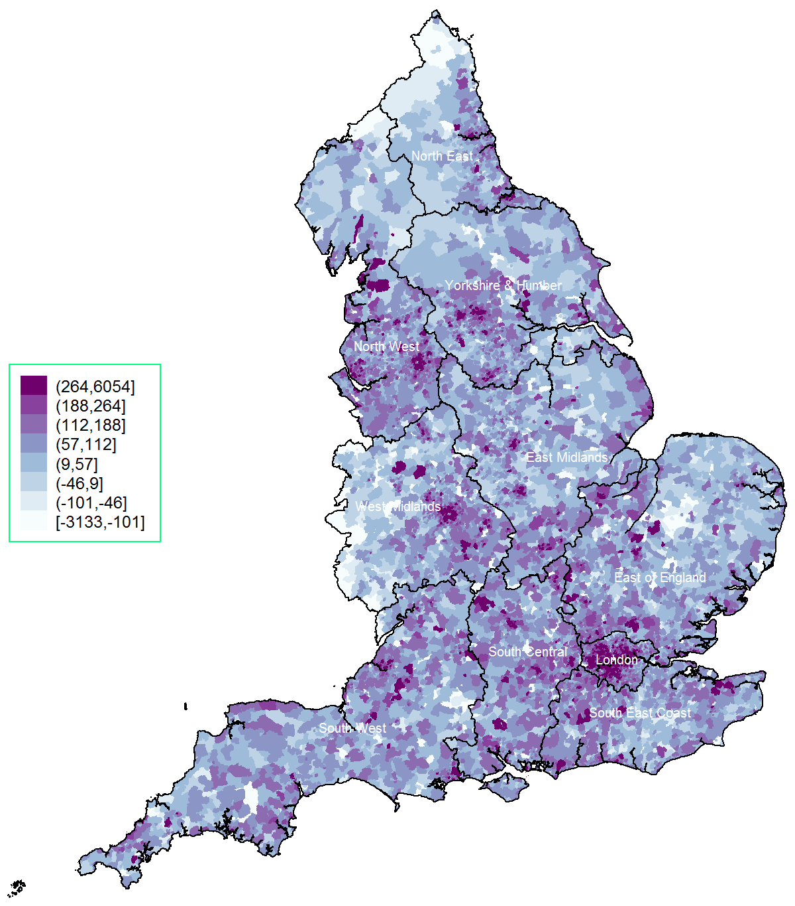

*map thresholds correspond to: minimum, 5th centile, 10th, 25th, 50th, 75th, 90th, 95th and maximum

†Black border lines correspond to regions (former Strategic Health Authorities)

Figure 2: Spatial ploTs of percentage of under- and over-registration at the LSOA level, 2014*†

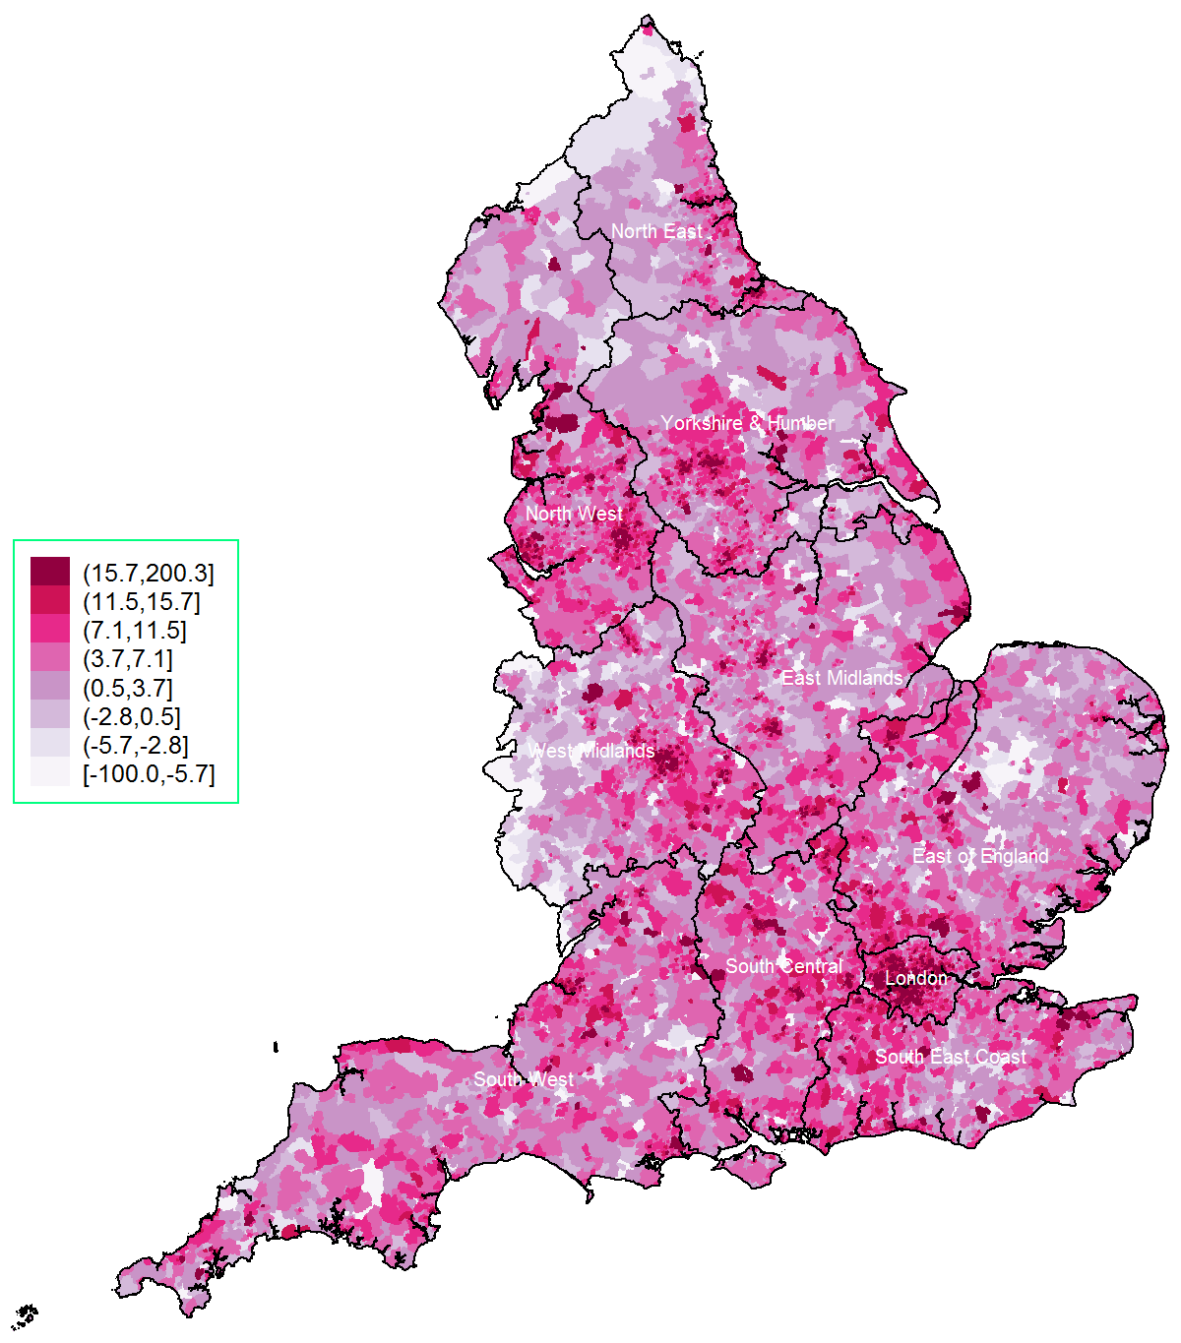

*map thresholds correspond to: minimum, 5th centile, 10th, 25th, 50th, 75th, 90th, 95th and maximum

†Black border lines correspond to regions (former Strategic Health Authorities)

Figure 3: Spatial ploTs of numbers of under- and over-registration at the CCG level, 2014*†‡

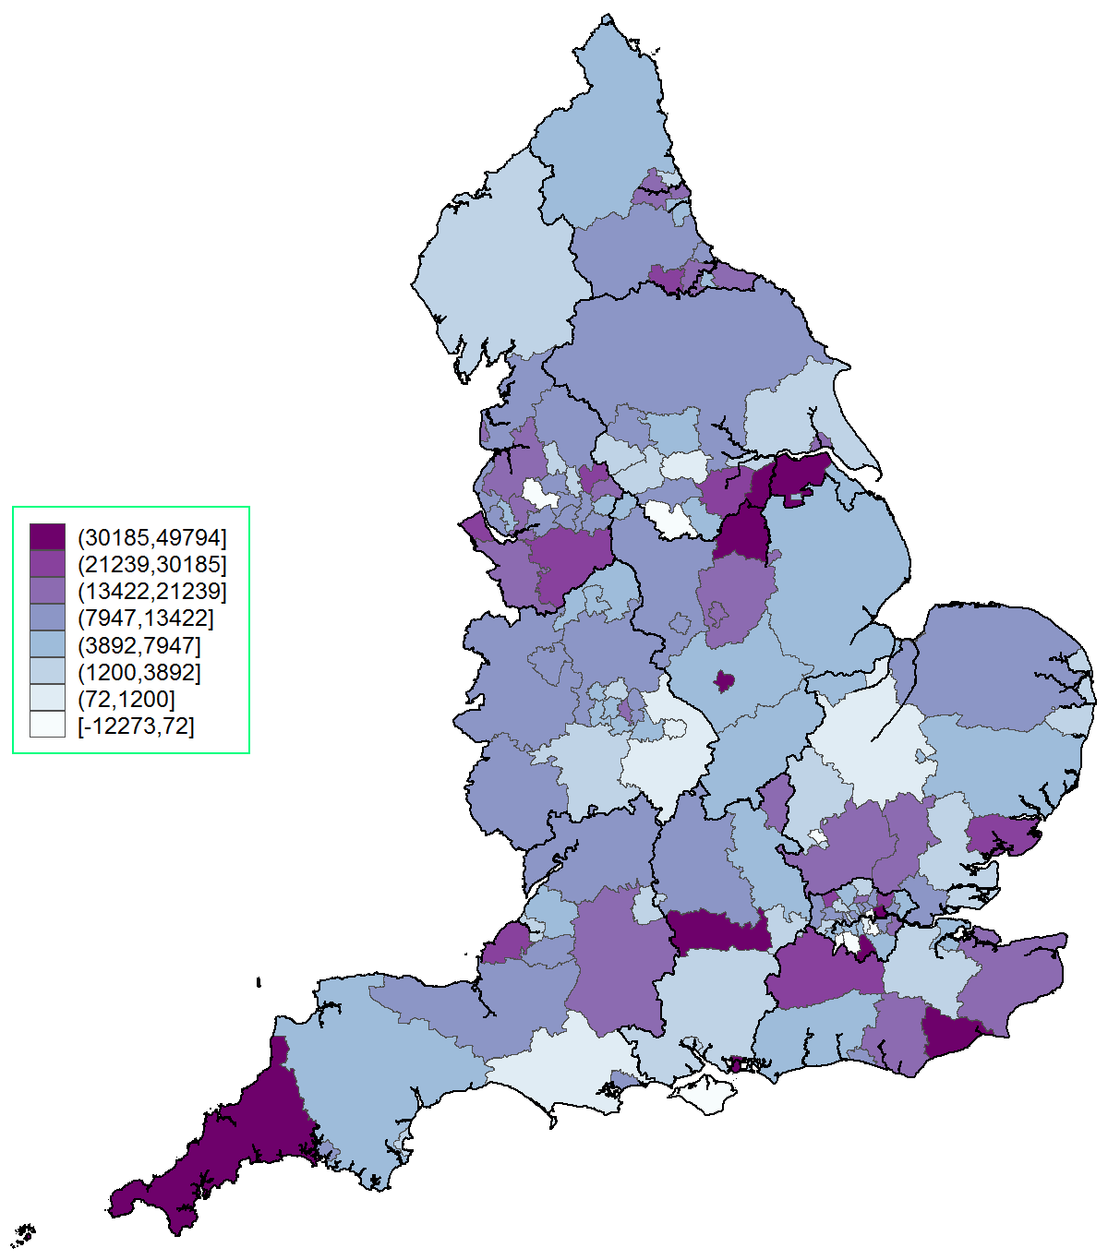

*map thresholds correspond to: minimum, 5th centile, 10th, 25th, 50th, 75th, 90th, 95th and maximum

†Black border lines correspond to regions (former Strategic Health Authorities)

‡Grey border lines correspond to 2016 Clinical Commissioning Groups

Figure 4: Spatial ploTs of percentages of under- and over-registration at the CCG level, 2014*†‡

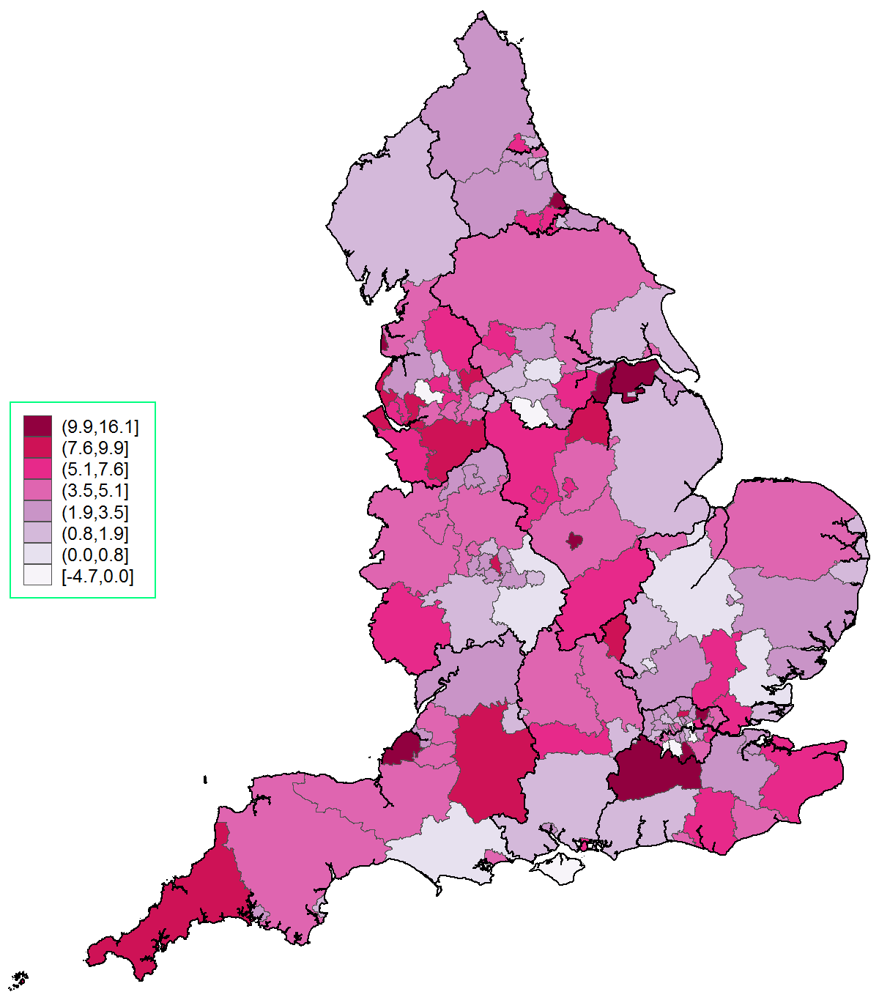

*map thresholds correspond to: minimum, 5th centile, 10th, 25th, 50th, 75th, 90th, 95th and maximum

†Black border lines correspond to regions (former Strategic Health Authorities)

‡Grey border lines correspond to 2016 Clinical Commissioning Groups

Figure 5: Spatial autocorrelation estimates (95% CIs) for differences between population estimates and practice list attributed populations by region and overall, with absolute numbers and percentages, 2014



Table 2: Linear regression results at the LSOA level, associations with percentage of over-registration*

|  |  |  |  |  |  |
| --- | --- | --- | --- | --- | --- |
|  | Coefficient | 95% Confidence Interval | | t-value | p-value |
| *Region* | | | | |  |
| North West | Reference | | | |  |
| North East | -0.288 | -0.767 | 0.191 | -1.18 | 0.238 |
| Yorkshire & Humber | -0.811 | -1.190 | -0.432 | -4.19 | <0.001 |
| East Midlands | -0.722 | -1.128 | -0.317 | -3.49 | <0.001 |
| West Midlands | -1.924 | -2.296 | -1.552 | -10.14 | <0.001 |
| East England | -0.876 | -1.261 | -0.492 | -4.47 | <0.001 |
| London | -4.235 | -4.663 | -3.807 | -19.38 | <0.001 |
| South East | -1.196 | -1.604 | -0.788 | -5.75 | <0.001 |
| South Central | -0.308 | -0.737 | 0.121 | -1.41 | 0.159 |
| South West | -0.471 | -0.865 | -0.078 | -2.35 | 0.019 |
| *Population* | | | | |  |
| ONS population 2015 (per 100) | -0.075 | -0.100 | -0.050 | -5.91 | <0.001 |
| % population aged 0 to 29 | -0.005 | -0.026 | 0.016 | -0.49 | 0.622 |
| % population aged 60 or over | 0.120 | 0.100 | 0.140 | 11.78 | <0.001 |
| % female | 0.940 | 0.902 | 0.979 | 47.59 | <0.001 |
| % White British | -0.176 | -0.183 | -0.169 | -48.90 | <0.001 |
| *Locality* | | | | |  |
| Rural area | -0.131 | -0.433 | 0.170 | -0.85 | 0.393 |
| Index of Multiple Deprivation, 2015 | 0.074 | 0.067 | 0.081 | 20.63 | <0.001 |
| *Primary care* | | | | |  |
| Number of practices | -0.005 | -0.015 | 0.005 | -1.00 | 0.319 |
| List size (per 1000) | 0.046 | 0.029 | 0.064 | 5.31 | <0.001 |
| Mean distance to practice in miles | -0.570 | -0.686 | -0.455 | -9.66 | <0.001 |
| *Model constant* | | | | |  |
| Constant | -31.087 | -33.339 | -28.834 | -27.05 | <0.001 |

*32,844 observations, adjusted R^2=18.01%