Supporting Information for manuscript:

“Synthesis and pH-Responsive Dissociation of Framboidal ABC Triblock Copolymer Vesicles in Aqueous Solution”
C. J. Mable, L. A. Fielding, M. J. Derry, O. O. Mykhaylyk, P. Chambon and S. P. Armes

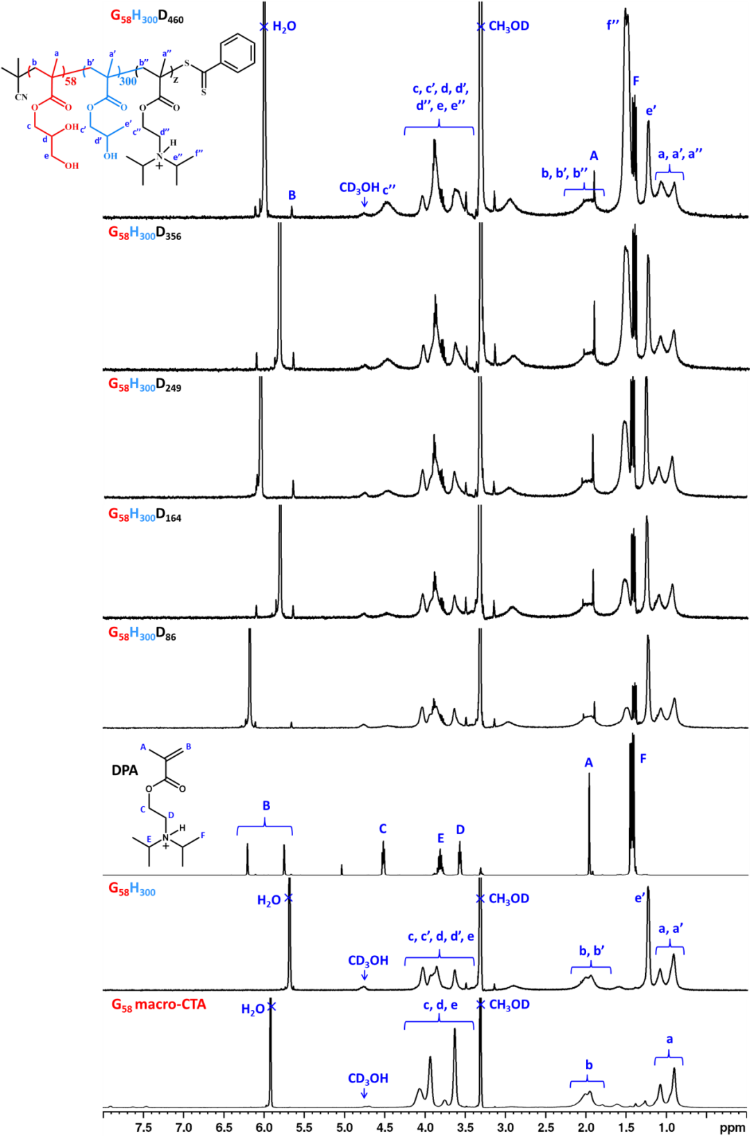

Fig. S1. Assigned ¹H NMR spectra in CD₃OD plus 4 % DCl/D₂O (20% w/w DCl) recorded for the G₅₈ macro-CTA, G₅₈H₃₀₀ diblock copolymer, DPA monomer and G₅₈H₃₀₀D_{z} triblock copolymers (where z = 86, 164, 249, 356 and 460).
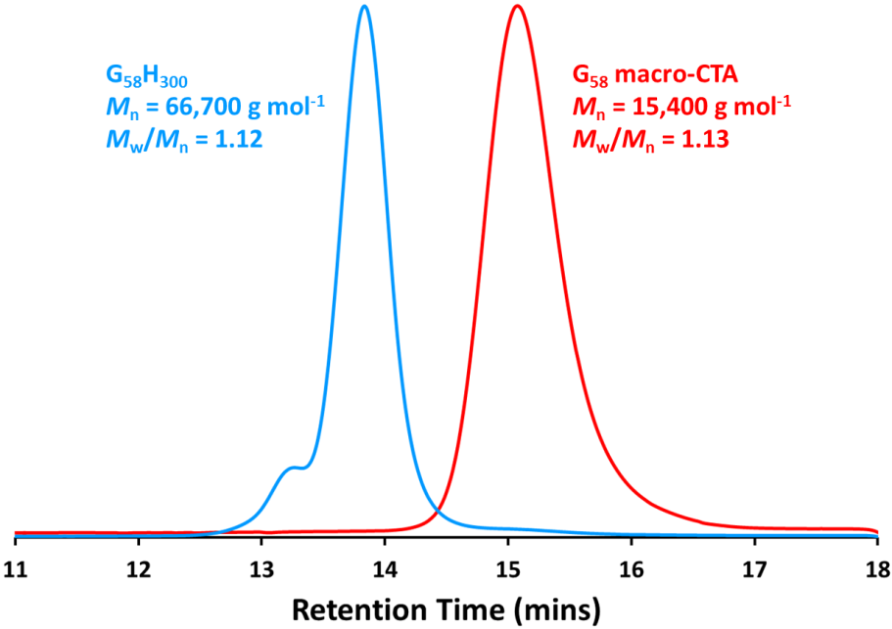

Fig. S2. DMF GPC curves (vs. a series of near-monodisperse PMMA standards) obtained for the G₅₈ macro-CTA (red) and the corresponding G₅₈H₃₀₀ diblock copolymer precursor (blue).

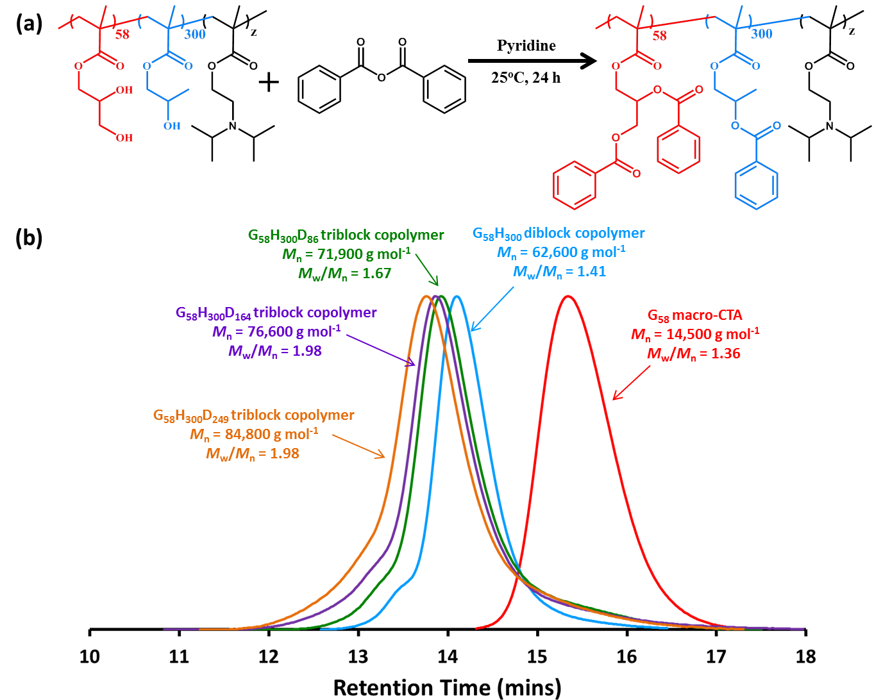
Fig. S3. (a) Reaction scheme for the esterification of GMA and HPMA residues of the triblock copolymers using excess benzoic anhydride. (b) THF GPC curves (vs. a series of near-monodisperse PMMA standards) obtained for the benzoate-modified G₅₈ macro-CTA, G₅₈H₃₀₀ diblock copolymer precursor and four G₅₈H₃₀₀D_{z} triblock copolymers (where z = 86, 164, 249 or 460).

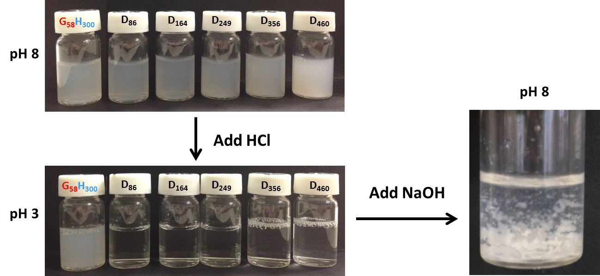
Fig. S4. Digital photographs recorded for G₅₈H₃₀₀D_{z} triblock copolymer vesicle dispersions (where z is 86, 164, 249, 356 or 460) at pH 8 and the resulting change in turbidity after switching to pH 3.

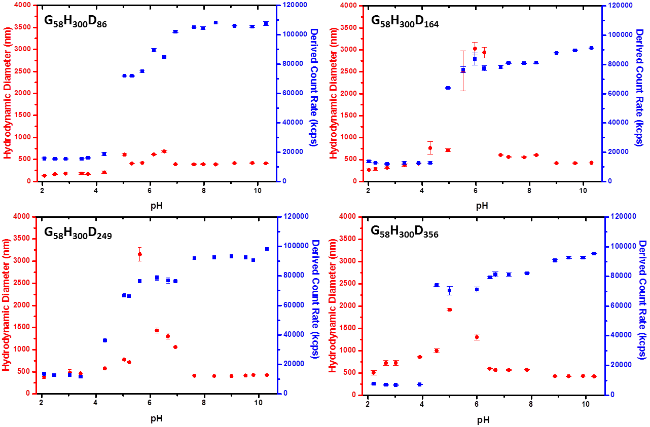

Fig. S5. Variation of the hydrodynamic diameter (red ●) and count rate (blue ■) with solution pH for (top left) G₅₈H₃₀₀D₈₆ triblock copolymer vesicles, (top right) G₅₈H₃₀₀D₁₆₄ triblock copolymer vesicles, (bottom left) G₅₈H₃₀₀D₂₄₉ triblock copolymer vesicles and (bottom right) G₅₈H₃₀₀D₃₅₆ triblock copolymer vesicles.

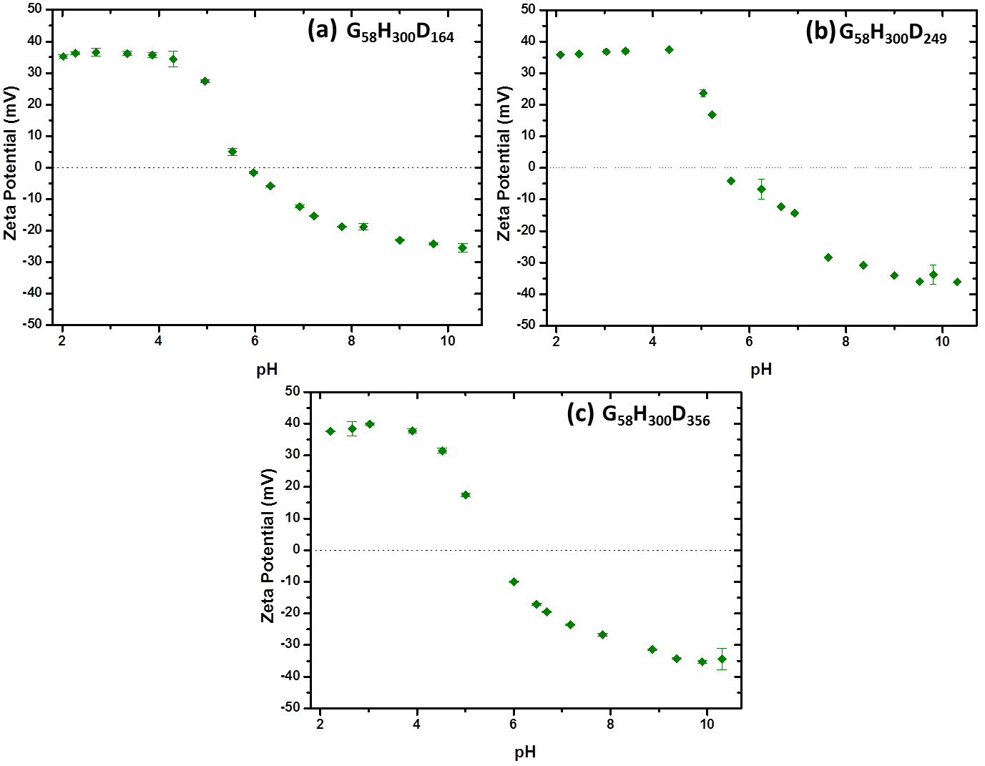

Fig. S6. Variation in zeta potential with solution pH for (a) G₅₈H₃₀₀D₁₆₄ triblock copolymer vesicles, (b) G₅₈H₃₀₀D₂₄₉ triblock copolymer vesicles and (c) G₅₈H₃₀₀D₃₅₆ triblock copolymer vesicles.

Table S1. Structural parameters obtained for a series of G₅₈H₃₀₀D_{z} (z = 0 to 249) aqueous copolymer dispersions from SAXS analysis. The volume and scattering length density of the brush/corona block (V_{brush} and ξ_{brush}, respectively) and the core block (V_{core} and ξ_{core}, respectively) were fixed parameters for fitting, based on theoretical calculations. Representative parameters for population 1 corresponding to vesicles: R_{mc} is the radius from the centre of the vesicle to the centre of the membrane and σ_{Rmc} is the associated standard deviation, T_{mc} is the thickness of the hydrophobic part of the vesicle membrane and σ_{Tmc} is the associated standard deviation, D_{SAXS} is the vesicle diameter: $D_{SAXS}={2(R}_{mc}+\frac{1}{2}T_{mc}+2R_{g}$), where R_{g} is the radius of gyration of the brush/corona block. Representative parameters for population 2 corresponding to spherical micelles: R_{s} is the core radius, σ_{Rs} is the standard deviation of the core radius, R_{PY} is the Percus-Yevick correlation radius of densely-packed spherical micelles (this parameter should be doubled for the inter-particle correlation distance) and F_{PY} is the Percus-Yevick effective volume fraction of the packed micelles. c₂/c₁ is the ratio of the copolymer volume fraction forming spherical micelles (population 2) to that forming vesicles (population 1). Finally, D is the mass fractal dimensions for the mass fractal model (population 3).
Copolymer Composition | pH | V_{brush}ª /nm³ | V_{core}^{b} /nm³ | ξ_{brush}ª ×10¹⁰ /cm⁻² | ξ_{core}^{b} ×10¹⁰ /cm⁻² | Population 1 - Vesicles |  |  | c₂/c₁ | Population 2 – Spherical Micelles |  |  | Population 3 - Mass Fractals
 |  |  |  |  |  | R_{mc} (σ_{Rmc})^{c} /nm | T_{mc} (σ_{Tmc})/ nm | D_{SAXS}^{c}/ nm |  | R_{s} (σ_{Rs})/ nm | R_{PY} /nm | F_{PY} /nm | D
G₅₈H₃₀₀ | 8.0 and 3.0 | 11.8 | 59.4 | 11.94 | 11.11 | 178 (40) | 16.8 (1.8) | 383
G₅₈H₃₀₀D₈₆ | 8.0 | 11.8 | 88.3 | 11.94 | 10.71 | 178 (49) | 24.9 (1.3) | 391 | 0.273 | 8.5 (1.2) | 11.9 | 0.34
 | 3.0 | 40.7 | 59.4 | 10.48 | 11.11 |  |  |  |  | 11.9 (1.6) | 12.0 | 0.05
G₅₈H₃₀₀D₁₆₄ | 8.0 | 11.8 | 114 | 11.94 | 10.52 | 178 (50) | 36.3 (1.5) | 402 | 0.701 | 13.7 (2.6) | 15.3 | 0.45
 | 3.0 | 66.9 | 59.4 | 10.25 | 11.11 |  |  |  |  | 10.5 (1.4) | 10.8 | 0.08 | 1.61
G₅₈H₃₀₀D₂₄₉ | 8.0 | 11.8 | 143 | 11.94 | 10.40 | 178 (45) | 46.4 (1.3) | 412 | 0.997 | 17.0 (4.1) | 20.7 | 0.53
 | 3.0 | 95.5 | 59.4 | 10.14 | 11.11 |  |  |  |  | 8.5 (1.3) | 10.0 | 0.12 | 1.88

ª At pH 8.0, $V_{\text{brush}}= \frac{M_{n, PGMA}}{N_{A}ρ_{PGMA}}$ and $ξ_{brush}= ξ_{PGMA}$. At pH 3.0, $V_{\text{brush}}= \frac{M_{n, PGMA}}{N_{A}ρ_{PGMA}}+\frac{M_{n, PDPA}}{N_{A}ρ_{PDPA}}$ and $ξ_{brush}= {φ_{PGMA}ξ}_{PGMA}+(1-φ_{PGMA})ξ_{PDPA}$ where $φ_{PGMA}$is the volume fraction of PGMA in the corona.

^{b}At pH 8.0, $V_{\text{core}}= \frac{M_{n, PHPMA}}{N_{A}ρ_{PHPMA}}+ \frac{M_{n, PDPA}}{N_{A}ρ_{PDPA}}$ and $ξ_{core}= {φ_{PHPMA}ξ}_{PHPMA}+\left(1-φ_{PHPMA}\right)ξ_{PDPA}$ where $φ_{PHPMA}$is the volume fraction of PHPMA in the core-forming block. At pH 3.0, $V_{\text{core}}= \frac{M_{n, PHPMA}}{N_{A}ρ_{PHPMA}}$and $ξ_{core}= ξ_{PHPMA}$.

^{c}These data are considered less reliable because the camera length used to obtain the SAXS data was not long enough to give accurate overall vesicle diameters.

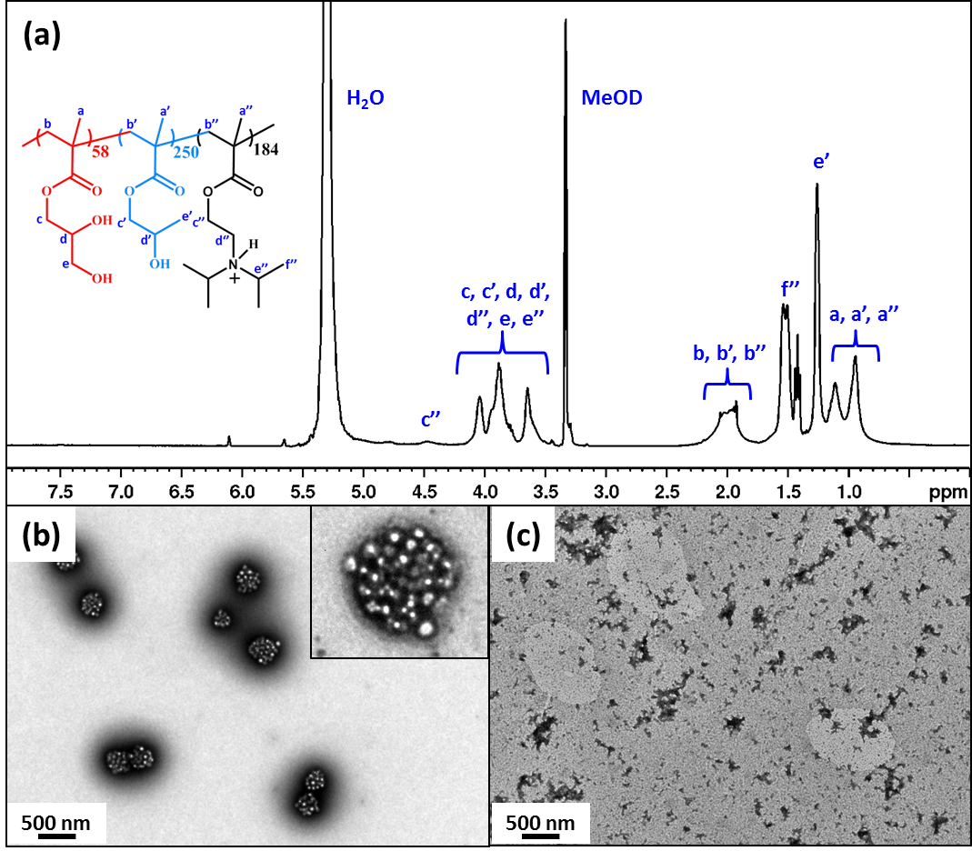

Fig. S7. (a) Assigned ¹H NMR spectrum of the G₅₈H₂₅₀D₁₈₄ triblock copolymer recorded in CD₃OD plus 4 % DCl/D₂O (20% w/w DCl). Representative TEM images obtained for (b) G₅₈H₂₅₀D₁₈₄ framboidal triblock vesicles at pH 8 and (c) fractal aggregates of cationic spheres formed by the same copolymer at pH 3.

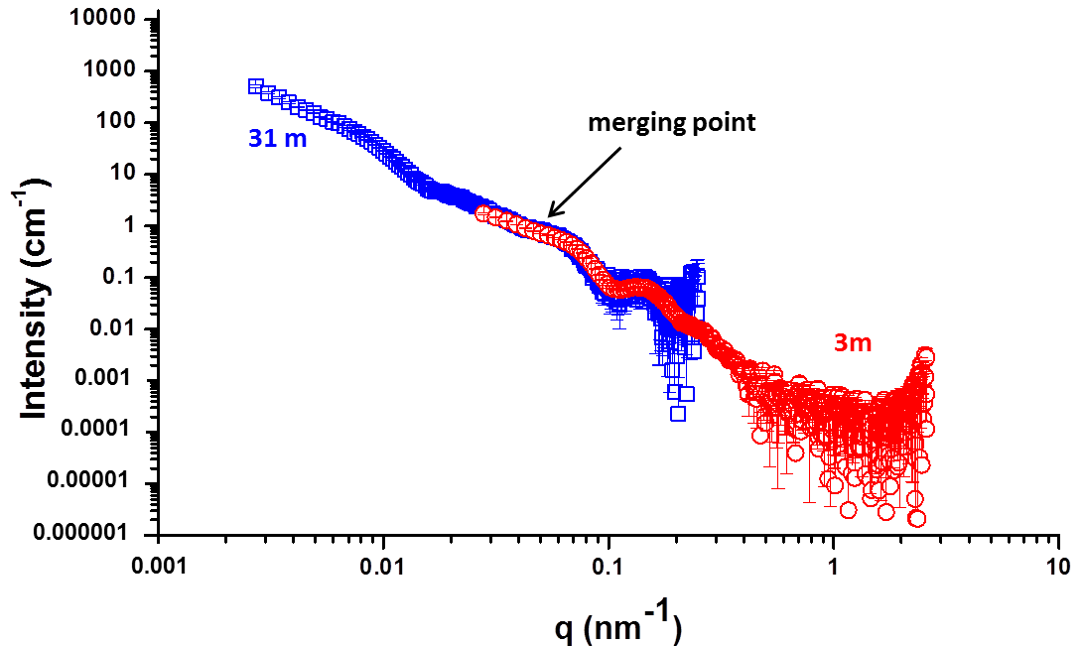
Fig. S8. Two SAXS patterns recorded for G₅₈H₂₅₀D₁₈₄ framboidal vesicles 100 ms after HCl addition. These patterns were obtained from two identical experiments run using a camera length of 3 m (red data) or 31 m (blue data). The overlap between the two data sets indicates excellent data reproducibility.

References

1. J. Ilavsky and P. R. Jemian, J. Appl. Crystallogr., 2009, 42, 347-353

