Optimization of Amidation Reactions using Predictive Tools for the Replacement of Regulated Solvents with Safer Bio-based Alternatives
Tabitha H. M. Petchey, James W. Comerford, Thomas J. Farmer*, Duncan J. Macquarrie, James Sherwood and James H. Clark
*thomas.farmer@york.ac.uk, Green Chemistry Centre of Excellence, Dept. of Chemistry, University of York, Heslington, York, YO10 5DD, UK

ABSTRACT: Catalytic methods for the synthesis of amides are much sought after. Silica catalysts have shown promise, but yields are generally moderate and the use of toluene, a toxic and regulated solvent is required. Here, the Hansen Solubility Parameters in Practice (HSPiP) software package has been used along with the Yalkowsky approximation to make predictions about the solubility of a series of aliphatic and aromatic amides in less hazardous solvents. The conventional solvent toluene has been modelled, along-side potential bio-derived alternatives, to find a safer and more productive reaction medium for amidation chemistry. The best candidate, 4-methylisopropylbenzene (p-cymene) was then examined experimentally against toluene in a range of silica-catalyzed reactions between carboxylic acids and amines, including both aromatic and aliphatic reactants. The increased temperatures achievable in the higher boiling p-cymene are shown to provide a significant improvement to yields compared to toluene. The low solubility of many of the amides in cold p-cymene proves an aid to separation. In general, higher polarity amides exhibit more favorable yields. In addition, tests run in a continuous flow system demonstrate the potential for further efficiency improvements by the recirculation of reactants.
INTRODUCTION
Amide synthesis is one of the most prevalent and important conversions in the pharmaceutical industry.^{1,2} This class of reaction is routinely carried out using one of many known coupling agents, which have been reviewed thoroughly in the literature.^{3–8} Employment of such reagents is an effective method of avoiding the formation of unwanted ammonium-carboxylate salt instead of the product. Regrettably, they are often toxic and corrosive, and their use is wasteful as stoichiometric amounts are used up in the process.^{9–11} More recently, this has inspired a move towards catalysis to improve efficiency and decrease toxicity and risk.^{12–16} Heterogeneous activated silica catalysts are particularly advantageous because they are cheap, robust and reusable.^{17,18}
For solubility reasons, coupling reagent enabled amidations are typically run in polar aprotic solvents such as dichloromethane (DCM) and N,N-dimethylformamide (DMF).¹⁹ In the absence of coupling reagents, toluene is preferable as a solvent because its poor hydrogen-bonding ability accelerates the reaction.²⁰ Unfortunately, all of the aforementioned solvents are subject to increasingly restrictive legislative actions.²¹ As the majority component, the solvent is routinely the chief contributor to the hazards of a reaction. Finding suitable alternative solvents is crucial for amidation chemistry to be performed safely, and pursuing this goal provides an opportunity to improve performance. The influence of the solvent on rates of reaction is quite profound, akin to a catalyst, and reaction equilibria are also solvent dependent. Although safer or bio-based solvents for amidation are occasionally investigated,¹⁹ most research efforts to date have focused on catalyst development.
Herein, we show that computational tools make it possible to rationally optimize a chemical process (such as amidation) with a straight-forward solvent substitution. The clear advantage of using predictive modelling software is the avoidance of “trial-and-error” approaches that are time consuming and only reveal the best solvent from within a limited set of experimental data. A useful and widely applied software package for solvent selection is HSPiP. The application of Hansen solubility parameters using HSPiP calculations makes the determination of appropriate solvents considerably faster than running practical experiments. For this investigation, we could predict the relative solubility of an amide in each solvent. This information permitted the rapid optimization of the experimental conditions, as amide recovery through precipitation was necessary due to typically high boiling points found with bio-based solvents.
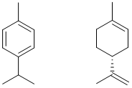
Figure 1. Structure of p-cymene (left) and D-limonene (right).
Toluene is a prime target for replacement, owing to its flammability, unsustainable origin (crude oil), and the fact that it is a suspected teratogen.²² p-Cymene (Figure 1) was identified as a promising bio-based solvent replacement for toluene due to its similar polarity and functionality. p-Cymene can be synthesised using silica supported palladium or mesoporous silica-alumina from D-limonene, which itself can be extracted from food waste such as citrus peels.^{20,23} p-Cymene is also naturally occurring in its own right, being present in certain essential oils, and is low enough in toxicity to be a recognised food additive.^{24,25} Another property of p-cymene that makes it appealing for this study is its boiling point (177 °C compared to 111 °C for toluene). We postulated a higher reflux temperature would likely increase the rate of direct amidation, and ideally translate to shorter reaction times.

RESULTS AND DISCUSSION
Thirteen amides were selected, covering a range of aliphatic, furan and aromatic structures (shown in Table 1), to test p-cymene as a reaction solvent. The ideal solubility of each amide was predicted using the Yalkowsky approximation (see Figure 2).²⁶ It is derived from the difference between the melting point of the solute and the temperature defined for the prediction. Amides with lower melting points have higher ideal solubilities due to the lower amount of energy required to break intermolecular interactions.

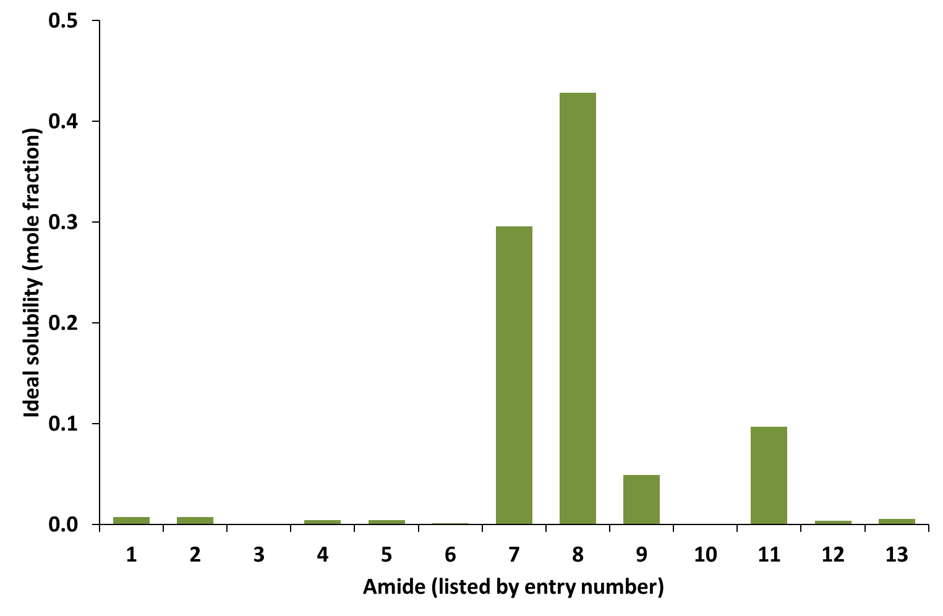
Figure 2. Ideal solubility prediction using the Yalkowsky approximation and literature melting points, at 25 °C.
This method is independent of the solvent. Even though the efficiency of the reaction is not predicted, the low solubility expected for amides 1-6, 10, 12 and 13 is of significant benefit to the recovery of the amides by filtration. To demonstrate the advantage of using a higher boiling solvent as a medium for the reactions, a heat map (Figure 3) was modelled using equations for enthalpy and entropy of activation (from the uncatalyzed amidation; see Supporting Information for details). Theoretically, the highest rates of reaction can be achieved using solvents in the bottom-right hand corner of the graph (i.e. elevated temperatures and low polarity). The temperature is the dominating influence on the rate of reaction, as the reaction is entropically driven. The absolute solubility of each acid and amide was tested in both toluene and p-cymene at 25 °C to establish the strength of the correlation between reality and our predicted results using these modelling techniques. The results are given in Table 1 and are consistent with the prediction in Figure 2 except for amide 9 which was found to be poorly soluble despite its relatively low melting point of 82-83 °C.²⁷ HSPiP software was used to determine the Hansen solubility parameters of each amide and reaction solvent (Figure 4).
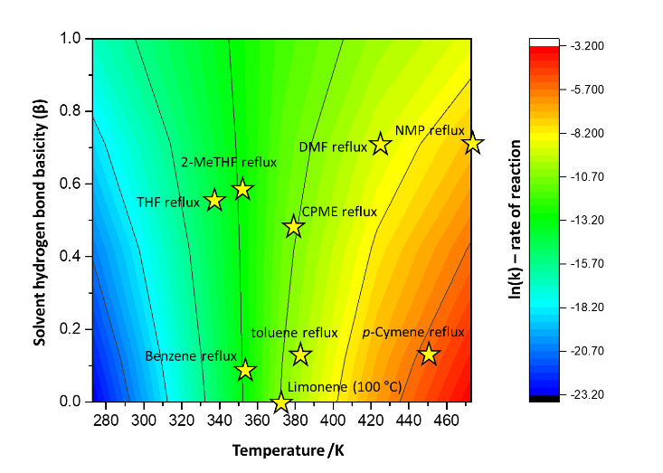
Figure 3. Heat map modelling showing the effect of solvent hydrogen bond basicity and temperature on the rate of reaction of phenylbutyric acid and benzylamine (un-catalyzed).

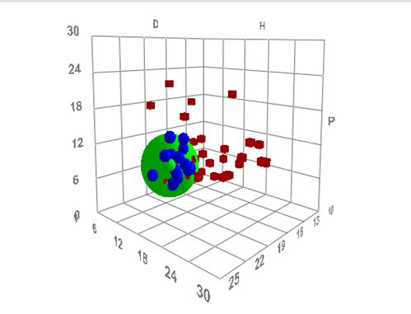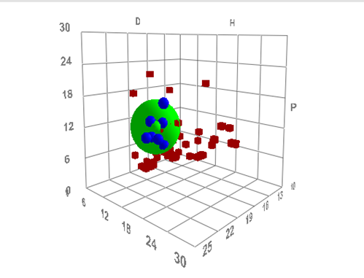
Figure 4. Hansen space featuring non-hazardous solvents from the CHEM21 selection guide for classical and neoteric solvents for amide 1 (left) and amide 12 (right) (green data points). Blue data points are within the sphere, and represent solvents that will dissolve the amide. Red data points represent solvents that will advantageously not dissolve the amide. See Figure S1 for 2D representations of the Hansen space.

Table 1. Isolated yields for direct amide formation in toluene or p-cymene solvents along with experimental solubilities of amides in toluene or p-cymene.
Entry | R^{1,a} | R^{2,a} | Isolated % Yield |  |  | Amide Solubility /mol kg⁻¹
 |  |  | Toluene | p-Cymene^{b} | p-Cymene | Toluene | p-Cymene
1 | C₆H₅CH₂CH₂CH₂ | C₆H₅ | 61 | 37 | 92 | 0.077^{c} | 0.017^{c}
2 | C₆H₅CH₂ | C₆H₅ | 80 | 57 | 88 | 0.042 | 0.013
3 | C₆H₅ | C₆H₅ | 36 | 5 | 69 | 0.015 | 0.005
4 | ClC₆H₄OCH₂^{d} | C₆H₅ | 74 | 75 | 77 | 0.073 | 0.021
5 | C₆H₅CH₂ | ClC₆H₄e | 18 | 6 | 55 | 0.085 | 0.045
6 | C₆H₅CH₂ | C₆H₄(CH₃)₂^{f} | 20 | 2 | 69 | 0.029 | 0.000
7^{g} | C₆H₅CH₂ | C₄H₈^{h} | 52* | 28* | 22* | high^{i} | high^{i}
8^{j} | C₆H₅ | CH₃CH₂CH₂CH₂ | (k) | (k) | 55 | high^{i} | high^{i}
9 | C₆H₄(NO₂)^{l} | CH₃(CH2)₄CH₂ | (k) | (k) | 34 | 0.052 | 0.004
10 | C₆H₄(NO₂) | C₆H₅ | 8 | <1 | 11 | 0.000 | 0.000
11^{g} | C₆H₁₁^{m} | CH₃(CH2)₄CH₂ | 9 | 16 | >99 | high^{i} | high^{i}
12 | C₆H₁₁ | C₆H₅ | 11 | 5 | 70 | 0.031 | 0.011
13 | C₄H₃O^{n} | C₆H₅ | (k) | (k) | 78 | 0.081 | 0.018
K60 catalyst activated at 700 °C; reactions run for 24 h; solubilities determined at 25 °C; (a) 12 mmol of each reagent, (b) 111 °C, otherwise solvents set to reflux, (c) mean of 3 tests, (d) 4-chlorophenoxyacetic acid, (e) 2-chloroaniline, (f) 2,6-dimethylaniline, (g) non-precipitating waxy solid, (h) pyrrolidine, (i) accurate measurement not possible by this method and with available quantities, (j) oil, (k) yield too low to isolate, (l) 4-nitrobenzoic acid, , (m) cyclohexane carboxylic acid, (n) 2-furoic acid. *Amide 7 isolated yield trend differs w.r.t. yields obtained on GC. As 7 did not precipitate, there were likely several losses during the isolation process. See Table S1 for GC yields, catalyst-free reaction yields and an example of catalyst reuse for amide 13.

By visualizing the relative solubilities in the “solvent-space”, it was possible to affirm the predictions about the likelihood that the amides would precipitate out of solution. The proximity of solvent and solute in the Hansen solvent space indicates a high affinity (“like-dissolves-like”). Amides have been plotted individually with a data set of solvents to show which will be likely to form a solution and which fall outside the solubility zone (green sphere). It is logical that the greater distance in solvent-space (corresponding to dissimilar polarity and H-bonding), the lower the solubility of the amide. It is important to bear in mind that the radius of the sphere of solubility is specific to each amide, so a clear trend could not be drawn between distance and the solubility of p-cymene or toluene. However, in general, the HSPiP predictions agree with the Yalkowsky approximation. The two amides nearest to the solvents, 7 and 11, were soluble in the two solvents and thus outside the range of amides suitable for filtration. The farthest amide in solvent space, 10, showed no solubility in either solvent, which can be attributed to the increased polarity afforded by the -NO₂ functionality. Although toluene and p-cymene occupy the same region of solvent space, amide solubility was consistently lower in p-cymene due to its relatively lower polarity, which is an advantage for recovery.
With the aim of testing the efficacy of p-cymene as a solvent for direct amidation, a study was conducted covering the range of amides with various functional groups to account for steric effects and selectivity (see Table 1). Amidations were run in toluene (reflux) and in p-cymene (111 °C and reflux) to investigate the potential benefits of a temperature increase made possible by the low volatility of p-cymene. The heterogeneous catalyst chosen for this purpose was K60 silica gel activated to 700 °C. Yields were obtained via GC analysis (Table S1) and by isolation of the pure amide to assess losses in the work up (Table 1).
It is evident from the results in Table 1 that the yields after 24 h were generally lower in p-cymene at 111 °C than those in refluxing toluene. However, raising the temperature of p-cymene to reflux caused a dramatic increase in the yield. In the case of N-(2,6-Dimethyl-phenyl)phenyl-acetamide, an increase of more than 50% was observed in refluxing p-cymene over toluene. In the cases of nitro containing amide, 9, the higher temperature is necessary to promote the reaction. Energy measurements were carried out on the synthesis 3 using both solvents at 111°C and p-cymene at reflux (see Supplementary Information). The high temperature p-cymene was the most energy efficient per unit product of all the systems (0.357 kWh g⁻¹), refluxing toluene giving the next best at 0.464 kWh g⁻¹. Given the lack of insulation on the vessel, heat losses would be significantly greater for the refluxing p-cymene system, meaning a well-insulated system would benefit the high temperature process further.
In general, the catalyst was effective where aromatic amines were used but did not make a significant difference to reactions involving aliphatic amines (see S1). However, it should be noted that in examples where the catalyst offered little benefit (Table S1, amides 7 and 11) there was still a significant improvement in yield on moving to the hotter refluxing p-cymene solvent over the toluene equivalent. The activated K60 silica catalyst was recovered and reused for the synthesis of 13 (see Table S1), showing no drop in yield and therefore suggesting excellent potential for use in continual flow reaction.
Amide 1 (4,N-diphenylbutyramide) was selected for the flow reaction as it was isolated in high yields from the batch reaction and how a low absolute solubility in cool p-cymene. The solubility of 1 was checked visually at increasing temperatures and found to have completely dissolved in p-cymene at 70 °C. Correspondingly, 4-phenylbutyric acid was checked at decreasing temperatures and found to precipitate out of solution at temperatures below -5 °C. This information was used to decide on the suitable operating temperatures for use in a flow reaction, i.e. the temperature of the reaction column to keep the amide in solution, and the temperature of the cooling reservoir to keep the acid in solution but allow precipitation of the amide. The results of this reaction in p-cymene are provided in Table 2.

Table 2. Results of continuous flow reaction between 4-phenylbutyric acid and aniline in p-cymene.
Recirculations | Residence timeª  (min) | Total time  (min) | Space time yield^{b}  (mg g h⁻¹)
1 | 23.3 | 67 | 60
2 | 46.6 | 134 | 48
3 | 69.9 | 201 | 39
(a) Calculated from volume of catalyst (3 g) and flow rate (0.3 mL min-1) (b) the incremental decrease in output is expected as the starting materials were not replenished.

The results confirm that this system has the potential to improve efficiency by recycling of the reaction products and, in a more sophisticated flow system, regular removal of the amide product.

CONCLUSION
Several amides have been successfully formed using p-cymene as the reaction solvent and a simple activated K60 silica catalyst as the activating agent. The results show that the higher boiling point of p-cymene compared to toluene has an advantage in this set of reactions as the higher temperatures achievable can produce higher yields of product within a given time frame. The low volatility of p-cymene makes it a safer choice considering concerns of safety and environmental health and the indication is that the high energy usage associated with distilling off the solvent can be mitigated in many cases where the products are precipitated out of solution. p-Cymene has been successfully applied to direct amidation set up in a continuous flow reactor, reducing the risks brought about by the high pressures associated with higher volatility solvents. It is important to note that much research still needs to be done into the production of bio-based p-cymene to make it economically competitive.²⁸ Hansen solubility parameters have been used to predict where this is likely to be the case highlighting the need for an intelligent approach and choosing solvents on a case-by-case basis. This approach may be applicable to many other processes where the properties of the solvent factor strongly in the outcome, and should be used to target toxic and undesirable solvents for replacement.

EXPERIMENTAL SECTION
K60 silica gel for chromatography was obtained from Sigma-Aldrich. NMR spectra were obtained on a 400 MHz JEOL spectrometer. GC chromatograms were obtained on a Hewlett-Packard 6890 Series gas chromatograph using 30 m Rxi-5HT column, 0.25 mm ID, 0.25 μm d_{f}. GC-MS were obtained on a Perkin-Elmer Clarus 500 gas chromatograph combined with Clarus 560 S mass spectrometer. CHN analysis was conducted by using an Exeter Analytical Inc CE-440 analyser and the samples were weighed by using a Sartorius SE-2 analytical balance. Infrared Spectroscopy was run on a Perkin Elmer FTIR/FTNIR Spectrum 400 Spectrophotometer. Amidations were carried out on a Radleys 6-position multipoint hot-plate and condenser. Flow reactions were run on a Uniqsis Flowsyn continuous flow reactor. Activation of silica catalyst. K60 silica gel was activated at 700 °C for 4 h in a furnace under ambient pressure, with a ramp rate of 10 °C min⁻¹. The catalyst was allowed to cool naturally to room temperature.
General procedure. Chosen carboxylic acid (12 mmol), activated K60 silica(0.62 g) and 20 mL of solvent (toluene or p-cymene) were heated to reflux (111 °C/177 °C) in a two-necked round bottom flask equipped with a condenser and suba-seal. Once reflux was reached, chosen amine (12 mmol) was injected into the reaction mixture. After 24 hours, the hot reaction mixture was filtered through a sintered glass funnel (sample taken for GC analysis, see Table S1) and the catalyst washed with 10 ml of hot solvent. The filtrate was left in a refrigerator (4 °C) to aid product precipitation. Product was obtained by filtration and washing with cyclohexane (unless stated otherwise in details for each amide in the SI).
Procedure for flow reaction. 4-phenylbutyric acid (1.97 g, 12 mmol) and aniline (1.12 g, 12 mmol) were dissolved in p-cymene (20 mL) and fed into a flow reactor. The catalyst chamber (0.785 x 7.000 cm) was filled with K60 silica activated at 700 °C (2.5 g). The reactant solution was fed through the catalyst chamber at 150 °C with a flow rate of 0.3 mL min-1. The output tube was fed into the input vessel (cooled with tap water, ~10 °C) to allow the reactants to flow through the system repeatedly. Yields were determined by gas chromatography.

ASSOCIATED CONTENT
Supporting Information (pdf) is available free of charge on the ACS Publications website. Supporting information for this manuscript includes: detailed characterization of each amide; 2-dimensional representations of the HSPiP predictions (δP vs. δH; δP vs. δD; δH vs. δD), further details of how HSPiP predictions and the solvent heat map were carried out; data for yields (determined by GC) for both catalyzed and un-catalyzed (blank) reactions for each amide; ¹H and ¹³C NMR spectra for each isolated amide; details for the energy efficiency calculation.
AUTHOR INFORMATION
Corresponding Author
*Thomas J. Farmer: thomas.farmer@york.ac.uk
Author Contributions
The manuscript was written through contributions of all authors. All authors have given approval to the final version of the manuscript.
Funding Sources
The authors thank the University of York for part funding this research. This research was also part funded by CHEM21 under the Innovative Medicines Initiative Joint Undertaking (grant agreement n°115360), resources of which are composed of financial contribution from the European Union's Seventh Framework Program (FP7/2007-2013) and EFPIA companies’ in-kind contributions.

ACKNOWLEDGMENT
Thanks to Joshua Reid and Romain Aufaure for preliminary work and to Paul Elliot for technical assistance. Thanks also to William Unsworth for assistance with flow reactions.
REFERENCES
(1) Carey, J. S.; Laffan, D.; Thomson, C.; Williams, M. T. Org. Biomol. Chem. 2006, 4, 2337.
(2) Roughley, S. D.; Jordan, A. M. J. Med. Chem. 2011, 54, 3451.
(3) Dunetz, J. R.; Magano, J.; Weisenburger, G. A. Org. Process Res. Dev. 2016, 20 (2), 140.
(4) Al-warhi, T. I.; Al-Hazimi, H. M. A.; El-Faham, A. J. Saudi Chem. Soc. 2012, 16 (2), 97.
(5) El-Faham, A.; Albericio, F. Chem. Rev. 2011, 111, 6557.
(6) Valeur, E.; Bradley, M. Chem. Soc. Rev. 2009, 38, 606.
(7) Montalbetti, C. A. G. N.; Falque, V. Tetrahedron. 2005, pp 10827–10852.
(8) Han, S.-Y.; Kim, Y.-A. Tetrahedron 2004, 60 (672), 2447.
(9) El-faham, A.; Funosas, R. S.; Prohens, R.; Alvericio, F. Chem. Eur. J. 2009, 15, 9404.
(10) Abdelmoty, I.; Albericio, F.; Carpino, L. A.; Foxman, B. M.; Kates, S. A. Lett. Pept. Sci. 1994, 1, 57.
(11) Coste, J.; Le-Nguyen, D.; Castro, B. Tetrahedron Lett. 1990, 31 (2), 205.
(12) Lundberg, H.; Tinnis, F.; Selander, N.; Adolfsson, H. Chem. Soc. Rev. 2014, 43, 2714.
(13) Pattabiraman, V. R.; Bode, J. W. Nature 2011, 480 (7378), 471.
(14) Roy, S.; Roy, S.; Gribble, G. W. Tetrahedron 2012, 68 (48), 9867.
(15) Allen, C. L.; Williams, J. M. J. Chem. Soc. Rev. 2011, 40, 3405.
(16) Charville, H.; Jackson, D.; Hodges, G.; Whiting, A. Chem. Commun. 2010, 46, 1813.
(17) Comerford, J. W.; Farmer, T. J.; Macquarrie, D. J.; Breeden, S. W.; Clark, J. H. ARKIVOC 2012, vii, 282.
(18) Comerford, J. W.; Clark, J. H.; Macquarrie, D. J.; Breeden, S. W. Chem. Commun. (Camb). 2009, No. 18, 2562.
(19) MacMillan, D. S.; Murray, J.; Sneddon, H. F.; Jamieson, C.; Watson, A. J. B. Green Chem. 2013, 15, 596.
(20) Clark, J. H.; Macquarrie, D. J.; Sherwood, J. Green Chem. 2012, 14 (0), 90.
(21) European commission, council directive 1907/2006. concerning the Registration, Evaluation, Authorisation and Restriction of Chemicals (REACH), establishing a European Chemicals Agency, amending Directive 1999/45/EC and repealing Council Regulation (EEC) No 793/93 and Commission Regulation (EC) No 1488/94; 2016.
(22) Toluene, Occupational Safety and Health Administration, United States Department of Labor.
(23) Martin-Luengo, M. A.; Yates, M.; Rojo, E. S.; Huerta Arribas, D.; Aguilar, D.; Ruiz Hitzky, E. Appl. Catal. A Gen. 2010, 387 (1–2), 141.
(24) Marchese, A.; Arciola, C. R.; Barbieri, R.; Silva, A. S.; Nabavi, S. F.; Sokeng, A. J. T.; Izadi, M.; Jafari, N. J.; Suntar, I.; Daglia, M.; Nabavi, S. M. Materials (Basel). 2017, 10 (8), 947.
(25) Food and Drug Administration. Substances Generally Recognized as Safe Food Additives Permitted for Direct Addition to Food for Human Consumption. https://www.accessdata.fda.gov/scripts/cdrh/cfdocs/cfCFR/CFRSearch.cfm?fr=172.515 (accessed Jan 12, 2017).
(26) Yalkowsky, S. H.; Wu, M. J. Pharm. Sci. 2010, 99, 1100.
(27) Nammalwar, B.; Muddala, N. P.; Watts, F. M.; Bunce, R. A. Tetrahedron 2015, 71 (48), 9101.
(28) Dávila, J. A.; Rosenberg, M.; Cardona, C. A. Waste and Biomass Valorization 2015, 6 (2), 253.

SYNOPSIS
Computational modelling predicts selective precipitation of structurally diverse amide products, facilitating substitution of toluene solvent with bio-derivable para-cymene.

KEYWORDS
Heterogeneous catalysis, amide, solvent substitution, flow chemistry, Hanson solubility parameters, Yalkowsky approximation, para-cymene.

