Appendix 1: Details of biomarker analysis (including women who had received anticoagulation)
The following figures show, for each biomarker, a box-whisker plot comparing biomarker levels for women with DVT, PE, no PE and those excluded from the primary analysis.

APTT
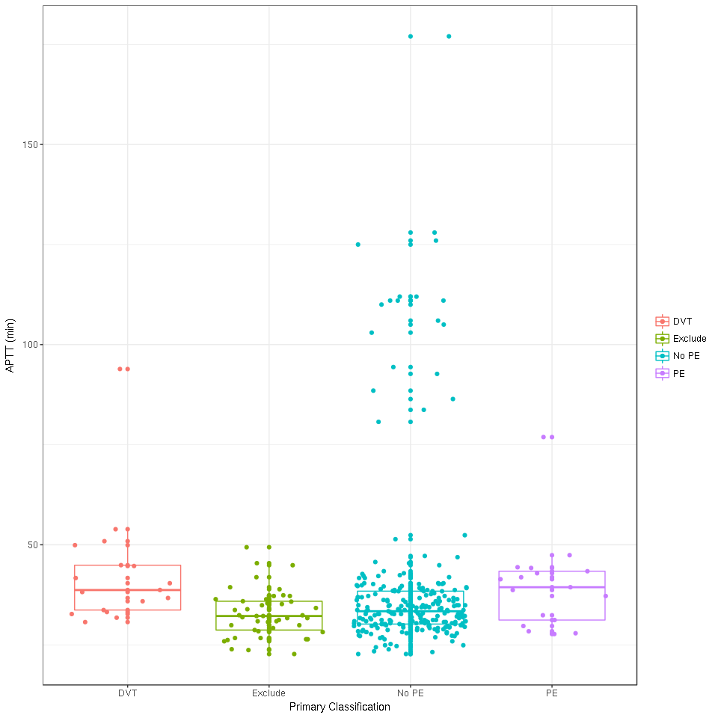
Appendix Figure 1: Box-whisker plot comparing APTT levels for women with DVT, PE, no PE and those excluded from the primary analysis

Clauss Fibrinogen
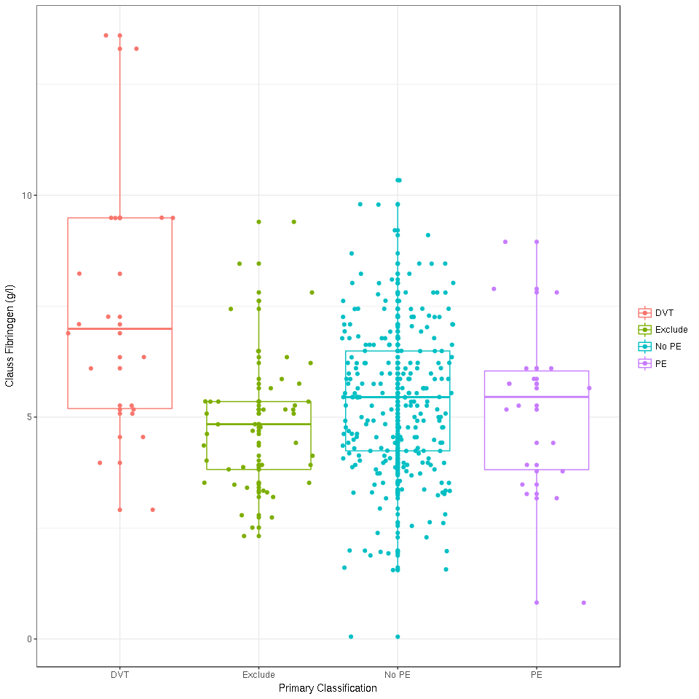
Appendix Figure 2: Box-whisker plot comparing Clauss Fibrinogen levels for women with DVT, PE, no PE and those excluded from the primary analysis

Prothrombin Time
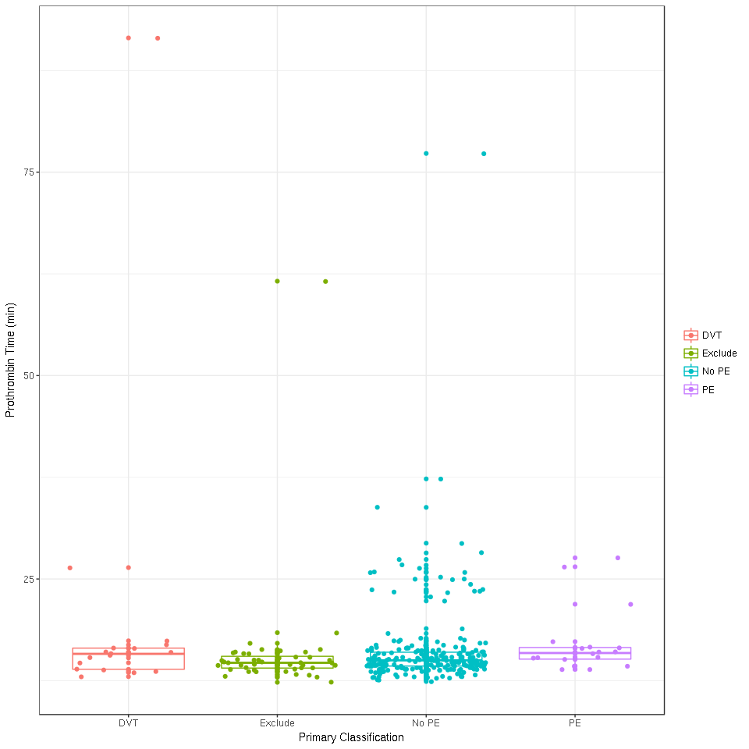
Appendix Figure 3: Box-whisker plot comparing prothrombin time levels for women with DVT, PE, no PE and those excluded from the primary analysis

D-Dimer (Innovance)
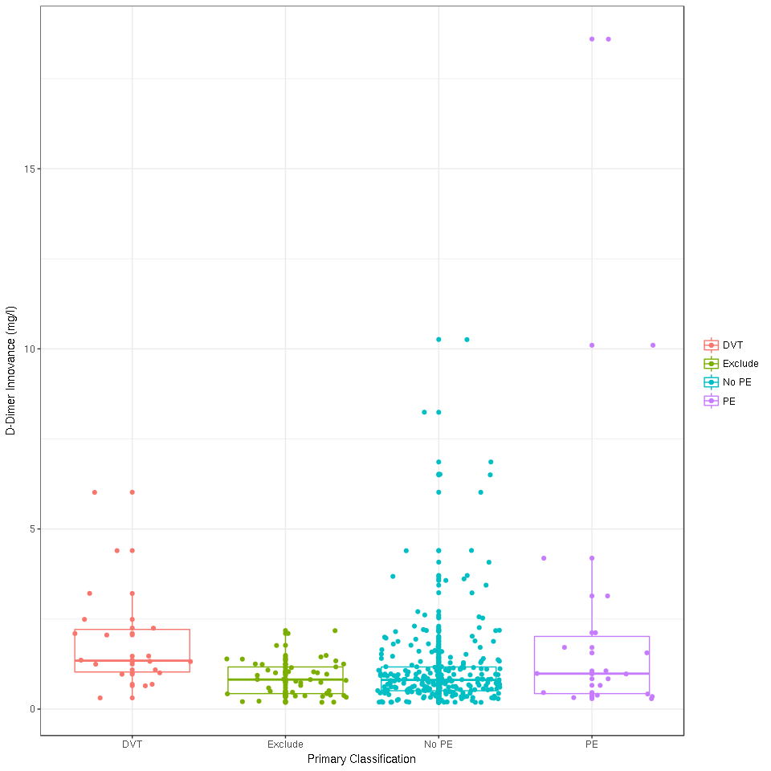
Appendix Figure 4: Box-whisker plot comparing D-dimer (Innovance) levels for women with DVT, PE, no PE and those excluded from the primary analysis

D-Dimer (ELISA)
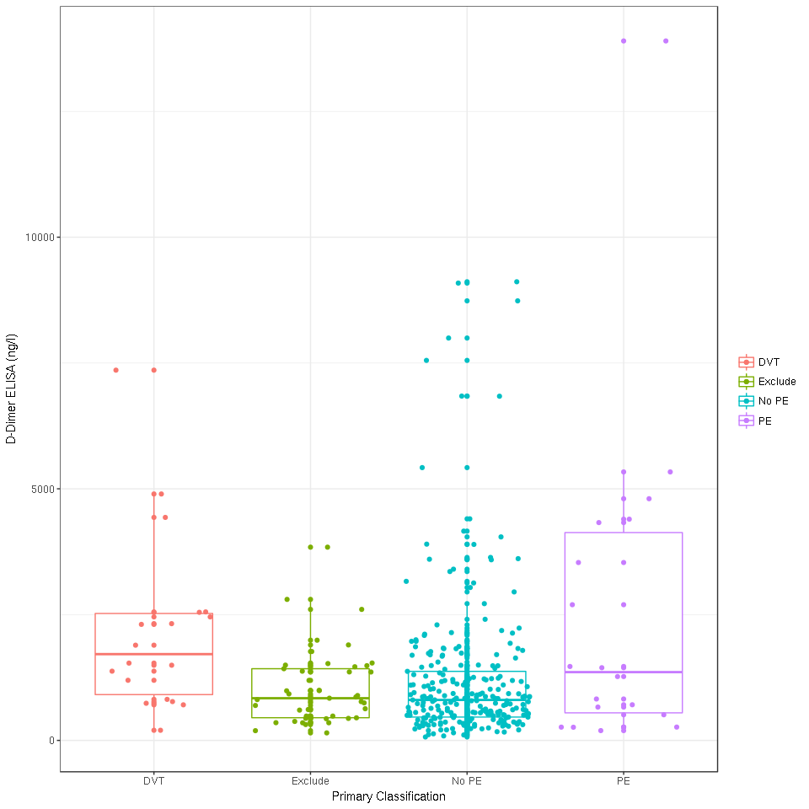
Appendix Figure 5: Box-whisker plot comparing D-dimer (ELISA) levels for women with DVT, PE, no PE and those excluded from the primary analysis

Thrombin Generation (Lag Time)
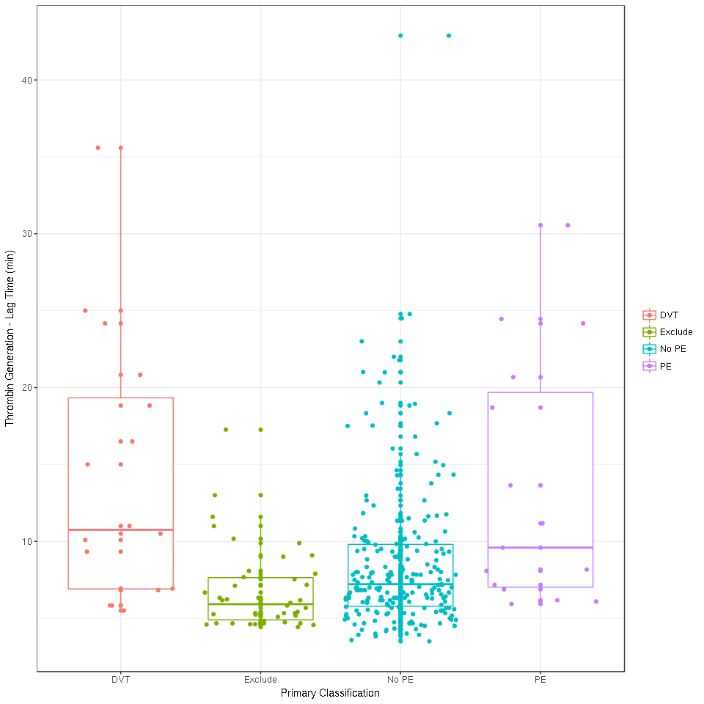
Appendix Figure 6: Box-whisker plot comparing Thrombin Generation (Lag Time) levels for women with DVT, PE, no PE and those excluded from the primary analysis

Thrombin Generation (Endogenous Potential)
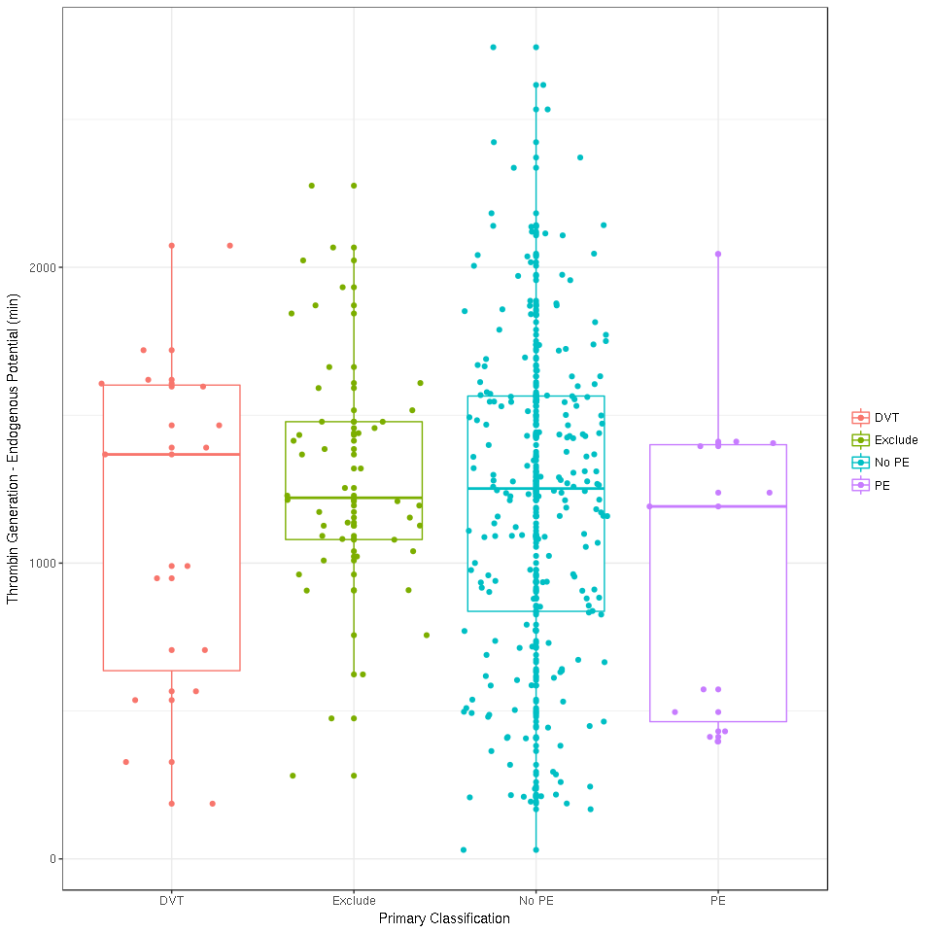
Appendix Figure 7: Box-whisker plot comparing Thrombin Generation (Endogenous Potential) levels for women with DVT, PE, no PE and those excluded from the primary analysis

Thrombin Generation (Peak)
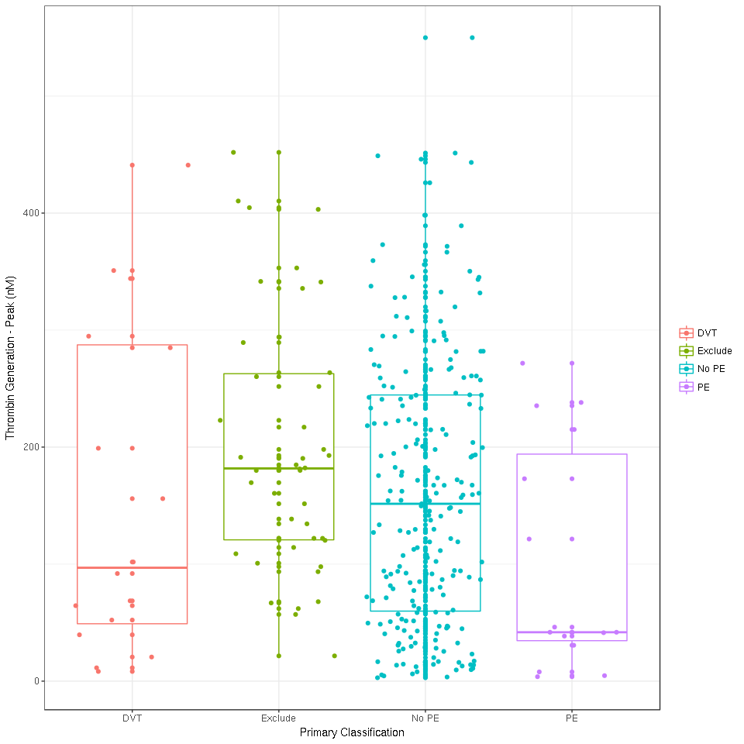
Appendix Figure 8: Box-whisker plot comparing Thrombin Generation (Peak) levels for women with DVT, PE, no PE and those excluded from the primary analysis

Thrombin Generation (Time to Peak)
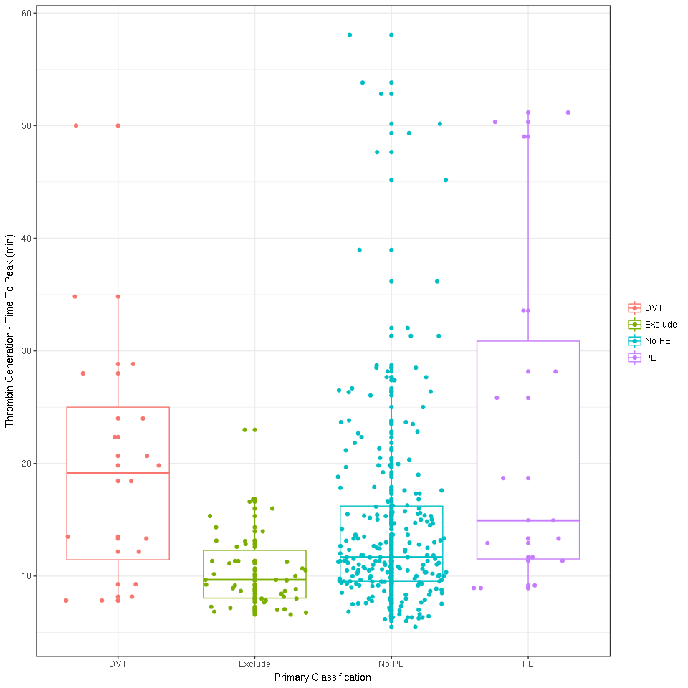
Appendix Figure 9: Box-whisker plot comparing Thrombin Generation (Time to Peak) levels for women with DVT, PE, no PE and those excluded from the primary analysis

Plasmin-antiplasmin
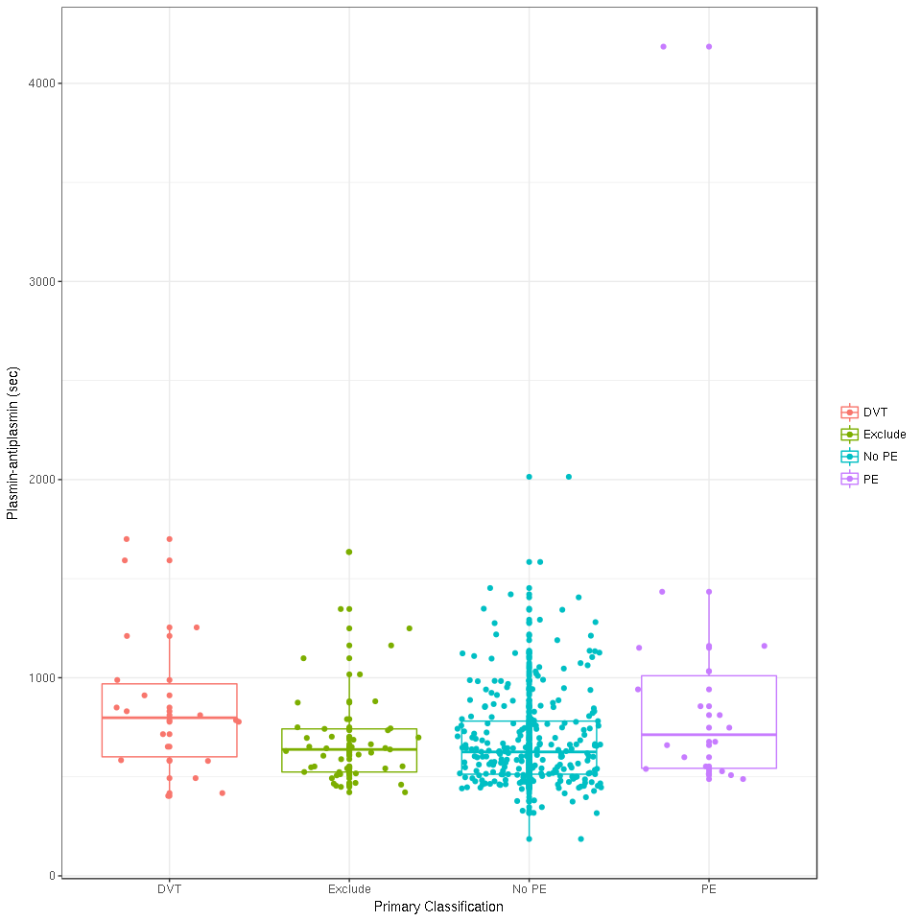
Appendix Figure 10: Box-whisker plot comparing plasmin-antiplasmin levels for women with DVT, PE, no PE and those excluded from the primary analysis

MRProANP
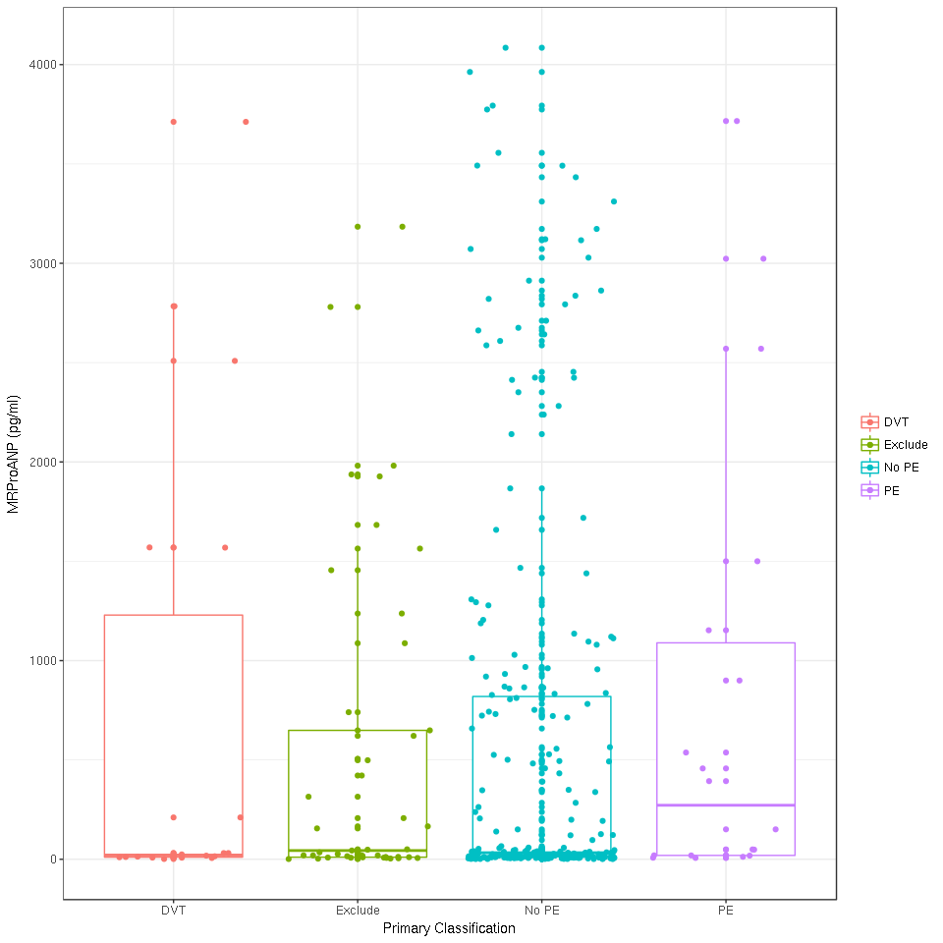
Appendix Figure 11: Box-whisker plot comparing MRProANP levels for women with DVT, PE, no PE and those excluded from the primary analysis

BNP
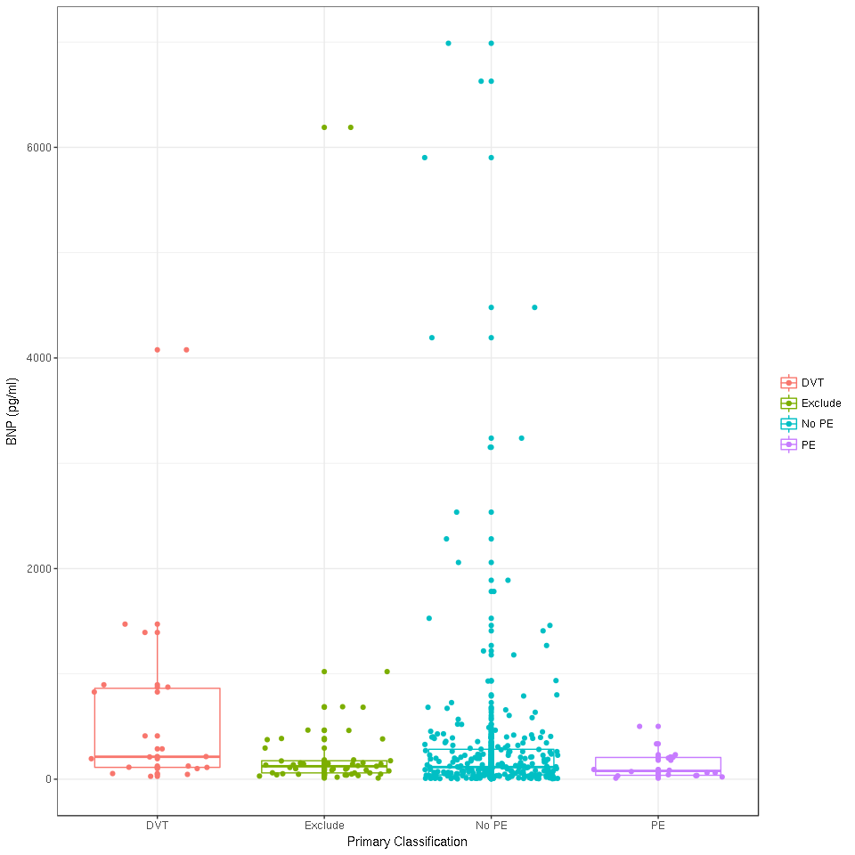
Appendix Figure 12: Box-whisker plot comparing BNP levels for women with DVT, PE, no PE and those excluded from the primary analysis

Tissue Factor
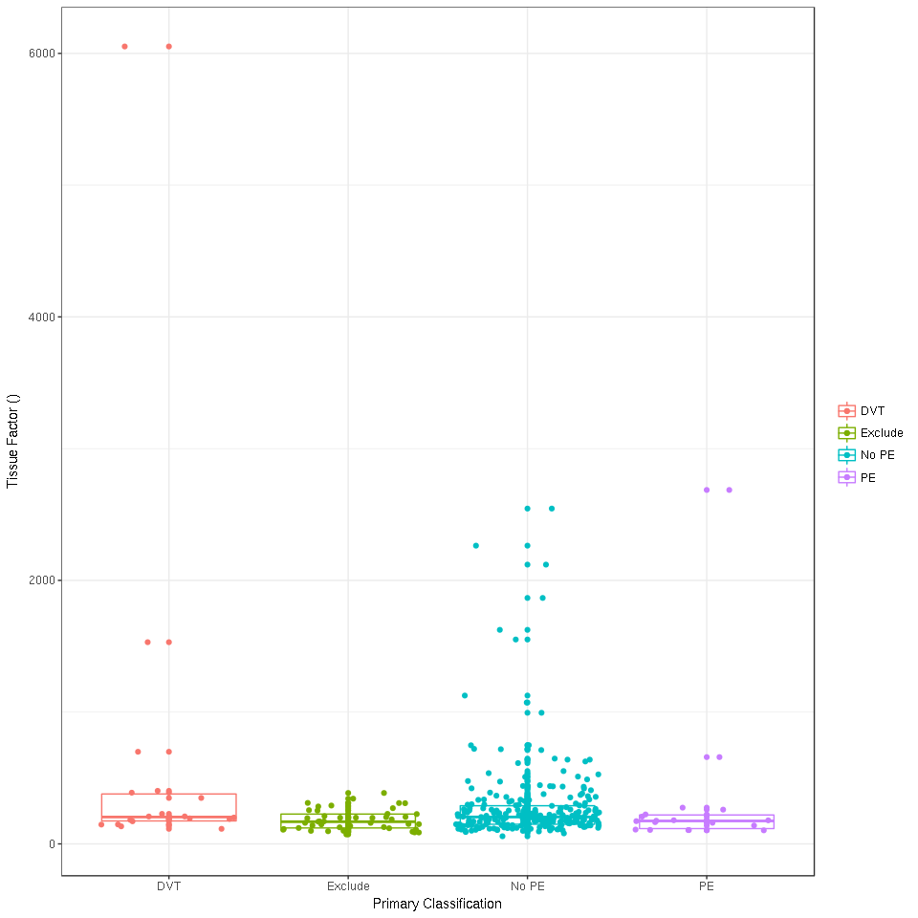
Appendix Figure 13: Box-whisker plot comparing Tissue Factor levels for women with DVT, PE, no PE and those excluded from the primary analysis

PF 1 + 2
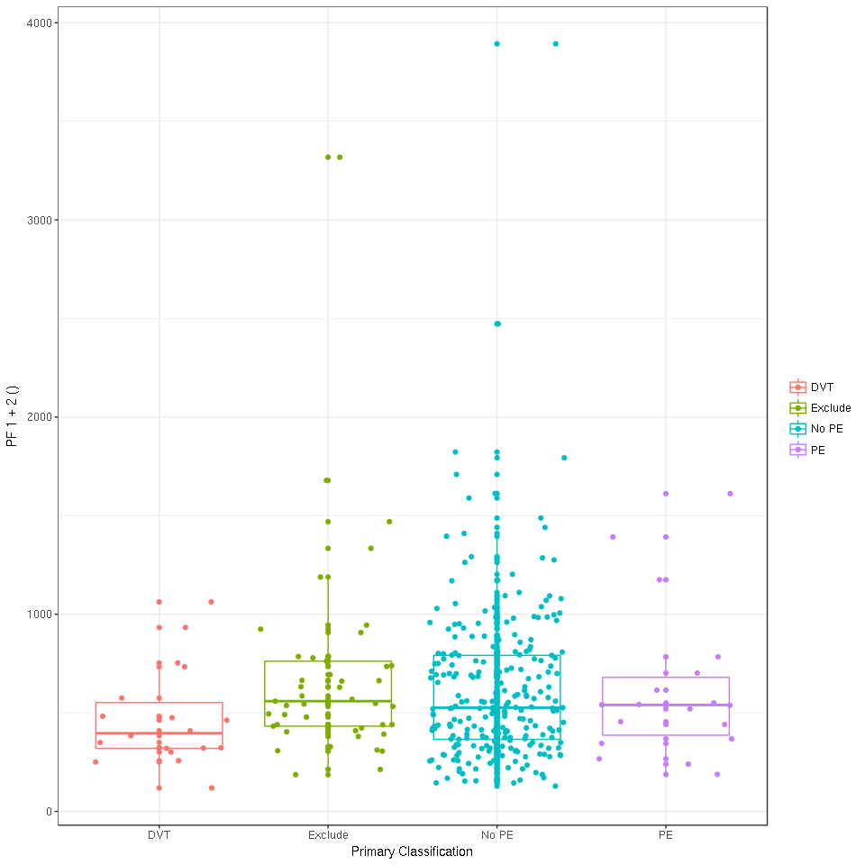
Appendix Figure 14: Box-whisker plot comparing PF1+2 levels for women with DVT, PE, no PE and those excluded from the primary analysis

Troponin
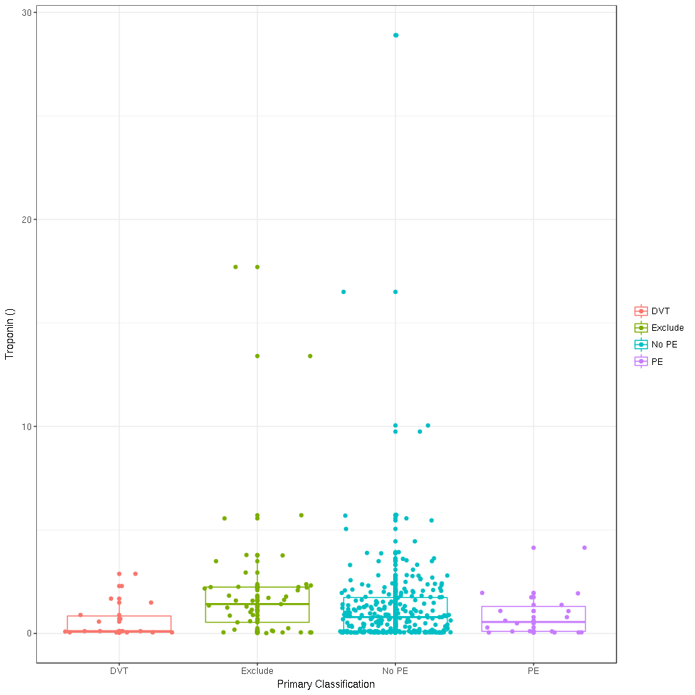
Appendix Figure 15: Box-whisker plot comparing troponin levels for women with DVT, PE, no PE and those excluded from the primary analysis

C-Reactive Protein
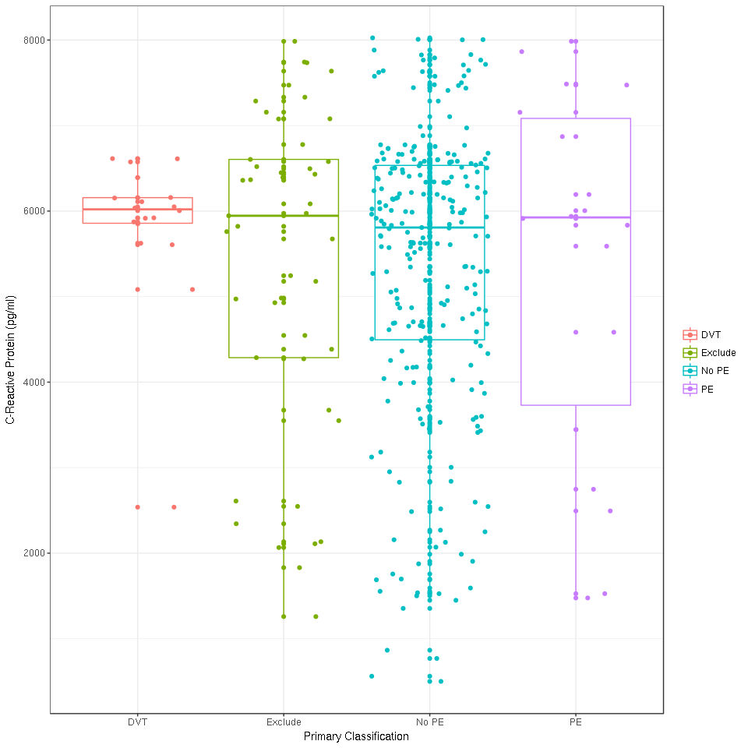
Appendix Figure 16: Box-whisker plot comparing CRP levels for women with DVT, PE, no PE and those excluded from the primary analysis

