Trends and themes in African Ornithology.

Colin M. Beale

Department of Biology, University of York, Wentworth Way, York, YO10 5DD, Uk

ABSTRACT:

Ornithology in Africa has a long history. I review trends in the ornithological literature since 1990 within the context of the recent Pan-African Ornithological Congress. Using full text searches of papers on PubMed and abstracts from main ornithological journals I found that most papers referencing African bird species are focussed on medical related research questions. Restricting the literature search to journals African ornithologists are most likely to publish in, I found 2 279 relevant papers. These describe work on 29% of African bird species from 82% of African bird families, in all but two African countries. Overall output has increased slightly over time, with more papers tackling more research topics. Most popular research topics were demography, conservation and climate, with disease ecology, physiology and ecological processes the least researched topics. I found that while many authors with African affiliations publish papers, outside of South Africa very few African based authors reliably publish in the international research literature, perhaps indicating difficulties in establishing a productive research career in much of Africa. I conclude with a call to overseas ornithologists working in Africa and to organisations funding research in Africa to work together to build capacity outside of the few established research centres.

KEYWORDS:
Quantitative review, Birds, Literature search, Research themes, Research capacity building

INTRODUCTION:

Ornithology, the scientific study of birds, has a long history in Africa: modern scientific understanding starting with pre-colonial European explorers (Johnson 2005). No doubt pre-colonial African civilisations had their own understanding of ornithology: traditional knowledge of birds is still high in many communities (Muiruri and Maundu 2010), but in the formal published literature most early scientific papers about African birds are providing descriptions of species new to European eyes. Since those early years, and although new descriptions have fallen dramatically since the heyday of discoveries in the early and mid-19th Century (Figure 1), ornithologists have continued to discover and describe new species in Africa with several species still awaiting description (such as the two endemic Cisticola species of the Kilombero valley in Tanzania now widely illustrated in field guides: Stevenson and Fanshawe 2002) and no doubt more will continue to be discovered. Mostly, however, ornithology has moved on from description of species, to a wide range of new questions covering distribution, behaviour, conservation and myriad other topics.

The most recent Pan African Ornithology Congress (held in Dakar, Senegal in 2016) was a showcase of current ornithological research activity in Africa, with 137 talks in 17 symposia describing fieldwork in 36 States of the African Union and over 240 delegates from across the world. Symposia covered topics as diverse as seabird populations, raptor ecology, parrots and conservation with contributions from students, professors, conservationists and dedicated amateurs alike, leading to several papers in this volume. All this suggests ornithology is thriving in Africa, but a cursory review of the programme (http://paoc-africa.org/programme) shows that some large and important bird families may not be receiving the attention they deserve: Alaudidae (larks: 80 African species and with diversity centred in Africa: Alström et al. 2013), Fringillidae (finches: 63 African species and including many involved in the captive bird trade: Bird Trade Subcommittee of the AOU Conservation Committee 1991), Sturnidae starlings (53 African species and another typically African group: Lovette and Rubenstein 2007) and Phasianidae (francolins and related gamebirds, 54 African species and widely hunted for food across the continent: Ceppi and Nielsen 2014, Whytock et al. 2016). Such observations suggest a wider review of the ornithological literature may help identify emerging trends and themes and identify gaps to prioritise for future research.

In recent years, several innovations have made quantitative reviews of large bodies of literature much easier than ever before. Most importantly, many international journals are now online and can be searched and summarised using new software designed to automatically analyse large bodies of text. For some ornithological journals, historic papers have been retrospectively added to the digital archives giving a rich source of information in some cases going back over 150 years. Unfortunately, not all journals have such a complete online presence, but all the main ornithological journals now have at least abstracts and titles for all papers since 1990 available online. More recently still, a move to make access to the scientific literature completely free and open (sometimes after a suitable embargo) has led to the creation of a repository of the full text of over 1.5 million papers from many higher impact and general interest journals (the PubMed database: Canese and Weis 2013). Unfortunately, none of the main ornithological journals routinely submit papers to this database, but over the last decade it has compiled many ecological journals where ornithological papers are regularly published. Using a combination of the PubMed database of full text papers since 2006 and the Web of Science database of titles, abstracts and metadata from five journals that regularly publish papers on ornithology in Africa (Ibis, Auk, Ostrich, Emu and African Journal of Ecology) since 1990, I aimed to locate and analyse trends in the science of modern ornithology in Africa.

When assessing the overall status of ornithology in Africa, several topics should be considered: trends in subject matter and taxonomic focus are obviously important, but so to are geographical patterns in where research is undertaken and where researchers are based. If ornithology is to thrive in Africa, practitioners must come from a broad diversity of backgrounds, be widely established in indigenous institutions and publish science of the highest calibre. In this paper I review the recent ornithological literature from Africa, seeking to identify trends in research topics, taxonomic, habitat and geographic biases and to assess how robust the science of ornithology is across Africa.

Methods
To identify trends in African ornithology I made two systematic literature searches: firstly, between 10-13th Feb 2017 I used ContentMine (Smith-Unna and Murray-Rust 2014) to query the PubMed database of c. 1.5M open access, full text articles searching systematically for any papers that mentioned in the main text or supporting materials ‘Africa’ and the scientific binomial or the common English name of any species recorded in Africa (Supplementary Table 1). Because taxonomic changes have been frequent in Africa, I used the International Ornithological Congress list of birds of the world v7.1 (Gill and Donsker 2016) as the master list and identified all synonyms in common usage since 2000 from AviBase (Lepage 2017), which also maintained a list of species recorded in Africa (including established exotics). For each paper found, I extracted the title, keywords, abstract, journal, authors names and affiliations and recorded the number of search results returned in each year for each taxonomic and country combination. If a paper listed multiple species or multiple countries it would therefore be counted multiple times, although the metadata were only recorded once per paper. This data set I refer to as the complete full-text search. Since the complete full-text search includes papers in many journals where traditional ornithologists may not be expected to publish (primarily the medical literature) I created a subset of this search focussing only on papers published in international ecological journals (full list in Supplementary Table 2). This data subset I call the ecological full-text search. Finally, because most ornithological journals are not collated in PubMed, I searched Web of Science to download all 9989 papers published between 1990 and 2016 in Auk, Ostrich, Ibis, Emu, or the African Journal of Ecology on 17th Oct 2017, and downloaded the same metadata as previously, then searched through the titles, abstracts and keywords for ‘Africa’ or any African country name and the same set of binomials or English names, again recording the number of matches returned by each search published in each year. This I refer to as the ornithological abstract search. Note that including geographic terms in the search may exclude some bonafide African ornithological literature if authors assumed that readers know the study area to be in Africa, and also that full text searches were not undertaken for the specifically ornithology literature and consequently some species not mentioned in the abstract, title or keywords may have been missed. It seems unlikely, however, that such differences bias temporal analyses within data sets. This third data set I refer to as the ornithological abstracts search.

I used regular expressions in R (R Core Team 2016) to search the metadata in each record of the three data sets and summarise the literature. To quantify trends in national and taxonomic coverage from each data set I used the recorded number of search matches for each taxon, country and year. I then successively aggregated these species level data sets to first genus and then family for coarser taxonomic analyses. Note that if an individual paper listed several species in the same genus or family, the total counts in the aggregated datasets will be over-estimates of the number of unique papers studying birds in each of these higher-level taxonomic groupings. To identify patterns of research in relation to threat category (a species-level property), I aggregated the species-level counts by 2016 IUCN redlist status as provided by BirdLife (BirdLife 2017).

To identify broad patterns in themes I followed standard text analysis workflows (following Jockers 2014) to build a text document (a ‘corpus’) containing the words from the abstracts of all papers in each year (one corpus for each of the three data sets). I set each word to lower case, filtered each annual corpus for small and frequent words (e.g. ‘and’, ‘of’, ‘it’, etc.) and removed common suffixes and word endings to ensure semantically identical concepts were identified by the same word root (for example, ‘nesting’, ‘nests’ and ‘nested’ would all be shortened to ‘nest’). I then computed the word frequency in each processed corpus and plotted word clouds for the top 100 words in each year.

To further quantify trends in core ecological research foci within the ornithological abstracts search data set, I generated key word lists associated with each of ten core ornithological topics: population demography (e.g. breeding success, mortality), conservation (e.g. threat, vulnerability), climate (e.g. temperature, rain), distribution (e.g. occupancy, range), community ecology (e.g. guild, richness), ecological interactions (e.g. predation, competition), migration, disease (e.g. health, virus), behavioural ecology (e.g. ethology, activity) and physiology (e.g. blood, heart). Full details of the search terms for each ornithology topic are available in Table 1. Using these terms I used regular expressions to search through the titles, keywords and abstract and counted the number of matches in each year. Again, the same paper could be classified within multiple research foci. To analyse trends in numbers I used generalised linear models with numbers of papers as the dependent variables and year as the single covariate, and a log link. To analyse trends in the relative interest by ornithologists in different research topics (independent of the overall numbers of papers) I used binomial models to predict the proportions of papers in each category with a logit link defining successes defined as the number of papers in a particular group (e.g. number of papers on behaviour) and failures as the number of all other papers.

Finally, to identify patterns in authorship and the research institutions involved in ornithological research in Africa I extracted all author names from the author field and all affiliations from the affiliation field of the ornithological abstracts search set. To extract and count surnames I first split the author name field by semi-colons, generating a full list of all authors. From this I removed initials (identifying capital letters separated by punctuation) and then searched for all remaining words over three characters long. This may both exclude some authors with short names, and incorrectly merge some author sets for authors with the same surname, but manual inspection of the most frequently returned names suggests this bias is minimal. To extract and count affiliations I again split the affiliation field by semi-colons to give a full list of all affiliations, and then processed this list as a text corpus, removing frequent words with no value for identifying affiliation such as ‘univ’, ‘dept’ and ‘inst’. From this processed corpus I computed word frequency and then manually identified the top 20 institutions and top 20 countries.

Results

Full text search:
I found a total of 19 985 papers mentioning African countries and African bird species by name. By far the most common words in abstracts from the complete full-text search in all years were human health related (Figure 2a), suggesting that birds were only mentioned in these papers as risk factors for human health and disease problems and were not the primary focus of the research. Despite this focus, a total of 1011 different species were mentioned in the literature, representing 38.5 % of the African avifauna.

Ornithological full-text subset:
Focussing only on journals in the PubMed database regularly used by ecologists and ornithologists my search resulted in only 417 papers, again mostly focussed on human health and disease (Figure 2b). Given the predominance of medical papers returned by the two PubMed searches, I continued detailed analysis using only the Ornithological abstracts search.

Ornithological abstracts search:
The ornithological abstracts search returned 2 279 papers mentioning African countries and African bird species by name (22.8% of a total of 9 989 papers published in the indexed journals). Annual output varied dramatically from 14 papers in 1990 to 203 papers in 2007 (Figure 3a), with a significant increase in the total number of papers published in the target journals that named African species and countries (increases of 3.8% per year: $χ^{2}$ =194.5, d.f = 1, P <0.001). I found significant differences in the temporal trends of eight of the ten topics (Figure 3b), driven primarily by increases in the proportion of papers discussing demography, conservation and community ecology, with a slight but significant decrease in the proportion of studies on behaviour (Table 2). Surprisingly, few papers in the search used words associated with disease or physiology, despite relatively frequent use of these terms in papers published in the ornithological literature that do not mention Africa’s countries and African species by name.

Papers described research on a total of 758 species (approximately 29% of the African avifauna), from 113 families (82%) with considerable differences in the number of papers per species (Figure 4a) and family (Figure 4b). I found a strong positive correlation between the number of papers published and the number of species in each family ($χ^{2}$ = 1309.9, d.f = 1, P <0.001), but not all variation in the numbers of papers published per family is explained by the number of species alone (Figure 4c). The most over-represented families with more than 10 species each were Falconidae, Psittacidae and Accipitridae, while the equivalent least studied groups were Campephagidae, Fringillidae and Apodidae (Table 2). The number of publications per species varied significantly by IUCN red list category ($χ^{2}$ = 2420.6, d.f = 3, P <0.001: Fig 4d), driven by more papers than expected on critically endangered and near threatened species relative to other threatened categories.

Geographical coverage of African countries was good with 51 (of 53 African countries) publishing at least one paper, though heavily skewed (Figure 5a). South Africa, with 376 papers accounted for 18% of all papers allocated to a specific country. West and central African countries were consistently among the least studied in Africa. Affiliations came from a wide range of countries, with USA (670 recorded affiliations pointed to an address in USA, not necessarily unique) and England (519 affiliations) the top countries for affiliation outside of Africa, and South Africa (1 297 affiliations) and Kenya (374 affiliations) the top within Africa (Table 3). I found 3 221 African affiliations in the top 40 nations (ranked by output) and 2664 affiliations to non-African authors. Top affiliations were the Fitzpatrick Institute of African Ornithology in South Africa (204); Makarere University, Uganda (185) and the University of Kwazulu Natal, South Africa (148). The 10 most prolific authors account for 12% of all the papers identified by my search (Figure 5b), but only 12 of the 100 most prolific authors (all with 7 or more papers, and out of over 3300 authors in the dataset) have affiliations in Africa outside South Africa suggesting there are many potential authors away from South Africa who publish only rarely. Some 38 of the 100 most prolific authors have South African affiliations.

Discussion
Unexpectedly, I found that in the wider scientific literature, African birds are most often associated with topics relating to human health. While this probably reflects in part the wider open availability of human health related literature, the pattern remains strong even within more restricted searches of papers in journals targeted by ecologists, suggesting that for many scientists and perhaps much of society (at least those who determine where research grants are spent), perceptions of birds are not the positive views desired by ornithologists (Dhama et al. 2008, Belaire et al. 2015). This is both a threat and an opportunity. Encouraging a positive attitude to biodiversity can be important for conservation success (Kapos et al. 2009) and we should be worried if this is not happening. However, if health researchers are interested in birds for their own reasons it seems likely that productive collaborations could be forged between those with knowledge of human health concerns and those who understand African birds: studies of migratory connectivity may be particularly suited to epidemiological research on disease spread (Liu et al. 2005).

Looking in more detail at the traditional ornithological literature I found that output of papers on African topics since 1990 has been highly variable. Peak productivity coincided with publication of special issues in Ostrich, often associated with publication of proceedings from the Pan-African Ornithological Congress, and there is evidence for a slight increase in productivity over time. Throughout the period, individual papers tend to have tackled an increasing variety of ornithological sub-disciplines, with small but significant increases in papers covering nearly all themes particularly demography, migrants and conservation, though a notable decline in the proportion of papers tackling behavioural themes since around 2005. Overall output of behaviour papers has not declined, but remained fairly flat while overall numbers of papers increased, perhaps suggesting new ornithological researchers are prioritising efforts in other areas rather than a decline in interest per se. The increasing interests in several fields is unlikely to be limited to African ornithology: increases in demographic analysis are likely underpinned by recent developments in analytic methods (Pradel 1996, White and Burnham 1999) and the increased availability of computers capable of analysing these models; increased interest in migration reflects the observation that many palaearctic migrants are declining fast, with corresponding increases in interest in the African wintering ecology of ‘European’ birds (Sanderson et al. 2006). Meanwhile, developments in understanding of Afrotropical migrants are still in their infancy (Nwaogu and Cresswell 2016) and conservation is a growing concern globally (Meine et al. 2006). Perhaps more surprisingly, traditional topics such as behavioural ecology and physiology appear to be a gap in the African ornithological literature. This is interesting: there are several well known behavioural studies of African birds. For example, much of the early literature on helpers at the nest originated in African bee-eaters (Fry 1972) and ongoing studies of brood parasites (Caves et al. 2017) and babblers (Ridley and Raihani 2006) are highly valued. It seems. However, that while behavioural studies of birds from elsewhere remain in the ornithological literature, African studies are in decline or increasingly published in the more general biological literature. A lack of physiological studies of African birds may also reflect different preferred publication outlets for these studies, but research in this area is likely to be of increased value as we seek to predict impacts of climate change with an increases in extreme weather events (Simmons et al. 2004, Whitfield et al. 2015).

Taxonomic coverage of African bird species in the recent literature is very patchy. Many species and families appear to have no recent studies in the widely available literature, including several globally threatened species. Species such as Artisornis moreaui, the Long-billed Tailor-bird, Lanius newtoni, the Sao Tome Fiscal, and Aythya innotata, the Madagascar Pochard, must be considered high priorities for future study. With the exception of the critically endangered vultures, the general lack of a strong impact of red-list status on research effort requires further consideration: most studies of highly threatened birds are of raptors, leaving most smaller birds unstudied, yet nearly half of all IUCN’s Endangered species in Africa are passerines (IUCN 2017). While there may be many reasons for the lack of research on threatened birds, two likely explanations are that population sizes of very rare species are typically low and that they often live far from centres of population, both making them hard to study but obvious challenges for African ornithologists. This does not mean all such species are not being studied, but that research is mainly descriptive rather than hypothesis testing and, if published at all, noted in regional journals such as Scopus (e.g. Clarke’s weaver Ploceus golandi has no papers in the main international journals, but valuable notes on natural history are recorded elsewhere: Jackson et al. 2015). Several quintessentially African families are underrepresented: finches have a particularly high diversity in African grasslands, but are barely studied in Africa (Lee and Barnard 2014); gamebirds are of economic importance and are widely consumed across the continent (Ceppi and Nielsen 2014, Whytock et al. 2016), yet studies of their basic ecology are scarce. By contrast, the breadth and depth of research on Afro-Palaearctic migrants presumably reflects the rather parochial concern of European researchers (Vickery et al. 2014), while the much larger literature on birds of prey reflects widespread concern about conservation status of African vultures (Ogada et al. 2015) and an interest in top predators as a general indicator of conservation status (e.g. Murgatroyd et al. 2016).

It is encouraging to see how geographically widespread ornithological research is in Africa, though it is concerning that the already considerable skew in the geographical distribution of research locations is further exaggerated in the geographical distribution of authors with affiliations in African research institutions. Only 12% of the most prolific authors of the African ornithological literature have affiliations in African countries that are not South Africa. Finding that so few African institutions (and indeed, relatively few individual researchers) contribute so heavily to the overall research capacity in Africa is deeply concerning and must be considered a structural weakness. It is not, however, a pattern restricted to ornithology: increases in conservation biology output across developing countries are relatively small (Griffiths and Dos Santos 2012) and is in fact decreasing as a proportion of overall research (Mammides et al. 2016). While initiatives such as the A.P. Leventis Ornithological Research Institute in Nigeria are clearly essential (Vickery and Jones 2002, Cresswell 2018), the impact so far is small. Moreover, the implication is that much of the ornithological research in many African countries is carried out by overseas researchers who show little evidence of having succeeded in developing local research capacity. In other fields, genuine capacity development is considered an ethical necessity of research in lower and middle income countries (Volmink and Dare 2005, Chu et al. 2014) but despite decades of research by overseas researchers in many countries, precious little evidence suggests this is working for African ornithology.

It is arguable, perhaps, that not only may overseas researchers not being doing enough to build local research capacity, but their influence may be worse than neutral. For example, most of the work on red-listed species is undertaken by teams including African affiliations, while topics of less applied nature (but perhaps more likely to be published in higher profile locations) are more regularly the domain of overseas researchers. This may actually hamper the development of African scientists, as potential for high impact publications is more limited when research is focussed purely on conservation priorities. If this happens because international scientists focus their attention on higher profile research questions, limiting the ‘intellectual space’ that remains for local scientists and thereby pushing them into applied questions of less general interest, it is arguable that they are guilty of a form of ‘scientific colonialism’. In reality, however, the research space offered by African ornithology is large enough for all: fundamental topics such as intra-African migration systems (Hockey 2000), tropical diversification (Jetz et al. 2012) and ecology of arid-system birds (Dean et al. 2009) are all ripe for development, but it is incumbent upon overseas researchers to assist African scientists to occupy adequate intellectual space to fully develop their research potential.

We are therefore presented with a paradox: a successful and well attended Pan-African Ornithological Congress provides evidence that excellent science is being undertaken across the continent, but the ornithological literature shows only very small growth in African ornithology and limited evidence that African ornithologists working away from established hubs are able to publish their work internationally. More detailed study of the West African literature confirms similar patterns (Cresswell 2018). Without a detailed study of the barriers to publication it is hard to identify solutions, but it is clear that a solution is required: without high profile publications African ornithologists will struggle to win funding and when collaborating with international scientists will always be junior partners thanks to the highly competitive nature of the funding review process. In my experience working with scientists in Tanzania, two common problems are (a) the relatively small immediate benefits of publishing peer-reviewed papers in international journals mean such work is undervalued by the institutions they work for, and (b) the ability to frame a scientific question and to craft a paper that maximises the chances of publishing in a higher profile journal is regrettably rare.

The first problem reflects the demands for immediate results often presented by conservation funders: funding conditions are usually met on the production of a report, not when the work is published in peer-reviewed journals. Equally, the additional weight of argument provided by a paper published in an international journal is perceived to be of limited value when persuading many politicians to action. Solving this requires both increased awareness that peer-reviewed papers often do hold more weight with policy makers than an unpublished report, but also systemic change in the way conservation funders work. Where reasonable, I suggest grant agreements include requirements that a peer-reviewed paper is submitted on completion, and that grant awarders not only financially support the work, but practically support paper writing if needed.

At root, the second issue is a mentoring problem. In most countries with strong research capacity, independence as a scientist only comes after many years of supervised work. It is not uncommon for scientists to have benefited from an undergraduate degree, a masters degree, a PhD and one or two post-doctoral positions before they may land an independent research fellowship, and even then are allocated a mentor. By contrast, away from South Africa many African ornithologists are expected to run university research groups after a masters degree, and certainly once they have a PhD. Providing opportunities for mentoring schemes lasting several years beyond PhD is an essential component of capacity building that we must value more, and could again be linked to funding. If funders routinely ask for papers to be written as a condition of an award, they can certainly be expected to help prepare that paper. The observation that away from South Africa there is an extremely high proportion of scientists who have published only one or two papers suggests that potential is great for mentoring African researchers.

In summary, ornithological research in Africa covers a wide range of species in a wide range of locations, relating to a wide range of topics and output has been growing slightly over recent years. There are, however, notable gaps in taxonomic, geographic and thematic coverage that should be priorities for future research. African ornithology currently owes much to relatively few individuals, a research base we need to grow if ornithology is to have the capacity to answer core challenges of the 21st Century. The 14th Pan-African Ornithological Congress demonstrated how widespread bright and talented young researchers are: it is the duty of all, but particularly of International ornithologists working in Africa to improve the local legacy of their work. I also encourage funders and international societies working in Africa to explore further the roles they can play in nurturing local scientists, and look forward to an even more successful 15th Congress in Addis Ababa in 2021!

Acknowledgements
I thank Will Cresswell and Allan Lee for useful comments that improved this paper. I thank all the participants of the Pan African Ornithological Congress in Senegal who stimulated thoughts discussed here and Alfan Rija and Alex Lobora for discussions that opened my eyes into how research works in Tanzania.

References
Alström P, Barnes KN, Olsson U, Barker FK, Bloomer P, Khan AA, Qureshi MA, Guillaumet A, Crochet P-A, Ryan PG. 2013. Multilocus phylogeny of the avian family Alaudidae (larks) reveals complex morphological evolution, non-monophyletic genera and hidden species diversity. Molecular Phylogenetics and Evolution 69: 1043–1056.
Belaire JA, Westphal LM, Whelan CJ, Minor ES. 2015. Urban residents’ perceptions of birds in the neighborhood: Biodiversity, cultural ecosystem services, and disservices. The Condor 117: 192–202.
BirdLife. 2017. HBW and BirdLife International Checklist of the Birds of the World v9.0. Available from: http://datazone.birdlife.org/species/taxonomy
Bird Trade Subcommittee of the AOU Conservation Committee. 1991. The Conservation Crisis: International Trade in Live Exotic Birds Creates a Vast Movement That Must Be Halted. The Auk 108: 982–984.
Canese K, Weis S. 2013. PubMed: The Bibliographic Database. National Center for Biotechnology Information (US).
Caves EM, Stevens M, Spottiswoode CN. 2017. Does coevolution with a shared parasite drive hosts to partition their defences among species? 284: DOI:10.1098/rspb.2017.0272.
Ceppi SL, Nielsen MR. 2014. A Comparative Study on Bushmeat Consumption Patterns in ten Tribes in Tanzania. Tropical Conservation Science 7: 272–287.
Chu KM, Jayaraman S, Kyamanywa P, Ntakiyiruta G. 2014. Building research capacity in Africa: equity and global health collaborations. PLoS Medicine 11: e1001612.
Cresswell W. 2018. The continuing lack of ornithological research capacity in almost all of West Africa. The Ostrich .
Dean W, Barnard P, Anderson MD. 2009. When to stay, when to go: trade-offs for southern African arid-zone birds in times of drought. South African Journal of Science 105: 24–28.
Dhama K, Mahendran M, Tomar S. 2008. Pathogens transmitted by migratory birds: threat perceptions to poultry health and production. International Journal of Poultry Science 7:516-525.
Fry CH. 1972. The social organisation of bee-eaters (Meropidae) and co-operative breeding in hot climate birds. The Ibis 114: 1–14.
Gill F, Donsker G. 2016. IOC World Bird List 7.1. DOI:10.14344/IOC.ML.7.1.
Griffiths RA, Dos Santos M. 2012. Trends in conservation biology: Progress or procrastination in a new millennium? Biological Conservation 153: 153–158.
Hockey PAR. 2000. Patterns and Correlates of Bird Migrations in Sub-Saharan Africa. The Emu 100: 401–417.
IUCN 2017 The IUCN Red List of Threatened Species. Version 2017-2 Available from: http://www.iucnredlist.org
Jackson C, Ng’weno F, Mwambire J, Mwachongo J, Baya A, Changawa P, Garama J, Kenga S, Katisho S, Barisa S, Thuva K, Wario P, Finch B, Ekesa S, Katana G. 2015. First recorded breeding of Clarke’s Weaver Ploceus golandi. Scopus: Journal of East African Ornithology 35: 1–10.
Jetz W, Thomas GH, Joy JB, Hartmann K, Mooers AO. 2012. The global diversity of birds in space and time. Nature 491: 444–448.
Jockers ML. 2014. Text Analysis with R for Students of Literature (Quantitative Methods in the Humanities and Social Sciences). Springer.
Johnson K. 2005. Type-specimens of birds as sources for the history of ornithology. Journal of the History of Collections 17: 173–188.
Kapos V, Balmford A, Aveling R, Bubb P, Carey P, Entwistle A, Hopkins J, Mulliken T, Safford R, Stattersfield A, Walpole M, Manica A. 2009. Outcomes, not implementation, predict conservation success. Oryx 43: 336–342.
Lee ATK, Barnard P. 2014. Aspects of the Ecology and Morphology of the Protea Seedeater, Crithagra Leucopterus, a Little-Known Fynbos Endemic. African Zoology 49: 295–300.
Lepage D. 2017. Available from: https://avibase.bsc-eoc.org/avibase.jsp?lang=EN
Liu J, Xiao H, Lei F, Zhu Q, Qin K, Zhang X-W, Zhang X-L, Zhao D, Wang G, Feng Y, Ma J, Liu W, Wang J, Gao GF. 2005. Highly pathogenic H5N1 influenza virus infection in migratory birds. Science 309: 1206.
Lovette IJ, Rubenstein DR. 2007. A comprehensive molecular phylogeny of the starlings (Aves: Sturnidae) and mockingbirds (Aves: Mimidae): congruent mtDNA and nuclear trees for a cosmopolitan avian radiation. Molecular Phylogenetics and Evolution 44: 1031–1056.
Mammides C, Goodale UM, Corlett RT, Chen J, Bawa KS, Hariya H, Jarrad F, Primack RB, Ewing H, Xia X, Goodale E. 2016. Increasing geographic diversity in the international conservation literature: A stalled process? Biological Conservation 198: 78–83.
Meine C, Soulé M, Noss RF. 2006. “A Mission-Driven Discipline”: the Growth of Conservation Biology. Conservation Biology 20: 631–651.
Muiruri MN, Maundu P. 2010. Birds, people and conservation in Kenya. Ethno-ornithology: birds, indigenous peoples, culture and society 279–289.
Murgatroyd M, Underhill LG, Rodrigues L, Amar A. 2016. The influence of agricultural transformation on the breeding performance of a top predator: Verreaux’s Eagles in contrasting land use areas. The Condor 118: 238–252.
Nwaogu CJ, Cresswell W. 2016. Body reserves in intra-African migrants. Journal of Ornithology / DO-G 157: 125–135.
Ogada D, Shaw P, Beyers RL, Buij R, Murn C, Thiollay JM, Beale CM, Holdo RM, Pomeroy D, Baker N. 2015. Another Continental Vulture Crisis: Africa’s Vultures Collapsing toward Extinction. Conservation Letters 9: 89-97.
Pradel R. 1996. Utilization of Capture-Mark-Recapture for the Study of Recruitment and Population Growth Rate. Biometrics 52: 703–709.
R Core Team. 2016. R: A Language and Environment for Statistical Computing.
Ridley AR, Raihani NJ. 2006. Facultative response to a kleptoparasite by the cooperatively breeding pied babbler. Behavioral Ecology 18:324-330.
Sanderson FJ, Donald PF, Pain DJ, Burfield IJ, van Bommel FPJ. 2006. Long-term population declines in Afro-Palearctic migrant birds. Biological Conservation 131: 93–105.
Simmons RE, Barnard P, Dean W, Midgley GF, Thuiller W, Hughes G. 2004. Climate change and birds: perspectives and prospects from southern Africa. Ostrich 75: 295–308.
Smith-Unna R, Murray-Rust P. 2014. The ContentMine Scraping Stack: Literature-scale Content Mining with Community-maintained Collections of Declarative Scrapers. D-Lib Magazine 20: .
Stevenson T, Fanshawe J. 2002. Field guide to the birds of East Africa. T & AD Poyser.
Vickery JA, Ewing SR, Smith KW, Pain DJ, Bairlein F, Škorpilová J, Gregory RD. 2014. The decline of Afro-Palaearctic migrants and an assessment of potential causes. The Ibis 156: 1–22.
Vickery J, Jones PJ. 2002. A new ornithological institute in Nigeria. Bull. ABC 9: 61–62.
Volmink J, Dare L. 2005. Addressing inequalities in research capacity in Africa. BMJ 331: 705–706.
White GC, Burnham KP. 1999. Program MARK: survival estimation from populations of marked animals. Bird Study 46: S120–S139.
Whitfield MC, Smit B, McKechnie AE, Wolf BO. 2015. Avian thermoregulation in the heat: scaling of heat tolerance and evaporative cooling capacity in three southern African arid-zone passerines. The Journal of Experimental Biology 218: 1705–1714.
Whytock RC, Buij R, Virani MZ, Morgan BJ. 2016. Do large birds experience previously undetected levels of hunting pressure in the forests of Central and West Africa? Oryx 50: 76-83.

TABLES:

Table 1: Search terms used to identify and group thematic trends.

Concept | Search terms | Total Papers | African Papers
Demography | "demograph", "population", "survival", "breeding success", "nesting success", "mortality" | 5481 | 1543
Conservation | "conserv", "decline", "recover", "threat", "risk", "vulnerab", "concern" | 4322 | 1286
Climate | "climate", "temperature", "rain", "phenolo" | 4430 | 1367
Distribution | "distrib", "occupancy", "range", "area", "niche model", "SDM", "habitat" | 4912 | 1564
Community | "community", "guild", "diversity", "richness" | 1438 | 544
Ecology | "niche", "predation", "competition" | 1383 | 337
Migration | "migrat" | 2713 | 775
Disease | "virus", "health", "bacteria", "parasite" | 329 | 61
Behaviour | "behav", "etholo", "group", "activity" | 2294 | 577
Physiology | "physio", "blood", "heart", "liver" | 401 | 70

Table 2: Binomial GLM results for trends in the proportion of African ornithological studies in each of ten topical themes. Each model was fitted separately, predicting the proportion of total papers in each topic in each year. Regression parameters are therefore the average annual change in logit proportion of the total literature that relates to the topic in question.

Topic | Regression parameter ($±$SE) | $χ2^{}$ (all with 1 d.f) | P
Demography | 0.0286 ($±$0.007) | 19.3 | <0.001***
Conservation | 0.0258 ($±$0.006) | 17.6 | <0.001***
Climate | 0.0149 ($±$0.006) | 5.7 | 0.017*
Distribution | 0.0137 ($±$0.007) | 4.3 | 0.036*
Community | 0.0562 ($±$0.008) | 56.9 | <0.001***
Ecology | 0.0221 ($±$0.009) | 6.4 | 0.011*
Migration | 0.0125 ($±$0.006) | 3.7 | 0.053
Disease | 0.0227 ($±$0.019) | 1.4 | 0.239
Behaviour | -0.0198 ($±$0.007) | 8.1 | 0.004**
Physiology | -0.0002 ($±$0.018) | 0.0001 | 0.991

Table 3: The top 40 countries of affiliation for authors of papers in the African ornithological literature. Number of affiliations is the count of author’s addresses that point to each country.
African Country | Number of affiliations | Non-African Country | Number of Affiliations
South Africa | 1297 | USA | 670
Kenya | 374 | England | 519
Uganda | 365 | Germany | 235
Tanzania | 165 | France | 153
Zimbabwe | 126 | Netherlands | 126
Ethiopia | 111 | Scotland | 104
Swaziland | 100 | Belgium | 104
Nigeria | 92 | Italy | 95
Botswana | 79 | Norway | 93
Ghana | 71 | Sweden | 76
Tunisia | 70 | Australia | 74
Namibia | 66 | Spain | 67
Madagascar | 58 | Canada | 65
Benin | 52 | Czech Republic | 52
Cameroon | 42 | Denmark | 49
Algeria | 40 | Portugal | 45
Morocco | 32 | Japan | 41
Egypt | 29 | Switzerland | 39
Seychelles | 27 | Norway | 32
Senegal | 25 | Poland | 25

FIGURE LEGENDS:

Figure 1: Description rates of new species of birds (numbers per year). Solid line indicates a species found in Africa, dotted line indicates all birds for comparison.

Figure 2: Word clouds depicting the frequency of words in (a) the full PubMed search and (b) the PubMed search restricted only to ecological journals. For both plots health related words are the primary focus.

Figure 3: Trends in topical themes in the ornithological literature of Africa. (a) Frequency of all papers on African birds and absolute frequency of each of ten topics: note the general increase but considerable annual variation. (b) Relative frequency of ten topics in the ornithological literature of Africa. Note stability or slight increases in all topics except behaviour, which shows a slight decline since 2005.

Figure 4: Taxonomic trends in the ornithological literature of Africa. (a) Histogram of the numbers of papers per species, for all species where at least one paper has been published. (b) Histogram of the numbers of papers per family, where at least one paper has been published on members of the family. (c) The relationship between the number of species in a family and the number of papers published about them for all families where at least one paper has been published. (d) The ratio of papers to number of species by IUCN red list category: note the preponderance of papers on critically endangered and near threatened species, relative to all others. CR = Critically endangered, EN = endangered, VU = vulnerable, NT = near threatened, LC = least concern.

Figure 5: Patterns in the ornithological literature of Africa. (a) Counts of the numbers of papers in the African ornithological literature that name each country. (b) Word cloud of the most 100 most prolific authors of paper about birds in Africa since 1990.

Figure 1:

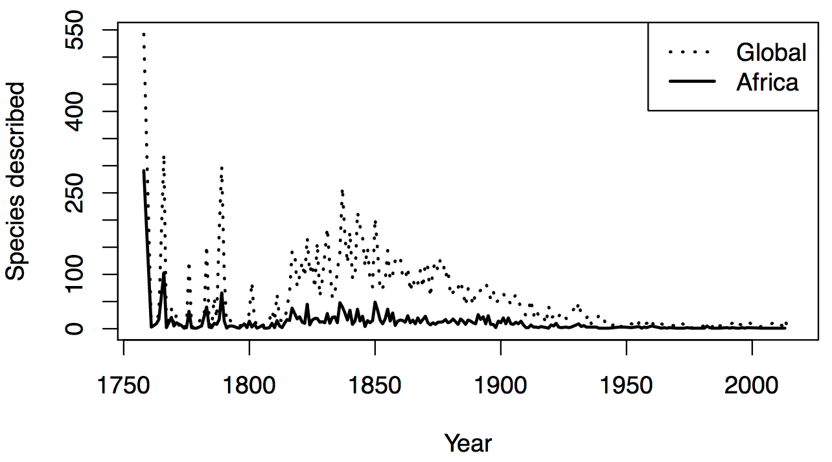

Figure 2
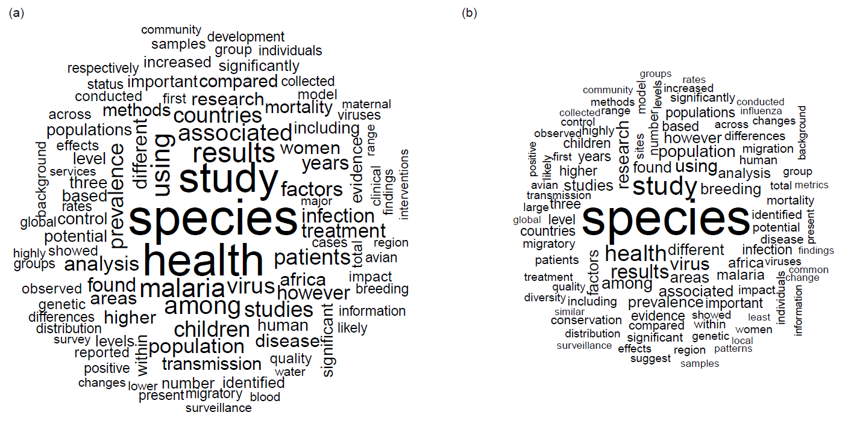

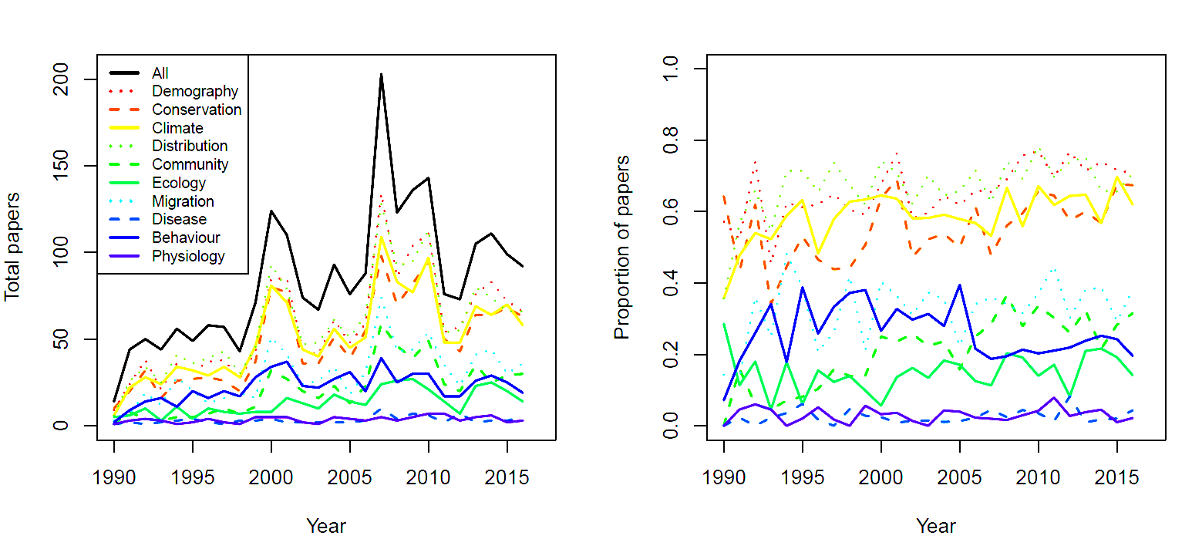
Figure 3

Figure 4

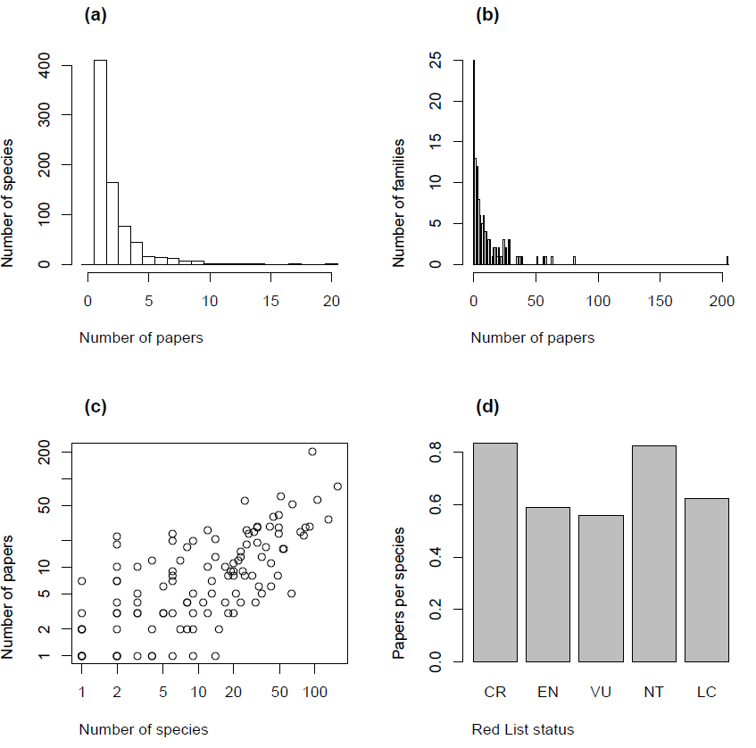

Figure 5
