Health equity monitoring for healthcare quality assurance

Revised 17 September 2017

Abstract
Population-wide health equity monitoring remains isolated from mainstream healthcare quality assurance. As a result, healthcare organizations remain ill-informed about the health equity impacts of their decisions – despite becoming increasingly well-informed about quality of care for the average patient. We present a new and improved analytical approach to integrating health equity into mainstream healthcare quality assurance, illustrate how this approach has been applied in the English National Health Service, and discuss how it could be applied in other countries. We illustrate the approach using a key quality indicator that is widely used to assess how well healthcare is co-ordinated between primary, community and acuate settings: emergency inpatient hospital admissions for ambulatory care sensitive chronic conditions (“potentially avoidable emergency admissions”, for short). Whole-population data for 2015 on potentially avoidable emergency admissions in England were linked with neighborhood deprivation indices. Inequality within the populations serviced by 209 clinical commissioning groups (CCGs: care purchasing organizations with mean population 272,000) was compared against two benchmarks – national inequality and inequality within ten similar populations – using neighborhood-level models to simulate the gap in indirectly standardized admissions between most and least deprived neighborhoods. The modelled inequality gap for England was 927 potentially avoidable emergency admissions per 100,000 people, implying 263,894 excess hospitalizations associated with inequality. Against this national benchmark, 17% of CCGs had significantly worse-than-benchmark equity, and 23% significantly better. The corresponding figures were 11% and 12% respectively against the similar populations benchmark. Deprivation-related inequality in potentially avoidable emergency admissions varies substantially between English CCGs serving similar populations, beyond expected statistical variation. Administrative data on inequality in healthcare quality within similar populations served by different healthcare organisations can provide useful information for healthcare quality assurance.

Keywords
Health Equity; Quality Indicators, Health Care; Small-Area Analysis; Socioeconomic Factors

Research Highlights

- Healthcare organizations are ill-informed about the equity impacts of their decisions
- This paper presents a new analytical approach to address this problem
- Inequality in quality in the served population is benchmarked to similar populations
- We illustrate using a widely used quality indicator: avoidable emergency admissions
- This approach had been adopted by the English NHS and could be applied elsewhere

Introduction
Quality of care and health equity have become two of the key issues on policy agendas worldwide. However, despite the inclusion of equity dimensions in foundational works on healthcare quality (Donabedian 2002; Institute of Medicine 2001) and efforts by organisations such as the Institute for Healthcare Improvement (Institute for Healthcare Improvement 2017) and the English National Health Service (NHS) (NHS England 2017b) to integrate equity and quality, responses to these issues have often progressed along separate lines. Efforts to improve quality have focused on safety and cost-effectiveness, with improvements in equity largely a by-product of reducing variation in performance between providers (Doran et al. 2008), whereas policy responses to health equity have focused on the wider social determinants of health rather than healthcare delivery (World Health Organization 2014). Due to this parallel development, quality improvement agencies (for example, the Organisation for Economic Co-operation and Development’s (OECD) Health Care Quality Indicators project) (Raleigh and Foot 2010) and quality improvement frameworks (for example, the Quality and Outcomes Framework in the UK (NHS Digital 2017b) and accountable care organizations (ACOs) in the US (Centers for Medicare & Medicaid Services 2017) often overlook equity. Because quality targets tend to be more difficult to achieve for socially disadvantaged populations, there are concerns that quality frameworks penalise providers serving these populations (Delgadillo et al. 2016; Doran, Maurer, and Ryan 2016; Yasaitis et al. 2016) potentially exacerbating existing disparities in the quality of care (Buntin and Ayanian 2017). Adjustment for social risk factors is now being advocated (Fiscella, Burstin, and Nerenz 2014; Joynt et al. 2017; National Academies of Sciences and Medicine 2016) but whilst there have been isolated examples of quality improvement programs that have explicitly addressed issues of equity (Badrick et al. 2014; Blustein et al. 2011) most are not designed to address this issue.

A major obstacle to improving equity in healthcare has been a lack of appropriate analytical tools. Performance measures in healthcare focus on a mythical “average” patient, providing insufficient information about differences in quality and outcomes that are considered unfair (Cookson et al. 2016; Fiscella et al. 2000). Periodic reports on healthcare inequalities are produced in some countries (Agency for Healthcare Research and Quality 2016; Harvey, Hynes, and Pichora 2016; Moy, Dayton, and Clancy 2005) but these typically focus on large geographical regions (Mayberry et al. 2006) or local government areas without specific responsibility for healthcare (Remington, Catlin, and Gennuso 2015) and lack the more specific equity metrics and benchmarks needed for assessing and improving the quality of healthcare organizations. To hold healthcare decision makers accountable for the equity dimension of quality, new metrics are needed which (1) speak directly to organizations with direct responsibility for healthcare purchasing, planning and delivery, and (2) are responsive to short-term changes in healthcare delivery. Only then will health equity metrics be incorporated into quality assurance dashboards commanding the attention of senior healthcare executives.

To address this challenge, in 2016 the English NHS introduced a new approach to health equity monitoring (NHS England 2016a, 2016b) applicable to a range of healthcare structure, process and outcome quality indicators (Cookson et al. 2016). One key equity metric is based on rates of potentially avoidable emergency hospitalization at the neighborhood level. These emergency admissions rise steeply with neighborhood deprivation, raising concern not only about equity of access to preventive and co-ordinated healthcare (Asaria et al. 2016a) but also about cost pressures on the healthcare system as a whole (Asaria, Doran, and Cookson 2016b). Under the new approach, inequality in potentially avoidable emergency hospitalization was measured within the populations of “clinical commissioning groups” (CCGs) – care organizations in England with responsibility for purchasing and planning healthcare for patients enrolled with local NHS family practices. Equity within the CCG’s enrolled population was then compared against two benchmarks: the national average level of inequality and the average level of inequality within ten CCG populations that are comparable in terms of deprivation, age profile, ethnic mix and rurality.(NHS England 2017a). The focus on potentially avoidable emergency hospitalization (an indicator of the quality of ambulatory care services in managing long-term conditions (Herrin et al. 2015; Purdy et al. 2009; Torio and Andrew 2014)) was intended to provide quality assurance information about inequalities in both access and outcomes of healthcare (Health and Social Care Act 2012). In this paper, we illustrate the general analytical approach using this indicator and discuss its potential application to healthcare quality assurance in other countries.

Methods
Data
Organizational geography
In England in 2015 there were 209 clinical commissioning groups (CCGs) – each serving a mean of 272,000 NHS patients registered with a local family practice (range 73,000 to 913,000). CCGs are responsible for purchasing and planning healthcare for the vast majority of their resident populations. However, the registered and resident populations do not fully overlap because residents can choose to register with a practice in a neighboouring CCG. We used registered population data from practice registers, rather than resident population data from the census, to match the legal responsibility of the CCG and to illustrate how the approach can be applied to ACOs in the US and other settings where the enrolled population does not coincide with the resident population.
Small area geography
Our basic unit of analysis was the registered population residing within a census unit called a “lower super output area” (LSOA). We refer to this as a “CCG-LSOA”. LSOAs have a mean population of 1,650 (range 1,000 to 3,000), while CCG-LSOAs have a mean population of 636 (range 1 to 2,536 from 1st to 99th percentile). CCG-LSOAs with smaller-than-resident populations arise near CCG boundaries, where residents of an LSOA are registered in more than one CCG with such LSOAs appearing in the analysis for more than one CCG. However, most LSOAs have the majority of their populations registered with a single CCG (mean 95.4%). Our CCG-LSOA population estimate was based on the fraction of the relevant NHS practice list attributed to the LSOA. The resulting mean number of CCG-LSOAs per CCG was 428 (range 95 to 1,972).
Hospital admissions
Data on emergency admissions were taken from NHS Hospital Episode Statistics (HES), a data warehouse containing details of all admissions at NHS hospitals in England. We extracted data for 1 October 2014 to 30 September 2015 and calculated the indirectly age-sex standardized admission rate for each CCG-LSOA. Admissions by people with unknown age, sex, LSOA or CCG were excluded, including individuals not registered with a family practice. Approximately 0.2% of admissions had no recorded age or sex, 0.7% had no LSOA (given valid age and sex) and 0.6% had no CCG (given valid age, sex and LSOA). Approximately 1.4% of admissions were excluded.
Measures
Potentially avoidable emergency hospitalization
We used emergency admissions for chronic ambulatory care sensitive conditions as defined in existing NHS indicators (NHS Digital 2017a). This includes diagnoses defined using ICD-10 codes for conditions such as asthma, bronchitis, diabetes, dementia and heart disease.
Neighborhood deprivation
The measure of deprivation we used was the Index of Multiple Deprivation 2015, a multi-domain index of deprivation (McLennan et al. 2011). This combines domains of deprivation including low income, unemployment, poor housing and crime.
Similar CCGs
The list of similar CCGs was created by the NHS to aid benchmarking of CCG level information, based on 10 CCGs with the lowest sum of squared distance on 12 indicators including age profiles, deprivation, population density and ethnicity (NHS England 2017a).
Analytic Approach
Figure 1 illustrates the general analytic approach to health equity monitoring against national and similar population benchmarks. The solid line is based on a linear regression weighted by population, and illustrates the positive association between the care quality indicator – in this case, potentially avoidable emergency hospitalization – and neighborhood deprivation within the registered population of the selected CCG. The slope of this line represents the CCG inequality “gradient” by level of deprivation within the registered population: the steeper the slope, the larger the degree of deprivation-related inequality in potentially avoidable emergency hospitalization. The dashed line is the gradient within England as a whole, and the dotted line is the gradient within a sub-set of England comprising the registered population of this CCG along with ten other CCGs with similar populations. These benchmark gradients are also based on linear regressions. In this example, the CCG gradient is less steep (better) than both the national and similar population gradients to an extent that is statistically significant, so we can conclude that this CCG is relatively equitable on both benchmarks. We can then monitor change over time against national and similar population benchmarks in response to actions taken by healthcare decision makers.
The benchmark gradients play a crucial role in quality assuring the equity performance of healthcare organizations. Healthcare organizations can be expected to address poor quality and equity of healthcare, but cannot address wider social determinants of the gradient in healthcare outcomes on their own (see Figure 2). The risk of an acute ill-health event requiring emergency hospital treatment is influenced by individual risk factors (e.g. age, morbidities) and behaviors (e.g. diet, smoking) which in turn are influenced by cumulative long-term environmental risk factors (e.g. childhood circumstances; living and working conditions; and access to resources for investing in health). A residual social gradient in potentially avoidable emergency hospitalization would therefore remain even if the CCG achieved perfect equity by providing equal access to high quality preventive and co-ordinated care.
It is not possible to adjust for all risk factors since detailed information may not be available in administrative data, especially for individuals who have limited contact with health providers. In addition, there is a danger of over-adjustment for risk factors that are highly correlated with deprivation and amenable to modification over time by healthcare services. The danger of over-adjustment increases with the breadth of policy responsibility: the broader the policy toolbox, the greater the ability to modify risk factors. Preventive and long-term care can modify individual risk factors, and wider public health and social policies can modify environmental risk factors which in turn will influence individual risk factors and behaviors.
The appropriate quality assurance benchmark is therefore not zero inequality, but the residual degree of inequality expected for a similar population with a similar social patterning of unobserved risk factors. Two key benchmarks are the national gradient and the similar population gradient, which assume that the social patterning of unobserved risk factors in a CCGs is the same as, respectively, the country as a whole or as a cluster of CCGs serving similar populations. We selected ten similar populations based upon a standard analysis by the NHS of CCG population “similarity” in terms of twelve variables reflecting deprivation, health, population size and age profile, population density and ethnicity (NHS England 2016c). The monitoring of time trends in relation to these benchmarks allows an assessment of how equity performance is responding to healthcare initiatives.
We measured the slope of the gradient using the “absolute gradient index” (AGI). This is the coefficient from the population-weighted linear regression of age-sex standardized avoidable hospitalization rates against fractional deprivation rank on a scale of 0 to 1, using all neighborhoods registered to the CCG. It is the same as the conventional slope index of inequality except that the AGI indices use the national deprivation rank rather than the local deprivation rank. This difference allowed us to compare CCG inequality on a like-for-like basis with the national inequality benchmark and the similar population benchmark, even though different CCG registered populations can have different deprivation profiles. For a CCG serving a relatively affluent population, for example, the most deprived fifth of neighborhoods might all be fairly affluent in national terms. A low rate of hospitalization in these neighborhoods would then not reflect the same equity achievement as a low rate among nationally deprived neighborhoods. The AGI can be interpreted as the simulated gap in potentially avoidable emergency hospitalization between the most and least deprived neighborhood in England, allowing for the gradient in between, if England had the same gradient as the registered population of the CCG.
To help decision makers interpret the AGI and assess the scale of their inequality challenge, we also derived an approximate estimate of the excess hospitalizations associated with inequality, drawing on the epidemiological concept of population attributable risk. This concept represents the number of emergency hospital admissions that would hypothetically be avoided if all neighborhoods had the same admission rate as the most affluent. We estimated this using the AGI multiplied by the relevant population and divided by two. This formula is a simple approximation, based on the assumptions of a linear relationship between deprivation and admissions and an evenly distributed population across the deprivation spectrum (Asaria et al. 2016b).
The analysis was carried out using R statistical software. (version 3.2.4). Full analysis code can be found at: https://github.com/miqdadasaria/ccg_equity

Results
The mean indirectly age-sex standardized rate of potentially avoidable emergency hospitalization in England was 792 per 100,000 people. The national absolute gradient index (AGI) – the estimated gap between the most and least deprived neighborhoods in England – was 927 (95% confidence interval 912 to 942), or 117% of the mean neighborhood level CCG-LSOA rate. The modelled rates for the most and least deprived neighborhoods were 1261 and 334, respectively.
Figure 3 shows healthcare equity in 2015 for all 209 CCGs in England, with 95% confidence limits. The horizontal line is the national AGI benchmark of 927; the similar ten benchmark is not shown as it varies by CCG. Against the national benchmark, 17% of areas (35 of 209) exhibited equity that was statistically worse-than-benchmark at a 95% confidence level – i.e. CCG inequality was larger than national inequality – and 23% (48 of 209) exhibited significantly better-than-benchmark equity. Against the similar population benchmark, the corresponding figures were 11% worse-than-benchmark and 12% better-than-benchmark. Against both benchmarks, 9% of areas show worse-than-benchmark equity performance and 10% show better-than-benchmark equity performance.
There was moderate negative correlation between the average deprivation of a CCG and its equity performance against the relevant similar population benchmark, as measured by the similar population inequality gap minus the CCG inequality gap (Pearson’s r -0.57). This means that English CCGs serving relatively deprived populations generally performed worse on health equity than those serving relatively affluent populations, though the correlation was not strong.
Figure 4 illustrates healthcare equity in six selected CCGs. We have selected pairs of organizations serving populations with different average levels of deprivation, with each pair illustrating better-than-benchmark versus worse-than-benchmark equity (“Horsham and Mid Sussex” versus “Windsor, Ascot and Maidenhead” with low deprivation, “Ashford” versus “North Lincolnshire” with medium deprivation, and “Brent” versus “Liverpool” with high deprivation). In five of these six examples both benchmark comparisons were statistically significant. However, the comparison for “Windsor, Ascot and Maidenhead” was not statistically significant against either national or similar population benchmarks – in this dataset, there was no example of an CCG serving a low deprivation population that had significantly worse-than-benchmark equity.
Figure 5 illustrates similar-ten benchmarking for a CCG – Liverpool – with worse-than-benchmark equity performance. It shows the AGI for Liverpool and its ten similar CCG populations, along with the average AGI pooled across all eleven populations. Inequality is significantly worse than the similar population benchmark in Liverpool and in one other CCG (South Manchester), and significantly better in two CCGs (Brighton & Hove and Sheffield). The AGI in Liverpool was 1,523 compared with a similar population benchmark AGI of 1,177. This equates to 3,840 excess hospitalizations a year associated with inequality among the Liverpool population.
Full results for every clinical commissioning group can be found online in our interactive inequality explorer: http://www.ccg-inequalities.co.uk/

Discussion
Summary of findings
We have illustrated the new analytical approach to health equity equity monitoring for healthcare quality assurance introduced in England in 2016, using the example of potentially avoidable emergency hospitalization. The approach aims to provide healthcare purchasing and planning organizations – in this case, English CCGs – with detailed, up-to-date information on the equity dimension of healthcare quality within their enrolled populations. It measures inequality in key indicators of healthcare quality within the enrolled population and then assesses equity against two benchmarks – national inequality, and inequality within a group of care organizations with similar populations. Inequality is measured on a comparable basis using population-weighted models of the neighborhood-level relationship between healthcare quality and deprivation, allowing for differences between neighborhoods in their demographic makeup.
Using data for 2015 on potentially avoidable emergency hospitalization, we found that 9% of the 209 CCGs in England showed significantly worse-than-benchmark equity against both national and similar population benchmarks, and 10% showed significantly better-than-benchmark equity. This is considerably more than the 5% in each category expected due to chance.
Strengths of the approach
The strengths of this approach include the ability (i) to incorporate equity metrics into mainstream quality assurance processes for organizations with direct responsibility for healthcare purchasing, planning and delivery for enrolled populations as small as 100,000 people; (ii) to assess the equity dimension of quality against two relevant benchmarks: national inequality and inequality within similar enrolled populations; and (iii) to assess the scale of the health inequality challenge facing the organization using the epidemiological concept of population attributable risk.. Particular strengths of potentially avoidable emergency hospitalization as a key equity indicator include the ability to address the equity dimension of a high profile quality issue with substantial cost implications, and to incorporate data on the quality of care for disadvantaged people who are relatively unlikely to participate in household surveys but relatively likely to suffer emergency hospital admission.
This approach can also be used to monitor how equity changes over time in response to short-term changes in healthcare delivery by particular care organizations (Sheringham et al. 2016). For example, Liverpool has recently introduced policies to improve the coordination of care and reduce avoidable emergency hospitalization, including integrated primary and long-term care services, “step down” hospital beds for non-acute care, and tele-monitoring in the home (Devlin et al. 2016). Our approach can also be used to examine which neighborhoods in which parts of the gradient see the biggest impacts, providing insights into who gains most from the initiatives and why.
Limitations of the approach
One limitation is the reliance on administrative data, which are prone to measurement error. In particular, although hospital data in England offers reasonably complete coverage of all patients admitted for emergency inpatient treatment, population denominator data are less complete due to gaps in NHS patient registration. This is a bigger problem in areas that are more deprived and have higher rates of immigration and more homeless people, leading to inflation of admission rates in those areas, thus potentially exaggerating the gradient.
A second limitation is the assumption that organizations serving apparently “similar” populations are comparable in terms of their gradients in unobserved individual risk factors and behaviors. Given the long-term cumulative impacts of social factors on gradients in health risk, particular caution is required when comparing populations with similar current sociodemographic characteristics but importantly different historical patterns of deprivation. For example, a population drawn from a region that has suffered from decades of industrial decline might have a steeper unobserved risk factor gradient than an otherwise similar population. Another potential issue is that accountable care organizations may “cream skim” enrollees who are healthier in terms of unobserved risk factors than suggested by their observed age, sex and neighborhood deprivation characteristics. This form of selection bias is not an issue in England, where CCGs serve nearly the whole resident population of a local area and have limited scope for selection. However, it is an issue in countries like the US, where accountable care organizations do not provide universal coverage for local populations. In such countries, additional risk adjustment and population matching techniques may be required to allow for selection bias and ensure that benchmark gradients from apparently similar populations are genuinely comparable.
A limitation of using potentially avoidable emergency hospitalization as an equity indicator is that aggregating emergency admissions for many different chronic conditions may mask varying influences of different conditions. Without further disease-specific analysis, therefore, we cannot tell whether equity performance reflects organization-wide performance across all disease areas, or particular issues in particular disease areas. It is possible to make equity comparisons using disease-specific hospitalization rates for broad disease categories such as cardiovascular disease (Vanasse et al. 2014). However, we would caution against doing so unless there are sufficiently large counts of events within each neighborhood to make statistically valid comparisons, which will typically require pooling data over several years. Our approach therefore provides an overall indicator of health equity for accountable care organizations which can be compared over time and thensupplemented by disease-specific analysis of pooled years to pinpoint long-term problems within specific disease areas and specialties.
A final limitation is that we used straightforward linear regression methods to facilitate communication of our findings to decision makers. We performed sensitivity analysis using more sophisticated methods, including non-linear models and empirical Bayes estimation of confidence intervals, but found this makes little difference to the identification of better-than-benchmark and worse-than-benchmark equity (Cookson et al. 2016). The gradient in potentially avoidable emergency hospitalization is in fact curved rather than linear, with an increasing slope towards the most deprived end of the spectrum. A single-parameter power transform prior to estimation fits better than either a linear or exponential model, and results in higher estimates of the gap between most and least deprived neighborhoods. This is because the linear approach flattens out the “uptick” in hospitalization towards the most deprived end of the spectrum. However, this does not substantially alter the pattern of equity comparisons. Different inequality indices use different assumptions and value judgements and we would recommend sensitivity analysis using alternative indices – in particular, the Relative Gradient Index, which measures the corresponding relative concept of inequality. Use of both absolute and relative indices is particularly important in time series equity comparisons when the mean is changing, since in those cases relative and absolute inequality can move in different directions (Kjellsson, Gerdtham, and Petrie 2015).
Communicating the equity dimension of quality to healthcare managers
It is important to find ways of communicating equity information clearly to healthcare decision makers. In consultations with healthcare managers and policymakers we found strong support for one-page “equity dashboards” combining information on quality and equity for a suite of key quality indicators (Cookson et al. 2016). Dashboards help decision makers visualize complex underlying inequality patterns, place equity information in context, identify how far particular quality problems have an equity dimension, and avoid the problem of equity indicators being isolated from mainstream quality indicators. Examples of equity dashboards and visualization tools developed by the authors are available at: http://www.york.ac.uk/che/research/equity/monitoring/
Applicability to other countries
The NHS approach to equity monitoring could be adapted for use in other countries with well-developed data systems for civil registration and healthcare quality assurance, in which data on healthcare access and outcomes can be disaggregated to small area or individual levels. In principle, inequality in avoidable hospitalization can be measured for any group of healthcare purchasing and planning organizations within any jurisdiction with data on hospitalization and socioeconomic disadvantage, so long as (i) each of the care organizations serves a sufficiently large numbers of individuals with a sufficiently broad range of socioeconomic backgrounds for reliable statistical estimation of the gradient, and (ii) the marker of disadvantage is sufficiently reliable (for example, the small areas are sufficiently small and homogeneous in terms of socioeconomic composition for meaningful comparisons). In our study the 209 clinical commissioning groups served 272,000 registered patients on average (range 73,000 to 913,000), residing within an average of 428 neighborhoods (range 95 to 1,972). What counts as a sufficient number of individuals and neighborhoods will vary from one setting to another, since statistical reliability and the accuracy of area deprivation markers depend upon contextual factors including the prevailing rates of avoidable hospitalization and the degree of residential segregation.
Although administrative health data in low-income countries are often incomplete (World Health Organization 2013), our approach should be applicable in many middle- and high-income countries with well-developed administrative data systems capable of disaggregating data on social factors to small and homogenous neighborhoods.
Further research
This approach to equity monitoring can be used as a data platform for future research to evaluate the health equity impacts of healthcare initiatives using quasi-experimental designs. Research is also needed to refine and improve the analytical approach, for example by analyzing the determinants of variation in care organization gradients, and applying statistical process control theory to separate common statistical variation in gradients from special cause variation attributable to healthcare quality. Another important refinement will involve adapting this approach to monitor the equity performance of hospitals, including investigation into the appropriate hospital unit – e.g. site, local organization, regional network – and the appropriate catchment population denominator – e.g. actual or potential patients. This is an important avenue for research, since equity is directly relevant to hospital quality assurance in many countries and settings. For example, hospital managers in England have a direct interest in preventing costly emergency hospitalization from disadvantaged populations, to free up their capacity to reduce waiting times and improve performance on other high profile quality indicators, and hospital staff could work more closely with community providers to achieve this. The approach may also be applicable to areas of healthcare policy other than quality assurance. For example, decomposition of the national gradient into between- and within-organization components could provide useful information about geographical resource allocation between and within administrative areas. Finally, research is needed to tailor this approach to other countries with well-developed data infrastructure for civil registration and healthcare quality assurance. One key issue is the selection of healthcare administration boundaries that are small enough to be useful for healthcare quality assurance yet large enough to allow robust statistical comparisons of social gradients; another is how to tailor the indicator definitions to different national policy contexts and data systems.
Conclusion
The production of equity indicators for organizations with direct responsibility for purchasing and planning healthcare is an essential first step for policy makers who are serious about reducing social inequalities in healthcare access and outcomes. The next step is to use these indicators to evaluate organization-wide initiatives and help decision makers learn how to reduce costly emergency admissions associated with deprived populations. As evidence accumulates on the most cost-effective ways of improving health equity, policy makers can then start encouraging healthcare organizations to scale-up the best approaches.
References
Agency for Healthcare Research and Quality. 2016. "National Healthcare Quality & Disparities Reports." [accessed on July, 2016]. Available at: http://www.ahrq.gov/research/findings/nhqrdr/index.html.
Asaria, M., S. Ali, T. Doran, B. Ferguson, R. Fleetcroft, M. Goddard, P. Goldblatt, M. Laudicella, R. Raine, and R. Cookson. 2016a. “How a universal health system reduces inequalities: lessons from England.” Journal of Epidemiology and Community Health: jech-2015-206742.
Asaria, M., T. Doran, and R. Cookson. 2016b. “The costs of inequality: whole-population modelling study of lifetime inpatient hospital costs in the English National Health Service by level of neighbourhood deprivation.” Journal of Epidemiology and Community Health 70(10): 990-96.
Badrick, E., S. Hull, R. Mathur, S. Shajahan, K. Boomla, S. Bremner, and J. Robson. 2014. “Health equity audits in general practice: a strategy to reduce health inequalities.” Primary health care research & development 15(01): 80-95.
Blustein, J., J. S. Weissman, A. M. Ryan, T. Doran, and R. Hasnain-Wynia. 2011. “Analysis raises questions on whether pay-for-performance in Medicaid can efficiently reduce racial and ethnic disparities.” Health Affairs 30(6): 1165-75.
Buntin, M. B. and J. Z. Ayanian. 2017. “Social Risk Factors and Equity in Medicare Payment.” New England Journal of Medicine 376(6): 507-10.
Centers for Medicare & Medicaid Services. 2017. "Quality Measures, Reporting and Performance Standards" [accessed on 9 March, 2017]. Available at: https://www.cms.gov/Medicare/Medicare-Fee-for-Service-Payment/sharedsavingsprogram/Quality-Measures-Standards.html.
Cookson, R., M. Asaria, S. Ali, B. Ferguson, R. Fleetcroft, M. Goddard, P. Goldblatt, M. Laudicella, and R. Raine. 2016. “Health Equity Indicators for the English NHS: a longitudinal whole-population study at the small-area level.” Health Services and Delivery Research, 4(26).
Delgadillo, J., M. Asaria, S. Ali, and S. Gilbody. 2016. “On poverty, politics and psychology: the socioeconomic gradient of mental healthcare utilisation and outcomes.” The British Journal of Psychiatry 209(5): 429-30.
Devlin, A. M., M. McGee-Lennon, C. A. O’Donnell, M.-M. Bouamrane, R. Agbakoba, S. O’Connor, E. Grieve, T. Finch, S. Wyke, and N. Watson. 2016. “Delivering digital health and well-being at scale: lessons learned during the implementation of the dallas program in the United Kingdom.” Journal of the American Medical Informatics Association 23(1): 48-59.
Donabedian, A. 2002. An introduction to quality assurance in health care: Oxford University Press.
Doran, T., C. Fullwood, E. Kontopantelis, and D. Reeves. 2008. “Effect of financial incentives on inequalities in the delivery of primary clinical care in England: analysis of clinical activity indicators for the quality and outcomes framework.” Lancet 372(9640): 728-36.
Doran, T., K. A. Maurer, and A. M. Ryan. 2016. “Impact of Provider Incentives on Quality and Value of Health Care.” Annual Review of Public Health 38(11).
Fiscella, K., H. R. Burstin, and D. R. Nerenz. 2014. “Quality measures and sociodemographic risk factors: to adjust or not to adjust.” JAMA 312(24): 2615-16.
Fiscella, K., P. Franks, M. R. Gold, and C. M. Clancy. 2000. “Inequality in quality: addressing socioeconomic, racial, and ethnic disparities in health care.” JAMA 283(19): 2579-84.
Harvey, J., G. Hynes, and E. Pichora. 2016. “Trends in Income-Related Health Inequalities in Canada.” Healthc Q 18(4): 12.
Health and Social Care Act 2012. London: The Stationary Office.
Herrin, J., J. St. Andre, K. Kenward, M. S. Joshi, A.-M. J. Audet, and S. C. Hines. 2015. “Community Factors and Hospital Readmission Rates.” Health Services Research 50(1): 20-39.
Institute for Healthcare Improvement. 2017. "Across the Chasm Aim 6: Health Care Must be Equitable" [accessed on 3 March 2017, 2017]. Available at: http://www.ihi.org/resources/Pages/ImprovementStories/HealthCareMustBeEquitable.aspx.
Institute of Medicine. 2001. “Crossing the Quality Chasm: A New Health System for the 21st Century.” 346.
Joynt, K. E., N. De Lew, S. H. Sheingold, P. H. Conway, K. Goodrich, and A. M. Epstein. 2017. “Should Medicare Value-Based Purchasing Take Social Risk into Account?” New England Journal of Medicine 376(6): 510-13.
Kjellsson, G., U.-G. Gerdtham, and D. Petrie. 2015. “Lies, damned lies, and health inequality measurements: understanding the value judgments.” Epidemiology 26(5): 673-80.
Mayberry, R. M., D. A. Nicewander, H. Qin, and D. J. Ballard. Year. “Improving quality and reducing inequities: a challenge in achieving best care.” In Baylor University Medical Center. Proceedings, edited by, pp. 103. Baylor University Medical Center.
McLennan, D., H. Barnes, M. Noble, J. Davies, E. Garratt, and C. Dibben. 2011. "The English indices of deprivation 2010" [accessed on 13 March, 2011]. Available at: https://www.gov.uk/government/statistics/english-indices-of-deprivation-2015.
Moy, E., E. Dayton, and C. M. Clancy. 2005. “Compiling the evidence: the national healthcare disparities reports.” Health Affairs 24(2): 376-87.
National Academies of Sciences, E. and Medicine. 2016. Accounting for Social Risk Factors in Medicare Payment: Identifying Social Risk Factors: National Academies Press.
NHS Digital. 2017a. "CCG Outcome Indicator Set" [accessed on 13 March, 2017a]. Available at: https://indicators.hscic.gov.uk/download/Clinical%20Commissioning%20Group%20Indicators/Specification/CCG_2.6_I00757_S.pdf.
NHS Digital. 2017b. "Quality and Outcomes Framework" [accessed on 9 March 2017, 2017b]. Available at: http://content.digital.nhs.uk/qof.
NHS England. 2016a. "CCG Improvement and Assessment Framework 2016/17" [accessed on July, 2016a]. Available at: https://www.england.nhs.uk/commissioning/ccg-auth/.
NHS England. 2016b. "Challenging Health Inequalities" [accessed on 2016b]. Available at: https://www.england.nhs.uk/about/gov/equality-hub/challenge-health-inequalities/.
NHS England. 2016c. "Commissioning for Value: Comprehensive data packs to support CCGs and NHS England in the regions" [accessed on 23 July 2016, 2016c]. Available at: https://www.england.nhs.uk/resources/resources-for-ccgs/comm-for-value/.
NHS England. 2017a. "Clinical Commissioning Groups" [accessed on 13 March, 2017a]. Available at: https://www.learnenv.england.nhs.uk/similar.
NHS England. 2017b. "Equality, Diversity and Health Inequalities" [accessed on 3 March 2017, 2017b]. Available at: https://www.england.nhs.uk/about/equality/.
Purdy, S., T. Griffin, C. Salisbury, and D. Sharp. 2009. “Ambulatory care sensitive conditions: terminology and disease coding need to be more specific to aid policy makers and clinicians.” Public Health 123(2): 169-73.
Raleigh, V. and C. Foot. 2010. “Getting the measure of quality.” Opportunities and challenges. London: Kings Fund.
Remington, P. L., B. B. Catlin, and K. P. Gennuso. 2015. “The County Health Rankings: rationale and methods.” Population Health Metrics 13(1): 11.
Sheringham, J., M. Asaria, H. Barratt, R. Raine, and R. Cookson. 2016. “Are some areas more equal than others? Socioeconomic inequality in potentially avoidable emergency hospital admissions within English local authority areas.” Journal of Health Services Research & Policy 22(2): 83-90.
Torio, C. and R. Andrew. 2014. “Geographic Variation in Potentially Preventable Hospitalizations for Acute and Chronic Conditions, 2005-2011. HCUP Statistical Brief #178. September 2014.”. Agency for Healthcare Research and Quality. Rockville, MD.
Vanasse, A., J. Courteau, S. Asghari, D. Leroux, and L. Cloutier. 2014. “Health inequalities associated with neighbourhood deprivation in the Quebec population with hypertension in primary prevention of cardiovascular disease.” Chronic diseases and injuries in Canada 34(4).
World Health Organization. 2013. Handbook on health inequality monitoring with a special focus on low-and middle-income countries: World Health Organization.
World Health Organization. 2014. “Measuring and monitoring intersectoral factors influencing equity in universal health coverage (UHC) and health: Summary report of a meeting in Bellagio, 6-8 May 2014.” Geneva, Switzerland: World Health Organization.
Yasaitis, L. C., W. Pajerowski, D. Polsky, and R. M. Werner. 2016. “Physicians’ participation in ACOs is lower in places with vulnerable populations than in more affluent communities.” Health Affairs 35(8): 1382-90.

FIGURE 1: Healthcare equity against national and similar population benchmarks – hypothetical scatterplot showing potentially avoidable emergency hospitalization and deprivation for all neighborhoods within a clinical commissioning group
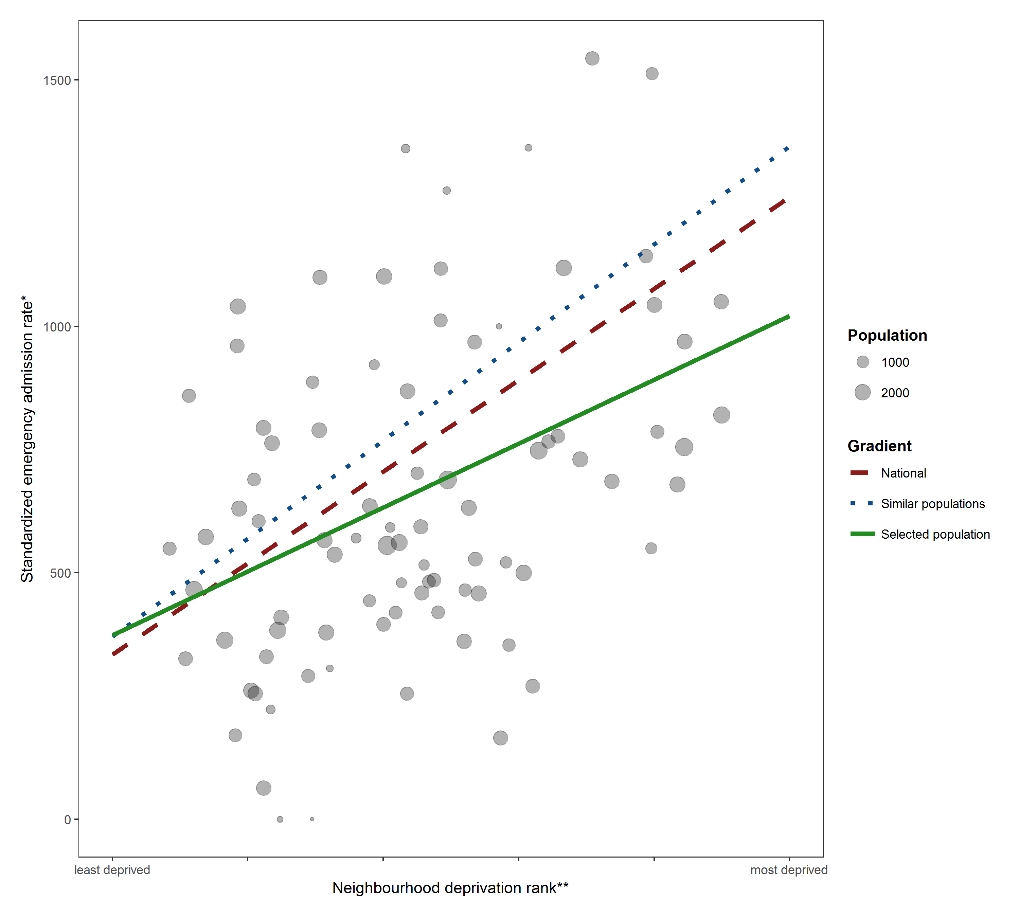
* Neighborhood rate of potentially avoidable emergency hospitalization, indirectly standardized for age and sex.
** Neighborhood national deprivation rank from the Index of Multiple Deprivation 2015, converted into a fraction between 0 (least deprived) and 1 (most deprived)
Note: Dots represent neighbourhoods registered to the clinical commissioning group. This example shows a clinical commissioning group with an inequality gradient that is shallower than both the national benchmark gradient and the similar area benchmark gradient, indicating better-than-benchmark equity.
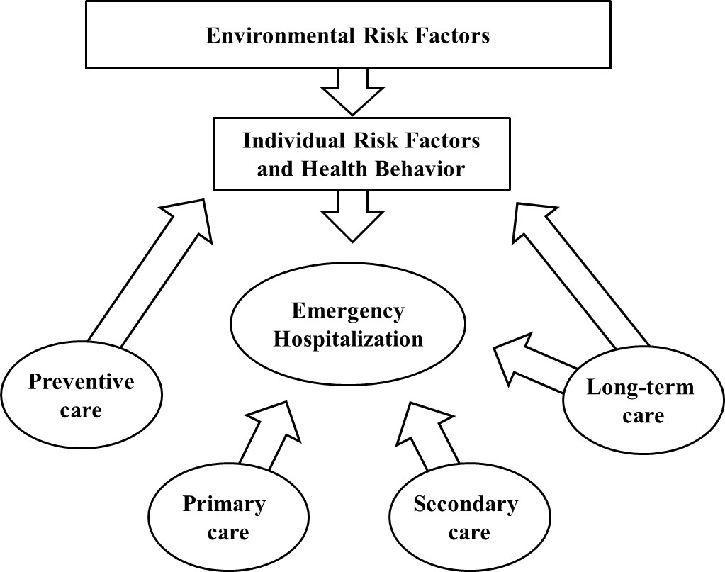
FIGURE 2: The healthcare and non-healthcare determinants of emergency hospitalization

Note: Long-term care can include various medical and non-medical services for people with chronic mental or physical illness or disability who cannot care for themselves for long periods, including help with normal daily tasks like dressing, feeding and housekeeping.
FIGURE 3: Variation in equity between clinical commissioning groups in 2015 – Absolute Gradient Index (AGI) of inequality in potentially avoidable emergency hospitalization
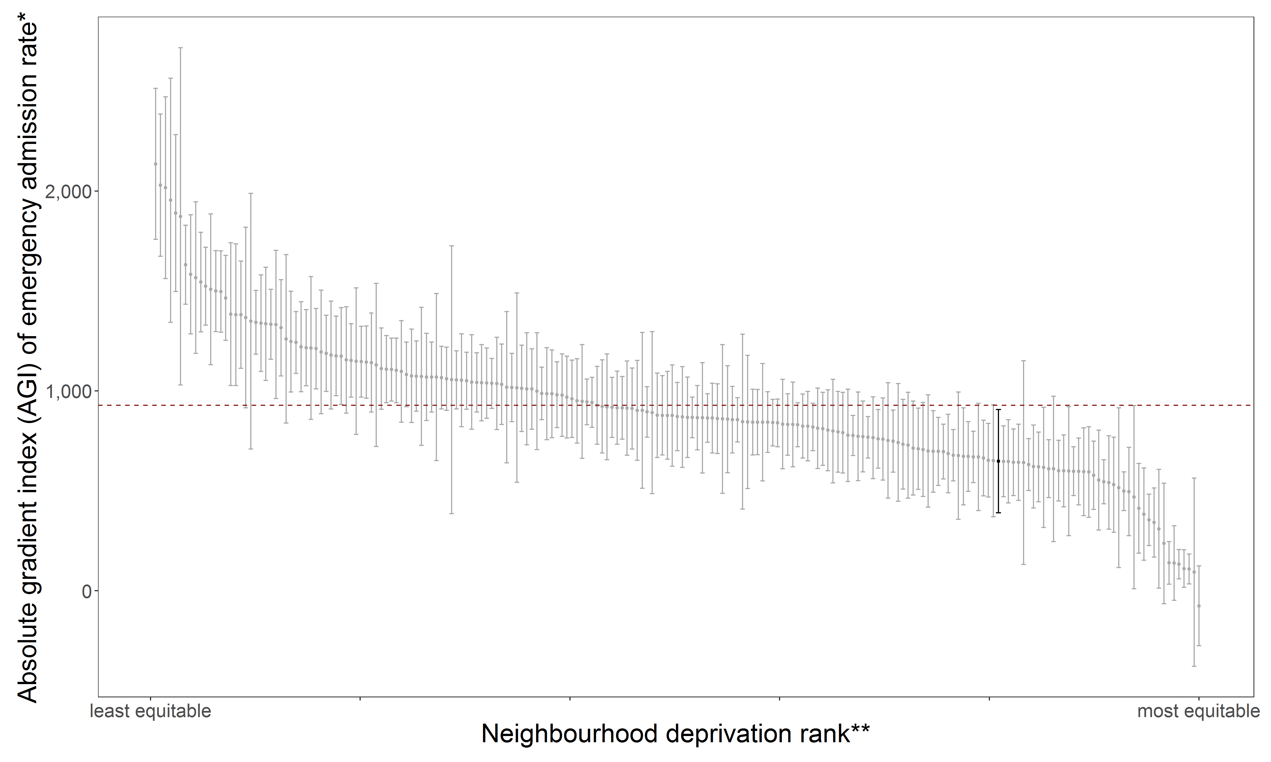
Notes
- The caterpillar legs show AGI estimates with 95% confidence intervals for 209 clinical commissioning groups in England.
- The dotted horizontal line is the national benchmark AGI.
- The accountable care organization highlighted in black, illustrating better-than-average equity against the national benchmark, is Ashford.
FIGURE 4: Healthcare equity in 2015 within six illustrative clinical commissioning groups, showing neighborhood level scatterplots of potentially avoidable emergency hospitalization versus deprivation
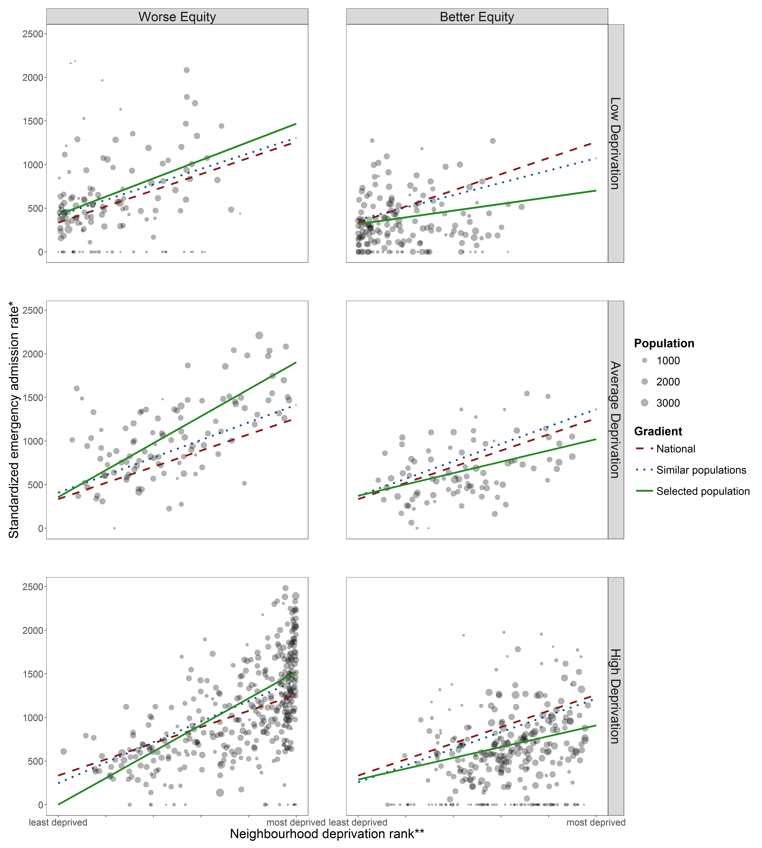
Windsor, Ascot and Maidenhead
North Lincolnshire
Liverpool
Brent
Ashford
Horsham and
Mid Sussex

Notes:
The dots show standardized neighborhood rates of potentially avoidable emergency hospitalization within each clinical commissioning group.
FIGURE 5: Equity assessment against the similar population benchmark for Liverpool in 2015 – Absolute Gradient Index (AGI) of inequality in potentially avoidable emergency hospitalization

Notes
- The vertical lines show AGI inequality estimates with 95% confidence intervals for Liverpool and ten similar clinical commissioning groups in England.
- The horizontal line shows the similar populations inequality benchmark, based on pooling the registered populations within this group of clinical comissioning groups with similar populations.

