Received 00th January 20xx,
- Green Chemistry Centre of Excellence, University of York, Heslington, York YO10 5DD, UK. E-mail: james.clark@york.ac.uk.
† Footnotes relating to the title and/or authors should appear here.
Accepted 00th January 20xx
DOI: 10.1039/x0xx00000x
www.rsc.org/
Unexpected nitrile formation in bio-based mesoporous materials (Starbons®).
Jennifer Attard,ª Roxana Milescu,ª Vitaliy Budarin,ª Avtar S. Matharuª and James H. Clarkª
The bio-based mesoporous materials made from polysaccharides, Starbons® can be modified by two different routes to give high levels of N-content, unexpectedly including significant quantities of nitrile groups which can improve the materials performance in applications including metal capture.
Mesoporosity (2 – 50 nm) remains the optimum pore size for catalytic accessibility, catalyst support, adsorption and mass transport, together with the ability to interact with species significant for energy applications, such as lithium and hydrogen ions.^{1, 2} The first reported mesoporous materials were silica-based, made through templating methods that allowed for very specific pore structures.^{3, 4} Their development was quickly followed by the synthesis of carbonaceous mesoporous materials: these generally have similar properties but can offer different surface functionalities. There are numerous known carbon materials with large surface areas and pore volumes and based on efficient and structurally precise synthesis methods.²
With the strong global movement towards sustainability, significant efforts are being made to create new environmentally benign materials. Biomass is a good starting point for sustainable materials as it is often cheap, abundant, biodegradable and available from agricultural waste and food production, and forestry by-products. Starbons® are carbonaceous mesoporous materials made of polysaccharides obtained from algae and other biomass sources.⁶ They are considered to be green and sustainable as they are made from renewable materials using a clean production process: the polysaccharides are gelated and freeze-dried to give a mesoporous aerogel that can be carbonised (300 – 800 °C) to obtain a range of mesoporous materials with varying surface functionalities.⁷
It is becoming increasingly clear that apart from the pore structure of materials, surface functionality also plays an important role in applicability.⁸ There is now a strong research focus on expanding the range of existing materials by functionalising their surfaces through the introduction of heteroatoms. Nitrogen-doping, for example, is known to improve heavy-metal binding, conductivity and catalytic activity, most notably in metal-free oxidative reduction reactions which are particularly important for fuel cell applications.⁹⁻¹⁴ It is for these reasons that we have attempted to similarly dope our Starbon materials with nitrogen.
Chitosan and ammonia were chosen, representing bio-based and low-cost but chemically different nitrogen sources. In route A chitosan is combined with alginic acid and the two materials are gelated together. In routes B and C ammonia can be injected and adsorbed into the polysaccharide materials (using starch as an example) at either the aerogel stage or into the final Starbon product respectively (Figure 1). The nitrogen containing Starbons will hereafter be referred to as N-Starbons.
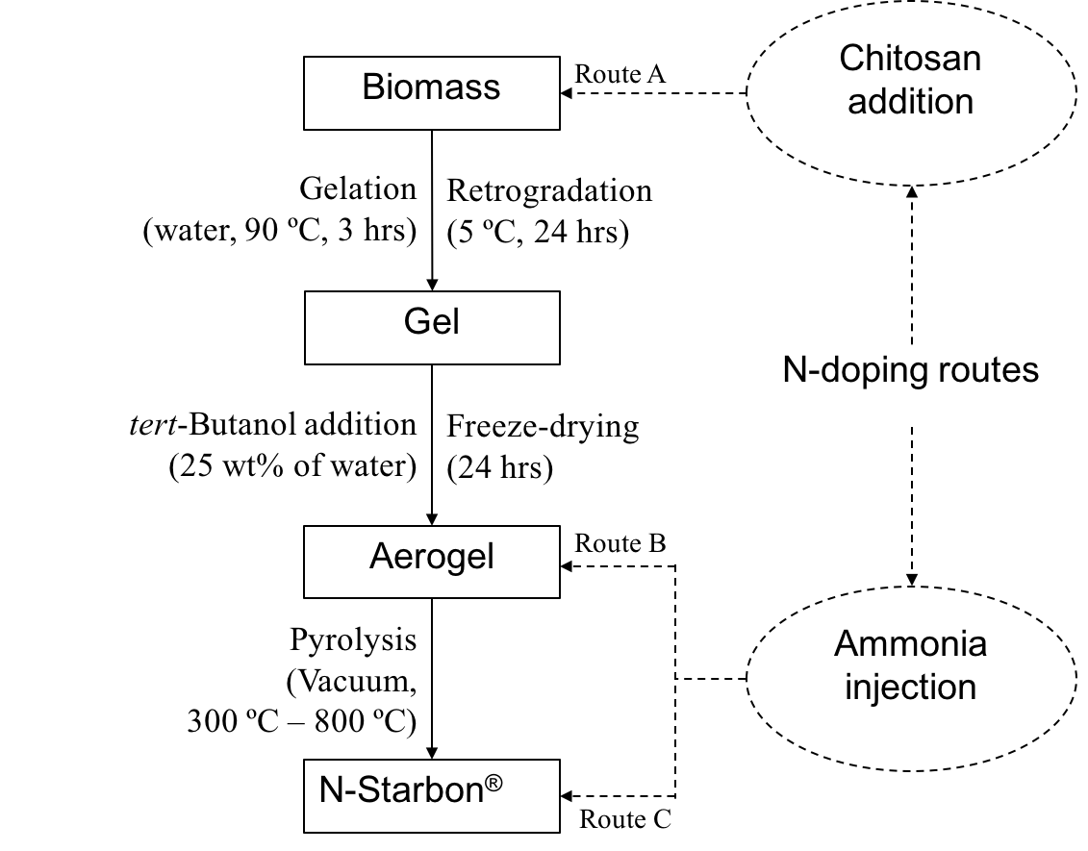
Fig. 1: Showing the routes towards nitrile formation in Starbon materials

Carbonisation temperature (°C) | Material | Mesoporosity  (%) | Total pore volume  (cm³g⁻¹) | BET surface area  (m²g⁻¹)
300 | Starbon | 88.3 | 0.627 | 174.2
 | N-starbonª | 86.7 | 0.663 | 412.6
 | N-starbon^{b} | 98.7 | 0.645 | 240.5
450 | Starbon | 84.5 | 0.515 | 339.5
 | N-starbonª | 81.9 | 0.615 | 448.3
600 | Starbon | 79.8 | 0.686 | 519.5
 | N-starbonª | 83.5 | 0.750 | 519.2
 | N-starbon^{c} | 92.8 | 0.324 | 249.5
^{a, b, c} Materials made by route A, B and C respectively.
Table 1: Porosimetry data of various N-Starbons compared to regular Starbons.
Carbonisation temperature (°C) | N-content (%) |  | C/N ratio
 | CHN | XPS | CHN | XPS
300ª | 6.4 | 4.9 | 9.2 | 15.3
300^{b} | 6.8 | 6.1 | 8.8 | 12.4
450ª | 10.6 | 11.6 | 5.7 | 5.8
600ª | 6.5 | 7.0 | 11.1 | 11.3
600^{c} | 12.4 | 12.9 | 5.8 | 5.9
Table 2: Elemental analysis data of various N-Starbons.
Table 3: The carbon and nitrogen XPSª peaks for N-Starbon (route A) at 450 °C after deconvolution⁵
Element | Binding energy (eV) | Functional group
C1s | 284.49 | graphitic C
 | 284.92 | non-functionalised sp², sp³
 | 286.36 | ether, ester, nitrile
 | 288.02 | O-C-O, amide
 | 289.38 | -COOR
 | 291.28 | π - π*
N1s | 398.37 | pyridinic N, imine
 | 400.21 | nitriles, amides
 | 401.35 | protonated imines
 | 403.39 | oxidised nitrogen (eg. -N-OH)

^{a, b, c} Materials made by route A, B and C respectively.
While we focused most of our preliminary characterisation work on materials prepared by route A, we also compared one sample prepared by routes B and C. Despite the fundamentally different routes, the products are surprisingly alike, with their most interesting feature being their substantial nitrile functionality. Although nitrogen-doping of carbons has been extensively studied by many groups, we can only find one prior report of nitrile formation in a method including hydrogen cyanide or ammonia chemisorption onto activated (microporous) carbons at high temperatures (600 °C – 800 °C).¹⁵ A very recent communication describes N-doped carbon nanohorns that possess different types of N-atoms depending on the carbonisation temperature.¹⁶
Our N-Starbons were initially characterised by porosimetry, which showed importantly that N-doping had no negative influence on the degree of mesoporosity although samples prepared by route A generally had the larger pore volumes and surface areas (Table 1). Substantial nitrogen content was evident in all samples, as shown both by elemental analysis and by XPS. There were some differences in the N-content shown by the different techniques as has been reported elsewhere and may be due to differences between bulk and surface N-concentration (Table 2).¹⁴
ª XPS data was obtained from the XPS surface analysis facility in the Cardiff Catalysis Institute at Cardiff University.
Thermal degradation of chitosan causes the release of several volatile compounds including H₂O, CO₂, CH₄, CH₃COOH, RCOOH and NH₃.¹⁷ These species were also detected by FTIR on heating the N-Starbon materials from room temperature up to 600 °C, with the notable exception of ammonia at low temperatures (Fig. S1). This implies that either the amine groups in chitosan are reacting before their decomposition, or the ammonia is being trapped by reaction inside the porous material forming nitriles, as well as other possible nitrogen-containing functional groups.
The presence of nitriles was confirmed by DRIFT analysis as each of the materials gave a clear, and uniquely attributable absorbance band at ∼ 2210 cm⁻¹. We believe that the nitrile group is chemically bonded to the surface of the materials as the peak remained even after thoroughly washing the materials with both ethanol and water for 24 hours each. Since it is known that Lewis acids can bind to nitriles (which can act as Lewis bases) causing the $υ$(C$≡$N) band to shift, we tested the materials by mixing them with an indium(III) chloride solution (representing a “critical element”) and then re-running the IR spectra. Using N-Starbon carbonised to 450 °C as an example, this showed a shift of the $υ$(C$≡$N) band of +10 cm⁻¹ on adsorption of In(III) consistent with electron transfer from the C$≡$N antibonding orbitals (Fig. S2).¹⁸
XPS was carried out in an attempt to further confirm the above observations (Table 3 and Fig. S6). Literature shows that deconvolution of the nitrogen peak region is highly subjective, especially with regards to nitrile peaks. Having said this, there are reports with similar peak assignments (400.20 ± 0.10 for nitriles), indicating that although this technique cannot be used alone to determine the presence of nitriles, our data is consistent with their presence.⁵
To try to understand the unexpected nitrile formation for route A, we prepared a range of similar materials, varying the temperature and rate of carbonisation, as well as the method of preparation of the starting material before carbonisation. Through DRIFT analysis, it was found that nitrile groups only form above 300 °C (Fig. S9). They are also formed on expanded (mesoporous) chitosan but hardly at all on the untreated commercial material (Fig. S10). While we can achieve a nitrile-modified mesoporous chitosan (even at fast heating rates of 10 °C min⁻¹), any mesoporous structure does not survive carbonisation, instead giving a largely microporous material. We need the combination of chitosan and the Starbon-forming polysaccharide to give mesoporous nitrile-modified material. While we do not know the exact mechanism by which the nitrile groups are formed, it seems likely that it is associated with the previously reported thermal event at 300 °C that occurs on slow heating of polysaccharides.¹⁹ It is possible that a highly acidic environment is created inside the pores (due to the proximity of OH groups) catalysing the dehydrogenation of amines to nitriles.
An alternative mechanistic route to nitriles is loss of ammonia through decomposition followed by re-adsorption by the material, making the process similar to that of routes B and C. The ammonium salts thus formed can be associated with carboxylate groups on the surface of the carbon which can be thermally dehydrated to amides, and then on to nitriles.¹⁵
Mesoporous carbon materials containing significant quantities of nitrile groups are especially attractive owing to the combination of their structural and functional benefits. Nitriles are known for their metal-binding ability as well as their ease of conversion to other functional groups.²⁰⁻²³ Furthermore, we can expect dielectric constants and permittivity to be improved by the presence of nitriles, making the materials potentially suitable for electrical energy storage.^{24, 25} We are now exploring their possible applications including capturing critical elements such as indium from e-waste.
The research work disclosed in this publication is partially funded by the ENDEAVOUR Scholarships Scheme.
Conflicts of interest
“There are no conflicts to declare”.
Notes and references

1. W. Li, J. Liu and D. Zhao, Nature Reviews Materials, 2016, 1, 1-17.
2. C. Liang, Z. Li and S. Dai, Angewandte Chemie International Edition, 2008, 47, 3696-3717.
3. C. T. Kresge, M. E. Leonowicz, W. J. Roth, J. C. Vartuli and J. S. Beck, Nature, 1992, 359, 710-712.
4. D. Zhao, J. Feng, Q. Huo, N. Melosh, G. H. Fredrickson, B. F. Chmelka and G. D. Stucky, Science, 1998, 279, 548.
5. D. Cagniant, P. Magri, R. Gruber, S. Berlozecki, P. D. Salbut, J. Bimer and G. Nansé, Journal of Analytical and Applied Pyrolysis, 2002, 65, 1-23.
6. V. Budarin, J. H. Clark, J. J. E. Hardy, R. Luque, K. Milkowski, S. J. Tavener and A. J. Wilson, Angewandte Chemie International Edition, 2006, 45, 3782-3786.
7. A. Borisova, M. De Bruyn, V. L. Budarin, P. S. Shuttleworth, J. R. Dodson, M. L. Segatto and J. H. Clark, Macromol Rapid Commun, 2015, 36, 774-779.
8. W. Li, J. Liu and D. Zhao, 2016, 1, 16023.
9. M. Li, F. Xu, H. Li and Y. Wang, Catalysis Science & Technology, 2016, 6, 3670-3693.
10. Y. Gao, X. Chen, J. Zhang and N. Yan, ChemPlusChem, 2015, 80, 1556-1564.
11. Z. R. Ismagilov, A. E. Shalagina, O. Y. Podyacheva, A. V. Ischenko, L. S. Kibis, A. I. Boronin, Y. A. Chesalov, D. I. Kochubey, A. I. Romanenko, O. B. Anikeeva, T. I. Buryakov and E. N. Tkachev, Carbon, 2009, 47, 1922-1929.
12. K. Gong, F. Du, Z. Xia, M. Durstock and L. Dai, Science, 2009, 323, 760.
13. G. A. Ferrero, A. B. Fuertes, M. Sevilla and M.-M. Titirici, Carbon, 2016, 106, 179-187.
14. T.-P. Fellinger, F. Hasché, P. Strasser and M. Antonietti, Journal of the American Chemical Society, 2012, 134, 4072-4075.
15. B. Stöhr, H. P. Boehm and R. Schlögl, Carbon, 1991, 29, 707-720.
16. D. Iglesias, A. Giuliani, M. Melchionna, S. Marchesan, A. Criado, L. Nasi, M. Bevilacqua, C. Tavagnacco, F. Vizza, M. Prato and P. Fornasiero, Chem (in press).
17. I. Corazzari, R. Nisticò, F. Turci, M. G. Faga, F. Franzoso, S. Tabasso and G. Magnacca, Polymer Degradation and Stability, 2015, 112, 1-9.
18. T. L. Brown and M. Kubota, Journal of the American Chemical Society, 1961, 83, 4175-4177.
19. P. S. Shuttleworth, V. Budarin, R. J. White, V. M. Gun'ko, R. Luque and J. H. Clark, Chemistry - A European Journal, 2013, 19, 9351-9357.
20. B. Gao, Y. Gao and Y. Li, Chemical Engineering Journal, 2010, 158, 542-549.
21. M. A. A. Zaini, Y. Amano and M. Machida, Journal of Hazardous Materials, 2010, 180, 552-560.
22. F. Rozada, M. Otero, A. Morán and A. I. García, Bioresource Technology, 2008, 99, 6332-6338.
23. P. Kampalanonwat and P. Supaphol, ACS Applied Materials & Interfaces, 2010, 2, 3619-3627.
24. I. Treufeld, D. H. Wang, B. A. Kurish, L.-S. Tan and L. Zhu, Journal of Materials Chemistry A, 2014, 2, 20683-20696.
25. D. Zhou, Y.-B. He, R. Liu, M. Liu, H. Du, B. Li, Q. Cai, Q.-H. Yang and F. Kang, Advanced Energy Materials, 2015, 5, 1500353-n/a.

