Received 00th January 20xx,
- CICECO - Aveiro Institute of Materials, Department of Chemistry, University of Aveiro, 3810-193 Aveiro, Portugal.
- Centro de Química Estrutural, Instituto Superior Técnico, 1049-001 Lisboa, Portugal.
- Instituto de Tecnologia Química e Biológica, UNL, AV. República Ap. 127, 2780-901 Oeiras, Portugal.
- York Structural Biology Laboratory, Department of Chemistry, University of York, Heslington, York YO10 5DD, UK
† Electronic Supplementary Information (ESI) available: Supporting figures and tables. See DOI: 10.1039/x0xx00000x
Accepted 00th January 20xx
DOI: 10.1039/x0xx00000x
www.rsc.org/
Enhanced dissolution of ibuprofen using ionic liquids as catanionic hydrotrope
T. E. Sintra,ª K. Shimizu,^{b,c} S. P. M. Ventura,ª S. Shimizu,^{d} J. N. Canongia Lopes^{b,c} and J. A. P. Coutinho*ª
The therapeutic effectiveness of a drug largely depends on its bioavailability, and thus ultimately on its aqueous solubility. Hydrotropes are compounds able to enhance the solubility of hydrophobic substances in aqueous media and therefore are extensively used in the formulation of drugs and personal care products. Recently, some ionic liquids were shown to display a strong ability to enhance the solubility of biomolecules through hydrotropy. In this work, the impact of the ionic liquid chemical structures and their concentration on the solubility of ibuprofen were evaluated and compared with the performance of conventional hydrotropes. The results obtained clearly evidence the exceptional capacity of ionic liquids to enhance the solubility of ibuprofen. [C₄C₁im][SCN] and [C₄C₁im][N(CN)₂] seem to be the most promising ionic liquids for ibuprofen solubilisation, where an increase in the solubility of 60- and 120-fold was observed with ionic liquids concentrations of circa 1 mol∙kg⁻¹, respectively. Dynamic light scattering and molecular dynamics simulations were used to investigate the mechanism of the IL-mediated drug solubility and the results obtained indicate that the structure of aqueous solutions of ionic liquids and the role it plays on the formation of ionic liquids-drug aggregates is the mechanism driving the hydrotropic dissolution.
Introduction
The solubilisation of poorly water-soluble drugs has been a very important issue in the screening of new drugs as well as in their formulation. More than 40% of the failures in the development of new drugs have been attributed to poor biopharmaceutical properties, including poor water solubility.¹ In fact, the therapeutic effectiveness of a drug can be severely limited by its aqueous solubility.² Among the various approaches employed to enhance the aqueous solubility of poorly water-soluble drugs, such as the use of surfactants, salt forms and change of pH, the hydrotropic solubilisation is one of the most studied due to its simplicity and efficiency.³ Furthermore, hydrotropes, in general, present low toxicity and low bioaccumulation potential due to their low octanol-water partition coefficients.⁴ The term hydrotropic agent was first introduced by Neuberg in 1916.⁵ By definition, hydrotropes are compounds capable to substantially increase the solubility of hydrophobic substances in water. Conventional hydrotropes are typically composed of a hydrophobic aromatic ring with an anionic group (hydrophilic part) where ammonium, calcium, potassium or sodium act as counter ions.⁶ The cationic hydrotropes are a minority, an example being the salts of aromatic amines (procaine hydrochloride).⁷ Although these compounds exhibit an amphiphilic nature, they are not surfactants. Actually, due to their short hydrophobic moiety, hydrotropes have a weak tendency to self-aggregate in water and therefore do not form micelles, nor do they present a CMC.⁸ Despite the large number of reviews addressing the hydrotropy, its mechanism of action is not yet clearly understood.^{3,9,10} Three main hypotheses have been proposed in order to explain the hydrotropic-mediated solubilisation. Some authors justify this phenomenon with the formation of a complex between the solute and the hydrotrope.^{11,12} On the other hand, some works suggest that the hydrotropes may change the solvent structure around the solute and can be therefore considered as structure makers or breakers.^{13,14} In recent years, co-aggregation of the solute with the hydrotropes above a minimum hydrotrope concentration (MHC) has been proposed as the main mechanism behind the enhanced solubility.^{15–21} The MHC of a hydrotrope is considered as a measure of the stability of its aggregation form relatively to its monomeric form. Thus, the lower the MHC, the greater is the hydrotrope stability.³
During the last years, the application of ionic liquids (ILs) was extended from solvents in “green” chemistry to pharmaceutical applications with the ultimate aim to improve the active pharmaceutical ingredient (API) dissolution, solubility and bioavailability and to prevent polymorphism.^{22–30} Rengstl and co-authors showed the capacity of the short chain choline carboxylates to act as hydrotropes for Disperse Red 13, a hydrophobic dye.³¹ Recently, ILs were reported as a promising class of catanionic hydrotropes since both the IL cation and anion contribute to enhance the solubility of hydrophobic compounds in aqueous solution.³² The aqueous solutions of ILs showed a much higher capacity to solubilize the two antioxidants studied than any of the pure solvents, with solubility enhancements of up to 40-fold.³² In this context, ILs appear as promising candidates to enhance the aqueous solubility of hydrophobic drugs by the selection of the adequate cation/anion combinations.
The present work proposes to investigate the effect of the IL chemical structures and their concentration on the solubility of ibuprofen, a poorly water-soluble compound whose chemical structure is shown in Figure 1. This anti-inflammatory drug belongs to BCS Class II (BCS 2), which drugs are characterized by a low solubility and high permeability.³³ To achieve an acceptable absorption after oral administration, APIs should present both, enough aqueous solubility and permeability through gastrointestinal mucosa.³⁴ Therefore, a solubility improvement is a powerful formulation strategy for compounds of this class to optimize their biopharmaceutical profiles.^{34,35} Finally, the hydrotropic solubilization mechanism induced by ILs for ibuprofen is investigated using molecular dynamics simulations.

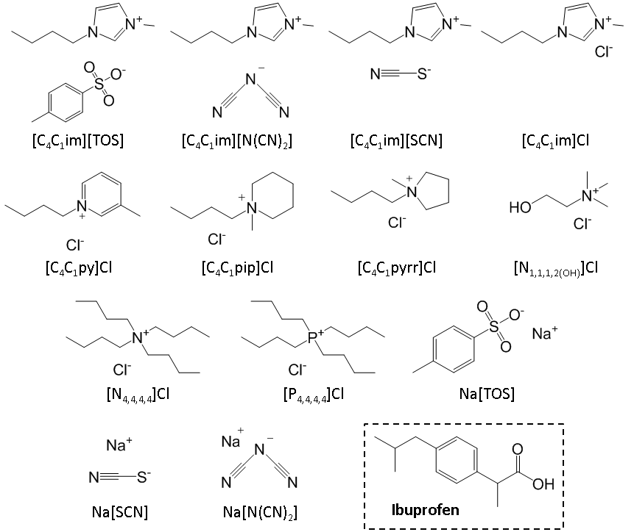
Figure 1. Chemical structure of the ILs and salts studied as hydrotropes and ibuprofen.

Experimental Section
Materials. In this work, ten ILs were investigated in terms of their capacity to enhance the solubility in water of ibuprofen, namely 1-butyl-3-methylimidazolium thiocyanate, [C₄C₁im][SCN]; 1-butyl-3-methylimidazolium tosylate, [C₄C₁im][TOS]; 1-butyl-3-methylimidazolium chloride, [C₄C₁im]Cl; 1-butyl-3-methylimidazolium dicyanamide, [C₄C₁im][N(CN)₂]; 1-butyl-3-methylpyridinium chloride, [C₄C₁py]Cl; 1-butyl-1-methylpiperidinium chloride, [C₄C₁pip]Cl; 1-butyl-1-methylpyrrolidinium chloride, [C₄C₁pyrr]Cl, tetrabutylammonium chloride, [N_{4,4,4,4}]Cl, tetrabutylphosphonium chloride, [P_{4,4,4,4}]Cl and cholinium chloride, [N_{1,1,1,2(OH)}]Cl. The imidazolium-, pyridinium-, piperidinium- and pyrrolidinium-based ILs were purchased from Iolitec. [N_{4,4,4,4}]Cl and [N_{1,1,1,2(OH)}]Cl were obtained from Sigma-Aldrich. [P_{4,4,4,4}]Cl was kindly supplied by Cytec Industries Inc. The ILs used have a stated supplier purity of at least 98 wt %, which were further checked by their ¹H and ¹³C NMR spectra. Sodium thiocyanate, Na[SCN] (98.0 wt % pure) was supplied by Fluka; sodium tosylate, Na[TOS] (95.0 wt % pure), was from TCI; and sodium dicyanamide, Na[N(CN)₂] (96.0 wt % pure) was from Sigma-Aldrich. Ibuprofen (98.0 wt % pure) was supplied by Sigma-Aldrich. The mobile phase used in the HPLC analysis was composed of ammonium acetate, (99.99 wt % pure) and acetic acid, (99.99 wt % pure), both from Sigma-Aldrich, HPLC grade acetonitrile from HiPerSolv Chromanorm® and ultrapure water, which was double distilled, passed by a reverse osmosis system and further treated with a Milli-Q plus 185 water purification apparatus. The ionic structure of all ILs and salts studied are depicted in Figure 1. The filters used during the filtration steps were syringe filters (0.45 μm) and regenerated cellulose membrane filters (0.45 μm), acquired at Specanalitica and Sartorius Stedim Biotech, respectively.
Solubility of Ibuprofen. Ibuprofen was added in excess to the IL aqueous solutions, pure water or pure IL. Then, it was equilibrated in an air oven at (303.1 ± 0.5) K, under constant agitation (750 rpm) and an equilibration time of 72h, using an Eppendorf Thermomixer Comfort equipment. The equilibration conditions were previously optimized. After the saturation was achieved, all samples were centrifuged at (303.1 ± 0.5) K during 20 minutes at 4500 rpm, using a Hettich Mikro 120 centrifuge. In order to quantify the pharmaceutical drug, the samples of the liquid phase were collected and filtered using syringe filters, in order to remove all solids particles in suspension. The saturated solution was diluted in a mixture of acetonitrile and ultrapure water in a volumetric ratio of 30 : 70 when required, and the amount of ibuprofen was quantified by HPLC-DAD (HPLC Elite LaChrom, VWR Hitachi, with a diode array detector l-2455), using an analytical method previously developed by our group.³⁶ DAD was set to measure the amount of ibuprofen at 230 nm using a calibration curve previously established, and reported in the Supporting Information, Table S1. Triplicates were performed for each assay.
Dynamic Light Scattering (DLS). To evaluate the presence of IL–solute aggregates, as well as to determine their size, aqueous solutions with 2.5 mol∙kg⁻¹ of [C₄C₁im][N(CN)₂] / [C₄C₁im][SCN] were prepared and saturated with ibuprofen at 303 K. The saturated solutions were filtrated using a 0.45 μm PTFE membrane and then analyzed by dynamic light scattering (DLS) using a Malvern Zetasizer Nano-ZS from Malvern Instruments. Samples were irradiated with red light (HeNe laser, wavelength of 565 nm) and the intensity fluctuations of the scattering light (detected at a backscattering angle of 173°) were analyzed to obtain an autocorrelation function. The respective software (DTS v 7.03) provides the particles’ size average and their distribution. The radii of each aggregate were determined from the DLS measurements using the Stokes–Einstein equation assuming spherical aggregates, and a low volume fraction of the dispersed phase. Consequently, the determined values must be considered with caution and regarded as approximate ones. Samples were measured in disposable polystyrene cuvettes at a temperature of 303 K. Data were then acquired in the automatic mode, ensuring that enough photons were accumulated for the result to be statistically relevant. The software also incorporates a ‘data quality report’. The solution viscosities and refractive indexes were previously measured by the DLS measurements.
Crystal Structure Analysis. A suitable amount of the ibuprofen was dissolved in 2 mL of the solvent ([C₄C₁im][SCN] with 2.5 mol∙kg⁻¹ or ethanol). In order to precipitate the drug, an equal volume of cold water was added. The crystals were analyzed in solution and after their filtration using a BX51 Olympus optical microscope (Olympus Co., Tokyo, Japan). The crystals were further investigated through: (i) powder X-ray diffractometry using an Empyrean powder diffractometer (PANalytical, Almelo, Netherlands) at room temperature, with nickel filter, Cu−Kα radiation (λ = 1.54180 Å), step-scanned in 0.04° (2θ) at each 30 s; and (ii) single crystal x-ray diffraction at 180 K with monochromated Mo−K_{α} radiation (λ = 0.71073 Å) on a Bruker SMART Apex II diffractometer (Bruker, Billerica, USA) equipped with a CCD area detector.
Molecular Dynamics (MD) Simulations. The atomistic description of water, ibuprofen and the [C₄C₁im][N(CN)₂] and [C₄C₁im][SCN] ionic liquids was implemented using the SPC,³⁷ OPLS³⁸ and CL&P^{39–41} force-fields, respectively. The MD simulations were carried out using the DL_POLY 2.20⁴² and Gromacs^{43–45} packages.
The runs in DL_POLY (systems 1 to 5 in Table 1) started from low-density configurations and were performed using 2 fs time-steps and 2 nm cutoff distances, with Ewald summation corrections performed beyond the cutoffs. All simulations were subjected to equilibration runs under isobaric isothermal ensemble conditions (p = 0.1 MPa and T = 300 K with Nosé−Hoover thermostats and barostats with relaxation time constants of 1 and 4 ps, respectively). After 1.3 ns, the density of each system reached constant and consistent values, indicating that equilibrium had been attained and possible ergodicity problems had been overcome. Finally, at least six consecutive production stages of 1.0 ns each were performed, and the combined results were used for the aggregation analyses of all studied ionic liquids (see below).
Gromacs simulations (systems 6 to 8 in Table 1) were started from configurations built with the PACKMOL package⁴⁶ and were performed using 1 fs time-steps and 2 nm cutoff distances, with Ewald summation corrections performed beyond the cutoffs. The isothermal-isobaric ensemble conditions used during equilibration were p = 0.1 MPa and T = 300 K with Nosé−Hoover thermostats and Parrinello-Rahman barostats with relaxation time constants of 1 and 4 ps, respectively. The systems were equilibrated for 4 ns and six consecutive production runs of 1.0 ns each were carried out.
The aggregation analyses of the [C₄C₁im][N(CN)₂], [C₄C₁im][SCN] ionic liquids and their mixtures with water and ibuprofen focused on four types of issues: (i) the evaluation of the connectivity between the charged moieties of the molecular ions that compose the so-called polar network; (ii) the evaluation of the connectivity within the molecular solute and an estimation of the corresponding aggregate size; (iii) the calculation of the connectivity between the molecular solute and the ionic liquids; and (iv) the evaluation of the connectivity between the anion of the ionic liquids and water. The connectivity analyses are based on algorithms^{32,47,48} previously described based on neighbour lists and interaction distance criteria, adapted to take into account the interaction centres of ibuprofen.

Table 1. Simulation conditions, size of the equilibrated boxes and concentrations.
 | System | n_{Ibu} | n_{IL} | n_{w} | l_{box}  nm | V_{box}  nm³ | [Ibu]  mol.L⁻¹ | [IL]  mol.L⁻¹
1 | [C₄C₁im][N(CN)₂] + water | 0 | 101 | 4600 | 5.568 | 172.6 | 0.000 | 0.971
2 | [C₄C₁im][SCN] + water | 0 | 105 | 4600 | 5.566 | 172.4 | 0.000 | 1.011
3 | ibuprofen + water | 130 | 0 | 4600 | 5.696 | 184.8 | 1.168 | 0.000
4 | [N(CN)₂]-based ternary | 130 | 101 | 4600 | 6.000 | 216.0 | 0.999 | 0.776
5 | [SCN]-based ternary | 130 | 105 | 4600 | 5.988 | 214.7 | 1.005 | 0.812
6 | ibuprofen + water | 10 | 0 | 4600 | 5.246 | 144.3 | 0.115 | 0.000
7 | [N(CN)₂]-based ternary | 10 | 101 | 4600 | 5.631 | 178.5 | 0.093 | 0.939
8 | [SCN]-based ternary | 10 | 105 | 4600 | 5.597 | 175.3 | 0.095 | 0.994

Results and Discussion
In order to evaluate the hydrotropic capability of ILs for the dissolution of hydrophobic drugs, the solubility of ibuprofen was determined in several aqueous solutions of ILs, at various concentrations, and compared with the results obtained with conventional hydrotropes. The value obtained for the solubility of ibuprofen in water at (303.15 ± 0.50) K was (37.54 ± 0.93) mg∙L⁻¹, which is in good agreement with literature, ranging from 15.48 to 66.84 mg∙L⁻¹ at same temperature. All the solubility data, as well as the respective standard deviations, are presented in Supporting Information (Table S2).
Minimum hydrotrope concentration (MHC) is the lowest concentration of hydrotrope required for the solubility of a certain compound in water to start increasing significantly, being used in the interpretation of the hydrotropic behavior.³ In order to investigate the MHC for [C₄C₁im][N(CN)₂], [C₄C₁im][SCN], [P_{4,4,4,4}]Cl, [C₄C₁pip]Cl and [C₄C₁pyrr]Cl, the solubility of ibuprofen was measured in aqueous solution with hydrotrope concentrations between 0.02 and 1.3 molHyd∙kgwater⁻¹. According to the slope changes observed in Figure 2, the MHC value appears to be approximately 0.10 mol∙kg_{water}⁻¹ for [C₄C₁im][N(CN)₂] and [C₄C₁im][SCN], and 0.18 mol∙kg_{water}⁻¹ for [P_{4,4,4,4}]Cl. On the other hand, a continuous variation in the solubility of ibuprofen was observed for [C₄C₁pip]Cl and [C₄C₁pyrr]Cl. In fact, although the MHC has been extensively used, various authors have been recently questioning this concept and relate it with less accurate experimental measurements (such as due to the presence of impurities) and with an incorrect interpretation of the experimental data.^{21,32,49–52}
The set of ILs here investigated was chosen to evaluate the influence of the anion nature and cation core upon its capacity to enhance the solubility of the drug. The results of the influence of ILs, as well as some common hydrotropes, on the solubility enhancement of ibuprofen are presented in Figure 3. It is shown that their performance as hydrotropes is much superior to that of conventional hydrotropes and chaotropic (salting-in inducing) salts (Na[TOS), Na[SCN], Na[N(CN)₂]). In order to obtain a quantitative assessment of the influence of the ILs chemical structure on the solubility enhancement, the solubility data was correlated with the hydrotrope concentration using the modified Setschenow equation below:
S/S₀ = 1 + K_{Hyd} C_{Hyd} (1)

where S and S₀ are the solubility (mol∙L⁻¹) of the drug in the hydrotrope aqueous solution and in pure water, respectively, C_{Hyd} is the concentration of hydrotrope in aqueous solution (mol_{Hyd}∙kg_{water}⁻¹). The hydrotropy constants, K_{Hyd}, and the respective standard deviations, were estimated for each hydrotrope and listed in Table 2.

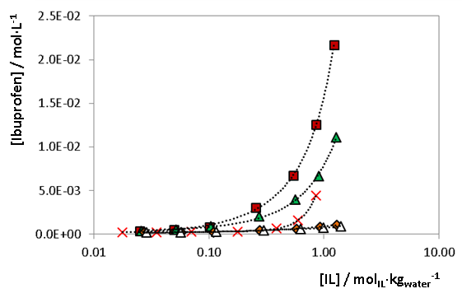
Figure 2. Impact of the IL concentration on the solubility of ibuprofen in aqueous solutions of () [C₄C₁im][N(CN)₂], () [C₄C₁im][SCN], () [P_{4,4,4,4}]Cl, () [C₄C₁pip]Cl and () [C₄C₁pyrr]Cl, in order to evaluate the MHC. Lines are guides for the eye.

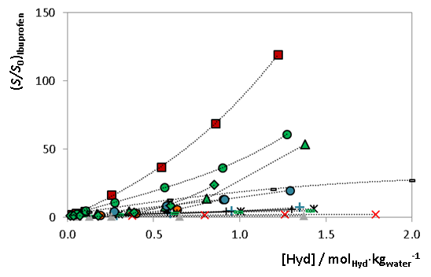
Figure 3. Impact of the hydrotrope concentration on the solubility of ibuprofen in aqueous solutions of () [C₄C₁im][N(CN)₂], () [C₄C₁im][SCN], () [P_{4,4,4,4}]Cl, () [C₄C₁im][TOS], () Na[N(CN)₂], () Na[TOS], () [N_{4,4,4,4}]Cl, () [C₄C₁py]Cl, () [C₄C₁pip]Cl, () [C₄C₁mim]Cl, (-) [C₄C₁pyrr]Cl, () [N_{1,1,1,2(OH)}]Cl and () Na[SCN]. S and S₀ represent the solubility of the drug in aqueous solution of the hydrotrope and in water, respectively. Lines are guides for the eye.
Table 2. K_{Hyd} values for the several hydrotropes analysed in the solubility of ibuprofen at (303.1 ± 0.5) K.
Hydrotrope | K_{Hyd} (kg_{water}∙mol_{Hyd}⁻¹) ± σ
[C₄C₁im][N(CN)₂] | 87.2 ± 5.0
[C₄C₁im][SCN] | 43.4 ± 1.7
[C₄C₁im][TOS] | 28.9 ± 5.8
[C₄C₁im]Cl | 3.6 ± 0.1
[C₄C₁py]Cl | 4.2 ± 0.4
[C₄C₁pip]Cl | 3.8 ± 0.1
[C₄C₁pyrr]Cl | 3.0 ± 0.1
[P_{4,4,4,4}]Cl | 20.0 ± 3.5
[N_{4,4,4,4}]Cl | 10.7 ± 1.9
[N_{1,1,1,2(OH)}]Cl | (7.1 ± 0.7) × 10⁻¹
Na[N(CN)₂] | 14.6 ± 1.2
Na[TOS] | 14.0 ± 0.3
Na[SCN] | (-8.5 ± 2.6) × 10⁻²

This constant can be considered as a measure of the effectiveness of a hydrotrope, in other words, the higher the constant, the higher its capacity to increase the solubility of a given compound in water. The ability of the various ILs and salts to act as a hydrotropes for ibuprofen increase in the following order: Na[SCN] < [N_{1,1,1,2(OH)}]Cl < [C₄C₁pyrr]Cl < [C₄C₁im]Cl < [C₄C₁pip]Cl < [C₄C₁py]Cl < [N_{4,4,4,4}]Cl < Na[TOS] < Na[N(CN)₂] < [P_{4,4,4,4}]Cl < [C₄C₁im][TOS] < [C₄C₁im][SCN] < [C₄C₁im][N(CN)₂].
In order to evaluate the effect of the IL cation on the solubility of these drugs, a series of chloride-based ILs was studied and are presented in Figure 4. The set of IL cations analysed includes aromatic ([C₄C₁im]⁺ and [C₄C₁py]⁺), cyclic non-aromatic ([C₄C₁pyrr]⁺ and [C₄C₁pip]⁺) and non-cyclic non-aromatic ([N_{4,4,4,4}]⁺, [P_{4,4,4,4}]⁺ and [N_{1,1,1,2(OH)}]⁺) compounds. Among the cations investigated in the chloride-based IL series, [N_{4,4,4,4}]Cl and [P_{4,4,4,4}]Cl presented the higher increase in the solubility of the drug studied in this work. The remaining IL cations showed a significant hydrotropic activity for ibuprofen, with the exception of the [N_{1,1,1,2(OH)}]Cl. The π-π interactions has been used in the past to explain the formation of solute-hydrotrope complexes, and thus the hydrotropic effect.^{11,12,53} However, the results obtained here do not support the idea that the π-π interactions between the aromatic drug and the aromatic cation core are the dominant driving forces behind the hydrotropic behavior, since the best results were achieved for non-cyclic non-aromatic ILs, in agreement with previous works.^{14,32,54,55} The influence of the IL cation on the hydrotropic constant was further evaluated using the tosylate, thiocyanate and dicyanamide anions, as depicted in Figure 5. The replacement of sodium cation (red bars) by an imidazolium cation (blue bars) leads to a remarkable enhancement in the solubility of ibuprofen.
To evaluate the influence of the IL anion on the solubility of ibuprofen, a series of [C₄C₁im]- and sodium-based hydrotropes was investigated. As previously mentioned, the conventional hydrotropes are usually anionic compounds composed of an aromatic ring substituted by an anionic group, such as sulfate, sulfonate, or carboxylate group. Nevertheless, contrary to expectations, [C₄C₁im][N(CN)₂] and [C₄C₁im][SCN] presented even higher hydrotropic activity than [C₄C₁im][TOS], as depicted in Figure 6. Although dicyanamide and thiocyanate present an outstanding hydrotropic activity when conjugated with the [C₄C₁im]⁺ cation, the same behaviour was not observed when these were combined with the sodium cation (Figure 5). The results obtained support the idea that both anion and cation contribute to the hydrotropic mechanism in a synergistic manner, different from those previously observed.³² The synergetic effect is confirmed by the MD simulation results discussed below.
In order to evaluate the formation of IL–ibuprofen aggregates, dynamic light scattering measurements were performed for saturated solutions of ibuprofen in 2.5 mol∙kg⁻¹ of the two best hydrotropes ([C₄C₁im][N(CN)₂] and [C₄C₁im][SCN]). The results obtained suggest the presence of co-aggregates between the ibuprofen and the IL ions in aqueous solution, with dimensions of 1-2 nm, as shown in Figure S1 of the Supporting Information.

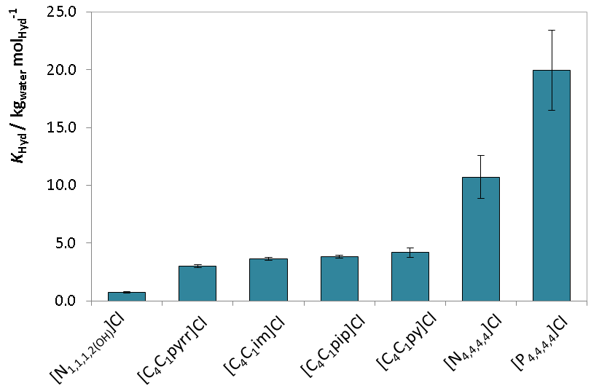
Figure 4. K_{Hyd} values of the chloride-based ILs for ibuprofen.

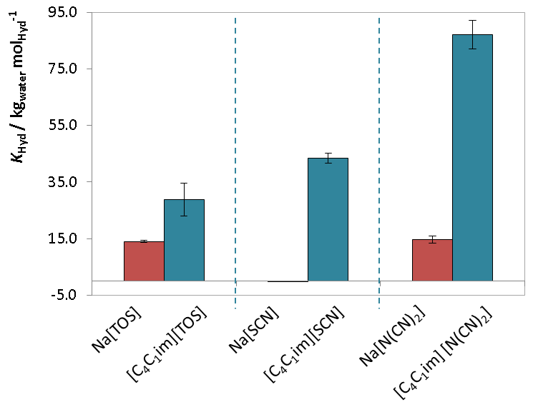
Figure 5. K_{Hyd} values for ibuprofen using tosylate-, thiocyanate- and dicyanamide-based hydrotropes.

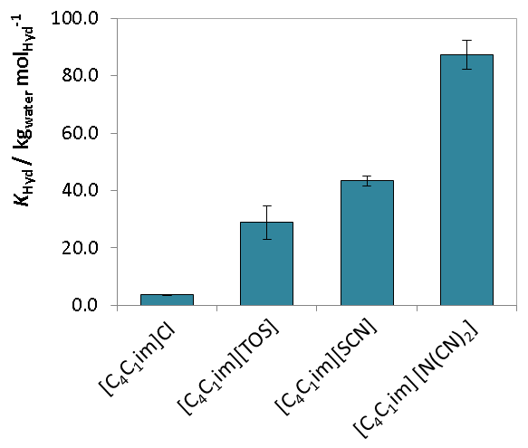
Figure 6. K_{Hyd} values of the [C₄C₁im]-based ILs for ibuprofen.
The phenomenon of polymorphism is quite common among organic molecules, and many drugs can crystallize into different polymorphic forms, including ibuprofen.^{56,57} Thus, to evaluate the impact of the medium on the crystallization, suitable crystals of ibuprofen precipitated in ethanol and [C₄C₁im][SCN] solution were analysed by powder and single crystal X-ray diffraction and optical microscopy. The lattice parameters of the unit cell (a 14.5337(17) Å; b 7.8500(8) Å; c 10.5382 (13) Å; α 90°; β 99.533(4)°; γ 90°) were in agreement with its crystallographic data reported in Cambridge Crystallographic Data Centre (www.ccdc.cam.ac.uk/data_request/cif) (see Figure S2 in the Supporting Information). Although the same unit cell was observed, and no significant differences were identified in the power diffractogram (Figure S2), the crystals precipitated from the two media show different crystal habit with significant differences in the ibuprofen crystal morphology, as shown in Supporting Information, Figure S3.^{58,59} When the crystallization is carried out in ethanol, plate-shape crystals were observed, as well as some tube-shape crystals with the solvent evaporation. On the other hand, when the ibuprofen is precipitated from the aqueous solution of [C₄C₁im][SCN], needle- and plate-shape crystals were obtained.

Molecular dynamics simulations
Since the best results on the hydrotropic solubilization of ibuprofen were achieved with [C₄C₁im][N(CN)₂] and [C₄C₁im][SCN], these compounds were selected to carry the MD simulations aimed at understanding the molecular mechanism of hydrotropic solublization, and the role of the cation and anion on the process.
Hydrotropic phenomena occurring in IL aqueous solutions have been previously probed from a microscopic perspective using Molecular Dynamics simulations.³² The MD results confirmed the existence of co-aggregates between the hydrophobic solute and the IL ions in aqueous solution and have shown that in the case of IL aqueous solutions containing vanillin, the hydrotrope effect was achieved via the synergy between specific vanillin-cation, cation-anion and anion-water interactions. The goal of the present MD study is to confirm if those mechanisms are still valid for poorly water-soluble substances like ibuprofen. All simulations were performed using ibuprofen as the solute. The very low solubility of ibuprofen posed important obstacles to the correct implementation of the simulation runs: even in cases where the solubility of ibuprofen in IL aqueous solutions is 100 times greater than that in pure water, the corresponding ibuprofen concentrations are still very small (10-30 mM solutions). This means that either the simulation boxes have adequate sizes but there are too few solute molecules, or the number of solute molecules is adequate but the boxes are too big and the simulations will take too long. This was not an issue in the previous MD study involving vanillin solutes since the solubility of vanillin in pure water is larger than the hydrotrope-enhanced solubility of ibuprofen in IL aqueous solutions.³² Since the study of co-aggregates in solutions with just one (or very few) solute molecules is a non-sequitur, we have decided to perform the simulations in conditions well above the solubility limit of ibuprofen in water. This means that, unlike the vanillin case, we will not be able to compare undissolved and dissolved solute (in pure water and IL aqueous solutions, respectively) but rather undissolved ibuprofen interacting in the two types of media.
Figure 7 shows three simulations snapshots corresponding to ibuprofen in pure water (panel A) and ibuprofen in [C₄C₁im][N(CN)₂] (panel B) and [C₄C₁im][SCN] (panel C) aqueous solutions (1 M IL concentrations). The ibuprofen concentration is 1.2 M in the pure water and 1 M in the IL aqueous solutions. In all cases, the ibuprofen occupy an important part of the simulation box (20% in volume) and, as expected, the two-phase nature of the system is evident. Aggregation analyses (small graph insets in each panel) quantify such state of affairs: all ibuprofen molecules remain aggregated to each other even when in contact with the IL aqueous solutions. Although this implies that in terms of solubilisation of the ibuprofen molecules nothing significant is happening —the amount of water-rich phases are simply too small to see any difference between pure water and the IL aqueous solutions in terms of their saturation by ibuprofen molecules — this does not mean that the molecular mechanisms responsible for the hydrotrope effects are absent in the IL aqueous solutions. In fact, the ibuprofen molecules are sensitive to the media where they are immersed, as attested by the orientation of the hydroxyl groups of the ibuprofen molecules at the surface of the ibuprofen sub-phase towards the aqueous sub-phase.
Figure 8 shows aggregate analyses between the ions of the IL present in the IL aqueous solutions and the ibuprofen molecules. These analyses are complemented by radial distribution functions (RDFs) between selected sites in the ions (most acidic hydrogen atoms in the imidazolium cation, HCR; nitrogen or sulfur atoms in the anions) and in the ibuprofen molecule (oxygen and hydrogen atoms of the hydroxyl group). The results show that there are important interactions between the IL ions and the ibuprofen molecules and an extensive network formed by the ions (mainly the cations) and the ibuprofen molecules at the surface of the ibuprofen sub-phase.
Actually, the aggregation patterns shown between the ibuprofen molecules and the IL ions are very similar to those found between the same ions and the vanillin molecules in a previous study³² (for comparison purposes we have also included the corresponding graphs in Figure 8). This means that the molecular mechanisms responsible for the hydrotrope effect are already in place even for molecules with extremely low water solubility: the IL ions are already being used as interaction mediators between the two sub-phases present in the system.

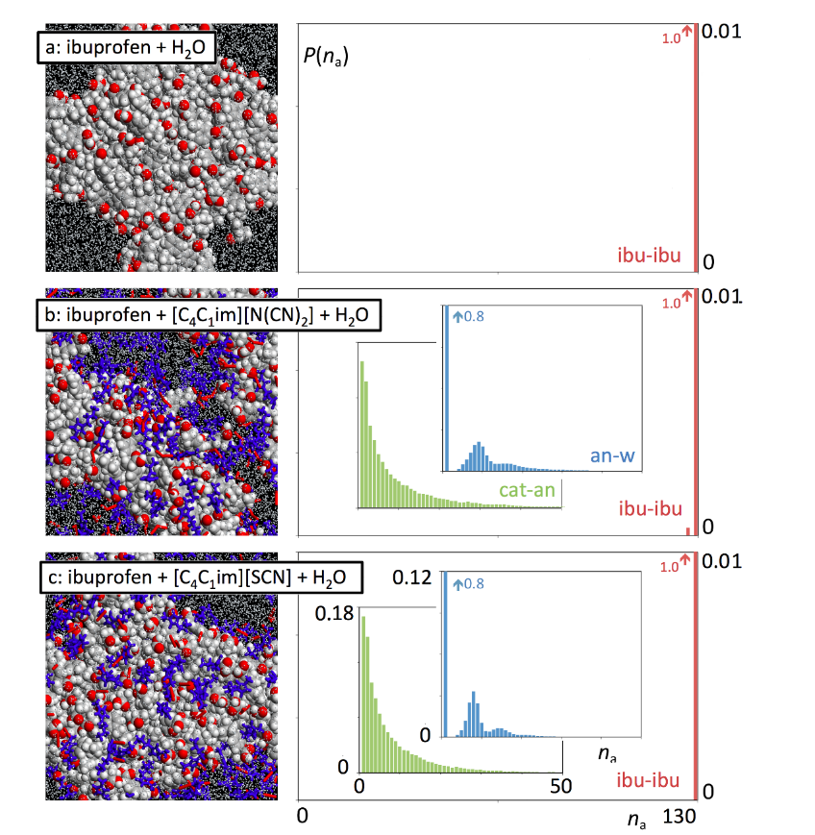
Figure 7. Simulation snapshots and discrete probability distribution functions of aggregate sizes, P(n_{a}), for ibuprofen in pure water (a) and in aqueous solutions of [C₄C₁im][N(CN)₂] (b) and [C₄C₁im][SCN] (c). The snapshots depict ibuprofen as space-filled molecules in CPK colors; water molecules as white dots and ionic liquid ions as blue (cation) and red (anion) wireframes. The histogram functions correspond to ibuprofen clusters (red bars), the anion-water network (blue) and the ionic liquid polar aggregates (green).
The big difference between the vanillin and ibuprofen systems in the concentration ranges analyzed by MD is that in the former case such interactions are sufficient to overcome the interactions between the (smaller) vanillin molecules, whereas in the latter case the stronger interactions between the larger hydrocarbon moieties of ibuprofen prevent such outcome. In other words, if simulations with ibuprofen solutions 100 times more diluted were performed (simulation boxes with 100 times more aqueous subphase) one would see dissolution patterns in pure water and in the IL aqueous solutions similar to those already witnessed for vanillin at much higher concentrations.
As already stated, such big simulations are not possible in terms of acceptable periods of time — time in a MD simulation scales with the square of the number of particles. Nevertheless, we have decided to perform simulations with similar box sizes but only 10 ibuprofen molecules (a 10-fold dilution in relation to the already described simulations) to check possible dissolution trends in a semi-quantitative way (statistics with just ten solute particles are poor and aggregation analyses are obviously very limited). The results, presented in Figure 9, show the partial dissolution of the ibuprofen subphase when pure water is replaced by an IL aqueous subphase. The ibuprofen aggregation patterns (very limited in this case) shift accordingly from larger aggregates to smaller ones and suggest that the hydrotrope effect is stronger for the dicyanamide-based systems relative to the thiocyanate-based ones.

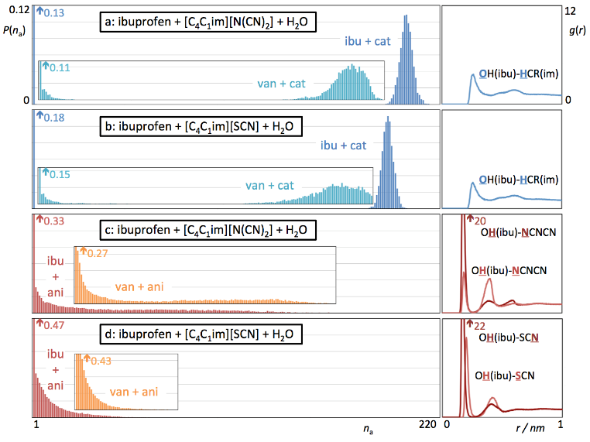
Figure 8. Discrete probability distribution functions of aggregate sizes, P(n_{a}), and pair radial distribution functions, g(r), for different types of aggregate and interaction centre. (a, b) Cation–ibuprofen aggregates and interactions in systems with dicyanamide- (a) and thiocyanate-based ILs (b). (c, d) Anion–ibuprofen aggregates and interactions in systems with dicyanamide- (c) and thiocyanate-based ILs (d).

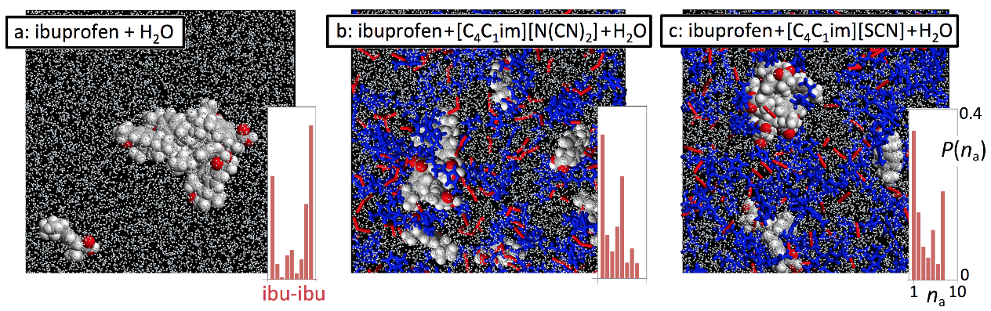

Figure 9. Simulation snapshots and discrete probability distribution functions of aggregate sizes, P(n_{a}), for ibuprofen in pure water (a) and in aqueous solutions of [C₄C₁im][N(CN)₂] (b) and [C₄C₁im][SCN] (c). The snapshots depict ibuprofen as space-filled molecules in CPK colours; water molecules as white dots and IL ions as blue (cation) and red (anion) wireframes. The histogram functions correspond to ibuprofen clusters (red bars).

The general character of the molecular mechanism underlying the hydrotrope effect revealed by the MD simulations (ILs as interaction mediators between organic and aqueous subphases without the need of invoking self-organized structures such as those found in surfactant systems) helps rationalize the experimental results obtained in the present work with other solute-IL combinations. On the side of the organic subphase, cations or anions with larger non-polar moieties (e.g. ammonium or phosphonium cations) enhance the hydrotrope effect due to stronger dispersive forces with the solute. It is interesting to note that such non-polar moieties can originate from either the anion or cation, which may account for the synergistic effects witnessed in many ion combinations. On the aqueous sub-phase side, ions that are able to interact with both their counter-ion and the water molecules simultaneously, are better hydrotropes. Halides are not as efficient as dicyanamide or thiocyanate anions and sodium is less efficient than most IL cations because they are solvated too strongly by water and are less prone to interact with their counter-ions in aqueous solution.
Conclusion
The results reported in this work clearly evidence the outstanding ability of ILs to act as hydrotropes for ibuprofen. Furthermore, the cation and anion may synergistically contribute to the hydrotropic mechanism of solubilization, which makes them powerful catanionic hydrotropes. Considering the chloride-based IL series, the [N_{4,4,4,4}]Cl and [P_{4,4,4,4}]Cl have presented the higher increase in the solubility of the all drugs studied. On the other hand, considering the 1-butyl-3-methylimidazolium family, dicyanamide and thiocyanate anions were the best hydrotropic solubilizing agents where this cation-anion synergy was more evident. As previously observed for vanillin, the results obtained using MD simulation support the idea that the hydrotropic phenomenon of the ILs for ibuprofen is driven by the formation of drug–IL aggregates.
Conflicts of interest
There are no conflicts to declare.
Acknowledgements
This work was developed within the scope of the project CICECO - Aveiro Institute of Materials POCI-01-0145-FEDER-007679 (FCT Ref. UID/CTM/50011/2013), financed by national funds through the FCT/MEC and when appropriate, co-financed by FEDER under the PT2020 Partnership Agreement. The authors are grateful for financial support through FCT for the postdoctoral grant SFRH/BPD/94291/2013 of Karina Shimizu, project UID/QUI/00100/2013 and for the IF contract of S. P. M. Ventura reference IF/00402/2015.
References

1 R. Liu, Water-insoluble drug formulation, CRC Press, 2008.
2 P. Jain, A. Goel, S. Sharma and M. Parmar, Solubility enhancement techniques with special emphasis on hydrotropy, Int. J. Pharma Prof. Res., 2010, 1, 34–45.
3 C. V Subbarao, I. P. K. Chakravarthy, A. V. S. L. Sai Bharadwaj and K. M. M. Prasad, Functions of Hydrotropes in Solutions, Chem. Eng. Technol., 2012, 35, 225–237.
4 K. Stanton, C. Tibazarwa, H. Certa, W. Greggs, D. Hillebold, L. Jovanovich, D. Woltering and R. Sedlak, Environmental risk assessment of hydrotropes in the United States, Europe, and Australia, Integr. Environ. Assess. Manag., 2010, 6, 155–163.
5 C. Neuberg, No Title, Biochem. Z., 1916, 76, 107–176.
6 T. K. Hodgdon and E. W. Kaler, Hydrotropic solutions, Curr. Opin. Colloid Interface Sci., 2007, 12, 121–128.
7 B. K. Roy and S. P. Moulik, Functions of hydrotropes (sodium salicylate, proline, pyrogallol, resorcinol and urea) in solution with special reference to amphiphile behaviors, Colloids Surfaces A Physicochem. Eng. Asp., 2002, 203, 155–166.
8 D. Subramanian, C. T. Boughter, J. B. Klauda, B. Hammouda and M. A. Anisimov, Mesoscale inhomogeneities in aqueous solutions of small amphiphilic molecules, Faraday Discuss., 2013, 167, 217–238.
9 J. Eastoe, M. H. Hatzopoulos and P. J. Dowding, Action of hydrotropes and alkyl-hydrotropes, Soft Matter, 2011, 7, 5917–5925.
10 V. Dhapte and P. Mehta, Advances in hydrotropic solutions: An updated review, St. Petersbg. Polytech. Univ. J. Phys. Math., 2015, 1, 424–435.
11 R. Sanghvi, D. Evans and S. H. Yalkowsky, Stacking complexation by nicotinamide: A useful way of enhancing drug solubility, Int. J. Pharm., 2007, 336, 35–41.
12 M. A. Hussain, R. C. Diluccio and M. B. Maurin, Complexation of moricizine with nicotinamide and evaluation of the complexation constants by various methods, J. Pharm. Sci., 1993, 82, 77–79.
13 A. Matero, Å. Mattsson and M. Svensson, Alkyl polyglucosides as hydrotropes, J. Surfactants Deterg., 1998, 1, 485–489.
14 P. Bauduin, A. Renoncourt, A. Kopf, D. Touraud and W. Kunz, Unified Concept of Solubilization in Water by Hydrotropes and Cosolvents, Langmuir, 2005, 21, 6769–6775.
15 J. Lee, S. C. Lee, G. Acharya, C. Chang and K. Park, Hydrotropic Solubilization of Paclitaxel: Analysis of Chemical Structures for Hydrotropic Property, Pharm. Res., 2003, 20, 1022–1030.
16 M. G. Neumann, C. C. Schmitt, K. R. Prieto and B. E. Goi, The photophysical determination of the minimum hydrotrope concentration of aromatic hydrotropes, J. Colloid Interface Sci., 2007, 315, 810–813.
17 J. J. Booth, S. Abbott and S. Shimizu, Mechanism of Hydrophobic Drug Solubilization by Small Molecule Hydrotropes, J. Phys. Chem. B, 2012, 116, 14915–14921.
18 S. Shimizu and N. Matubayasi, Hydrotropy: Monomer–Micelle Equilibrium and Minimum Hydrotrope Concentration, J. Phys. Chem. B, 2014, 118, 10515–10524.
19 S. Shimizu and N. Matubayasi, The origin of cooperative solubilisation by hydrotropes., Phys. Chem. Chem. Phys., 2016, 18, 25621–25628.
20 J. J. Booth, M. Omar, S. Abbott, S. Shimizu and M. A. Anisimov, Hydrotrope accumulation around the drug: the driving force for solubilization and minimum hydrotrope concentration for nicotinamide and urea, Phys. Chem. Chem. Phys., 2015, 17, 8028–8037.
21 S. Shimizu, J. J. Booth and S. Abbott, Hydrotropy: binding models vs. statistical thermodynamics, Phys. Chem. Chem. Phys., 2013, 15, 20625–20632.
22 R. Ferraz, L. C. Branco, C. Prudêncio, J. P. Noronha and Ž. Petrovski, Ionic Liquids as Active Pharmaceutical Ingredients, ChemMedChem, 2011, 6, 975–985.
23 W. L. Hough and R. D. Rogers, Ionic Liquids Then and Now: From Solvents to Materials to Active Pharmaceutical Ingredients, Bull. Chem. Soc. Jpn., 2007, 80, 2262–2269.
24 K. Bica and R. D. Rogers, Confused ionic liquid ions-a ‘liquification’ and dosage strategy for pharmaceutically active salts, Chem. Commun., 2010, 46, 1215–1217.
25 J. Stoimenovski and D. R. MacFarlane, Enhanced membrane transport of pharmaceutically active protic ionic liquids, Chem. Commun., 2011, 47, 11429–11431.
26 K. Bica, H. Rodríguez, G. Gurau, O. Andreea Cojocaru, A. Riisager, R. Fehrmann and R. D. Rogers, Pharmaceutically active ionic liquids with solids handling, enhanced thermal stability, and fast release, Chem. Commun., 2012, 48, 5422–5424.
27 W. L. Hough, M. Smiglak, H. Rodriguez, R. P. Swatloski, S. K. Spear, D. T. Daly, J. Pernak, J. E. Grisel, R. D. Carliss, M. D. Soutullo, J. J. H. Davis and R. D. Rogers, The third evolution of ionic liquids: active pharmaceutical ingredients, New J. Chem., 2007, 31, 1429–1436.
28 K. Bica, C. Rijksen, M. Nieuwenhuyzen and R. D. Rogers, In search of pure liquid salt forms of aspirin: ionic liquid approaches with acetylsalicylic acid and salicylic acid, Phys. Chem. Chem. Phys., 2010, 12, 2011–2017.
29 A. Balk, J. Wiest, T. Widmer, B. Galli, U. Holzgrabe and L. Meinel, Transformation of acidic poorly water soluble drugs into ionic liquids, Eur. J. Pharm. Biopharm., 2015, 94, 73–82.
30 T. E. Sintra, A. Luís, S. N. Rocha, A. I. M. C. Lobo Ferreira, F. Gonçalves, L. M. N. B. F. Santos, B. M. Neves, M. G. Freire, S. P. M. Ventura and J. A. P. Coutinho, Enhancing the Antioxidant Characteristics of Phenolic Acids by Their Conversion into Cholinium Salts, ACS Sustain. Chem. Eng., 2015, 3, 2558–2565.
31 D. Rengstl, B. Kraus, M. Van Vorst, G. D. Elliott and W. Kunz, Effect of choline carboxylate ionic liquids on biological membranes, Colloids Surfaces B Biointerfaces, 2014, 123, 575–581.
32 A. F. M. Claudio, M. C. Neves, K. Shimizu, J. N. Canongia Lopes, M. G. Freire and J. A. P. Coutinho, The magic of aqueous solutions of ionic liquids: ionic liquids as a powerful class of catanionic hydrotropes, Green Chem., 2015, 17, 3948–3963.
33 Biowaiver Monographs for Immediate Release Solid Oral Dosage Forms: Ibuprofen, J. Pharm. Sci., 2005, 94, 2121–2131.
34 R. O. Williams, A. B. Watts and D. A. Miller, Formulating Poorly Water Soluble Drugs, Springer New York, 2011.
35 A. Dahan, J. M. Miller and G. L. Amidon, Prediction of Solubility and Permeability Class Membership: Provisional BCS Classification of the World’s Top Oral Drugs, AAPS J., 2009, 11, 740–746.
36 F. A. e Silva, M. Caban, P. Stepnowski, J. A. P. Coutinho and S. P. M. Ventura, Recovery of ibuprofen from pharmaceutical wastes using ionic liquids, Green Chem., 2016, 18, 3749–3757.
37 M. Praprotnik, D. Janežič and J. Mavri, Temperature Dependence of Water Vibrational Spectrum: A Molecular Dynamics Simulation Study, J. Phys. Chem. A, 2004, 108, 11056–11062.
38 W. L. Jorgensen, D. S. Maxwell and J. Tirado-Rives, Development and Testing of the OPLS All-Atom Force Field on Conformational Energetics and Properties of Organic Liquids, J. Am. Chem. Soc., 1996, 118, 11225–11236.
39 J. N. Canongia Lopes, J. Deschamps and A. A. H. Pádua, Modeling Ionic Liquids Using a Systematic All-Atom Force Field, J. Phys. Chem. B, 2004, 108, 2038–2047.
40 J. N. Canongia Lopes and A. A. H. Pádua, Molecular Force Field for Ionic Liquids Composed of Triflate or Bistriflylimide Anions, J. Phys. Chem. B, 2004, 108, 16893–16898.
41 J. N. Canongia Lopes and A. A. H. Pádua, CL&amp;P: A generic and systematic force field for ionic liquids modeling, Theor. Chem. Acc., 2012, 131, 1129.
42 W. Smith and T. R. Forester, 2006.
43 H. J. C. Berendsen, D. van der Spoel and R. van Drunen, GROMACS: A message-passing parallel molecular dynamics implementation, Comput. Phys. Commun., 1995, 91, 43–56.
44 S. Páll, M. J. Abraham, C. Kutzner, B. Hess and E. Lindahl, in Solving Software Challenges for Exascale. Vol. 8759, Springer, Cham, 2015, pp. 3–27.
45 M. J. Abraham, T. Murtola, R. Schulz, S. Páll, J. C. Smith, B. Hess and E. Lindahl, GROMACS: High performance molecular simulations through multi-level parallelism from laptops to supercomputers, SoftwareX, 2015, 1-2, 19–25.
46 L. Martínez, R. Andrade, E. G. Birgin and J. M. Martínez, PACKMOL: A package for building initial configurations for molecular dynamics simulations, J. Comput. Chem., 2009, 30, 2157–2164.
47 K. Shimizu, C. E. S. Bernardes and J. N. Canongia Lopes, Structure and Aggregation in the 1-Alkyl-3-Methylimidazolium Bis(trifluoromethylsulfonyl)imide Ionic Liquid Homologous Series, J. Phys. Chem. B, 2014, 118, 567–576.
48 C. E. S. Bernardes, M. E. Minas da Piedade and J. N. Canongia Lopes, The Structure of Aqueous Solutions of a Hydrophilic Ionic Liquid: The Full Concentration Range of 1-Ethyl-3-methylimidazolium Ethylsulfate and Water, J. Phys. Chem. B, 2011, 115, 2067–2074.
49 J. W. Russo and M. M. Hoffmann, Measurements of Surface Tension and Chemical Shift on Several Binary Mixtures of Water and Ionic Liquids and Their Comparison for Assessing Aggregation, J. Chem. Eng. Data, 2011, 56, 3703–3710.
50 D. Subramanian, D. A. Ivanov, I. K. Yudin, M. A. Anisimov and J. V Sengers, Mesoscale Inhomogeneities in Aqueous Solutions of 3-Methylpyridine and Tertiary Butyl Alcohol, J. Chem. Eng. Data, 2011, 56, 1238–1248.
51 D. Subramanian and M. A. Anisimov, Phase behavior and mesoscale solubilization in aqueous solutions of hydrotropes, Fluid Phase Equilib., 2014, 362, 170–176.
52 M. Hopkins Hatzopoulos, J. Eastoe, P. J. Dowding, S. E. Rogers, R. Heenan and R. Dyer, Are Hydrotropes Distinct from Surfactants?, Langmuir, 2011, 27, 12346–12353.
53 A. A. Rasool, A. A. Hussain and L. W. Dittert, Solubility Enhancement of Some Water-Insoluble Drugs in the Presence of Nicotinamide and Related Compounds, J. Pharm. Sci., 1991, 80, 387–393.
54 C. R. E. Mansur, L. S. Spinelli, E. F. Lucas and G. González, The influence of a hydrotropic agent in the properties of aqueous solutions containing poly(ethylene oxide)–poly(propylene oxide) surfactants, Colloids Surfaces A Physicochem. Eng. Asp., 1999, 149, 291–300.
55 M. Hopkins Hatzopoulos, J. Eastoe, P. J. Dowding, I. Grillo, B. Demé, S. E. Rogers, R. Heenan and R. Dyer, Effects of Structure Variation on Solution Properties of Hydrotropes: Phenyl versus Cyclohexyl Chain Tips, Langmuir, 2012, 28, 9332–9340.
56 G. M. Khan and Z. Jiabi, Preparation, Characterization, and Evaluation of Physicochemical Properties of Different Crystalline Forms of Ibuprofen, Drug Dev. Ind. Pharm., 1998, 24, 463–471.
57 A. Martín, K. Scholle, F. Mattea, D. Meterc and M. J. Cocero, Production of Polymorphs of Ibuprofen Sodium by Supercritical Antisolvent (SAS) Precipitation, Cryst. Growth Des., 2009, 9, 2504–2511.
58 N. Rasenack and B. W. Müller, Properties of Ibuprofen Crystallized Under Various Conditions: A Comparative Study, Drug Dev. Ind. Pharm., 2002, 28, 1077–1089.
59 W. Tang, H. Mo, M. Zhang, S. Parkin, J. Gong, J. Wang and T. Li, Persistent Self-Association of Solute Molecules in Solution, J. Phys. Chem. B, 2017, 121, 10118–10124.

