The 2017 Report of

The Lancet Countdown on Health and Climate Change

From 25 years of inaction to a global transformation for public health

Nick Watts, Markus Amann, Sonja Ayeb-Karlsson, Kristine Belesova, Timothy Bouley, Maxwell Boykoff, Peter Byass, Wenjia Cai, Diarmid Campbell-Lendrum, Jonathan Chambers, Peter M Cox, Meaghan Daly, Niheer Dasandi, Michael Davies, Michael Depledge, Anneliese Depoux, Paula Dominguez-Salas, Paul Drummond, Paul Ekins, Antoine Flahault, Howard Frumkin, Lucien Georgeson, Mostafa Ghanei, Delia Grace, Hilary Graham, Rébecca Grojsman, Andy Haines, Ian Hamilton, Stella Hartinger, Anne Johnson, Ilan Kelman, Gregor Kiesewetter, Dominic Kniveton, Lu Liang, Melissa Lott, Robert Lowe, Georgina Mace, Maquins Odhiambo Sewe, Mark Maslin, Slava Mikhaylov, James Milner, Ali Mohammad Latifi, Maziar Moradi-Lakeh, Karyn Morrissey, Kris Murray, Tara Neville, Maria Nilsson, Tadj Oreszczyn, Fereidoon Owfi, David Pencheon, Steve Pye, Mahnaz Rabbaniha, Elizabeth Robinson, Joacim Rocklöv, Stefanie Schütte, Joy Shumake-Guillemot, Rebecca Steinbach, Meisam Tabatabaei, Nicola Wheeler, Paul Wilkinson, Peng Gong*, Hugh Montgomery*, Anthony Costello*
* Denotes Co-Chair

[Current Word Count: 21,749
(excluding figures, captions, tables, references and executive summary)]

Table of Contents
List of Figures, Tables, and Panels 5
List of Figures 5
List of Tables 7
List of Panels 7
List of Abbreviations 9
Executive Summary 10
Introduction 14
Indicators of Progress on Health and Climate Change 14
Delivering the Paris Agreement for Better Health 16
1. Climate Change Impacts, Exposures and Vulnerability 18
Introduction 18
Indicator 1.1: Health effects of temperature change 19
Indicator 1.2: Health effects of heatwaves 20
Indicator 1.3: Change in labour capacity 22
Indicator 1.4: Lethality of weather-related disasters 24
Indicator 1.5: Global health trends in climate-sensitive diseases 26
Indicator 1.6: Climate-sensitive infectious diseases 27
Indicator 1.7: Food security and undernutrition 29
Indicator 1.7.1: Vulnerability to undernutrition 30
Indicator 1.7.2: Marine primary productivity 31
Indicator 1.8: Migration and population displacement 32
Conclusion 34
2. Adaptation Planning and Resilience for Health 36
Introduction 36
Indicator 2.1: National adaptation plans for health 36
Indicator 2.2: City-level climate change risk assessments 38
Indicator 2.3: Detection and early warning of, preparedness for, and response to climate related health emergencies 39
Indicator 2.4: Climate information services for health 43
Indicator 2.5: National assessments of climate change impacts, vulnerability, and adaptation for health 44
Indicator 2.6: Climate-resilient health infrastructure 45
Conclusion 46
3. Mitigation Actions and Health Co-Benefits 46
Introduction 47
Tracking the health co-benefits of climate change mitigation 47
Energy Supply and Demand Sectors 48
Indicator 3.1: Carbon intensity of the energy system 48
Indicator 3.2: Coal phase-out 49
Indicator 3.3: Zero-carbon emission electricity 51
Indicator 3.4: Access to clean energy 52
Indicator 3.5: Exposure to ambient air pollution 53
3.5.1: Exposure to air pollution in cities 53
3.5.2: Sectoral contributions to air pollution 55
3.5.3: Premature mortality from ambient air pollution by sector 57
Transport Sector 58
Indicator 3.6: Clean fuel use for transport 58
Indicator 3.7: Sustainable travel infrastructure and uptake 59
Food and agriculture 62
Indicator 3.8: Ruminant meat for human consumption 62
Healthcare sector 64
Indicator 3.9: Healthcare sector emissions 64
Conclusion 65
4. Finance & Economics 66
Introduction 66
Indicator 4.1: Investments in zero-carbon energy and energy efficiency 67
Indicator 4.2: Investment in coal capacity 68
Indicator 4.3: Funds divested from fossil fuels 69
Indicator 4.4: Economic losses due to climate-related extreme events 69
Indicator 4.5: Employment in low-carbon and high-carbon industries 72
Indicator 4.6: Fossil fuel subsidies 73
Indicator 4.7: Coverage and strength of carbon pricing 74
Indicator 4.8: Use of carbon pricing revenues 75
Indicator 4.9: Spending on adaptation for health and health-related activities 76
Indicator 4.10: Health adaptation funding from global climate financing mechanisms 78
Conclusion 79
5. Public and Political Engagement 81
Introduction 81
Indicator 5.1: Media coverage of health and climate change 81
5.1.1: Global newspaper reporting on health and climate change 82
5.1.2: In-depth analysis of newspaper coverage on health and climate change 83
Indicator 5.2: Health and climate change in scientific journals 83
Indicator 5.3: Health and climate change in the United Nations General Assembly 85
Conclusion 86
Conclusion - the Lancet Countdown in 2017 88
The direction of travel is set 88
References 90

List of Figures, Tables, and Panels

List of Figures
Figure 1.1 Mean summer warming from 2000 to 2016 area weighted and exposure weighted, relative to the 1986-2008 recent past average.
Figure 1.2 The change in exposure (in people aged over 65 years) to heatwaves from 2000 to 2016, relative to the heatwave exposure average from 1986-2008.
Figure 1.3 The area and exposure weighted change in mean heatwave lengths globally from 2000 to 2016 (in people aged over 65 years), relative to the 1986-2008 recent past average.
Figure 1.4 The exposure weighted labour capacity change (%) globally from 2000 to 2016, relative to the 1986-2008 recent past average.
Figure 1.5 Map of the change in labour capacity loss from 2000 to 2016, relative to the 1986-2008 recent past average.
Figure 1.6 Deaths and people affected by weather-related disasters. 1.6a) Percentage change over time in the global number of deaths, the number of those affected, and the ratio of these (measured against 1990-2009). 1.6b) Change over time in the number of people affected globally by different weather-related disasters.
Figure 1.7 Trends in mortality from selected causes of death as estimated by the Global Burden of Disease 2015, for the period 1990 to 2015, by WHO region.
Figure 1.8 Left: Academic publications reporting climate-sensitive infectious diseases by year. Right: proportion of responses reported in publications by year and direction of impact.
Figure 1.9 Average annual vectorial capacity (VC) for dengue in Aedes aegypti and Aedes albopictus for selected Aedes-positive countries (countries with Aedes present) (top panel; matrix coloured relative to country mean 1950-2015; red = relatively higher VC, blue = relatively lower VC; countries ordered by centroid latitude (north to south)). Bottom panel: average vectorial capacity (VC) for both vectors calculated globally (results shown relative to 1990 baseline).
Figure 1.10 Total number of undernourished people multiplied by regional dependency on grain production for countries.
Figure 2.1 Countries with national heath climate adaptation strategies or plans.
Figure 2.2 Number of global cities undertaking climate change risk assessments by a) income grouping, and b) WHO region.
Figure 2.3 IHR Core Capacity Requirement by WHO region 2.3a) Percentage attainment of human resources available to implement the International Health Regulations Core Capacity Requirements. 2.3b) Percentage attainment of having indicator-based surveillance for early warning function for the early detection of a public health event. 2.3c) Percentage attainment for having a multi-hazard public health emergency preparedness and response plan developed and implemented. 2.3d) Percentage attainment of having a public health emergency response mechanisms established and functioning.
Figure 2.4 National Meteorological and Hydrological Services (NHMSs) of WHO member states reporting to provide targeted/tailored climate information, products and services to the health sector.
Figure 2.5 Countries with national assessment of climate change impacts, vulnerability and adaptation for health.
Figure 2.6 Countries taking measures to increase the climate resilience of health infrastructure.
Figure 3.1 Carbon intensity of Total Primary Energy Supply (TPES) for selected countries, and total CO2 emissions (shaded area against secondary y-axis),1971-2013.
Figure 3.2 Total primary coal supply by region, and globally (shaded area against secondary y-axis), 1990-2013.
Figure 3.3 Renewable and zero-carbon emission energy sources electricity generation a) Share of electricity generated from zero carbon sources; b) Electricity generated from zero carbon sources, TWh; c) Share of electricity generated from renewable sources (excluding hydro); d) Electricity generated from renewable sources (excl. hydro), TWh.
Figure 3.4 Proportion of population relying primarily on clean fuels and technology.
Figure 3.5 Annual mean PM2.5 concentration vs per capita GDP for 143 cities in the SHUE database. Colours indicate WHO regions: blue – Africa; red – Europe; green – the Americas; Lime – Eastern Mediterranean; orange – Western Pacific; purple – South East Asia. The dotted line marks the WHO recommended guidance level of 10 µg.m-3.
Figure 3.6 Selected primary air pollutants and their sources globally in 2015.
Figure 3.7 a) Energy related PM2.5 emissions in 2015 and b) NOx emissions from transport from 1990-2010 by region.
Figure 3.8 Health impacts of exposure to ambient PM2.5 in terms of annual premature deaths per million inhabitants in South and East Asian countries in 2015, broken down by key sources of pollution.
Figure 3.9 Per capita fuel use by type (TJ/person) for transport sector with all fuels
Figure 3.10 Cumulative Global Electric Vehicle Sales. Note: BEV is Battery Electric Vehicle and PHEV is Plug-in Hybrid Electric Vehicle.
Figure 3.11 Modal Shares in world cities. Note: ‘Other’ typically includes paratransit (transport for people with disabilities) and/or electronic bikes.
Figure 3.12 Trends in modal share in selected cities. Note: Data from Santiago in 1991 represents travel on a usual day; Data from Sydney represent Weekdays only; Cycling modal share in Sydney is <1%.
Figure 3.13 The total amount of ruminant meat available for human consumption in kg/capita/year by WHO-defined regions.
Figure 3.14 The proportion of energy (kcal/capita/day) available for human consumption from ruminant meat vs from all food sources by WHO-defined regions.
Figure 4.1 Annual Investment in the Global Energy System.
Figure 4.2 Annual Investment in coal-fired power capacity.
Figure 4.3 Economic Losses from Climate-Related Events – Absolute.
Figure 4.4 Economic Losses from Climate-Related Events – Intensity.
Figure 4.5 Employment in Renewable Energy and Fossil Fuel Extraction.
Figure 4.6 Global Fossil Fuel Consumption Subsidies - 2010-2015.
Figure 4.7 Carbon Pricing Instruments implemented, scheduled for implementation and under consideration.
Figure 4.8 For the financial year 2015-2016. 4.8a) Total health and health-related adaptation spending and 4.8b) health and health-related adaptation and resilience to climate change (A&RCC) spending as a proportion of GDP. All plots are disaggregated by World Bank Income Grouping.
Figure 4.9 Year on year multilateral and bilateral funding for all adaptation projects and health adaptation projects (2003 through May 2017).
Figure 5.1 Newspaper reporting on health and climate change (for 18 newspapers) from 2007 to 2016, broken down by WHO region.
Figure 5.2 Number of scientific publications on climate change and health per year (2007-2016) from PubMed and Web of Science journals.
Figure 5.3 Political engagement with the intersection of health and climate change, represented by joint references to health and climate change in the UNGD.
Figure 5.4 Regional political engagement with the intersection of health and climate change, represented by joint references to health and climate change in the UNGD, broken down by WHO region.

List of Tables
Table 1 Thematic groups and indicators for the Lancet Countdown’s 2017 report.
Table 1.1 Locations migrating now due to only climate change.
Table 4.1 Carbon Pricing - Global Coverage and Weighted Average Prices. *Global emissions coverage is based on 2012 total anthropogenic CO2 emissions.
Table 4.2. Carbon Pricing revenues and allocation in 2016.

List of Panels
Panel 1 Developing Lancet Countdown’s Indicators: An Iterative and Open Process.
Panel 1.1 Mental health and Climate Change.
Panel 2.1 WHO-UNFCCC Climate and Health Country Profiles.
Panel 2.2 The International Health Regulations.
Panel 3.1 Energy and Household Air Pollution in Peru.
Panel 4.1 International Donor Action on Climate Change and Health.

List of Abbreviations

A&RCC – Adaptation & Resilience to Climate Change
AAP – Ambient Air Pollution
AUM – Assets Under Management
BEV – Battery Electric Vehicle
CDP – Carbon Disclosure Project
CFU – Climate Funds Update
CO₂ – Carbon Dioxide
COP – Conference of the Parties
COPD – Chronic Obstructive Pulmonary Disease
CPI – Consumer Price Indices
DALYs – Disability Adjusted Life Years
DPSEEA – Driving Force-Pressure-State-Exposure-Effect-Action
ECMWF – European Centre for Medium-Range Weather Forecasts
EJ – Exajoule
EM-DAT – Emergency Events Database
ERA – European Research Area
ETR – Environmental Tax Reform
ETS – Emissions Trading System
EU – European Union
EU28 – 28 European Union Member States
FAO – Food and Agriculture Organization of the United Nations
FAZ – Frankfurter Allgemeine Zeitung
FISE – Social Inclusion Energy Fund
GBD – Global Burden of Disease
GDP – Gross Domestic Product
GHG – Greenhouse Gas
GtCO₂ – Gigatons of Carbon Dioxide
GW – Gigawatt
GWP – Gross World Product
HAB – Harmful Algal Blooms
HIC – High Income Countries
ICS – Improved Cook Stove
IEA – International Energy Agency
IHR – International Health Regulations
IPC – Infection Prevention and Control
IPCC - Intergovernmental Panel on Climate Change
IRENA - International Renewable Energy Agency
LMICs – Low and Middle Income Countries
LPG – Liquefied Petroleum Gas
Mt – Megaton
MtCO₂e – Metric Tons of Carbon Dioxide Equivalent
NAP – National Adaptation Plan
NDCs = Nationally Determined Contributions
NHMSs – National Meteorological and Hydrological Services
NHS- National Health Service
NO_{x} – Nitrogen Oxide
OECD – Organization for Economic Cooperation and Development
PHEV – Plug-in Hybrid Electric Vehicle
PM_{2.5} – Fine Particulate Matter
PV – Photovoltaic
SDG – Sustainable Development Goal
SDU – Sustainable Development Unit
SHUE – Sustainable Healthy Urban Environments
SO₂ – Sulphur Dioxide
SSS – Sea Surface Salinity
SST – Sea Surface Temperature
tCO₂ – Tons of Carbon Dioxide
tCO2/TJ – Total Carbon Dioxide per Terajoule
TJ – Terajoule
TPES – Total Primary Energy Supply
TWh – Terawatt Hours
UN – United Nations
UNFCCC – United Nations Framework Convention on Climate Change
UNGA – United Nations General Assembly
UNGD – United Nations General Debate
VC – Vectorial Capacity
WHO – World Health Organization
WMO – World Meteorological Organization

Executive Summary

The Lancet Countdown tracks progress on the relationships between human health and climate change, providing an independent assessment of global progress to implement the Paris Agreement, and the health implications of these actions.
It follows on from the work of the 2015 Lancet Commission, which concluded that anthropogenic climate change threatens to undermine the last 50 years of gains in public health, and conversely, that a comprehensive response to climate change could be “the greatest global health opportunity of the 21st century”.
The Lancet Countdown exists as a collaboration between 24 academic institutions and inter-governmental organisations, based in every continent, and with representation from a wide range of disciplines, including: climate scientists, ecologists, economists, engineers, experts in energy, food and transport systems, geographers, mathematicians, social and political scientists, public health professionals, and physicians. The collaboration reports annual indicators across five domains: climate change impacts, exposures and vulnerability; adaptation planning and resilience for health; mitigation actions and health co-benefits; economics and finance; and public and political engagement.
The 2017 key messages from its 40 indicators in its first annual report are summarised below.

The human symptoms of climate change are unequivocal and potentially irreversible – affecting the health of populations around the world, today. Whilst these effects will disproportionately impact the most vulnerable in society, every community will be affected.
The impacts of climate change are disproportionately affecting the health of vulnerable populations, and those in low- and middle-income countries. By undermining the social and environmental determinants that underpin good health, it exacerbates social, economic and demographic inequalities with the effects eventually felt by all populations.
The evidence is clear that exposure to more frequent and intense heatwaves are increasing, with an estimated 125 million additional vulnerable adults exposed to heatwaves from 2000 to 2016 (Indicator 1.2). Higher ambient temperatures have resulted in estimated reduction of 5.3% in labour productivity, globally, from 2000 to 2016 (Indicator 1.3). Taken as a whole, a 44% increase in weather-related disasters has been observed since 2000, with no clear upward or downward trend in the lethality of these extreme events (Indicator 1.4), potentially suggesting the beginning of an adaptive response to climate change. Yet, the impacts of climate change are projected to worsen over time, with current levels of adaptation becoming insufficient in the future. The total value of economic losses that resulted from climate-related events has been increasing since 1990, and totalled $129 billion in 2016, with 99% of these losses in low-income countries uninsured (Indicator 4.4). Additionally, over the longer-term, altered climatic conditions are contributing to growing vectorial capacity for the transmission of dengue fever by Aedes aegypti, reflecting an estimated 9.4% increase since 1950 (Indicator 1.6).
If governments and the global health community do not learn from the past experience of HIV/AIDS and the recent outbreaks of Ebola and Zika virus, another slow response will result in an irreversible and unacceptable cost to human health.

The delayed response to climate change over the past 25 years has jeopardised human life and livelihoods.
Since the UN Framework Convention on Climate Change (UNFCCC) commenced global efforts to tackle climate change in 1992, most of the indicators tracked by the Lancet Countdown have either shown limited progress, particularly with regards to adaptation, or moved in the wrong direction, particularly in relation to mitigation. Most fundamentally, carbon emissions, and global temperatures, have continued to rise..
A growing number of countries are assessing their vulnerabilities to climate change, and are increasingly developing adaptation and emergency preparedness plans, and providing climate information to health services (Indicators 2.1, 2.3-2.6). The same is seen at the city-level, with over 449 cities around the world reporting having undertaken a climate change risk assessment (Indicator 2.2). However, the coverage and adequacy of such measures in protecting against the growing risks of climate change to health remains uncertain. Indeed, health and health-related adaptation funding accounts for 4.6% and 13.3% of total global adaptation spending, respectively (Indicator 4.9).
Whilst there has been some recent progress in strengthening health resilience to climate impacts, it is clear that adaptation to new climatic conditions can only protect up to a point; an analogy to human physiology is useful here. The human body can adapt to insults caused by a self-limiting minor illness with relative ease. However, where disease steadily worsens, positive feedback cycles and limits to adaptation are quickly reached. This is particularly true when many systems are affected, and where the failure of one system may impact on the function of another, as is the case for ‘multi-organ system failure’, or where the body has already been weakened through repeated previous diseases or exposures. The same is true for the health consequences of climate change. It acts as a threat multiplier, compounding many of the issues communities already face, and strengthening the correlation between multiple health risks, making them more likely to occur simultaneously. Indeed, it is not a ‘single system disease’, instead, often acting to compound existing pressures on housing, food and water security, poverty, and many of the determinants of good health. Adaptation has limits, and prevention is better than cure to prevent potentially irreversible effects of climate change.
Progress in mitigating climate change since the signing of the UNFCCC has been limited across all sectors, with only modest improvements in carbon emission reduction from electricity generation. Whilst there are increasing levels of sustainable travel in Europe and some evidence of decline in dependence on private motor vehicles in cities in the USA and Australia, the situation is generally less favourable in cities in emerging economies (Indicator 3.7). This, and a slow transition away from highly-polluting forms of electricity generation, has yielded a modest improvement in air pollution in some urban centres. However, global population-weighted PM_{2.5} exposure has increased by 11.2% since 1990 and some 71.2% of the 2971 cities in the WHO air pollution database exceed recommendations of annual fine particulate matter exposure (Indicator 3.5). The strength and coverage of carbon pricing covers only 13.1% of global anthropogenic CO₂ emissions, with the weighted average carbon price of these instruments at 8.81USD/tCO₂e in 2017 (Indicator 4.7). Furthermore, responses to climate change have yet to fully take advantage of the health co-benefits of mitigation and adaptation interventions, with action taken to-date only yielding modest improvements in human wellbeing. In part, this reflects a need for further evidence and research on these ancillary effects and the cost-savings available. However, it also reflects a need for more joined-up policymaking across health and non-health ministries of national governments.
This delayed mitigation response puts the world on a ‘high-end’ emissions trajectory, resulting in global warming of between 2.6°C and 4.8°C of warming by the end of the century.

The voice of the health profession is essential in driving forward progress on climate change and realising the health benefits of this response.
This report, and previous Lancet Commissions, have argued that the health profession has not just the ability but the responsibility to act as public health advocates, communicating the threats and opportunities to the public and policymakers, and ensuring climate change is understood as being central to human wellbeing.
There is evidence of growing attention to health and climate change in the media and in academic publications, with global newspaper coverage of the issue increasing 78% and the number of scientific papers more than tripling, since 2007 (Indicator 5.1.1 and 5.2). However, despite these positive examples, the 2017 indicators make it clear that further progress is urgently required.

Whilst progress has historically been slow, the last five years have seen an accelerated response, and the transition to low-carbon electricity generation now appears inevitable, suggesting the beginning of a broader transformation. In 2017, momentum is building across a number of sectors, and the direction of travel is set, with clear and unprecedented opportunities for public health.
In 2015, the Lancet Commission made 10 recommendations to governments, to accelerate action over the following five years. The Lancet Countdown’s 2017 indicators track against these 2015 recommendations, with results suggesting that discernible progress has been made in many of these areas, breathing life into previously stagnant mitigation and adaptation efforts. Alongside the Paris Agreement, these provide reason to believe that a broader transformation is under way.
Recommendation 1) Invest in climate change and public health research: since 2007, the number of scientific papers on health and climate change has more than trebled (Indicator 5.2).

Recommendation 2) Scale-up financing for climate-resilient health systems: spending on health adaptation is currently at 4.63% (16.46 billion USD) of global adaptation spend; and in 2017, health adaptation from global development and climate financing mechanisms is at an all-time high – although absolute figures remain low (Indicators 4.9 and 4.10).

Recommendation 3) Phase-out coal-fired power: In 2015, more renewable energy capacity (150GW) than fossil fuel capacity was added to the global energy mix. Overall, annual installed renewable generation capacity (almost 2000 GW) exceeds that for coal, with about 80% of this recently added renewable capacity located in China (Indicator 3.2). Whilst investment in coal capacity has increased since 2006, in 2016 this turned and declined substantially (Indicator 4.1) and several countries have now committed to phasing-out coal.

Recommendation 4) Encourage a city-level low-carbon transition, reducing levels of urban pollution:
Despite historically modest progress over the last two decades, the transport sector is approaching a new threshold, with electric vehicles expected to reach cost-parity with their non-electric counterparts by 2018 – a phenomenon that was not expected to occur until 2030 (Indicator 3.6).

Recommendation 6) Rapidly expand access to renewable energy, unlocking the substantial economic gains available from this transition: Every year since 2015, more renewable energy has been added to the global energy mix than all other sources, and in 2016, global employment in renewable energy reached 9.8 million, over one million more than are employed in fossil fuel extraction. The transition has become inevitable. However, in the same year, 1.2 billion people still did not have access to electricity, with 2.7 billion people relying on the burning of unsafe and unsustainable solid fuels (Indicators 3.3, 4.6 and 3.4).

Recommendation 9) Agree and implement an international treaty which facilitates the transition to a low-carbon economy: In December 2015, 195 countries signed the Paris Agreement, which provides a framework for enhanced mitigation and adaptation, and pledges to keep the global mean temperature rise to “well below 2°C”. Going forward, a formal Health Work Programme within the UNFCCC would provide a clear and essential entry point for health professionals at the national level, ensuring that the implementation of the Paris Agreement maximises the health opportunities for populations around the world.

Following the United States government’s announced intention to withdraw from the Paris Agreement, the global community has demonstrated overwhelming support for enhanced action on climate change, affirming clear political will and ambition to reach the treaty’s targets. The mitigation and adaptation interventions committed to under the Paris Agreement have overwhelmingly positive short- and long-term health benefits, but greater ambition is now essential. Whilst progress has been historically slow, there is evidence of a recent turning point, with transitions in sectors crucial to public health accelerating towards a low-carbon world. Whilst these efforts must be greatly accelerated and sustained over the coming decades in order meet these commitments, recent policy changes and the indicators presented here suggest that the direction of travel is set.
From 2017 until 2030, the Lancet Countdown: Tracking Progress on Health and Climate Change will continue its work, reporting annually on progress implementing the commitments of the Paris Agreement, future commitments that build on them, and the health benefits that result.

Introduction
Climate change has serious implications for our health, wellbeing, livelihoods and the structure of organised society. Its direct effects result from rising temperatures, and changes in the frequency and strength of storms, floods, droughts, and heatwaves – with physical and mental health consequences. Its impacts will also be mediated through less direct pathways, including changes in crop yields, the burden and distribution of infectious disease, and in climate-induced population displacement and violent conflict.¹⁻³ Whilst many of these effects are already being experienced, their progression in the absence of climate change mitigation will greatly amplify existing global health challenges and inequalities.⁴ It threatens to undermine many of the social, economic and environmental drivers of health, which have contributed greatly to human progress.
Urgent and substantial climate change mitigation will help to protect human health from the worst of these impacts, with a comprehensive and ambitious response to climate change potentially transforming the health of the world’s populations.⁴ The potential benefits and opportunities are enormous, including cleaning up the air of polluted cities, delivering more nutritious diets, ensuring energy, food and water security, and alleviating poverty and social and economic inequalities.
Monitoring this transition – from threat to opportunity – is the central role of the Lancet Countdown: Tracking Progress on Health and Climate Change.⁵ The collaboration exists as a partnership of 24 academic institutions from every continent, and brings together individuals with a broad range of expertise across disciplines (including climate scientists, ecologists, mathematicians, geographers, engineers, energy, food, and transport experts, economists, social and political scientists, public health professionals, and physicians). The Lancet Countdown aims to track a series of indicators of progress, publishing an annual ‘health check’, from now until 2030, on the state of the climate, progress made in meeting global commitments under the Paris Agreement, and adapting and mitigating to climate change (Panel 1). The initiative was formed following the 2015 Lancet Commission, which concluded that “tackling climate change could be the greatest global health opportunity of the 21st century”.⁴ It builds on, and reinforces, the work of the expanding group of researchers, health practitioners, national governments, and the World Health Organization (WHO), who are working to ensure that this opportunity becomes a reality.

Indicators of Progress on Health and Climate Change
In 2016, the Lancet Countdown proposed a set of potential indicators to be monitored, launching a global consultation to define a conclusive set for 2017.⁵ A number of factors determined the selection of indicators, including: (i) their relevance to public health, both in terms of the impacts of climate change on health, and the health effects of the response to climate change; (ii) their relevance to the main anthropogenic drivers of climate change; (iii) their geographical coverage and relevance to a broad range of countries and income-groups; (iv) data availability; and (v) resource and timing constraints. Table 1 divides these into broad themes, aligned with the global action agenda on climate change and health, agreed at the Second WHO Global Conference on Health and Climate, Paris, July 2016: climate change impacts, exposures, and vulnerabilities; adaptation planning and resilience for health; mitigation actions and health co-benefits; economics and finance; and public and political engagement.⁶
Panel 1 Developing Lancet Countdown’s Indicators: An Iterative and Open Process.
The development of the Lancet Countdown’s indicators took a pragmatic approach, taking in to account the considerable limitations in data availability, resources, and time. Consequently, the indicators presented here represent what is feasible for 2017 and will evolve over time in response to feedback and data improvements.
The purpose of this collaboration is to track progress on the links between public health and climate change, and yet, much of the data analysed here was originally collected for purposes not directly relevant to health. Initial analysis therefore principally captures changes in exposure, states, or processes, as proxies for health outcomes – the ultimate goal. Employing new methodologies to improve attribution to climate change is a particular priority. Subsequent reports will see the Lancet Countdown set 2030 targets for its indicators which align more directly with the Paris Agreement, allowing an assessment of its implementation over the course of the next 13 years.
The indicators presented thus far are the beginning of an ongoing, iterative and open process, which will work to continuously improve as capacity, data quality, and methods evolve. The objectives of the Lancet Countdown are both ambitious and essential, requiring support from a broad range of actors. To this end, the collaboration welcomes support from academic institutions and technical experts able to provide new analytical methods and novel data sets with appropriate geographical coverage. Appendix 1 provides a short overview of several parallel and complementary processes currently underway.
Throughout this report, the results and analysis of each indicator are presented alongside a brief description of the data sources and methods. A more complete account of each indicator can be found in the corresponding appendices. For a number of areas – such as the mental health impacts of climate change, or hydrological mapping of flood exposure – a robust methodology for an annual indicator has not been reported, reflecting the complexity of the topic and the paucity of data, rather than its lack of importance. Table 1 provides a summary of the 2017 indicators, with a more complete overview of these indicators provided in the supplementary online material. The thematic groups and indicator titles provide an overview of the domain being tracked, allowing for the growth and development of these metrics – for example, to more directly capture health outcomes – in subsequent years.

Thematic Group | Indicators
1. Climate Change Impacts, Exposures and Vulnerability | 1.1. Health effects of temperature change
1. Climate Change Impacts, Exposures and Vulnerability | 1.2. Health effects of heatwaves
1. Climate Change Impacts, Exposures and Vulnerability | 1.3. Change in labour capacity
1. Climate Change Impacts, Exposures and Vulnerability | 1.4. Lethality of weather-related disasters
1. Climate Change Impacts, Exposures and Vulnerability | 1.5. Global health trends in climate-sensitive diseases
1. Climate Change Impacts, Exposures and Vulnerability | 1.6. Climate-sensitive infectious diseases
1. Climate Change Impacts, Exposures and Vulnerability | 1.7. Food security and undernutrition |  | 1.7.1. Vulnerability to undernutrition
1. Climate Change Impacts, Exposures and Vulnerability |  |  | 1.7.2. Marine primary productivity
1. Climate Change Impacts, Exposures and Vulnerability | 1.8. Migration and population displacement
2. Adaptation Planning and Resilience for Health | 2.1. National adaptation plans for health
2. Adaptation Planning and Resilience for Health | 2.2. City-level climate change risk assessments
2. Adaptation Planning and Resilience for Health | 2.3. Detection and early warning of, preparedness for, and response to health emergencies
2. Adaptation Planning and Resilience for Health | 2.4. Climate information services for health
2. Adaptation Planning and Resilience for Health | 2.5. National assessment of vulnerability, impacts and adaptation for health
2. Adaptation Planning and Resilience for Health | 2.6. Climate-resilient health infrastructure
3. Mitigation Actions and Health Co-Benefits | 3.1. Carbon intensity of the energy system
3. Mitigation Actions and Health Co-Benefits | 3.2. Coal phase-out
3. Mitigation Actions and Health Co-Benefits | 3.3. Zero-carbon emission electricity
3. Mitigation Actions and Health Co-Benefits | 3.4. Access to clean energy
3. Mitigation Actions and Health Co-Benefits | 3.5. Exposure to ambient air pollution | 3.5.1. Exposure to air pollution in cities
3. Mitigation Actions and Health Co-Benefits | 3.5. Exposure to ambient air pollution | 3.5.2. Sectoral contributions to air pollution
3. Mitigation Actions and Health Co-Benefits | 3.5. Exposure to ambient air pollution | 3.5.3. Premature mortality from ambient air pollution by sector
3. Mitigation Actions and Health Co-Benefits | 3.6. Clean fuel use for transport
3. Mitigation Actions and Health Co-Benefits | 3.7. Sustainable travel infrastructure and uptake
3. Mitigation Actions and Health Co-Benefits | 3.8. Ruminant meat for human consumption
3. Mitigation Actions and Health Co-Benefits | 3.9. Healthcare sector emissions
4. Economics and Finance | 4.1. Investments in zero-carbon energy and energy efficiency
4. Economics and Finance | 4.2. Investment in coal capacity
4. Economics and Finance | 4.3. Funds divested from fossil fuels
4. Economics and Finance | 4.4. Economic losses due to climate-related extreme events
4. Economics and Finance | 4.5. Employment in low-carbon and high-carbon industries
4. Economics and Finance | 4.6. Fossil fuel subsidies
4. Economics and Finance | 4.7. Coverage and strength of carbon pricing
4. Economics and Finance | 4.8. Use of carbon pricing revenues
4. Economics and Finance | 4.9. Spending on adaptation for health and health-related activities
4. Economics and Finance | 4.10. Health adaptation funding from global climate financing mechanisms
5. Public and Political Engagement | 5.1. Media coverage of health and climate change | 5.1.1. Global newspaper reporting on health and climate change
5. Public and Political Engagement | 5.1. Media coverage of health and climate change | 5.1.2. In-depth analysis of newspaper coverage on health and climate change
5. Public and Political Engagement | 5.2. Health and climate change in scientific journals
5. Public and Political Engagement | 5.3. Health and climate change in the United Nations General Assembly
Table 1 Thematic groups and indicators for the Lancet Countdown’s 2017 report.

Delivering the Paris Agreement for Better Health
The Paris Agreement has been ratified at the national level by 153 of 197 parties to the UNFCCC, and currently covers 84.7% of greenhouse gas (GHG) emissions. It set out a commitment of ambitious GHG emissions reduction to limit climate change to well below a global average temperature rise of 2°C above pre-industrial levels, with an aim to limit temperature increases to 1.5°C.⁷
Most countries (187) have committed to near-term GHG emission reduction actions up to 2030, through their Nationally Determined Contributions (NDCs). Article 4 paragraph 2 of the Paris Agreement states that each signatory “shall prepare, communicate and maintain successive nationally determined contributions that it intends to achieve”.⁷ However, the NDCs of the 153 parties that have ratified the agreement currently fall short of the necessary reductions by 2030 to meet the 2°C pathway.⁸
The Lancet Countdown’s indicators place national decisions within a broader context. They highlight the fact that globally, total power capacity of ‘pre-construction’ coal (commitments for new coal power plants) has halved from 2016 to 2017 alone; that every year since 2015, more renewable energy has been added to the global energy mix than all other sources combined; its installed costs continue to fall (with solar photovoltaic (PV) electricity generation now being cheaper than conventional fossil fuels in an ever growing number of countries); electric vehicles are poised to reach cost-parity with their petrol-based counterparts; and in 2016 global employment in renewable energy reached 9.8 million, over one million greater than that in fossil fuel extraction.
These positive examples in recent years must not mask the dangerous consequences of failing to meet the Paris Agreement, the past two decades of relative inaction, the economies and sectors currently lagging behind, and the enormity of the task ahead, which leave achieving the Agreement’s aims in a precarious position. Indeed, much of the data presented should serve as a wake-up call to national governments, businesses, civil society, and the health profession.
However, as this report demonstrates, the world has already begun to embark on a path to a low-carbon and healthier world. Whilst the pace of action must greatly accelerate, the direction of travel is set.

1. Climate Change Impacts, Exposures and Vulnerability

Introduction
This section provides a set of indicators that track health impacts related to anthropogenic climate change. Such impacts are dependent upon the nature and scale of the hazard, the extent and nature of human exposure to them, and the underlying vulnerability of the exposed population.⁹ Thus, these indicators aim to measure exposure to climatic hazards and vulnerabilities of people to them, and over time, quantify the health impacts of climate change. These, in turn, inform protective adaptation and mitigation interventions (sections two and three), the economic and financial tools available to enable such responses (section four), and the public and political engagement that facilitates them (section five).
Climate change affects human health primarily through three pathways: direct; ecosystem-mediated; and human-institution-mediated.¹⁰ Direct effects are diverse, being mediated, for instance, by increases in the frequency, intensity, and duration of extreme heat, and by rises in average annual temperature experienced (leading to, for instance, increased heat-related mortality). Rising incidence of other extremes of weather, such as flood and storms, increase the risk of drowning and injury, damage to human settlements, the spread of water-borne disease, and mental health sequelae.¹⁰ Ecosystem-mediated impacts include changes in the distribution and burden of vector-borne diseases (such as malaria and dengue) and food and water-borne infectious disease. Human undernutrition from crop failure, population displacement from sea-level rise, and occupational health risks are examples of human-institution-mediated impacts.
Whilst the literature, and indeed some of the data presented here has traditionally focused on impacts such as the spread of infectious diseases and mortality from extremes of weather, the health effects from non-communicable diseases are just as important. Mediated through a variety of pathways, they take the form of cardiovascular disease and acute and chronic respiratory disease from worsening air pollution and aero-allergens, or the often-unseen mental health effects of extreme weather events, or of population displacement.^{11,12} Indeed, emerging evidence is exploring links between a rising incidence of chronic kidney disease, dehydration, and climate change.^{13,14}
Eight indicators were selected and developed for this section:
- Health effects of temperature change
- Health effects of heatwaves
- Change in labour capacity
- Lethality of weather-related disasters
- Global health trends in climate-sensitive diseases
- Exposure to climate-sensitive infectious diseases
- Food security and undernutrition
- Migration and population displacement

Appendix 2 provides a more detailed discussion on the data and methods used, as well as the limitations and challenges encountered in the selection of each indicator. The indirect indicators (1.5 to 1.8) each provide a ’proof of concept’, rather than being fully comprehensive, focusing variably on a specific diseases, populations, or locations. Additionally, future iterations of the Lancet Countdown’s work will seek to capture indicators of the links between climate change and air pollution, and with mental ill-health.

Indicator 1.1: Health effects of temperature change
Headline Finding: People experience far more than the global mean temperature rise. Between 2000 and 2016, human exposure to warming was about 0.9ºC - more than double the global area average temperature rise over the same period.
Rising temperatures can exacerbate existing health problems among populations and also introduce new health threats (including cardiovascular disease and chronic kidney disease). The extent to which human populations are exposed to this change, and thus the health implications of temperature change, depend on the detailed spatial-temporal trends of population and temperature over time.
Temperature anomalies were calculated relative to 1986 to 2008, from the European Research Area (ERA) produced by the European Centre for Medium-Range Weather Forecasts (ECMWF).¹⁵ This dataset uses climate reanalysis to give a description of recent climate, produced by combining models with observations.¹⁶ The time series shown in Figure 1.1 are global mean temperatures calculated from the gridded data, weighted by area (to avoid bias from measurements near the poles) and by population (to show the number of people exposed); these are described as “area weighted” and “exposure weighted”, respectively.
Changes in population were obtained per country and the data projected onto the gridded population.¹⁷ Figure 1.1 shows area- (yellow lines) and exposure-weighted (blue lines) changes in mean summer temperatures since 2000. Exposure-weighted warming from 2000 to 2016 (0.9ºC) is much higher than the area-weighted warming (0.4ºC) over the same period. Hence, mean exposure to warming is more than double the global warming since 2000.
The increase in exposure relative to the global average is driven partly by growing population densities in India, parts of China and Sub-Saharan Africa. Accounting for population when assessing temperature change provides a vital insight into how human wellbeing is likely to be affected by temperature change, with the analysis here showing that temperature change where people are living is much higher than average global warming. Details of the global distribution of this warming can be found in Appendix 2.

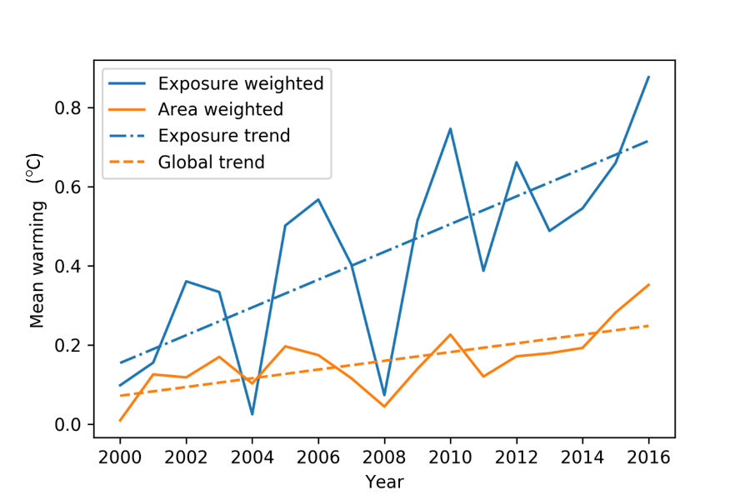
Figure 1.1 Mean summer warming from 2000 to 2016 area weighted and exposure weighted, relative to the 1986-2008 recent past average.

Indicator 1.2: Health effects of heatwaves
Headline Finding: Between 2000 and 2016, the number of vulnerable people exposed to heatwave events has increased by approximately 125 million, with a record 175 million more people exposed to heatwaves in 2015.
The health impacts of extremes of heat range from direct heat stress and heat stroke, through to exacerbations of pre-existing heart failure, and even an increased incidence of acute kidney injury resulting from dehydration in vulnerable populations. The elderly, children under the age of 12 months, and people with chronic cardiovascular and renal disease are particularly sensitive to these changes.¹⁰
Here, a heatwave is defined as a period of more than 3 days where the minimum temperature is greater than the 99th percentile of the historical minima (1986-2008 average).¹⁸ This metric therefore focuses on periods of high night-time temperatures, which are critical in denying vulnerable people vital recuperation between hot days. Heatwave data were calculated against the historical period 1986-2008. The population for the exposure calculations was limited to people over the age of 65 (as this age group is most vulnerable to the health impacts of heatwaves), which was obtained on a per-country basis from the UN World Population Prospects archives for each year considered.
Figure 1.2 shows the increase in total exposure to heatwaves over the 2000-2016 period (one heatwave experienced by one person). In 2015, the highest number of exposure events was recorded, with approximately 175 million additional people exposed to heatwaves. Figure 1.3 shows how the mean number of heatwave days experienced by people during any one heatwave (exposure-weighted) increases at a much faster rate than the global mean (area-weighted) number of heatwave days per heatwave; this is due to high populations densities in areas where heatwaves have occurred.

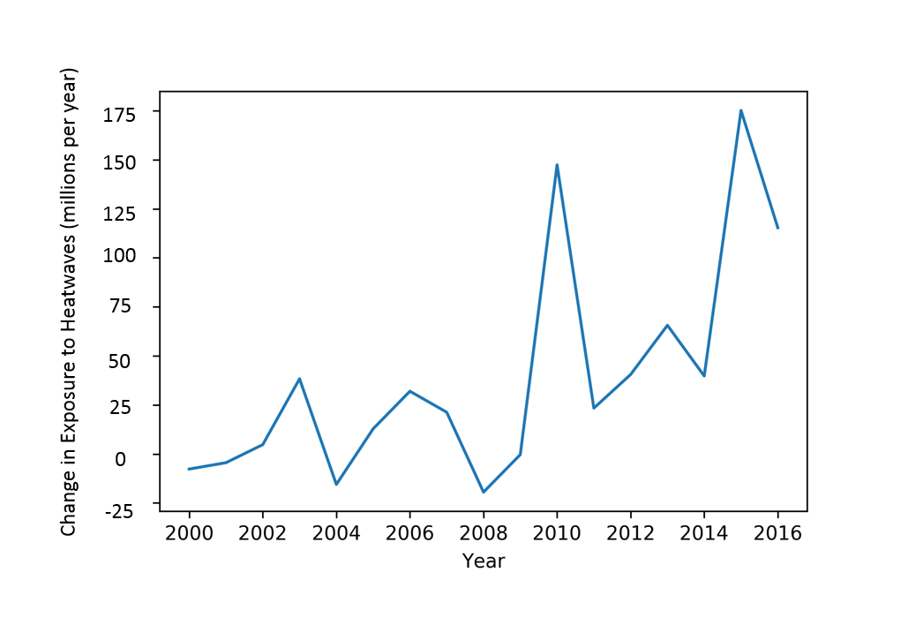
Figure 1.2 The change in exposure (in people aged over 65 years) to heatwaves from 2000 to 2016, relative to the heatwave exposure average from 1986-2008.

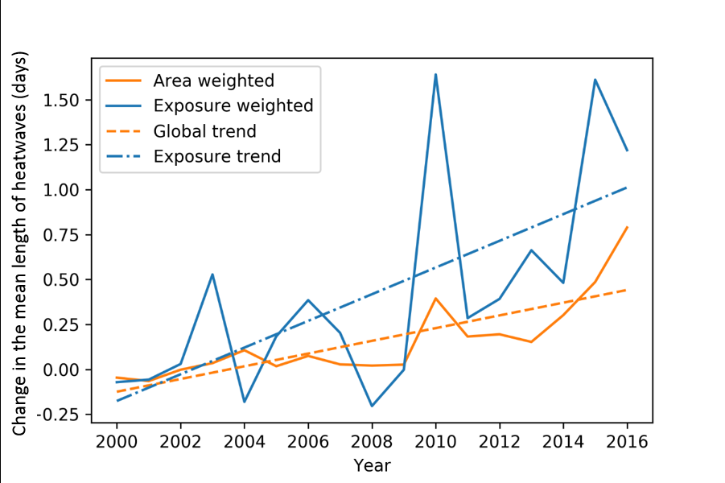
Figure 1.3 The area and exposure weighted change in mean heatwave lengths globally from 2000 to 2016 (in people aged over 65 years), relative to the 1986-2008 recent past average.

Indicator 1.3: Change in labour capacity
Headline Finding: Global labour capacity in populations exposed to temperature change is estimated to have decreased by 5.3% from 2000 to 2016.
Higher temperatures pose significant threats to occupational health and labour productivity, particularly for those undertaking manual labour outside in hot areas. This indicator shows the change in labour capacity (and thus productivity) globally and specifically for rural regions, weighted by population (see Appendix 2 for details). Reductions in labour capacity have important implications for the livelihoods of individuals, families, and communities, with particular impacts on those relying on subsistence farming.
Labour capacity was estimated in the manner documented by Watts et al. (2015), based on wet bulb globe temperatures.⁴ Figure 1.4 shows the estimated change in outdoor labour productivity represented as a percentage relative to the reference period (1986-2008), with 0% implying no change. Labour capacity is estimated to have decreased by 5.3% between 2000 and 2016, with a dramatic decrease of over 2% between 2015 and 2016. Although there are some peaks of increased labour capacity (notably 2000, 2004 and 2008), the overwhelming trend is one of reduced capacity (Figure 1.4). These effects are most notable in some of the most vulnerable countries in the world (Figure 1.5).
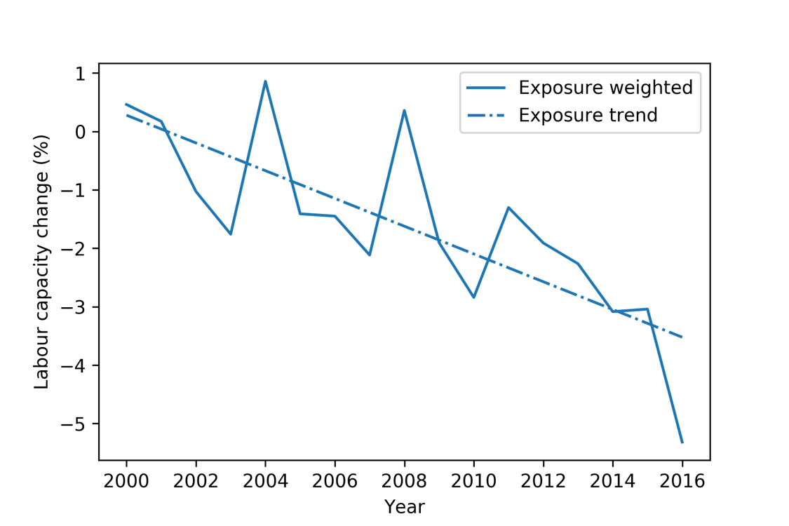
Figure 1.4 The exposure weighted labour capacity change (%) globally from 2000 to 2016, relative to the recent past (1986-2008) average

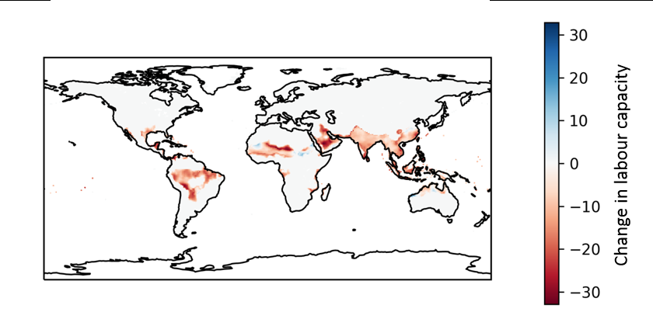
Figure 1.5 Map of the change in labour capacity loss from 2000 to 2016, relative to the recent past (1986-2008) average.

This indicator currently only captures the effects of heat on rural labour capacity. The Lancet Countdown will work to expand this metric in the future to capture impacts on labour capacity in other sectors, including manufacturing, construction, transportation, tourism and agriculture. Through collaboration with HEAT-SHIELD, the Lancet Countdown will work to develop this process going forward, providing more detailed analysis of labour capacity loss and the health implications of heat and heatwaves, globally.^{19,20}

Indicator 1.4: Lethality of weather-related disasters
Headline Finding: Despite a 46% increase in annual weather-related disasters from 2007 to 2016, compared with the 1990-1999 average, there has been no accompanying increase in the number of deaths, nor in those affected by disasters, nor in the ratio of these two outcomes.
Weather-related events have been associated with over 90% of all disasters worldwide over the last twenty years. As expected, considering its population and area, the continent most affected by weather-related disasters is Asia, with some 2,843 events between 1990-2016 affecting 4.8 billion people and killing 505,013. Deaths from natural hazard-related disasters are largely concentrated in poorer countries.²¹ Crucially, this must be understood in the context of potentially overwhelming health impacts of future climate change, worsening significantly over the coming years. Indeed, the 2015 Lancet Commission estimated an additional 1.4 billion drought exposure events, and 2.3 billion flood exposure events occurring by the end of the century – demonstrating clear public health limits to adaptation.⁴
Disaster impact is a function of hazard and vulnerability, with vulnerability from a climate change perspective sometimes defined as a function of exposure, sensitivity, and adaptive capacity.²² This indicator measures the ratio of the number of deaths, to the number of people affected by weather-related disasters. Weather-related disasters included are: droughts, floods, extreme temperature events, storms and wildfires. The health impacts of weather-related disasters expand beyond mortality alone, including injuries, mental health impacts, spread of disease, and food and water insecurity. Data for the calculations for this indicator come from the Emergency Events Database (EM-DAT).^{23,24} Here, in line with the EM-DAT data used for analysis, a disaster is defined as either: 1) 10 or more people reported killed, 2) 100 or more people affected, 3) a declaration of a state of emergency, or 4) a call for international assistance.
Between 1994 and 2013, the frequency of reported weather-related events (mainly floods and storms) increased significantly. However, this trend may be partially accounted for by information systems having improved in the last 35 years, and statistical data are now more available as a result of increased socio-cultural sensitivity to disaster consequences and occurrence.²⁵ From 2007 to 2016, EM-DAT recorded an average of 306 weather-related disasters per annum, up 46% from the 1990-1999 average. However, owing to impressive poverty reduction and health adaptation efforts, this has not yet been accompanied by any discernible trend in number of deaths, nor in those affected by disasters, nor in the ratio of these two (Figure 1.6a). Indeed, separating out the disasters by the type of climate and weather hazard associated with the disaster (Figure 1.6b) shows there has been a statistically significant global decrease in the numbers affected by floods, equating to a decrease of 3 million people annually. Importantly, best available estimates and projections expect a sharp reversal in these trends over the coming decades, and it is notable that a number of countries have experienced increases in deaths associated with weather-related disasters, with many of these being high-income countries, illustrating that no country is immune to the impacts of climate change (see Appendix 2 for more details).A
a) 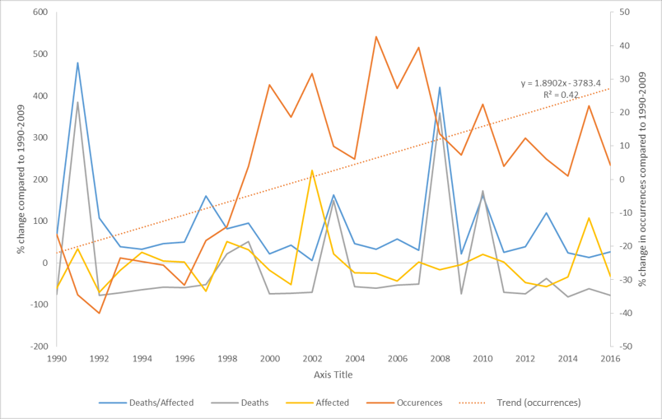
b) 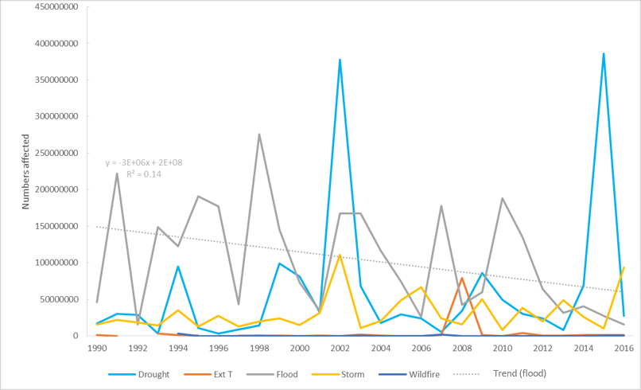
Figure 1.6 Deaths and people affected by weather-related disasters. 1.6a) Percentage change over time in the global number of deaths, the number of those affected, and the ratio of these (measured against 1990-2009). 1.6b) Change over time in the number of people affected globally by different weather-related disasters.

The relative stability of the number of deaths in a disaster as a proportion of those affected, despite an increase in the number of disasters, could be interpreted in a number of ways. One plausible conclusion is that this represents an increase in health service provision and risk reduction. However, although weather-related disasters have increased in number over the past three to four decades, the data here does not capture the severity of such events – a factor directly relevant to a country’s vulnerability and ability to adapt.²²It is also important to note the difficulties in discerning overall trends, owing to the stochastic nature of the data and the relatively short time series. This poses limitation on the significance of findings that can be drawn from analysis to date. Improving the validity of this indicator will be a focus going forward.

Indicator 1.5: Global health trends in climate-sensitive diseases
Headline Finding: Global health initiatives have overwhelmingly decreased deaths associated with climate-sensitive diseases since 1990, owing to important economic and public health advances over the last three decades.
Disease occurrence is determined by a complex composite of social and environmental conditions and health service provision, all of which vary geographically. Nonetheless, some diseases are particularly sensitive to variations in climate and weather, and may thus be expected to vary with both longer-term climate change and shorter-term extreme weather events.¹⁰ This indicator draws from Global Burden of Disease (GBD) mortality estimates to show trends in deaths associated with seven climate-sensitive diseases since 1990 (Figure 1.7).²⁷
Figure 1.7 Trends in mortality from selected causes of death as estimated by the Global Burden of Disease 2015, for the period 1990 to 2015, by WHO region.²⁷ (Created using Global Burden of Disease, 2016 data).
The disease trends above reveal global increases in dengue mortality, particularly in the Asia-Pacific and Latin America and Caribbean regions, with some peak years (including 1998) known to be associated with El Niño conditions.²⁸ Beyond climate, likely drivers of dengue mortality include trade, urbanization, global and local mobility and climate variability; the association between increased dengue mortality and climate change is therefore complex.²⁹ It naturally follows that an increase spread of the disease resulting from climate change will be a significant contributing factor in the increased likelihood of an associated increase in mortality. Malignant melanoma is a distinctive example of a non-communicable disease with a clear link to ultraviolet exposure, with mortality increasing steadily despite advances in surveillance and treatment; although it is important to recognise that increased exposures also occur as a result of changing lifestyles (for example, a rise in sun tanning). Heat and cold exposure is a potentially important aspect of climate-influenced mortality, although the underlying attribution of deaths to these causes in the estimates is uncertain.³⁰⁻³⁵ Deaths directly related to forces of nature have been adjusted for the effects of the most severe seismic events. Of the ten highest country-year mortality estimates due to forces of nature, seven were directly due to specific seismic activity, and these have been discounted by replacing with the same countries’ force of nature mortality for the following year. The remaining major peaks relate to three extreme weather events (Bangladesh cyclone of 1991, Venezuela floods and mudslides of 1999 and Myanmar cyclone of 2008), which accounted for over 300,000 deaths.
Overall, the findings here highlight the effectiveness and success of global health initiatives since 1990, in largely reducing deaths associated with these diseases. Furthermore, these trends provide a proxy for the global health profile of climate-sensitive diseases and thus to some degree, indication of existing vulnerabilities and exposures to them.

Indicator 1.6: Climate-sensitive infectious diseases
Headline Finding: Vectorial capacity for the transmission of dengue by the mosquito vectors Aedes aeqypti and Aedes albopictus in regions where these vectors are currently present has increased globally due to climate trends by an average of 3% and 5.9%, respectively, compared to 1990 levels, and by 9.4% and 11.1%, respectively, compared to 1950s levels.
Despite a declining overall trend, infectious diseases still account for around 20% of the global burden of disease and underpin more than 80% of international health hazards as classified by the World Health Organization (WHO).^{36,37} Climatic factors are routinely implicated in the epidemiology of infectious diseases, and they often interact with other factors, including behavioural, demographic, socio-economic, topographic and other environmental factors, to influence infectious disease emergence, distribution, incidence and burden.^{2,38} Understanding the contribution of climate change to infectious disease risk is thus complex, but necessary for advancing climate change mitigation and adaptation policies.¹⁴ This indicator is split into two components: a systematic literature review of the links between climate change and infectious diseases, and a vectorial capacity model for the transmission of dengue virus by the climate-sensitive vectors.
For the first component, a systematic review of the climate change infectious disease literature was performed (see Appendix 2 for details), in which trends in the evolution of knowledge and direction of impact of climate change disease risk associations were measured (Figure 1.8). The number of new publications fitting the search criteria in 2016 (n=89) was the highest yet reported, almost double the number published in 2015 (n=50) and more than triple the number published in 2014 (n=25) (Figure 1.8, left). Over this period, the complexity of interactions between climate change and infectious disease has been increasingly recognised and understood (Figure 1.8, right).

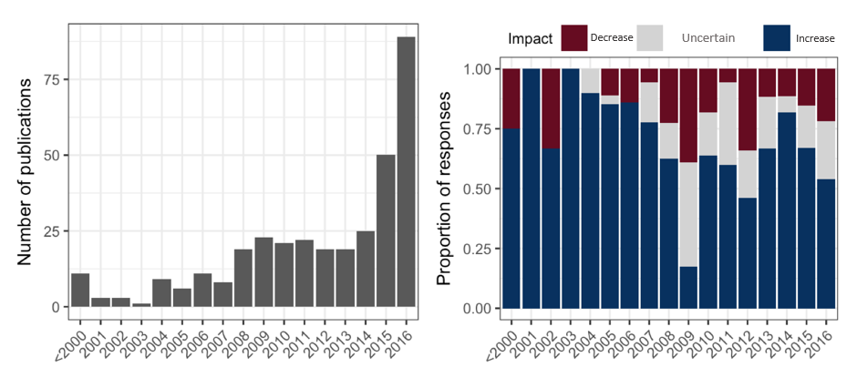
Figure 1.8 Left: Academic publications reporting climate-sensitive infectious diseases by year. Right: proportion of responses reported in publications by year and direction of impact.

Trends in the global potential for dengue virus transmission (as represented by vectorial capacity (VC) in the mosquito vectors Aedes aeqypti and Aedes albopictus) are presented. VC is “the rate (usually daily) at which a bloodsucking insect population generates new inoculations from a currently infectious case”.³⁹ A global, mechanistic investigation was conducted of changes in annual transmission potential for a model, high burden, climate-sensitive vector-borne disease, dengue fever (Figure 1.9). For both vectors, VC in locations where these vectors are currently present reached its highest or equal highest average level in 2015 over the period considered (Figure 1.9, bottom panel). This consolidates a clear and significant increase in VC starting in the late 1970s (+3.0% and +6.0% compared to 1990 levels for A. aegypti and A. albopictus, respectively). Nearly all Aedes-positive countries showed relative increases in VC for both vectors over the period considered (Figure 1.9, top panel). Annual numbers of cases of dengue have doubled every decade since 1990, with 58.4 million (23.6 million–121.9 million) apparent cases in 2013, accounting for over 10,000 deaths and 1.14 million (0.73 million–1.98 million) disability-adjusted life-years.⁴⁰ Climate change has been suggested as one potential contributor to this increase in burden.⁴¹ Aedes aegypti and Aedes albopictus, the principal vectors of dengue, also carry other important emerging or re-emerging arboviruses, including Yellow Fever, Chikungunya, Mayaro and Zika viruses, which are likely similarly responsive to climate change.
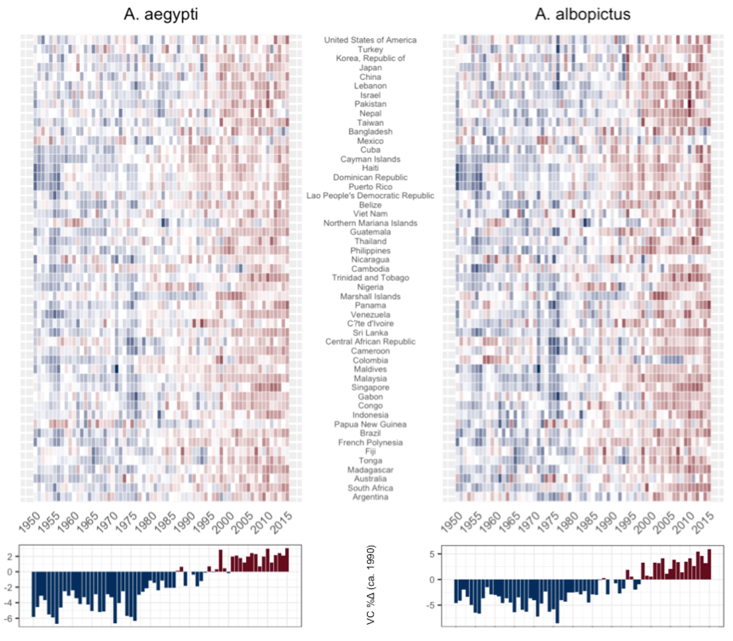
Figure 1.9 Average annual vectorial capacity (VC) for dengue in Aedes aegypti and Aedes albopictus for selected Aedes-positive countries (countries with Aedes present) (top panel; matrix coloured relative to country mean 1950-2015; red = relatively higher VC, blue = relatively lower VC; countries ordered by centroid latitude (north to south)). Bottom panel: average vectorial capacity (VC) for both vectors calculated globally (results shown relative to 1990 baseline).

Indicator 1.7: Food security and undernutrition
Isolating the impact of climate change on health through the indirect impacts on food security is complicated, as policies, institutions, and the actions of individuals, organisations, and countries, strongly influence the extent to which food systems are resilient to climate hazards or can adapt to climate change, and whether individual households are able to access and afford sufficient nutritious food. For example, with respect to undernourishment, vulnerability has been shown to be more dependent on adaptive capacity (such as infrastructure and markets) and sensitivity (such as forest cover and rain-fed agriculture) than exposure (such as temperature change, droughts, floods, storms).⁴² Given the role of human systems in mediating the links between climate, food, and health, the chosen indicators focus on abiotic and biotic indicators and current population vulnerabilities, considering both terrestrial and marine ecosystems. Undernutrition has been identified as the largest health impact of climate change in the 21st century.^{10,43-46}

Indicator 1.7.1: Vulnerability to undernutrition
Headline Finding: The number of undernourished people in the 30 countries located in Africa and Southern Asia with the highest prevalence (>15%) has increased from 398 million in 1990 to 422 million in 2016. These are countries located in regions which are highly dependent on regional production for their food needs and where climate change is predicted to have the greatest negative impact on yields.
The purpose of this indicator is to track the extent to which health will be compromised by climate change in countries where both current dependence on domestic production of food, and current level of undernourishment (which is strongly related to undernutrition) is already high. Climate change could further compromise health through changes in localised temperature and precipitation, manifested in falling yields.
Food markets are increasingly globalised, and food security is increasingly driven by human systems. In response to falling yields caused by temperature increases, governments, communities, and organisations can and will undertake adaptation activities that might variously include breeding programmes, expansion of farmland, increased irrigation, or switching crops. However, the greater the loss of yield potential due to temperature increases, the more difficult adaptation becomes for populations dependent upon domestic food supply.
Rising temperatures have been shown to reduce global wheat production, which has been estimated to fall 6% for each degree Celsius of additional temperature increase.⁴⁷⁻⁴⁹ Rice yields are sensitive to higher night temperatures, with each 1°C increase in growing-season minimum temperature in the dry season resulting in a fall in rice grain yield of 10%.⁵⁰ Higher temperatures have been demonstrated rigorously to have a negative impact on crop yields in lower-latitude countries.⁵¹⁻⁵³ Moreover, agriculture in lower-latitudes tends to be more marginal, and more people are food insecure.
This indicator, using data from the Food and Agriculture Organization of the United Nations (FAO), focuses on vulnerability to undernutrition.⁵⁴ Countries are selected for inclusion based on three criteria: the presence of moderate or high level of undernourishment, reflecting vulnerability; their physical location, focusing on geographies where a changing climate is predicted with high confidence to have a negative impact on the yields to staples produced; and dependence on regional production for at least half of its cereal consumption, reflecting high exposure to localised climate hazards. Based on these criteria, 30 countries, all located in Africa or Southern Asia, are included. Figure 1.10 presents the aggregated indicators, which shows the total number within the population undernourished in these 30 countries, multiplied by total dependence on regional production of grains. This gives a measure of how exposed already undernourished populations, who are highly dependent on regionally produced grains, are to localized climate hazards.

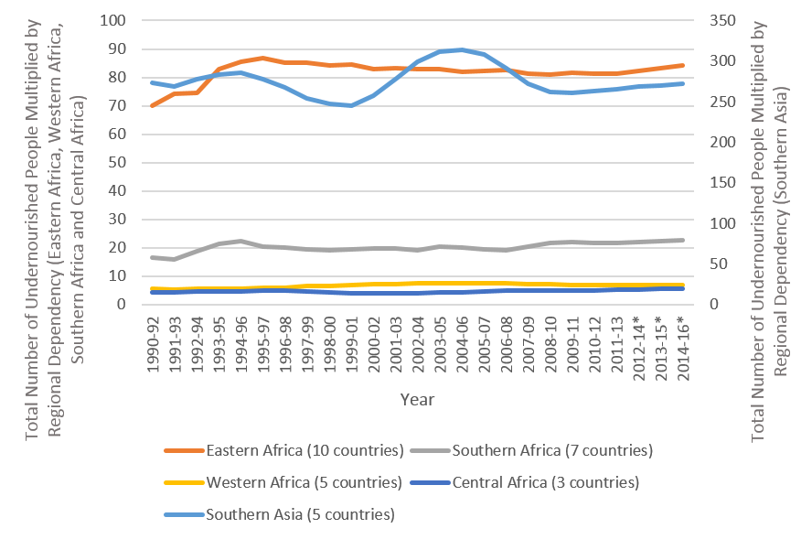
Figure 1.10 Total number of undernourished people multiplied by regional dependency on grain production for countries.
The regions with the highest vulnerability to undernutrition also coincide with areas where yield losses due to warming are predicted to be relatively high, thus increasing the vulnerability of these populations to the negative health consequences of undernutrition. High dependence on one crop increases the vulnerability of individual countries further. For example, Kenya, which has a domestic production dependency for cereals of almost 80%, 69% dependent on maize, is experiencing high levels of undernutrition, and is particularly vulnerable to climate-related yield losses. Going forward, these data will be refined through country-level exploration, incorporation of the predicted impact of warming on yield losses, and incorporation of key temperature indicators such as ‘growing degree days’ above critical crop-specific thresholds.^{55,56}

Indicator 1.7.2: Marine primary productivity
Declining fish consumption provides an indication of food insecurity, especially in local shoreline communities dependent upon marine sources for food, and hence are especially vulnerable to any declines in marine primary productivity affecting fish stocks.⁵⁷ This is particularly concerning for the 1 billion people around the world who rely on fish as their principal source of protein, placing them at increased risk of stunting (prevented from growing or developing properly) and malnutrition from food insecurity.⁵⁸ In addition, fish are important for providing micronutrients, such as zinc, iron, vitamin A, vitamin B12, and Omega-3 fatty acids. If current fish declines continue, as many as 1.4 billion people are estimated to become deficient and at elevated risk of certain diseases, particularly those associated with the cardiovascular system.^{59,60}
Marine primary productivity is determined by abiotic and biotic factors; measuring these globally and identifying relevant marine basins is complex. Factors such as sea surface temperature (SST), sea surface salinity (SSS), coral bleaching and phytoplankton numbers are key determinants of marine primary productivity. Other local determinants have particularly strong influences on marine primary productivity. For example, harmful algal blooms (HAB) occur as a result of uncontrolled algal growth producing deadly toxins. The consumption of seafood contaminated with the toxins of harmful algal blooms, such as those produced by Alexandrium tamarense, is often very dangerous to human health, and potentially fatal.⁶¹
Changes in SST and SSS from 1985 to present, for twelve fishery locations essential for aquatic food security are presented here. Data was obtained from NASA’s Earth Observatory Databank, and mapped across to the significant basins outlined in Appendix 2. From 1985 to 2016, a 1ºC increase in SST (from an annual average of 22.74ºC to 23.73ºC) was recorded in these locations.⁶² This indicator requires significant further work to draw out the attribution to climate change and the health outcomes that may result. A case study on food security and fish stocks in the Persian Gulf is presented in Appendix 2.

Indicator 1.8: Migration and population displacement
Headline Finding: Climate change is the sole contributing factor for at least 4,400 people already being forced to migrate, globally. The total number for which climate change is a significant or deciding factor is significantly higher.
Climate change-induced migration may occur through a variety of different social and political pathways, ranging from sea level rise and coastal erosion, through to changes in extremes and averages of precipitation and temperature decreasing the arability of land and exacerbating food and water security issues. Estimates of future “climate change migrants” up to 2050 vary widely, from 25 million to 1 billion.⁶³ Such variation indicates the complexity of the multi-factorial nature of human migration, which depends on an interaction of local environmental, social, economic, and political factors. For example, in Syria, many attribute the initial and continued conflict to the rural-to-urban migration that resulted from a climate change-induced drought.^{64,65} However, the factors leading to the violence are wide-ranging and complex, with clear quantifiable attribution particularly challenging. Indeed, climate change is often thought of as playing an important role in exacerbating the likelihood of conflict, and as a threat multiplier and an accelerant of instability. Nonetheless, migration driven by climate change has potentially severe impacts on mental and physical health, both directly and through the disruption of essential health and social services.⁶⁶
Despite the methodological difficulties in proving a direct causal relationship between climate change and population displacement, there are areas where this is methodologically possible. This indicator focuses on these situations, attempting to isolate instances (as exemplars) where climate change is the sole contributory factor in migration decisions. Sea level rise provides the clearest example of this, although other examples exist as shown in Table 1.1. Estimating the number of people who have involuntarily migrated (both internally and internationally) as a result of climate change alone helps overcome the complexity of accounting for other societal, economic and environmental factors that also influence migration.
Based on data derived from peer-reviewed academic publications (see Appendix 2 for full details). A minimum of 4,400 people have been forced to migrate due solely to climate change (Table 1.1). This will be an underestimate, as it excludes cases where more than one factor may be contributing to a migration decision – such as a combination of both climate-related sea level rise and coastal erosion not associated with climate change (possibly such as the village of Vunidogola, relocated by the Fijian Government in 2014 for such reasons, and the planned relocation of the Fijian village of Narikoso by 2018).⁶⁷⁻⁶⁹

Location | Population | Citation | Notes on causes
Carteret Islands, PNG | 1,200 | Connell (2016)⁷⁰  Strauss (2012)⁷¹ | Migrating due to sea-level rise
Alaska (need to migrate as soon as possible)* |  | Bronen and Chapin III (2013)⁷²  Shearer (2012)⁷³ | Migrating due to changing ice conditions leading to coastal erosion and due to permafrost melt, destabilising infrastructure
Kivalina | 398-400 | Bronen and Chapin III (2013)⁷²  Shearer (2012)⁷³
Newtok | 353 | Bronen and Chapin III (2013)⁷²  Shearer (2012)⁷³
Shaktoolik | 214 | Bronen and Chapin III (2013)⁷²  Shearer (2012)⁷³
Shismaref | 609 | Bronen and Chapin III (2013)⁷²  Shearer (2012)⁷³
Alaska (need to migrate gradually)* |  | Bronen and Chapin III (2013)⁷² | Migrating due to changing ice conditions leading to coastal erosion and due to permafrost melt, destabilising infrastructure
Allakaket | 95 | Bronen and Chapin III (2013)⁷²
Golovin | 167 | Bronen and Chapin III (2013)⁷²
Hughes | 76 | Bronen and Chapin III (2013)⁷²
Huslia | 255 | Bronen and Chapin III (2013)⁷²
Koyukuk | 89 | Bronen and Chapin III (2013)⁷²
Nulato | 274 | Bronen and Chapin III (2013)⁷²
Teller | 256 | Bronen and Chapin III (2013)⁷²
Unalakleet | 724 | Bronen and Chapin III (2013)⁷²
Isle de Jean Charles, Louisiana | 25 homes |  | Coastal erosion, wetland loss, reduced accretion, barrier island erosion, subsidence, and saltwater intrusion were caused by dredging, dikes, levees, controlling the Mississippi River, and agricultural practices. Climate change is now bringing sea-level rise
Table 1.1 Locations migrating now due to only climate change. *The village names and populations are sourced from the US Government Accountability Office’s report, “Alaska Native Villages: Limited Progress Has Been Made on Relocating Villages Threatened by Flooding and Erosion”.⁷⁰⁻⁷³

Over the long-term, human exposure and vulnerability to ice sheet collapse is increasing, as the number of people living close to the coast and at elevations close to sea level are also increasing. In 1990, 450 million people lived within 20 km of the coast and less than 20 metres above sea level.⁷⁴ In 2000, 634 million (~10% of the global population), of whom 360 million are urban, lived below 10 metres above sea level, (the highest vertical resolution investigated).⁷⁵ With 2000 as a baseline, the population living below 10 metres above sea level will rise from 634 million to 1,005-1,091 million by 2050 and 830-1,184 million by 2100.⁷⁶ From 2100 and beyond, without mitigation and adaptation interventions, over one billion people may need to migrate due to sea level rise caused by any ice sheet collapse which occurs.^{76,77}
Whilst this indicator is not yet able to capture the true number of people being forced to migrate due to climate change, that at least 4,400 people are already being forced to migrate as a result of climate change only is concerning and demonstrates that there are limits to adaptation. The fact that this is a significant underestimate further highlights the need to mitigate climate change and improve the adaptive capacity of populations to reduce future forced migration. Significantly, only instances of migration where climate change is isolated as the only factor are captured. Moving forward, new approaches will be required to more accurately reflect the number of people forced to migrate due to climate change, looking to capture situations where climate change plays an important contributory role alongside other social and economic considerations.

Conclusion
Climate change impacts health through diverse direct and indirect mechanisms. The indicators captured here provide an overview of a number of these effects, capturing exposure, impact, and underlying vulnerabilities. Going forward, indicators will be developed to better measure direct health outcome from climate change, in addition to exposure and vulnerabilities.
The indicators presented here will be continuously developed over time in order to more directly capture mortality and morbidity outcomes from communicable and non-communicable diseases. Indeed, work is already underway to produce new indicators to capture these concepts for subsequent reports. Panel 1.1 and Appendix 2 describe one such ongoing process focused on mental health and climate change.
Adaptation pathways can help to minimise some of the negative health impacts of global warming, especially for the lower range of projected average temperature rises. However, there are powerful limits to adaptation, and this section has drawn attention to the non-linearity and the spatial distribution of the health impacts of climate change. The indicators presented here demonstrate clearly that these impacts are being experienced across the world today, and provide a strong imperative for both adaptation and mitigation interventions to protect and promote public health.

Panel 1.1 Mental Health and Climate Change
Measuring progress in the effects of climate change on mental health and wellbeing is difficult. Whilst this is partly due to problems of attribution, the main measurement difficulty lies in the inherently complicated nature of mental health, which embraces a diverse array of outcomes (for instance, anxiety and mood disorders), many of which co-occur and all of which vary over contexts and lifetimes. They are products of long and complex causal pathways, many of which can be traced back to distal but potent root causes, such as famine, war and poverty, of which climate change is both an example and an accelerator.⁷⁸
Mental health, with its inherent intricacy, is a field where systems thinking is likely to be particularly valuable. A first step, therefore, in tracking progress on mental health and climate change is to build a conceptual framework using systems thinking. Initial work in partnership with the University of Sydney has begun to trace through the many direct and indirect causal pathways, in order to aid the identification of indicators. A number of challenges (e.g. how to gather and interpret highly subjective measures across cultures and income settings) are immediately apparent. Whilst further work, and engagement with other partners will be required, potential indicators may focus on a range of issues, including: national and local mental health emergency response capacity to climate-related extreme events; the extent to which climate change is considered within national mental health strategies; or the social and psychological impact of uninsured economic losses that result from extreme weather events.

2. Adaptation Planning and Resilience for Health

Introduction

Climate change adaptation is defined by the IPCC as the “adjustment in natural or human systems in response to actual or expected climatic stimuli or their effects, which moderates harm or exploits beneficial opportunities”.⁸⁰ With respect to health, adaptation consists of efforts to reduce injury, illness, disability, and suffering from climate-related causes. Resilience has been defined as “the capacity of individuals, communities and systems to survive, adapt, and grow in the face of stress and shocks, and even transform when conditions require it”.⁸¹ In the context of climate change and health, resilience is an attribute of individuals, communities, and health care systems; resilience at all levels can reduce adverse health outcomes of climate change and should be a goal of adaptation planning.
Indicators of resilience and adaptation are challenging to identify. Resilience is related to preparedness, response, resource management and coordination capacity, but it is not synonymous with them. Understanding the current resilience of a population’s health and health systems provides some indication of resilience to climate change, although direct indicators measuring this have not yet been developed by the Lancet Countdown. The indicators presented here are predominantly process-based, focusing on health adaptation planning, capacity, and response. Whilst the underlying resilience of communities is present to some extent in all of the indicators in this section, it is currently only captured directly for health systems, and hence most indicators that follow will focus more specifically on health adaptation.

The indicators presented here are:
2.1 National adaptation plans for health
2.2 City-level climate change risk assessments
2.3 Detection and early warning of, preparedness for, and response to health emergencies
2.4 Climate information services for health
2.5 National assessment of vulnerability, impacts and adaptation for health
2.6 Climate-resilience health infrastructure

Corresponding Appendix 3 provides more detailed discussion of the data and methods used.

Indicator 2.1: National adaptation plans for health
Headline finding: 30 out of 40 responding countries have a national health adaptation plan or strategy approved by the relevant national health authority.
Effective national responses to climate risks require that the health sector identify strategic goals in response to anticipated – and unanticipated – threats. A critical step in achieving these strategic goals is the development of a national health adaptation plan, outlining priority actions, resource requirements and a specific timeline and process for implementation. This indicator tracks the policy commitments of national governments for health and climate change adaptation. Data are drawn from the recent WHO Climate and Health Country Survey (Panel 2.1).
Of the 40 countries responding to this baseline survey, 30 reported having a national adaptation strategy for health, approved by their Ministry of Health or relevant health authority (Figure 2.1). This number includes countries with a health component of their National Adaptation Plan (NAPs), which was established by the UNFCCC to help nations identity medium- and long-term adaptation needs and develop and implement programmes to address those needs.⁸² There is a need for caution in extrapolating the results to global level, as many of the respondent countries have received support from WHO in developing and implementing their plans.^{83,84} Nonetheless, with 75% of respondents in the survey having an approved national health adaptation plan there is evidence of the recognition of the need to adapt to climate change. Countries with national health adaptation plans are found across all regions and, perhaps most significantly, among some of the most vulnerable countries across Africa, South East Asia and South America. In future iterations of the survey, data will be gathered on the content and quality of these adaptation plans, their level of implementation, the main priorities for health adaptation, internal monitoring and review processes, and the level of funding available to support policy interventions.

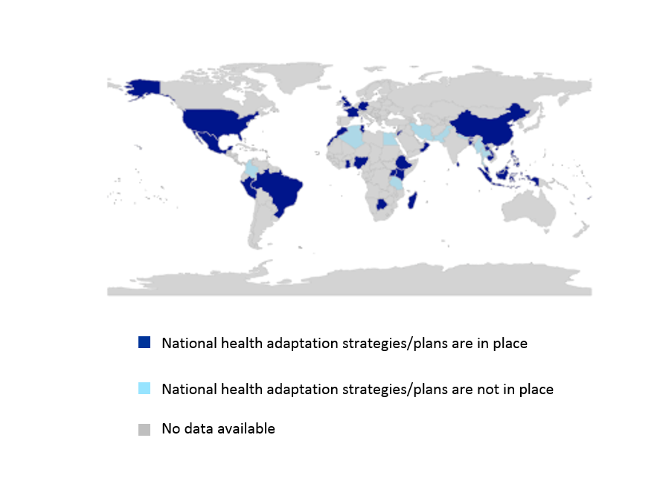
Figure 2.1 Countries with national heath climate adaptation strategies or plans.

Panel 2.1: WHO-UNFCCC Climate and Health Country Profiles.
The WHO-UNFCCC Climate and Health Country Profile Project forms the foundation of WHO’s national level provision of information, and monitoring of progress, in this field. The profiles, developed in collaboration with ministries of health and other health determining sectors, support evidence-based decision making to strengthen the climate resilience of health systems and promote actions that improve health while reducing carbon emissions. In part, the data used in the development of the climate and health country profiles is collected through a biennial WHO Climate and Health Country Survey. Data from this survey is reported on for indicators 2.1, 2.5 and 2.6
The 2015 baseline survey findings for 40 responding nations are presented in this report (for a complete list of country respondents, see Appendix 3). The findings include countries from all WHO regions (high, middle and low income groups) and with varying levels of risks and vulnerabilities to the health impacts of climate change. The 2015 survey data were validated as part of the national consultation process seeking input on respective WHO UNFCCC Climate and Health Country Profiles from key in-country stakeholders, including representatives of the Ministry of Health, Ministry of Environment, meteorological services and WHO country and regional technical officers.
The validated data presented in this report tended to include a high number of countries that are actively working on climate and health with WHO; as such, the results here are indicative and are not meant to be inferred as an exact indicator of global status. The number of country respondents is expected to double in subsequent iterations of the survey. As such, the results presented here represent the beginning of the development of a more comprehensive survey, presenting results available at the start of this process.

Indicator 2.2: City-level climate change risk assessments
Headline Finding: Of the 449 self-reporting cities, 45% have climate change risk assessments in place.
Globally, 54.5% of people live in cities, where key health infrastructure is often concentrated.⁸⁵ These urban centres are increasingly at risk from climate change, with negative impacts predicted for human health and health services. These risks require city-level responses to complement NAPs, in order to improve cities’ ability to adapt to climate change. Indeed, cities have a unique opportunity to provide adaptation measures that help improve the resilience of urban populations, whilst also helping mitigate the impacts of climate change on public health.⁸⁶
Data for this indicator comes from the 2016 global survey of the Compact of Mayors and the Carbon Disclosure Project (CDP).⁸⁷ ⁸⁸ Of the 449 cities with public responses (533 cities responded overall), 45% reported to “have undertaken a climate change risk or vulnerability assessment for [their] local government” (Figure 2.2).⁸⁹
The highest number of cities with climate change risk assessments are in high income countries (HICs) (118 cities), with only 42 cities in low-income countries. This partly reflects the fact that more cities in HICs were surveyed, and partly the fact that these cities have a greater capacity to develop such plans. There were a higher number of respondents from cities in HICs compared with low income (236 versus 61).
European cities in this survey have the highest number of climate change risk assessments (56 cities), representing 83% of European cities surveyed. Conversely, only 28% of surveyed African cities have climate change risk assessments. This has serious implications for the adaptive capacity of some of the most vulnerable populations to climate change in low income countries. A concerted effort must be made to increase the number of climate change risk assessment in cities in low-income countries, in order to better understand their vulnerability to climate change impacts and implement adaptation actions.
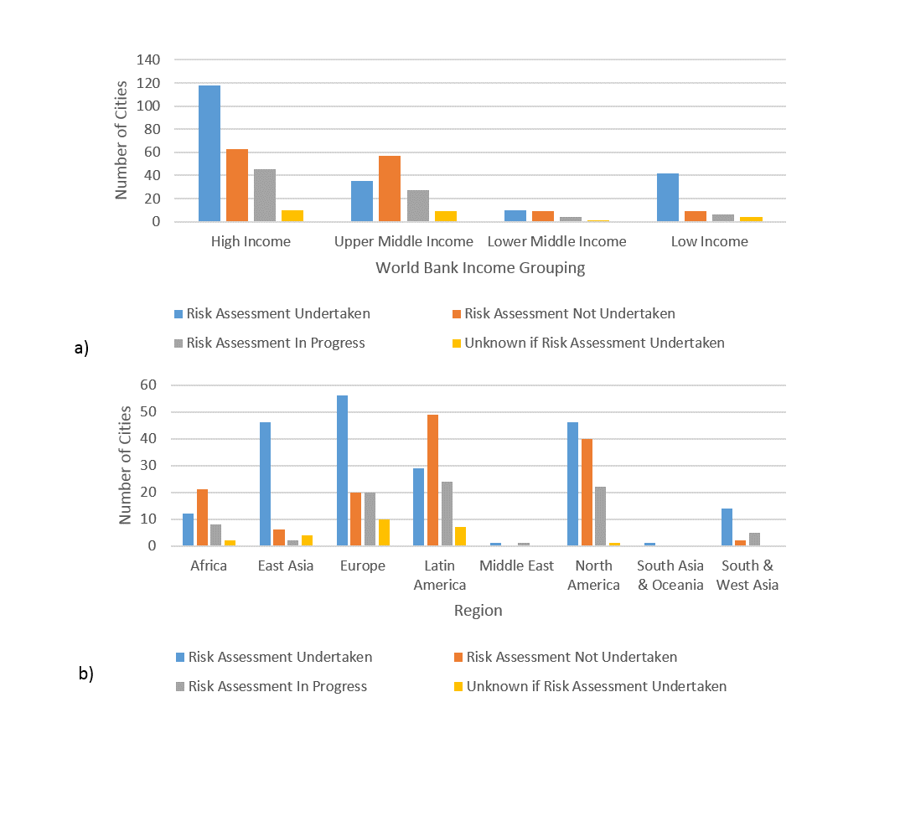
Figure 2.2 Number of global cities undertaking climate change risk assessments by a) income grouping, and b) WHO region.

Indicator 2.3: Detection and early warning of, preparedness for, and response to climate related health emergencies
Headline Finding: Due to focused investment in the implementation of the International Health Regulations (2005), national capacities relevant to climate adaptation and resilience, including disease surveillance and early detection, multi-hazard public health emergency preparedness and response, and the associated human resources to perform these public health functions, have increased markedly from 2010 to 2016 in all world regions.
Many initiatives at community, national, regional and global levels support strengthening country capacities for health emergency and disaster risk management and complement the implementation of the Sendai Framework for Disaster Risk Reduction, Sustainable Development Goal 3D, the Paris Agreement on Climate Change and the International Health Regulations (2005). Under the International Health Regulations (IHR (2005)), all States Parties should report to the World Health Assembly annually on the implementation of IHR (2005).^{91,92} In order to facilitate this process, WHO developed an IHR Monitoring questionnaire, interpreting the Core Capacity Requirements in Annex 1 of IHR (2005) into 20 indicators for 13 capacities (Panel 2.2). These metrics can serve as important proxies of health system adaptive capacity and system resilience, since they measure the extent to which health systems demonstrate a range of attributes necessary to detect, prepare for and respond to public health emergencies, some of which are climate sensitive. Four capacities reflecting seven indicators from IHR Monitoring questionnaire are reported here: surveillance, preparedness, response, and human resources. Additional details of all four of these IHR Capacities can be found in Appendix 3.
Panel 2.2: The International Health Regulations (2005).
The current IHR (2005), which entered into force in 2007, is legally binding on 196 States Parties, including all WHO member states. It requires States Parties to detect, assess, notify and report, and respond promptly and effectively to public health risks and public health emergencies of international concern (IHR Article 5, 13) and to develop, strengthen and maintain the capacity to perform these functions (IHR Article 5). Examples of required core capacities include national legislation, policy and financing; public health surveillance; preparedness and response; risk communication; human resources; and laboratory services. Under the International Health Regulations (IHR (2005)), all States Parties should report to the World Health Assembly annually on the implementation of IHR (2005). In order to facilitate this process, WHO developed an IHR Monitoring questionnaire.⁹³ The method of estimation calculates the proportion/percentage of attributes (a set of specific elements or functions that reflect the performance or development of a specific indicator) reported to be in place in a country. Since 2010, 195 States Parties have submitted self-reports at least once. Indicator 2.3 is drawn from the results of these questionnaires to which 129 of 196 States Parties responded in 2016.⁹⁴

The first of these capacities is human resources, which reflects a single indicator: ‘human resources available to implement the International Health Regulations Core Capacities’. This is a useful proxy in lieu of an indicator that looks at specific capacity for health adaptation to climate change (Figure 2.3a). In 2010, capacity scores ranged from 25% in Africa to 57% in Western Pacific. Human resource capacity has improved markedly by 2016, where on the average the capacity score is 67% (with the lowest score in the Africa region reporting 51% and the highest in the Western Pacific Region 89%).
Secondly, surveillance capacity, summarizes two indicators in the IHR questionnaire ‘Indicator-based surveillance includes an early warning function for early detection of a public health event’, and ‘Event-Based Surveillance is established and functioning’. This capacity score is used as a proxy for a health system’s ability to anticipate and identify outbreaks and changing patterns of climate-sensitive infectious diseases, such as zoonosis and food-related outbreaks. Globally, 129 reporting States Parties scored 88% for this capacity in 2016 (Figure 2.3b). This proportion has increased steadily since 2010 (average score of 63%), indicating that health systems have increasing capacity for early detection of public health events.
Thirdly, preparedness capacity reflects ‘Multi-hazard National Public Health Emergency Preparedness and Response Plan is developed and implemented’, comprised of the presence of a plan, the implementation of the plan, and the ability for this plan to operate under unexpected stress, and ‘priority public health risks and resources are mapped and utilized’. Of responding countries, progress can be seen in all world regions from 49% in 2010 to a 2016 global average of 76% (Figure 4.3c).
Finally, response capacity, reflects the availability and functioning of public health emergency response mechanisms, and Infection Prevention and Control (IPC) at national and hospital levels. This capacity is an important proxy for the ability of the health system to mobilize effective responses when shocks or stresses are detected. All countries demonstrate between 73-91% response capacity in 2016, with notable progress seen in Africa between 2010 (47%) and 2016 (73%) (Figure 2.3d).
a) 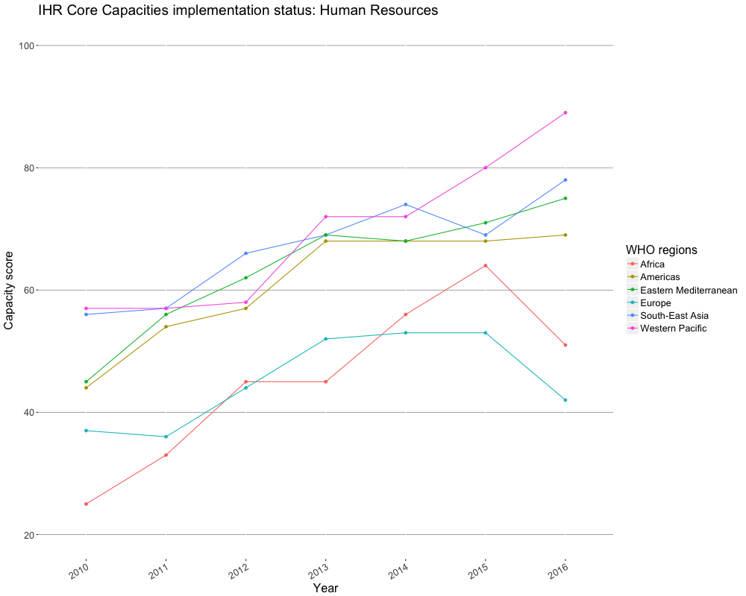
b) 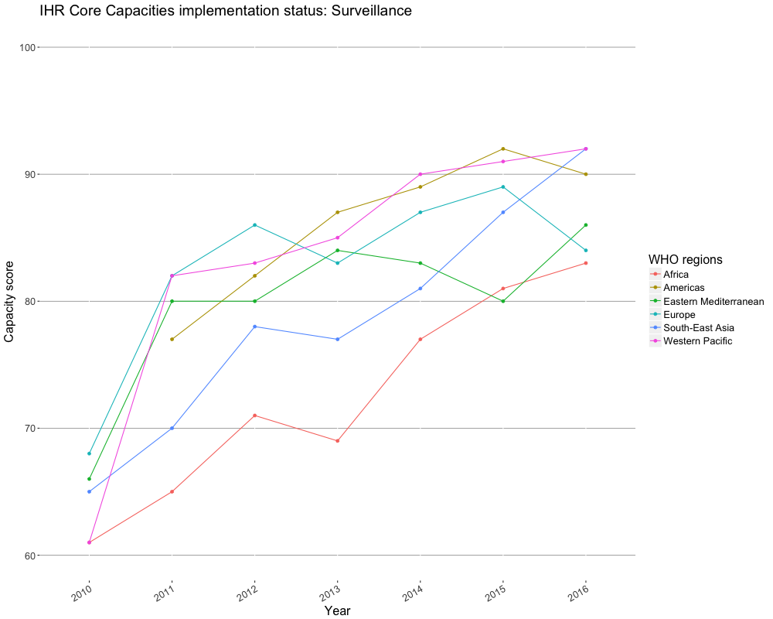
c) 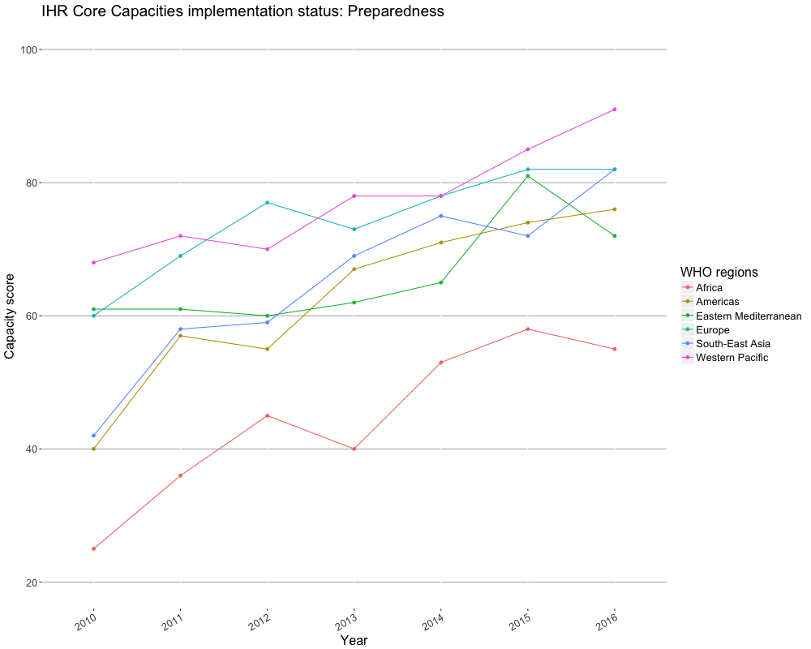
d) 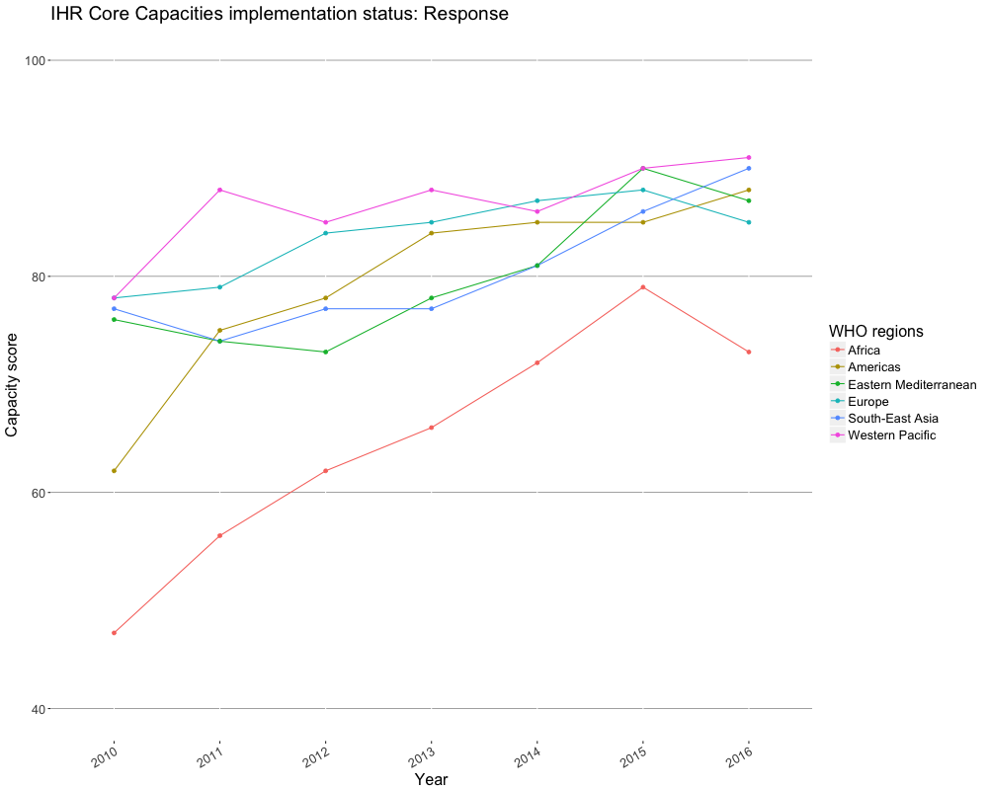
Figure 2.3: IHR capacity scores by WHO region. 2.3a) Human Resources capacity score. 2.3b) Surveillance capacity score. 2.3c) Preparedness capacity score. 2.3d) Response capacity score.
There are some limitations to considering these capacities. Most importantly, IHR survey responses are self-reported; although national-level external verification has begun it currently remains relatively limited. Additionally, these findings capture potential capacity – not action. Finally, the quality of surveillance for early detection and warning is not shown, nor is the impact of that surveillance on public health. Response systems have been inadequate in numerous public health emergencies and thus the presence of such plans is not a proxy for their effectiveness.

Indicator 2.4: Climate information services for health
Headline Finding: Out of the 100 WHO Member States responding to the WMO Survey, 73% report providing climate information to the health sector in their country.
This indicator measures the proportion of countries whose Meteorological and Hydrological services self-reported to the World Meteorological Organization (WMO), providing tailored climate information, products and services to their national public health sector.⁹⁵ Response rates for the 2015 WMO survey were: 71% in the African region, 67% in the Eastern Mediterranean Region, 79% in the European Region, 81% in the Region of the Americas, 67% in the South-East Asia Region and 44% in the Western Pacific Region.
Taking into account the total number of WHO members (respondent and non-respondent) per WHO region, only between 14.8 % and 51.4% are known to provide climate information to the health sector (Figure 2.4) and between 18% and 55% did not provide information.

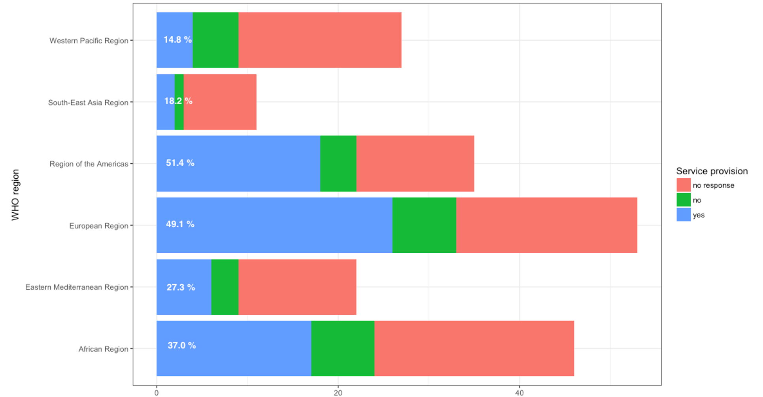
Figure 2.4: National Meteorological and Hydrological Services (NHMSs) of WHO member states reporting to provide targeted/tailored climate information, products and services to the health sector.
However, it is important to note that this sample is not representative of all countries (49% non-response rate) and these are self-reported results. Crucially, this indicator does not capture the type of climate products made available, quality of the data provided, the ways in which the health sector makes use of this data (if at all), and whether the data is presented in a format and timely fashion relevant to public health. Future WMO surveys will aim to provide greater insight to the specific applications of climate information. See Appendix 3 for more information.

Indicator 2.5: National assessments of climate change impacts, vulnerability, and adaptation for health
Headline Finding: Over two thirds of responding countries report having conducted a national assessment of climate change impacts, vulnerability, and adaptation for health.
National assessments of climate change impacts, vulnerability, and adaptation for health allow governments to understand more accurately the extent and magnitude of potential threats to health from climate change, the effectiveness of current adaptation and mitigation policies and future policy and programme requirements. Although national assessments may vary in scope between countries, the number of countries that have conducted a national assessment of climate change impacts, vulnerability, and adaptation for health is a key indicator to monitor the global availability of information required for adequate management of health services, infrastructure and capacities to address climate change. This indicator tracks the number of countries that have conducted national assessments, based on responses to the 2015 WHO Climate and Health Country Survey (Panel 2.1).
Over two-thirds of countries sampled (27 out of 40) reported having conducted a national assessment of impacts vulnerability, and adaptation for health (Figure 2.5). These countries cover all regions and include countries that are particularly vulnerable; for instance, of the nine responding countries in the South-East Asia Region, eight countries (Bangladesh, Bhutan, Indonesia, Maldives, Nepal, Sri Lanka, Thailand and Timor-Leste) reported having national assessments of impacts, vulnerability, and adaptation for health. Increasing global coverage of countries with national vulnerability and adaptation assessments for health is the result of WHO’s support to countries through projects and technical guidance.⁹⁶
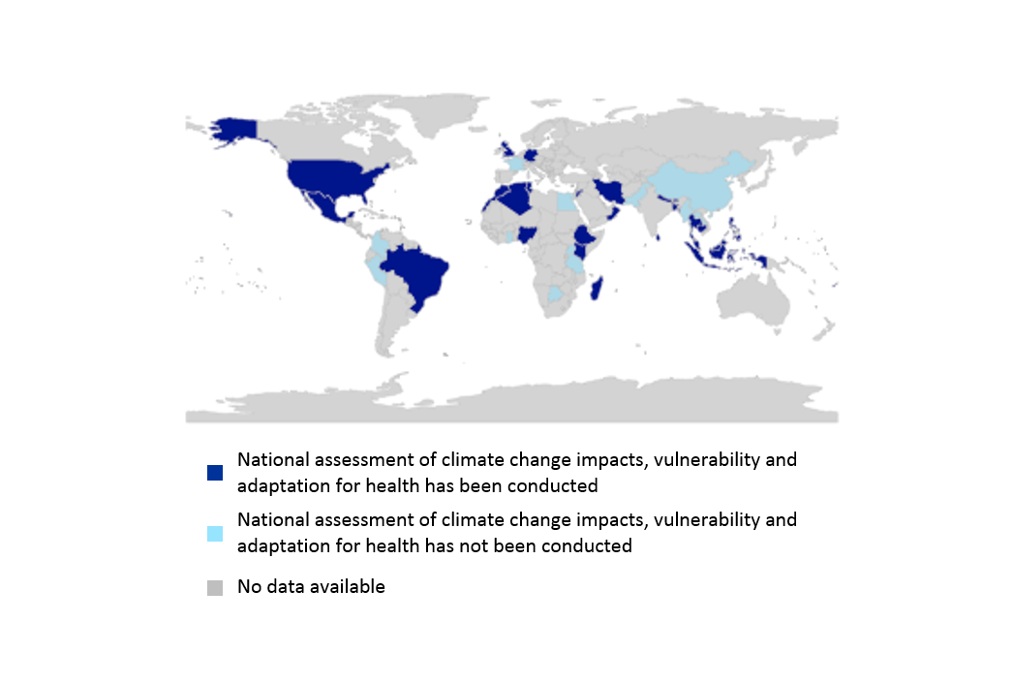
Figure 2.5 Countries with national assessment of climate change impacts, vulnerability and adaptation for health.

Indicator 2.6: Climate-resilient health infrastructure
Headline Finding: Only 40% (16 out of 40) of responding countries reported implementing activities to increase the climate resilience of their health infrastructure.
Functioning health infrastructure is essential during emergencies. Climate-related events, such as severe storms and flooding, may compromise electrical and water supplies, interrupt supply chains, disable transportation links, and disrupt communications and IT networks, contributing to reduced capacity to provide medical care. This indicator measures efforts by countries to increase the climate resilience of health infrastructure. The climate resiliency of health infrastructure reflects the extent to which these systems can prepare for and adapt to changes in climate impacting the system. Data is drawn from the WHO Climate and Health Country Survey (Panel 2.1). Only 40% of countries (16 out of 40) reported having taken measures to increase the climate resilience of their health infrastructure (Figure 2.6). These results suggest widespread vulnerability of health system infrastructure to climate change. For example, only two out of nine responding countries in the African Region report efforts to improve the climate resiliency of health infrastructure. Similar trends were found across other WHO regions.

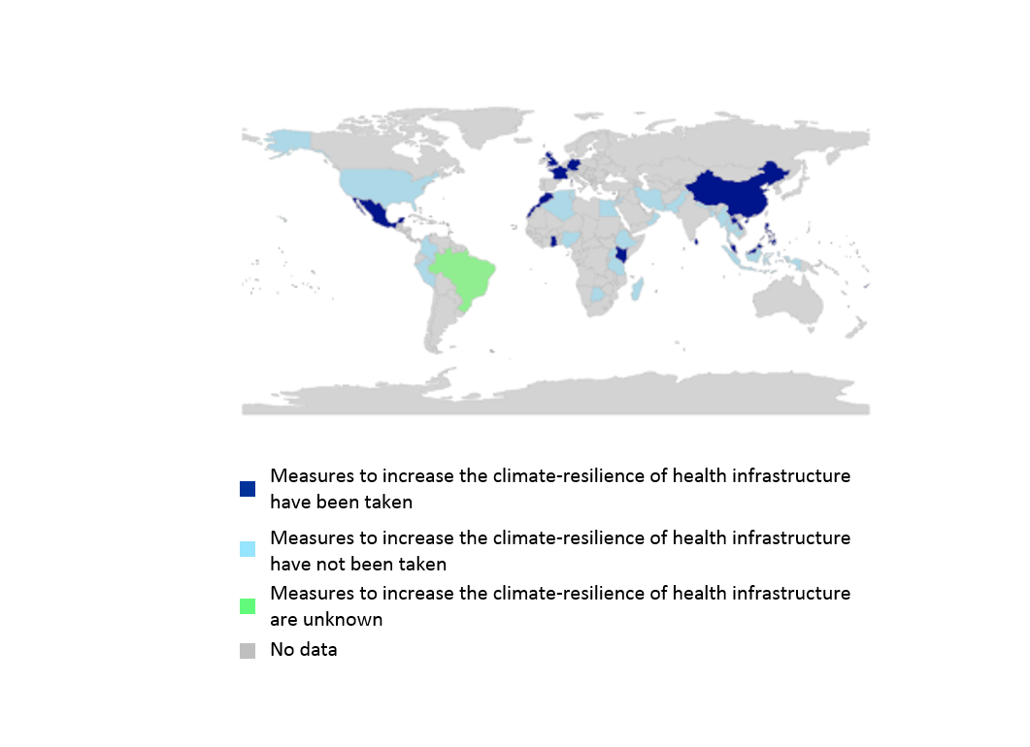
Figure 2.6 Countries taking measures to increase the climate resilience of health infrastructure.

This indicator does not capture the quality or effectiveness of efforts to build climate-resilient health system infrastructure. Nonetheless, it highlights the importance of ensuring that countries work to implement climate-resilient health infrastructure, as these findings suggest this is generally lacking.

Conclusion
This section has presented indicators across a range of areas relevant to health adaptation and resilience. It is clear that the public, and the health systems they depend upon, are ill-prepared to manage the health impacts of climate change.
In many cases, the data and methods available provide only a starting-point for an eventual suite of indicators that capture health-specific adaptation, and include both process-and outcome-based indicators. New indicators will also be required to better capture important indicators of resilience.

3. Mitigation Actions and Health Co-Benefits

Introduction
Sections one and two have covered the health impacts of climate change, the adaptation available and currently being implemented, and the limits to this adaptation.¹⁰ This third section presents a series of indicators relevant to the near-term health co-benefits of climate mitigation policies. Accounting for this enables a more complete consideration of the total cost and benefits of such policies, and is essential in maximising the cumulative health benefits of climate change mitigation.
The health co-benefits of meeting commitments under the Paris Agreement are potentially immense, reducing the burden of disease for many of the greatest global health challenges faced today and in the future.⁹⁷ The indicators presented in this section describe a clear and urgent need to increase the scope of mitigation ambition if the world is to keep global average temperatures “well below 2°C”.⁷
Countries are accelerating their response to climate change, with Finland, the UK, China, France, Canada and the Netherlands making strong commitments to phase-out or dramatically reduce their dependence on coal.⁹⁸⁻¹⁰¹ By 2017, electric vehicles are poised to be cost-competitive with their petroleum equivalents, a phenomenon that was not expected until 2030. Globally, more renewable energy capacity is being built every year than all other sources combined.^{101,102} Consequently, renewable energy is now broadly cost-competitive with fossil fuels, with electricity from low-latitude solar PV being cheaper than natural gas.¹⁰¹⁻¹⁰³

Tracking the health co-benefits of climate change mitigation
Meeting the Paris Agreement will require global GHG emissions to peak within the next few years and undergo rapid reduction thereafter, implying near-term actions and medium- and long-term cuts through country-level activities.⁸ Global CO₂ emissions from fossil fuels and industry were 36.3 GtCO₂ in 2015 (60% higher than in 1990), while emissions from land use change – which is intrinsically difficult to estimate – was approximately 4.8 GtCO₂. In the same year, 41% of the total fossil fuel and industry emissions were estimated to come from coal, 34% from oil, 19% from gas, and 6% from cement.¹⁰⁴ In 2015, the largest emitters of CO₂ were China (29%), the USA (15%), the European Union’s (EU) 28 member states ((EU28); 10%) and India (6.3%). However, per capita emissions of CO₂ belie the disparity driven by consumption, with global mean emissions at 4.8 tCO₂ per person per year compared to 16.8 in the USA, 7.7 in China, 7.0 in EU28, and 1.8 in India.¹⁰⁴
The actions needed to embark on rapid decarbonisation include avoiding the ‘lock-in’ of carbon intensive infrastructure and energy systems, reducing the cost of ‘scaling-up’ low-carbon systems, minimising reliance on unproven technologies, and realising opportunities of near-term co-benefits for health, security, and the environment.⁸ These actions will need to also be cost-effective and supported by non-state actors and industry.
Indicators in this section are broadly considered within the framework of Driving Force-Pressure-State-Exposure-Effect-Action (DPSEEA). The DPSEEA framework is recognized as being suitable for the development of environmental health indicators, and identification of entry points for policy intervention.¹⁰⁵ An adaptation of the framework for examination of the health co-benefits of climate change mitigation is explained in Appendix 4.
Here, health co-benefit indicators are captured for four sectors: 1) energy, 2) transport, 3) food, and 4) healthcare. Appendix 4 provides more detailed discussion of the data and methods used.

Energy Supply and Demand Sectors
Fossil fuel burning comprises the largest single source of GHG emissions globally, producing an estimated 72% of all GHG emissions resulting from human activities.^{106,107} The majority (66%) of these emissions arise in the energy sector from the production of thermal and electric power for consumption across a range of sectors including industry, commercial, residential and transport.
To meet the climate change mitigation ambitions of the Paris Agreement, it is widely accepted that the energy system will need to largely complete the transition towards near zero-carbon emissions by, or soon after, 2050, and then to negative emissions in the latter part of the century.^{108,109} Recent analysis has framed the necessary action as a halving of CO₂ emissions every decade.¹¹⁰
The potential short-term health benefits of such strategies are substantial, with significant improvements from a reduction in indoor and outdoor air pollution; more equitable access to reliable energy for health facilities and communities; and lower costs of basic energy services for heating, cooking, and lighting to support higher quality of life.

Indicator 3.1: Carbon intensity of the energy system
Headline Finding: Globally, the carbon intensity of total primary energy supply (TPES) has remained stable since 1990, between 55-56 tCO2/TJ, reflecting the significant global challenge of energy system decarbonisation. This has occurred because countries, which have achieved a reduction in carbon intensity (USA, UK, Germany), have been offset by those which have increased the carbon intensity of their energy supply (India and China).
To achieve the 2°C target (at a 66% probability), the global energy sector must reduce CO₂ emissions to more than 70% below current levels by 2050. This means a large reduction in the carbon intensity of the global energy system, which can be measured as the tonnes of CO₂ for each unit of total primary energy supplied (tCO₂/TJ). TPES reflects the total amount of primary energy used in a specific country, accounting for the flow of energy imports and exports.¹¹¹ Commitments under the Paris Agreement should begin to lower the overall carbon intensity of TPES, with the aim of reducing to near-zero by 2050.
Drawing on data from the International Energy Agency (IEA), this indicator shows that globally, since the 1990s, the carbon intensity of primary energy supply has remained between 55-56 tCO₂/TJ.¹¹² However, a 53% growth in energy demand over the period has meant that global CO₂ emissions have grown significantly. Rapidly, low and middle income countries (LMICs) have seen an increase in carbon intensity since the 1970s, driven by increased coal use (Figure 3.1). For example, India’s TPES has almost tripled since 1980, with the share of coal in the mix doubling (from 22% to 44%). Over the same period, 1980-2014, a fourfold increase in China’s TPES, combined with increasing carbon intensity due to the coal share of TPES increasing from 52% to 66%, has led to strong growth in emissions.
High-income countries have seen carbon intensity fall since the 1970s (for example, the USA and Germany in Figure 3.1). This decrease has resulted from a move away from coal use in energy production and use, reduced heavy industrial output, and increased use of lower carbon fuels, notably moving from coal to natural gas in the power sector and the use of renewable energy.

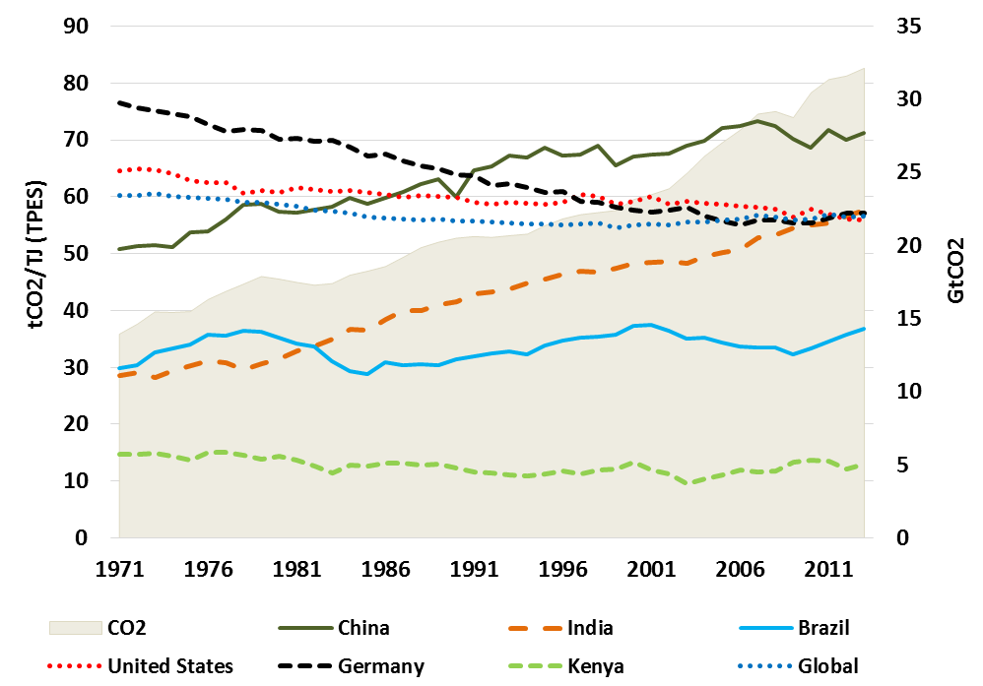
Figure 3.1 Carbon intensity of Total Primary Energy Supply (TPES) for selected countries, and total CO₂ emissions (shaded area against secondary y-axis),1971-2013.

Indicator 3.2: Coal phase-out
Headline Finding: Globally, total primary coal supply has increased from 92 EJ in 1990, to 160 EJ in 2015. However, the 2015 supply level represents a reduction from the high point of 164 EJ in 2013, providing an encouraging indication that global coal consumption has peaked and is now in decline.

The primary means of reducing carbon intensity of the energy system within necessary timescales will be the phase-out of coal. Worldwide, coal supplies 30% of energy use and is the source of 44% of global CO₂ emissions. The dirtiest form of coal produces almost twice the carbon per unit of primary energy than the least carbon intensive fossil fuel – natural gas.¹¹² Given that a large share of coal is used for power generation, it is an important sector of focus, both to reduce CO₂ emissions and mitigate a major source of air pollution.¹¹²
This indicator of coal phase-out is the total primary coal supply (EJ) in the energy system (Figure 3.2), which makes use of recent data from the IEA.¹¹²
Globally, coal use has increased by just under 60% since 1990. This is due to strong growth in global energy demand, and an increasing share of TPES coming from coal, rising from 26% to 29% between 1990 and 2014.¹¹² This growth has largely been driven by China’s increasing use of coal in industry and for electricity production, particularly in the 2000s (see East Asia trend in Figure 3.2). Crucially, growth in coal use has plateaued and reduced since 2013, in large part due to a recognition of the health effects of air pollution, slower growth and structural changes in China’s economy, and a slowing in energy sector expansion.¹¹³ India has also seen significant growth in coal use, with the share of coal in TPES increasing from 31% in 1990 to 46% in 2015. The other large coal consuming regions are the USA and Europe. The USA has had a stable level of consumption since the 1990s, but experienced a recent fall in use, particularly in energy production and use, due to the cost-competitiveness of shale gas. Europe has seen a steady decline in coal use since the 1990s, again through a move to gas in economies such as the UK, although this overall downward trend has transitioned to a plateau in recent years.
Today, China and India both have similar shares of electricity generate by coal, at around 75% of total generation. Whilst this trend is plateauing in China, this is not observed in other parts of Asia, and the rapidly-emerging economies of Indonesia, Vietnam, Malaysia, and the Philippines see strong growth from coal.¹¹²
Meeting the IEA’s 2°C pathway and the Paris Agreement requires that no new coal-fired plants be built (beyond those with construction currently underway), with a complete phase-out of unabated plants (not fitted with carbon capture and storage) occurring by 2040. Crucially, such a transition may have started, with the amount of coal power capacity in pre-construction planning at 570 gigawatts (GW) in January 2017, compared to 1,090 GW in January 2016.¹¹⁴ There are a range of reasons for this large reduction, including decreasing planned capacity expansion, a desire to tackle air pollution, and active efforts to expand renewable investment.

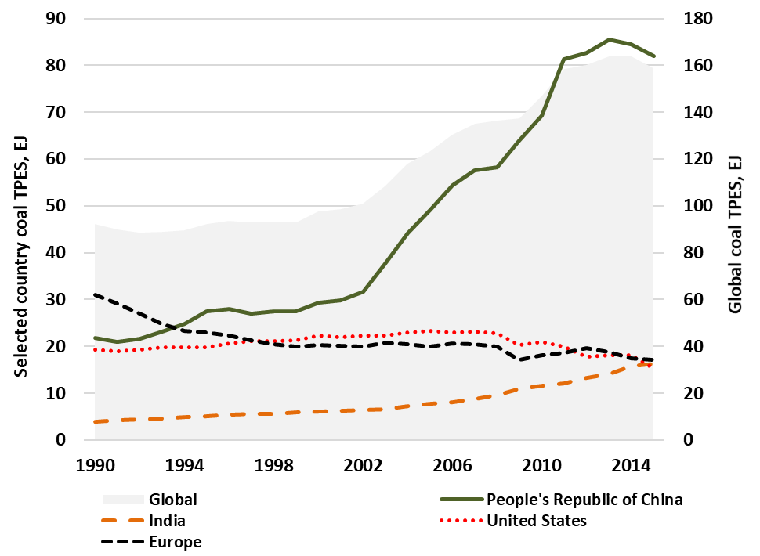
Figure 3.2 Total primary coal supply by country or region, and globally (shaded area against secondary y-axis), 1990-2015.

Indicator 3.3: Zero-carbon emission electricity
Headline Finding: Globally, renewable electricity as a share of total generation has increased by over 20% from 1990 to 2013. In 2015, renewable energy capacity added exceeded that of new fossil fuel capacity, with 80% of recently added global renewable energy capacity currently located in China. Where renewables displace fossil fuels, in particular coal, it represents the beginning of reductions in morbidity and mortality from air pollution, and a potentially remarkable success for global health.
As coal is phased out of the energy system, in particular in electricity production, the rapid scaling up of zero-carbon energy production and use will be crucial. To remain on a 2°C pathway, renewables-based capacity additions will need to be sustained over the next 35 years, reaching 400 GW per year by 2050, which is two and a half times the current level. Critical renewable technologies for achieving this will be solar, wind and hydroelectric.
Indicator 3.3 draws on IEA data, and considers both renewable and other zero-carbon electricity.¹¹² Conversely, renewable energy refers to “all forms of energy produced from renewable sources in a sustainable manner, which include: bioenergy, geothermal, hydropower, ocean energy (tidal, wave, thermal), solar energy and wind energy”.¹¹⁵ By comparison, zero-carbon energy means no GHG emissions (i.e. zero-carbon and carbon equivalent) at the point of energy production and use, which therefore also includes nuclear-powered electricity, but excludes biomass.
Both displace the use of fossil fuels (although notably fossil capacity tends to have annual higher load factors than renewables), reducing air pollution and GHG emissions, and so are important indicators for climate change and for health. One caveat is that the combustion of solid biomass fuels such as wood, sometimes promoted for climate change mitigation purposes, may increase fine particulate air pollution exposure and may not be carbon-neutral.¹¹⁶
As a share of total generation, renewable energy has increased by over 20% from 1990 to 2013. Renewable energy continues to grow rapidly, mainly from increasing wind and solar PV investment, most notably in the USA, China and Europe (Figure 3.3). In 2015, more renewable energy capacity (150GW) was added than fossil fuel plant capacity added globally. Overall, there is now more added renewable generation capacity installed globally (almost 2000 GW) than coal, with about 80% of this newly installed capacity located in China.¹¹²

a)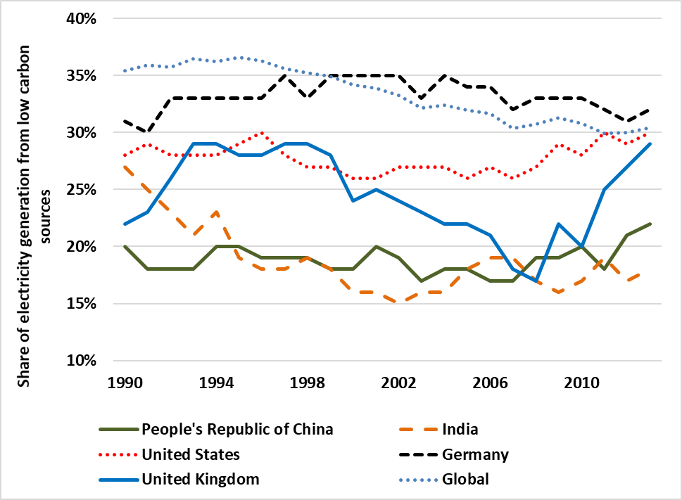b)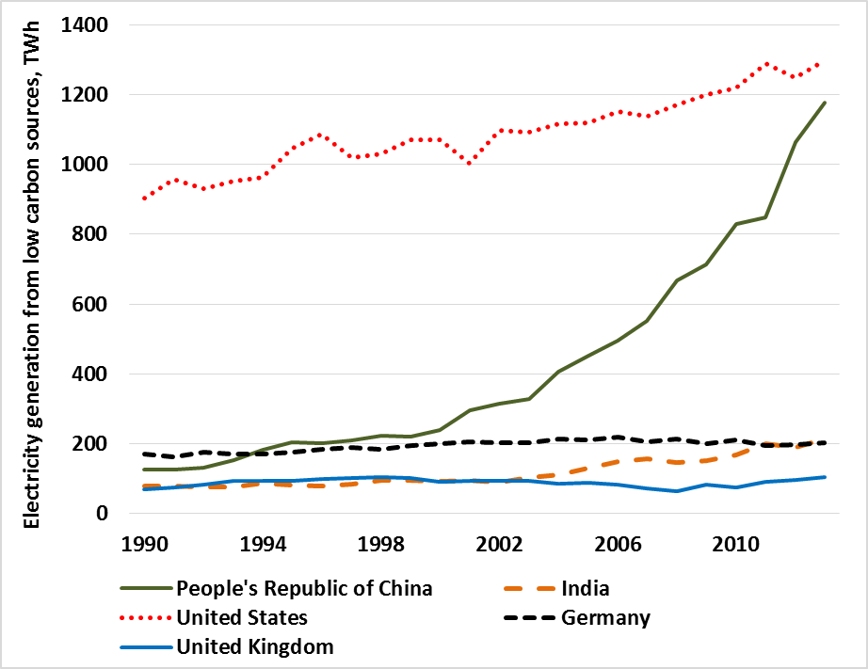
c)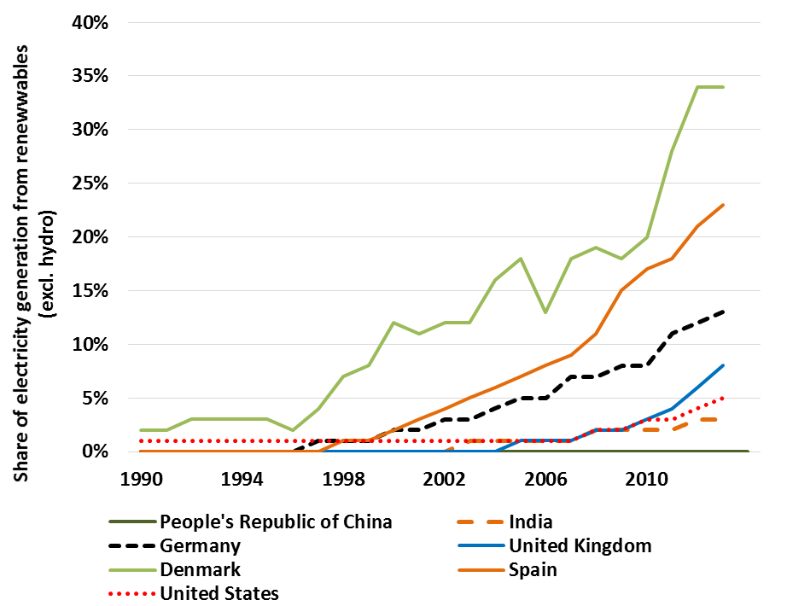d)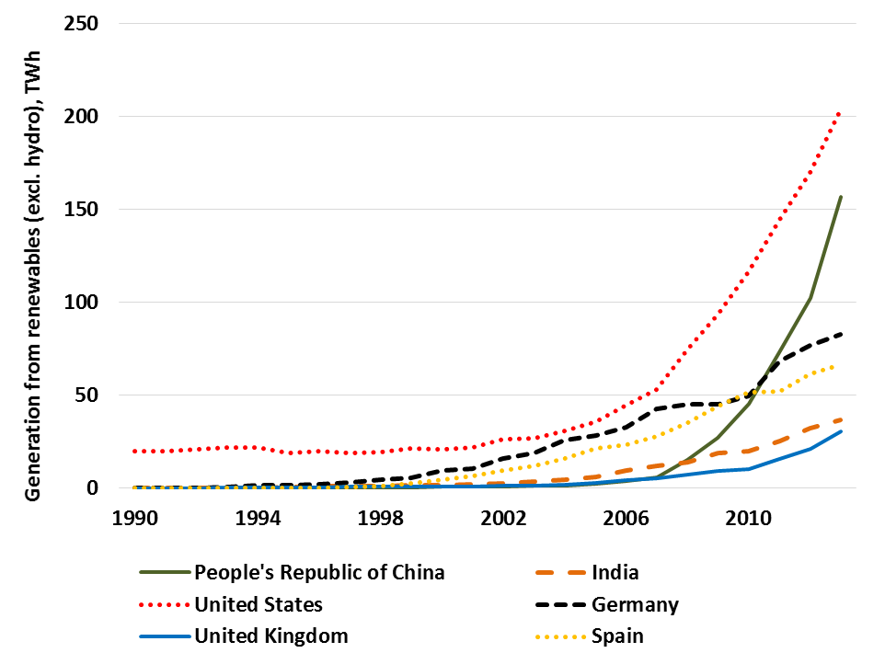
Figure 3.3 Renewable and zero-carbon emission electricity generation a) Share of electricity generated from zero carbon sources; b) Electricity generated from zero carbon sources, TWh; c) Share of electricity generated from renewable sources (excluding hydro); d) Electricity generated from renewable sources (excl. hydro), TWh.

Indicator 3.4: Access to clean energy
Headline Finding: In 2016, it was reported that 1.2 billion people did not have access to electricity, with 2.7 billion people relying on the burning of unsafe, unsustainable, and inefficient solid fuels.
Increased access to clean fuels and clean energy technologies will have the dual benefit of reducing indoor air pollution exposure, and reducing GHG emissions by displacing fossil fuels.¹¹⁷ The use of clean energy for heating, cooling, cooking and lighting plays an important role in improving global health and wellbeing, economic productivity, and reducing the risk of harm from living in energy poverty.¹¹⁸
It is estimated that globally, 1.2 billion people do not currently have access to electricity and 2.7 billion people rely on burning unsustainable and inefficient solid fuels, which contributes to poor indoor air quality (see Panel 3.1), estimated to result in 4.3 million premature deaths related to pneumonia, stroke, lung cancer, heart disease, and chronic obstructive pulmonary disease (COPD) each year.^{119,120} Access to electricity, an energy source that emits no direct airborne particles (though particles may be emitted indirectly through the fuel used to generate the electrical power), is currently 85.3% globally but varies widely among countries and urban and rural settings.
This indicator draws on and aligns with the proposed Sustainable Development Goal (SDG) indicator 7.1.2, defining ‘clean energy’ in terms of emission rate targets and specific fuel recommendations (i.e. against unprocessed coal and kerosene) included in the WHO normative guidance.¹²¹ It estimates the proportion of the population who primarily rely on clean fuels (including liquefied petroleum gas, which, while still a fossil fuel, is cleaner than many solid fuels) and technologies for cooking, heating and lighting compared to all people accessing those services. The data used for this indicator comes from estimates of fuel use from WHO household survey data from roughly 800 nationally representative surveys and censuses, and is modelled to estimate the proportion of their reliance on clean fuels (Figure 3.4).¹²²
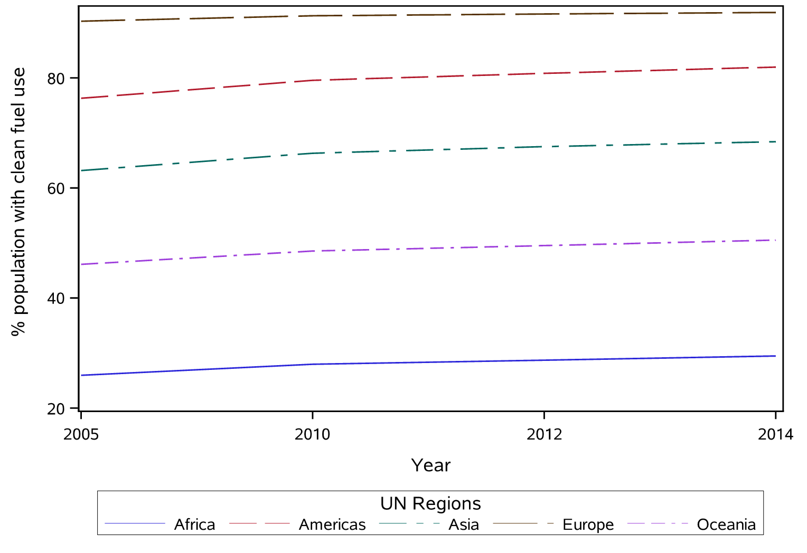
Figure 3.4 Proportion of population relying primarily on clean fuels and technology.

Indicator 3.5: Exposure to ambient air pollution
Headline Finding: 71% of the 2,971 cities in the WHO’s database do not satisfy WHO annual fine particulate matter exposure recommendations.
Air pollutants directly harmful to health are emitted by combustion processes that also contribute to emissions of GHGs. As such, properly designed actions to reduce GHG emissions will lead to improvements in ambient air quality, with associated benefits for human wellbeing.¹²³ Current estimates suggest that global population-weighted fine particulate matter (PM_{2.5}) exposure has increased by 11.2% since 1990.^{123,124} To represent levels of exposure to air pollution, this indicator collects information on annual average urban background concentrations of PM_{2.5} in urban settings across the world.

3.5.1: Exposure to air pollution in cities
The data for this indicator makes use of the WHO’s Urban Ambient Air Pollution Database, which compiles information from a range of public sources, including national and subnational reports and websites, regional networks, intergovernmental agencies, and academic publications.¹²⁵ The air pollution measurements are taken from monitoring stations located in urban background, residential, commercial, and mixed areas. The annual average density of emission sources in urban areas and the proximity of populations to those sources led the Lancet Countdown to focus on exposure in cities.
For this indicator, the Lancet Countdown has combined the WHO database with the Sustainable Healthy Urban Environments (SHUE) database, presenting data on 246 randomly sampled cities across the world (stratified by national wealth, population size, and Bailey’s Ecoregion) (Figure 3.5).¹²⁶

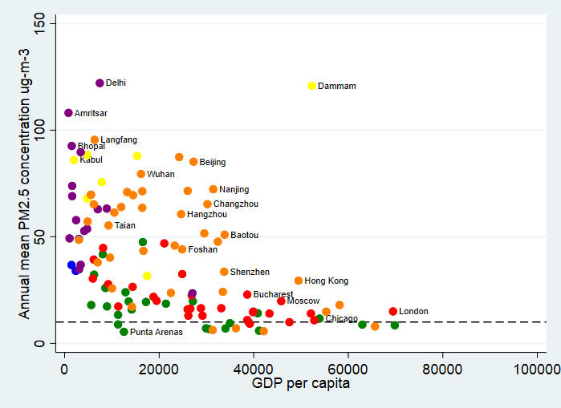
Figure 3.5 Annual mean PM2.5 concentration vs per capita GDP for 246 cities in the SHUE database. Colours indicate WHO regions: blue – Africa; red – Europe; green – the Americas; Lime – Eastern Mediterranean; orange – Western Pacific; purple – South East Asia. The dotted line marks the WHO recommended guidance level of 10 µg.m-3.

PM_{2.5} levels in the majority of global cities are currently well above the WHO’s annual guideline level of 10 µg.m⁻³, with particularly high levels in cities in central, South and East Asia. Of almost 3,000 cities in the WHO database, levels in 71.2% are above the guideline level. However, since monitoring is more common in high income settings, this is likely to represent an underestimation; for randomly-selected cities in the SHUE database, 87.3% of cities are above the guideline. The data suggests that air pollution levels have generally decreased in high income settings over recent decades, although it has marginally increased, globally.¹²⁷
Panel 3.1. Energy and Household Air Pollution in Peru.
Universal access to energy is a major challenge in most LMICs and access to clean energy or energy sources that do not adversely affect health is a considerable problem. In Peru, low-income families spend a higher percentage (5%-18%) of average monthly income on energy services than those with higher-incomes.¹²⁸ Furthermore, a large portion of Peru’s rural population (83%) use firewood, dung, or coal for cooking, making indoor air pollution one of the main environmental risk factors experienced.¹²⁹
Since the 1990s, the Peruvian government and various NGOs have promoted programmes and policies oriented towards addressing the problem of solid fuels’ use for lighting, cooking and heating and lack of access to energy sources in low-income sectors. In 2009, legislative changes enabled sub-national governments to invest up to 2.5% of the national mining revenues in improved cook stove (ICS) deployment, resulting in more than 280,000 ICS installed nationwide (52% public and 43% private) as part of the multi-sectorial campaign “Half Million ICS for a Smokeless Peru”. This campaigned to help improve quality of life and health through the instalment of certified ICS. Studies show that well-kept and certified ICS can reduce personal exposure to particulate matter (PM_{2.5}).
Peru released its 2010-2040 National Energy Policy in 2010. Of the nine goals, two discuss access to energy services to low-income sectors. Special programmes have been developed in rural high altitude and Amazonian regions in Peru to address energy access issues. In 2012, programmes were established to substitute kerosene and other contaminating stoves with liquefied petroleum gas (LPG) and ICS; and the Social Inclusion Energy Fund (FISE) was established, promoting access to LPG for the most vulnerable populations through subsidies. By 2015, according to FISE, more than 1.3 million families had received an LPG stove, mitigating 91% of their CO₂ emissions and leading to a corresponding reduction of 553,000 tons of CO₂ in using cleaner sources of energy.^{130,131}

3.5.2: Sectoral contributions to air pollution
The energy sector –both production and use - is the single largest source of man-made air pollution emissions, producing 85% of particulate matter and almost all of the sulphur oxides and nitrogen oxides emitted around the world (Figure 3.6).¹¹²
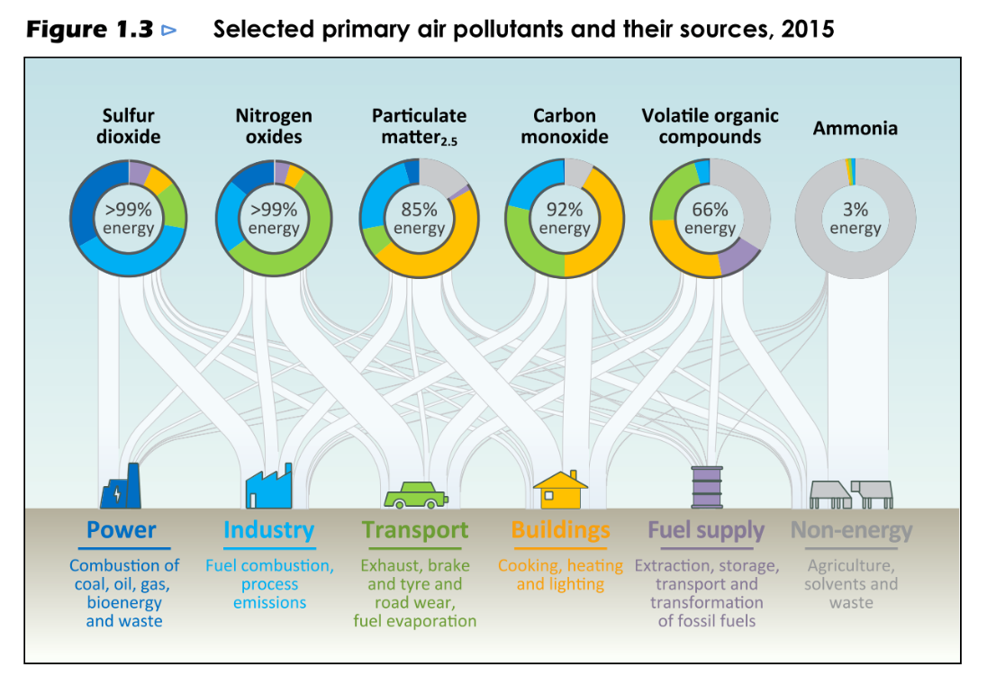
Figure 3.6 Selected primary air pollutants and their sources globally in 2015.¹¹² (Source: IEA, 2016)

Of this, coal power is responsible for three-quarters of the energy production and use sector’s Sulphur Dioxide (SO₂) emissions, 70% of its Nitrogen Oxide (NO_{x}) emissions and more than 90% of its PM_{2.5} emissions.¹¹² However, over the past decade, these emissions have largely decoupled from increases in coal-fired generation in several geographies, due to the introduction of emission standards for coal power plants.^{132,133}
In 2015, manufacturing and other industries (for example, refining and mining) were responsible for about half of global energy-related emissions of SO₂ as well as 30% of both NO_{x} (28 Mt) and PM_{2.5}.¹¹² Furthermore, transport was responsible for around half of all energy-related NO_{x} emissions in 2015 as well as 10% of PM_{2.5}. Within this sector, road vehicles were by far the largest source of the sector’s NO_{x} and PM_{2.5} emissions (58% and 73%, respectively), while the largest portion of SO₂ emissions came from shipping.¹¹² Trends in NO_{x} emissions from the transport sector (1990 to 2010) are shown in Figure 3.7.

a) 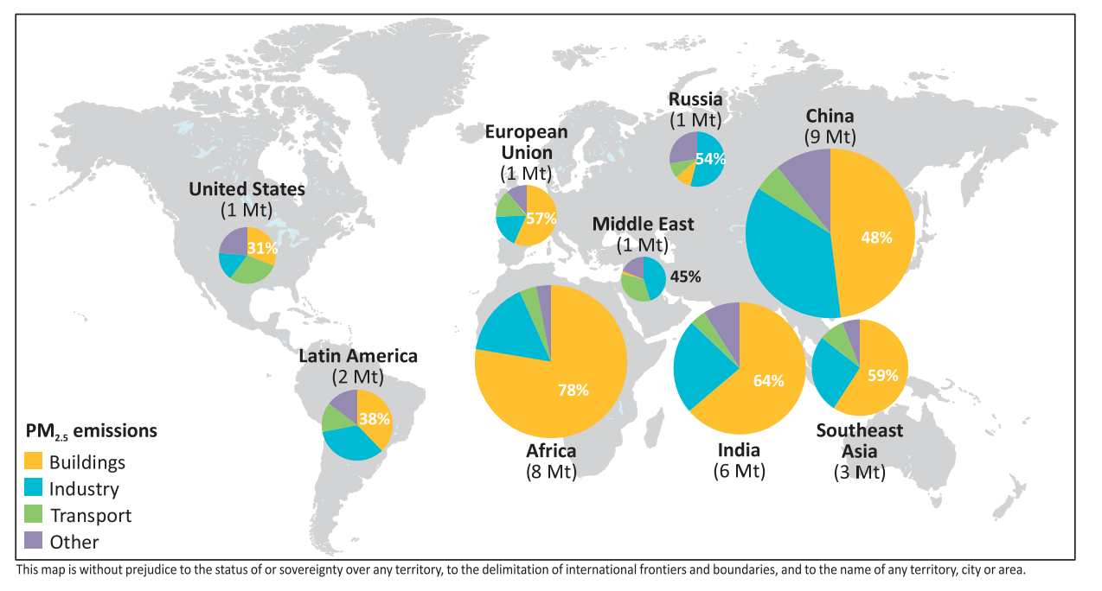
b)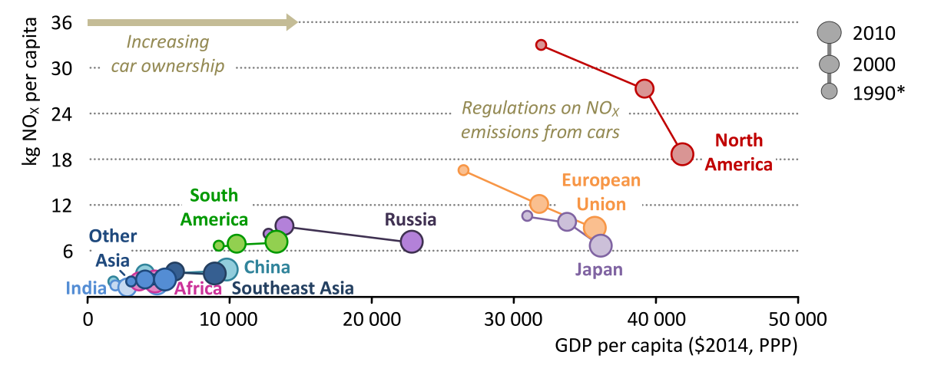
Figure 3.7 a) Energy related PM_{2.5} emissions in 2015 and b) NO_{x} emissions from transport from 1990-2010 by region.¹¹² (Created using IEA, 2016 data)

3.5.3: Premature mortality from ambient air pollution by sector
The extent to which emissions of different pollutants from different sectors contribute to ambient PM_{2.5} levels depends on atmospheric processes, such as the dispersion of primary particles and the formation of secondary aerosols from precursor emissions. Sources with low stack heights located close to populations, such as household combustion for cooking and heating as well as road vehicles, typically play a disproportionally larger role for total population exposure in relation to their absolute emissions.
Long-term exposure to ambient PM_{2.5} is associated with increased mortality and morbidity from cardiovascular and pulmonary diseases.¹³⁴⁻¹³⁶ A recent WHO assessment estimated that ambient air pollution (AAP) is responsible for roughly three million premature deaths worldwide every year.¹³⁷ As the sources of air pollution and greenhouse gases are overlapping in many cases, greenhouse gas mitigation measures can have large co-benefits for human health.
Figure 3.8 shows an attribution of estimated premature mortality from AAP to the sources of pollution as calculated in the GAINS model for the year 2015 in a set of South and East Asian countries, using emissions data as published by the IEA.¹³⁸ Here, the contributions of individual source sectors to ambient PM_{2.5} concentrations have been calculated using linearized relationships based on full atmospheric chemistry transport model simulations, and premature deaths are calculated following the methodology used by the WHO and the GBD 2013 study.^{136,137}
In some countries, such as China, North Korea and the Republic of Korea, agriculture is a large contributor to premature deaths. Significant direct benefits for human health can therefore be expected if these emission sources are addressed by climate policies. Significant benefits could also be are available if, for instance, coal fired power plants were replaced by wind and solar. Replacement of household combustion of coal, for example in China, would result in health benefits not only from ambient (outdoor) but also household (indoor) exposure to air pollution.
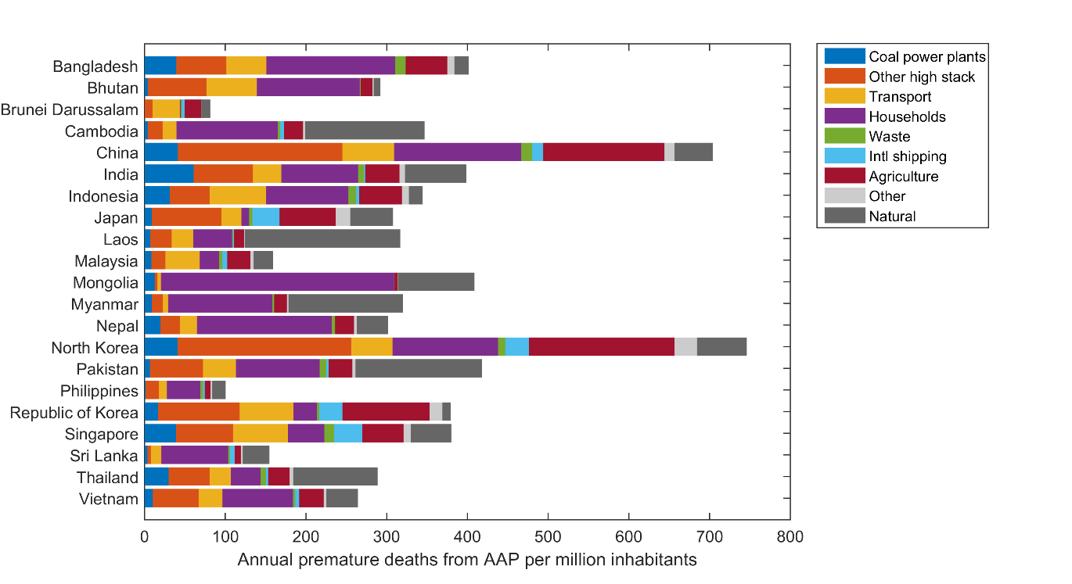
Figure 3.8 Health impacts of exposure to ambient PM_{2.5} in terms of annual premature deaths per million inhabitants in South and East Asian countries in 2015, broken down by key sources of pollution.

Transport Sector
Transportation systems – including road vehicles, rail, shipping, and aviation – are a key source of GHG emissions, contributing 14% of global emissions in 2010.^{111,112} In order to meet the 2°C target, the global transport sector must reduce its total GHG emissions by more than 20% below current levels, by 2050, and to be on a trajectory to zero carbon emissions in the second half of the century.¹³⁹ Compared to other energy demand sectors, key sub-sectors of transportation (urban personal and freight transport, long distance road transport, shipping, short haul aviation, and long haul aviation) are more difficult to decarbonise because of the high energy density of fossil fuels, thus emissions reductions targets are lower for transport than the energy sector as a whole.
The transport sector is also a major source of air pollutants, including particulate matter, nitrogen oxides, sulphur dioxide, carbon monoxide, volatile organic compounds, and indirectly, ozone. Furthermore, exposure to air pollution from road transport is particularly challenging in cities where vehicles emit street-level air pollution. In turn, significant opportunities for health exist through the reduction of GHG emissions from transport systems, both in the near-term through cleaner air and increased physical activity, and the long-term through the mitigation of climate change.

Indicator 3.6: Clean fuel use for transport
Headline Finding: Global transport fuel use (TJ) has increased by almost 24% since 1990 on a per capita basis. While petrol and diesel continue to dominate, non-conventional fuels have been rapidly expanding, with more than 2 million electric vehicles being sold between 2010 and 2016.
Fuels used for transport produce more than half the nitrogen oxides emitted globally and a significant proportion of particulate matter.^{111,112} Switching to low-emission transport systems is an important component of climate change mitigation and will help to reduce concentrations of most ambient air pollutants. However, the transport sector’s extremely high reliance on petroleum-based fuels makes this transition particularly challenging.
This indicator focuses on monitoring global trends in levels of fuel efficiency, and on the transition away from the most polluting and carbon intensive transport fuels. More specifically, this indicator follows the metric of fuel use for transportation on a per capita basis (TJ/person) by type of fuel. To develop this indicator, the Lancet Countdown draws on transport fuel data from the IEA and population data from the World Bank.¹¹²
While some transition away from carbon-intensive fuel use, towards increasing levels of fuel efficiency has occurred in select countries, transport is still heavily dominated by gasoline and diesel. Global transport fuel use has increased by almost 65% since 1970 on a per capita basis (Tj/person) (Figure 3.9). However, non-conventional fuels (for example, electricity, biofuels, and natural gas) have been rapidly gaining traction since the 2000s, with more than two million electric vehicles having been sold around the globe since 2010, mostly in the US, China, Japan and some European countries (Figure 3.10).¹⁴⁰ These figures remain modest when compared to the overall number of cars sold per year, 77 million in 2017, and the total global fleet of 1.2 billion cars.

Figure 3.9 Per capita fuel use by type (TJ/person) for transport sector with all fuels.
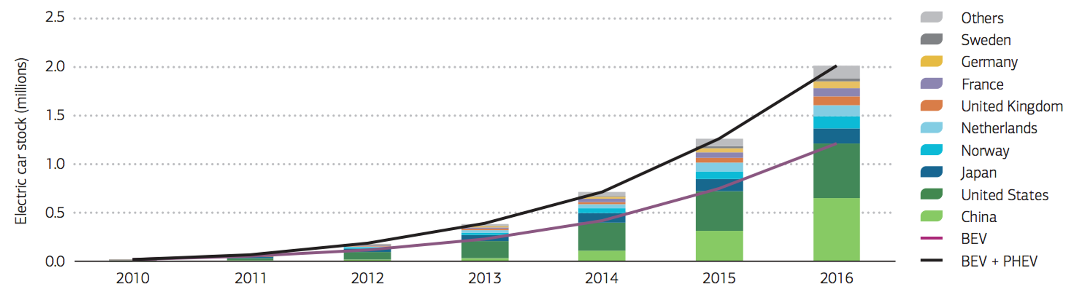
Figure 3.10 Cumulative Global Electric Vehicle Sales. Note: BEV is Battery Electric Vehicle and PHEV is Plug-in Hybrid Electric Vehicle.^{141,142} (Source: IEA, 2017)

Indicator 3.7: Sustainable travel infrastructure and uptake
Headline Finding: Levels of sustainable travel appear to be increasing in many European cities, but cities in emerging economies are facing sustainable mobility challenges. While levels of private transport use remain high in many cities in the USA and Australia, evidence suggests that they are starting to decline.
Global trends of population growth and increasing urbanization suggests that demand for mobility in urban areas will increase. Moving from private motorized transport to more sustainable modes of travel (such as public transport, walking and cycling) in urban areas not only helps to reduce emissions from vehicles, but also has several health co-benefits. This indicator tracks trends in sustainable travel infrastructure and uptake in urban areas.
Whilst this indicator would ideally track the proportion and distance of journeys undertaken by different modes of transport over time, data availability for city-level trends in modal share is particularly scarce. Therefore, the Lancet Countdown will instead present data for selected locations, across a limited time-scale. Figure 3.11 presents data on current modal shares (i.e. recent year estimates of the proportion of trips by different modes of transport) in world cities (see Appendix 4 for details). The data, collated by the Land Transport Authority come from travel surveys of individual cities and national census data (see Appendix 4 for details).¹⁴³

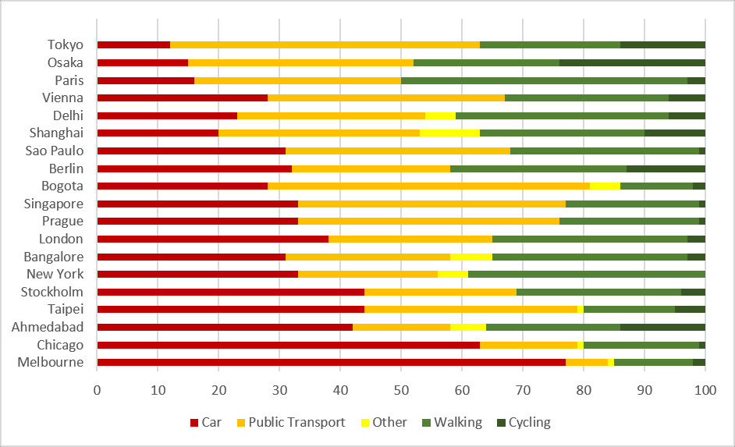
Figure 3.11 Modal Shares in world cities. Note: ‘Other’ typically includes paratransit (transport for people with disabilities) and/or electric bikes.

Figure 3.12 collates data on trends in modal share in select cities, where data from at least three time points (including one pre-2000 time point) is available. While many cities have started to collect this information in the past decade, there is a paucity of data on trends from before 2000, with particularly wide gaps in data availability from cities in Asia, Africa and South America.¹⁴⁴
In Berlin, London and Tokyo, the proportion of trips by privatised motor transport has slowly declined since the late 1990s, while levels have remained high in Vancouver and Sydney and appear to be increasing in Santiago. Levels of cycling are generally low, but appear to be increasing in many cities.
Public transport in emerging cities is often insufficient, inefficient and in poor condition, potentially leading to further declines in sustainable travel in many rapidly growing cities in the future. ¹⁴⁵ As this transition occurs, ensuring the mistakes made in Organization for Economic Cooperation and Development (OECD) countries are not repeated will be vital. In particular, it is critical to improve walking and cycling environments, in order to both make these modes attractive choices and protect road users from injury. Recent United Nations (UN) guidance recommends devoting 20% of transport budgets to funding non-motorized transport at national and local levels in low- and middle-income countries.¹⁴⁶
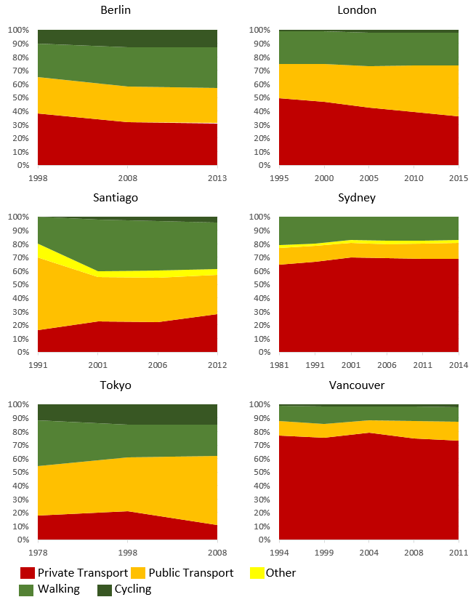
Figure 3.12 Trends in modal share in selected cities. Note: Data from Santiago in 1991 represents travel on a usual day; Data from Sydney represent Weekdays only; Cycling modal share in Sydney is <1%.¹⁴⁷⁻¹⁵⁶ (Figure created using data from the following sources: Institute for Mobility Research (2016); Transport for London (2016); NSW Department of Transport (1996); NSW Department of Transport (2003); NSW Department of Transport (2009); NSW Department of Transport (2017); Translink (2012); Dictuc S.A. (1992); Rode et al (2015); and City of Berlin (2013))

Food and agriculture
The availability of food is central to human health. Its production, however, is also a major contributor to climate change, with the agricultural sector alone contributing 19-29% of anthropogenic GHG emissions globally.^{10,157}
Dietary choices determine food energy and nutrient intake, which are essential for human health, with inadequate and unhealthy diets associated with malnutrition and health outcomes including diabetes, cardiovascular diseases, and some cancers. Globally, dietary risk factors were estimated to account for over 10% of all Disability Adjusted Life Years (DALYs) lost in 2013.¹⁵⁸ A transition to healthier diets, with reduced red and processed meat consumption, and higher consumption of locally and seasonally produced fruits and vegetables, could provide significant emissions savings.¹⁵⁹
Tracking progress towards more sustainable diets requires consistent and continuous data on food consumption, and related GHG emissions throughout food product life cycles. This would require annual nationally representative dietary survey data on food consumption. However, due to the complexity and cost of such data collection, dietary surveys are available for a limited number of countries and years only.¹⁶⁰ Although efforts to compile data and ensure comparability are under way, their current format is not suitable for global monitoring of progress towards optimal dietary patterns in terms of health benefits of climate change mitigation.^{161,162}

Indicator 3.8: Ruminant meat for human consumption
Headline Finding: Globally, the amount of ruminant meat available for human consumption has declined slightly from 12.09 kg/capita/year in 1990 to 11.23 in 2013; the proportion of energy (kcal/capita/day) available for human consumption from ruminant meat as opposed to other sources has declined marginally from 1.86% in 1990 to 1.65% in 2013.
This indicator focuses on ruminants because the production of ruminant meat, in particular cattle, dominates GHG emissions from the livestock sector (estimated at 5.6-7.5 GtCO2e per year), and consumption of red meat has known associations with adverse health outcomes.¹⁶³It measures the total amount of ruminant meat available for consumption, and the ratio of ruminant meat energy supply to total energy supply. Together, these reflect the relative amount of high GHG emission foods in the system (Figure 3.13).¹⁶⁴⁻¹⁶⁶ Assuming correlation between ruminant meat supply and consumption, the indicator therefore also provides information on variations in certain diet-related health outcomes (such as colorectal cancer and heart disease).^{167,168} This indicator should be viewed in the context of the specific setting where this trend is examined (in some populations, meat consumption is a main source of food energy and provides essential micronutrients, as well as livelihoods). Data was constructed using data from the FAO food balance sheets, which comprises national supply and utilisation accounts of primary foods and processed commodities.¹⁶⁹
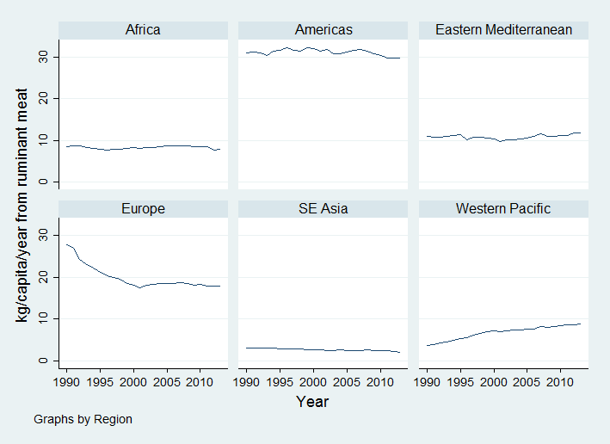
Figure 3.13. The total amount of ruminant meat available for human consumption in kg/capita/year by WHO-defined regions.
The amount of ruminant meat available for consumption is high in the Americas and has remained relatively stable across 1990-2013. In Europe, the amount of ruminant meat was relatively high in 1990, declined rapidly from 1990-2000 and has remained stable from 2000-2013. Amounts are more moderate in Africa and the Eastern Mediterranean and have remained reasonably constant over time; South East Asia and Western Pacific have low amounts but have been slowly increasing in the Western Pacific since 1990.
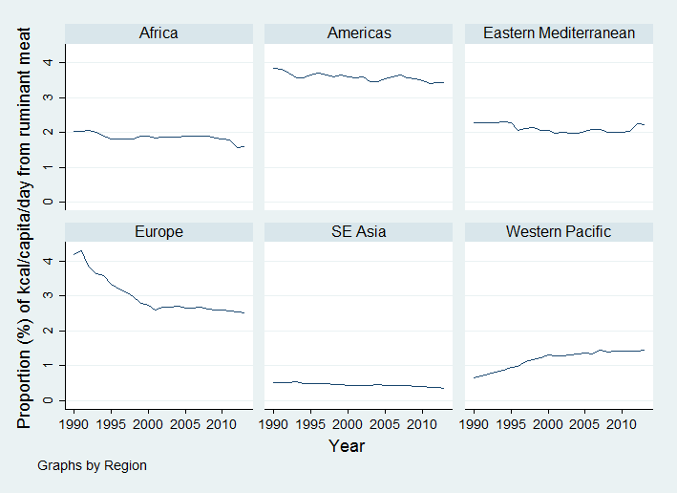
Figure 3.14 The proportion of energy (kcal/capita/day) available for human consumption from ruminant meat vs from all food sources by WHO-defined regions.
The proportion of energy supply from ruminant meat has been markedly higher in the Americas than other regions since the 1990s, although the trend has been decreasing over time (Figure 3.14). In Europe, the proportion of energy from ruminant meat rapidly declined from 1990-2000 and has continued to slowly decline. By contrast, the trend has been increasing in the Western Pacific, possibly reflecting the increasing trend in beef consumption in China (16% annually).¹⁷⁰

Healthcare sector
The healthcare sector is a considerable contributor to GHG emissions, and has both a responsibility and an appreciable opportunity to lead by example in reducing its carbon footprint. In 2013, the estimated US healthcare sector emissions were 655 MtCO₂e, which exceeded emissions of the entire UK.¹⁷¹ GHG emissions in the healthcare sector illustrate an obvious externality which contributes to climate change, contradicting the sector’s aim of improving population health.
The World Bank estimates that a 25% reduction from existing healthcare emissions in Argentina, Brazil, China, India, Nepal, Philippines, and South Africa would equate to 116-194 million metric tons of CO₂e emission reduction, in other terms equal to decommissioning of 34-56 coal fired power plants or removing 24-41 million passenger vehicles from the road.¹⁷¹

Indicator 3.9: Healthcare sector emissions
Headline Finding: Whilst no systematic global standard for measuring the greenhouse gas emissions of the healthcare sector currently exists, a number of healthcare systems in the UK, US, and around the world are working to reduce their contribution to climate change.
Several health sector emission reduction targets can be highlighted as positive examples. The National Health Service (NHS) in the UK set an ambitious target of 34% health-system wide GHG emission reduction by 2020; Kaiser Permanente in the U.S. has set 2025 as a target to become net carbon positive; the Western Cape Government health system in South Africa committed to 10% emission reduction by 2020 and 30% by 2050 in government hospitals; and Albert Einstein Hospital in Sao Paulo, Brazil, has reduced its annual emissions by 41%.¹⁷¹
In the UK, comprehensive GHG emissions reporting was facilitated by the centralized structure of the NHS. The Sustainable Development Unit (SDU) of the NHS has been monitoring GHG emissions from a 1992 baseline, including major contributions from procurement of pharmaceuticals and other products. NHS emissions reduced by 11% from 2007 to 2015, despite an 18% increase in activity.¹⁷² Mitigation efforts from the healthcare sector provide remarkable examples of hospitals and health care systems leading by example, yielding impressive financial savings and health benefits for their patients. To this end, the efforts of the hospitals, governments, and civil society organisations driving this work forward must be supported and redoubled, ensuring a full transition to a healthier, more sustainable model of climate-smart, and increasingly carbon neutral healthcare.¹⁷¹
Monitoring healthcare system emissions is an essential step towards accounting for the externality of these emissions. Comprehensive national GHG emissions reporting by the healthcare system is currently only routinely performed in the UK. Elsewhere, select healthcare organisations, facilities, and companies provide self-reported estimates of emissions, however this is rarely standardized across sites. The Lancet Countdown will continue to work on developing a standardised indicator on health sector emissions for subsequent reports.

Conclusion
The indicators presented in this section have provided an overview of activities relevant to public health for the energy, transport, food and healthcare sectors’ mitigation. They have been selected for their relevance to both climate change and human health and wellbeing.
A number of areas show remarkable promise – each of which should yield impressive benefits for human health. However, these positive examples must not distract from the enormity of the task at hand. The indicators presented in this section serve as a reminder of the scale and scope of increased ambition required to meet commitments under the Paris Agreement. They demonstrate a world which is only just beginning to respond to climate change, and hence only just unlocking the opportunities available for better health.

4. Finance & Economics

Introduction
Interventions to protect human health from climate change risks have been presented above. This section focuses on the economic and financial mechanisms necessary for them to be implemented, and their implications. Some the indicators here do not have an explicit link to human health, and yet, investment in renewable energy and a declining investment in coal capacity, for instance, is essential in displacing fossil fuels and reducing their two principal externalities – the social cost of climate change and the health costs from air pollution. Other indicators, such as economic and social losses from extreme weather events, have more explicit links to human wellbeing.
The 2006 Stern Review on the Economics of Climate Change estimated that the impacts of climate change would cost the equivalent of reducing annual global Gross World Product (GWP) – the sum of global economic output – by “5-20% now, and forever”, compared to a world without climate change.¹⁷³ The Intergovernmental Panel on Climate Change’s (IPCC) AR5 estimates an aggregate loss of up to 2% GWP even if the rise in global mean temperatures is limited to 2.5°C above pre-industrial levels.²² However, such estimates depend on numerous assumptions, such as the rate at which future costs and benefits are discounted. Further, existing analytical approaches are poorly suited to producing estimates of the economic impact of climate change, and hence their magnitude is likely greatly underestimated.¹⁷⁴ ¹⁷⁵ In the presence of such uncertainty, with potentially catastrophic outcomes, risk minimisation through stringent emissions reduction seems the sensible course of action.
The indicators in this section, which seek to track flows of finance and impacts on the economy and social welfare resulting from (in)action on climate change, fall into four broad themes: investing in a low-carbon economy; the economic benefits of tackling climate change; pricing GHG emissions from fossil fuels; and adaptation financing. The indicator presented are:
- Investments in zero-carbon energy and energy efficiency
- Investment in coal capacity
- Funds divested from fossil fuels
- Economic losses due to climate-related extreme events
- Employment in low-carbon and high-carbon industries
- Fossil fuel subsidies
- Coverage and strength of carbon pricing
- Use of carbon pricing revenues
- Spending on adaptation for health and health-related activities
4.10 Health adaptation funding from global climate financing mechanisms

Appendix 5 provides more detailed discussion of the data and methods used.

Indicator 4.1: Investments in zero-carbon energy and energy efficiency
Headline Finding: Proportional investment in renewable energy and energy efficiency increased in 2016, whilst absolute and proportional investment in fossil fuels decreased, and crucially, ceased to account for the majority of annual investments in the global energy system.
This indicator tracks the level of global investment in zero-carbon energy and energy efficiency in absolute terms, and as a proportion of total energy system investment. Figure 4.1 illustrates the data for 2015 and 2016; the data for this indicator is sourced from the IEA.^{176,177}
Figure 4.1 Annual Investment in the Global Energy System.

In 2015, total investment in the energy system was around $1.83 trillion (in US$2016), accounting for 2.4% of GWP. Renewables and nuclear comprised 19% of this investment, and energy efficiency 12%. Most investment (54%) was in fossil fuel infrastructure. Electricity networks accounted for the remaining 15%. In 2016, total investment in the energy system reduced to around $1.68 trillion, accounting for 2.2% of GWP. Although the absolute value of investment in renewables and nuclear energy reduced slightly in absolute (real) terms, its proportional contribution increased to 20%. Investment in energy efficiency increased in both absolute and proportional terms to 14%. Fossil fuel infrastructure suffered a significant reduction in investment, ceasing to account for the majority of investment (at 49%). Such trends broadly represent a continuation of the trends experienced between 2014 and 2015.¹⁷⁸
Investment in renewables and nuclear is driven by renewable electricity capacity (with over 87% of investment by value in this category in 2016). This, in turn, is largely driven by investments in solar PV and onshore wind. Solar PV capacity additions in 2016 were 50% higher than 2015 (reaching record levels of 73GW), driven by new capacity in China, the USA and India. However, this was coupled with just a 20% increase in investment, resulting from a 20% reduction in the cost of solar PV units. By contrast, investments in onshore wind reduced by around 20% between 2015 and 2016, largely driven by changes to incentive schemes and elevated wind power curtailment rates in China. The increase in energy efficiency investment was driven by policies that shifted markets towards more energy efficient goods (such as appliances and lighting) and buildings (along with the expansion of the construction industry), and an increase in the sales of energy efficient (and low-carbon) vehicles. Europe accounted for the largest proportion of spending on energy efficiency (30%), followed by China (27%), driven by efficiency investments in the buildings and transport sectors.¹⁷⁷
The substantial reduction in fossil fuel infrastructure investment, both upstream (such as mining, drilling and pipelines, which dominate fossil fuel investment) and downstream (such as fossil fuel power plants) is driven by a combination of low (and reducing) fossil fuel prices and cost reductions (particularly upstream, which have on average reduced by 30% since 2014).¹⁷⁷

In order to hold a 66% probability of remaining within 2°C of warming, it is estimated that average annual investments in the energy system between 2016 and 2050 must reach $3.5 trillion, with renewable energy investments increasing by over 150%, and energy efficiency increasing by around a factor of ten.¹⁷⁹

Indicator 4.2: Investment in coal capacity
Headline Finding: Although investment in coal capacity has increased since 2006, in 2016 this trend turned and declined substantially.
The combustion of coal is the most CO₂-intensive method of generating of electricity..¹⁸⁰This indicator tracks annual investment in coal-fired power capacity. Figure 4.2 presents an index of global annual investment in coal power generation capacity from 2006 to 2016, using IEA data.¹⁷⁷
Figure 4.2. Annual Investment in coal-fired power capacity.

It is clear that global investment in coal-fired electricity capacity generally increased from 2006 to 2012, before returning to 2006 levels in 2013-14, and rebounding significantly to over 40% above this level in 2015. This rapid growth was driven principally by China, which increased investment in coal-fired power capacity by 60% from 2014, representing half of all new global coal capacity in 2015 (with investment in India and other non-OECD Asia countries also remaining high).¹⁷⁸ The subsequent reduction in investment in 2016 was similarly driven by reduced investment in China, due to overcapacity in generation, concerns about local air pollution and new government measures to reduce new capacity additions and halt the construction of some plants already in progress.¹⁷⁷

Indicator 4.3: Funds divested from fossil fuels
Headline Finding: Global Value of Funds Committing to Divestment in 2016 was $1.24 trillion, of which Health Institutions represent $2.4 billion; this represents a cumulative sum of $5.45 trillion (with health accounting for $30.3 billion).
The fossil fuel divestment movement seeks to encourage institutions and investors to divest themselves of assets involved in the extraction of fossil fuels. ‘Divestment’ is defined relatively broadly, ranging from an organisation that has made a binding commitment to divest from coal companies only, to those who have fully divested from any investments in fossil fuel companies and have committed to avoiding such investments in future. Proponents cite divestment as embodying both a moral purpose (for example, reducing the fossil fuel industry’s ‘social licence to operate’), and an economic risk reduction strategy (for example, through reducing the investor’s exposure to the risk of ‘stranded assets’). However, others believe active engagement between investors and fossil fuel businesses is a more appropriate course of action (for instance, encouraging diversification into less carbon-intensive assets, through stakeholder resolutions).¹⁸¹
This indicator tracks the global total value of funds committing to divestment in 2016, and the value of funds committed to divestment by health institutions in 2016, which was $1.24 trillion, and $2.4 billion respectively. The values presented above are calculated from data collected and provided by 350.org. They represent the total assets (or assets under management (AUM)) for institutions that have committed to divest in 2016, and thus do not directly represent the sums divested from fossil fuel companies. It also includes only those institutions for which such information is publicly available (or provided by the institution itself), with non-US$ values converted using the market exchange rate when the commitment was made.
By the end of 2016, a total of 694 organisations with cumulative assets worth at least $5.45 trillion, including 13 health organisations with assets of at least $30.3 billion, had committed to divestment. From the start of January 2017 to the end of March 2017, a further 12 organisations with assets worth $46.87 billion joined this total (including Australia’s Hospitals Contribution Fund – HCF – with assets of $1.45 billion).

Indicator 4.4: Economic losses due to climate-related extreme events
Headline Finding: In 2016, a total of 797 events resulted in $129 billion in overall economic losses, with 99% of losses in low-income countries uninsured.
Climate change will continue to increase the frequency and severity of meteorological (tropical storms), climatological (droughts) and hydrological (flooding) phenomena, across the world. As demonstrated by indicator 1.4, the number of weather-related disasters has increased in recent years. The number of people affected and the economic costs associated with this increase is expected to have risen. This indicator tracks the number of events and the total economic losses (insured and uninsured) resulting from such events. In addition to the health impacts of these events, economic losses (particularly uninsured losses) have potentially devastating impacts on wellbeing and mental health.¹⁸²
The data upon which this indicator is based is sourced from Munich Re.¹⁸³ Economic losses (insured and uninsured) refer to the value of physical assets, and do not include the economic value of loss of life or ill health, or health and casualty insurance. Values are first denominated in local currency, converted to US$ using the market exchange rate in the month the event occurred, and inflated to US$2016 using country-specific Consumer Price Indices (CPI). This indicator and underlying data does not seek to attribute events and economic losses to climate change per se, but may plausibly be interpreted as showing how climate change is changing the frequency and severity of these events.
Figure 4.3 presents insured and uninsured economic losses resulting from all significant meteorological, climatological and hydrological events across the world, from 2010 to 2016, by country income group. An annual average of 700 events resulted in an annual average of $127 billion in overall economic losses per year over this timeframe. Upper-middle and high-income countries experienced around two-thirds of the recorded events and around 90% of economic losses, with <1% attributable to those of low-income. The same ratios for the number of events and economic losses between income groups is present in the data for the period 1990-2016, despite an increasing trend in the total global number of events and associated total value of economic losses over this period.

Figure 4.3 Economic Losses from Climate-Related Events – Absolute.

However, the data in Figure Error! Reference source not found.3 does not indicate the relative scale of impacts across different income groups. For example, although the majority of economic losses have occurred in upper-middle and high-income countries, these countries are among the most populous, with more economically valuable property and infrastructure (in absolute terms). A rather different picture emerges in Figure 4.4, which presents the data in terms of ‘intensity’ – insured and uninsured economic losses per $1000 GDP (in US$2016).
Figure 4.4 Economic Losses from Climate-Related Events - Intensity.

Between 2010 and 2016, high and upper-middle income countries experienced the least average annual economic loss as a proportion of GDP ($1.45/$1000 GDP and $1.95/$1000 GDP, respectively), with low and lower-middle income countries subject to somewhat higher values ($2.65/$1000 GDP and $2.3/$1000 GDP, respectively). Economic losses in low-income countries were more than three times as high in 2016 than in 2010. However, for 1990-2016, average annual values vary significantly (see Appendix 5 for the full dataset). Whilst high and upper-middle income countries maintain relatively similar values ($1.60/$1000 GDP and $2.9/$1000 GDP, respectively), average annual economic losses experienced by (particularly) low and lower-middle income countries increase substantially (to $10.95/$1000 GDP and $4.22/$1000 GDP, respectively).
It is clear that, on average, lower income countries experience greater economic loss as a proportion of GDP as a result of climate-related events than higher-income countries. However, a more striking result is the difference in the proportion of economic losses that are uninsured. In high-income countries, on average around half of economic losses experienced are insured. This share drops rapidly to under 10% in upper-middle income countries, and to well under 1% in low-income countries. Over the period 1990-2016, uninsured losses in low-income countries were on average equivalent to over 1.5% of their GDP. For contrast, expenditure on healthcare in low-income countries on average for the period 1995-2015 was equivalent to 5.3% of GDP.¹⁸⁴

Indicator 4.5: Employment in low-carbon and high-carbon industries
Headline Finding: In 2016, global employment in renewable energy reached 9.8 million, with employment in fossil fuel extraction trending down, to 8.6 million.
The generation and presence of employment opportunities in low- and high-carbon industries have important health implications, both in terms of the safety of the work environment itself and financial security for individuals and communities. As the low-carbon transition gathers pace, high-carbon industries and jobs will decline. A clear example is seen in fossil fuel extraction. Some fossil fuel extraction activities, such as coal mining, have substantial impacts on human health. Coal mining accidents led to over 1,000 deaths in 2008 in China alone (a rapid decline from nearly 5,000 in 2003), with exposure to particulate matter and harmful pollutants responsible for elevated levels of cardiovascular, respiratory and kidney disease, in coal mining areas.¹⁸⁵⁻¹⁸⁸ The low-carbon transition is also likely to stimulate the growth of new industries and employment opportunities. With appropriate planning and policy, the transition from employment in high-carbon to low-carbon industries will yield positive consequences for human health.
This indicator tracks global employment levels in fossil fuel extraction industries (coal mining and oil and gas exploration and production), and in renewable energy. Figure 4.5 presents these values for 2012-2016. The data for this indicator is sourced from International Renewable Energy Agency (IRENA) (renewables), and IBIS World (fossil fuel extraction).¹⁸⁹⁻¹⁹¹

Figure 4.5 Employment in Renewable Energy and Fossil Fuel Extraction.

From a peak of 9.1 million in 2014, jobs in the global fossil fuel extraction industry reduced by around 500,000 to 8.6 million in 2016. Reductions in the coal mining industry largely drove this change, which was the result of a range of factors, including its substitution by lower-cost natural gas in the power sector in many countries, reducing the demand for coal and leading to overcapacity, industry consolidation, and the rising automation of extractive activities.¹⁹¹
By contrast, employment in the renewable energy industry increased rapidly from over 7.1 million jobs in 2012 to over 9.3 million in 2014, and reaching 9.8 million in 2016. This growth has largely been driven by the solar PV industry, which added over 1.7 million jobs between 2012 and 2016. Solar PV is now the largest renewable energy employer, overtaking bioenergy, which has experienced a reduction of 250,000 jobs since 2012.

Indicator 4.6: Fossil fuel subsidies
Headline Finding: In 2015, fossil fuel consumption subsidies followed a trend seen since 2012, decreasing markedly to $327 billion, principally as a result of declining global oil prices.
The combustion of fossil fuels results in a variety of harmful consequences for human health, and the presence of subsidies for fossil fuels, either for its production (such as fossil fuel extraction) or consumption (such as regulated gasoline prices), artificially lowers prices, promoting overconsumption. This indicator tracks the global value of fossil fuel consumption subsidies. Figure 4.6 illustrates the value of fossil fuel consumption subsidies for 2010-2016 using IEA data.^{178,192}

Figure 4.6 Global Fossil Fuel Consumption Subsidies - 2010-2015.

Despite rising from $444 billion in 2010 to a peak of $571 billion in 2012, fossil fuel consumption subsidies have decreased markedly to $327 billion in 2015 (in US$2016). The principal driver for this is the doubling in oil price between 2010 and 2012, after which it plateaued, before falling rapidly to below 2010 levels from mid-2014. Fossil fuel consumption subsidies are typically applied in order to moderate energy costs for low-income consumers (although in practice, 65% of such subsidies in LMICs benefit the wealthiest 40% of the population).¹⁹³ As such, rising oil (and other fossil fuel) prices tend to increase subsidy levels, as the differences between market and regulated consumer prices increase, and governments take further action to mitigate the impact on citizens. When fossil fuel prices decrease, the gap between market and regulated prices reduces, and governments can reform fossil fuel subsidies whilst keeping overall prices relatively constant.
Between 2014 and 2015, several countries took advantage of this opportunity, particularly regarding oil-based fuels, which accounted for over 60% of the reduction in total fossil fuel subsidies between 2012 and 2015 (followed by natural gas at around 25%). This included India, which in deregulating diesel prices accounted for a $19 billion subsidy reduction between 2014 and 2015 (~13% of the global total reduction), and the major oil and natural gas producing nations (including Angola, Algeria, Indonesia, Iran, Qatar, Saudi Arabia and Venezuela), in which reduced hydrocarbon revenue created pressure for fiscal consolidation, and in turn for consumption subsidy reform.¹⁷⁸ To encourage the low-carbon transition, fossil fuel subsidies should be phased out as soon as possible. The commitment made by the G7 in 2016 to achieve this goal by 2025 should be extended to all OECD counties, and globally by 2030.¹⁹⁴

Indicator 4.7: Coverage and strength of carbon pricing
Headline Finding: So far in 2017, various carbon pricing mechanisms covered13.1% of global anthropogenic CO₂ emissions, up from 12.1% in 2016. This reflects a doubling in the number of national and sub-national jurisdictions with a carbon pricing mechanism over the last decade.
This indicator tracks the extent to which carbon pricing instruments are applied around the world as a proportion of total GHG emissions, and the weighted average carbon price such instruments provide (Table 4.1).

 | 2016 | 2017
Global Emissions Coverage* | 12.1% | 13.1%
Weighted Average Carbon Price of Instruments (current prices, US$) | $7.79 | $8.81
Global Weighted Average Carbon Price (current prices, US$) | $0.94 | $1.12
Table 4.1 Carbon Pricing - Global Coverage and Weighted Average Prices per tCO2e. *Global emissions coverage is based on 2012 total anthropogenic GHG emissions.¹⁹⁵ (Source: World Bank, 2017)

Between 2016 and 2017, the proportion of global emissions covered by carbon pricing instruments, and the weighted average price of these instruments (and thus the global weighted average price for all anthropogenic GHG emissions), increased. This is due to the introduction of four new instruments in 2017 (note, this data runs up to 1 April 2017) - the carbon taxes in Alberta, Chile and Colombia, and an Emissions Trading System (ETS) in Ontario. As such, over 40 national and 25 sub-national jurisdictions now put a price on at least some of their GHG emissions (with substantially varying prices, from less than $1/tCO₂e in Chongqing, to over $126/tCO₂e in Sweden). The last decade has seen a rapid increase in the number of carbon pricing instruments around the world, with the number of jurisdictions introducing them doubling.¹⁹⁶ Over 75% of the GHG emissions covered by carbon pricing instruments are in HICs, with the majority of the remainder covered by the 8 pilot pricing instruments in China (Figure 4.7).
The World Bank provides the data for this indicator.^{195,196} Prices for 2016 and 2017 are those as of 1 August 2016 and 1 April 2017, respectively. For 2017, the indicator includes only instruments that had been introduced by 1 April 2017. Instruments without price data are excluded.

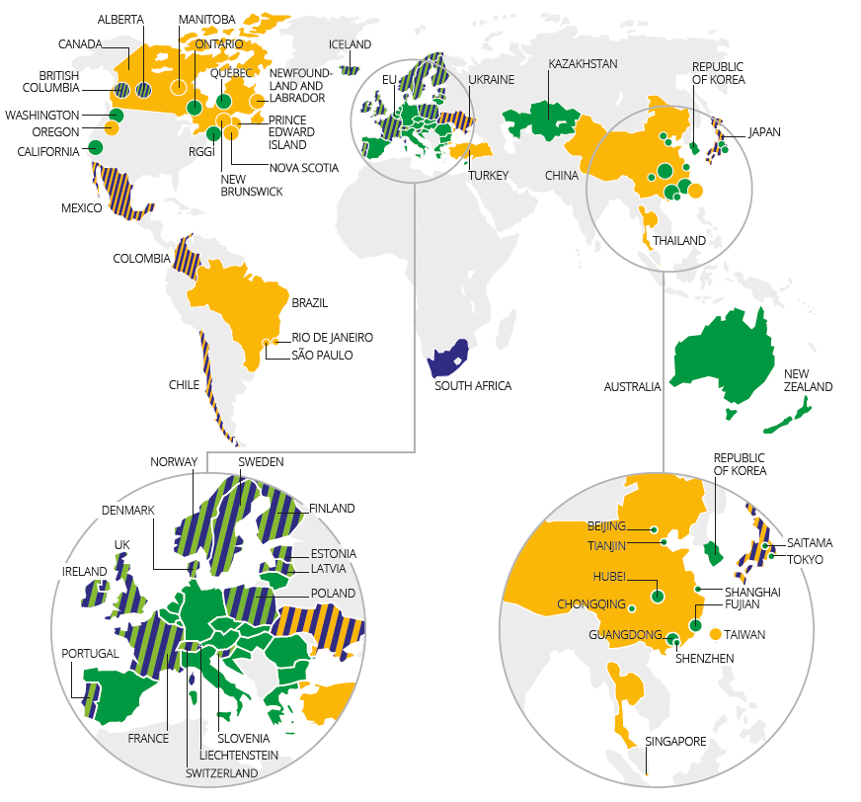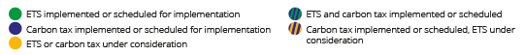
Figure 4.7 Carbon Pricing Instruments implemented, scheduled for implementation and under consideration.¹⁹⁶ (Source: World Bank, 2017)

In total, a further 21 carbon pricing instruments are either scheduled for implementation, or are under consideration. This includes the commencement of a national ETS in China expected in the second half of 2017. Although this would replace the 8 pilot schemes currently in place in China, it could expand their emissions coverage fourfold, surpassing the European ETS to become the largest carbon pricing instrument in the world.¹⁹⁶

Indicator 4.8: Use of carbon pricing revenues
Headline Finding: 40% of government revenues generated from carbon pricing are spent on climate change mitigation, totalling US$9 billion.
Carbon pricing instruments require those responsible for producing the emissions concerned to pay for their emissions, in one form or another. In most cases this generates revenue for the governments or authorities responsible for introducing the instrument. Such revenue may be put to a range of uses, including investment in climate change mitigation or adaptation or environmental tax reform (ETR), which involves shifting the burden of tax from negative activities, such as the generation of pollution, to positive activities, such as labour or environmentally beneficial products or activities. Such options may produce a ‘double dividend’ of environmental improvement with social and economic benefits.¹⁹⁷ This indicator tracks the total government revenue from carbon pricing instruments, and how such income is allocated.
 | Mitigation | Adaptation | Environmental Tax Reform (ETR) | General Funds | Total Revenue (US$2016)
Proportion (%) | 40.4% | 4% | 19.5% | 36.1% | $22.31 Billion
Value (US$2016) | $9.01 Billion | $0.9 Billion | $4.34 Billion | $8.06 Billion | $22.31 Billion

Table 4.2. Carbon Pricing revenues and allocation in 2016.¹⁹⁵ (Source: World Bank, 2017)

Tale 4.2 presents total government revenue generated by carbon pricing instruments in 2016, and four categories of expenditure for this revenue. The largest expenditure category is climate change mitigation, which is in receipt of over $9 billion annually in funds. Despite this, less than half of revenue-generating instruments allocate revenue for mitigation.
ETR policies accounted for around 20% of revenue allocation in 2016. Just two instruments (the Portuguese and British Colombia Carbon Taxes) allocate all their revenue to allowing revenue-neutral reduction in other (for example, income) taxes, with another four allocating part of their revenue to this purpose. By contrast, only four instruments do not have any revenue allocated to general government funds (The British Colombian, Swiss, Japanese and Portuguese carbon taxes), with 11 instruments allocating all revenues to this category (reaching €8 billion – or more than a third – of revenues generated in 2016). Data for individual carbon pricing instruments may be found in Appendix 5.
Data on revenue generated is provided by the World Bank, with revenue allocation information obtained from various sources (see Appendix 5).¹⁹⁵ Only instruments with revenue estimates, and only revenue received by the administering authority before redistribution, are considered. Revenue must be explicitly allocated to climate change mitigation or adaptation, or for ETR, to be considered in these categories. If such explicit earmarking is not present, or no data is available, then revenue is assumed to be allocated to general funds.

Indicator 4.9: Spending on adaptation for health and health-related activities
Headline finding: Out of the world's total adaptation spend just 4.63% ($16.46 billion USD) is on health and 13.3% ($47.29 billion USD) on health-related adaptation.
This indicator reports estimates of spending on health and health-related climate change adaptation and resilience. Many adaptation activities within and beyond the formal health sector yield health co-benefits, which are important to understand and capture. Here, estimates of the total health and health-related adaptation spending were derived from the Adaptation & Resilience to Climate Change (A&RCC) dataset produced by kMatrix. This global dataset, covering financial transactions relevant to climate change adaptation, was compiled from a relevant subset of over 27,000 independent databases and sources (such as public disclosures and reports from insurance companies, the financial sector, and governments).¹⁹⁸ In this case, entries were triangulated between at least seven independent sources before being included.
Examples of transactions captured here range from the procurement of goods or services (for example, purchasing sandbags for flood levees) through to spending on research and development (for example, for vulnerability and adaptation assessments) or staff training.¹⁹⁸ Each of these ‘adaptation activities’ are grouped in to eleven sectors: Agriculture and Forestry, Built Environment, Disaster-Preparedness, Energy, Health, ICT, Natural Environment, Professional Services, Transport, Waste, and Water. Whilst adaptation spending relevant directly to the formal health sector is clearly important (the ‘health’ category), interventions outside of the healthcare system will also yield important benefits for health and wellbeing. ‘Health-related adaptation spending’ was defined as that which additionally included adaptation spending from the agricultural sector (due to the centrality of food and nutrition to health) and disaster preparedness sector (due to the direct public health benefits that often result from these efforts).
This data from the A&RCC dataset is reported here, showing health and health-related adaptation spending for 180 countries for the 2015-2016 financial year. Global health adaptation spending for the financial year 2015-2016, calculated in this way, totalled 16.46 billion USD, representing 4.63% of the global aggregate adaptation spend. Health-related adaptation spending totalled 47.29 billion USD, or 13.3% of the global total adaptation spend (Figure 4.8).
Health-related adaptation and resilience spending, both national totals and per capita levels, is extremely low in low-income countries, and increase across the continuum towards high-income countries. Interestingly, health and health-related adaptation spending as a proportion of total adaptation spending is relatively constant across income groups.

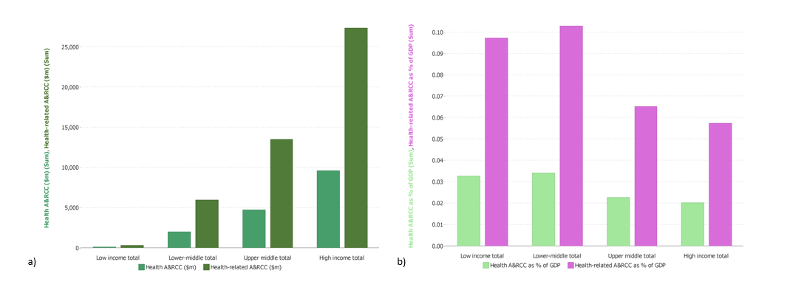
Figure 4.8 For the financial year 2015-2016. 4.8a) Total health and health-related adaptation spending and 4.8b) health and health-related adaptation and resilience to climate change (A&RCC) spending as a proportion of GDP. All plots are disaggregated by World Bank Income Grouping.

It is important to note that further work is required to more completely determine what should be considered as ‘health-related adaptation spending’. Spending for agriculture and disaster preparedness were included here, however other forms of adaptation spending clearly have important health implications. Second, only economic data relating to the financial year 2015-2016 was available, precluding time trend analysis. Third, since public sector transactions may not leave a sufficient ‘footprint’ to be picked up by this methodology, adaptation spending data here may exclude some public-sector spending.

Indicator 4.10: Health adaptation funding from global climate financing mechanisms
Headline Finding: Between 2003 and 2017, 0.96% of total adaptation funding for development, flowing through global climate change financing mechanisms, was dedicated to health adaptation.
The final indicator in this section is designed in parallel with indicator 4.9, and aims to capture development funds available for climate change adaptation. It reports global financial flows dedicated to health adaptation to climate change, moving through established global climate financing mechanisms. Data was drawn from the Climate Funds Update (CFU), an independent source which aggregates funding data from multilateral and bilateral development agencies since 2003.^{16,199} CFU data is presented in four categories (pledged, deposited, approved, and disbursed); this indicator uses data designated as ‘approved’.
Between 2003 and 2017, only 0.96% of approved adaptation funding was allocated to health adaptation, corresponding with a cumulative total of 39.55 million USD (Figure 4.9). Total global adaptation funding peaked in 2013 at 910.36 million USD and declined thereafter. However, health-related adaptation funding reached its highest level in early 2017, resulting in the near-doubling in the proportion of adaptation funding allocated to health. Panel 4.1 provides a brief overview of growing interest in health and climate change from the international donor community.

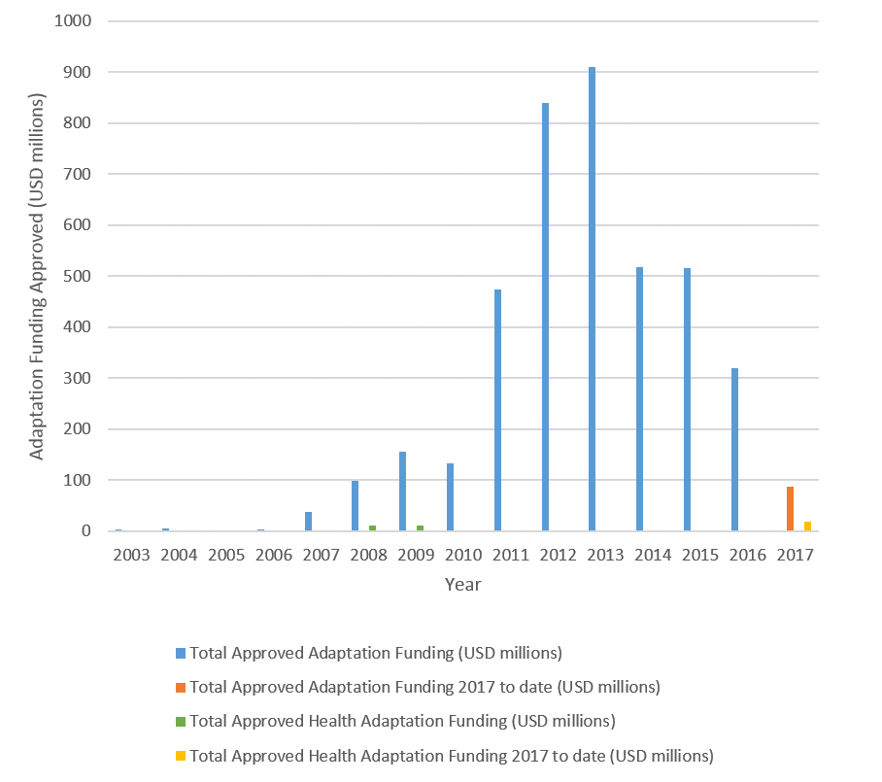
Figure 4.9 Year on year multilateral and bilateral funding for all adaptation projects and health adaptation projects (2003 through May 2017).

Panel 4.1 International Donor Action on Climate Change and Health.
In 2017, the World Bank released three independent reports on climate change and health, articulating (i) a new action plan for climate change and health, (ii) geographic focus areas, and (iii) new strategy for climate-smart healthcare. In addition to training staff and increasing government capacity, the World Bank outlines an approach to ensuring that at least 20% of new World Bank health investments are climate-smart by 2020, corresponding to as much as $1bn in new climate-smart health finance for countries. Other development institutions and foundations are also getting involved. Two separate, major gatherings of public and private funders occurred in 2016 (May, Helsinki) and 2017 (May, Chicago) toward establishing new channels for health and climate finance, and a third is planned for late 2017 (October, Washington, DC).

Conclusion
The indicators presented in this section seek to highlight the status of the economics and finance associated with climate change and health across four themes; investing in a low-carbon economy, economic benefits of tackling climate change, pricing the GHG emissions from fossil fuels, and adaptation financing.
Many of the trends show positive change over time, notably global investment in zero-carbon energy supply, energy efficiency, new coal-fired electricity capacity, employment in renewable energy, and divestment in fossil fuels. However, the rate of change is relatively slow, and must accelerate rapidly to meet the objectives of the Paris Agreement.

5. Public and Political Engagement

Introduction
So far, this report has presented indicators on the health impacts of climate hazards; resilience and adaptation to climate change; health co-benefits of climate change mitigation; and economics and finance mechanisms that facilitate a transition to a low-carbon economy.
Policy change requires public support and government action. This is particularly true of policies with the reach and impact to enable societies to transition to a low-carbon future.²⁰⁰ The overarching theme of this section is therefore the importance of public and political engagement in addressing health and climate change, and the consequent need for indicators that track engagement in the public and political domains.
The aim is to track engagement with health and climate change in the public and political domains and identify trends since 2007. In selecting indicators, priority has been given to high-level indicators, which can be measured globally, tracked over time and provide a platform for more detailed analysis in future Lancet Countdown reports. The indicators relate to coverage of health and climate change in the media, science, and government. Search terms for the indicators are aligned and a common time-period was selected for all indicators (2007-2016). The period runs from before the resolution on health and climate change by the 2008 World Health Assembly, which marked a watershed in global engagement in health and climate change; for the first time, member states of the UN made a multilateral commitment to protect human health from climate change.²⁰¹
The indicators presented are:
5.1. Media coverage of health and climate change
5.2. Health and climate change in scientific journals
5.3. Health and climate change in the United Nations General Assembly

Corresponding Appendix 6 provide more detailed discussion of the data and methods used.

Indicator 5.1: Media coverage of health and climate change
Headline Finding: Global newspaper coverage of health and climate change has increased 78% since 2007, with marked spikes in 2009 and 2015, coinciding with the 15th and 21st Conference of the Parties (COP).
Media plays a crucial role in communicating risks associated with climate change.²⁰² Knowledge about climate change is related to perceptions of risk and intentions to act.^{203,204} Public perceptions of a nation’s values and identity are also an important influence on public support for national action.²⁰⁵ Indicator 5.1 therefore tracks media coverage of health and climate change, with a global indicator on newspaper coverage on health and climate change (5.1.1), complemented by an in-depth analysis of newspaper coverage on health and climate change for two national newspapers (5.1.2).

5.1.1: Global newspaper reporting on health and climate change
Focusing on English-language and Spanish-language newspapers, this indicator tracks global coverage of health and climate change in high-circulation national newspapers from 2007 to 2016. Using 18 high-circulation ‘tracker’ newspapers, global trends are shown and disaggregated regionally to provide a global indicator of public exposure to news coverage of health and climate change.
Since 2007, newspaper coverage of health and climate change has risen globally by 78% (Figure 5.1). However, this trend is largely driven by South-East Asian newspapers. Although mostly due to the higher number of South-East Asian newspapers included in this analysis, the South-East Asian newspapers here did have a higher than average coverage of health and climate change than other regions, particularly among Indian sources (see Appendix 6). This generally high volume of coverage in the Indian press can be attributed to the centrality of newspapers as communication channels for elite-level discourse in India and to relatively high levels of climate change coverage throughout Asia.²⁰⁶⁻²⁰⁸ For the Eastern Mediterranean, Americas, and Western Pacific, there is not a strong trend in the media reporting. Some spikes are notable in 2009 in Europe, which is largely maintained for the rest of the time series, and in the Americas, which drops until a secondary spike between 2012 and 2014. The first major spike globally was in 2009, coinciding with COP15 (Conference of the Parties) in Copenhagen, for which there was high expectation. Newspaper reporting then dropped around 2010, but since 2011 has been rising overall globally.

Figure 5.1 Newspaper reporting on health and climate change (for 18 newspapers) from 2007 to 2016, broken down by WHO region.

Data was assembled by accessing archives through the Lexis Nexis, Proquest and Factiva databases. These sources were selected through the weighting of four main factors: geographical diversity (favouring a greater geographical range), circulation (favouring higher circulating publications), national sources (rather than local/regional), and reliable access to archives over time (favouring those accessible consistently for longer periods). Search terms were aligned to those used for the indicators of scientific and political engagement and searches, with Boolean searches done in English and Spanish.

5.1.2: In-depth analysis of newspaper coverage on health and climate change
The second part of this indicator provides an analysis of two national newspapers; Le Monde (France) and Frankfurter Allgemeine Zeitung (FAZ) (Germany). Le Monde and FAZ were chosen for this analysis, as these are leading newspapers in France and Germany; two countries with political weight in Europe. Both newspapers continue to set the tone of public debates in France and Germany.^{209,210}
Only a small proportion of articles on climate change mentioned the links between health and climate change: 5% in Le Monde and 2% in FAZ. The analysis also pointed to important national differences in reporting on health and climate change. For example, in France, 70% of articles referring to health and climate change represented the health-climate change nexus as an environmental issue, whereas in Germany articles had a broader range of references: the economy (23%), local news (20%) and politics (17%). The recommended policy responses also differed; in Le Monde, the emphasis was on adaptation (41% of articles), while FAZ put more emphasis on mitigation (40% of articles). The co-benefits that public health policies can represent for mitigation were mentioned by 17% of Le Monde articles and 9% of FAZ articles. Overall, the analysis points to the marked differences in media reporting of health and climate change, and therefore in the information and perspectives to which the public is exposed (see Appendix 6 for details).

Indicator 5.2: Health and climate change in scientific journals
Headline Finding: Since 2007, the number of scientific papers on health and climate change has more than trebled.
Science is critical to increasing public and political understanding of the links between climate change and health; informing mitigation strategies; and accelerating the transition to low-carbon societies.^{211,212} This indicator, showing scientific engagement with health and climate change, tracks the volume of peer-reviewed publications in English-language journals from PubMed and Web of Science (see Appendix 6 for details). The results show there has been a marked increase in published research on health and climate change in the last decade, from 94 papers in 2007 to over 275 published in both 2015 and 2016. Within this overall upward trend, the volume of scientific papers increased particularly rapidly from 2007-2009 and from 2012, with a plateauing between these periods (Figure 5.2).
Figure 5.2 Number of scientific publications on climate change and health per year (2007-2016) from PubMed and Web of Science journals.

The two periods of growth in scientific outputs coincided with the run-up to the UNFCCC COPs held in Copenhagen in 2009 (COP15) and in Paris in 2015 (COP21). This pattern suggests that scientific and political engagement in health and climate change are closely linked, with the scientific community responding quickly to the global climate change agenda and the need for evidence.
Most publications focus on the impacts of climate change and health in Europe and North America. Overall, more than 2000 scientific articles were identified, of which 30% of papers focussed on Europe, followed by 29% on the Americas. Within the Americas, the large majority (72%) of the papers related to health and climate change in North America (see Figure S5.1 in Appendix 6). By contrast, only 10% of published articles had a focus on Africa or the Eastern Mediterranean Region, demonstrating a marked global inequality in the science of health and climate change (see Figures S5.1 and S5.2 in Appendix 6).
Among the journals in the analysis, infectious diseases, particularly dengue fever and other mosquito-transmitted infections, are the most frequently investigated health outcomes; approximately 30% of selected papers covered these health-related issues. Important gaps in the scientific evidence base were identified, including migration and mental ill-health.
For this indicator, a scoping review of peer-reviewed articles on health and climate change, published in English between 2007 and 2016, was conducted; an appropriate approach for broad and inter-disciplinary research fields.²¹³ Two databases were used, PubMed and Web of Science, to identify papers through a bibliometric analysis using keyword searches (see Appendix 6 for details).²¹⁴ Inclusion and exclusion criteria were applied to capture the most relevant literature on the human health impacts of climate change within the chosen timeframe and papers were independently reviewed and screened three times to identify relevant publications.²¹⁵

Indicator 5.3: Health and climate change in the United Nations General Assembly
Headline Finding: There is no overall trend in United Nations General Debate (UNGD) references to health and climate change, but two significant peaks occurred in 2009 and 2014.
The General Debate (GD) takes place every September at the start of each new session of the United Nations General Assembly (UNGA). Governments use their annual statements to present their perspective on events and issues they consider the most important in global politics, and to call for greater action from the international community. All UN Member States can address the UNGA, free from external constraints. Therefore, GD statements provide an ideal data source on political engagement with health and climate change, which is comparable spatially and temporally. This indicator focuses on the extent to which governments refer to linkages between health and climate change issues in their annual statements in the GD, with one reference representing one ‘hit’.
Health and climate change are issues frequently raised in UNGD statements (see Figures S5.3-S5.5 in Appendix 6). However, statements less frequently link health and climate change together. Between 2007 and 2016, linked references to health and climate change in the annual UNGD ranged from 44 to 124 (Figure 5.3). The comparable figures for references to climate change alone were 378 and 989. It was found that there is no overall trend in conjoint references to health and climate change across the period.
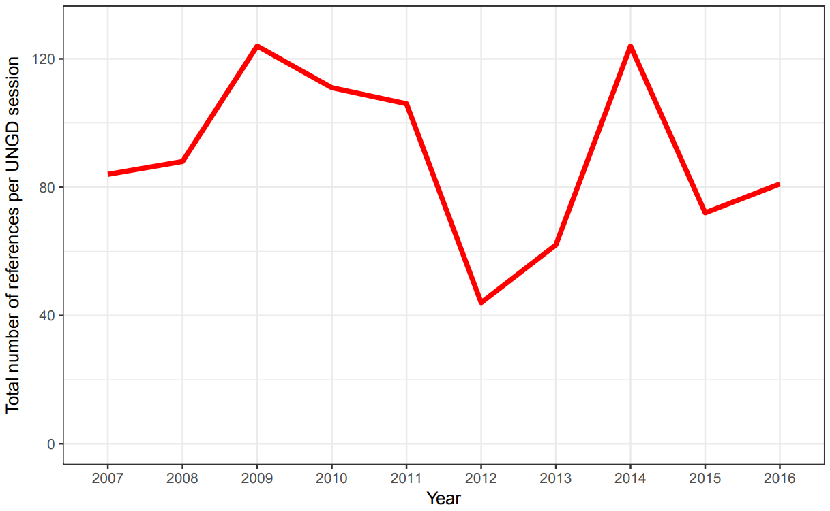
Figure 5.3 Political engagement with the intersection of health and climate change, represented by joint references to health and climate change in the UNGD.

While no overall trend is apparent, there are two distinct peaks between 2009 and 2011 and in 2014. In both 2009 and 2014, there were 124 references linking health and climate change in the GD statements. The 2009 peak occurred after the 2008 World Health Day, which focussed on health and climate change, and in the build-up to COP15 in Copenhagen in 2009. The 2014 peak is indicative of the influence of the large UNGA on climate change in 2014 and the lead up to COP21 in Paris in 2015.
The 2015 UNGA, which focused on the Sustainable Development Goals, made relatively limited reference to climate change, and, after the 2014 peak, conjoint references to health and climate change declined. This irregular pattern points to the importance of key events in the global governance of health and climate change in driving high-level political engagement.
There are country-level differences in the attention given to health and climate change in UNGD statements (Figure 5.4). More frequent reference is made to the issue by countries in the Western Pacific, particularly by the SIDS in these regions. In contrast, governments in the East Mediterranean, the Americas and South-East Asia tend to make fewer references to health and climate change.
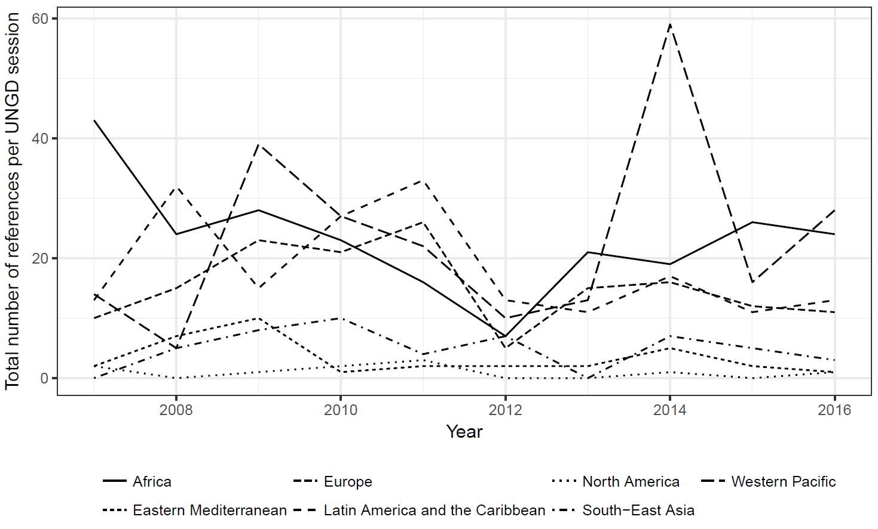
Figure 5.4 Regional political engagement with the intersection of health and climate change, represented by joint references to health and climate change in the UNGD, broken down by WHO region.

This indicator is based on the application of keyword searches in the text corpus of debates. A new dataset of GD statements was used (UNGD corpus), in which the annual UNGD statements have been pre-processed and prepared for use in quantitative text analysis (see Appendix 6 for details).²¹⁶

Conclusion
The indicators in this section have demonstrated the importance of global governance in mobilising public and political engagement in health and climate change. The UN (and particularly the annual COPs) have a significant role here, clearly influencing media, scientific and political engagement with health and climate change.
To further improve understanding of public and political engagement, indicators relating to national governments’ health and climate change legislation, private sector engagement, the inclusion of climate change in professional health education, and the prominence given to health in UNFCCC negotiations are proposed for future analysis. The previous sections in this report have presented findings on the impacts of climate hazards, adaptation and resilience, co-benefits of mitigation, and finance and economics. All of these hinge upon policy, which in turn is dependent upon public and political engagement.

Conclusion - the Lancet Countdown in 2017
In June 2015, the Lancet Commission laid the groundwork for its global monitoring platform, designed to systematically track progress on health and climate change, and hold governments to account for their commitments under the then to-be-finalised Paris Agreement.⁴ The Lancet Countdown will continue this work, reporting annually on the indicators presented in this report and on new indicators in future.

The direction of travel is set
The data and analysis presented in this 2017 report cover a wide range of topics and themes from the lethality of weather-related disasters, to the phase-out of coal-fired power. The report begins with an indicator set dedicated to tracking the health effects of climate change and climate hazards. The analysis here demonstrates that the symptoms of climate change have been clear for a number of years, with the health impacts far worse than previously understood. These effects have been spread unequally, with a 9.4% increase in vectorial capacity of the dengue fever carrying Aedes aegypti predominantly spreading to low- and middle-income countries since 1950; and India disproportionately affected by the additional 75 million exposure events to potentially fatal heatwaves since 2000.
These indicators also suggest that populations are beginning to adapt, with improvements in the world’s overall health profile strengthening its resilient capacity, and national governments beginning to invest in health adaptation planning for climate change. This is supported by some $47.29 billion USD spent annually on health-related adaptation (some 13.3% of global total adaptation spend). However, the academic literature and past experience make it clear that there are very real and immediate technological, financial, and political barriers to adaptation.¹⁰
The indicators in the third section track health-relevant mitigation trends across four sectors, with an ultimate focus of keeping temperature rise “well below 2°C” and meeting the Paris Agreement. At an aggregate level, the past two decades have seen limited progress here, with many of the trends and indicators remaining flat or moving strongly in the opposite direction. More recently, trends in the electricity generation (deployment of renewable energy and a dramatic slow-down in coal-fired power) and transport sectors (soon-to-be cost parity of electric vehicles with their petrol-based equivalents) provide cause for optimism, which, if sustained, could reflect the beginning of system-wide transformation.
Indicators in the fourth and fifth sections underpin and drive forward this transition. Again, trends across the last two decades reflect concerning levels of inaction, with accelerated investment and intervention seen in more recent years. They reflect record levels of employment in the renewable energy sector to overtake those in fossil fuel extraction, and a global reduction in fossil fuel consumption subsidies. Carbon pricing mechanisms are slowly widening and now cover some 13.1% of global CO₂ emissions. The final section considers the degree to which the public, political and academic communities have engaged with the links between climate change and health. It points to uneven patterns of engagement and the vital role of global institutions, and the UN particularly, in driving forward public, political and scientific support for enhanced mitigation and adaptation policies.
Overall, the trends elucidated in the Lancet Countdown’s 2017 report provide cause for deep concern, highlighting the immediate health threats from climate change and the relative inaction seen across the world over the past two decades. However, they also point to more recent trends over the last five years demonstrating a rapid increase in action, which was solidified in the Paris Agreement. These ‘glimmers of progress’ are encouraging, and reflect a growing political consensus and ambition, which was seen in full-force in response to the US’s departure from the 2015 climate change treaty. Whilst action needs to increase rapidly, taken together, this provides the clearest signal to-date that the world is beginning to transition to a low-carbon world, that no one country or head of state can halt this progress, and that from today until 2030, the direction of travel is set.

Contributors
The Lancet Countdown: Tracking Progress on Health and Climate Change is an international academic collaboration which builds off the work of the 2015 Lancet Commission on Health and Climate Change, convened by The Lancet. The Lancet Countdown’s work for this paper was conducted by its five working groups, each of which were responsible for the design, drafting, and review of their individual indicators and sections. All authors contributed to the overall paper structure and concepts, and provided input and expertise to the relevant sections. Authors contributing to Working Group 1: Jonathan Chambers; Peter M Cox; Mostafa Ghanei; Ilan Kelman; Lu Liang; Ali Mohammad Latifi; Maziar Moradi-Lakeh; Kris Murray; Fereidoon Owfi; Mahnaz Rabbaniha; Elizabeth Robinson; Meisam Tabatabaei. Authors contributing to Working Group 2: Sonja Ayeb-Karlsson; Peter Byass; Diarmid Campbell-Lendrum; Michael Depledge; , Paula Dominguez-Salas; Howard Frumkin; Lucien Georgeson; Delia Grace; Anne Johnson; Dominic Kniveton; Georgina Mace; Maquins Odhiambo Sewe; Mark Maslin; Maria Nilsson; Tara Neville; Karyn Morrissey; Joacim Rocklöv; Joy Shumake-Guillemot. Authors contributing to Working Group 3: Markus Amann; Kristine Belesova; Wenjia Cai; Michael Davies; Andy Haines; Ian Hamilton; Stella Hartinger; Gregor Kiesewetter; Melissa Lott, Robert Lowe; James Milner; Tadj Oreszczyn; David Pencheon, Steve Pye; Rebecca Steinbach; Paul Wilkinson. Authors contributing to Working Group 4: Timothy Bouley; Paul Drummond; Paul Ekins. Authors Contributing to Working Group 5: Maxwell Boykoff; Meaghan Daly; Niheer Dasandi; Anneliese Depoux; Antoine Flahault; Hilary Graham; Rébecca Grojsman; Slava Mikhaylov; Stefanie Schütte. The coordination, strategic direction, and editorial support for this paper was provided by Anthony Costello (Co-Chair), Hugh Montgomery (Co-Chair), Peng Gong (Co-Chair), Nick Watts (Executive Director), and Nicola Wheeler (Programme Officer). The findings and conclusions in this article are those of the authors and do not necessarily represent the official position of World Health Organization, the World Bank, or the World Meteorological Organization.

Declarations of Interest
The Lancet Countdown’s work is supported by an unrestricted grant from the Wellcome Trust (ref: 200890/Z/16/Z)). The Lancet Countdown covered travel costs for meetings related to the development of the paper. Seven of the authors (NWa, NWh, ML, PD, MB, MD and JC) were compensated for their time while working on the Lancet Countdown’s drafting and development. HM is a board member of the UK Climate and Health Council, an Advisory Board member of the Energy and Climate Intelligence Unit, and is developing an air pollution mask (which represents no conflict of interest). NWa reports being the Director of the UK Health Alliance on Climate Change. AJ is a Governor of the Wellcome Trust, and a member of the Adaptation Sub-Committee of the Committee on Climate Change. MA, SAK, KB, TB, PB, WC, DCL, AC, PC, ND, MDa, MDe, AD, PDS, PE, AF, HF, LG, MG, PG, DG, HG, RG, AH, IH, SH, IK, GK, DK, LL, RL, GM, MM, SM, JM, AML, MML, KMo, KMu, TN, MN, TO, FO, DP, SP, MR, ER, JR, SS, MS, JSG, RS, MT, and PW declare no conflicts of interest.

Acknowledgements
The Lancet Countdown would like to thank the Wellcome Trust, in particular Saskia Heijnen, Sarah Molten and Sophie Tunstall-Behrens, for its financial and strategic support—without which, this research collaboration would not be possible. While carrying out its work, the Lancet Countdown received invaluable technical advice and input from a number of individuals, including Neil Adger (University of Exeter), Kevin Andrews (University of Colorado Boulder), Nigel Arnell (University of Reading), Rob Bailey (Chatham House), John Balbus (National Institute of Environmental Health Sciences), Simon Bennet (International Energy Agency), Helen Berry (Australiana National University), Kathryn Brown (Climate Change Committee), Yossi Cadan (350.org), Tony Capon (University of Sydney), Carbon Disclosure Project (CDP), Michelle Chan (Universidad Peruana Cayetano Heredia), Lucia Fernandez (World Health Organization), Lauren Gifford (University of Colorado Boulder), Francesca Harris (London School of Hygiene & Tropical Medicine), Mathieu Hemono (Centre Virchow-Villermé), Niamh Herlihy (Centre Virchow-Villermé), Richard King (Chatham House), Tord Kjellstrom (Australian National University), Noemie Klein (Ecofys), Long Lam (Ecofys), Seline Lo (The Lancet), Rachel Lowe (London School of Hygiene & Tropical Medicine), Gesa Luedecke (University of Colorado Boulder), Lucy McAllister (University of Colorado Boulder), Marisa McNatt (University of Colorado Boulder), Jonathan Patz (University of Wisconsin-Madison), Sonia Roschnik (Sustainable Health Solutions), Osman Sankoh (INDEPTH), Ami Nacu-Schmidt (University of Colorado Boulder), Pauline Scheelbeek (London School of Hygiene & Tropical Medicine), Jan Semenza (European Centre for Disease Prevention and Control), Imogen Tennison (National Health Service), Hanna Tuomisto (London School of Hygiene and Tropical Medicine), Armando Valdes Valasquez (Universidad Peruana Cayetano Heredia) and Shelagh Whitley (Overseas Development Institute). Administrative and communications support was provided by Richard Black (Energy and Climate Intelligence Unit), Pete Chalkley (Energy and Climate Intelligence Unit), Tan Copsey (Climate Nexus), Tom Fern, Jack Fisher (University College London), Sarah Hurtes (European Climate Foundation), Paige Knappenberger (Climate Nexus) and George Smeeton (Energy and Climate Intelligence Unit). Mr Georgeson wishes to express gratitude for funding from the Economic and Social Research Council and the Natural Environment Research Council (grant number ES/J500185/1).
The Lancet Countdown is funded through an unrestricted grant from the Wellcome Trust (200890/Z/16/Z).

References

1. Kang Y, Khan S, Ma X. Climate change impacts on crop yield, crop water productivity and food security – A review. Progress in Natural Science 2009; 19(12): 1665–74.
2. Lindgren E, Andersson, Y, Suk, J.E, Sudre, B. and Semenza, J.C. Monitoring EU Emerging Infectious Disease Risk Due to Climate Change. Science 2012; 336(6080): 418-9.
3. Reuveny R. Climate change-induced migration and violent conflict. Political Geography 2007; 26(6): 656–73.
4. Watts N, et al. Health and climate change: policy responses to protect public health. The Lancet 2015; 386(10006): 1861–914.
5. Watts N, et al. The Lancet Countdown: tracking progress on health and climate change. The Lancet 2016; 389(10074): 1151–64.
6. World Health Organization. Second Global Conference: Health and Climate (Paris 7-8 July 2016), 2016.
7. United Nations Framework Convention on Change. Paris Agreement. In: United Nations, editor. Paris, France; 2015.
8. United Nations Environment Program. The Emissions Gap Report 2016. In: United Nations, editor. Nairobi, Kenya; 2016.
9. Intergovernmental Panel on Climate Change. Climate Change 2014: Impacts, Adaptation, and Vulnerability. Part A: Global and Sectoral Aspects. Contribution of Working Group II to the Fifth Assessment Report of the Intergovernmental Panel on Climate Change. Cambridge, United Kingdom and New York, NY, USA, 2014.
10. Smith KR, Woodward A, Campbell-Lendrum D, et al. Human health: Impacts, adaptation, and co-benefits. In: Field CB, Barros VR, Dokken DJ, et al., eds. Climate Change 2014: Impacts, Adaptation, and Vulnerability Part A: Global and Sectoral Aspects Contribution of Working Group II to the Fifth Assessment Report of the Intergovernmental Panel of Climate Change. Cambridge and New York: Cambridge University Press; 2014: 709-54.
11. Berry HL, Bowen K, Kjellstrom T. Climate change and mental health: a causal pathways framework. International Journal of Public Health 2010; 55(2): 123-32.
12. Reinmuth-Selzle K, et al. Air Pollution and Climate Change Effects on Allergies in the Anthropocene: Abundance, Interaction, and Modification of Allergens and Adjuvants. Environmental Science and Technology 2017; 51(8): 4119-41.
13. Glaser J, et al. Climate Change and the Emergent Epidemic of CKD from Heat Stress in Rural Communities: The Case for Heat Stress Nephropathy. Clinical Journal of the American Society of Nephrology 2016; 11(8): 1472–83.
14. McMichael AJ. Globalization, Climate Change, and Human Health. The New England Journal of Medicine 2013; 368: 1335-43.
15. European Centre for Medium-Range Weather Forecasts (ECMWF). 2017. https://www.ecmwf.int/.
16. European Centre for Medium-Range Weather Forecasts (ECMWF). Climate Reanalysis. 2017. https://www.ecmwf.int/en/research/climate-reanalysis.
17. NASA. Gridded Population of the World (GPW), v4. 2017.
18. Jacob D, Petersen J, Eggert B, et al. EURO-CORDEX: new high-resolution climate change projections for European impact research. Regional Environmental Change 2014; 14(2): 563-78.
19. HEAT-SHIELD. 2017. https://www.heat-shield.eu/.
20. Kjellstrom T, Briggs D, Freyberg C, Lemke B, Otto M, Hyatt O. Heat, Human Performance, and Occupational Health: A Key Issue for the Assessment of Global Climate Change Impacts. Annual Review of Public Health 2016; 37: 97–112.
21. Ijaz K, Kasowski E, Arthur RR, Angulo FJ, Dowell SF. International Health Regulations—What Gets Measured Gets Done. Emerging Infectious Diseases 2012; 18(7): 1054-7.
22. Intergovernmental Panel on Climate Change. Climate Change 2014: Synthesis Report. Contribution of Working Groups I, II and III to the Fifth Assessment Report of the Intergovernmental Panel on Climate Change [Core Writing Team, R.K. Pachauri and L.A. Meyer (eds.)]. Geneva, Switzerland: IPCC, 2014.
23. Emergency Events Database. The Human Cost of Weather-Related Disasters 1995-2015: Centre for Research on the Epidemiology of Disasters (CRED), 2015
24. Emergency Events Database. The International Disaster Database - Centre for Research on the Epidemiology of Disasters. 2017.
25. International Federation of Red Cross and Red Crescent Societies. World Disasters Report 2014: Focus on Culture and Risks, 2014.
26. Centre for Research on the Epidemiology of Disasters. The Human Cost of Natural Disasters: A Global Perspective. Brussels: CRED (Centre for Research on the Epidemiology of Disasters), 2015.
27. Global Burden of Disease. Global Burden of Disease Study 2015. Global Burden of Disease Study 2015 (GBD 2015) Results. In: Institute for Health Metrics and Evaluation (IHME), editor. Seattle, United States; 2016.
28. Liyanage P, Tissera H, Sewe M, et al. A Spatial Hierarchical Analysis of the Temporal Influences of the El Nino-Southern Oscillation and Weather on Dengue in Kalutara District, Sri Lanka. International journal of environmental research and public health 2016; 13(11).
29. Wilder-Smith A, Byass P. The elusive global burden of dengue. The Lancet Infectious diseases 2016; 16(6): 629-31.
30. Mitchell D, Heaviside C, Vardoulakis S, et al. Attributing human mortality during extreme heat waves to anthropogenic climate change. Environmental Research Letters 2016; 11(7): 074006.
31. Zanobetti A, Schwartz J. Temperature and mortality in nine US cities. Epidemiology (Cambridge, Mass) 2008; 19(4): 563-70.
32. Gasparrini A, Guo Y, Hashizume M, et al. Temporal Variation in Heat-Mortality Associations: A Multicountry Study. Environmental health perspectives 2015; 123(11): 1200-7.
33. Shi L, Kloog I, Zanobetti A, Liu P, Schwartz JD. Impacts of Temperature and its Variability on Mortality in New England. Nature climate change 2015; 5: 988-91.
34. Guo Y, Gasparrini A, Armstrong BG, et al. Temperature Variability and Mortality: A Multi-Country Study. Environmental health perspectives 2016.
35. Wang Y, Shi L, Zanobetti A, Schwartz JD. Estimating and projecting the effect of cold waves on mortality in 209 US cities. Environment international 2016; 94: 141-9.
36. Murray CJL, et al. Disability-adjusted life years (DALYs) for 291 diseases and injuries in 21 regions, 1990–2010: a systematic analysis for the Global Burden of Disease Study 2010. The Lancet 2013; 380(9859): 2197–223.
37. Dye C. After 2015: infectious diseases in a new era of health and development. Royal Philosophical Transactions of The Royal Society B 2014; 369(1645).
38. World Health Organization. Using climate to predict infectious disease epidemics. Geneva, Switzerland, 2005.
39. World Health Organization. The Health and Environment Lexicon: Multi-Language Glossary of Health and Environment Terminology. 2017. http://apps.who.int/thelexicon/entry.php.
40. Stanaway JD, et al. The global burden of dengue: an analysis from the Global Burden of Disease Study 2013. The Lancet: Infectious Diseases 2016; 16(6): 712–23.
41. Hales S, de Wet, N, Maindonald, J. and Woodward, A. Potential effect of population and climate changes on global distribution of dengue fever: an empirical model. The Lancet 2002; 360(9336): 830-4.
42. Krishnamurthy PK, et al. A methodological framework for rapidly assessing the impacts of climate risk on national-level food security through a vulnerability index. Global Environmental Change 2014; 24: 121–32.
43. Nelson GC, Rosegrant MW, Palazzo A, et al. Food Security Farming and Climate Change to 2050: scenarios, results, policy options: International Food Policy Research Institute, 2010.
44. Schmidhuber J, Tubiello FN. Global food security under climate change. Proceedings of the National Academy of Sciences of the United States of America 2007; 104(50): 19703-8.
45. Campbell-Lendrum D, Woodruff R. Comparative risk assessment of the burden of disease from climate change. Environmental health perspectives 2006; 114: 1935–41.
46. Campbell-Lendrum DH, Corvalán CF, Prüss–Ustün A. How Much Disease Could Climate Change Cause? Geneva: The World Health Organization, 2003.
47. Naylor RL, Falcon WP. Food security in an era of economic volatility. Population and development review 2010; 36(4): 693-723.
48. Headey D, Fan S. Reflections on the global food crisis: how did it happen? how has it hurt? and how can we prevent the next one?, 2010.
49. Asseng S, Ewert F, Martre P, et al. Rising temperatures reduce global wheat production. Nature climate change 2015; 5(2): 143-7.
50. Peng S, Huang, J., Sheehy, J.E., Laza, R.C., Visperas, R.M., Zhong, X., Centeno, G.S., Khush, G.S. and Cassman, K.G. Rice yields decline with higher night temperature from global warming. Proceedings of the National academy of Sciences of the United States of America 2004; 101(27): 9971-5.
51. Lobell DB, Burke, M.B., Tebaldi, C., Mastrandrea, M.D., Falcon, W.P. and Naylor, R.L. Prioritizing climate change adaptation needs for food security in 2030. Science 2007; 319(5863): 607-10.
52. Lobell DB, Schlenker, W. and Costa-Roberts, J. Climate trends and global crop production since 1980. Science 2011; 333(6042): 616-20.
53. Gornall J, et al. Implications of climate change for agricultural productivity in the early twenty-first century. Philosophical Transactions of the Royal Society B Biological Sciences 2010; 365(1554).
54. FAO. The FAO Hunger Map 2015. In: Food and Agriculture Organization of the United Nations, editor.; 2015.
55. Jones PG, Thornton PK. The potential impacts of climate change on maize production in Africa and Latin America in 2055. Global Environmental Change 2003; 13(1): 51-9.
56. Lobell DB, Bänziger M, Magorokosho C, Vivek B. Nonlinear heat effects on African maize as evidenced by historical yield trials. Nature climate change 2011; 1(1): 42-5.
57. High Level Panel of Experts on Food Security and Nutrition of the Committee on World Food Security. Sustainable Fisheries and Aquaculture for Food Security and Nutrition. Rome, Italy, 2014.
58. World Health Organization. Availability and consumption of fish. 2017. http://www.who.int/nutrition/topics/3_foodconsumption/en/index5.html (accessed July 2017.
59. Djouse L, et al. Fish consumption, omega-3 fatty acids and risk of heart failure: a meta-analysis. Clinical Nutrition 2012; 31(6): 846-53.
60. Golden Cea. Fall in fish catch threatens human health. Nature 2016; 534(317).
61. Bushaw-Newton KL, Sellner KG. Harmful Algal Blooms: National Oceanic and Atmospheric Administration, 1999.
62. Armstrong EM, Vazquez-Cuervo J. A New Global Satellite-Based Sea Surface Temperature Climatology. Geophysical Research Letters 2001; 28(22): 4199-202.
63. International Organization for Migration. Migration and Climate Change, 2008.
64. Gleick PH. Water, Drought, Climate Change, and Conflict in Syria. American Meteorological Society 2014.
65. Kelley CP, Mohtadib S, Canec MA, Seagerc R, Kushnirc Y. Climate change in the Fertile Crescent and implications of the recent Syrian drought. Proceedings of the National Academy of Sciences of the United States of America 2015; 112(11): 3241–6.
66. McMichael C, Barnett J, McMichael AJ. An Ill Wind? Climate Change, Migration, and Health. Environmental health perspectives 2012; 120(5): 646-54.
67. Green M. Contested territory. Nature climate change 2016; 6: 817–20.
68. United Nations Office for the Coordination of Humanitarian Affairs. Fiji: Building resilience in the face of climate change, 2014.
69. EU-GIZ Adapting to Climate Change and Sustainable Energy Programme. Planned Relocation Project. 2017.
70. Connell J. Last days in the Carteret Islands? Climate change, livelihoods and migration on coral atolls. Asia Pacific Viewpoint 2016; 57(1): 3-15.
71. Strauss S. Are cultures endangered by climate change? Yes, but ... WIREs Climate Change 2012; 3(4): 371-7.
72. Bronen R, Chapin I. Adaptive governance and institutional strategies for climate-induced community relocations in Alaska. PNAS, Proceedings of the National Academy of Sciences 2013; 110(23): 9320-5.
73. Shearer C. The political ecology of climate adaptation assistance: Alaska Natives, displacement, and relocation. Journal of Political Ecology 2012; 19: 174-83.
74. Small C, Nicholls RJ. A Global Analysis of Human Settlement in Coastal Zones. Journal of Coastal Research 2003; 19(3): 584-99.
75. McGranahan G, Balk, D. and Anderson, B. The rising tide: assessing the risks of climate change and human settlements in low elevation coastal zones. Environment & Urbanization 2007; 19(1): 17-37.
76. Merkens JL, Reimann, L, Hinkel, J. and Vafeidis, A.T. Gridded population projections for the coastal zone under the Shared Socioeconomic Pathways. Global and Planetary Change 2016; 145: 57-66.
77. Gregory J. Projections of sea level rise: Working Group I contribution to the IPCC Fifth Assessment Report - Climate Change 2013: The Physical Science Basis, 2013.
78. Collins PY, et al. Grand challenges in global mental health: A consortium of researchers, advocates and clinicians announces here research priorities for improving the lives of people with mental illness around the world, and calls for urgent action and investment. Nature 2011; 475: 27-30.
79. Vins H, Bell J, Saha S, Hess J. The mental health outcomes of drought: A systematic review and causal process diagram. International journal of environmental research and public health 2015; 12: 13251.
80. Intergovernmental Panel on Climate Change. Climate Change 2007: Working Group II: Impacts, Adaptation and Vulnerability, 2001.
81. Rockerfeller Foundation. Resilience. 2017. https://www.rockefellerfoundation.org/our-work/topics/resilience/ (accessed 02 Jul 2017).
82. United Nations Framework Convention on Change. National Adaptation Plans. 2017.
83. World Health Organization. WHO guidance to protect health from climate change through health adaptation planning. Switzerland, 2014.
84. World Health Organization. Operational framework for building climate resilient health systems. Geneva, Switzerland, 2015.
85. United Nations. The World's Cities in 2016, 2016.
86. Doherty M, Klima K, Hellmann JJ. Climate change in the urban environment: Advancing, measuring and achieving resiliency. Environmental Science & Policy 2016; 66: 310-3.
87. Compact of Mayors. 2017. https://www.compactofmayors.org/.
88. Carbon Disclosure Project. Carbon Disclosure Project Data. 2017.
89. Carbon Disclosure Project. CDP Cities 2016 Information Request, 2016.
90. Sustainable Development Knowledge Platform. Sustainable Development Goal 3 - Ensure healthy lives and promote well-being for all at all ages. 2017. https://sustainabledevelopment.un.org/sdg3.
91. World Health Organization. International Health Regulations (2005) Second Edition, 2008.
92. World Health Assembly. World Health Assembly resolution WHA 62.1 2008.
93. International Health Regulations. IHR Core Capacity Monitoring Framework: Questionnaire for monitoring progress in the implementation of IHR core capacities in states parties: World Health Organization, 2005.
94. World Health Organization. International Health Regulations (2005). IHR Core Capacity Monitoring Framework: Questionnaire for Monitoring Progress in the Implementation of IHR Core Capacities in States Parties, 2017.
95. World Meteorological Organization. Monitoring and Evaluation. 2017.
96. World Health Organization. Protecting Health from Climate Change: Vulnerability and Adaptation Assessment, 2013.
97. Lim SS, Allen K, Bhutta ZA, et al. Measuring the health-related Sustainable Development Goals in 188 countries: a baseline analysis from the Global Burden of Disease Study 2015. The Lancet 2016; 16: 31467-2.
98. Ministry of Economic Affairs and Employment. National Energy and Climate Strategy. In: Government of Finland, editor.; 2016.
99. Department for Business Energy and Industrial Strategy. Coal Generation in Great Britain. The pathway to a low-carbon future: consultation document In: HM Government, editor.; 2016.
100. Mason J. In latest move, China halts over 100 coal power projects. 2017. http://uk.reuters.com/article/us-china-coal-idUKKBN151090 (accessed July 2017.
101. UBS. UBS Evidence Lab Electric Car Teardown – Disruption Ahead?, 2017.
102. International Energy Agency. Medium-Term Renewable Energy Market Report 2016, 2016.
103. Dezem V. Solar Sold in Chile at Lowest Ever, Half Price of Coal. 2016. https://www.bloomberg.com/news/articles/2016-08-19/solar-sells-in-chile-for-cheapest-ever-at-half-the-price-of-coal.
104. Le Quéré C, Andrew, R.M, Canadell, J.G, et al. Global Carbon Budget 2016. Earth System Science Data 2016; 8: 605-49.
105. Schirnding YV. Framework for Linkages between Health, Environment and Development, 2002.
106. Intergovernmental Panel on Climate Change. Climate Change 2014: Mitigation of Climate Change. Contribution of Working Group III to the Fifth Assessment
Report of the Intergovernmental Panel on Climate Change. Cambridge, United Kingdom and New York, NY, USA, 2014.
107. International Energy Agency. Energy and Climate Change, 2015.
108. Rogelj J, Schaeffer, M, Meinshausen, M, et al. Zero emission targets as long-term global goals for climate protection. Environmental Research Letters 2015; 10(105007).
109. Pye S, Li FGN, Price J, Fais B. Achieving net-zero emissions through the reframing of UK national targets in the post-Paris Agreement era. Nature Energy 2017; 2.
110. Rockström J, Gaffney, O, Rogelj, J, Meinshausen, M, Nakicenovic, N. and Schellnhuber, H.J. A roadmap for rapid decarbonization. Science 2017; 80(355): 1269–71.
111. International Energy Agency. World Energy Outlook. Paris, France, 2016.
112. International Energy Agency. Energy and Air Pollution: World Energy Outlook Special Report. Paris, France, 2016.
113. Green F, Stern N. China’s changing economy: implications for its carbon dioxide emissions. Climate Policy 2017; 17: 423–42.
114. Shearer C, Ghio, N, Myllyvirta, L, Yu, A. and Nace, T. Boom and Bust 2017 - Tracking the global coal plant pipeline, 2017.
115. IRENA. Conference on the establishment of the international renewable energy agency. Bonn, Germany, 2009.
116. World Health Organization. The European health report 2015: Targets and beyond – reaching new frontiers in evidence, 2015.
117. World Health Organization. Proportion of population with primary reliance on clean fuels and technology. Geneva, Switzerland, 2017.
118. International Energy Agency, World Bank. Sustainable Energy for All 2017—Progress toward Sustainable Energy. Washington, D.C., 2017.
119. World Energy Oulook. WEO 2016 Biomass Database. 2016.
120. World Energy Outlook. WEO 2016 Electricity Access Database. 2016.
121. World Health Organization. Household Fuel Combustion: WHO guidelines for indoor air quality, 2014.
122. Bonjour S, Adair-Rohani, H, Wolf, J. et al. Solid Fuel Use for Household Cooking: Country and Regional Estimates for 1980–2010. Environmental health perspectives 2013; 121: 784–90.
123. West JJ, Smith, S.J, Silva, R.A. et al. Co-benefits of Global Greenhouse Gas Mitigation for Future Air Quality and Human Health. Nature climate change 2013; 3: 885–9.
124. Institute for Health Metrics and Global Burden of Disease. State of Global Air - 2017: A special report on global exposure to air pollution and its disease burden, 2017.
125. World Health Organization. WHO’s Urban Ambient Air Pollution database – Update 2016. Geneva, Switzerland, 2017.
126. Milner J, Taylor, J, Barreto, M.L. et al. Environmental risks of cities in the European region: analyses of the Sustainable Healthy Urban Environments (SHUE) database. Public Health Panorama 2017; 3: 300-9.
127. World Health Organization. Air pollution levels rising in many of the world’s poorest cities, 2016.
128. European Commission. Europe, Latin America and The Caribbean: sharing experiences in regional development policies, 2015.
129. Instituto Nacional de Estadistica e Informatica. 2017.
130. Fondo De Inclusion Social Energetico. Memoria Anual De Gestion Fise 2015, 2015.
131. Fondo De Inclusion Social Energetico. Memoria Anual De Gestion Fise 2014, 2014.
132. European Commission. Directive 2001/80/EC of the European Parliament and of the Council on the limitation of emissions of certain pollutants into the air from large combustion plants. OJEC L 309/1. 2001.
133. EU Parliament and Council. Directive 2010/75/EU of the European Parliament and of the Council of 24 November 2010 on industrial emissions (integrated pollution prevention and control). OJEC L 334/17. 2010.
134. Pope CAea. Lung Cancer, Cardiopulmonary Mortality and Long-Term Exposure to Fine Particulate Air Pollution. Journal of the American Medical Association 2002; 287 (9): 1132–41.
135. Lim SSea. A Comparative Risk Assessment of Burden of Disease and Injury Attributable to 67 Risk Factors and Risk Factor Clusters in 21 Regions, 1990–2010: A Systematic Analysis for the Global Burden of Disease Study 2010. The Lancet 2012; 380(9859): 2224–60.
136. Forouzanfar MHea. Global, Regional, and National Comparative Risk Assessment of 79 Behavioural, Environmental and Occupational, and Metabolic Risks or Clusters of Risks in 188 Countries, 1990–2013: A Systematic Analysis for the Global Burden of Disease Study 2013. The Lancet 2015; 386(10010): 2287–323.
137. World Health Organization. Ambient Air Pollution: A Global Assessment of Exposure and Burden of Disease. Geneva, Switzerland, 2016.
138. Amann M, I. Bertok, J. Borken-Kleefeld, J. Cofala, C. Heyes, L. Höglund-Isaksson, Z. Klimont, et al. Cost-Effective Control of Air Quality and Greenhouse Gases in Europe: Modeling and Policy Applications. Environmental Modelling & Software 2011; 26(2): 1489–501.
139. International Energy Agency. Energy Technology Perspectives. Paris, France, 2016.
140. International Energy Agency. Global EV Outlook 2016: Beyond on million electric cars. Paris, France, 2016.
141. International Energy Agency. Global EV Outlook 2017: Two Million and Counting, 2017.
142. Electric Vehicle Initiative. Global Electric Vehicle Outlook. 2016.
143. Land Transport Authority. Passenger Transport Mode Shares in World Cities, 2014.
144. Salon D, Gulyani S. Mobility, Poverty, and Gender: Travel ‘Choices’ of Slum Residents in Nairobi, Kenya. Transport Reviews 2010; 30: 641–57.
145. Sims R. RS, F. Creutzig, X. Cruz-Núñez, M. D’Agosto, D. Dimitriu, M.J. Figueroa Meza, L. Fulton, S., Kobayashi, O. Lah, A. McKinnon, P. Newman, M. Ouyang, J.J. Schauer, D. Sperling, and G. Tiwari. Transport, 2014.
146. United Nations Environment Program. Global Outlook on Walking and Cycling: United Nations, 2016.
147. Institute for Mobility Research. Mobility trends in cutting edge cities, 2016.
148. Transport for London. Travel in London Report 9, 2016.
149. NSW Department of Transport. Public transport travel patterns in the greater Sydney Metropolitan area 1981-1991. 1996.
150. NSW Department of Transport. Household Travel Survey Summary Report 2002. 2003.
151. NSW Department of Transport. Household Travel Survey Summary Report 2007. 2009.
152. NSW Department of Transport. Key Transport Indicators- How do people travel. 2017.
153. Translink. Metro Vancouver Regional Trip Diary Survey Briefing Paper #1. 2012.
154. S.A. D. Estudio Encuesta origen destino de viajes del Gran Santiago, 1991, 1992.
155. Rode P, Hoffmann C, Kandt J, Smith D, Graff A. Toward New Urban. Mobility: The case of London and Berlin. London: London School of Economics and Political Science, 2015.
156. City of Berlin. Mobility in the City: Berlin Traffic in Figures, 2013.
157. Vermeulen SJ, Campbell BM, Ingram JSI. Climate change and food systems. Annual Review of Environment and Resources 2012; 37: 195-222.
158. Lim SS, Vos, T, Flaxman, A.D. et al. Global, regional, and national comparative risk assessment of 79 behavioural, environmental and occupational, and metabolic risks or clusters of risks in 188 countries, 1990-2013: a systematic analysis for the Global Burden of Disease Study 2013. The Lancet 2016; 380: 2224–60.
159. Springmann Mea. Analysis and valuation of the health and climate change cobenefits of dietary change. PNAS, Proceedings of the National Academy of Sciences 2016; 15: 4146-51.
160. Hawkesworth S, Dangour, A.D, Johnston, D. et al. Feeding the world healthily: the challenge of measuring the effects of agriculture on health. Philosophical Transactions of the Royal Society B Biological Sciences 2010; 365: 3083–97.
161. Smith MR, Micha, R, Golden, C.D. et al. Global Expanded Nutrient Supply (GENuS) Model: A New Method for Estimating the Global Dietary Supply of Nutrients. PLoS One 2016; 11.
162. Gobbo LCD, Khatibzadeh, S, Imamura, F. et al. Assessing global dietary habits : a comparison of national estimates from the FAO and the Global Dietary Database 1 – 4, 2015.
163. Herrero Mea. Greenhouse gas mitigation potentials in the livestock sector. Nature climate change 2016; 6: 452–61.
164. O’Mara FP. The significance of livestock as a contributor to global greenhouse gas emissions today and in the near future. Animal Feed Science and Technology 2011; 166–167: 7–15.
165. Herrero M, Havlík P, Valin H, et al. Biomass use, production, feed efficiencies, and greenhouse gas emissions from global livestock systems. Proceedings of the National Academy of Sciences of the United States of America 2013; 110: 20888–93.
166. Carlsson-Kanyama A, González AD. Potential contributions of food consumption patterns to climate change. American Journal of Clinical Nutrition 2009; 89: 1704S–9S.
167. Larsson SC, Wolk A. Meat consumption and risk of colorectal cancer: A meta-analysis of prospective studies. International Journal of Cancer 2006; 119: 2657–64.
168. Norat T, Lukanova, A, Ferrari, P. and Riboli, E. Meat consumption and colorectal cancer risk: Dose-response meta-analysis of epidemiological studies. International Journal of Cancer; 98: 241–56.
169. FAOSTAT. Food Balance Sheets, 2017.
170. Ng M, Fleming T, Robinson M, al. e. Global, regional, and national prevalence of overweight and obesity in children and adults during 1980-2013: A systematic analysis for the Global Burden of Disease Study 2013. The Lancet 2013; 384: 766–81.
171. World Bank. Climate-Smart Healthcare: Low-Carbon and Resilience Strategies for the Health Sector. Washington DC, 2017.
172. NHS Sustainable Development Unit. NHS carbon footprint, 2016.
173. Stern N. Stern Review on the Economics of Climate Change. In: Kingdom GotU, editor. London: Blackwell Publishing; 2006. p. 5.
174. Weitzmann. M. Fat-Tailed Uncertainty in the Economics of Catastrophic Climate Change. Review of Environmental Economics and Policy 2011; 5(2): 17.
175. Stern N. The Structure of Economic Modeling of the Potential Impacts of Climate Change: Grafting Gross Underestimation of Risk onto Already Narrow Science Models. Journal of Economic Literature 2013; 51(3): 21.
176. International Energy Agency. World Energy Investment 2016. Paris, 2016.
177. International Energy Agency. World Energy Investment 2017. Paris, 2017.
178. International Energy Agency. World Energy Outlook 2016. Paris, France, 2016.
179. International Energy Agency, International Renewable Energy Agency. Perspectives for the energy transition: Investment needs for a low-carbon energy system. Berlin, Germany, 2017.
180. Olivier JGJ, Janssens-Maenhout G, Muntean M, Peters JAHW. Trends in Global CO2 Emissions: 2016 Report: PBL Netherlands Environmental Assessment Agency, The Hague, 2016.
181. Ansar A, Caldecott B, Tilbury J. Stranded assets and the fossil fuel divestment campaign: what does divestment mean for the valuation of fossil fuel assets?: Smith School of Enterprise and the Environment, 2013.
182. North CS. Disaster Mental Health Epidemiology: Methodological Review and Interpretation of Research Findings. Psychiatry 2016; 79(2): 16.
183. Munich Re. NatCatSERVICE. In: Re M, editor.; 2017.
184. World Health Organization. Global Health Observatory (GHO) data. In: World Health Organization, editor. Geneva; 2017.
185. Ming-Xiao. W, Tao. Z, Miao-Rong. X, Bin. Z, Ming-Qiu. J. Analysis Of National Coal-mining Accident data In China, 2001–2008. Public Health Rep 2011; 126(2): 5.
186. Hendryx M, Ahern MM. Relations Between Health Indicators and Residential Proximity to Coal Mining in West Virginia. American Journal of Public Health 2008; 98(4): 2.
187. Zullig. KJ, Hendryx. M. A Comparative Analysis of Health-Related Quality of Life for Residents of U.S. Counties with and without Coal Mining. Public Health Reports 2010; 125(4): 7.
188. Hendryx M. Mortality from heart, respiratory, and kidney disease in coal mining areas of Appalachia. International Archives of Occupational and Environmental Health 2009; 82(2): 6.
189. IBIS World. Global Coal Mining: Market Research Report, 2016.
190. IBIS World. Global Oil & Gas Exploration & Production: Market Research Report, 2017.
191. IRENA. Renewable Energy and Jobs: Annual Review 2017. Abu Dhabi: International Renewable Energy Agency, 2017.
192. International Energy Agency. World Energy Outlook 2012. Paris, France, 2012.
193. Granado JA, Coady D, Gillingham R. The Unequal Benefits of Fuel Subsidies: A Review of Evidence for Developing Countries, 2010.
194. General Secretariat of the Council. G7 Ise-Shima Leaders' Declaration. Brussels, Blegium; 2016. p. 1.
195. World Bank. Carbon Pricing Dashboard. 2017. http://carbonpricingdashboard.worldbank.org (accessed 06.06.2017 2017).
196. World Bank, Ecofys. Carbon Pricing Watch 2017. Washington DC, USA, 2017.
197. Patuelli R, Nijkamp P, Pels E. Environmental tax reform and the double dividend: a meta-analytical performance assessment. Ecological Economics 2005; 55: 564-83.
198. Georgeson L, al. e. Global Disparity in the Supply of Commercial Weather and Climate Information Services. Science Advances 2017; 3(5).
199. Climate Funds Update. Climate Funds Update: The Data. 2017. http://www.climatefundsupdate.org/.
200. Crompton T. Common Values: The Case for Working with our Cultural Values: WWF, 2010.
201. World Health Assembly. Sixty-first World Health Assembly WHA61.19. 2008.
202. Boykoff MT, Goodman MK, Curtis I. Cultural Politics of Climate Change: Interactions in Everyday Spaces, 2009.
203. Lee TM, Markowitz EM, Howe PD, al e. Predictors of public climate change awareness and risk perception around the world Nature climate change 2015; 5: 1014–20.
204. Boykoff MT. Media and scientific communication: a case of climate change Geological Society 2008; 305: 11-8.
205. Steentjes K, al e. European Perceptions of Climate Change: Topline findings of a survey conducted in four European countries in 2016, 2017.
206. Billett S. Dividing climate change: global warming in the Indian mass media. Climatic Change 2010; 99(1/2): 525-37.
207. Bhatta SNA. Coverage of Climate Change Issues in Indian Newspapers and Policy Implications. Current Science 2015; 108(11): 1972-3.
208. Andrews K, Boykoff, M., Daly, M., Gifford, L., Luedecke, G., McAllister, L., and Nacu-Schmidt, A. . World Newspaper Coverage of Climate Change or Global Warming, 2004-2017: Center for Science and Technology Policy Research, Cooperative Institute for Research in Environmental Sciences, University of Colorado, 2017.
209. Schütte S, Depoux A, Vigil S, al. e. The influence of health concerns in scientific and policy debates on climate change. 2015; Journal of Epidemiology and Community Health.
210. Depoux A, Hémono M, Puig-Malet S, Pédron R, Flahault A. Communicating climate change and health in the media. Public Health Reviews 2017; 38(1): 7.
211. Hosking J, Campbell-Lendrum D. How well does climate change and human health research match the demands of policymakers? A scoping review. Environmental health perspectives 2012; 120(8): 1076-82.
212. Campbell-Lendrum D, Bertollini R, Neira M, Ebi K, McMichael A. Health and climate change: a roadmap for applied research. The Lancet 2009; 373(9676): 1663-5.
213. Arksey H, O’Malley L. Scoping studies: towards a methodological framework. International Journal of Social Research Methodology 2005; 8(1): 19-32.
214. Janssen MA, Schoon, M.L, Ke, W, and Börner, K. Scholarly networks on resilience, vulnerability and adaptation within the human dimensions of global environmental change. Global Environmental Change 2006; 16(3): 240-52.
215. Herlihy N, Bar-Hen A, Verner G, et al. Climate change and human health: what are the research trends? A scoping review protocol. British Medical Journal 2016; 6.
216. Baturo A, Dasandi N, Mikhaylov S. Understanding State Preferences with Text as Data: Introducing the UN General Debate Corpus. Research and Politics 2017; 4(2).

