Greening the esterification between isosorbide and acetic acid
Alexandra Inayat*,^{a,b} Alexandre van Assche,ª James H. Clarkª and Thomas J. Farmerª
a) Green Chemistry Centre of Excellence, Department of Chemistry, University of York, Heslington, York, YO10 5DD, United Kingdom
b) current address: Institute of Chemical Reaction Engineering, Friedrich-Alexander University Erlangen-Nürnberg, Egerlandstr. 3, 91058 Erlangen, Germany
*corresponding author: alexandra.inayat@fau.de
Abstract
This contribution deals with the investigation of greener conditions for the preparation of 2,5-diacetyl-isosorbide from the bio-based substances isosorbide and acetic acid. The influence of solvent, catalyst and reactant ratio on the course of the isosorbide conversion and selectivity to 2,5-diacetyl-isosorbide as well as to the intermediate 2-acetyl-isosorbide is examined. It was found that the conventionally used solvent toluene can be substituted by the greener solvent n-propyl acetate. Additionally, the homogeneous acid catalyst p-toluene sulfonic acid can be replaced by the heterogeneous catalyst Amberlyst-15, resulting in an easier isolation of the desired 2,5-diacetyl-isosorbide, this being an important precursor for the vasodilatory drug isosorbide-5-nitrate.
keywords: isosorbide; 2,5-diacetyl-isosorbide; 2-acetyl-isosorbide; green synthesis; esterification

Introduction
The optimisation of production routes for pharmaceuticals under a green chemistry perspective is a contribution towards a more sustainable chemical/pharmaceutical industry [Kümmerer2010]. In order to lower the risk of a future feedstock supply shortfall, all reactants have to be obtained from renewable (bio-based) feedstocks. This is particularly important for pharmaceuticals which help to prevent or cure life-threatening diseases and which will therefore still be urgently needed even in a sustainable, i.e. eco sufficiency-based economy [Princen2005] [Paech2012].
Isosorbide (2,4-3,6-dianhydro-D-sorbitol) is a bio-based diol which has potential as a future platform molecule for the production of bio-based pharmaceuticals, solvents and polymers [Rose2012] [Farmer2015].
The esterification of isosorbide with acetic acid is of importance for the pharmaceutical industry because 2-acetyl-isosorbide is the intermediate for the production of isosorbide-5-nitrate, which is the active pharmaceutical ingredient in vasodilatory drugs like Isomonit, Imdur, Monoket or Chemydur used for the treatment of angina pectoris and coronary artery disease [Pubchem2017] [Tan2013]. Isosorbide-2,5-dinitrate is a vasodilatory drug, too, but the active metabolite is the mononitrate, so that the dinitrate brings effectively too much nitrate into the body which can cause insensitivity towards such drugs. Furthermore the metabolisation of isosorbide-2,5-dinitrate is much faster than for isosorbide-5-nitrate which forces the patient to take the drug twice instead of only once a day causing difficulties for some patients [Lehman2010] [Gunasekara1999]. Thus, from a pharmaceutical point of view, the use of isosorbide-5-nitrate is preferred over the dinitrated equivalent.
Figure 1 shows a possible synthesis pathway from isosorbide to isosorbide-5-nitrate as described by Karl Schönafinger in two German patents from 1982 [Schönafinger1982a] [Schönafinger1982b]. In a first step isosorbide is reacted with acetic acid in the presence of p-toluene sulfonic acid (p-TSA) as the acidic catalyst. Toluene is used as the heteroazeotropic solvent for water removal in a Dean-Stark apparatus. 2-acetyl-isosorbide is then isolated and nitrated, with the 2-acetyl group protecting the former 2-hydroxyl group from nitration. The final synthesis step is the hydrolysis of the 2-acetyl group to give isosorbide-5-nitrate in a yield of over 60 % in respect to the isosorbide starting material.
It was found that the isolation of the mono-acetylated intermediate 2-acetyl-isosorbide is more difficult than the isolation of the di-acetylated product 2,5-diacetyl-isosorbide, because the synthesis mixture contains unreacted isosorbide, 5-acetyl-isosorbide and 2,5-diacetyl-isosorbide, too, if full acetylation is avoided. The results of the present study (see Table 1) indicate that a maximum theoretical yield of 2-acetyl-isosorbide of 38 % can be obtained before further acetylation to 2,5-diacetyl-isosorbide takes place. To increase the 2-acetyl-isosorbide yield, the patent [Schönafinger1982a] suggests a simple two-step process, where the first step is the complete esterification of isosorbide to form 2,5-diacetyl-isosorbide (conversion ca. 90 %). In a second step 2,5-diacetyl-isosorbide is converted back into 2-acetyl-isosorbide via a short treatment with KOH or p-TSA at higher temperature, which is reported to yield 84 % (only step 2) or 76 % (steps 1 +2) 2-acetyl-isosorbide with only minor impurities of isosorbide and 5-acetyl-isosorbide. An alternative, enzymatic route converts 2,5-diacetyl-isosorbide with similarly high selectivity to 2-acetyl-isosorbide or 5-acetyl-isosorbide, respectively [Schneider1993].
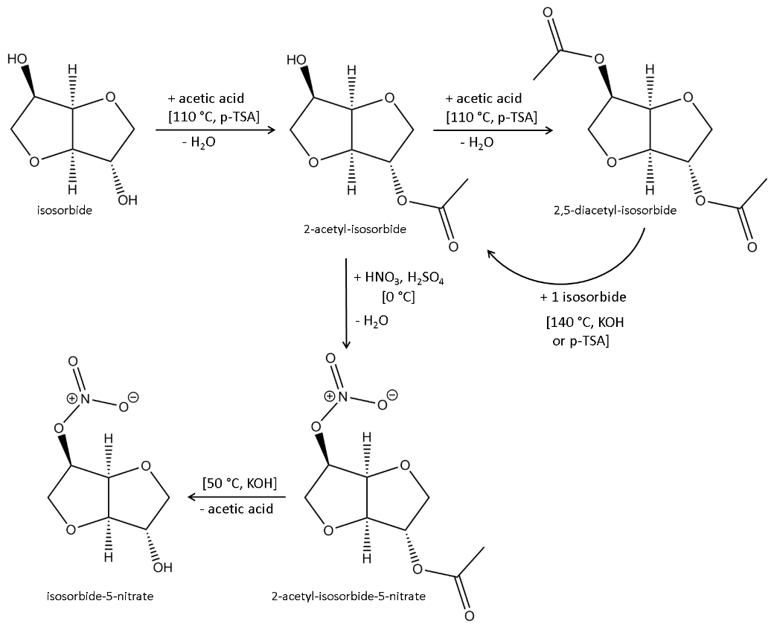
Figure 1 Synthesis route for the production of isosorbide-5-nitrate via the esterification of isosorbide with acetic acid according to Schönafinger [Schönafinger1982a] [Schönafinger1982b]
According to Schönafinger [Schönafinger1982b] the direct nitration of isosorbide to isosorbide-5-nitrate is not preferable because it results in a mixture of different nitrates where isosorbide-5-nitrate is a minor component, thus giving very low yields after costly purification. Also the direct nitration of isosorbide to isosorbide-2,5-dinitrate and subsequent selective reduction to isosorbide-5-nitrate seems inappropriate from a green as well as economic point of view since it involves substances like toxic dichloromethane, high amounts of toxic sodium borohydride (2 molar equivalents) and expensive catalysts like iron phthalocyanine [Marston2001]. So there is a need for the intermediate acetylation of isosorbide.
From a life cycle and safety perspective the use of acetic acid instead of acetyl chloride or acetic anhydride [Otera2010] is the greener way of acetylating isosorbide. Among the reported synthesis procedures using acetic acid for the esterification of isosorbide [Thiyagarajan2014] [Howard2009] [Cekovic1989] [Schönafinger1982a] the industrially most appropriate and greenest protocol seems to be the one described in example 1 of the patent of Schönafinger [Schönafinger1982a], which was therefore used as the state of the art procedure for our greening study. However, the acid catalyst is p-toluene sulfonic acid (p-TSA), which is homogeneous and thus not reusable, requires neutralisation agents for its removal after synthesis and subsequently leads to the generation of salty waste water as well as the use of toxic CH₂Cl₂ for the extraction of the reaction product [Schönafinger1982a]. Furthermore, toluene is used as a solvent for the azeotropic water removal, which is not ideal from a green chemistry point of view and the related health issues lead to its “compound of concern” marking in solvent selection guides [Byrne2016].
The present contribution shows the results of our “greening” efforts for the Fischer esterification of isosorbide with acetic acid, which includes:
- search for active heterogeneous catalysts
- testing greener solvents for the azeotropic removal of the reaction water
- determination of the minimum reaction time needed for full conversion to the diacetyl ester, thereby also giving insights into the formation of the intermediate monoacetyl esters
- greener workup and isolation of the reaction product
Furthermore, since the literature on 2,5-diacetyl-isosorbide is with few exceptions (NMR data [Hopton1969]) patents, physicochemical and analytical data for this bio-based compound are rare. Therefore, this contribution also aims to provide such data.

Experimental
Chemicals and materials
Isosorbide (98 %, Sigma-Aldrich), acetic acid (glacial 99.8 %, Fisher Scientific UK), Amberlyst-15 (H-form, wet, Aldrich), sulfuric acid (98 %, Sigma-Aldrich), p-toluene sulfonic acid mono hydrate (Sigma-Aldrich), toluene (99 %, VWR Chemicals), diethyl ether (99 %, Sigma-Aldrich), methylcyclopentane (97 %, Sigma-Aldrich), cyclopentane (98 %, Acros Organics), 2-pentanone (98 %, Sigma-Aldrich), 2-methyl-tetrahydrofurane (99 %, stabilised, Acros Organics) and n-propyl acetate (99 %, Sigma-Aldrich) were used as received. The zeolite catalysts H-Y (Degussa) and H-ZSM5 (Südchemie) were dried at 300 °C for 4 hours, the hydrotalcite (MgAl hydroxycarbonate, synthetic, Aldrich) at 120 °C for 4 h prior to use.
General procedure for the esterification of isosorbide with acetic acid
10 g isosorbide (0.069 mol) were filled into a 100 ml 2-neck round bottom flask equipped with a magnetic stirrer bar and a Dean-Stark condenser (the 15 ml Dean-Stark trap was already filled with the respective solvent). Then 40 ml of solvent was added and the mixture heated to 90 °C. When the isosorbide was molten (melting point ca. 58 °C) and dissolved, acetic acid was added and then the catalyst (= t₀). The mixture was heated to about 110-120 °C so that it boiled vigorously and water separation into the Dean-Stark trap started after about 25 minutes.
The progress of the esterification reaction was monitored by means of gas chromatographic (GC) analysis. For this purpose, 3 drops of sample were taken after certain times of reaction, filtered through cotton wool (mounted in a glass pipette) to remove the catalyst and diluted with diethyl ether in a GC vial.
Finally, the reaction mixture was cooled down. The catalyst was removed by atmospheric filtration through filter paper. Solvent and remaining acetic acid were removed at 60 °C under vacuum in a rotation evaporator (Heidolph). The residual liquid was stored in a closed flask at room temperature, where the 2,5-diacetyl-isosorbide usually formed cubic colourless crystals overnight. If any liquid remained (which typically consisted of remains of solvent, acid, isosorbide and mono-acetyl-isosorbide) the 2,5-diacetyl-isosorbide crystals were separated by filtration with filter paper.
Table 1 gives an overview over all experimental variations and the formed products.
Table 1 Synthesis variations undertaken in this study; for each experiment 10 g (0.069 mol) isosorbide and 40 ml solvent were used; the maxiumum mol fractions of 2,5-diacetyl-isosorbide (2,5-DAI) and 2-acetyl-isosorbide (2-AI) observed during the syntheses were calculated according to equation (1); the numbers in the “image” column relate to photographs of the final synthesis mixtures which can be found in the supplementary information in Figure S6
variation | acetic acid | catalyst | solvent | T [°C] | image | max. mol fraction  (after synthesis time)
 |  |  |  |  |  | 2-AI | 2,5-DAI
standard synthesis | 15 ml (0.25 mol) | 0.25 g Amberlyst-15 | toluene | 111 | 1 | 0.33 (3h) | 0.99 (30h)
acetic acid amount | 12 ml (0.20 mol)  9 ml (0.15 mol)  6 ml (0.10 mol) | 0.25 g Amberlyst-15 | toluene | 111 | 2  3 | 0.36 (6h)  0.38 (6h)  0.38 (6h) | 0.68 (31h)  0.58 (30h)  0.29 (30h)
catalyst amount | 15 ml (0.25 mol) | 0.50 g Amberlyst-15  0.15 g Amberlyst-15  0.05 g Amberlyst-15 | toluene | 111 | 4  5 | 0.30 (1h)  0.34 (5h)  0.37 (3h) | 0.91 (25h)  0.79 (30h)  0.61 (26h)
type of catalyst | 15 ml (0.25 mol) | 0.5 g H-Y  0.5 g H-ZSM5  0.5 g hydrotalcite  0.4 g p-TSA  (mono hydrate)  0.02 g H₂SO₄  no catalyst | toluene | 111 |  | 0.33 (23h)  0.32 (55h)  0.30 (54h)  0.34 (2h)  0.32 (4h)  0.31 (50h) | 0.10 (28h)  0.28 (79h)  0.20 (54h)  0.99 (26h)  0.99 (26h)  0.45 (120)
type of solvent | 15 ml (0.25 mol) | 0.25 g Amberlyst-15 | toluene  n-propyl acetate  methylcyclopentane | 111  102  72 | 7  6,8 | 0.33 (3h)  0.31 (5h)  0.28 (6h) | 0.88 (25h)  0.99 (51h)  0.59 (27h)

Furthermore, for the preselection of useful solvents, the pure solvents toluene, 2-methyl-tetrahydrofurane (2-methyl-THF), methylcyclopentane, cyclopentane, cyclopentanone, n-propyl acetate and 2-pentanone were tested for their heteroazeotropic water removal ability by mixing 40 ml solvent with 8 ml water and heating at boiling temperature until no further water formed in the Dean-Stark trap.
Analytical methods
GC-FID analyses were performed with the gas chromatograph CPG 6890N (Agilent) equipped with a Rxi-5HT column (phase of low polarity, diphenyl dimethyl polysiloxane) of 30 m length and 0.25 mm diameter, 20 psi column pressure. The FID detector was heated at 340 °C with a flow rate of air and H2 of 350 ml/min and 35 ml/min, respectively. The inlet temperature was 290 °C. The column oven was heated from 50 °C to 300 °C at 30 °C/min with a 5 min isothermal step at 300 °C. Helium was used as the carrier gas at a constant flow rate of 2 ml/min. All samples were diluted in diethyl ether prior to analysis. For the calculation of mol fractions, conversions and selectivities, the peak areas A of the respective components i (IS = isosorbide, 2AE = 2-acetyl-isosorbide, 5AS = 5-acetyl-isosorbide, 2,5DE = 2,5-diacetyl-isosorbide) under the chromatograms were used in formulas (1) to (3).
- Mol fraction M of component i: $M_{i}=\frac{A_{i}}{\sum{A_{IS}}+A_{2AE}+A_{5AE}+A_{2,5DE}}$

- Conversion C of isosorbide [%]: $C_{IS}=\frac{A_{2AE}+A_{5AE}+A_{2,5DE}}{A_{IS}+A_{2AE}+A_{5AE}+A_{2,5DE}}∙100$

- Selectivity S to component i within all reaction products [%]: $S_{i}=\frac{A_{i}}{A_{2AE}+A_{5AE}+A_{2,5DE}}∙100$
The GC method for the GC-MS analyses was the same as for the GC-FID analyses and the instrument was a Clarus 560S from Perkin Elmer.
NMR spectra were recorded in a JEOL JNM-ECS400A instrument at a frequency of 400 MHz. All samples were dissolved in deuterated dimethyl sulfoxide (DMSO-d6).
Melting point determination was carried out with a Gallenkamp (England) Melting Point Apparatus.

Results and discussion
Reaction and time dependency
The esterification of isosorbide with acetic acid proceeds via the two mono-acetylated intermediates 2-acetyl-isosorbide and 5-acetyl-isosorbide to the di-acetylated product 2,5-diacetyl-isosorbide as shown in Figure 2.
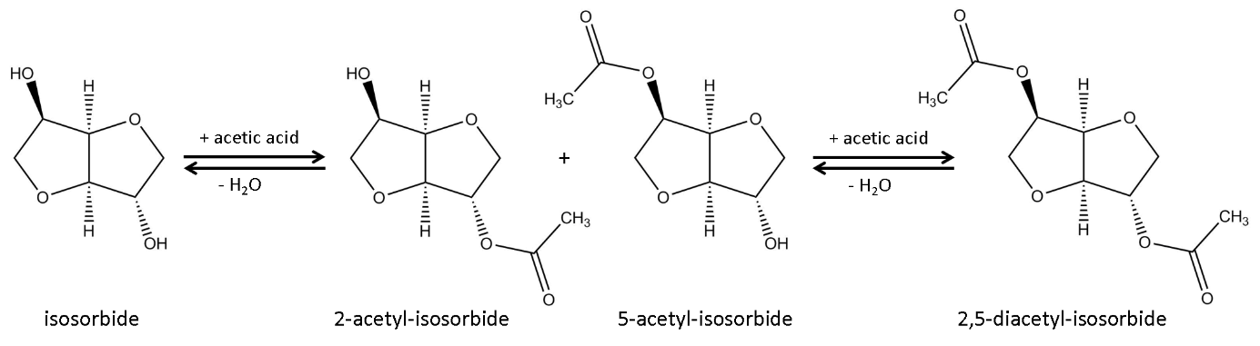
Figure 2 Reaction scheme of the esterification of isosorbide with acetic acid
For each mol of di-acetylated isosorbide two moles of water are formed as the by-product. If acetic acid is present in insufficient amounts and/or if the reaction water is not removed, an equilibrium composition with all reactants present is obtained.
The reaction progress over time was followed by means of gas chromatography. The results are shown in Figure 3 and summarised in Table 1. In this standard experiment, Amberlyst-15 was used as the catalyst and acetic acid was used in slight excess (acid/isosorbide molar ratio = 3.6). Toluene was used for the azeotropic water removal.
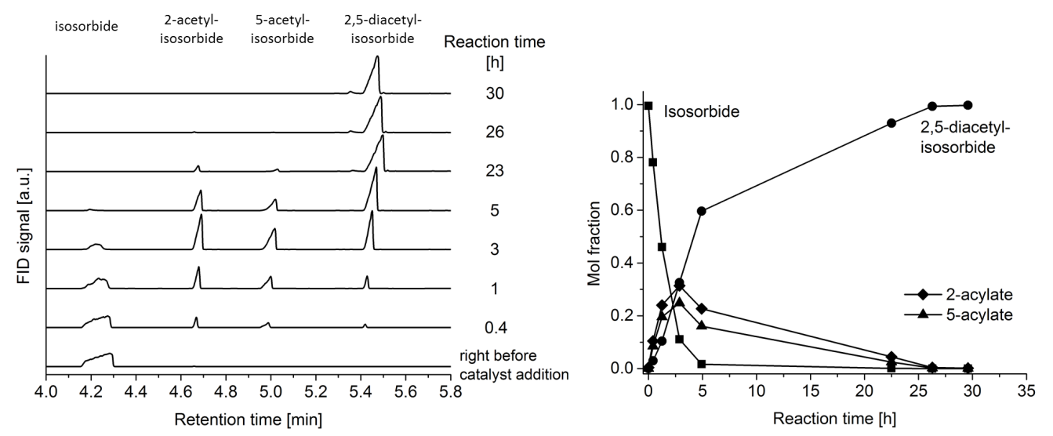
Figure 3 Reaction progress in the standard experiment for the esterification of isosorbide; left: gas chromatograms of samples taken after different reaction times, right: derived diagram showing the time dependency of the different compounds converted/formed in the reaction mixture
The 2-step esterification of isosorbide was clearly visible from the gas chromatograms measured at different reaction times (Figure 3, left). After about 3 hours of reaction the highest mol fraction of 0.3 for 2-acetyl-isosorbide (acetylation of the exo-OH group) was reached (Figure 3, right). 5-acetyl-isosorbide was formed in lower amounts with the highest mol fraction being 0.24. Full conversion of isosorbide was reached after about 7 hours but it took almost 20 hours more until the intermediate mono-acetyl-isosorbide esters were converted into 2,5-diacetyl-isosorbide, too, giving a selectivity for 2,5-diacetyl-isosorbide of 99 % at 100 % conversion.

The catalyst
It was state of the art to use the homogeneous catalyst p-toluene sulfonic acid (p-TSA) as the acid catalyst in the esterification of isosorbide with acetic acid [Schönafinger1982a]. In order to make the workup of the reaction product greener, we tested different catalysts with the focus on heterogeneous catalysts, which can be separated from the reaction mixture by simple filtration and do not require neutralisation washing as in the case of homogeneous acid catalysts.
We selected Amberlyst-15 (polystyrene-based ion exchange resin containing sulfonic acid groups) because it was known to be an active heterogeneous catalyst for the esterification of isosorbide with longer-chain acids [VanEs2001]. Additionally, the option to use an acidic ion exchange resin for the esterification of isosorbide with acetic acid as well as for a subsequent transesterification of 2,5-diacetyl-isosorbide with isosorbide to form 2-acetyl-isosorbide (which would be the next step in the production process of isosorbide-5-nitrate as described in Figure 1) was already mentioned in the patent of Schönafinger [Schönafinger1982a]. The acidic heterogeneous zeolite catalysts H-Y and H-ZSM5 were chosen for this study due to their environmentally benign material properties (non-toxic, safe to handle, easy to recover and reuse). Hydrotalcite (non-toxic MgAl hydroxy carbonate) was chosen in order to test if its combination of weak acid and base groups would be able to catalyse the esterification of isosorbide. For comparison, one experiment was performed without any catalyst and the homogeneous catalysts p-TSA and sulfuric acid were also tested. The results can be found in Figure 4. For better visibility the results for sulfuric acid are not shown in Figure 4 because they were identical to p-TSA. Zeolite H-Y showed almost identical performance as H-ZSM5 and is therefore also not shown. For all experiments the maximum mol fractions obtained for 2,5-diacetyl isosorbide and 2-acetyl-isosorbide are summarised in Table 1.

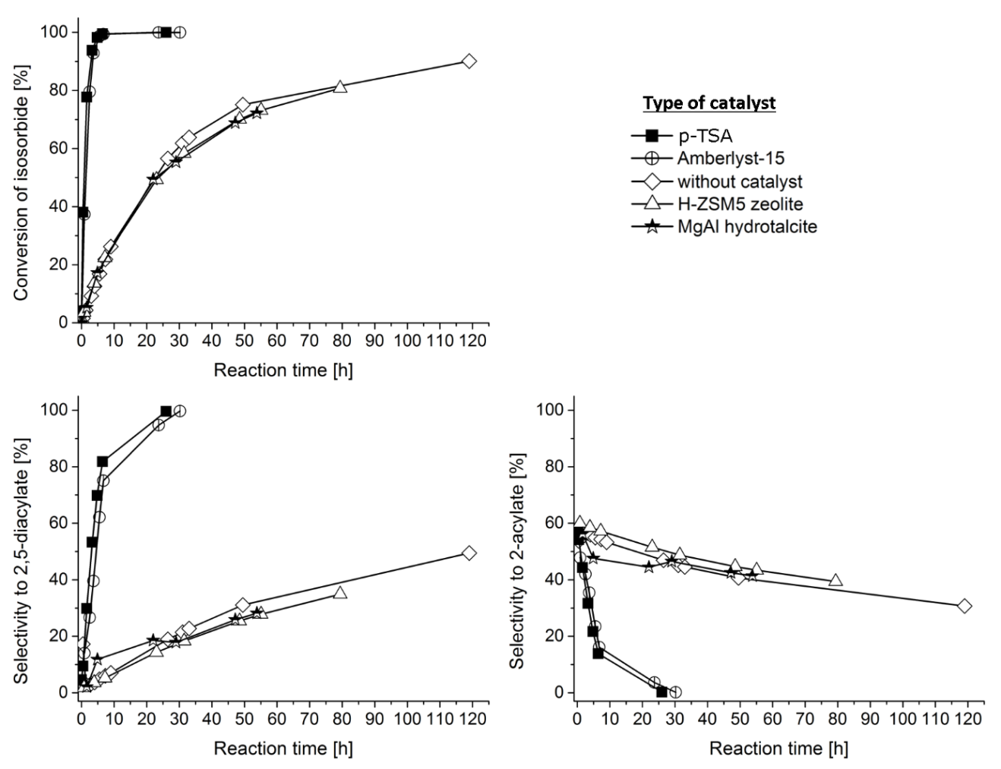
Figure 4 Performance of different catalysts in the esterification between isosorbide and acetic acid (for better visibility the results of esterifications in the presence of sulfuric acid and zeolite HY catalyst are not shown here but summarised in Table 1)
It can be seen from Figure 4 that the tested catalysts can be divided into two groups. The first group consists of the zeolite catalysts and hydrotalcite, where the esterification proceeds in an identical manner as without any catalyst. After 50 h of reaction, only about 70 % of isosorbide were converted, ca. 25 % of which was 2,5-diacetyl-isosorbide and 45 % 2-acetyl-isosorbide (remaining 30 % being 5-acetyl-isosorbide, graph not shown). A strong brown colouration of the reaction mixture together with increasing formation of various impurities (visible in the gas chromatograms) after prolonged reaction time (>40 h) could be observed, probably due to partial decomposition of isosorbide. Furthermore a strong dissolution of the hydrotalcite material was noted, making its removal from the reaction mixture almost impossible. Such structural instability in the reaction medium was not found for the zeolite catalysts.
The second group of catalytic performance consists of p-TSA, sulfuric acid and Amberlyst-15, which clearly accelerated the esterification and thus were active in this reaction, giving almost 100 % conversion to 2,5-diacetyl-isosorbide after 30 h. The reaction mixture colour after 30 h at 111 °C was yellow to bright orange.
Accordingly, Amberlyst-15 was the only active heterogeneous catalyst we could identify for the esterification of isosorbide and was then used for all other investigations within this study.
The results of the variation of the Amberlyst-15 amount are shown in Figure S1. Doubling the standard amount of 0.25 g did not give any better catalytic performance. On the other hand, a reduction of the catalyst amount resulted in a slower conversion of isosorbide though full conversion could still be reached within 30 h of reaction time but with worse selectivity to 2,5-diacetyl-isosorbide.
In order to find out how stable this polystyrene-based catalyst is under the applied reaction conditions, reuse experiments with Amberlyst-15 and toluene as the solvent were carried out. Between the catalytic runs, the catalyst was completely recovered by filtration (0.25 g Amberlyst-15), washed with acetone and dried over night at room temperature. Those experiments revealed that Amberlyst-15 loses activity over time. As can be seen from Figure 5, the loss of activity is especially pronounced in the second run (first reuse), whereas the catalyst performance finds an almost constant level in the third run (second reuse).
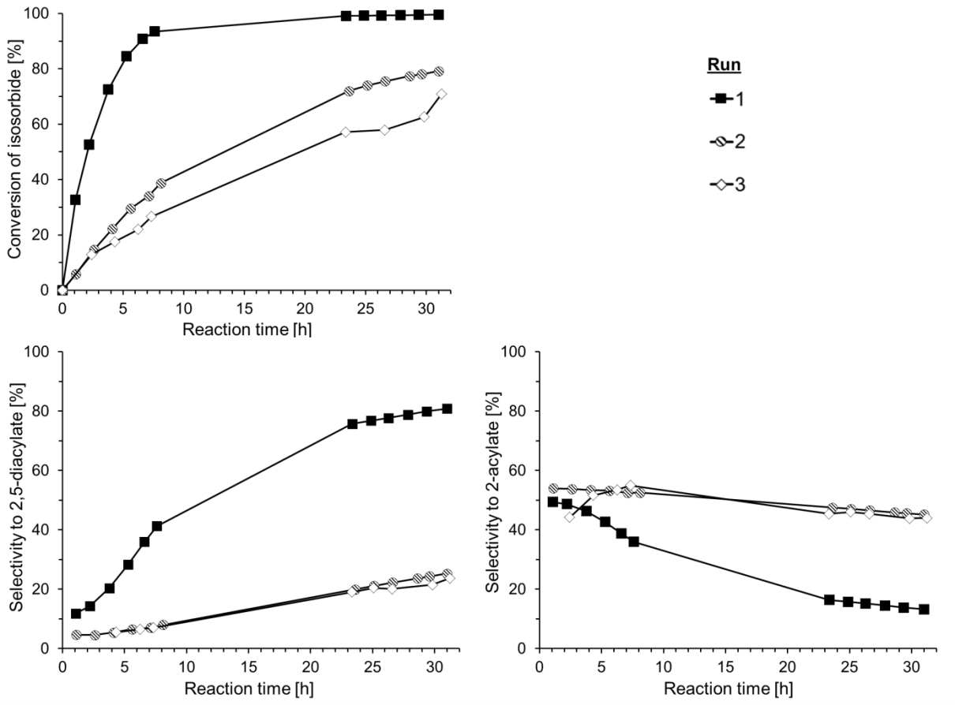
Figure 5 Reuse experiments with Amberlyst-15 in toluene; run 1: fresh catalyst, run 2: first reuse, run 3: second reuse
This loss of activity upon reuse is not ideal but due to the much simplified and greener workup procedure with this heterogeneous catalyst compared to using homogeneous acids it seems still advantageous to use the Amberlyst-15 catalyst instead of free acids for this reaction. The simpler workup enables 2,5-diacetyl-isosorbide yields of almost 100 %, which (in the two-step process suggested by Schönafinger [Schönafinger1982a], see introduction section) would lead to an increase of the theoretical 2-acetyl yield from 76 % to 84 %. For the future we hope that solid acid catalysts will be available which are (i) more stable upon reuse and (ii) more temperature stable than Amberlyst-15 (temperature limit = 120 °C), which would then enable the use of the same catalyst not only for the production of 2,5-diacetyl-isosorbide but also for its subsequent transesterification with isosorbide at around 140 °C to form 2-acetyl-isosorbide (towards production of isosorbide-5-nitrate).

The acid quantity
The amount of acetic acid was varied in order to find out if it is needed in slight excess (standard acid/isosorbide molar ratio = 3.6) or if it could ideally be reduced down to the stoichiometrically necessary molar ratio of 2, which would then make a post-synthetic distillative removal of excess acetic acid unnecessary.
The results in Figure 6 indicate that even a slight reduction of the acetic acid amount (acid/isosorbide molar ratio of 3.4 instead of 3.6) is disadvantageous for a high conversion of isosorbide to 2,5-diacetyl-isosorbide.
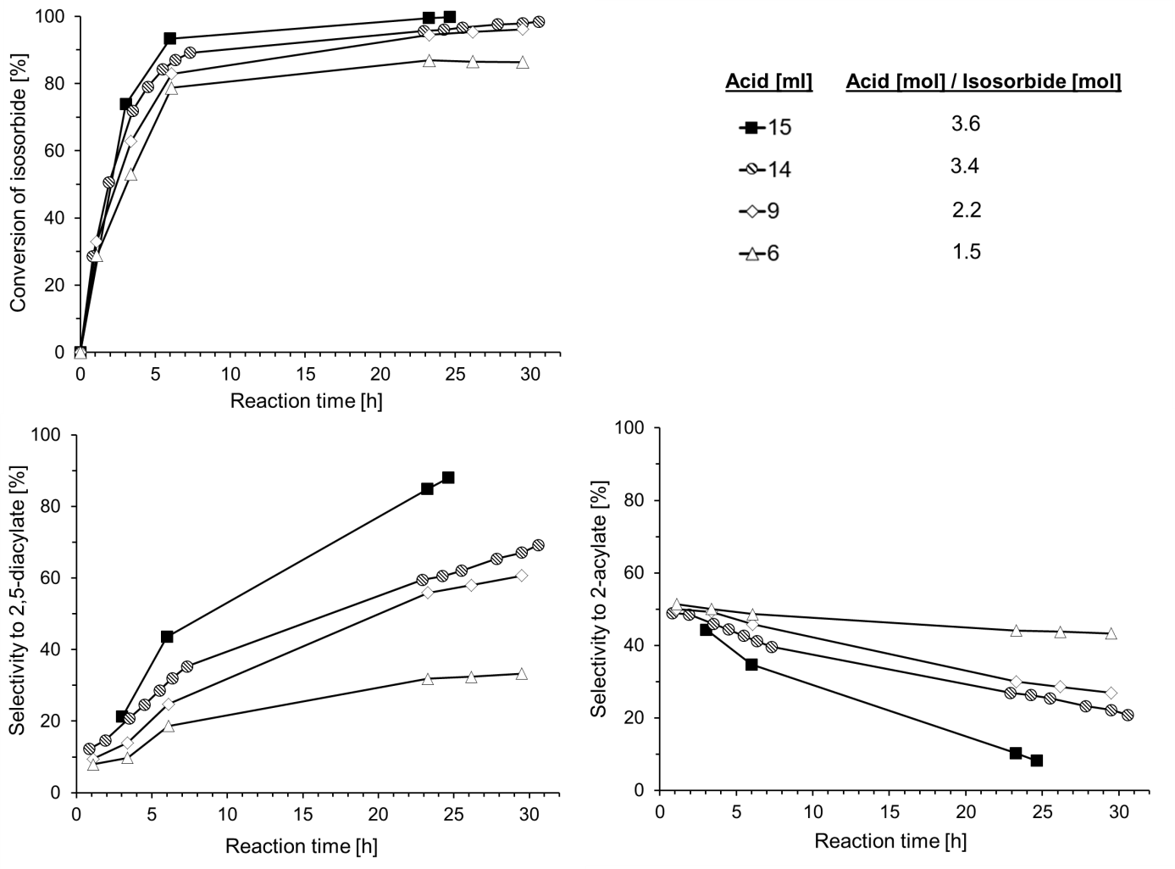
Figure 6 Influence of different amounts of acetic acid on the esterification of 10 g isosorbide
However, if it was the aim to produce 2-acetyl-isosorbide directly from isosorbide, then a low acid/isosorbide molar ratio of 1.5 or probably even lower [Schönafinger1982a] would be indicated for a selectivity to 2-acetyl-isosorbide of almost 50 % at still pretty high isosorbide conversion of 80 %. By-products would then be 5-acetyl-isosorbide and 2,5-diacetyl-isosorbide in portions of 20-30 % each.

The solvent
In order to overcome the thermodynamic reaction equilibrium and to reach complete conversion to 2,5-diacetyl-isosorbide, the water by-product needs to be removed. 2,5-diacetyl-isosorbide has a higher boiling point (ca. 300 °C at 10 mbar) than the other components in the reaction mixture and therefore cannot be distilled off.
Different solvents were tested for their heteroazeotropic water removal abilities. The solvent selection for this preliminary test was based on three solvent characteristics: the solvent should not be miscible with water to facilitate the water separation in the Dean-Stark trap, its boiling point should not exceed 130 °C to avoid strong by-product formation and degradation of the Amberlyst-15 catalyst (thermal stability specified for up to 120 °C), and it should be ideally recommended or at least be non-hazardous according to solvent selection guides [Byrne2016].
The results for the water removal test with different solvents are shown in Figure 7.
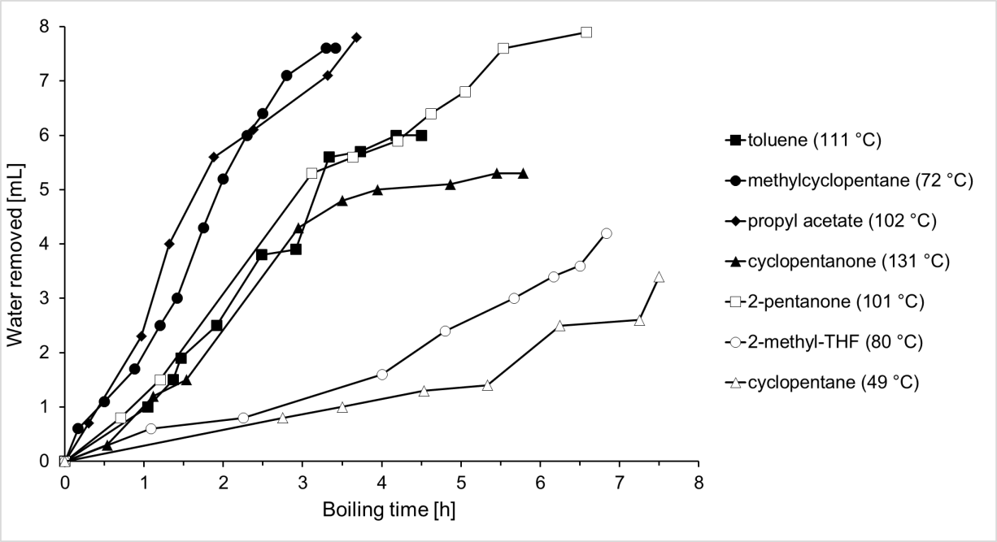
Figure 7 Water removal performance of different organic solvents (boiling points of the pure solvents are given in brackets)
Figure 7 indicates the fastest and highest water removal ability for methylcyclopentane and n-propyl acetate.
Therefore, n-propyl acetate, methylcyclopentane and toluene (as a reference) were finally tested as azeotropic solvents in the esterification of isosorbide with acetic acid. The results are shown in Figure 8.
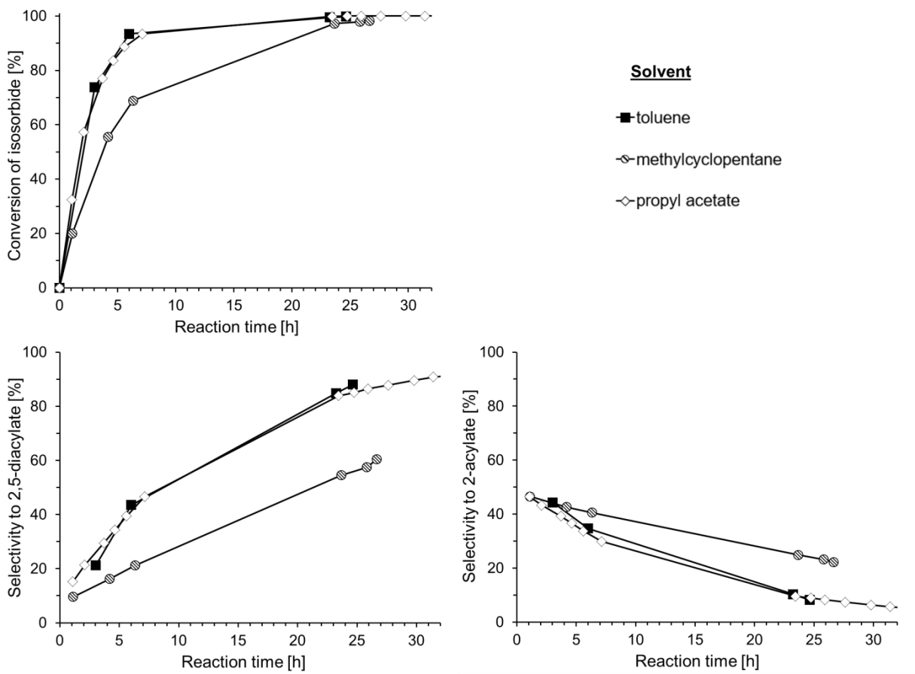
Figure 8 Influence of different solvents in the esterification of isosorbide with acetic acid
N-propyl acetate is a green solvent and therefore recommended in solvent selection guides [Byrne2016]. It showed the same superior performance as toluene in the esterification and therefore seems to be a good substitute for toluene in this reaction. However, a disadvantage of using n-propyl acetate might be the stronger colouration of the final reaction mixture (compare images 1 and 6 in Figure S6). While the reaction mixture after 30 h was yellow in the case of toluene, it was already orange when n-propyl-acetate was used. Prolonged reaction time intensified this colour. Currently we are not sure why this happens, but it seems to be related to the formation of trace amounts (according to GC analyses) of a coloured by-product which is more pronounced for n-propyl acetate. However, this colouration did not hinder the final crystallisation of 2,5-diacetyl-isosorbide, which then still formed almost colourless crystals as indicated in photographic image 8 in Figure S6. The isolated yield was around 90 %, which is comparable to the yield obtained with toluene as the solvent.
Similarly to toluene, methylcyclopentane is a solvent of health concern [Ono1981], but it was tested in the esterification reaction because of its very good water removal ability and low boiling point (72 °C). The latter property was relevant because this could save heating energy for Dean-Stark processes and we wanted to see if the esterification at lower temperature leads to less colouration of the reaction mixture. However, methylcyclopentane did not work very well in the esterification reaction, because longer time was needed for full conversion of isosorbide and the selectivity for 2,5-diacetyl-isosorbide was much lower with only 50 % after 25 h compared to almost 90 % for toluene and n-propyl acetate. This worse performance could be attributed to the fact that in contrast to the other two solvents methylcyclopentane was not miscible with the reaction mixture (2 phases were formed) and thus might not have been in ideal contact with the formed water and might have caused a different catalyst swelling and activity. However, this phase separation of methylcyclopentane could be of advantage for the post-synthetic workup because distillative removal would not be needed if a removal of excess acetic acid was not indicated. The colouration of the final reaction mixture was indeed not as strong as with n-propyl acetate. But since n-propyl acetate is a much greener solvent with better overall performance, it should be favoured over methylcylcopentane.

Isolation and characteristics of 2,5-diacetyl-isosorbide
The greener method for the isolation of 2,5-diacetyl-isosorbide is based on its ability to easily crystallise and on the use of the heterogeneous catalyst Amberlyst-15 instead of sulfuric acid or p-TSA. The Amberlyst-15 beads could be removed by simple filtration and therefore the neutralisation washes with aqueous NaHCO₃ solution, subsequent liquid-liquid extraction with dichloromethane and its distillative removal [Schönafinger1982a] could be omitted.
Furthermore, acetic acid could be distilled off together with the solvent, which also makes neutralisation washes unnecessary and facilitates a reuse of unreacted acid as well as solvent.
2,5-diacetyl-isosorbide purifies itself upon crystallisation, forming large cubic colourless crystal lumps as shown in Figure 9 and giving yields of 90 % and above in respect to isosorbide.
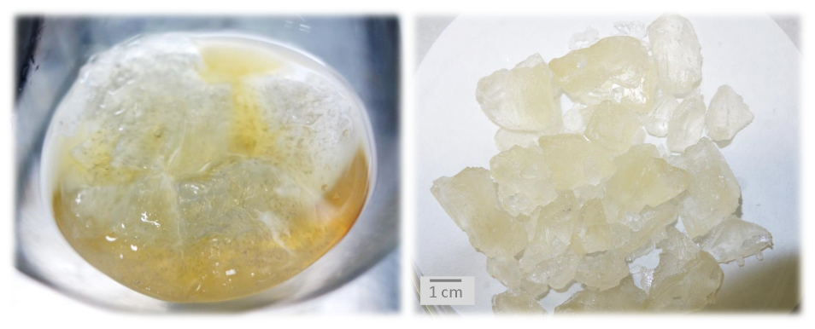
Figure 9 Image of 2,5-diacetyl-isosorbide crystals produced with the greener synthesis method; left: after solvent (here: toluene) removal and crystallisation, right: after separation from the remaining yellow liquid
The purity of the isolated 2,5-diacetyl-isosorbide crystals was about 98 % according to 1H NMR analyses. Theassigned ¹H and ¹³C NMR spectra as well as a ¹H-NMR spectra comparison are given in the supplementary information (Figures S2, S3 and S4).
Any remaining acid, solvent, colour and monoester (if present) stayed predominantly in the non-crystallised liquid residue and only some water and traces of solvent were found in the final product. However, we noticed that the crystallisation was hindered if too much acid (more than 5 %) and mono-acetylated isosorbide (selectivity to 2,5-diacetyl-isosorbide below 85 %) was still present in the 2,5-diacetyl-isosorbide crude product after solvent removal.
2,5-diacetyl-isosorbide showed very good solubility in water, methanol, ethanol, ethyl acetate and DMSO. The dissolution in toluene and diethyl ether took longer. In contrast to isosorbide, 2,5-diacetyl-isosorbide was not found to be hygroscopic. It is also a very stable product, because leaving the 2,5-diacetyl-isosorbide crystals in an open crucible in the laboratory for 3 months did not result in any weight gain or chemical modification (based on GC and NMR analyses). The melting point of the 2,5-diacetyl-isosorbide crystals is 57-58 °C.
The mass spectra of isosorbide and 2,5-diacetyl-isosorbide in Figure S5 show the expected mass peaks at m/z = 146 and 231, respectively.
It is also evident that the fractionation patterns are very different especially for the fragments with m/z above 100. Accordingly, a different reactivity can be assumed and in a future bio-economy 2,5-diacetyl-isosorbide might be a versatile intermediate not only for the preparation of vasodilatory drugs but also for the production of several new molecules which might not be directly accessible from isosorbide.
Conclusions
The present study gave insight into the esterification of isosorbide with acetic acid. It was shown that it is possible to produce 2,5-diacetyl-isosorbide in high purity (98 %) and yield (> 90 %) under greener conditions than available up to now.
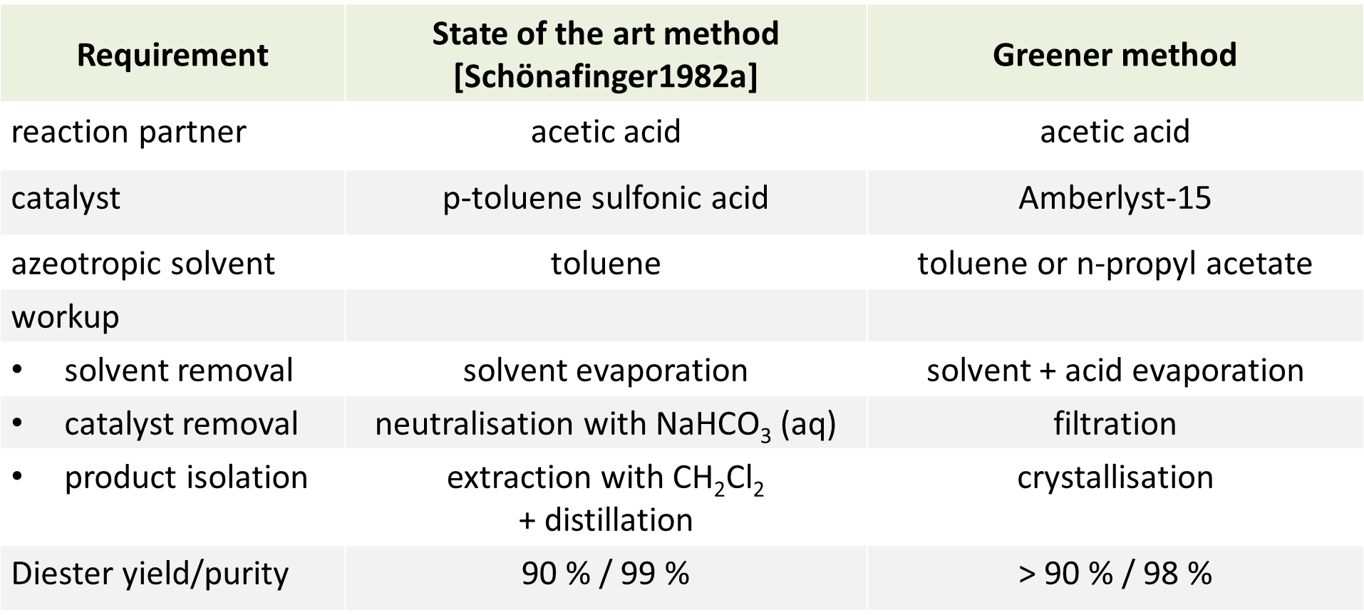
The greener synthesis method uses the heterogeneous catalyst Amberlyst-15, which enables an easier, cheaper and cleaner workup of the reaction product. N-propyl acetate as the heteroazeotropic solvent was found to be a greener substitute for toluene but with the drawback of a stronger colouration of the reaction product. The solvent and excess acetic acid can be reused. Furthermore, the greener method produces no waste except for the Amberlyst-15 catalyst which cannot be reused over many subsequent reaction cycles due to degradation. Research towards a more stable heterogeneous acidic catalyst for such esterification reactions would be a very versatile contribution to a greener chemical production.

Acknowledgement
A. I. would like to thank the German National Academy of Sciences Leopoldina for financial support through the Leopoldina research fellowship programme. J. H. C. and T. J. F. would like to thank the UK Engineering and Physical Sciences Research Council (EPSRC) for funding their involvement in this research through grant EP/L017393/1.
Access Statement
All data used in the preparation of this manuscript for the sections funded by the EPSRC grant EP/L017393/1 is contained within this document, the electronic supplementary information, or available on request from DOI: 10.15124/89e39495-492e-45ef-aafe-352d1cd3a8ff

References
[Byrne2016] F. P. Byrne, S. Jin, G. Paggiola, T. H. M. Petchey, J. H. Clark, T. J. Farmer, A. J. Hunt, C. R. McElroy, J. Sherwood, Tools and techniques for solvent selection: green solvent selection guides, Sustain. Chem. Process., 2016, 4, 7.
[Cekovic1989] Z. Cekovic, Z. Tokic, Selective esterification of 1,4:3,6-dianhydro-D-glucitol, Synthesis, 1989, 8, 610.
[Farmer2015] T. J. Farmer, M. Mascal, Platform Molecules, in: Introduction to Chemicals from Biomass, 2nd ed. (eds J. H. Clark, F. Deswarte), Wiley & Sons, Ltd, Chichester, UK, 2015.
[Gunasekara1999] N. S. Gunasekara, S. Noble, Isosorbide 5-mononitrate: a review of a sustained-release formulation (Imdur) in stable angina pectoris, Drugs, 1999, 57, 261.
[Hopton1969] F. J. Hopton, G. H. S. Thomas, Conformations of some dianhydrohexitols, Canadian Journal Chemistry, 1969, 47, 2395.
[Howard2009] S. Howard, A. Sanborn, Production of 5-membered and 6-membered cyclic esters of polyols, WO2009US45383 20090528, 2009.
[Kümmerer2010] Green and Sustainable Pharmacy, Springer Berlin Heidelberg, 2010, eds. Klaus Kümmerer, Maximilian Hempel.
[Lehman2010] Laura S. Lehman. Why Use Isosorbide Dinitrate vs Isosorbide Mononitrate? - Medscape - Aug 23, 2010.
[Marston2001] R. W. Marston, P. F. Quigley, C. M. Brown, S. M. Roberts, S. J. Cross, Synthesis of isorsorbide mononitrate, WO2001049692 A1, 2001
[Ono1981] Y. Ono, Y. Takeuchi, N. Hisanaga, A comparative study on the toxicity of n-hexane and its isomers on the peripheral nerve, International Archives of Occupational and Environmental Health, 1981 48, 289.
[Otera2010] J. Otera, J. Nishikido, Esterification – Methods, Reactions and Applications, 2nd ed., WILEY-VCH Verlag, Weinheim, 2010.
[Paech2012] N. Paech, Liberation from Excess. The Road to a Post-Growth Economy, Oekom Verlag, Munich, 2012.
[Princen2005] T. Princen, The Logic of Sufficiency, MIT Press, Cambridge (MA), 2005.
[Pubchem2017] PubChem Compound Database for entry “Isosorbide mononitrate”, National Center for Biotechnology Information.; CID=27661, https://pubchem.ncbi.nlm.nih.gov/compound/27661 (accessed July 2017)
[Rose2012] M. Rose, R. Palkovits, Isosorbide as a renewable platform chemical for versatile applications - Quo vadis?, ChemSusChem, 2012, 5, 167.
[Schneider1993] M. Schneider, R. Seemayer, Process for the enzymatic preparation of pure isosorbide-2 or 5-monoester-isomers and conversion to isosorbide-2- and 5-nitrate, DE4129093 (A1), 1993.
[Schönafinger1982a] K. Schönafinger, Verfahren zur Herstellung von Isosorbid-2-acylaten, EP0070401A2, 1982.
[Schönafinger1982b] K. Schönafinger, Verfahren zur Herstellung von Isosorbid-5-nitrat, EP0064194A2, 1982.
[Tan2013] Z. Tan, X. Shang, L. Li, L. Tian, Y. Ma, Y. Peng, L. Gao, Clinical study of isosorbide mononitrate treatment for angina pectoris in coronary heart disease, Exp. Therap. Med., 2013, 5, 1133.
[Thiyagarajan2014] S. Thiyagarajan, J. Wu, R. J. I. Knoop, J. van Haveren, M. Lutz, D. S. van Es, Isohexide hydroxy esters: synthesis and application of a new class of biobased AB-type building blocks, RSC Adv., 2014, 4, 47937.
[VanEs2001] D. Van Es, A. E. Frissen, H. Luitjes, Synthesis of anhydroglycitol esters of improved colour, Patent WO2001083488A1, 2001.

