Tropical forests are thermally buffered despite intensive selective logging
Running head: Logged forests retain high thermal variation
Rebecca A. Senior^{1*}, Jane K. Hill², Suzan Benedick³ and David P. Edwards¹
¹Department of Animal and Plant Sciences, Alfred Denny Building, University of Sheffield, Western Bank, Sheffield, 210 2TN, UK
²Department of Biology, University of York, Wentworth Way, York, YO10 5DD, UK
³ Faculty of Sustainable Agriculture, Universiti Malaysia Sabah, Locked Bag No. 3, 90509, Sandakan, Sabah, Malaysia
*Corresponding author: rebecca.a.senior@gmail.com, +44(0)114 2220123 (R.A. Senior)
Key words: land-use change, microclimate, tropics, thermal buffering, climate change
Type of paper: Primary Research Article

Abstract
Tropical rainforests are subject to extensive degradation by commercial selective logging. Despite pervasive changes to forest structure, selectively logged forests represent vital refugia for global biodiversity. The ability of these forests to buffer temperature-sensitive species from climate warming will be an important determinant of their future conservation value, although this topic remains largely unexplored. Thermal buffering potential is broadly determined by: (1) the difference between the ‘macroclimate’ (climate at a local scale, 10¹ to 10³ m) and the ‘microclimate’ (climate at a fine-scale, 10⁻³ to 10⁻¹ m, that is distinct from the macroclimate); and (2) the availability of microclimates to organisms. We compared these metrics in undisturbed primary forest and intensively logged forest on Borneo, using thermal images to capture cool microclimates on the surface of the forest floor, and dataloggers to capture those inside leaf litter, tree holes and deadwood. Despite major differences in forest structure 9-12 years after repeated selective logging, we found that logged forest was largely indistinguishable from primary forest in terms of macroclimate and microclimate temperature, and the overall availability of microclimates. Microclimate temperature inside deadwood warmed slightly faster in logged forests than in primary forests, but the opposite was true within leaf litter and tree holes, and the effect amounted to less than 0.1°C difference between forest types for 1°C warming in the macroclimate. We therefore conclude that selectively logged forests are similar to primary forests in their potential for thermal buffering, and subsequent ability to retain temperature-sensitive species under climate change. Selectively logged forests can play a crucial role in the long-term maintenance of global biodiversity.
263 words (max. 300)

Introduction
Land-use change is a profound threat to Earth’s terrestrial biodiversity (Sala et al., 2000; Maxwell et al., 2016). Most of this biodiversity is found in tropical regions (Jenkins et al., 2013), where rates of deforestation and forest degradation are among the highest globally (Hansen et al., 2013). The detrimental impacts of deforestation on tropical biodiversity are well known (Gibson et al., 2011; Barlow et al., 2016); however, tropical forest degradation via commercial selective logging is 20 times more widespread than on-going conversion (Hansen et al., 2008; Asner et al., 2009), making it important to understand the value of these disturbed forests for biodiversity. Selectively logged forests constitute a large and effective refuge for species of conservation concern that cannot survive in deforested land (Edwards et al., 2011; Gibson et al., 2011; Edwards & Laurance, 2013). Protecting selectively logged forests may be a cost effective way to retain tropical biodiversity (Edwards et al., 2014a), but this is heavily contingent on the assumption that these forests will maintain their current conservation value into the future.
Several factors may influence the value of selectively logged forests for biodiversity in the long-term, and a key consideration is the interaction of multiple drivers of biodiversity loss (Brook et al., 2008; Mantyka-pringle et al., 2012; Sirami et al., 2016). The impacts of climate change are particularly important, and increasingly so as this century progresses (Sala et al., 2000; Chou et al., 2013; IPCC, 2013). Novel (non-analogous) climatic conditions are predicted to appear first in the tropics (Mora et al., 2013), where many species have narrow thermal limits (Deutsch et al., 2008; Tewksbury et al., 2008; Khaliq et al., 2014) and where there is limited dispersal potential owing to poor dispersal ability of many species (Van Houtan et al., 2007). This vulnerability of tropical species is compounded by an absence of target habitats containing analogous climates (Colwell et al., 2008), and widespread deforestation creating a hostile matrix through which dispersal must occur (Brook et al., 2008; Scriven et al., 2015). The ability of tropical species to withstand climate change, and so avoid extinction, is likely to be highly dependent on their ability to adapt in situ within existing forest areas. The extent to which species persistence can be facilitated within selectively logged forests will, therefore, greatly influence the conservation value of these habitats.
In primary forests and secondary forests re-growing on abandoned farmland, previous studies found that organisms – particularly ectotherms – avoid suboptimal temperatures in the wider ‘macroclimate’ (climate at a spatial scale of 10¹-10³ m) by moving locally into ‘microclimates’ (climate at a fine-scale, 10⁻³ to 10⁻¹ m, that is distinct from the macroclimate; Scheffers et al., 2014a, 2014b; González del Pliego et al., 2016). Climate at this fine-scale is more relevant for the majority of terrestrial biodiversity, which primarily consists of small-bodied ectotherms (Suggitt et al., 2011; Potter et al., 2013; Nadeau et al., 2016). Indeed, the vast proportion of terrestrial species are small in size, flat in shape, or thermoregulate via contact with the ground, and so it is important to consider microclimates close to, and including, the surfaces on which these species live (Kaspari et al., 2014; Scheffers et al., 2016).
The most informative fine-scale temperature data are derived from highly replicated point measurements, and demonstrate that loss of vegetation cover causes local daytime warming (Senior et al., in review; Ewers & Banks-Leite, 2013; Hardwick et al., 2015; González del Pliego et al., 2016). Selective logging affects vegetation by lowering and thinning the canopy, reducing the number of vegetation strata, and creating large forest gaps (Okuda et al., 2003; Kumar & Shahabuddin, 2005). As such, the forest floor of logged forests likely receives a greater amount of solar radiation, partitioned increasingly as direct rather than diffuse radiation (Oke, 1987). The most tangible impact on the local climate would be overall warming of logged forests, increasing the necessity for thermal buffering. Simultaneously, the potential for thermal buffering may be compromised if structural changes also influence the temperature and distribution of cool microclimates, particularly if their temperature becomes more similar to that of the wider macroclimate (e.g. Caillon et al., 2014), or there are simply fewer cool microclimates available overall. Previous evidence suggests that the availability of cool ‘microhabitats’ (localised environments within which cool microclimates are contained; (Scheffers et al., 2014a; González del Pliego et al., 2016; Shi et al., 2016) can be reduced (e.g., leaf litter; Saner et al., 2009) or increased (e.g., deadwood; Carlson et al., 2016) by selective logging, implying that forest disturbance does alter thermal environments.
A key novel question that we address in this paper is whether vegetation change following commercial selective logging reduces the potential for thermal buffering. We focused on cool microclimates in the understorey only (climate at 10⁻³ to 10⁻¹ m scale that is cooler than the macroclimate and located within 2 m of the forest floor). Microclimates on the surface of the forest floor were captured by a thermal camera, while dataloggers were used to capture microclimates within cool understorey microhabitats: leaf litter, tree holes and deadwood (Scheffers et al., 2014a, 2014b; González del Pliego et al., 2016). We determined thermal buffering potential according to: (1) the microclimate temperature relative to that of the macroclimate; and (2) the availability of microclimates in space. The former is roughly a measure of microclimate ‘quality’ – assuming an organism can move into the microclimate, how effectively will it be buffered from macroclimate warming? The latter captures the likelihood that organisms can locate and move into microclimates, according to their occurrence and configuration within the habitat (Caillon et al., 2014). We expected that logged forests would be structurally distinct from primary forest, leading to reduced thermal buffering potential and, thus, impaired ability of temperature-sensitive species to respond in situ to excessively high temperatures in the wider macroclimate.

Methods

Study Area
Sampling took place in in an extensive area of contiguous forest in Sabah (Malaysian Borneo; Fig. 1a). This area represents over 10,000 km² of lowland dipterocarp forest, comprising production forest and areas of undisturbed protected forest (Reynolds et al. 2011). In this study, we sampled sites in forest that had been commercially selectively logged twice (Ulu Segama-Malua Forest Reserve, 4°57'42.8"N, 117°56'51.7"E). The area was first logged from 1987-1991, using tractors and high-lead extraction techniques to harvest commercial trees (those in the family Dipterocarpaceae) with stems >0.6 m diameter at breast height (D.B.H.), and yielding ~113 m³ of timber per hectare (Fisher et al., 2011; Edwards et al., 2014b). Between 2001 and 2007, the area was re-logged and the minimum harvested tree diameter reduced to >0.4 m D.B.H., yielding an additional 31 m³/ha of timber (Fisher et al., 2011). Thus, we sampled sites that had been heavily disturbed about 10 years prior to the study, at which point 67% of the forest was classified as being in ‘very poor’ condition (Reynolds et al., 2011), and the area was left to recover naturally. Control sites were located in undisturbed, protected primary forest (Danum Valley Conservation Area (DVCA); 4°57'45.2"N, 117°48'10.4"E).

Sampling design
We sampled twelve sites, six in twice-logged forest and six in primary forest, along existing transects (Edwards et al., 2011, 2014b; Fig. 1b). Sites were more than 2 km apart, and at least 100 m from forest edges. Within each site, we established five 50 x 50 m plots, with plot centres spaced at 125 m intervals along the transect (Fig. 1c; 60 plots in total). Fieldwork was conducted from April to July 2015, during the severe El Niño Southern Oscillation (ENSO) event of 2015-2016 (NOAA Climate Prediction Center: http://www.cpc.noaa.gov/products/analysis_monitoring/ensostuff/ensoyears.shtml) when maximum daily temperature was 7% higher and mean rainfall 17% lower than the 5-year average (across April to July for the years 2007 to 2011).

Forest structure
To quantify the level of disturbance to the forest from selective logging, we used an established methodology for assessing forest structure in each plot (Hamer et al., 2003; Lucey & Hill, 2012). The variables we measured were: the basal area (cm²/m² forest) of mature trees (circumference > 0.6 m) and saplings (circumference 0.1-0.6 m), based on the distance to and circumference at breast height of the two nearest in each of four quadrants centred on the plot centre (Fig. 1d); the proportion of mature trees that were dipterocarps (indicative of mature, complex forest); percentage shade cover; and visual estimates of percentage vegetation cover at ground (1.5 m above ground), understorey (15 m above ground) and canopy (the main stratum of leaf cover > 15 m above ground) levels. For full methodological details see Supplementary Text S1.

Quantifying surface microclimates
Fine-scale surface temperature of the forest floor is particularly relevant for small-bodied, surface-dwelling organisms, such as many insect and reptile species. We measured surface temperature within each plot using an infrared camera (FLIR Systems, model E40); macroclimate temperature was defined as the air temperature at 1.5 m above-ground, measured using a whirling hygrometer. Each site was visited on two days, and each plot within the site was sampled five times each day between 05:00 hrs to 14:30 hrs. During each sample of any given plot, the observer stood at the centre of the plot, took a single hygrometer reading and then, holding the camera at breast height and pointing 45° downwards (relative to the ground), took a photo in four orthogonal directions (Scheffers et al., 2016). Each thermal image comprised 19200 distinct observations of surface temperature (one per pixel), and covered a surface area of approximately 1 m². In total, we recorded 2400 thermal images (4 images per plot x 5 repeats x 2 site visits x 60 plots).
For all subsequent analyses, a unique data point comprised thermal information from the four photographs taken each time a plot was sampled: 76800 observations of surface temperature measurements for each plot (i.e. combining 19200 observations from the four photos taken in each orthogonal direction). The temperature of cool surface microclimates was defined as the 5th percentile (i.e. coolest) across all 76800 pixels. To identify individual ‘cool’ pixels we determined lower and upper threshold values from the 5th and 25th percentile, respectively, from each two-hour time period (05:00-07:00 hrs, 07:00-09:00 hrs, 09:00-11:00 hrs, 11:00-13:00 hrs and 13:00-15:00 hrs) across all temperatures from all photos taken in that time period (Fig. 2). This ensured that cool pixels were defined relative to all other observations taken in that time period. The area of surface microclimates was then calculated as the average number of cool pixels per m² (the surface area encompassed in one photo), multiplied by the area of one pixel (0.5 cm²; FLIR). Spatial configuration of cool pixels was quantified using the Aggregation Index: the number of edges that cool pixels share, divided by the maximum number of edges that they could possibly share (He et al. 2000; Caillon et al. 2014). Higher values of the Aggregation Index indicate less dispersal of microclimates through space (increased clustering), which makes them more difficult for organisms to track (Sears et al., 2016).

Quantifying microclimates in leaf litter, tree holes and deadwood
Many ectotherms, such as amphibians, spend some or all of their time exploiting cool microclimates inside microhabitats, which thermal images are unable to capture. We selected three types of microhabitat known to provide cool microclimates (Scheffers et al., 2014b, 2014a; González del Pliego et al., 2016), and placed one temperature datalogger (HOBO pendant datalogger, Onset, model UA-001-64K or model UA-002-64K) per plot in each microhabitat type: leaf litter (1.5 m left of the plot centre), tree holes (> 2 cm at widest point of entrance hole, < 2 m above the ground) and deadwood (> 10 cm stem diameter). The hygrometer measurements of macroclimate temperature were not always synchronised with the dataloggers inside microhabitats, hence we additionally measured macroclimate temperature using a datalogger suspended 1.5 m above the ground at the centre of each plot, shielded against direct radiation and precipitation by an inverted plastic funnel (Shoo et al., 2010; Scheffers et al., 2014a). All dataloggers recorded temperature every 20 minutes for five consecutive days, occurring within one week of thermal image collection. We used only data from within the same diurnal time period as that during which thermal images were taken (05:00 hrs to 14:30 hrs), to facilitate qualitative comparisons of thermal buffering by microclimates at the surface and inside microhabitats.
To estimate the occurrence of microclimates inside microhabitats, we measured the volume of leaf litter, tree holes and deadwood within a 50 x 5 m subplot centred on each plot centre (60 sub-plots in total), with the long edge running parallel to the transect. For full methodological details see Supplementary Text S2. We divided microhabitat volume by the total area surveyed to generate microhabitat volume per m² forest, for each plot.

Statistical analyses

Forest structure
To examine the impact of selective logging on forest structure, we assessed seven structural response variables: tree basal area sapling basal area; proportion of trees that were dipterocarps (binomial data: dipterocarp vs. non-dipterocarp); percentage shade cover (proportion data); and percentage vegetation cover at ground, understorey and canopy strata (proportion data). Forest type (categorical: primary or logged) was the only explanatory variable included.

Macroclimate and microclimate temperature
Macroclimate temperature is the temperature at a coarse spatial scale, and was captured in this study using both a hygrometer and suspended datalogger (measuring the same variable but at different times). The macroclimate does not affect thermal buffering potential per se, but it does dictate the overall necessity for thermal buffering. We modelled hygrometer and datalogger temperature separately, including forest type as the only explanatory variable.
To assess the impact of selective logging on the ability of microclimates to buffer organisms from macroclimate warming, we modelled microclimate temperature against macroclimate temperature and its interaction with forest type. The model intercept is a measure of what Shi et al. (2016) refer to as the ‘thermal buffering effect’ (the difference between macroclimate and microclimate temperature), while the slope is a measure of the ‘rate of change’ (the change in microclimate temperature for every 1°C rise in macroclimate temperature). Surface microclimate temperature refers to the 5th percentile of surface temperature observations for each plot, and this was compared against macroclimate temperature as measured by the hygrometer. Microclimate temperature inside leaf litter, tree holes and deadwood refers to the raw temperature recorded by dataloggers inside microhabitats, and this was compared against macroclimate temperature as measured by a suspended datalogger. Models were run separately for surface, leaf litter, tree hole and deadwood microclimates.

Microclimate availability
Microclimate occurrence was modelled separately for surface microclimates (i.e. the average surface area of cool pixels per m² forest), and those inside leaf litter, tree holes and deadwood (each quantified by their average volume per m² forest). The spatial configuration of surface microclimates refers to the Aggregation Index of cool pixels (binomial data: edges shared by cool pixels vs. edges not shared by cool pixels). For all models, forest type was the only explanatory variable.

Statistical analyses
All data were analysed using mixed effects models in R (version 3.3.0; R Core Team 2016). To account for spatial pseudoreplication, forest structure models included ‘site’ as a random intercept term, and all other models included ‘plot’ nested in ‘site’. Temperature data were recorded at multiple time points, and so full models were visually assessed for evidence of temporal autocorrelation of residuals (function “acf” in the nlme package; Pinheiro et al. 2016), and an autoregressive correlation structure incorporated into all models with temperature as a response variable (Zuur et al., 2009). Generalized linear mixed effects models (GLMMs) with a binomial error distribution, tested for overdispersion, were used for binomial data (proportion of dipterocarps and surface microclimate Aggregation Index). Diagnostic plots were assessed for all models to confirm model fit, and variables transformed to normality where necessary. For true proportion data (percentage shade cover and percentage vegetation cover), the transformation used was a modification of the empirical logit (Warton & Hui, 2011).
For all models, statistical significance was inspected using likelihood ratio tests, dropping each fixed effect in turn and comparing it to the full model (Zuur et al. 2009). The significance of main effects involved in an interaction was assessed in the same way, except reduced models were compared to a full model without the interaction term.

Results

Changes in forest structure after logging
Following two rounds of commercial selective logging, tree basal area was reduced by 36% compared to undisturbed primary forests (P = 0.00612; Fig. S1a). There was no difference between primary and logged forests in terms of sapling basal area (P = 0.115; Fig. S1b), the proportion of trees that were dipterocarps (P = 0.12; Fig. S1c), or percentage shade cover (P = 0.272; Fig. S1d). Percentage vegetation cover at ground level was also comparable between forest types (P = 0.0968; Fig. S1e), but in the understorey and canopy vegetation cover was 13.7% (P = 0.0215; Fig. S1f) and 14.5% (P = 0.00246; Fig. S1g) lower in logged than in primary forests, respectively. Thus, 9-12 years after logging there were significant differences in forest structure between logged and primary forests, especially in terms of occurrence of mature trees.

macroclimate and microclimate temperature comparable between forest types
There was no effect of selective logging on macroclimate temperature, whether measured by the hygrometer (P = 0.519; Fig. 3a) or suspended datalogger (P = 0.27; Fig. 3b). Thus, the necessity for thermal buffering was comparable between forest types. Additionally, because the baseline macroclimate temperature is constant between forest types, we can consider the temperature of microclimates relative to that of the macroclimate as a sufficient measure of thermal buffering potential, without needing to explicitly consider the absolute temperature of microclimates.
The overall difference between macroclimate and microclimate temperature (‘thermal buffering effect’) was unaffected by selective logging, regardless of whether microclimate temperature was measured at the surface (P = 0. 0.701; Fig. 3c), or inside leaf litter (P = 0. 0.36; Fig. 3d), tree holes (P = 0.293; Fig. 3e) or deadwood (P = 0.445; Fig. 3f). There was a highly significant relationship between macroclimate and microclimate temperature (P < 0.0001 for all microclimates). The slope of this relationship was consistent between forest types for surface microclimates (P = 0.947; Fig. 3c), which warmed by 0.76°C for a 1°C rise in macroclimate temperature. In contrast, for 1°C macroclimate warming, microclimates inside leaf litter warmed less in logged forest (0.23°C) than in primary forest (0.32°C; P < 0.001; Fig. 3d), and the same was true of tree holes in logged forest (0.34°C) compared to primary forest (0.38°C; P < 0.001; Fig. 3e). The pattern was reversed in deadwood (P < 0.001; Fig. 3f), where 1°C macroclimate warming resulted in deadwood microclimates warming by 0.35°C in logged forest and 0.25°C in logged forest. Leaf litter and tree holes therefore had greater thermal buffering potential in logged forest than in primary forest, and the reverse was true for deadwood. At the surface, however, thermal buffering potential was equivalent between logged and primary forests.

Microclimate availability comparable between forest types
The thermal buffering potential within a habitat depends not only on the temperature of microclimates relative to the macroclimate, but also on the overall availability of those microclimates. The occurrence of surface microclimates was not impacted by selective logging (P = 0.999; Fig. 4a). Per m² forest, the area of surface microclimates was 2178 cm² in logged forest compared to 2183 cm² in primary forest. The occurrence of microhabitats was also constant between forest types. In 1 m² habitat, logged and primary forests respectively contained: 3430 versus 3790 cm³ of leaf litter (P = 0.224; Fig. 4b); 17.5 versus 12.5 cm³ of tree holes (P = 0.665; Fig. 4c); and 21700 versus 22000 cm³ deadwood (P = 0.978; Fig. 4d). Using thermal images we were also able to quantify the spatial configuration of surface microclimates, which has a bearing on the ease with which organisms can utilise microclimates. The Aggregation Index of cool surface microclimates was 89% in both logged and primary forests (P = 0.903; Fig. 4e). Thus, the overall availability of microclimates, including both occurrence and configuration, was not affected by selective logging, regardless of whether microclimates were located at the surface or inside leaf litter, tree holes or deadwood.

Discussion
Forest degradation by commercial selective logging affects huge expanses of the tropics (Asner et al., 2009; Lewis et al., 2015). Southeast Asia has experienced the most intensive selective logging of all tropical rainforests (Lewis et al., 2015), and in our study area ~145 m³ of timber was removed per hectare. Despite a recovery time of only 9-12 years (Fisher et al., 2011), and the coincidental occurrence of abnormally hot and dry conditions associated with the strongest El Niño Southern Oscillation (ENSO) event since 1998 (NOAA Climate Prediction Center: http://www.cpc.noaa.gov/products/analysis_monitoring/ensostuff/ensoyears.shtml), intensively logged forests showed very few thermal differences compared to undisturbed primary forest. This is an important finding for tropical conservation because it suggests that the potential for thermal buffering will not limit the ability of selectively logged forests to maintain high biodiversity under climate change (Scheffers et al., 2013a; González del Pliego et al., 2016).

Forest structure
At a local scale, climate is highly dependent upon vegetation (Oke, 1987; Sears et al., 2011). Selective logging targets the largest and oldest trees, leading to many accompanying changes in vegetation structure (Okuda et al., 2003; Kumar & Shahabuddin, 2005; Edwards et al., 2014a). A clear signal of historical logging in our study area was the reduction in basal area of mature trees (Fig. S1a; Berry et al. 2008), and in percentage vegetation cover at ≥15 m above ground (Fig. S1f-g). The absence of any differences in other variables (vegetation cover at 1.5 m, shade cover, proportion of trees that were dipterocarps and sapling basal area) may be a consequence of sampling only a small area of forest understorey several years after logging operations ceased, during which time there was likely rapid growth in understorey vegetation, including regeneration of both small dipterocarps and large herbaceous pioneer species (Berry et al., 2008; Edwards et al., 2014a).

Macroclimate and microclimate temperature
Local temperature is affected by multiple local factors, particularly vegetation structure. In all cases, although primary forest contained more, larger trees (Fig. S1a), the absence of any long-term effect of selective logging on the amount of shade cover (Fig. S1d) suggests that forest vegetation as a whole – regardless of how it was distributed vertically – intercepted comparable amounts of incoming solar radiation in both logged and primary forests. Alternatively, vegetation in logged forest may have intercepted less incoming radiation than in primary forest (i.e. if there was less vegetation overall), but reflected a greater proportion of that which was intercepted, owing to the higher albedo of habitats with an abundance of non-tree species (Oke, 1987; Davin & de Noblet-Ducoudré, 2010; Edwards et al., 2014a). In either case, given comparable levels of solar radiation reaching the understorey of logged and primary forests, it follows that the temperature at coarse and fine scales (macroclimate and microclimate temperatures) should also be comparable (Fig. 3).
The temperature of cool microclimates relative to average conditions is what largely determines their ability to buffer macroclimate warming (Scheffers et al., 2014a; González del Pliego et al., 2016; Shi et al., 2016). We found no overall difference in temperature buffering either at the surface (Fig. 3c) or inside microhabitats (Fig. 3d-f), although there were very slight differences between logged and primary forests in rates of microhabitat warming. For a given increase in macroclimate temperature, leaf litter and tree holes warmed more in primary forests than in logged forests, and the opposite was true for temperature inside deadwood (Fig. 3d-f). That said, these differences were extremely small in biological terms – a maximum of 0.1°C difference in microhabitat warming between logged and primary forests, relative to a 1°C increase in average air temperature. We therefore conclude that available microclimates in logged and primary forest had equal potential to buffer organisms from macroclimate temperature change.

Microclimate availability
Even if cool microclimates are present and individually effective at buffering temperature change, overall rarity or isolation could render them functionally redundant (Sears et al., 2011, 2016). We demonstrate that microclimates in logged and primary forests had a similar availability (Fig. 4), whether measured at the surface or as the volume of microhabitats. This is contrary to expectations from previous studies (Ball et al., 1999; Blakely & Didham, 2008; Saner et al., 2009). However, high volumes of leaf litter and deadwood could be maintained in logged forest by lower decomposition rates (Ewers et al., 2015; Yeong et al., 2016) and large remnant pieces of deadwood from harvest operations. In undisturbed forests, tree holes tend to be associated with larger, older trees (Lindenmayer et al., 2000; Blakely & Didham, 2008). A comparable quantity of tree holes might be found on relatively small trees in logged forests because of damage from logging operations (Edwards et al., 2014a) and increased wind in gaps (Chen et al., 1995). Additionally, we assessed tree holes in the understorey only; differences may well manifest at higher forest strata.
The true availability of microclimates to organisms is also influenced by their distribution in space. We found that microclimates on the surface of the forest floor were generally highly clustered in space, but this was not affected by logging (Fig. 4b). Spatial configuration of microclimates is a novel facet of thermal buffering potential (but see Caillon et al., 2014; Sears et al., 2016), likely determined by the composition of the forest floor and the relative radiative properties of these different components (e.g. bare soil vs. leaves vs. water; Oke, 1987). We therefore suggest that these characteristics of the forest floor were also comparable between forest types, further supported by the absence of any difference in leaf litter volume.

Caveats and future directions
The potential for thermal buffering and its general necessity are influenced by moisture levels, as well as temperature (McLaughlin et al., 2017). Many ectotherms, including amphibians (Duellman & Trueb, 1986) and isopods (Hassall et al., 2010), can survive in hot temperatures for longer if relative humidity is sufficiently high to prevent desiccation. Although we did not measure fine-scale vapour pressure deficit (a variable combining both temperature and relative humidity), we did find that average vapour pressure deficit measurements from the hygrometer and from hygrochron iButtons (Supplementary Text S2), showed little variation within or between forests (Fig. S2).
Relative climates in primary and logged forests could be very different above the understorey (Scheffers et al., 2013b), which we were unable to capture in our study. Some ectotherms move down from the upper strata to exploit more favourable temperatures in the lower storey (Scheffers et al., 2013b). Hence, if temperatures in higher strata were indeed hotter in logged forest compared to primary forest, species could utilise the favourable temperatures in the understorey of logged forest that we demonstrate here.
The ability of selectively logged tropical forests to retain current levels of biodiversity will critically depend on their ability to protect species from the impacts of increasingly severe climate change (Sala et al., 2000; Mora et al., 2013). As average temperatures increase over this century, so too will the intensity and frequency of extreme climatic events (IPCC, 2013), including ENSO (Cai et al., 2014). Thermal buffering will likely be crucial in allowing species to move locally to avoid suboptimal climates (Scheffers et al., 2014a, 2014b; González del Pliego et al., 2016). We sampled in some of the most intensively logged forest in the tropics, during an ENSO event with maximum temperatures 7% higher and rainfall 16% lower than the 5-year average (across April to July, for the years 2007 to 2011); it is highly unlikely that our study would have failed to detect any appreciable thermal differences between primary and logged forests had they existed. Regardless of whether commercially selectively logged forests remain biologically or structurally distinctive from undisturbed forests, this study shows for the first time that they are functionally equivalent in the provisioning of cool microclimates, and underscores their vital role in conservation both now and under future climate warming.

Acknowledgements
Thanks to staff at Danum Valley Field Centre for logistical support; and Azlin Bin Sailim, Jessica Olid and Chloe Walker-Trivett for field assistance. R.A.S. was funded by a NERC studentship through the ACCE (Adapting to the Challenges of a Changing Environment) Doctoral Training Partnership (Grant No. NE/L002450/1). Data available from the Dryad Digital Repository: http://dx.doi.org/10.5061/dryad.[NNNN] [REF].

Conflict of Interest
Authors declare no conflicts of interest.

References
Asner GP, Rudel TK, Aide TM, Defries R, Emerson R (2009) A contemporary assessment of change in humid tropical forests. Conservation Biology, 23, 1386–1395.
Ball IR, Lindenmayer DB, Possingham HP (1999) A tree hollow dynamics simulation model. Forest Ecology and Management, 123, 179–194.
Barlow J, Lennox GD, Ferreira J et al. (2016) Anthropogenic disturbance in tropical forests can double biodiversity loss from deforestation. Nature, 535, 144–147.
Berry NJ, Phillips OL, Ong RC, Hamer KC (2008) Impacts of selective logging on tree diversity across a rainforest landscape: the importance of spatial scale. Landscape Ecology, 23, 915–929.
Blakely TJ, Didham RK (2008) Tree holes in a mixed broad-leaf–podocarp rain forest, New Zealand. New Zealand Journal of Ecology, 32, 197–208.
Brook BW, Sodhi NS, Bradshaw CJA (2008) Synergies among extinction drivers under global change. Trends in Ecology & Evolution, 23, 453–460.
Cai W, Borlace S, Lengaigne M et al. (2014) Increasing frequency of extreme El Nino events due to greenhouse warming. Nature Climate Change, 4, 111–116.
Caillon R, Suppo C, Casas J, Arthur Woods H, Pincebourde S (2014) Warming decreases thermal heterogeneity of leaf surfaces: implications for behavioural thermoregulation by arthropods. Functional Ecology, 28, 1449–1458.
Carlson BS, Koerner SE, Medjibe VP, White LJT, Poulsen JR (2016) Deadwood stocks increase with selective logging and large tree frequency in Gabon. Global Change Biology, n/a-n/a.
Chen J, Franklin JF, Spies TA (1995) Growing-season microclimatic gradients from clearcut edges into old-growth douglas-fir forests. Ecological Applications, 5, 74–86.
Chou C, Chiang JCH, Lan C-W, Chung C-H, Liao Y-C, Lee C-J (2013) Increase in the range between wet and dry season precipitation. Nature Geoscience, 6, 263–267.
Colwell RK, Brehm G, Cardelús CL, Gilman AC, Longino JT (2008) Global warming, elevational range shifts, and lowland biotic attrition in the wet tropics. Science, 322, 258–261.
Davin EL, de Noblet-Ducoudré N (2010) Climatic impact of global-scale deforestation: radiative versus nonradiative processes. Journal of Climate, 23, 97–112.
Deutsch CA, Tewksbury JJ, Huey RB, Sheldon KS, Ghalambor CK, Haak DC, Martin PR (2008) Impacts of climate warming on terrestrial ectotherms across latitude. Proceedings of the National Academy of Sciences, 105, 6668–6672.
Duellman WE, Trueb L (1986) Biology of Amphibians. JHU Press, 706 pp.
Edwards DP, Laurance WF (2013) Biodiversity Despite Selective Logging. Science, 339, 646–647.
Edwards DP, Larsen TH, Docherty TDS et al. (2011) Degraded lands worth protecting: the biological importance of Southeast Asia’s repeatedly logged forests. Proceedings of the Royal Society B: Biological Sciences, 278, 82–90.
Edwards DP, Tobias JA, Sheil D, Meijaard E, Laurance WF (2014a) Maintaining ecosystem function and services in logged tropical forests. Trends in Ecology & Evolution, 29, 511–520.
Edwards DP, Magrach A, Woodcock P et al. (2014b) Selective-logging and oil palm: multitaxon impacts, biodiversity indicators, and trade-offs for conservation planning. Ecological Applications, 24, 2029–2049.
Ewers RM, Banks-Leite C (2013) Fragmentation Impairs the Microclimate Buffering Effect of Tropical Forests. PLOS ONE, 8, e58093.
Ewers RM, Boyle MJW, Gleave RA et al. (2015) Logging cuts the functional importance of invertebrates in tropical rainforest. Nature Communications, 6, 6836.
Fisher B, Edwards DP, Larsen TH, Ansell FA, Hsu WW, Roberts CS, Wilcove DS (2011) Cost-effective conservation: calculating biodiversity and logging trade-offs in Southeast Asia. Conservation Letters, 4, 443–450.
FLIR User’s manual FLIR Exx series.
Gibson L, Lee TM, Koh LP et al. (2011) Primary forests are irreplaceable for sustaining tropical biodiversity. Nature, 478, 378–381.
González del Pliego P, Scheffers BR, Basham EW et al. (2016) Thermally buffered microhabitats recovery in tropical secondary forests following land abandonment. Biological Conservation, 201, 385–395.
Hamer KC, Hill JK, Benedick S, Mustaffa N, Sherratt TN, Maryati M, K. CV (2003) Ecology of butterflies in natural and selectively logged forests of northern Borneo: the importance of habitat heterogeneity. Journal of Applied Ecology, 40, 150–162.
Hansen MC, Stehman SV, Potapov PV et al. (2008) Humid tropical forest clearing from 2000 to 2005 quantified by using multitemporal and multiresolution remotely sensed data. Proceedings of the National Academy of Sciences, 105, 9439–9444.
Hansen MC, Potapov PV, Moore R et al. (2013) High-resolution global maps of 21st-century forest cover change. Science, 342, 850–853.
Hardwick SR, Toumi R, Pfeifer M, Turner EC, Nilus R, Ewers RM (2015) The relationship between leaf area index and microclimate in tropical forest and oil palm plantation: Forest disturbance drives changes in microclimate. Agricultural and Forest Meteorology, 201, 187–195.
Hassall M, Edwards DP, Carmenta R, Derhé MA, Moss A (2010) Predicting the effect of climate change on aggregation behaviour in four species of terrestrial isopods. Behaviour, 147, 151–164.
IPCC (2013) Climate Change 2013: The Physical Science Basis: Working Group I Contribution to the IPCC Fifth Assessment Report. Cambridge University Press, Cambridge.
Jenkins CN, Pimm SL, Joppa LN (2013) Global patterns of terrestrial vertebrate diversity and conservation. Proceedings of the National Academy of Sciences, 110, E2602–E2610.
Kaspari M, Clay NA, Lucas J, Yanoviak SP, Kay A (2014) Thermal adaptation generates a diversity of thermal limits in a rainforest ant community. Global Change Biology, n/a-n/a.
Khaliq I, Hof C, Prinzinger R, Böhning-Gaese K, Pfenninger M (2014) Global variation in thermal tolerances and vulnerability of endotherms to climate change. Proceedings of the Royal Society of London B: Biological Sciences, 281, 20141097.
Kumar R, Shahabuddin G (2005) Effects of biomass extraction on vegetation structure, diversity and composition of forests in Sariska Tiger Reserve, India. Environmental Conservation, 32, 248.
Lewis SL, Edwards DP, Galbraith D (2015) Increasing human dominance of tropical forests. Science, 349, 827–832.
Lindenmayer DB, Cunningham RB, Pope ML, Gibbons P, Donnelly CF (2000) Cavity sizes and types in Australian eucalypts from wet and dry forest types–a simple of rule of thumb for estimating size and number of cavities. Forest Ecology and Management, 137, 139–150.
Lucey JM, Hill JK (2012) Spillover of Insects from Rain Forest into Adjacent Oil Palm Plantations. Biotropica, 44, 368–377.
Mantyka-pringle CS, Martin TG, Rhodes JR (2012) Interactions between climate and habitat loss effects on biodiversity: a systematic review and meta-analysis. Global Change Biology, 18, 1239–1252.
Maxwell SL, Fuller RA, Brooks TM, Watson JEM (2016) Biodiversity: The ravages of guns, nets and bulldozers. Nature News, 536, 143.
McLaughlin BC, Ackerly DD, Klos PZ, Natali J, Dawson TE, Thompson SE (2017) Hydrologic refugia, plants, and climate change. Global Change Biology, n/a-n/a.
Mora C, Frazier AG, Longman RJ et al. (2013) The projected timing of climate departure from recent variability. Nature, 502, 183–187.
Nadeau CP, Urban MC, Bridle JR (2016) Coarse climate change projections for species living in a fine-scaled world. Global Change Biology, n/a-n/a.
Oke TR (1987) Boundary layer climates, 2nd ed. edn. Methuen, London.
Okuda T, Suzuki M, Adachi N, Quah ES, Hussein NA, Manokaran N (2003) Effect of selective logging on canopy and stand structure and tree species composition in a lowland dipterocarp forest in peninsular Malaysia. Forest Ecology and Management, 175, 297–320.
Potter KA, Arthur Woods H, Pincebourde S (2013) Microclimatic challenges in global change biology. Global Change Biology, 19, 2932–2939.
Reynolds G, Payne J, Sinun W, Mosigil G, Walsh RPD (2011) Changes in forest land use and management in Sabah, Malaysian Borneo, 1990–2010, with a focus on the Danum Valley region. Philosophical Transactions of the Royal Society B: Biological Sciences, 366, 3168–3176.
Sala OE, Chapin FS, Iii et al. (2000) Global biodiversity scenarios for the year 2100. Science, 287, 1770–1774.
Saner P, Lim R, Burla B, Ong RC, Scherer-Lorenzen M, Hector A (2009) Reduced soil respiration in gaps in logged lowland dipterocarp forests. Forest Ecology and Management, 258, 2007–2012.
Scheffers BR, Brunner RM, Ramirez SD, Shoo LP, Diesmos A, Williams SE (2013a) Thermal Buffering of Microhabitats is a Critical Factor Mediating Warming Vulnerability of Frogs in the Philippine Biodiversity Hotspot. Biotropica, 45, 628–635.
Scheffers BR, Phillips BL, Laurance WF, Sodhi NS, Diesmos A, Williams SE (2013b) Increasing arboreality with altitude: a novel biogeographic dimension. Proceedings of the Royal Society B: Biological Sciences, 280, 20131581–20131581.
Scheffers BR, Edwards DP, Diesmos A, Williams SE, Evans TA (2014a) Microhabitats reduce animal’s exposure to climate extremes. Global Change Biology, 20, 495–503.
Scheffers BR, Evans TA, Williams SE, Edwards DP (2014b) Microhabitats in the tropics buffer temperature in a globally coherent manner. Biology Letters, 10, 20140819.
Scheffers BR, Edwards DP, Macdonald SL et al. (2016) Extreme thermal heterogeneity in structurally complex tropical rain forests. Biotropica, n/a-n/a.
Scriven SA, Hodgson JA, McClean CJ, Hill JK (2015) Protected areas in Borneo may fail to conserve tropical forest biodiversity under climate change. Biological Conservation, 184, 414–423.
Sears MW, Raskin E, Angilletta MJ (2011) The world is not flat: defining relevant thermal landscapes in the context of climate change. Integrative and Comparative Biology, 51, 666–675.
Sears MW, Angilletta MJ, Schuler MS et al. (2016) Configuration of the thermal landscape determines thermoregulatory performance of ectotherms. Proceedings of the National Academy of Sciences, 113, 10595–10600.
Senior RA, Hill JK, González del Pliego P, Goode LK, Edwards DP (in review) A pan-tropical analysis of the impacts of forest degradation and conversion on local temperature.
Shi H, Wen Z, Paull D, Guo M (2016) A framework for quantifying the thermal buffering effect of microhabitats. Biological Conservation, 204, Part B, 175–180.
Shoo LP, Storlie C, Williams YM, Williams SE (2010) Potential for mountaintop boulder fields to buffer species against extreme heat stress under climate change. International Journal of Biometeorology, 54, 475–478.
Sirami C, Caplat P, Popy S et al. (2016) Impacts of global change on species distributions: obstacles and solutions to integrate climate and land use. Global Ecology and Biogeography, n/a-n/a.
Suggitt AJ, Gillingham PK, Hill JK, Huntley B, Kunin WE, Roy DB, Thomas CD (2011) Habitat microclimates drive fine-scale variation in extreme temperatures. Oikos, 120, 1–8.
Tewksbury JJ, Huey RB, Deutsch CA (2008) Putting the heat on tropical animals. Science, 320, 1296–1297.
Van Houtan KS, Pimm SL, Halley JM, Bierregaard RO, Lovejoy TE (2007) Dispersal of Amazonian birds in continuous and fragmented forest. Ecology Letters, 10, 219–229.
Warton DI, Hui FKC (2011) The arcsine is asinine: the analysis of proportions in ecology. Ecology, 92, 3–10.
Yeong KL, Reynolds G, Hill JK (2016) Leaf litter decomposition rates in degraded and fragmented tropical rain forests of Borneo. Biotropica, n/a-n/a.
Zuur A, Ieno EN, Walker N, Saveliev AA, Smith GM (2009) Mixed Effects Models and Extensions in Ecology with R. Springer Science & Business Media, 579 pp.

Supporting information
Text S1. Sampling methods for forest structure.
Text S2. Sampling methods for microhabitat volume.
Text S3. Sampling methods and results for analyses of vapour pressure deficit.
Figure S1. Comparison between primary and logged forest for the seven forest structure measures.
Figure S2. Comparison between primary and logged forest for vapour pressure deficit.

Figures
Figure 1. Study location in Malaysian Borneo (a), and distribution of sites (b): six sites in primary forest (blue) and six sites in logged forest (orange). Each site comprised five plots along an existing transect, with plot centres separated by 125 m (c). Tree and sapling basal area was calculated from the distance to and circumference of the nearest two trees and saplings in each of four quadrants centred on the plot centre (d; see Supplementary Text S1 for more details). Curved arrows indicate the direction of magnification, from panels a-d.
Figure 2. Single thermal image with temperature as a continuous variable (a) and categorised into quantiles (b). Quantile boundaries are based on percentile values calculated across all temperature observations, from all photos taken during each two-hour time period (05:00-07:00 hrs, 07:00-09:00 hrs, 09:00-11:00 hrs, 11:00-13:00 hrs and 13:00-15:00 hrs). For our analyses we focused only on ‘cool pixels’, defined as those with a value greater than the 5th percentile and less than or equal to the 25th percentile (quantile 5% - 25% in panel b).
Figure 3. Comparison of temperature in primary (blue; PF) and logged (orange; LF) forest. Macroclimate temperature was measured using a hygrometer (a) for comparison with surface microclimates (c), and with a suspended datalogger (b) for comparison with microclimates inside leaf litter (b), tree holes (c) and deadwood (d). The grey dashed line in panels c-f indicates zero temperature buffering, where the microclimate temperature is equal to the macroclimate temperature.
Figure 4. Comparison between primary (blue) and logged (orange) forest in the availability of microclimates. This includes the average area of surface microclimates, per m² forest (a); the Aggregation Index of surface microclimates (b); and the average volume, per m² of forest, of leaf litter (c), tree holes (d) and deadwood (e).
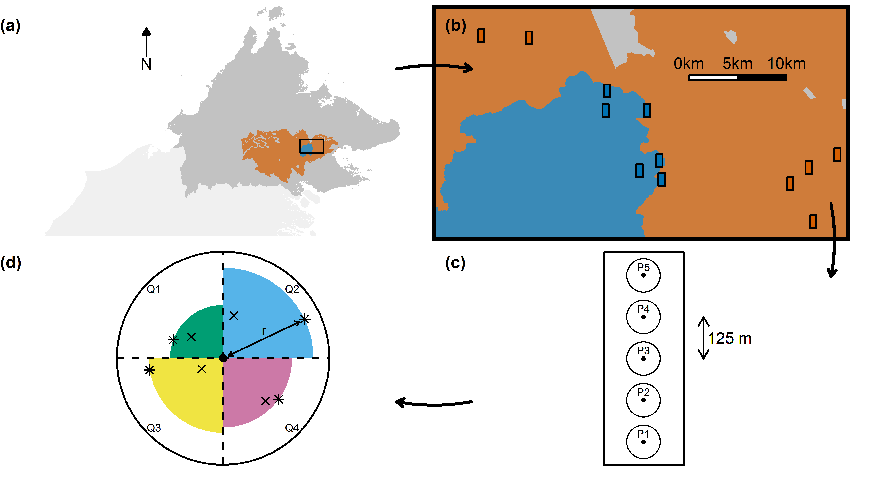
Figure 1.
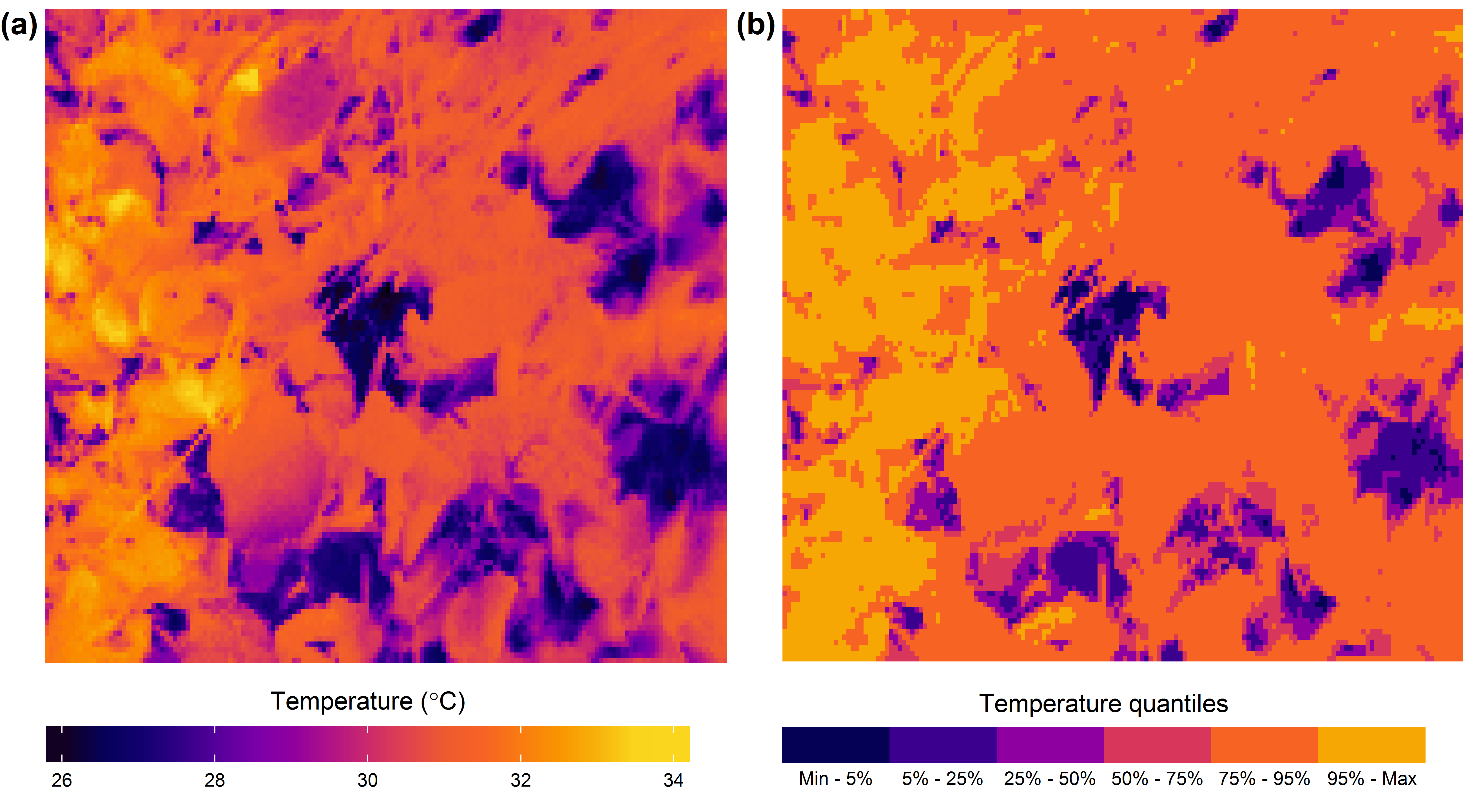
Figure 2
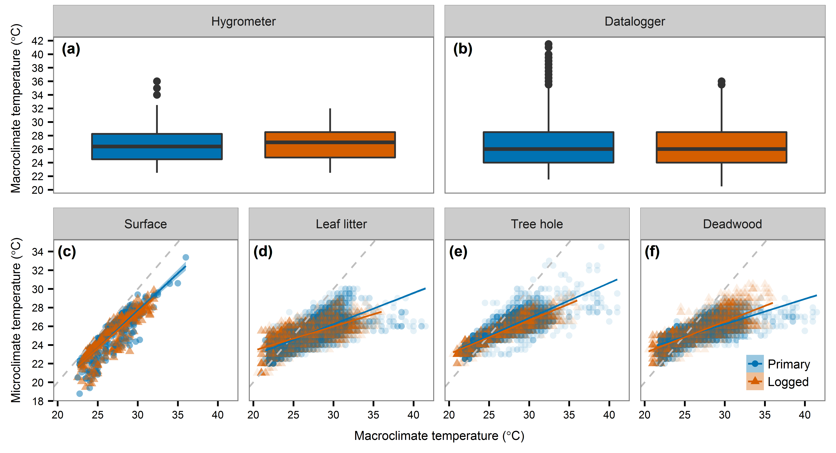
Figure 3.
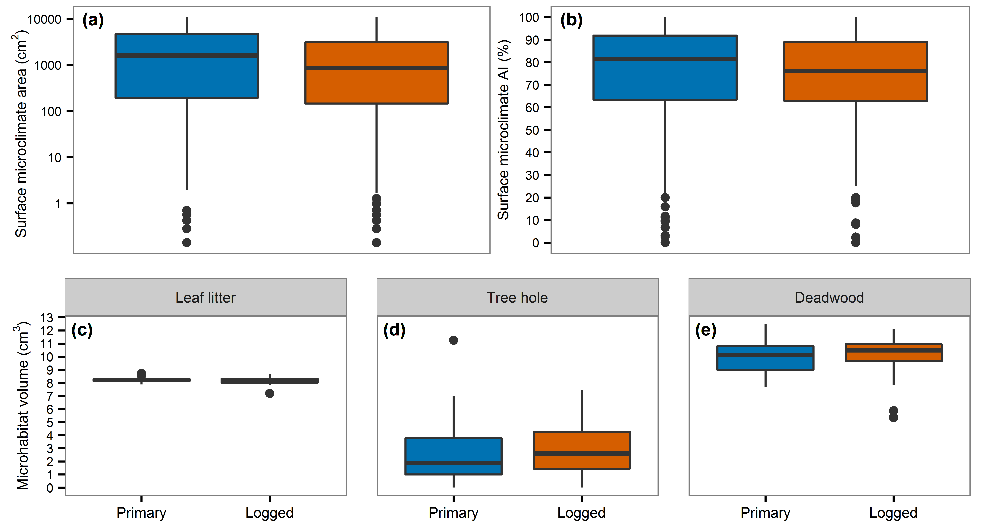
Figure 4.

