Going in, out, through: A dialogue around long skirts, fried chips, frozen shacks and the makeshifts of ethnography

Michele Lancione and Elisabetta Rosa

[Michele] They always welcomed me with fried chips. They weren't necessarily always cooking those chips, but they constantly invited me to have some food, something to drink, something to share. And in that provisional camp, set up by the City of Turin in the middle of a desolated post-industrial area, eating something and sharing meant first and foremost fried chips and chicken wings (Figure 1). Now the problem for me was that I did not like those chips and I am vegetarian. Just take it and eat the stuff!, my inner ethnographer voice would shout. But it was never that easy. Although I ended up eating the chips, because of their bonding power layered in saturated fat, I was nonetheless unable to fully mask my partial discomfort. And I sensed that people perceived that I was faking my polite enthusiasm - in the mist of our bodies one close to another, my fingers selecting food in the plate like robotic sticks, and my head down until I could declare it cleaned. I knew they perceived it. And not only that: they knew that I knew it. We could read that in our eyes and bodily gestures. Yet, nobody complained. We assembled the ritual of our respective positioning dutifully, chewing and smiling, smiling and chewing, silently listening to our jaws or being override by loud manele’s music. A lot of chips would have to be consumed before we felt that we could eventually start talking.

Figure 1. Woman cooking in the ‘Emergenza Freddo’ Roma camp of the Arrivore Park, Turin, February 2008
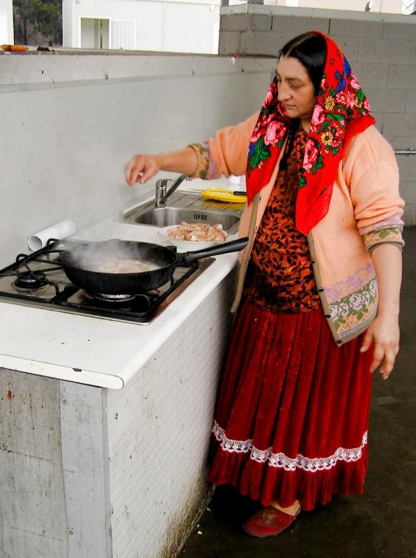
Source: Lancione

[Elisabetta]: I know what you mean. I still have in my nose the sticking smell of the pork fat they use to fry chicken legs. Yet, my encounter with Roma people in Marseille was especially made of exchanged objects and the gestures and affective atmospheres that follow through. Shoes had a pivotal role, both practical and symbolic. Throughout the fieldwork I was offered four pairs. A gift and everything it entails, it is not just a matter of receiving, it is more about what you are expected to do with it. In my case, it was a matter of wearing those high-heeled sandals to go to church on Sunday afternoon. I am absolutely hopeless at walking in them, but Somna told me my flip-flops were dirty and ugly, no good for praying. The whole family was there when I took them off and put the shiny silvery sandals on, and everybody was laughing at my awkward demeanour. When Alex put on my flip-flops and went for a shower, reciprocity arose and my feeling embarrassed disappeared. They insisted to take photos together and sent them to their relatives in Romania soon afterwards. The following day I found they have added one of those photos to the framed pictures on the dresser.

Figure 2. Somna, me with my new sandals and Mariana, Marseille 2015
Source: Rosa

[Both] It was even before extended commitment to the field or theorisation around it, that the key theme of our doing research at the urban margins came to the fore. This is something foundational for any ethnographic encounter: we are talking about sharing, about giving and taking, about trusting and being trust — about going in, out and through different stage of a continuous positioning and (re)positioning related to an entanglement of expectations, trust, political and intellectual commitment to a group, a process or a ‘cause’. In this paper we speak about ethnography understanding this not only as the process of writing about cultures starting from participant observations, interviews or other forms of data collections. For us ethnography is more: it is the way we do things and the approach we have towards the field; it is how we negotiate access and how we live; it is about writing about the other but also about ourselves. Sharing is what ethnography is before writing it: it is about the ethno, what links people and makes their doings and claims possible.

(Re)writing the self to write the urban margins
Reflecting on our respective works as citizens, activists and researchers with Roma people in Italy, France and Romania (2004-ongoing), in this paper we propose an experimental dialogue around what we conceive as the most pressing challenges of doing ethnography at the urban margins. These includes the perils of positioning and repositioning; the building of relationships of trust, care and affect, and their break; the production and role of ethnographic knowledge in activist work; the risk and the certainty of failure; the difficulties associated with entering and leaving the field; and more. Our dialogue is purposely experimental, imitating the experimental nature of ethnographic practice in itself. With it we do not aim to offer definite answers but to (re)open a field of reflection and questioning on the practice of ethnography that others may find stimulating as we do. If ethnography is about ‘writing the other’ we aim, moreover, to promote a differential way of writing ‘ourselves’, as a first necessary step to ‘disrupt/challenge/question dominant writing construction as part of [our] own commitment to critical engagement’ (Askins 2009, 6). In this sense the paper is an exercise in ego-geography/auto-ethnography: an open and aloud reflection coming out of our friendship and deliberations about our common 'field' and based around a number of our individual research works.
The French égo-géographie stands for a geography of the geographer. Via postulating that questioning the role of the researcher is essential to understand the knowledge production process (Dupont 2014), égo-géographie refers to the auto-biography of a geographer who reflects on his/her research practices within and through the various contexts (teaching, research programs, conferences, fieldwork), to then open the reflection to power relations and hierarchies of knowledge production within the academy. The ego-geographic narrative is placed between the fieldwork, the field-notes and the academic texts that we write here, when we come back (Emerson et al., 1995).
As Calbérac and Volvey (2015) put it, placing the epistemological subject and one's own identity politics (both conscious and unconscious) at the heart of the analysis does not fall within egotism or self-centredness. It means instead to completely assume the interpretative and actorial turn, and to take charge of the reflexive need they impose. Ego-geography means questioning not only the geographers' lives in their academic, scientific and practical dimensions, but also their spatial dimensions and the way they are concerned with the knowledge they produce. It means to bring attention not only to the geographer as an academic and scientific personality, but also as an epistemic subject with all his/her dimensions (subjectivity, identity, narcissistic and social). Finally, it means focusing the attention on spatial forms where the ego and the geography articulate through practices and experience.
The égo-géographie is explicitly built around the practice of auto-ethnography, which in recent years has received considerable attention in anthropology, geography and sociology (Denshire 2013). There too, the practice is one of self-narrative oriented at placing ‘the self within a social context’ (Reed-Danahay 1997, 9). This narrative is however different from a ‘simple’ autobiographical narration. The purpose of ego-geography/auto-ethnography is not to offer a neat chronology of what has happened to the researcher in the field, but to (re)position the researcher into the field in order to question his/her original placement in the first place. In this sense, ego-geography/auto-ethnography invites a spatial narrative of the self (Laplante 2010), i.e. a narrative focused on the clarification of a relation with bodies and space. If taken seriously ego-geography/auto-ethnography becomes, as Calberca and Volvay (2015) indicate, a project: to nuancely articulate the ego (epistemic subject within its identity dimension) with and through his/her geography (understood both as knowledge and method).
A central aspect of this form of self-questioning and (re)placing is what Butz and Besio have called ‘autoethnographic sensibility’, which is all about ‘recognizing that clear-cut distinctions among researchers, research subjects and the objects of research are illusory, and that what we call the research field occupies a space between these overlapping categories’ (Butz and Besio 2009, 1664). Ego-geography/auto-ethnography is therefore about questioning how we - as researcher - negotiate and make sense of our blurred role and shifting positioning in the field (for a similar line of argument, see Rose 1997). This is a ‘project’ with three main aims: one about thinking aloud about the hermeneutic circle of doing ethnography (Lawless 1992); one to question, as many feminist scholars have done, the place of geographers in knowledge production (Gibson-Graham 2000; Rose 1997; Katz 1994); and one about inviting a reflection about the relevance of an ethnographic approach to the study of of urban margins today.
In this paper we argue that a critical approach to the urban margins is also about reflecting further and better on the role that the ethnographer has in the ethnographic practice. Calls for a more engaged form of ethnography enquiry are not uncommon (Fassin 2013), and new forms of engagement crossing the thresholds between ‘pure’ research and research-activism are increasingly spreading, both in anthropology (Hale 2006) and human geography (Pain 2004; Mason 2015; The Autonomous Geographies Collective 2010). To us, engaging in this kind of ethnographic practice is about questioning our place - as researcher - in the ‘contact zone’ made of shared spaces, objects, affects and emotions that is unavoidably activated in engaged form of urban ethnography (Askins and Pain 2011). Such zone need to be questioned not least because of the unbalanced power at play in its makeshift practice. In the end, the only way for ethnography to be about the ethno - meaningful sharing and practice - before the graphy - representation and diffusion - is to account for, discuss and then challenge the unbalanced power taming its practice. We propose ego-geography/auto-ethnography as a fruitful way to speak aloud about these concerns and the always provisional craft of dealing with them.
We frame our collective form of ego-geography/auto-ethnography around three main axes, or questions, which we use as springboard for our discussion. We propose simple, evident axes, which have been discussed at length in the discipline of anthropology but are perhaps still taken too-much-for-granted in contemporary urban ethnography and urban geography. Our discussion is framed around why (we do the fieldwork), what (we want to do and actually end up doing) and how (we ‘feel’ the field). The aim, once again, is not to provide a definitive answer to these questions but to generate a series of reflections that, we hope, will stimulate other urban ethnographers to work toward a critical and reflexive approach to writing the other, the city and their margins.

1. Why we do ethnography at/in/through the margins

[Elisabetta] I have no doubt that my attraction to the urban margins comes from my own personal life history, particularly having grown up between the slow decline of an upper class family on the one side and the emancipation from the migrant working class on the other. Living in an rich Turin neighbourhood and listening to stories of mess tins, cold lunchboxes and factory noise, this was my contradictory daily life. In my own representation margins were something made of poverty and laziness, illness and dirty – supposedly a thousand miles from what we were, a thousand miles from what I ought to be. This was the front side of the picture. On the backside, a catholic-bourgeois-left-oriented sense of justice called for care and responsibility. This incoherent mix resulted both in fear and attraction to marginal people and spaces, the unknown other I felt much closer to than I was expected to. That is why I am not interested in urban margins per se but particularly the space and the experience of the in-between, the contact zones where both the becoming marginal and the getting out are possible (Figure 3). Here I started my ethnographic journey, an intimate journey before the academic one.

Figure 3. In-between, series of open doors, Marseille 2016

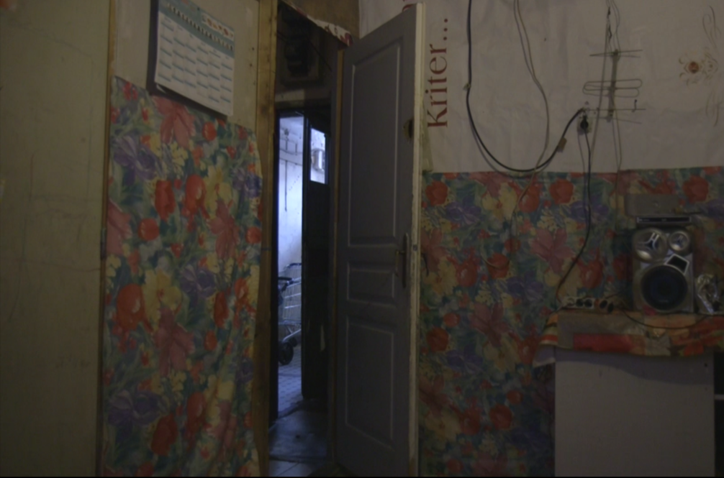

Source: Rosa

[Michele] I am attracted to dark alleys, rusty metal espunging from modernist blocks, groups of eastern-european-looking men drinking and smoking ouside of decadent bars, high heels and exaggerated patch-work make-up. I am attracted by the stories of these protagonists and their contexts -- better yet, by the layered narratives of those spaces themselves. This attraction does not come from nowhere. It’s related to the readings I did when I was a teenager (beatnik, Russians, Italians’ neorealism and poetry), which fueled in me a peculiar kind of empathy and sense of justice. It’s forged through the peripheral village in the north of Italy where I grew up, the bad schools I attended, my working class background, and the Catholic atmosphere I breathed while going to the ‘oratorio’ when I was a kid. But it is also connected to my first ‘big’ move, toward the city, Turin, where, already 19 years old, I smelled for the first time complexity, richness, anarchy. Readings, people, spaces, relations -- these and other things as grounds where a peculiar sensibility was (and still is) assembled, with all its quirks, limits and (countless) ethical compromises. I perhaps do ethnography in my very messy way, with partial outcomes and very long journeys, disappointments and frustrations, failures and only very provisional achievements... because there is nothing else - in terms of engagement and orientation, not profession - which I could imagine doing.

Figure 4. The entrance of an occupied block in Bucharest, Romania (2014)
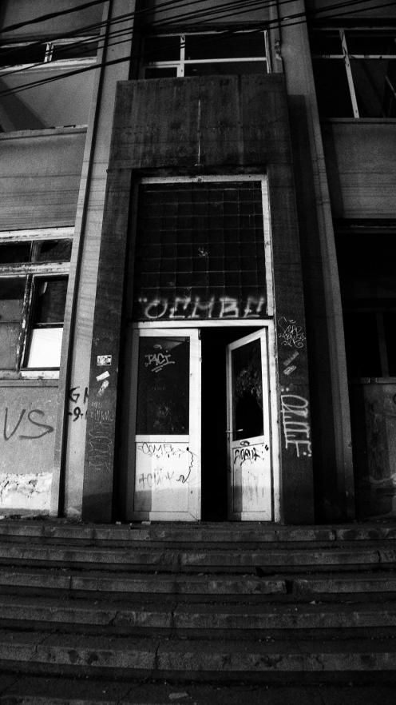
Source: Lancione

[Both] Fieldwork for us is about experiencing the encounter with l’autre. It is about experiencing something that we find ourselves attracted to and repulsed by at the same time (for a similar argument see Thieme, this issue). Perhaps even before an ethics there is an aesthetic at play in doing fieldwork (Volvay 2014). We are fascinated by a sort of exotisme exerted by the ‘unknown other’… the ‘sublime trash’ (Žižek 2013). It is nothing new. There is a lure in there, and a powerful, dangerous one. Why did we ‘choose’ Roma/Gipsy? Why do they keep on surfacing in our lives, on and on again, everywhere we go? Why did we choose to study the margins? This is something we have in common. How did we get there? One can argue, following again Žižek, or the post-colonial critique of the sociology of the margins (Ferguson et al. 1990), that we – geographers, scholars, academics – are using (exploiting, taking advantage of) poverty and marginal people for our own research purpose, that we rely on them to nourish our thirst of knowledge and then we throw them away, as Capitalism does.
We are not afraid or ashamed in admitting, aloud, that we are attracted and fascinated by the beauty of the urban margins. This is the first ego-auto-reflexive step we have to take in order to approach ‘why’ we do things. The exotisme of that aesthetics has something to do with the distance with the other and it is that distance, through its gravitational force, which attracts us in the first place. Once one approaches the aesthetic of the margins with a critical eye, it become clear that the distance could be either the starting or the ending point of the ethnography. If aesthetic is celebrated, if beauty becomes something to fix in the grid of fancy photo exhibition without substance, without grip, engagement, participation -- then there is no encounter, no proposition, no real ethno-urban-graphy.
The point, then, is to understand how much we are able to fill that distance with direct contact (Calbérac 2007), meaningful encounter (Valentine 2008), constitutive negotiations (Rose 1997), participatory engagement (Pain 2004) and the likes. By working in this way, one can be triggered by beauty and then use it to fight for differential cultural understanding of people and spaces (Hall 1992); to bring to the fore productive ‘discursive destabilisation’ of life at the margins (Gibson-Graham 1994); and to open up new political articulations of and for that life (Lancione 2016) -- rather than simply fixing it in journalistic voyeurism or academic labelling.
In short, we research the margins because we are attracted by them and because through that attraction we aim to establish constitutive and contextually-based form of negotiations. There is, however, another point: we see fieldwork also as a way to express our unexpressed (or inexpressible) desire of being and becoming in such a way able to augment rather than reduce freedom, both ours and of l’autre (Deleuze and Guattari 2009). Fieldwork is in this sense a way to always (re)find our way to be in the world (il nostro modo di stare al mondo). This is about liminality -- namely about conceiving the makeshift of urban ethnography also, among the things listed above, as a rite de passage (Gennep 1960; Deegan 1989, 1998). The anthropologist and sociologist Victor Turner says that liminality ‘is a movement between fixed points and is essentially ambiguous, unsettled, and unsettling. ‘Liminars’ are betwixt and between the positions assigned and arrayed by law, custom, convention and ceremonial’ (1969: 95). In liminality the fictive boundaries between us and the other and between objective and subjective are blurred and can only be so (Haraway 1988). This liminality - made of encounters, makeshift and unarticulated desires - is one of the reasons why we do fieldwork: not only to advocate and promote discursive and practical change of the margins, but also to constantly chaise our way of being in the world.

2. What we want to do in the fieldwork/what we actually do in the fieldwork

[Michele] I went to that street just to meet Marian, the head of a Romanian NGO working with drug users in Bucharest. That day I called him and he said to me, Yes, we can meet today, but you will have to come in Strada Vulturilor 50, do you know where it is? Lots of Roma have been evicted and I am very busy with them. So I went, just to meet him but also unconsciously lured by those words, Roma, eviction, and after no more than 15 minutes I found myself plugged into a space too big and dense to be ignored, populated by lives too bright to simply smile and pass by... In a moment I got sucked into a web of activism, friendship, Roma-crazyness, exhaustion and extended video-ethnography that still defines part of my life today -- after almost two years from that original call. I went there to have a coffee with an interlocutor and I found myself right in the middle of another engaged ethnography, which I had not planned and I was not prepared for.

Figure 5. The Vulturilor street camp of evicted Roma people, Bucharest, September 2014
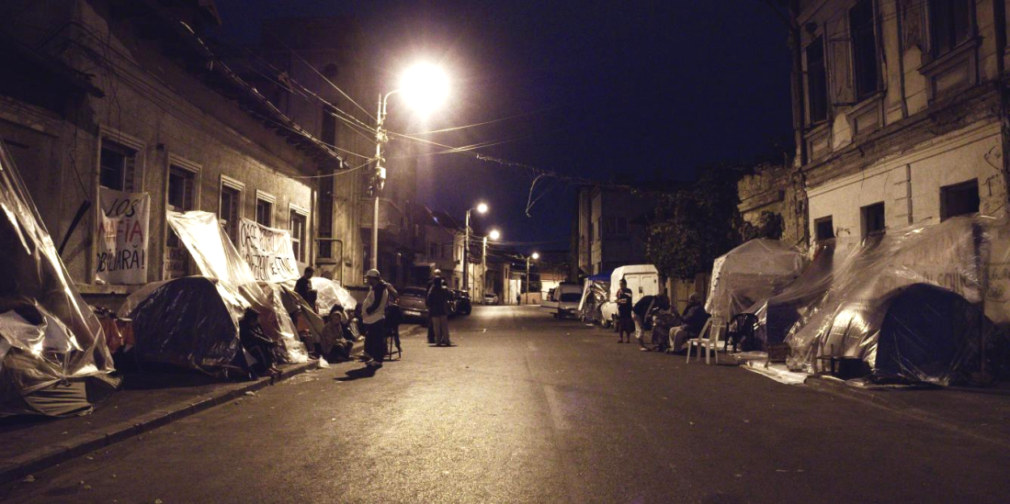
Source: Lancione

[Elisabetta] The turning point you speak about, for me it has been something more gradual. I met Somna and her family in March 2015. When I started the fieldwork in Marseille my idea was to focus on urban practices of the Roma living in informal settlements, following them in their daily activities within the city and beyond the margins where they lived, be they squats or bidonvilles. I thought the space of the encounter was to be looked for outside their place. But then I met Somna, and after a few weeks I realised the very centre of their life – and of our encounter accordingly – was the squat where they lived and where she invited me every day. This is where everything – people, objects, affects and emotions – leaves and comes back. I then found myself embedded in the private and intimate atmospheres of their daily life, made of food, home-made bread, mourning period, children catching beetles, holy music, extortion and open doors. A kind of inversion occurred – I was chez eux, and it could not be otherwise, all these messy things became the very focus of my ethnography.

Figure 6. Somna’s place. The squat in Belle de Mai, Marseille 2015

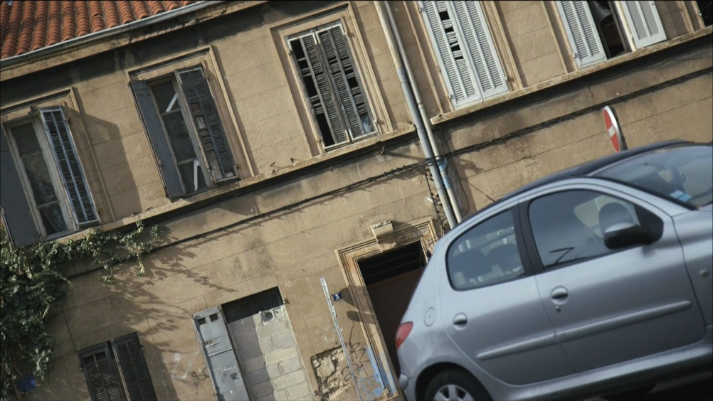
Source: Rosa

[Both] Before leaving for the fieldwork we are invited to have everything accurately planned: what one is going to do, how long it will last, how many people one will meet, which methodological approach one will follow -- everything needs to be put in place, as requested by the normative imperative of due diligence or by a funder or a supervisor. In particular there is the expectation that one has to have a clear research ‘object’, coherent with a number of research question(s) and, possibly, one should already articulate what 'data' will eventually be ‘brought back’ from the field. Although there are differences between the French, Italian, Romanian and English academies in their understanding of ethnographic fieldworks (see for instance Volvey et al., 2012), it seems to us that a sort of positivist rationale still guides expectations, practices and knowledge production. After more than ten years (or only ten years?) of ethnographic work we can safely say that the positivist perspective is at best deceptive or, as it seems in most cases, a matter of a-posteriori maquillage.
The more one’s own field progresses, the more one becomes aware that it is the fieldwork that drives our actions, not the contrary. The key moment in any fieldwork is when one is loosing control over it. It is a key moment because it can either be about poetic openings and eventful encounters or about closure and domestication (Lanne 2016). Our experience tells us that at that moment, in the liminal space where things seem to get off hand, trying to oppose this stream of becoming is useless and even counter-productive. This is because it is only following the action, rather than overriding it, that new insights can be generated, new perspectives acquired and encounters strengthened. The idea here is not to follow the action just for the sake of describing it, but to be poetically attuned to the immanent capability of anything and then to bring to the fore nuances, patterns and matter that can be used to (re)write the margins themselves (Latour 2005; Bignall and Patton 2010). This is what we both do: we patiently expect for things to unfold in a way or another, and while we get exhausted and tired and bored, we recollect sample of life to be fed into the political ‘destabilisations’, of knowledge and power, we want to pursue (Gibson-Graham 1994).

If what we have just said could be relevant more or less for any kind of ethnographic work, investigating urban margins makes things even more complicated. Firstly, the contemporary city is a complex mechanosphere that exceed any definition and escape any attempt of taming it a-priori (Amin and Thrift 2002; McFarlane 2011), which means that things, in the urban, change by definition. Secondly, in the liminal spaces of the city the unpredictable is accelerated or, on the contrary, slowed down to such an extent that it becomes permeating, a constant succession of discontinuities. Doing fieldwork at the urban margins is therefore messy, shifting and it cannot be otherwise. Take the case of evictions of illegal Roma settlements: ‘your’ fieldsite can disappear overnight, disperse within the city, reassembling somewhere else with other configurations, families can decide to leave, temporary or definitely, and you may loose the contacts you have all at once. If you have money, time, authorisations, and the right information (which is not granted at all), then you can (try to) follow them, otherwise your fieldwork is ephemeral and bound to fail. The real challenge is therefore to be able to follow the chaotic sequence of events and to (re)adjust and multiply your analytical points of view (Anderson 2006). Only through this constant adaptability ethnography of the contemporary urban is possible -- everything else is just re-instantiation of dominant knowledge and practices, which should not find a place anywhere in the academy, or at least not in the kind of critical ethnography of the margins we aim for.

3. How we do it: feeling the field
[Elisabetta] Early Sunday morning, my cell-phone was ringing ten times in ten minutes. When I picked it up, Are you coming Lisa? Somna asked with anxiety but without giving me the slightest clue of what was going on. All sort of tragic scenarios then came to my mind: the police has come to evict the squat, fire has broken out and they were in danger, they have been burgled again … I hurried up to be there as soon as possible. When I arrived, nobody was there. I rang up Somna and she quietly told me oh, yes, we are at the park doing the laundry, we’ll be back in one hour. Then I set on the stairs of the empty squat and listen to the noise of the city outside. This kind of thing occurs very often: you wait for the worst to come, you try to be ready, to plan a re-action, but all you can do is to share this ‘here and now’ they are embedded in. Despite your commitment, you feel you are (almost) helpless, and this permanent ‘waiting for nothing’ is just stress, and stress. Yet, you can’t give up.

Figure 7. The Caserne Massena during the eviction of the 50 Roma families squatting since September 2014, Marseille 2015

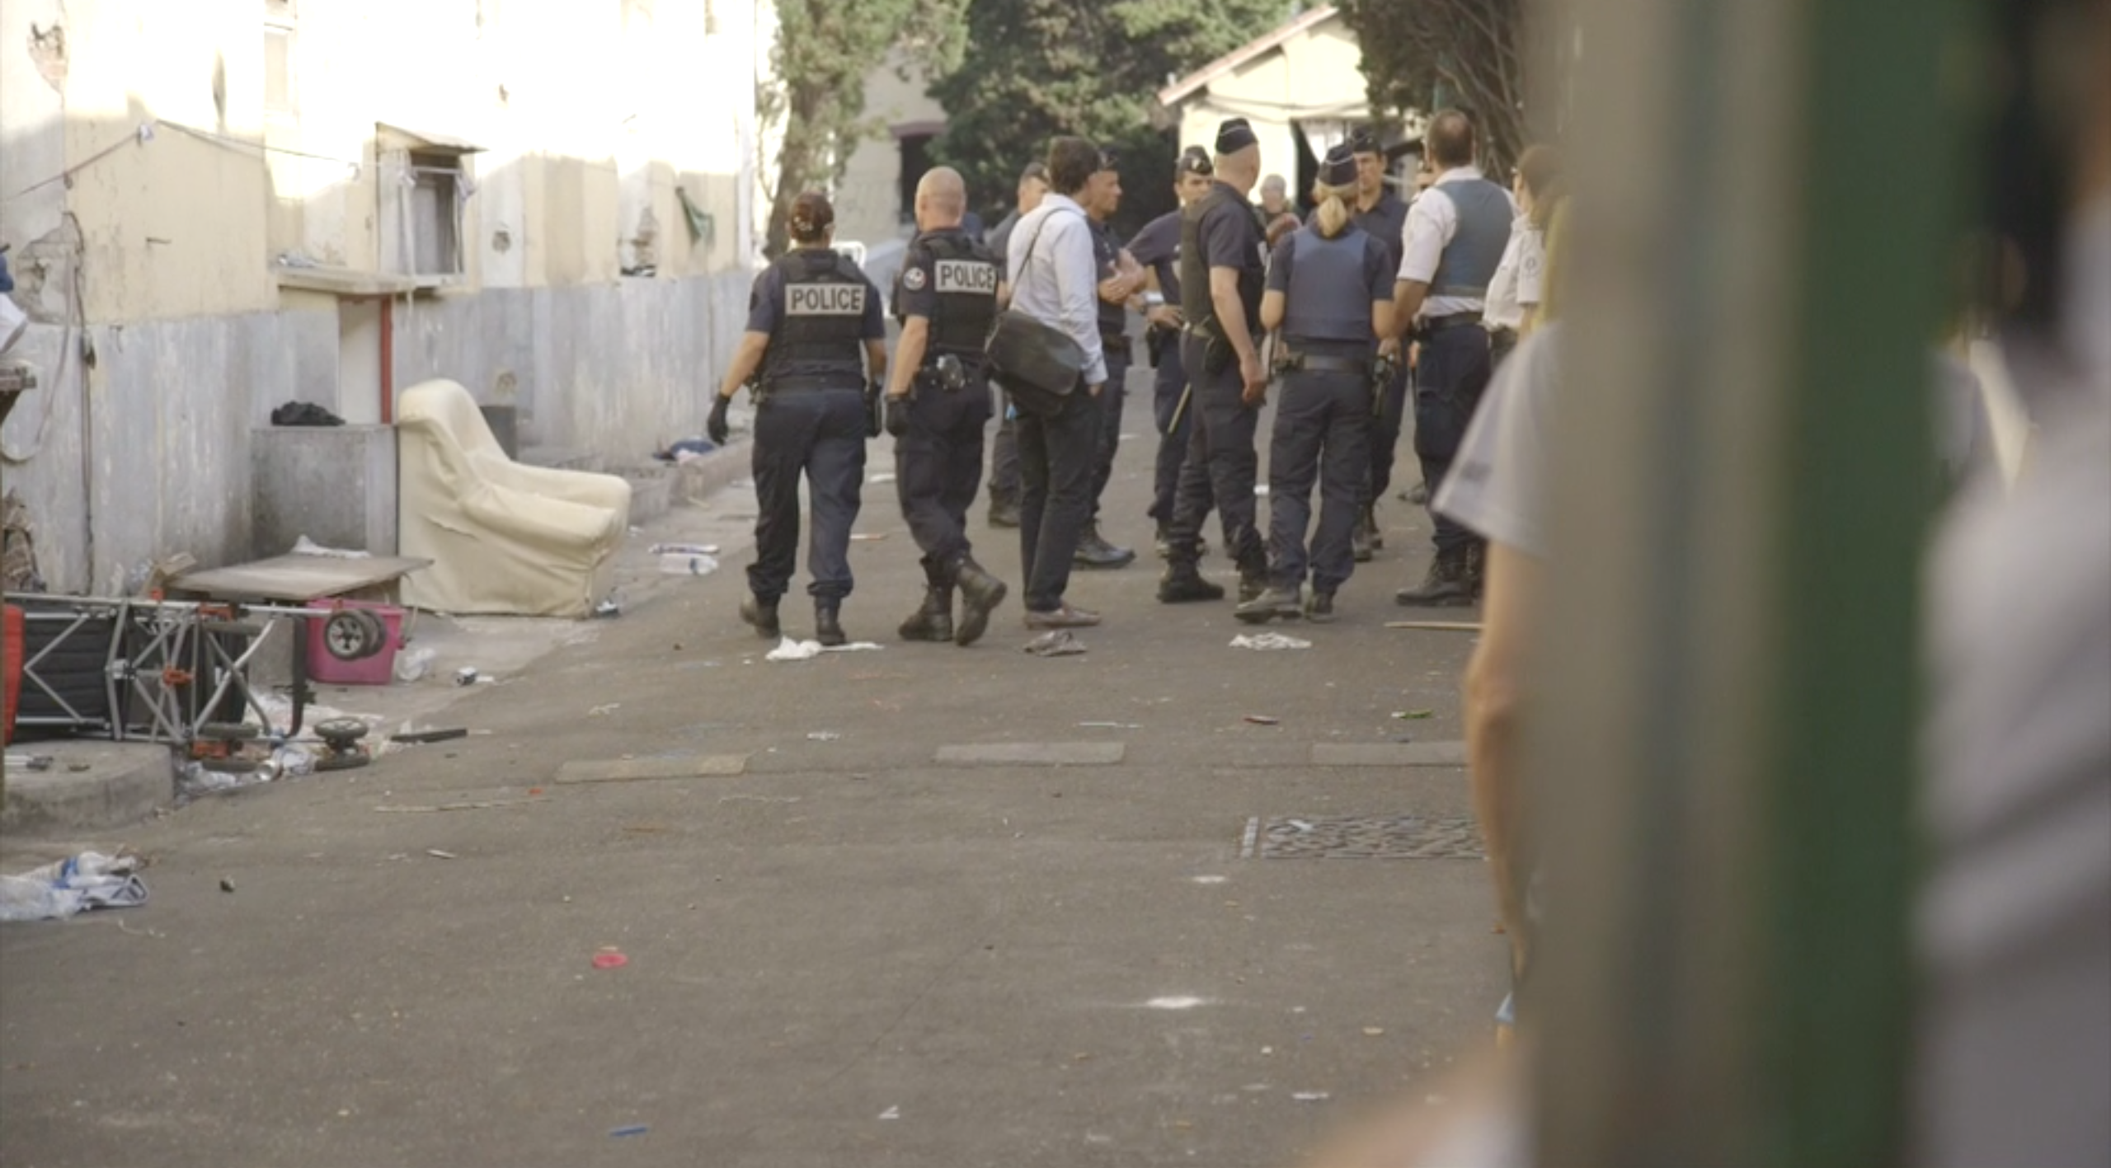
Source: Rosa

[Michele] A cold sidewalk; freezing tents and shacks; piles of clothes; a broken van; many activists (some stay, lots go away); a bunch of new friends; a fire, revived every-night for months as forming a tiny public space in the middle of the dark road; my own flat used as a collective washing-machine; pasta cooked by an Italian with love, which Roma people did not like at all; bathrobes used as jackets; bathrobes used as dresses; bathrobes but no toilets, only an open plot of land; a small diary carried by hand by Nico; an online blog; a camera and a microphone; going together everyday to buy a café for Vasilica, a coke for Claudia and three Angry Birds croissants for G. and his brothers; manele from mobile phones, stolen wi-fi; chopped wood and lined clothes; angry fights and larger laughs; tiny plastic dishes and cups and so, so much more. It was in being there, all the time I could be and even in the one I shouldn’t have for my own sake, in being there -- present, constant -- that they were able to understand that I cared about their sort because, indeed, I did care and I still do. With their bare presence they asked me a lot and I asked them even more with mine -- this is the event of sharing and thus the raw joy of doing ethnography.

Figure 8. G. in front of the shack where he was living. The sign reads: ‘Homes for everyone indifferent to ethnicity’
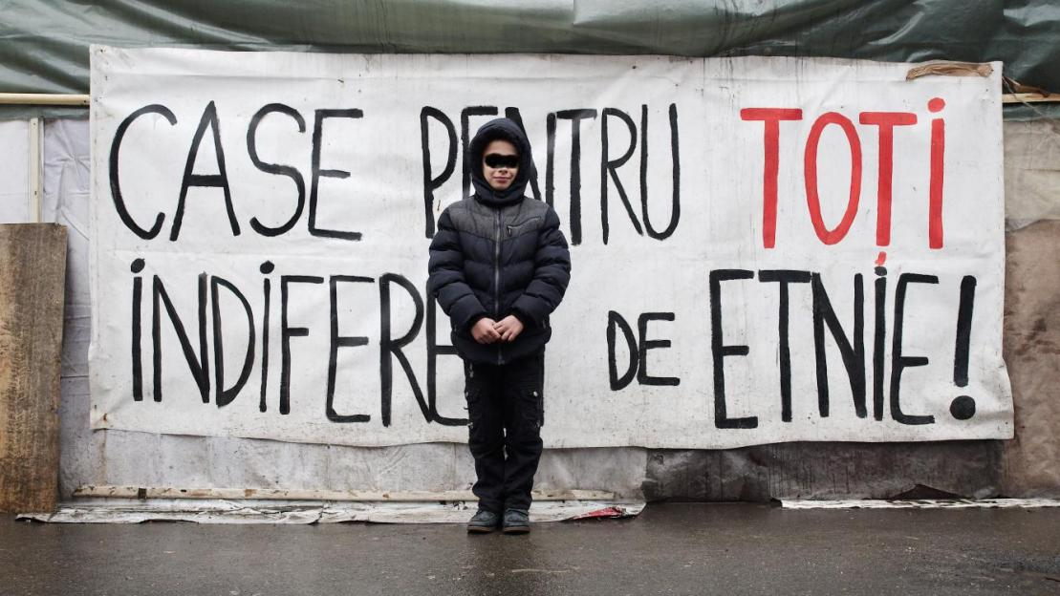
Source: Lancione

[Both] Fieldwork, especially when done with care, affection and a political orientation, is always emotionally demanding and draining (Brown and Pickerill 2009). If ethnography is about sharing, then what else but emotions does one implicitly and explicitly share in the field? This sharing is productive: as it is one of new affections, meanings and it contributes to the (re)assemblage of one’s own subjectivity. As Askins puts it, ‘Emotions are subjective and contextual, affected by place and our interactions with other people – intersubjectivities – thus we are always being produced and producing selves and others through situated, relational perspectives' (Askins 2009, 9–10). In this sense emotions are not something ‘out there in the air’, but are encountered and thus felt in the everyday makeshift of being-in-the-field. Ethnography demands a socio-material understanding of emotions: they are felt under one’s own skin, but they are also shared with others and mediated by others, human and non-humans alike (Bondi 2005). Affection is the process triggering emotional responses from us and our collaborators (Anderson 2006; Thrift 2004) -- a process that is inextricably dependent on the urban machines at play: a disrupted occupied house, a crumpled car, a tiny shack shaken by cars passing by, and more.
How we do fieldwork is in the end about how we change in, out and through our encounter with the field and the emotions that constitute it. But thinking about this process is possible only if one remembers and admits a bare, fundamental fact: insofar as we go in, out and through the margins means that we do not belong there. After all, we know that the squat, the pavement or the shacks are not the places where we live. We know how to feel dirty, tired, smelly and sick -- we may even seek out these experiences as they leave us with a sense of having been there. But we know that soon we will get home, have a shower, and a good and healthy meal, rendering the fieldwork by definition ephemeral in every respect. Chez moi, we can wash the laundry and the unpleasant smell of hours and hours spent on the street. We can go to the toilet and re-place a distance between our corporal-self and its excrements, a metabolic distance that is more problematic to achieve when one is living in a shack or squat with provisional hygienic infrastructures. If living at the margins is marked by a lack/penury of margins -- because the body is exposed, always, open air (Desai, Mcfarlane, and Graham 2014) -- the only way for us to be in the field is to get some of those margins back. This is about restoring our affective balance, which is at the same time emotional and intensively embodied (or corporeal).
We suggest that the answer to how we do the field is simple: exhausting ourselves in hours of prolonged engagement that leave marks on who we are and what we feel, marks that last well beyond the end of a research project. Burning out is just beyond the corner, and it so happens that this happened to the both of us respectively each time we ‘ended’ an intensive ethnographic piece of work. For us, reclaiming ‘our’ space in the field is thus not only a matter of survival, but it is a more profound epistemic act: without such reclaiming there would be no energy -- emotional energy -- for the encounter with l’autre, for a meaningful sharing able to fuel those productive ‘destabilisations’ we aim for. If the discontinued practice of the field entails a constant negotiation of (self)identity and emotional stability, then the first task for urban ethnographers is therefore that of taking care of themselves. This is easier said than done -- we are indeed both very, very bad at doing so. Perhaps the reason why we have felt it was important to write about this here is in order to remind each other, and other colleagues, about the need to take care of one self . We never heard someone saying us: Be ready: fieldwork is beautiful, it will give you a lot, but it will also totally and utterly exhaust you.
Strategies and self-tricks needs therefore to be put in place. For instance, to feel ‘comfortable’ with our ‘ordinary’ selves we usually play down with our fieldwork, either making a liberating use of irony while narrating our encounter with Roma people to our friends on Saturday night at the bar, or avoiding to explain all the details of this or that field-episode to our loved ones. These and other tricks help us manage unpleasant feelings -- such as the sense of helplessness in the face of the violence of evictions -- but evading intense feelings when our research participants are at risk or worst, can only ever be momentary. For the most part, doing ethnography at the urban margins is a tiring journey filled with emotional traps and demands. Being honest about one’s own limits and necessity, and reclaiming one’s own space, may not be compatible with the canonical image of the heroic scholars of the margins, but is the prerequisite for any sustainable critical ethnography of marginalisation.

Concluding statement
As dozens of post-colonial, feminist and critical urban scholars have declared before us, when it comes to the margins, power is concerned. In our case, as urban ethnographers, this is the power of producing knowledge, the power of representation. The issues that such power brings to the fore are political and ethical, particularly when life at the margins is at stake, as it has been for many of our Roma friends and research collaborators. With this paper, we have tried to bring to the fore a number of elements that, we believe, need particular attention if one is concerned with doing a critical form of ethnographic enquiry. By ‘critical’ we mean an ethnography that does not take things for granted (Marcuse 2009), which include also the role of the researcher in the makeshift of the fieldwork. We have crafted this text in form of a dialogue, reflecting on some ethnographic vignettes taken from our respective fieldwork experiences, with the aim to be frank and open precisely about this last point. Why we do fieldwork, what we do in it and how we negotiate its intense emotional burden are all questions that underpin the dilemmas associated with ethnographic work before, during and after its practice. We hope that our ego-geography/auto-ethnography has opened some points of reflections around the aesthetic of the margins, the problematic desires we as researchers and human beings bring to our method and encounters, the unacceptability of positivist dreams about field research and the complex role of emotions in the makeshift practice of ethnography. These and possibly other points need to be reflexively brought to the centre of a renovated critical ethnography of the urban margins, of which our cities - managed in the name of uniformity and generalisations - are in urgent need.

References
Amin, A, and N Thrift. 2002. Cities, Re-Imaging the Urban. Cambridge: Polity.
Anderson, Ben. 2006. “Becoming and Being Hopeful: Towards a Theory of Affect.” Environment and Planning D: Society and Space 24 (5): 733–52. doi:10.1068/d393t.
Anderson L., 2006. Analytic Autoethnography. Journal of Contemporary Ethnography, 35(4), 373–395.
Askins, Kye. 2009. “‘That’s Just What I Do’: Placing Emotion in Academic Activism.” Emotion, Space and Society 2 (1). Elsevier Ltd: 4–13. doi:10.1016/j.emospa.2009.03.005.
Askins, Kye, and Rachel Pain. 2011. “Contact Zones: Participation, Materiality, and the Messiness of Interaction.” Environment and Planning D: Society and Space 29 (5): 803–21. doi:10.1068/d11109.
Bignall, S, and P Patton, eds. 2010. Deleuze and the Postcolonial. Edinburgh: Edinburgh University Press.
Bondi, Liz. 2005. “Making Connections and Thinking through Emotions: Between Geography and Psychotherapy.” Transactions of the Institute of British Geographers 30: 433–48. doi:10.1111/j.1475-5661.2005.00183.x.
Brown, Gavin, and Jenny Pickerill. 2009. “Space for Emotion in the Spaces of Activism.” Emotion, Space and Society 2 (1). Elsevier Ltd: 24–35. doi:10.1016/j.emospa.2009.03.004.
Butz, David, and Kathryn Besio. 2009. “Autoethnography.” Geography Compass 3 (5): 1660–74. doi:10.1111/j.1749-8198.2009.00279.x.
Calbérac Y., 2007. Terrain d’affrontement: la relecture d’une controverse scientifique (1902-1922). Bullettin de l’Association de géographes français, 4, 429–436.
Calbérac Y., Volvey A., 2015. Introduction. J’égo-géographie …In Calbérac Y., Volvey A. (eds.), « J'égo-géographie », Géographie et Cultures, n° 89/90, 5–32.
Deegan M. J., 1989. American Ritual Dramas: Social Rules and Cultural Meanings. New York: Greenwood Press.
Deegan M. J., 1998. The American Ritual Tapestry: Social Rules and Cultural Meanings. Westport, CT: Greenwood Press.
Deleuze, G, and F Guattari. 2009. “Balance-Sheet for ‘Desiring-Machines.’” In Chaosophy. Texts and Interviews 1972-1977, edited by S Lotringer, 90–115. Los Angeles: Semiotext(e).
Denshire, Sally. 2013. “Autoethnography.” Sociopedia.isa, 1–12.
Desai, Renu, Colin Mcfarlane, and Stephen Graham. 2014. “The Politics of Open Defecation: Informality, Body, and Infrastructure in Mumbai.” Antipode 47 (1): 98–120. doi:10.1111/anti.12117.
Dupont L., 2014. Terrain, réflexivité et auto-ethnographie en géographie. Géographies et cultures, 89-90 | 2014, mis en ligne le 09 octobre 2015, consulté le 09 janvier 2016. URL : http://gc.revues.org/3235.
Emerson R. et al., 1995. Writing ethnographic fieldnotes. Chicago: The University of Chicago Press.
Fassin, Didier. 2013. “Why Ethnography Matters: On Anthropology and Its Publics.” Cultural Anthropology 28 (4): 621–46. doi:10.1111/cuan.12030.
Ferguson, R, M Gever, T T Minh-ha, and C West, eds. 1990. Out There. Marginalization and Contemporary Culture. New York: The New Museum of Contemporary Art.
Gibson-Graham, J K. 1994. “‘Stuffed If I Know!’: Reflections on Post-Modern Feminist Social Research.” Gender, Place & Culture 1 (March 2015): 205–24. doi:10.1080/09663699408721210.
———. 2000. “Poststructural Interventions.” In , edited by E Sheppard and T Barnes. Oxford: Blackwell.
Hale, Charles R. 2006. “Activist Research v . Cultural Critique : Indigenous Land Rights and the Contradictions of Politically Engaged Anthropology” 21 (1): 96–120.
Hall, S. 1992. “The West and the Rest: Discourse and Power.” In Formations of Modernity, edited by S Hall and B Gieben, 275–331. London: Polity press. http://books.google.com/books?hl=en&lr=&id=VhVcCv1C6N0C&oi=fnd&pg=PA165&dq=The+West+and+the+Rest+:+Discourse+and+Power&ots=LTHdQ32bzN&sig=ld1VsLSq4bnfxpYu49M-ASogY1A.
Haraway, Donna Jeanne. 1988. “Situated Knowledges: The Science Question in Feminism and the Privilege of Partial Perspective.” Feminist Studies 14 (3): 575–99. doi:10.2307/3178066.
hooks, Bell. 1989. “Choosing the Margin as a Space of Radical Openess.” In Yearnings: Race, Gender and Cultural Politics, 203–9. New York: South End Press.
Katz, Cindi. 1994. “Playing the Field: Questions of Fieldwork in Geography.” The Professional Geographer 46 (1): 67–72. doi:10.1111/j.0033-0124.1994.00067.x.
Lancione, M. 2010. “Giustizia Sociale, Spazio E Città. Un Approccio Teorico Metodologico Applicato a Un Caso Studio.” Rivista Geografica Italiana 117: 625–52.
Lancione, M. 2015. “Eviction and Housing Racism in Bucharest.” Open Democracy.
———. , ed. 2016. Rethinking Life at the Margins. The Assemblage of Contexts, Subjects and Politics. London: Routledge.
Lanne, J-B. 2016. “The Machine and the Poet: A Tale about How the Subject Goes into the Field (and How It Comes Back).” In Re-Thinking Life at the Margins. The Assemblage of Contexts, Subjects and Politics, edited by M. Lancione. London: Routledge.
Latour, B. 2005. Reassembling the Social. Oxford: Oxford University Press.
Lawless, Elaine J. 1992. “‘I Was Afraid Someone like You... an Outsider... Would Misunderstand’: Negotiating Interpretive Differences between Ethnographers and Subjects.” The Journal of American Folklore 105 (417): 302–14. doi:10.2307/541758.
Marcuse, Peter. 2009. “From Critical Urban Theory to the Right to the City.” City 13 (2-3): 185–97. doi:10.1080/13604810902982177.
Mason, Kelvin. 2015. “Participatory Action Research : Coproduction , Governance and Care.” Geography Compass 9 (9): 497–507. doi:10.1111/gec3.12227.
McFarlane, C. 2011. Learning the City: Knowledge and Translocal Assemblage. Oxford: Wiley Blackwell.
Pain, Rachel. 2004. “Social Geography: Participatory Research.” Progress in Human Geography 28 (5): 652–63. doi:10.1191/0309132504ph511pr.
Reed-Danahay, D. 1997. “Introduction.” In Auto ⁄ Ethnography: Rewriting the Self and the Social, edited by D Reed-Danahay. Oxford: Berg.
Rose, G. 1997. “Situating Knowledges: Positionality, Reflexivities and Other Tactics.” Progress in Human Geography 21: 305–20. doi:10.1191/030913297673302122.
The Autonomous Geographies Collective. 2010. “Beyond Scholar Activism: Making Strategic Interventions inside and Outside the Neoliberal University.” Acme 9 (2): 245–75.
Thrift, N. 2004. “Intensities of Feeling: Towards a Spatial Politics of Affect.” Geografiska Annaler, Series B: Human Geography 86 (1): 57–78. doi:10.1111/j.0435-3684.2004.00154.x.
Turner V. W., 1969. The Ritual Process. Structure and Anti-Structure. Chicago, Aldine Publishing Company.
Van Gennep A., 1960[1908]. Rites de Passage. Chicago: The University of Chicago Press.
Valentine, G. 2008. “Living with Difference: Reflections on Geographies of Encounter.” Progress in Human Geography 32 (3): 323–37. doi:10.
1177/0309133308089372.
Volvey A., 2014. Le corps du chercheur et la question esthétique de la science géographique, L’information géographique, 31(1), 92-117.
Volvey A., Calbérac Y., Houssay-Holzschuch M., 2012. Terrains de je. (Du) sujet (au) géographique. Annales de géographie, 5(687-688), 44–461.
Žižek S., 2013. Il trash sublime, Mimesis.

Academically speaking, the followings have been our engagement with Roma people across Europe. Michele: in 2005, after months of friendship and engagement with some of them, I wrote my BA dissertation on the street kids of Bucharest (a great part of whom were Roma). In 2008 my MA dissertation was mainly about the condition of a group of Roma people living along the banks of the river Stura, in Turin (see Figure 1 and Lancione 2010). In 2014-2015 I worked as an activist and researcher with a community of 100 Roma people evicted from their homes in Bucharest, Romania (Lancione 2015). Elisabetta: I met Roma people in Marseille and Turin in 2013, when I started working within an international research program on urban marginality in Mediterranean cities. In Turin I mainly worked on the relation between urban planning policies and Roma people practices of the city, showing how the are mutually intertwined (Rosa 2015, 2016). In 2015-2016 I moved to Marseille where I met a Roma family of 20 people. I spend some twelve months with them and participate to their daily life with a visual-ethnography. The documentary Entrer, sortir, traverser (France, 36’, 2016) is about our encounter. Interestingly enough, none of us consider him/herself a Romani scholar. Our aim is to look at the urban margins and to locate the Roma within broader societal dynamics rather than closing them in neat ethno-classifications or discipline.
These are the ones that we know best and we frequent the most, although we are confident that a similar argument could be sustained also with other western academies.
The blog that Michele organised and curated for the community of evicted people, www.jurnaldinvulturilor50.org

