Title: Culture shapes 7-month-olds’ perceptual strategies in discriminating facial expressions of emotion.

Authors: Elena Geangu , Hiroko Ichikawa² , Junpeng Lao² , So Kanazawa, Masami K. Yamaguchi³, Roberto Caldara⁶, Chiara Turati

Contact: roberto.caldara@unifr.ch

Emotional facial expressions are considered adaptive universal signals that emerged through phylogenetic evolution because of their crucial role for the survival of social species. Indeed, from infancy, humans develop dedicated neural circuits [1] to exhibit and recognize a variety of facial expressions that support complex social interactions [2]. However, increasing evidence has shown instead that culture can greatly influence emotional facial expressions and their discrimination [3]. Not only culture specifies when and how certain emotions can be expressed – i.e., social norms -, but the mature perceptual mechanisms used to transmit and decode the visual information from emotional signals also differ between adults from the Western and Eastern cultures [4,5]. Specifically, the mouth is more informative for transmitting emotional signals in Westerners and the eye region for Easterners [4], engendering culture-specific perceptual biases towards these facial features [5]. During development, it is generally recognized that important cultural differences can be observed at the level of emotional reactivity and regulation [6]. Cross-cultural research also indicates that children gradually learn culturally dominant modes of attention to the surrounding environment, which appear fully evident by 6 years of age [7]. Nonetheless, no study has ever explored whether cultural specific modes of processing facial emotional signals are available early in development. To this aim, we used a visual discrimination paradigm, based on the principles of familiarization and novelty preference, while tracking the eye movements of Western Caucasian (WC) and East Asian (EA) 7-month-old infants. Our data show that by 7 months infants from both cultures visually discriminate own- and other-race facial expressions of emotion. Crucially, discrimination is achieved by relying on culturally distinct perceptual strategies, resembling to those used by the adults [3, 4] of the environment in which they develop.
Seven-month-old WC (born and raised in the UK; N = 77) and EA infants (born and raised in Japan; N = 76) were familiarized with one emotional expression (i.e., fear or happiness) across different facial identities (familiarization phase), followed by the presentation of pairs of faces displaying the familiarized emotion alongside the novel one (test phase) (Supplemental Figure S1a-b, Supplemental Information - SI). Half of the infants were familiarized to fear, the other half to happiness. The race of the faces (own- vs. other-) was kept constant across familiarization and test phases and manipulated between participants. The visual preference during the test phase indicates infants’ ability to discriminate between facial expressions of emotion. To determine the perceptual strategies infants used to accomplish the discrimination task, we tracked infants’ eye movements during both the familiarization and test phases.
A data driven analysis method based on robust non-parametric statistics [8] revealed that during the familiarization phase (Supplemental Figure S1d) WC infants fixated significantly more on the mouth compared to EAs. EA infants showed a significant bias towards the eye region and displayed longer fixations on the eyes than WCs (Figure 1a). Crucially, the facial expression and the race of the faces did not alter infants’ perceptual strategies. These cultural differences in eye movements are in line with those previously reported in adults for emotional recognition [5], and distinct from those typically found when infants [9], children and older adults [10] extract face identity information. To then assess whether infants discriminate between emotional facial expressions during the test phase, we applied a multivariate generalized linear model and novel 2D-surface visualization (Figure 1b-d). All infants looked longer towards fearful compared to happy faces (Figure 1b). Also, as a result of familiarization, they fixated longer the novel compared to the familiarized emotional expression (Figure 1c), which indicates an effective expression discrimination. The viewing bias towards the fearful expression (i.e., longer fixation duration) was reduced when the infants were familiarized with own-race fearful faces (Figure 1d). In addition, we applied unsupervised clustering using a Gaussian mixture model to quantify the fixation strategy between familiarization and test phases (see SI). Importantly, the analysis of the relation between the fixation patterns during the familiarization and test phase showed that the cultural fixation bias is consistently present at the individual level in infant observers (Supplemental Figure S2b). The strength of this perceptual bias was weaker in WC infants after familiarization to fearful faces, compared to the EA infants whom persistently fixated the eye region regardless of task demands such as exploration and discrimination of emotional facial expressions (Supplemental Figure S2c).
The acquisition of effective representations in infants for discriminating facial expressions is based on an optimal combination of neural systems dedicated to the processing of emotion and their refinement through experience [1]. Our results show that culture-specific early experience can determine the information intake for the biological neural circuitry. Eastern and Western 7-month-old infants effectively discriminate happy and fearful faces, but the eye movements used to reach this developmental milestone differ. These culturally-specific information sampling biases mimic the previously reported eye movement fixation mappings in adults [5], with the Easterners focusing more toward the eye region while coding facial expressions and Westerns focusing more on the mouth [4]. These perceptual strategies identified in eye movements resonate with the cultural differences in the communication of emotions by the use of emoticons, with Easterners coding predominantly changes in expressions through the eyes ^_^ (i.e., happy) and Westerners through the mouth :-). The cultural environment, such as parental practices, may also contribute in several ways to the development of these perceptual differences. Asian mothers use less emotional expressivity and more non-direct body contact stimulation than the Western ones [6], which could lead to Asian infants’ increased attention to the culturally-specific facial emotional signals in the eye region. This attentional strategy may be further reinforced by other culturally driven parental practices for promoting learning throughout childhood, consolidating into the diverse modes of attention observed in older children and adults [7]. Overall, our findings show that culture heavily shapes the development of perceptual strategies used to process biologically-relevant social signals from an early stage in life.

Acknowledgments.
We are grateful to all families who agreed to participate in this study. This research was supported by Great Britain Sasakawa Foundation (Grant No. 4454) to E. G., Grant-in-Aid for Scientific Research by JSPS Research Fellowships for Young Scientists (No. 24 7809) to H. I., a European Research Council Starting Grant (ODMIR No. 241176) awarded to C. T. and a grant from the Swiss National Science Foundation (No. 100014_138627) awarded to RC.

References
[1] Leppänen JM, Nelson CA. Tuning the developing brain to social signals of emotions. Nat Rev Neurosci 2009;10:37–47. doi:10.1038/nrn2554.
[2] Hoehl S. Emotion processing in infancy. In: Lagattuta KH, editor. Child. Emot. New insights into Dev. Affect. Sci., Basel: Karger; 2014, p. 1–12.
[3] Jack RE, Schyns PG. The Human Face as a Dynamic Tool for Social Communication. Curr Biol 2015;25:R621–34. doi:10.1016/j.cub.2015.05.052.
[4] Jack RE, Garrod OGB, Yu H, Caldara R, Schyns PG. Facial expressions of emotion are not culturally universal. Proc Natl Acad Sci U S A 2012;109:7241–4. doi:10.1073/pnas.1200155109.
[5] Jack RE, Blais C, Scheepers C, Schyns PG, Caldara R. Cultural confusions show that facial expressions are not universal. Curr Biol 2009;19:1543–8. doi:10.1016/j.cub.2009.07.051.
[6] Kisilevsky BS, Hains SMJ, Lee K, Muir DW, Xu F, Fu G, et al. The still-face effect in Chinese and Canadian 3- to 6-month-old infants. Dev Psychol 1998;34:629–39. doi:10.1037/0012-1649.34.4.629.
[7] Senzaki S, Masuda T, Takada A, Okada H. The Communication of Culturally Dominant Modes of Attention from Parents to Children : A Comparison of Canadian and Japanese Parent-Child Conversations During a Joint Scene Description Task. PLoS One 2015:1–20. doi:10.1371/journal.pone.0147199.
[8] Lao J, Miellet, S., Pernet C, Sokhn N, Caldara R. iMap4: An Open Source Toolbox for the Statistical Fixation Mapping of Eye Movement data with Linear Mixed Modeling. Behav Res Methods n.d.
[9] Wheeler A, Anzures G, Quinn PC, Pascalis O, Omrin DS, Lee K. Caucasian Infants Scan Own- and Other-Race Faces Differently. PLoS One 2011;6:e18621. doi:10.1371/journal.pone.0018621.
[10] Kelly DJ, Liu S, Rodger H, Miellet S, Ge L, Caldara R. Developing cultural differences in face processing. Dev Sci 2011;14:1176–84. doi:10.1111/j.1467-7687.2011.01067.x.

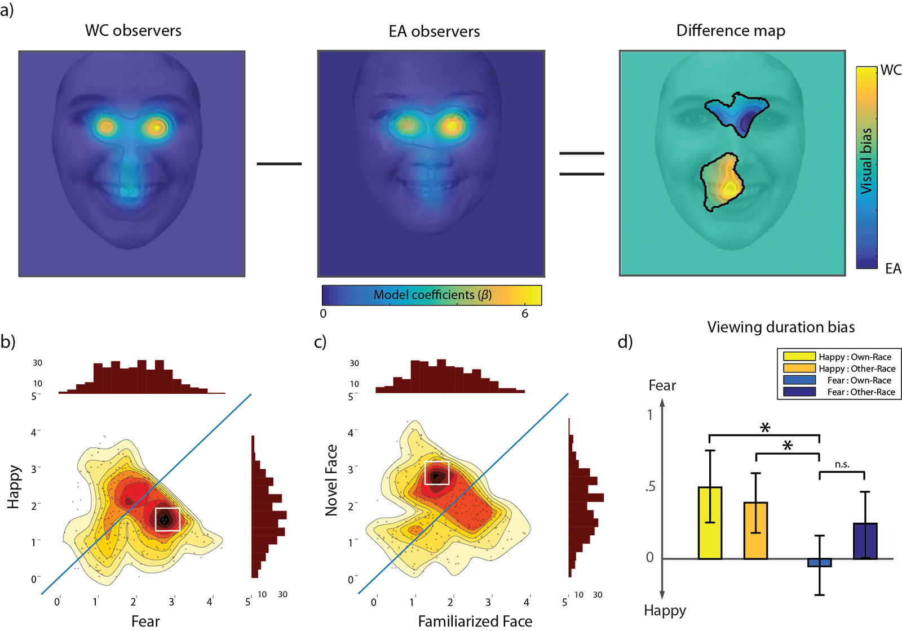

Figure 1. Testing cultural differences in emotional face exploration and discrimination.
(a) The spatial modelling of the fixation patterns was conducted using iMap4, a data-driven framework for statistical fixation mapping ([8] - see Supplemental Information for more details). Pixel-wise ANOVA on the model coefficients of the linear mixed model (Eq. s3) revealed a significant main effect of Culture on the mouth and the nose area and a significant main effect of Culture around the eye region. By performing a linear contrast between WC and EA infants, our data show that WC infants fixated more on the mouth compared to EAs (local maximum within the significant cluster: β_{WC} = 2.49 [1.992, 2.981], β_{EA} = 1.24 [0.747, 1.743], F (1, 757) = 12.07; local minimum: β_{WC} = 1.54 [1.279, 1.809], β_{EA} = 1.17 [0.899, 1.434], F (1, 757) = 3.86, p < 0.05 cluster corrected; brackets show 95% confidence interval). In comparison, EA infants showed a bias towards the eye region and displayed longer fixation duration on the eye than WCs (local maximum within the significant cluster: β_{WC} = 1.72 [1.360, 2.081], β_{EA} = 2.81 [2.451, 3.176], F (1, 757) = 17.59; local minimum: β_{WC} = 0.26 [0.160, 0.351], β_{EA} = 0.39 [0.295, 0.487], F (1, 757) = 3.86, p < 0.05 cluster corrected).
(b, c, d) To disentangle the effect of viewing duration of the test phase, we applied a multivariate generalized linear model and a novel visualization of the effect on a 2D surface. Linear contrast on the multivariate generalized linear model coefficients (Eq. s4 in Supplemental Information) revealed the effect of facial expression during the test phase (b). Infants showed a strong fixation bias towards fearful compared to happy faces, looking longer at the fearful (M_{viewing duration} = 1.95s [1.853, 2.051]) than at the happy faces (M_{viewing duration} = 1.68s [1.589, 1.772]; F (1, 596) = 16.00, p = 7.119e-05; brackets show bootstrapped 95% confidence interval). This bias for facial expressions is presented as a 2D surface with the estimated density peak showed in white square (more details in Supplemental Information). Moreover, we found a main effect of familiarity (c), as infants fixated longer on the novel expression (M_{viewing duration} = 1.90 [1.807, 2.000]) compared to the familiarized expression (M_{viewing duration} = 1.73 [1.633, 1.831]; F (1, 596) = 6.61, p = .0104). We also found a significant Culture difference in the fearful face bias (F (1, 596) = 3.95, p = .0473), whereas the Culture difference in the novel face bias is not significant (F (1, 596) = 1.12, p = .2691). Importantly, as shown in (d), the viewing bias towards fearful expressions is reduced when the infants were familiarized with fearful faces, thus explaining the main effect of familiarity. Infants familiarized with own-race fearful faces showed the least viewing bias towards fear compared to the other three conditions (F (3, 596) = 3.09, p = .0266). Error bars report 95% bootstrapped CI.

Department of Psychology, Lancaster University, Bailrigg, Lancaster LA1 4YF, UK
Co-first author
Department of Psychology, Chuo University, Hachioji-city, Tokyo, 192–0393, Japan
Japan Society for the Promotion of Science, Chiyoda-ku, Tokyo, 102–0083, Japan
Current affiliation: Faculty of Science and Technology, Tokyo University of Science, Yamazaki 2641, Noda, 278-8510, Chiba, Japan
Department of Psychology, University of Fribourg, Faucigny 2, 1700 Fribourg, Switzerland
Department of Psychology, Japan Women’s University, Kawasaki, Kanagawa, 214– 8565, Japan
Department of Psychology, University of Milano-Bicocca, Piazza dell'Ateneo Nuovo, 1, 20126 Milano, Italy

