Hydrotropy and scattering: Pre-ouzo as extended near-spinodal region
Seishi Shimizu^{1,*} and Nobuyuki Matubayasi^{2,3}
¹York Structural Biology Laboratory, Department of Chemistry, University of York, Heslington, York YO10 5DD, United Kingdom.
²Division of Chemical Engineering, Graduate School of Engineering Science, Osaka University, Toyonaka, Osaka 560-8531, Japan
³Elements Strategy Initiative for Catalysts and Batteries, Kyoto University, Katsura, Kyoto 615-8520, Japan
KEYWORDS: Hydrotropy / Kirkwood-Buff Theory / Minimum Hydrotrope Concentration / Self-aggregation / Micelle
Corresponding Author: Seishi Shimizu
York Structural Biology Laboratory, Department of Chemistry, University of York, Heslington, York YO10 5DD, United Kingdom.
Tel: +44 1904 328281, Fax: +44 1904 328281, Email: seishi.shimizu@york.ac.uk
Abbreviations: KB, Kirkwood-Buff; MHC, Minimum Hydrotrope Concentration

ABSTRACT
Solubilization or mixing in the presence of hydrotropes are often accompanied by the increase of scattering intensity. When the scattering corresponding to mesoscale structuring grows, the mixed state is called the “pre-ouzo” aggregate, which appears often and is distinct from critical density fluctuation, yet its precise mechanism of appearance is still obscure. Combining the results from the theories of scattering and thermodynamic phase stability with differential geometry, we have constructed a theory which can account for hydrotrope mixing thermodynamics and the pre-ouzo effect in a unified manner. In addition, another well-known signature of hydrotropy, the minimum hydrotrope concentration (MHC) at which solubility of sparingly soluble hydrophobic solutes suddenly increase, has also been linked to the scattering increase. The thermodynamic signatures of the pre-ouzo effect and MHC reveal a mechanistic difference between them, which manifests in the thermodynamic order of derivatives.

1. Introduction

Any combination of distinct species de-mix to some extent. On a macroscopic scale, a mixed phase becomes unstable at the spinodal point.^{1,2} On a microscopic scale, subtle tendency towards de-mixing (still within a single phase) is called preferential solvation, caused by disparity in intermolecular interactions.^{3–6} Particularly important is the mesoscopic regime, where de-mixing leads to the formation of micelles, lipid membranes and microemulsions, that are useful in laboratories, industries and daily life.^{7,8} Mesoscale de-mixing has been a continuous source of discovery and controversy, especially in the field of hydrotropy.^{9–16}

Hydrotropy refers to a drastic increase of solubility upon the addition of chemically inert “hydrotropes” to (aqueous) solution.^{9–15} Hydrotropes exhibit varying shades of amphiphilicity, not strong enough to form micelles but strong enough to form loose droplets, sometimes as large as mesoscale.^{9–16} Their weak amphiphilicity, which lies between micelles⁷ and simple cosolvents,³ has posed difficulties in revealing how hydrotropes work at a molecular level.^{14,15} Indeed, to understand hydrotropy is to elucidate how their weak structuring enhances the mixing of species that would normally de-mix in the absence of hydrotropes. Hence the question is to clarify the relationship between the thermodynamics of (de-)mixing and the mesoscale structural features.

Understanding how hydrotropes work has been particularly challenging in the following two realms:
- The pre-ouzo effect, i.e., the formation of mesoscale aggregates and droplets, which accompanies increased scattering intensity, in the solution composition range in which hydrophobic solutes are miscible with the aqueous hydrotrope solution.^{14,15,17–20}
- Minimum hydrotrope concentration (MHC), i.e., the threshold hydrotrope concentration (usually 0.5-1 molar) at which the solubility of hardly-soluble hydrophobic solutes suddenly increases.^{10–14,21–28}
Although (a) and (b) occupy different areas in the ternary phase diagram (see Figure 1), they are both discussed under the single aegis of hydrotropy.^{9–15} However, whether there is a relationship between the two or whether they are entirely different phenomena has not been made clear.

Thus we aim to clarify the relationships (1) between scattering (structuring) and solubilization (mixing) and (2) between different types of hydrotropy, such as MHC and the pre-ouzo effect. To achieve this end, we need to understand how phase stability and scattering at various length scales are related to one another.

2. Scattering and thermodynamics on a mesoscopic scale

Here we briefly summarize the pros and cons of two approaches in characterizing meso-scale aggregation, that are:
- via the real space, in which the intermolecular distance $r$ as spatial parameter, and the radial distribution function (RDF) between the species $i$ and $j$, $g_{ij}\left(r\right)$, as a spatial profile;^{21–31}
- via the Fourier-space, which employs the wave vector $q=2π/λ$ as the scale parameter (where $λ$ is the wave length), and the Faber-Ziman structure factor, $S_{ij}(q)$, as the measure of the spatial profile.^{32–34}
The two perspectives are complementary because they are related with one another by
$S_{ij}\left(q\right)-1=4πρ\int{dr r^{2}\frac{\sin{(qr)}}{qr}\left[g_{ij}\left(r\right)-1\right]}$ (1a)
$g_{ij}\left(r\right)-1=\frac{1}{2π^{2}ρ}∫dqq^{2}\frac{\sin{(qr)}}{qr} \left[S_{ij}\left(q\right)-1\right]$ (1b)
where $ρ$ is the density of the solution.³³ To characterize fluctuating meso-scale aggregates, RDF is often not useful. Indeed, spatially distinct aggregates such as micelle can be given a clear picture in real space, while more diffuse structures such as pre-ouzo mix are often characterized in the domain of spatial frequency. Since $S_{ij}(q)$ is a spatial frequency distribution, it can be better descriptor of overall aggregate size and structure.^{32–34}

There is a link between the structure factor and solution thermodynamics, but only at the macroscopic ($q→0$) limit:^{32–37}
$S_{ij}\left(0\right)=1+4πρ\int{dr r^{2}\left[g_{ij}\left(r\right)-1\right]}=1+ρG_{ij}$ (2)
where
$G_{ij}=\int{dr 4πr^{2}\left[g_{ij}\left(r\right)-1\right]}$ (3)
is referred to as the Kirkwood-Buff (KB) integral between the species $i$ and $j$.^{32–37} This $q→0$ limit reflects the macroscopic nature of chemical thermodynamics. $G_{ij}$ is nevertheless useful, as $g_{ij}(r)-1$ reflects the local inhomogeneity in solution structure.

The $q$-representation, $S_{ij}\left(q\right)$, is especially useful for mesoscopic systems, because $q$ is the inverse of size, the magnitude of $q$ corresponding to mesoscale aggregation is so small that it is close to $q=0$, at which the chemical thermodynamics of phase stability can be discussed.^{1,2,38} Inferring the magnitude of $S_{ij}\left(0\right)$ from $S_{ij}(q)$ at $q→0$ is made possible by the thermal broadening of the $S_{ij}\left(q\right)$ spectrum.

3. Pre-ouzo effect: linking mesostructure to mixing free energy curvature

Here we establish a relationship between scattering and mixing free energy, through which the origin of pre-ouzo mesostructures will be clarified. In the following, we discuss the phase stability in terms of the derivatives of the mixing free energy; with this setup, the “stability” here may also mean metastability.

To this end, let us establish a link between the concentration-concentration structure factor $S_{CC}(0)$ and the thermodynamic stability function $Ψ$ for $3$-component mixtures, utilizing the results obtained by Gazzillo.³⁸ based upon multiple-component thermodynamic theory of Lupis.² This can be achieved by combining the results from the theory of phase stability in multiple-component systems and the relationship between stability and scattering.^{2,38}

Let $g_{mix}\left(x_{2},x_{3},…,x_{M}\right)$be the free energy of mixing in the M-component system, where $x_{i}$ is the mole-fraction of the component $i$. Note that there are only $M-1$ variables due to $\sum_{i}{x_{i}}=1$. Gazzillo³⁸ defined the following matrix
$Γ_{ij}={\left(\frac{∂g^{mix}}{∂x_{i}∂x_{j}}\right)}_{T,ρ_{k}}$ for $i≥2,j≥2$ (4)
in order to introduce the following stability function $Ψ$:
$Ψ=\frac{\prod_{i}{x_{i}}}{{\left(k_{B}T\right)}^{M-1}}\det{Γ}$ (5)
Using Eq. (5), the phase stability condition for the mixture is $Ψ>0$, and the collection of $\left(x_{2},…,x_{M}\right)$ that satisfy $Ψ\left(x_{2},…,x_{M}\right)=0$ is the spinodal line.³⁸ Now the stability function $Ψ$ has been shown to be related to the concentration-concentration structure factor at $q=0$, $S_{CC}(0)$, as³⁸
$Ψ=\frac{\prod_{i}{x_{i}}}{S_{CC}(0)}$ (6)
Note, as is well documented, that the thermodynamically metastable but not (most) stable region may stretch further than the region with $Ψ<0$, which may give rise to demixing before the spinodal point.^{1,2}

Here we show that use of elementary differential geometry³⁹ facilitates the interpretation of Eq. (6). Note that $Γ$, defined in Eq. (4), is a Hessian matrix of $g^{mix}\left(x_{2},x_{3}\right)$. Since Hessian determinant can be expressed as the product of its principal curvatures, $α_{i}$ along the principal axes³⁹, we obtain that
$\prod{α_{i}}=\frac{{\left(k_{B}T\right)}^{M-1}}{S_{CC}(0)}$ (7)
Thus the divergence of $S_{CC}(0)$ at a given composition $\left(x_{2},x_{3}\right)$ makes at least one of the principal curvatures close to zero. Note that, in experiments, the system approaches to spinodal via pre-ouzo region by the change of mixing composition, through which the ternary mixture is always (meta-)stable until reaching spinodal. In this case, the eigenvalues of Eq. (4) are all positive. The stability condition $Ψ>0$ may also be satisfied by two negative eigenvalues of Eq. (4), but the mixture is unstable in this case, which does not correspond to actual experiments.

In ternary water-hydrotrope-solute mixtures, $S_{CC}(0)$ diverges at the spinodal phase boundary, where critical fluctuation takes place,^{14,15,17–20} yet without showing any particular structural features.^{1,2} In the “pre-ouzo” region on the way to the phase boundary, a large $S\left(q\right)$ at small $q$ is observed, which corresponds structurally to the formation of large-scale aggregates or droplets.^{14,15,17–20} Phase diagrams suggest that such pre-ouzo region is stretched widely over a (reasonably) wide composition range^{14,15,17–20} on the way to spinodal decomposition.

The above summary of experimental observations, when taken together with Eq. (7), suggests that a large $S_{CC}(0)$ in the pre-ouzo region is caused by a small principal curvature along at least one principal axis, as can be summarized schematically in Figure 2. Note that the curvature itself, being the 2nd order derivative of the mixing free energy, is not sufficient in itself to tell us the value of free energy of mixing. In spite of this limitation, Figure 2 demonstrates that in the pre-ouzo region, located on the way to phase de-mixing, the free energy of mixing varies roughly linearly along the line corresponding to phase-separated state, which arises from the smallness of the mixing free energy curvature.

The inherent difficulty in establishing a connection between scattering and thermodynamics is due to the difficulty of determining $S_{CC}(0)$ at very low $q$. We therefore propose the following two possible scenarios upon which the mixture approaches demixing following the change of solution composition (Figure 3). The first possibility is the shift towards lower frequency of the wave vector $q_{max}$ at which $S_{CC}(q)$ exhibits a peak. According to this possibility, the aggregates of certain size scale disappear and make a way to larger aggregates. The second possibility is the growth of $S_{CC}(q)$ at $q→0$ while maintaining the large $S_{CC}(q)$ (i.e., mesostructure) at a certain $q$. Further experiments and theory will be necessary to clarify how the system approaches demixing through pre-ouzo mesostructures from a structural perspective. To establish which of the scenarios is true would require an extensive scattering measurements. In addition, elucidating how $S_{CC}(q)$ at small $q$ changes with composition requires us to consider a fine balance between the mixing entropy and hydration at work in determining the aggregate stability.²⁰ How these two factors depend on composition is expected to be complex, and would require further experiments and simulations.

To summarize, a synthesis of scattering and mixing free energies via geometry has captured the signature of the pre-ouzo effect: a long stretch of the mixing free energy trough on the way to spinodal.

4. Minimum hydrotrope concentration can also be linked to scattering

A sudden, cooperative onset of solubilization (i.e., minimum hydrotrope concentration, MHC^{10–14}) of hydrophobic solutes in the presence of relatively dilute hydrotropes is another important facet of hydrotropy. Here we show that MHC can also be linked to scattering.

4.1. A fluctuation theory of MHC

We have shown in our previous paper that MHC is characterized by a large negative trough of $k_{B}T{\left(\frac{∂^{2}μ_{u}^{*}}{∂μ_{1}^{2} }\right)}_{T,P,N_{u}→0}$, and can be attributed to the increase of hydrotrope self-association in the presence of the solute.^{23–25} This insight came from the rigorous statistical thermodynamic expression derived originally in our previous work,^{23,25} which has been rewritten (see Appendix A) into a compact form:
$k_{B}T{\left(\frac{∂^{2}μ_{u}^{*}}{∂μ_{1}^{2} }\right)}_{T,P,N_{u}→0}=-\left[W_{u}-\frac{ {〈N_{2}〉}_{u}}{〈N_{2}〉}W\right]$ (8)
where $W_{u}$ and $W$ are defined respectively as
$W_{u}=\left({〈N_{1}^{2}〉}_{u}-{〈N_{1}〉}_{u}^{2}\right)-2\frac{〈N_{1}〉}{〈N_{2}〉}\left({〈N_{1}N_{2}〉}_{u}-{〈N_{1}〉}_{u}{〈N_{2}〉}_{u}\right)+\frac{{〈N_{1}〉}^{2}}{{〈N_{2}〉}^{2}}\left({〈N_{2}^{2}〉}_{u}-{〈N_{2}〉}_{u}^{2}\right)$ (9)
$W=\left(〈N_{1}^{2}〉-{〈N_{1}〉}^{2}\right)-2\frac{〈N_{1}〉}{〈N_{2}〉}\left(〈N_{1}N_{2}〉-〈N_{1}〉〈N_{2}〉\right)+\frac{{〈N_{1}〉}^{2}}{{〈N_{2}〉}^{2}}\left(〈N_{2}^{2}〉-{〈N_{2}〉}^{2}\right)$ (10)
where $N_{i}$ is the number of species $i$ and ${〈 〉}_{u}$ and respectively denote the ensemble averages in the inhomogeneous and homogeneous systems, respectively.^{23,25}

Our goal is to rewrite Eqs. (8)-(10) in the language of scattering. To do so, we introduce the following concentration scale $c$ useful in the interpretation of scattering data:^{35,36}
$c=\frac{N_{2}}{N_{1}}$ (11)
Now we express $W$ and $W_{u}$ in terms of $c$. To do so, let us first note that, taking up to the first order in terms of $δN_{1}$ and $δN_{2}$, the change of $c$ (denoted as $δc$) can be shown to be expressed in terms of $δN_{1}$ and $δN_{2}$ as
$δc=\frac{1}{〈N_{1}〉}\left(δN_{2}-\frac{〈N_{2}〉}{〈N_{1}〉}δN_{1}\right)$ (12)
where the bracket signifies the ensemble average. Eq. (12) can easily be justified by introducing
$δc=c-〈c〉=\frac{N_{2}}{N_{1}}-\frac{〈N_{2}〉}{〈N_{1}〉}$ (13)
and rewriting it in terms of $δN_{i}=〈N_{i}〉-N_{i}$ in the following manner:
$δc=\frac{N_{2}〈N_{1}〉-〈N_{2}〉N_{1}}{N_{1}〈N_{1}〉}=\frac{N_{2}〈N_{1}〉-〈N_{1}〉〈N_{2}〉+〈N_{1}〉〈N_{2}〉-〈N_{2}〉N_{1}}{N_{1}〈N_{1}〉}$ (14)
$=\frac{〈N_{1}〉δN_{2}-〈N_{2}〉δN_{1}}{N_{1}〈N_{1}〉}=\frac{1}{N_{1}}\left(δN_{2}-\frac{〈N_{2}〉}{〈N_{1}〉}δN_{1}\right)$ (15)
By noting in Eq. (15) that
$\frac{1}{N_{1}}=\frac{1}{〈N_{1}〉+δN_{1}}≃\frac{1}{〈N_{1}〉}\left(1-\frac{δN_{1}}{〈N_{1}〉}\right)$ (16)
and taking up to the first order of $δN_{i}$, we obtain Eq. (12).

Using Eq. (15), the mean square fluctuation can be shown via straightforward algebra as
$〈{\left(δc\right)}^{2} 〉=\frac{1}{{〈N_{1}〉}^{2}}\left[〈{\left(δN_{2}\right)}^{2} 〉-\frac{2〈N_{2}〉}{〈N_{1}〉}〈δN_{1}δN_{2} 〉+\frac{{〈N_{2}〉}^{2}}{{〈N_{1}〉}^{2}}〈{\left(δN_{1}\right)}^{2} 〉\right]$ (17)
Comparing Eqs. (10) and (17), we obtain
$W=\frac{{〈N_{1}〉}^{4}}{{〈N_{2}〉}^{2}}〈{\left(δc\right)}^{2} 〉$ (18)
To relate $W_{u}$ to fluctuation requires a careful consideration. Let us first generalize Eq. (18) to an inhomogeneous system as
$W_{u}^{'}=\frac{{{〈N_{1}〉}_{u}}^{4}}{{{〈N_{2}〉}_{u}}^{2}}{〈{\left(δc\right)}^{2} 〉}_{u}$ (19)
by introducing the concentration fluctuation in the inhomogeneous system as
${〈{\left(δc\right)}^{2} 〉}_{u}=\frac{1}{{〈N_{1}〉}_{u}^{2}}\left[{〈{\left(δN_{2}\right)}^{2} 〉}_{u}-\frac{2{〈N_{2}〉}_{u}}{{〈N_{1}〉}_{u}}{〈δN_{1}δN_{2} 〉}_{u}+\frac{{〈N_{2}〉}_{u}^{2}}{{〈N_{1}〉}_{u}^{2}}{〈{\left(δN_{1}\right)}^{2} 〉}_{u}\right]$ (20)
However, unlike the case of the homogeneous solution, the relationship between ${〈{\left(δc\right)}^{2} 〉}_{u}$ and $W_{u}$ is not straightforward. This is because of the difference between $W_{u}^{'}$ and $W_{u}$
$δW_{u}=W_{u}^{'}-W_{u}=\left[-2\left(\frac{{〈N_{1}〉}_{u}}{{〈N_{2}〉}_{u}}-\frac{〈N_{1}〉}{〈N_{2}〉}\right){〈δN_{1}δN_{2} 〉}_{u}+\left(\frac{{〈N_{1}〉}_{u}^{2}}{{〈N_{2}〉}_{u}^{2}}-\frac{{〈N_{1}〉}^{2}}{{〈N_{2}〉}^{2}}\right){〈{\left(δN_{2}\right)}^{2} 〉}_{u}\right]$ (21)
yet can be shown to be negligible via an order-of-magnitude analysis (see Appendix B). Using Eq. (21), Eq. (8) can be rewritten as
$k_{B}T{\left(\frac{∂^{2}μ_{u}^{*}}{∂μ_{1}^{2} }\right)}_{T,P,N_{u}→0}=-\left[W_{u}^{'}-\frac{ {〈N_{2}〉}_{u}}{{〈N_{2}〉}_{0}}W\right]+δW_{u}≃-\left[W_{u}^{'}-\frac{ {〈N_{2}〉}_{u}}{{〈N_{2}〉}_{0}}W\right]$ (22)
where the final step comes from Appendix B.

4.2. Linking MHC to structure factors

Taking a full advantage of the variable $c=N_{1}/N_{2}$ commonly used in scattering,^{35–37} here we link the second-order derivative to structure factors. To do so, let us employ a relationship between the structure factor and concentration fluctuation in the homogeneous system^{35–37}
$S_{CC}\left(0\right)={〈N〉}^{2}〈{\left(δc\right)}^{2} 〉$ (23) where $N=N_{1}+N_{2}$. Eq. (23) can be generalized into the inhomogeneous system as
$S_{u,CC}\left(0\right)={〈N〉}_{u}^{2}{〈{\left(δc\right)}^{2} 〉}_{u}$ (24)
Using Eqs. (23) and (24), $W$and $W_{u}^{'}$ can straightforwardly be expressed in terms of the structure factors. Using Eqs. (18) and (23), we obtain
$W=\frac{{〈N_{1}〉}^{4}}{{〈N〉}^{2}{〈N_{2}〉}^{2}}S_{CC}\left(0\right)$ (25)
Eqs. (19) and (25) leads to the following generalization into the inhomogeneous system
$W_{u}^{'}=\frac{{〈N_{1}〉}_{u}^{4}}{{{〈N〉}_{u}^{2}〈N_{2}〉}_{u}^{2}}S_{u,CC}\left(0\right)$ (26)
Eqs. (25) and (26) transform Eq. (22) into the following form (see Appendix C):
$k_{B}T{\left(\frac{∂^{2}μ_{u}^{*}}{∂μ_{1}^{2} }\right)}_{T,P,N_{u}→0}≃-\frac{{〈N_{1}〉}^{4}}{{{〈N〉}^{2}〈N_{2}〉}^{2}}\left[S_{u,cc}\left(0\right)-\frac{ {〈N_{2}〉}_{u}}{〈N_{2}〉}S_{cc}\left(0\right)\right]$ (27)

Now we rewrite the $μ_{1}$-derivative in Eq. (27) in terms of the $c$-derivative through the following identity
${\left(\frac{∂^{2}μ_{u}^{*}}{∂c^{2}}\right)}_{T,P}={\left[{\left(\frac{∂μ_{1}}{∂c}\right)}_{T,P}\right]}^{2}{\left(\frac{∂^{2}μ_{u}^{*}}{∂μ_{1}^{2}}\right)}_{T,P}+{\left(\frac{∂^{2}μ_{1}}{∂c^{2}}\right)}_{T,P}{\left(\frac{∂μ_{u}^{*}}{∂μ_{1}}\right)}_{T,P}$ (28)
which can easily be justified by differentiating
${\left(\frac{∂μ_{u}^{*}}{∂c}\right)}_{T,P}={\left(\frac{∂μ_{u}^{*}}{∂μ_{1}}\right)}_{T,P}{\left(\frac{∂μ_{1}}{∂c}\right)}_{T,P}$ (29)
once more with respect to $c$. Appendix D shows that the dominant contribution in Eq. (28) comes from the first term. In addition, ${\left(\frac{∂μ_{1}}{∂c}\right)}_{T,P}$ in the first term of Eq. (28) can also be expressed in terms of the structure factor, which can be shown via the statistical thermodynamic fluctuation theory ^{35,36,40}:
$〈{\left(δc\right)}^{2} 〉=\frac{k_{B}T}{〈N_{1}〉}{\left(\frac{∂c}{∂μ_{2}}\right)}_{T,P} =-k_{B}T\frac{〈N_{2}〉}{{〈N_{1}〉}^{2}}{\left(\frac{∂c}{∂μ_{1}}\right)}_{T,P}$ (30)
where the second step involves the Gibbs-Duhem equation. Combining Eqs. (18), (28) and (30) leads to the following conclusion:
${\left(\frac{∂^{2}μ_{u}^{*}}{∂c^{2}}\right)}_{T,P}=\frac{{\left(\frac{∂^{2}μ_{u}^{*}}{∂μ_{1}^{2}}\right)}_{T,P}}{{\left[{\left(\frac{∂c}{∂μ_{1}}\right)}_{T,P}\right]}^{2}}≃-{k_{B}T〈N〉}^{2}\frac{S_{u,cc}\left(0\right)-\frac{ {〈N_{2}〉}_{u}}{〈N_{2}〉}S_{cc}\left(0\right)}{{\left[S_{cc}\left(0\right)\right]}^{2}}$ (31)

Thus the sudden onset of solubilization has now been linked to the increase of the structure factor arising from structure formation, in the presence of a solute. Moreover, the presence of ${\left[S_{CC}\left(0\right)\right]}^{2}$ in the denominator of Eq. (31) further underscores our previous conclusion that bulk-phase hydrotrope self-association lowers the efficiency of hydrotropic solubilization.^{21–28} Thus scattering also accompanies MHC.

5. Classifying hydrotropic signatures

Based on our theories developed in Sections 3 and 4, we can now show that pre-ouzo structuring^{14,15,17–20} and MHC^{10–14,21–28} belong to different classes of hydrotropic phenomena. We have shown that thermodynamic signature for pre-ouzo scattering is the curvature (Eq. (7)) of mixing free energy surface, which is the second order derivative of the mixing free energy (Eq. (4)). MHC’s thermodynamic signature, on the other hand, is the second-order derivative of $μ_{u}^{*}$ (Eq. (31)), which therefore is the third-order derivative of the free energy. Pre-ouzo structuring and MHC thus belong thermodynamically to the different classes of hydrotrope action, as has been clarified from the order of derivatives of the signature thermodynamic functions.

Combining together all our statistical thermodynamic insights on hydrotropy^{21–28} as well as their connection to scattering provided in this paper, we are in the position to attribute the difference in thermodynamic signature between pre-ouzo structuring and MHC to a difference in molecular-based mechanism between the two.

MHC has recently been identified statistical thermodynamically to arise from the enhancement of hydrotrope self-association caused by the presence of a solute molecule,^{23–26} which leads to the solute-induced increase in the structure factor (Eq. (31)). Its direct observation via scattering would face extremely difficulty, due to the diluteness of the solute, which would make the consequent solute-induced increase in scattering very subtle; computer simulation would be a more feasible approach to capture such a subtle change in hydrotrope self-association. However, the interrelationship between solubility and scattering is powerful in that what cannot be easily observed by scattering may be accessible via solubility measurements. This is indeed the case for MHC, in which the sudden onset of solubilization, readily observable via solubility, can reveal the subtle change in the structure factor.

Pre-ouzo structuring, on the other hand, has been characterised structurally to be fluctuation of mesoscale structures, which has been observed by scattering.^{9–16} Unlike the case of MHC (which was difficult to characterize from a structural basis), it is the thermodynamic consequences of pre-ouzo structuring that has been difficult to elucidate. Our clarification (Section 3) has reinforced the translatability between thermodynamics and scattering. What remains to be done experimentally is to identify the route from pre-ouzo to spinodal (Figure 2) through an extensive determination of the structure factors at small $q$ (Figure 3).

6. Conclusion

Mixing of chemical components takes place over diverse size-scales, accompanied by a strong increase of scattering intensity, characteristic of large-scale fluctuation and aggregation.^{14,15,17–20} A clear explanation on the relationship between solubilization and scattering has long been sought, especially upon the discovery that pre-ouzo aggregates, whose structural features are different from critical density fluctuations, play an important role in solubilization.^{14,15,17–20} Yet the lack of a theoretical framework led to controversies over the true cause of solubilization and scattering.

We have established here a link between mixing/solubilization and scattering, by synthesizing the insights from statistical thermodynamics,^{3–6,21–28} scattering theory,^{32–37} and the chemical thermodynamics of phase stability.^{2,38} Using elementary differential geometry,³⁹ scattering from the pre-ouzo region has been shown to correspond to the stretch of near-zero mixing free energy curvature, and hence the free energy trough, on the way to spinodal.

The cooperative onset of solubilization at the minimum hydrotrope concentration (MHC) has also been shown to be accompanied by the increase of the structure factor in the presence of the solute. Pre-ouzo structuring and MHC have both been shown to be linked to scattering, yet they differ fundamentally in the order of derivatives of the characteristic thermodynamic functions.

We have thus established a conceptual framework for bridging structural-thermodynamic phenomena that take place over widely-varying length scales, in which a link has been established between the thermodynamic signature for macroscopic de-mixing (such as phase separation) and structural signature for molecular aggregations over a variety of length scales.

Appendix A: Justification of Eqs. (8)-(10)

Let us start from Eq. (C6) of Ref ²³. From now on, we will omit the suffix 0 that denote the homogeneous system. We first note that
$\left[〈N_{1}^{2}〉-\frac{2〈N_{1}〉}{〈N_{2}〉}〈N_{1}N_{2}〉+{\left(\frac{〈N_{1}〉}{〈N_{2}〉}\right)}^{2}〈N_{2}^{2}〉\right]$
$=\left[\left(〈N_{1}^{2}〉-{〈N_{1}〉}^{2}\right)-\frac{2〈N_{1}〉}{〈N_{2}〉}\left(〈N_{1}N_{2}〉- 〈N_{1}〉〈N_{2}〉\right)+{\left(\frac{〈N_{1}〉}{〈N_{2}〉}\right)}^{2}\left(〈N_{2}^{2}〉-{〈N_{2}〉}^{2}\right)\right]=W$ (A1)
$\left[{〈N_{1}^{2}〉}_{u}-\frac{2〈N_{1}〉}{〈N_{2}〉}{〈N_{1}N_{2}〉}_{u}+{\left(\frac{〈N_{1}〉}{〈N_{2}〉}\right)}^{2}{〈N_{2}^{2}〉}_{u}\right]$
$=\left[\left({〈N_{1}^{2}〉}_{u}-{〈N_{1}〉}_{u}^{2}\right)-\frac{2〈N_{1}〉}{〈N_{2}〉}\left({〈N_{1}N_{2}〉}_{u}- {〈N_{1}〉}_{u}{〈N_{2}〉}_{u}\right)+{\left(\frac{〈N_{1}〉}{〈N_{2}〉}\right)}^{2}\left({〈N_{2}^{2}〉}_{u}-{〈N_{2}〉}_{u}^{2}\right)\right]$
$+{\left({〈N_{1}〉}_{u}-\frac{〈N_{1}〉}{〈N_{2}〉}{〈N_{2}〉}_{u}\right)}^{2}=W_{u}+{\left({〈N_{1}〉}_{u}-\frac{〈N_{1}〉}{〈N_{2}〉}{〈N_{2}〉}_{u}\right)}^{2}$ (A2)
Rewriting Eq. (C6) of Ref ²³ using Eqs. (A1) and (A2), one obtains Eqs. (8)-(10).

Appendix B: Justification of Eq. (22)

Using the definition of the KB integrals,
$\frac{{〈N_{i}〉}_{u}}{〈N_{i}〉}=1+\frac{G_{ui}}{V}$ (B1)
where $\frac{G_{ui}}{V}$ is $o(1)$, Eq. (21) can be rewritten via Maclaurin expansion as
$δW_{u}=2\frac{G_{u1}-G_{u2}}{V}\left[-\frac{〈N_{1}〉}{〈N_{2}〉}{〈δN_{1}δN_{2} 〉}_{u}+\frac{{〈N_{1}〉}^{2}}{{〈N_{2}〉}^{2}}{〈{\left(δN_{2}\right)}^{2} 〉}_{u}\right]$
$=2\frac{G_{u1}-G_{u2}}{V}W_{u}-2\frac{G_{u1}-G_{u2}}{V}\left[{〈{\left(δN_{1}\right)}^{2} 〉}_{u}-\frac{〈N_{1}〉}{〈N_{2}〉}{〈δN_{1}δN_{2} 〉}_{u}\right]$ (B2)

The factor within in the second term of Eq. (B2), using again the definitions of the KB integrals, $V\frac{{〈{\left(δN_{1}\right)}^{2} 〉}_{u}-{〈N_{1}〉}_{u}}{{〈N_{1}〉}_{u}^{2}}=G_{u,11}$ and $V\frac{{〈δN_{1}δN_{2} 〉}_{u}}{{〈N_{1}〉}_{u}{〈N_{2}〉}_{u}}=G_{u,12}$, can be simplified further into the following form
${〈{\left(δN_{1}\right)}^{2} 〉}_{u}-\frac{〈N_{1}〉}{〈N_{2}〉}{〈δN_{1}δN_{2} 〉}_{u}=\frac{{〈N_{1}〉}_{u}^{2}}{V}G_{u,11}+{〈N_{1}〉}_{u}-\frac{〈N_{1}〉}{〈N_{2}〉}\frac{{〈N_{1}〉}_{u}{〈N_{2}〉}_{u}}{V}G_{u,12}$
$=\frac{{〈N_{1}〉}_{u}^{2}}{V}G_{u,11}+{〈N_{1}〉}_{u}-\frac{{〈N_{1}〉}^{2}}{V}\left(G_{u,12}+o\left(1\right)\right)$ (B3)
where we have used $\frac{{〈N_{i}〉}_{u}}{〈N_{i}〉}=1+o(1)$ based on Eq. (B1). Using Eq. (B3), the second term of Eq. (B2) becomes
$-2\frac{G_{u1}-G_{u2}}{V}\left[{〈{\left(δN_{1}\right)}^{2} 〉}_{u}-\frac{〈N_{1}〉}{〈N_{2}〉}{〈δN_{1}δN_{2} 〉}_{u}\right]$
$=-2\left(G_{u1}-G_{u2}\right)\left[\frac{{〈N_{1}〉}_{u}^{2}}{V}G_{u,11}+\frac{{〈N_{1}〉}_{u}}{V}-\frac{{〈N_{1}〉}^{2}}{V^{2}}\left(G_{u,12}+o\left(1\right)\right)\right]$ (B4)
The first two terms within is reminiscent of the relationship between the KB integral and the isothermal compressibility $κ_{T}$, i.e., $\frac{{〈N_{1}〉}^{2}}{V^{2}}G_{11}+\frac{〈N_{1}〉}{V}≃RTκ_{T}\frac{{〈N_{1}〉}^{2}}{V^{2}}$; since the MHC is usually less than 1 molar, these two terms should be close to $κ_{T}$, hence is expected to be negligible. The third term, using the order of magnitude relationship $G_{u,12}=G_{12}+o(1)$, makes a very small contribution compared to $W_{u}-W$, as can be demonstrated based on our previous analysis in the following manner:^{21,23}
- For sodium benzoate, the peak value of ${\left(\frac{∂μ_{u}^{*}}{∂μ_{1}}\right)}_{T,P}=\frac{〈N_{1}〉}{V}\left(G_{u2}-G_{u1}\right)$ is ca. 50 for benzyl benzoate as solute,²¹ and $-2\frac{〈N_{1}〉}{V}G_{12}≃4.8$, hence the product of the two is $∼250$, much smaller than the trough of $RT{\left(\frac{∂^{2}μ_{u}^{*}}{∂μ_{1}^{2}}\right)}_{T,P}$ at around $-$50000.²³
- For sodium salicylate $\frac{〈N_{1}〉}{V}\left(G_{u2}-G_{u1}\right)$ peak is ca. 75 for benzyl benzoate as a solute, $-2\frac{〈N_{1}〉}{V}G_{12}≃5.2$, hence the product of the two is $∼400$, much smaller than the trough of $RT{\left(\frac{∂^{2}μ_{u}^{*}}{∂μ_{1}^{2}}\right)}_{T,P}$at around $-$10000.²³
- For urea, $\frac{〈N_{1}〉}{V}\left(G_{u2}-G_{u1}\right)$ peak is ca. 150 for benzyl benzoate as solute, $-2\frac{〈N_{1}〉}{V}G_{12}≃5$, hence the product of the two is $∼750$, which is much lower than the $RT{\left(\frac{∂^{2}μ_{u}^{*}}{∂μ_{1}^{2}}\right)}_{T,P}$trough of ca. $-$45000.²³
Thus we neglect the second term of Eq. (B2) from now onwards.

Appendix C: Justification of Eq. (27)

Using Eqs. (23)-(26), Eq. (22) can now be expressed in terms of the structure factors as
$k_{B}T{\left(\frac{∂^{2}μ_{u}^{*}}{∂μ_{1}^{2} }\right)}_{T,P,N_{u}→0}=-\frac{{〈N_{1}〉}^{4}}{{〈N〉}^{2}{〈N_{2}〉}^{2}}\left[\frac{\frac{{{〈N_{1}〉}_{u}}^{4}}{{〈N_{1}〉}^{4}}}{\frac{{〈N〉}_{u}^{2}{〈N_{2}〉}_{u}^{2}}{{〈N〉}^{2}{〈N_{2}〉}^{2}}}S_{u,cc}\left(0\right)-{\frac{ {〈N_{2}〉}_{u}}{〈N_{2}〉}S}_{cc}\left(0\right)\right]+δW_{u}$ (C1)
To derive Eq. (27) from Eq. (C1), we use the definition of the KB integral (Eq. (B1)), as well as its following consequence
$\frac{{〈N〉}_{u}}{〈N〉}=\frac{〈N_{1}〉}{〈N〉}\frac{{〈N_{1}〉}_{u}}{〈N_{1}〉}+\frac{〈N_{2}〉}{〈N〉}\frac{{〈N_{2}〉}_{u}}{〈N_{2}〉}=1+\frac{x_{1}G_{u1}}{V}+\frac{x_{2}G_{u2}}{V}$ (C2)
where $x_{i}$ is the mole fraction of the species $i$. Using Eqs. (B1) and (C2), the factor in Eq. (C1) can be rewritten as
$\frac{\frac{{{〈N_{1}〉}_{u}}^{4}}{{〈N_{1}〉}^{4}}}{\frac{{〈N〉}_{u}^{2}{〈N_{2}〉}_{u}^{2}}{{〈N〉}^{2}{〈N_{2}〉}^{2}}}=1+\left(\frac{2G_{u1}}{V}-\frac{2G_{u2}}{V}\right)+x_{2}\left(\frac{2G_{u1}}{V}-\frac{2G_{u2}}{V}\right)$ (C3)
Using Eq. (C3), we obtain the following expression as the difference between Eqs. (C1) and (27):
$\left(\frac{2G_{u1}}{V}-\frac{2G_{u2}}{V}\right)W_{u}-\left(\frac{2G_{u1}}{V}-\frac{2G_{u2}}{V}\right)\frac{{〈N_{1}〉}^{4}}{{〈N〉}^{2}{〈N_{2}〉}^{2}}S_{u,cc}\left(0\right)-x_{2}\left(\frac{2G_{u1}}{V}-\frac{2G_{u2}}{V}\right)\frac{{〈N_{1}〉}^{4}}{{〈N〉}^{2}{〈N_{2}〉}^{2}}S_{u,cc}\left(0\right)$
$≃-\left(\frac{2G_{u1}}{V}-\frac{2G_{u2}}{V}\right)δW_{u}-x_{2}\left(\frac{2G_{u1}}{V}-\frac{2G_{u2}}{V}\right)W_{u}^{'}$
$≃-2{\left(\frac{2G_{u1}}{V}-\frac{2G_{u2}}{V}\right)}^{2}W_{u}-x_{2}\left(\frac{2G_{u1}}{V}-\frac{2G_{u2}}{V}\right)W_{u}^{'}$ (C4)
where the second step involves the Eq. (26) and taking up to the leading term using Eq. (B1), and the third step has used Eq. (B2), whose the second term was already shown to be negligible. Thus we have shown that the first term of Eq. (C4) is two orders of magnitude smaller than $W_{u}^{'}$ and $W$, and therefore negligible. The second term of Eq. (C4) involves $x_{2}$, which is usually below ca. $0.02$ (as MHC and cooperative solubility increase takes place below ca.1 M),²³ hence is expected to make a minor contribution.

Appendix D. Justification for neglecting the second term of Eq. (28)

Let $b_{2}$ be the molality of the osmolyte, and $M_{1}$ be the molecular weight of water. Hence $c=\frac{N_{2}}{N_{1}}$, $b_{2}=\frac{N_{2}}{M_{1}N_{1}}$. Hence $\frac{c}{M_{1}}=b_{2}$. With this unit conversion, we can now use the osmotic coefficient data
$ϕ=1+Bb_{2}+Cb_{2}^{2}+…$ (D1)
Note that $ϕ$ is linked to the chemical potential of the solvent as
$μ_{1}=μ_{1}^{o}-RTM_{1}b_{2}ϕ$ (D2)
Hence
${\left(\frac{∂μ_{1}}{∂c}\right)}_{T,P}=\frac{1}{M_{1}}\left(\frac{∂μ_{1}}{∂b_{2}}\right)=-RT\left(1+Bb_{2}+Cb_{2}^{2}+…\right)-RTb_{2}\left(B+2Cb_{2}+…\right)$
$=-RT\left[1+2Bb_{2}+3Cb_{2}^{2}+…\right]$ (D3)
Therefore
${\left(\frac{∂^{2}μ_{1}}{∂c^{2}}\right)}_{T,P}=\frac{1}{M_{1}}\frac{∂}{∂b_{2}}{\left(\frac{∂μ_{1}}{∂c}\right)}_{T,P}=-RT\left[\frac{2B}{M_{1}}+\frac{6C}{M_{1}}b_{2}+…\right]$ (D4)
Taking up to the leading terms of Eqs. (D1) and (D3), we can rewrite the first and the second terms of Eq. (28) into the following form:
${\left(\frac{∂^{2}μ_{u}^{*}}{∂c^{2}}\right)}_{T,P}={\left[{\left(\frac{∂μ_{1}}{∂c}\right)}_{T,P}\right]}^{2}{\left(\frac{∂^{2}μ_{u}^{*}}{∂μ_{1}^{2}}\right)}_{T,P}+{\left(\frac{∂^{2}μ_{1}}{∂c^{2}}\right)}_{T,P}{\left(\frac{∂μ_{u}^{*}}{∂μ_{1}}\right)}_{T,P}$
$=RT\left[RT{\left(\frac{∂^{2}μ_{u}^{*}}{∂μ_{1}^{2}}\right)}_{T,P}-\frac{2B}{M_{1}}{\left(\frac{∂μ_{u}^{*}}{∂μ_{1}}\right)}_{T,P}\right]$ (D5)

Here we demonstrate that the second term in [] is negligible compared to the first.
- For sodium benzoate, $\frac{2B}{M_{1}}=-$2 $×$ 0.03253 / 0.018 = $-$3.6. Hence the peak value of ${\left(\frac{∂μ_{u}^{*}}{∂μ_{1}}\right)}_{T,P}$ is ca. 50 for benzyl benzoate as solute.²¹ In contrast, the trough of the first term in [] is $-$50000.²³
- For sodium salicylate, $\frac{2B}{M_{1}}=-$2 $×$ 0.0338 / 0.018 = $-$3.8. Hence ${\left(\frac{∂μ_{u}^{*}}{∂μ_{1}}\right)}_{T,P}$ peak is ca. 75 for benzyl benzoate as solute.²¹ They are much lower than the first term in [], whose trough is around $-$10000.²³
- For urea, $B$ is commonly very close to zero.²¹

Acknowledgements

We thank Steven Abbott and Werner Kunz for stimulating discussions, Josh Reid and Jonny Booth for a critical reading of the manuscript, and Minoru Sayou and Ryunosuke Yoshino for bibliographical assistance. This work was supported by the Gen Foundation (to S.S.), Steven Abbott TCNF Ltd (to S.S.), the Grants-in-Aid for Scientific Research (Nos. 15K13550 and 26240045) from the Japan Society for the Promotion of Science (to N.M.), the Elements Strategy Initiative for Catalysts and Batteries and the Post-K Supercomputing Project from the Ministry of Education, Culture, Sports, Science, and Technology (to N.M.), and the HPCI System Research Project (Project IDs: hp170046, hp170097, and hp170221) (to N.M.).

References
1 I. Prigogine and R. Defay, Chemical Thermodynamics, Longmans, London, 1954.
2 C. Lupis, Chemical Thermodynamics of Materials, North Holland, Dortrecht, 1983.
3 S. Shimizu, Proc. Natl. Acad. Sci. U. S. A., 2004, 101, 1195–1199.
4 S. Shimizu and C. L. Boon, J. Chem. Phys., 2004, 121, 9147–9155.
5 S. Shimizu and N. Matubayasi, J. Phys. Chem. B, 2014, 118, 3922–3930.
6 S. Shimizu and N. Matubayasi, Biophys. Chem., 2017, DOI: 10.1016/j.bpc.2017.02.003.
7 J. A. Long, B. M. Rankin and D. Ben-Amotz, J. Am. Chem. Soc., 2015, 137, 10809–10815.
8 H.-J. Butt, K. Graf and M. Kappl, Physics and Chemistry of Interfaces, Wiley-VCH, 2013.
9 C. Neuberg, Biochem. Z., 1912, 76, 107–176.
10 D. Balasubramanian, V. Srinivas, V. G. Gaikar and M. M. Sharma, J. Phys. Chem., 1989, 93, 3865–3870.
11 S. E. Friberg, Curr. Opin. Colloid Interface Sci., 1997, 2, 490–494.
12 P. Bauduin, A. Renoncourt, A. Kopf, D. Touraud and W. Kunz, Langmuir, 2005, 21, 6769–6775.
13 T. K. Hodgdon and E. W. Kaler, Curr. Opin. Colloid Interface Sci., 2007, 12, 121–128.
14 W. Kunz, K. Holmberg and T. Zemb, Curr. Opin. Colloid Interface Sci., 2016, 22, 99–107.
15 S. Schöttl and D. Horinek, Curr. Opin. Colloid Interface Sci., 2016, 22, 8–13.
16 D. Subramanian and M. A. Anisimov, J. Phys. Chem. B, 2011, 115, 9179–9183.
17 O. Diat, M. L. Klossek, D. Touraud, B. Deme, I. Grillo, W. Kunz and T. Zemb, J. Appl. Crystallogr., 2013, 46, 1665–1669.
18 M. L. Klossek, D. Touraud and W. Kunz, Phys. Chem. Chem. Phys., 2013, 15, 10971–7.
19 S. Schöttl, J. Marcus, O. Diat, D. Touraud, W. Kunz, T. Zemb and D. Horinek, Chem. Sci., 2014, 5, 2909–3340.
20 T. N. Zemb, M. Klossek, T. Lopian, J. Marcus, S. Schöettl, D. Horinek, S. F. Prevost, D. Touraud, O. Diat, S. Marčelja and W. Kunz, Proc. Natl. Acad. Sci. U. S. A., 2016, 113, 4260–4265.
21 J. J. Booth, S. Abbott and S. Shimizu, J. Phys. Chem. B, 2012, 116, 14915–14921.
22 S. Shimizu, J. J. Booth and S. Abbott, Phys. Chem. Chem. Phys., 2013, 15, 20625–20632.
23 S. Shimizu and N. Matubayasi, J. Phys. Chem. B, 2014, 118, 10515–10524.
24 J. J. Booth, M. Omar, S. Abbott and S. Shimizu, Phys Chem Chem Phys, 2015, 17, 8028–8037.
25 T. W. J. Nicol, N. Matubayasi and S. Shimizu, Phys. Chem. Chem. Phys., 2016, 18, 15205–15217.
26 S. Shimizu and N. Matubayasi, Phys. Chem. Chem. Phys., 2016, 18, 25621–25628.
27 S. Abbott, J. J. Booth and S. Shimizu, Green Chem., 2017, 19, 68–75.
28 S. Shimizu and N. Matubayasi, Phys. Chem. Chem. Phys., 2017, DOI: 10.1039/c7cp02132a.
29 J. G. Kirkwood and F. P. Buff, J. Chem. Phys., 1951, 19, 774–777.
30 A. Ben-Naim, J. Chem. Phys., 1977, 67, 4884–4890.
31 P. E. Smith, J. Chem. Phys., 2008, 129, 124509.
32 J. M. Ziman, Philos. Mag., 1961, 6, 1013–1034.
33 D. A. Keen, J. Appl. Crystallogr., 2001, 34, 172–177.
34 D. T. Bowron, J. L. Finney, A. Hallbrucker, I. Kohl, T. Loerting, E. Mayer and A. K. Soper, J. Chem. Phys., 2006, 125, 1–14.
35 A. B. Bhatia and D. E. Thornton, Phys. Rev. B, 1970, 2, 3004–3012.
36 K. Nishikawa, Chem. Phys. Lett., 1986, 132, 50–54.
37 H. Hayashi, K. Nishikawa and T. Iijima, J. Appl. Crystallogr., 1990, 23, 134–135.
38 D. Gazzillo, Mol. Phys., 1994, 83, 1171–1190.
39 D. J. Struik, Lectures on Classical Differential Geometry, Addison-Wesley, Reading, Mass, 1961.
40 L. D. Landau and E. M. Lifshitz, Statistical Physics, 3rd Edition, Part I, Pergamon Press, London, 1986.

Figures

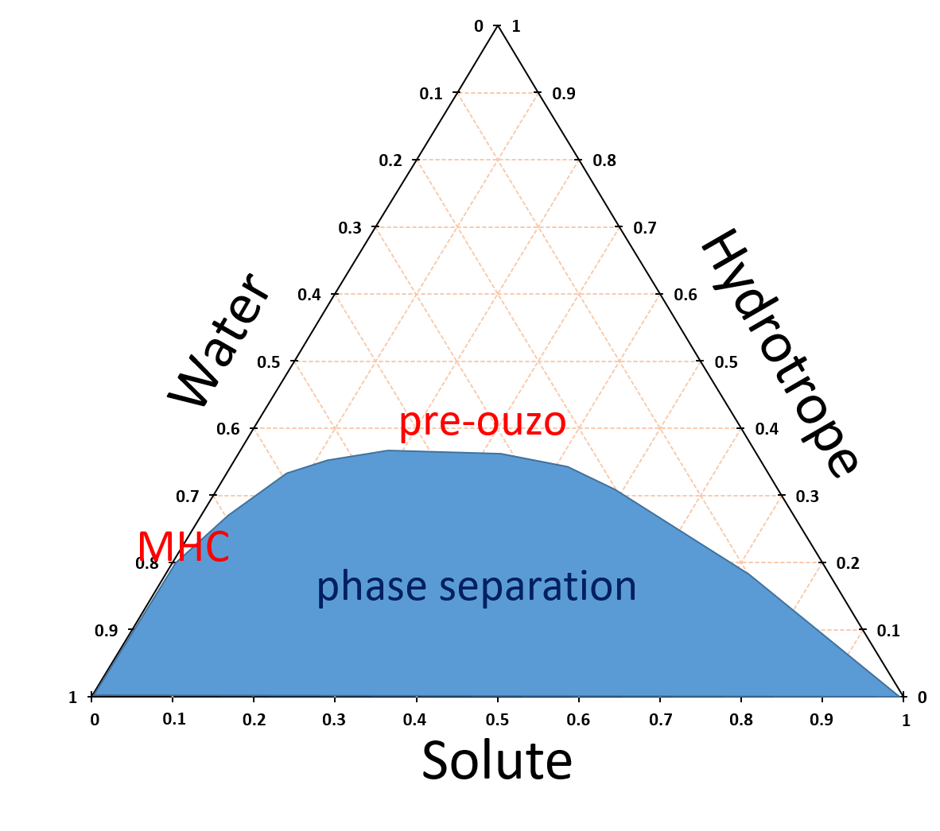
Figure 1. A schematic ternary phase diagram of water-hydrotrope-solute mixture, indicating the locations of MHC and pre-ouzo structuring.

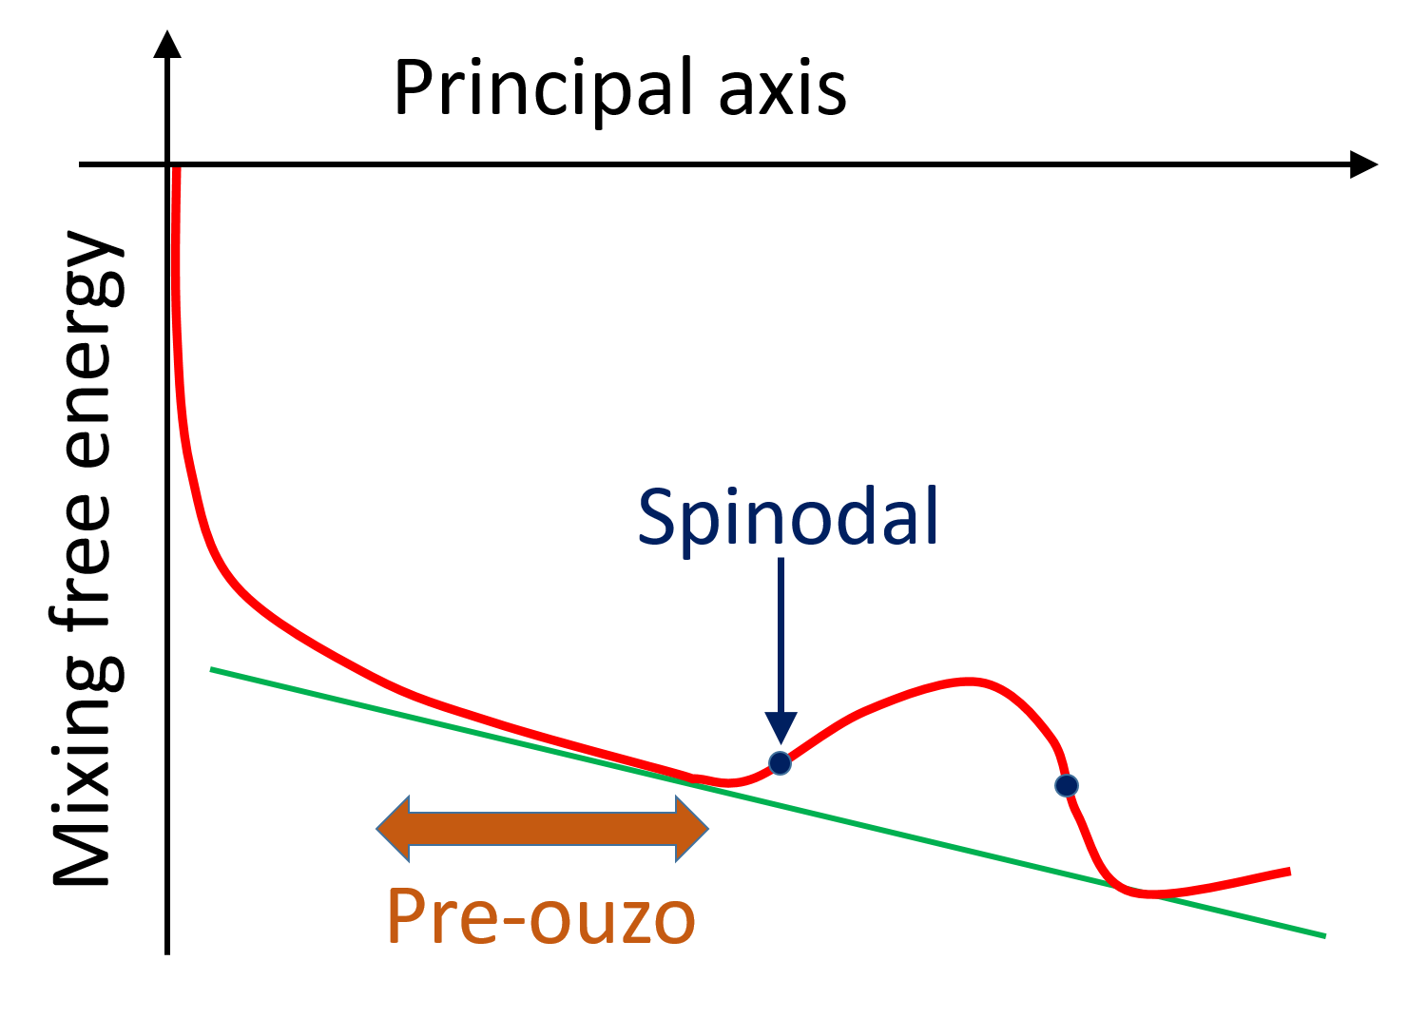
Figure 2. A schematic summary of experimental and theoretical insights on pre-ouzo solubilisation. A large scattering intensity corresponds via Eq. (7) to a small principal curvature of the free energy of mixing; such a region stretches widely on the way to the spinodal point. The green line refers to the free energy line corresponding to phase-separated state.

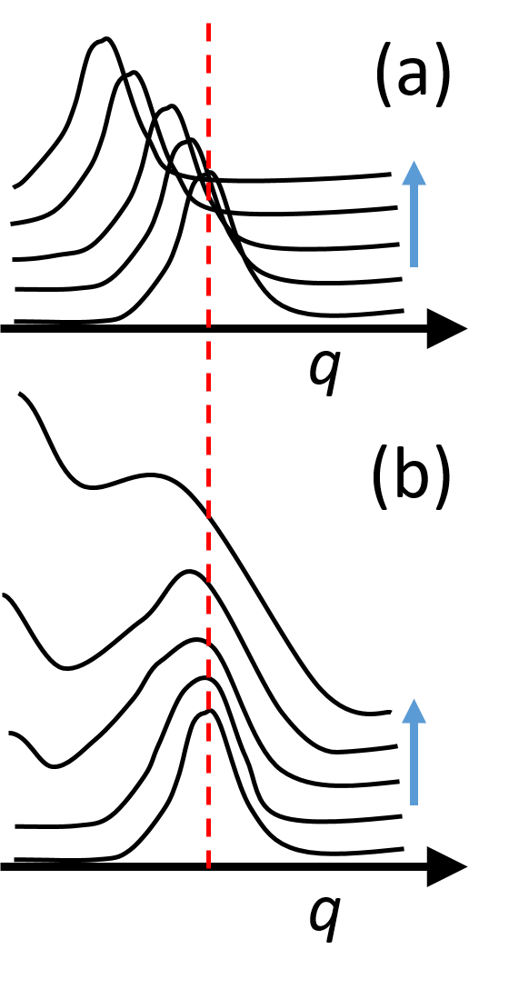
Figure 3. Two possible scenarios, represented schematically, of the transition from pre-ouzo towards spinodal (i.e., direction indicated by the blue arrow). (a) The peak of the structure factor shifts towards low $q$, which means that the structure corresponding to a certain length scale (red) disappears towards spinodal; (b) The growth of intensity at $q→0$ while the scattering at a certain length scale remains as the mixture approaches spinodal.

