Forty years of collaborative computational crystallography

Jon Agirre and Eleanor Dodson

York Structural Biology Laboratory, Department of Chemistry, The University of York, YO10 5DD, UK

Macromolecular crystallography is a technique which relies on a set of strict conventions driven by creative computational methodology. While most conventions have historically fallen under the International Union of Crystallography’s remit, piecemeal development of crystallographic software by geographically-scattered groups became the norm in the early seventies. The Collaborative Computational Project No. 4, best known as CCP4 (1), was established by the UK Science Research Council almost 40 years ago (1979) to address these problems. Collaboration within this initiative is not just a tag, but the true essence of the project. The new macromolecular crystallography (MX) groups being set up around the UK in the late seventies needed access to the full range of MX software to flourish. Strong methodological advances in phasing and refinement were being made at that time, but for these to permeate between laboratories, a dedicated compilation and distribution channel was needed. CCP4 filled that gap, collecting software from various groups in the crystallographic scene and supporting the whole structure solution process. Funds, limited at that time, were used to facilitate the following issues:

General distribution enforced certain standards
Computing hardware of different power and accessibility varied from laboratory to laboratory, so all programs were written in the most basic Fortran language - without the use of vendor-specific extensions. CCP4 was extremely lucky that its first professional appointment was half of Penelope Anne (Pella) Machin, a member of the Daresbury software team. Her partner, Mike Elder, was also an excellent crystallographer and programmer, not officially seconded to CCP4, but an excellent teacher for all the contributors. The Daresbury group took responsibility for distribution and ironing out inconsistencies at local installations.

Developers and users (often the same people!) needed to talk together
Without access to the Internet, a working group (WG2) met face to face every three months. Many bugs were fixed quickly at these meetings, and new projects initiated. The CCP4 Study Weekend was set up with the aim of bringing every practising MX researcher in Britain together to discuss some aspect of the discipline – the first meeting in Bristol in 1979 discussed anomalous phasing - and now this is a mind-expanding, non-partisan annual meeting that usually hosts ~400 structural biologists from all over the world (in very particular cases, students could apply for CCP4’s David Blow fellowships for travel support). Funds were always found to allow two speakers from the Americas, and two more from Europe to be invited. These gave a wonderful opportunity to exchange ideas with other developers, and for the user community to hear from experts of new ideas and procedures, and to be ready to test and criticise them. Let us not forget that, at that time, debuggers were real people and not computer programs.

Philosophy for software
Certain criteria for good practice were embraced - and we believe these are still crucial to successful software development. Software was to be comprehensive and exploitable by a multitude of related problems – e.g. the refinement pipeline comprising SFALL, PROTIN and PROLSQ was reworked to treat all non-centric space groups. It was to be freely available to all users. Licensing issues were lax or blissfully ignored.

Common formats were enforced for the three main crystallographic modules. Reflections and maps were stored in binary format; coordinates used the PDB atom listing convention (2), with the conversion matrix provided to calculate the fractional crystallographic coordinates. The data files all carried header information describing symmetry, history, data types, etc. - useful for many applications. As much common code as possible was provided in library routines - these saved programmers’ effort, but also were more reliable and error-free than many individual contributions, and also enforced conventions. Examples were: Fast Fourier Routines, popular thanks to audio engineering applications, symmetry functions, and mathematical routines, many of them pillaged from existing small molecule crystallographic programs.

The algorithms were fairly modular. Programs were available to process and scale data, to carry out the steps for experimental phasing, to do molecular replacement, to calculate maps and structure factors using modified FFTs, and to do restrained refinement by least-squares minimisation. All programs adopted a common keyworded parameter set – e.g. XYZIN for specifying a PDB file, or HKLOUT for reflection file output. This made it easy to use and connect the programs together.

A brief history of developments in the 1980s
This was a very exciting time for MX. The advent of synchrotrons meant that data quality and quantity took a quantum leap. The new PCR cloning techniques meant that engineered protein became available; so it was possible to study the effect of mutations, and to tinker with the underlying biochemistry. Suddenly, new doors opened and the discipline was renamed from macromolecular crystallography to Structural Biology. And alongside these developments, new improved algorithms appeared. Some of the ideas for these developments were cradled by the Study Weekends - the 1980 meeting, which discussed refinement, brought considerable excitement with the youthful Axel Brünger presenting XPLOR, and there were passionate exchanges on the value of restraints versus constraints. Experimental phasing was changed by the ideas of maximum likelihood. Molecular replacement became more powerful and automated with the use of the AmoRE package (3) and the increase in deposited structures at the PDB. The modular design of the CCP4 suite made it quite easy to supersede older methodology with the new. It also allowed for peaceful coexistence: programs tackling old problems will typically do it in a more sophisticated but complementary way (e.g. reliable maximum likelihood target functions instead of the older, but faster, Patterson-based targets used for molecular replacement).

Originally, the programming language of choice was Fortran, but without any of the extensions distributed by hardware vendors so that code would run on most machines. Gradually, the choice was widened to include C, C++ and more recently, Python and web technologies (HTML5, CSS, XML and JS). Also, there were no tight constraints on the choice of programming language or libraries - if it is freely distributable, then chances are it is already being distributed with the suite! - with many programs even adopting GNU GPL (4) or LGPL (5-7) licences.

More generous funding has revolutionised the initiative, bringing permanent professional support and dedicated core developers. The research council’s funding was increased to support five-year fellowships to address perceived needs: The first, awarded in 1998, was for Garib Murshudov, to develop the refinement program REFMAC (8); the next, in 2003 for Eugene Krissinel, to analyse protein assemblies, leading to the development of PISA (9); then in 2008, Paul Emsley was funded to continue work on Coot (4); and in 2013, a fellowship was awarded to Kevin Cowtan, the computational crystallographer stalwart now leading methods development at York Structural Biology Laboratory (University of York).

By the 1990s, the user community was changing. As structure solution became more routine multidisciplinary scientists who were not crystallographic experts realised structure could inform and guide their biological research. Consequently, CCP4’s user base changed to one which needed more guidance and quicker results. In response to this, development on a TCL/TK graphical user interface was started in 1997, led by Liz Potterton in York. The aim was to provide this user guidance on screen, and prepare tailored scripts to run the software for them, and secondly to include a database that would keep a record of the calculations and project history. The resulting program, named CCP4i (10), was taken up by the entire community. A few tasks were organised into rudimentary pipelines, and some others fed into computer graphics applications (FRODO and O (11; 12), third-party graphics programs developed by Alwyn Jones, Uppsala; and later, Coot (4), by Paul Emsley and Kevin Cowtan). Also, the interface presented many key results graphically, to some extent replacing the time-consuming need to scan wordy log files.

As structures were solved faster and in greater numbers, the community needed better tools for validation and analysis of these results. In 2001, Neil Isaacs, who was chairman of CCP4 WG1 at the time, initiated development of CCP4mg. Liz Potterton moved to this project, initially using TCL/TK and later with the pyQT multi-platform toolkit. In a parallel development, Paul Emsley and Kevin Cowtan worked on a map fitting toolkit based on the Clipper libraries (13), which evolved into the aforementioned Coot graphical model building tool.

An alternative software suite has been developed under the code name PHENIX (14). The PHENIX staff included a skilled small molecule crystallographer, Ralf Grosse-Kunstleve, who developed an extremely complete Computational Crystallography Toolbox - best known as cctbx – which is released under an open source license (15). Owing to its modular design, this toolkit has been also used and extended by CCP4 developers over the years.

The whole field now depends on visualisation - assessment of map and model quality, using indicators such as Ramachandran, B-factor or density correlation outliers is now done graphically in programs such as Coot (4) or CCP4i2 (16). We now look at graphs, maps or diagrams instead of studying tables in log files. This shift has made the programming environment much more complicated: the suite has had to scale up to include graphical and interfacing libraries such GTK, PyQT or Boost.Python, which are themselves very complex. Support for the multiple platforms has thus narrowed: it is extremely complicated to produce binaries for all combinations of hardware and operating systems - e.g. 32-bit GNU/Linux has been recently excluded after checking that the user base was not wide enough to warrant distribution. The CCP4i2 (16) and CCP4-online (https://www.ccp4.ac.uk/ccp4online) graphical user interfaces are an example of this increased complexity, with not just interfaces to many current CCP4 programs but to many third-party Python modules to build pipelines that can provide the expert guidance and synthesized graphical reports the community now demands. This new technology now aims not just to help automate tasks, but also to summarise crystallographic wisdom in informative reports which help reassure users of success, or highlight any problem areas which need further examination - e.g. data collection aberrations, crystal twinning, space group ambiguities. Also, the new clipper_python module (described in this special issue) has been introduced to boost functionality of pipelines. Perhaps the greatest exponent of these useful new tools is CRANK2 (17), a very complex pipeline that goes from data processing to model building and refinement, and works in both CCP4i2 and CCP4-online environments.

CCP4 has traditionally promoted the teaching of macromolecular crystallography, with a stable list of workshops happening around the world (Okinawa, Chicago, Montevideo, Diamond) and the aforementioned CCP4 Study Weekend (Figures 1 and 2). Also, forums have been created to enable not only developer discussions (the ccp4-dev mailing list), but exchanges between crystallography users. The CCP4 bulletin board (the ubiquitous ‘CCP4bb’) supports this kind of user-user and user-developer discussions, with the occasional, never-ending developer-developer exchange. Just like crystallography has evolved, so has the bulletin board, now routinely holding discussions about cell culture, protein purification or the combination of crystallography with other techniques such as electron cryo-microscopy. Users have always been in the driving seat, acting as source of excellent suggestions, which usually translate in improvements to the programs. Precisely these improvements are now transmitted more quickly than ever through a non-disruptive update mechanism (first requested at a WG1 meeting in 2006 at Leeds, and introduced with CCP4 6.3.0) that has seen more than 40 updates for the 7.0 series, which were originally released in January 2016.

Finally, CCP4 can only be grateful to generations of friendly competitors, who have over the years discussed, refuted or adopted many original CCP4 propositions, and taken some of them further along with their very many own ground-breaking contributions. And not just that - collaboration has happened and is happening between us, as exemplified by the DIALS project (a modular data integration framework, done in a joint effort between CCP4 and PHENIX developers) and Gemmi (a new macromolecular I/O library, funded by CCP4 and Global Phasing ltd.).

Moore’s law has allowed us to solve bigger and solve faster over the years, but only standing up, talking to people and collaborating have made the impossible possible. Those have been the ingredients for a recipe of collective success that has been cooked over the last 40 years.

References

1. Winn MD, Ballard CC, Cowtan KD, Dodson EJ, Emsley P, Evans PR, Keegan RM, Krissinel EB, Leslie AGW, McCoy A, McNicholas SJ, Murshudov GN, Pannu NS, Potterton EA, Powell HR, Read RJ, Vagin A, Wilson KS (2011) Overview of the CCP4 suite and current developments. Acta Crystallogr D 67:235-242.
2. Berman H, Henrick K, Nakamura H, Markley JL (2007) The worldwide Protein Data Bank (wwPDB): ensuring a single, uniform archive of PDB data. Nucleic acids research 35:D301-303.
3. Navaza J (2001) Implementation of molecular replacement in AMoRe. Acta Crystallogr D Biol Crystallogr 57:1367-1372.
4. Emsley P, Lohkamp B, Scott WG, Cowtan K (2010) Features and development of Coot. Acta Crystallogr D 66:486-501.
5. Cowtan K (2006) The Buccaneer software for automated model building. 1. Tracing protein chains. Acta Crystallogr D Biol Crystallogr 62:1002-1011.
6. Evans PR, Murshudov GN (2013) How good are my data and what is the resolution? Acta Crystallographica Section D 69:1204-1214.
7. Agirre J, Iglesias-Fernández J, Rovira C, Davies GJ, Wilson KS, Cowtan KD (2015) Privateer: software for the conformational validation of carbohydrate structures. Nat Struct Mol Biol 22:833-834.
8. Murshudov GN, Skubak P, Lebedev AA, Pannu NS, Steiner RA, Nicholls RA, Winn MD, Long F, Vagin AA (2011) REFMAC5 for the refinement of macromolecular crystal structures. Acta Crystallogr D 67:355-367.
9. Krissinel E, Henrick K (2007) Inference of macromolecular assemblies from crystalline state. Journal of molecular biology 372:774-797.
10. Potterton E, Briggs P, Turkenburg M, Dodson E (2003) A graphical user interface to the CCP4 program suite. Acta Crystallogr D Biol Crystallogr 59:1131-1137.
11. Jones TA (1978) A graphics model building and refinement system for macromolecules. Journal of Applied Crystallography 11:268-272.
12. Jones TA (1985) Diffraction methods for biological macromolecules. Interactive computer graphics: FRODO. Methods Enzymol 115:157-171.
13. Cowtan K (2003) The ClipperC++ libraries for X-ray crystallography. IUCr Computing Commission Newsletter 2:4-9.
14. Adams PD, Afonine PV, Bunkoczi G, Chen VB, Davis IW, Echols N, Headd JJ, Hung LW, Kapral GJ, Grosse-Kunstleve RW, McCoy AJ, Moriarty NW, Oeffner R, Read RJ, Richardson DC, Richardson JS, Terwilliger TC, Zwart PH (2010) PHENIX: a comprehensive Python-based system for macromolecular structure solution. Acta Crystallogr D Biol Crystallogr 66:213-221.
15. Grosse-Kunstleve RW, Sauter NK, Moriarty NW, Adams PD (2002) The Computational Crystallography Toolbox: crystallographic algorithms in a reusable software framework. Journal of Applied Crystallography 35:126-136.
16. Potterton E, Agirre J, Ballard CC, Cowtan K, Dodson E, Evans PE, Jenkins HT, Keegan R, Krissinel E, Stevenson K, Lebedev AA, McNicholas S, Nicholls A, Noble M, Pannu NS, Roth C, Sheldrick G, Skubak P, Turkenburg JP, Uski V, von Delft F, Waterman DG, Wilson K, Winn M, Wojdyr M (2018) CCP4i2 - the new graphical user interface to the CCP4 program suite. Acta Crystallogr D Struct Biol Proceedings of the CCP4 Study Weekend, under review.
17. Skubak P, Pannu NS (2013) Automatic protein structure solution from weak X-ray data. Nature Communications 4.
Figures
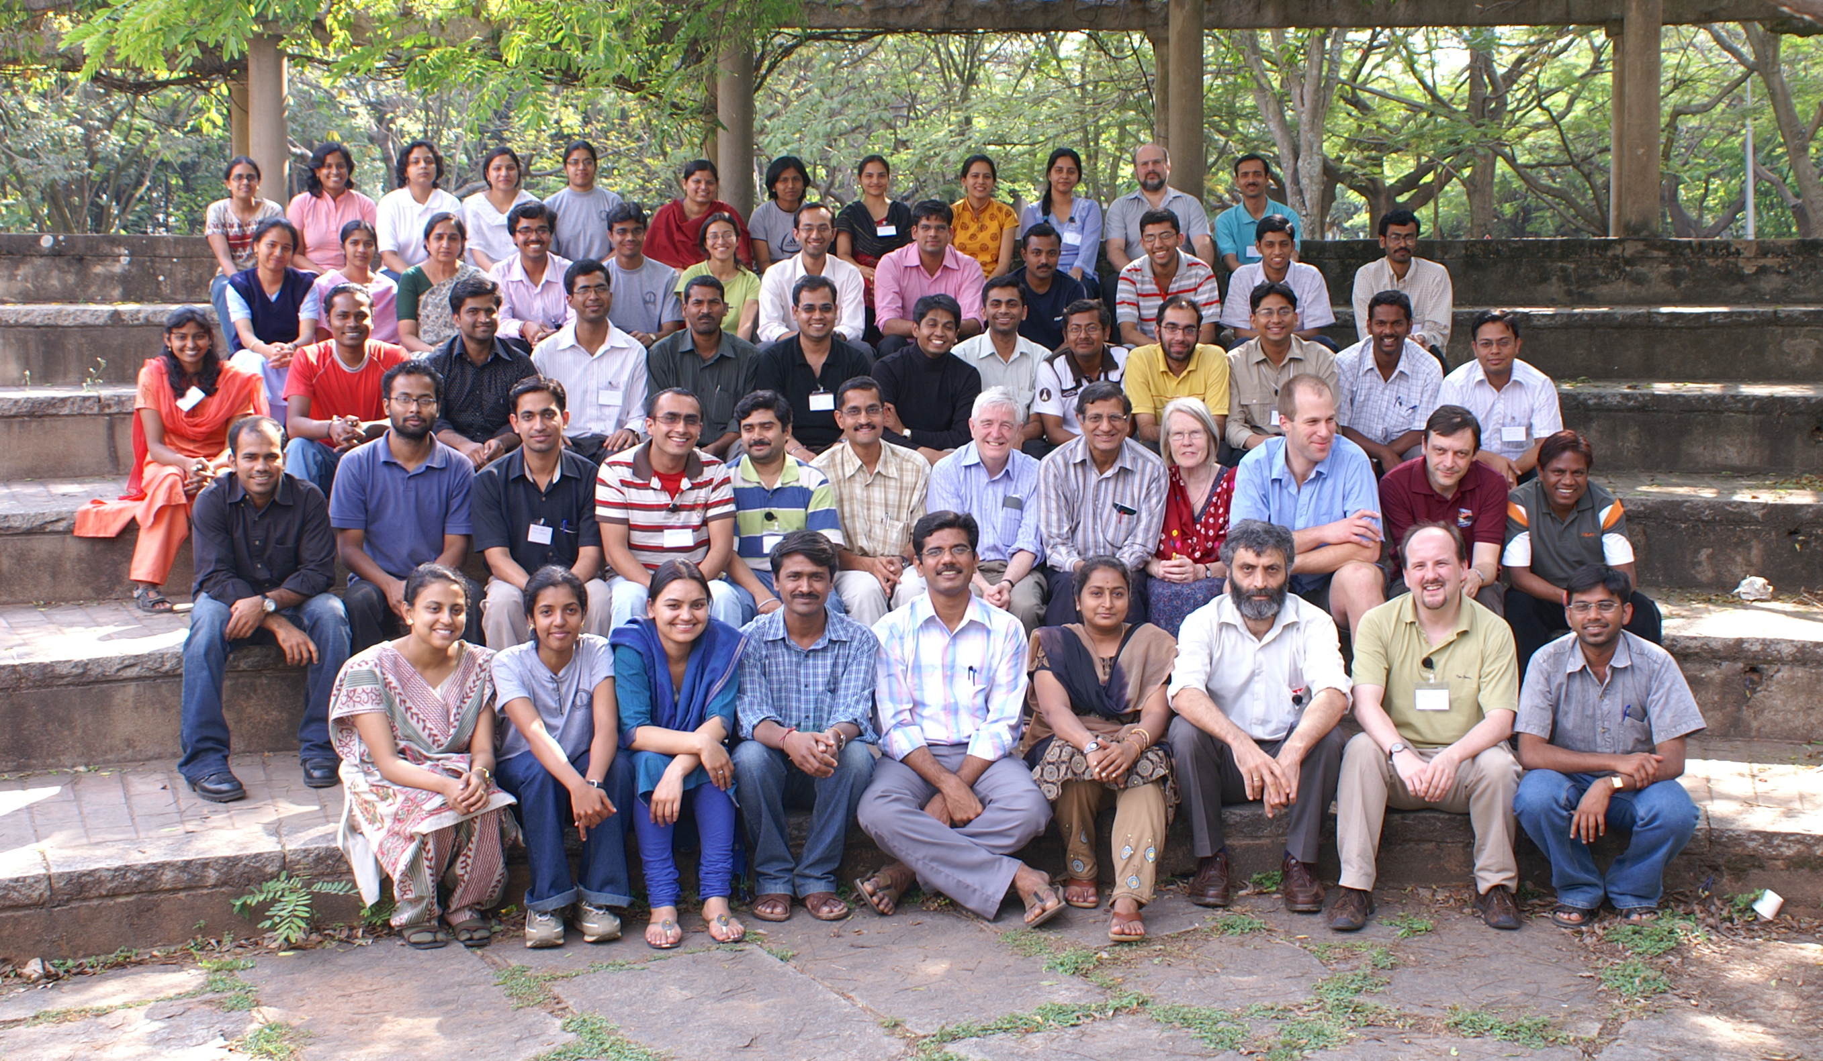
Figure 1. Photograph from a CCP4-organised workshop in Bangalore, India (March 2008). This event was funded by a UK Biotechnology and Biological Sciences Research Council (BBSRC) India Partnering Award, and made possible by the hard work of all the local organisers. Photo courtesy of Paul Emsley (MRC-LMB, Cambridge, UK).
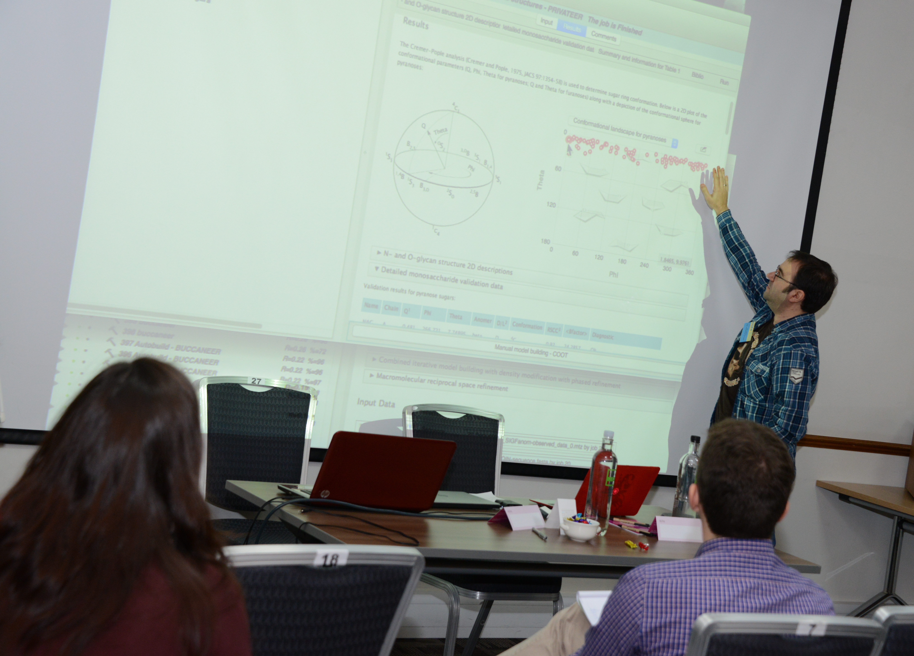
Figure 2. A lunchtime byte during a CCP4 Study Weekend. As their name indicates, these sessions take place during lunchtime breaks at the Study Weekends, and offer users the possibility to interact directly with developers, who usually demonstrate their software live at the session. In the picture, Jon Agirre (University of York, UK) describes the output of the Privateer (7) carbohydrate validation tool, which uses results from small molecule crystallography and theoretical chemistry to interrogate the output from macromolecular refinement of saccharides. Photograph used under permission from UK Science and Technology Facilities Council (STFC).

