Blame it on the bossa nova: transfer of perceived sexiness from music to touch

Thomas Hans Fritz* 1,2,3, Berit Brummerloh 1, Maria Urquijo 1, Katharina Wegner 1, Enrico Reimer 1, Sven Gutekunst 1, Lydia Schneider 1, Jonathan Smallwood 4, Arno Villringer 1
1 Max Planck Institute for Human Cognitive and Brain Sciences, Stephanstrasse 1A, 04103 Leipzig, Germany
2 Department of Nuclear Medicine University of Leipzig, Liebigstrasse 18, 04103 Leipzig, Germany
3 Institute for Psychoacoustics and Electronic Music (IPEM), Blandijnberg 2, B-9000 Ghent, Belgium
4 Department of Psychology / York Neuroimaging Centre, University of York, Hesslington, York, UK.
*Corresponding author, fritz@cbs.mpg.de, Max Planck Institute for Human Cognitive and Brain Sciences, Stephanstrasse 1A, 04103 Leipzig, Germany

Abstract

Emotion elicited through music transfers to subsequent processing of facial expressions. Music may accordingly function as a social technology by promoting social bonding. Here, we investigated whether music would cross-modally influence the perception of sensual touch, a behavior related to mating. A robot applied precisely controlled gentle touch to a group of healthy participants while they listened to music that varied with respect to its perceived sexiness. As the perceived sexiness of the music increased, so did the subjective sexiness of the touch stimulations. In short, the perception of sexiness transferred from music to touch. Because sensual touch is key to mating behavior and relates to procreation, this association has implications for the universality and evolutionary significance of music.
Keywords: Cross-modal transfer, touch, multisensory integration, music, esthetics, contagion, emotion, group behavior, crowd behavior, meaning, evolution, dance, intentional agency, theory of mind, courting behavior

Blame it on the bossanova: Transfer of perceived sexiness from music to touch
Music is prevalent in every culture, and it is safe to say that when applied correctly, music subjectively amplifies positive experiences in a crowd. How does music occupy such a central role in human culture? First, music is often perceived as pleasant and rewarding partly through an activation of the ventral striatum, suggesting an activation of the dopaminergic system (Menon & Levitin, 2005; Mueller et al., 2015; Salimpoor et al., 2013). Through a process of operant conditioning, this music-driven reward may reinforce ongoing aspects of behavior such as social interactions.
Second, such a modulating influence of music processing on social interactions seems to be supported by transfer effects to other psychological processes, even other modalities while listening to music, as demonstrated in an experiment where music-elicited emotion transferred to subsequent processing of facial expressions (Logeswaran & Bhattacharya, 2009). Music as a social technology can thus promote the perception of emotional group synchrony, which probably facilitates social bonds to form - a view that is further substantiated by a related finding, reporting cross-modal matches from music to emotionally expressive faces (Palmer, Schloss, Xu, & Prado-León, 2013). Note that the observed transfer effects of music to other domains also included other aspects of perception, such as cross-modal matches between music and colors (e.g., faster music in the major mode produced color choices that were more saturated, lighter, and yellower), and it was argued that such a transfer is mediated by emotional associations (Palmer et al., 2013). Music as a means of social bonding might be further promoted by an effect of “floating intentionality” (Cross, 2009), where music listeners generalize positive musical experience to goals they share with other individuals, thereby decreasing social uncertainty.
Third, an inherent aspect of music is that it allows many individuals to entrain to the same stimulus, such as when they dance together at a club, and it is probable that entrainment with others leads to an increase in social bonding and group cohesion (Hove & Risen, 2009; Huron, 2001; Kirschner & Tomasello, 2010; Merker, Madison, & Eckerdal, 2009).
Together, these lines of evidence suggest that a primary reason for the universality of music could be that it helps promote a sense of sociability, which is essential to many of the social situations central to the lives of our species. Here, we investigated a specific example of this general hypothesis by examining the relation between music and the subjective interpretation of touch. We aimed to identify whether the subjective sensation of tactile stimulation was modulated by the apparent sexiness of concurrently presented music. Tactile stimuli are among the most powerful to modulate bonding, so that, for example, in some societies physical contact is taboo when social bonding is to be avoided (Eibl-Eibesfeldt, 1989). This is probably related to a communicative quality of touch, for example with respect to emotional expression, where it parallels communicative strength in the visual (Vertegaal & van der Veer, 2000) and auditory (Carney, 1996) domains.
Cross-modal processing of music has been addressed before (see also the two examples in paragraph 2). For example, it has been hypothesized that dynamic procedures of touch have parallels with those of emotional musical expressions (Clynes & Nettheim, 1982), and it has been shown that music may even influence gustation to the extent that, in an experiment, the taste of the wine seemed to reflect the emotional connotations of background music participants listened to while they drank the wine (North, 2012).
In three experiments, we investigated transfer effects from music to touch and vice versa, asking participants to rate the apparent sensual nature of tactile stimulation or music. To precisely control for the quality of tactile stimulation, unbeknown to the participants, touch was administered by a robot in the first two experiments. In the third experiment, a robot also administered the touch stimulation, but the procedure was demonstrated to the participants before the experiment.

Experiment 1
Methods
Participants. The sample consisted of 18 participants who gave written informed consent (5 females, age range 23–34 years, mean age = 27.7 years). All participants had normal hearing as well as non-damaged haptic perception and were naïve to the purpose of the study.
Materials. Forty musical stimuli (see Supplementary Table 1) were presented during the experiment. Each excerpt was played for 20 s with a short fade (400 ms) at the beginning and end to avoid extreme signal on- and offset responses. The stimuli were instrumental music excerpts without lyrics pre-selected by the experimenters to include 20 rather sexy music pieces and 20 rather non-sexy music pieces that were matched with respect to instrumentation (furthermore, the participants assessed the sexiness of each musical piece during the experiment for themselves). The participants were unaware that there were two categories of music stimuli, presented in a pseudo-randomized order.
Haptic stimulation during the experiment was applied by a robot specifically designed for the experiment (see Figure 1). It featured a brush mounted on a spinning robotic arm. In default position, the brush was oriented vertically and could be switched to a horizontal position (touching the forearm of the participant) for defined time intervals (speed and strength of the brush movements were programmed to remain constant). Touch was measured from the first moment of contact with the brush to the last moment of contact. After automatically triggering the robot in the experiment, the brush would immediately turn and make contact with the skin, where it would sustain contact. The arm would promptly resume its original position after the stimulus duration. This procedure was independent from properties of the arm, such as height (i.e., the applied touch was physically similar for all participants). In Experiments 1 and 2, participants were allowed to look into the experimenter’s space, and the robot was not displayed during this period. To control for familiarity with the musical stimuli, in a post-experimental questionnaire, we assessed participants’ familiarity with the songs (“how well do you know this song?”) and specifically whether they had had any previous sexual associations with the songs (“how often have you listened to this song during sex?”). All answers were given using a Likert scale from one to five.

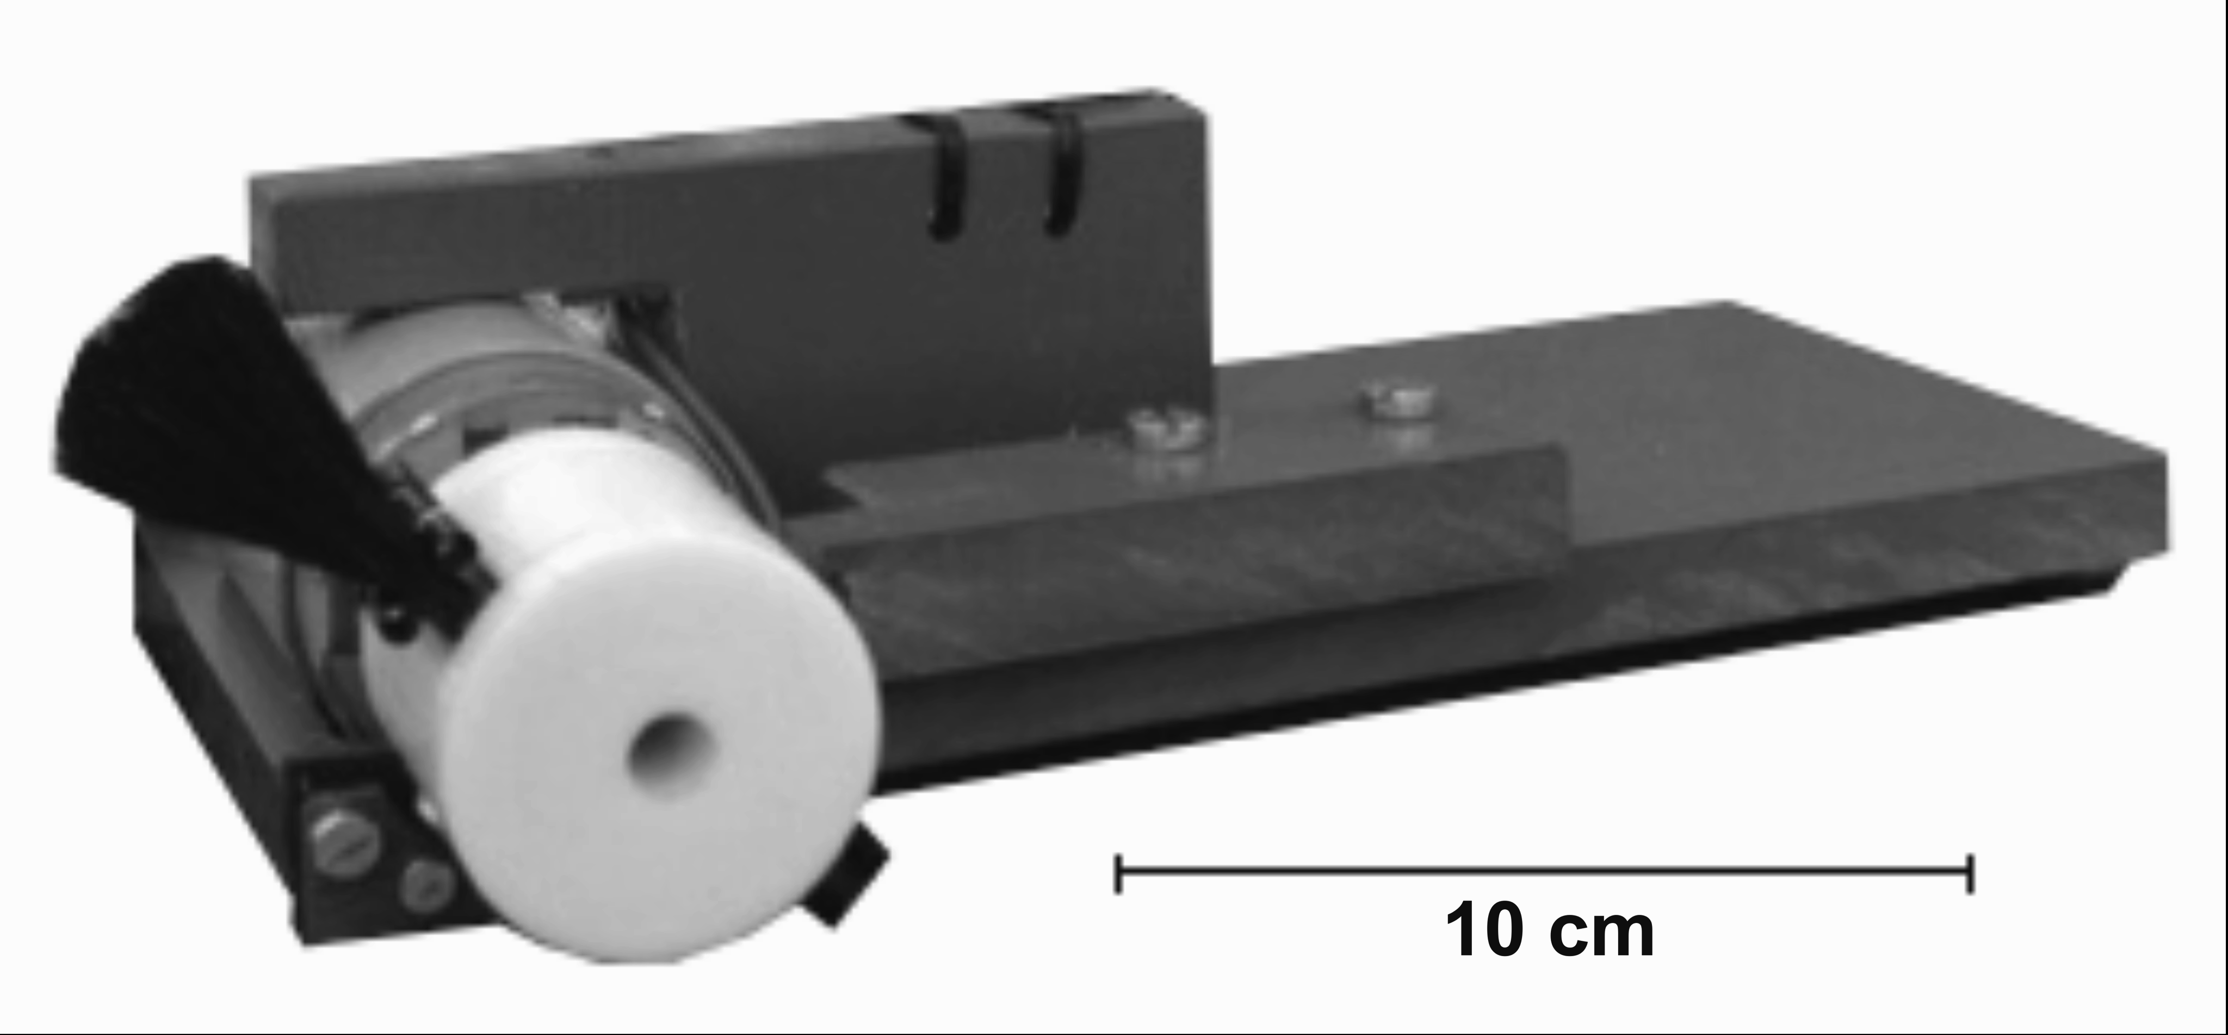
Figure 1. Robot with brush.

Procedure. After giving informed consent, participants were shown the experiment room (soundproof cabin) that was divided into two by a curtain. At the beginning of the procedure, the curtain was open so that participants could see both sides of the room, their space, and the experimenter’s space. In the experimenter’s space, several brushes were visible. The curtain was then closed and participants were asked to sit down and put their right arm (with the more sensitive underside up) through an opening in the curtain, which blocked their view to the experimenter’s space. They were given headphones and told that they would hear music, but were instructed to only focus on the touch applied to their forearm by the assistant (who they were told would also wear headphones and listen to the music). Whenever prompted on the computer monitor (at the end of each music piece), they had to rate with their left hand (because the right hand was behind the curtain) how sexy they perceived the touch to be on a scale from 1 to 10 (using 0 as 10) on the alphanumeric keyboard, where “1” corresponded to the answer “not sexy at all” and 10 to “very sexy”. The next song started as soon as a response was given.
Without the participant’s knowledge, the robot was placed perpendicular to their forearm. The robot’s touch was administered 10 seconds after the start of each musical piece and lasted for different durations (short: 400 ms, medium: 1200 ms or 2800 ms, and long: 4000 ms) that were counterbalanced across sexy and non-sexy songs. All participants received precisely the same pseudo-randomized sequence of songs and touch stimulations, such that the order of stimulation was identical between participants.
After experiment 1, the pieces of music were rated on a five-point scale with respect to how sexy each musical excerpt was perceived where “1” corresponded to the answer “not sexy at all” and 5 to “very sexy” (the excerpts were presented in the same sequence as during the experiment; the music sexiness-ratings were assessed with paper/pencil). Additionally, participants completed a post-experimental familiarity questionnaire (see Materials section above) where they could advance to the next song at their own pace, by pressing a button.
Results
A paired t-test of the mean sexiness ratings for the two categories of music excerpts (sexy or non-sexy) from Experiment 1 showed that, as a group, those stimuli chosen to represent "non-sexy" music actually had significantly higher sexiness ratings than the "sexy" music (t(19) = -3.534, p = .002; mean sexy music preselection: 2.472; SD sexy music preselection: 0.608; mean non-sexy music preselection: 3.080; SD non-sexy music preselection: 0.317), demonstrating that the experimenters’ pre-selection of music in sexy and non-sexy music was unsuccessful and that perception of sexiness of music varied substantially between participants. For an analysis of variances (ANOVA) addressing possible effects of touch duration and possible interaction effects of touch duration and music category (to test if participants indeed paid attention to qualities of touch), we created three music sexiness categories from the mean music ratings of participants in Experiment 1: non-sexy (smaller values than median), medium-sexy (median), and sexy (higher values than median). A 3 (sexiness of music) x 3 (duration of touch) repeated measures ANOVA with perceived sexiness of touch as dependent variable was performed (see Table 1 for means and SDs of perceived sexiness of touch). The assumption of sphericity was violated, as demonstrated by Mauchly’s test. As a consequence, the conservative Greenhouse-Geisser correction was employed. A main effect of the music sexiness category was significant (F(1.30, 12.98) = 12.50, p < 0.01, partial η² = .56). A main effect for duration of touch was observed (F(1.25, 12.54) = 12.61, p < 0.01, partial η² = .56). No interaction effect could be detected (F(1.945, 19.45) = 0.22, p = 0.80).

Table 1. Mean values of perceived sexiness of touch with rating-based sexiness of music category (N=non-sexy; M=medium-sexy; S=sexy), and touch duration (1=short, 2=medium, 3=long).

musicCat durationCat N MeanTouch SD
N 1 16 2.81 1.87
N 2 17 3.30 1.60
N 3 17 3.66 2.06
M 1 14 3.45 1.78
M 2 15 4.00 2.12
M 3 15 4.46 2.41
S 1 17 3.77 2.04
S 2 18 4.39 2.03
S 3 17 4.58 2.22

To test the hypothesis that the sexiness ratings of music would transfer to the sexiness ratings of the touch stimulation, we additionally calculated a regression analysis with sexiness ratings of touch and the sexiness ratings of music for each participant (see Figure 2). Subsequently, we tested the mean slope (β) for significance in a one-sample t-test, linking it to the null regression model. We found a positive relationship between the sexiness ratings of music and touch (β = 0.40, SD = .12, t(17) = 3.40, p < .01, mean R² = .20, SD = .15). The regression line is depicted in Fig. 2. The slope shows that when the perceived sexiness of the music increased, the perception of the sensual nature of touch also increased. A comparison of this cross-modal transfer between men and women did not yield any significant effects (β _{male} = 0.29; β _{female} = 0.43; t(16) = -0.80; p= .44).

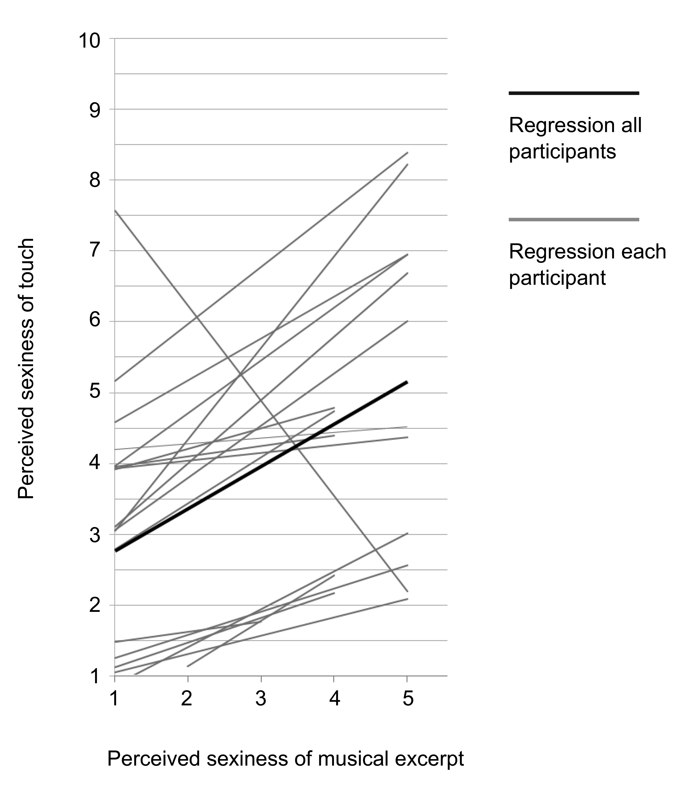
Figure 2. Experiment 1, individual regression slopes of the perceived sexiness of touch and perceived sexiness of the musical excerpts, and the mean regression slope for all participants (range of music sexiness ratings from 1–5). One individual showed a different rating behavior to the other participants.

Experiment 2
To assess a possible transfer in the opposite direction, from touch to music, we conducted Experiment 2 to explore whether individuals rated music as sexier when touched rather than when not.

Methods
Participants. We recruited 18 participants who did not participate in Experiment 1 and gave written informed consent (10 females, age range 21–40 years, mean age 26.9, SD = 4.9). All participants reported having normal hearing as well as non-damaged haptic perception and were naïve to the purpose of the study. One out of the 18 participants was excluded from the analysis because of missing values.

Procedure. The stimulation was identical to Experiment 1, but participants were asked to rate the sexiness of the music pieces instead of the sexiness of the touch experience. The musical sequence was presented twice, once with touch stimulation and once without (it was controlled for order of presentation, so that half the participants first rated the musical pieces with touch stimulation and the other half first rated the music without touch stimulation).

Results
To test whether sexiness ratings of perceived music differ when being concurrently touched, we compared the sexiness ratings of all music excerpts (regardless of being classified as sexy or non-sexy) with and without tactile stimulation. To achieve this aim, we calculated a paired samples t-test investigating the main effect of touch in which a participant mean sexiness rating for all songs played during touch was compared to a participant mean sexiness rating for all songs played without being touched. The main effect of touch was not significant (t(16) = 0.421, p = .68) in this analysis, and accordingly we did not observe an effect of touch modulating the percept of the music.

Experiment 3
To test whether intentional agency (an aspect of theory of mind) plays a crucial role in the perceived transfer of sexiness from music to touch, we conducted Experiment 3. As opposed to making participants believe that the experimenter would administer the touch stimulation, we showed participants the robot at the beginning of the experiment, and the experimenter then left the experiment booth.

Methods
Participants. We recruited 18 participants (9 females), whose age ranged between 20 and 36 years (M= 26.28, SD= 4.36) and who did not participate in the previous experiments. Participants gave informed consent and reported having normal hearing, as well as non-damaged haptic perception. They were naïve to the purpose of the study.

Stimuli and Procedure. The same materials and procedure were used as in Experiment 1, except that the source of haptic stimulation (robot) was shown to the participant at the beginning of the experiment, and the participant was left alone in the room throughout the experiment. After the experiment participants rated the sexiness of the musical stimuli on a 10-point scale, where “1” corresponded to the answer “not at all sexy” and 10 to “very sexy” (the excerpts were presented in the same sequence as during the experiment; the music sexiness-ratings were entered electronically (computer keyboard), which was an alteration of the pencil/paper rating procedure using a 5-point scale in Experiment 1).

Results
Similar to Experiment 1, for an ANOVA addressing possible effects of touch duration and possible interaction effects of touch duration and music category (to test if participants indeed paid attention to qualities of touch), we created three music sexiness categories from the mean music excerpts ratings of participants in Experiment 3: non-sexy (smaller values than median), medium-sexy (median), and sexy (higher values than median). A 3 (sexiness of music) x 3 (duration of touch) repeated measures ANOVA with perceived sexiness of touch as dependent variable was performed (see Table 2 for means and SDs of perceived sexiness of touch). As the assumption of sphericity was violated, the Greenhouse-Geisser correction was applied. A main effect of music sexiness category was significant (F(1.26, 12.63) = 18.40, p < 0.01, partial η² = .65). A main effect for duration of touch was observed (F(1.14, 11.38) = 10.00, p < 0.01, partial η² = .50). No interaction effect could be detected (F(1.90, 18.97) = 1.59, p = 0.23). The absence of interaction effects in experiment 1 and 3 show that duration of touch indeed had an effect on the perceived sexiness of touch, but not on the perceived sexiness of music, while perceived sexiness of touch and perceived sexiness of music were significantly related (see Table 3 for means and SDs of perceived sexiness of music).

Table 2. Mean values of perceived sexiness of touch with sexiness of music category (N=non-sexy; M=medium-sexy; S=sexy), and touch duration (1=short, 2=medium, 3=long).

musicCat durationCat N MeanTouch SD
N 1 17 2.31 1.31
N 2 17 3.08 1.22
N 3 17 3.24 1.74
M 1 14 2.69 1.03
M 2 14 3.44 1.45
M 3 15 4.39 1.97
S 1 18 3.59 1.89
S 2 18 4.29 1.54
S 3 17 5.25 1.59

Table 3. Mean values of perceived sexiness of music in Experiment 1 and 3 subject to touch duration (1=short, 2=medium, 3=long).
MeanMusic SD durationCat
2.64 (Exp1) | 3.69 (Exp2) 1.22 (Exp1) | 2.02 (Exp3) 1
2.85 (Exp1) | 3.83 (Exp2) 1.18 (Exp1) | 2.32 (Exp3) 2
2.75 (Exp1) | 3.82 (Exp2) 1.24 (Exp1) | 2.31 (Exp3) 3

As in the analysis of experiment 1, we additionally calculated a linear regression of sexiness rating of touch on the sexiness rating of music for each participant (see Figure 3) and tested the significance of the mean slope using a one-sample t-test. On average, the touch sexiness rating significantly increased with a slope of β = 0.60 (SD = 0.28) as the sexiness of music increased (t(17) = 9.03, p < .001, mean R² = .30, SD = .21). This increase did not differ to the one observed in Experiment 1, where participants believed that the experimenter applied the touch (t(17) = 1.28, p = .22).

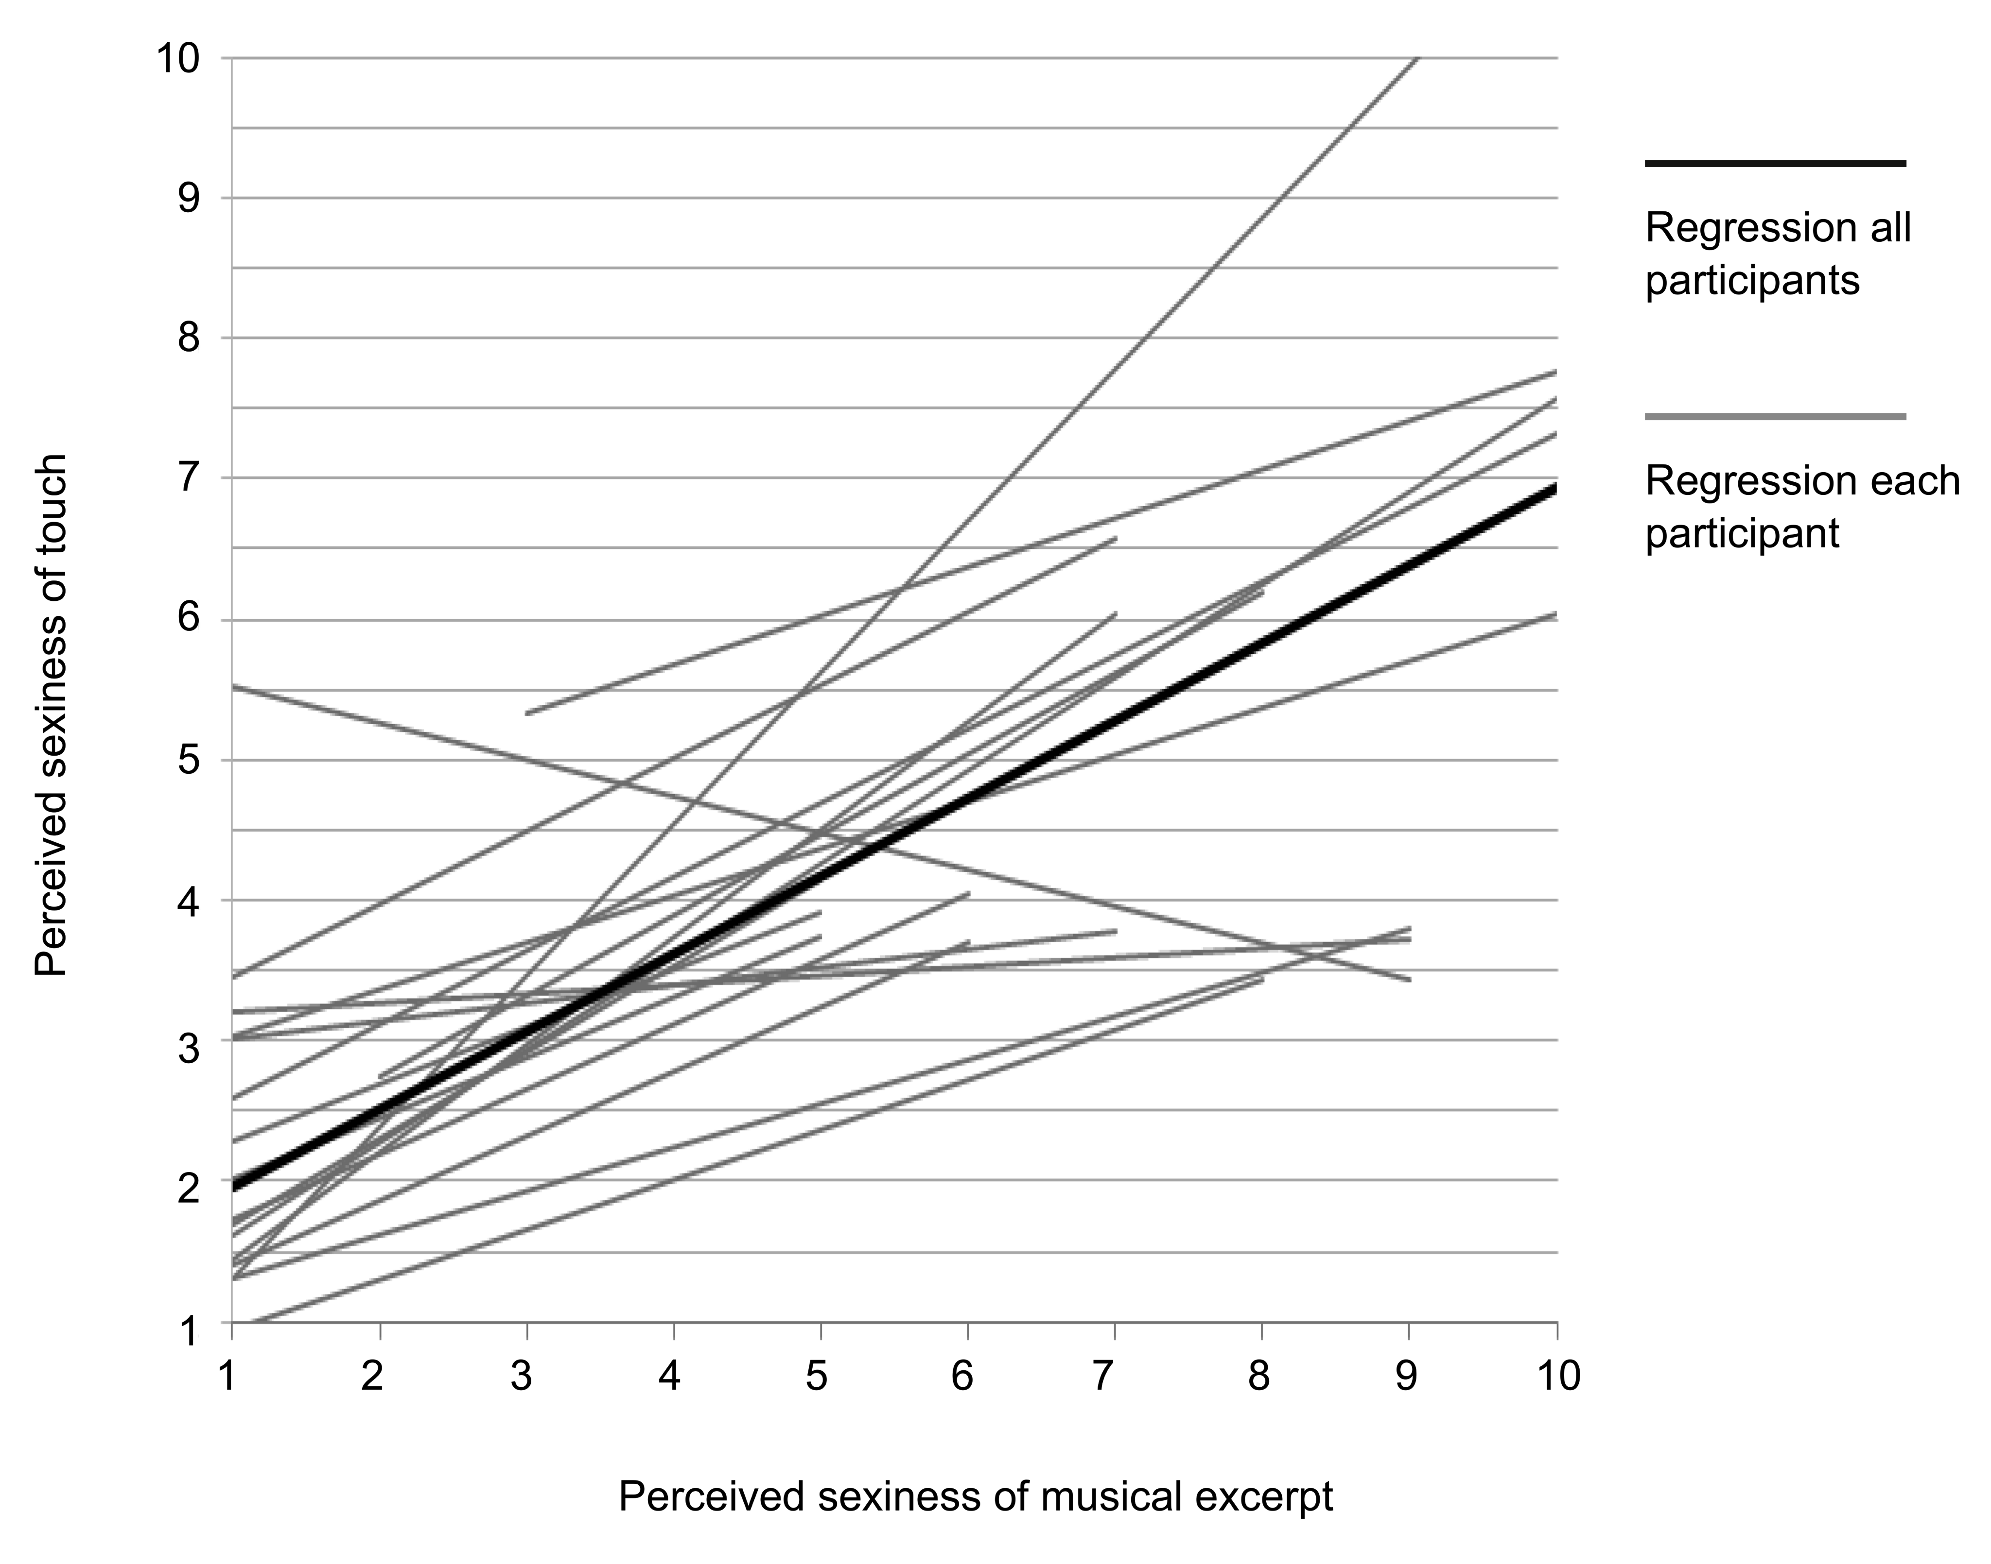
Figure 3. Experiment 3, individual regression slopes of the perceived sexiness of touch and the perceived sexiness of the musical excerpts, and the mean regression slope for all participants (range of music sexiness ratings from 1–10). One individual showed a different rating behavior to the other participants.

General Discussion
This study set out to examine the hypothesis that a primary reason for the prevalence of music in human society is the value that it brings for promoting social bonds. In the current study, we explored a specific example of this hypothesis by testing whether the apparent sensual nature of touch is enhanced by the presentation of music with a sexy nature. We developed a procedure in which touch was administered by a robot, a procedure that guaranteed that the parameters of stimulation were precisely controlled. We found that participants did rate the experience of touch as more sensual when it was presented in the context of music that was rated as sexier, and this occurred regardless of whether they believed the touch was administered by a human or a robot. In a subsequent experiment, we observed that there was no transfer from being touched to how sexy music excerpts were perceived.
Since social attributions depend upon the process of intentional agency (Amodio & Frith, 2006), we anticipated that this might provide the mechanism mediating the observed transfer from music to touch. The results of Experiment 3, however, demonstrate that the sexiness of the music transferred to the haptic sense, even when participants knew a robot administered the touch. Moreover, the use of the robotic apparatus to elicit sensual touch rules out the possibility that the observed transfer of sexiness from music to touch could have occurred as a result of a motor entrainment process between humans (which, for example, could happen during dance). Instead, our data can be simply accounted for by the assumption that emotional significance of music, in terms of its subjectively perceived sensual nature, impacts on a basic perceptual level. Considering sensual touch is a gateway to procreation, our results suggest that features of this type of music can transfer to a quality of social behavior that is evolutionarily highly relevant. While the results from Experiment 2 rather suggest that being touched did not modulate the assessed sensual quality of the music excerpts, it is important to note that in the current experiment we did not systematically vary the sensual quality of touch and therefore cannot exclude the possibility of a transfer of perceived sexiness from touch to music (and consequently a sexiness-feedback-loop between music and touch).
The musical excerpts were chosen with the aim of creating a variation in how much individuals perceived them as sexy and non-sexy. While this was effective at the level of the individuals in that songs were perceived to vary along the sexiness dimension, the categorization in sexy and non-sexy songs across participants as originally intended by the experimenters was not confirmed. Instead, individual assessments varied substantially in how sexy/non-sexy specific excerpts were perceived. This is irrelevant to the current finding of a transfer of perceived sexiness from music to touch, because we correlate sexiness-ratings of each individual for each excerpt with the touch percept during each trial. However, it does create an interesting perspective on the current data: Music listeners, for example during dancing, would only perceive a transfer of perceived sexiness from music to touch if they had a common qualitative assessment of the perceived music in terms of sensual quality. This would suggest that a joint experience of music as a tool to facilitate procreation would relate to commonalties in musical assessment and taste that probably also depend on shared (sub-) cultural experience (and would therefore probably not always apply cross-culturally or even across sub-cultures).
To control whether participants had indeed paid attention to perceived variations of touch and not solely to the music, we analyzed an influence of objective variations of the touch stimulation: touch duration. Analyses from Experiments 1 and 3 showed that touch duration had an influence on perceived sexiness of touch, such that longer touch durations were perceived as more sexy (see Tables 1 and 2), demonstrating that participants were indeed paying attention to perceived qualities of touch. That touch duration had an influence on perceived sexiness of touch (such that a longer touch duration would be perceived as more sexy) also shows that participants did not simply cling to previous ratings associated with a certain music piece. This is interesting to note because the sexiness of touch ratings during the experiment and the post-experimental sexiness ratings of the music excerpts are thus not simply due to efforts made on the part of participants to be consistent with their judgments of sexiness across ratings. If there were such a consistency effect then duration of touch during the experiment (which has been shown to correlate with perceived sexiness of touch) should also correlate with perceived sexiness of the music in the post-experimental assessment of the music. However, results demonstrate that this is not the case (see Table 3).

One individual in Experiment 1 and one individual in Experiment 3 showed a different rating behavior to the other participants. Although these two participants, who probably misunderstood the direction of the rating scale, were included in the analysis, the results show a robust positive relationship between the sexiness ratings of music and touch. A limitation of the current study is that the basic ability of the robotic apparatus to simulate sensual touch was not investigated. For example, it did not include a condition where the sexiness of touch was rated in the absence of music. Furthermore, it would have been advantageous to keep rating scales the same in Experiments 1 and 3, instead they differed in range and method of assessment: In Experiment 1 a scale from 1–5 with pencil/paper was used, and in Experiment 3 a scale from 1–10 was used with a computer keyboard as the input device. Also, we did not address the influence of participant/experimenter sex combinations on the perception of touch in its entire scope, because we did not assess homosexuality in the participants. Attitudes toward hetero/homosexual contact could have influenced participant comfort with the procedure and hence the ratings (e.g., some participants might have felt more comfortable being touched by the machine in Experiment 3 than by a human in Experiment 1).

In conclusion, the current data suggest that music with a sexual overtone directly enhances the perception of touch as a sensual experience, a basic predecessor for almost all forms of sexual behavior. We also show that the observed transfer from music to touch is readily attributed to basic sensation and does not seem to be modulated by knowledge about agency. This enhances our understanding of the prevalence of music across cultures with respect to its role in forming social bonds. Notably, the role of music in forming social bonds is not limited to behaviors directly related to reproduction: Producing music is also a communal activity. It therefore seems likely that the sense of camaraderie that such a joint activity brings is another way that music can facilitate feelings of affiliation.

Author Note: Data from Experiment 1 were presented to a panel on music as communication at the Society of Ethnomusicology Annual Meeting, Washington D.C., 2016. None of the data have been posted on a listserv, shared on a website, or otherwise published.

References

Amodio, D. M., & Frith, C. D. (2006). Meeting of minds: the medial frontal cortex and social cognition. Nature Reviews Neuroscience, 7(4), 268-277.
Carney, A. E. (1996). Audition and the development of oral communication competency. Amplification for children with auditory deficits, 29-53.
Clynes, M., & Nettheim, N. (1982). The living quality of music Music, mind, and brain (pp. 47-82): Springer.
Cross, I. (2009). The evolutionary nature of musical meaning. Musicae Scientiae, 13(2 suppl), 179-200.
Eibl-Eibesfeldt. (1989). HumanEthology. NewYork: Aldine de Gruyter.
Hove, M. J., & Risen, J. L. (2009). It’s all in the timing: Interpersonal synchrony increases affiliation. Social Cognition, 27(6), 949-961.
Huron, D. (2001). Is Music an Evolutionary Adaptation? Annals of the New York Academy of Sciences, 930(1), 43-61.
Kirschner, S., & Tomasello, M. (2010). Joint music making promotes prosocial behavior in 4-year-old children. Evolution and Human Behavior, 31(5), 354-364.
Logeswaran, N., & Bhattacharya, J. (2009). Crossmodal transfer of emotion by music. Neuroscience Letters, 455(2), 129-133.
Menon, V., & Levitin, D. J. (2005). The rewards of music listening: Response and physiological connectivity of the mesolimbic system. Neuroimage, 28(1), 175-184.
Merker, B., Madison, G., & Eckerdal, P. (2009). On the role and origin of isochrony in human rhythmic entrainment. Cortex, 45(1), 4-17.
Mueller, K., Fritz, T., Mildner, T., Richter, M., Schulze, K., Lepsien, J., . . . Möller, H. E. (2015). Investigating the dynamics of the brain response to music: A central role of the ventral striatum/nucleus accumbens. Neuroimage, 116, 68-79.
North, A. C. (2012). The effect of background music on the taste of wine. British Journal of Psychology, 103(3), 293-301.
Palmer, S. E., Schloss, K. B., Xu, Z., & Prado-León, L. R. (2013). Music–color associations are mediated by emotion. Proceedings of the National Academy of Sciences, 110(22), 8836-8841.
Salimpoor, V. N., van den Bosch, I., Kovacevic, N., McIntosh, A. R., Dagher, A., & Zatorre, R. J. (2013). Interactions Between the Nucleus Accumbens and Auditory Cortices Predict Music Reward Value. Science, 340(6129), 216-219.
Vertegaal, R., & van der Veer, G. (2000). Effects of Gaze on Multiparty Mediated Communication. Graphics Interface, 95-102.

