SUPPLEMENTARY INFORMATION

TITLE: Rescue therapy within the UK Cystic Fibrosis Registry: An exploration of predictors of intravenous antibiotic use amongst adults with CF

Authors’ full names: Zhe Hui Hoo^{1,2}, Martin James Wildman^{2,1}, Rachael Curley^{2,1}, Stephen John Walters¹, Michael Joseph Campbell¹

Authors’ affiliation(s):
¹ School of Health and Related Research (ScHARR), University of Sheffield, Sheffield, UK
² Sheffield Adult CF Centre, Northern General Hospital, Sheffield, UK

Appendix S1 The relationships between age, BMI, % FEV1 & prior-year IV days with current year IV days for 2013 and 2014

Appendix S2 A contingency table showing the distribution of covariates according to current year IV days

Appendix S3 Sensitivity analyses using number of IV courses (instead of IV days) as the dependent variable in a logistic regression model and using ordinal regression models to explore different cut-offs for IV courses & IV days

Table S3.1 Summary of the output from the final binary logistic regression model which include all nine covariates listed

Table S3.2 Summary of the output from the ordinal logistic regression model which include all nine covariates listed

Table S3.3 Summary of the output from the ordinal logistic regression model which include all nine covariates listed

Appendix S4 Sensitivity analyses using number of IV courses (instead of IV days) and different cut-offs to generate the clinical subgroups

Figure S4.1 Tree-based diagram for 2013 to summarise current year IV days according to the different clinical subgroups using two categories of prior-year IV courses (≤ 1 course vs ≥ 2 courses)

Figure S4.2 Tree-based diagram for 2013 to summarise current year IV days according to the different clinical subgroups using four categories of prior-year IV courses (no IV, 1 course, 2-3 courses, ≥ 4 courses)

Figure S4.3 Tree-based diagram for 2013 to summarise current year IV days according to the different clinical subgroups using four categories of prior-year IV days (no IV, 1-17 days, 18-42 days, ≥ 43 days)

Figure S4.4 Tree-based diagram for 2014 to summarise current year IV days according to the different clinical subgroups using two categories of prior-year IV courses (≤ 1 course vs ≥ 2 courses)

Figure S4.5 Tree-based diagram for 2014 to summarise current year IV days according to the different clinical subgroups using four categories of prior-year IV courses (no IV, 1 course, 2-3 courses, ≥ 4 courses)

Figure S4.6 Tree-based diagram for 2014 to summarise current year IV days according to the different clinical subgroups using four categories of prior-year IV days (no IV, 1-17 days, 18-42 days, ≥ 43 days)

Appendix S1: The relationships between age, BMI, % FEV₁ & prior-year IV days with current year IV days for 2013 and 2014

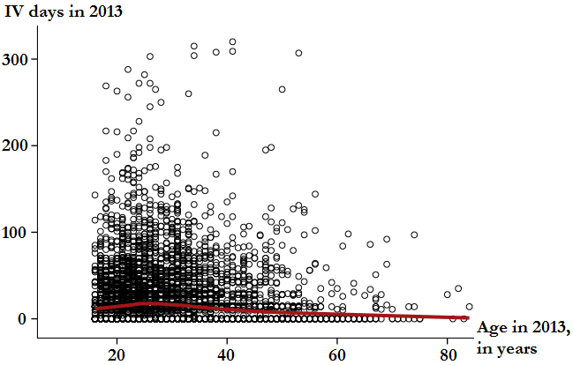
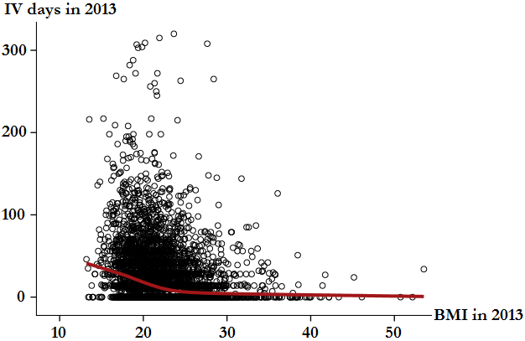
Scatter plot of IV days in 2013 vs age Scatter plot of IV days in 2013 vs BMI

Current year IV days showed no clear relationship with age Current year IV days was negatively correlated with BMI

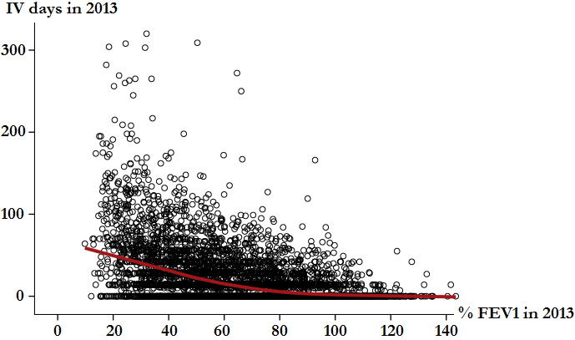
Scatter plot of IV days in 2013 vs % FEV₁ Scatter plot of IV days in 2013 vs IV days in 2012
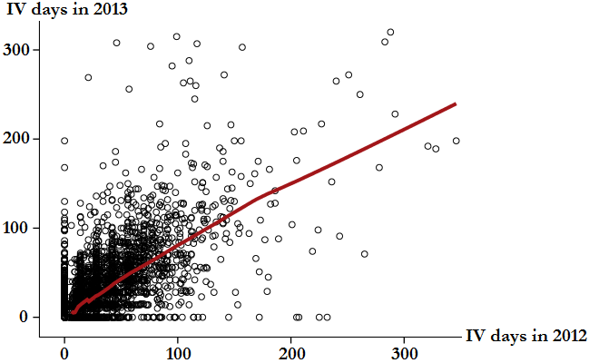

Current year IV days was negatively correlated with % FEV₁ Current year IV days was positively correlated with prior-year IV days

Scatter plot of IV days in 2014 vs age Scatter plot of IV days in 2014 vs BMI
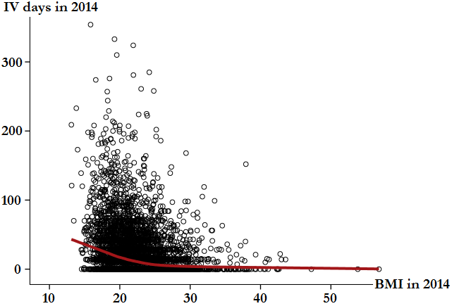
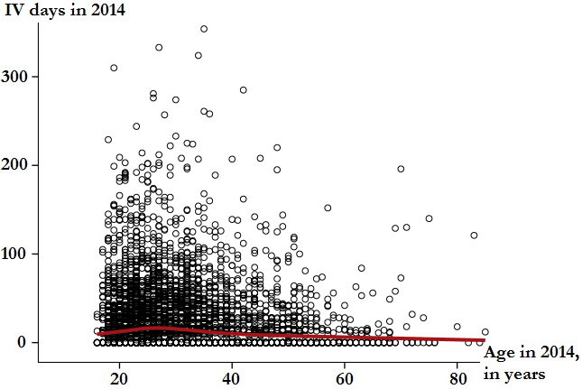

Current year IV days showed no clear relationship with age Current year IV days was negatively correlated with BMI

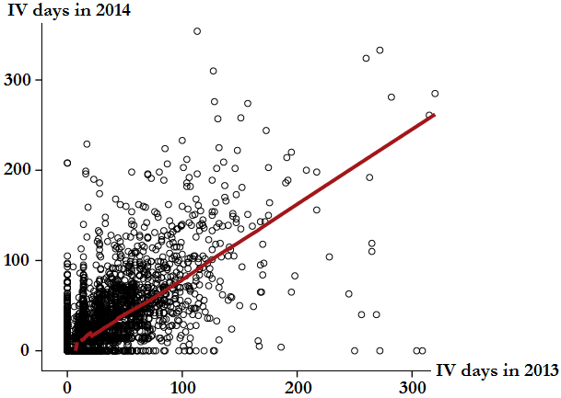
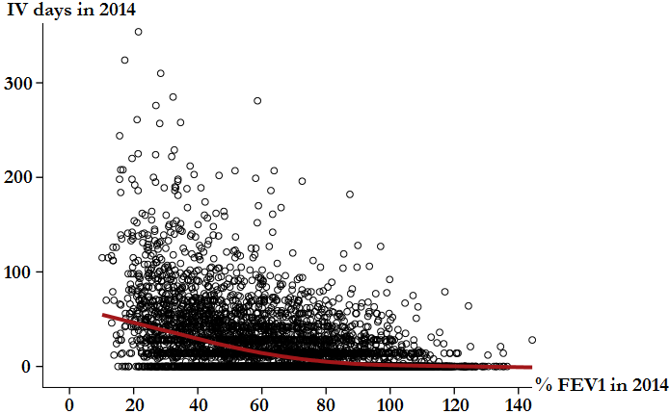
Scatter plot of IV days in 2014 vs % FEV₁ Scatter plot of IV days in 2014 vs IV days in 2013

Current year IV days was negatively correlated with % FEV₁ Current year IV days was positively correlated with prior-year IV days

*The Local Polynomial Regression (LOESS) curve is a non-parametric method for fitting smooth curves to empirical data, to depict relationships between variables. For reference, see:
Cleveland WS, Devlin SJ. Locally weighted regression: an approach to regression analysis by local fitting. J Am Stat Assoc 1988; 83: 596–610.
Appendix S2: A contingency table showing the distribution of covariates according to current year IV days

Demographics and clinical characteristics (covariates): | 2013 |  | 2014
 | Current year IV days ≤ 14  N = 2542 | Current year IV days > 14  N = 1722 | Current year IV days ≤ 14  N = 2772 | Current year IV days > 14  N = 1872
Age in years, median (IQR)  Female, %  Pancreatic insufficient, %  CF related diabetes, %  P. aeruginosa status  Chronic P. aeruginosa, %  Intermittent P. aeruginosa, %  BMI in kg/m², median (IQR)  % predicted FEV1, median (IQR)  Prior-year IV days, median (IQR) | 28 (22 – 37)  1043 (41.0%)  1889 (75.7%)  562 (22.1%)  1065 (41.9%)  364 (14.3%)  22.8 (20.7 – 25.3)  75.0 (56.7 – 90.6)  0 (0 – 14) | 27 (22 – 33)  891 (51.7%)  1558 (91.9%)  793 (46.1%)  1211 (70.3%)  212 (12.3%)  21.1 (19.1 – 23.3)  49.1 (34.7 – 66.8)  37 (15 – 60) | 28 (22 – 37)  1123 (40.5%)  2045 (74.7%)  654 (23.6%)  1049 (37.8%)  455 (16.4%)  22.8 (20.7 – 25.3)  76.3 (58.3 – 91.8)  0 (0 – 14) | 28 (23 – 34)  973 (52.0%)  1711 (91.9%)  871 (46.5%)  1291 (69.0%)  234 (12.5%)  21.2 (19.1 – 23.4)  49.7 (35.1 – 66.8)  35 (14 – 59)

Appendix S3: Sensitivity analyses using number of IV courses (instead of IV days) as the dependent variable in a logistic regression model and using ordinal regression models to explore different cut-offs for IV courses & IV days

Sensitivity analysis 1: using number of IV courses in a stepwise logistic regression model
Using number of IV courses in the current year (≤1 course vs ≥2 courses) as the dependent variable in a stepwise binary logistic regression model as described in the ‘Methods’, prior-year IV use was the strongest predictor for current year IV use followed by FEV₁ for both 2013 and 2014. The final model is summarised in Table S3.1. These results show that prior-year IV use and FEV₁ were the most robust predictors for current year IV use. The results were not influenced by considering cumulative IV exposure (as IV days) or the number of IV courses as the outcome.

Table S3.1: Summary of the output from the final binary logistic regression model which include all nine covariates listed
2013 (3843 study subjects included in the analysis) |  |  |  | 2014 (4040 study subjects included in the analysis)
Covariates: | Wald statistic | P-value | Adjusted odds ratio  (95% CI) | Covariates: | Wald statistic | P-value | Adjusted odds ratio  (95% CI)
Prior-year IV days  % predicted FEV1  CF centre  Age in years  Chronic P. aeruginosa  Female  CF related diabetes  Pancreatic insufficient | 437.6  136.4  107.4  20.2  23.4  21.8  10.1  8.4 | < 0.001  < 0.001  < 0.001  < 0.001  < 0.001  < 0.001  0.001  0.004 | 1.05 (1.05 – 1.06)  0.97 (0.97 – 0.98)  0.98 (0.97 – 0.99)  1.61 (1.33 – 1.95)  1.54 (1.28 – 1.84)  1.37 (1.13 – 1.67)  1.57 (1.16 – 2.13) | Prior-year IV days  % predicted FEV1  Chronic P. aeruginosa  CF centre  Female  Pancreatic insufficient  BMI in kg/m²  Intermittent P. aeruginosa  CF related diabetes | 441.3  132.7  34.9  89.6  28.9  12.7  10.4  5.2  4.4 | < 0.001  < 0.001  < 0.001  < 0.001  < 0.001  < 0.001  0.001  0.023  0.035 | 1.05 (1.05 – 1.06)  0.98 (0.97 – 0.98)  1.90 (1.54 – 2.35)  1.62 (1.36 – 1.93)  1.69 (1.27 – 2.26)  0.96 (0.93 – 0.98)  1.39 (1.05 – 1.85)  1.23 (1.01 – 1.48)

Sensitivity analysis 2: using four categories of IV courses in an ordinal regression model
Using number of IV courses in the current year (no IV, 1 course, 2-3 courses, ≥4 courses) as the dependent variable in an ordinal logistic regression model with the same co-variates as described in the ‘Methods’, prior-year IV use remained the strongest predictor for current year IV use followed by FEV₁ for both 2013 and 2014. The final model is summarised in Table S3.2. These show the results are robust regardless of the cut-off points used.

Table S3.2: Summary of the output from the ordinal logistic regression model which include all nine covariates listed
2013 (3843 study subjects included in the analysis) |  |  |  | 2014 (4040 study subjects included in the analysis)
Covariates: | Wald statistic | P-value | Adjusted odds ratio  (95% CI) | Covariates: | Wald statistic | P-value | Adjusted odds ratio  (95% CI)
Prior-year IV days  % predicted FEV1  Chronic P. aeruginosa  Female  Age in years  CF related diabetes  Pancreatic insufficient  Intermittent P. aeruginosa  BMI in kg/m²  Centre 23 (vs Centre 28)*  Centre 15 (vs Centre 28)*  Centre 2 (vs Centre 28)*  Centre 11 (vs Centre 28)*  Centre 1 (vs Centre 28)* | 735.2  240.7  49.6  33.8  25.8  13.4  8.8  7.4  4.3  5.4  4.9  4.7  4.1  3.9 | < 0.001  < 0.001  < 0.001  < 0.001  < 0.001  < 0.001  0.003  0.007  0.039  0.020  0.026  0.031  0.043  0.049 | 1.05 (1.05 – 1.06)  0.97 (0.97 – 0.98)  1.79 (1.52 – 2.11)  1.49 (1.30 – 1.71)  0.98 (0.97 – 0.99)  1.32 (1.14 – 1.53)  1.39 (1.12 – 1.72)  1.36 (1.09 – 1.71)  0.98 (0.97 – 0.99)  2.92 (1.18 – 7.24)  2.74 (1.13 – 6.67)  2.94 (1.11 – 7.81)  0.28 (0.08 – 0.96)  2.68 (1.00 – 7.16) | Prior-year IV days  % predicted FEV1  Chronic P. aeruginosa  Female  Pancreatic insufficient  Intermittent P. aeruginosa  Age in years  BMI in kg/m²  CF related diabetes  Centre 6 (vs Centre 28)*  Centre 20 (vs Centre 28)*  Centre 9 (vs Centre 28)*  Centre 5 (vs Centre 28)* | 719.1  230.2  80.8  58.6  22.2  16.1  12.4  11.8  3.6  5.3  4.7  4.5  4.0 | < 0.001  < 0.001  < 0.001  < 0.001  < 0.001  < 0.001  < 0.001  0.001  0.057  0.021  0.030  0.033  0.045 | 1.05 (1.05 – 1.06)  0.97 (0.97 – 0.98)  2.05 (1.75 – 2.40)  1.67 (1.46 – 1.90)  1.66 (1.34 – 2.04)  1.53 (1.24 – 1.88)  0.99 (0.98 – 0.99)  0.97 (0.95 – 0.99)  1.15 (1.00 – 1.33)  0.40 (0.18 – 0.87)  0.41 (0.17 – 0.91)  0.40 (0.18 – 0.93)  0.41 (0.47 – 0.98)
* Unlike a logistic regression model, the ordinal regression model is unable to determine the overall effect of CF centres on IV use. Therefore, 27 centres were compared against centre 28. Only centres with IV use that are significantly different from Centre 28 are shown in table C2.
Sensitivity analysis 3: using four categories of IV days in an ordinal regression model
Using current year IV days (no IV, 1-17 days, 18-42 days, ≥43 days) as the dependent variable in an ordinal logistic regression model with the same co-variates as described in the ‘Methods’ also yielded similar results. The final model is summarised in Table S3.3. These show the results with IV days are robust regardless of the cut-off points used.

Table S3.3: Summary of the output from the ordinal logistic regression model which include all nine covariates listed
2013 (3843 study subjects included in the analysis) |  |  |  | 2014 (4040 study subjects included in the analysis)
Covariates: | Wald statistic | P-value | Adjusted odds ratio  (95% CI) | Covariates: | Wald statistic | P-value | Adjusted odds ratio  (95% CI)
Prior-year IV days  % predicted FEV1  Chronic P. aeruginosa  Female  Age in years  CF related diabetes  Pancreatic insufficient  Intermittent P. aeruginosa  BMI in kg/m²  Centre 23 (vs Centre 28)*  Centre 11 (vs Centre 28)* | 784.9  228.8  51.2  27.6  21.7  14.3  7.7  6.5  4.4  4.7  4.5 | < 0.001  < 0.001  < 0.001  < 0.001  < 0.001  < 0.001  0.006  0.011  0.036  0.031  0.034 | 1.05 (1.05 – 1.06)  0.97 (0.97 – 0.98)  1.82 (1.54 – 2.14)  1.44 (1.26 – 1.65)  0.98 (0.98 – 0.99)  1.34 (1.15 – 1.56)  1.36 (1.10 – 1.69)  1.34 (1.07 – 1.68)  0.98 (0.98 – 0.99)  2.73 (1.10 – 6.80)  0.26 (0.08 – 0.90) | Prior-year IV days  % predicted FEV1  Chronic P. aeruginosa  Female  Pancreatic insufficient  Intermittent P. aeruginosa  BMI in kg/m²  Age in years  CF related diabetes | 780.5  224.9  70.3  40.1  23.2  13.8  9.5  6.7  2.9 | < 0.001  < 0.001  < 0.001  < 0.001  < 0.001  < 0.001  0.002  0.009  0.087 | 1.05 (1.05 – 1.06)  0.97 (0.97 – 0.98)  1.96 (1.68 – 2.30)  1.53 (1.34 – 1.75)  1.68 (1.36 – 2.08)  1.49 (1.21 – 1.83)  0.97 (0.95 – 0.99)  0.99 (0.98 – 1.00)  1.14 (0.98 – 1.32)
* Unlike a logistic regression model, the ordinal regression model is unable to determine the overall effect of CF centres on IV use. Therefore, 27 centres were compared against centre 28. Only centres with IV use that are significantly different from Centre 28 are shown in table C3. In 2014, none of other adult CF centres differed significantly from Centre 28 in terms of IV days.

Appendix S4: Sensitivity analyses using number of IV courses (instead of IV days) and different cut-offs to generate the clinical subgroups

Figure S4.1: Tree-based diagram for 2013 to summarise current year IV days according to the different clinical subgroups using two categories of prior-year IV courses (≤ 1 course vs ≥ 2 courses)

Adults with CF in 2013

n = 4269

Median IV days in 2013 = 14 (IQR 0 – 35 days)

Jonckheere-Terpstra p-value for these three subgroups <0.001
Jonckheere-Terpstra p-value for these three subgroups <0.001
Mann-Whitney p-value for these two groups <0.001
FEV₁ < 40%

n = 490

Median IV days in 2013
= 62

(IQR
36 – 98 days)
FEV₁ 40-69.9%

n = 634

Median IV days in 2013
= 40

(IQR
18 – 58 days)
FEV₁ ≥ 70%

n = 280

Median IV days in 2013
= 28

(IQR
14 – 42 days)
FEV₁ < 40%

n = 263

Median IV days in 2013
= 14

(IQR
0 – 30 days)
FEV₁ 40-69.9%

n = 856

Median IV days in 2013
= 5

(IQR
0 – 15 days)
FEV₁ ≥ 70%

n = 1385

Median IV days in 2013
= 0

(IQR
0 – 9 days)
Prior-year (i.e. 2012) ≥ 2 IV courses

n = 1477

Median IV days in 2013 = 42 (IQR 23 – 70 days)
Prior-year (i.e. 2012) ≤ 1 IV course

n = 2594

Median IV days in 2013 = 0 (IQR 0 – 14 days)

Figure S4.2: Tree-based diagram for 2013 to summarise current year IV days according to the different clinical subgroups using four categories of prior-year IV courses (no IV, 1 course, 2-3 courses, ≥ 4 courses)

Adults with CF in 2013

n = 4264

Median IV days in 2013 = 14 (IQR 0 – 35 days)

Jonckheere-Terpstra
p-value for these four groups <0.001
Prior-year (i.e. 2012) ≥4 IV courses n = 618

Median IV days in 2013 = 67 (IQR 42 – 98 days)
Prior-year (i.e. 2012) 2-3 IV courses n = 859

Median IV days in 2013 = 28 (IQR 14 – 48 days)
Prior-year (i.e. 2012) 1 IV course n = 806

Median IV days in 2013 = 14 (IQR 0 – 27 days)
Prior-year (i.e. 2012) no IV
n = 1788

Median IV days in 2013 = 0
(IQR 0 – 8 days)

FEV₁
< 40%

n = 275

Median IV days in 2013
= 80

(IQR
56 – 118 days)
Jonckheere-Terpstra p-value for these three subgroups <0.001

FEV₁
≥ 70%

n = 64

Median IV days in 2013
= 34

(IQR
14 – 61 days)
FEV₁ 40-69.9%

n = 238

Median IV days in 2013
= 56

(IQR
40 – 83 days)
FEV₁ 40-69.9%

n = 396

Median IV days in 2013
= 28

(IQR
14 – 43 days)
Jonckheere-Terpstra p-value for these three subgroups <0.001

FEV₁
≥ 70%

n = 216

Median IV days in 2013
= 28

(IQR
12 – 40 days)

FEV₁
< 40%

n = 215

Median IV days in 2013
= 42

(IQR
25 – 63 days)
FEV₁ 40-69.9%

n = 339

Median IV days in 2013
= 14

(IQR
0 – 28 days)
Jonckheere-Terpstra p-value for these three subgroups <0.001

FEV₁
≥ 70%

n = 324

Median IV days in 2013
= 11

(IQR
0 – 17 days)

FEV₁
< 40%

n = 120

Median IV days in 2013
= 15

(IQR
10 – 45 days)
Jonckheere-Terpstra p-value for these three subgroups <0.001
FEV₁ 40-69.9%

n = 517

Median IV days in 2013
= 0

(IQR
0 – 14 days)

FEV₁
< 40%

n = 143

Median IV days in 2013
= 4

(IQR
0 – 27 days)
FEV₁
≥ 70%

n = 1061

Median IV days in 2013
= 0

(IQR
0 – 0 days)
Figure S4.3: Tree-based diagram for 2013 to summarise current year IV days according to the different clinical subgroups using four categories of prior-year IV days (no IV, 1-17 days, 18-42 days, ≥ 43 days)

Adults with CF in 2013

n = 4264

Median IV days in 2013 = 14 (IQR 0 – 35 days)

Jonckheere-Terpstra
p-value for these four groups <0.001
Prior-year (i.e. 2012) ≥43 IV days n = 743

Median IV days in 2013 = 60 (IQR 38 – 93 days)
Prior-year (i.e. 2012) 18-42 IV days n = 791

Median IV days in 2013 = 28 (IQR 14 – 44 days)
Prior-year (i.e. 2012) 1-17 IV days n = 749

Median IV days in 2013 = 14 (IQR 0 – 24 days)
Prior-year (i.e. 2012) no IV
n = 1788

Median IV days in 2013 = 0
(IQR 0 – 8 days)

FEV₁
< 40%

n = 317

Median IV days in 2013
= 77

(IQR
51 – 115 days)
Jonckheere-Terpstra p-value for these three subgroups <0.001

FEV₁
≥ 70%

n = 82

Median IV days in 2013
= 30

(IQR
14 – 56 days)
FEV₁ 40-69.9%

n = 298

Median IV days in 2013
= 55

(IQR
35 – 79 days)
FEV₁ 40-69.9%

n = 369

Median IV days in 2013
= 28

(IQR
14 – 42 days)
Jonckheere-Terpstra p-value for these three subgroups <0.001

FEV₁
≥ 70%

n = 204

Median IV days in 2013
= 28

(IQR
13 – 41 days)

FEV₁
< 40%

n = 190

Median IV days in 2013
= 42

(IQR
21 – 60 days)
FEV₁ 40-69.9%

n = 306

Median IV days in 2013
= 14

(IQR
0 – 28 days)
Jonckheere-Terpstra p-value for these three subgroups <0.001

FEV₁
≥ 70%

n = 318

Median IV days in 2013
= 11

(IQR
0 – 16 days)

FEV₁
< 40%

n = 103

Median IV days in 2013
= 14

(IQR
10 – 35 days)
Jonckheere-Terpstra p-value for these three subgroups <0.001
FEV₁ 40-69.9%

n = 517

Median IV days in 2013
= 0

(IQR
0 – 14 days)

FEV₁
< 40%

n = 143

Median IV days in 2013
= 4

(IQR
0 – 27 days)
FEV₁
≥ 70%

n = 1061

Median IV days in 2013
= 0

(IQR
0 – 0 days)
Figure S4.4: Tree-based diagram for 2014 to summarise current year IV days according to the different clinical subgroups using two categories of prior-year IV courses (≤ 1 course vs ≥ 2 courses)
Adults with CF in 2014

n = 4644

Median IV days in 2014 = 14 (IQR 0 – 34 days)

Jonckheere-Terpstra p-value for these three subgroups <0.001
Jonckheere-Terpstra p-value for these three subgroups <0.001
Mann-Whitney p-value for these two groups <0.001
FEV₁ < 40%

n = 494

Median IV days in 2014
= 56

(IQR
30 – 91 days)
FEV₁ 40-69.9%

n = 630

Median IV days in 2014
= 40

(IQR
20 – 60 days)
FEV₁ ≥ 70%

n = 298

Median IV days in 2014
= 28

(IQR
14 – 43 days)
FEV₁ < 40%

n = 270

Median IV days in 2014
= 14

(IQR
0 – 37 days)
FEV₁ 40-69.9%

n = 911

Median IV days in 2014
= 8

(IQR
0 – 17 days)
FEV₁ ≥ 70%

n = 1485

Median IV days in 2014
= 0

(IQR
0 – 9 days)
Prior-year (i.e. 2013) ≥ 2 IV courses

n = 1501

Median IV days in 2014 = 42 (IQR 21 – 69 days)
Prior-year (i.e. 2013) ≤ 1 IV course

n = 2760

Median IV days in 2014 = 0 (IQR 0 – 14 days)

Figure S4.5: Tree-based diagram for 2014 to summarise current year IV days according to the different clinical subgroups using four categories of prior-year IV courses (no IV, 1 course, 2-3 courses, ≥ 4 courses)
Adults with CF in 2014

n = 4644

Median IV days in 2014 = 14 (IQR 0 – 34 days)

Jonckheere-Terpstra
p-value for these four groups <0.001
Prior-year (i.e. 2013) ≥4 IV courses n = 588

Median IV days in 2014 = 66 (IQR 42 – 98 days)
Prior-year (i.e. 2013) 2-3 IV courses n = 913

Median IV days in 2014 = 28 (IQR 14 – 49 days)
Prior-year (i.e. 2013) 1 IV course n = 902

Median IV days in 2014 = 14 (IQR 0 – 28 days)
Prior-year (i.e. 2013) no IV
n = 1858

Median IV days in 2014 = 0
(IQR 0 – 8 days)

FEV₁
< 40%

n = 263

Median IV days in 2014
= 73

(IQR
51 – 112 days)
Jonckheere-Terpstra p-value for these three subgroups <0.001

FEV₁
≥ 70%

n = 59

Median IV days in 2014
= 43

(IQR
28 – 58 days)
FEV₁ 40-69.9%

n = 217

Median IV days in 2014
= 56

(IQR
37 – 75 days)
FEV₁ 40-69.9%

n = 413

Median IV days in 2014
= 28

(IQR
14 – 49 days)
Jonckheere-Terpstra p-value for these three subgroups <0.001

FEV₁
≥ 70%

n = 239

Median IV days in 2014
= 21

(IQR
11 – 41 days)

FEV₁
< 40%

n = 231

Median IV days in 2014
= 37

(IQR
20 – 61 days)
FEV₁ 40-69.9%

n = 387

Median IV days in 2014
= 14

(IQR
0 – 28 days)
Jonckheere-Terpstra p-value for these three subgroups <0.001

FEV₁
≥ 70%

n = 349

Median IV days in 2014
= 10

(IQR
0 – 15 days)

FEV₁
< 40%

n = 137

Median IV days in 2014
= 26

(IQR
14 – 42 days)
Jonckheere-Terpstra p-value for these three subgroups <0.001
FEV₁ 40-69.9%

n = 524

Median IV days in 2014
= 0

(IQR
0 – 14 days)

FEV₁
< 40%

n = 133

Median IV days in 2014
= 11

(IQR
0 – 28 days)
FEV₁
≥ 70%

n = 1136

Median IV days in 2014
= 0

(IQR
0 – 0 days)
Figure S4.6: Tree-based diagram for 2014 to summarise current year IV days according to the different clinical subgroups using four categories of prior-year IV days (no IV, 1-17 days, 18-42 days, ≥ 43 days)
Adults with CF in 2014

n = 4644

Median IV days in 2014 = 14 (IQR 0 – 34 days)

Jonckheere-Terpstra
p-value for these four groups <0.001
Prior-year (i.e. 2013) ≥43 IV days n = 770

Median IV days in 2014 = 60 (IQR 40 – 92 days)
Prior-year (i.e. 2013) 18-42 IV days n = 791

Median IV days in 2014 = 28 (IQR 14 – 42 days)
Prior-year (i.e. 2013) 1-17 IV days n = 842

Median IV days in 2014 = 14 (IQR 0 – 28 days)
Prior-year (i.e. 2013) no IV
n = 1858

Median IV days in 2014 = 0
(IQR 0 – 8 days)

FEV₁
< 40%

n = 325

Median IV days in 2014
= 70

(IQR
47 – 107 days)
Jonckheere-Terpstra p-value for these three subgroups <0.001

FEV₁
≥ 70%

n = 85

Median IV days in 2014
= 43

(IQR
28 – 61 days)
FEV₁ 40-69.9%

n = 302

Median IV days in 2014
= 52

(IQR
29 – 72 days)
FEV₁ 40-69.9%

n = 359

Median IV days in 2014
= 28

(IQR
14 – 42 days)
Jonckheere-Terpstra p-value for these three subgroups <0.001

FEV₁
≥ 70%

n = 230

Median IV days in 2014
= 16

(IQR
8 – 35 days)

FEV₁
< 40%

n = 182

Median IV days in 2014
= 33

(IQR
21 – 56 days)
FEV₁ 40-69.9%

n = 356

Median IV days in 2014
= 14

(IQR
0 – 28 days)
Jonckheere-Terpstra p-value for these three subgroups <0.001

FEV₁
≥ 70%

n = 332

Median IV days in 2014
= 10

(IQR
0 – 15 days)

FEV₁
< 40%

n = 124

Median IV days in 2014
= 24

(IQR
9 – 42 days)
Jonckheere-Terpstra p-value for these three subgroups <0.001
FEV₁ 40-69.9%

n = 524

Median IV days in 2014
= 0

(IQR
0 – 14 days)

FEV₁
< 40%

n = 133

Median IV days in 2014
= 11

(IQR
0 – 28 days)
FEV₁
≥ 70%

n = 1136

Median IV days in 2014
= 0

(IQR
0 – 0 days)

