Supplementary Information
for

Strong Exciton-Photon Coupling in a Nanographene Filled Microcavity
By
D M Coles¹, Q Chen², L C Flatten³, J M Smith³, K Müllen², A Narita² and D G Lidzey¹

¹⁾ Department of Physics & Astronomy, University of Sheffield, Sheffield S3 7RH, UK
²⁾ Max Planck Institute for Polymer Research, Mainz D-55128, Germany
³⁾ Department of Materials, University of Oxford, Oxford OX1 3PH, UK
Correspondence and requests for materials should be addressed to D G Lidzey (email: d.g.lidzey@sheffield.ac.uk) or to K Müllen (email: muellen@mpip-mainz.mpg.de) or to A Narita (email: narita@mpip-mainz.mpg.de).

Synthesis Methods

General methods
All reactions working with air- or moisture- sensitive compounds were carried out under argon atmosphere using standard Schlenk line techniques. Unless otherwise noted, all starting materials, solvents, and reagents were purchased from commercial sources and used without further purification. Thin layer chromatography (TLC) was done on silica gel coated aluminum sheets with F254 indicator and column chromatography separation was performed with silica gel (particle size 0.063-0.200 mm). Melting points were determined on a Büchi hot stage apparatus and were uncorrected. Nuclear Magnetic Resonance (NMR) spectra were recorded using Bruker DPX 250, Bruker DPX 300, and Bruker DPX 700 MHz NMR spectrometers. Chemical shifts (δ) were expressed in ppm relative to the residual of solvent. Coupling constants (J) were recorded in Hertz. Field desorption mass (FD-MS) spectra were measured using a VG instruments ZAB 2-SE-FPD using 8 kV accelerating voltage. High resolution mass spectra (HRMS) were recorded on a Bruker Reflex II-TOF spectrometer by matrix-assisted laser decomposition/ionization (MALDI) using 7,7,8,8-tetracyanoquinodimethane (TCNQ) as matrix.

Synthetic details
DBOV-Mes was synthesized as shown in Scheme S1, adapting and partially improving a procedure we have recently reporte.^{1,2} Starting materials 1¹ and 2² were prepared according to reported procedures.

Scheme S1. Synthetic route towards DBOV-Mes.

7-(2-((Triisopropylsilyl)ethynyl)phenyl)-2-naphthaldehyde (3):
To a 250-mL Schlenk flask were added (2-((triisopropylsilyl)ethynyl)phenyl)boronic acid 1 (2.12 g, 7.02 mmol), 7-bromo-2-naphthaldehyde 2 (1.20 g, 6.38 mmol), and Na₂CO₃ (2.23 g, 21.1 mmol). The flask was evacuated and backfilled with Ar for 3 times. Then toluene/EtOH/H₂O = 4:1:1 (72 mL/18 mL/18 mL) was added via a syringe. After degassed by bubbling with Ar for 15 min, Pd(PPh₃)₄ (369 mg, 0.319 mmol) was added in one portion. The mixture was then heated at 80 °C for 6 h under Ar atmosphere. After completion of the reaction, the mixture was cooled down to room temperature and extracted with ethyl acetate (50 mL) for 3 times. The combined organic layers were washed with brine (80 mL), dried over Na₂SO₄, and evaporated. The residue was purified by silica gel column chromatography (n-hexane/ethyl acetate = 10 : 1) to give the title compound (2.80 g, 97% yield) as colorless oil. TLC R_{f} = 0.5 (n-hexane/ethyl acetate = 10 : 1); ¹H NMR (250 MHz, CD₂Cl₂) δ 10.16 (s, 1H), 8.30 (d, J = 33.5 Hz, 2H), 8.04 – 7.82 (m, 4H), 7.73 – 7.59 (m, 2H), 7.54 – 7.20 (m, 3H), 1.03 – 0.90 (m, 21H); ¹³C NMR (75 MHz, CDCl₃) δ 192.4, 143.5, 139.7, 135.8, 135.1, 134.4, 134.0, 132.6, 131.2, 129.9, 129.6, 128.9, 128.8, 127.7, 127.6, 122.9, 122.4, 106.2, 94.8, 18.6, 11.3. FD-MS (8 kV): m/z 412.9; HRMS (MALDI-TOF): m/z Calcd for C₂₈H₃₀OSi: 413.2295 [M+H]⁺, found: 413.2302.

7-(2-Ethynylphenyl)-2-naphthaldehyde (4):
To a solution of 7-(2-((triisopropylsilyl)ethynyl)phenyl)-2-naphthaldehyde (3) (2.80 g, 6.78 mmol) in anhydrous tetrahydrofuran (THF) (50 mL) was added tetra-n-butylammonium fluoride (TBAF) (6.78 mmol, 6.78 mL, 1.00 M in THF) dropwise, and the mixture was stirred at room temperature for 2 h. After completion of the reaction, MeOH (10 mL) was added followed by stirring for another 30 min. Then the mixture was diluted with ethyl acetate (100 mL), washed with water (50 mL) and brine (50 mL), dried over Na₂SO₄, and evaporated. The residue was purified by silica gel column chromatography (n-hexane/ethyl acetate = 10 : 1) to yield the title compound (1.6 g, 92%) as white solid. TLC R_{f} = 0.2 (n-hexane/ethyl acetate = 10 : 1); Mp: 93.7 – 94.1 °C; ¹H NMR (300 MHz, CD₂Cl₂) δ 10.17 (s, 1H), 8.41 (s, 1H), 8.22 (s, 1H), 8.05 – 7.96 (m, 3H), 7.95 – 7.86 (m, 1H), 7.73 – 7.65 (m, 1H), 7.57 – 7.46 (m, 2H), 7.45 – 7.33 (m, 1H), 3.12 (s, 1H); ¹³C NMR (75 MHz, CD₂Cl₂) δ 192.4, 135.0, 135.0, 134.4, 131.1, 130.2, 130.1, 129.7, 129.2, 128.0, 128.0, 123.4, 83.2, 80.9; FD-MS (8 kV): m/z 256.6; HRMS (MALDI-TOF): m/z Calcd for C₁₉H₁₂O: 256.0888 [M]⁺, found: 256.0868.

1,4-Bis(2-(7-formylnaphthalen-2-yl)phenyl)buta-1,3-diyne (5):
To a solution of 7-(2-ethynylphenyl)-2-naphthaldehyde (4) (1.60 g, 6.24 mmol) in dry N,N-dimethylformamide (16 mL) was added CuCl (620 mg, 6.24 mmol). The mixture was heated at 80 °C under air for 12 h. After completion of the reaction, the mixture was cooled down to room temperature, and then diluted with ethyl acetate (100 mL) and washed with 1 N HCl (50 mL). The aqueous phase was extracted with ethyl acetate (30 mL) for 3 times. The combined organic layers were washed with saturated solution of Na₂CO₃ (60 mL), brine (60 mL), dried over Na₂SO₄, and concentrated in vacuo. The precipitated solid was collected by filtration and washed with cold methanol (30 mL) to give compound 5 (1.34 g, 98%) as a white solid. TLC R_{f} = 0.2 (n-hexane/ethyl acetate = 4 : 1); Mp: 206.1 – 206.9 °C; ¹H NMR (300 MHz, CD₂Cl₂) δ 10.10 (s, 1H), 8.32 (s, 1H), 8.13 (s, 1H), 7.98 – 7.90 (m, 2H), 7.88 – 7.81 (m, 2H), 7.68 – 7.57 (m, 1H), 7.53 – 7.45 (m, 1H), 7.42 – 7.30 (m, 1H); ¹³C NMR (75 MHz, CD₂Cl₂) δ 192.3, 144.5, 139.2, 136.0, 135.0, 134.9, 134.7, 132.9, 130.8, 130.3, 130.1, 129.9, 129.2, 128.1, 128.0, 123.4, 120.5, 81.9, 77.1; FD-MS (8 kV): m/z 510.6; HRMS (MALDI-TOF): m/z Calcd for C₃₈H₂₂O₂: 510.1620 [M]⁺, found: 510.1587.

1,4-Bis(2-(7-diacetoxymethylnaphthalen-2-yl)phenyl)buta-1,3-diyne (6):
To a solution of 1,4-bis(2-(7-formylnaphthalen-2-yl)phenyl)buta-1,3-diyne (5) (900 mg, 1.76 mmol) in a mixture of THF (150 mL) and methanol (30 mL) was added NaBH₄ (200 mg, 5.29 mmol). The mixture was stirred at room temperature for 1 h. After completion of the reaction, acetone (10 mL) was added into the mixture and stirred for 10 min. The solvents were evaporated and the residue was redissolved in ethyl acetate (50 mL), and washed with water (50 mL), brine (50 mL), and dried over Na₂SO₄. The solvent was tehn removed in vacuo to obtain a diol intermediate (892 mg, 99% yield) as a white solid. The diol intermediate (892 mg, 1.73 mmol) was redissolved in anhydrous dichloromethane (150 mL), and then triethylamine (534 mg, 5.28 mmol), 4-dimethylaminopyridine (65 mg, 0.53 mmol), and acetic anhydride (539 mg, 5.28 mmol) were added. The mixture was stirred at room temperature for 2 h. After completion of the reaction, the solvent was evaporated and the residue was purified by column chromatography over silica gel (n-hexane/ethyl acetate = 10 : 1) to give compound 6 (912 mg, 87% yield) as a white solid. TLC R_{f} = 0.3 (n-hexane/ethyl acetate = 10 : 1); Mp: 60.0 – 60.5 °C; ¹H NMR (300 MHz, CD₂Cl₂) δ 8.02 (d, J = 1.7 Hz, 2H), 7.94 – 7.86 (m, 4H), 7.82 (d, J = 8.5 Hz, 2H), 7.74 (dd, J = 8.5, 1.8 Hz, 2H), 7.69 – 7.61 (m, 2H), 7.58 – 7.45 (m, 6H), 7.38 (ddd, J = 7.7, 6.6, 2.2 Hz, 2H), 5.29 (s, 4H), 2.13 (s, 6H). ¹³C NMR (75 MHz, CD₂Cl₂) δ 171.0, 145.1, 138.4, 134.6, 134.6, 133.4, 132.7, 130.2, 130.0, 128.4, 128.0, 127.8, 127.7, 127.6, 126.6, 120.5, 81.9, 76.9, 66.6, 21.2; FD-MS (8 kV): m/z 597.0; HRMS (MALDI-TOF): m/z Calcd for C₄₂H₃₀O₄: 598.2144 [M]⁺, found: 598.2115.

3,3'-Diacetoxymethyl-5,5'-bichrysene (7):
1,4-Bis(2-(7-diacetoxymethylnaphthalen-2-yl)phenyl)buta-1,3-diyne (6) (800 mg, 1.34 mmol) and PtCl₂ (89.0 mg, 0.334 mmol) in a 250-mL Schlenk flask was dried under vacuum for 1 h, and then the apparatus was evacuated and backfilled with Ar for 3 times before anhydrous toluene (80 mL) was added. The mixture was degassed by three freeze-pump-thaw cycles and then heated at 90 °C for 60 h. The reaction was monitored by ¹H NMR. After completion of the reaction, the mixture was cooled down to room temperature and the solvent was evaporated. The resulting yellow brown residue was purified by column chromatography over silica gel (n-hexane/ethyl acetate = 10 : 1) to give the title compound (260 mg, 33% yield) as a white solid. TLC R_{f} = 0.3 (n-hexane/ethyl acetate = 4 : 1); Mp: 196.2 – 196.9 °C; ¹H NMR (300 MHz, CD₂Cl₂) δ 9.00 – 8.87 (m, 4H), 8.14 – 8.04 (m, 4H), 7.93 – 7.82 (m, 6H), 7.81 – 7.72 (m, 2H), 7.70 – 7.60 (m, 2H), 7.30 – 7.22 (m,, 2H), 4.51 – 4.34 (m, 4H), 1.23 (s, 6H). ¹³C NMR (75 MHz, CD₂Cl₂) δ 170.4, 130.7, 128.7, 128.4, 127.4, 127.4, 126.8, 125.6, 123.7, 122.3, 66.0, 20.0; FD-MS (8 kV): m/z 598.3; HRMS (MALDI-TOF): m/z Calcd for C₄₂H₃₀O₄: 598.2144 [M]⁺, found: 598.2345.

5,14-Diacetoxymethylbenzo[a]dinaphtho[2,1, 8-cde:1',2',3',4'-ghi]perylene (8):
A solution of 3,3'-diacetoxymethyl-5,5'-bichrysene (7) (60 mg, 0.10 mmol) in dichloromethane (60 mL) was cooled down to –78 °C, and then trifluoromethanesulfonic acid (TFMSA) (0.6 mL) was added slowly via a syringe. The mixture was stirred for about 10 min to make the solution homogeneous, and then a solution of 2,3-dichloro-5,6-dicyano-1,4-benzoquinone (DDQ) (50 mg, 0.22 mmol) in anhydrous dichloromethane (6 mL) was added dropwise. The mixture was stirred at this temperature for another 2 h. After completion of the reaction, the mixture was poured into cold saturated aqueous solution of Na₂CO₃ (10 mL), and then extracted with dichloromethane (30 m) for 2 times. The combined organic layers were washed with brine (50 mL), dried over Na₂SO₄, and evaporated. The residue was purified by column chromatography over silica gel (n-hexane/ethyl acetate = 4 : 1) to give title compound (15 mg, 25% yield) as a yellow solid. TLC R_{f} = 0.3 (n-hexane/ethyl acetate = 3 : 1); Mp: 281.1 – 282.7 °C; ¹H NMR (250 MHz, CD₂Cl₂) δ 9.12 – 9.01 (m, 4H), 8.46 – 8.31 (m, 4H), 8.30 – 8.21 (m, 2H), 8.17 – 8.08 (m, 2H), 7.87 – 7.65 (m, 4H), 5.57 – 5.46 (m, 2H), 4.90 – 4.80 (m, J = 12.8, 1.8 Hz, 2H), 1.84 – 1.70 (m, 6H); ¹³C NMR (63 MHz, CD₂Cl₂) δ 170.7, 133.0, 131.2, 130.0, 129.0, 128.0, 127.9, 127.8, 127.6, 127.5, 127.1, 126.9, 126.5, 126.1, 125.5, 123.9, 122.3, 121.9, 66.4, 20.9; FD-MS (8 kV): m/z 594.9; HRMS (MALDI-TOF): m/z Calcd for C₄₂H₂₆O₄: 594.1831 [M]⁺, found: 594.1823.

5,14-Diformylbenzo[a]dinaphtho[2,1, 8-cde:1',2',3',4'-ghi]perylene (9):
To a solution of 5,14-diacetoxymethylbenzo[a]dinaphtho[2,1,8-cde:1',2',3',4'-ghi]perylene (8) (60 mg, 0.10 mmol) in a mixture of dichloromethane (30 mL) and methanol (10 mL) was added K₂CO₃ (1.2 g, 8.7 mmol). The suspension was stirred at room temperature for 24 h. After completion of the reaction, the insoluble solid was filtered off and the filtrate was washed with water (20 mL), brine (20 mL), dried over Na₂SO₄, and evaporated. The residue was dried under vacuum using oil pump for 2 h. The obtained residue was redissolved in dry dichloromethane (40 mL), and then pyridinium chlorochromate (PCC) (80 mg, 0.37 mmol) was added in portions under vigorous stirring. The mixture was stirred for 2 h at room temperature, and methanol (1 mL) was added after confirming the completion of the reaction. The insoluble solid was filtered off and the filtrate was concentrated in vacuo. The residue was purified by column chromatography over silica gel (n-hexane/ethyl acetate = 4 : 1) to give title compound (30 mg, 59% yield in two steps) as red solid. TLC R_{f} = 0.3 (n-hexane/EA = 4 : 1); Mp: >400 °C; ¹H NMR (300 MHz, C₂D₂Cl₄) δ 9.46 (s, 2H), 9.01 (d, J = 9.1 Hz, 2H), 8.90 (d, J = 8.4 Hz, 2H), 8.52 – 8.42 (m, 4H), 8.34 (t, J = 9.1 Hz, 4H), 7.83 – 7.72 (m, 2H), 7.64 (dd, J = 8.1, 1.1 Hz, 2H); ¹³C NMR (75 MHz, C₂D₂Cl₄) δ 190.8, 133.7, 131.7, 131.6, 130.6, 128.5, 128.2, 127.9, 127.5, 127.1, 127.1, 125.9, 124.9, 124.4, 124.0, 123.9, 123.2, 121.2, 120.6; FD-MS (8 kV): m/z 506.9; HRMS (MALDI-TOF): m/z Calcd for C₃₈H₁₈O₂: 506.1307 [M]⁺, found: 506.1293.

6,14-Dimesityldibenzo[hi,st]ovalene (DBOV-Mes):
To a solution of 5,14-diformylbenzo[a]dinaphtho[2,1,8-cde:1',2',3',4'-ghi]perylene (9) (5 mg, 10 µmol) in anhydrous THF (5 mL) was added mesitylmagnesium bromide (0.15 mL, 150 µmol, 1.0 M in ether) dropwise under the protection of Ar. The mixture was stirred at room temperature for 2 h. After completion of the reaction, the yellow green colored solution was poured into saturated aqueous solution of NH₄Cl (10 mL) and then extracted with ethyl acetate (20 mL) for 3 times. The combined organic layers were washed with brine (30 mL), dried over Na₂SO₄, and evaporated. After drying under vacuum using an oil pump for 2 h, the residue was redissolved in anhydrous dichloromethane (50 mL) and BF₃·OEt₂ (0.5 mL) was added using a syringe. The mixture was stirred at room temperature for 2 h. After completion of the reaction, the mixture was poured into saturated NaHCO₃ solution (10 mL). The organic phase was separated and dried over Na₂SO₄. The solvents were evaporated under reduced pressure and the residue was purified by column chromatography over silica gel (eluent: n-hexane/DCM = 10 : 1) to give DBOV-Mes (4 mg, 56%) as blue powder. TLC R_{f} = 0.6 (n-hexane/ethyl acetate = 10 : 1); Mp: >400 °C; ¹H NMR (700 MHz, o-dichlorobenzene-d₆) δ 9.33 (d, J = 7.8 Hz, 2H), 9.04 (d, J = 7.2 Hz, 2H), 8.44 (d, J = 7.4 Hz, 2H), 8.00 (d, J = 9.1 Hz, 2H), 7.98 (d, J = 8.3 Hz, 2H), 7.89 (t, J = 7.5 Hz, 2H), 7.78 (d, J = 9.0 Hz, 2H), 7.19 (s, 4H), 2.50 (s, 6H), 1.99 (s, 12H); FD-MS (8 kV): m/z 709.5; HRMS (MALDI-TOF): m/z Calcd for C₅₆H₃₆: 708.2817 [M]⁺, found: 708.2814.

NMR and MS Spectra
Figure S1. ¹H NMR spectra of compound 3 in CD₂Cl₂ (250 MHz, 298 K).
Figure S2. ¹³C NMR spectra of compound 3 in CD₂Cl₂ (75 MHz, 298 K).
Figure S3. ¹H NMR spectra of compound 4 in CD₂Cl₂ (300 MHz, 298 K).
Figure S4. ¹³ C NMR spectra of compound 3 in CD₂Cl₂ (75 MHz, 298 K).
Figure S5. ¹H NMR spectra of compound 5 in CD₂Cl₂ (300 MHz, 298 K).
Figure S6. ¹³ C NMR spectra of compound 5 in CD₂Cl₂ (75 MHz, 298 K).
Figure S7. ¹H NMR spectra of compound 6 in CD₂Cl₂ (300 MHz, 298 K).
Figure S8. ¹³ C NMR spectra of compound 6 in CD₂Cl₂ (75 MHz, 298 K).
Figure S9. ¹H NMR spectra of compound 7 in CD₂Cl₂ (300 MHz, 298 K).
Figure S10. ¹³ C NMR spectra of compound 7 in CD₂Cl₂ (75 MHz, 298 K).
Figure S11. ¹H NMR spectra of compound 8 in CD₂Cl₂ (250 MHz, 298 K).
Figure S12. ¹³ C NMR spectra of compound 8 in CD₂Cl₂ (63 MHz, 298 K).
Figure S13. ¹H NMR spectra of compound 9 in C₂D₂Cl₄ (300 MHz, 298 K).
Figure S14. ¹³ C NMR spectra of compound 9 in C₂D₂Cl₄ (75 MHz, 298 K).
Figure S15. ¹H NMR spectra of DBOV-Mes in o-dichlorobenzene (d₆) (700 MHz, 343 K).
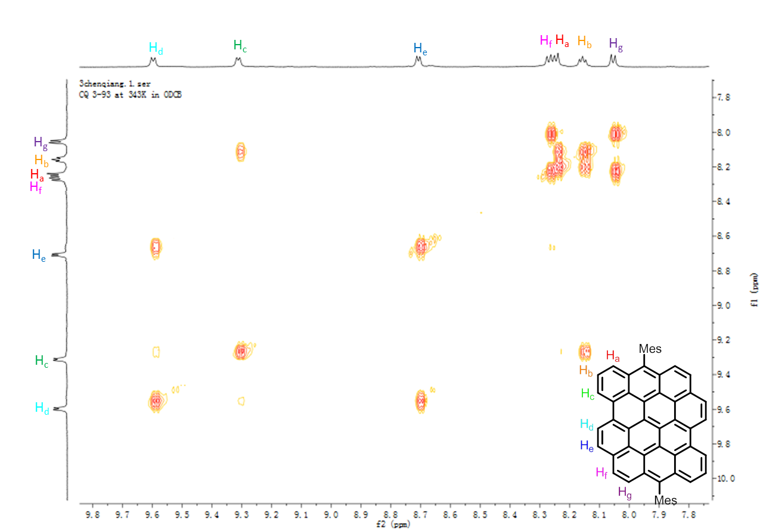
Figure S16. H-H COSY spectra of DBOV-Mes in o-dichlorobenzene (d₆) (700 MHz, 343 K).
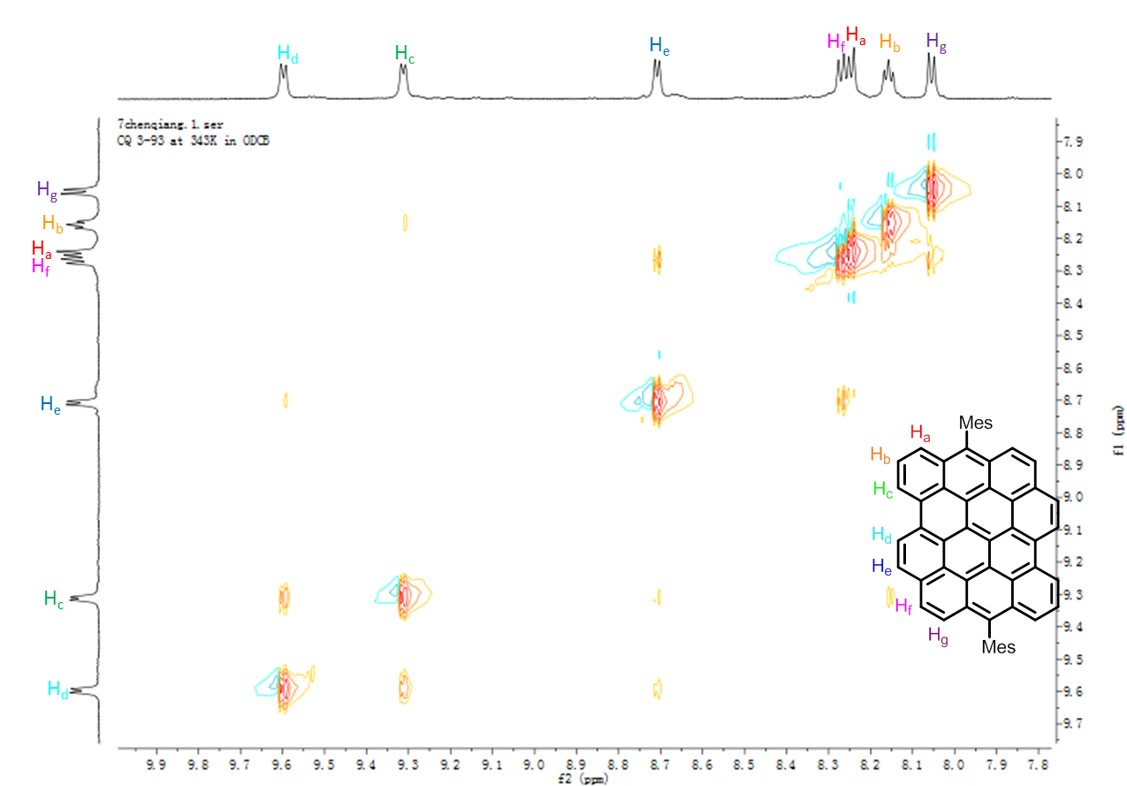
Figure S17. NOESY spectra of DBOV-Mes in o-dichlorobenzene (d₆) (700 MHz, 343 K).
Figure S18. HR MALDI-TOF MS spectra of DBOV-Mes.

Absorption and photoluminescence in solution

The absorption and photoluminescence of a dilute solution of DBOV-Mes in toluene is shown in Figure S19. The vibronic structure is more pronounced, and the high energy photoluminescence seen in a concentrated film is absent. We assume that the most reasonable way to explain the high-energy emission between 500 and 600 nm is indeed that a tiny amount of impurity presumably having benzo[a]dinaphtho[2,1,8-cde:1',2',3',4'-ghi]perylene structure, originating from precursor 9, is contained in the sample and contributing to this emission. This impurity might have significantly lower degree of self-quenching compared to DBOV-Mes, showing detectable emission only in the film.
Figure S19. Absorption and photoluminescence of DBOV-Mes in toluene (10⁻⁵ mol/L). The excitation wavelength is 355 nm.

Photostability

Photostability of the DBOV-Mes was compared to two other organic materials that are used to reach the strong coupling regime – the J-aggregate 5,6-dichloro-2[3-[5,6-dichloro-1-ethyl-3-(3-sulfopropyl)-2(3H)-benzimidazolidene]-1-propenyl]-1-ethyl-3-(3-sulfopropyl) benzimidazolium hydroxide (TDBC)³⁻⁵ and the small molecule bromine-substituted boron-dipyrromethene (BODIPY-Br).^{6,7} Films of DBOV-Mes in polymethyl methacrylate, TDBC in polyvinyl alcohol and BODIPY-Br in polystyrene were prepared. A white light supercontinuum laser was used to probe the absorption of the films as function of time. The laser was focused to a spot diameter of 2 μm at a spectrally integrated total power density of 1.3×10⁶ Wcm⁻². The optical density of the films was adjusted through chromophore concentration such that A_{p} = $\int_{450 nm}^{680 nm}{α\left(λ\right) I^{'}\left(λ\right) dλ}$ was approximately equal for all samples, where $α\left(λ\right)$is the film absorbance, $I^{'}\left(λ\right)=where Iual across the samples.was focused to a spot diamter 2tion of the films.inated with a white-l\frac{I\left(λ\right)}{\int_{0 nm}^{∞}{ I\left(λ\right) dλ }}$ and $I(λ)$ is the laser excitation spectrum. This ensured that each film absorbed the same optical power. The absorbance of each of the films at t = 0 is shown in Figure S20, along with $I^{'}\left(λ\right)$.

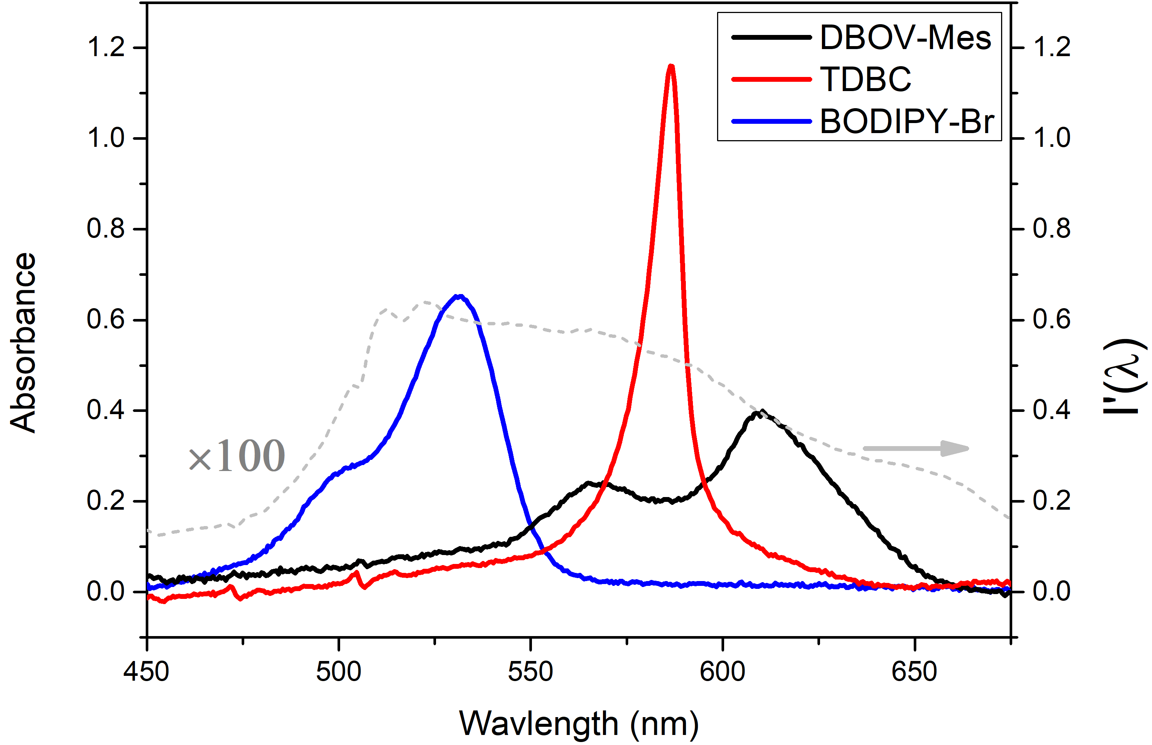
Figure S20. Absorbance of thin films containing the different chromophores. The absorbance and thickness of the films are typical of those used in a strong-coupled microcavity. The dashed grey line is the normalized excitation spectrum of the laser used in the photobleaching measurements.

Figure S21 shows A_{p} as a function of time for the 3 films. It can be seen that the absorption of BODIPY-Br undergoes rapid, exponential decay indicating rapid photobleaching having a t_{1/2} time of 125s. TDBC undergoes a more linear photo-bleaching, having a t_{1/2} of 650s. The DBOV-Mes undergoes much slower photobleaching, with the relative absorption only reducing by 15% over 1000s.

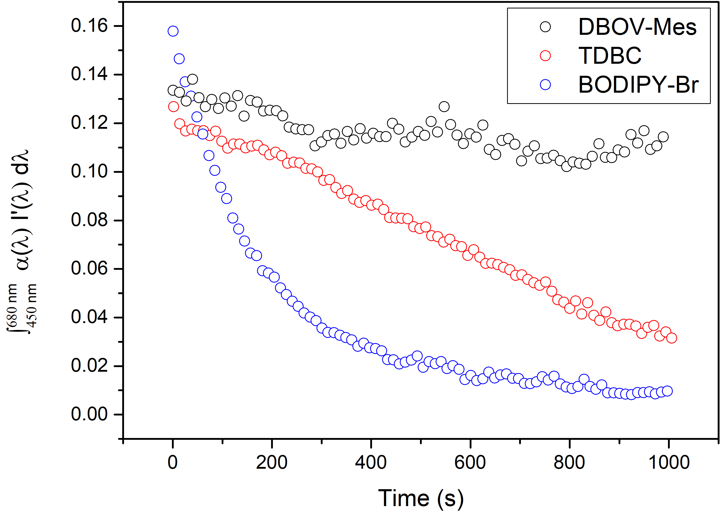

Figure S21. Spectrally integrated absorbed laser power as a function of time.

The absorption spectra of the films over time are shown in Figure S22.
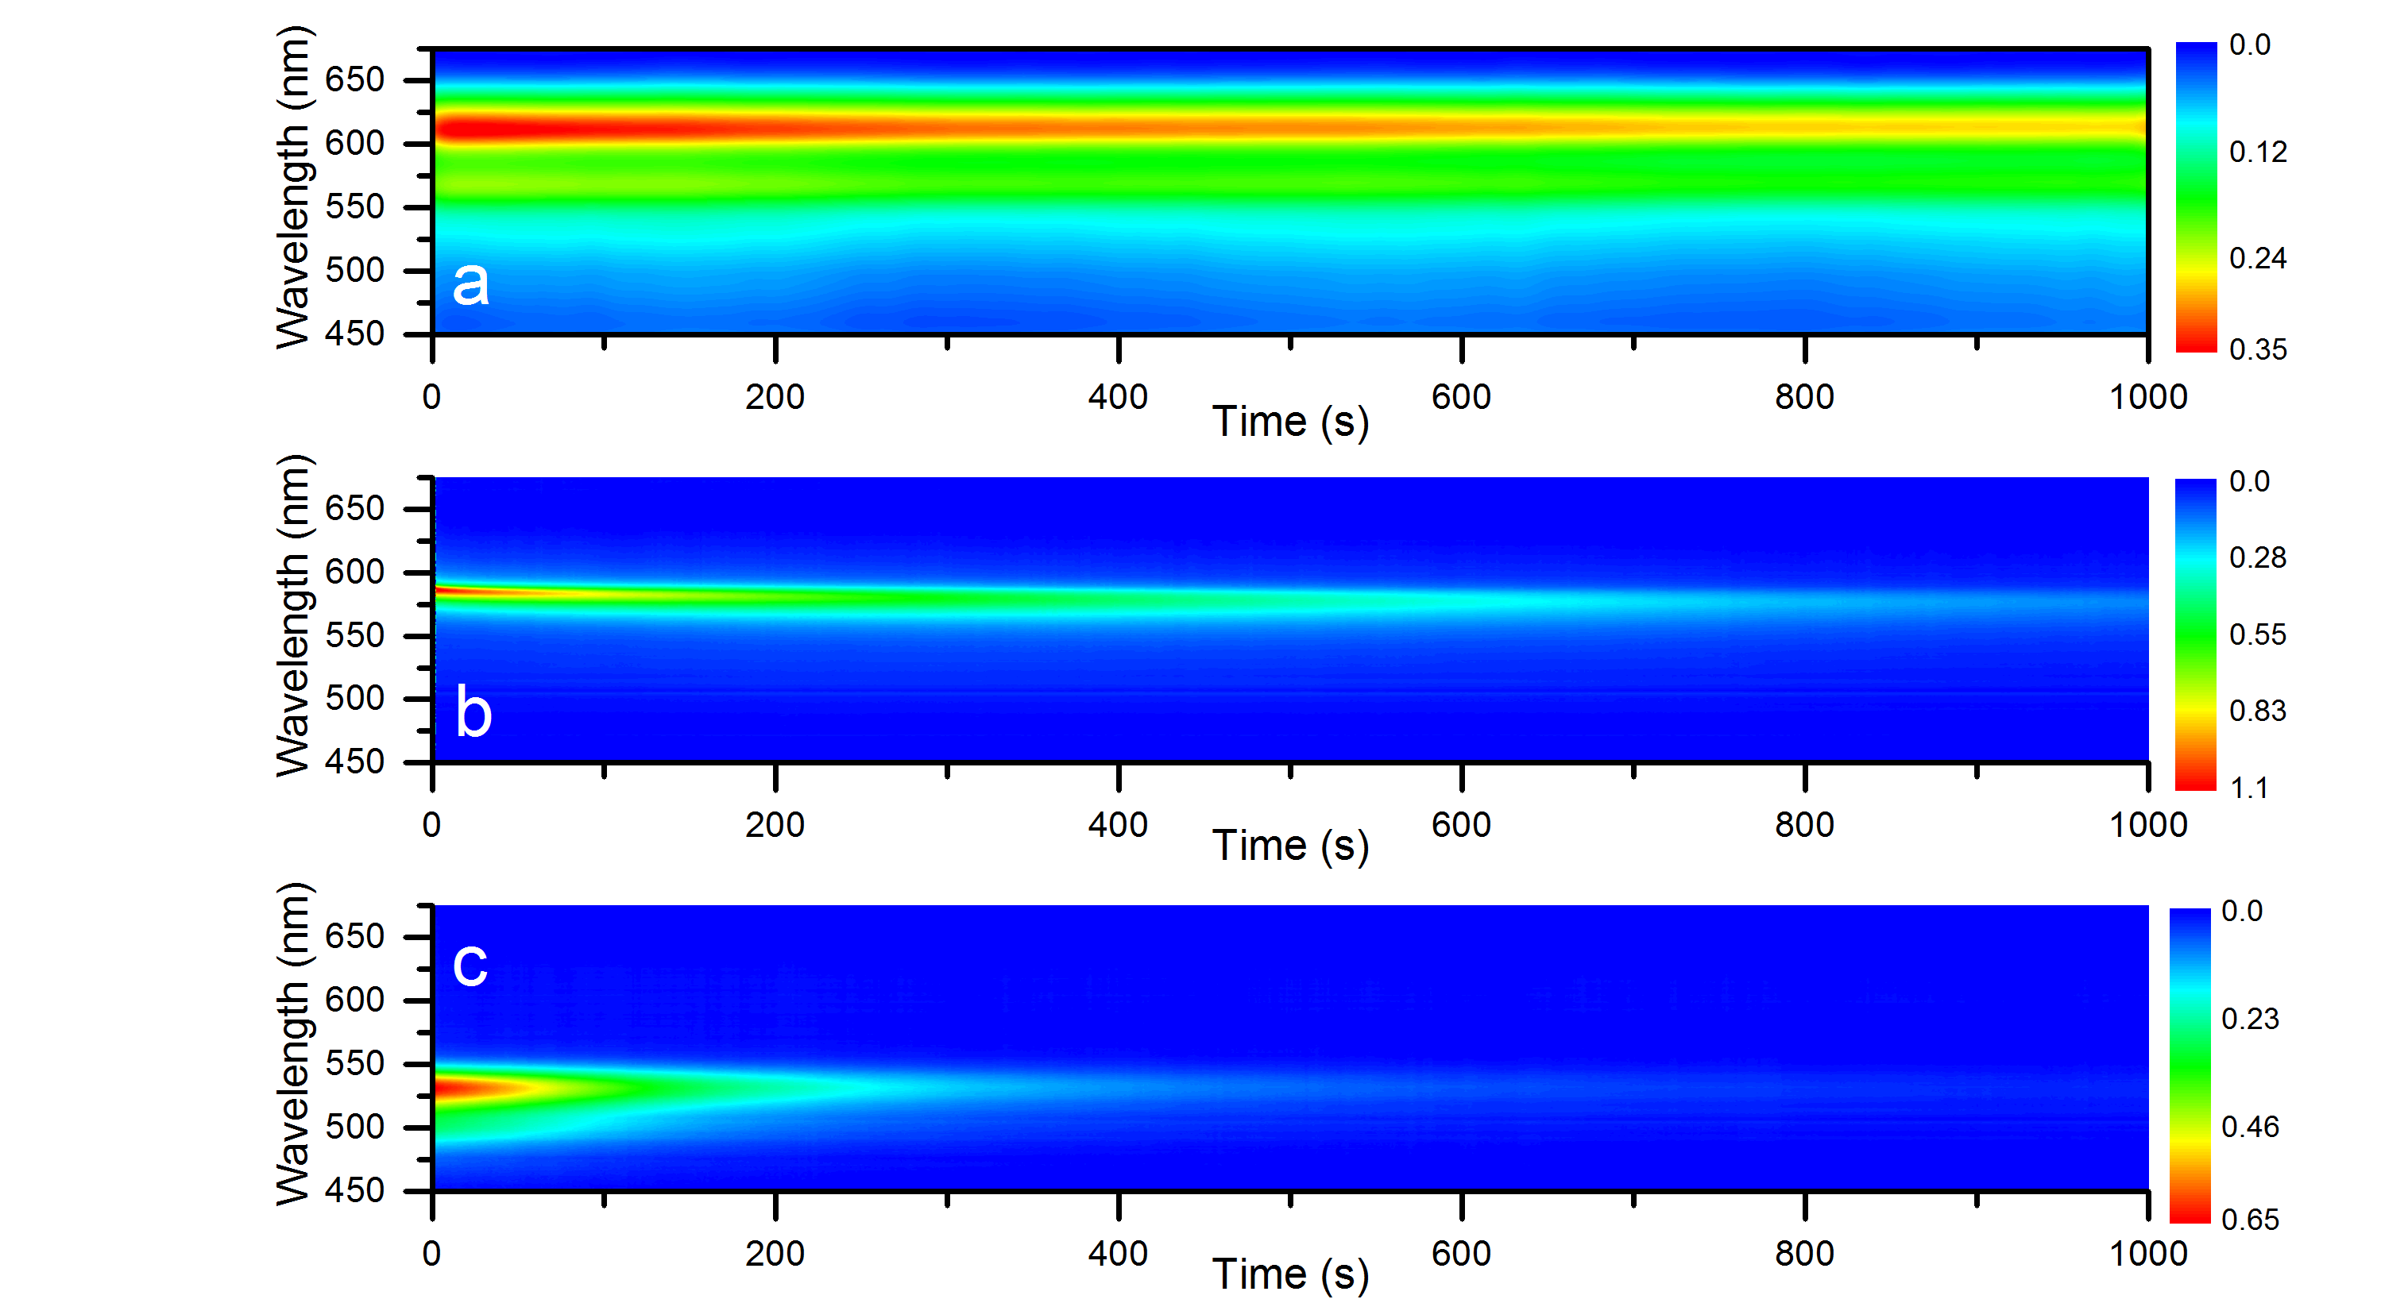

Figure S22. Time resolved absorbance of (a) DBOV-Mes, (b) TDBC and (c) BODIPY-Br doped thin films.

References

1. T. Dumslaff, B. Yang, A. Maghsoumi, G. Velpula, K. S. Mali, C. Castiglioni, S. D. Feyter, M. Tommasini, A. Narita, X. Feng, and K. Müllen, J. Am. Chem. Soc. 2016 138 (14), 4726-4729.
2. G. M. Paterno, Q. Chen, X.-Y. Wang, J. Liu, S. G. Motti, A. Petrozza, X. Feng, G. Lanzani, K. Müllen, A. Narita, and F. Scotognella, Angew. Chem. Int. Ed., 2017, DOI: 10.1002/anie.201700730
3. J. R. Tischler, M. S. Bradley, V. Bulović, J. H. Song and A. Nurmikko, Phys. Rev. Lett. 2005, 95, 036401.
4. J. George, S. Wang, T. Chervy, A. Canaguier-Durand, G. Schaeffer, J. M. Lehn, J. A. Hutchison, C. Genet, T.W. Ebbesen, Faraday Discuss. 2015, 178, 281–294.
5. D. M. Coles, P. Michetti, C. Clark, W. C. Tsoi, A. M. Adawi, J. S. Kim, D. G. Lidzey, Advanced Functional Materials 2011, 21, 3691–3696.
6. R. T. Grant, P. Michetti, A. J. Musser, P. Gregoire, T. Virgili, E. Vella, M. Cavazzini, K. Georgiou, F. Galeotti, C. Clark, J. Clark, C. Silva, D. G. Lidzey, Advanced Optical Materials 2016, 4, 1615–1623.
7. T. Cookson, K. Georgiou, A. Zasedatelev, R. T. Grant, T. Virgili, M. Cavazzini, F. Galeotti, C. Clark, N. G. Berloff, D. G. Lidzey, P. G. Lagoudakis, Advanced Optical Materials 2017, 1700203.

