Young children’s and adults’ perceptions of natural play spaces:

A case study of Chengdu, southwestern China
Abstract: Urbanization has resulted in children in many cities being separated from contact with nature, despite the many benefits that this can provide for play and learning. Influenced by research and practice from the ‘west’ there is increasing evidence that in recent years these benefits for young children are being acknowledged and expressed in policy and practice in China. Chengdu, a rapidly expanding city in the south-west of China, has playgrounds in public spaces dominated by the Kit, Fence, Carpet approach but also has some kindergartens with a more natural approach, which supports a higher play and educational value. Nothing is known of parents’ perceptions of different approaches to the provision of playgrounds and this paper seeks to begin to fill this gap. It reports on research with parents and young children at two kindergartens in Chengdu that sought to understand parents’ perceptions of different playground styles, aesthetics and play risk associated with the different styles and children’s perceptions of different playground styles. The results of an on-line questionnaire revealed that over 87% of the parents understood and recognized the benefits of natural elements within a playground. Vegetation and water were the most popular elements followed by sand and stone, landform and then insects and small animals. Physical and creative developments were the two most recognized development functions of natural elements acknowledged by the parents. Images of different playground styles were used with both adults and children and revealed that both groups tended to select a natural style with parents more inclined to select a higher degree of nature than children. Parents also considered that more natural playgrounds to be of low risk and attractive to look at. Two policy changes in China make this work of great significance: the change from one to two-child policy and the introduction of a natural education approach. The resultant increased numbers of children in future will benefit if the positive findings of this research inform policy and practice.
Key Words: Urbanization; China; Young Children; Outdoor Play; Nature; Kindergardens
1. Introduction
1.1 Introducing the relationship of children and nature
The importance of nature for children’s play, development and being as individuals is increasingly acknowledged by a growing body of international scholarly literature, in particular from North America, Europe and Scandanavia (Lester & Maudsley, 2007). Children enjoy playing with and using natural elements (Titman, 1994) and educationalists put great value on learning from direct experience of nature (Malone &Tranter, 2003; Fjørtoft & Sageie, 2000). Benefits for children accessing natural environments (Lester & Maudsley, 2006) can include increased confidence, independence, development of motor skills and reduction of symptoms of Attention Deficit and Hyperactivity Disorder (Fjortoft, 2004; Grahn et al., 1997; Murray & O’Brien, 2005; Taylor et al., 2001; Wells & Evans, 2003). The availability of nature can also improve language and collaborative skills, foster more imaginative and creative play (Fjortoft & Sageie, 2000; Moore & Wong, 1997) and advance an individual’s intellectual, emotional, social, spiritual and physical development (Kellert, 2005). In China little evidence exists about the relationship of children and nature but there is a suggestion that contact with insects and small animal habitats can contribute to emotional development (Wang & Liu, 2015), an aspect not identified elsewhere in the world.

1.2 Playgrounds: an opportunity to reconnect children with nature?
Across the world urbanization has resulted in higher density housing, increased transportation, industry, associated pollution and changes in technology. These environmental and technological changes have been accompanied by a reduction in children’s independent mobility and associated contact with nature as identified in cities such as New York, USA (Gaster, 1995); Newcastle, Australia (Tandy, 1999); Amsterdam, Netherlands (Karsten, 2005); Brumunddal, Norway (Skar and Krogh, 2009); Tokyo, Japan (Kinoshita, 2009) and Sheffield, England (Woolley and Griffin, 2015). Such separation from nature thus denying children the benefits of contact with nature already discussed.

In some cities urbanisation has also been accompanied by the development of playgrounds in which society deems it suitable for children to play, sometimes with the expectation that children should only play in such designated spaces and not elsewhere. Playgrounds can be built to replicate natural environments (Greenman, 1993; Wardle, 1995) providing opportunities for children to reconnect with nature with a positive therapeutic benefit for children’s development (Cosco & Moore, 2009). However, in many situations this does not happen and playgrounds are often of the Kit, Fence, Carpet approach (Woolley, 2007; 2008) where a range of fixed play equipment (Kit) is surrounded by a Fence, rarely designed in a creative or playful way and where the ground surface consists of a rubber Carpet which is both expensive and of little play value.
1.3 Defining a natural playground style
A natural playground can be understood to include elements such as landform, vegetation/trees, natural materials (e.g. stone, water, sand, bark, moss, leaves, mud, logs, fruit, sticks) and moving/loose parts (Woolley and Lowe, 2013). In China this more natural style of playground is understood to use landform and naturalistic planting (Wang & Liu, 2015). The research reported here uses the four commonly recommended natural elements suggested by Chinese researchers together with one more recent suggestion: vegetation, landform, sand and stone, water, insects and small animal habitats (Wang, Y, 2009: Hu & Zhang, 2009; Wang & Liu, 2015). A continuum of approaches from a Kit, Fence, Carpet to Composite and Natural approach to playgrounds was identified by Woolley and Lowe (2013) and this research takes that continuum further by suggesting different degrees of Natural and Composite styles of playgrounds according to the elements contained within them.
1.4 Development functions of children’s play
The play value (Woolley & Lowe 2013; Jenkins et al., 2015) of a space can be derived from its ability to maximize a child’s developmental functions and opportunities for different types of play (Woolley and Lowe 2013). Five developmental themes have been identified as environmental, physiological, creative, educational and social (Heseltine & Holborn, 1987). Five development aspects of children play: physical faculties, creativity, sociality, sensitivity and readiness to challenge have been suggested by Senda (2012). Czalczynska-Podolska (2014) proposed that to function effectively as a play environment a playground should be built supporting physical, social, emotional, and cognitive development. Woolley (2012) further interpreted that physiological development helps both sensory and motor function which contributes towards creativity and suggested four types of play: environmental development, physiological and creative development, educational development and social development. Based on these research findings five developmental types were identified: physiological development, educational development, emotional development, social development and creative development. These were adapted to five, more understandable, terms for use in the questionnaire for this research: physical strength, intellectual development, sensitivity and sympathy, social and communication development and creativity.
1.5 The value of natural elements for early childhood play and education
Some have addressed how children’s play and development can best be accommodated in outdoor environments for early childhood play. Seven Cs are considered as key to such outdoor provision: character context, connectivity, change, chance, clarity and challenge by Herrington and Lesmeister (2006). Others acknowledge that outdoor environments can provide a crucial pedagogical setting for early childhood and that diversity of landscape elements such as vegetation and topography provide a stimulating and varied play environment for young children. This positively affects the range and levels of physical activity and supports the motor development and fitness of young children (Fjørtoft & Sageie, 2000; Fjørtoft, 2004). Topography, slopes, steps, terraces and other level changes increase the affordance for movement and play potential and provide great provocation for use of the body (White &Woolley, 2014). For young children, it is particularly essential to have materials, resources and equipment, such as sand, water and vegetation, that are ‘open’ (Prescott, 2008), versatile, adaptable and responsive to whatever the child wants to do. These elements also provide the supportive characteristic of ‘softness’ which can meet the rapid change of energy level of young children (Prescott, 2008). Providing a sense of control and empowerment or agency and security is also critical to make a good experience of outdoor play space for young children (White &Woolley, 2014). Outdoor spaces with such provision reflect the natural playground style already discussed.

1.6 Policy Changes in China
China has urbanized rapidly during the last 50+ years with cities expanding at rates not experienced in other parts of the world. During this time children’s outdoor play spaces supporting contact with nature disappeared (Fu, 2012). The first children’s playgrounds appeared in Concession Park in Shanghai in the early 1900s (Zhang et al., 2012). Research on children's play spaces in China started in the 1990s, compared to other countries where such research started in the 1900s (Han, et al., 2011). In recent years there is evidence that the importance and contribution of nature for children’s development is increasingly recognized in China, largely as a result of the introduction of western nature education concepts (Dou, 2012; Sun, 2015; Wang & Liu 2015). One expression of this is a China Nature Education Forum with the theme of ‘promoting the diversity of natural education and social participation’, held in 2014 and 2015. Another expression is the Kindergarten Working Guidance of 2016, published by the National Education Council. This requires all kindergartens to make full use of natural elements, such as sunlight, air, water, and local natural environments to promote children’s physical activity. In addition, the first national nature education text book Have Our Own Nature School was published with support of the Ministry of Environmental Protection in March 2016.
Another policy change is from a one child policy to two-child policy in January 2016. The annual new birth population of China is predicted to increase from 2.3 million to 4.3 million, so the total new birth population from 2016 to 2020 is estimated to be 18 million (Wang, 2016). There will be a resultant increased demand for children’s education as parents, particularly in urban areas, pay increased attention to the quality of their children’s education (Li, 2015).
Only a few publications about young children’s outdoor environments in China can be found in Chinese journals, non in international journals. This is therefore the first article on this subject in an international journal. In addition no literature has been found that explores parents’ perceptions of different styles of playgrounds. The present research aims to explore two issues. First to provide an initial understanding of the perception of natural style playgrounds by parents and children, and second how to appropriately incorporate this approach into design in order to meet children’s needs. To do this the following questions were posited:
- What is the perception of parents towards natural style playgrounds?
- What is the difference between young children and parents’ towards natural style playgrounds?
- How do these findings effectively help to present new opportunities to improve existing and make a contribution to future designs?
2. Methodology
2.1 The current situation in China - Chengdu city as a study area
Chengdu, capital city of Sichuan Province, serves as a political, industrial, cultural, logistics, and technology center in the province and as a major economic center in Southwest China (Qin, 2015). It is highly urbanized with a population of ~14 million and a land area of 12,390 km². Chengdu was chosen as the study area for three reasons. First, with rapid urbanization the city has systematically expanded through the town and country planning concept of ‘Big Chengdu’ since 2003. Second, it is a very green city with over 30% of the total area being green space and 22% urban parks. Third, based on the Livable City Scientific Evaluation Standard issued by the Ministry of Construction of China in 2007, Chengdu is one of the most livable cities in China. This means the quality of life in Chengdu is higher than other cities in terms of environmental quality, safety and economic status. The city has 8 administrative districts with two being transformed from countryside since January 2016. The number of children’s playgrounds in urban parks has dramatically increased from 5 to 25 since 2000 and a visual survey of these new playgrounds, prior to this research, revealed that 75% use the Kit, Fence Carpet style while 25% are designed using a more natural approach.
2.2 Identification of nurseries and participants
One public nursery and one private nursery, from two different core districts of Chengdu, were selected because both have good outdoor environmental settings for children. Questionnaires were used to understand the perceptions of parents and young children towards natural style playgrounds. Parents of the children to be invited in the research were invited to do an on-line questionnaire. However, not all the parents wanted to participate. Therefore an on-line questionnaire link was distributed to the children’s parents and they were asked to circulate it to their friends who also were parents. In this way a snowballing effect was used to gather opinions of parents of young children.
Children aged 4 to 6 from the two nurseries were invited to participate. There were three reasons for involving young children in this research. First, they psychologically have built-in initial recognition towards the world and have the ability to play freely as well as a relatively strong desire to learn (Bai &Yan, 2007). Second 4-6 year old children begin to have awareness of social activity and their play types are beginning to diversify (Liu et al., 2009). Third at the preliminary investigation stage of Chengdu city urban park playgrounds, most of the children who independently played by themselves were in this age range.
2.3 Questionnaire design for parents
The questionnaire for parents started with an introduction to provide a definition, informed by the literature, of a natural playground. It was divided into four sections with a total of 19 closed questions and one open-ended question.
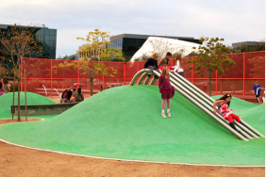
Section one consisted of two questions to elicit preference of playground styles through the use of two series of four images. The first group of images was a mixture of two Kit, Fence, Carpet style playgrounds and two natural style playgrounds, which can provide similar play function and play types through repeating multi-functional slides in all four images. These were identified as a Kit, Fence Carpet Style (KFCS), an Imitation Natural Style (INS), a Light Natural Style (LNS) and a Bold Natural Style (BNS), as seen in Figure 1. The second group of images included playgrounds easily recognizable of a natural style by depicting wooden structures of play equipment, sand, stone and vegetation of varying degrees. These represented a Light Natural Style (LNS), Medium Natural Style (MNS), Complex Natural Style (CNS) and Bold Natural Style (BNS). LNS used one type of wooden fixed play equipment and one type of planting, for example a tree and in a very simple layout. MNS used 2 different types of wooden fixed play equipment and plantings. CNS used 3-5 different types of wooden fixed play equipment and plantings. BNS was a highly natural style playground with more than 5 different types of wooden fixed play equipment and plantings, closely integrated with the surrounding natural environment, for example the use of an existing tree trunk as play equipment. Parents were asked to select any number of playground styles from the eight pictures that fell into their definition of ‘natural style’. They were also asked which they would prefer to see featured more prominently in Chengdu urban parks in the future.
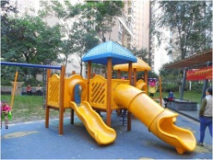

A) Kit, Fence, Carpet style (KFCS) B) Imitation Natural Style (INS)
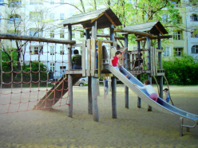
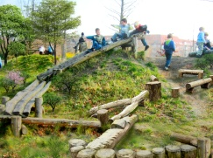

C) Light Natural Style (LNS) D) Bold Natural Style (BNS)
Figure 1. Pictorial playground mixtures of types presented in the survey
A B

C D

Section two consisted of 11 Likert scale (1 to 5) questions. The first five questions measured acceptance of the five natural elements, previously identified, of water, vegetation, landform, sand and stone, plus insects and small animal habitats. Another five questions measured the respondents’ awareness of the importance of nature for children’s development, including physical strength, intellectual development, sensitivity and sympathy, social and communication development and creativity. The 11th question asked about people’s perception towards risk during play.
The third section consisted of three single choice questions to understand people’s perception about potential function, risk and aesthetic aspects towards natural style playgrounds. The fourth section consisted of four questions profiling respondents’ demographic information including age, gender and educational background.
2.4 Questionnaire design for children
A shorter version of the questionnaire was developed for use with children which included only section 1 with the 2 groups of images used in the parents’ survey. This was initially facilitated by the teacher who explained the research and what the children should do. Then two sets of printed images were presented to each child in a face-to-face interview.
2.5 Data analysis
Since the data of section 1 question did not meet the assumption of normality, non-parametric statistical methods were used to analyze the data. The Spearman’s rank-order correlation was used to determine association between the first and second question in section 1 for parents and children individually. In addition, Excel diagrams were generated to indicate the specific preference results of parents and children. The Mann-Whitney U-test with exact p-values was also used to evaluate significant difference between the two types (natural style and non-natural style) and risk acceptance in section 3. The same method was used to identify any significant difference between the data of the second question in section 1 and risk acceptance in section 3.
Cronbach’s alpha was used to estimate the internal consistency reliability of the 11 Likert scale questions of section 2 and two tail correlation analysis was used to evaluate the data of two questions of section 1 and the score of the 10 Likert scale questions. All data analyses were conducted using IBM Statistics Package for Social Science (SPSS) for Windows, version 22 (www.spss.com) and Microsoft Excel.
2.6 Ethics
In China, universities are not required to undertake a formal ethics review. However, an ethical approach is expected and for this research this included providing information and seeking permission from the principals of 2 nurseries, the teachers in the nurseries and the children involved. As in other countries parents who completed the questionnaire were deemed to have given their permission to be involved in the research. The names and locations of the nurseries, staff and children have not been used in order to preserve anonymity.
3. Results
The total number of children aged 4 to 6 interviewed was 247. The validity rate was 99.6% because one child felt it was too difficult to answer, and did not compete the interview. Among 240 questionnaires of parents 236 were complete, a validity rate of 98.3%. The parents groups had different age ranges: 54.9% were aged 30-40 years old; 26.1% were aged 40-50 years old and 18.6% were aged 20-30, and 0.5% were aged above 60 years old. Ninety percent of the parents had at least a bachelor degree, probably a result of the purposive sampling method, not reflecting the population at large.
3.1 Preference for playground style for children
Children’s preference ranking of the first group of images (Fig. 2) is: first the Light Natural Style (45.9%); second the Kit, Fence Carpet style (22.4%); third the Imitation Natural Style (15.9%) and fourth the Bold Natural Style (15.8%). The more natural styles were preferred by 61.8% of the responses, while the less natural styles were preferred by 38.2% of the respondents. The results of the preferences for the second group of images (Fig. 3) are: first the Light Natural Style (38.2%); second Bold Natural Style (27.6%); third Complex Natural Style (25.2%) and fourth Medium Natural Style (9.0%).
3.2 Preference for playground style for parents
Only 14.0% of parents selected option A, a Kit Fence Carpet Style playground (Fig. 2), from the first group of images, as the most preferred for 4 to 6 year old children. The photographs representing more natural styles were preferred by 86% with Light Natural Style (32.6%) most preferred, followed by Bold Natural Style (32.2%) and Imitation Natural Style (21.2%). For the second group of photographs (Fig. 3) 53.8% preferred the Bold Natural Style, while 21.6% preferred the Complex Natural Style, 17% the Light Natural Style and 7.6% the Medium Natural Style.
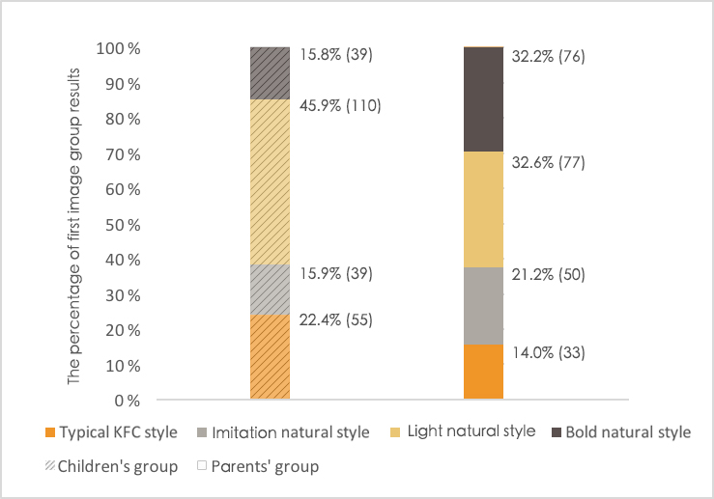
Figure 2. Results of children’s group and parent’s group of first image group
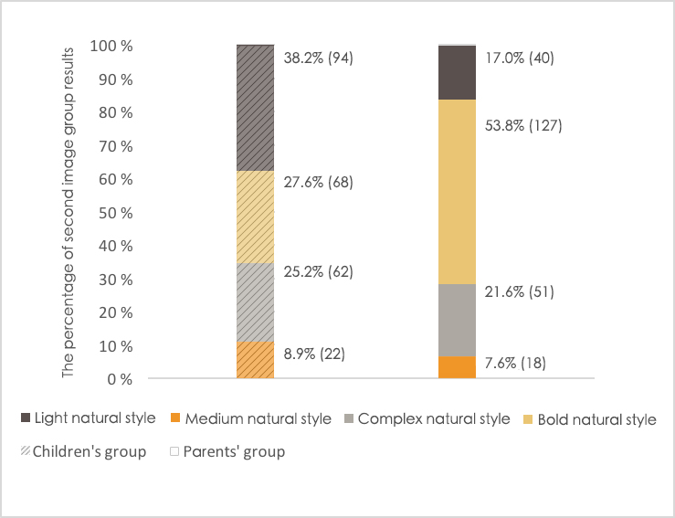
Figure 3. Results of children’s group and parent’s group of second image group
3.3 Comparison of preferences for playground style between parents and children
Option C of the first group of images, the Light Natural Style, and option D of the second group of images, the Bold Natural Style, were identified as the most popular playgrounds. Moreover, the result of parents’ selection of Light and Bold Natural Style playgrounds (C and D, 64.4% in total) in the first group of images was very similar with children’s selection of Light and Bold Natural Style playgrounds (C and D, 61.8% in total). The Bold Natural Style was preferred by 53.8% parents compared to 27.6% of children.
3.5 Reliability assessment and validity analysis for questions using Likert scales
The internal consistency reliability of the 11 questions of section 2 as estimated by Cronbach’s alpha was 0.86 (between 0.80-0.90), which was considered excellent. The KMO value is 0.91 (> 0.7) and the P value of Bartlett test was 0, which means the validity was very high and able to reflect the characteristics of its variables.
3.6 Results of adult attitudes towards natural elements, children’s development
Table 1 Results of parents’ acceptance towards natural elements

Natural Elements | Average Score | Ranking
Vegetation | 4.12 | 1
Water | 3.82 | 2
Sand and stone | 3.8 | 3
Landform | 3.77 | 4
insects and small animal habitat | 3.53 | 5

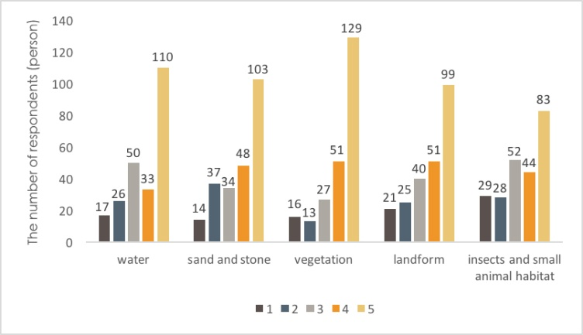

Figure 4. Results of parents’ acceptance towards natural elements (Importance degree of natural elements: 1-not important, 2-relatively low important, 3- important, 4-relatviely high important, 5-very important)
The average score of the questions about the appropriateness of the five natural elements were all above 3.5. Vegetation was the most important natural element, followed by water, sand and stone (Table 1, Fig.4).
Table 2 Results of people’s awareness of the importance of nature for children’s development

Children’s development | Average Score | Ranking
physical strengthen | 4.46 | 1
creativity | 4.44 | 2
intellectual development | 4.38 | 3
sensitivity and sympathy | 4.28 | 4
social and communication | 4.25 | 5
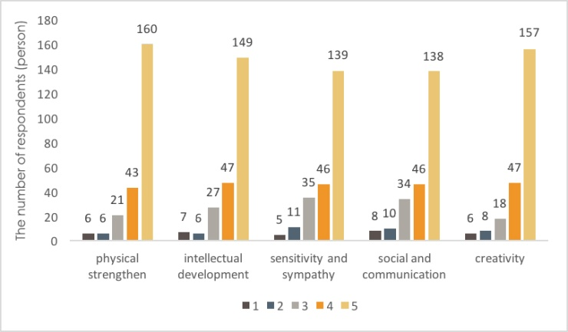
Figure 5. Results of people’s awareness of the importance of nature for children’s development (Level of effect: 1-no effect, 2-relatively low effect, 3-good effect, 4-relatively high effect, 5-very high effect)

The average response score of all the five children’s development questions were above 4.2 (Table 2), which is a high score. Ratio for ‘5-very high effect’ of five aspects was 67.8% (160/236), 63.1%% (149/236), 59.0% (139/236), 58.5% (138/236), 66.5% (157/236) (Fig. 5), respectively, all over 50%. It shows that contact with nature was widely recognized as contributing effectively to children’s development. Apart from the above listed development functions, in the section 3 of the questionnaire, 76.4% of respondents believed that nature has potential functions towards children’s development which are not clearly realized by human beings.
3.7 Correlation Analysis
Based on the analysis from Spearman’s rank-order correlation, positive correlation was significant (P < 0.01, Correlation coefficient was 0.203**)between the two preference choice results of two image groups of parents (Table 3) indicating that parents who selected a natural style in the first group of images had a high tendency to select natural playground of higher degree in the second group of images. However, no significant correlation was observed in the children’s responses.
The data of the first question in section 1 were divided into natural style (C and D) and non-natural style (option A and B). The Mann-Whiteny U-test with exact p-values was used to evaluate the correlation between the above two types and risk acceptance respectively. Significant difference was observed between non-natural style and risk acceptance and natural style and risk acceptance (Z =-2.889, P = 0.004, < 0.01), which indicated that those choosing a natural style have a tendency to select a higher level of risk (Table. 3). However, the data of the second group of images had no significant relevance with risk acceptance.
Table 3 Results of Spearman’s rank-order correlation coefficient
Preference results of two image groups of parents |  |  | 2nd image group
Spearman ‘s rho | 1st image group | Correlation coefficient | 0.203**
 |  | Significance (two tail) | 0.002
 |  | N | 236
Preference results of two image groups of children |  |  | 2nd image group
Spearman ‘s rho | 1st image group | Correlation coefficient | 0.047
 |  | Significance (two tail) | 0.467
 |  | N | 247

Based on the analysis of Spearman’s rank-order correlation, a positive correlation was significant P < 0.01= between the first preference question and water (Correlation coefficient = 0.357**), landform (0.330**), creativity (0.341**) and social and communication (0.331**). This indicated that those who like the natural style playground preferred water and landform and recognized the development functions of creativity and social and communication of these natural elements. Furthermore, positive significant correlation P < 0.01= was also seen between the second preference question and insects and small animal habitat (0.226**), sand (0.173**), as well as sensitivity and sympathy (0.169**). This indicated that those who selected a higher degree of natural playground recognized that the two natural elements of insects and animals habitat and sand supported the development functions of sensitivity and sympathy.
3.8 Risk and aesthetics towards natural style playgrounds
The question about risk in playgrounds with natural elements resulted in less than 27% of respondents selecting‘4-relatively high risk’and‘5-very high risk’ (Fig. 6), therefore, over 70% believe that natural playgrounds offer an ordinary or a low level of risk. About 56.8% of the parents believed that the natural style was safer compared with 13.5% of parents who chose fixed equipment playground as safer (Fig. 7).
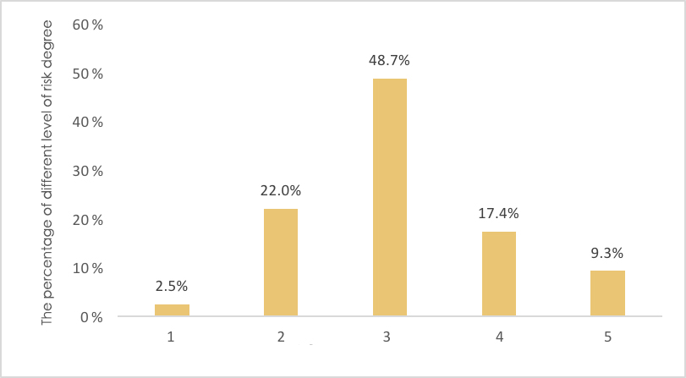
Figure 6. Results of level of risk degree of natural playground (1-compelet no risk, 2-light risk,3-ordinary risk,4-relatively high risk,5-very high risk)
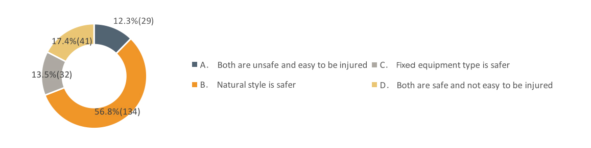
Figure 7. Results of risk comparison between natural style and fixed equipment type

A large majority of parents (90.2%) liked the aesthetics of the natural style playground displayed in urban public space and only 1.3% of parents did not like them for their aesthetics (Fig. 8).
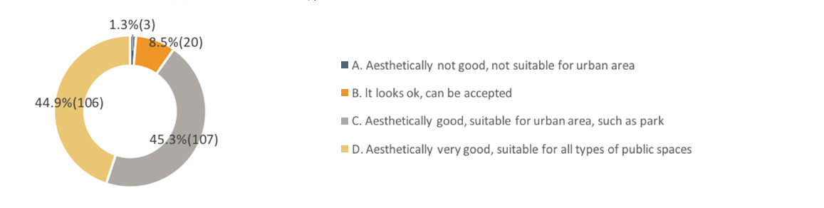 Figure 8. Results of aesthetics towards natural style playgrounds
4. Discussion
This is the first international piece of research to explore children’s relationship with natural elements associated with playgrounds in China. It has done this to understand preferences of playground styles of both children and parents and to explore parents’ opinions about the relationship between natural elements and children’s development, risk and aesthetics of such playgrounds. The research focused on young children and accessed opinions through two nurseries in the city of Chengdu.

The key findings reveal that the more natural style playgrounds were preferred by both the children and the parents, with the parents having a preference for bolder natural style playgrounds more than the children. This implies that the parents have a greater awareness of the importance of natural elements in playgrounds than the children. Parents also revealed that vegetation, followed by water and then sand and stone are the most important elements for such playgrounds. This could not have been predicted, partly because of the lack of previous research about both adults and children’s perceptions of playground styles not only in China but also elsewhere in the world. Indeed in many parts of the world decades of Kit Fence Carpet playgrounds indicates that society, which includes parents, have not wanted to move towards more natural style playgrounds. This preference for natural style playgrounds and specific elements agrees with the academic discussion of what constitutes a natural style playground (Woolley, 2008), that these elements contribute to the rich normality required in a play space (Greenman, 2007) and the character of a good play space for young children (White and Woolley, 2014).

The parents’ responses also revealed a wide recognition that natural elements can contribute to children’s development and again this has not been explored either in China or elsewhere. Water and landform were affirmed as supporting the development functions of creativity and social communication while insects and small animal habitats and sand were affirmed to support the development of sensitivity and sympathy. Although there is no previous evidence of parent’s perceptions of this there is academic evidence that enriched natural environments for play can have a positive impact of children’s development (e.g. Grahn, et al., 1997; Fjortoft, 2004).

In some parts of the world risk in children’s play has become a significant constraint to the planning and design of playgrounds in cities and has contributed to the ongoing provision of Kit Fence Carpet playgrounds, with large amounts of expensive rubber surfacing being laid providing no play value and little if any prevention of physical risk. This has been accompanied by an aversion to the provision of more natural style playgrounds. Yet the parents involved in this research had a positive view of this, with the majority believing that natural playgrounds are of an ordinary or lower level of risk. Outdoor natural spaces can be full of unpredictable elements (Stephenson, 2003) making them inherently risky (Sandseter, 2009) but also rich in affordances for thinking, moving and interacting (Fjortoft, 2001). Indeed managing reasonable risks and dealing with setbacks can result in positive dispositions towards learning (Athey, 2009; Dweck, 2000; Huggins and Wickett, 2011) and self-motivation (Katz, 1995).

More than 90% of the parents reported that natural style playgrounds looked good or very good and are suitable for all types of public spaces in cities. Again this question has not been asked before as far as we can tell: if it has the answer has not been published but is only known within the context of practice.

Overall the parents in this research seem to hold positive, progressive views about natural play spaces in cities: they have a level of understanding of the benefits of natural play spaces, perceive such spaces to be of low risk and find them attractive to look at.

5. Limitations
We acknowledge two main limitations to this research. First, nearly 90% of parents were well-educated with a bachelor degree or above, which might affect the generalisability of the results. Second, when the face-to-face interviews were done with children, it became apparent that some of them had not experienced a more natural style of playground and this coupled with the fact that children perceive functions rather than forms of spaces, (Fjørtoft & Sageie, 2000; Sandseter, 2009) may have influenced their responses.
6. Conclusion
Rapid urbanization in many cities of the world particularly in China has resulted in the provision of playgrounds for children being given little consideration for the opportunities they can provide for contact with nature, which is not only desirable but considered to be a human need (Kaplan, 1995). The changing policies in China of nature education and two child families means that the provision of good outdoor play environments for young children are vital for the increased population in future years. This research has revealed that the more natural style of playgrounds is acceptable for both young children and parents in a Chinese context. Implications for policy and practice are that planners, designers and developers of cities should consider carefully the quality of the outdoor environments and play spaces by providing more natural style spaces. This can relate to early childhood settings such as playgrounds and outdoor spaces associated nurseries and therefore should also be of interest to educators. But this should also be considered in the context of planning and designing public outdoor spaces. Vegetation, water, sand and stone should be included in such designs to maximize play and educational value and please parents. So policy, design and implementation of playgrounds in Chinese cities should be brave and respond to the positive findings of this research.

References
Athey, C (2009) Extending thought in young children: A parent-Teacher partnership, 2nd ed. London: Sage.
Bai, D. & Yan, Y. T. (2007) Analysis of the impact of landscape space for child development and the design approach, Huazhong Architecture, 25, 147-151. (In Chinese)
Cosco, N. & Moore, R. (2009) Sensory integration and contact with nature: Designing outdoor inclusive environments. The North American Montessori Teachers Association Journal, 34 (2), 159-177.
Czalczynska-Podolska, M. (2014) The impact of playground spatial features on children’s play and activity forms: An evaluation of contemporary playgrounds’ play and social value. Journal of Environmental Psychology, 38,132-142.
Dou, Q. N. (2012) Early childhood education in natural environment-research on the abroad preschool educational institutions using park resources for early childhood education and the enlightenment. Journal of Hubei University of Education, (29), 120-123. (In Chinese)
Dweck, C. (2000) Self-theories: Their Role in Motivation, Personality and Development. Hove: Psychology Press.
Fjørtoft, I. (2004) Landscape as playscape: The effects of natural environments on children’s play and motor development. Children, Youth and Environments, 14(2), 21-44.
Fjørtoft, I. & Sageie, J. (2000) The natural environment as a playground for children: landscape description and analysis of a natural landscape. Landscape and Urban Planning, 48(1/2), 83-97.
Fjørtoft, I. (2001) The natural environment as a playground for children: the impact or outdoor play activities in pre-primary school children. Early Childhood Education Journal, 29 (2), 111-117.
Fu, C. J. (2012) Exploring on children’s playgrounds with interaction of children and nature in park - A case study of children’s play space in Yanjiao Botanical Garden, Hebei Province. Chinese & Overseas Architecture, (7), 100-102. (In Chinese)
Gaster, S. (1995)Rethinking the Children’s Home-range Concept. Architecture and Comportment, 11(1), 35-42.
Grahn, P., Martensson, F., Linblad, B., Nilsson, P. & Ekma, A. (1997) Outdoors at day-care. City and County, 145, 20-27.
Greenman, J. (1993) It ain’t easy being green-Beginnings workshop. Child Care Information Exchange, 91, 336-337.
Greenman, J. (2007) Caring Spaces, Learning Places: Children’s Environments That Work. Redmond, WA: Exchange Press.
Han, X. L., Sternudd, C., & Zhao, W. Q.(2011) Progress in the research on children’s outdoor physical activity in cities. Human Geography, (6), 29-33. (In Chinese)
Herrington, S. & Lesmeister, C (2006) The design of landscapes at child-care centers. Landscape Research, 31(1), 63-82.
Heseltine, P. & Holborn, J. (1987) Playgrounds: The Planning, Design and Construction of Play Environments. London: Mitchell.
Huggins, V. & Wickett, K. (2011) Crawling and toddling in the outdoors: Very young children’s learning. In- Waite, S (ed.) Children Learning Outside the Classroom: From Birth to Eleven. London: Sage.
Hu, S. Q. & Zhang, C. Y. (2009) Based on design of psychological and behavioral characteristics of children in outdoor of playground residential areas. Modern Landscape Architecture, (2), 35-38. (In Chinese)
Jenkins, G. A., Yuen, H. K., Rose, E. J., Maher A. I., Gregory, K. C., & Cotton, M. E. (2015) Disparities in quality of park play spaces between two cities with diverse income and race/ethnicity composition: A pilot study. International Journal of Environmental Research and Public Health, 12, 8009-8022.
Kaplan, S. (1995)The restorative benefits of nature: Towards an integrative framework, Journal of Environmental Psychology, 15, 169-182.
Karsten, L. (2005) It all used to be better? Different generations on continuity and change in urban children’s daily use of space. Children’s Geographies, 3 (3), 275–290
Katz, L. (1995) Talks with Teachers of Young Children, NJ: Ablex.
Kellert, S. R. (2005) Nature and Childhood Development: Building for Life: Designing and Understanding the Human–Nature Connection. Washington DC: Island Press.
Kinoshita, I. (2009) Charting generational differences in conceptions and opportunities for play in a Japanese neighborhood. Journal of Intergenerational Relationships, 7 (1), 53–77.
Lester, S. and Maudsley, M. (2007) Play Naturally: a review of children’s natural play. London: Play England/National Children’s Bureau.
Li, P. (2015) Full liberalization two-child policy impact on pre-school education and measures. Journal of Xingyi Normal University for Nationalities, (04), 83-92. (In Chinese)
Liu M., Piao, Y. J., & Zha Y. G. (2009) Analysis of different choice for children's playing environmental types among different age groups. Modern Landscape Architecture, (4), 25-30. (In Chinese)
Malone, K. & Tranter, P. (2003) School grounds as sites for learning: making the most of environmental opportunities. Environment Education Research, 9 (3), 283-303.
May, T. (1997) Social Research: Issues, methods and process. Buckingham: Open University Press.
Moore, R. & Wong, H. (1997)Natural Learning: Rediscovering Nature’s Way of Teaching. Berkeley, CA: MIG Communications.
Murray, R. & O’Brien, L. (2005) Such enthusiasm - a joy to see: An evaluation of Forest School in England. Forest Research and the New Economics Foundation.
Prescott, E. (2008) The physical environment: a powerful regulator of experience, Exchange, 180, 34.
Qin, B. (2015) City profile: Chengdu. Cities, 43, 18-27.
Sandseter, E. B. H. (2009) Affordances for risky play in preschool: The importance of features in the play environment. Early Childhood Education Journal, 36(5), 439-446.
Senda, M. (2012) What is a good environment for children's growth. Landscape Architecture, (03), 149-151.
Skår, M, & Krogh, E (2009) Changes in children’s nature-based experiences near home: From spontaneous play to adult-Controlled, planned and organized activities. Children’s Geographies, 7(3), 339–354. DOI: 10.1080/14733280903024506
Stephenson, A. (2003) Physical risk taking: dangerous or endangered? Early Years, 23(10), 35-43.
Sun, Y. X. (2015) Towards nature - A new perspective of early childhood education. Journal of Jilin Radio and TV University, (7), 77-78. (In Chinese)
Tandy, C. (1999) Children’s diminishing play space: a study of intergenerational change in children’s use of their neighborhoods. Australian Geographical Studies, 37 (2), 154–164.
Taylor, A. F., Kuo, F. E., & Sullivan, W. C. (2001) Coping with ADD-the surprising connection to green play settings, Environment and Behaviour, 33(1), 54-77.
Titman, W. (1994) Special Places, Special People: The Hidden Curriculum of School Grounds. Cambridge UK: Learning Through Landscapes/WWF UK.
Wang, G. Z. (2016) Analysis of several key factors influencing the new birth population size of the two child policy. Academia Bimestrie, (1), 82-89. (In Chinese)
Wang, X. & Liu, H. S. (2015) The design of natural style playground-A case study of a primary school in the UK, Chinese Landscape Architecture, (01), 46-50. (In Chinese)
Wang, Y. (2009) Discussion on the design of children’s amusement spaces in Chinese parks. Journal of An Hui Technical College of Water Resources and Hydroelectric Power, (6), 33-34. (In Chinese)
Wardle, F. (1995) Alternatives-Bruderh of education: Outdoor schools. Young Children, 50(3), 68-73.
Wells, N. & Evans, G. (2003) Nearby nature: A buffer of life stress among rural children, Environment and Behaviour, 35, 311-330.
White, J. & Woolley, H. (2014) What makes a good outdoor environment for young children? In- Maynard T., & Waters J. (Eds.), Exploring outdoor play in early years (pp. 29-41). New York: Open University Press.
Woolley, H. (2007) where do the children play? How policies can influence practice, Municipal Engineer, 160, 89–95.
Woolley, H. (2008) Watch this space: Designing for children’s play in public open spaces, Geography Compass, 2(.2), 495-512.
Woolley, H. & Lowe, A. (2013) Exploring the relationship between design approach and play value of outdoor play spaces. Landscape Research, 38(1), 53-74. DOI: 10.1080/01426397.2011.640432
Woolley, H. & Griffin, E. (2015) Decreasing experiences of home range, outdoor spaces, activities and companions: changes across three generations in Sheffield in north England. Children’s Geographies, 13(6), 677-691 DOI: 10.1080/14733285.2014.952186
Zhang, T. J., Liu, T. F., & Li, Z. (2012) Re-ascertaining and disciplining children: An introduction to the development of children's playground in modern China. Chinese Landscape Architecture, (05), 91-94. (In Chinese)

