Quantifying non-specific interactions between flavour and food biomolecules
Seishi Shimizu,^{1,}* Steven Abbott^{2,3} and Nobuyuki Matubayasi^{4,5}

¹York Structural Biology Laboratory, Department of Chemistry, University of York, Heslington, York YO10 5DD, United Kingdom.
²Steven Abbott TCNF Ltd., 7 Elsmere Road, Ipswich, Suffolk IP1 3SZ, United Kingdom.
³School of Mechanical Engineering, University of Leeds, Leeds LS2 9JT, United Kingdom.
⁴Division of Chemical Engineering, Graduate School of Engineering Science, Osaka University, Toyonaka, Osaka 560-8531, Japan.
⁵Elements Strategy Initiative for Catalysts and Batteries, Kyoto University, Katsura, Kyoto 615-8520, Japan.

KEYWORDS: statistical thermodynamics; Kirkwood-Buff theory; flavour; headspace; binding; denaturation

AUTHOR INFORMATION
Corresponding Author:
Seishi Shimizu
York Structural Biology Laboratory, Department of Chemistry, University of York, Heslington, York YO10 5DD, United Kingdom
Tel: +44 1904 328281, Fax: +44 1904 328281, Email: seishi.shimizu@york.ac.uk

ABBREVIATIONS
KB, Kirkwood-Buff.

ABSTRACT

The ways in which flavour molecules interact with proteins in foods have an impact on flavour and aroma and on the (in)stability of the proteins. There is a long history of analysing these interactions using a “specific binding model” that gives values for the number of molecules, n, bound to the proteins with a binding constant K_{b}. However, recent progress in molecular thermodynamics forced us to reconsider this approach. In addition, there are a number of methods for determining these values and it is not at all clear whether the various assumptions behind the various methods allow legitimate comparisons between techniques. By adopting an assumption-free molecular thermodynamics approach, Kirkwood-Buff theory, we find that we gain a welcome universality, simplicity and deep understanding of what is happening at the molecular level. Here we look at three different methods for examining flavour-protein interactions (vapour pressure, dialysis equilibrium and melting temperature changes), show how historical data can be re-cast into the universal language of Kirkwood-Buff and provide a free, open-source app that can both re-analyze historical data and be a platform for analyzing fresh data. In each case the fundamental theory is described along with a pragmatic implementation accepting the realities of experimentation. One key insight is that the n and K_{b} parameters of the classical binding models can be turned directly, via simple arithmetic, into the Kirkwood-Buff integrals that accurately capture non-specific flavour-protein interactions.

1. Introduction: A clear guideline is needed to interpret experiments on flavour-protein interaction

Food flavour is one of the important sensory property of food. Hence the aim of this review is to provide a foundation for understanding how flavour molecules interact with food, particularly with macromolecules and their assemblies that constitute food.^{1–8} The objectives of this review is to show that
- experiments aiming at the characterization of flavour-macromolecule interaction require a sound basis for analysis;
- existing thermodynamic models^{9,10} proposed for the purpose require many assumptions which are unrealistic and cannot grasp the non-specific and dynamic nature of the interactions;
- a novel theory, which is rigorous, free of assumptions, yet surprisingly easy to implement, should replace the old thermodynamic models.^{11–22}

The study of flavour-macromolecule interactions in food science has been motivated by the need for the enhancement and controlled release of food flavoring in general,^{1–8} as well as the reduction of off-flavours, e.g. for the utilization of oilseed proteins.^{1,2} In addition, flavour molecules, through their interaction with the protein, affect the denaturation and gel melting temperatures of proteins, thereby influencing cooking processes.^{23–28} Control over these processes require quantitative information on flavour-macromolecule interactions.

Several different experimental techniques have been employed so far to quantify flavour-macromolecule interactions. The most common approaches seem to be the following:
- Estimation of the binding constant via dialysis equilibria using semi-permeable membranes^{1,2,29–33}
- Headspace vapour pressure measurements of flavour molecules,^{5,34–40} including static headspace solid-phase extraction (SPME).⁵
- Denaturation temperature changes induced by flavour molecules.^{23–28}

All the above measurements yield the flavour-macromolecule binding constant. This means, however, that several assumptions have crept in, explicitly or implicitly, in the process of data analysis, which are
- There are specific binding sites for flavour molecules and water on macromolecular surfaces;^{9,10,41–48}
- There are stoichiometric binding reactions ($f+s→fs$, where f is the flavour molecule and s is the binding site) for each binding sites whose equilibrium constants in principle have different values and may be related to one another; ^{9,10,41–48}
- There is, in practice, the same binding constant for all the binding sites. ^{9,10,41–48}

These assumptions are the basis for the classical binding approaches established by Wyman,^{41,42} Cassassa and Eisenberg,⁴³ Tanford,^{44,45} and Schellman.^{46–48} Their goal was to capture the non-specific interactions between biomolecules and solvent species, but the approach was limited by the language of stoichiometric binding applied to the modelling of such interactions.^{11,12,16,22} The motivation and limitation have subsequently been shared by food scientists working on flavour-biomolecule interactions. The contradiction between the nonspecific interactions and stoichiometric binding (based on the assumptions (i)-(iii)) led to many paradoxes and controversies in the study of protein thermodynamics, which has forced us to abandon the classical approach (see below).^{11,12,16,22} Only fairly recently a unified theoretical framework has been established from a rigorous molecular thermodynamic theory.^{11–22,49–51}

We advocate instead this new approach, which can describe flavour-macromolecule interactions without the need for any of the above assumptions. The advantages of the new approach are
- it is free of models and assumptions, and has been derived directly from the first principles of molecular thermodynamics;^{11,12,17,22,49–55}
- it is able to quantify the non-specific, dynamic and long-ranged nature of flavour-biomolecule interactions through the use of molecular distribution functions; ^{11,12,17,22,49–55}
- it provides a remarkably simple methodology for going from experimental data to theoretical analysis thanks to the lack of need to validate any assumptions (such as stoichiometry).^{15,19,21,56,57}

There are clear advantages for replacing and updating the theoretical foundation, for the following reasons.

Firstly, stoichiometric models are not only incapable of describing the subtle molecular mechanism of nonspecific interactions but are also prone to misidentify the true molecular mechanism; for example, protein cosolvent repulsion is often misidentified as protein hydration.^{11,22,58} This is why a true molecular thermodynamic theory had to be constructed in order to identify what these experiments really measure at a molecular scale.^{11–22} By clearly defining what is (and is not) required experimentally to gain a deep understanding of events at the molecular level it becomes possible to mine those portions of historical data (often with different approaches/traditions) that are amenable to analysis and thereby use these valuable data to build a coherent picture of molecular effects. Such a picture will in turn produce an understanding which at the same time is applicable to practical formulation and/or identify holes in the data that can be filled effectively with the simplest-possible experiments and data analysis. Of course, as the approach is free of assumptions, it equally covers those cases where specific binding takes place.

Secondly, a unified and rigorous theoretical foundation makes it possible to relate, collate and compare the data obtained from different experimental techniques. Thanks to the simplicity of the novel theory compared to the classical, drawing a relationship between different experiments has, as we shall see, been made much easier.^{11–22} This will be beneficial at the practical level in the hands of experimentalists, who can choose whichever is the simplest approach which will yield molecular-level information without the need for over-complicated experimental setups.

Thirdly, as will be shown later, the same theoretical framework has made it possible to unite several different subfields of research within food science: flavour-food interaction, the role of cosolvents (additives, cosolutes, denaturants, stabilizers etc) on protein gelation and denaturation,^{11–13,19} and hydrotropic solubilisation of hydrophobic molecules (such as flavour) into aqueous solution.^{15,16,18,20,57}

In the following, we shall show how the novel theory drastically simplifies the analysis of experimental data, and bring in the added benefit of an accurate and unified perspective. The experimental data gathered from the literature have been made available in the web-based “apps” accompanying this paper, through which the reader can use to follow the process of analysis.

2. Flavour-biomolecule binding should be characterized not by the binding constant but by the Kirkwood-Buff integrals

Because of the evidence against the assumptions (i)-(iii) in Section 1, we advocate the replacement of the binding model by a molecular thermodynamic theory which has clear advantages summarised as (1)-(3) in Section 1.²² In this section, we clarify what we can get out of the experimental data, in order to pave a way towards how to analyze different types of experiments in Sections 3-5.

Our approach is based on the Kirkwood-Buff (KB) theory of molecular thermodynamics, which not only is rigorous and assumption-free but also readily maps on to our normal chemical intuitions.^{11,17,22,57} At the heart of the KB theory is the radial distribution function (RDF) which, roughly speaking, is a descriptor of how many molecules of type $i$ are at any given distance from molecules of type $j$. The KB integral (KBI) sums the (density-corrected) RDF and gives a single number ($G_{ij})$that describes how much or how little species $i$ likes to be in the presence of species $j$, as has been defined schematically in Figure 1.^{11,17,22,57} An intuitive understanding of KBIs and RDFs may further be facilitated by our previous tutorial review on hydrotropy⁵⁷ which features a large set of free interactive “apps” to bring each concept to life.

A very familiar RDF is the solvent shell around a solute where there is a relatively large local concentration of the solvent in the first solvation shell (Figure 1). Yet the KBI is usually slightly negative for the simple reason that there is an “excluded volume” where the molecules cannot overlap, which dominates over the RDF peaks (Figure 1). If there is especially strong affinity between $i$ and $j$ then the KBI is large and positive, and the KBI is large and negative for molecules that are mutually incompatible.^{11,17,22,57}

The key feature of the KB approach is that by knowing all relevant KBI it is possible to see which species is affecting which other species positively or negatively. For example, the popular idea that many food flavour issues are affected by changes in “water structure” is readily refuted when it is found that the water-water KBI, $G_{WW}$, is effectively unchanged over the formulation range. ^{11,17,22,57} If we have a protein-flavour interaction, then following how the protein-flavour KBI, $G_{PF}$, changes with formulation parameters gives us a precise knowledge of what is happening at the molecular level. This may require the evaluation of other KBIs (such as protein-water and flavour-water KBIs, $G_{PW}$ and $G_{FW}$) to complete the picture, following the methodology outlined in Sections 3-5. Indeed, the most surprising aspect of KB theory is that these molecular-level parameters can be obtained via relatively simple measurements of flavour concentration, vapour pressure, water activity and density. Although the parameters can be obtained via small angle scattering techniques,^{17,59–61} these complex and expensive tools are not mandatory for the food scientist. Note that from the definition of KBIs the ordering of the subscript is unimportant; so the flavour-water parameter, G_{FW} is identical to the water-flavour parameter, G_{WF}.

Thus in our new approach, not only can the KBIs be obtained from experiments in a straightforward manner (see Sections 3-5), but they can tell us what is going on at a molecular scale.

3. Headspace measurement of flavour volatility

3.1. Theory

Let us consider an aqueous solution as a system consisting of water ($W$), protein ($P$) and flavour ($F$) molecules. Flavour molecules are volatile, and their solubility in water is relatively low. The question is how the vapour-water partition coefficient of the flavour molecule $K_{vw}=\frac{c_{F}}{c_{F}^{vap}}$ ($c_{F}$: molar concentration of flavour molecule in the aqueous phase; $c_{F}^{vap}$: in the vapour phase) is affected by the presence of protein molecules. This question can be answered using the competition between the flavour-water and flavour-protein KBIs as^{11,16,17,22}
${\left(\frac{∂{\ln{K}}_{vw}}{∂\ln{a_{W}}}\right)}_{T,P,c_{F}→0}=c_{W}\left(G_{FW}-G_{FP}\right)$ (1)
A full derivation of Eq. (1) is found in Appendix A. The concentration of water may be an unfamiliar concept but is, of course, as easily calculated as any other concentration.

Note that there are two variables involved Eq. (1), i.e., $G_{FW}$ and $G_{FP}$, both of which can be determined from experiments. To do so, note that the simultaneous determination of two variables requires two independent equations.^{11,12,17,22} We have shown that the partial molar volume of the flavour $V_{F}$ can be the second equation we need
$V_{F}=-c_{W}V_{W}G_{FW}-c_{P}V_{P}G_{FP}+RT κ_{T}$ (2)
where $κ_{T}$, isothermal compressibility, makes a negligibly small contribution.^{11,12,17,22} In turn the partial molar volume can be obtained, in principle, from the measurement of the change of density of the aqueous solution of the flavour molecule.⁶² Because most flavour molecules have low aqueous solubility the technique may not be suitable in practice. A workaround for this issue is discussed below.

3.2. Practice

How can we analyze the headspace vapour data? ^{5,34–40} Ideally, the following procedure should be followed:

The most general scenario: outcome = $G_{FW}-G_{FP}$
- In the absence of proteins measure the water activity $a_{W}$ against flavour concentration $c_{F}$.
- At each protein concentration, measure
- the vapour phase flavour concentration $c_{F}^{vap}$ from the headspace vapour measurements;
- the solution phase flavour concentration $c_{F}$;
- $K_{vw}=c_{F}/c_{F}^{vap}$ from (a) and (b)
- According to Eq. (1), the gradient of $\ln{K}$ against $\ln{a_{W}}$yields $\left(G_{FW}-G_{FP}\right)$
Note that $c_{F}^{vap}$ alone cannot yield any information on flavour-protein and flavour-water interactions, as has been shown by the theory.

Simplified practical procedure for dilute proteins: outcome = $\left(G_{FW}-G_{FP}\right)$
Taking advantage of the fact that protein and flavour molecules are generally dilute, the data analysis can be simplified drastically. Under this condition, Eq. (1) can be simplified as
${\left(\frac{∂\ln{K_{vw}}}{∂c_{P}}\right)}_{T,P,c_{F}→0;c_{P}→0}=-\left(G_{FW}-G_{FP}\right)$ (3)
- Change and record protein concentration $c_{P}$
- Same as before
- The slope of Figure 2, centre, (l.h.s. of Eq. (3)) yields $\left(G_{FW}-G_{FP}\right)$.

Practical difficulty in the independent determination of $G_{FW}$ and $G_{FP}$ comes, as discussed above, because an extensive series of density measurements to determine $V_{W}$ and $V_{P}$ for Eq. (2) is not practical because of the low solubility of the flavour molecules in aqueous solutions, much lower than the order of a few mg/ml required for the density meter. An alternative is to measure $V_{F}$ via the pressure dependence of solubility, but this requires high pressure measurements. If proteins in dilution are the system of interest, then Eq. (2) can be simplified to yield
$V_{F}=-G_{FW}$ (4)
which is a much simpler expression with only the need for estimating $V_{F}$ to obtain both $G_{FW}$ and $G_{FP}$ from the combination of Eqs. (3) and (4).

Practical approach for the independent determination of $G_{FW}$ and $G_{FP}$ should employ empirical formulae⁶³ to estimate $V_{F}$, because of the above-mentioned difficulty in its direct measurement. In most cases a rough estimation of $V_{F}$ is good enough (see below), because $G_{FW}$ is often much smaller in magnitude than $G_{FP}$.

The app-based approach is to allow the user to input suitable vapour pressure versus protein concentration data, provide an approximate value of $V_{F}$,⁶³ and for the inputs and fitted curves to be plotted and calculated KBIs to be provided automatically, using the analytical derivative of the fitted data. The app also contains the experimental data gathered from the literature to illustrate the process of data analysis. The assertion that high accuracy of $V_{F}$ is not required can be tested by adjusting that parameter within reasonable bounds and seeing the effect on the calculated values of $G_{FP}$. It is especially important that the app is open-source with the (Javascript) code readily examined, challenged and, perhaps, improved by the user community. Figure 2 shows a screenshot from one example. All three flavour apps shown here are from the same URL: http://www.stevenabbott.co.uk/practical-solubility/kb-flavours.php. The apps work on phones, tablets and PCs, are safe for corporate environments. The code is fully accessible and is licensed under Creative Commons. Criticisms and suggestions for improvement are welcome. An app for estimating $V_{F}$⁶³ is also available on the same website.

It is common to show $G_{ij}$ values in units of cc/mol. The app uses l/mol because the values are so large when expressed in cm³ mol⁻¹. It is instructive to get a feel for what this means at the molecular level. It is possible to calculate an “excess number” $N_{PF}=c_{F}G_{PF}$ of flavour molecules around the protein at any given concentration, which signifies the net excess number of flavour molecules around the protein molecule as compared to the bulk solution. ^{11,16,17} The final data-point in the graph is a protein concentration of 2.2 μM and $G_{PF}$ ($6×{10}^{5}$ dm³ mol⁻¹), the formula gives us a value of $N_{PF}=$ 1.2, comparable in magnitude to the typical values of $n$ from traditional analysis.^{5,34–40} The key difference, of course, is that this excess number is a purely statistical value with no implications of solvent “binding” sites according to the binding model.^{11,16,17,22}

4. The use of semi-permeable membrane to quantify protein-flavour interaction

4.1. Theory

Now we consider protein molecules in dilution inside the semi-permeable membrane.⁶⁴ Outside the semi-permeable membrane, we inject the flavour molecule, which can go through the semi-permeable membrane; protein stays inside the membrane. Note that, unlike Section 3, we consider here the vicinity of a protein, not of the flavour molecule. If we could measure the concentration of the species $F$ both in the bulk phase ($c_{i}$) and inside the semi-permeable membrane (“vicinity” concentration, $c_{i}^{vic}$) at the protein concentation $c_{P}$, we could obtain the KBI directly from the following definition:^{11,17,22}
$G_{PF}=\frac{1}{c_{F}}\frac{c_{F}^{vic}-c_{F}}{c_{P}}$ (5)
(The relationship between $G_{PF}$ and the solvation free energy is outlined in Appendix B.)

However, it is practically impossible to determine $c_{F}$ and $c_{F}^{vic}$ directly from experiments. What is possible instead is to measure the increment of (or decrease in) flavour molecule concentration that accompanies the introduction of protein molecules inside the membrane.^{58,64,65} Such an approach follows the well-established protocol for determining ligand binding on proteins by the use of semi-permeable membrane.^{9,10} The amount of flavour molecules bound to a mole of protein is expressed as
$Γ={\left(\frac{∂m_{F}}{∂m_{P}}\right)}_{T,P,μ_{F}}$ (6)
where $m_{i}$ is the molality of the species $i$. The dependence of $ν$ on $c_{F}$ has long been modelled using stoichiometric binding models,^{9,10} which assumes $n$ flavour-binding sites on the surface of a protein, each of which binds the flavour molecule with the binding constant $K_{b}$, as
$Γ=\frac{nK_{b}c_{F}}{1+K_{b}c_{F}}$ (7)
In the conventional binding analysis, the reciprocal of Eq. (7) is used to yield n and $K_{b}$ from a single plot.^{9,10} Because it is often impossible to re-analyze historical data, we have to adapt the theory so as to makes it easy to mine historical data (see below),^{1,2,29–33} instead of conforming historical data into the form of Eq. (5), which requires a large degree of care in converting molality to molarity,^{50,66,67} as shown in Appendix C.

The problem of this classical approach is that the non-specific interactions are not stoichiometric binding; for a full characterization the KBIs are indispensable.^{11,16,17,22} Here we propose that this conventional analysis be modernized. Firstly, we show that the binding parameters that have been reported in the literature^{1,2,29–33} can readily be converted to the KBIs. To do so, let us employ the following KB expression for $ν$ (see Appendix C)
$Γ≃c_{F}\left(G_{PF}-G_{PW}\right)$ (8)
where the approximation holds as flavour molecules are much smaller in general than proteins, hence $\left|G_{PW}\right|≫\left|G_{FW}\right|$ and$\left|G_{PF}\right|≫\left|G_{FW}\right|$. A comparison of Eqs. (7) and (8) yields
$G_{PF}-G_{PW}=\frac{K_{b}}{1+K_{b}c_{F}}$ (9)
To determine $G_{PF}$ and $G_{PW}$ independently, simultaneous equations consisting of Eq. (9) and Eq. (2) should be solved.

4.2. Practice

KBIs can be obtained directly from traditional binding analysis, even though the classical binding models employ unrealistic model assumptions.^{11,16,17,22} Here we employ the classical binding models merely as a way to fit experimental data.^{1,2,29–33} To do so, let us consider the reality of data analysis. Firstly, the flavour molecules are in dilution, and that the dependence of $V_{P}$ on $c_{F}$ is weak. Hence we use Eq. (4) (with replacing $F$ to $P$) to estimate $G_{PW}$ from the partial molar volume of the protein in pure water.⁶⁸ Once $G_{PW}$ has been estimated (a convenient app is available), we can estimate how $G_{PF}$ changes with the flavour concentration.

The app-based approach allows the user to load the binding constant $K$ and the number of binding sites $n$ that have been obtained from conventional binding analysis of the experimental data gathered from the literature.^{1,2,29–33} This will be converted automatically via Eq. (9) to the KBIs. Figure 3 shows an example.

5. The effect of flavour molecules on protein denaturation and gel-melting temperatures

5.1. Theory

We now consider the difference in KBIs between the native $(n)$ and denatured ($d$) states.^{12,14,17} We only present the outline and the main results, since the subject here has received an in-depth treatment in our recent review.²² Writing down Eqs. (1) and (2) for these two states enables one to calculate the difference in free energy between the two states (denoted by $Δμ_{P}^{*}$), by introducing the change of KBI $ΔG_{PF}=G_{PF}^{(d)}-G_{PF}^{\left(n\right)}$ and similarly for $ΔG_{PW}$. The differences are²²
$-{\left(\frac{∂{Δμ}_{P}^{*}}{∂μ_{W}}\right)}_{T,P,c_{P}→0}=c_{W} \left(ΔG_{PW}-ΔG_{PF} \right)$ (10)
${\frac{1}{RT}\left(\frac{∂Δμ_{P}^{*}}{∂c_{F}}\right)}_{T,P,c_{P}→0;c_{F}→0}= ΔG_{PW}-ΔG_{PF}$ (11)
Combining Eqs. (10) and (11) with the Clausius-Clapeyron yields a link between the KBIs and the effect of flavour on the denaturation/gel melting temperature ($T_{g→s}$), in the following form:^{14,19,21,22}
$-\frac{ΔH_{g→s}}{T}\frac{δT_{g→s}}{δμ_{W}}=c_{W} (ΔG_{PW}-ΔG_{PF} )$ (12)
$\frac{ΔH_{g→s}}{RT^{2}}\frac{δT_{g→s}}{δc_{F}}= ΔG_{PW}-ΔG_{PF}$ (13)
where $ΔH_{g→s}$ is the enthalpy change accompanying the denaturation or gel melting.

5.2. Practice

How the gel melting or denaturation temperature depends on water activity, in combination with the enthalpy of melting/denaturation yields $ΔG_{PW}-ΔG_{PF}$ via Eq. (12). The analysis is simplified drastically when the flavour molecules are dilute, which is generally the case.^{14,19,21,22} In these circumstances, Eq. (13) can be used, which shows that measuring the flavour concentration dependence of the melting temperature is sufficient to yield the KBIs, in combination with the melting/denaturation enthalpy in the absence of the flavour.^{23–28}

In many applications $ΔG_{PW}$ has been reported to be negligible compared to $ΔG_{PF}$, which simplifies the analysis significantly.^{12,14,17,19,21,22} The volume changes that accompany denaturation or gelation are usually reported to be very small. Whether or not this is indeed the case can be examined using the relationship between the KBI and the volume change that accompanies denaturation, $ΔV_{P}=-ΔG_{PW}$, which allows a direct comparison between $ΔG_{PW}$ and $ΔG_{PF}$. Under $\left|ΔG_{PW}\right|≪\left|ΔG_{PF}\right|$, Eq. (13) can be simplified further as
$\frac{ΔH_{g→s}}{RT^{2}}\frac{δT_{g→s}}{δc_{F}}≃ -ΔG_{PF}$ (14)

The app-based approach requires the user to input the ΔH of melting/denaturation in the absence of flavour molecules and the melting/denaturation temperature as a function of flavour concentration, $c_{F}$ as described above in the practical procedure. The experimental data gathered from the literature have been provided in the app to demonstrate the process of analysis all the way from the raw data to the KBIs.^{23–28} As demonstrated in Figure 4, the app will then carry out regression so that the gradient required in Eq. (14) can be calculated (centre). Note that Eq. (14) is only valid at $c_{F}→0$. The output ($ΔG_{PF}$) is smaller in magnitude than the output from vapour and membrane experiments (and is reported in cc/mol), because, unlike the above two apps, $ΔG_{PF}$ refers to the difference in flavour binding between the denatured and the native states or sol and gel states.

6. Comparison between different techniques and link to wider context of food science

The rigorous theoretical derivations presented in Sections 3 and 4 have shown that the same $G_{FP}$ can be obtained from two different routes, headspace and membrane binding measurements. Since the equivalence and differences of these two experiments have been clearly laid out, the investigator can choose the appropriate technique based upon availability and technical facility.

Section 5 demonstrated that the effect of flavour on denaturation or gel melting temperature is also driven by $ΔG_{PF}=G_{PF}^{(d)}-G_{PF}^{(n)}$, the difference of $G_{PF}$ between the native and the denatured states at the melting temperature.^{14,19,21,22} Note that $G_{PF}^{(n)}$ can be obtained from headspace and binding measurements, usually at temperatures much lower than the denaturation/melting temperature. If $G_{PF}^{(n)}$ at the melting temperature can be obtained by the extrapolation of the temperature dependence of $G_{PF}^{(n)}$ at lower temperatures, $G_{PF}^{(n)}$ and $G_{PF}^{(d)}$ at the denaturation/melting temperature can be obtained, yielding useful information on flavour-biomolecule interaction for each conformational state. However, the presence of the flavour may affect the native conformational structure of the biomolecule, which may affect the estimation.

Thus we have demonstrated the different route into the flavour-biomolecule interactions characterized by the KBIs, establishing that flavour-biomolecule interactions can be described in the same language that has been used to describe a wider range of phenomena in food science.^{19,21,22,69} The effect of sugars, polyols and salts on biomolecular gelation and denaturation can be described in the same theoretical framework as in Sections 4 and 5.^{14,19,21,22} Solubilisation of hydrophobic solutes, including flavours, using hydrotropes has been shown to be described by an extension of Section 4.^{15,16,18,20,69,70} Flavour-biomolecule interaction has thus been given a theoretical foundation which fits into a wider range of food science issues, providing a common, deep, molecular language as a basis for rational understanding and control of complex food behaviours.

7. Conclusion

It has long been recognized that flavour molecules interact with food macromolecules in a non-specific manner. However, the lack of an appropriate theoretical language for non-specific interactions forced the interaction to be modelled by stoichiometry models, which not only introduced a number of unrealistic assumptions but also made the experimental analysis more complicated than it should be.^{11,16,17,22}

We have proposed a much better alternative. It can not only describe the non-specific interactions without any unrealistic assumptions but also comes directly from the first principles of molecular thermodynamics.^{11,12,17,21,22} More importantly, it simplifies the analysis of experimental measurements drastically by making the stoichiometry assumption redundant, and links the experiments directly to the collective, statistical behavior of molecules in the solution phase.

We have provided a practical guide to analyzing headspace, binding, and melting/denaturation measurements and by making available a set of open-source apps (with the collection of experimental data from the literature) have made it easy to apply the theories. The equivalence and interrelationship between these measurements have been clearly laid out, based firmly on a rigorous theory. ^{11,12,17,21,22} The food scientist has now acquired a language which is appropriate for the subtlety of flavour-biomolecule interactions.

Acknowledgements

This work was supported by the Gen Foundation, the Grants-in-Aid for Scientific Research (Nos. 15K13550 and 26240045) from the Japan Society for the Promotion of Science, the Elements Strategy Initiative for Catalysts and Batteries and the Post-K Supercomputing Project from the Ministry of Education, Culture, Sports, Science, and Technology, and the HPCI System Research Project (Project IDs: hp160013, hp160019, and hp160214).

Appendix A

To derive Eq. (1), let us first consider the bulk solution away from the flavour molecule as the reference state.^{11,17,18,22,53,55} Under constant temperature (i.e., $dT=0$) the Gibbs-Duhem equation for the bulk solution is
$N_{W}dμ_{W}+N_{P}dμ_{P}=VdP$ (A1)
where $N_{i}$ and $μ_{i}$ respectively express the number and chemical potential of species $i$, $V$ is the volume, $P$ is the pressure of the system. Now we consider the vicinity of a flavour molecule. Such a consideration requires the flavour molecule to be fixed in its position,⁷¹ namely that of its centre of mass in order for the vicinity to be defined. Such a thought experiment has been facilitated by the fact that the free energy of liberation can be calculated exactly from the molar concentration of the flavour molecule. We denote the species with the fixed centre of mass by an asterisk *. The Gibbs-Duhem equation for the vicinity of a flavour molecule is^{11,17,18,22,53,55}
$N_{W}^{vic}dμ_{W}+N_{P}^{vic}dμ_{P}+N_{F}^{vic}dμ_{F}^{*}=V^{vic}dP$ (A2)
where “$v$ic” indicates the number and volume of the vicinity. Note that $μ_{i}$ and $P$ are the same in the local and bulk systems due to phase equilibrium condition.^{11,17,18,22,53,55}

In this framework, flavour-protein interaction can be translated into the concentration difference between the bulk and the vicinity, namely, how the presence of the flavour molecule changes the concentration of proteins and water. To do so, we introduce the vicinity and bulk molar concentrations, $c_{i}^{vic}=N_{i}^{vic}/V^{vic}$ and $c_{i}=N_{i}/V$, which transform the combination of Eqs. (A1) and (A2) into the following form expressed in terms of the vicinity-bulk concentration difference, $c_{i}^{vic}-c_{i}$:
$\left(c_{W}^{vic}-c_{W}\right)dμ_{W}+\left(c_{P}^{vic}-c_{P}\right)dμ_{P}+c_{F}^{vic}dμ_{F}^{*}=0$ (A3)
Now we introduce the key concept, excess solvation numbers, $N_{Fi}$, defined as the vicinity-bulk concentration change per solute molecule^{11,17,18,22,53,55}
$N_{Fi}=\frac{c_{i}^{vic}-c_{i}}{c_{F}^{vic}}$ (A4)
With the help of Eq. (A4), Eq. (A3) can be rewritten as
$-dμ_{F}^{*}=N_{FW}dμ_{W}+N_{FP}dμ_{P}$ (A5)
Now differentiating Eq. (A5) with respect to $μ_{W}$ yields
$-{\left(\frac{∂μ_{F}^{*}}{∂μ_{W}}\right)}_{T,P,c_{F}→0}=N_{FW}+N_{FP}{\left(\frac{∂μ_{P}}{∂μ_{W}}\right)}_{T,P,c_{F}→0}$ (A6)
Combining Eq. (A6) with ${\left(\frac{∂μ_{P}}{∂μ_{W}}\right)}_{T,P,c_{F}→0}=-\frac{c_{W}}{c_{P}}$, which can be shown straightforwardly from Eq. (A1) under the isobaric condition $dP=0$, and the definitions of the KBIs, $N_{FW}=c_{W}G_{FW}$ and $N_{FP}=c_{P}G_{FP}$, we obtain^{11,17,18,22,53,55}
$-{\left(\frac{∂μ_{F}^{*}}{∂μ_{W}}\right)}_{T,P,c_{F}→0}=c_{W}\left(G_{FW}-G_{FP}\right)$ (A7)

To render Eq. (A7) useful, we have to consider how $μ_{F}^{*}$ can be measured experimentally. To do so, let us consider the equilibrium condition between the flavour molecules in the vapour phase and those in the aqueous phase. This means that the chemical potential in the vapour $μ_{F}^{vap}$ and the aqueous $μ_{F}$ phases are constrained by
$μ_{F}^{vap}=μ_{F}$ (A8)

Now we relate the chemical potentials of the freely-moving flavour molecules with those with the fixed centres of mass. Utilizing the well-established statistical thermodynamic relationships, the following holds true respectively in the vapour and aqueous phases⁷¹
$μ_{F}^{vap}=RT\ln{c_{F}^{vap}Λ_{F}^{3}}$ (A9)
$μ_{F}=μ_{F}^{*}+RT\ln{c_{F}Λ_{F}^{3}}$ (A10)
where $Λ_{F}^{3}$ is the momentum distribution function, which will vanish below upon the definition of the vapour-water partition coefficient $K_{vw}$ of the flavour, through which Eqs. (A9) and (A10) can be combined into the following form:
$μ_{F}^{*}=-RT\ln{\frac{c_{F}}{c_{F}^{vap}}}=-RT\ln{K_{vw}}$ (A11)
Combination of Eqs. (A11) and (A7) yields Eq. (1). Note that Eq. (A9) assumes the vapour behaves as an ideal gas.

Appendix B

The outline thermodynamic derivation presented below is necessary only for the sake of connecting the experimental reality (protein molecules are freely moving around in the solution confined within the membrane) and the theoretical necessity (a protein molecule must be fixed in its position to calculate the flavour density in its vicinity).^{11,17,18,22,53,55} For completeness, there is intentionally some overlap between Appendix A and the discussion below.

The Gibbs-Duhem equation for the bulk phase (membrane exterior) solution can be expressed in terms of the bulk concentrations $c_{i}$ as^{11,17,18,22,53,55}
$c_{W}dμ_{W}+c_{F}dμ_{F}=dP$ (B1)
Likewise, the Gibbs-Duhem equation inside the semi-permeable membrane, using the “vicinity” concentration $c_{i}^{vic}$, is^{11,17,18,22,53,55}
$c_{W}^{vic}dμ_{W}+c_{F}^{vic}dμ_{F}+c_{P}^{vic}dμ_{P}-dΠ=dP$ (B2)
since $μ_{W}$, $μ_{P}$ and $P$ are the same in the local and bulk systems due to phase equilibrium condition, and the osmotic pressure arises from the confinement of the protein molecules.^{11,17,18,22,53,55} Now the transition from the free to fixed protein molecules, requested by the KB theory, can be made by the use of van’t Hoff’s law, $Π=RT c_{P}$,^{11,17,18,22,53,55} through which Eq. (B2) can be rewritten in terms of the fixed protein
$c_{W}^{vic}dμ_{W}+c_{F}^{vic}dμ_{F}+c_{P}^{vic}dμ_{P}^{*}=dP$ (B3)
As in Appendix A, Eqs. (B2) and (B3) are combined through the vicinity-bulk concentration difference $c_{F}^{vic}-c_{F}$ and KBI defined by Eq. (5) to yield^{11,17,18,22,53,55}
$-{\left(\frac{∂μ_{P}^{*}}{∂μ_{W}}\right)}_{T,P,c_{P}→0}=c_{W} (G_{PW}-G_{PF} )$ (B4)
At the $c_{F}→0$ limit, Eq. (B4) can be simplified to^{12,17,22}
${\left(\frac{∂μ_{P}^{*}}{∂c_{F}}\right)}_{T,P,c_{P}→0}= G_{PW}-G_{PF}$ (B5)

Appendix C

Here we summarize the outline results used to discuss the KB approach to membrane equilibrium. A forthcoming paper will be devoted to a clear and concise statistical thermodynamic re-derivation of all the results. Here we refer to the original papers that used thermodynamic approaches.

Let us start from the following thermodynamic relationship⁵⁰
${\left(\frac{∂c_{F}}{∂c_{P}}\right)}_{T,P,μ_{F}}=\left(1-c_{F}V_{F}\right){\left(\frac{∂m_{F}}{∂m_{P}}\right)}_{T,P,μ_{F}}-c_{F}V_{P}$ (C1)
which holds true for proteins at infinite-dilution. The same quantity can be expressed statistical thermodynamically as^{13,50,72}
${\left(\frac{∂c_{F}}{∂c_{P}}\right)}_{T,P,μ_{F}}=c_{F}\left(G_{PF}-G_{FW}\right)≈c_{F}G_{PF}$ (C2)
The approximation holds true since biomolecules are much larger than flavour molecules, hence $\left|G_{PF}\right|≫\left|G_{FW}\right|$ in Eq. (C2). Combining Eqs. (C1) and (C2) yields Eq. (8).

References

1 S. Damodaran and J. E. Kinsella, J. Agric. Food Chem., 1981, 29, 1249–1253.
2 S. Damodaran and J. E. Kinsella, J. Agric. Food Chem., 1981, 29, 1253–1257.
3 R. J. McGorrin and J. V. Leland, Eds., Flavor-Food Interactions, American Chemical Society, Washington, DC, 1996, vol. 633.
4 A. P. Hansen, Adv Exp Med Biol, 1997, 415, 67–76.
5 J. Kuhn, T. Considine and H. Singh, J. Food Sci., 2006, 71, R72–R82.
6 A. Voilley and P. Etievant, Eds., Flavour in Food, CRC Press, Boca Raton, Fl, 2006.
7 J. Kühn, T. Considine and H. Singh, J. Agric. Food Chem., 2008, 56, 10218–10224.
8 K. Wang and S. D. Arntfield, Flavour Fragr. J., 2016.
9 I. M. Klotz, Ligand-receptor energetics : a guide for the perplexed, Wiley, New York, 1997.
10 J. Wyman and S. J. Gill, Binding and linkage : functional chemistry of biological macromolecules, University Science Books, Mill Valley, CA, 1990.
11 S. Shimizu, Proc. Natl. Acad. Sci. U. S. A., 2004, 101, 1195–1199.
12 S. Shimizu and C. L. Boon, J. Chem. Phys., 2004, 121, 9147–9155.
13 S. Shimizu, W. M. McLaren and N. Matubayasi, J. Chem. Phys., 2006, 124, 234905/1-234905/4.
14 S. Shimizu, Chem. Phys. Lett., 2011, 514, 156–158.
15 J. J. Booth, S. Abbott and S. Shimizu, J. Phys. Chem. B, 2012, 116, 14915–14921.
16 S. Shimizu, J. J. Booth and S. Abbott, Phys. Chem. Chem. Phys., 2013, 15, 20625–20632.
17 S. Shimizu and N. Matubayasi, J. Phys. Chem. B, 2014, 118, 3922–3930.
18 S. Shimizu and N. Matubayasi, J. Phys. Chem. B, 2014, 118, 10515–10524.
19 S. Shimizu and N. Matubayasi, J. Phys. Chem. B, 2014, 118, 13210–13216.
20 J. J. Booth, M. Omar, S. Abbott and S. Shimizu, Phys Chem Chem Phys, 2015, 17, 8028–8037.
21 R. Stenner, N. Matubayasi and S. Shimizu, Food Hydrocoll., 2016, 54, 284–292.
22 S. Shimizu, R. Stenner and N. Matubayasi, Food Hydrocoll., 2017, 62, 128–139.
23 L. M. Mikheeva, N. V Grinberg, V. Y. Grinberg and V. B. Tolstoguzov, Nahrung, 1998, 42, 185–186.
24 T. . Burova, N. . Grinberg, I. . Golubeva, A. Y. Mashkevich, V. Y. Grinberg and V. . Tolstoguzov, Food Hydrocoll., 1999, 13, 7–14.
25 V. Tolstoguzov, Food Hydrocoll., 2003, 17, 1–23.
26 V. Y. Grinberg, N. V. Grinberg, A. Y. Mashkevich, T. V. Burova and V. B. Tolstoguzov, Food Hydrocoll., 2002, 16, 333–343.
27 T. V. Burova, N. V. Grinberg, V. Y. Grinberg and V. B. Tolstoguzov, Colloids Surfaces A Physicochem. Eng. Asp., 2003, 213, 235–244.
28 V. I. Polyakov, V. Y. Grinberg and V. B. Tolstoguzov, Food Hydrocoll., 1997, 11, 171–180.
29 T. E. O’Neill and J. E. Kinsella, J. Food Sci., 1987, 52, 98–101.
30 T. E. O’Neill, 1996, pp. 59–74.
31 E. Guichard and S. Langourieux, Food Chem., 2000, 71, 301–308.
32 S. Muresan, A. van der Bent and F. A. De Wolf, J. Agric. Food Chem., 2001, 49, 2609–2618.
33 A. Arora and S. Damodaran, J. Am. Oil Chem. Soc., 2010, 87, 673–679.
34 T. E. O’Neill and J. E. Kinsella, J. Agric. Food Chem., 1987, 35, 770–774.
35 I. Andriot, I. Marin, G. Feron, P. Relkin and E. Guichard, Lait, 1999, 79, 577–586.
36 I. Andriot, M. Harrison, N. Fournier and E. Guichard, J. Agric. Food Chem., 2000, 48, 4246–4251.
37 M. Fabre, V. Aubry and E. Guichard, J. Agric. Food Chem., 2002, 50, 1497–1501.
38 S. M. van Ruth and E. Villeneuve, Food Chem., 2002, 79, 157–164.
39 S. M. Van Ruth, Biomol. Eng., 2001, 17, 121–128.
40 D.-M. Jung and S. E. Ebeler, J. Agric. Food Chem., 2003, 51, 200–205.
41 J. Wyman, Adv. Protein Chem., 1948, 4, 407–531.
42 J. Wyman, Adv. Protein Chem., 1964, 19, 223–286.
43 E. F. Casassa and H. Eisenberg, Adv. Protein Chem., 1964, 19, 287–395.
44 C. Tanford, Adv. Protein Chem., 1968, 23, 121–282.
45 C. Tanford, Adv. Protein Chem., 1970, 24, 1–95.
46 J. A. Schellman, Biopolymers, 1975, 14, 999–1018.
47 J. A. Schellman, Biopolymers, 1978, 17, 1305–1322.
48 J. A. Schellman, Biopolymers, 1987, 26, 549–559.
49 P. E. Smith, J. Phys. Chem. B, 2004, 108, 18716–18724.
50 I. L. Shulgin and E. Ruckenstein, J. Chem. Phys., 2005, 123, 054909/1-054909/9.
51 V. Pierce, M. Kang, M. Aburi, S. Weerasinghe and P. E. Smith, Cell Biochem. Biophys., 2008, 50, 1–22.
52 J. G. Kirkwood and F. P. Buff, J. Chem. Phys., 1951, 19, 774–777.
53 D. G. Hall, Trans. Faraday Soc., 1971, 67, 2516.
54 A. Ben‐Naim, J. Chem. Phys., 1977, 67, 4884–4890.
55 K. E. Newman, Chem. Soc. Rev., 1994, 23, 31–40.
56 S. Shimizu and S. Abbott, J. Phys. Chem. B, 2016, 120, 3713–3723.
57 S. Abbott, J. J. Booth and S. Shimizu, Green Chem., 2017, 19, 68–75.
58 S. N. Timasheff, Proc. Natl. Acad. Sci., 2002, 99, 9721–9726.
59 A. B. Bhatia and D. E. Thornton, Phys. Rev. B, 1970, 2, 3004–3012.
60 K. Nishikawa, Chem. Phys. Lett., 1986, 132, 50–54.
61 D. T. Bowron, J. L. Finney, A. Hallbrucker, I. Kohl, T. Loerting, E. Mayer and A. K. Soper, J. Chem. Phys., 2006, 125, 1–14.
62 T. V. Chalikian, Annu. Rev. Biophys. Biomol. Struct., 2003, 32, 207–235.
63 L. Lepori and P. Gianni, J. Solution Chem., 2000, 29, 405–447.
64 S. N. Timasheff, Biochemistry, 2002, 41, 13474–13482.
65 S. N. Timasheff, J. Biol. Chem., 1967, 242, 5080–5085.
66 J. C. Lee, K. Gekko and S. N. Timasheff, Methods Enzymol., 1979, 61, 26–49.
67 S. N. Timasheff, Adv. Protein Chem., 1998, 51, 355–432.
68 T. V Chalikian and R. Filfil, Biophys. Chem., 2003, 104, 489–499.
69 S. Shimizu, Food Funct., 2015, 6, 3228–3235.
70 T. W. J. Nicol, N. Matubayasi and S. Shimizu, Phys. Chem. Chem. Phys., 2016, 18, 15205–15217.
71 A. Ben-Naim, Molecular Theory of Solutions, Oxford University Press, Oxford, 2006.
72 S. Shimizu and N. Matubayasi, Chem. Phys. Lett., 2006, 420, 518–522.

Figures
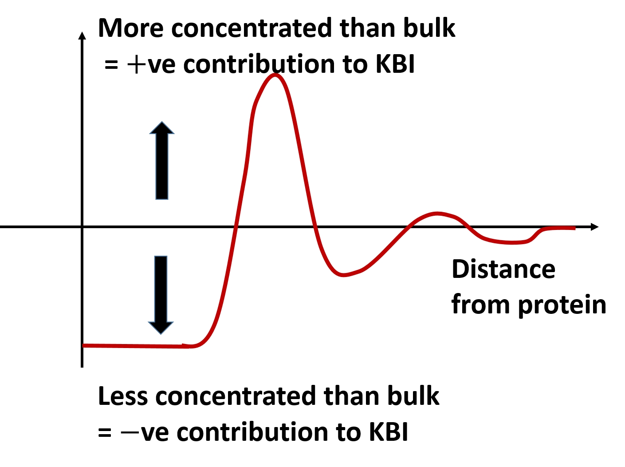
Figure 1. The physical meaning of the protein-flavour Kirkwood-Buff integral (KBI). It is the spatial integration of $g_{PF}\left(r\right)-1$ (red), where $g_{PF}(r)$ is the protein-flavour radial distribution function as a function of protein-flavour distance. KBI is defined as $G_{PF}=∫dr 4πr^{2}\left[g_{PF}\left(r\right)-1\right]$, which means that it consists of positive and negative contributions. The examples of positive and negative contributions are: protein-flavour contact distance (positive) and protein-flavour overlap which cannot happen because of the excluded volume effect (negative). The resultant KBI is the sum of all the positive and negative contributions which stretches over some distance from the protein.

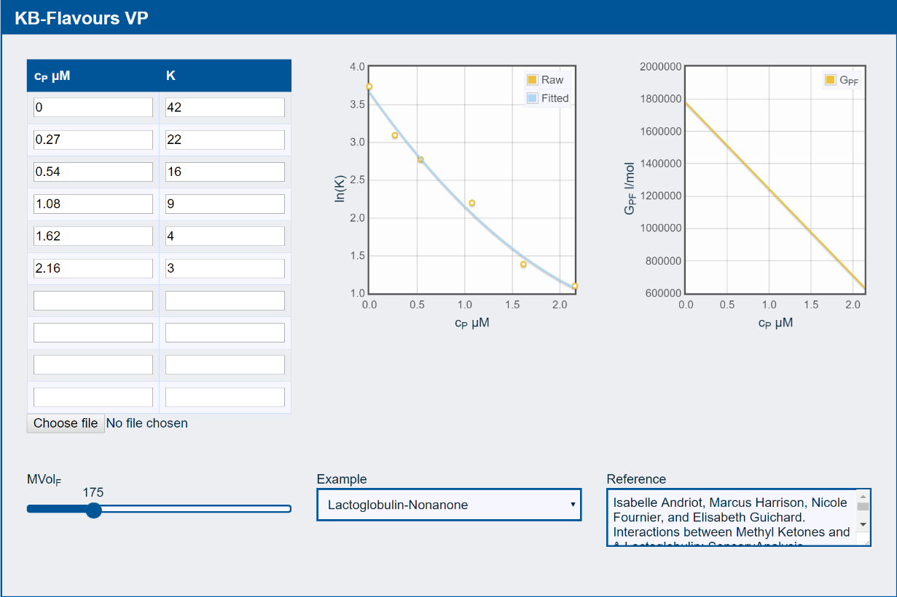

Figure 2. A screenshot of a web-based “app” that can be used interactively to calculate the KBI for protein-flavour interaction $G_{PF}$ from experimental data on the solution-vapour partition coefficient $K$ of the flavor molecule as the function of protein concentration $c_{P}$. The app can be accessed at http://www.stevenabbott.co.uk/practical-solubility/kb-flavours.php.

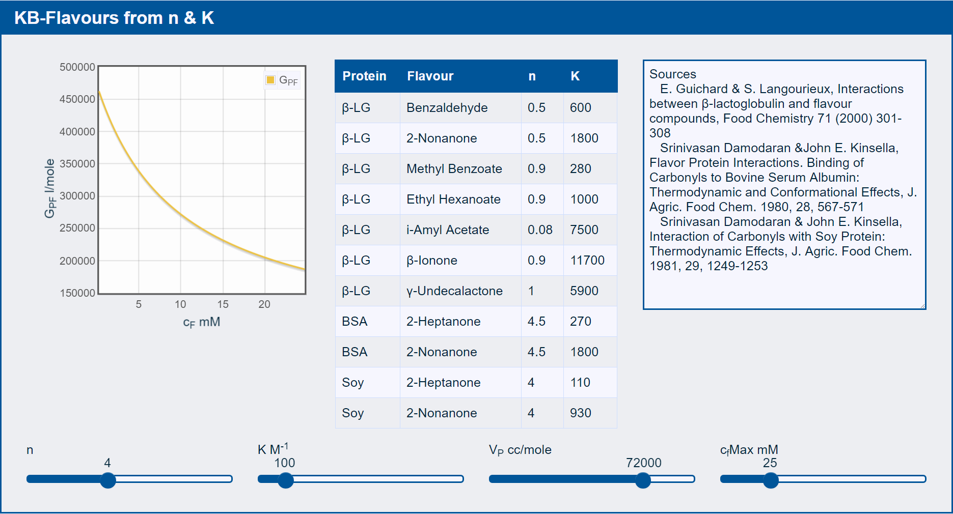

Figure 3. A screenshot of a web-based “app” that can be used interactively to calculate the KBI for protein-flavour interaction $G_{PF}$ using the binding parameters ($n$: number of binding sites and $K$: binding constant) determined from traditional analysis of experimental data using the stoichiometric binding model. The app can be accessed at http://www.stevenabbott.co.uk/practical-solubility/kb-flavours.php. The app lists some historical n and K values from the literature.

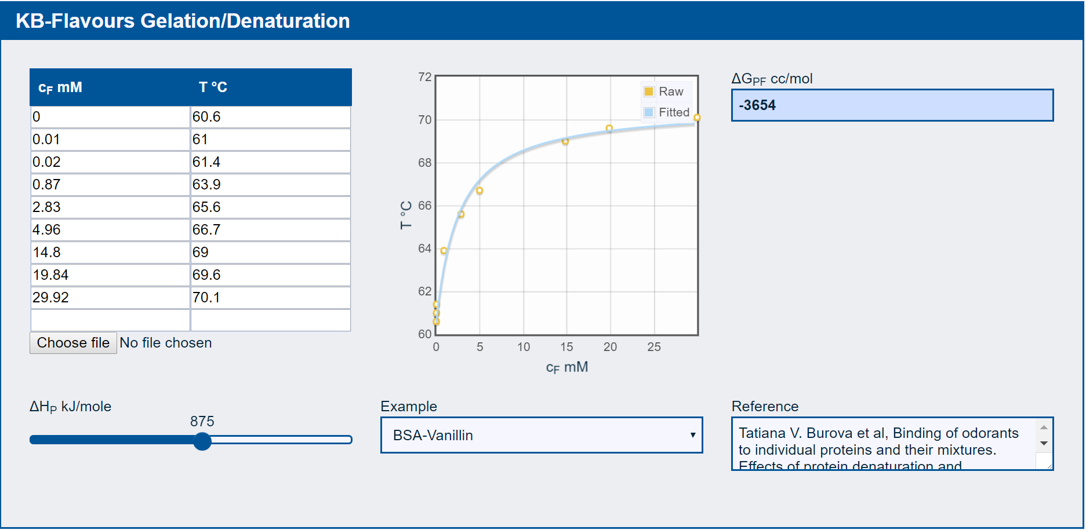

Figure 4. A screenshot of a web-based “app” that can be used interactively to calculate the change in the KBI $ΔG_{PF}$ that accompanies protein-flavour interaction. The app can be accessed at http://www.stevenabbott.co.uk/practical-solubility/kb-flavours.php. All the user has to do is to input the experimental data on denaturation temperature or gel melting temperature as a function of flavour concentration (left) along with the ΔH of the corresponding change in the absence of the flavour molecule. The app calculates the gradient (Eq. (14)) based on the data (centre). The output (right) is valid only at $c_{F}→0$.

