Interactive training and decision support to optimise exercise prescription in cardiovascular disease: the European Association of Preventive Cardiology (EAPC) EXercise Prescription in Everyday practice & Rehabilitative Training (EXPERT) tool

Dominique Hansen, PhD, FESC^{a,b}; Karin Coninx, PhD^{c}; Paul Dendale, MD, PhD, FESC^{a,b}

On behalf of the EAPC EXPERT working group: Luc Vanhees, PhD, FESC; Massimo F. Piepoli, MD, PhD; Josef Niebauer, MD, MBA, PhD; Veronique Cornelissen, PhD; Roberto Pedretti, MD; Gustavo Rovelo Ruiz, PhD; Ugo Corrà, MD; Jean-Paul Schmid, MD; Eugenio Greco, MD, PhD, FESC; Constantinos H. Davos, MD, PhD, FESC; Frank Edelmann, MD; Ana Abreu, MD; Bernhard Rauch, MD; Marco Ambrosetti, MD; Simona Sarzi Braga, MD; Olga Barna, MD; Paul Beckers, PhD; Maurizio Bussotti, MD; Robert Fagard, MD, PhD; Pompilio Faggiano, MD; Esteban Garcia-Porrero, MD; Evangelia Kouidi, MD, PhD; Michel Lamotte, PhD; Daniel Neunhäuserer, MD, PhD; Rona Reibis, MD; Martijn A. Spruit, PhD, FERS; Christoph Stettler, MD; Tim Takken, PhD; Cajsa Tonoli, PhD; Carlo Vigorito, MD, PhD; Heinz Völler, MD, PhD; Patrick Doherty, PhD

ªHeart Centre Hasselt, Jessa Hospital, Hasselt, Belgium
^{b}UHasselt, Faculty of Medicine and Life Sciences, BIOMED-REVAL-Rehabilitation Research Centre, Hasselt University, Belgium
^{c}UHasselt, Faculty of Sciences, Expertise Centre for Digital Media, Hasselt University, Belgium

Full text word count (excluding title page and references): 1080

Address correspondence:
Dominique Hansen, PhD, FESC
Hasselt University, Faculty of Medicine and Life Sciences, BIOMED-REVAL-Rehabilitation Research Centre, Agoralaan Building A, 3590 Diepenbeek, Belgium
e-mail: dominique.hansen@uhasselt.be
Background
As part of multidisciplinary rehabilitation, exercise training is important as it independently leads to improvements in cardiovascular disease (CVD) risk, endurance exercise capacity, muscle strength, quality of life and prognosis in patients with CVD (risk).¹⁻⁴ As a result, exercise training is considered a class 1A intervention in the (secondary) prevention of CVD.^{5,6} According to European recommendations CVD (risk) patients should execute >150 minutes of endurance exercise training per week at a moderate intensity, ideally spread over 3-5 days per week, eliciting an energy expenditure of 1000-2000 kcal per week.^{5,6} Moreover, endurance exercise training should be complemented by resistance exercise training two times per week at a moderate exercise intensity.^{5,6}

Problem statement
These European recommendations provide a relevant guideline in how to prescribe exercise to CVD (risk) patients for clinicians, but must not lead to a one-size-fits-all approach in CV rehabilitation. On the contrary, evidence is accumulating that a different exercise prescription is required according to the severity and type of CVD (risk), and, ideally, this should persuade clinicians to target different goals during CV rehabilitation (i.e. reducing fat mass, improving blood lipid profile, exercise tolerance, glycaemic control, etc).⁷ Tailoring the exercise intervention to each single patient according to his/her specificity is a crucial aspect in this endeavour. However, properly prescribing exercise in different combinations of CVDs and risk factors within the same patient is difficult as this requires integration and prioritisation of different exercise recommendations. Indeed, a large heterogeneity in exercise prescription (exercise type, frequency, volume, intensity, session and programme duration) has been observed between and within different CV rehabilitation units.⁸⁻¹⁵ Clinicians involved in CV rehabilitation are in need of an instrument that assists them in exercise prescription, hereby leading to personalised medicine and better standardisation of exercise intervention.

Interactive training and decision support system for exercise prescription in CVD (risk): the EAPC EXPERT tool
With this in mind, the EAPC, together with Hasselt University (Belgium), constructed an interactive training and decision support system for exercise prescription in patients with CVD (risk): the EAPC EXPERT tool.¹⁶
In 2010-2011, the first initiatives to create a CV rehabilitation decision support scheme were launched in Jessa hospital at Hasselt as clinicians felt that variance in exercise prescription, due to personal preferences, should be minimised. It was however soon realised that such decision support scheme should be digitalised and that an enormous amount of data had to be collected to be able to prescribe exercise in all CVD’s and risk factors that clinicians encounter in rehabilitation programmes. As a result, in 2013, >30 CV rehabilitation experts (EXPERT working group, based on scientific and clinical expertise) out of 11 European countries agreed to collaborate and to deliver state-of-the-art exercise recommendations (based on guidelines and evidence) for CVD (risk). These data were then used to construct an algorithm within an interactive training and decision support system by computer scientists (from the Expertise Centre of Digital Media (EDM) of Hasselt University). Several prototypes with different functionalities were tested and discussed with the EXPERT working group.

Functionalities of the EAPC EXPERT tool
This EAPC EXPERT tool supports two application modes: a recommendation centre and a training centre.
In the EXPERT recommendation centre (see Figure 1 and 2) exercise recommendations are available for ten primary indications for rehabilitation (i.e. coronary artery disease (with or without percutaneous coronary intervention or coronary artery bypass graft surgery), heart failure, cardiomyopathy, intermittent claudication, implantable cardioverter defibrillator or pacemaker, ventricular assist devices, heart transplantation, valve disease or surgery, congenital heart disease, pulmonary arterial hypertension, in-hospital phase rehabilitation), five CVD risk factors (i.e. type 1 and 2 diabetes, obesity, hypertension, dyslipidaemia), and three chronic non-CV diseases (i.e. sarcopenia, chronic pulmonary disease, renal failure). Based on the patient’s medical history, the clinician can activate these CVD’s or risk factors, leading to the corresponding exercise prescriptions. In addition, from fill out of the patient’s body height and weight, arterial blood pressure, blood lipid profile, fasting glycaemia, resting and peak heart rate during exercise testing, and peak oxygen uptake capacity, these CVD risk factors are automatically activated when certain thresholds are exceeded (leading to the corresponding exercise prescriptions). In final, clinicians can also activate certain medications with significant repercussions for exercise prescription and performance (i.e. beta-blockers, statins, exogenous insulin administration, meglitinide/sulfonylurea) and adverse events during exercise testing (i.e. myocardial ischemia, exercise-induced atrial fibrillation, exercise-induced ventricular tachycardia, ICD firing threshold), for further refinement of exercise prescription.
As a result, the EXPERT tool refines exercise prescription for many patient characteristics, medication intake, adverse events during exercise testing, CVDs and risk factors to maximise tailoring and standardisation of exercise intervention. The clinician can adjust this recommended exercise prescription, revise and recalculate during follow-up. Next to exercise training recommendations the EXPERT tool also mentions contra-indications for certain types of exercise, as well as which safety precautions should be taken into account, based on the patient’s profile. These safety advices include which symptoms during exercise training may be anticipated and how to monitor these, and how to adapt training modalities to prevent eliciting/worsening in these symptoms. The EXPERT tool thus not only aims to maximize the clinical benefits of exercise intervention, but also the medical safety.
In the EXPERT training centre (see Figure 3) numerous patient cases (from easy to difficult, but also rare cases) are available. By using this part of the tool, clinicians can train and optimise their exercise prescription skills. The clinician consults the patient’s characteristics. Only after fill out of his/her own exercise prescription, the clinician gets immediate feedback in the tool by showing the recommendations from the EXPERT algorithm.

Opportunities for the cardiovascular rehabilitation community
By use of the EXPERT tool in clinical practice, certain opportunities for the CV rehabilitation community may emerge, but it will be studied further to verify these hypotheses:
- greater clinical effectiveness of CV rehabilitation
- enhanced medical safety of CV rehabilitation
- improved adherence to, or getting to know better, the European exercise prescription recommendations for CVD (risk), leading to lower variance in exercise prescription between different clinicians

Future of the EAPC EXPERT tool
The EXPERT tool is now available via the EAPC website (https://www.escardio.org/Education/Practice-Tools/CVD-prevention-toolbox/EXPERT-Tool) and can be accessed after paying a licence fee. It is hoped that this tool becomes, next to other digital ESC tools, a standard instrument in the cardiology community. The EXPERT tool is updated regularly according to new guidelines or important findings from clinical studies. In addition, new functionalities will be added to the tool and a substantial acceptance rate by healthcare professionals is strived for.

References
1. Rauch B, Davos CH, Doherty P. et al. The prognostic effect of cardiac rehabilitation in the era of acute revascularisation and statin therapy: A systematic review and meta-analysis of randomized and non-randomized studies - The Cardiac Rehabilitation Outcome Study (CROS). Eur J Prev Cardiol 2016; Epub ahead of print.
2. Lewinter C, Doherty P, Gale CP, et al. Exercise-based cardiac rehabilitation in patients with heart failure: a meta-analysis of randomised controlled trials between 1999 and 2013. Eur J Prev Cardiol 2015;22:1504-1512.
3. Sibilitz KL, Berg SK, Tang LH, et al. Exercise-based cardiac rehabilitation for adults after heart valve surgery. Cochrane Database Syst Rev 2016;3:CD010876.
4. Lane R, Ellis B, Watson L, et al. Exercise for intermittent claudication. Cochrane Database Syst Rev 2014;7:CD000990.
5. Piepoli MF, Hoes AW, Agewall S, et al. 2016 European Guidelines on cardiovascular disease prevention in clinical practice. Eur J Prev Cardiol 2016;23:NP1-96.
6. Piepoli MF, Corra U, Benzer W, et al. Secondary prevention through cardiac rehabilitation: physical activity counselling and exercise training: key components of the position paper from the Cardiac Rehabilitation Section of the European Association of Cardiovascular Prevention and Rehabilitation. Eur Heart J 2010;31:1967-1974.
7. Hansen D, Dendale P, van Loon LJ, et al. The impact of training modalities on the clinical benefits of exercise intervention in patients with cardiovascular disease risk or type 2 diabetes mellitus. Sports Med 2010;40:921-940.
8. Bjarnasons-Wherens B, McGee H, Zwisler AD, et al. Cardiac rehabilitation in Europe: results from the European cardiac rehabilitation inventory survey. Eur J Cardiovasc Prev Rehabil 2010;17:410-418.
9. Vromen T, Spee RF, Kraal JJ, et al. Exercise training programs in Dutch cardiac rehabilitation centres. Neth Heart J 2013;21:138-143.
10. Brodie D, Bethell H, and Breen S. Cardiac rehabilitation in England: a detailed national survey. Eur J Cardiovasc Prev Rehabil 2006;13:122-128.
11. Thompson DR, Bowman GS, Kitson AL, et al. Cardiac rehabilitation services in England and Wales: a national survey. Int J Cardiol 1997;59:299-304.
12. McGee HM, Hevey D, and Horgan JH. Cardiac rehabilitation service provision in Ireland: the Irish Association of Cardiac Rehabilitation survey. Ir J Med Sci 1998;170:159-162.
13. Abell B, Glasziou P, Briffa T, et al. Exercise training characteristics in cardiac rehabilitation programmes: a cross-sectional survey of Australian practice. Open Heart J 2016;3:e000374.
14. Tramarin R, Ambrosetti M, De Feo S, et al. The Italian Survey on Cardiac Rehabilitation-2008 (ISYDE-2008). Part 3. National availability and organization of cardiac rehabilitation facilities. Monaldi Arch Chest Dis 2008;70:175-205.
15. Ambrosetti M, Doherty P, Faggiano P, et al. Characteristics of structured physical training currently provided in cardiac patients: insights from the Exercise Training in Cardiac Rehabilitation (ETCR) Italian survey. Mon Arch Chest Dis 2017; in press.
16. Hansen D, Dendale P, Coninx K, et al. The European Association of Preventive Cardiology Exercise Prescription in Everyday Practice and Rehabilitative Training (EXPERT) tool: A digital training and decision support system for optimized exercise prescription in cardiovascular disease. Concept, definitions and construction methodology. Eur J Prev Cardiol 2017; Epub ahead of print.

Conflicts of interest
The Authors declare that there is no conflict of interest.

Funding
The realisation of the proof of concept of the EXPERT tool was supported by an UHasselt IOF PoC project.

Figures
Figure 1 EAPC EXPERT tool recommendation centre
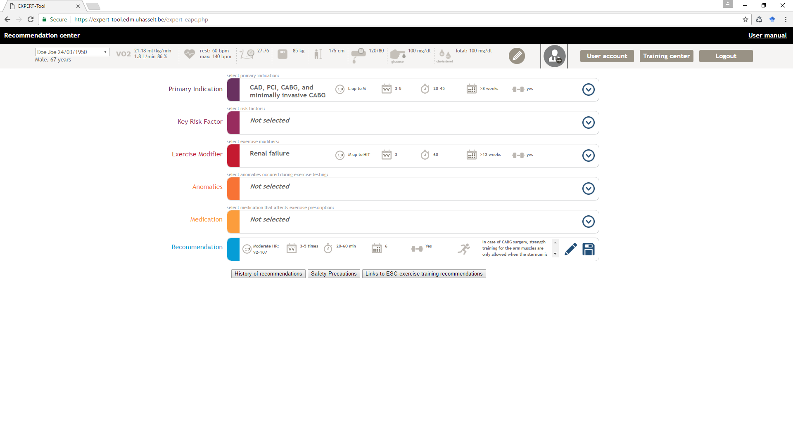

Figure 2 EAPC EXPERT tool exercise recommendation

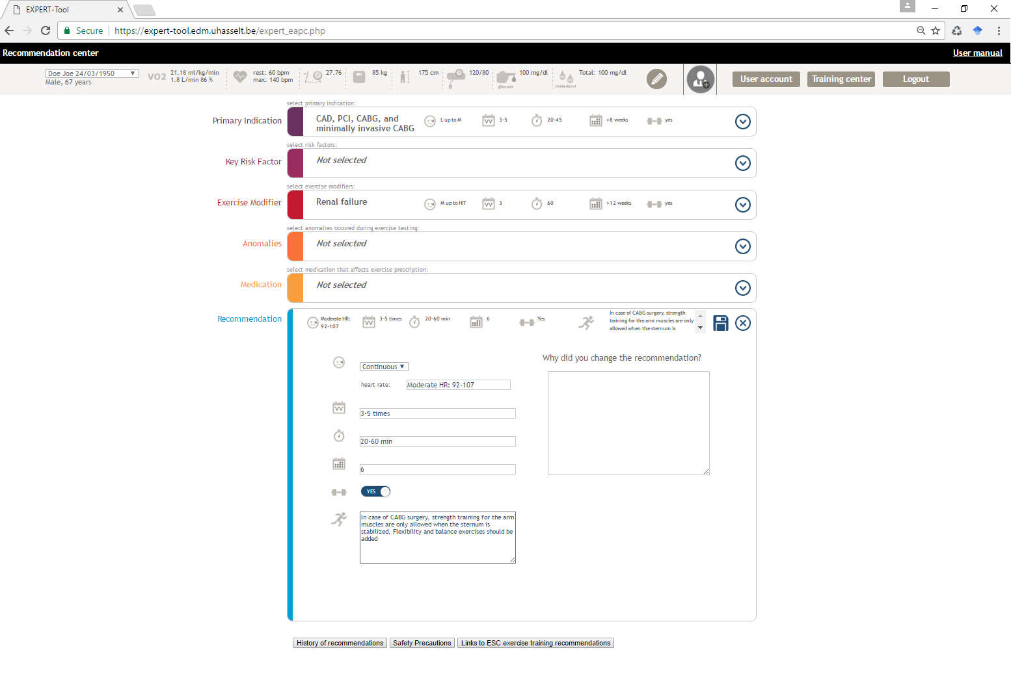
Figure 3 EAPC EXPERT tool training centre
