The effect of the structural architecture of the spacer unit on the incidence of the twist-bend nematic phase in liquid crystal dimers.
Could we the title change to:
Effect of the Linking Unit on the Twist-Bend Nematic Phase in Liquid Crystal Dimers: A Comparative Study of Two Homologous Series of Methylene and Ether Linked Dimers.
And if so, make sure to change it in the SI too!
Craig T. Archbold*, Jessica L. Andrews, Richard J. Mandle, Stephen J. Cowling and John W. Goodby
*Department of Chemistry, University of York, York, UK Email: ca559@york.ac.uk
Abstract
It has been reported that bimesogens composed of rigid aromatic units linked together by methylene spacers of odd parity are more likely to exhibit the twist bend nematic phase in comparison to their analogues in which the spacer chain is linked to the aromatic units by ether moeities. In order to investigate this structure-property correlation bimesogens were prepared consisting of phenyl-benzoate aromatic units and either a heptamethylene or pentamethylene-1,5-dioxy linking group. The nematic to twist-bend nematic phase transitions of these materials were determined either directly or by extrapolation of binary phase diagrams with the standard N_{TB} material CB9CB.It was found that when comparing methylene linked materials to their ether linked analogues, the N-N_{TB} transition temperatures were, in most cases, higher in the ether linked materials. This is contrary to reported theories which predict that the incorporation of ether linkages serves to destabilise the N_{TB} phase.
Two series of bimesogens with rigid phenyl benzoate mesogenic units were prepared: one series having a heptamethylene spacer and the other a pentamethylene spacer with two ether linking groups. These materials were prepared to provide experimental backing to the widely held hypothesis that methylene-linked bimesogens are more likely to exhibit the twist-bend nematic mesophase than their ether-linked counterparts. Several of the methylene linked materials exhibited nematic and N_{TB} mesophases, whereas the analogous ether linked materials gave only nematic phases albeit with significantly higher clearing points. Virtual N-N_{TB} transition temperatures for both methylene and ether-linked bimesogens were extrapolated by constructing binary phase diagrams with the well-studied twist-bend material CB9CB. Contrary to our expectations these virtual transition temperatures were in most cases higher for the ether-linked bimesogens than in the analogous methylene compounds, contrary to reported theories and hypotheses that the incorporation of ether linking groups should serve to destabilise the N_{TB} phase.
NOTE – is that ok? Just tried to make it more abstract-y
Keywords: Liquid crystals, bimesogens, twist-bend nematic.
Introduction
The study of liquid crystal bimesogens, referred to as dimers in the case of symmetrical materials, has seen a large increase in popularity in recent years, primarily due to the propensity of these materials to form the so called "twist-bend nematic" (N_{TB}) phase.^{1–6} This phase, first postulated by Dozov in 2001 ⁷ has been the subject of much debate in current research, with its structure and properties yet to be conclusively determined despite the fact that the nature of this phase has been probed via various analytical techniques including polarised and conoscopic optical microscopy; differential scanning calorimetry, X-ray diffraction (XRD), freeze-fracture transmission electron microscopy (FFTEM), electron spin resonance (ESR), dynamic light scattering (DLS), variable temperature ²H NMR spectroscopy and Raman spectroscopy. ^{8–23} The most widely accepted model of this phase is the heliconical model presented by Dozov, ⁷ in which a spontaneous twist bend deformation of the nematic director results in a heliconical local structure. Recently an elegant resonant small-angle X-ray scattering experiment has provided the first in situ measurement of the pitch length of the twist-bend phase, ²⁴ although several alternative models proposed for the structure of the N_{TB} phase stemming from experimental evidence that has arisen in opposition to the heliconical model.^{25–27}
The vast majority of materials reported to exhibit this mesophase have been dimers or bimesogens where the two mesogenic units are linked by a flexible methylene spacer, ^{1,3,28–40} however trimers,⁴¹ tetramers ⁴² and polymers ⁴³ are also known to exhibit the N_{TB} phase. Recently it has been experimentally demonstrated that the thermal stability of the N_{TB} phase displays a strong dependency on the angle between the two mesogenic units. ⁴⁴ The observation of the N_{TB} phase in ether-linked bimesogens ^{33,34} runs contrary to previous theories on the nature of the relationship between molecular architecture and the N_{TB} phase, which have stated that the bend angle in ether linked materials is too large, thus the bend elastic constant too high, to support the formation of the N_{TB} phase.¹⁴
In this work we present a series of methylene and ether linked materials along with their mesomorphic properties. We use phase diagrams to determine the virtual N-N_{TB} transition temperatures for those materials with no enantiotropic or monotropic N_{TB} phase and discuss the relationship between the physical properties and phase behaviour of the various analogues
Experimental
Compounds 1-6 were prepared as described previously.³¹ Compounds 6-11 were prepared by the Steglich esterification between 1,7-bis (4-hydroxyphenyl)heptane and an appropriate benzoic acid, in a modification of our previously reported synthesis.² Compounds 14-24 were prepared by the Steglich esterification between 4,4'-(pentane-1,5-diylbis(oxy))diphenol ³¹ and an appropriate benzoic acid (Scheme 1).

Scheme 1: Synthetic pathway used to prepare compounds 12-24.
Geometry optimisations of the molecular structure of the products were performed at the B3LYP/6-31G(d) level of theory in Gaussian G09 revision d01.⁴⁵ Small angle X-ray Scattering was performed on a Bruker D8 Discover equipped with a custom built temperature controlled furnace. Full experimental details including Gibb’s phase diagrams for binary mixtures with CB9CB are given in the ESI to this article.
Results and Discussion
Methylene linked bimesogens
A series of materials based on previously published nonamethylene linked liquid crystal bimesogens were prepared. The materials were composed of a heptamethylene spacer unit terminated by two phenyl-benzoate ester mesogenic units. In order to vary the properties of these dimers, the terminal group of the mesogenic units was altered, giving methylene-lined dimers with a heptamethylene spacer and polar end groups. ³¹ Several additional methylene linked dimers with a heptamethylene spacer and apolar terminal groups (namely alkyl and alkyloxy) were synthesised. The mesogenic behaviour of these compounds is reported in Table 1.
 |  | Transition Temperatures / °C
Compound no. | R | Cr |  | N_{TB} |  | N |  | Iso
1 | CN | • | 149.0  [43.18] | (• | 120.0  [0.62] | • | 139.0)  [1.43] | •
2 | SCN | • | 105.0  [36.51] | (• | 103.3)  [0.4] | • | 120.5  [0.18] | •
3 | NO₂ | • | 113.3  [24.22] | - | - | - | - | •
4 | F | • | 91.5  [48.31] | - | - | - | - | •
5 | CF₃ | • | 114.9  [39.15] | - | - | - | - | •
6 | C₂H₅ | • | 71.5  [30.8] | - | - | - | - | •
7 | C₃H₇ | • | 108.0  [33.0] | (• | 47.6  [#] | • | 49.5)  [1.40] | •
8 | C₄H₉ | • | 56.3  [32.0] | - | - | - | - | •
9 | OC₂H₅ | • | 108.3  [58.83] | (• | 95.3)  [0.65] | • | 108.8  [0.54] | •
10 | OC₃H₇ | • | 89.6  [52.80] | (• | 69.1  [1.0] | • | 75.5)  [0.2] | •
11 | OC₄H₉ | • | 87.0  [36.60] | (• | 79.2  [1.2] | • | 85.9)  [0.4] | •
Table 1:Molecular structures and thermal behaviour of compounds 1-11. Monotropic phase transitions are given in parentheses. Transition enthalpies as determined by DSC are in kJ mol⁻¹ and denoted in square brackets.31 # enthalpy unobtainable, transition observed by microscopy whereas during DSC the transition occurred simultaneously with crystallisation
As shown in Table 1 compounds 1 and 2 are the only materials bearing polar terminal groups that were found to be liquid crystalline whereas 3 – 5 were found to be non mesogenic.³¹ Of the six apolar (i.e. lacking a polar terminal group) materials reported in Table 1, four were found to exhibit a monotropic N_{TB} phase; compounds 7, 9, 10 and 11, whereas compounds 6 and 8 were found to be non mesogenic. These are the first apolar bimesogens to exhibit the N_{TB} phase with a heptamethylene spacer, previous compounds have always incorporated a nonamethylene spacer.² When investigated by POM, upon cooling from the amorphous liquid compounds 7, 9, 10 and 11 were found to exhibit schlieren textures with both 2 and 4 brush singularities, which is consistent with the presence of a nematic phase. Upon further cooling a transition to a blocky texture possessing parabolic defects was observed, this texture is characteristic of the N_{TB} phase (Figure 1).¹³
Figure 1: Compound 9 in the nematic phase (a) and N_{TB} phase (b) at 107.9 °C and 93.3 °C respectively. Sample was cooled at 0.1 °C min⁻¹.
DSC was used to further investigate the phase behaviour, a first order transition was observed from the isotropic liquid to the nematic phase whereas the transition from the nematic phase to the lower temperature N_{TB} phase was weakly first order. An example DSC trace (compound 11, obtained at 10 ° min⁻¹) is shown in Figure 2.
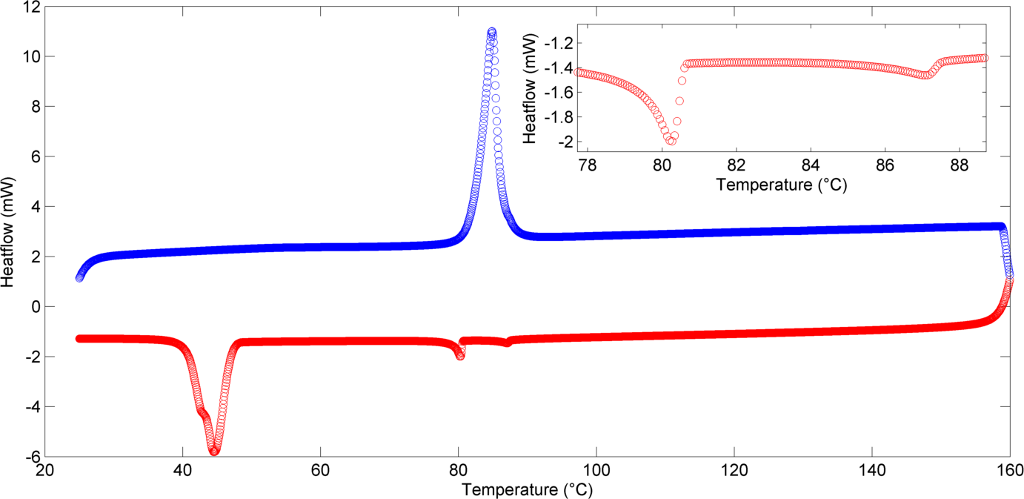
Figure 2: DSC thermogram of compound 11 obtained at a heat/cool rate of 10 °C min⁻¹ with an expansion showing the region between 78 °C and 89 °.

Both the nematic and twist-bend mesophases were also studied via variable temperature X-ray diffraction. Upon cooling from the isotropic liquid to the nematic phase a significant increase in scattered intensity in the small-angle region was observed, and upon further cooling into the N_{TB} phase this peak became marginally more defined. Concerning the wide angle region, the broad diffuse scattering peak in the isotropic liquid becomes both less intense and narrower in the nematic phase before broadening again in the N_{TB} phase. The data obtained for compound 2 is shown in Figure 3.
Figure 3: SAXS data for compound 2, showing scattered intensity (arbitrary units, Z axis), d-spacing (Angstroms, X-axis) and temperature (2 °C steps, °C, Y-axis)
Finally, for all compounds exhibiting a lower temperature phase, the phase was confirmed to be the N_{TB} phase via miscibility studies with compound 1, which itself was shown to unequivocally exhibit this phase through miscibility with CB9CB.³¹
These results are consistent with previous data that has shown that, for apolar bimesogens, the N_{TB} phase is stabilised more by alkyloxy terminal chains than by alkyl chains.² Furthermore, the propyl terminated material is the only one of the three alkyl terminated compounds which exhibits the N_{TB} phase. This mirrors our previous results which show that terminal chains of odd parity give more stable N_{TB} phases than those of even parity. ² We next elected to construct binary phase diagrams between the compounds in Table 1 and CB9CB, allowing extrapolation of virtual N-N_{TB} transitions for materials that do not exhibit the twist-bend phase in their neat state. By assuming a linear relationship between the concentration of the host material and the I-N and N-N_{TB} transitions, something that has been previously demonstrated, ^{3,31,} these phase diagrams were used to calculate the virtual phase transitions for all of the materials, the results obtained are summarised in Table 2. Examples of the phase diagrams are shown for compounds 6 and 8 in Figure 4 ,the remainder of the diagrams are presented in the ESI to this article, while statistical analysis of each the linear fits (for both I-N and N-N_{TB}) is also presented in the ESI (table SI-17).
Figure 4: Example phase diagrams showing the linear relationship between concentration (wt %) and transition temperatures for compounds 6 and 8 with the standard material CB9CB.

 |  | Transition Temperatures / °C
no. | R | Cr |  | N_{TB} |  | N |  | Iso
1 | CN | • | 149.0 | (• | 120.0 | • | 139.0) | •
2 | SCN | • | 105.0 | (• | 103.3) | • | 120.5 | •
3 | NO₂ | • | 113.3 | (* | 66.1 | * | 83.1) | •
4 | F | • | 91.5 | (* | 34.7 | * | 56.6) | •
5 | CF₃ | • | 114.9 | (* | 49.6 | * | 56.4) | •
6 | C₂H₅ | • | 71.5 | (* | 37.1 | * | 40.1) | •
7 | C₃H₇ | • | 108.0 | (• | 47.6 | • | 49.5) | •
8 | C₄H₉ | • | 56.3 | (* | 34.7 | * | 37.9) | •
9 | OC₂H₅ | • | 108.3 | (• | 95.3) | • | 108.8 | •
10 | OC₃H₇ | • | 89.6 | (• | 69.1 | • | 75.5) | •
11 | OC₄H₉ | • | 87.0 | (• | 79.2 | • | 85.9) | •
Table 2: Transition temperatures for compounds 1-11. Virtual transitions determined from phase diagrams are shown in italics and denoted by a "*". Monotropic phase transitions are quoted in parentheses.

Ether linked bimesogens
Replacement of the first and last methylene units of compounds 1 – 12 with ether linking groups gives compounds 14 – 24. In order to limit the number of variables altered the overall length of the spacer unit was kept the same (seven atoms), thus the spacer in these materials contained five methylene units rather than seven and therefore the overall length is comparable. The mesomorphic behaviour of these materials is summarised in Table 3.
 |  | Transition Temperatures / °C
no. | R | Cr |  | N_{TB} |  | N |  | Iso
14 | CN | • | 166.6  [53.52] | (* | 96.8) | • | 189.2  [3.67] | •
15 | SCN | • | 142.8  [35.59] | (* | 87.8) | • | 178.8  [2.27] | •
16 | NO₂ | • | 150.5  [77.26] | (* | 88.3 | (• | 141.2)  [0.13] | •
17 | F | • | 125.1  [50.51] | (* | 48.7 | (* | 85.4 | •
18 | CF₃ | • | 151.4  [51.83] | (* | 25.7 | (* | 49.2 | •
19 | C₂H₅ | • | 116.1  [39.38] | (* | 49.6 | (* | 101.8 | •
20 | C₃H₇ | • | 127.0  [44.63] | (* | 58.6 | (* | 109.3 | •
21 | C₄H₉ | • | 125.4  [63.92] | (* | 43.2 | (* | 89.2 | •
22 | OC₂H₅ | • | 139.9  [57.14] | (* | 89.6) | • | 171.4  [2.9] | •
23 | OC₃H₇ | • | 108.3  [24.82] | (* | 72.9) | • | 143.1  [1.83] | •
24 | OC₄H₉ | • | 109.0  [27.17] | (* | 78.7) | • | 142.2  [1.79] | •
Table 3: General structure and mesomorphic behaviour of compounds 14-24. Monotropic phase transitions are quoted in parentheses. Transition enthalpies are in kJ mol⁻¹ and denoted in square brackets. Virtual transitions are shown in italics and denoted by a “*”.
As shown in Table 3, the introduction of an ether moiety into the spacer chain serves to drastically increase both the melting and clearing points of all of the materials presented. Additionally the N_{TB} phase is suppressed in the neat materials as none of the ether linked materials were found to exhibit this mesophase in their neat state. Similarly to the methylene linked materials a series of phase diagrams were constructed for compounds 14 – 24 with CB9CB, allowing virtual transition temperatures to be determined. The results determined from the linear fits to the experimental data are presented in Table 3 and denoted by an asterisk, with example phase diagrams presented in Figure 5.

Figure 5: Examples of phase diagrams showing the linear relationship between concentration (wt %) and transition temperatures for compounds 22 and 23 and the standard material CB9CB.

For the polar materials, all but compounds 16 and 17 showed a decrease in the virtual N-N_{TB} transition temperature when an ether moiety was included in the spacer unit. Interestingly however, compounds 11 and 12 as well as all of the apolar bimesogens show an increase in the virtual N-N_{TB} transition temperature in comparison to the methylene linked materials. Indeed the apolar materials show a significantly higher transition temperatures in general when an ether linking group is introduced into the spacer unit. The trends observed for the apolar materials fit well with both those observed for the methylene linked materials reported in the previous section, and for nonamethylene spaced materials in previous studies.^{2,31} A plot of the difference between I-N and N-N_{TB} for methylene and ether-linked dimers is given in Figure 6.
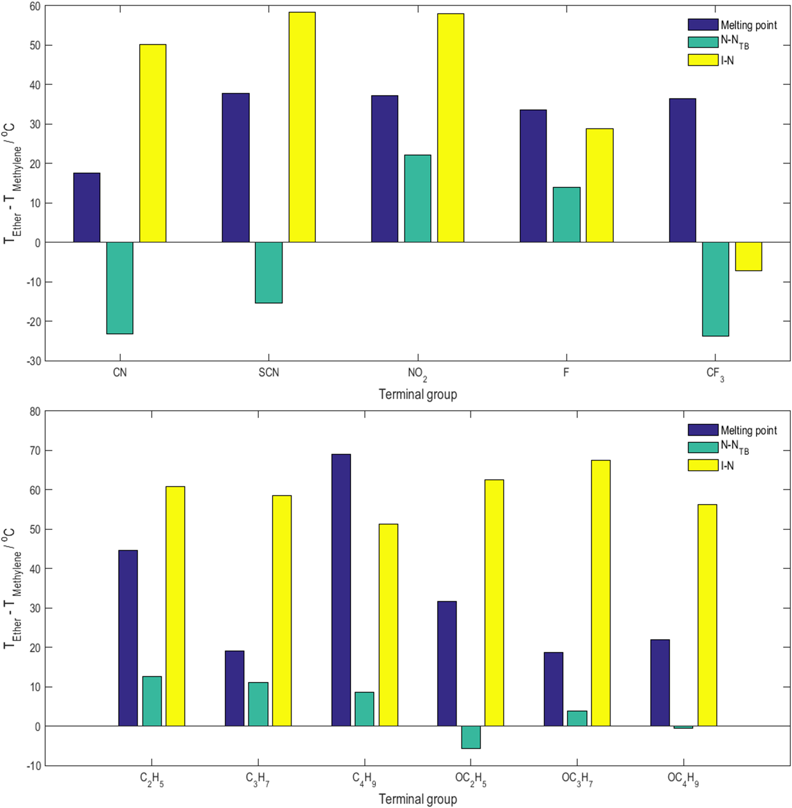
Figure 6: Plots of the difference in transition temperatures between ether and methylene linked materials (T_{ether} - T_{methylene} / °C) for polar (top) and apolar (bottom) terminal groups.

For materials with a polar terminal group the clearing point is significantly higher when the linking group is an ether rather than a methylene group. With respect to the N_{TB} phase, it appears that the trend is a small destabilisation when the methylene unit is replaced by an ether linkage, however increases in transition temperature were observed with nitro (compound 16) and fluoro (compound 17) terminated analogues. For apolar materials, the same increase in clearing point is apparent when the methylene unit is replaced with an ether linking group. For alkyl terminated materials, the virtual N-N_{TB} transition is marginally higher for ether linked systems than for methylene, however in alkoxy terminated materials this trend does not occur. It would appear that although the N_{TB} phase can, for certain compounds, be stabilised by the incorporation of ether linkages in lieu of methylene groups, the observation of the nematic to twist-bend nematic transition in the neat materials is precluded by short ranges of supercooling and high melting points. This runs counter to both established thinking, namely that the introduction of ether linkages should destabilise the N_{TB} phase. For polar materials, however, the etherific compounds showed a generally less stable N_{TB} phase than those with methylene spacers.
The increase in melting and clearing points for the ether linked materials can be attributed to a change in molecular topology upon introducing the ether moiety. As the bond angle of a C-O-C bond is generally larger (≈115-120°) than a C-C-C bond (≈109.5°), the molecules containing an ether linkage will tend towards being more linear in shape compared to their methylene linked analogues.
As a bent molecular architecture is one of the known prerequisites for the formation of the N_{TB} phase a decrease in molecular bend would lead to a destabilising effect on the N_{TB} phase. This increased linearity is also a probable cause for the increase in melting and clearing points of the materials, as the more linear molecules will be able to more effectively pack into a crystal phase and into the nematic phase as opposed to the more bent materials thereby increasing the thermal stability of these phases. This hypothesis is supported through molecular modelling used to calculate the intermesogen angle of both methylene and ether linked dimers (Figure 7), and correlating this with the transition temperatures.
Figure 7: Energy minimised geometries of compounds 1 and 14 showing the differences in intermesogen angle (θ). Geometry optimised at the B3LYP/6-31G(d) level of DFT.
The intermesogen angle of all trans conformer of the ether linked compound 14 is significantly larger, i.e. less bent, than that of the all trans methylene-linked compound 1 (140.8 ° and 106.8 ° respectively). 1D NOESY NMR has been used to show that for both methylene ether-linked dimers the all trans conformers is dominant, ⁴⁴ so while calculating an angle for a single geometry is not as desirable as knowing the full conformational distribution it is still valid in this instance.

Compound 14 has a significantly higher melting point than compound 1, 166.6 °C versus 149.0. The nematic phase of compound 14 is enantiotropic, with a clearing point of 189.2 °C. This is far more stable than the monotropic nematic phase of compound 1, with the isotropic to nematic phase transition occurring at 139.0 °C. This shows that the increased linearity of the ether spaced materials stabilises the nematic phase when compared to the more bent methylene linked dimer. With respect to the N_{TB} phase, compound 14 does not exhibit this phase in it's neat state, however, when the N-N_{TB} phase transition of this material is extrapolated from mixtures with CB9CB it is found to occur at 96.8 °C, almost 25 °C lower than the methylene linked analogue, where the N-N_{TB} transition occurs at 120 °C, demonstrating that the linearity of the molecule does indeed have an effect on the N_{TB} phase stability.
Conclusions
In this study we have shown that the primary barrier to ether linked materials forming the N_{TB} phase appears to be the substantial increase in melting point caused by the increased linearity imparted by etherific linking group as opposed to its more bent, methylene linked counterpart. Although in some cases the introduction of the ether moiety into the spacer chain served to lower the N-N_{TB} transition, in the majority of the materials presented herein the virtual N-N_{TB} transition of the etherific materials actually occurs at slightly higher temperatures than for their methylene linked analogues. This suggests that the molecular bend is an important factor in the formation of the N_{TB} phase, as dimers with spacers of an even parity do not exhibit this phase as these materials are significantly more linear than those with spacers of odd parity. These results complement the recently reported experimental link between the bend-angle of a dimer and the thermal stability of the N_{TB} phase. ⁴⁴
In the same vein the change in transitional properties between the methylene linked and ether linked materials can be inferred to be caused by the change in intermesogen angle, as this is the most significant change when comparing these two groups of compounds. The increased N-N_{TB} transitions in the dimers with more flexible terminal chains (alkyl and alkyloxy) as opposed to the drop observed for most of the materials with inflexible, polar terminal groups suggests that the mobility of these chains serves to disrupt the packing between the molecules, offsetting the higher ordering made possible by the more linear molecular architecture. Although this disruption allows the N_{TB} phase to form more easily, it is still not sufficient to see it in the neat material.
Acknowledgements
CTA thanks the University of York for funding this research through the award of a doctoral scholarship. The authors also recognise the support of the Engineering and Physical Sciences Research Council (EPSRC) via grant codes EP/J007714/1, EP/K039660/1 and EP/M020584/1. Raw data are available upon request from the University of York data catalogue.

References
1. Henderson, P. A. & Imrie, C. T. Methylene-linked liquid crystal dimers and the twist-bend nematic phase. Liq. Cryst. 38, 1407–1414 (2011).

2. Mandle, R. J. Davis, E. J, Archbold, C. T., Voll, C. C. A, Andrews, J. L., Cowling, S. J. & Goodby, J.W.. Apolar Bimesogens and the Incidence of the Twist-Bend Nematic Phase. Chem. Eur. J. 21, 8158–8167 (2015).

3. Adlem, K. M., Luckhurst, G. R., Mertelj, A., Parri, O., Richardson, R. M., Snow, B. D., Timimi, B. A., Tuffin, R. P., Wilkes, D. Chemically induced twist-bend nematic liquid crystals, liquid crystal dimers, and negative elastic constants. Phys. Rev. E 88, 8 (2013).

4. Beguin, L., Emsley, J. W., Lelli, M., Lesage, A., Luckhurst, G. R., Timimi, B. A. & Zimmermann H. The Chirality of a Twist-Bend Nematic Phase Identified by NMR Spectroscopy. J. Phys. Chem. B 116, 7940–7951 (2012).

5. Yun, C. J., Vengatesan, M. R., Vij, J. K. & Song, J. K. Hierarchical elasticity of bimesogenic liquid crystals with twist-bend nematic phase. Appl. Phys. Lett. 106, 5 (2015).

6. Virga, E. G. Double-well elastic theory for twist-bend nematic phases. Phys. Rev. E 89, 10 (2014).

7. Dozov, I. On the spontaneous symmetry breaking in the mesophases of achiral banana-shaped molecules. Europhys. Lett. 56, 247–253 (2001).

8. Blatch, A. E., Fletcher, I. D. & Luckhurst, G. R. Symmetric and non-symmetric liquid crystal dimers with branched terminal alkyl chains: Racemic and chiral. J. Mater. Chem. 7, 9–17 (1997).

9. Gorecka, E., Vaupotic̆, N., Zep, A., Pociecha, D., Yoshioka, J., Yamamoto, J., & Takezoe, H. A Twist-Bend Nematic (N_{TB} ) Phase of Chiral Materials. Angew. Chem. Int. Ed. Engl. 54, 10155–9 (2015).

10. Balachandran, R., Panov, V. P., Vij, J. K., Kocot, A., Tamba, M. G., Kohlmeier, A. & Mehl, G. H. Elastic properties of bimesogenic liquid crystals. Liq. Cryst. 40, 681–688 (2013).

11. Chen, D., Porada, J. H., Hooper, J. B., Klittnick, A., Shen, Y., Tuchband, M. R., Korblova, E., Bedrov, D., Walba, D. M., Glaser, M. A., Maclennan J. E. & Clark, N. A. Chiral heliconical ground state of nanoscale pitch in a nematic liquid crystal of achiral molecular dimers. Proc. Natl. Acad. Sci. U. S. A. 110, 15931–15936 (2013).

12. Chen, D., Nakata, M., Renfan, S., Tuchband, M. R., Shuai, M., Baumeister, U., Weissflog, W., Walba, D. M., Glaser, M.A., Maclennan, J.E. & Clark, N.A. Twist-bend heliconical chiral nematic liquid crystal phase of an achiral rigid bent-core mesogen. Phys. Rev. E 89, (2014).

13. Mandle, R. J., Davis, E. J., Archbold, C. T., Cowling, S. J. & Goodby, J. W. Microscopy studies of the nematic N_{TB} phase of 1,11-di-(1’'-cyanobipheny1-4-yl)undecane. J. Mater. Chem. C 2, 556–566 (2014).

14. Greco, C., Luckhurst, G. R. & Ferrarini, A. Enantiotopic discrimination and director organization in the twist-bend nematic phase. Phys. Chem. Chem. Phys. 15, 14961–5 (2013).

15. Meyer, C., Luckhurst, G. R. & Dozov, I. Flexoelectrically Driven Electroclinic Effect in the Twist-Bend Nematic Phase of Achiral Molecules with Bent Shapes. Phys. Rev. Lett. 111, 5 (2013).

16. Jokissari J. P., Luckhurst G. R., Timimi B. A., Zhu J. and Zimmerman H., “Twist-bend nematic phase of the liquid crystal dimer CB7CB: orientational order and conical angle determined by ¹²⁹Xe and ²H NMR spectroscopy”, Liq. Cryst., 2015, 42, 708-721.

17. Emsley J. W., Lelli M., Joy H., Tamba M.-G. and Mehl G.H., “Similarities and differences between molecular order in the nematic and twist-bend nematic phases of a symmetric liquid crystal dimer”, PCCP, 2016, 18, 9419-9430.

18. Pardaev S. A., Shamid S.M., Tamba M. G., Welch C., Mehl G. H., Gleeson J. T., Allender D. W., Selinger J.V., Ellman B., Jakli A. and Sprunt S., “Second harmonic light scattering induced by defects in the twist-bend nematic phase of liquid crystal dimers” Soft Matter, 2016, 12, 4472-4482

19. Robles-Hernandez B., Sebastian N., Rosario de la Fuente M., Lopez D. O., Diez-Berart S., Salud J., Ros M. B., Dunmur D. A , Luckhurst G. R. and Timimi B. A., “Twist, tilt, and orientational order at the nematic to twist-bend nematic phase transition of 1″,9″-bis(4-cyanobiphenyl-4′-yl) nonane: A dielectric, ²H NMR, and calorimetric study”, Phys. Rev. E, 2015, 92, 062505

20. Tripathi, C. S. P., Losada-Perez, P., Glorieux, C., Kohlmeier, A., Tamba, M. G. & Leys, J. Nematic-nematic phase transition in the liquid crystal dimer CBC9CB and its mixtures with 5CB: A high-resolution adiabatic scanning calorimetric study. Phys. Rev. E 84, (2011).

21. Panov, V. P., Nagaraj, M., Vij, J. K., Panarin, Y. P., Kohlmeier, A., Tamba, M. G., Lewis, R. A. & Mehl, G. H. Spontaneous Periodic Deformations in Nonchiral Planar-Aligned Bimesogens with a Nematic-Nematic Transition and a Negative Elastic Constant. Phys. Rev. Lett. 105, (2010).

22. Wang, Y., Singh, G., Agra-Kooijman, D. M., Gao, M., Bisoyi, H. K., Xue, C., Fisch, M. R., Kumar, S. & Li, Q. Room temperature heliconical twist-bend nematic liquid crystal. CrystEngComm 17, 2778–2782 (2015).

23. Zhang, Z., Panov, V. P., Nagaraj, M., Mandle, R. J., Goodby, J. W., Luckhurst, G. R., Jones, C. & Gleeson, H. F. Raman scattering studies of order parameters in liquid crystalline dimers exhibiting the nematic and twist-bend nematic phases. J. Mater. Chem. C 3, 10007–10016 (2015).

24. Zhu C., Tuchband M. R., Young A., Shuai M., Scarrough A., Walba D.M., Maclennan J. E., Wang C., Hexemer A. and Clark N. A., “Resonant Carbon K-Edge Soft X-Ray Scattering from Lattice-Free Heliconical Molecular Ordering:Soft Dilative Elasticitiy of the Twist-Bend Liquid Crystal Phase.” Phys. Rev. Lett., 2016¸116, 147803.

25. Hoffmann, A., Vanakaras, A. G., Kohlmeier, A., Mehl, G. H. & Photinos, D. J. On the structure of the Nx phase of symmetric dimers: inferences from NMR. Soft Matter 11, 850–855 (2015).

26. Vanakaras, A. G. & Photinos, D. J. A Molecular Theory of the Nematic-Nematic Phase Transitions in Mesogenic Dimers. arXiv:1510.01265v1 [cond-mat.soft] (2015).

27. Gorecka, E., Salamonczyk, M., Zep, A. & Pociecha, D. Do the short helices exist in the nematic TB phase? Liq. Cryst. 42, 1–7 (2015).

28. Henderson, P. A., Niemeyer, O. & Imrie, C. T. Methylene-linked liquid crystal dimers. Liq. Cryst. 28, 463–472 (2001).

29. Cestari, M., Diez-Berart, S., Dunmur, D. A., Ferrarini, A., de la Fuente, M. R., Jackson, D. J., Lopez, D. O., Luckhurst, G. R., Perez-Jubindo, M. A., Richardson, R. M., Salud, J., Timimi, B. A. & Zimmermann, H. Phase behavior and properties of the liquid-crystal dimer 1 ,7 -bis(4-cyanobiphenyl-4 ’- yl) heptane: A twist-bend nematic liquid crystal. Phys. Rev. E. 84, (2011).

30. Archbold, C. T., Davis, E. J., Mandle, R. J., Cowling, S. J. & Goodby, J. W. Chiral dopants and the twist-bend nematic phase - induction of novel mesomorphic behaviour in an apolar bimesogen. Soft Matter , 11, 7547–7557 (2015).

31. Mandle, R. J., Davis, E. J., Voll, C. C. A., Archbold, C. T., Goodby, J. W., & Cowling, S. J.The relationship between molecular structure and the incidence of the N_{TB} phase. Liq. Cryst. 42, 688–703 (2015).

32. Ivšić T., Vinković M., Baumeister U., Mikleušević A. and Lesac A., “Towards understanding the N_{TB} phase: a combined experimental, computational and spectroscopic study”, RSC Adv.”, 2016, 6, 5000-5007, DOI: 10.1039/C5RA26078G
33. Mandle R. J., Davis E.J., Lobato S.A., Vol C.C.A., Cowling S.J. and Goodby J.W., Characterisation of an Unsymmetrical, Ether-linked, Fluorinated Bimesogen Exhibiting a New Polymorphism Containing the NTB or ‘Twist-Bend’ Phase”, PCCP, 2014, 16, 6907 – 6915.

34. Mandle R.J., Voll C.C.A., Lewis D.J. and Goodby J.W., “Etheric Bimesogens and the Twist-Bend Nematic Phase”, Liq. Cryst. 2015, 43, 13 - 21, DOI: 10.1080/02678292.2015.1091095

35. Ahmed Z., Welch C., Mehl G. H., “The design and investigation of the self-assembly of dimers with two nematic phases”, RSC. Adv., 2015, 5, 93513 – 93521.

36. Mandle R.J. and Goodby J.W., “Progression from Nano to Macro Science in Soft Matter Systems: Dimers to Trimers and Oligomers in Twist-Bend Liquid Crystals”, RSC Adv., 2016, 6, 34885-34893.

37. Mandle R. J. and Goodby J. W., “A Twist-bend Nematic to an Intercalated, Anticlinic, Biaxial Phase Transition in Liquid Bimesogens”, Soft Matter, 2016, 12, 1436-1443.

38. Mandle R. J. and Goodby J. W., “Dependence of Mesomorphic Behaviour of Methylene-Linked Dimers and the Stability of the N_{TB}/N_{X} Phase upon Choice of Mesogenic Units and Terminal Chain Length”, Chem. Eur. J., 2016, in press.

39. Zep A., Aya S., Aihara K., Ema K., Pociecha D., Madrak K., Bernatowicz P., Takezoe H. and Gorecka E., “Multiple nematic phases observed in chiral mesogenic dimers” J. Mater. Chem. C., 2013, 1, 46 – 49.

40. Paterson D. A., Xiang J., Singh G., Walker R., Agra-Kooijman D. M., Martinez-Felipe A., Gao M., Storey J.M.D., Kumar S., Larentovich O. D. and Imrie C.T., JACS, 2016, 138, 5283-5289.

41. Mandle R. J. and Goodby J. W., “A Liquid Crystalline Oligomer Exhibiting Nematic and Twist-Bend Nematic Mesophases”, ChemPhysChem, 2016, 7, 967-970, DOI: 10.1002/cphc.201600038

42. Ungar G., Percec V. and Zuber M., “Liquid crystalline polyethers based on conformational isomerism. 20. Nematic-nematic transition in polyethers and copolyethers based on 1-(4-hydroxyphenyl)2-(2-R-4-hydroxyphenyl)ethane with R = fluoro, chloro and methyl and flexible spacers containing an odd number of methylene units”, Macromolecules, 1992, 25, 75-80.

43. Jansze S.M., Martínez-Felipe A., Storey J.D.M., Marcelis A.T.M. and Imrie C.T., “A Twist-Bend Nematic Phase Driven by Hydrogen Bonding”, Angew. Chem. Int. Ed., 2015, 54, 643-636.

44. Mandle R.J., Archbold C.T., Sarju J.P., Andrews J.L., Goodby J.W., “The Dependency of Nematic and Twist-bend Mesophase Formation on Bend Angle”, Liq. Cryst., 2016, submitted

45. Frisch, M. J. Trucks, G. W., Schlegel, H. B., Scuseria, G. E., Robb, M. A., Cheeseman, J. R., Scalmani, G., Barone, V., Mennucci, B., Petersson, G. A., Nakatsuji, H., Caricato, M., Li, X., Hratchian, H. P., Izmaylov, A. F., Bloino, J., Zheng, G., Sonnenberg, D. J., Hada, M., Ehara, M., Toyota, K., Fukuda, R., Hasegawa, J., Ishida, M., Nakajima, T., Honda, Y., Kitao, O., Nakai, H., Vreven, T., Montgomery, J. A. Jr., Peralta, J. E., Ogliaro, F., Bearpark, M., Heyd, J. J., Brothers, E., Kudin, K. N., Staroverov, V. N., Kobayashi, R., Normand, J., Raghavachari, K., Rendell, A., Burant, J. C., Iyengar, S. S., Tomasi, J., Cossi, M., Rega, N., Millam, J. M., Klene, M., Knox, J. E., Cross, J. B., Bakken, V., Adamo, C., Jaramillo, J., Gomperts, R., Stratmann, R. E., Yazyev, O., Austin, A. J., Cammi, R., Pomelli, C., Ochterski, J. W., Martin, R. L., Morokuma, K., Zakrzewski, V. G., Voth, G. A., Salvador, P., Dannenberg, J. J., Dapprich, S., Daniels, A. D., Farkas, Ö., Foresman, J. B., Ortiz, J. V., Cioslowski, J. & Fox, D. J. Gaussian 09, Revision D.01. Gaussian 09, Revision A.02 (2009).

