Table 1. Description of Medication Harm and Benefit Formats
Information Type | Format  Type | Probability of  Harm/Benefit | Format  Description
Harm | Non-numeric |  | The table included the header “What side effects can the medication cause?” followed by the list of side effects shown in Figure 1 with no frequency information provided.
Harm | Numeric:  Frequency | High | This format is shown in Figure 1.
Harm | Numeric:  Frequency | Low | This format was identical to that shown in Figure 1 except side effect frequency was cut in half (i.e., 7,000; 3,500; 3,500; 200; 25; 1)
Benefit | Non-numeric |  | The table included the header “How can the medication help?” followed by the statement “It reduces the risk of having a heart attack or stroke.”
Benefit | Numeric: Risk Difference | High | This format is shown in Figure 1.
Benefit | Numeric: Risk Difference | Low | This format was identical to that shown in Figure 1 except benefit probability was cut in half (i.e., 1,125 fewer heart attacks or strokes.
Benefit | Numeric: Risk With and Without Treatment | High | The table included the same information as the Non-numeric Format followed by the statement “Among a group of people followed for 10 years, 1.95% of those who took the medication had a heart attack or stroke, compared to 5% of people who did not take the medication.”
Benefit | Numeric: Risk With and Without Treatment | Low | This format was identical to that described above except benefit probability was cut in half (i.e., 1.95% was replaced with 3.9%).

Table 2. Regression of primary and secondary outcome variables on group assignment and control variables
Predictor Variable | Outcome Variable
 | Likely to Take Medication | Medication is Safe | Medication is Likely to Help | Medication is Likely to Cause Side-Effects | Medication Benefits Outweigh Risks | Likely to Recommend Medication to Others
Model R² | .106 | .182 | 0.094 | 0.078 | 0.102 | 0.109
Numeric Risk Information  (Ref: Non-Numeric) | 0.77 (0.11)**** | 0.95 (0.08)**** | 0.38 (0.09)*** | -0.50 (0.09)**** | 0.84 (0.11)**** | 0.68 (0.11)****
Numeric Benefit Information  (Ref: Non-Numeric) | -0.52 (0.13)**** | -0.23 (0.10)* | -0.76 (0.11)**** | 0.29 (0.11)** | -0.52 (0.12)**** | -0. 64 (0.12)****
(table continued on next page)

Predictor Variable | Outcome Variable
 | Likely to Take Medication | Medication is Safe | Medication is Likely to Help | Medication is Likely to Cause Side-Effects | Medication Benefits Outweigh Risks | Likely to Recommend Medication to Others
Socio-Demographic Characteristics
Age (yrs) | -0.01 (0.005)* | -0.009 (0.004)* | 0.001 (0.004) | -0.004 (0.004) | -0.006 (0.005) | -0.01 (0.005)**
Male  (Ref: Female) | 0.29 (0.11)* | 0.16 (0.08) | -0.02 (0.09) | -0.27 (0.09)** | 0.09 (0.11) | 0.26 (0.11)*
White  (Ref: Non-white) | 0.25 (0.12)* | 0.39 (0.09)**** | 0.03 (0.10) | -0.44 (0.10)**** | 0.17 (0.12) | 0.005 (0.12)
College Graduate  (Ref: Not College Graduate) | 0.18 (0.11) | 0.10 (0.08) | -0.06 (0.09) | -0.01 (0.09) | 0.07 (0.10) | 0.09 (0.10)
Health Status | 0.08 (0.06) | 0.12 (0.04)** | 0.13 (0.05)* | -0.04 (0.05) | 0.10 (0.06) | 0.16 (0.06)**

Predictor Variable | Outcome Variable
 | Likely to Take Medication | Medication is Safe | Medication is Likely to Help | Medication is Likely to Cause Side-Effects | Medication Benefits Outweigh Risks | Likely to Recommend Medication to Others
Takes Medications  (Ref: Does Not Take Medications | 0.58 (0.12)**** | 0.53 (0.09)**** | 0.47 (0.10)**** | -0.14 (0.10) | 0.45 (0.11)**** | 0.59 (0.12)****
Had Serious Medication  Side-Effect  (Ref: No Serious Medication Side Effects) | -0.17 (0.14) | -0.08 (0.10) | -0.16 (0.12) | 0.33 (0.11)** | -0.10 (0.13) | -0.19 (0.13)

Note: Reference groups are indicated by Ref. Health status was assessed on a 5-point scale that ranged from 1=Poor to 5=Excellent.
*p < 0.05 **p < 0.01 ***p < 0.001 ****p < 0.0001
Figure 1. Example of Experimental Materials
How can the medication help?
It reduces the risk of having a heart attack or stroke. Out of 100,000 people who take this medication, 2,250 fewer people would have a heart attack or stroke.
What side effects can the medication cause?
Out of 100,000 people who take this medication, the following number of people would have the side effects shown.
14,000 | Dry mouth
7,000 | Constipation
7,000 | Headache
400 | Stomach upset
50 | Dizziness
2 | Muscle damage leading to a very serious condition called rhabdomyolysis

Figure 2. Adjusted Means for Primary and Secondary Outcome Variables by Medication Side-Effect Format Condition
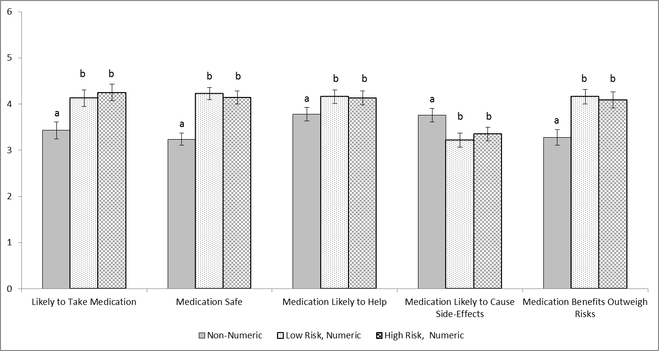
Note. For each outcome variable, the difference in means between groups that share a common superscript are not statistically significant at p < 0.05. Means are adjusted for: medication benefit format condition, age, gender, education, health status, current medication use, and experience of a serious medication side-effect. Error bars show 95% confidence intervals.
Figure 3. Adjusted Means for Primary and Secondary Outcome Variables by Medication Benefit Format Condition
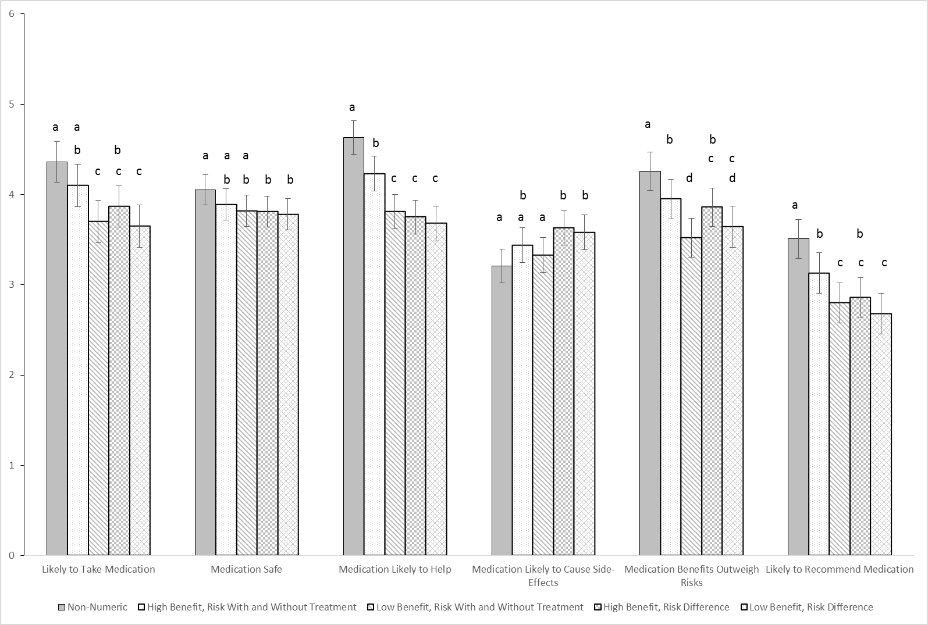
Note. For each outcome variable, the difference in means between groups that share a common superscript are not statistically significant at p < 0.05. Means are adjusted for: medication side-effect format condition, age, gender, education, health status, current medication use, and experience of a serious medication side-effect. Error bars show 95% confidence intervals.

