Creating Better Doctors: exploring the value of learning medicine in primary care

Elizabeth Newbronner 1, Rachel Borthwick 2, Gabrielle Finn 3, Michael Scales 4 & David Pearson 5

1 Firefly Research & Evaluation & PhD Student, Department of Health Sciences, University of York
2 Clinical Research Officer, Castleford, Normanton and District Hospital (formerly Firefly Research and Evaluation).
3 Senior Lecturer, Hull York Medical School
4 GP Principal and Clinical Lecturer, University of Leeds School of Medicine
5 GP & Honorary Professor (Primary Care Education) Hull York Medical School

Corresponding Author:
Elizabeth Newbronner (c/o Head of Department)
Department of Health Sciences
Area 2 Seebohm Rowntree Building
University of York
Heslington
York
YO10 5DD
Phone/Fax: 01751 798927
Email: liz@firefly-research.co.uk or evn505@york.ac.uk

Abstract
Background: Across the UK, 13% of undergraduate medical education is undertaken in primary care (PC). Students value their experiences in this setting but uncertainty remains about the extent to which these placements influence their future practice.
Aims: To explore the impact of PC based undergraduate medical education on the development of medical students and new doctors as clinicians, and on students’ preparedness for practice.
Methods: Mixed method study across two UK medical schools. Focus groups and individual interviews with Year 5 medical students, Foundation Year 2 doctors and GP Specialty Trainees; online surveys of Year 5 medical students and Foundation Year 2 doctors.
Results: PC placements play an important part in the development of all ‘apprentice’ doctors, not just those wanting to become GPs. They provide a high quality learning environment, where students can: gradually take on responsibility; build confidence; develop empathy in their approach to patient care; and gain understanding of the social context of health and illness.
Conclusions: The study indicates that for these results to be achieved, PC placements have to be high quality, with strong links between practice-based learning and teaching/assessment in medical school. GP tutors need to be enthusiastic and students actively involved in consultations.

Key Words
General practice; primary care; medical students; undergraduate medical education; placements.

Status Box
What is already known in this area:
Students value their experiences in primary care and there is growing evidence that undergraduate education in primary care makes an important contribution to students’ development as clinicians and their preparedness for practice.
What this work adds:
- Primary care placements were acknowledged by medical students to provide a safe, supportive, high quality learning environment.
- They support future doctors to develop an holistic, patient - centred approach, with awareness of the social context of ill-health and increased empathy for the patients they see.
- They help students prepare for practice as a doctor, especially in the development of their clinical decision making, confidence and judgement.
- These findings are consistent both amongst those choosing GP careers and those entering other specialties.
Suggestions for future work or research:
- More in-depth outcome-based work on how learning medicine from complex conditions may allow more sophisticated clinical reasoning including a more nuanced, patient-centred approach, and doctors with less tendency for investigation, testing and referral.
- Further exploration of ways to add value to students’ time in primary care by focusing on the unique strengths of such placements, particularly patient and family perspectives, understanding of social and psychological context, communication and shared decision making, and long term complex conditions.

Introduction
Across the UK, 13% of undergraduate medical education is undertaken in primary care [1], a figure unchanged for a decade. Students value their experiences in this setting [2,3,4,5] and a growing body of research examines the contribution undergraduate education in primary care makes to students’ development as clinicians and their preparedness for practice as doctors in all settings [6,7,8,9]. Uncertainty remains about the extent primary care placements during doctors’ undergraduate years influences their career intentions and future practice [10,11]. Health Education Yorkshire and the Humber (HEY&H) commissioned research at two UK schools (Hull York & Leeds) to explore the impact and perceived value of primary care based undergraduate medical education on:
- Medical students’ and new doctors’ development as clinicians
- Medical students’ preparedness for future practice
- Career intentions and career pathways in the early years after qualification.
This paper covers the findings from the first two of these areas.
At Hull York Medical School (HYMS) students cover approximately 33% of their curriculum within primary care placements. These include 50% of early clinical placements (Years 1 & 2), 25% of integrated clinical placements (Years 3 & 4), and 33% of final year placements (Year 5). Students undertake placement in groups of four, except during final year individual placements (apprenticeship model).
The University of Leeds’ School of Medicine [Leeds] has primary care placements throughout its five year undergraduate course with learning outcomes becoming more complex as students’ progress along their spiral curriculum. Years 1 and 2 have 50% of early placements in primary care (Years 1& 2) with 20% of all clinical placements across later years (Years 3, 4 and 5). Year 3 are individual student placements; other placements are in groups of four.
HYMS and Leeds fall at the higher end of the spectrum of primary care based learning across UK medical schools, (UK mean 13%, range 3% to more than 30%) [12,1].

Methods
This mixed methods study involved focus group and individual interviews with students at three stages of career development - final year undergraduate, foundation year 2, and speciality GP training, plus online surveys of Year 5 medical students and Foundation Year 2 (FY2) doctors. The study was conducted in Yorkshire and Humber at HYMS and Leeds within 2014/15.
Scoping literature review of English language publications since 2003 examined the value and/or impact of primary care based medical education. 2915 references from searches of 12 bibliographic databases revealed 353 papers considered potentially relevant; with 158 sufficiently focused to be included. A curricula review across the two medical schools explored the amount and nature of primary care teaching.
Individual and focus groups interviews:
- Final year students were recruited via their medical schools for four focus groups in Leeds (2), Hull (1) and York(1). 28 students took part (11 male, 17 female).
- Foundation Year 2 doctors in the region who graduated from HYMS or Leeds were invited to telephone interview. Four FY2s interviewed (all HYMS’ graduates).
- First year GP Specialty Trainees in the region who were HYMS’ or Leeds’ graduates were recruited for two focus groups. Ten took part (seven Leeds’, three HYMS’), representing 12% of HYMS/Leeds first year GPSTs.
Focus group and interview topic guides had five sections: overall experiences of different primary care placements; impact on development as a clinician; preparedness for practice; career intentions; and wider questions (e.g. ideas for placement improvement). They were conducted by two team members (LN & RB); neither are doctors, or work in medical education. This helped reduce bias. They were recorded and transcribed verbatim. Transcripts were thematically analysed using a ‘Framework’ approach [13]. Analysis was undertaken by two members (LN & RB), with initial findings discussed and developed with the research team. Findings helped inform the online survey (below).
Online surveys of final year students and Foundation Year 2 doctors (HYMS’ or Leeds’ graduates) helped quantify key issues emerging from focus groups and interviews. There were 102 responses to the student survey (25% response rate), 27 to the FY2 survey (12% response). The profile of respondents corresponded with the two medical schools’ intake, both for male/female balance and proportion of students with a prior degree.

Results
Importance of primary care placements
Most respondents thought the balance between primary and secondary care placements in their undergraduate curricula was about right (83% Year 5; 70% FY2 doctors). Similar percentages indicated that, overall, primary care placements had been important or very important to their development as a doctor (Figure 1). As one foundation doctor commented: ‘I think the balance between PC and hospital placements was about right. I know I don’t want to be one [a GP] but I do appreciate how important it was’ (FY2)

[Insert Figure 1 here]

A high quality learning environment
Across all groups of study participants, four elements were highlighted within a ‘good’ placement:
Students allowed to conduct consultations. Focus group and interview participants from all stages of training reinforced survey findings, highlighting the value of ‘taking the reins’ in consultations: ‘In fifth year when you have seen your own patients, that's when you started to feel a bit more like a doctor and practise more independently and you aren't observing, you're sort of running the clinic.’ (GP Specialty Trainee)
Tutor enthusiasm. The vast majority of survey respondents thought tutor enthusiasm was an important or very important element in a good placement. Students valued tutors taking a genuine interest in their learning:
Whether a GP placement is good or not, it depends so much on the GP and whether they want to engage with the students and try and teach. If the GP, after consultation, takes their time to kind of discuss or maybe to ask questions and then to discuss those thought processes. For me, that is when I really learn, when they share those insights. (Year 5 student)
Alignment with curriculum Participants highlighted that ‘good placements’ offered an explicit link between learning in the placements and teaching/assessment in medical school. The role of clinical educators in practices was highly valued in achieving this connection.
Developing a relationship with the tutor. Participants from all stages of training valued one-to-one time with their GP tutor (opportunity to be observed, receive individual feedback) and the individual longitudinal relationship (increased how focussed and trustworthy the feedback was).
...you’ve got a GP sitting right next to you while you’re going through the history and examining the patient and explaining the management process. So they can see actually everything that you’re doing and give you a really detailed feedback on that. So I think as a learning opportunity, that’s fantastic. You don’t get that anywhere else. (Year 5 student)

[Insert Figure 2 here]

Range of patients.
Participants reflected on the value of seeing a range of patients and the depth of contact. This offered learning opportunities not available within secondary care placements.
Because you got quite a really quick turnover of patients, there’s a lot of learning opportunities if you’re allowed to get involved with the consultation. Sort of every 10, 15 minutes there’s something new for you to try and do and you just don’t get that sort of speed of turnover in secondary care, even in acute medicine. (Year 5 student)
This turnover offered ‘the real world’ of medicine and required students to keep knowledge fresh, perhaps having to recall and use learning from earlier in their course. Participants highlighted the nature of conditions seen, including chance to ‘recognise the normal’ and see patients with common conditions not seen elsewhere. ‘GP also teaches you to notice well patients because otherwise, you lose perspective because everybody you see in hospital is ill, because that’s why they’re there, whereas GP, a lot of the patients you see actually aren't that ill’ (Year 5 Student).
Primary care was considered an important setting for learning about long term conditions and their management, not something easily learned in secondary care. More specifically, it helped them appreciate the complexities of living with a long term condition or multiple morbidities.
One of the main things that I learned from primary care placements is more about the chronic diseases. So a lot about diabetes, a lot about COPD, how they’re managed in the community. Whereas in hospital, it’s kind of like, ‘Oh, this person has diabetes’, and then, they just move on. Like, you don’t normally learn from it unless you’re actually doing a diabetes placement. You get a much broader overview in primary care of chronic conditions. (Year 5 Student)
Developing as a clinician
The survey results show that primary care placements make a major contribution to the participants’ development as clinicians (Figure 3). Focus groups and interviews highlighted ways primary care placements helped students’ development. Some areas of learning were focused on at different times; e.g. early years, basic clinical and communication skills; later years, clinical reasoning.

[Insert Figure 3 here]

The survey asked how helpful primary care placements were to learning and development in ten areas (Figure 4). Areas of importance highlighted were: developing skills in history taking, managing long term conditions, and clinical decision making and developing management plans, closely followed by making a diagnosis and recognising the normal.

[Insert Figure 4 here]

Consultation skills
Many participants believed primary care placements offered an opportunity to develop core consultation skills in a real world situation, with time pressures and complexities. GP tutors could make sure students were going through the process correctly, and provide feedback. Participants commented (focus groups/interviews) primary care was a safer environment in which to make and learn from mistakes, enhanced by longer placements and relationship continuity with the GP tutor:
I think if you make a mistake in a GP they say, ‘Oh okay, well you could that or you could look at it this way’, whereas in hospital, I certainly felt as a medical student, I felt completely belittled in hospital by most of the people I was working with. It's awful but it's true. (GP Specialty Trainee)
Participants from all stages of training felt primary care placements were very important for improving communication with patients, especially interviewing skills and shared decision making. This reflected observed behaviours; both the language used in consultations but also observed empathy and trust with patients.
There are limits of what you can actually do for somebody and a lot of it is just spending a bit of time with somebody, showing a bit of kindness and understanding, isn't it? Just to help move them through what they're going through. They've [GPs] obviously had that time to build up relationships and respect with that patient and that's enough sometimes. (GP Specialty Trainee)
Participants suggested students were more likely to see good examples of communication with patients in general practice than hospital, and observe how difficult consultations involving breaking bad news or asking sensitive questions might be handled well. They benefited from working one-to-one with a patient, helping them feel more like ‘apprentice doctors’ than students. They were then better prepared for communicating with patients in secondary care.

Primary care placements offered a valued insight into the social context of health care, in particular through seeing patients in their homes and understanding their family circumstances. One student highlighted the importance of observing GPs who care for patients in a very holistic way:
It's made me think, in every single consultation I do in hospital now, I will always ask something along the lines of, ‘what support have you got, what's going on at home?’, which I think if I hadn't have had the experience that I've had at GP, I wouldn't always think to ask that. I see that as important as everything else. It's influencing your discharge and everything. (Year 5 student)

Clinical decision making
Placements in general practice enabled students to develop clinical decision making skills, and specifically deal with uncertainty in relation to clinical decision making:
In the hospital, it’s very easy to rely upon tests results and investigations whereas in general practice….you’ve only got to rely upon your clinical acumen and ability to take a good history and examine well to work out whether this patient needs treatment, whether they don’t, whether they need admission. (Foundation Year 2 Doctor)
‘Real world’ decision making involving co-morbidity is also enhanced:
[You can learn] how complicated patients can be because when they come into hospital it tends to be just one problem whereas in the GP it's sort of trying to manage everything. So I guess you start to learn the importance of looking at all the co-morbidities and other problems. (GP Specialty Trainee)
Many final year students said primary care placements offered more opportunities to practise developing management plans than secondary care equivalents, although some were frustrated when GP tutors were reluctant to provide this responsibility. Students valued long term primary care placements which enabled them to observe the consequences of decisions they made, for example, and whether a patient was happy with the treatment choice.

Preparedness for practice
At both HYMS and Leeds, primary care offers the only placements that students have across five years of study, giving students an opportunity to gauge their progress towards being qualified doctors.
In third year, like, histories and stuff like signs and symptoms, beginning to do diagnosis. Fourth year was much more about, like, management, beginning to, like, do the diagnosis and go a step further. And in fifth year, you’re pretty much expected to do all the management and I’d say…that’s something, the placement I’ve just done, I got much much better at having the confidence to go as far as management. (Year 5 student)
Almost two thirds of final year students, and half of FY2 doctors, believed primary care placements had been ‘important’ or ‘very important’ in preparing them for practise as doctors (Figure 5).

[Insert Figure 5 here]
Survey data (Figure 6) indicated that the most valuable contributions of primary care placements to students’ preparation for practice were communicating with patients, sharing decision making with patients and developing confidence as a clinician.

[Insert Figure 6 here]

Primary care placements played an important role in students developing confidence as clinicians, through exposure to the ‘real world’ of caring for patients, dealing with uncertainly and complexity, making more decisions and taking more responsibility.
It’s a massive, massive confidence booster when you can see a patient taken all the way through to management and explanation, and [the] GP just comes in and says, ‘Yeah, perfect’. And then, they just go home. That’s really awesome because you kind of like sit there at the end and you’re like, ‘Oh, I can do this. I can be a doctor’. (Year 5 student)
Confidence gained in primary care placements was carried over into hospital placements.
I’m quite glad that I started fifth year on my GP placement because it felt like I gained my confidence back up with my consultation skills. And actually now, when it is a bit more hectic on the wards I'm a bit more, like, I can sort of go dive in. (Year 5 student)
GP Specialty Trainees agreed primary care placements helped them develop confidence as a clinician and better prepared them to accept more responsibility, although some suggested the transition remained challenging: ‘I started on nights as a surgical house officer and I think absolutely nothing could prepare you for that’ (GP Specialty Trainee).

Discussion
Previous work in this field has highlighted the variability of students’ experiences in primary care [14,15]. Placements are often polarised into either ‘good’ or ‘bad’ experiences, with negative experiences being difficult to reverse [2]. This study found that participants were mainly positive about their primary care experiences but some were concerned about variability in placement quality and suggested poor placements could have a negative impact. ‘Good’ placements were ones where there were opportunities to build one-to-one relationships with GP tutors and where tutors were enthusiastic teachers. These findings echo previous work which has suggested that students benefit from the close relationships developed with their primary care tutors [4,5,7,16,17] and that the enthusiasm and attitude, as well as teaching ability, of primary care tutors appears to significantly affect students’ views about primary care, as well as their learning [2,4,14,18,19].
Being able to ‘take the reins’ in consultations and having direct patient contact were also highlighted in this study as important aspects of a high quality primary care placement. This supports previous work which has also found that students’ level of involvement - being ‘actors’ rather than ‘observers’ - makes a substantial difference to the quality of primary care experiences [17,20,21,22] and is a significant factor in whether a placement is considered good or not [2,23].
The importance of primary care placements for seeing a range of patients and conditions was highlighted in this study, particularly ‘recognising the normal’ and encountering long term conditions. Previous work has also found that students view primary care experiences as valuable for seeing patients with a wide variety of common and long term conditions [16,20,24, 25,26] and gain confidence in managing these conditions [27,28,29]. The value of longer term placements in relation to enabling students to see the effects of their management decisions, highlighted by this study’s participants, has also been reported elsewhere [30]. Longitudinal placements in primary care may be one way of ensuring students see acute and chronic presentations in a joined up way [31].
One of the main ways students are enabled to develop as clinicians in a primary care setting is through the opportunity to practise consultation skills with patients e.g. taking histories [20, 26,32,33]. Previous research has also found that communication skills are improved through placements in primary care, particularly through being able to practise directly with patients [30,32,34]. Likewise, in this study, primary care placements were seen as opportunities to develop consultation skills in an environment that was real but nevertheless safe and supported, and participants appreciated the chance to hone their interviewing skills as well as learn from good examples of communication from their GP tutors.
Previous work suggests that placements in primary care can benefit students by enabling them to see patients in their own environment which is often very different to the hospital setting [2,25,35]; an outcome which was also found in this study. Students gained insight through seeing patients in the context of their own lived experience.
Primary care placements had helped participants in this study to deal with uncertainty in relation to clinical decision making. Other studies also suggest that students learn how to deal with uncertainty in diagnosis in primary care and provides an opportunity for them to observe the complexities doctors face in clinical practice (26,36].
The findings of this study indicate students can build confidence as clinicians within primary care placements. Students’ confidence in relation to practising as doctors is increased through experience in a primary care setting [27,38,39], with some suggesting that this occurs through actively engaging in consultations with patients [20,21].

Conclusions
Primary care placements help create better doctors. They play an important part in the development of all ‘apprentice’ doctors, not only those wishing to become GPs. They help medical students prepare for practice in ways other placements may not. They provide a safe learning environment, where students can gradually take on more responsibility and develop confidence and judgement as clinicians. Significantly, with the increasing emphasis in healthcare on the ‘partnership’ between clinicians and patients, they enable students to develop and maintain empathy in their approach to patient care, and provide a greater understanding of the social context of health and illness.
However, for these things to be achieved, primary care placements have to be high quality, with strong links between practice-based learning and teaching/assessment in medical school. GP tutors need to be enthusiastic and students need to be actively involved in consultations and other activities within the practice.
Students’ final year primary care placements should be explicitly geared to help students prepare for practice with the best qualified GPs actively involved in this crucial education. These placements create immediate gain but also have long term influence both on attitudes to patients and skills in complex decision making. Investment should be made to build on these short and long term goals.

Additional information
Strengths and limitations
The research was conducted across two medical schools, serving three million people in Yorkshire and Humber, UK. In both schools the percentage of learning taking place in primary care exceeds the UK average. Whilst the number of participants was not large (n=129 surveys; n=42 interviews/focus groups), and the response from FY2 doctors was poor, the response rate to the Year 5 survey and the range and number of participants in the qualitative arm are strengths. The study draws on the existing literature and uses data from different sources; both survey and interview perspectives and, uniquely, the combined perspectives of undergraduates, Foundation Year doctors (albeit a poor response) and GP Specialty Trainees. We believe these strengths offer a sound basis to draw conclusions and make recommendations for future practice.
Funding: name of funding body with reference number where appropriate
This research was commissioned on behalf of the Hull York Medical School and University of Leeds School of Medicine with funding via Health Education England (Yorkshire & Humber).

Ethical approval: body giving ethics approval with reference number where appropriate
Ethical approval was obtained from Hull York Medical School’s Ethics Committee (July 2014) with reciprocal approval from the University of Leeds’ Medicine and Health University Ethics Review (November 2014)

Declaration of interests
Liz Newbronner, Rachel Borthwick & Gabrielle Finn have no conflict of interest to declare. Michael Scales & David Pearson are GPs, both working with their respective medical schools to help develop GP Placements for medical students.
Acknowledgements
The support of students and doctors who took part in the survey and interviews is gratefully acknowledged, as is the support from staff at our medical schools and within Health Education Yorkshire & Humber. Specific thanks go to Dr Louise Gardner for her help with the literature review.

References
1. Harding A, Rosenthal J, Al-Seaidy M, et al. Provision of medical student teaching in UK general practices: a cross-sectional questionnaire study. Br J Gen Pract 2015; DOI: 10.3399/bjgp15X685321. Accessed 1 July 2015.
2. Firth A and Wass V. Medical students' perceptions of primary care: The influence of tutors, peers and the curriculum. Educ Prim Care 2007; 18, 364-372.
3. Howe A. Has a decade made a difference? The contribution of UK primary care to basic medical training in 2004. Educ Prim Care 2005; 16, 10-19.
4. Lucas B and Pearson D. Learning medicine in primary care: Medical students' perceptions of final-year clinical placements. Educ Prim Care 2005; 16, 440-449.
5. Mennin S and Petroni-Mennin R. Community-based medical education. Clin Teach 2006; 3, 90-96.
6. Farmer J, Iversen L, Bond C and Duthie I. Medical students' orientation towards rural general practice: results from an exploratory study of a Scottish cohort. Educ Prim Care 2003; 14, 463-467.
7. Thomson JS, Anderson K, Haesler E, et al. The learner's perspective in GP teaching practices with multi-level learners: a qualitative study. BMC Med Educ 2014; 14, 55.
8. van der Zwet J, Zwietering PJ, Teunissen PW, et al. Workplace learning from a socio-cultural perspective: creating developmental space during the general practice clerkship. Adv Health Sci Educ Theory Pract 2011; 16, 359-373.
9. Watmough S. An evaluation of the impact of an increase in community-based medical undergraduate education in a UK medical school. Educ Prim Care 2012; 23, 385-390.
10. Maudsley G, Williams L and Taylor D. Medical students' and prospective medical students' uncertainties about career intentions: cross-sectional and longitudinal studies. Med Teach 2010; 32, e143-151.
11. Siddiky A. General practitioners for the next millennium: suggestions for medical curriculum reform. Br J Gen Pract 2004; 54, 638-640; discussion 641.
12. Jones R and Stephenson A. Quality assurance of community based undergraduate medical curricula: A cross-sectional survey. Educ Prim Care 2008; 19, 135-142.
13. Ritchie J and Lewis J. (Eds) Qualitative Research Practice: A Guide for Social Science Students and Researchers. London: Sage Publication, 2003.
14. Cotton P, Sharp D, Howe A, et al. Developing a set of quality criteria for community-based medical education in the UK. Educ Prim Care 2009; 20(3), 143-151.
15. Watmough S, Garden A and Taylor D. Pre-registration house officers' views on studying under a reformed medical curriculum in the UK. Med Educ 2006; 40, 893-899.
16. Grant A and Robling M. Introducing undergraduate medical teaching into general practice: an action research study. Med Teach 2006; 28, e192-197.
17. van der Zwet J, Hanssen VGA, Zwietering PJ, et al. Workplace learning in general practice: supervision, patient mix and independence emerge from the black box once again. Med Teach 2010; 32, e294-299.
18. Kaur I and Lucas B. GP tutor opinions on quality criteria generated for undergraduate education in primary care: a practice-based educational evaluation. Educ Prim Care 2013; 24, 185-194.
19. Mainhard MT, van den Hurk MM, van de Wiel MWJ, et al. Learning in a clinical education programme in primary care: the Maastricht Adoption Programme. Med Educ 2004; 38, 1236-1243.
20. Cullen W, Langton D, Kelly Y and Bury G. Undergraduate medical students’ experience in general practice. Ir J Med Sci 2004; 173, 30-33.
21. Macallan J and Pearson D. Medical student perspectives of what makes a high-quality teaching practice. Educ Prim Care 2013; 24, 195-201.
22. Ottenheijm RPG, Zwietering PJ, Scherpbie AJJA and Metsemakers JFM. Early student-patient contacts in general practice: an approach based on educational principles. Med Teach 2008; 30, 802-808.
23. Firth A and Wass V. The impact of general practice attachments on foundation doctors: Achieving the goals of Modernising Medical Careers. Educ Prim Care 2011; 22, 314-320.
24. Bryant P, Hartley S, Coppola W, et al. Clinical exposure during clinical method attachments in general practice. Med Educ 2003; 37, 790-793.
25. Mathers J, Parry J, Lewis S and Greenfield S. What impact will an increased number of teaching general practices have on patients, doctors and medical students? Med Educ 2004; 38, 1219-1228.
26. Walters K, Raven P, Rosenthal J, et al. Teaching undergraduate psychiatry in primary care: The impact on student learning and attitudes. Med Educ 2007; 41, 100-108.
27. Hunsaker ML, Glasser ML, Nielsen KM and Lipsky MS. Medical students' assessments of skill development in rural primary care clinics. Rural Remote Health 2006; 6, 616.
28. Pearson DJ and McKinley RK. Why tomorrow's doctors need primary care today. J R Soc Med 2010; 103, 9-13.
29. Power DV, Harris IB, Swentko W, et al. Comparing rural-trained medical students with their peers: Performance in a primary care OSCE. Teach Learn Med 2006; 18, 196-202.
30. Thistlethwaite J and Storr E. The views of general practitioner tutors on developing medical students' communication and management skills. Educ Prim Care 2004; 15, 370-377.
31. Mihalynuk T, Bates J, Page G and Fraser J. Student learning experiences in a longitudinal clerkship programme. Med Educ 2008; 42(7), 729-732.
32. Kelly M, Bennett D and O'Flynn S. General practice: the DREEM attachment? Comparing the educational environment of hospital and general practice placements. Educ Prim Care 2012; 23, 34-40.
33. Peters AS, Schnaidt KN, Seward SJ, et al. Teaching care management in a longitudinal primary care clerkship. Teach Learn Med 2005; 17, 322-327.
34. Nicholson S, Rana-Masson S and Cushing A. Developing communication skills: A selected study module for first-year medical students using an educational constructivist approach. Educ Prim Care 2003; 14, 44-50.
35. Norris TE, House P, Schaad D, et al. Student Providers Aspiring to Rural and Underserved Experiences at the University of Washington: Promoting Team Practice among the Health Care Professions. Acad Med 2003; 78, 1211-1216.
36. Svenberg K, Wahlqvist M and Mattsson B. ‘A memorable consultation’: writing reflective accounts articulates students' learning in general practice. Scand J Prim Health Care 2007; 25, 75-79.
37. Walters L, Greenhill J, Richards J, et al. Outcomes of longitudinal integrated clinical placements for students, clinicians and society. Med Educ 2012; 46, 1028-41.
38. Van Rooyen M. Using fourth-year medical students' reflections to propose strategies for primary care physicians, who host students in their practices, to optimise learning opportunities. S Afr Fam Pract 2012; 54, 513-517.
39. Wilkinson JE, Hoffman M, Pierce E and Wiecha J. FaMeS: an innovative pipeline program to foster student interest in family medicine. Fam Med 2010; 42, 28-34.

Figures
Figure 1 Overall, how important have primary care placements been to your learning and development as a doctor?

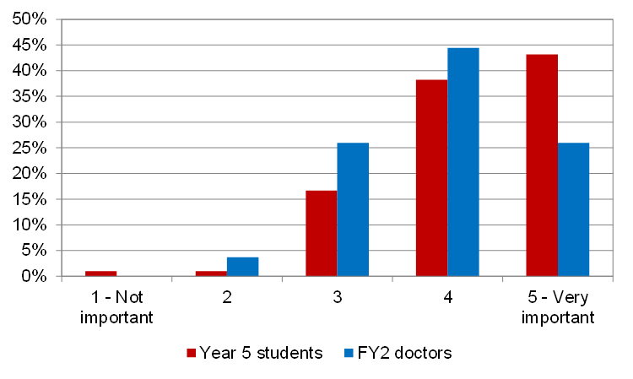

Figure 2 Thinking about the best primary care placements you had, how important were each of the following elements in making those placements good? [Medical students and FY2s]
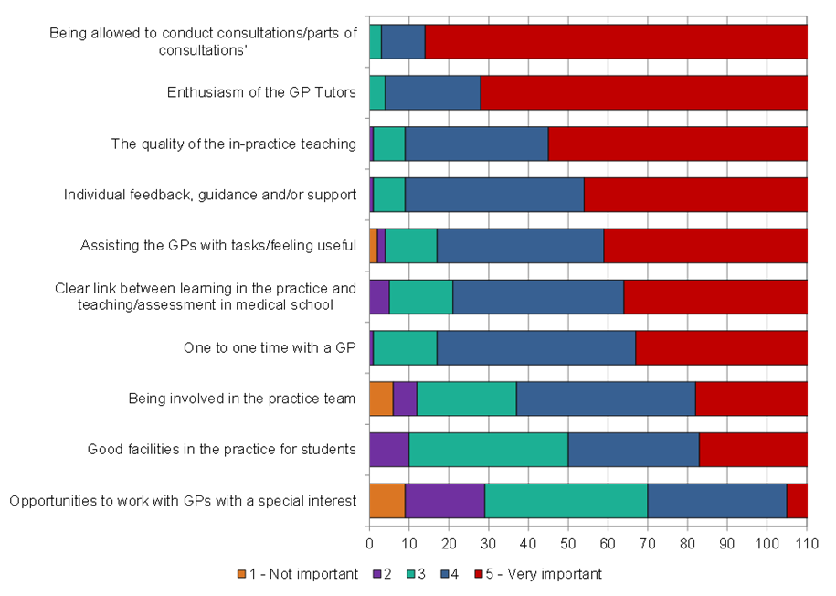

Figure 3 Overall how important have primary care placements been to your development as a clinician?

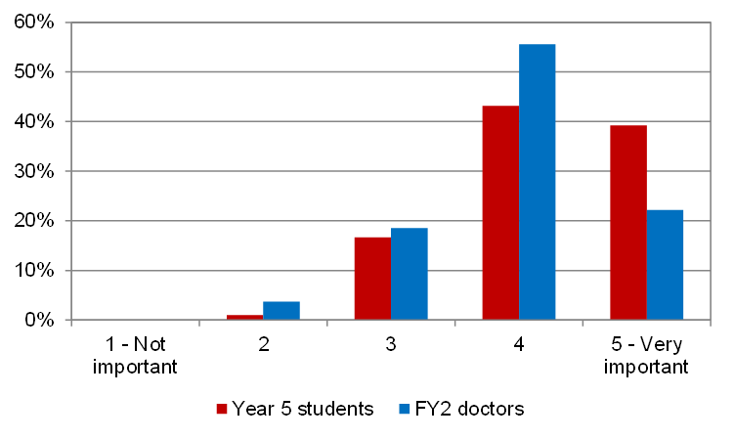

Figure 4 In which of the following areas of learning/development as a clinician did your primary care placements prove to be helpful? [Medical students & FY2s]

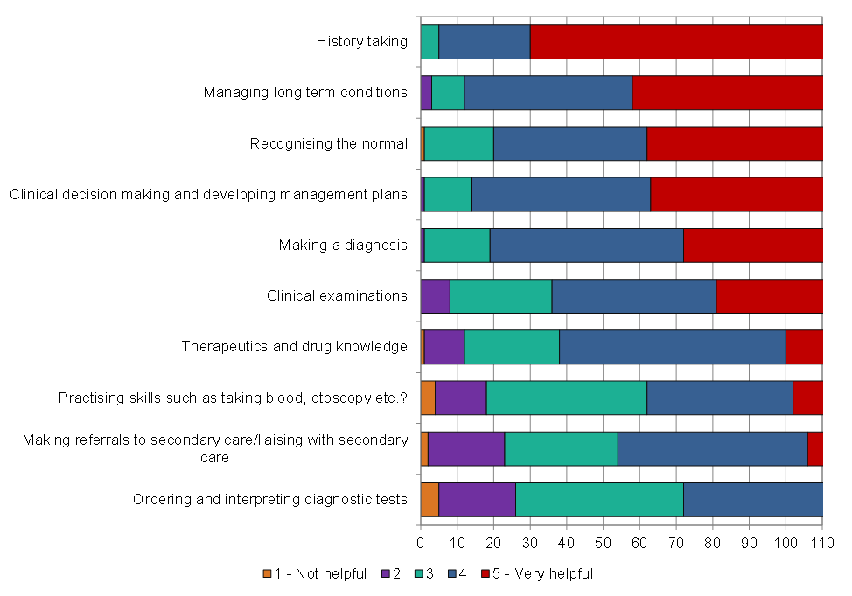

Figure 5 Overall, how important have primary care placements been in preparing you for practice in your foundation years?

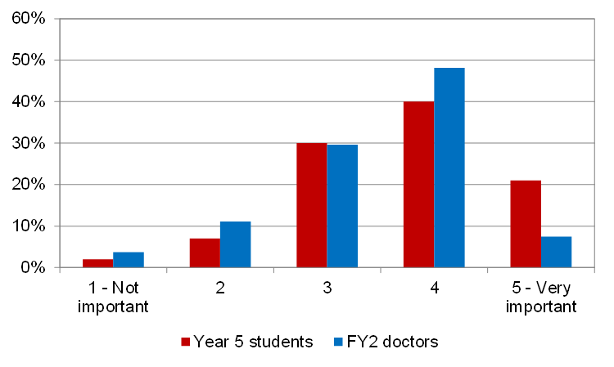

Figure 6 In which of the following areas of preparation for practice did your primary care placements prove to be helpful?

