How osmolytes counteract pressure denaturation on a molecular scale
Seishi Shimizu^{1*} and Paul E. Smith²
¹York Structural Biology Laboratory, Department of Chemistry, University of York, Heslington, York YO10 5DD, U.K. Email: seishi.shimizu@york.ac.uk
²Department of Chemistry, Kansas State University, 213 CBC Building, Manhattan, Kansas 66506-0401, U.S.A.
Abstract
Life in the deep sea exposes enzymes to high hydrostatic pressure which decreases their stability. For survival, deep sea organisms tend to accumulate various osmolytes, most notably trimethylamine N-oxide (TMAO) used by fish, to counteract pressure denaturation. Yet, exactly how they work still remains unclear. Here, we use a rigorous statistical thermodynamics approach to clarify the mechanism of osmoprotection. We show that the weak, non-specific, and dynamic interactions of water and osmolytes with proteins can be characterized only statistically, and that the competition between protein-osmolyte and protein-water interactions is crucial in determining conformational stability. Osmoprotection is driven by a stronger exclusion of osmolytes from the denatured protein than from the native conformation, and the water distribution has no significant effect on these changes for low osmolyte concentrations.

1. Introduction
Life in the deep sea is subject to high pressures up to ca.120 MPa. Some fish have been found to live as deep as 8000 meters below sea level, facing up to ca. 80 MPa pressures.^{[1–4]} Proteins are responsible for most tasks required for life, but are designed to be only marginally stable.^{[5]} Unfortunately, the volume of the denatured state of most proteins is typically smaller than that of the native state.^{[6–9]} Consequently, high pressure poses a challenge to their structural stability necessary for normal function as many proteins are susceptible to pressure denaturation.^{[10–17]} How then does life protect the structural stability of proteins in deep sea environments?
Deep sea organisms have been reported to contain various organic molecules, mainly amino acids or sugar derivatives, accumulated in their cells to as much as 0.5 molar concentrations. These molecules are commonly referred to as osmolytes, and are considered to be responsible for keeping the folded (active) state of proteins stable.^{[18–20]} One of the osmolytes used by fish is trimethylamine N-oxide (TMAO), whose cellular concentration reportedly increases with sea depth, further highlighting their crucial role for survival in high pressure environments.^{[21]}
Mounting evidence suggests that osmolytes do indeed increase the stability of native protein structures.^{[22–26]} The native structure is generally more compact with a significantly smaller surface area than the denatured state, as obtained by thermal and cosolvent-induced denaturation.^{[27,28]} Hence the preferential exclusion of osmolytes (including TMAO), as has been demonstrated by experiment, provides added stability to the compact native state due to the inherently lower excluded volume.^{[24]} To identify which atomic groups in proteins are particularly responsible for the stabilization and preferential osmolyte exclusion, many solubility measurements of amino acid analogues have been undertaken.^{[29–36]} However, the vast majority of such studies have focused on stabilization against urea and thermal denaturation; very few studies deal explicitly with how pressure denaturation is counteracted by osmolytes, where the denatured state occupies a smaller volume than the native state.^{[37–40]}
Although measurements of protein denaturation under high pressure (in the absence of osmolytes) have revealed useful insights into protein folding and stability in general, pressure has been used far less frequently than heat as a means to probe protein denaturation.^{[10–17]} An even smaller subset of studies have investigated the role of osmolytes on pressure denaturation.^{[37–41]} They have nevertheless made it possible to quantify the osmoprotection capacity of osmolytes on proteins via the observed increase in pressure required for denaturation upon the addition of different osmolytes.
However, understanding why osmolytes can increase the denaturation pressure on a molecular scale still remains unanswered. To answer this question, we show in this study:
- how to quantitatively characterize the protein-water and protein-osmolyte interactions using data from high pressure experiments.
- how the competition between these two types of interactions can explain the osmoprotection capacity of a osmolyte.
This is achieved by employing a first principles of statistical thermodynamics approach, which is responsible for bridging the microscopic and the macroscopic worlds, to establish a link between the experimental thermodynamic data and the molecular distributions present at the atomic level.^{[42–51]}
2. Molecular thermodynamics clarifies how osmolytes protect enzymes from denaturation
2.1. Thermodynamics and osmoprotection capacity
Let us consider a protein molecule (denoted as $B$ for biomolecule) in a solution mixture consisting of water ($W$) and osmolyte (denoted as $C$ for a general cosolvent) at a temperature $T$ which is kept constant throughout. The protein can adopt either the native ($n$) or denatured ($d$) state, whose respective molar concentrations are $ρ_{B}^{\left(d\right)}$ and $ρ_{B}^{(n)}$. The equilibrium constant $K=ρ_{B}^{\left(d\right)}/ρ_{B}^{(n)}$ is defined for the denaturation process $n→d$, and is dependent on the pressure $P$ and osmolyte concentration, $ρ_{C}$. The denaturation pressure is defined as the pressure required to reach the transition midpoint, $P_{m}$, for the pressure denaturation equilibrium, i.e. when $K=1$. Our goal, formulated thermodynamically, is to understand the mechanism upon which osmolytes reduce $K$ and thereby increase $P_{m}$.
How effectively an osmolyte protects a protein from denaturation can be quantified by the increase in the required denaturation pressure in the presence of the osmolyte. More precisely, the increase of $P_{m}$ per osmolyte’s molar concentration yields a quantitative measure for osmoprotection. Hence, we term $O_{C}=\frac{δP_{m}}{δρ_{C}}$ the osmoprotection capacity of the osmolyte, and will explore its relationship to $K$, the underlying thermodynamics, and then subsequently to the molecular mechanism.
We start from the following first order Taylor expansion of $\ln{K}$ at constant temperature to give,
$δ\ln{K}={\left(\frac{∂\ln{K}}{∂ρ_{C}}\right)}_{T,P}δρ_{C}+{\left(\frac{∂\ln{K}}{∂P}\right)}_{T,m_{C} }δP$ (1)
valid for small changes and where the derivatives are taken at a reference pressure and osmolyte concentration ($m_{C}$ refers to the molality of the osmolyte). We now consider the change in denaturation pressure $P_{m}$ observed on introduction of an osmolyte to the system. If we follow this thermodynamic path, then $δ\ln{K}=0$ when $δP=δP_{m}$ and $δρ_{C}=ρ_{C}$. Therefore, Eq. (1) can be written
$O_{C}=\frac{δP_{m}}{δρ_{C}}=-\frac{{\left(\frac{∂\ln{K}}{∂ρ_{C}}\right)}_{T,P}}{{\left(\frac{∂\ln{K}}{∂P}\right)}_{T }}$ (2)
Consequently, the osmoprotection capacity has thus been directly linked to changes in the denaturation equilibrium. This relationship, derived in the same manner as the Clausius-Clapeyron equation, is exact for low osmolyte concentrations and for linear variations of the denaturation pressure with osmolyte concentration. Cosolvents can give rise to a positive, negative, or zero osmoprotection value depending on whether they act as osmolytes, denaturants, or have no effect, respectively.
2.2. Osmoprotection capacity on a molecular scale
Now we interpret the osmoprotection capacity on a molecular basis. This can be achieved directly from the first principles of statistical thermodynamics using Kirkwood-Buff (KB) theory,^{[52,53]} a subset of Fluctuation Solution Theory (FST),^{[54]} without any need for models or assumptions.^{[42–48]} Recently, this rigorous approach has proven powerful in clarifying the molecular-based mechanism of a number of chemical, biological and industrial processes.^{[49–51]} Indeed, an approach similar to the one presented in this paper has recently been proven successful recently in understanding how osmolytes affect protein thermal denaturation and the melting temperature of food gels.^{[51,55,56]}
Our goal here is to relate the osmoprotection power to the competition between protein-water and protein-osmolyte interactions. By “interaction”, we do not mean a specific (stoichiometric) interaction that can be expressed in terms of a chemical equation. Unfortunately, protein-osmolyte and protein-water interactions are weak and non-specific in nature, as well as being long-ranged.^{[42,49]} Such interactions are beyond the grasp of chemical equations or models employing a description of possible solvent binding sites on a protein (see later discussion).^{[57–61]} Consequently, it is the spatial distribution of solvent molecules around the protein in each conformational state that must be considered.
Let us examine the water and osmolyte molecules around each conformational state of a protein, as shown in Figure 1 for the native state. Water and osmolyte molecules are constantly moving, yet their time-averaged distribution around the protein is the only concern for understanding the corresponding thermodynamics. The radial distribution function (RDF) $g_{Bi}^{(α)}(r)$, as a function of protein-solvent distance, is the signature quantity representing the net result of all the protein-osmolyte and protein-water interactions (Figure 2) that captures the weak, dynamic, and non-stoichiometric nature of these interactions.^{[42–48]} The RDF quantifies the distribution of solvent molecules around a protein conformation as a function of distance from the protein solute. Regions where the RDF is significantly greater than unity, i.e. the bulk (random) distribution value, indicate a region of attraction between the protein and the solvent molecules, whereas regions where the RDF is significantly lower than unity indicate regions of repulsion or exclusion of solvent from the protein.^{[42–48]}
Whether a solvent species $i$ (=water or cosolvent/osmolyte) is net attracted or excluded from a particular conformational state of a protein can be quantified by the integrals over the RDFs between the protein and species i as defined by
$G_{Bi}^{(α)}=4π\int{dr r^{2}\left[g_{Bi}^{\left(α\right)}\left(r\right)-1\right]}$ ($i=C$ or $W$, $α=d$ or $n$) (3)
which expresses the overall (integrated) deviation of the RDF from its (random) value of unity.^{[42–48]} These are known as Kirkwood-Buff integrals. The distribution of water and osmolyte molecules around the protein varies with distance due to a multitude of interactions and the role of packing effects. As shown in Figure 3, any increase in the distribution of species $i$, above the random distribution value of unity, leads to values of $g_{Bi}^{\left(α\right)}\left(r\right)$ that contribute positively to the KB integral; whereas any decrease in the distribution leads to regions for which $g_{Bi}^{\left(α\right)}\left(r\right)$ is smaller than unity and thereby contributes negatively to the KB integral. Formally, the integration is performed to infinity. However, in reality the RDF tends to unity after a few solvation shells (1 nm or so) and the integral can then be truncated without significant loss of accuracy.^{[62–65]} A more physical description is provided later.
The KB integrals therefore provide a measure of overall net protein-solvent and protein-osmolyte affinity and can be linked to the thermodynamics of denaturation through a knowledge of the changes in the KB integrals that accompany denaturation. This means that the key to understanding osmoprotection is to focus on the difference in the osmolyte and solvent distributions around the protein between the denatured and the native state (see Figure 4). To achieve this goal, we use our previous results.^{[42–48]}
${\left(\frac{∂\ln{K}}{∂ρ_{C}}\right)}_{T,P_{m};m_{C}→0}=ΔG_{BC}^{∞}-ΔG_{BW}^{∞}$ (4)
${RT\left(\frac{∂\ln{K}}{∂P}\right)}_{T }=-ΔV_{B}^{∞}=ΔG_{BW}^{∞}$ (5)
where $ΔV_{B}^{∞}$ is the change in the protein partial molar volume upon denaturation at the denaturation pressure for pure water, and $∆G_{BC}^{∞}=G_{BC}^{(d)}-G_{BC}^{(n)}$ and $ΔG_{BW}^{∞}=G_{BW}^{(d)}-G_{BW}^{(n)}$ are the change in the protein-osmolyte and protein-water KB integrals that accompany denaturation at the denaturation pressure for pure water. Here, as indicated by the superscript $∞$, we focus on the infinitely dilute osmolyte range for two reasons. First, physiological osmolyte concentrations are normally fairly low, 0.04 to 0.26 molal TMAO in teleost fishes, for example.^{[3,4]} Second, we have shown previously that the use of the $m_{C}→0$ limit yields a simpler and clearer understanding of the molecular picture without the loss of accuracy.^{[45,51,55]} Using Eq. (4) and (5), we obtain the simple expression
$\frac{1}{RT}O_{C}=-\frac{ΔG_{BC}^{∞}-ΔG_{BW}^{∞}}{ΔG_{BW}^{∞}}$ (6)
which is exact in the limit of low osmolyte (and protein) concentrations. Hence, the osmoprotection capacity has thus been shown to have a rigorous molecular-based interpretation in terms of the KB integrals characterizing the protein-water and protein-osmolyte interactions.
The above result has the advantage that it is based on a rigorous thermodynamic and statistical mechanics approach, the treatment of weak binding osmolytes is easy to handle, and one can make a direct link to experimental data. The main disadvantages lie in the fact one requires knowledge of the corresponding KB integrals, and the corresponding interpretation may be more complicated as the statistical nature of the distributions can be difficult to rationalize.^{[42–48]} However, we show below that many of these difficulties can be overcome by using available experimental data.

3. Molecular-level protection mechanism can be revealed directly from experimental data
Here we show that the molecular basis of osmoprotection capacity against pressure denaturation (i.e., l.h.s. of Eqs. (6)), namely the competition between the non-specific protein-osmolyte and protein-water interactions (r.h.s.), can be understood quantitatively by the analysis of experimental data.
Direct measurement of the osmoprotection capacity is still rare in the literature. This can be directly attributed to the relative technical difficulty of high-pressure experiments compared to their high temperature analogues.^{[37,39–41]} However, Winter and coworkers^{[37,41]} have reported experimental data (summarized in Table 1) that can be used directly to calculate the necessary input for the theory resulting in Eq. (2) and (4)-(6). These include the osmoprotection capacity O_{C} for several osmolytes and denaturants, as well as the volume change $ΔV_{B}^{∞}$ which accompanies pressure denaturation.^{[37,41]}
First of all, we note that $ΔV_{B}^{∞}<0$, which indicates the volume of the protein decreases on denaturation. This is consistent with Le Chatlier’s principle, and also with the well-established picture that pressure-denatured states are more hydrated than the native state.^{[37,41]} Hence the sign of $ΔG_{BW}^{∞}$ is positive. Consequently, the direction of the osmoprotection effect is given by the sign of the numerator on the r.h.s. of Eq. (6).
The change in the KB integrals that accompany denaturation can be calculated directly using the data of Winter and coworkers.^{[37,41]} The results obtained using Eqs. (4)-(6) are summarized in Table 1. Table 1 clearly shows that the osmoprotection capacity can be attributed to
- a positive $ΔG_{BW}^{∞}$; the denatured state hydration is larger than the native state as discussed above.
- a large negative $ΔG_{BC}^{∞}$; considering that $ΔG_{BC}^{∞}=G_{BC}^{(d)}-G_{BC}^{(n)}$, this signifies that the osmolytes are more excluded from the denatured state(s) than from the native state.
- $\left|ΔG_{BC}^{∞}\right|≫\left|ΔG_{BW}^{∞}\right|$; the difference in protein-osmolyte interaction (repulsion) between the denatured and native states is much larger that of protein-water, and the water distribution is independent of the osmolyte due to the low osmolyte concentration limit.
Such scenarios are summarized schematically in Figure 5.
The conditions 2 and 3 above also have been identified previously in osmoprotection against thermal denaturation.^{[50,51,56]} However, in the case of thermal denaturation the volume change can either be positive or negative, as determined by the competition between protein structure expansion (positive contribution) and increased hydration (negative contribution) upon denaturation. Hence the sign of $ΔG_{BW}^{∞}$ can either be positive or negative. Note that Le Chatlier’s principle for heat denaturation determines the sign of the denaturation enthalpy but not the denaturation volume. In pressure denaturation, however, it is the sign of $ΔG_{BW}^{∞}$ that is set by Le Chatlier’s principle, which is entirely different from heat denaturation, giving rise to condition 1 which is specific to the pressure denaturation.
Table 1 also demonstrates the outstanding effectiveness of TMAO in comparison to other osmolytes. The theory presented here is also valid for denaturants (chaotropes). However, chaotropes decrease the denaturation pressure, as in indicated by the results for urea and CaCl₂ in Table 1. This decrease is directly related to an increased affinity of urea and CaCl₂ for the protein upon denaturation, presumably due to increased specific (direct) interactions with the denatured state, giving rise to a positive numerator in Eq. (1). Note that the KB integrals for salts have been calculated per ion, namely for the average constituent ion, following the standard procedure for ionic solutions.^{[45,66]}
In summary, since the weak, non-specific interactions between protein and solvent molecules are statistical in nature, capturing the mechanism of osmoprotection requires a more statistical approach, using radial distribution functions, to describe the liquid solution structure. The net statistical exclusion of osmolytes from biomolecular surfaces, more so from the denatured state than from the native state, is the mechanism of osmoprotection against pressure denaturation.
4. Fluctuation Solution Theory versus thermodynamic models
We have demonstrated that the competition between weak, non-specific protein-osmolyte and protein-water interactions can be captured by FST via KB integrals directly from experimental data without any model assumptions whatsoever. Classical thermodynamic models, on the other hand, have provided a powerful approach towards the elucidation of the osmolyte effects on biomolecular folding and stability.^{[57–60]} Here we clarify that thermodynamic models involve more assumption on the nature of protein-solvent interaction and are less clear in terms of the relationship between thermodynamic variables and independently-obtainable interactions.
Cosolvent binding models assume $N_{b}$ binding sites on a protein that can bind cosolvents. In practical applications, all $N_{b}$ sites are assumed to be the same, i.e. the same binding constant $K_{b}$ for the osmolyte (cosolvent) at each site is used.^{[57,58]} This model, which is essentially the application of Hill model to account for the cosolvent role on proteins, gives
$ν≡-{\left(\frac{∂μ_{B}}{∂μ_{C}}\right)}_{T,P,m_{B}}=N_{b}\frac{K_{b}ρ_{C}}{1+K_{b}ρ_{C}}$ (7)
where $m_{i}$ and $μ_{i}$ respectively represent the molality and chemical potential of the species $i$. The input of this model is the $ρ_{C}$ dependence of $ν$. The output of the model are $N_{b}$ and $K_{b}$, which are determined by plotting $\frac{1}{ν }$ against $\frac{1}{ρ_{C}}$, because we have
$\frac{1}{ν}=\frac{1}{N_{b}}+\frac{1}{N_{b}K_{b}}\frac{1}{ρ_{C}}$ (8)
in which the gradient $\frac{1}{N_{b}K_{b}}$ and the intercept $\frac{1}{N_{b}}$ provide the two independent quantities required for the determination of $N_{b}$ and $K_{b}$.^{[61]} For strongly excluded osmolytes, $K_{b}$ must become negative to account for the cosolvent-induced destabilization ($ν<0$). Clearly, this contradicts the definition of the binding constant. Moreover, since this model only considers the binding of cosolvents, protein hydration effects are not included. Finally, it is difficult to incorporate the effects of pressure into the binding model.
Solvent exchange model was introduced to resolve the paradox of the negative binding constant by allowing for an exchange equilibrium between water and cosolvent at the binding sites. This exchange can be characterized by an equilibrium constant, $K_{e}=\frac{K_{C}}{K_{W}}$, where $K_{W}$ and $K_{C}$ are the mean binding constants of water and cosolvent at the binding sites, respectively.^{[60]} Even though this model successfully resolved the paradox of negative binding constant through solvent exchange, this model completely ignores the major contribution from the excluded volume effect, which should be incorporated into analysis in an ad-hoc manner.^{[67–70]} Furthermore, it is not easy to incorporate pressure effects into such a model.
FST, in contrast, provides a clear guideline for the independent determination of protein-osmolyte and protein-water interactions. The interactions have been characterized by KB integrals. Determining the two interactions requires the modulation of protein solvation free energy via two independent thermodynamic parameters, whose independence is guaranteed by the Gibbs phase rule.^{[50,71,72]} The KB integrals quantify the distribution of osmolyte and water around the protein. Hence, there are no binding sites in this approach, although any strong binding is naturally incorporated into the integrals. Using the fluctuation formulas for the these integrals one can provide an alternative interpretation of the quantities of interest here.^{[54,73]} The difference in KBIs defining the osmoprotection capacity can then be written
$ΔG_{BC}^{∞}=G_{BC}^{(d)}-G_{BC}^{\left(n\right)}=ρ_{C}^{-1}[<N_{C}>_{d}-<N_{C}>_{n}]$ (9)
where $<N_{C}>_{d}$ is the average number of cosolvent molecules in a fixed local volume around the denatured protein, compared to the average number in the same fixed local volume around the native form, $<N_{C}>_{n}$. The “local volume” includes all bound and perturbed cosolvents out to a distance where the unperturbed bulk cosolvent distribution is realized. A similar expression can be written for $ΔG_{BW}^{∞}$. We believe that this provides a rigorous simple picture of the effects of osmolytes on the denaturation equilibrium.

5. Conclusion
Deep sea organisms accumulate various osmolytes to counteract high hydrostatic pressures that would otherwise destabilize the proteins responsible for necessary cellular functions.^{[1–4]} In particular, the well-known osmolyte, trimethylamine N-oxide (TMAO), is used by deep sea fish in increasing concentration with depth.^{[3,4]} The aim of this paper was to understand, at a molecular level, the general mechanism by which osmolytes (including TMAO) stabilize proteins under high pressure conditions.
Denaturation pressure increases with osmolyte concentration have been measured already,^{[37,41]} but exactly how such data should be interpreted on a molecular scale has remained unclear. This study has attempted to fill the gap between experimental observations and molecular interactions using a rigorous statistical thermodynamics approach.^{[42–51]} The theory attributes the origin of osmolytes’ varying osmoprotection capacity to the competition between protein-osmolyte and protein-water interactions. Analysis of the experimental data using the theory indicates the following molecular-scale scenario for strong osmoprotection (see Figure 5):
- the osmolyte is more strongly excluded from the denatured state than the native state;
- the difference in osmolyte exclusion between the denatured and the native states are much larger than the change in hydration;
- the denatured state is more hydrated than the native state.
TMAO represents the best osmoprotectant studied here and this indicates it is the most excluded from protein surfaces. Exactly why TMAO remains solvated rather than interacting directly with the protein surface has yet to be fully understood. Clearly, strongly solvated molecules will prefer to retain their solvation shells rather than desolvate to interact with specific groups on the protein, i.e. they will be excluded from the protein surface. Nevertheless, rationalizing the relative strengths of different osmolytes, all of which are generally excluded from the protein surface, is more difficult and will probably require computer simulation studies to provide the necessary detail. However, the theory presented here allows one to quantify this effect and provides a direct link between the molecular distributions and the corresponding thermodynamics.
The protein-water and protein-osmolyte interactions in solution give rise to a general “solvation” of the protein that is beyond the reach of traditional chemistry models - such as chemical equations and solvent binding site stoichiometry - despite decades of seminal attempts. Instead, this solvation results from weak, non-specific and long-ranged interactions, whose dynamic nature can only be characterized statistically, through the average spatial distribution of solvents.^{[42–51]} Deep sea organisms have long been exploiting such weak interactions whose subtlety has eluded the theory of biomolecular solutions. Only recently have the required distributions been quantified using KB integrals, thereby providing the necessary insights into osmolyte and chaotrope behavior.

Acknowledgements
The project described was supported by the Gen Foundation to SS and by grant R01GM118719 from the National Institute of General Medical Sciences to PES. The content is solely the responsibility of the authors and does not necessarily represent the official views of the Gen Foundation, the National Institute of General Medical Science, or the National Institutes of Health.

References
[1] P. H. Yancey, J. F. Siebenaller, J. Exp. Biol. 1999, 202, 3597–3603.
[2] P. H. Yancey, A. L. Fyfe-Johnson, R. H. Kelly, V. P. Walker, M. T. Aun, J. Exp. Zool. 2001, 289, 172–176.
[3] P. H. Yancey, M. E. Gerringer, J. C. Drazen, A. a Rowden, A. Jamieson, Proc. Natl. Acad. Sci. U. S. A. 2014, 111, 4461–4465.
[4] P. H. Yancey, J. F. Siebenaller, J. Exp. Biol. 2015, 218, 1880–96.
[5] D. M. Taverna, R. A. Goldstein, Proteins 2002, 46, 105–109.
[6] C. A. Royer, in High Press. Mol. Sci. (Eds.: R. Winter, J. Jonas), Springer, Dordrecht, 1999, pp. 473–495.
[7] C. A. Royer, Biochim. Biophys. Acta 2002, 1595, 201–209.
[8] G. Hummer, S. Garde, A. E. García, M. E. Paulaitis, L. R. Pratt, Proc. Natl. Acad. Sci. U. S. A. 1998, 95, 1552–1555.
[9] T. V. Chalikian, R. B. Macgregor, J. Mol. Biol. 2009, 394, 834–842.
[10] J. F. Brandts, R. J. Oliveira, C. Westort, Biochemistry 1970, 9, 1038–1047.
[11] K. Heremans, Annu. Rev. Biophys. Bioenergy 1982, 11, 1–21.
[12] G. Weber, H. G. Drickamer, Q. Rev. Biophys. 1983, 16, 89–112.
[13] M. Gross, R. Jaenicke, Eur. J. Biochem. 1994, 221, 617–630.
[14] V. V Mozhaev, K. Heremans, J. Frank, P. Masson, C. Balny, Proteins 1996, 24, 81–91.
[15] L. Smeller, Biochim. Biophys. Acta 2002, 1595, 11–29.
[16] A. Picard, I. Daniel, Biophys. Chem. 2013, 183, 30–41.
[17] Q. Huang, K. N. Tran, J. M. Rodgers, D. H. Bartlett, R. J. Hemley, T. Ichiye, Condens. Matter Phys. 2016, 19, 1–16.
[18] P. H. Yancey, M. E. Clark, S. C. Hand, R. D. Bowlus, G. N. Somero, Science 1982, 217, 1214–1222.
[19] G. N. Somero, P. H. Yancey, in Compr. Physiol. Suppl. 31 Handb. Physiol. Cell Physiol., 1997, pp. 441–484.
[20] G. N. Somero, in Encycl. Fish Physiol., Elsevier, Amsterdam, 2011, pp. 1681–1687.
[21] A. B. Bockus, B. A. Seibel, Deep Sea Res. I 2016, 112, 37–44.
[22] F. Anjum, V. Rishi, F. Ahmad, Biochim. Biophys. Acta 2000, 1476, 75–84.
[23] P. Bruździak, A. Panuszko, J. Stangret, J. Phys. Chem. B 2013, 117, 11502–11508.
[24] D. Harries, J. Rösgen, Methods Cell Biol. 2008, 84, 679–735.
[25] S. Imoto, H. Forbert, D. Marx, Phys. Chem. Chem. Phys. 2015, 17, 24224–37.
[26] R. Sarma, S. Paul, J. Phys. Chem. B 2013, 117, 677–689.
[27] S. Shimizu, H. S. Chan, Proteins 2002, 49, 560–566.
[28] H. S. Chan, S. Shimizu, H. Kaya, Methods Enzymol. 2004, 380, 350–379.
[29] A. Wang, D. W. Bolen, Biochemistry 1997, 36, 9101–9108.
[30] M. Auton, D. W. Bolen, Biochemistry 2004, 43, 1329–1342.
[31] D. W. Bolen, I. V Baskakov, J. Mol. Biol. 2001, 310, 955–963.
[32] D. W. Bolen, G. D. Rose, Annu. Rev. Biochem. 2008, 77, 339–362.
[33] D. W. Bolen, Methods 2004, 34, 312–322.
[34] Y. Qu, D. W. Bolen, Biochemistry 2003, 42, 5837–5849.
[35] B. Moeser, D. Horinek, J. Phys. Chem. B 2014, 118, 107–114.
[36] B. Moeser, D. Horinek, Biophys. Chem. 2015, 196, 68–76.
[37] C. Krywka, C. Sternemann, M. Paulus, M. Tolan, C. Royer, R. Winter, ChemPhysChem 2008, 9, 2809–2815.
[38] G. Panick, R. Malessa, R. Winter, Biochemistry 1999, 38, 6512–6519.
[39] M. A. Schroer, Y. Zhai, D. C. F. Wieland, C. J. Sahle, J. Nase, M. Paulus, M. Tolan, R. Winter, Angew. Chemie Int. Ed. 2011, 50, 11413–11416.
[40] Y. Zhai, R. Winter, ChemPhysChem 2013, 14, 386–393.
[41] H. Herberhold, R. Winter, Biochemistry 2002, 41, 2396–2401.
[42] S. Shimizu, Proc. Natl. Acad. Sci. U. S. A. 2004, 101, 1195–1199.
[43] P. E. Smith, J. Phys. Chem. B 2004, 108, 18716–18724.
[44] P. E. Smith, J. Phys. Chem. B 2004, 108, 16271–16278.
[45] S. Shimizu, C. L. Boon, J. Chem. Phys. 2004, 121, 9147–9155.
[46] P. E. Smith, J. Phys. Chem. B 2006, 110, 2862–2868.
[47] P. E. Smith, Biophys. J. 2006, 91, 849–856.
[48] S. Shimizu, W. M. McLaren, N. Matubayasi, J. Chem. Phys. 2006, 124, 234905.
[49] V. Pierce, M. Kang, M. Aburi, S. Weerasinghe, P. E. Smith, Cell Biochem. Biophys. 2008, 50, 1–22.
[50] S. Shimizu, N. Matubayasi, J. Phys. Chem. B 2014, 118, 3922–3930.
[51] S. Shimizu, R. Stenner, N. Matubayasi, Food Hydrocoll. 2017, 62, 128–139.
[52] J. G. Kirkwood, F. P. Buff, J. Chem. Phys. 1951, 19, 774–777.
[53] A. Ben-Naim, J. Chem. Phys. 1977, 67, 4884–4890.
[54] E. A. Ploetz, P. E. Smith, Adv. Chem. Phys. 2013, 153, 311–372.
[55] S. Shimizu, N. Matubayasi, J. Phys. Chem. B 2014, 118, 13210–13216.
[56] S. Shimizu, Chem. Phys. Lett. 2011, 514, 156–158.
[57] C. Tanford, Adv. Protein Chem. 1968, 23, 121–282.
[58] C. Tanford, Adv. Protein Chem. 1970, 24, 1–95.
[59] J. A. Schellman, Biopolymers 1978, 17, 1305–1322.
[60] J. A. Schellman, Biopolymers 1987, 26, 549–559.
[61] I. M. Klotz, Ligand-Receptor Energetics : A Guide for the Perplexed, Wiley, New York, 1997.
[62] S. Weerasinghe, P. E. Smith, J. Phys. Chem. B 2003, 107, 3891–3898.
[63] S. Weerasinghe, P. E. Smith, J. Phys. Chem. B 2005, 109, 15080–15086.
[64] E. A. Ploetz, P. E. Smith, J. Phys. Chem. B 2015, 119, 7761–7777.
[65] E. A. Ploetz, S. Rustenburg, D. P. Geerke, P. E. Smith, J. Chem. Theory Comput. 2016, 12, 2373–2387.
[66] R. Chitra, P. E. Smith, J. Phys. Chem. B 2002, 106, 1491–1500.
[67] S. Shimizu, K. Shimizu, J. Am. Chem. Soc. 1999, 121, 2387–2394.
[68] S. Shimizu, M. Ikeguchi, S. Nakamura, K. Shimizu, J. Chem. Phys. 1999, 110, 2971–2982.
[69] J. A. Schellman, Biophys. J. 2003, 85, 108–125.
[70] J. A. Schellman, Biophys. Chem. 2002, 96, 91–101.
[71] S. Shimizu, N. Matubayasi, Biophys. Chem. 2017, DOI: 10.1016/j.bpc.2017.02.003.
[72] S. Shimizu, N. Matubayasi, Phys. Chem. Chem. Phys. 2017, DOI: 10.1039/c7cp02132a.
[73] S. Shimizu, N. Matubayasi, J. Phys. Chem. B 2014, 118, 10515–10524.

Figures and a Table

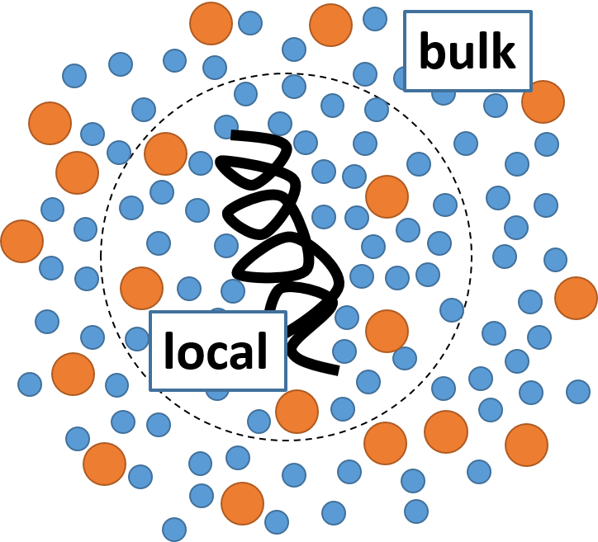
Figure 1. Schematic approach to capturing weak and nonspecific interactions. The difference in concentration of water (blue) and osmolyte (orange) molecules between the “local” and “bulk” regions provides the key to describe the solvent effect in a statistical manner.
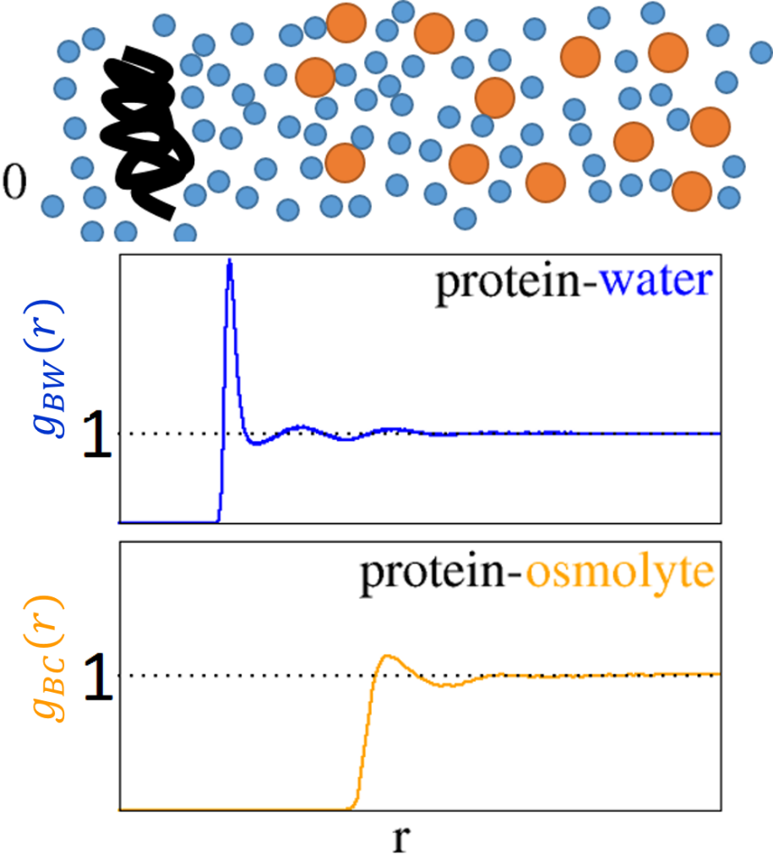
Figure 2. Schematic representation of the radial distribution functions (RDF) for water ($W$) and osmolyte ($C$) molecules around a conformational state of a protein. RDFs represent the local density of water and osmolyte in comparison to the bulk value corresponding to unity.

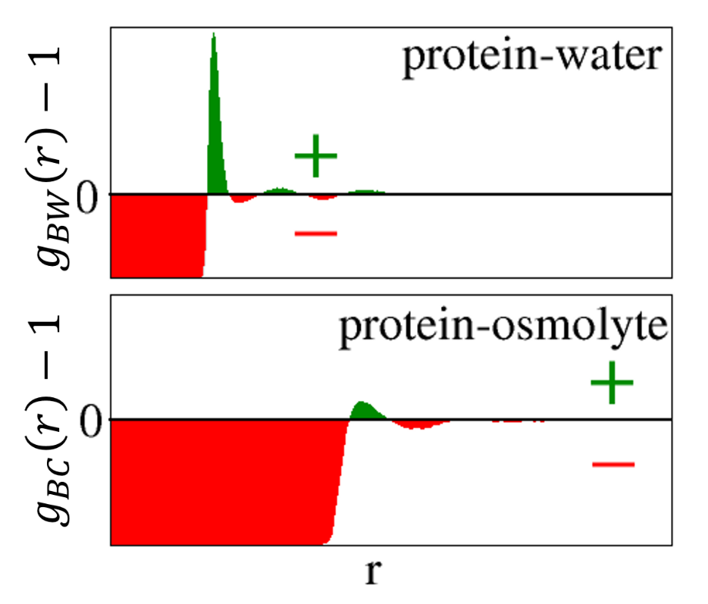
Figure 3. Protein-water and protein-osmolyte Kirkwood-Buff (KB) integrals, defined as $G_{Bi}=4π\int{drr^{2}\left[g_{Bi}\left(r\right)-1\right]}$ for $i=W$ and $C$ for each conformation. Positive (green) and negative (red) contributions to the KB integral come from the range of $r$ where $g_{Bi}\left(r\right)>1$ and $g_{Bi}\left(r\right)<0$, respectively.

Figure 4. Understanding the osmolyte effect on protein stability requires the consideration of local-bulk concentration differences for the water (blue) and osmolyte (orange) molecules around both the denatured and the native states of a protein (black).

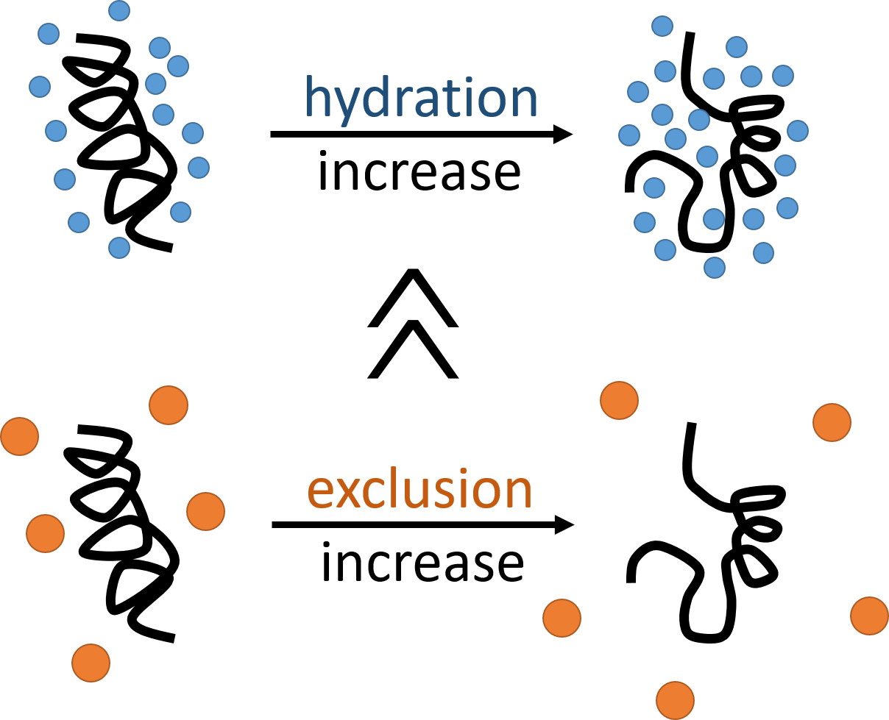
Figure 5. Mechanism of osmoprotection against pressure denaturation. (i) The pressure-denatured state is more hydrated (water=blue) than the native. (ii) Osmolytes (orange) are more excluded from the denatured state than from the native. (iii) The effect of (ii) is much larger than (i).

Table 1
osmolyte | $ΔV_{B}^{∞}$ | $O_{C}=\frac{δP_{m}}{δρ_{C}}$ | $ΔG_{BW}^{∞}$ | $ΔG_{BC}^{∞}$
 | cm³ mol⁻¹ | kbar M⁻¹ | cm³ mol⁻¹ | cm³ mol⁻¹
TMAO | -66 | 3 | 66 | -7930
Glycerol | -66 | 1.7 | 66 | -4520
Sorbitol | -66 | 2 | 66 | -5330
Sucrose | -66 | 2.3 | 66 | -6140
K₂SO₄ | -66 | 4.1 | 66 | -3670ª
Urea | -66 | -2.8 | 66 | 7620
CaCl₂ | -66 | -1 | 66 | 920ª

Table 1. Pressure denaturation of Snase A in the presence of various osmolytes and chaotropes. Experimental data have been taken from Herberhold and Winter (2002) and Krywka et al. (2008). The temperature was fixed at 25 ºC, except for TMAO (21 ºC). ªPer ion. The volume decrease on denaturation corresponds to approximately four water molecules. Glycerol did not display linear behavior even at low concentrations and so this result should be considered approximate.

