Title: Three methods for integration of environmental risk in the benefit-risk assessment of veterinary medicinal products
Running head: Benefit-Risk of Veterinary Drugs
Jennifer L Chapman*† (jlc571@york.ac.uk), Lucas Porsch‡ (lucas.porsch@ecologic.eu), Rodrigo Vidaurre‡ (rodrigo.vidaurre@ecologic.eu), Thomas Backhaus§ (thomas.backhaus@bioenv.gu.se), Chris Sinclair|| (chris.sinclair@fera.co.uk), Glyn Jones|| (glyn.d.jones@fera.co.uk), Alistair Boxall† (alistair.boxall@york.ac.uk)

Affiliations:
†University of York Environment Department
Heslington, York, UK YO10 5DD

§‡Ecologic Institut
Pfalzburger Str. 43-44, 10717 Berlin, Germany

§Department of Biological and Environmental Science, University of Gothenburg,
Medicinaregatan 18, 405 30 Gothenburg, Sweden

||FERA Science Ltd.
National Agri-food Innovation Campus, Sand Hutton, York, UK YO41 1LZ

*To whom correspondence may be addressed

Abstract
Veterinary medicinal products (VMPs) require, as part of the European Union (EU) authorization process, consideration of both risks and benefits. Uses of VMPs have multiple risks (e.g., risks to the animal being treated, to the person administering the VMP) including risks to the environment. Environmental risks are not directly comparable to therapeutic benefits; there is no standardized approach to compare both environmental risks and therapeutic benefits. We have developed three methods for communicating and comparing therapeutic benefits and environmental risks for the benefit-risk assessment that supports the EU authorization process. Two of these methods support independent product evaluation (i.e., a summative classification and a visual scoring matrix classification); the other supports a comparative evaluation between alternative products (i.e., a comparative classification). The methods and the challenges to implementing a benefit-risk assessment including environmental risk are presented herein; how these concepts would work in current policy is discussed. Adaptability to scientific and policy development is considered. This work is an initial step in the development of a standardized methodology for integrated decision-making for VMPs.
Keywords (5): veterinary medicinal products, benefit-risk assessment, environmental risk, product authorization, decision support

1. Introduction
Large amounts of veterinary medicinal products (VMPs) are applied in agriculture to prevent and treat diseases. In 2004 VMP usage in 25 European countries was estimated to be 6051 tonnes of active compounds in meat producing animals (Kools et al. 2008). European policies regulate VMPs to ensure product availability for disease management and maintenance of animal and human health and welfare, while minimizing risks. While these substances have benefits to animal and humans (e.g., through the prevention of zoonotic diseases) and to the economy, they also create a potential for environmental exposure and consequent risk.
Post-application VMPs can reach the environment through a variety of pathways. Depending on the livestock system (i.e., aquaculture, intensively-reared, or pasture), different routes of entry (e.g., through manure or wash off) can result in environmental exposure (VICH 2004). Exposure pathways are both direct (e.g., topical application wash off) and indirect (e.g., excretion and subsequent spreading of dung and urine) (Boxall et al. 2003). Environmental monitoring has detected a range of active ingredients used in VMPs across the globe (Boxall et al. 2004; Sarmah et al. 2006; Obimakinde et al. 2017).
The anticipated exposure of the natural environment to VMPs has led to a number of investigations to understand the environmental risks of these substances. Toxic effects have been shown for a range of VMPs in both aquatic and terrestrial organisms (Boxall et al. 2004; Lumaret et al. 2012; Pan and Chu 2016; Obimakinde et al. 2017) and biomagnification of VMPs is also a possibility (Obimakinde et al. 2017). Further, there is increasing concern and evidence for the selection and dissemination of antimicrobial resistance in the natural environment from the use of antimicrobial compounds as VMPs (Kemper 2008; Marshall and Levy 2011). If environmental risks are not avoided impacts can occur and damages can be costly.
While there are a large number of studies reporting the potential adverse impacts of VMPs on the environment, we have identified on two case studies where an attempt has been made to link predicted or observed VMP impacts in the natural environment to economic costs. In the first case, diclofenac, a non-steroidal anti-inflammatory drug, applied to cattle in India caused a 99% decrease in Indian Vulture populations (Green et al. 2004, 2007). This decline of the vulture populations increased the food available to dog populations; therefore, dog populations grew as did rabid dog bites. Estimated medical expenses from rabid dog bites of US$34 billion were thought to have been incurred over the 14 years of the vulture population decline (Markandya et al. 2008). The second example is ivermectin, a parasiticide, whose use is thought to pose an unacceptable risks to aquatic and terrestrial biota (Liebig et al. 2010). Of specific terrestrial concern for this compound is the dung beetle. Ivermectin is excreted in dung at concentrations that are toxic to dung beetles (Floate et al. 2005). Depletion of dung beetle populations has potential for knock-on effects to predator species and affects dung degradation (Floate et al. 2005). Food availability is increased when dung degrades and grass is no longer fouled. Dung degradation supports nitrogen volatilization and the availability of nitrogen for plants. The ecosystem services provided by dung beetles from dung degradation was estimated by Losey and Vaughan (2006) at US$38 million per year in the United States. Toxic effects to dung beetles have potential to result in the loss of valuable ecosystem services.
Avoidance of costly environmental damage from VMPs is supported through the market authorisation process for new products. Authorization authorities within Europe are responsible for the evaluation of VMPs seeking access to the market. The decision as to whether to authorize a VMP or not will require that the benefits of the VMP are weighed up against the risks in a Benefit Risk Assessment. Considering that risk cannot be fully eliminated the benefit-risk assessment is a balance between benefit and risk trade-offs. Environmental risks can therefore be considered acceptable given a VMPs benefit. However, the current guidelines on VMP benefit-risk are not clear on how this trade-off should be evaluated (CVMP 2009).
Integrating environmental risk and benefits data for VMPs in decision-making will support VMP use when the benefits are greater than the risks. At present, environmental risks are not comparable to therapeutic benefits. There is no standardized approach or method to compare both environmental risks and therapeutic benefits. Here, after providing background information on the current regulatory process, we describe three methods that could be applied to incorporate environmental risk into the benefit-risk assessment of VMPs, specifically methods that can be applied using data mainly generated for market authorization assessments. We also broadly discuss implementing benefit-risk methodologies in the current legislative framework and possible future directions.
2. Background
In the EU there are four VMP authorization pathways (i.e. centralized, decentralized, national, and mutually recognized) (European Parliament 2004a). For centrally authorized products the European Medicines Agency’s (EMA) Committee for Veterinary Medicinal Products (CVMP) will review applications and advise to authorize or reject authorization (Commission Regulation (EC) No 726/2004 (European Parliament 2004b)). Centrally authorized products have access to the current 28 member states and 3 European Economic Area countries. All 31 countries have their own competent authorities (EMA 2017). Decisions for decentralized, national, and mutually recognized processes will involve the competent authorities of the member state for which applicants are seeking market access (European Parliament 2004a).
All VMP market authorization processes require that environmental risk be included in the benefit-risk assessment (Directive 2001/82/EC, as amended by Directive 2004/28/EC (European Parliament 2004a)). Consideration of the environmental risks of VMPs in the authorization process was established in 1990 (Directive 90/676/EEC (European Parliament 1990)). Environmental risk assessments (ERAs) generate data on environmental exposure, effects and risks following guidance documents (VICH 2000, 2004; EMA 2008). In the benefit-risk assessment, ERA data and other risk data must be compared to efficacy data and the ethical considerations of animal welfare. The benefit-risk assessment must be favourable for VMP authorization. A VMP market application can have three outcomes: (i) authorization; (ii) authorization with risk mitigation; or, (iii) refusal of authorization (European Parliament 2004a). It is critical that the benefit-risk assessments support decisions so that VMP products are available to adequately treat animals while also not adversely affecting environmental quality.
Conducting a benefit-risk assessment of VMPs involves a high level of complexity. Benefits and risks (i.e., for the target animal, user, environment, and consumer of animal-derived foodstuff) need to be considered (Figure 1). Additionally, risks specific to the VMP class may also need to be included (e.g., the risk of resistance development). The initial independent evaluation of benefits to the main risks decreases the complexity. For example the user safety assessment could result in a risk and consequent risk mitigation measure (Woodward 2008) similar to the ERA (VICH 2000, 2004, EMA 2008). The independent evaluation of each category will support amalgamation of data into an overall benefit-risk evaluation. Therefore, here we focus on environmental risk and development of methods, which integrate ERA data in a benefit-risk methodology to support authorization decision-making.
Integrating environmental risk in the benefit-risk assessment does not follow standardized and transparent methodology. For example, guidance from the CVMP does not present a structured approach to comparing environmental risks and VMP benefits (EMA 2009). Expert opinion is highlighted as a key tool. While expert opinion is valuable, it can be inconsistent between experts and less transparent than a standardized methodology.
In the case that an ERA results in an acceptable risk and adequate benefits, the benefit-risk will be favourable (EMA 2009). The ERA can result in an acceptable risk when results are below defined thresholds. Comparison of ERA data and thresholds is applied in two steps (i.e., Phase I: exposure assessment; and, Phase II: risk assessment). Phase I is conducted by applying a decision tree to evaluate specific aspects of exposure (VICH 2000). For example, VMPs for non-food producing animals are considered to have lower use and be specific for individual treatment, have less environmental concern, and can conclude at Phase I. The exposure calculations measure predicted exposure concentration for soil (PECsoil) or an environmental introduction concentration for water (EICaquatic). Products which do not exceed Phase I criteria (e.g. PEC(soil) ≥ 100 µg/kg; EIC(aquatic) ≥ 1 µg/L) are concluded to have acceptable environmental risk (VICH 2000). Assuming sufficient benefits and acceptable risks from other criteria in Tier I (e.g., consumer safety), the product will then be authorized; otherwise, more rigorous data collection and testing in Tier II will be required (Figure 2).
Phase II generates hazard, exposure and risk data in a tiered approach. Tier A is more basic and conservative while Tier B is more intensive and realistic. At either Tier A or Tier B the results may be below required risk and hazard thresholds, defined in the VICH guidelines, and the same pathway as Phase I can lead to authorization (Figure 2). If the risk is unacceptable after Phase II Tier B, the benefit-risk evaluation will critically support authorization (Figure 2). The specific data used to support the decision include hazard data, which classify a VMP as a PBT compound (persistent, bioaccumulative, and toxic) or a vPvB (very persistent, very bioaccumulative) based on criteria in EMA (2012a). Additionally, exposure data for groundwater (PECgw) is initially generated in simple conservative models. Refinement with FOCUS models, which support pesticide regulations, is recommended (Montforts 2006; EMA 2008). Finally, the risk quotient (RQ) compares exposure and effects data. The effect is measured by environmental compartment (i.e. aquatic, terrestrial, sediment, and dung), by testing indicator species (e.g., Daphnia and earthworms) to measure which exposure concentrations cause adverse effects (e.g., mortality, changes in growth or reproduction). From these data a predicted no effects concentration (PNEC) is calculated. The risk quotient is calculated by dividing the PEC by the PNEC (i.e. RQ=PEC/PNEC). An acceptable risk is below 1 (RQ<1). In the case of an unacceptable risk, mitigation measures are an option to refine risk (VICH 2000, 20004; EMA 2009). However, available risk mitigation measures for VMPs are not guaranteed to be implemented (Montforts et al. 2004; EMA 2012b; Liebig et al. 2014).
Establishing favourable/unfavourable benefit-risk require integration of benefits and ERA data. The consideration of benefits focuses on the direct therapeutic benefit for authorization (EMA 2009). In most cases the product is compared to the lowest efficacy level of available products to establish sufficient efficacy (EMA 2009). The exception is the case of ectoparasiticides, which require 80-100% efficacy levels (EMA 1994). Integration in a benefit-risk methods must focus on making benefit and risk data comparable.

3. Benefit-risk method development
A major challenge to incorporating environmental risk into the benefit-risk assessment is the differences in scales for benefits and risks (i.e., the treated animal vs. the environment). Structured methods are therefore needed to better communicate benefits and risks, support decision-makers, and overcome differences in measurements and recipients of the benefits and risks. For example, a VMP may have a high level of efficacy for a disease in sheep but also have a high RQ for daphnia but challenge is how to compare the two endpoints. Consideration of the benefit and risk profile of this example product in a standardized method would support the challenging comparison. Further, because risk mitigation is not assured as noted above, benefit-risk methods should be implemented prior to assignment of risk mitigation measures.
Here we present three benefit-risk methods that have been developed to fit within and enhance the current decision-making process. This was done by first considering the VMP environmental evaluation procedure and data requirements and assessing how these could be used to inform a comparison of benefits against risks. The challenge of incomparable endpoints was then addressed through development of a basic categorization mechanism. Finally, the data requirements were combined in three categorization methods. We describe these steps sequentially.
Division of benefits and risks into categories was developed to support direct comparisons. Categories, which are, organized into levels of increasing risk and benefit can be directly compared; the higher level indicates a higher benefit or risk. For example, in a 5 level benefit-risk categorization, a level 3 risk will have two combinations of benefits>risks, and benefits<risks as well as one combination where benefits=risks (Figure 3).
VMP products are currently assessed individually based on their benefits and risks, and not compared to other products available on the European market other than for determining efficacy (EMA 2009). We developed three methods for benefit-risk assessment by applying categorization. Two of these methods support the evaluation of a product independently without comparing to other products available for the same indication (i.e., summative classification and a visual scoring matrix); the other supports comparative evaluation of a number of different products with the same indication (i.e., comparative classification) (Figure 2).
We apply example criteria to the benefits and risks to demonstrate the categorization methods. Four criteria for benefits and five environmental risk criteria were selected through discussions of the author group to represent important benefit and risk aspects. The benefit criteria selected for demonstration focus on application of VMPs for prevention and treatment of disease. The definition of VMPs in Directive 2001/82/EC also includes products for restoring, correcting or modifying physiological functions or to support medical diagnosis (European Parliament 2004a). Criteria for the benefits can be adapted to consider products those benefits are not specific to disease (e.g., oestrus synchronization to increase reproduction). The four example benefits criteria are: (i) efficacy; (ii) resistance; (iii) severity; and, (iv) disease distribution. To empathize our focus on the concepts we do not suggest thresholds but briefly discuss quantification options.
The first benefit criterion is efficacy, which considers how effective the VMP is in its specific treatment. The measurement of efficacy will be dependent on the type of drug and would measure the success rate of the treatment. Second, a resistance criterion could measure the VMPs contribution to prevention of resistance, specifically for antimicrobials and antiparasiticides. Quantification of the contribution of the VMP to the fight against resistance could measure specific tests against resistant strains or consider if the mode of action is different than available products and therefore likely to be effective against strains resistant to other VMPs. Third, a high disease severity, considers the consequences of non-treatment. For this criterion, the highest benefit would be treatments for life-threatening diseases, ranking could be applied to quantify this criteria. Finally, widely distributed considers how many animals will benefit from the VMP.
Environmental risk categorization applied five criteria: (i) PBT/vPvB; (ii) PECgw; (iii) RQ; (iv) spatial risk; and, (v) temporal risk. The first three (PBT/vPvB, PECgw, and RQ) result from the environmental risk assessment and will be included in a market authorization application. These criteria have established thresholds (i.e. PBT/vPvB in EMA (2012a); RQ<1; PECgw<0.1µg/L). We also introduce a spatial and temporal category, which would capture how widespread the severity of the risks are in time and space and be evaluated for exceedances separately from the ERA risk criteria. Setting the spatial and temporal criteria is further discussed in section 5.
The example benefit and risk criteria are applied selectively in the different categorization methodologies. Selection of criteria was adapted based on the intended application of the methodology. The three approaches are: a summative categorization, the visual scoring matrix and the comparative categorization (sections 3.1, 3.2, and 3.3, respectively). The selection of which approach to use will depend on the scenario being assessed and preferences of practitioners involved in the benefit-risk process. Our aim in presenting these methods is to demonstrate different approaches to categorization of benefits and risks, not to provide absolute comparisons. The selection of criteria and thresholds will be important for implementation and this is discussed later.
3.1 Summative categorization method
Summative categorization supports the application of a decision rule (e.g., the benefit level must be equal to or greater than the risk level for authorization). It defines levels of benefits and risks through combinations of threshold exceedances. The method is demonstrated in Table 1 with 5 levels of benefits (left) and risks (right). The highest level (5) is set by exceedance of all criteria. The lowest level (1) is set by all criteria being met. Different combinations of exceedance and non-exceedance define intermediate levels. This first approach is very simple and involves a direct comparison of risk and benefit levels for different endpoints. The second approach is more complex and provides more information on where the risks and benefits lie and is designed to promote discussion and debate around the authorisation of a VMP.
Table 1. A summative classification system for treatment benefits (left) and environmental risks (right) of a VMP; thresholds for potential criteria can vary (see text for further details). Green colors differing in intensity indicate desirable benefits. Red colors differing in intensity indicate degree of exceedances. ªPersistent, bioaccumulative, toxic (PBT)/very persistent, very bioaccumulative (vPvB) criteria defined in EMA (2012a); ^{b}Predicted exposure concentration for groundwater; ^{c}Risk quotient (predicted exposure concentration / predicted no effects concentration).
BENEFIT |  |  |  |  | RISK
 | Potential criteria |  |  |  |  | Potential criteria
Levels | High efficacy | Contributing to fight against resistance | High disease severity | Widely distributed | Levels | PBT /vPvBª | PECgw^{b} | RQ^{c} | Spatial risk | Temporal risk
Level 5 | Exceeds all criteria |  |  |  | Level 5 | Exceeds all criteria
Level 4 | Exceeds 3 criteria |  |  |  | Level 4 | Exceeds 1 or 2 criteria |  |  | 2 Exceeded
Level 3 | Exceeds 2 criteria |  |  |  | Level 3 | Exceeds 1 or 2 criteria |  |  | 1 Exceeded
Level 2 | Exceeds 1 criterion |  |  |  | Level 2 | Exceeds 1 criterion |  |  | None Exceeded
Level 1 | None Exceeded |  |  |  | Level 1 | None Exceeded

3.2 Visual scoring matrix
The visual scoring matrix categorizes the entire benefit and risk data sets into levels of increasing severity (i.e. negligible (N) to very high (VH)) (Table 2). Table 2 demonstrates how benefit and risk criteria could be separated into different levels, by assigning specific intervals to each level. Example scores range from 0 to 4 increasing in a geometric series (i.e. score_{n} = 0.5(2^{(n-1)}), where n = 1, 2, 3, 4) from negligible risk (N) to very high risk (VH). Example benefit criteria focus on disease treatments and include details of the livestock and infection. The demonstration applies percentages to three risk criteria. The percentage of animals successfully treated with normal and resistant strains could be tested (Table 2, efficacy and efficacy against resistant strains, respectively). The severity could measure the number of cases, which result in a severe outcome (e.g., mortality). The demonstration intervals were assigned so that the higher end has a larger interval (i.e., VH = 70%-100%), the intermediate levels a moderate interval (i.e., H, M, L = 20% interval) and the lowest the smallest interval (N = 0 – 10%). The categorization must capture and communicate benefits effectively and for adjusting and defining criteria and intervals expert and veterinarian opinion will be required.
Risk criteria are from the ERA and have also been divided into intervals specifically for concept demonstration. Values below the acceptable levels of RQ and PEC values are assigned to the negligible category. For RQ intermediate levels capture changes in the order of magnitude of the RQ. The very high level will capture all values greater than the assigned threshold (e.g., RQ> 10³, Table 2). The RQ is subdivided to clearly indicate where risks will be received (i.e. environmental compartment and test organism). If the PEC is below thresholds specified by VICH then this will be assigned to the negligible category. Different intervals for values of the PECgw in µg/L are designated for intermediate categories. The highest category captures exceedances of its specified category. The PBT criteria are separated into categories based on the number of criteria exceeded (Table 2). In this case the negligible category is not defined as the acceptable level. The unacceptable levels are the high and very high levels.
Scores could be compared if the total matrix score was the same for benefits and risks. However, the primary advantage of the matrix is the visual component, which supports transparent communication to decision makers and flexibility (i.e., a strict decision rule isn’t the basis of the approach). The colour coding of the ERA data clearly and quickly communicates the distribution of benefits and risk across the criteria (Table 2); the calculation of the score is clear from the matrix, which is essential to the scoring system. The scoring system can be used in decision-making but should not be the primary determinant. Coplan et al. (2011) proposed a visual approach to communicate the health benefits and risks of medicines to patients; transparent communication of the data resulted in greatly improved communication and decision-making (Levitan et al. 2011).
Overall, the increased details communicate specifics of where the benefits and risk will be distributed. The use of the matrix can support discussion and application of decision-maker judgement over specific decision-rules.
Table 2. Possible benefit matrix (right) and risk matrix (left) for visual comparison and scoring of VMPs (explained further in text). Thresholds are used as a demonstration of the concept rather than a recommendation. Colors indicate benefit intensity from high (i.e., green) to moderate (i.e., yellow) to low (i.e., red). ªVery high; ^{b}High; ^{c}Moderate; ^{d}Low; ^{e}Negligible.
Level |  |  | VHª |  | H^{b} | M^{c} | L^{d} |  | N^{e} | Level |  |  | VH | H | M | L | N
Score |  |  | 4 |  | 2 | 1 | 0.5 |  | 0 | Score |  |  | 4 | 2 | 1 | 0.5 | 0
 | Target Animal | Infection |  |  |  |  |  |  |  | PBT |  |  | vP + vB | P +B + T | 2 of 3 | 1 of 3 | Not PBT
Efficacy | Livestock species 1 | Species 1 | ≥70% | 50%- 69% |  | 30%-  49% |  | 10%-29% | <10% | RQ | Compartment | Organisms
 |  | Species 2 |  |  |  |  |  |  |  |  | Surface water | Algae | RQ≥ 10³ | 10²≤ RQ <10³ | 10≤ RQ <10² | 1≤ RQ <10 | RQ < 1
 | Livestock species 2 | Species 3 |  |  |  |  |  |  |  |  |  | Daphnia
Efficacy against resistant strains | Livestock species 1 | Resistant species 1 | ≥70% | 50%- 69% |  | 30%-  49% |  | 10%-29% | <10% |  |  | Fish
 |  | Resistant species 2 |  |  |  |  |  |  |  |  | Sediment | Sediment organisms
 | Livestock species 2 | Resistant species 3 |  |  |  |  |  |  |  |  | Soil | Plants
Severity | Livestock species 1 | Species 1 | ≥70% | 50%- 69% |  | 30%-  49% |  | 10%-29% | <10% |  |  | Earthworms
 |  | Species 2 |  |  |  |  |  |  |  |  | Dung | Dung beetles and flies
 | Livestock species 2 | Species 3 |  |  |  |  |  |  |  | PECgw |  |  | PEC≥5 | 1≤ PEC <5 | 0.5≤ PEC <1 | 0.1≤ PEC<0.5 | PEC< 0.1

3.3 Comparative classification
A comparative approach is not currently explicitly consistent with the VMP authorization process. However, such an approach would support substitution of VMPs with higher environmental risk for those with lower risk, given that benefit is reasonably maintained. Substitution principles are currently applied to chemical regulation (Swedish Chemicals Agency 2007).
Comparative categorization focuses on the differences between a product applying for authorization and previously authorized VMPs with the same clinical use. Table 3 demonstrates a 5 level categorization method designed to evaluate changes between the product and the alternative. In this case criteria that relate to the specific treatment will be consistent between the alternatives and, therefore, would not be assessed in this method.
An example of five levels is provided to determine whether benefits and risks are increasing or decreasing; level 3 is a neutral level with highest risks and benefits at level 5 and lowest at level 1 (Table 3). The comparison of combinations is consistent with Figure 3. Application of this method requires determination of thresholds that constitute a significant change. The output would be a separate benefit and risk level for the authorization of a new product compared to an authorized VMP. A decision-rule could be applied to the levels assigned relative to the trade-offs between products.
Table 3. Comparative benefit classification (left) considering changes in 2 criteria and comparative risk classification (right) considering changes in 3 criteria to evaluate alternative products for the same treatment (colors differing in intensity indicate undesirable changes (i.e., red) and desirable changes (i.e., green). Thresholds for potential criteria can vary (see text for further details). ªPersistent, bioaccumulative, toxic (PBT)/very persistent, very bioaccumulative (vPvB) criteria defined in EMA (2012a); ^{b}Predicted exposure concentration for groundwater; ^{c}Risk quotient (predicted exposure concentration / predicted no effects concentration).
BENEFIT |  |  |  | RISK
 |  | Example criteria |  |  |  | Example criteria
Category | Change in benefit level | High efficacy | Contributing to fight against resistance | Category | Change in risk level | PBT/vPvBª | PECgw^{b} | RQ^{c}
Category 5 | Highly increased | Both higher |  | Category 5 | Highly increased | ≥2 criteria increased & none decreased
Category 4 | Increased | 1 higher |  | Category 4 | Increased | 2 criteria increased & 1 decreased or  1 criterion increased & 2 without change
Category 3 | No Change | No difference |  | Category 3 | No Change | No substantial in any criteria or  1 criterion increased & 1 decreased
Category 2 | Reduced | 1 lower |  | Category 2 | Reduced | 2 criteria decreased & 1 increased or  1 criterion decreased & 2 without change
Category 1 | Highly reduced | Both lower |  | Category 1 | Highly reduced | ≥2 criteria decreased & none increased

4. Selection of criteria
The three benefit-risk methodologies presented all require efficacy data and criteria for benefits. The list of benefits from VMP use is extensive (EMA 2009); only a subset is presented in Figure 1.
Ensuring that the benefit-risk assessment adequately represents the benefits can be done through the selection of benefit criteria. For example, an increase in available products is beneficial to contribute to the fight against resistance (Tables 1-3). Additionally, animal welfare could be considered in the benefits by measuring the severity of diseases that are prevented (Tables 1, 2). Finally, the number of animals affected could be measured and used for weighting purposes. The focus of this paper is to present methodologies for the comparisons of VMP benefits and environmental risk. The use of example criteria supports the presentation of developed methodologies. Discussion with regulators and veterinarians could identify benefits criteria.
All three methods utilize currently required data for environmental risk (i.e., PBT/vPvB, PECgw, RQ). Additional criteria for spatial and temporal risk are included in the summative approach (Table 1). To some extent, spatial risk is already considered. In the authorization process, minor use products are considered those for which the disease occurs infrequently or in a specific geographical area (EMA 2016). A limited market authorization considers a product that will be used infrequently (EMA 2016). However, additional adjustment of environmental risk criteria may also be desirable, as discussed below.
5. Setting benefit and risk levels
Balancing the benefits and the risks with any of the three methods will require carefully selected thresholds for categories. The current concepts use only illustrative thresholds; setting thresholds extends to the judgement side of the risk assessment. To empathize this we have not specified thresholds where possible (e.g. benefits criteria in the summative categorization). Setting appropriate risk levels is vital; implementing any of the proposed methods will require a shift from a single level for risk to multiple levels. This can be accomplished through combinations of exceedance (e.g., summative classification method; Table 1). Alternatively, increasing thresholds could be applied (e.g., visual scoring matrix; Table 2). In the case of the comparative method, thresholds for a significant change must be selected carefully to emphasize meaningful changes.
For all three methods, certain cases will need careful consideration. The case where benefit and risk levels are equal will require judgement by decision-makers. Another important case will be risks in the highest level (i.e., level 5: Tables 1 and 3; or VH: Table 2). The highest risk level could be specified as a cut-off point that could not be set aside by any level of benefit. However, if benefits are also at the highest level, more flexibility may be necessary. Flexibility can be applied or restricted by the decision-maker. The use of multiple benefit-risk levels over the current single thresholds better capture the reality of complexity and support an increased understanding and evaluation of both benefits and risk.
Increased understanding of environmental risk to support benefit and risk assessment requires additional environmental risk criteria, for example consideration of both spatial and temporal risk. Investigation of spatial environmental risk could be conducted with data currently generated in the ERA, for instance considering whether the VMP will be used in an area where it poses an unacceptable risk. PEC values are generated with FOCUS models for different areas in the EU in the Phase II ERA. FOCUS models are adapted from pesticide exposure modelling to generate 10 surface water PECs and 9 groundwater PECs for different areas in the EU (FOCUS 2000, 2011). The combination of the surface water PEC and effects data would create 10 RQs. In the case where some scenarios have more than 1 type of water body, the highest RQ would be conservatively considered. How many FOCUS scenarios exceed the trigger would be a spatial measure of the risk; a threshold could be applied. For example, a threshold could be defined as more than 5 scenarios with a RQ≥1. The application of FOCUS has the benefit that data can be generated for specific scenarios; however, these scenarios do not include those suggested by Schneider et al. (2007) and likely others, relevant for VMPs. Further, the FOCUS results do not consider terrestrial spatial aspects.
Consideration of the temporal aspect of risk should consider the timing and duration of exposure. Treatments that are continuously applied are more likely to accumulate in the environment. Similarly, for treatments that overlap with a sensitive life stage, the risk will be higher. Therefore, we suggest that products used during the entire year and used during seasons with sensitive life stages require special consideration. Both the temporal and spatial criteria are an opportunity to consider the larger-scale pattern of the fate and exposure data and would require further investigation.
We currently illustrate environmental risks by focusing on data specifically supported in the VMP guidelines (VICH 2004). However, the ERA can proceed beyond the Phase II Tier B under regulator advice (VICH 2004). Additionally, previous criticism has been made of the usefulness of standard ERA data in decision support (Syberg and Hansen 2016). A specific gap in the ERA testing is a lack of population level investigation. For example, a study by Viaene et al. (2015) demonstrated the importance of interactions within and between populations in chemical exposure testing.
Further opportunity for setting criteria may involve the linking of environmental science and economics. There is continued interest in ecosystem services and valuing nature (e.g. Losey and Vaughan 2006). Policy has also adapted; for example, within Europe the REACH (Registration, Evaluation, Authorization and Restriction of Chemicals) Regulation has integrated environmental evaluation into the required Socio-Economic Assessment (SEA) (Regulation 1907/2006 (European Parliament 2006)). Adaptation of the ERA to consider the economic implications of risk would increase overall understanding of the relevance of potential risk.
6. Benefit-risk methods implementation
The implementation of any of the three methods will have potential advantages and disadvantages. It is therefore important to understand points of difference and agreement between the proposed methods and current policy and practice. Here we broadly discuss the main features of each proposed method and then expand to the wider context of both policy and scientific development.
For potential implementation there are three important differences between the methodologies (Table 4). The first is an independent versus comparative approach. It is advantageous for implementation that the benefit-risk approach be supported by the current legislative framework. Both the independent methods (i.e., the summative categorization and visual scoring matrix) fit within current legislation. If comparative assessments (e.g., a substitution principle, which encourages development of alternatives for hazardous substances) are implemented in the future, the comparative method would be supported. The second critical difference is whether a formulaic or more judgement-based approach is applied. Both the summative and comparative methods are more supportive of a formulaic approach and use of a decision-rule. Finally, the methods vary in how levels are assigned. The levels are assigned in the summative and comparative methods by comparing criteria to a single threshold or specific level of change, respectively. Alternatively, the visual scoring matrix assigns levels to the criteria. The desirability of any of these main distinctions will depend on the preferences of decision-makers.
Table 4. A comparison of the three main differences between the three developed methodologies.
Summative Categorization | Visual Scoring Matrix | Comparative Categorization
Independent evaluation | Independent evaluation | Comparative evaluation
Formulaic | Judgement-based | Formulaic
Combinations of single criteria create levels | Multiple thresholds create levels within criteria | Magnitude of change in criteria creates levels
VMP ERA requirements define single thresholds for all current criteria (i.e., PBT/vPvB in EMA (2012a); RQ<1; PECgw<0.1µg/L in EMA (2009)). Values below these thresholds are required for all criteria in a favourable benefit-risk assessment (EMA 2009). The summative categorization method would only fulfil all thresholds for risks ranked in level 1 (i.e., the lowest risks). In the comparative method, exceedance of current thresholds would depend on the risk level of the alternative. Finally, for the visual scoring matrix, RQ and PECgw criteria in the negligible risk category and PBT in the moderate, low or negligible categories would meet the current thresholds. Therefore, each method would potentially allow authorizations made with environmental risks higher than currently considered acceptable, if benefits are higher than risks.
Environmental risks higher than thresholds can be lowered to acceptable levels by applying risk mitigation measures (EMA 2009). However, as previously noted, available risk mitigation measures are not reliably implemented for VMPs. Therefore, application of risk mitigation measures may lead to underestimation of environmental risk and a lack of transparency. Conducting the benefit-risk prior to assignment of mitigation measures would create more transparency regarding the environmental risk accepted for a product. Increased transparency could also be used to justify risk mitigation measures when they are implemented, and potentially strengthen risk communication and risk mitigation measure uptake. All of the three proposed methods would increase this transparency and help to avoid authorizations with higher risks than benefits. Increased transparency would have the advantage of supporting consistent decision-making across a diverse group of European decision-makers.
The greatest advantage from implementing any of the three methods will be for cases where an environmental risk is indicated in a Phase II assessment (Figure 2). Previous experience with authorizations suggests 10% of VMPs products may fall into this category (Küster and Adler 2014). The remaining cases where environmental risk is below the acceptable level still require a benefit-risk assessment (EMA 2009). In all assessments the methods would support standardized communication of the acceptable environmental risk level and sufficient benefits level. The benefit-risk evaluations are also required post-authorization, (e.g., renewal after 5 years on the market) (EMA 2009). The proposed methods are clear structures into which updated data can be entered for post-authorization benefit-risk assessments. However, environmental monitoring data for pharmaceuticals are limited (Küster and Adler 2014; Acuña et al. 2015).
The problem of different recipients of benefits (i.e., animal and farmer) and risks (e.g., to the animal, to the wider environment) is challenging. Balancing is an important role of regulation. In the case of VMPs, the benefits are not only profits for farmers but also animal health and welfare as well as human health (e.g., prevention of zoonotic diseases). Further, it is a legal requirement that reasonable actions be applied to alleviate unnecessary pain and suffering of livestock (Article 3 of Directive 98/58/EC (European Parliament 1998)). The other case where welfare is a significant benefit is the case of human medicinal products. For human medicines an ERA is required but environmental risks do not constitute grounds for refusal of the authorization (Directive 2001/83/EC (European Parliament 2001)). VMPs are a unique case in which regulators must explicitly consider both the ethics of benefits and the environmental risks.
7. Adaptability of the three methods
Variability between classes of VMPs can be incorporated into benefit and risk levels. The benefits of drugs will differ depending on the treatment (e.g., disease treatment, zootechnical benefit). For example, different classifications may include or exclude resistance criteria (e.g., antibiotics and nonsteroidal anti-inflammatory drugs, respectively) (Table 1). The methods could also be adapted in the case that ERAs are adjusted for specific pharmaceutical classes as has been previously recommended (Brandt et al. 2015).
A decision rule could be implemented with agreed benefit and risk classification. Both the summative and comparative methods would support a more structured decision-rule approach. The applied decision rule could follow the example in Figure 3, where a benefit equal to the risk or a level higher is required for authorization. Alternatively, higher levels of risk may need two levels of benefits to satisfy decision-makers and address uncertainty. Consideration of uncertainty is vital in interpreting ecotoxicological data (Breitholtz et al. 2006); thus, more conservative approaches may be favoured.
Flexibility in benefit-risk assessment is key to adapt the ERA component. Scientific work develops and improves the scientific methods for ERA (Werner and Hitzfeld 2012). Additionally, experience evaluating ERAs for VMPs has developed since becoming a regulatory requirement (Koschorreck et al. 2002; Küster and Alder 2014). Adaptability will be critical for a benefit-risk assessment to integrate emerging scientific knowledge and regulatory experience. For example, pharmaceutical mixtures in the environment will likely be more toxic than single compounds (Backhaus 2016). Consideration of the environmental effects of multiple VMP compounds is limited to the case of combination products, which have 2 or more active ingredients (EMA 2006). The ERA of single compound products does not currently consider mixture toxicity (VICH 2000, 2004; EMA 2008). Further, pharmaceuticals are likely to occur within the environment with other compounds. The individual evaluation and separation of chemicals (e.g., VMPs and pesticides) has been questioned for human mixture risk assessment (Evans et al. 2015). Effective consideration of mixtures may require data from different chemical regulation sectors (Backhaus 2016). Adaptation of decision-support systems in all regulations is a future challenge and opportunity for any benefit-risk assessment.

8. Conclusion
The development and testing of benefit-risk methods for VMPs with focus on assessing benefits and environmental risks is novel work that requires further investigation. This paper proposes three methods to examine ERA data in a benefit-risk assessment. We have developed two of these methods to support independent benefit-risk comparison. Classifications could either support a formulaic approach focused on a decision rule (i.e. the summative classification) or a flexible approach based on decision-maker judgement (i.e. the visual scoring matrix). Both approaches would be supported by current legislation.
Future development of regulation to consider substitutes would be supported by the final method, the comparative classification. Data beyond current ERA requirements are suggested in the classification to support more realistic evaluations. All three methods have potential to support a large and diverse group of decision-makers. The flexibility, adaptability, and transparency of each approach are the main strengths of implementing any of the methods.
Adaptability will ensure that the methods can evolve with scientific knowledge and regulatory experience to address emerging challenges. Further work with regulators and veterinarians could define benefit and risk categories and decision rules for comparisons. Regulator input would also identify the most suitable method for the VMP market authorization procedure.

Acknowledgements
The authors would like to thank the Federal Ministry for the Environment, Nature Conservation, Building and Nuclear Safety for funding this research. We are grateful for the project support from the staff at Federal Ministry for the Environment, Nature Conservation, Building and Nuclear Safety. Further thanks to Peter Howley from the University of York for suggestions on the draft manuscript.

Disclaimer
The Project underlying this publication was supported with funding from the Federal Ministry for the Environment, Nature Conservation, Building and Nuclear Safety under project number FKZ 3713 14 400. The responsibility for the content of this publication lies with the authors.
References
Acuña V, Ginebreda A, Mor JR, Petrovic M, Sabater S, Sumpter J, Barceló D. 2015. Balancing the health benefits and environmental risks of pharmaceuticals: Diclofenac as an example. Environ Int 85:327-333.
Backhaus T. 2016. Environmental risk assessment of pharmaceutical mixtures: Demands, gaps, and possible bridges. Aaps Journal 18:804-813.
Boxall ABA, Kolpin D, HallingSørensen B, Tolls J. 2003. Are veterinary medicines causing environmental risks? Environ Sci Technol 37:286A–294A.
Boxall ABA, Fogg LA, Blackwell PA, Kay P, Pemberton EJ, Croxford A. 2004. Veterinary medicines in the environment. Rev Environ Contam Toxicol 180:1-91.
Brandt KK, Amézquita A, Backhaus T, Boxall A, Coors A, Heberer T, Lawrence JR, Lazorchak J, Schönfeld J, Snape JR, Zhu Y, Topp E. 2015. Ecotoxicological assessment of antibiotics: A call for improved consideration of microorganisms. Environ Internat 85:189-205.
Breitholtz M, Ruden C, Hansson SO, Bengtsson BE. 2006 Ten challenges for improved ecotoxicological testing in environmental risk assessment. Ecotox Environ Safe 63:324−335.
Coplan PM, Noel RA, Levitan BS, Ferguson J, Mussen F. 2011. Development of a framework for enhancing the transparency, reproducibility and communication of the benefit-risk balance of medicines. Clin Pharmacol Ther 89:312-315.
EMA (European Medicines Agency, CVMP Committee). 1994. Demonstration of efficacy of ectoparasiticides.http://www.ema.europa.eu/docs/en_GB/document_library/Scientific_guideline/2009/10/WC500004662.pdf
EMA. 2006. Guidance on pharmaceutical fixed combination products. EMEA/CVMP/83804/2005. http://www.ema.europa.eu/ema/pages/includes/document/open_document.jsp?webContentId=WC500004645
EMA. 2008. Revised guideline on environmental impact assessment for veterinary medicinal products in support of the VICH guidelines GL6 and GL 38. EMEA/CVMP/ERA/418282/2005-Rev.1 http://www.ema.europa.eu/docs/en_GB/document_library/Scientific_guideline/2009/10/WC500004386.pdf
EMA. 2009. Recommendation on the evaluation of the benefit-risk balance of veterinary medicinal products. EMEA/CVMP/248499/2007. http://www.ema.europa.eu/docs/en_GB/document_library/Other/2009/10/WC500005264.pdf
EMA. 2012a. Guidance on the assessment of persistent, bioaccumulative and toxic (PBT) or very persistent and very bioaccumulative (vPvB) substances in veterinary medicine. EMA/CVMP/ERA/52740/2012. http://www.ema.europa.eu/docs/en_GB/document_library/Scientific_guideline/2012/07/WC500130368.pdf
EMA. 2012b. Reflection paper on risk mitigation measures related to the environmental risk assessment of veterinary medicinal products. EMA/CVMP/ERAWP/409328/2010. http://www.ema.europa.eu/docs/en_GB/document_library/Scientific_guideline/2012/03/WC500124187.pdf
EMA. 2016. Guideline on efficacy and target animal safety data requirements for veterinary medicinal products intended for minor use or minor species (MUMS/limited market). EMA/CVMP/EWP/117899/2004. http://www.ema.europa.eu/docs/en_GB/document_library/Scientific_guideline/2016/02/WC500200979.pdf
EMA. 2017. The European Medicines Agency works closely with the national competent authorities of the Member States of the European Union (EU) and the European Economic Area (EEA) responsible for veterinary medicines. http://www.ema.europa.eu/ema/index.jsp?curl=pages/medicines/general/general_content_000167.jsp
European Parliament. 1990. Council Directive 90/676/EEC of 13 December 1990 modifying amending Directive 81/852/EEC on the approximation of the laws of the Member States relating to veterinary medicinal products. Off J Eur Union L 373, 31/12/1990, pp 15-25.
European Parliament. 1998. Council Directive 98/58/EC of 20 July 1998 concerning the protection of animals kept for farming purposes. Off J Eur Union L 221, 08/08/1998, pp 23–27.
European Parliament. 2001. Directive 2001/83/EC of the European Parliament and of the Council of 6 November 2001 on the community code relating to medicinal products for human use. Off J Eur Union L – 311, 28/11/2004, pp 67 – 128.
European Parliament. 2004a. Consolidated Version of Directive 2001/83/EC of the European Parliament and of the Council of 6 November 2001 on the community code relating to medicinal products for human use, amended by Directive 2002/98/EC, Directive 2004/24/EC, Directive 2004/27/EC. Off J Eur Union L – 311, November 2001, pp 67–128.
European Parliament. 2004b. Regulation (EC) No 726/2004 of the European Parliament and of the Council of 31 March 2004 laying down community procedures for the authorisation and supervision of medicinal products for human and veterinary use and establishing a European Medicines Agency. Off J Eur Union L 136, April 2004, pp 1–33.
European Parliament. 2006. Regulation (EC) No 1907/2006 of the European Parliament and of the Council of 18 December 2006 of 18 December 2006 concerning the Registration, Evaluation, Authorisation and Restriction of Chemicals (REACH), establishing a European Chemicals Agency, amending Directive 1999/45/EC and repealing Council Regulation (EEC) No 793/93 and Commission Regulation (EC) No 1488/94 as well as Council Directive 76/769/EEC and Commission Directives 91/155/EEC, 93/67/EEC, 93/105/EC and 2000/21/EC. Off J Eur Union 396, December 2006, pp 1–520.
Evans RM, Martin OV, Faust M, Kortenkamp A. 2015. Should the scope of human mixture risk assessment span legislative/regulatory silos for chemicals? Sci Total Environ 543: 757-764.
Floate KD, Wardhaugh KG, Boxall ABA, Sherratt TN. 2005. Fecal residues of veterinary parasiticides: Nontarget effects in the pasture environment. Annu Rev Entomol 50:153–79.
FOCUS. 2000. FOCUS groundwater scenarios in the EU pesticide registration process. Report of the FOCUS Groundwater Scenarios Workgroup, EC Document Reference Sanco/321/2000 rev 2. 202pp.
FOCUS 2011. Surface Water Scenarios in the EU Evaluation Process under 91/414/EEC”. Report of the FOCUS Working Group on Surface Water Scenarios, EC Document Reference SANCO/4802/2001-rev.2. 245 pp
Green RE, Newton I, Shultz S, Cunningham AA, Gilbert M, Pain DJ, Prakash V. 2004. Diclofenac poisoning as a cause of vulture population declines across the Indian subcontinent. J Appl Ecol 41:793-800.
Green RE, Taggart MA, Senacha KR, Raghavan B, Pain DJ, Jhala Y, Cuthbert R. 2007. Rate of decline of the oriental white-backed vulture population in India estimated from a survey of diclofenac residues in carcasses of ungulates. Plos One 2 (8): e686. doi:10.1371/journal.pone.0000686.
Kemper N. 2008. Veterinary antibiotics in the aquatic and terrestrial environment. Ecol Indic 8:1-13.
Kools SAE, Moltmann JF, Knacker T. 2008. Estimating the use of veterinary medicines in the European Union. Regul Toxicol Pharmacol 50:59-65.
Koschorreck J, Koch C, Ronnefahrt I. 2002. Environmental risk assessment of veterinary medicinal products in the EU - a regulatory perspective. Toxicol Lett 131:117-124.
Küster A, Adler N. 2014. Pharmaceuticals in the environment: scientific evidence of risks and its regulation. Phil Trans R Soc B Nov 19, 369(1656); doi: 10.1098/rstb.2013.0587.20130587.
Levitan BS, Andrews EB, Gilsenan A, Ferguson J, Noel RA, Coplan PM, Mussen F. 2011. Application of the BRAT Framework to case studies: Observations and insights. Clin Pharmacol Ther 89:217-224.
Liebig M, Fernandez AA, Bluebaum-Gronau E, Boxall A, Brinke M, Carbonell G, Egeler P, Fenner K, Fernandez C, Fink G, Garric J, Halling-Sorensen B, Knacker T, Krogh KA, Küster A, Loeffler D, Angel M, Cots P, Pope L, Prasse C, Roembke J, Roennefahrt I, Schneider MK, Schweitzer N, Tarazona JV, Ternes TA, Traunspurger W, Wehrhan A, Duis K. 2010. Environmental risk assessment of ivermectin: a case study. Integr Environ Assess Manage 6:567-587.
Liebig M, Floeter C, Hahn T, Koch W, Wenzel A, Römbke J. 2014. Risk mitigation measures: An important aspect of the environmental risk assessment of pharmaceuticals. Toxics 2:35-49.
Losey JE, Vaughan M. 2006. The economic value of ecological services provided by insects. Bioscience 56:311-323.
Lumaret J-P, Errouissi F, Floate K, Roembke J, Wardhaugh K. 2012. A review on the toxicity and non-target effects of macrocyclic lactones in terrestrial and aquatic environments. Curr Pharm Biotechnol 13:1004-1060.
Markandya A, Taylor T, Longo A, Murty MN, Murty S, Dhavala K. 2008. Counting the cost of vulture decline—An appraisal of the human health and other benefits of vultures in India. Ecol Econ 67:194-204.
Marshall BM, Levy SB. 2011. Food animals and antimicrobials: impacts on human health. Clin Microbiol Rev 24:718–733.
Montforts M, van Rijswick H, de Haes HAU. 2004. Legal constraints in EU product labelling to mitigate the environmental risk of veterinary medicines at use. Regul Toxicol Pharmacol 40:327-335.
Montforts M. 2006. Validation of the exposure assessment for veterinary medicinal product. Sci Total Environ 385:121-136.
Obimakinde S, Fatoki O, Opeolu B, Olatunji O. 2017. Veterinary pharmaceuticals in aqueous systems and associated effects: an update. Environ Sci Pollut Res 24:3274-3297.
Pan M, Chu L. 2016. Phytotoxicity of veterinary antibiotics to seed germination and root elongation of crops. Ecotox Environ Safe 126:228-237.
Sarmah AK, Meyer MT, Boxall ABA. 2006. A global perspective on the use, sales, exposure pathways, occurrence, fate and effects of veterinary antibiotics (VAs) in the environment. Chemosphere 65:725-759.
Schneider MK, Stamm C, Fenner K. 2007. Selecting scenarios to assess exposure of surface waters to veterinary medicines in Europe. Enviro Sci Technol 41:4667-4676.
Swedish Chemicals Agency. 2007. The Substitution Principle. Report 8/07.
Syberg K, Hansen SF. 2016. Environmental risk assessment of chemicals and nanomaterials - the best foundation for regulatory decision-making? Sci Total Environ 541:784-794.
Viaene KPJ, De Laender F, Rico A, Van den Brink PJ, Di Guardo A, Morselli M, et al. 2015. Species interactions and chemical stress: Combined effects of intraspecific and interspecific interactions and pyrene on daphnia magna population dynamics. Environ Toxicol Chem 34:1751-1759.
VICH (International cooperation on harmonisation of technical requirements for registration of veterinary medicinal products). 2000. Guideline on environmental impact assessment (EIAs) for veterinary medicinal products–Phase I. CVMP/VICH/592/98. http://www.ema.europa.eu/docs/en_GB/document_library/Scientific_guideline/2009/10/WC500004394.pdf
VICH. 2004. Guideline on environmental impact assessment for veterinary medicinal products Phase II. CVMP/ VICH/790/03­FINAL. http://www.ema.europa.eu/docs/en_GB/document_library/Scientific_guideline/2009/10/WC500004393.pdf
Werner I, Hitzfeld B. 2012. 50 years of ecotoxicology since silent spring - a review. Gaia 21:217-224.
Woodward KN. 2008. Assessment of user safety, exposure and risk to veterinary medicinal products in the European Union. Regul Toxicol Pharmacol 50:114-128.
Figures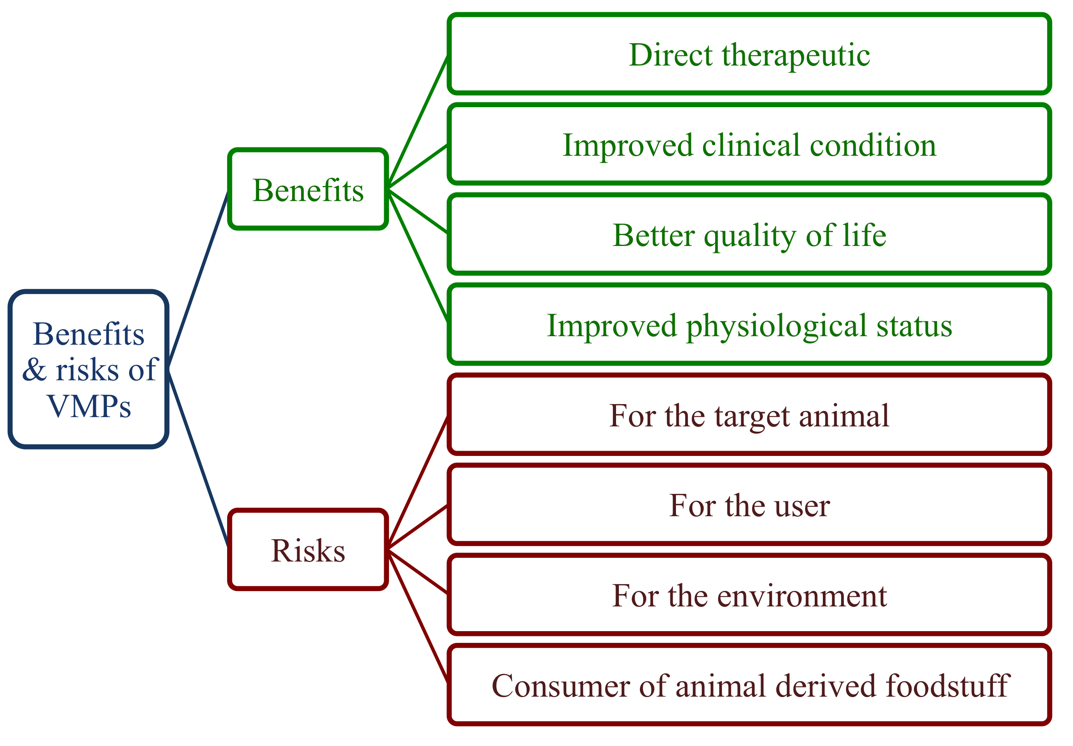
Figure 1. Schematic of a subset of benefits and the main risks from the VMP benefit-risk recommendation (EMA 2009).

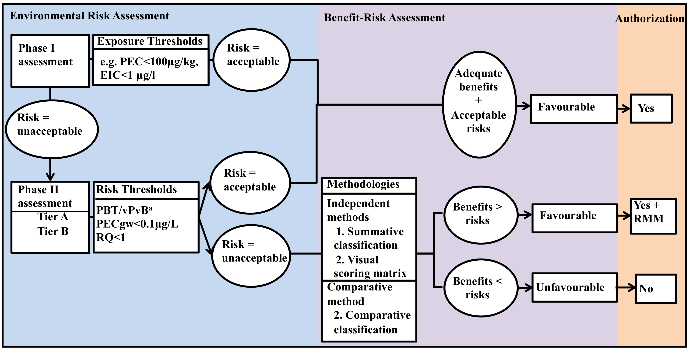

Figure 2. Overview of how environmental risk assessment data from Phase I and II feed into the benefit-risk assessment (BRA) and inform the final authorization decision. Flow illustrates how the three benefit-risk methods (see text) will fit into the authorization process. ª Persistent, bioaccumulative, toxic (PBT)/very persistent, very bioaccumulative (vPvB) criteria defined in EMA (2012a). PEC: Predicted exposure concentration, EIC: Environmental introduction concentration, PECgw: groundwater PEC, RQ: risk quotient (exposure/effect), RMM: risk mitigation measures.

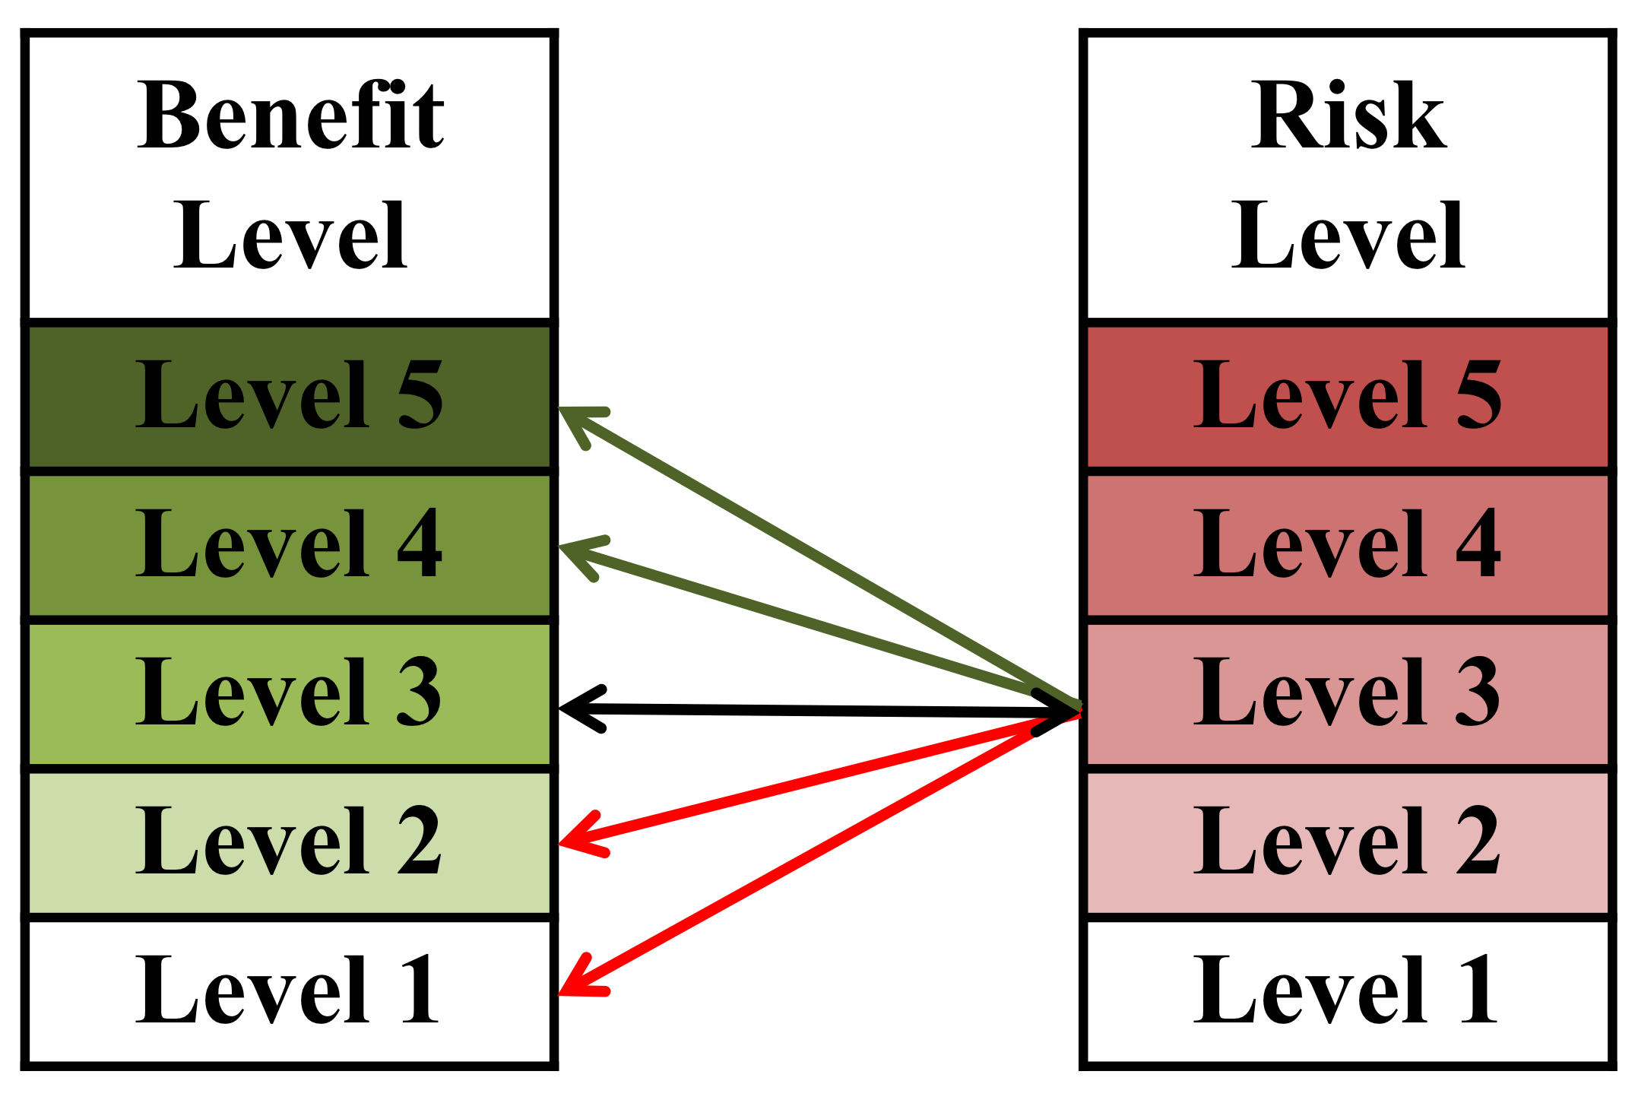

Figure 3. Subset of possible combinations for a level 3 risk in a categorization method with 5 levels of risks and benefits to support authorization decisions for VMPs. Black line connects scenario with the same risks and benefits (i.e., authorization dependent on decision rule). Red lines connect example scenarios with higher risks than benefits (i.e., no authorization); green lines connect example scenarios with higher benefits than risks (i.e., authorization).

