Exploring national variations in child subjective well-being
Jonathan Bradshaw, Gwyther Rees
Affiliation: Social Policy Research Unit, University of York, UK

Abstract
This paper explores variation in national levels of subjective well-being (using mean SLSS scores) for children aged 10 and 12 participating in the Children’s Worlds Survey. We have found it difficult to explain much of the variation in subjective well-being using indicators of the economic, social, political or cultural characteristics of the country. This may be because of the limited number of countries and the fact that Romania is a high outlier and S. Korea a low outlier. However as with the World Happiness Report we did find an association between child SLSS scores and social support as reported by adults in the World Values Survey. Like the World Happiness Report for adults we also found some strong associations between child SLSS scores and other indicators in the Children’s Worlds Survey, particularly friendliness and choice about time use. We developed explanatory models of SLSS using the Good Childhood framework based on domain satisfaction questions which explained 57% of the variation in SLSS scores of the whole sample. In this model satisfaction with freedom was most salient and satisfaction with home and friends least important. However when the model was applied country by country the proportion of variance explained varied from 36% to 76% and the relative importance of the different explanatory factors also varied. It is probable that multi-level modelling will conclude that most variation in subjective well-being occurs, and can be explained best, at the national level.

Keywords: Child well-being, subjective well-being, international comparisons

1. Introduction
There is clear evidence, mainly from analyses of the Health Behaviour of School Aged Children surveys (HBSC), that the subjective well-being of children varies between countries (Bradshaw, Martorano, Natali & de Neubourg, 2013; Casas et al., 2011; Casas, Tiliouine & Figuer, 2014; Currie et al., 2012; 2012; Inchley et al., 2016; Klocke, Clair & Bradshaw, 2014, UNICEF 2007, 2010 and 2016; OECD, 2009). This finding immediately raises the question why? What are the factors that determine this variation? The ambition is that by answering that question policy makers, parents, teachers, or even children themselves, might be able to make children happier. Some encouragement has come from the study of adult happiness, where Helliwell, Layard and Sachs (2015) managed to explain 74% of the international variation in national adult life satisfaction. So the objective of this paper is to explore how subjective child well-being is related to other indicators at a country level.

1.1 Previous research
Few previous studies have explored variations in child subjective well-being at the macro country level. Until recently the only available source of international data was the HBSC survey. Using this data, Bradshaw et al (2013) found quite strong associations between subjective well-being and all the more objective domains of well-being among OECD countries. Countries that performed better on material well-being, education, health, behaviour, and housing and the environment of children, tended to have children with higher levels of subjective well-being. Figure 1 shows the association between the z scores of overall objective well-being (a summary of those domains excluding the subjective indicators) and life satisfaction (using Cantril’s ladder). The objective domains explain 40% of the variation in life satisfaction, but there are a lot of outliers.
Figure 1: Association of life satisfaction and overall objective well-being
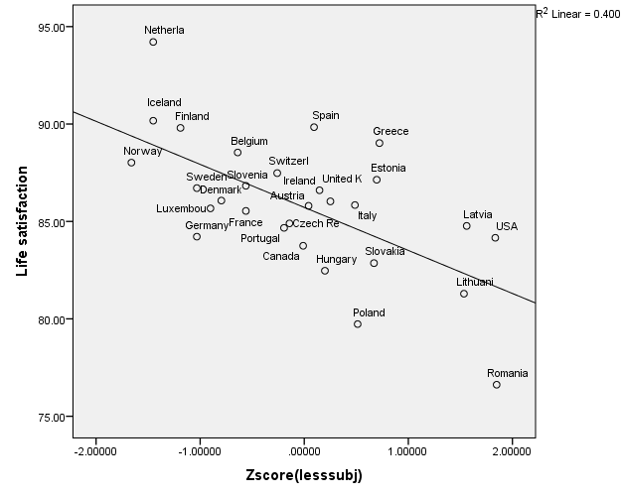
Source: Own analysis of data base UNICEF RC11 (2011)
As well as the overall objective domain measure there were also strong associations at the country level with some individual indicators. Thus for example the correlations between mean life satisfaction and the percentage of children lacking three or more deprivation items was r=-0.70**, and with the percentage of children with equivalent incomes less than 60% of the median is r=-0.54** and with inequality (the Gini coefficient) it was r=-0.38*. However the correlations with GDP per capita, % of GDP spent on family benefits and services in 2011, and the % families headed by a lone parent were not statistically significant (see also Bradshaw 2015).
Building on the above work, Klocke, Clair & Bradshaw (2014) developed an index of subjective well-being using HBSC data and tested multilevel models including individual, school and country levels. This study found that only a small proportion of the total variance in child subjective well-being could be explained at the country level. Further, the country-level variables included in the model – GDP per capita, public spending and youth unemployment – did not make a significant contribution to the model.
Lee and Yoo (2015) used data from the pilot wave of the Children’s Worlds study to examine the effects of individual-level and macro-level variables on child subjective well-being using hierarchical linear models. They also found very limited evidence of significant effects of macro-level variables, although the rate of child mortality under 5 did make a small contribution to the model. They found that within-country variance was much larger than between-country variance.
Analysis at the micro level using HBSC has not been so successful. Klocke Clair & Bradshaw (2014) multi-level analysis found that, of individual factors, gender and age explained 8% of the variation. Adding family structure, parental employment and family affluence increased this to 12%. Adding bullying, smoking, drinking and exercise increased this to 23%. However it is not clear that behavioural indicators can be regarded as causal factors of subjective well-being, as it also plausible that levels of subjective well-being may influence these behaviours – for example, children with low subjective well-being may exercise less and smoke or drink more.
In micro analysis of a series of surveys of child subjective well-being in England (the most recent Pople, Rees, Main, and Bradshaw (2015)), we have also struggled to explain much more than 10% of the variation in subjective well-being using gender, age, family structure, ethnicity and material deprivation. Recent experience of bullying increases this. Only when personality type (Goswami 2014) or the child’s satisfaction with family, friends, neighbours, school, choice are included does this increase. But these are not necessarily independent of subjective well-being.

1.2 Research questions
In this article we explore these issues further making use of data from Wave 2 of the Children’s Worlds study. We seek to answer two questions which are keys to translating research findings on subjective well-being into messages for policy and practice aimed at improving the quality of children’s lives:
- What factors can explain the variations in levels of child subjective well-being between countries?
- To what extent are the factors that influence child subjective well-being similar or different across countries?

2. Methods
The Children’s Worlds survey presents a new opportunity to explore national variations in subjective well-being.
Sample
The Children’s Worlds survey is a comparative school-based survey of representative samples of circa 3000 children per country aged 8, 10 and 12 in 15 countries carried out with the support of the Jacobs Foundation in 2013 to 2015. Malta was added later and is included in some analyses below. Country reports have been published on the website (www.isciweb.org) and there are descriptive comparative overview reports on the 10- and 12-years-old age groups (Rees and Main 2015) and on the 8-years-old age group (Rees, Andresen & Bradshaw, 2016).
In relation to our research questions, the Children’s Worlds survey has two major advantages over previous international child self-report surveys such as the HBSC: first, it is focussed on subjective well-being and contains many more questions on the topic; second, it covers a wider range of types of countries across four continents and includes poor and rich countries. The age range of the children is younger, though the number of countries is fewer than the HBSC.
In this article we have made use of data for 34,000 children from the 10- and 12-years-old surveys only, because these incorporate a wider range of questions than the 8-years-old survey, which also uses different response formats for some questions.

2.1 Measures
In terms of measures of overall subjective well-being, the survey questionnaire includes one single-item question about satisfaction with life as a whole (OLS) and three multi-item scales of subjective well-being – a modified version of the Student Life Satisfaction scale (SLSS) (Huebner, 1991); a modified version of the Brief Multidimensional Student Life Satisfaction Scale (BMSLSS) (Seligson, Huebner and Valois 2003; Huebner, Seligson, Valois and Suld 2006) and the Personal Well-Being Index – School Children (PWI-SC) (Cummins and Lau, 2005). In practice all the scales produce very similar results as shown in the correlation matrix in Table 1.
Table 1: Correlation matrix of the subjective well-being measures in Children’s Worlds
 | OLS | PWI | BMSLSS | SLSS
OLS | 1 | .852** | .925** | .922**
PWI |  | 1 | .831** | .874**
BMSLSS |  |  | 1 | .953**
SLSS |  |  |  | 1
Note: Here and elsewhere *=p<0.05, **=p<0,01, ***=p=<0,001
Casas (2016) has explored the psychometrics of these scales and concluded that SLSS is the best one to use if the analysis is comparing mean scores. The scale consists of five items (e.g. ‘My life is going well’) to which children are asked to respond on an 11-point scale from 0 (‘Not at all agree’) to 10 (‘Totally agree’). The score is calculated by adding together the five responses and multiplying by two, thus generating a life satisfaction score from 0 to 100. For simplicity we will refer to this score throughout the remainder of the article as ‘life satisfaction’.
In the second part of the article, we also make use of a number of other questions from the survey. Some ask about satisfaction with particular aspects of life and used an 11-point response scale with endpoints labelled as 0 (‘Not at all satisfied’) and 10 (‘Totally satisfied’). Most of the remaining questions were statement-based. Some of these used the same 11-point response scale as the life satisfaction items described above while some used a five-point agreement scale labelled ‘Not at all agree’, ‘Agree a little’, ‘Agree somewhat’, ‘Agree a lot’ and ‘Totally agree’. Finally, we make use of some questions on economic and demographic factors. These include descriptive questions about gender, age, whether born in the country of the survey and which people the child lives with. We also use a set of nine questions which asked children about their possession of, or access to, particular items (e.g. clothes in good condition to go to school in, a family car for transportation). These questions used a yes-no format. We sum the responses for nine of these items to create a deprivation score from 0 to 9 where a higher score indicates a greater degree of deprivation.

2.2 Analysis
In the first part of the results section we present the results of bivariate correlation analyses of the associations at the country level between mean child life satisfaction (from the Children’s Worlds survey) and a range of other indicators (from international sources). Because of the limited number of countries in our sample we are not able to develop this analysis further using multivariate techniques. All associations reported as statistically significant in this part of the analysis have p-values below 0.05.
In the second part we present analysis of the associations between various questions within the Children’s Worlds survey and children’s life satisfaction using linear regression analysis. The use of linear regression using life satisfaction as a dependent variable is well-established within the field of subjective well-being research. Despite the typically skewed nature of life satisfaction distributions, Ferrer-i-Carbonnel and Frijters (2004) found that it makes little difference to substantive conclusions whether one treats life satisfaction as a cardinal or ordinal variable. In this section of the paper, because of the relatively large sample size, all results reported as statistically significant refer to a p-value of less than 0.01.
We also decompose the influence of independent satisfaction variables in the linear regressions using the Lindeman-Merenda-Gold method (Lindeman, Merenda and Gold, 1980) which calculates the R² contribution of each independent variable based on its average contribution over different orderings of regressors. The calculations were undertaken using the relaimpo package in R (Grömping, 2006).
All analysis uses the weightings provided in the Children’s Worlds data set to correct for non-responses and to take account of differences between the achieved samples and demographics within each country. Data is also weighted equally by age group. Where we undertake pooled analysis for the whole sample, the data is additionally weighted so that each country has equal influence (i.e. to take account of differences in sample sizes between countries).

3. Results

3.1 The associations between mean life satisfaction and other factors at the country level
Table 2 compares the mean life satisfaction scores for each country in the survey. Romania has the highest subjective well-being and South Korea the lowest. A one-way ANOVA test indicates that there are significant differences between country means, but that these explain less than 10% of the total variance in life satisfaction – indicating that there is much more variation within countries than between countries.
There are no immediately obvious patterns (regional, cultural, religious, economic or social) that emerge from this ranking.
Table 2: Life satisfaction by country (means and standard deviations)
Country | Mean | SD | N
Romania | 93.9 | 12.0 | 2793
Colombia | 89.6 | 15.5 | 1830
Turkey | 89.5 | 19.0 | 2008
Norway | 89.4 | 15.5 | 1862
Israel | 88.9 | 17.6 | 1364
Malta | 88.2 | 17.4 | 1746
Spain | 88.0 | 15.6 | 2628
Algeria | 87.0 | 18.5 | 1162
England | 85.4 | 20.6 | 2199
Poland | 84.8 | 20.5 | 2064
Germany | 84.1 | 19.4 | 1862
Estonia | 83.7 | 18.6 | 2003
S Africa | 83.1 | 21.0 | 2192
Nepal | 83.1 | 17.0 | 1929
Ethiopia | 81.0 | 19.6 | 1911
S Korea | 77.8 | 21.3 | 4991
Total | 85.5 | 19.0 | 34544

The objective of the analysis is to explore how subjective child well-being is related to other indicators at a country level. We hypothesised that child subjective well-being in these countries might be associated with some of the social, economic, political, religious or cultural characteristics of the country. So in preliminary analysis for this paper we developed a data matrix of over 100 indicators taken from World Bank Economic Indicators, the UNDP World Development Indicators, and UNICEF’s State of the World’s Children data base. We also explored the 99 indicators of institutional arrangements in childhood collected by the World Policy Forum. Exploratory analysis of these datasets came up with no significant associations – or at least none that made sense (for example there was a statistically significant association between mean life satisfaction and the country inflation rate - but the higher the inflation the better the subjective well-being!).
So we decided to explore some specific hypotheses. These were selected on the basis that either they had some theoretical prospect of generating an association (eg it might be expected that richer countries might have happier children), or empirical evidence at the micro level (eg mother’s employment was shown to be associated with higher SWB by Klocke, Clair and Bradshaw 2014). Was child subjective well-being related to adult life satisfaction, GDP per capita, spending on schools, female employment, inequality, or youth unemployment? The bivariate regressions are presented in the following figures (Malta data arrived after this database had been created and is excluded here).
Basically there is no association between subjective well-being and any of these indicators. Regression lines have been drawn on Figures 3-8 in the Annex but none of the correlations are statistically significant. There are two possible explanations for this.
The first is that we have only fifteen very disparate countries. Second, and related, we may be being stymied by outliers – particularly Romania at the top of the league, which had response sets at the top end of the range, and South Korea which is an outlier at the bottom of the distribution and where there may be a cultural tendency not to report extremes. Indeed when Romania and Korea are removed we tend to get stronger associations. Figure 9 shows the association between adult life satisfaction and child life satisfaction without those two countries r= 0.65. However we need to be cautious about removing inconvenient patterns and overfitting the associations.
Figure 9: life satisfaction and adult happiness excluding Romania and South Korea.
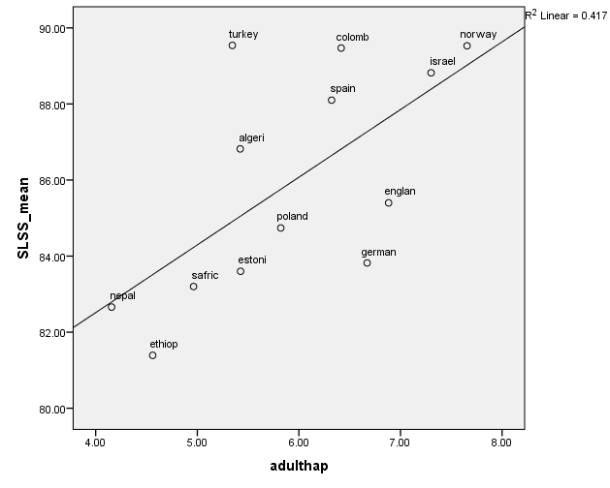
These results are disappointing, especially, on the face of it, in comparison with the adult results. However it is worth having another look at Helliwell, Layard and Sachs (2015). In the World Happiness Report 2015 they used a combination of six factors to explain cross-national variation in life satisfaction, positive affect and negative affect. The six factors were: GDP per capita, social support, healthy life expectancy, freedom to make life choices, generosity of giving and perceptions of corruption. It can be seen in Table 3 that social support and freedom to make life choices (aggregate self-report data) make a significant contribution in all three models. In fact social support and freedom to make life choices explains two-thirds of the variance in Cantril’s ladder explained by the model. However the question needs to be asked – are these variables really independent of subjective well-being, which is incidentally collected from the same respondents in the World Values Survey?
Table 3: International variations in adults’ subjective well-being
Independent variable | Cantril's Ladder | Positive Affect | Negative Affect
Log GDP per capita | .326** | -.005 | .011
Social support | 2.385** | .233** | -.220**
Health life expectancy at birth | .028** | .001 | .002*
Freedom to make life choices | 1.054** | .330** | -.106*
Generosity | .787** | .169** | -.001
Perceptions of corruption | -.632* | .031 | .092**
Adjusted R² | 74% | 49% | 22%
Source: Helliwell et al. (2015) World Happiness Report 2015
Standardised coefficients. ** = p-value < .01; * = p-value < .05
Unfortunately the World Happiness Report relies on Gallup data which is not in the public domain and so we were not able to replicate the above analysis using the Children’s Worlds data. However a similar question on social support is included in the State of Global Well-being 2014 rankings (Gallup, 2014). We have found in Figure 10 that child life satisfaction scores have a significant correlation with the rank of the Social indicator (Having supportive relationships and love in your life). It was also related to the percentage thriving in three or more elements of the five elements of well-being in the same report (R² = 0.436). So countries where adults say they have supportive relationships and love in their life, tend to have children with better subjective well-being – at least in Children’s Worlds countries.
Figure 10: Subjective well-being by supportive relationships
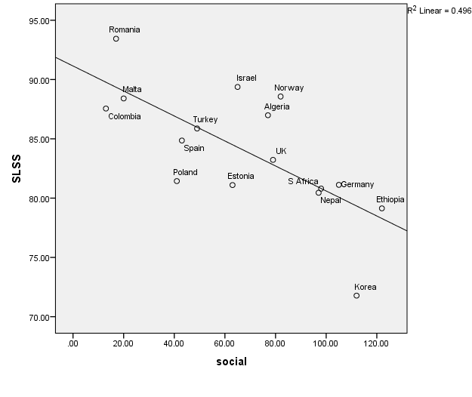
We can do some further exploration similar to Helliwell et al.’s analysis using the Children’s Worlds data. Table 4 shows a set of correlations with some other indicators. The associations are not simply a matter of country variations in positive bias – some associations are significant and others are not.
Table 4: Country-level correlations with life satisfaction of selected aggregate indicators (means) from the Children’s Worlds data set
 | Pearson correlation
People are generally pretty friendly towards me | .959**
I have enough choice about how I spend my time | .905**
I feel safe at school | .664**
My parents/carers treat me fairly | .563*
I feel safe when I walk in the area I live in | .504*
I have enough friends | .457
My friends are usually nice to me | .198
I like going to school | -.010
My teachers listen to me and takes me seriously | -.042

The association between life satisfaction scores and the responses to the statements ‘people are generally pretty friendly to me’ and ‘I have enough choice about how I spend my time’ are both very close (see figures 11 and 12). Also, the correlations in Table 4 suggest that safety may be an important aspect to explore further.
Figure 11: Life satisfaction by ‘People are generally pretty friendly towards me’
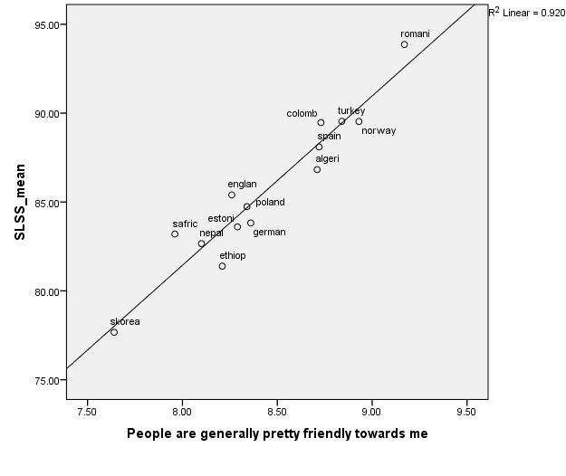
Figure 12: Life satisfaction by ‘I have enough choice about how I spend my time’
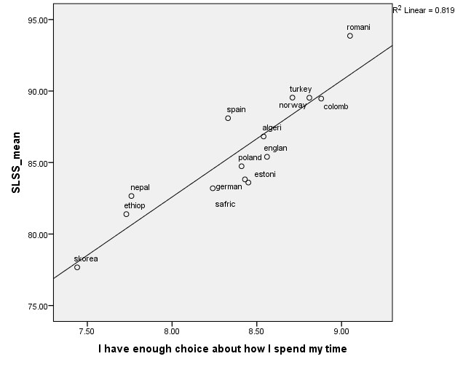
To summarise the conclusions from this first part of the analysis, we have found limited evidence of significant associations between many country-level macro indicators and mean subjective well-being scores, although we only have a small sample of countries to work with. Some of the indicators that one might expect to be associated with subjective well-being, such as GDP, do not appear to be at all. It is only when one looks at less traditional measures such as social support and relationships that one finds significant patterns. A measure of supportive relationships, as reported by adults in each country, shows a significant association with mean child subjective well-being. Backing this message up, aggregate scores for a measure of people’s friendliness, as perceived by children themselves, has a very strong correlation with children’s mean life satisfaction scores. A measure of children’s perceptions of choice shows a similarly strong relationship. These tentative results indicate some useful potential directions for future research aimed at explaining between-country variations in children’s subjective well-being.

3.2 Between-country comparison of variables associated with mean subjective well-being scores
We now turn to our second related research question which is to compare the influence of different factors on children’s subjective well-being between countries.
First of all we explore the relative contribution to explaining variations in subjective well-being within countries of demographic and economic variables. We are limited in what can be included here because, for example, it is not possible to ask children about household income or parental education. But we make the best use possible of variables that are available in the data set. Table 5 summarises the results of linear regression analyses for each country with independent variables for gender, age group, people lived with, deprivation and country of birth. Where children lived in two homes we used data on people lived with for their first home only. (The full regression tables are available on request from the authors). The second column shows the explanatory power of each model (adjusted R²). The third column shows, for additional information, the explanatory power for a model with only the deprivation variable (effectively the square root of the correlation between deprivation and life satisfaction). It was not possible to calculate this statistic for Israel due to variations in the questions asked of different sub-groups of the population in that country.
The remaining columns show significant contributions made to the model by independent variables.
This table is quite revealing in two ways.
First there is quite a wide variation in the explanatory power of the models – ranging from just over 5% in Malta, Nepal and the UK to over 15% in Algeria. Thus, these demographic and economic factors are much more important in understanding variations in subjective well-being in some countries than others.
Second, there is evidence here that different factors carry more importance in different countries. Greater material deprivation was strongly associated with lower life satisfaction in all 16 countries. The figures in the third column show that this was a much more important factor in some countries than others with the greatest associations being seen in the three African countries in the survey and in Romania. These are all countries in the lower half of the rankings for GDP per capita in our sample of 16 countries. However the relationship between these two factors is not completely straightforward as Nepal is the country with the second lowest GDP per capita and yet deprivation explains relatively little of the variation in child subjective well-being in this country.
Gender made a significant contribution to the model in nine of the 16 countries. In four countries, when controlling for other variables, females had higher life satisfaction than males while in four countries the opposite was true. There was evidence of a decline in life satisfaction between the ages of 10 and 12 in most countries – the exceptions being Israel and Malta (note that data was only available for the 12-years-old survey in Algeria). Being born outside the country reduced life satisfaction significantly only in Turkey, and to a lesser extent, in Estonia and Norway. Finally the influence of who the children lived with varied from country to country. In most countries living with one’s father was associated with higher life satisfaction. This was also true in eight countries for living with one’s mother. It should be noted that the large majority of children in all countries lived with their mother and there was limited variation in this variable in many countries. Living with a grandparent was associated with higher life satisfaction in Romania, South Africa and Poland but lower life satisfaction in Nepal. Living with at least one sibling or other child was associated with higher life satisfaction in Norway and South Africa but slightly lower life satisfaction in the UK.
Table 5: Summary of linear regressions of life satisfaction using demographic and economic variables by country
 | Adjusted R² |  |  |  |  |  | Lives with
Country | All | Deprivation only | Female | Older | More deprived | Born in country | Mother | Father | Grand- parent | Other children
Algeria | 15.1% | (14.3%) | + + | n.a. | - - |  | +
Colombia | 6.7% | (5.3%) |  | - - | - - |  |  | +
Estonia | 10.7% | (7.1%) |  | - - | - - | + | + | + +
Ethiopia | 11.8% | (9.3%) | + + | - - | - - |  | + + | + +
Germany | 11.2% | (5.1%) | - - | - - | - - |  | + + | + +
Israel | 6.2% | n.a. | + |  | - -
Malta | 5.1% | (2.7%) | - - |  | - - |  | + + | + +
Nepal | 5.3% | (1.8%) | + + | - - | - - |  |  | + | -
Norway | 6.0% | (2.7%) |  | - | - - | + |  | + + |  | + +
Poland | 10.8% | (5.7%) | - | - - | - - |  |  | + + | +
Romania | 10.8% | (8.8%) |  | - - | - - |  | + + |  | + +
S Africa | 9.3% | (6.9%) | - | - - | - - |  |  |  | + + | + +
S Korea | 11.1% | (1.0%) | - - | - - | - - |  | + + | + +
Spain | 11.8% | (2.8%) |  | - - | - - |  | + | + +
Turkey | 11.1% | (4.4%) |  | - - | - - | + + |  | + +
UK | 5.6% | (2.6%) |  | - - | - - |  |  | + + |  | -
Note: A single + indicates a positive effect of the variable (p-value < 0.05); a single – indicates a negative effect of the variable (p-value < 0.05); double symbols indicate stronger positive or negative effects (p-value < 0.01).
We now go on to consider the association between children’s evaluations of various aspects of their lives and their overall life satisfaction. Lee and Yoo (2015) organised 29 variables from the pilot wave of the Children’s Worlds survey to represent children’s responses in eight domains: self, environment, learning, leisure, money, relationships and freedom. They found a regression using these domains explained 58% of the variation in life satisfaction. We have taken a slightly different approach. We have identified single variables to represent the status of children in relation to the ten domains of the Good Childhood Index originally developed in the UK (Rees, Goswami and Bradshaw, 2010). These are the single item satisfaction questions collected on an eleven point scale described in the measures section above covering money and things, family, home, friends, health, freedom, time use, school, future and appearance. We do not see these as independent variables which ‘explain’ overall life satisfaction. In fact domain satisfactions are generally seen as forming part of the subjective well-being concept. However, analysis of the associations between satisfaction in various domains and life satisfaction can provide useful indications of the potential routes through which children’s life satisfaction may be influenced. For example if we find that children’s satisfaction with money and possessions shows a particularly strong association with their life satisfaction in one country then this may point to the need to further explore this aspect of life in more detail.
Table 6 gives the results of a linear regression of life satisfaction with these variables. This model explains 57% of the variation in life satisfaction. Satisfaction with freedom contributed most to the explanation of the variance, and satisfaction with the house contributing least. (Poland had to be dropped from this analysis because it did not ask all the satisfaction variables.)
Table 6: Regression model of overall life satisfaction with individual satisfaction variables.
(All countries except Poland)
 | B | S.E. | Beta | t | Sig.
(Constant) | -7.987 | .517 |  | -15.450 | .000
All the things you have | 1.460 | .046 | .146 | 32.036 | .000
Your family life | 1.520 | .050 | .141 | 30.708 | .000
The house or flat where you live | .536 | .044 | .055 | 12.136 | .000
Your friends | .545 | .042 | .056 | 13.129 | .000
Your health | .857 | .048 | .083 | 17.720 | .000
The freedom you have | 1.307 | .039 | .160 | 33.169 | .000
What you do in your free time | 1.165 | .048 | .118 | 24.127 | .000
Your school experience | 1.003 | .040 | .111 | 25.126 | .000
What may happen later in your life | 1.028 | .034 | .130 | 30.010 | .000
The way that you look | 1.290 | .039 | .159 | 33.438 | .000

Table 7 and Figure 13 show what happens if the linear regression analysis is done at the country level. Here, for the purposes of comparisons between countries, we calculate the relative importance of each independent variable to the model in each country, expressed as a percentage, using the Lindeman-Merenda-Gold method (see Analysis section). There are quite big variations between countries, both in the proportions of variance explained, and the satisfactions that explain most of the variance.
Looking first at the explanatory power of the models (final column of Table 7), South Korea which has the lowest mean life satisfaction has the highest proportion (76%) explained by these satisfaction variables, followed by Germany (68%) and Israel (67%). The ten variables explain the least amount of variation in life satisfaction scores in Colombia (37%), South Africa (40%) and Nepal (41%). While the ten aspects of life are fairly comprehensive in their coverage of children’s lives, future analysis might usefully focus on testing different sets of satisfaction variables (for example the local area and safety) for their relative explanatory power.
Turning to the relative importance of each domain, the first and second most important domains in each country are highlighted in Table 7. Satisfaction with freedom was the most important domain in five countries – Ethiopia, Malta, South Africa, Turkey and the UK – and the second most important in a further two. Satisfaction with family life was the most important in three countries – Colombia, Germany and Spain. Satisfaction with what may happen in the future was also the most important in three countries – Israel, Norway and South Korea. In Estonia and Nepal, appearance was the most important domain; in Romania it was time use and in Algeria money and possessions. Overall, freedom had the highest mean ranking of importance across all countries, followed by appearance; satisfaction with friends was the domain with the lowest mean ranking of importance followed by home. Thus this analysis shows both differences and similarities across countries in the relative importance of different aspects of life to children’s life satisfaction. While some of the differences in relative importance are quite small (see Figure 13), some relative importance scores such as the high importance of satisfaction with the future in South Korea, and with family in Colombia and Germany, are quite pronounced.

Table 7: Relative importance of domain satisfaction items for overall life satisfaction, and explanatory power of the model, by country
 | Home | Family | Things | Friends | School | Freedom | Health | Appearance | Time | Future | Adj. R²
Algeria | 11% | 6% | 15% | 4% | 8% | 12% | 11% | 13% | 15% | 5% | 0.579
Colombia | 7% | 21% | 11% | 6% | 5% | 18% | 5% | 11% | 7% | 9% | 0.365
Estonia | 5% | 13% | 12% | 8% | 5% | 11% | 8% | 14% | 10% | 13% | 0.651
Ethiopia | 13% | 12% | 16% | 8% | 7% | 21% | 4% | 5% | 10% | 4% | 0.491
Germany | 9% | 20% | 12% | 3% | 8% | 11% | 6% | 12% | 7% | 12% | 0.678
Israel | 7% | 12% | 8% | 5% | 7% | 9% | 9% | 17% | 10% | 17% | 0.670
Malta | 7% | 10% | 14% | 6% | 8% | 15% | 8% | 12% | 11% | 11% | 0.503
Nepal | 4% | 8% | 12% | 8% | 8% | 13% | 14% | 14% | 11% | 9% | 0.413
Norway | 6% | 13% | 9% | 11% | 8% | 8% | 4% | 15% | 9% | 17% | 0.570
Romania | 5% | 8% | 15% | 5% | 7% | 14% | 10% | 11% | 21% | 5% | 0.500
S Africa | 7% | 9% | 13% | 8% | 6% | 16% | 11% | 13% | 15% | 4% | 0.395
S Korea | 5% | 8% | 8% | 6% | 12% | 12% | 9% | 9% | 11% | 22% | 0.763
Spain | 5% | 17% | 10% | 3% | 6% | 14% | 4% | 16% | 8% | 16% | 0.464
Turkey | 7% | 6% | 13% | 5% | 13% | 17% | 5% | 10% | 10% | 13% | 0.587
UK | 7% | 12% | 9% | 5% | 8% | 15% | 9% | 11% | 12% | 12% | 0.659

Figure 13: Relative importance of each domain satisfaction item for overall life satisfaction by country

4. Discussion

4.1 Key messages
In this article we have explored factors associated with variations in mean child subjective well-being between countries and have also compared the relative importance of different factors in explaining variations in subjective well-being within countries.
Our analysis found little or no association between country variations in children’s subjective well-being and a large number of social, economic, cultural and religious characteristics of the countries in the Children’s Worlds survey. However there was an association with adult perceptions of having supportive relationships and love in your life and very strong associations with the country rankings on children’s views about friendliness they experience from others and the amount of choice in their lives. This may be due to the difference between objective indicators of country characteristics and the subjective perceptions of adults. But it suggests a potentially fruitful area for future research.
It is interesting to compare these findings with those from research with adults. Findings presented in the World Happiness Report 2015 (Helliwell, Layard and Sachs 2015) suggest that social support and freedom to make life choices are also important factors explaining variations in mean adult subjective well-being between countries, but that GDP per capita is also an important variable as well as aspects such as perceptions of corruption. It is possible therefore that the factors that explain international variations in child subjective well-being are rather different from those that explain variations in adult subjective well-being.
Our analysis also supports the conclusion of two previous studies that country-level differences only explain a relatively small proportion of the variation in children’s subjective well-being – i.e. there is much more variation within countries than between countries. Child subjective well-being is best explained at national level and the national explanations will vary between countries. Nevertheless there is more that can be learned from making comparisons between countries in the relative associations between different factors and children’s subjective well-being at the micro level, as shown in the second part of the analysis.
First, we find substantial differences between countries in the extent to which demographic and economic factors can explain variations in child subjective well-being. In particular, the influence of deprivation seems to vary considerably between countries. It appears that deprivation has a greater impact in poorer countries, although this finding is tentative and there are exceptions. Demographic factors make a contribution to the model in some countries and not others and sometimes the direction of these contributions varies. For example, when controlling for other factors, girls have higher life satisfaction than boys in some countries, the reverse is true in some other countries, and for some countries there is no significant difference.
Second, we explore the relative importance of different domains of life in explaining life satisfaction. This model explained more than half of the variation in subjective well-being in the pooled sample, but again there was variation at the country-level with the model having much greater explanatory power in some countries than others. There is also evidence of variations in the relative importance of the different aspects of life across countries. For example satisfaction with freedom had relatively high importance in Ethiopia, Malta, South Africa, Turkey and the UK while satisfaction with family was most important in Colombia, Spain and Germany. These kinds of findings are potentially highly informative in identifying aspects of life to focus on in order to improve children’s lives. Comparisons in relative importance across countries can enhance understanding of this issue.

4.2 Limitations
Although The Children’s Worlds data set is an important new source of information on children’s lives and well-being, covering an age range and a more diverse set of countries than existing surveys, some limitations of the data should be noted in terms of the questions addressed in this article.
Our attempts to analyse the macro factors associated with between-country differences in mean subjective well-being scores is hampered by the relatively small number of countries in the sample. It is hoped that future waves of the survey will include a greater number of countries and improve the potential for this type of analysis. This aspect of the analysis is also limited by the macro variables available. There may be other important aspects that could be considered – such as respect for children’s rights – which we have not been able to take account of.
The analysis of factors associated with individual variations in children’s subjective well-being within countries is also limited by available data. We have no information on household income or other similar factors such as quality of housing. It may also be helpful in future to have more information on minority groups within each country (for example on the basis of ethnicity, language or religion), who may have lower than average subjective well-being. We have also not covered the full range of other influences. For example we know that bullying (see Bradshaw et al. elsewhere in this issue) and some other behaviours are associated with subjective well-being.
The analysis we present here is relatively exploratory and multi-level modelling approaches could be utilised to throw additional light on some of the topics covered.
In general we should also note that the data is cross-sectional and so, although we have used regression models, directions of causality cannot be assumed. Finally, our data only focuses on a limited number of countries and a relatively narrow age range and our findings are not necessarily generalizable to other contexts or age groups.

4.3 Concluding comments
Relatively little is still known about the reasons for variations in children’s subjective well-being within and between countries. Our analysis suggests that many traditional macro indicators such as GDP have little relevance to understanding why children in some countries report substantially higher subjective well-being than children in others, but measures related to variations in the adults’ and children’s perceptions of the quality of social relationships within countries may be illuminating. At the micro-level we find important differences in the extent to which demographic and economic factors link to variations in children’s subjective well-being and also some initial indications of variations in the aspects of life that may be important for understanding and improving children’s experience of childhood in different countries around the world. These findings carry important messages for future research and for policy and practice aimed at improving children’s lives.

References
Bradshaw, J. (2015) Child poverty and child well-being in international perspective, in Fernandez, E., Zeira, A., Vecchiato, T. and Canali, C. (eds) Theoretical and empirical insights in child and family poverty: Cross national perspectives, Springer: Dordrecht. 59-70.
Bradshaw, J. (2015) Child poverty and child well-being in international perspective, in Fernandez, E., Zeira, A., Vecchiato, T. and Canali, C. (eds) Theoretical and empirical insights in child and family poverty: Cross national perspectives, Springer: Dordrecht. 59-70.
Bradshaw, J., B. Martorano, L. Natali and C. de Neubourg (2013). Children’s Subjective Well-being in Rich Countries, Child Indicators Research, 6, 4, 619–635.
Casas, F., Sarriera, J. C., Abs, D., Coenders, G., Alfaro, J., Saforcada, E., & Tonon, G. (2011). Subjective Indicators of Personal Well-Being among Adolescents. Performance and Results for Different Scales in Latin-Language Speaking Countries: A Contribution to the International Debate. Child Indicators Research, 5(1), 1–28.
Casas, F., Tiliouine, H., & Figuer, C. (2014). The Subjective Well-being of Adolescents from Two Different Cultures: Applying Three Versions of the PWI in Algeria and Spain. Social Indicators Research, 115(2), 637-651.
Casas, F. (2016). Analysing the Comparability of 3 Multi-Item Subjective Well-Being Psychometric Scales Among 15 Countries Using Samples of 10 and 12-Year-Olds. Child Indicators Research. http://doi.org/10.1007/s12187-015-9360-0
Cummins, R. A., & Lau, A. L. (2005). Personal Wellbeing Index – School Children. Manual (Third Edition). Melbourne: School of Psychology, Deakin University.
Currie, C., Zanotti, C., Morgan, A., Currie, D., de Looze, M., Roberts, C., Samdal, O., Smith, O.R.F. and Barnekow, V. (eds) (2012) Social determinants of health and well-being among young people. Health Behaviour in School-aged Children (HBSC) study: International report from the 2009/2010 survey, Health Policy for Children and Adolescents No 6, Copenhagen: WHO Regional Office for Europe.
Ferrer-i-Carbonell, A., & Frijters, P. (2004). How Important is Methodology for the estimates of the determinants of Happiness?*. The Economic Journal, 114(497), 641–659.
Gallup (2014) The state of Global well-being 2014 http://www.well-beingindex.com/2014-global-report
Goswami, H. (2014). Children's Subjective Well-being: Socio-demographic Characteristics and Personality. Volume 7, Issue 1, pp. 119-140. Child Indicators Research.
Grömping, U. (2006). Relative importance for linear regression in R: the package relaimpo. Journal of Statistical Software, 17(1), 1–27.
Helliwell, J. Layard, R. and Sachs, J. (2015) (eds) World Happiness Report 2015 http://worldhappiness.report/wp-content/uploads/sites/2/2015/04/WHR15.pdf
Huebner, E. S. (1991). Initial Development of the Student’s Life Satisfaction Scale. School Psychology International, 12(3), 231–240. http://doi.org/10.1177/0143034391123010
Huebner, E. S., Seligson, J. L., Valois, R. F., & Suldo, S. M. (2006). A review of the brief multidimensional students’ life satisfaction scale. Social Indicators Research, 79, 477–484.
Inchley, J., & others. (2016). Growing up unequal: gender and socioeconomic differences in young people’s health and well-being. World Health Organization Regional Office for Europe Copenhagen, Denmark.
Klocke, A., Clair, A. and Bradshaw, J. (2014) 'International Variation in Child Subjective Well-Being', Child Indicators Research. 7, 1, 1-20.
Lee, B. J., & Yoo, M. S. (2015). Family, School, and Community Correlates of Children’s Subjective Well-being: An International Comparative Study. Child Indicators Research, 8(1), 151–175. http://doi.org/10.1007/s12187-014-9285-z
Lindeman, R.H., Merenda, P.F. and Gold, R.Z. (1980) Introduction to Bivariate and Multivariate Analysis. Glenview IL: Scott, Foresman.
OECD (2009) Doing better for children, Paris: OECD.
Pople, L., Rees, G., Main, G. and Bradshaw, J. (2015) The Good Childhood Report 2015, The Children’s Society and the University of York http://www.childrenssociety.org.uk/sites/default/files/TheGoodChildhoodReport2015.pdf
Rees, G., Goswami, H., & Bradshaw, J. (2010). Developing an Index of Children’s Subjective Well-being in England. London: The Children’s Society.
Rees, G. and Main, G. (eds.) (2015) Children’s views on their lives and well-being in 15 countries: A report on the Children’s Worlds survey, 2013-14: 10- and 12-year-olds. http://www.isciweb.org/_Uploads/dbsAttachedFiles/ChildrensWorlds2015-FullReport-Final.pdf
Rees, G., Andresen, S. & Bradshaw, J. (eds.) (2016) Children’s views on their lives and well-being in 15 countries: A report on the Children’s Worlds survey, 2013-14: 8-year-olds
Seligson, J. L., Huebner, E. S., & Valois, R. F. (2003). Preliminary Validation of the Brief Multidimensional Students’ Life Satisfaction Scale (BMSLSS). Social Indicators Research, 61(2), 121–145.
UNICEF (2007) Child poverty in perspective: An overview of child wellbeing in high income countries, Innocenti Report Card no 7, Florence: UNICEF Innocenti Research Centre.
UNICEF (2010) The children left behind: A league table of inequality in child well-being in the world’s richest countries, Innocenti Report Card no 9, Florence: UNICEF Innocenti Research Centre.
UNICEF (2013) Child well-being in rich countries: a comparative view, Innocenti Report Card 11, UNICEF Office of Research, Florence.
UNICEF (2016) Fairness for children: a league table of inequality in child well-being in rich countries, Innocenti Report Card 13, UNICEF Office of Research, Florence.

Annex
Figure 3: Life satisfaction by adult life satisfaction  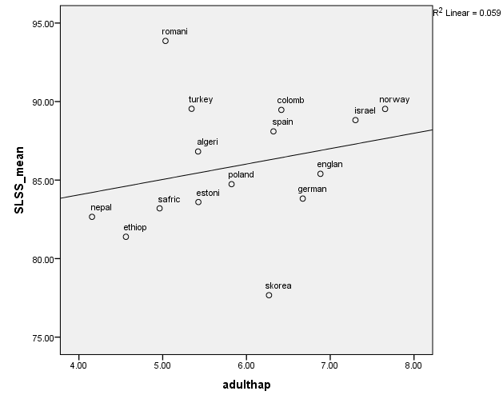 |  | Figure 4: Life satisfaction and GDP per capita  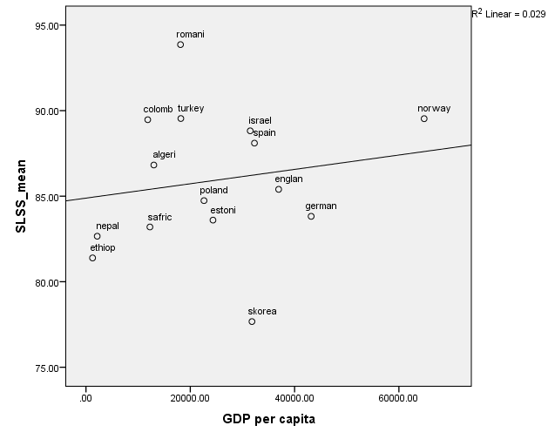
Figure 5: Life satisfaction and education spending as % GDP  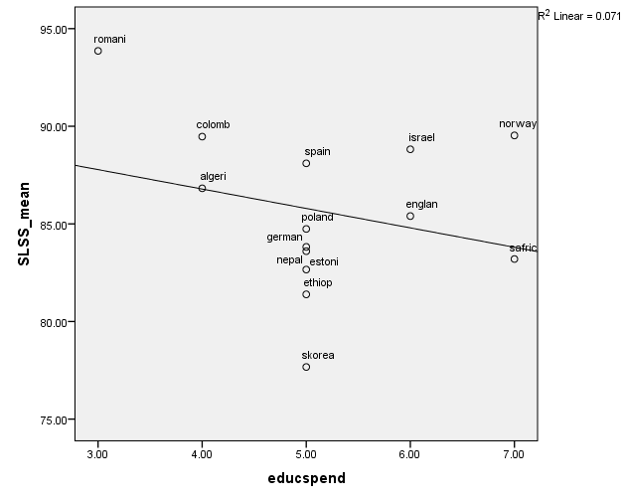 | Figure 6: Life satisfaction by female employment  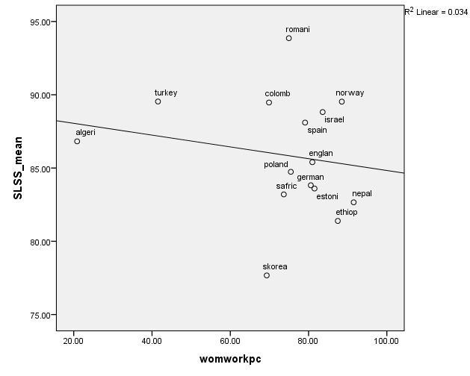
Figure 7: Life satisfaction by inequality (Gini coefficient)  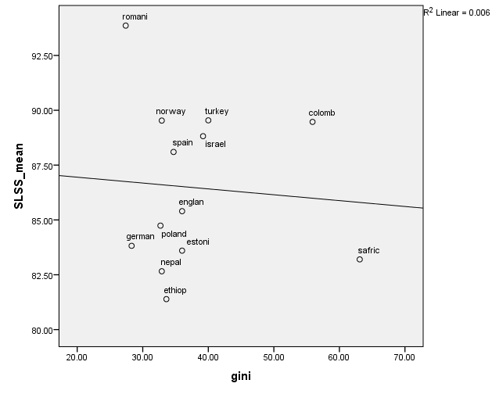 | Figure 8: Life satisfaction by youth unemployment  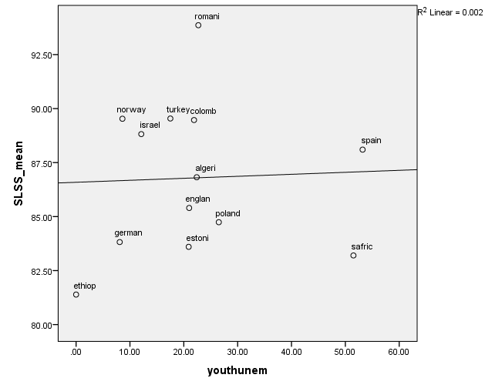

Social support (or having someone to count on in times of trouble) is the national average of the binary responses (either 0 or 1) to the question “If you were in trouble, do you have relatives or friends you can count on to help you whenever you need them, or not?” For OECD countries this is in the Better Life index.
Freedom to make life choices is the national average of responses to the question “Are you satisfied or dissatisfied with your freedom to choose what you do with your life?”

