Monitoring the crystalline structure of sugar cane bagasse in aqueous ionic liquids
Ming-Jie Chen,†,‡ Xue-Qin Zhang,‡ Avtar Matharu,§ Eduardo Melo,§ Rui-Min Li,† Chuan-Fu Liu‡ and Qing-Shan Shi†,*
† State Key Laboratory of Applied Microbiology Southern China, Guangdong Provincial Key Laboratory of Microbial Culture Collection and Application, Guangdong Institute of Microbiology, No. 100, Central Xianlie Road, Guangzhou 510070, China.
‡ State Key Laboratory of Pulp and Paper Engineering, South China University of Technology, No. 381, Wushan Road, Guangzhou 510640, China.
§ Department of Chemistry, University of York, Heslington, York YO10 5DD, England, United Kingdom
* Corresponding author: Tel.: +86 20 87137652; E-mail: shiqingshan@hotmail.com.

KEYWORDS: Aqueous ionic liquid; Biomass pretreatment; Cellulose crystallite; Lignocellulose
ABSTRACT The use of aqueous ionic liquids as a pretreatment for enhancing enzymatic saccharification of lignocellulosic biomass is well-known with focus on lignin and hemicellulose removal. However, an in-depth knowledge of changes in cellulose crystallinity during the pretreatment is limited. To this effect, detailed FT-IR, CP/MAS ¹³C NMR and XRD studies sugarcane bagasse pretreated with aqueous ionic liquids is presented. Secondary-derivatives of FT-IR spectra and Gauss deconvolution of XRD patterns were applied to give detailed understanding of sugarcane bagasse cellulose crystalline changes upon the pretreatment. The results showed that aqueous ionic liquids pretreatment destroys the semi-crystalline region of sugarcane bagasse cellulose, thus disordering the orientation of cellulose crystallite.

Introduction
The need for effective and efficient pretreatment methodologies that negate biomass recalcitrance still remains as one of the major bottlenecks that limits the use of lignocellulosic materials as feedstocks for next generation biorefineries.¹ Ionic Liquids (ILs) have been extensively explored as green solvents for the pretreatment of lignocellulosic biomass due to their ability to vary the degree of hydrogen bonding between solute-solute and solute-solvent interaction.²
In particular, the use of aqueous ILs (water and IL mixture) as pretreatment is suggested to be more desirable than using pure ILs alone.^{3, 4} The addition of water to ILs significantly reduces: expensive ILs usage; energy cost associated with recycling ILs recycle; solution viscosity, and avoids gel formation.⁵ Most importantly, aqueous ILs show exceptional lignin solubility.⁶ Simultaneous swelling and hydrolysis of cellulose is observed in aqueous ILs,⁷ which favors lignocellulosic biomass pretreatment. Therefore, there is increasing interest in the use of aqueous ILs as a pretreatment for enhancing enzymatic saccharification of lignocellulosic biomass.⁸ For example, aqueous 1-ethyl-3-methyl-imidazolium acetate (EmimAc) pretreatment of straw gave higher fermentable sugars recovery compared with pure IL pretreatment.³ Brandt et al.⁹ reported a glucose yield of 90% via enzymatic saccharification of Miscanthus pulp pretreated with 80 vol% aqueous ILs. Size independent sugar cane bagasse pretreatment process was set up with 50% aqueous cholinium amino acids ILs.⁴
Aqueous pretreatment efficiency is strongly dependent on composition and structural properties of the biomass.¹⁰⁻¹² Many researchers have focused on lignin and hemicellulose removal from lignocellulosic biomass using aqueous ILs as a pretreatment methodology.^{3, 5, 8, 12} However, the influence of changes in cellulose crystallinity during pretreatment with aqueous ILs pretreatment is still not that clear. In crystalline cellulose the chains are precisely arranged. Strong inter-chain hydrogen bonding forces the cellulose chains into a sheet-like structure, where aliphatic hydrogen atoms at the sheet surface contribute to weak hydrophobic interactions between the sheets.¹ The combination of hydrogen bonding and hydrophobic interactions within crystalline cellulose makes it highly resistant to chemical and biological hydrolysis.¹ A detailed knowledge of the interaction of SCB crystalline cellulose with aqueous IL pretreatment would help making processing efficient.
Fu et al.³ reported a reduction in cellulose crystallinity in straw after aqueous EmimAc pretreatment. Zhang et al.¹² reported a slight increase of the cellulose crystalline index in sugar cane bagasse (SCB) after acid aqueous IL pretreatment. Whereas, Xia et al.⁸ reported no evident effect on cellulose crystalline index with aqueous 1-butyl-3-methylimidazolium acetate pretreatment of Avicel PH-101 (Particle size 50mm, DP 225). However, Chen et al.¹³ reports that the aqueous ILs distort the cellulose crystalline structure. However, there is no study addressing the size, orientation and organization of cellulose crystals response to aqueous IL pretreatment.
In the present study, detailed XRD, CP/MAS ¹³C NMR and FT-IR studies were undertaken in order to examine changes in the crystallinity of sugar cane bagasse (SCB) upon treatment with aqueous EmimAc. The secondary-derivatives of FT-IR spectra were applied to enhance resolution and Gauss deconvolution of XRD patterns were performed, and d-spacing, crystallite size, and proportion of crystallite interior chains were calculated accordingly.
Experimental
Materials
SCB was obtained from Guangxi Gui-Tang Group Co., Ltd. (Guigang, China). EmimAc was purchased from supplied by Shanghai Cheng Jie Chemical Co. Ltd. (Shanghai, China). SCB (100 g) was washed with hot water (5 x 2 L, 90 ºC), dried (50 ºC, 24 h) and then ground into 20- to 40-mesh particles. The latter was dewaxed by Soxhlet extraction using toluene/ethanol (2:1 v/v) for 10 h. The dewaxed SCB was vacuum dried at 50 ºC for 24 h.
Aqueous EmimAC pretreatment of SCB
Dried, dewaxed SCB (2 g), water (4 g) and EmimAc (16 g) were contained in 50 mL Teflon-lined stainless steel autoclave and subjected to the pretreatment protocol as outlined in Table 1. Post treatment, the resultant suspension was filtered (Buchner), washed with hot water (2 x 100 mL, 70 ºC) and oven dried (50 ºC, 24 h) to afford the desired pretreated SCB.
FT-IR studies
FT-IR spectra were recorded on an FT-IR spectrophotometer (Bruker) using the KBr disc method (KBr, 100 mg) finely ground with sample (1 mg) and pressed under pressure in to a thin disc). Thirty-two scans were collected from 4000 to 400 cm⁻¹ at a resolution of 4 cm⁻¹. The second derivative was obtained with Savitsky-Golay method upon 21 smooth points.
CP/MAS ¹³C NMR study
NMR experiments were performed on a Bruker DRX-400 spectrometer at the frequency of 100 MHz with 5 mm MAS BBO probe. Acquisition time was 0.034 s. The delay time was 2 s, and the proton 90° pulse time 4.85 μs. Each spectrum was obtained with an accumulation of 5000 scans.
XRD analysis
The XRD analysis was conducted on a D8 Advance X-ray diffractometer (Bruker, Germany) equipped with Ni-filtered Cu K_{α1} radiation (λ = 0.15418 nm) at room temperature. The scattering angle range was 5-40º with 8º/min scanning speed and a 2θ step interval of 0.02º. Peak separations were carried out using Gaussian deconvolution. The d-spacings (d) were calculated using the Bragg equation:^{14, 15}
d = λ/(2sinθ) Eq. 1
where
λ, the X-ray wavelength (0.15418 nm)
θ, the Bragg angle corresponding to the plane
The apparent crystallite size (L) of the refection plane was calculated with the Scherrer equation:¹⁶
L = (K×λ)/(β×cosθ) Eq. 2
where
K, the Scherrer constant of value 0.94
β, the half-height width of the diffraction band
The surface chains of cellulose crystals occupy a layer of 0.57 nm thick (h), thus the proportion of crystallite interior chains (X) was calculated as the following Equation:¹⁷
X = ((L-2h)/L)² Eq. 3
The Hermans crystalline index (CrI_{H}) was calculated as:¹⁸
CrI_{H} = A_{crystal}/A_{total} Eq. 4
where
A_{crystal}, the sum of crystalline band areas (all bands besides 18°)
A_{total}, the total area under the XRD curve
The Segal crystalline index (CrI_{S}) was calculated as:¹⁹
CrI_{S} = (I₂₀₀-I_{am})/I₂₀₀ Eq.5
where
I₂₀₀, the intensity of the (200) peak (at about 2θ = 22º)
I_{am}, the intensity amorphous contribution (at about 2θ = 18º)
Acronyms:
pIL: SCB pretreated with pure EmimAc at 150 ºC for 2h;
pW: SCB pretreated with pure water at 150 ºC for 2h;
2h: SCB pretreated with 80wt% aqueous EmimAc at 150 ºC for 2h;
4h: SCB pretreated with 80wt% aqueous EmimAc at 150 ºC for 4h;
160: SCB pretreated with 80wt% aqueous EmimAc at 160 ºC for 2h.
Results and discussion
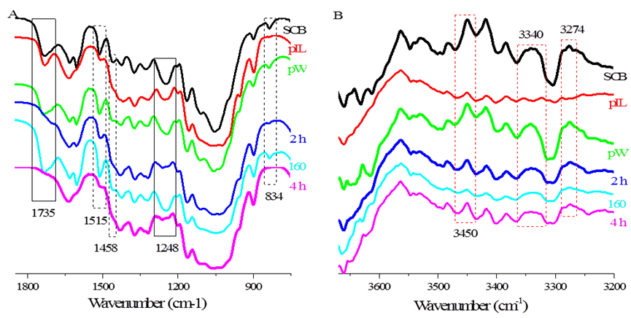
Figure 1. FT-IR spectra of the SCB samples (A), and the second-derivative FT-IR spectra (B).

FT-IR studies were performed to confirm lignin and hemicellulose removal during aqueous EmimAc pretreatment. Absorbance band assignments are in accordance with literature.²⁰⁻²⁴ The bands at 1515 cm⁻¹, 1458 cm⁻¹, and 834 cm⁻¹ are correspond to aromatic skeletal vibrations, aromatic –C-H stretching, and aromatic –C-H deformation from lignin, respectively. The bands at 1735 cm⁻¹, and 1248 cm⁻¹ are attributed to acetyl C=O stretching, and acetate ester C-O stretching from hemicellulose. The intensity of these bands (Figure 1. A, refer to table 1 for the legends) decreased upon aqueous EmimAc pretreatment, suggesting the partial removal of lignin and hemicellulose.
The second-derivative FT-IR spectra of the SCB samples (Figure 1. B) were examined to understand hydrogen bonding changes upon the pretreatment. The absorbance band at 3274 cm⁻¹ is attributed to the intrachain O2−H•••O6 bonding of cellulose I_{β}, whilst the band at 3340 cm⁻¹ is attributed to coupled O2−H•••O6−H•••O3−H•••O5 bonding.²⁰ Both these bands disappeared upon treatment with pure (non-aqueous) EmimAc but remained unchanged after aqueous EmimAc pretreatment. The band at 3450 cm⁻¹ is attributed to OH groups with weakly hydrogen bonding in the semi-crystalline regions²⁰ (described as having more order than amorphous cellulose and less order than crystalline cellulose²⁵). The intensity of this band decreased sharply after aqueous EmimAc pretreatment. These results suggested that aqueous EmimAc pretreatment did not change cellulose crystalline polymorph of SCB, but instead dissolved the semi-crystalline regions of the samples.
The lignin and hemicellulose removal was further confirmed by solid state ¹³C NMR studies (Figure 2). The ¹³C NMR signals at 56.2 ppm and 21.6 ppm corresponded to –OCH₃ from lignin and –COCH₃ from hemicellulose, respectively. The intensity of these signals decreased upon aqueous IL pretreatment, suggesting the removal of lignin and hemicellulose. Typically, SCB has crystallinity lower than 50%, so, the chemical shift at 65-61 ppm, corresponding to C6 carbons in anhydrous glucose unit of cellulose, cannot be used detect cellulose polymorphs difference.²⁶ The chemical shift at 89-80 ppm corresponded to C4 carbons in polysaccharides²⁷ which is conventionally used to understand the cellulose polymorphs. Gaussian deconvolution was applied to this signal for an improved resolution (Figure 2). SCB displayed a typical cellulose Ⅰ_{β} polymorph with chemical shift at 88.5 ppm corresponding to cellulose Ⅰ_{β}²⁸, 86.6 ppm corresponding to crystalline surface²⁸. These peaks remained upon aqueous IL pretreatment, suggesting that the pretreatment did not destroy the crystalline structure of SCB. If the total peak area of 89-80 ppm was normalized to 100%, the peak area of ~86.6 ppm (crystalline surface) was 9.95% (SCB), 17.85% (pIL), 11.33% (pW), 13.19% (2h), 16.2% (160), and 14.67% (4h). This result suggests that the pretreatment exposes the cellulosic crystalline surface.
Figure 2. CP/MAS ¹³C NMR studies of the samples.
XRD analyses of the original and pretreated SCB were performed (Figure 3). XRD peaks are assigned in accordance with literature.²⁹ Native SCB displayed a typical cellulose I XRD pattern. Upon treatment with pure (non-aqueous) EmimAc, any (semi)crystalline cellulose present in SCB residue was totally converted to amorphous stacks. Upon pure water and aqueous EmimAc pretreatment of SCB, cellulose polymorphism was not altered, consistent with the results from FT-IR studies.

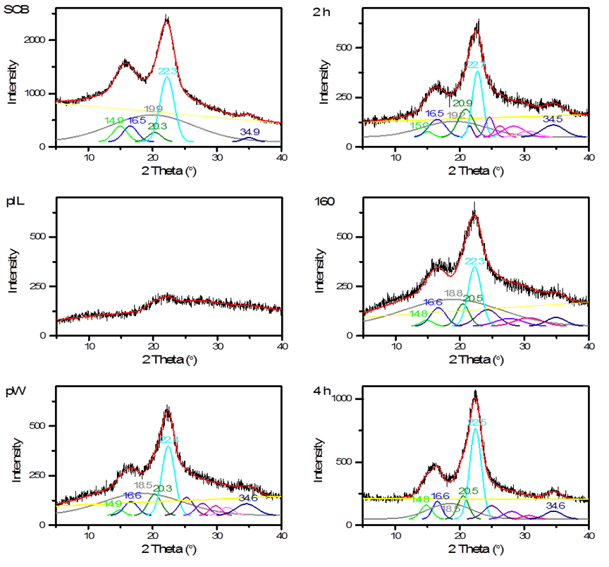
Figure 3. Gauss deconvolution of the XRD patterns.

Table 1 SCB pretreatment processing parameters and the residue crystalline index
Sample | EmimAc content  /wt% | Time  /h | Tem.  /ºC | CrI
 |  |  |  | Hermans | Segal
SCB | - | - | - | 41.1 | 48.6
pIL | 100 | 2 | 150 | - | -
pW | 0 | 2 | 150 | 56.5 | 58.6
2h | 80 | 2 | 150 | 70.7 | 58.8
160 | 80 | 2 | 160 | 48.9 | 49.5
4h | 80 | 4 | 150 | 76.1 | 65.6

Table 2 The d-spacing of the SCB samples
Samples | ī10/nm | 110/nm | 012/nm | 200/nm | 004/nm
SCB | 0.595 | 0.537 | 0.437 | 0.399 | 0.257
pW | 0.595 | 0.534 | 0.437 | 0.397 | 0.259
2h | 0.591 | 0.537 | 0.425 | 0.392 | 0.260
160 | 0.599 | 0.534 | 0.433 | 0.399 | 0.257
4h | 0.599 | 0.534 | 0.433 | 0.395 | 0.259

Gauss deconvolution of the XRD patterns was performed to further understand the SCB residue crystallites. For native SCB, Miller indices of (ī10), (110), (012), (102), (200), and (004) diffraction peaks were obtained, indicating orientation of the original SCB crystallites along the fiber axis.²⁹ After pure water and aqueous EmimAc pretreatment, several peaks ranging from 2θ=25º-34º were obtained upon Gauss deconvolution for pretreated SCB residues, indicating random orientation of the SCB residue crystallites.²⁹ This suggests that the aqueous EmimAc would also lead to the disorder of SCB cellulose crystallites.

Table 3 The crystalline site of the SCB samples
Samples | ī10/nm | 110/nm | 012/nm | 200/nm | 004/nm
SCB | 3.28 | 3.25 | 3.51 | 3.28 | 4.10
pW | 5.10 | 3.38 | 3.52 | 3.59 | 2.34
2h | 4.66 | 2.79 | 3.05 | 4.51 | 2.17
160 | 3.99 | 3.01 | 3.69 | 3.50 | 2.51
4h | 4.11 | 4.87 | 4.27 | 4.01 | 2.90

Table 4 The proportion of the crystallite interior chains of the SCB samples
Samples | ī10 | 110 | 012 | 200 | 004
SCB | 0.426 | 0.421 | 0.456 | 0.425 | 0.522
pW | 0.603 | 0.440 | 0.457 | 0.466 | 0.262
2h | 0.571 | 0.349 | 0.393 | 0.559 | 0.225
160 | 0.510 | 0.386 | 0.478 | 0.454 | 0.299
4h | 0.522 | 0.587 | 0.537 | 0.512 | 0.369

The d-spacings of SCB cellulose, the crystallite size, and the proportion of crystallite interior chains were calculated from XRD profiles. Native SCB showed typical cellulose I_{β} crystalline stacks with d-spacing of 0.595 nm, 0.537 nm, and 0.399 nm (Table 2) for (ī10), (110), and (200) planes,³⁰ respectively. The aqueous EmimAc pretreatment showed no discernible effect on the d-spacing of SCB cellulose. Plotting of (110) d-spacing to (ī10) d-spacing (Figure 4) further confirmed no change of cellulose I_{β} crystalline stacks within SCB during aqueous EmimAc pretreatment.³¹ The crystallite size, and the proportion of crystallite interior chains changed remarkably after aqueous EmimAc pretreatment. The crystallite size of (004) plane decreased (Table 3), while the crystallite size of (ī10) and (200) planes increased after aqueous EmimAc pretreatment (Table 3). The decrease in crystallite size of (004) plane resulted in increasing amount of cellulose chains exposed (Table 4). On the other hand, the increment in crystallite size of (ī10) and (200) planes resulted in an increase of crystallite interior chains (Table 4).

Figure 4． Plotting of (110) d-spacing to (ī10) d-spacing.

The crystallinity index (CrI) of SCB was calculated from XRD profiles according to the Hermans¹⁸ and Segal¹⁹ method, respectively. The results showed that aqueous EmimAc pretreatment significantly increased the CrI of SCB (Table 1). However, the CrI values of the samples calculated from the two methods showed significant difference from each other. The CrI of original SCB calculated using Herman method gave lower values compared with Segal method. The aqueous EmimAc pretreatment SCB at 150 ºC showed a higher Hermans CrI (Table 1). While Segal method calculates crystallinity index according to (200) plane, Hermans method calculates crystallinity index according to the sum of all lattice planes. These results suggested that more lattice planes of SCB crystal were exposed after pretreated, therefore, leading to a high Herman crystallinity index value.
As stated earlier, Fu and Mazza³ reported a reduction in the crystallinity index upon aqueous IL pretreatment, whilst Zhang et al.¹² reported that the pretreatment process increases lignocellulose crystallinity. We have shown an increase in crystallinity index of SCB post aqueous EmimAc pretreatment. The changes in CrI are considered to be governed by two competing factors,¹¹ (1) lignin and hemicellulose removal, which lead to an increase of crystallinity index, and (2) swelling and dissolution of crystalline cellulose, which lead to a decrease of CrI. The lignin and hemicellulose removal during aqueous ILs pretreatment has been generally accepted.^{2-4, 8, 12} As previously discussed, FT-IR analysis (Figure 1) also confirmed lignin and hemicellulose removal from SCB upon pretreatment, which should have contributed to the observed increase in CrI.

Figure 5. Model of aqueous IL pretreatment effect on SCB.

Though, molecular dynamics suggests that water served as co-solvent above 50wt% EmimAc concentration for the dissolution of cellulose,¹¹ the simulation was performed with a cellulose model system of 9 chains with degree of polymerization of 6. Practically, confocal laser scanning microscopy (CLSM) and transmission electron microscopy (TEM) studies showed that aqueous ILs are difficult to penetrate into the secondary walls of plant cell wall.³² Therefore, the crystalline regions of SCB cellulose should not change during aqueous ILs pretreatment as is confirmed by the FT-IR and XRD studies. However, the FT-IR studies showed that semi-crystalline regions were destroyed by the pretreatment, which should contribute to the random orientation of the crystallites, as is observed from XRD studies. Then, the random orientation crystallite turned more crystalline planes exposed, as is showed by the Gauss deconvolution of XRD patterns and CP/MAS ¹³C NMR studies (Figure 5).
Conclusions
FT-IR, CP/MAS ¹³C NMR and XRD studies were performed to understand the changes on crystalline structure of SCB after aqueous EmimAc pretreatment. The results showed that aqueous ILs pretreatment do not change cellulose polymorphism of SCB. The crystallinity index of SCB increased after the pretreatment, which is attributed to the lignin and hemicellulose removal. New crystalline planes were observed, due to the destruction of semi-crystalline regions during the pretreatment. These results may give light on the mechanism understanding of aqueous ILs pretreatment on lignocellulosic biomass, making its cellulose structure easily accessible.

Acknowledgements
This work was supported by National Natural Science Foundation of China (31600477), and the State Key Laboratory of Pulp and Paper Engineering (201602). ASM would like to thank CNPq, Conselho Nacional de Desenvolvimento Cientifico e Tecnologico (Brazil), for scholarly funding of Eduardo Melo to undertake research at University of York, UK.
References
1. M. E. Himmel, S.-Y. Ding, D. K. Johnson, W. S. Adney, M. R. Nimlos, J. W. Brady and T. D. Foust, Biomass recalcitrance: Engineering plants and enzymes for biofuels production. Science, 2007, 315, 804.
2. A. A. Elgharbawy, M. Z. Alam, M. Moniruzzaman and M. Goto, Ionic liquid pretreatment as emerging approaches for enhanced enzymatic hydrolysis of lignocellulosic biomass. Biochem. Eng. J., 2016, 109, 252-267.
3. D. Fu and G. Mazza, Aqueous ionic liquid pretreatment of straw. Bioresour. Technol., 2011, 102, 7008-7011.
4. X.-D. Hou, N. Li and M.-H. Zong, Facile and simple pretreatment of sugar cane bagasse without size reduction using renewable ionic liquids–water mixtures. ACS Sustain. Chem. Eng., 2013, 1, 519-526.
5. D. Fu and G. Mazza, Optimization of processing conditions for the pretreatment of wheat straw using aqueous ionic liquid. Bioresour. Technol., 2011, 102, 8003-8010.
6. Y. Wang, L. Wei, K. Li, Y. Ma, N. Ma, S. Ding, L. Wang, D. Zhao, B. Yan, W. Wan, Q. Zhang, X. Wang, J. Wang and H. Li, Lignin dissolution in dialkylimidazolium-based ionic liquid–water mixtures. Bioresour. Technol., 2014, 170, 499-505.
7. Y. Wang, S. Yao, C. Jia, P. Chen and H. Song, Swelling behaviors of natural cellulose in ionic liquid aqueous solutions. J. Appl. Polym. Sci., 2014, 131, 1-6.
8. S. Xia, G. A. Baker, H. Li, S. Ravula and H. Zhao, Aqueous ionic liquids and deep eutectic solvents for cellulosic biomass pretreatment and saccharification. RSC Adv., 2014, 4, 10586-10596.
9. A. Brandt, M. J. Ray, T. Q. To, D. J. Leak, R. J. Murphy and T. Welton, Ionic liquid pretreatment of lignocellulosic biomass with ionic liquid-water mixtures. Green Chem., 2011, 13, 2489-2499.
10. J. N. Putro, F. E. Soetaredjo, S.-Y. Lin, Y.-H. Ju and S. Ismadji, Pretreatment and conversion of lignocellulose biomass into valuable chemicals. RSC Adv., 2016, 6, 46834-46852.
11. J. Shi, K. Balamurugan, R. Parthasarathi, N. Sathitsuksanoh, S. Zhang, V. Stavila, V. Subramanian, B. A. Simmons and S. Singh, Understanding the role of water during ionic liquid pretreatment of lignocellulose: co-solvent or anti-solvent? Green Chem., 2014, 16, 3830-3840.
12. Z. Zhang, I. M. O'Hara and W. O. S. Doherty, Effects of pH on pretreatment of sugarcane bagasse using aqueous imidazolium ionic liquids. Green Chem., 2013, 15, 431-438.
13. Q. Chen, T. Endo and Q. Wang, Characterization of bamboo after ionic liquid-H₂O pretreatment for the pyrolysis process. BioResources, 2015, 10, 2797-2808.
14. Q. Wang, Q. Chen and T. Endo, Thermal decomposition of bamboo phyllostachys edulis pretreated with ionic liquids-water mixtures. Green Sustain. Chem., 2015, 5, 55-62.
15. C. Montero, B. Clair, T. Alméras, A. v. d. Lee and J. Gril, Relationship between wood elastic strain under bending and cellulose crystal strain. Compos. Sci. Technol., 2012, 72, 175-181.
16. M.-C. Popescu, C.-M. Popescu, G. Lisa and Y. Sakata, Evaluation of morphological and chemical aspects of different wood species by spectroscopy and thermal methods. J. Mol. Struct., 2011, 988, 65-72.
17. T. C. Davidson, R. H. Newman and M. J. Ryan, Variations in the fibre repeat between samples of cellulose I from different sources. Carbohyd. Res., 2004, 339, 2889-2893.
18. P. H. Hermans, J. J. Hermans, D. Vermaas and A. Weidinger, Deformation mechanism of cellulose gels. IV. General relationship between orientation of the crystalline and that of the amorphous portion. J. Polym. Sci., 1948, 3, 1-9.
19. L. Segal, J. J. Creely, A. E. Martin and C. M. Conrad, An empirical method for estimating the degree of crystallinity of native cellulose using the x-ray diffractometer. Text. Res. J., 1959, 29, 786-794.
20. C. M. Lee, J. D. Kubicki, B. Fan, L. Zhong, M. C. Jarvis and S. H. Kim, Hydrogen-bonding network and OH stretch vibration of cellulose: Comparison of computational modeling with polarized IR and SFG spectra. J. Phys. Chem. B, 2015, 119, 15138-15149.
21. C. Y. Liang and R. H. Marchessault, Infrared spectra of crystalline polysaccharides. I. Hydrogen bonds in native celluloses. J. Polym. Sci., 1959, 37, 385-395.
22. H. J. Marrinan and J. Mann, Infrared spectra of the crystalline modifications of cellulose. J. Polym. Sci., 1956, 21, 301-311.
23. S. Y. Oh, D. I. Yoo, Y. Shin, H. C. Kim, H. Y. Kim, Y. S. Chung, W. H. Park and J. H. Youk, Crystalline structure analysis of cellulose treated with sodium hydroxide and carbon dioxide by means of X-ray diffraction and FTIR spectroscopy. Carbohyd. Res., 2005, 340, 2376-2391.
24. M. Traoré, J. Kaal and A. Martínez Cortizas, Application of FTIR spectroscopy to the characterization of archeological wood. Spectrochim. Acta A, 2016, 153, 63-70.
25. M. Foston, Advances in solid-state NMR of cellulose. Curr. Opin. Biotech., 2014, 27, 176-184.
26. S. Maunu, T. Liitiä, S. Kauliomäki, B. O. Hortling and J. Sundquist, ¹³C CPMAS NMR investigations of cellulose polymorphs in different pulps. Cellulose, 2000, 7, 147-159.
27. A. Idström, S. Schantz, J. Sundberg, B. F. Chmelka, P. Gatenholm and L. Nordstierna, 13C NMR assignments of regenerated cellulose from solid-state 2D NMR spectroscopy. Carbohyd. Polym., 2016, 151, 480-487.
28. G. Zuckerstätter, N. Terinte, H. Sixta and K. C. Schuster, Novel insight into cellulose supramolecular structure through 13C CP-MAS NMR spectroscopy and paramagnetic relaxation enhancement. Carbohyd. Polym., 2013, 93, 122-128.
29. A. D. French, Idealized powder diffraction patterns for cellulose polymorphs. Cellulose, 2014, 21, 885-896.
30. R. H. Newman, Simulation of X-ray diffractograms relevant to the purported polymorphs cellulose IV I and IV II. Cellulose, 2008, 15, 769-778.
31. M. Wada, T. Okano and J. Sugiyama, Allomorphs of native crystalline cellulose I evaluated by two equatoriald-spacings. J. Wood Sci., 2001, 47, 124-128.
32. X.-D. Hou, N. Li and M.-H. Zong, Renewable bio ionic liquids-water mixtures-mediated selective removal of lignin from rice straw: Visualization of changes in composition and cell wall structure. Biotechnol. Bioeng., 2013, 110, 1895-1902.

Abstract Graphic
Monitoring the crystalline structure of sugar cane bagasse in aqueous ionic liquids
Ming-Jie Chen,†,‡ Xue-Qin Zhang,‡ Avtar Matharu,§ Eduardo Melo,§ Rui-Min Li,† Chuan-Fu Liu‡ and Qing-Shan Shi†,*
* Corresponding author: Tel.: +86 20 87137652; E-mail: shiqingshan@hotmail.com.

Aqueous ionic liquids pretreatment lead to destruction of semicrystalline sugar cane bagasse cellulose and disorder of cellulose crystal

