Achieving High Levels of NMR-Hyperpolarization in Aqueous Media With Minimal Catalyst Contamination via SABRE
W. Iali,^{[a]} A. M. Olaru,^{[a]} G. G. R. Green,^{[b]} and S. B. Duckett*^{[a]}
[a] Dr. W. Iali, Dr. A. M. Olaru, Prof. G. G. R. Green, Prof. S. B. Duckett*
Department of Chemistry, University of York
Heslington, York, YO10 5DD, UK
E-mail: simon.duckett@york.ac.uk
[b] Prof. Dr. G. G. R. Green
York Neuroimaging Centre, The Biocentre, York Science Park Innovation Way, Heslington, York, YO10 5DD, UK
Supporting information for this article is given via a link at the end of the document.

Abstract: Signal amplification by reversible exchange (SABRE) is shown to allow access to strongly enhanced ¹H NMR signals in a range of substrates in aqueous media. In order to achieve this outcome phase-transfer-catalysis is exploited which leads to less than less than 1.5 x 10⁻⁶ mol dm⁻³ of the iridium catalyst in the aqueous phase. These observations reflect a compelling route to produce a saline based hyperpolarized bolus in just a few seconds for subsequent in vivo MRI monitoring. The new process has been called CAtalyst Separated Hyperpolarization via Signal Amplification By Reversible Exchange or CASH-SABRE. We illustrate this method for the substrates pyrazine, 5-methylpyrimidine, 4,6-d₂-methyl nicotinate, 4,6-d₂-nicotinamide and pyridazine achieving ¹H signals gains of approximately 790-, 340-, 3000-, 260- and 380-fold per proton at 9.4 T at the time point where phase separation is complete.
NMR is commonly used across a large number of disciplines, including chemistry and medicine, but is inherently insensitive as it probes a population difference between states that are close in energy. This population difference can be increased by employing hyperpolarization techniques, such as optical pumping, DNP^{[1]} or the use of parahydrogen (p-H₂)^{[2]}, via p-H₂ induced polarization (PHIP)^{[3]}, to increase sensitivity.
A form of PHIP, known as Signal Amplification by Reversible Exchange (SABRE),^{[4]} is used here to hyperpolarize a substrate in just a few seconds. One of the main advantages of SABRE is that it achieves this result without the incorporation of p-H₂ into the substrate. This technique utilizes a suitable catalyst^{[5]}, to reversibly bind both H₂ (p-H₂) and the substrate in order to assemble a species which can transfer spin order at low magnetic fields from p-H₂ into the substrate.^{[6]}
One important objective of hyperpolarization lies in the area of magnetic resonance imaging (MRI) for use in medical diagnosis.^{[7]} In fact, employing hyperpolarized agents^{[8]} in applications such as tumor or metabolic-flux imaging, is beginning to become a reality.^{[9]} The toxicity of the SABRE catalyst, solvent and substrate need to be minimized though before the SABRE method could be used clinically.
Currently the best reported catalyst for SABRE is [IrCl(COD)(IMes)] (1),^{[10]} delivering ¹H-signal enhancements reaching ~50% polarization in methanol-d₄ solutions, in which both catalyst and p-H₂ solubility is very high.^{[11]} While previous studies have shown that less toxic ethanol-d₆/D₂O mixtures can be employed, the level of signal gain is typically reduced^{[12]} even though activity is seen in neat D₂O although catalyst activation can be slow in this solvent.^{[13]} Feiters et al., and Shi et al., respectively, prepared a water soluble catalyst for use with SABRE but the resulting enhancements in water were again weak when compared to those in methanol,^{[13-14]} as were those achieved by heterogeneous catalysis.^{[15]} Here, we demonstrate how the principles of phase transfer catalysis can be used to improve the SABRE response in water whilst simultaneously achieving catalyst separation (Scheme 1). A related approach has been used very successfully with PHIP such that 10% ¹³C polarization was achieved.^{[16]}
Scheme 1. Partitioning of the SABRE catalyst and hyperpolarization target between the two immiscible phases of chloroform and water allows the principles of phase-transfer catalysis to be employed in conjunction with p-H₂ to produce high levels of hyperpolarization in the aqueous phase with essentially no catalyst contamination.
In order to develop this method, a sample was prepared by combining 0.3 ml of a CDCl₃ solution that contained 5 mM of 1 with a 0.3 ml of a D₂O solution containing 20 mM of the hyperpolarization target pyrazine (pz). As the organic and aqueous phases are immiscible, the lower CDCl₃ layer retained the original orange color due to the catalyst, while the water remained colorless. When H₂ was added on top of the solution, and the sample shaken to dissolve it, a rapid reaction ensued, that led to the CDCl₃ phase becoming deeply red in color due to the formation of [Ir(H)₂(IMes)(pz)₃]Cl. Shaking, however, causes the two initially distinct phases to emulsify prior to separating over 60 seconds. Once separated, the aqueous phase retains its colorless nature and hence these changes are readily discernable optically as shown in Scheme 1. We note that chloroform is partially soluble in water, ultimately reaching a 0.5% level by volume^{[17]}, although we have assessed it at a reaching 0.08% level here 10 seconds after mixing. Given the toxicity of chloroform^{[18]} an N₂ purge would be needed to lower this level in the aqueous phase if it were to be used clinically as the environmental protection agencies recommended water quality criteria specify a limit of 0.07 mg/L.^{[19]}
These changes can be readily assessed by acquiring a series of 1-D projections of the samples ²H-NMR signal along the z-axis of the tube using well established gradient echo methods (Figure 1). When the corresponding ¹H image is recorded to track the weaker pz signal of this sample, the slow separation of the two phases can be assessed, and ultimately a 62.5:37.5 pz partitioning in favor of the CDCl₃ phase is seen.

Figure 1. ²H signal intensity profiles derived from the solvent response as a function of distance from the bottom of the NMR tube (right). (a) Prior to shaking the separated 0.3 ml of a CDCl₃ containing 5 mM of 1 and the 0.3 ml of D₂O containing 20 mM pz, (b) Immediately after shaking an emulsion with no formal phase separation is evident and (c) 25 seconds later partial phase separation is evident.
When this biphasic mixture is exposed to a 3 bar pressure of p-H₂, and the sample shaken in the stray field of the magnet for 10 seconds, SABRE occurs, as shown by a high resolution ¹H NMR spectrum recorded immediately after the sample was inserted in the high field spectrometer. The resulting hyperpolarized pz response shows a 645 ± 15 fold signal enhancement (2% polarization) per proton when compared to that recorded under Boltzmann conditions for a phase separation time of zero. We probed the enhanced pz response in a series of 1-D ¹H-signal intensity projections along the z-axis of the tube as a function of increasing phase-separation time. These results reveal that initially the pz signal intensity is slightly weighted towards the lower end of the tube in which the aqueous phase dominates (Figure 2).
Figure 2. ¹H NMR signal intensity as a function of distance from the bottom of the NMR tube that results after emulsion-based SABRE derived phase-transfer-catalysis to produce a hyperpolarized pz response. The fall in pz signal intensity, as a function of time (s), reveals that the hyperpolarized response decays before phase-separation is achieved.
The level of this response reduces in size with increase in separation time due to relaxation and we note that complete phase separation is not seen before relaxation destroys the hyperpolarized response in such a sample. As the aim of this work was to achieve pz hyperpolarization in water without catalyst contamination, rapid phase separation is essential. A further series of test samples were therefore prepared to explore the effect of varying the amount of CDCl₃ and D₂O, while keeping the total sample volume constant at 0.6 ml. The level of signal gain proved to increase by 25 ± 7 % on moving from pure CDCl₃ to a 17 % loading but again full relaxation occurs before the phase separation is complete.
As saline represents an ideal solvent for in vivo applications, we repeated these studies using 0.35 ml of D₂O doped with 0.16% w/v of NaCl and 0.25 ml of CDCl₃. The effect of this change was dramatic with the resulting signal gain increasing to 790 ± 20 fold (2.5% polarization) per proton after 10 seconds when phase separation is achieved. These results are illustrated in Figure 3, with the hyperpolarized pz signal area in the organic and aqueous phases having a ratio of 48.8:51.2 after 10 seconds. The retained pz signal gain after 15 seconds is 400-fold (1.3% polarization) and when the fully relaxed image was recorded the ratio of pz in the two phases is ~23:77 respectively, which shows that the salt is beneficial in improving the aqueous pz loading under these conditions. We used UV monitoring to compare the rate of transfer of pz from H₂O into CHCl₃ in the presence (0.16% w/v) and absence of NaCl and saw an ~4-fold increase which means the reverse process is also accelerated. Furthermore, the red color associated with the catalyst is still selectively retained in the organic phase. This statement was supported by the fact UV spectroscopy on the aqueous phase revealed that its concentration was less than 1.5 x 10⁻⁶ mol dm⁻³ after 10 seconds, in agreement with the failure to see a SABRE response when this layer was tested. Hence we conclude that we have established a rapid route to produce a hyperpolarized bolus in D₂O that is essentially catalyst free where adding salt plays a beneficial role.^{[20]} We note that CDCl₃ contaminates the aqueous phase at a 0.08% level (5 mg/L) which is reduced to 0.06% by NaCl at this point.

Figure 3. ¹H NMR signal intensity as a function of distance from the bottom of the NMR tube that results after SABRE derived phase-transfer-catalysis in the presence of NaCl. In this case, phase-separation occurs significantly faster than the relaxation of the hyperpolarized pz response.
In order to show that it is possible to exploit this behavior in the collection of MRI data, we replaced the 5 mm NMR tube with a 10 mm sample and used a triple axis gradient system to acquire 2D one shot images of slices parallel to the main axis of the tube (Figure 4), as well as single voxel spectra (SVS) of pz in CDCl₃ and D₂O respectively which confirm the origin of these signals as the hyperpolarized agent, distributed between the organic and aqueous phases (supporting information). The hyperpolarized responses presented in Figure 4 were recorded 15 seconds after completion of the initial hyperpolarization step.
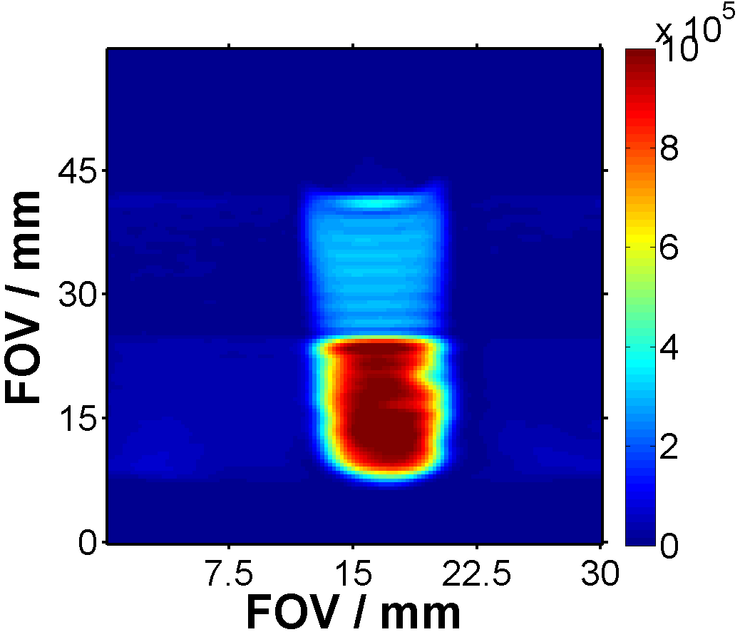
a) b)

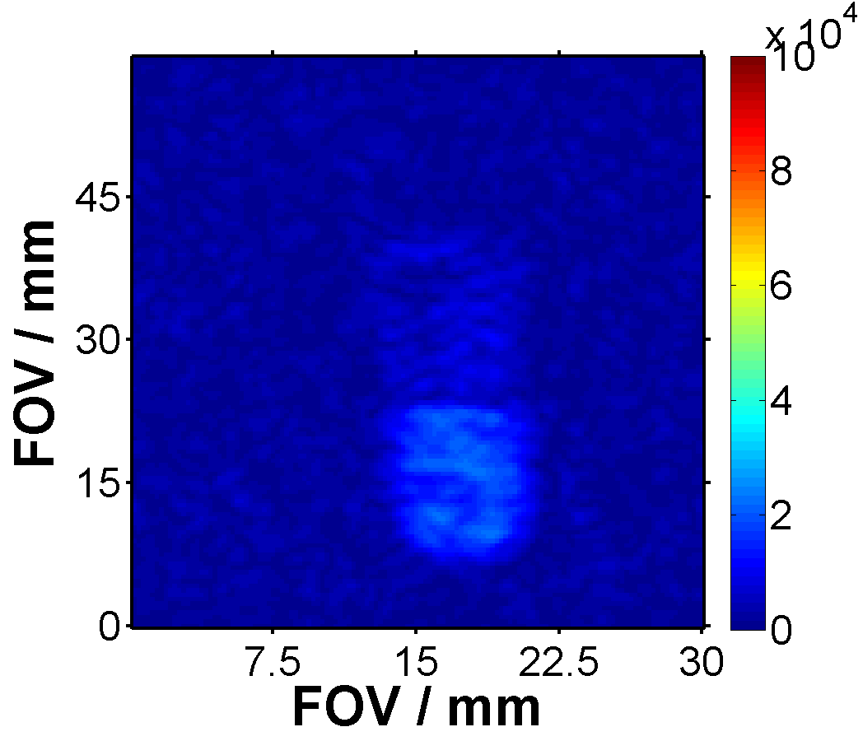
c) d)

Figure 4. 2D-¹H-MRI images of slices parallel to the B_{o} field encoding pz (100 mM) and pyridazine (50 mM) responses under hyperpolarized (a and b respectively, 15 seconds after mixing) and thermal conditions (c and d respectively). Partitioning between the separated aqueous (upper) and organic (lower) phases is clearly visible with the pyridazine response being particularly notable.
As a result of recently published results that showed a high pH dependence to SABRE efficiency^{[21]} we also tested the effects of adding the salts NaCO₂Me, NH₄CO₂Me, NH₄Cl, NaOH, NaH(CO₃) and Na₂CO₃. These results are described in the supporting information and reveal that under spectroscopic examination separate signals for pz can be seen in the two distinct phases in the majority of cases. This point confirms a role for phase transfer without the need for imaging. NaCl, however, proved to deliver the best separation times and enhancement levels.
Considering recent ¹⁵N developments^{[22]}, we have also demonstrated that when the high-resolution ¹³C and ¹⁵N responses of pz at a 100 mM concentration, are examined, strong signals are detected in the aqueous and chloroform phases at different frequencies (Figure 5, 180- and 3000-fold enhancements respectively). Furthermore, as there is a wide interest in diversifying the range of agents hyperpolarized by SABRE^{[23]}, we then tested the generality of this approach by reference to the substrates 5-methylpyrimidine, 4,6-d₂-methyl nicotinate, 4,6-d₂-nicotinamide and pyridazine. All four agents produced SABRE enhanced resonances in the aqueous phase, coupled with phase separation times of less than 10 seconds and good catalyst separation (signal gains of approximately 340, 3000, 260 and 380-fold respectively under similar conditions to those used for pz earlier, see supporting information).The scale of the 4,6 d₂-methyl nicotinate response is particularly noteworthy, and will reflect its long relaxation time^{[11]} while the pyridazine MRI data of Figure 4c and 4d illustrate how the partitioning between the phases varies with agent, in this case leading to a very strong aqueous signal.
Hence we believe that this new and simple CAtalyst Separated Hyperpolarization via Signal Amplification By Reversible Exchange (CASH-SABRE) approach reflects an exciting route to produce high levels of hyperpolarization in a biocompatible aqueous medium with very limited catalyst contamination. We have demonstrated here that ¹H, ¹³C and ¹⁵N detection is possible and are now seeking to develop this approach further through the introduction of chloroform optimized catalysts and new substrates whilst simultaneously exploring new solvent combinations to further minimize contamination of the aqueous phase.

Figure 5. (A): SABRE ¹³C response of pz in the water (blue) and chloroform (orange) phases after transfer at 30 G. (B): SABRE ¹⁵N NMR pz response in the water (blue) and chloroform (orange) phases after transfer at ∼0 G in a μ-metal shield.
Acknowledgements
The Wellcome Trust (092506 and 098335), and the University of York are also thanks for supporting this work. We thank Dr Peter Rayner for scientific discussions and providing the 4,6-d₂-methyl nicotinate and 4,6-d₂-nicotinamide used in this study.
Keywords: NMR spectroscopy • Hyperpolarization • Parahydrogen • SABRE
References
[1] J. H. Ardenkjær-Larsen, B. Fridlund, A. Gram, G. Hansson, L. Hansson, M. H. Lerche, R. Servin, M. Thaning and K. Golman, Proc. Natl. Acad. Sci. 2003, 100, 10158-10163.
[2] C. R. Bowers and D. P. Weitekamp, J. Am. Chem. Soc. 1987, 109, 5541-5542.
[3] T. C. Eisenschmid, R. U. Kirss, P. P. Deutsch, S. I. Hommeltoft, R. Eisenberg, J. Bargon, R. G. Lawler and A. L. Balch, J. Am. Chem. Soc. 1987, 109, 8089-8091.
[4] R. W. Adams, J. A. Aguilar, K. D. Atkinson, M. J. Cowley, P. I. P. Elliott, S. B. Duckett, G. G. R. Green, I. G. Khazal, J. Lopez-Serrano and D. C. Williamson, Science 2009, 323, 1708-1711.
[5] K. D. Atkinson, M. J. Cowley, P. I. P. Elliott, S. B. Duckett, G. G. R. Green, J. Lopez-Serrano and A. C. Whitwood, J. Am. Chem. Soc. 2009, 131, 13362-13368.
[6] R. W. Adams, S. B. Duckett, R. A. Green, D. C. Williamson and G. G. R. Green, J. Chem. Phy. 2009, 131, 194505.
[7] a) J. Kurhanewicz, D. B. Vigneron, K. Brindle, E. Y. Chekmenev, A. Comment, C. H. Cunningham, R. J. DeBerardinis, G. G. Green, M. O. Leach, S. S. Rajan, R. R. Rizi, B. D. Ross, W. S. Warren and C. R. Malloy, Neoplasia 2011, 13, 81-97; b) D. A. Barskiy, A. M. Coffey, P. Nikolaou, D. M. Mikhaylov, B. M. Goodson, R. T. Branca, G. J. Lu, M. G. Shapiro, V. V. Telkki, V. V. Zhivonitko, I. V. Koptyug, O. G. Salnikov, K. V. Kovtunov, V. I. Bukhtiyarov, M. S. Rosen, M. J. Barlow, S. Safavi, I. P. Hall, L. Schroder and E. Y. Chekmenev, Chem. Eur. J. 2017, 23, 28; c) S. J. Nelson, J. Kurhanewicz, D. B. Vigneron, P. E. Z. Larson, A. L. Harzstark, M. Ferrone, M. van Criekinge, J. W. Chang, R. Bok, I. Park, G. Reed, L. Carvajal, E. J. Small, P. Munster, V. K. Weinberg, J. H. Ardenkjaer-Larsen, A. P. Chen, R. E. Hurd, L. I. Odegardstuen, F. J. Robb, J. Tropp and J. A. Murray, Science Translational Medicine 2013, 5, 10; d) T. W. M. Fan and A. N. Lane, Prog. Nucl. Magn. Reson. Spectrosc. 2016, 92-93, 18-53.
[8] a) M. A. Schroeder, H. J. Atherton, L. C. Heather, J. L. Griffin, K. Clarke, G. K. Radda and D. J. Tyler, NMR Biomed. 2011, 24, 980-987; b) B. Pullinger, H. Profka, J. H. Ardenkjaer-Larsen, N. N. Kuzma, S. Kadlecek and R. R. Rizi, NMR Biomed. 2012, 25, 1113-1118; c) T. H. Witney and K. M. Brindle, Biochem. Soc. Trans. 2010, 38, 1220-1224; d) E. Y. Chekmenev, J. Hoevener, V. A. Norton, K. Harris, L. S. Batchelder, P. Bhattacharya, B. D. Ross and D. P. Weitekamp, J. Am. Chem. Soc. 2008, 130, 4212-+; e) T. G. Walker and W. Happer, Rev. Mod. Phys. 1997, 69, 629-642.
[9] a) K. Golman, R. in't Zandt, M. Lerche, R. Pehrson and J. H. Ardenkjaer-Larsen, Cancer Res. 2006, 66, 10855-10860; b) M. J. Albers, R. Bok, A. P. Chen, C. H. Cunningham, M. L. Zierhut, V. Y. Zhang, S. J. Kohler, J. Tropp, R. E. Hurd, Y. F. Yen, S. J. Nelson, D. B. Vigneron and J. Kurhanewicz, Cancer Res. 2008, 68, 8607-8615.
[10] M. J. Cowley, R. W. Adams, K. D. Atkinson, M. C. R. Cockett, S. B. Duckett, G. G. R. Green, J. A. B. Lohman, R. Kerssebaum, D. Kilgour and R. E. Mewis, J. Am. Chem. Soc. 2011, 133, 6134-6137.
[11] P. J. Rayner, M. J. Burns, A. M. Olaru, P. Norcott, M. Fekete, G. G. R. Green, L. A. R. Highton, R. E. Mewis and S. B. Duckett, Proc. Natl. Acad. Sci. 2017, 114, E3188-E3194.
[12] R. E. Mewis, K. D. Atkinson, M. J. Cowley, S. B. Duckett, G. G. R. Green, R. A. Green, L. A. R. Highton, D. Kilgour, L. S. Lloyd, J. A. B. Lohman and D. C. Williamson, Magn. Reson. Chem. 2014, 52, 358-369.
[13] M. L. Truong, F. Shi, P. He, B. X. Yuan, K. N. Plunkett, A. M. Coffey, R. V. Shchepin, D. A. Barskiy, K. V. Kovtunov, I. V. Koptyug, K. W. Waddell, B. M. Goodson and E. Y. Chekmenev, J. Phys. Chem. B 2014, 118, 13882-13889.
[14] a) P. Spannring, I. Reile, M. Emondts, P. P. M. Schleker, N. K. J. Hermkens, N. G. J. van der Zwaluw, B. J. A. van Weerdenburg, P. Tinnemans, M. Tessari, B. Blumich, F. Rutjes and M. C. Feiters, Chem. Eur. J. 2016, 22, 9277-9282; b) F. Shi, P. He, Q. A. Best, K. Groome, M. L. Truong, A. M. Coffey, G. Zimay, R. V. Shchepin, K. W. Waddell, E. Y. Chekmenev and B. M. Goodson, J. Phys. Chem. C 2016, 120, 12149-12156; c) M. Fekete, C. Gibard, G. J. Dear, G. G. R. Green, A. J. J. Hooper, A. D. Roberts, F. Cisnetti and S. B. Duckett, Dalton Trans. 2015, 44, 7870-7880; d) H. F. Zeng, J. D. Xu, M. T. McMahon, J. A. B. Lohman and P. C. M. van Zijl, J. Magn. Reson. 2014, 246, 119-121.
[15] a) F. Shi, A. M. Coffey, K. W. Waddell, E. Y. Chekmenev and B. M. Goodson, Angew. Chem., Int. Ed. 2014, 53, 7495-7498; b) F. Shi, A. M. Coffey, K. W. Waddell, E. Y. Chekmenev and B. M. Goodson, J. Phys. Chem. C 2015, 119, 7525-7533.
[16] a) F. Reineri, T. Boi and S. Aime, Nature Communications 2015, 6, 6; b) F. Reineri, A. Viale, G. Giovenzana, D. Santelia, W. Dastru, R. Gobetto and S. Aime, J. Am. Chem. Soc. 2008, 130, 15047-15053; c) E. Cavallari, C. Carrera, S. Aime and F. Reineri, Chemistry – A European Journal 2017, 23, 1200-1204.
[17] B. Nicholson, B. P. Maguire and D. B. Bursill, Environ. Sci. Technol. 1984, 18, 518-521.
[18] S. L. Rosenthal, Environ. Mol. Mutagen. 1987, 10, 211-226.
[19] https://www.federalregister.gov/documents/2017/01/11/2016-31262/national-primary-drinking-.
[20] F. Montanari, D. Landini and F. Rolla, Top. Curr. Chem. 1982, 101, 147-200.
[21] A. M. Olaru, M. J. Burns, G. G. R. Green and S. B. Duckett, Chem. Sci. 2017.
[22] a) D. A. Barskiy, R. V. Shchepin, A. M. Coffey, T. Theis, W. S. Warren, B. M. Goodson and E. Y. Chekmenev, J. Am. Chem. Soc. 2016, 138, 8080-8083; b) R. V. Shchepin, D. A. Barskiy, A. M. Coffey, T. Theis, F. Shi, W. S. Warren, B. M. Goodson and E. Y. Chekmenev, Acs Sensors 2016, 1, 640-644; c) T. Theis, G. X. Ortiz, A. W. J. Logan, K. E. Claytor, Y. Feng, W. P. Huhn, V. Blum, S. J. Malcolmson, E. Y. Chekmenev, Q. Wang and W. S. Warren, Science Advances 2016, 2.
[23] a) R. V. Shchepin, M. L. Truong, T. Theis, A. M. Coffey, F. Shi, K. W. Waddell, W. S. Warren, B. M. Goodson and E. Y. Chekmenev, J. Phys. Chem. Let. 2015, 6, 1961-1967; b) H. F. Zeng, J. D. Xu, J. Gillen, M. T. McMahon, D. Artemov, J. M. Tyburn, J. A. B. Lohman, R. E. Mewis, K. D. Atkinson, G. G. R. Green, S. B. Duckett and P. C. M. van Zijl, J. Magn. Reson. 2013, 237, 73-78; c) E. B. Ducker, L. T. Kuhn, K. Munnemann and C. Griesinger, J. Magn. Reson. 2012, 214, 159-165; d) N. Eshuis, N. Hermkens, B. J. A. van Weerdenburg, M. C. Feiters, F. Rutjes, S. S. Wijmenga and M. Tessari, J. Am. Chem. Soc. 2014, 136, 2695-2698.

CAtalyst Separated Hyperpolarization via Signal Amplification By Reversible Exchange or CASH-SABRE is shown to allow access to strongly enhanced ¹H, ¹³C and ¹⁵N NMR signals in a range of substrates in aqueous media via phase-transfer-catalysis. Very limited catalyst contamination is observed and  hence a biocompatible bolus is  readily achieved |  |  |  | W. Iali, A. M. Olaru, G. G. R. Green and S. B. Duckett  Page No. – Page No.  Achieving High Levels of NMR-Hyperpolarization in Aqueous Media With Minimal Catalyst Contamination via SABRE

