Introduction: Roundtable on John Tallis’s London Street Views (1838-1840)

By the 1830s, a range of genres had developed to capture the city in print. Guidebooks, histories, topographical prints and surveys, and commercial directories organized the city in different ways for a range of different audiences. The latter were familiar to contemporaries as a means of locating merchants and shopkeepers in the growing cities and perhaps gaining an overview of their socio-economic character. They took a broadly similar format comprising lists of tradespeople and private residents, organized alphabetically and sometimes by trade and location as well. Such directories were essentially text-based; illustrations were almost invariably restricted to advertisements, generally grouped together at the back of the volume.
John Tallis’s London Street Views (1838-1840) form a radical departure from this familiar trope and offer a striking view of London’s streets at the start of the Victorian period. Produced in 88 separate pamphlets covering 74 streets, the Street Views attempt to capture London’s commercial energy in a new, distinctive, and – crucially – profitable way. Organized around a two-page architectural elevation of a particular street or part thereof normally framed by a map of the area and a topographical vignette (Figure 1), the medium is designed to provide maximum opportunities for advertising revenue. Broadly speaking, each volume’s elevation is surrounded by four pages consisting of a brief topographical description of the area in a central column and advertisements on each side, with the inside covers featuring a street directory and further advertisements. The small size of the individual numbers in the series, which were designed to be portable, combined with the limited geographical coverage kept to a minimum the cost to purchasers: typically 1½d., with the occasional copy selling for 2d.. All businesses on the street were listed in the ‘Directory’ and willing business owners could pay to place an advertisement, to have their name and trade listed on or above their shop in the elevation, or to feature in the vignette framing the elevation. The advertisements on the elevations and in the surrounding pages were continually under renewal: as Peter Jackson notes, evidence that names on the elevation have been altered or deleted can be detected in certain numbers, and different printings of the same volume can feature different advertisements in the pages surrounding the elevation.
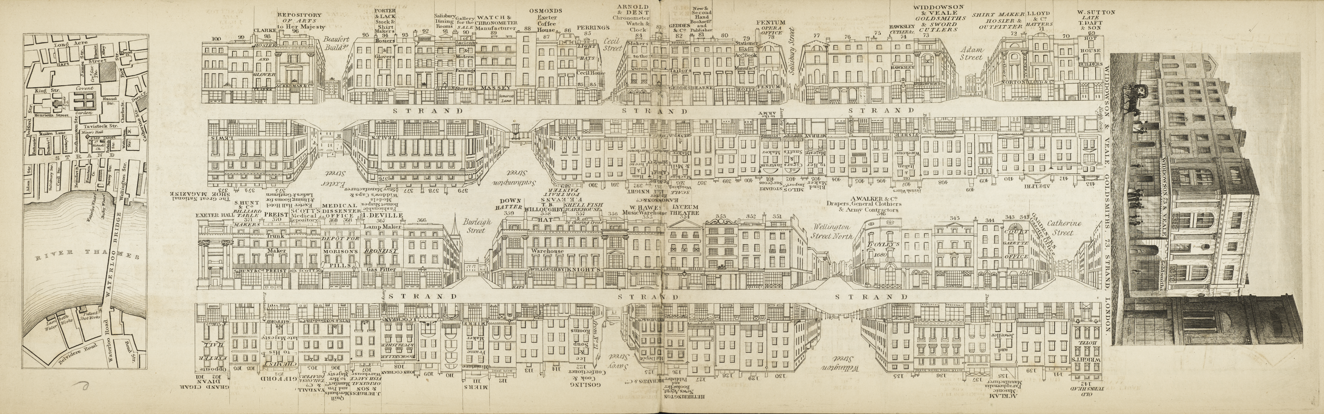
Figure 1. View of the Strand showing typical layout of the two-page architectural elevation framed by a topographical vignette and map of the surrounding area. John Tallis, London Street Views no. 19 (1838-1840). Courtesy, The Lilly Library, Indiana University, Bloomington, Indiana.

In the full title, Tallis presents the series as “forming a complete stranger’s guide through London”, but this is no guidebook to the city (Figure 2). While the various font sizes on the title page give equal weighting to “The Public Buildings, Places of Amusement, Tradesmen’s Shops, [and] Name and Trade of Every Occupant”, trade is the driving force of the publication. The streets, after all, would have been chosen to maximise opportunities for advertising revenue. While landmarks and other historic buildings that visitors to the capital would want to see do appear, these are not the focus or organizing principle; if anything, they are an addendum. The elevation of Parliament Street, for example, replaces the map with a view of Westminster Abbey which otherwise would not appear in the series, and the issue featuring St. Paul’s Churchyard traces the outline of the cathedral in the centre of the elevation, but does not go so far as to feature it in the vignette, which showcases Woodhill, Jeweller and Silversmith (figure 3). Throughout, the streetscape is made to fit the rigid confines of the elevation. The Monument is lopped off at the base; the elegant curve of The Quadrant, Regent Street is straightened, and indoor shopping streets like Burlington Arcade and Lowther Arcade appear indistinguishable from outdoor streets (figures 4 and 5). The detailed nature of the elevations suggests a visual accuracy that the medium cannot maintain.
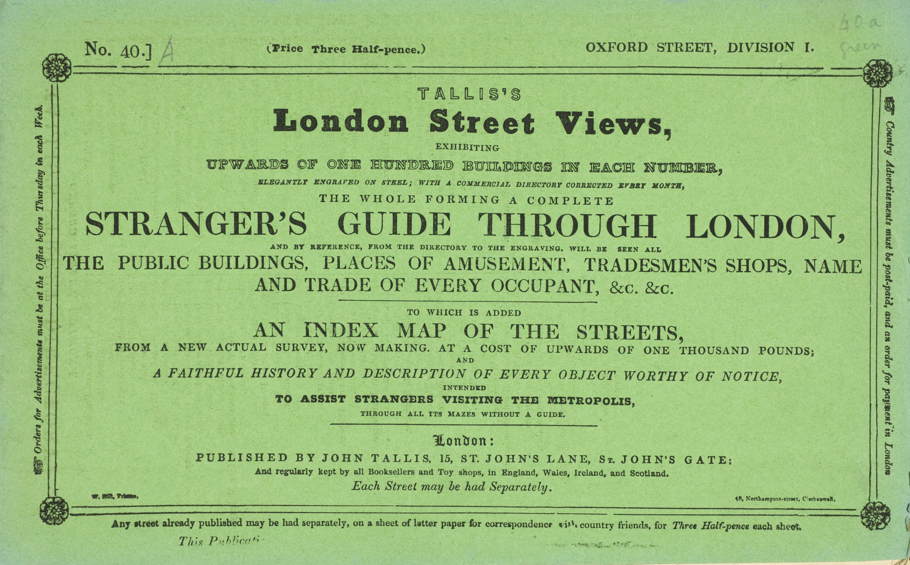
Figure 2. Cover of an issue of Tallis’s London Street Views (1838-1840). Courtesy, The Lilly Library, Indiana University, Bloomington, Indiana.

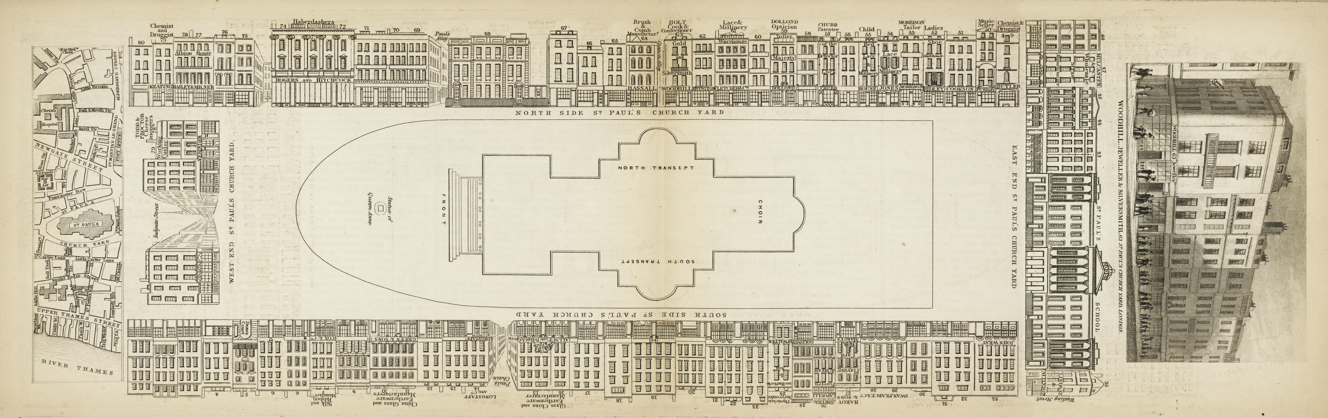
Figure 3. St. Paul’s Churchyard. John Tallis, London Street Views no. 46 (1838-1840). Courtesy, The Lilly Library, Indiana University, Bloomington, Indiana.
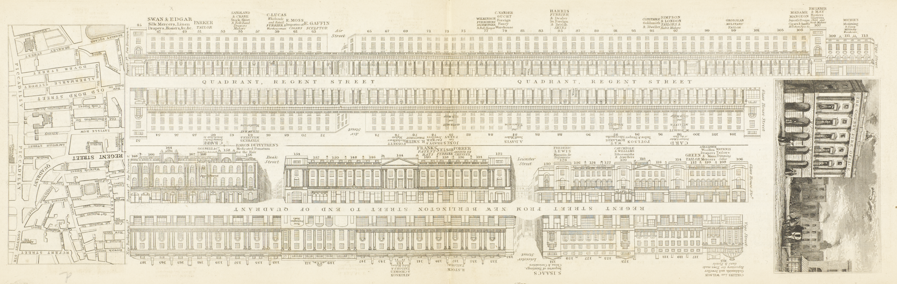
Figure 4. The Quadrant, Regent Street, shown as straight in the elevation, while the map reflects its curve. John Tallis, London Street Views no. 12 (1838-1840). Courtesy, The Lilly Library, Indiana University, Bloomington, Indiana.

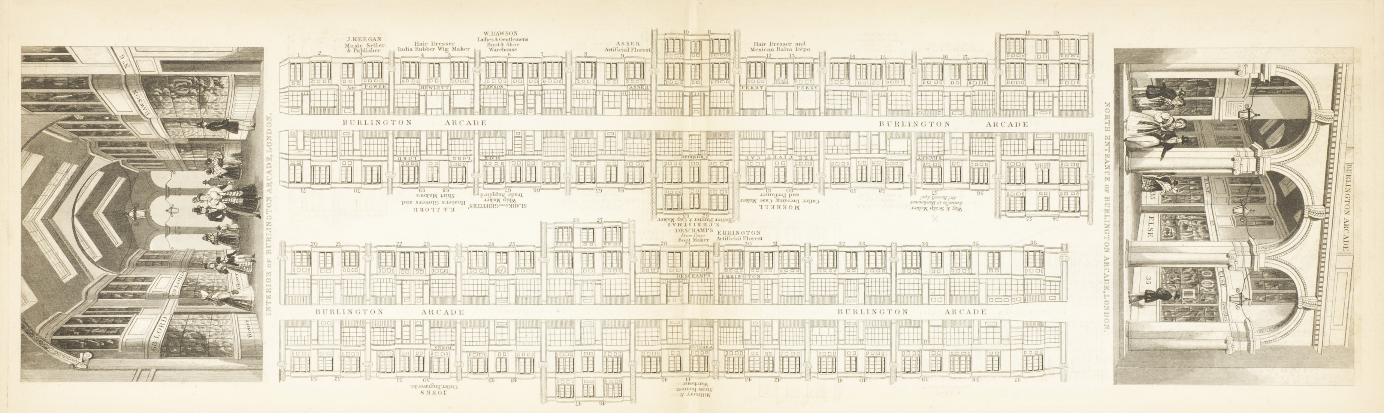
Figure 5. The Burlington Arcade. John Tallis, London Street Views no. 71 (1838-1840). Courtesy, The Lilly Library, Indiana University, Bloomington, Indiana.

Piecing together the fragmented city created by the Street Views is a difficult task for a number of reasons. The streets do not appear in any kind of topographical order, even when a single street spreads over a number of issues. A reader wanting to cover Oxford Street from east to west, for example, would need to move from number 40, to 34, to 36, to 41, to 48, to 72. While cross streets are presented, there is little indication of what is on them: the topographical description may point to something of note, but businesses on those streets are left off of the directory. The sense of disjuncture is further enhanced by the way in which each issue splits the section of street in half, placing one half of the elevation on top of the other.
The poor survival rate of individual issues adds to the complication. Maurice Rickards and Michael Twyman have described the Street Views as “among the rarest of London ephemera: few collections, public or private, contain the complete series”. This reflects both the loss of individual issues and the rarity of complete sets. The scarcity of individual issues is no doubt a consequence of the eminent practicality of the Street Views, which were small and cheap enough to be stuffed into a pocket or bag and carried about as a guide that could be referred to while walking London’s streets. In comparison, the large bound directories published by Pigot & Co., the Post Office, and others were far less portable; consulted at home, they were far less prone to wear and tear and thus survive in large numbers. Of course, it would have been quite possible to bind together issues of Tallis’s Street Views into larger volumes; that this was very rarely done suggests that those who purchased copies (or, as Peter Jackson speculates, were possibly given them by shopkeepers who featured in the Views) did not think in terms of a whole work – perhaps unsurprisingly, given the fragmentation noted earlier. Nevertheless, as Jackson explains, there is evidence that Tallis imagined that these might be collected as complete sets, including, for example, a rare single-sheet title page that refers to ‘Volume I’ and the binder’s signatures that run through the series on the bottom of page 1 that indicate placement in a bound collection. Jackson speculates that the absence of any collections bound in volumes in this manner suggests that Tallis may have felt that they were too out of date to sell in this format, and that he chose instead to embark on a second series, published in 1847.
The ephemeral nature of the individual issues of Tallis’s Street Views, and the absence of any copies bound in volumes, ensured that they quickly became collectors’ items. As a result, their value increased rapidly from the early twentieth century; a century later, in 2010, a bound collection of the elevations alone incorporating parts 1-40 sold at Christies for $5000. This makes the complete, or near complete, sets held by the London Guildhall Library, Museum of London, and the British Architectural Library at the Royal Institute of British Architects in the United Kingdom, and Indiana University’s Lilly Library and the Yale Centre for British Art in the United States, extremely important, both as artifacts and as historical sources through which we can recreate something of London’s commercial development. The Street Views offer a different perspective on the metropolis and its commercial thoroughfares than is afforded by other sources, be they topographies, guides or directories. Their unique appeal and insights come from the blending of different media on each page, and from their intensely visual qualities, reminding us that the spectacle of consumption is not something that took shape only after the Great Exhibition, or with the development of London’s department stores.
Tallis’s Street Views are occasionally used today as source material to identify particular businesses or locate long lost side streets, providing evidence of the topographical details of the metropolis in this period. Much rarer are attempts to grapple with Tallis’s project as a whole. Peter Jackson’s 1969 introduction to his edition of the London Street Views remains the major authoritative source on the production of the series. More recently, Elizabeth Grant has examined them in relation to the physical and imaginative construction of urban space in early Victorian London. In truth, the full potential of the Street Views has yet to be realized. This roundtable forms an initial attempt to address this by examining what we know about them and how they fit into established tropes of urban representation, and by exploring some of the ways in which they might be used to further our understanding of London’s commercial character at this often neglected moment in its development. It emerges out of a workshop held at the RIBA in June 2016, which considered the London Street Views from a variety of angles. The result was a lively and interesting day of discussion, and we are grateful to the participants who took part in the day - a range of urban historians, geographers, art historians, literary critics, archaeologists, planning historians, curators, and librarians – for helping to shape a discussion around Tallis’s unique presentation of the city.
Tallis’s publications offer a distinctive view of the metropolis at the start of this period, enriching our understanding of material culture; the production of space; the development of forms of urban representation; and the history of advertising. In this way, they offer much to the scholar of Victorian culture, society, and economy because they bring together these various strands on the page of the book and in the mind of the reader. In the essays that follow, we consider how the Street Views can be opened up to tell us more about four related themes. The first centres on Tallis’s place within the world of Victorian advertising. Alison O’Byrne’s essay considers the Street Views as a new kind of commercial directory, one more driven by advertising profits than by the suggestion of completeness that characterized contemporary directories. While the elevations gesture towards a sense of fixity in the built environment, the advertisements offer a glimpse of the dynamic world of early nineteenth-century trade. Peering through doors, Lesley Hoskins, Matthew Jenkins, and Charlotte Newman consider how the interior spaces of some of the frontages outlined in the elevation allowed a business to function efficiently and entice in passing customers. For a dental surgeon like Henry Orme, the subject of Hoskins’s essay, the shared entrance to his surgery and home featured a range of furnishings appropriate to the wealthy clientele his business sought to attract. Wallpapers and shop fittings in the case studies explored by Jenkins and Newman also suggest the desire to design a tasteful and elegant environment that might be seen to reflect the refinement of the proprietor.
Second are the mechanisms through which the city and the street are represented by Tallis. In many respects, he was pioneering and innovative in constructing a directory in a highly visual manner: the elevations themselves are the most famous and compelling aspect of the Street Views, creating a unique view of London that seemed to reflect the actual contours of the streetscape. Yet Tallis was, of course, working within an established tradition of topographies and illustrated guides, as Matthew Sangster’s essay makes clear. The brief topographical description in each issue and the vignettes featuring shops and landmarks that, along with a map, framed the elevation, gesture towards the Street Views’ indebtedness to such a tradition. Moreover, the use of pen-portraits of particular shops links closely to the methods used by the writers of guidebooks and town histories, whose text sometimes bordered on the ‘puffs’ found in Tallis. However, as Jon Stobart notes in his contribution, we need to be sensitive to the purpose and impact of these portraits, which could also promote the city as well as the individual business.
This links closely to the third theme: that of place promotion, which can be seen at a variety of scales. Viewed as an overall publishing project, the Street Views create and promote an image of London as a whole. However, the way in which they were produced and published fragments this city-wide image, making it hard for the reader to draw links or distinctions between, say, Norton Folgate and Oxford Street. Instead, we get a much stronger image of the individual street and, through the paid-for advertising, particular businesses: as places, some shops were explicitly promoted through each media on the page (see O’Byrne). All three scales could be linked, as Stobart notes of William West’s History of Warwickshire, in which the individual shop is tied to the street and to the city both through the goods being sold and the architectural and spatial associations it shares with civic and cultural infrastructure.
Lastly, there is a need to look behind the regular and flattened façades that characterize the Street Views and consider the businesses and buildings that lay behind them. This involves peering through the window or, better, still, opening the door and stepping inside to enter the kind of world explored by Lynda Nead in her analysis of Holywell Street. In doing this, we might then explore the built structures that formed the reality behind Tallis’s representations, as Jenkins and Newman do in their contribution. In this way, Tallis provides a framework and a point of entry into a different – and more visceral and material – world comprising relict features and scraps of wallpaper which hold important clues to past lives, businesses and practices. If we are lucky, we might be able to give to a shop front the kind of material time-line provided by the domestic cesspits analysed by Owens et. al. Alternatively, we might seek out a range of other archival sources for the building we enter: inventories listing the contents which tell of lifestyles and livelihoods in a way explored by Hoskins, or census records, rate books or other directories which can give us an idea of temporality – the changing ownership and shifting economic fortunes of a particular building or a street.
Given this variety of possibilities, it is hopefully clear why we see this very much as a starting point to a larger reexamination of Tallis’s Street Views, one that considers how his work both shaped and reflected the ways in which inhabitants and visitors to the metropolis understood the city and the world of consumer goods on offer in it in the years before the Great Exhibition, and how we might use these works to develop our understanding of an often overlooked period in the capital’s literary and cultural history.

Alison O’Byrne
University of York

Jon Stobart
Manchester Metropolitan University

P. Corfield, ‘Giving directions to the town: the early town directories’, Urban History Yearbook, xi (1984), 22-34; G. Shaw and A. Tipper, British Directories: a Bibliography and Guide (Leicester: Leicester University Press, 1989).
Peter Jackson, “Introduction” in John Tallis’s London Street Views (London: Nattali and Maurice, 1969), pp. 9-15, p. 12.
Maurice Rickards, The Encyclopedia of Ephemera: A Guide to the Fragmentary Documents of Everyday Life for the Collector, Curator, and Historian, edited and completed by Michael Twyman (New York: Routledge and London: The British Library, 2000), p. 315.
Jackson, pp. 12-13.
Jackson, p. 13
Jackson, p. 14
(Jackson, p.14; Christie’s, “Beautiful Evidence: The Library of Edward Tufte”, lot 98 http://www.christies.com/lotfinder/Lot/tallis-john-talliss-london-street-views-exhibiting-5388614-details.aspx).
Elizabeth Grant, “John Tallis’s London Street Views” in London Scenes, ed. Alison O’Byrne (London Journal 37: 3 (November 2012)), 234-51.
Lynda Nead, Victorian Babylon: People, Streets, and Images in Nineteenth-Century London (New Haven and London: Yale University Press), pp. 161-188
Owens, A. Jeffries, N., Wehner, K. and Featherby, R. (2010) ‘Fragments of the modern city: material culture and the rhythms of everyday life in Victorian London’, Journal of Victorian Culture 15: 2, pp. 212–225.

