The influence of vegetation on rain garden hydrological performance

Jia Yuan¹*, Nigel Dunnett²& Virginia Stovin³

*Corresponding author
¹ Chongqing University, Faculty of Architecture and Urban Planning, Key Laboratory of New Technology for Construction of Cities in Mountain Area, Chongqing 400045, China
E-mail:jyuan523@vip.163.com
² University of Sheffield, Department of Landscape, Arts Tower, Western Bank, Sheffield S10 2TN, UK.
Tel.: +44 (0)114 222 0611; fax: +44 (0)114 275 4176.
³ University of Sheffield, Department of Civil and Structural Engineering, Mappin Street, Sheffield S1 3JD, UK.

Acknowledgements: Thanks to Ms. Sue France and Green Estate Ltd. (Sheffield, UK) for providing the experimental site and materials.

Abstract: Rain gardens are increasingly adopted in urban areas to mitigate urban stormwater impacts. They provide an opportunity to adopt taxonomically diverse plantings to enhance habitat and aesthetic value. However, few studies to date have quantified how rain garden hydrological performance is affected by vegetation type. In the present study, two vegetation types were considered: taxonomically diverse communities composed of forb-rich perennials; and mown grasses, as well as a bare soil control group. Detention effects were measured independently from retention. The forb-rich perennial mixes consistently provided the best hydrologic performance in terms of both stormwater retention and detention. The diverse perennial community showed up to 1.2 mm higher initial losses over the experimental catchment compared with mown grasses, and also offered 54 and 32% longer detention compared with bare soils and mown grasses respectively. We therefore recommend prioritising taxonomically and structurally diverse planting for vegetated stormwater management facilities wherever possible.
Keywords: Detention; Hydrologic performance; Rain garden; Retention; Vegetation

Introduction
Rain gardens can mitigate stormwater runoff in a variety of climates (Burge et al., 2012), typically accommodating runoff from buildings, roads, pavements and car parks. Rain gardens are often in the public right-of-way, and therefore provide opportunities to introduce attractive planting, adding biodiversity and aesthetic value (Steiner & Domm, 2012). The wider uptake of such features, particularly in high density urban areas, may be partly dependent on ensuring an attractive and visually-acceptable appearance. However, the majority of urban rain gardens implemented to date are dominated by vegetation with low species richness, potentially leading to unnatural and unpleasing visual effects and poor interaction with local biodiversity (Dunnett & Clayden, 2007).
Forbs (i.e. non-grassy herbaceous flowering plants) provide an alternative vegetation option (Dunnett & Clayden, 2007). Taxonomically diverse forb-rich plant mixes provide structurally complex plant communities with high plant diversity and phenological (seasonal) changes to ensure visual interest over time (Hitchmough & Dunnett, 2003). Forb-rich meadow and prairie planting schemes have received positive responses from the public (Kingsbury, 1996). Some domestic rain gardens in the US and the UK have adopted border-like plantings, which are strongly valued for their aesthetics, with various colours in flowering displays (Steiner & Domm, 2012).

Rain garden hydrology
Rain gardens depend upon vegetation and soils to store, infiltrate and evaporate stormwater. Stormwater control may be quantitatively described in terms of retention (i.e. the reduction of the amount of rainfall that becomes runoff) and detention (i.e. the lag and attenuation of the runoff hydrograph). Retention processes include interception and evapotranspiration by the plants, as well as (in unlined systems) infiltration into the natural soil (Jennings et al., 2015). Several authors have presented data that confirms the general effectiveness of rain gardens in retaining stormwater runoff, e.g. Lu and Yuan (2011). Where runoff is observed from rain gardens (for example in lined systems), there is a lag between the peak inflow and the peak runoff, and the peak runoff is reduced (or attenuated) when compared with the peak inflow.
During a storm event, a rain garden will retain stormwater within the substrate’s micropores until it reaches field capacity (Bengtsson et al., 2005). The retained water will eventually return to the atmosphere via evapotranspiration. Evapotranspiration (ET) is driven by solar energy (Allen et al., 1998), and is reduced in cooler climates (Hunt et al., 2006). Field evapotranspiration effects may be enhanced in built-up urban areas due to the ‘oasis’ effect; in a mixed wetland community surrounded by urban development in Tennessee, estimates of ET approached 20 mm/day, nearly double the normal ET for that vegetation (Hill & Neary, 2007). Retention will typically be higher following a longer antecedent dry weather period (ADWP) due to the cumulative effects of ET generating a soil moisture deficit.
Once the growing media has reached field capacity, any subsequent rainfall will fill the larger pores, increasing the soil moisture towards saturation. Most rain gardens are designed to allow ponding to occur once the saturation reaches the surface. Moisture in excess of field capacity will be returned to the ground via infiltration (i.e. the downward movement of rainwater through soil) if the rain garden is unlined, or directed into a storm or combined sewer if the system is lined. In unlined rain gardens, stormwater retention is dominated by infiltration, while evapotranspiration is reported to play a minor role (Jennings et al., 2015).

The role of vegetation
Plants alter the soil-water dynamics in various ways. Plants can enlarge and elongate soil pores following root turnover (McCallum et al., 2004), reverse soil compaction and create macropores (Yunusa & Newton, 2003). Gonzalez-Merchan et al. (2014) and Virahsawmy et al. (2014) provided evidence of enhanced infiltration rates in rain garden media as a result of improved soil permeability and porosity from adopting vegetation.
Stormwater may be temporarily retained in plant tissues (Nagase & Dunnett, 2012), but their main contribution to retention is via evapotranspiration (ET) (Lundholm et al., 2010). Plants with greater aboveground growth traits (i.e. leaf area index and biomass) are typically associated with increased rates of ET, and ET rates will also be higher during the growing season compared with dormant periods (Lundholm et al., 2010; Hunt et al., 2006). It is worth acknowledging that trees may often offer large canopy areas, which may significantly enhance ET for small stormwater management systems such as rain gardens.
In addition to the effects that a single plant type may have on both soil-water interactions and evapotranspiration rates, there is evidence that carefully-selected mixtures of species may provide benefits over and above a monoculture (Rixen & Mulder, 2005). One mechanism that contributes to this is when tall plants are surrounded by contrasting shorter vegetation; the ‘clothesline’ effect can result in proportionally high soil-water loss via transpiration (Allen et al., 1998). Other proposed mechanisms include the presence of overlapping leaf canopies increasing plant interception and a range of root depths and root characteristics widening the range of soil moisture pores that can be accessed.
Johnston (2011) compared four vegetative treatments (control, turfgrass, prairie and shrubs), finding that the greatest peak runoff rates were associated with turfgrass, whereas the greatest reductions in runoff volume were associated with shrubs and prairie. This is consistent with the observation that prairie vegetation had consistently higher ET rates than turfgrass.

Objectives
For the designers of stormwater management facilities, the relative performance benefits associated with different vegetation options are of limited interest; the key objective is to be able to quantitatively predict retention (i.e. losses due to evapotranspiration and infiltration (in unlined systems)) and physical detention processes in response to an arbitrary rainfall event. It is important to note that the detention effects reported for vegetated stormwater management facilities generally reflect a combination of retention (i.e. initial losses) and physical detention (delay) processes (Stovin et al., 2015a). From a stormwater management perspective, the rate of runoff from a system that offers no retention (i.e. a lined rain garden that is already at field capacity) represents a worst case scenario, providing only runoff attenuation. However, the authors are not aware of any existing studies that have focused on quantifying this detention effect in isolation.
This study aims to experimentally compare the hydrological performance of a taxonomically diverse mix of forb-rich plants against conventional mown grasses and bare soil in lined rain garden test plots. In the first set of experiments the retention response is evaluated as a function of the antecedent dry weather period. The second set of experiments aims to identify the detention effects of the different vegetation types using pre-wetted systems.

Methods
Runoff data were collected from fifteen experimental rain garden modules with three different vegetation treatments. Two independent experiments were undertaken to separately quantify retention and detention.

Site and materials
This study was conducted at a nursery area located at Green Estate Ltd., Sheffield, UK (1˚26’11”W, 53˚22’37”N). Fifteen experimental rain garden modules were constructed on site using uncovered plywood boxes with a surface area of 2000 mm by 1000 mm (2 m²) and a depth of 500 mm. The insides of these boxes were covered with impervious liners (Figure 1). A drainage layer (depth 100 mm) was placed at the base of each module. It comprised ~20 mm pea gravel and was separated from the overlying growing media (depth 300 mm) with a filter mat to prevent the drain from clogging. The growing media was a mixture of sharp sand, topsoil and compost (5:2:3, volume ratio) and was classified as a gritty sandy loam (67.2% sand, 13.7% silt and 0.01% clay) with an organic matter content of 8.21% in volume and a pH of 7.9. The substrate was free-draining with a porosity of 66.5% and a permeability of 5.7 cm/hour. Similar media mixes are widely recommended in established technical guidance, such as Prince George’s County (2007) and Woelfle-Erskine and Uncapher (2012). The mineral components ensure that the media is sufficiently permeable to allow the rain gardens to drain effectively, whilst the organic component retains sufficient soil water and provides nutrients to support vegetation development. Each module had a 100 mm ponding depth. The bases of the modules were laid at a slope of 1.5˚. Each module drained into a gutter and was conveyed to the water tank for measurement. The experimental modules were oriented adjacent to one another on open flat ground, with 400 mm spacing between them. The modules were supported 300 mm above the ground.
The modules were designed on the assumption that each 2 m² module would safely accommodate both the rain falling on itself and the runoff from an adjacent impermeable area of 8 m², i.e. a total catchment area of 10 m². This gives a rain garden to catchment area ratio of 1:5, or 20% of the overall catchment area. With a 100 mm ponding depth, the gardens are capable of fully capturing a 20 mm rainfall depth at the point when the substrate is fully saturated (Woelfle-Erskine & Uncapher, 2012). It is noted that, in Australia, FAWB (2009) suggests an extremely low ratio, ranging from 2% to 5%, but the rain garden must have a 400-600 mm ponding depth and the soil infiltration rate is recommended to be at least between 100 to 300 mm/h. More typically, Emanuel et al. (2010) and PADEP (2006) recommend that the ratio should not exceed 10:1 and 5:1 respectively.
Figure 1 - Sectional illustration of the experimental rain garden modules
Three different vegetation treatments were used: mown grasses (A series), mixed forb-rich perennials (B series) and a non-vegetated control group (C series). Each treatment had five replicate modules. The mown grasses consisted of a commercial mixture of six typical lowland grass species that between them should tolerate the range of soil moisture regimes in a typical rain garden profile: Agrostis capillaris, Alopecurus pratensis, Anthoxanthum odoratum, Cynosurus cristatus, Deschampsia cespitosa and Festuca rubra. Seeds were obtained from Emorsgate Seeds Ltd. (Norfolk, UK).
The mixed forb-rich perennial plants consisted of eight forbs and two grasses: Amsonia tabernaemontana var. salicifolia, Astilbe 'Purple Lance', Calamagrostis brachytricha, Filipendula purpurea, Hemerocallis 'Golden Chimes', Iris sibirica, Molinia caerulea, Rudbeckia fulgida var. deamii, Sanguisorba tenuifolia ‘Purpurea’, Veronicastrum virginicum. These species were selected from genera that are widely suggested in current rain garden manuals (e.g. Dunnett & Clayden, 2007; Steiner & Domm, 2012), as being able to tolerate periodic saturation and potential drought. Plants were supplied in 90 mm diameter pots from Orchard Dene Nurseries (Lower Assendon, Henley-on-Thames, Oxfordshire, UK).
Seeds of grass in A series were sown into the modules on 22 April 2013 at a sowing rate of 2 g/m², and were then allowed five months to establish before the experiments were conducted. From July 2013, monthly hand-shears were undertaken to maintain their height at approximately 100 mm. The plants in B series were planted on a 200 mm grid spacing. The non-vegetated control modules were raked monthly to maintain flat ground. There was no intentional nutrient input to any of the test beds. All modules were maintained by hand-weeding and no supplemental irrigation was given until the start of the experiments.
The retention and detention experiments were undertaken from 8 to 30 September 2013. Waterproof luminance diffused polythene was used to cover the top of the rain shelters to enable exact quantities of simulated runoff to be added, while sewn net covers were used to provide ventilation at the sides (Figure 2). Figure 3 shows the different vegetation in situ during the experimental period. The mean temperature inside the modules was 14.4°C, the maximum day temperature was 33.9°C and minimum temperature at night was 6.1°C.
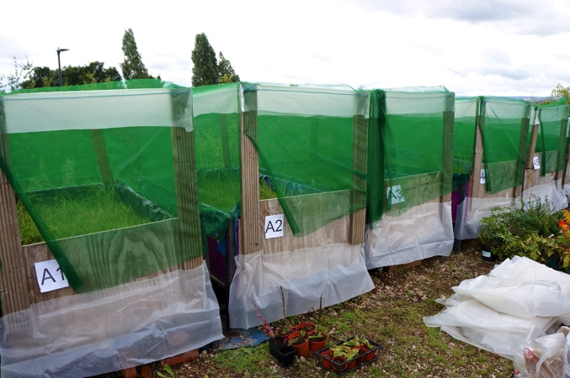
Figure 2 - Experimental rain garden modules with ventilated rain shelters (Jia Yuan, September 2013).
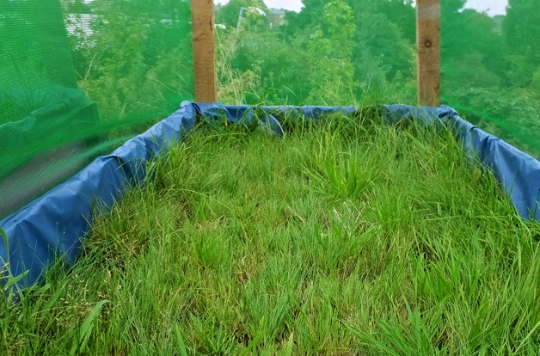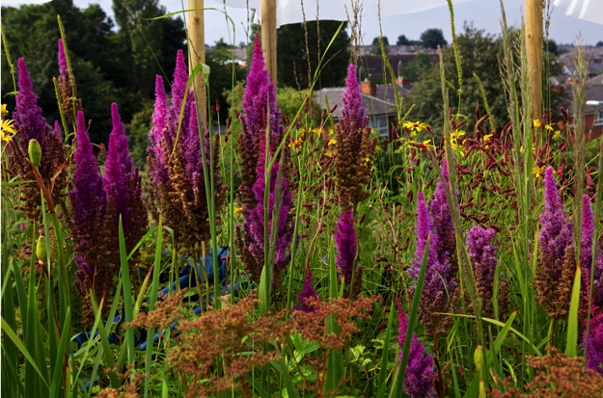
Figure 3 - Different vegetation in situ during the experimental period (Jia Yuan, September 2013). Series A – Mown grasses (left); Series B – Forb-rich perennials (right).

Retention
In the retention tests, the Antecedent Dry Weather Period (ADWP) was defined as the duration that soil had been left to dry following a previous runoff-generating event. The retention tests took place three times under different ADWPs (2, 5 and 7 days). The mean daily temperatures during the 2-, 5- and 7-day ADWPs were 17.2°C, 16.5°C and 11.2°C, respectively. Lower temperatures during the 7-day ADWP are expected to have contributed to a lower daily evapotranspiration rate compared with the other two ADWPs.
This experiment aimed to observe how the systems responded to a ‘significant’ event, specifically the 1 h duration 10 yr return period rainfall depth for Sheffield, which is 21.94 mm (FEH CD-ROM, (NERC, 1999)). Note that this depth marginally exceeds the 20 mm temporary storage associated with the ponding zone, but that the systems had always fully drained (i.e. to a maximum moisture content equivalent to the substrate’s field capacity) prior to the tests. At field capacity, the larger air-filled pores within the substrate provide additional temporary storage capacity. Moisture loss from the substrate due to evapotranspiration was expected to result in the development of moisture retention capacity within the substrate over time.
Tap water was applied using a mist nozzle. A water flow meter (Gardena 8188-20, Husqvarna UK Ltd., Newton Aycliffe, UK) was connected to the mist nozzle to monitor the flow. The precision of the water flow meter was 0.1 l with 0.1 l/min resolution. The required inflow rate was 0.37 mm/min (3.7 l/min), which implies a maximum error of +/- 3%. Each module received 0.2194 m³ inflow in total. The mist nozzle was positioned 500 mm above the planted bed and oscillated to distribute the inflow evenly over the surface. The total amount of runoff leaving each module was collected and recorded the next day, after the runoff had stopped. The retention volume was determined from the difference between the inflow and outflow volumes. The moisture retention depth (in mm) within the planter was determined by dividing the retained volume by the planter surface area. Equivalent rainfall losses (in mm) were determined by dividing the retained volume by the total catchment area. For example, an outflow volume of 0.1097 m³ (compared with an inflow volume of 0.2194 m³) equates to 50% retention, 54.85 mm increase in moisture depth within the planter and 10.97 mm rainfall losses over the catchment.

Detention
The detention tests were carried out separately from the retention experiments. Inflow equivalent to a catchment-wide rainfall of 1.21 mm/min (i.e. 12.1 l/min) was applied for one hour across all fifteen rain garden modules. The rainfall intensity equated to a 1-h rainfall depth of 72.6 mm, which is representative of an extreme event, in excess of 1 in 50 yrs for Sheffield (FEH CD-ROM). The detention tests started with pre-wetted soil media (i.e. irrigated to in excess of field capacity and then allowed to drain for two hours). This ensured that there was no retention capacity, such that all inflow should become runoff, and effects due to detention in the soil media could be clearly isolated and quantified.
Runoff hydrographs from each module were measured for 100 minutes at 5-min intervals. The outflow rate from all treatments peaked within 100 minutes. Runoff delay was determined as the t₅₀ delay, i.e. the time between the median value on the cumulative inflow profile and the same absolute depth on the cumulative runoff profile (Stovin et al., 2015a). Each detention experiment was repeated 3 times in each of the five replicate test beds for each treatment. This gave fifteen repeats of the detention experiment per treatment overall. Further replications were not possible due to seasonal weather constraints and site access restrictions.

Data analysis
Two-way ANOVA analysis was applied to determine whether the runoff retention was significantly affected by the different vegetation types and the antecedent dry weather periods (ADWP), and whether there was an interaction between vegetation types and ADWP. One-way ANOVA was introduced to determine if the different vegetative treatments’ detention metrics (e.g. runoff t₅₀ delay and peak attenuation) were independent of one another. To meet the assumptions necessary for ANOVA, the datasets were checked using Levene’s test for normality and homogeneity. No conclusive evidence that the assumptions were infringed was found, and therefore the analysis was performed with untransformed data. Means were separated by Duncan’s test, and differences were considered statistically significant for P<0.05. All analyses were performed using SPSS 20.0.

Results

Retention
In general the retention performance data all fall within a fairly narrow range of 66 to 76% (or 14.6 to 16.8 mm initial losses over the catchment). However, standard deviations between replicates were very small, such that some of the differences between treatments were statistically significant. A two-way ANOVA showed that the different vegetation treatments (P < 0.001) and the different ADWPs (P < 0.001) had significant effects on runoff retention. The interaction was significant (P < 0.001).
Figure 4 shows the mean runoff retention among vegetative treatments across the three ADWPs. The mixed forb-rich perennials consistently had the greatest mean runoff retention. With a short ADWP (2 days), the control group with bare soils had the smallest retention, whereas, after 7-day ADWP, runoff retention in bare soils was significantly higher than in the mown grasses. After 2 days ADWP, retention levels in the mown grasses and mixed forb-rich perennials treatments were respectively 4.80% and 12.14% greater than the bare soil alone.
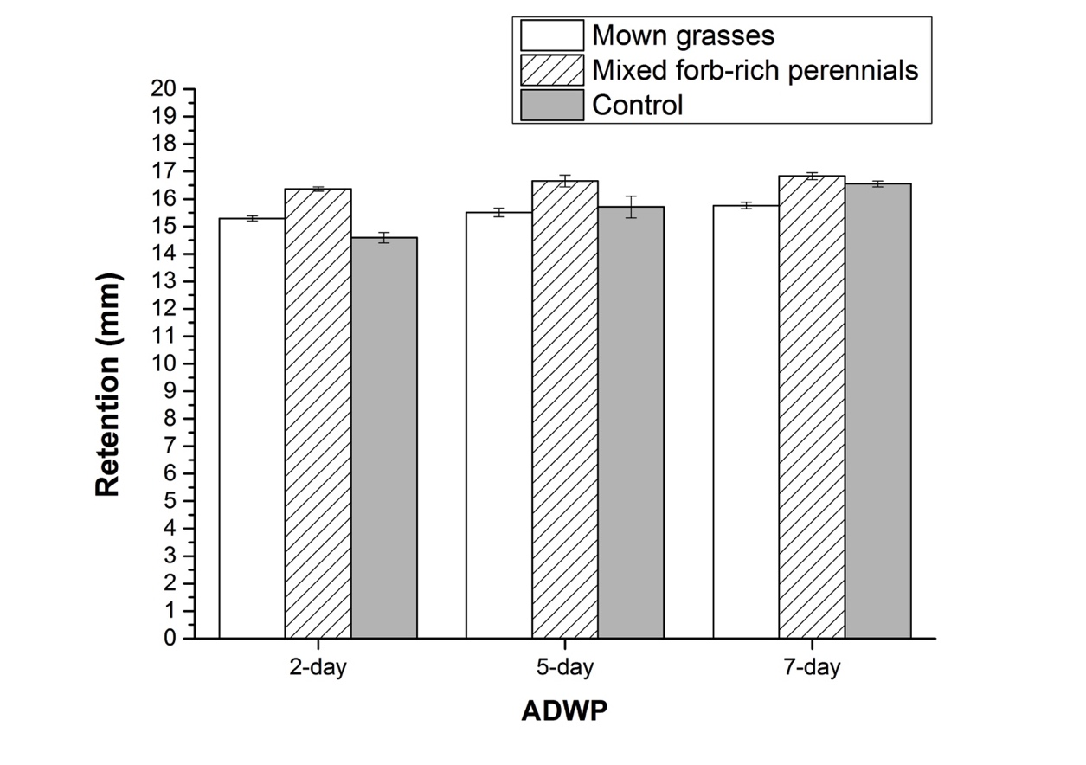
Figure 4 - Mean retention of the three different treatments after 2-Day, 5-Day and 7-Day ADWP (Error bars indicate standard deviation from the mean).
ADWP had a significant effect on retention across all three treatments, with longer ADWPs leading to higher retention in all cases. However, the incremental differences due to 5- and 7-day ADWPs (compared with 2-day ADWP) are far lower than might reasonably have been expected. This is considered further in the Discussion.

Detention
Figure 5a shows the mean cumulative runoff profiles for the three treatments, whilst Figure 5b shows the 5-minute discrete runoff rate data. The error bars confirm that the runoff data was very consistent over the replicated experiments.
Figure 5a shows that the runoff response was fastest from the bare soil control and slowest from the mixed forb-rich perennials. Calculated t₅₀ delay times (runoff t₅₀ minus inflow t₅₀) differed significantly between vegetative treatments (P<0.001), averaging 24.74, 29.02 and 38.18 min for the control group, mown grasses and mixed forb-rich perennials, respectively. The mixed forb-rich perennials offered 32 and 54% longer detention compared with the mown grasses and bare soil respectively.
Lower peak runoff rates were observed from the vegetated treatments compared to the non-vegetated control group (Figure 5b), with the mixed forb-rich perennials having the greatest peak attenuation. The peak runoff rates differed significantly between vegetative treatments (P<0.001). The rate of runoff from the control group equalled the inflow rate, while the vegetated treatments offered some peak attenuation for this one-hour event. It should be noted, however, that in a longer duration event the runoff rate from all beds is expected to equilibrate with the inflow rate. Similarly, all beds would demonstrate increased levels of attenuation for a shorter duration event.

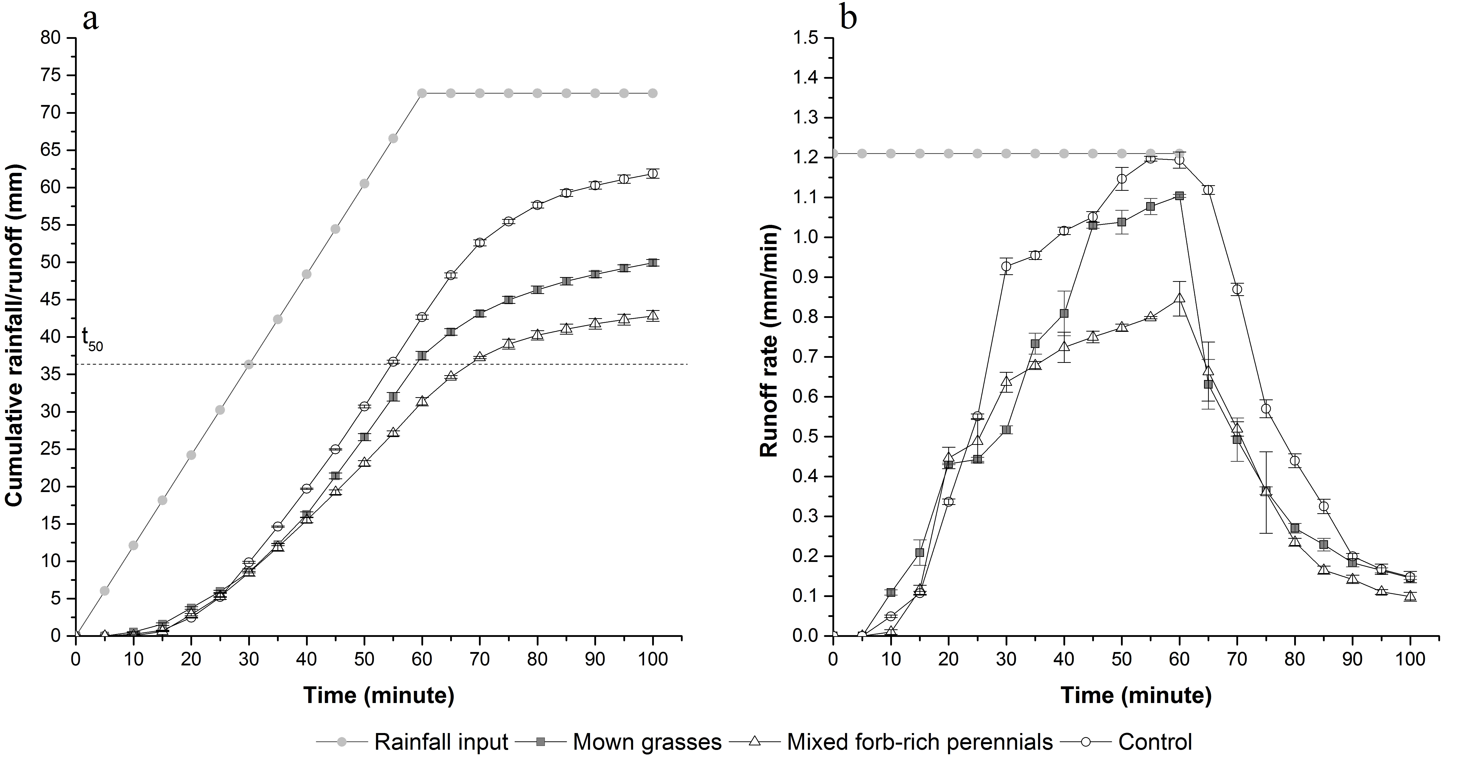
Figure 5 - (a) Cumulative runoff profiles for the systems during the detention tests; (b) Mean runoff rates over the course of the detention experiment (Error bars indicate standard deviation from the mean.)

Discussion
Overall, the forb-rich perennials were the most effective for both retention and detention. This confirms the potential for using taxonomically diverse forb-rich plant communities to replace more conventional vegetation (e.g. mown grasses) in rain gardens.
Increases in runoff retention have previously been associated with increased plant biomass and/or plant dimensions. For example, Nagase and Dunnett (2012) suggested that dry shoot weights of particular species or mixed plantings positively correlated with runoff retention. Their species-specific study also indicated that taller plants with larger spreads tended to retain and intercept more runoff in experimental modules, compared with shorter plants with smaller diameters. Waring and Landsberg (2011) and Vanuytrecht et al. (2014) suggested that greater leaf mass and leaf area could increase the evapotranspiration rate. Similarly, Barrett et al. (2013) and Passeport et al. (2009) have highlighted the contribution of root depth and root volume respectively to retention.
Measurements of plant shoot and root growth were made for all species in the present study (see Yuan, 2016 for further details). Overall, the mixed forb-rich perennial community had higher structural diversity in terms of its canopy, roots and species mix compared to the mown grasses. It also had considerably greater overall biomass. Although the biomass of different vegetation types was not formally assessed in this study, the greater plant shoot heights/spreads, rooting depths and root spreads, as well as the % cover found in the mixed forb-rich perennials are likely to explain their enhanced retention performance compared with the mown grasses and bare soils. Whilst there is some evidence in the literature (Rixen & Mulder, 2005; Dunnett et al., 2008) that increased species diversity may contribute to enhanced retention over and above the effects due to plant biomass alone, the experimental design does not permit the effects of biomass and species diversity to be separated here. This aspect is clearly something that would be worthy of further research.
As expected, ADWP had a significant effect on retention across all three treatments, with longer ADWPs leading to higher retention in all cases. However, the incremental differences due to 5- and 7-day ADWPs were lower than expected, whilst the 2-day ADWP retention seems unfeasibly large. Catchment losses of around 15 mm after 2 days (Figure 4) imply that the rain garden soil moisture deficit must have been around 75 mm prior to the start of the test. This would require ET rates from the rain gardens of 40 mm/day, which exceeds any comparable rates reported in the literature. For example, Johnston (2011) reported a maximum rate of 13 mm/day. A reduction in ET rates over time is expected in response to reductions in media moisture content (e.g. as observed in green roof systems by Berretta et al (2014) and others). However, the very limited additional ET inferred for the two longer ADWPs suggests either that ET from the systems effectively stopped after two days, or that the mean ET rates over 5 and 7-days were proportionately lower compared with the 2-day experiments. The mean temperatures during the 2- and 5-day ADWPs were within one degree of one another, suggesting that noticeable differences in daily ET rates should not be expected. However, it is also acknowledged that ET rates are also affected by other meteorological parameters, such as wind speed and cloud cover, which were not recorded at the site. It is clear that future experiments of this type would benefit from more complete records of meteorological conditions and media moisture content.
One possible explanation for the high estimates of ET is that the actual inflow differed significantly from the target inflow, e.g. due to an error in the inflow rate meter. Alternatively, there may have been some water retention within the drainage layers. It was not possible to revisit the test beds subsequently to investigate these issues. Therefore, whilst the significant systematic differences reported here are believed to be real, the absolute values of retention performance and t₅₀ delay should be treated with some caution.
The observed differences in retention performance as a result of vegetation treatment are expected to have a relatively minor impact on overall hydrological performance. This is because most of the inflow that enters a rain garden leaves the system either via subsurface infiltration or drainage into the sewer system; losses due to ET will typically constitute less than 20% of the annual water balance. The likelihood of a rain garden generating surface overflow is far more sensitive to the underdrain rate than it is to ET.
The mixed forb-rich perennials demonstrated a longer lag and a greater peak reduction compared with the other two treatments, with bare soil consistently demonstrating the smallest detention effects. Greater runoff delay is expected in vegetative treatments than in bare soils, due to canopy interception and soil-root interactions. Whilst plant roots can act to increase soil porosity and permeability, which would tend to reduce detention, there is no evidence of that occurring here. Indeed it is possible that the plant roots are contributing to improved detention by filling in some of the soil macropores. The positive influence of vegetation on detention is consistent with findings from green roof test beds (Stovin et al., 2015b).

Conclusions
The mixed forb-rich perennials were the most effective in reducing stormwater runoff, providing runoff delay and attenuating peak runoff rate. Conventional vegetation with low species richness and structural diversity (e.g. mown grasses) offers limited capacity to improve either stormwater retention or detention, although it undoubtedly helps to stabilise the soil and reduce erosion risk.
There is some evidence in the data presented here to support previously-published findings that diverse species mixes may offer increased hydrological performance benefits over monocultures or more restricted plant mixtures, even when the total plant biomass is comparable. Factors contributing to this effect include enhanced interception due to overlapping canopies and the capacity for different root structures to access moisture held at a wider range of pore sizes and depths within the soil.
When combined with the acknowledged benefits that more diverse planting will have for biodiversity and amenity, the positive hydrological performance benefits outlined here provide strong motivation to prioritise taxonomically and structurally diverse planting in rain gardens wherever possible. Whilst the current paper has focused on rain gardens, these principles are expected to be applicable to a broad range of vegetated stormwater management facilities.

References
Allen, R.G., Pereira, L.S., Raes, D., & Smith, M.L. (1998). Crop evapotranspiration guidelines for computing crop water requirements-FAO irrigation and drainage paper 56. Food and Agriculture Organization of the United Nations (FAO), Rome, 300(9), D05109.
Barrett, M. E., Limouzin, M., & Lawler, D. F. (2013). Effects of media and plant selection on biofiltration performance. Journal of Environmental Engineering, 139(4), 462-470.
Bengtsson, L., Grahn, L., & Olsson, J. (2005). Hydrological function of a thin extensive green roof in southern Sweden. Nordic Hydrology, 36(3), 259-268.
Berretta, C., Poë, S., & Stovin, V. (2014). Moisture content behaviour in extensive green roofs during dry periods: the influence of vegetation and substrate characteristics. Journal of Hydrology, 511(4), 374-386.
Burge, K., Browne, D., Breen, P., & Wingad, J. (2012). Water Sensitive Urban Design in a changing climate: estimating the performance of WSUD treatment measures under various climate change scenarios. In WSUD 2012: Water sensitive urban design; Building the water sensitive community; 7th international conference on water sensitive urban design, 21-23 February 2012, Melbourne Cricket Ground (p. 119). Engineers Australia.
Dunnett, N. & Clayden, A. (2007). Rain gardens, managing water sustainably in the garden and designed landscape. London, Timber Press.
Dunnett, N., Nagase, A., Booth, R., & Grime, P. (2008). Influence of vegetation composition on runoff in two simulated green roof experiments. Urban Ecosystems, 11(4), 385-398.
Emanuel, R., & Godwin, D. (2010). The Oregon Rain Garden Guide: Landscaping for Clean Water and Healthy Streams. Available from: http://seagrant.oregonstate.edu/sgpubs/onlinepubs/h10001.pdf. Accessed in March 2015.
FAWB (Facility for Advancing Water Biofiltration). (2009). Stormwater biofiltration systems adoption guidelines: Planning, design and practical implementation Version 1, Monash University, Victoria.
Gonzalez-Merchan, C., Barraud, S., & Bedell, J. P. (2014). Influence of spontaneous vegetation in stormwater infiltration system clogging. Environmental Science and Pollution Research, 21(8), 5419-5426.
Hill, A.J. Neary, V.S. (2007). Estimating evapotranspiration and seepage for a sinkhole wetland from diurnal surface water cycles. Journal of the American Water Resources Association, 43, 1373-1382.
Hitchmough, J., & Dunnett, N. (2003). Introduction to naturalistic planting in urban landscapes. In: The Dynamic Landscape: Ecology, Design and Management of Urban Naturalistic Vegetation (Dunnett, N., & Hitchmough, J. eds.). London: Spon Press.
Hunt, W.F., Jarrett, A.R., Smith, J.T., & Sharkey, L.J. (2006). Evaluating bioretention hydrology and nutrient removal at three sites in North Carolina. Journal of Irrigation and Drainage Engineering, 132(6), 600-608.
Jennings, A. A., Berger, M. A., & Hale, J. D. (2015). Hydraulic and hydrologic performance of residential rain gardens. Journal of Environmental Engineering, 141(11), 10.1061/(ASCE)EE.1943-7870.0000967, 04015033.
Johnston, M. R. (2011) Vegetation type alters rain garden hydrology through changes to soil porosity and evapotranspiration. PhD Thesis, University of Wisconsin-Madison.
Kingsbury, N. (1996). The new perennial garden. London: Frances Lincoln Ltd.
Lu, P., & Yuan, T. (2011). Low impact development design for urban stormwater management-A case study in USA. In Water Resource and Environmental Protection (ISWREP), 2011 International Symposium on (Vol. 4, pp. 2741-2744). IEEE.
Lundholm, J., MacIvor, J. S., MacDougall, Z., & Ranalli, M. (2010). Plant species and functional group combinations affect green roof ecosystem functions. PLoS ONE, 5(3), e9677.doi:10.1371/journal.pone.0009677.
McCallum, M.H., Kirkegaard, J.A., Green, T.W., Cresswell, H.P., Davies, S.L., Angus, J.F., & Peoples, M.B. (2004). Improved subsoil macroporosity following perennial pastures. Australian Journal of Experimental Agriculture, 44, 299-307.
Nagase, A., & Dunnett, N. (2012). Amount of water runoff from different vegetation types on extensive green roofs: Effects of plant species, diversity and plant structure. Landscape and urban Planning, 104, 356-363.
NERC (Natural Environment Research Council), (1999). Flood Estimation Handbook (FEH) CD.
PADEP (Pennsylvania Department of Environmental Protection). (2006). Pennsylvania Stormwater Best Management Practices Manual. Bureau of Watershed Management, Harrisburg, Pennsylvania.
Passeport, E., Hunt, W.F., Line, D.E., Smith, R.A., & Brown, R.A. (2009). Field study of the ability of two grassed bioretention cells to reduce storm-water runoff pollution. Journal of Irrigation and Drainage Engineering, 135, 505-510.
Prince George’s County. (2007). Bioretention Manual. MD Department of Environmental Resources, Prince George’s County, MD.
Rixen, C., & Mulder, C. P. H. (2005). Improved the water retention links high species richness with increased productivity in arctic tundra moss communities. Oecologia, 146(2), 287–299.
Steiner, L.M., & Domm, R.W. (2012). Rain gardens: sustainable landscaping for a beautiful yard and a healthy world. Minneapolis: Voyageur Press.
Stovin, V., Vesuviano, G., & De-Ville, S. (2015a). Defining green roof detention performance. Urban Water Journal: 1-15.
Stovin, V., Poë, S., De-Ville, S. and Berretta, C., (2015b). The influence of substrate and vegetation configuration on green roof hydrological performance, Ecological Engineering, 85, 159-172.
Vanuytrecht, E., Van Mechelen, C., Van Meerbeek, K., Willems, P., Hermy, M., & Raes, D. (2014). Runoff and vegetation stress of green roofs under different climate change scenarios. Landscape and Urban Planning, 122, 68-77.
Virahsawmy, H., Stewardson, M., Vietz, G., & Fletcher, T. D. (2014). Factors that affect the hydraulic performance of raingardens: implications for design and maintenance. Water Science & Technology, 69(5), 982-988.
Waring, R. H., & Landsberg, J. J. (2011). Generalizing plant-water relations to landscapes. Journal of Plant Ecology, 4(1-2), 101-113.
Woelfle-Erskine, C., & Uncapher, A. (2012). Creating rain gardens: capturing the rain for your own water-efficient garden. London: Timber Press.
Yuan, J. (2016). Investigating the planting potential for urban rain gardens: plant selection, establishment and performance. PhD Thesis, The University of Sheffield.
Yunusa, I.A.M., & Newton, P.J. (2003). Plants for amelioration of subsoil constraints and hydrological control: the primer-plant concept. Plant and Soil, 257(2), 261-281.

