Hiding the Headgroup? Remarkable Similarity in Alkyl Coverage of the Surfaces of Pyrrolidinium- and Imidazolium-Based Ionic Liquids
Maria A. Tesa-Serrate,¹ Eric J. Smoll, Jr.,² Lucía D’Andrea,³ Simon M. Purcell,¹ Matthew L. Costen,¹ Duncan W. Bruce,³ John M. Slattery,³ Timothy K. Minton,² Kenneth G. McKendrick*¹
¹ Institute of Chemical Sciences, School of Engineering and Physical Sciences, Heriot-Watt University, Edinburgh EH14 4AS UK
² Department of Chemistry and Biochemistry, Montana State University, Bozeman, Montana 59717 USA
³ Department of Chemistry, University of York, Heslington, York YO10 5DD UK

ABSTRACT: The liquid-vacuum interfaces of a series of ionic liquids (ILs) containing 1-alkyl-1-methylpyrrolidinium ([C_{n}mpyrr]⁺) cations of different alkyl chain lengths have been studied by reactive-atom scattering with laser-induced fluorescence detection (RAS-LIF) and molecular dynamics (MD) simulations. A direct quantitative comparison has been performed between [C_{n}mpyrr]⁺ and the previously better-characterized 1-alkyl-3-methylimidazolium ([C_{n}mim]⁺) ILs with the same chain lengths n and common anion, bis(trifluoromethylsulfonyl)imide ([Tf₂N]⁻). Both RAS-LIF experiments, using O(³P) as the projectile and monitoring OH yield, and MD simulations indicate that the coverage of the surface by alkyl chains is almost independent of the identity of the cation headgroup. Moreover, the potentially abstractable H atoms of the saturated pyrrolidinium ring do not contribute appreciably to the experimental OH yield. In both these senses, the headgroup is ‘hidden’ from the probe articles approaching from vacuum. More predictably, the alkyl coverage depends strongly and non-stoichiometrically on the length of the alkyl chain, n, for either cation. These results imply the presence of an alkyl-rich layer on the surface formed by preferential orientation of the cations to expose their chains to the vacuum phase. We suggest that the lack of dependence of the packing density of this layer on cation type results from compensating effects of charge density and steric blocking.

INTRODUCTION

Ionic liquids (ILs), or low-temperature molten salts, are attracting substantial and sustained interest thanks to their potential technological applications and their unusual physical properties. These applications are very diverse, but a significant proportion of them involve the interfacial properties of ionic liquids, including solid-liquid, liquid-liquid, and gas-liquid interfaces. Consequently, the last decade has seen a rise in the number of experimental and theoretical studies on the ionic liquid surface, so that “ionic liquid surface science” has become a field in its own right.¹Most of these surface-analysis studies have focused on 1-alkyl-3-methylimidazolium ionic liquids, which are the most common type of ILs due to their ease of synthesis and low melting points. However, ionic liquids based on ammonium ions, such as the 1-alkyl-1-methylpyrrolidinium cation, also have a significant role to play in a range of applications from catalysis,²⁻⁴ to carbon capture and storage (CCS),⁵⁻⁷ electrochemistry,⁸ and analytical chemistry.⁹ Pyrrolidinium and imidazolium ILs have been compared empirically, for example, as stationary phases in supported-ionic liquid phase (SILP) catalysis.¹⁰ At a more fundamental level, depletion of certain Pt(II) and Pt(IV) complexes in the surface layers of imidazolium ILs has been found to contrast with the enrichment of the same species at the surfaces of pyrrolidinium ILs, with potential implications for related catalytic systems.¹¹
Since the structure of the IL-liquid interface with other phases plays an important role in these and other applications, it would be beneficial to characterize its behavior as a function of bulk-liquid composition. There have been a few recent reports on the surface structure of pyrrolidinium-based ionic liquids, but they are still greatly outnumbered by the existing studies on imidazolium-based ILs. Aliaga et al. employed sum-frequency generation spectroscopy (SFG) to study a family of 1-alkyl-1-methylpyrrolidinium ([C_{n}mpyrr]⁺) ILs with different alkyl chain lengths n, obtaining information about the preferred orientation of each chemical moiety at the gas-liquid interface.¹² A series of papers using angle-resolved X-ray photoelectron spectroscopy (ARXPS) have studied pyrrolidinium ILs¹³⁻¹⁵ and found that their surfaces are enriched in alkyl groups for the longer chains, analogous to imidazolium ILs. A low-energy ion scattering (LEIS) study characterized a wide range of vacuum-liquid interfaces of ILs including [C₄mpyrr][Tf₂N] (where [Tf₂N] is the bis(trifluoromethylsulfonyl)imide anion).¹⁶ Recently, Paredes et al. have reported molecular dynamics (MD) simulations of IL surfaces containing the [C₄mpyrr]⁺ cation.¹⁷ A comparison of relative alkyl abundances in the surface region between imidazolium and pyrrolidinium cations was carried out by Lockett et al.,¹⁴ who studied [C₄mpyrr][Tf₂N] and [C₄mim][Tf₂N] by synchrotron XPS at variable photon energies.
The current work aims to expand the body of knowledge about 1-alkyl-1-methylpyrrolidinium IL gas-liquid interfaces and draw a comparison with their 1-alkyl-3-methylimidazolium ([C_{n}mim]⁺) counterparts, by quantitative surface-analysis experiments and theoretical simulations on [C_{n}mpyrr][Tf₂N] and [C_{n}mim][Tf₂N] ILs with n = 2 - 12. We have chosen the [Tf₂N] anion both because of its prevalence in applied uses of ILs and because it provides a wide range in n for which both types of IL are liquids at accessible temperatures. The experimental technique employed is reactive-atom scattering – laser-induced fluorescence (RAS-LIF), which characterizes the alkyl coverage of the liquid surface by reaction with gas-phase O(³P) atoms and spectroscopic detection of the H-abstraction products (OH radicals) that scatter from the surface.¹⁸⁻¹⁹ The RAS-LIF results are compared against MD simulations of the liquid surface characterizing the alkyl coverage and the availability of the headgroup at the surface.
In RAS-LIF, due to the relatively low energies of the O(³P) atoms, the H-abstraction reaction energetics depend considerably on the C–H site at which reaction takes place. The O(³P) atoms, generated by 355-nm photolysis of NO₂, have a broad distribution of translational energies with an average of ~16 kJ mol⁻¹ and 26 kJ mol⁻¹ FWHM. The high-energy tail of the translational energy distribution extends up to ~40 kJ mol⁻¹, but the substantial majority of the O(³P) atoms possess translational energies < 30 kJ mol⁻¹. In standard alkyl chains in hydrocarbons, abstraction by O(³P) of secondary H atoms (with gas-phase reaction enthalpies ΔH = -19 kJ mol⁻¹ and barriers E₀ = 19 kJ mol⁻¹) is strongly preferred over that of primary H atoms (with ΔH = -7 kJ mol⁻¹ and E₀ = 29 kJ mol⁻¹).²⁰ This means that the RAS-LIF technique is selective towards exposed CH₂ units (as opposed to the terminal methyl group), and is therefore a discriminating tool to characterize the alkyl coverage of the surface. The C–H bonds in the imidazolium and pyrrolidinium rings possess different reaction energetics, leading to different regioselectivity for the reaction with O(³P), particularly with the headgroups (by which we mean the heterocyclic ring and pendant methyl group for either [C_{n}mpyrr]⁺ or [C_{n}mim]⁺). The aromatic imidazolium cation rings are very substantially less reactive than the alkyl chains and are not expected to contribute to the observed OH yield in our experiments, whereas the saturated pyrrolidinium cation headgroups could potentially contribute to the apparent overall alkyl coverage of the surface. In other words, cation headgroups exposed at the surface could in principle be detected in the case of [C_{n}mpyrr][Tf₂N], but not [C_{n}mim][Tf₂N]. To aid the interpretation of the experimental results, the energetics of H abstraction by O(³P) for different sites in the cations have been obtained here from ab initio theoretical calculations. The calculations are presented alongside the RAS-LIF and MD results.

MATERIALS AND METHODS

Materials
The chemical structures of [C_{n}mpyrr][Tf₂N] and [C_{n}mim][Tf₂N] are shown in Figure 1, along with that of the long-chain hydrocarbon squalane (2,6,10,15,19,23-hexamethyltetracosane), which was used as a reference. Some of the liquids were purchased from a commercial supplier, while others were synthesized as part of this work (details of the synthetic procedures are given in the Supporting Information, SI). Table 1 lists all of the liquids studied, their commercial source and the concentration of water as stated by the supplier. The purity of all liquids was ≥ 99%. After the RAS-LIF experiments, the ionic liquids were analyzed by ¹H-NMR spectroscopy and Karl Fisher titration to confirm that there had been no changes to their composition. The ionic liquids synthesized as part of this work were handled under an inert atmosphere so their water content is expected to be very low. This was further reduced by the degassing process carried out in the reaction chamber prior to the RAS-LIF measurements (see below).

Figure 1. Chemical structures of the 1-alkyl-1-methylpyrrolidinium cation ([C_{n}mpyrr]⁺), 1-alkyl-3-methylimidazolium cation ([C_{n}mim]⁺), bis(trifluoromethylsulfonyl)imide anion ([Tf₂N]⁻), and squalane (C₃₀H₆₂).

Table 1. Chemical names and abbreviations of the liquids studied, together with their supplier and concentration of H₂O impurity.
Chemical name | Abbreviation or common name | Supplier | Water content / ppm
1-ethyl-1-methylpyrrolidinium bis(trifluoromethylsulfonyl)imide | [C₂mpyrr][Tf₂N] | IoLiTec | 390
1-butyl-1-methylpyrrolidinium bis(trifluoromethylsulfonyl)imide | [C₄mpyrr][Tf₂N] | IoLiTec | 41
1-hexyl-1-methylpyrrolidinium bis(trifluoromethylsulfonyl)imide | [C₆mpyrr][Tf₂N] | IoLiTec | 80
1-methyl-1-octylpyrrolidinium bis(trifluoromethylsulfonyl)imide | [C₈mpyrr][Tf₂N] | synthesised
1-dodecyl-1-methylpyrrolidinium bis(trifluoromethylsulfonyl)imide | [C₁₂mpyrr][Tf₂N] | synthesised
1-ethyl-3-methylimidazolium bis(trifluoromethylsulfonyl)imide | [C₂mim][Tf₂N] | synthesised
1-butyl-3-methylimidazolium bis(trifluoromethylsulfonyl)imide | [C₄mim][Tf₂N] | IoLiTec | 30
1-hexyl-3-methylimidazolium bis(trifluoromethylsulfonyl)imide | [C₆mim][Tf₂N] | IoLiTec | 70
1-octyl-3-methylimidazolium bis(trifluoromethylsulfonyl)imide | [C₈mim][Tf₂N] | IoLiTec | 53
1-dodecyl-3-methylimidazolium bis(trifluoromethylsulfonyl)imide | [C₁₂mim][Tf₂N] | synthesised
2,6,10,15,19,23-hexamethyltetracosane | Squalane | Sigma-Aldrich | Not stated

RAS-LIF experiments

The RAS-LIF experimental setup is represented schematically in Figure 2. The experiments were conducted in a custom-built stainless-steel reaction chamber. The chamber was evacuated to approximately 10⁻⁷ Torr by a turbomolecular pump (Edwards nEXT 300). O(³P) atoms were generated by 355-nm photolysis of NO₂, introduced into the chamber via a metering valve. The pressure of NO₂ was controlled carefully during experiments to maintain a constant value of 1.00 mTorr, which is sufficiently low to avoid secondary gas-phase collisions of the incoming O(³P) or of the outgoing OH before detection. NO₂ was photolyzed by 4-6 ns long pulses of approximately 80 mJ, generated with a frequency-tripled Nd:YAG laser (Continuum Surelite II-10). The laser beam propagated parallel to the liquid surface at a fixed distance of 6.5 mm. Gas-phase OH radicals were detected by laser-induced fluorescence (LIF) using a second tunable laser pulse fired after the photolysis laser and counter-propagating along the same axis. The probe pulse of similar duration was produced by frequency doubling the output of a 532-nm pumped dye laser (Sirah Cobra-Stretch) and had an energy of 250 μJ. This excited rotationally resolved transitions on the A – X (1,0) band of OH, at approximately 280 – 284 nm. A liquid light guide collected LIF and directed it onto a photomultiplier tube, after passing through dichroic filters that isolated emission on the (1,1) band from scattered laser light.
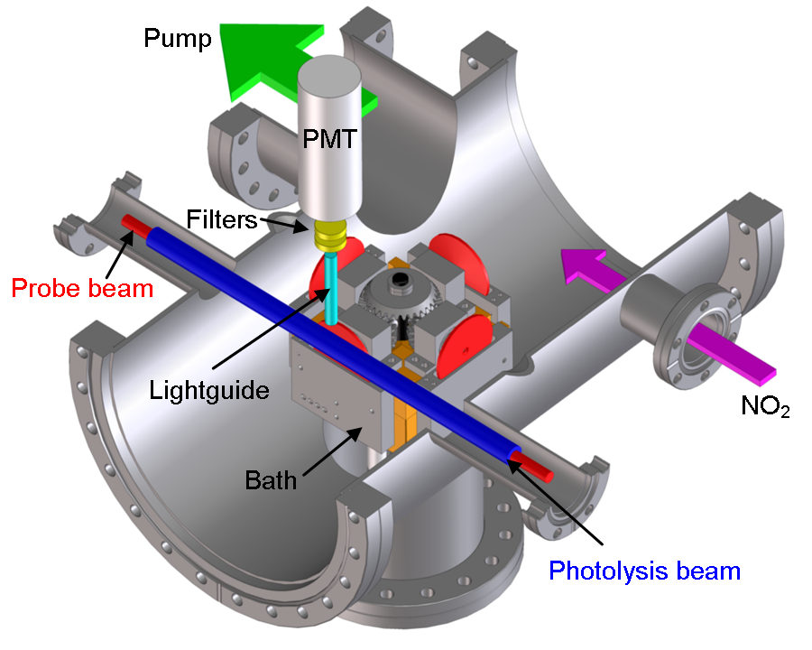
Figure 2. Schematic representation of the RAS-LIF apparatus. The four liquid-coated wheels which can be positioned alternately in front of the laser axis are indicated in red.
In previous RAS-LIF studies, the liquid surface was generated with a single wheel rotating inside a bath of the liquid.^{18,21-23} This approach required the breaking of the vacuum to change the liquid sample in the chamber, potentially modifying the experimental conditions between liquids. The new apparatus used here had four different baths and wheels placed at 90° to each other so that up to four different liquids may be studied sequentially without changing the conditions of the measurement. The multi-wheel assembly was attached to a rotating flange, which allowed any one of the four liquid surfaces to be presented for study in isolation from the other three wheels. Simultaneous rotation of the four wheels was achieved via four bevel gears, at right angles to each other, which intersected a larger bevel gear attached to a central axle. This axle was turned by a motor outside the vacuum chamber. The four wheels were each stainless steel (5 cm diameter) and rotated at 0.5 Hz. Each wheel was partially immersed in a stainless steel bath filled with ~4 mL of liquid. The rotation of the wheel inside the bath created a continuously refreshed liquid surface on the wheel. Stainless steel blades were occasionally used as surface scrapers, especially with viscous liquid samples, to achieve similar thicknesses of the liquid films. The main potential source of irreproducibility between wheels was their distance to the laser axis. For this reason, care was taken to ensure that the wheel-to-beam distance was the same for all wheels within 100 μm.
The assembly contained four copper heaters placed behind each liquid bath. The heaters allowed measurements at high temperature by circulating heating fluid (SIL180) through them. The temperature of the fluid was controlled by an external circulator (Cole-Parmer Polystat). Thermocouple probes were attached to each heater to monitor its temperature. The temperature of the liquid surface itself was characterized by separate calibration measurements. The relationship between circulator, bath and liquid temperatures was very reproducible. A circulator temperature of 120 °C led to a liquid temperature of approximately 95 °C, and 50 °C led to approximately 45 °C. Measuring the surface temperature during the scattering experiments was not practical, so only the circulator temperature was controlled. The surface temperature values quoted in this paper are estimates based on the calibration measurements.
We present two types of RAS-LIF measurements: OH excitation spectra and appearance profiles. Excitation spectra were acquired by varying the wavelength of the probe laser at a fixed pump-probe delay, and provide the internal state distribution of the scattered products. OH appearance profiles were obtained by varying the delay between photolysis and probe lasers while maintaining the same excitation wavelength. They contain information on the yield and translational energy of the OH radicals in the internal state probed. During the acquisition of appearance profiles, a series of background corrections were performed in order to obtain reliable OH yields. The contributions of scattered light from the photolysis and probe laser were characterized by sequentially blocking each laser to obtain “photolysis-only” and “probe-only” profiles, which were then subtracted from each data set. As found previously,^{18,24} the 355 nm pulse produced a small amount of OH by photolysis of nitrous acid (HONO), which was present as a contaminant in the NO₂ gas. The contribution of this “photolytic” OH to the results was characterized by recording appearance profiles without the NO₂ precursor, using a mixture of HONO in N₂ instead. HONO was generated from the reaction of NaNO₂ with H₂SO₄, in the same manner described in previous publications.^{18,25-26} A suitably scaled multiple of the HONO-induced profile was subtracted from the O(³P) reactive profiles, as explained in more detail below.
All liquids were degassed prior to measurements by keeping them under high vacuum for at least 4 hours. The experiments were carried out at room temperature, with the exception of the n = 2 and n = 12 datasets, which were measured at 95 °C and 45 °C respectively, in order to melt the corresponding [C_{n}mpyrr][Tf₂N] ILs. For n = 4 – 12, the [C_{n}mim][Tf₂N] and [C_{n}mpyrr][Tf₂N] ILs of the same chain length were studied simultaneously in order to make them as directly comparable as possible. When acquiring appearance profiles, [C_{n}mim][Tf₂N] and [C_{n}mpyrr][Tf₂N] were placed in opposite baths, with the reference squalane bath at 90° to both of them. The approach was different for n = 2, as it was found that the neighboring wheel contributed slightly to the background, due to the fact that these IL surfaces did not produce any OH above the detection limit. In consequence, these ILs were studied separately with the reference wheel placed at 180° to the IL wheel.

MD simulations

Computational predictions of the vacuum-liquid surface structure for six [C_{n}mpyrr][Tf₂N] liquids and three [C_{n}mim][Tf₂N] liquids were generated using classical molecular dynamics simulations. Molecular dynamics trajectories were calculated with tools distributed in the GROMACS 5 software package.²⁷ For both imidazolium and pyrrolidinium ionic liquids, all intra and intermolecular interactions were described by the Canongia-Lopes and Pádua (CL&P) additions²⁸⁻³² to the OPLS-AA³³⁻³⁹ force-field. 640 ion pairs were used for all three [C_{n}mim][Tf₂N] ionic liquids (n = 4, 6, and 8). For the [C_{n}mpyrr][Tf₂N] ionic liquids, the number of ion pairs in the system was decreased with alkyl chain-length n to maintain an approximately constant total system size. Specifically, total ion pair counts of 1439, 1256, 1096, 955, 829, and 717 were used for n = 2, 4, 6, 8, 10, and 12, respectively. All dynamical calculations used 3D periodic boundary conditions, C–H bond constraints, particle-mesh Ewald long-range electrostatics, and a 2 fs time step. Following random ion-pair packing in a rectangular unit cell, all liquids were subjected to steepest-descent energy minimization, annealing at 500 K under NVT ensemble conditions, and propagation toward an equilibrated model of the IL bulk-phase under NPT ensemble conditions at 298 K. The terminal frame of each bulk-phase trajectory was used to prepare an initial vacuum-liquid-vacuum slab structure by expanding the z-dimension of the periodic boundary unit-cell by a factor of 3. This initial vacuum-liquid-vacuum slab structure was annealed at 500 K and equilibrated at 298 K under NVT ensemble conditions. Each imidazolium ionic liquid was equilibrated for a total of 12 ns and all analysis calculations were performed on the final 6 ns. However, each pyrrolidinium ionic liquid was equilibrated for a total of 36 ns and all analysis calculations were performed on the final 12 ns.
Data analysis made use of various GROMACS 5 tools and the Visual Molecular Dynamics (VMD) program.⁴⁰ All results were averaged over both interfaces of the liquid slab model and across 8-13 frames late in the production-run equilibration trajectory. Surface hydrogen atoms were identified with a modified “accessible surface area” calculation using the double cubic lattice method.⁴¹ Specifically, surface hydrogen was defined as all hydrogen atoms near the vacuum-liquid interface that can accommodate contact with a 0.16 nm radius probe sphere without overlapping with neighboring atoms. The probe particle radius was chosen to approximate the size of atomic oxygen. Surface roughness was associated with the width of the total surface-hydrogen number-density profile along the z-axis at a vacuum-IL interface. This surface width was quantified by fitting the surface-hydrogen profile at a vacuum-IL interface to a single Gaussian function with a least-squares procedure. To characterize and quantify ion packing near the vacuum-IL interface, cation-anion radial distribution functions (RDFs) were computed around axes parallel to the unit cell z-dimension (i.e., around axes parallel to the liquid slab interface normal). The RDF location of the [Tf₂N]⁻ anion was defined by the center-of-mass (c.m.) of its nitrogen, sulfur, and oxygen atoms. The RDF location of the [C_{n}mpyrr]⁺ cation was defined by the c.m. of its nitrogen atom and the four carbon atoms directly attached to its nitrogen atom. Lastly, the location of the [C_{n}mim]⁺ cation was defined by the c.m. of both nitrogen atoms, the 5 carbon atoms directly bonded to nitrogen, and the 3 hydrogen atoms attached to the imidazolium ring. To emphasize surface packing RDF signal and minimize RDF signal contamination from the interior of the liquid slab, the analysis did not integrate over the ions in the slab interior. Only ions with a z-coordinate displacement from the slab c.m. greater than a liquid-dependent threshold were considered. An appropriate threshold value (~1.2 nm for [C_{n}mim][Tf₂N] liquids and ~2.4 nm for [C_{n}mpyrr][Tf₂N] liquids) was selected by visualizing the slab dynamics along the relevant portion of its trajectory. Only the amplitude-normalized, nearest-neighbor RDF peak was interpreted in this study.

Bond dissociation energy calculations

The gas-phase structures of selected isomers of the cations [C₄mim]⁺ and [C₄mpyrr]⁺ and the products of their reaction with O(³P) (including the radical cations [C₄mim]^{+•} and [C₄mpyrr]^{+•}) were initially optimized at the BP86/SV(P) level in TURBOMOLE V6.40 using the resolution of identity (RI) approximation.⁴²⁻⁵² Optimizations were followed by frequency calculations at the same level. All minima were confirmed as such by the absence of imaginary frequencies. No symmetry constraints were applied during optimizations. These species were then re-evaluated at the G4 level in GAUSSIAN 09,⁵³ using the previously optimized structures as starting points. The G4 approach uses a sequence of ab initio calculations, including the use of the highly correlated CCSD(T) level with a modest basis set in combination with extrapolations to the basis-set limit using less computationally expensive methods, to generate highly accurate thermochemical data.⁵⁴ The suitability of this approach for the calculation of C–H bond dissociation enthalpies (or energies) (BDEs) in this system was assessed by calculating the gas-phase BDE of methane (437 kJ mol⁻¹), which compared favorably with the experimental value of 439 kJ mol⁻¹.⁵⁵
RESULTS

RAS-LIF

As in previous studies,¹⁸ the alkyl coverage of the surface was measured via the yield of OH produced in the interfacial reaction. The experimental approach to obtaining OH yields was identical to the one followed previously: OH appearance profiles were recorded on the most intense spectral transition, converted into fluxes and integrated to obtain relative IL:squalane OH yields. The new multi-wheel assembly greatly improves the efficiency and reproducibility of the measurements over the previous single-wheel arrangement. However, it could potentially have introduced systematic errors due to small differences in beam-to-surface distances for the different wheels. This was investigated by measuring the same liquid, squalane, on all four wheels. Appearance profiles were acquired sequentially from each wheel using the Q₁(1) LIF transition, which arises from the lowest rotational state, although it should be noted that this line has a small contribution from the partially overlapping R₂(3) transition. Throughout this paper, this transition is labeled as Q₁(1) for simplicity. The shape and intensity of the Q₁(1) profiles were the same within statistical error. The standard deviation of the results was 2.3% relative to the mean of the four wheels, comparable to the standard deviation of successive measurements of the same wheel.
The Q₁(1) appearance profiles are a measure of the population of N = 1, with a minor contribution from N = 3. In their use to quantify the total OH yield without any further correction, there is the implicit assumption that the population distribution across the rotational levels of the OH products is the same for all liquids. In order to test this assumption, OH excitation spectra were recorded from all liquids. The spectra were recorded at a photolysis-probe delay of 15 μs, corresponding to the peak density of OH detected in the appearance profiles. Five independent spectra were acquired for each liquid, including squalane, but with the exceptions of [C₂mpyrr][Tf₂N] and [C₂mim][Tf₂N], which did not produce detectable yields of OH (see below). Populations from N = 1 to N = 5 were extracted from the Q₁ branch by fitting the experimental spectra to simulations in LIFBASE.⁵⁶ No analysis of higher rotational levels or other spectroscopic branches was attempted due to the low signal-to-noise levels for some of the ILs (especially n = 4). For each individual spectrum, the N = 1 – 5 populations were fitted to a Boltzmann distribution described by a rotational temperature T_{rot}. The rotational temperatures from individual spectra were subsequently averaged together for each IL, to yield the average values of T_{rot} presented in Figure 3. Although [C_{n}mpyrr][Tf₂N] systematically yields marginally lower T_{rot} than the corresponding [C_{n}mim][Tf₂N], there is no strong variation between liquids (noting that the error bars are ±1σ standard error of the mean). As a result, the contribution of N = 1 to the total OH yield is very similar between liquids: at the extremes, it is 0.27 ± 0.01 for [C₄mim][Tf₂N] (highest T_{rot}) and 0.32 ± 0.01 for [C₁₂mpyrr][Tf₂N] (lowest T_{rot}).
Figure 3. OH rotational temperatures from [C_{n}mpyrr][Tf₂N] (red), [C_{n}mim][Tf₂N] (blue), and squalane (black). The corresponding cations are indicated in the horizontal axis. Each T_{rot} is an average of five independently acquired temperatures, and the error bars represent ±1σ standard errors of the mean.
Appearance profiles were acquired in several (at least six) sets of five consecutive profiles, with a set from squalane being taken immediately after each IL data set. Whenever possible (i.e., for n = 4 – 12, see Materials and Methods) the acquired data sets alternated between [C_{n}mim][Tf₂N] and [C_{n}mpyrr][Tf₂N], recording one immediately after the other in order to make them as directly comparable as possible. Each set of profiles was averaged and corrected for photolysis and probe laser background signals. The background contribution of photolytic OH was characterized by independently acquired appearance profiles using HONO as a precursor, as indicated above and done in previous work.¹⁸ The HONO profiles, which were found to be very similar for all liquids, were subtracted from the NO₂ profiles after scaling them to their signal at a photolysis-probe delay of 1 μs. This early LIF signal corresponds exclusively to HONO photolysis, as there is not enough time for any OH produced at the liquid surface to travel back to the probe region. The average background subtracted appearance profile from each IL data set was scaled to the peak signal of the corresponding squalane profile.
In the case of n = 2, an additional complication arose from the high temperature required to melt [C₂mpyrr][Tf₂N] (~90 °C). At this temperature, squalane evaporated significantly under high vacuum so it could not be used as a reference liquid. Instead, [C₁₂mim][Tf₂N] was used as a reference for both [C₂mim][Tf₂N] and [C₂mpyrr][Tf₂N]. As noted above, these two ILs were studied in independent data sets, both at high temperature. After averaging and subtracting the background contributions, each set of appearance profiles was normalized to the peak [C₁₂mim][Tf₂N] signal, and subsequently scaled to squalane by multiplying the data by the previously obtained [C₁₂mim][Tf₂N]:squalane OH flux ratio (0.48, see Table 2). This approach assumes the same temperature-dependent behavior for squalane and [C₁₂mim][Tf₂N]. Previous measurements of squalane⁵⁷ and [C₁₂mim][Tf₂N]²³ have shown that the effect of surface temperature on reactivity is almost negligible for both liquids. Regardless of this, the yield of OH from both [C₂mpyrr][Tf₂N] and [C₂mim][Tf₂N] was practically zero. The average appearance profiles for all of the liquids studied are presented in Figure 4.
Figure 4. Average Q₁(1) appearance profiles for all of the [C_{n}mpyrr][Tf₂N] (red symbols) and [C_{n}mim][Tf₂N] (blue symbols) ionic liquids studied: n = 2 (blank squares), n = 4 (filled triangles), n = 6 (blank diamonds), n = 8 (filled circles) and n = 12 (blank triangles). Some error bars are omitted for clarity: those shown represent ±1σ standard errors of the mean.
The OH yields relative to squalane were obtained by integrating the appearance profiles from 0 to 30 μs. The profiles from the ILs peak consistently earlier than from squalane, by approximately 1 μs. Since LIF detects number density, the experiment is biased towards the detection of slower OH, which has a longer residence time in the probe region. The integrated number densities therefore need to be converted into OH fluxes to obtain reliable relative yields. This conversion was carried out by matching the average appearance profile for each liquid to Monte Carlo simulated profiles with different Maxwell-Boltzmann temperatures, as in previous work.¹⁸ The experimental profiles were found to be well-described by translational temperatures between 700 K and 900 K. The best-match simulation was used to obtain a density-to-flux correction factor (defined as the ratio between the integrated simulated flux and simulated number density for photolysis-probe delays ≤ 30 μs) that was then applied to the experimental integrated number density. The resulting corrected OH yields, relative to squalane, are listed in Table 2. They are plotted as a function of chain length n in Figure 5.

Table 2. Relative OH yield from each of the ionic liquids studied, expressed as the integrated OH flux relative to that from squalane as described in the text. Errors are ±1σ standard error of the mean.
n | [C_{n}mpyrr][Tf₂N] relative OH yield | [C_{n}mim][Tf₂N] relative OH yield
2 | 0.005 ± 0.005 | -0.004 ± 0.004
4 | 0.029 ± 0.001 | 0.037 ± 0.002
6 | 0.136 ± 0.003 | 0.149 ± 0.003
8 | 0.214 ± 0.009 | 0.208 ± 0.008
12 | 0.445 ± 0.013 | 0.482 ± 0.015

Figure 5. Relative OH yield from RAS-LIF experiments on [C_{n}mpyrr][Tf₂N] (red circles) and [C_{n}mim][Tf₂N] (blue squares) as a function of chain length n. Error bars are ±1σ standard error of the mean.

MD simulations

Computational approximations of the vacuum-IL interface generated by classical molecular dynamics simulations were used to predict surface composition and structure directly. The RAS-LIF experiments presented here are a measure of surface hydrogen that is dynamically accessible to O(³P) over the range of incident angles and translational energies used. These dynamical constraints are not included in the analysis of the MD simulations. Nevertheless, the predicted trends in surface hydrogen as a function of cation alkyl chain length via the surface area accessible to a probe particle, described above, provide valuable insight into the relationship between interface composition and the experimental reactively scattered OH yield. The distinction between C–H bonds on primary, secondary, and aromatic carbons has an important impact on reactivity given the O(³P) translational energies used in this study. In addition to this chemical grouping of surface hydrogen, both imidazolium and pyrrolidinium cations contain a heterocyclic ring, an n-alkyl substituent, and a methyl substituent. Surface hydrogen has been binned according to these chemical and structural divisions as a function of alkyl chain length in Figure 6. It is clear that both ionic liquids show similar trends for all categories of surface hydrogen. As widely observed in previous work on related ILs, total surface hydrogen increases with n. This increase is driven primarily by a strong growth in alkyl 2º surface hydrogen from methylene units in the chain. In contrast, methyl 1º, alkyl 1º from the terminal methyl groups of the chain, and ring surface hydrogen decrease weakly or remain approximately constant for all values of n ≥ 4. Importantly, this method of quantifying surface hydrogen predicts that the alkyl 2º surface hydrogen for [C_{n}mim][Tf₂N] and [C_{n}mpyrr][Tf₂N] show nearly identical abundances. For [C_{n}mpyrr][Tf₂N], although alkyl 1º surface hydrogen and ring surface hydrogen show a different trend from n = 2 to n = 4, the alkyl 2º surface hydrogen trend with alkyl chain-length is smooth and tracks almost exactly the corresponding trend for [C_{n}mim][Tf₂N].

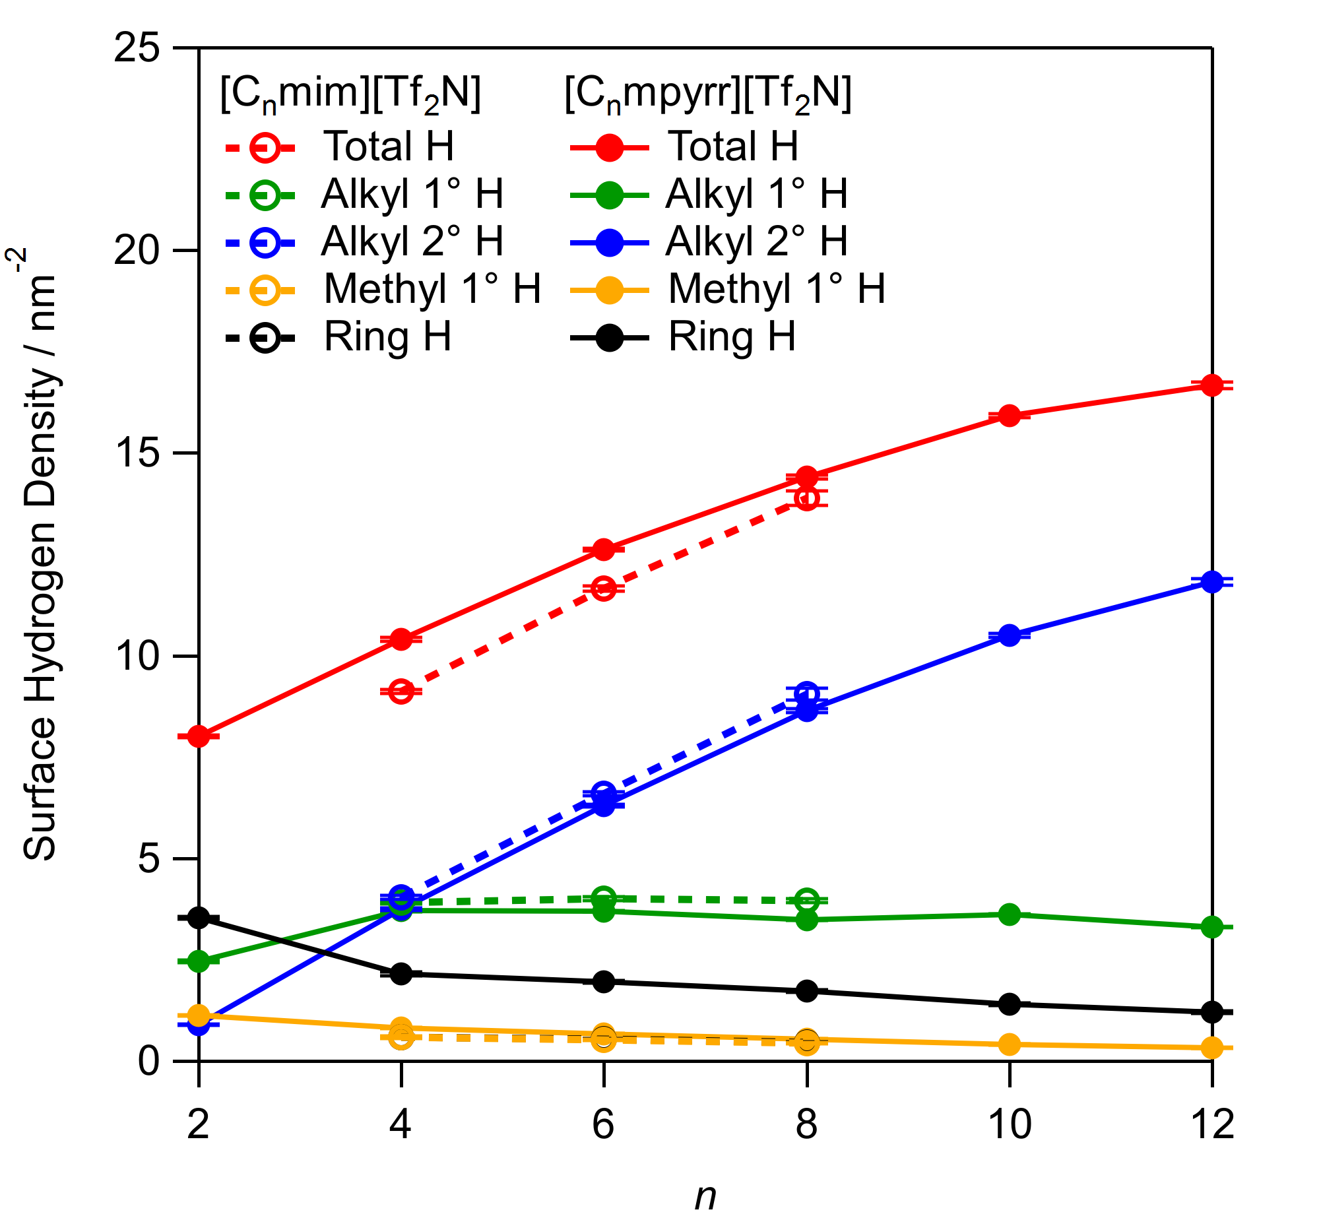

Figure 6: MD predictions of surface hydrogen density per unit area, for different H-atom types, plotted as a function of alkyl group chain length, n. Surface hydrogen is defined as all hydrogen atoms near the vacuum-liquid interface that can accommodate contact with a 0.16 nm radius probe sphere without overlapping with neighboring atoms. Error bars represent ±1σ standard errors of the mean. The lines and markers associated with [C_{n}mim][Tf₂N] ring surface hydrogen are nearly identical to and visually obscured by the lines and markers associated with [C_{n}mim][Tf₂N] methyl 1º surface hydrogen.

Bond dissociation energies

The results of the calculated BDEs for the representative pair of cations [C₄mpyrr]⁺ and [C₄mim]⁺ are collected in Table 3. Details of the coordinates and vibrational frequencies of the optimized structures of reactants and products are included in the SI.
The main purpose in these calculations was to establish gross distinctions between the various classes of C–H bond in the two cation types. Most straightforwardly and as expected, the weaker C–H bonds in the CH₂ units of the alkyl chain (positions C₍₈₎-H and C₍₇₎-H) are predicted to be most vulnerable to abstraction by O(³P), with BDEs that are broadly similar for both cation types. When combined with the O–H BDE of 430.5 kJ mol⁻¹ calculated at the same level of theory, these abstraction reactions are exothermic by 20-30 kJ mol⁻¹ (see SI for full details of reaction energetics from each position).
In either cation, loss of a hydrogen atom from a methyl group at the end of an alkyl chain (Table 3, position C₍₉₎-H) is unambiguously less favorable than from a methylene group in the chain. This further supports our contention that the terminal methyl sites do not contribute significantly to the OH yield. However, the BDEs (or corresponding reaction enthalpies) only correlate indirectly, of course, with the relative reactivities via the corresponding dynamic thresholds. These thresholds will depend on more subtle effects, particularly partial resonance stabilization of the transition state for abstraction from sites adjacent to the ring in the imidazolium cation. Such delocalization of spin density, and thus stabilization of the radical cation, may account for the rather low BDEs for hydrogen loss from C₍₁₀₎-H and C₍₆₎-H on the imidazolium cation. From a thermodynamic viewpoint, the imidazolium N-Me and N-CH₂ groups might therefore appear to be reactive towards O(³P). Nevertheless, it is an established fact that essentially no OH yield is observed for [C₂mim]⁺ ILs in RAS-LIF experiments.^{18,21-23} This implies that there must be a significantly higher barrier to hydrogen abstraction from these positions than from alkyl CH₂ groups.
The C–H bonds of the aromatic imidazolium ring are much stronger and will be effectively immune from abstraction by O(³P) in our RAS-LIF experiments; these reactions are endothermic by around 85 kJ mol⁻¹ (see the SI for full details), while the maximum collision energy is only approximately 40 kJ mol⁻¹. In contrast, the H atoms on the aliphatic pyrrolidinium ring have BDEs that are similar to those of the alkyl chain and might reasonably be assumed to have comparable reactivity with O(³P).

Table 3. Calculated bond dissociation energies at the G4 level for each of the C–H bonds in [C₄mpyrr][Tf₂N] and [C₄mim][Tf₂N], at 298 K.
C – H site | BDE / kJ mol⁻¹ | C – H site | BDE / kJ mol⁻¹
C_{(2,5)} – H | 411 | C₍₂₎ – H | 518
C_{(3,4)} – H | 399 | C₍₄₎ – H | 515
C₍₆₎ – H | 418 | C₍₅₎ – H | 515
C₍₇₎ – H | 401 | C₍₆₎ – H | 393
C₍₈₎ – H | 405 | C₍₇₎ – H | 409
C₍₉₎ – H | 416 | C₍₈₎ – H | 404
C₍₁₀₎ – H | 432 | C₍₉₎ – H | 416
 |  | C₍₁₀₎ – H | 405

DISCUSSION

The interfacial reactivities in Table 2 and Figure 5 show that [C_{n}mpyrr][Tf₂N] and [C_{n}mim][Tf₂N] ILs with the same chain length give remarkably similar OH yields in RAS-LIF experiments. We return to the discussion of this striking result shortly, following an analysis of the interesting but more precedented variation of the OH yield with chain length for either cation type.
ILs with longer alkyl chains have a larger number of abstractable H atoms and therefore can be expected to produce more OH radicals in RAS-LIF, as observed. However, the increase in reactivity with n is unambiguously nonlinear: comparing n = 2 and 4 with longer alkyl chains in Figure 5, it can be seen that the OH yield increases more rapidly with n than expected from stoichiometry. This behavior indicates preferential exposure of the longer alkyl chains at the vacuum interface: as n increases, there are not simply longer chains at the surface, but more of them are exposed to reactive attack by O(³P). This is in agreement with other IL surface analysis studies,⁵⁸ including our previous results for [C_{n}mim][Tf₂N].²¹⁻²³ The results indicate that the alkyl enrichment previously observed for imidazolium-based ILs is also present in their pyrrolidinium equivalents. Long alkyl chains tend to occupy the outer surface, and the polar groups (cation headgroup and anion) pack together forming a second layer. Other studies involving [C_{n}mpyrr]⁺ cations with different chain lengths have reached qualitatively similar conclusions. ARXPS experiments on [C_{n}mpyrr][Tf₂N] (n = 4 – 10) found an alkyl enrichment of the surface for long-chain, but not for short-chain ILs: the fraction of alkyl carbon was ~25% higher at the surface than at the bulk for n = 8 and n = 10, but it was the same for n = 4 and n = 6.¹⁵ The more strongly non-stoichiometric trend in the RAS-LIF results is probably due to the more surface-specific character of the technique compared to ARXPS.¹⁹ Indeed, more surface-sensitive synchrotron XPS experiments did find an enrichment in alkyl chains for the [C₄mpyrr][Tf₂N] surface.¹⁴
Having established that the general chain length-dependent trend in alkyl coverage is broadly in line with previous results, we now turn to the striking quantitative similarity between imidazolium and pyrrolidinium ILs. In this passive sense, the headgroups are ‘hidden’, because the alkyl chain abundance at the surface is apparently virtually independent of the identity of the headgroup. We seek to emphasize how surprising this result is a priori, given the intrinsic structural factors that might have been expected to affect the packing of alkyl chains at the surfaces of the two liquids, to which we return below. There are also distinct factors arising from the specific sensitivity of the RAS-LIF method to different C–H bond types that would be expected to result in different yields from the two liquid types if the headgroups were significantly exposed. As pointed out above, supported by the C–H BDEs in Table 3 (and corresponding reaction energetics in the SI), the majority of OH radicals produced in RAS-LIF arise from reactions with secondary C–H bonds. While the alkyl-chain bond energies are generally very similar, the H atoms in the imidazolium and pyrrolidinium rings should have very different reactivities at these modest O(³P) collision energies. The three aromatic C–H bonds in imidazolium can very safely be assumed to be unreactive towards the O(³P) atoms in RAS-LIF, whereas, in principle, the eight H atoms in the aliphatic pyrrolidinium ring are all abstractable thermodynamically. The fact that [C_{n}mpyrr][Tf₂N] ILs have very similar reactivity to their imidazolium counterparts suggests strongly that the pyrrolidinium ring H does not contribute greatly to the OH yield. In this active sense the headgroups are therefore also ‘hidden’, at least to an incoming O(³P) atom potentially capable of abstracting H atoms, because the pyrrolidinium headgroups are not accessible for reaction.
The independence of alkyl chain coverage of cation type is supported by the MD results in Figure 6: the surface density of secondary H belonging to the alkyl chain is practically the same for imidazolium and pyrrolidinium ILs of the same chain length, following the qualitative trend in RAS-LIF reactivity. However, the inaccessibility of the pyrrolidinium headgroups in the RAS-LIF experiments is not so directly reproduced. The ring H atoms in pyrrolidinium are predicted to contribute significantly to the surface coverage in the MD simulations (for example, their contribution to the total H coverage is larger than that of the ethyl CH₂ in [C₂mpyrr][Tf₂N] in Figure 6). As emphasized, this is not reflected in the RAS-LIF results. Assuming, of course, that the MD simulations reproduce the surface structure faithfully, there must be some difference between the accessibility of the ring H atoms as measured by the surface-wetting procedure in the MD simulations and their capacity to react with an O(³P) projectile. One possible explanation lies in the preferential orientation of the rings at the surface: both experiment¹² and simulation¹⁷ have indicated a preferred vertical orientation for the ring plane, consistent with the thermodynamic drive to expose their alkyl chains to the vacuum phase. This is consistent with the results in Figure 6 and our previous simulations of [C_{n}mim][Tf₂N] surfaces, with fewer ring atoms exposed at the surface than would be expected from stoichiometry.¹⁸ If the chains sit above the rings and form a partially penetrable overlayer above the cation headgroups and anions, the incident O(³P) atoms will encounter these alkyl chains preferentially instead of ring atoms. In contrast, the surface-wetting MD analysis method detects all exposed atoms, regardless of the direction of a trajectory to reach that site and hence whether they are partially overshadowed by alkyl chains or, in principle, anion groups. In addition, the simulations do not account for the stereodynamical constraints of the H-abstraction reaction. As is well known, this reaction requires a near-collinear approach of the reactants in order to lead to H abstraction.⁵⁹ Perpendicularly oriented pyrrolidinium cations require the O(³P) atom to approach at a relatively shallow angle to the surface if they are to achieve this favored configuration with a C–H bond in the ring, which maximizes the probability of colliding with an alkyl chain first.
The intrinsic differences between the analysis method and the real experiment are also evident when comparing the trends with chain length: the RAS-LIF OH yields in Figure 5 increase abruptly with n, as discussed above, whereas the surface coverage of secondary H in Figure 6 follows a less steep trend. This effect has been noted previously for imidazolium ILs.¹⁸ It is again likely a consequence of chain orientation: at low n the CH₂ units tend to be shielded from a direct O atom approach by the terminal CH₃ group, so that they do not lead to OH in RAS-LIF, but they are accounted for in the surface-wetting analysis of the MD simulations. At higher n, MD simulations predict that the chains become more parallel to the surface,⁶⁰ accentuating both their exposure and their chances of a collinear O-H-C encounter. This interpretation is supported by complementary RAS-MS (reactive-atom scattering with mass-spectrometric detection) experiments on closely related [C_{n}mim][BF₄] liquids, which imply that the longer-chain liquids have smoother surfaces associated with horizontally oriented chains.⁶¹
The rotational temperatures in Figure 3 provide some additional information related to the surface structure. For a given chain length, the rotational temperatures are systematically lower for pyrrolidinium ILs. This could indicate that the [C_{n}mpyrr][Tf₂N] surfaces are rougher than their [C_{n}mim][Tf₂N] equivalents, on the basis that rougher surfaces result in more secondary encounters that dissipate the initial rotational excitation. However, the MD simulations do not support this explanation. In the simulations, the surface alkyl secondary hydrogen number-density profile along the z-axis contains one, highly Gaussian peak at each liquid-vacuum interface. Figure 7 shows the average FWHM of this feature as a function of alkyl chain length: its width can be taken as a measure of surface corrugation. Overall, the FWHM of the surface hydrogen distribution increases with n for both pyrrolidinium and imidazolium ionic liquids. However, the increase beyond n ~ 4 is relatively shallow (and not monotonic), indicating that the longer chains must tend to have at least their outer segments lying parallel to the surface plane. This is once again consistent with previous MD simulations of longer-chain [C_{n}mim][Tf₂N] surfaces, as noted above.⁶⁰ Comparing [C_{n}mpyrr][Tf₂N] to [C_{n}mim][Tf₂N], the liquids appear to have similar FWHM values. It is therefore reasonable to assume that the surface roughness of both liquids is similar, contrary to the suggestion based on T_{rot}. This would also be further consistent with the very similar OH yields for the two classes of ILs, which might otherwise have been affected by a greater propensity for secondary loss of OH at a rougher surface.
An alternative explanation for the slight differences in the levels of rotational excitation might therefore be that the pyrrolidinium ILs are ‘softer’ than imidazolium ILs, resulting in less efficient conversion of repulsive recoil into OH product rotation in direct reactive encounters. This would be consistent with both ILs being somewhat stiffer than the pure hydrocarbon reference, squalane, which produces the overall lowest T_{rot} in Figure 3. It is also consistent with the general modest decrease in T_{rot} with n for both ILs in Figure 3, with the surfaces becoming softer as the alkyl coverage increases.
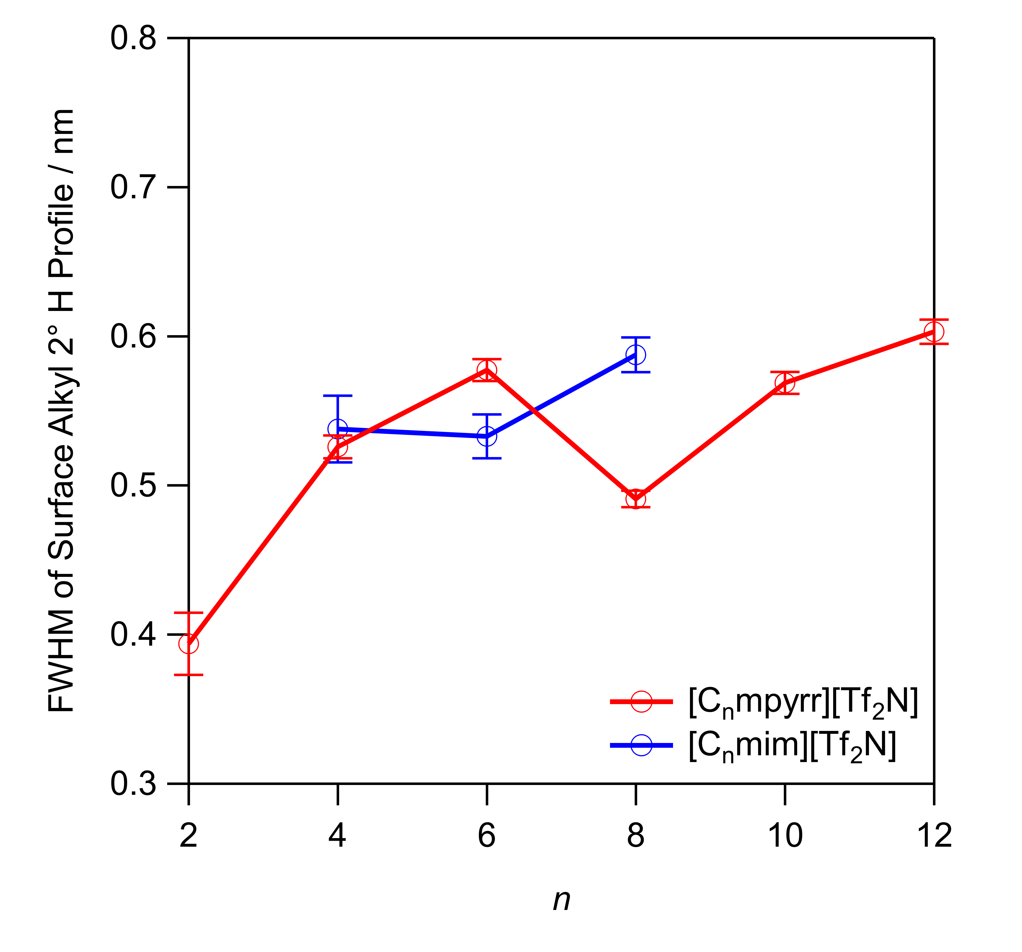
Figure 7: The width of the MD-simulated surface alkyl secondary-hydrogen number-density profile along the z-axis for [C_{n}mpyrr][Tf₂N] and [C_{n}mim][Tf₂N] ionic liquids. Error bars represent ±1σ standard errors of the mean.
Lastly, we return to the surprising implication that the alkyl density at the surfaces of the two types of ILs is very similar despite differential factors that might have been expected to affect the ion packing. It has been shown previously^{18,62} that the ionic volumes and the strength of the cation-anion interaction greatly influence the alkyl coverage of the surface: stronger interactions induce closer packing of anions and headgroups, and therefore more alkyl chains on the surface. The positive charge is more localized in [C_{n}mpyrr]⁺ than in [C_{n}mim]⁺, implying stronger cation-anion Coulombic interactions.⁶³⁻⁶⁴ On its own, this might therefore be expected to lead to a denser surface and higher yield of OH than from imidazolium ILs. The fact that this is not observed in RAS-LIF is interesting. It could be due to an opposing effect, such as the shape of the headgroups: while imidazolium rings are planar, pyrrolidinium is not, and this could result in lower packing efficiency, as pointed out by Steinrück and co-workers.¹³ Those authors found that the bulk density was lower for [C₄mpyrr][Tf₂N] than for [C₄mim][Tf₂N], consistent with less efficient packing (which may correlate with the slightly ‘softer’ surface we infer above from the trends in OH T_{rot}). However, the surface tension was higher for the pyrrolidinium IL. They suggested that this could be partly associated with an offsetting lower propensity for the [C₄mpyrr]⁺ ring to be orientated with the butyl chain projecting towards vacuum, inferred from the N_{cation} : N_{anion} ratios in XPS experiments.¹³ These combined effects may fortuitously almost perfectly cancel out, leading to nearly quantitatively identical alkyl surface coverages.
We have tested these arguments by further analysis of the MD simulations. In Figure 8, the distribution of nearest-neighbor distances between the centers of mass of the charged atoms in the cation and anion, respectively, is plotted for all of the simulated IL surfaces. For either cation type, the results vary only weakly with n, indicating that the structure of the ionic layer is largely independent of the presence of the overlaying alkyl chains. Comparing imidazolium against pyrrolidinium, many more imidazolium-anion pairs are found at short distances. This supports the argument that the [Tf₂N]⁻ anion can approach the planar [C_{n}mim]⁺ ring in a perpendicular geometry, whereas close approach is sterically inhibited for [C_{n}mpyrr]⁺ due to the tetrahedral geometry at the nitrogen atom. The differences are less marked at long cation-anion distances, although it can be appreciated that, for the same chain length, longer distances are more prevalent for the imidazolium-anion pairs. This can be rationalized by the already-noted, more-localized charge density on the pyrrolidinium cation giving rise to a narrower distribution of cation-anion distances. Overall, the average distance is very similar for imidazolium and pyrrolidinium ILs, suggesting that the density of packing is indeed comparable for these two cation types, consistent with the similarity in alkyl chain surface coverage.

Figure 8: Nearest-neighbor peak of the cation-anion radial distribution function in the xy-plane. The maximum amplitude of all peaks is normalized to unity. The cation-anion separation is defined as the distance between the center-of-mass of the charged atoms in the cation and the center-of-mass of the charged atoms in the anion.

CONCLUSIONS

Both the RAS-LIF experiments and the MD simulations in this paper provide clear evidence that the ionic liquids studied undergo structural organization at the liquid-vacuum interface. An extensive quantitative comparison between 1-alkyl-1-methylpyrrolidinium and 1-alkyl-3-methylimidazolium ILs of different chain lengths has been carried out for the first time. [C_{n}mpyrr][Tf₂N] and [C_{n}mim][Tf₂N] ILs of the same chain length give remarkably similar results in RAS-LIF. In this passive sense, the headgroups are ‘hidden’, with the identity of the cation headgroup having very little differential effect on alkyl enrichment. For either IL type, the alkyl surface coverage is driven primarily by the length of the alkyl chain, Quantitative analyses of the MD results support this picture, complementing the RAS-LIF results in terms of the qualitative chain-length-dependent trends. The MD results lend support to the explanation that the more localized charge density on the pyrrolidinium cation is offset by steric blocking of the site of the charge, resulting in overall very similar packing densities of alkyl chains at the surfaces of pyrrolidinium and imidazolium ILs. In a more active sense, the pyrrolidinium headgroups are hidden from the incoming O(³P) projectiles, because they make no apparent contribution to the observed OH yield in RAS-LIF experiments despite their expected capacity to react based on calculated bond energies. This is not so well reproduced in the MD simulations, suggesting that the surface-wetting analysis does not capture dynamical or steric factors which affect the abstraction of the pyrrolidinium ring-H atoms by O(³P).

ASSOCIATED CONTENT

Supporting Information
Methods used to prepare the non-commercial ionic liquids and their precursors; optimized structures, vibrational frequencies and energies found in BDE calculations.
Notes
Raw data on which this publication is based can be accessed via the Heriot-Watt University Data Repository.

AUTHOR INFORMATION
Corresponding Author
* K.G.McKendrick@hw.ac.uk
Notes
The authors declare no competing financial interest.

ACKNOWLEDGMENT
This work has been supported by the U.S. National Science Foundation (CHE-1266032) and by the U.K. Engineering and Physical Sciences Research Council (EP/H011455/1, EP/K031589/1 and EP/K032062/1). M. A. T.-S. acknowledges Heriot-Watt University for a James Watt PhD scholarship.

REFERENCES
1. Grenoble, Z.; Baldelli, S. Ionic Liquids at the Gas–Liquid and Solid–Liquid Interface – Characterization and Properties. In Supported Ionic Liquids, Wiley-VCH Verlag GmbH & Co. KGaA: 2014; pp 145-176.
2. Parvulescu, V. I.; Hardacre, C. Catalysis in ionic liquids. Chem. Rev. 2007, 107, 2615-2665.
3. Hallett, J. P.; Welton, T. Room-Temperature Ionic Liquids: Solvents for Synthesis and Catalysis. 2. Chem. Rev. 2011, 111, 3508-3576.
4. Steinruck, H. P.; Wasserscheid, P. Ionic Liquids in Catalysis. Catal. Lett. 2015, 145, 380-397.
5. Ramdin, M.; de Loos, T. W.; Vlugt, T. J. H. State-of-the-Art of CO2 Capture with Ionic Liquids. Industrial & Engineering Chemistry Research 2012, 51, 8149-8177.
6. Zhang, X. P.; Zhang, X. C.; Dong, H. F.; Zhao, Z. J.; Zhang, S. J.; Huang, Y. Carbon capture with ionic liquids: overview and progress. Energ Environ Sci 2012, 5, 6668-6681.
7. Cui, G. K.; Wang, J. J.; Zhang, S. J. Active chemisorption sites in functionalized ionic liquids for carbon capture. Chem. Soc. Rev. 2016, 45, 4307-4339.
8. Wasserscheid, P.; Welton, T. Ionic Liquids in Synthesis; Wiley-VCH Verlag GmbH & Co. KGaA, 2008.
9. Ho, T. D.; Zhang, C.; Hantao, L. W.; Anderson, J. L. Ionic Liquids in Analytical Chemistry: Fundamentals, Advances, and Perspectives. Anal. Chem. 2014, 86, 262-285.
10. Pavel, O. D.; Goodrich, P.; Cristian, L.; Coman, S. M.; Parvulescu, V. I.; Hardacre, C. Direct oxidation of amines to nitriles in the presence of ruthenium-terpyridyl complex immobilized on ILs/SILP. Catal Sci Technol 2015, 5, 2696-2704.
11. Kolbeck, C.; Taccardi, N.; Paape, N.; Schulz, P. S.; Wasserscheid, P.; Steinruck, H. P.; Maier, F. Redox chemistry, solubility, and surface distribution of Pt(II) and Pt(IV) complexes dissolved in ionic liquids. J. Mol. Liq. 2014, 192, 103-113.
12. Aliaga, C.; Baker, G. A.; Baldelli, S. Sum Frequency Generation Studies of Ammonium and Pyrrolidinium Ionic Liquids Based on the Bis-trifluoromethanesulfonimide Anion. J. Phys. Chem. B 2008, 112, 1676-1684.
13. Kolbeck, C.; Lehmann, J.; Lovelock, K. R. J.; Cremer, T.; Paape, N.; Wasserscheid, P.; Fröba, A. P.; Maier, F.; Steinrück, H. P. Density and Surface Tension of Ionic Liquids. J. Phys. Chem. B 2010, 114, 17025-17036.
14. Lockett, V.; Sedev, R.; Harmer, S.; Ralston, J.; Horne, M.; Rodopoulos, T. Orientation and mutual location of ions at the surface of ionic liquids. Phys. Chem. Chem. Phys. 2010, 12, 13816-13827.
15. Men, S.; Hurisso, B. B.; Lovelock, K. R. J.; Licence, P. Does the influence of substituents impact upon the surface composition of pyrrolidinium-based ionic liquids? An angle resolved XPS study. Phys. Chem. Chem. Phys. 2012, 14, 5229-5238.
16. Villar-Garcia, I. J.; Fearn, S.; De Gregorio, G. F.; Ismail, N. L.; Gschwend, F. J. V.; McIntosh, A. J. S.; Lovelock, K. R. J. The ionic liquid-vacuum outer atomic surface: a low-energy ion scattering study. Chem. Sci. 2014, 5, 4404-4418.
17. Paredes, X.; Fernández, J.; Pádua, A. A. H.; Malfreyt, P.; Malberg, F.; Kirchner, B.; Pensado, A. S. Bulk and Liquid–Vapor Interface of Pyrrolidinium-Based Ionic Liquids: A Molecular Simulation Study. J. Phys. Chem. B 2014, 118, 731-742.
18. Tesa-Serrate, M. A.; Marshall, B. C.; Smoll, E. J.; Purcell, S. M.; Costen, M. L.; Slattery, J. M.; Minton, T. K.; McKendrick, K. G. Ionic Liquid–Vacuum Interfaces Probed by Reactive Atom Scattering: Influence of Alkyl Chain Length and Anion Volume. J. Phys. Chem. C 2015, 119, 5491-5505.
19. Tesa-Serrate, M. A.; Smoll, E. J.; Minton, T. K.; McKendrick, K. G. Atomic and Molecular Collisions at Liquid Surfaces. Annu. Rev. Phys. Chem. 2016, 67, 515-540.
20. Andresen, P.; Luntz, A. C. The chemical dynamics of the reactions of O(³P) with saturated hydrocarbons. I. Experiment. J. Chem. Phys. 1980, 72, 5842-5850.
21. Waring, C.; Bagot, P. A. J.; Costen, M. L.; McKendrick, K. G. Reactive Scattering as a Chemically Specific Analytical Probe of Liquid Surfaces. J. Phys. Chem. Lett. 2011, 2, 12-18.
22. Waring, C.; Bagot, P. A. J.; Slattery, J. M.; Costen, M. L.; McKendrick, K. G. O(³P) Atoms as a Probe of Surface Ordering in 1-Alkyl-3-methylimidazolium-Based Ionic Liquids. J. Phys. Chem. Lett. 2010, 1, 429-433.
23. Waring, C.; Bagot, P. A. J.; Slattery, J. M.; Costen, M. L.; McKendrick, K. G. O(³P) Atoms as a Chemical Probe of Surface Ordering in Ionic Liquids. J. Phys. Chem. A 2010, 114, 4896-4904.
24. Tesa-Serrate, M. A.; King, K. L.; Paterson, G.; Costen, M. L.; McKendrick, K. G. Site and bond-specific dynamics of reactions at the gas-liquid interface. Phys. Chem. Chem. Phys. 2014, 16, 173-183.
25. Waring, C.; King, K. L.; Bagot, P. A. J.; Costen, M. L.; McKendrick, K. G. Collision dynamics and reactive uptake of OH radicals at liquid surfaces of atmospheric interest. Phys. Chem. Chem. Phys. 2011, 13, 8457-8469.
26. Bagot, P. A. J.; Waring, C.; Costen, M. L.; McKendrick, K. G. Dynamics of inelastic scattering of OH radicals from reactive and inert liquid surfaces. J. Phys. Chem. C 2008, 112, 10868-10877.
27. Abraham, M. J.; Murtola, T.; Schulz, R.; Páll, S.; Smith, J. C.; Hess, B.; Lindahl, E. GROMACS: High performance molecular simulations through multi-level parallelism from laptops to supercomputers. SoftwareX 2015, 1–2, 19-25.
28. Shimizu, K.; Almantariotis, D.; Gomes, M. F. C.; Pádua, A. A. H.; Canongia Lopes, J. N. Molecular Force Field for Ionic Liquids V: Hydroxyethylimidazolium, Dimethoxy-2- Methylimidazolium, and Fluoroalkylimidazolium Cations and Bis(Fluorosulfonyl)Amide, Perfluoroalkanesulfonylamide, and Fluoroalkylfluorophosphate Anions. J. Phys. Chem. B 2010, 114, 3592-3600.
29. Canongia Lopes, J. N.; Pádua, A. A. H.; Shimizu, K. Molecular Force Field for Ionic Liquids IV: Trialkylimidazolium and Alkoxycarbonyl-Imidazolium Cations; Alkylsulfonate and Alkylsulfate Anions. J. Phys. Chem. B 2008, 112, 5039-5046.
30. Canongia Lopes, J. N.; Pádua, A. A. H. Molecular Force Field for Ionic Liquids III: Imidazolium, Pyridinium, and Phosphonium Cations; Chloride, Bromide, and Dicyanamide Anions. J. Phys. Chem. B 2006, 110, 19586-19592.
31. Canongia Lopes, J. N.; Pádua, A. A. H. Molecular Force Field for Ionic Liquids Composed of Triflate or Bistriflylimide Anions. J. Phys. Chem. B 2004, 108, 16893-16898.
32. Canongia Lopes, J. N.; Deschamps, J.; Pádua, A. A. H. Modeling Ionic Liquids Using a Systematic All-Atom Force Field. J. Phys. Chem. B 2004, 108, 11250-11250.
33. Rizzo, R. C.; Jorgensen, W. L. OPLS All-Atom Model for Amines: Resolution of the Amine Hydration Problem. J. Am. Chem. Soc. 1999, 121, 4827-4836.
34. Jorgensen, W. L.; McDonald, N. A. A Faithful Couple: Qualitative and Quantitative Understanding of ChemistryDevelopment of an all-atom force field for heterocycles. Properties of liquid pyridine and diazenes. J. Mol. Struct. THEOCHEM 1998, 424, 145-155.
35. McDonald, N. A.; Jorgensen, W. L. Development of an All-Atom Force Field for Heterocycles. Properties of Liquid Pyrrole, Furan, Diazoles, and Oxazoles. J. Phys. Chem. B 1998, 102, 8049-8059.
36. Jorgensen, W. L.; Maxwell, D. S.; Tirado-Rives, J. Development and Testing of the OPLS All-Atom Force Field on Conformational Energetics and Properties of Organic Liquids. J. Am. Chem. Soc. 1996, 118, 11225-11236.
37. Price, M. L. P.; Ostrovsky, D.; Jorgensen, W. L. Gas-phase and liquid-state properties of esters, nitriles, and nitro compounds with the OPLS-AA force field. J. Comput. Chem. 2001, 22, 1340-1352.
38. Watkins, E. K.; Jorgensen, W. L. Perfluoroalkanes: Conformational Analysis and Liquid-State Properties from ab Initio and Monte Carlo Calculations. J. Phys. Chem. A 2001, 105, 4118-4125.
39. Kaminski, G. A.; Friesner, R. A.; Tirado-Rives, J.; Jorgensen, W. L. Evaluation and Reparametrization of the OPLS-AA Force Field for Proteins via Comparison with Accurate Quantum Chemical Calculations on Peptides. J. Phys. Chem. B 2001, 105, 6474-6487.
40. Humphrey, W.; Dalke, A.; Schulten, K. VMD: Visual molecular dynamics. Journal of Molecular Graphics 1996, 14, 33-38.
41. Eisenhaber, F.; Lijnzaad, P.; Argos, P.; Sander, C.; Scharf, M. The Double Cubic Lattice Method - Efficient Approaches to Numerical-Integration of Surface-Area and Volume and to Dot Surface Contouring of Molecular Assemblies. J. Comput. Chem. 1995, 16, 273-284.
42. Csaszar, P.; Pulay, P. Geometry Optimization by Direct Inversion in the Iterative Subspace. J. Mol. Struct. 1984, 114, 31-34.
43. Ahlrichs, R.; Bar, M.; Haser, M.; Horn, H.; Kolmel, C. Electronic-Structure Calculations on Workstation Computers - the Program System Turbomole. Chem. Phys. Lett. 1989, 162, 165-169.
44. Eichkorn, K.; Treutler, O.; Ohm, H.; Haser, M.; Ahlrichs, R. Auxiliary Basis-Sets to Approximate Coulomb Potentials. Chem. Phys. Lett. 1995, 240, 283-289.
45. Treutler, O.; Ahlrichs, R. Efficient Molecular Numerical-Integration Schemes. J. Chem. Phys. 1995, 102, 346-354.
46. Eichkorn, K.; Weigend, F.; Treutler, O.; Ahlrichs, R. Auxiliary basis sets for main row atoms and transition metals and their use to approximate Coulomb potentials. Theor. Chem. Acc. 1997, 97, 119-124.
47. von Arnim, M.; Ahlrichs, R. Geometry optimization in generalized natural internal coordinates. J. Chem. Phys. 1999, 111, 9183-9190.
48. Deglmann, P.; Furche, F. Efficient characterization of stationary points on potential energy surfaces. J. Chem. Phys. 2002, 117, 9535-9538.
49. Deglmann, P.; Furche, F.; Ahlrichs, R. An efficient implementation of second analytical derivatives for density functional methods. Chem. Phys. Lett. 2002, 362, 511-518.
50. Deglmann, P.; May, K.; Furche, F.; Ahlrichs, R. Nuclear second analytical derivative calculations using auxiliary basis set expansions. Chem. Phys. Lett. 2004, 384, 103-107.
51. Baldes, A.; Weigend, F. Efficient two-component self-consistent field procedures and gradients: implementation in TURBOMOLE and application to Au-20(-). Mol. Phys. 2013, 111, 2617-2624.
52. Furche, F.; Ahlrichs, R.; Hattig, C.; Klopper, W.; Sierka, M.; Weigend, F. Turbomole. Wires Comput Mol Sci 2014, 4, 91-100.
53. Frisch, M. J., et al. GAUSSIAN 09, Gaussian, Inc.: Wallingford CT, 2010.
54. Curtiss, L. A.; Redfern, P. C.; Raghavachari, K. Gaussian-4 theory. J. Chem. Phys. 2007, 126, 084108.
55. Blanksby, S. J.; Ellison, G. B. Bond dissociation energies of organic molecules. Acc. Chem. Res. 2003, 36, 255-263.
56. Luque, J.; Crosley, D. R. LIFBASE: Database and spectral simulation, 1.5; SRI International: 1999.
57. Allan, M.; Bagot, P. A. J.; Costen, M. L.; McKendrick, K. G. Temperature dependence of OH yield, translational energy, and vibrational branching in the reaction of O(³P)(g) with liquid squalane. J. Phys. Chem. C 2007, 111, 14833-14842.
58. Lovelock, K. R. J. Influence of the ionic liquid/gas surface on ionic liquid chemistry. Phys. Chem. Chem. Phys. 2012, 14, 5071-5089.
59. Ausfelder, F.; McKendrick, K. G. The dynamics of reactions of O(³P) atoms with saturated hydrocarbons and related compounds. Prog. React. Kinet. Mec. 2000, 25, 299-370.
60. Wu, B.; Zhang, J.; Minton, T. K.; McKendrick, K. G.; Slattery, J. M.; Yockel, S.; Schatz, G. C. Scattering Dynamics of Hyperthermal Oxygen Atoms on Ionic Liquid Surfaces: [emim][NTf₂] and [C₁₂mim][NTf₂]. J. Phys. Chem. C 2010, 114, 4015-4027.
61. Marshall, B. C.; Smoll, E. J.; Purcell, S. M.; Costen, M. L.; McKendrick, K. G.; Minton, T. K. Scattering Dynamics of Oxygen Atoms on Imidazolium Tetrafluoroborate Ionic Liquid Surfaces: Dependence on Alkyl Chain Length. J. Phys. Chem. C 2016, 120, 12472-12483.
62. Kolbeck, C.; Cremer, T.; Lovelock, K. R. J.; Paape, N.; Schulz, P. S.; Wasserscheid, P.; Maier, F.; Steinrueck, H. P. Influence of Different Anions on the Surface Composition of Ionic Liquids Studied Using ARXPS. J. Phys. Chem. B 2009, 113, 8682-8688.
63. Fernandes, A. M.; Rocha, M. A. A.; Freire, M. G.; Marrucho, I. M.; Coutinho, J. A. P.; Santos, L. M. N. B. F. Evaluation of Cation−Anion Interaction Strength in Ionic Liquids. J. Phys. Chem. B 2011, 115, 4033-4041.
64. Men, S.; Lovelock, K. R. J.; Licence, P. X-ray photoelectron spectroscopy of pyrrolidinium-based ionic liquids: cation-anion interactions and a comparison to imidazolium-based analogues. Phys. Chem. Chem. Phys. 2011, 13, 15244-15255.

TOC graphic

