APPLICATION OF BACTERIOPHAGES
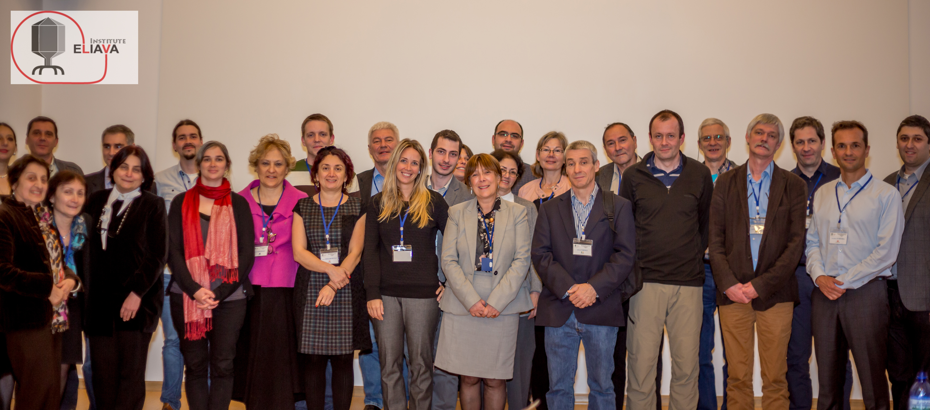

Expert Round Table Participants

Phage_therapy@pha.ge

Abstract

This article is compiled by the participants of the Expert Round Table conference “Bacteriophages as tools for therapy, prophylaxis and diagnostics” (19-21 October 2015) at the Eliava Institute of Bacteriophage, Microbiology & Virology, Tbilisi, Georgia. The first paper from the Round Table “Silk route to the acceptance and re-implementation of bacteriophage therapy” was published in the Biotechnology Journal (2016), 11: 595-600 (DOI 10.1002/biot.201600023). This In Focus article expands from the first one and includes recent developments reported since then by the Expert Round Table participants including the implementation of the Nagoya Protocol for the applications of bacteriophages.

Introduction

Antimicrobials are one of the most successful forms of therapy but their broad and often indiscriminate use resulted in a widespread antimicrobial resistance (Aminov, 2010). The annual death toll due to multidrug-resistant bacterial infections is estimated at 23,000 in the US and 25,000 in Europe (CDC, 2013; EMA, 2015). Complementary strategies are urgently needed, and bacteriophage therapy offers:

- Specificity, target directed removal of pathogens via narrow spectrum and do not affect beneficial commensals,
- Multiplication at infection sites, thus amplifying the local antimicrobial effects,
- Minimum, if any, side effects,
- Resistance can be dealt by introduction of new bacteriophages, which is faster and cheaper compared to new antibiotics,
- Bacteriophages are active against multidrug-resistant and biofilm-forming bacteria,
- Lytic bacteriophages may limit the evolution and spread of antimicrobial resistance (Zhang and Buckling, 2012),
- Bacteriophages act in synergy with antimicrobials,
- Phage CRISPR-Cas systems provide a new way to target antibiotic-resistant pathogens (Yosef et al., 2015).
Bacteriophage therapy was pioneered at the Eliava Institute in Tbilisi, Georgia (Fig. 1), and the reader is referred to the excellent Historical Review article by Chanishvili and Sharp (2008) published in Microbiology Australia.

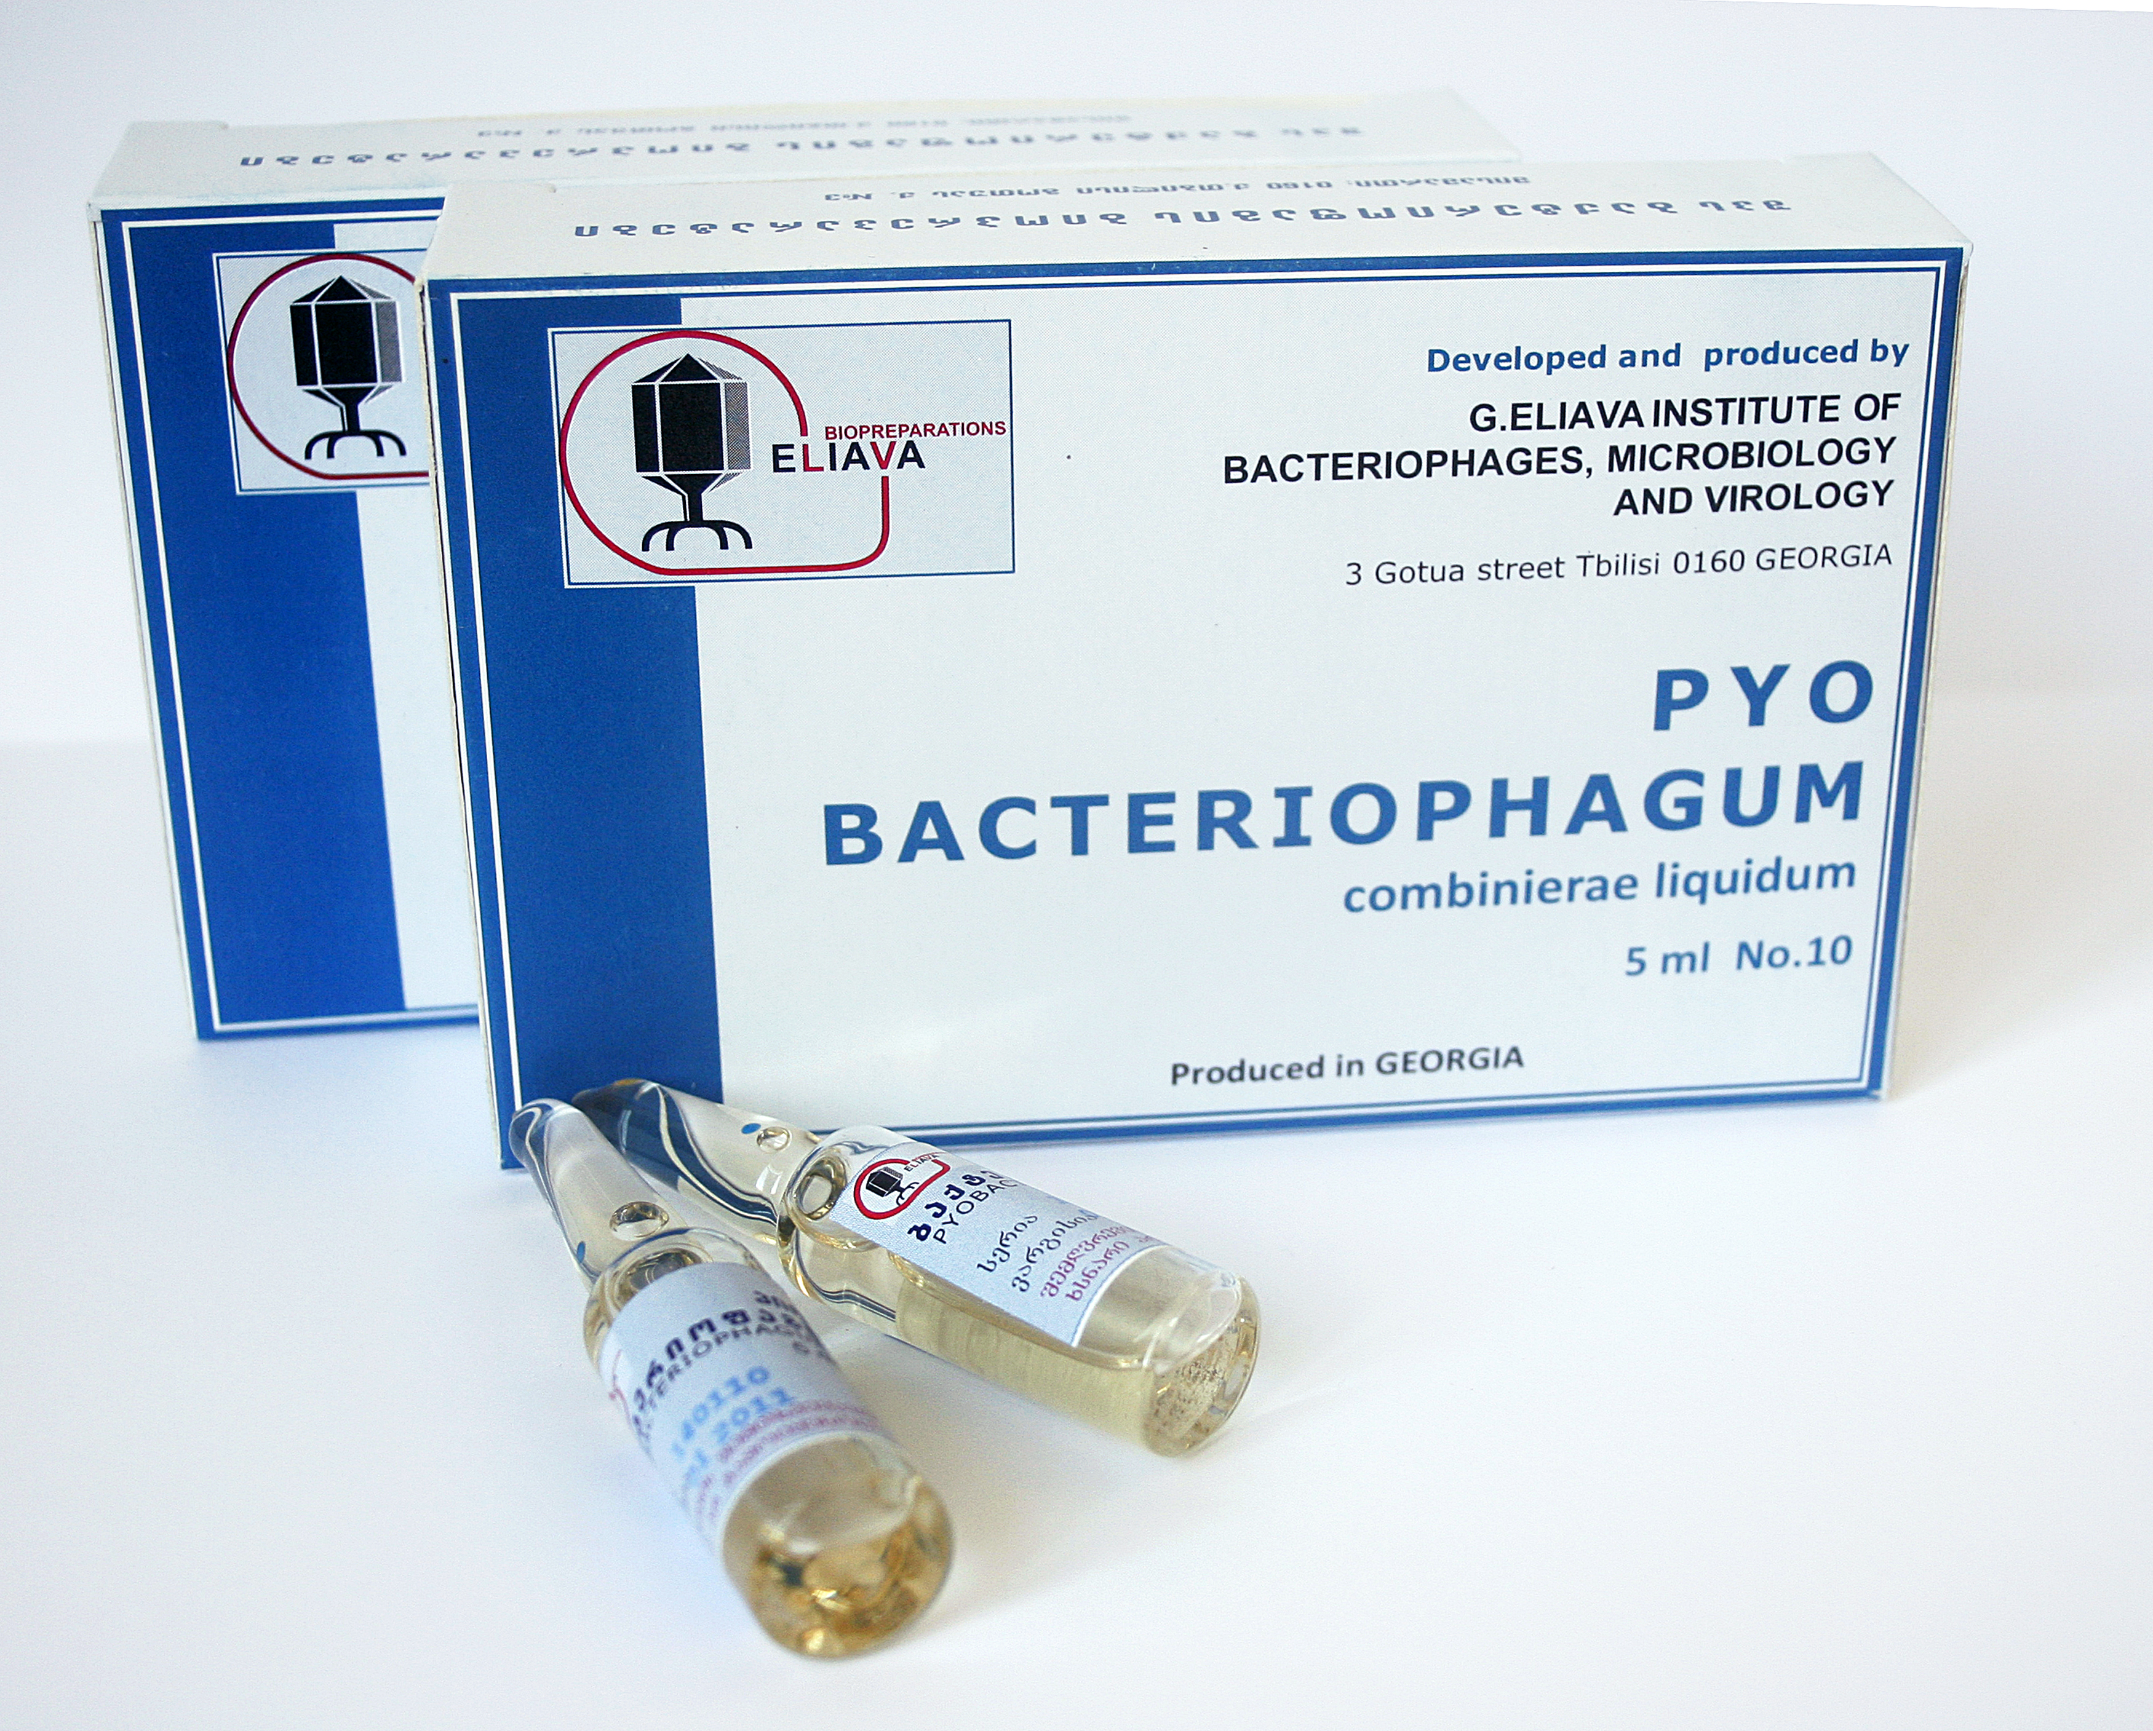

Fig. 1: Bacteriophage medicine sold to patients at the Eliava Institute’s Pharmacy

- Therapeutic application of bacteriophages and resistance

Large burn wounds lead to immunosuppression, making burn patients susceptible to infections. Although medical advances have resulted in increased survival of burn victims, most deaths are due to the wound sepsis or sepsis secondary to pneumonia. Animal studies showed that bacteriophages could rescue burnt mice and guinea pigs with wound infection or bacteraemia. Presently, bacteriophage therapy aficionados eagerly await the results of the “PhagoBurn” study (www.phagoburn.eu), the first trial conducted per the occidental standards of good practices. This phase I/II multicentric, randomized and single-blind clinical trial involves 15 burn units in France, Switzerland and Belgium and targets burn wounds infected by Escherichia coli or Pseudomonas aeruginosa. Manufacturing the investigational products took 20 months and bacteriophage specificity issues hampered the recruitment of patients (Servick, 2016). Regardless of the clinical outcome of the trial, dedicated and realistic production requirements are urgently needed.
Antagonistic bacterium-phage co-evolution is a dynamic process, where phage-resistant bacteria and infective bacteriophages are selected in turn. While emergence of bacteria resistant against challenging bacteriophages is a part of a dynamic coevolution, it could be problematic for the therapy. Thus, preventing selection of phage-resistant variants that could result in treatment failure is crucial. Interestingly, while phage-resistant P. aeruginosa can be readily selected in a test tube when challenged by the anti-P. aeruginosa cocktail used in Phagoburn, these were not observed in a rat model of P. aeruginosa-induced experimental endocarditis (Oechslin, 2016). Accordingly, two resistant variants recovered in vitro showed >70% and >40% decrease in infectivity of rats, explaining the failure to recover them from in vivo biopsies. These variants were respectively lacking lipopolysaccharide (LPS) and having the pili impaired, both structures being known as phage-receptors (Bertozzi-Silva, 2016). This study illustrated that phage-resistance can emerge at a very high cost in terms of virulence - and possibly in vivo survival - for the bacterium. This observation, which is not new (Leon, 2015), is reassuring but the clinical relevance of phage-resistance should be carefully evaluated for future clinical trials.

- Bacteriophages for food hygiene and safety and environmental applications

Bacteriophages are used since the 1980s to control and eliminate bacterial contaminants from food surfaces, food-borne spoilage bacteria and bacteria causing gastrointestinal diseases (Garcia et al. 2008) as well as to decontaminate raw food. Due to their specificity, bacteriophages are attractive for sanitization of ready-to-eat foods (RTE) such as milk, vegetables and meat products (Endersen et al., 2014). In 2007, the US Department of Agriculture (USDA) approved bacteriophage products targeting Salmonella species and E. coli O157:H7. They are designed as spray sanitizers to disinfect cattle hides prior to slaughter to reduce pathogen contamination of meat (Goodridge and Abedon, 2008). In parallel, the commercial product Agriphage™ was developed to control black spot disease on tomato and pepper plants caused by Xanthamonas campestris and Pseudomonas syringae (Monk et al. 2010).
Similarly, bacteriophages are also potentially useful as surface and environment decontaminants. Listeria phages (3.5 x 10⁸ PFU/ml), for instance, were as effective as a 20-ppm solution of a quaternary ammonium compound (QAC) disinfectant for stainless steel decontamination. Interestingly, synergism between different bacteriophages and phages-QAC was reported with bacteriophages being unaffected by QAC at 50 ppm and up to 4 hours of contact time (Roy et al. 1993).

- Agricultural applications of bacteriophages

Bacteriophage effects on target pathogens depend on the ecological and environmental context such as abiotic environmental factors or surrounding microbial community. For example, phage-mediated killing of pathogenic bacteria can be amplified in the presence of non-pathogenic bacteria that impose strong resource competition with the pathogen. More recently, it was shown that the presence of antimicrobial producing Bacillus amyloliquefaciens bacterium could shape the effect of bacteriophage selection on the plant pathogen Ralstonia solanacearum (Wang et al. 2017). In this case, the effect was driven by evolutionary trade-off where evolving resistance to a phage led to increased susceptibility to antimicrobials produced by B. amyloliquefaciens. Similar evolutionary trade-offs can also lead to lowered expression of multiple important R. solanacearum virulence factors and reduced virulence in tomato in vivo (Addy et al. 2012). Identifying bacteriophages that impair pathogen virulence by binding to various surface structures (flagella, pili and LPS), could be important for selecting therapeutic bacteriophages (Buttimer et al. 2017).
When applied topically or orally to animals, bacteriophages will eventually become associated with the skin and wool/hair of animals. Thus, bacteriophages specific for animal pathogens could be isolated from wool (Patten et al., 1995). These bacteriophages can reduce the number of bacteria associated with 'clumping', and thus represent an option for agricultural practices as opposed to antibiotics. Similarly, bacteriophages have been recovered from the skin of healthy humans (Foulongne et al., 2012), or when they were successfully incorporated into fibers used for human clothing (Mao, 2009).

- Current hurdles and regulatory status of bacteriophages

Bacteriophages are not currently classified in medicinal legislation, since they are neither living nor chemical agents. Therefore, it is complicated to regulate and perform clinical trials and commercialization (Fauconnier 2017). To ensure the efficiency of phage preparations, their effectiveness and host range towards currently circulating pathogenic strains must be monitored. This might explain why the phage preparations approved in the Russian Federation and Georgia are not static but are continuously updated to target newly emerging pathogenic strains (Kutter et al. 2010). Legislation to allow these updates is necessary to circumvent repeated registration procedures.
On July 5 2016, the Belgian Minister of Social Affairs and Public Health has formally acknowledged that it is difficult to define the status of therapeutic phage preparations: should they be considered as industrially-prepared medicinal products (subjected to constraints related to marketing authorization) or as magistral preparations (prepared in pharmacies’ officina) (Commission de la santé publique, de l'environnement et du renouveau de la société, 2016). Magistral preparations (compounded prescription drug products in the US) are made by a pharmacist from the constituent ingredients to meet specific patient needs. On October 26th, 2016, it was formally agreed that natural bacteriophages and their products, which are not fully compliant with the European Directive requirements for medicinal products for human use and for which there is no monograph in an official pharmacopoeia, can be processed by a pharmacist as raw materials (active ingredients) in magistral preparations, providing compliance to several logical provisions.

- Bacteriophage application in the Access and Benefit Sharing (ABS) context: The Nagoya Protocol

To combat antibiotic resistances, there is urgent need to build up large phage collections against the pathogens like ESKAPE (Enterococcus faecium, Staphylococcus aureus, Klebsiella pneumoniae, Acinetobacter baumannii, P. aeruginosa and Enterobacteriaceae). However, culture collections holding and offering quality-checked authenticated bacteriophages in the sense of phage banks are confronted with two constraints. First, there are no requirements for authors by journals to deposit bacteriophages with public repositories before publishing, which differs from agreed procedures for their bacterial hosts (Murray, 1996). The second issue that should be considered is the current development of rules for legal handling of bioresources that of course includes the bacteriophages. On October 12th, 2014, the Nagoya Protocol https://www.cbd.int/abs/ has entered force in several countries that ratified the Convention on Biological Diversity (CBD) https://www.cbd.int/. These laws deal with sampling, the accession and distribution of all genetic resources including microorganisms regarding the ABS. One of the reasons of the ratification of the protocol is protecting biodiversity under national sovereignty to prevent “biopiracy” and to restrict access. All microbiologists who are sampling or distributing bioresources must be aware of these restrictions and should refer to their respective national regulations. National regulations might differ in each country and failure to comply with might result in legal consequences. For further information please see the DSMZ website at https://www.dsmz.de/deposit/nagoya-protocol.html.

- Conclusions and Future Perspectives

As already stated by Skurnik and Strauch (2006) a decade ago, the therapeutic use of bacteriophages, possibly combined with antibiotics, is a promising therapy option. Safe and controlled use of bacteriophage therapy will however, require as detailed information as possible on the properties and behaviour of specific phage-bacterium systems, in vitro and especially in vivo. Susceptibility of bacterial pathogens in vivo to bacteriophages is still not completely understood and requires dedicated (pre-)clinical research on more phage-bacterium systems. The requirements for quality and safety in bacteriophage production and application have been defined and communicated (Pirnay et al., 2015; Verbeken et al., 2014, Fauconnier, 2017).
Natural resources will naturally be utilized further to isolate many more bacteriophages to build-up large phage collections to fight the antibiotic crisis. These efforts will then be translated into cooperation across borders and continents which will be regulated by The Nagoya Protocol to some extent. Therefore, facilitative regulations governing therapeutic use of bacteriophages should be implemented to counter antibiotic resistance on a global scale. Bacteriophage application obviously have significant potential to bridge human and veterinary medicine and bring effective solutions to antibiotic resistant problem as pointed out in this article.

Acknowledgements

This article is produced on behalf of the Expert Round Table Participants as follows:

Rustam Aminov, School of Medicine and Dentistry, University of Aberdeen, UK

Jonathan Caplin, School of Environment & Technology, University of Brighton, UK
Nina Chanishvili, Eliava Institute of Bacteriophage, Microbiology and Virology, Tbilisi, Georgia

Aidan Coffey, Cork Institute of Technology, Department of Biological Sciences, Ireland
Ian Cooper, School of Pharmacy and Biomolecular Sciences, University of Brighton, UK
Daniel De Vos, Laboratory for Molecular and Cellular Technology, Queen Astrid Military Hospital, Brussels, Belgium
Jiří Doškař, Masaryk University, Faculty of Science, Department of Experimental Biology, Brno, Czech Republic

Ville-Petri Friman, University of York, Department of Biology, UK
İpek Kurtbӧke, University of the Sunshine Coast, GeneCology Research Centre and the Faculty of Science, Health, Education and Engineering, QLD, Australia
Roman Pantucek, Masaryk University, Faculty of Science, Department of Experimental Biology, Brno, Czech Republic
Jean-Paul Pirnay, Laboratory for Molecular and Cellular Technology, Queen Astrid Military Hospital, Brussels, Belgium
Grégory Resch, University of Lausanne, Department of Fundamental Microbiology, Switzerland
Christine Rohde, Leibniz Institute DSMZ-German Collection of Microorganisms and Cell Cultures, Braunschweig, Germany

Wilbert Sybesma, Nestec Ltd - Nestlé Research Center, Lausanne, Switzerland
Johannes Wittmann, Leibniz Institute DSMZ-German Collection of Microorganisms and Cell Cultures, Braunschweig, Germany

References
- Expert round table on acceptance and re-implementation of bacteriophage therapy 2016. Silk route to the acceptance and re-implementation of bacteriophage therapy. Biotechnology Journal 11: 595-600 (DOI 10.1002/biot.201600023).
- Aminov, R. 2010. A brief history of the antibiotic era: lessons learned and challenges for the future. Front. Microbiol. 1:134. DOI: 10.3389/fmicb.2010.00134.
- CDC Report. 2013. Antibiotic Resistance Threats in the United States, 2013. Available at: http://www.cdc.gov/drugresistance/threat-report-2013.
- EMA. 2015. Antimicrobial resistance. Available at: http://www.ema.europa.eu/ema/index.jsp?curl=pages/special_topics/general/general_content_000439.jsp
- Zhang, Q.G. and Buckling, A., 2012. Phages limit the evolution of bacterial antibiotic resistance in experimental microcosms. Evolutionary Applications, 5(6), pp.575-582.
- Yosef, I., Manor, M., Kiro, R. and Qimron, U., 2015. Temperate and lytic bacteriophages programmed to sensitize and kill antibiotic-resistant bacteria. Proceedings of the National Academy of Sciences, 112(23), pp.7267-7272.
- Chanishvili, N. and Sharp, R. 2008. Bacteriophage Therapy: experience from the Eliava Institute, Georgia. Microbiology Australia, 29(2): 96-101.
- Servick K. 2016. DRUG DEVELOPMENT. Beleaguered phage therapy trial presses on. Science 24, 352(6293): 1506.
- Garcia PB, Martinez B, Obeso JM, Rodriguez A. 2008. Bacteriophages and their application in food safety. Letts Appl Microbiol. 47: 479–485.
- Endersen, L., O’Mahony, J, Hill, C, Ross, R.P, McAuliffe, O, Coffey, A. 2014. Phage Therapy in food industry. Annual Review in Food Science and Technology, 5: 327-349.
- Goodridge LD, Abedon, ST (2008) Bacteriophage biocontrol: the technology matures. Microbiol. Australia. March 2008:48-49.
- Monk AB, Rees CD, Barrow P, Hagens S, Harper DR (2010) Bacteriophage applications: where are we now? Letts Appl Microbiol. 51:363-369.
- Roy, B., Ackermann, H.W., Pandian, S., Picard, G. and Goulet, J., 1993. Biological inactivation of adhering Listeria monocytogenes by listeria bacteriophages and a quaternary ammonium compound. Applied and Environmental Microbiology 59(9):2914-2917.
- Wang, Xiaofang, et al. "Parasites and competitors suppress bacterial pathogen synergistically due to evolutionary trade‐offs. Evolution (2016).
- Addy HS, Askora A, Kawasaki T, Fujie M, Yamada T. Loss of virulence of the phytopathogen Ralstonia solanacearum through infection by ϕRSM filamentous bacteriophages. Phytopathology. 2012 May;102(5):469-77.
- Buttimer C, McAuliffe O, Ross RP, Hill C, O'Mahony J, Coffey A. Bacteriophages and Bacterial Plant Diseases. Frontiers in Microbiology. 2017, 8-34.
- Patten K., Kurtböke D., Lindsay D. (1995) Isolation of Dermatophilus congolensis phage from the ‘Lumpy Wool’ of sheep in Western Australia. Letters in Applied Microbiology, 199-203.
- Foulongne V, Sauvage V, Hebert C, et al. Human Skin Microbiota: High Diversity of DNA Viruses Identified on the Human Skin by High Throughput Sequencing. Toland AE, ed. PLoS ONE. 2012; 7(6):e38499. doi:10.1371/journal.pone.0038499.
- Mao J. (2009) Genetically Engineered Phage Fibers and Coatings for Antibacterial Applications. MSc Thesis, Massachusetts Institute of Technology, USA.
- Fauconnier A. Regulating phage therapy: The biological master file concept could help to overcome regulatory challenge of personalized medicines. EMBO Rep. 2017; 18:198-200.
- Kutter E, De Vos D, Gvasalia G, Alavidze Z, Gogokhia L, Kuhl S, Abedon ST. Phage therapy in clinical practice: treatment of human infections. Curr. Pharm. Biotechnol. 2010; 11:69-86.
- Commission de la santé publique, de l'environnement et du renouveau de la société. Questions jointes de Mme Muriel Gerkens et M. Philippe Blanchart à la ministre des Affaires sociales et de la Santé publique sur "la phagothérapie" à la ministre des Affaires sociales et de la Santé publique” (N 11955 and N 12911). 2016. Available from: https://www.dekamer.be/doc/CCRA/pdf/54/ac464.pdf.
- Murray, RGE (1996) Taxonomic Note: a Rule about the Deposition of Type Strains. International Journal of Systematic Bacteriology 46: 831
- Skurnik, M., & Strauch, E. (2006). Phage therapy: facts and fiction. International Journal of Medical Microbiology, 296(1), 5-14.
- Pirnay J.-P. et al. (2015). Quality and Safety Requirements for Sustainable Phage Therapy Products. Pharm. Res. 32
- Verbeken G. et al. (2014). Call for a Dedicated European Legal Framework for Bacteriophage Therapy. Arch. Immunol. Ther. Exp. 62
- Fauconnier A. (2017). Regulating Phage Therapy. EMBO reports Science & Society 18

