Ring expansion approach to medium-sized lactams and analysis of their medicinal lead-like properties

Laetitia G. Baud, Morgan A. Manning, Helen L. Arkless, Thomas C. Stephens and William P. Unsworth*[a]

[a] L. G. Baud, M. A. Manning, H. L. Arkless, T. C. Stephens and Dr. W. P. Unsworth  
University of York  
York, YO24 4PP (UK)  
E-mail: william.unsworth@york.ac.uk

Supporting information for this article is given via a link at the end of the document.((Please delete this text if not appropriate))

**Abstract:** Medium-sized rings are widely considered to be under-represented in biological screening libraries for lead identification in medicinal chemistry. To help address this, a library of medium-sized lactams has been generated using a simple, scalable and versatile ring expansion protocol. Analysis of the library using open access computational tool LLAMA suggests that these lactams and their derivatives have highly promising physicochemical and 3D spatial properties and thus have much potential in drug discovery.

Introduction

Five- and six-membered rings are ubiquitous in medicinal chemistry, with a least one of these rings being present in most marketed pharmaceuticals.[1] However, in recent years, there has been a significant rise in interest in the medicinal applications of larger ring compounds;[2] various methods to generate libraries of such compounds for bioassay have been developed, with medium-sized (8–11 membered rings) and macrocyclic scaffolds (12+) both having been examined.[3,4] Larger ring scaffolds generally have sufficiently well-defined conformations to bind to target receptors without major entropic penalties,[5] but are more flexible than their smaller ring analogues and hence able to change their conformation to facilitate binding if needed. They have also been shown to exhibit improved bioavailability, enhanced cell permeability and greater metabolic stability compared to related linear analogues in various studies.[6] An array of bioactive natural products are also known based on medium-sized rings and macrocycles,[7,8] including macrocyclic examples that have been developed for use as drugs in the clinic.[2b,c]

Despite these favourable characteristics, medium-sized and macrocyclic ring systems have historically been under-explored in medicinal chemistry.[2] Both compound classes are widely considered to be under-represented in most drug screening libraries[3c] and very few larger ring pharmaceuticals *produced by chemical synthesis* have made it to market.[9] Various factors have contributed to this outcome, but in view of the importance of chemical synthesis at various stages of the drug discovery process, the well-established difficulties associated with their synthesis are undoubtedly a significant contributor.[10,11] Traditional end-to-end cyclisation approaches are typically hampered by unfavourable enthalpic factors (*e.g.* ring/torsional strain) and less favourable entropic factors (compared to smaller ring cyclisations) meaning that unwanted intermolecular reactions and/or transannular reactions often out-compete the desired cyclisation. The most common method used to circumvent these problems is to perform the cyclisation at high-dilution, to minimise intermolecular collisions,[12] but such processes can be highly sensitive to changes in the substrate and are impractical on large scale. Various innovative macrocyclisation strategies have emerged in which high-dilution can be avoided,[13] but there remains a pressing need for the development of new reliable, practical and scalable methods for the synthesis of medicinally important larger ring compounds.

The expansion of smaller ring systems is an attractive alternative for the construction of larger ring compounds, most notably because the difficult end-to-end cyclisation step that blights traditional approaches can be completely avoided.[14,15] In 2015, our group reported one such approach, that enables the insertion of amino acid and hydroxy acid derived 3- or 4-atom fragments into cyclic β-keto esters via a telescoped acylation/ring expansion sequence to form lactams and lactones (**1** + **2** → **4**, Scheme 1).[16] A notable feature of this method is that the cyclic β-keto ester motif present in the starting material is replicated in the ring-enlarged product, hence Successive Ring Expansion (SuRE) reactions can be performed (*e.g.* **4** → **5**); repeating the same C-acylation/ring expansion sequence with different amino/hydroxy acid fragments on the product means that rings of any size are potentially accessible.



***Scheme 1*.** Successive Ring Expansion (SuRE).

Our previous publication on the SuRE method was mainly focused on the synthesis of macrocyclic lactams, but in selected cases, we also found that this ring expansion method was suitable for the synthesis of medium-sized lactams. The method is exemplified by the conversion of 6-membered ring β-keto ester **1a** into 10-membered ring lactam **6a**; an initial MgCl2/pyridine mediated *C*-acylation reaction with acid chloride **2a** is followed by Fmoc cleavage under standard conditions, promoting spontaneous ring expansion via the mechanism shown (Scheme 1). In total, the syntheses of seven medium-sized products (**6a**–**6g**) using this method have been reported to date (Scheme 2).[16]



***Scheme 2*.** Synthesis of 9–11-membered ring lactams **6a**–**6g**. For full reactions details see reference 16.

In principle, the ring expansion should be reversible (although we have never observed either of intermediates **4** or **5** in any of our previous reactions) and given this, we were particularly pleased to find that the formation of medium ring products **6a**–**6g** worked so well; medium-sized rings often experience destabilizing transannular interactions, and the fact they can be formed from 5–7-membered rings under thermodynamic control is important. The research described herein details our efforts to build upon these findings and use this method to generate a library of 8–12 membered ring products with diverse structural, physicochemical and 3D-spatial properties. To demonstrate the usefulness and value of the products, the ‘lead-likeness’ and 3D spatial properties of the molecular scaffolds formed were analysed using the open access computational resource LLAMA (Lead-Likeness and Molecular Analysis).[17,18]

Results and Discussion

To enable the preparation of the medium-ring library described herein, a range of functionalised β-keto esters **1a**–**g** and protected amino acid chlorides **2a**–**2h** were each required, with all of these compounds being either commercially available or readily synthesised by known procedures (detailed in the Supporting Information). Figure 1 shows all of the starting materials used, while Scheme 3 outlines the ring-expanded product library formed (**6h**–**6zd**), grouped by ring size.[19]



***Figure 1*.** Substrates **1a**–**g** and **2a**–**h**



***Scheme 3*.** Synthesis of **6h**–**6zd**. i) Dicarbonyl **1** (1 equiv.), MgCl2 (2 equiv.) and pyridine (6 equiv.) pre-mixed for 30 min in CH2Cl2 (7 mL/mmol of **1**) before adding acid chloride **2** (1.5–3 equiv.) in CH2Cl2 (3 mL/mmol of **1**) and stirring for 1–2 h at RT; ii) piperidine (10 equiv.), CH2Cl2 (10 mL/mmol), RT, 1–2 h.

A range of 8–12 membered ring products **6h**–**6zd** were generated using this method, providing a library of 30 medium ring compounds when compounds **6a**–**g** are included. Noteworthy examples include the use of benzannulated and cyclic ether-containing β-keto esters for the first time and a much wider range of branched α- and β-amino acids than those used in our earlier work.[16] The isolated yields of the ring expanded products following column chromatography range from 12–84%, with around 60% yield for the two-step sequence being typical.

Most of the examples showed in Scheme 3 proceeded as expected, with no obvious side product formation and with little/no changes to the standard reaction conditions being required. However, it is also instructive to highlight two rare exceptions that did not proceed as expected, to illustrate ways which the reaction course can deviate (Scheme 4). For example, when β-keto ester **1c** was reacted withacid chloride **2h** using the standard protocol, imine condensation product **7** was formed as the major product, with the expected product **6o** isolated as a minor side product only.[20] The reaction of β-keto ester **1h** with acid chloride **2a** also proceeded unexpectedly; in this example, it appears that the acylation/ring expansion sequence proceeded in the usual way, but that piperidine used to cleave the Fmoc protecting group condensed with the product ketone to form enamine **8**.[21] It is likely that both of these side reactions could be avoided following optimisation of the reaction conditions (*e.g*. by using aqueous conditions during the ring expansion step); additional optimisation experiments such as these are planned and will be reported in due course.



***Scheme 4*.** Rare examples of side product formation

With a library of 30 compounds (**6a**–**zd**) in-hand, attention turned to analysing their molecular properties, in particular with respect to their potential to act as lead compounds in medicinal chemistry.[22] This analysis was done using online open-access tool LLAMA.[17] LLAMA assesses the lead-likeness[18] of small molecule scaffolds based on their molecular weight, predicted lipophilicity, heavy atom count, number of aromatic rings and functional group makeup. In addition, LLAMA is able assess the predicted 3D spatial properties of the compounds using the principal moments of inertia (PMI) method,[23,24] and also provides an indication on their novelty.[25]

Compounds **6a**–**zd** are unlikely to be medicinally relevant in their own right, as they all contain a metabolically labile β-keto ester motif. Nonetheless, the majority of compounds **6a**–**zd** were at least calculated to have favourable lead-likeness properties in terms of their molecular weight (200–350) and lipophilicity (−1 to +3), with these results included in the Supporting Information. More realistically, it was considered that compounds **6a**–**zd** could serve as valuable precursors for more medicinally useful compounds following additional synthetic steps. This notion was exemplified using 11-membered ring compound **6u**. First, β-keto ester **6u** was converted into ketone **9u** via hydrolysis and decarboxylation in one-pot under standard basic conditions in high yield. Ketone **9** was then shown to undergo facile reductive amination, affording amines **10a** and **10b**, which in turn could be sulfonylated or acylated, generating compounds **11** and **12** respectively. Functionalisation on the amide nitrogen was also demonstrated, with compound **13** beingformed from secondary amide **12** in good yield (Scheme 5).



***Scheme 5*.** Chemical elaboration of compound **6u**

A major strength of LLAMA is its ability to create and enumerate virtual libraries of compounds for analysis. To do this, a new virtual library of 30 compounds **9a**–**zd** was created, based on the hydrolysis/decarboxylation of the original synthetic library (i.e. compounds **6a**–**zd** in which CO2Et has been replaced with H, see Supporting Information for a table of these structures). We then used LLAMA to enumerate these 30 compounds via five distinct reactions modes (reductive amination, sulfonamide formation, secondary amide alkylation/arylation and amide formation) based on the synthetic reactions that were successfully demonstrated on compound **9u**. More specific details of these five reactions, as well as the structures of the set of 40 reagents used to enumerate the compounds, are included in the Supporting Information.

Upon performing a single enumeration, a virtual library of 402 compounds was generated, comprising compounds that can theoretically be synthesised in a single synthetic step from any of compounds **9a**–**zd**. Some of the data generated is shown in Figure 2 as a plot of molecular weight against calculated AlogP;[26] of the 402 compounds in this virtual library, 283 (70.4%) fall within ‘lead-like’ chemical space (defined as having a molecular weight of 200–350 and AlogP of −1 to +3) and almost all are within traditional Lipiniski rule-of-five space. As an additional point of analysis, all of the compounds in the library are assigned a numerical ‘lead-likeness penalty’; this is a parameter specific to LLAMA in which compounds considered to have the best ‘lead-like’ properties are given a value of 0 (shown in green), and larger numbers (shown in orange/red) represent increasing deviation from defined ideal parameters for medicinal lead compounds.[17] Encouragingly, 200 of the 402 compounds in this library have a lead-likeness penalty of 0, with an average lead-likeness penalty for the whole data set of just 1.30.

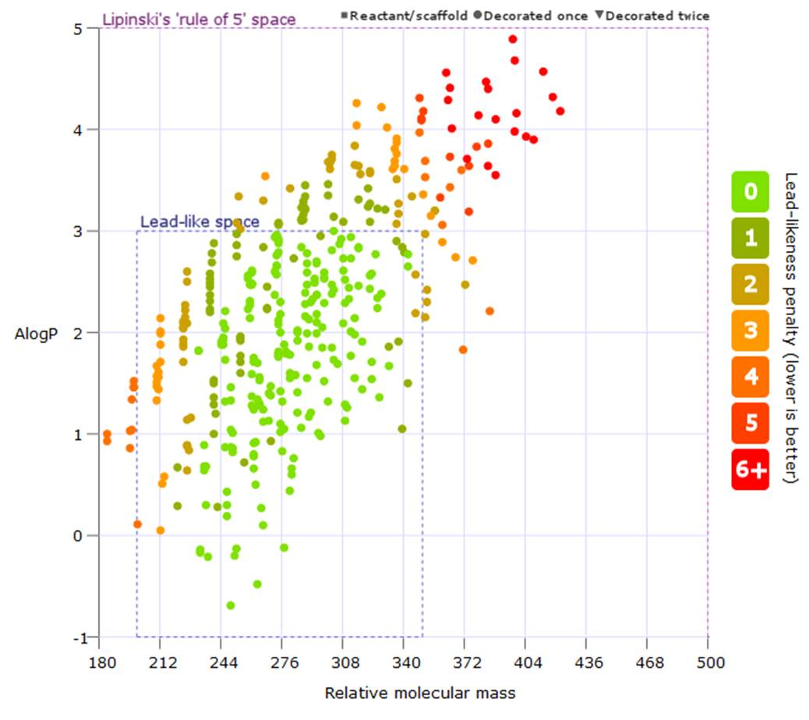

***Figure 2*.** Plot of molecular weight against calculated AlogP for a virtual library generated from compounds **9a–zd** with one enumeration.

Information on the spatial properties of the compounds in the virtual library is also obtained from LLAMA using the PMI method,[23,24] with a PMI plot of the same compound set depicted in Figure 3.[26,27] The lowest energy conformation and normalised principal moments of inertia ratios (I1 and I2) of the compounds are displayed on a triangular plot, with the three vertices corresponding to rod, disc, and spherical-shaped molecules. A trend that is typically seen when PMI analysis is performed on medicinally-oriented compound collections is a tendency for multiple data points to be found close to the ‘rod-disc’ axis, which corresponds to an abundance of relatively flat molecules.[28] What is clearly evident from this plot is that the compounds in this library have unusually diverse 3D spatial properties. With average PMI coordinates well away from the rod-disc axis (denoted by the blue + on the plot) of I1 = 0.404, I2 = 0.859 the virtual library can certainly be said to possess much higher levels of 3D character than is typically found in high throughput screening libraries.[29] Arguably of more importance is the spread of the data points; the distribution of 3D spatial properties means that wide areas of chemical space can be probed, which is particularly pleasing giving that all of the compounds derive from medium-ring scaffolds produced by the same synthetic method.

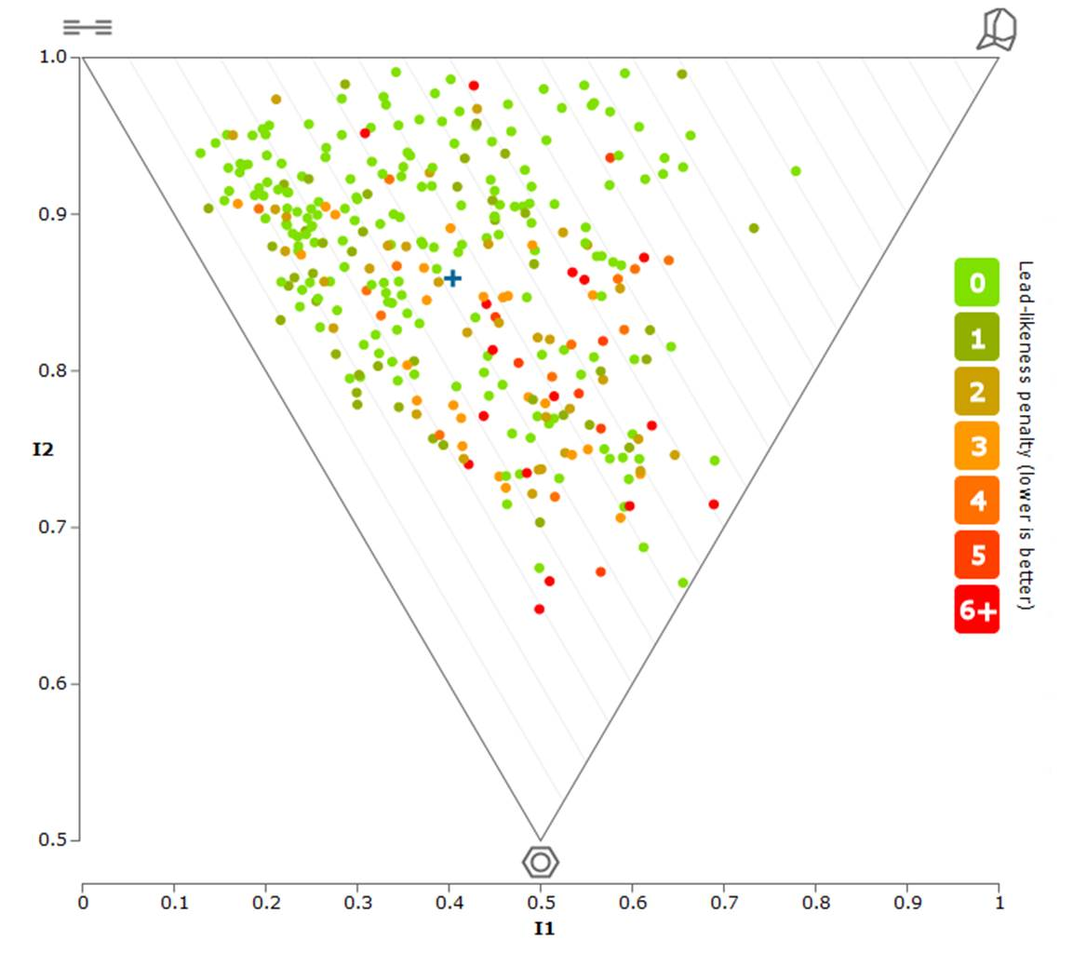

***Figure 3*.** PMI plot for a virtual library generated from compounds **9a–zd** with one enumeration. The blue + denotes the average PMI coordinates.

By allowing LLAMA to perform two consecutive enumerations, an even larger virtual library can be generated; using the same compound set described above, a virtual library of 3546 compounds was generated and analysed, with plots of these data included in the Supplementary Information. In this data set, diverse 3D spatial properties were again observed (I1 = 0.381, I2 = 0.825), but the average lead-likeness penalty was higher (3.16). This is not particularly surprising, given that after two enumerations, the molecular weight, heavy atom count and number of aromatic rings will inevitably be higher than for the singly enumerated library. Indeed, after enumerating a compound twice, it is reasonable to expect that it will be less ‘lead-like’ and ideally will start becoming more ‘drug-like’, and to this end, it is noteworthy that the majority of this 3546 compound library fall within Lipinski rule-of-five space. Thus, the medium-sized lactam scaffolds generated appear to have significant potential as medicinal lead compounds. The predictive power of the data generated using LLAMA should be useful in directing future chemical synthesis and bioassay studies towards compounds with the most promising lead-likeness and 3D spatial properties.

Conclusions

The ring expansion protocol described herein has been validated for the synthesis of a broad range of medium-sized ring lactams. A library of 30 such compounds (8–12-membered rings) was produced using the method and their lead-likeness properties were analysed using LLAMA. An enumerated virtual library was generated based on validated synthetic transformations, suggesting that the compounds have highly promising lead-like characteristics. Furthermore, 3D shape analysis, performed using the PMI method, also suggests that the compounds occupy diverse regions of chemical space, further increasing the likelihood that this method will generate novel medicinal lead compounds.

This research demonstrates the value of ring expansion reactions for the synthesis of medicinally relevant medium-ring scaffolds. We hope that improving access to a compound class considered to be underrepresented in screening libraries will help to address this current shortfall. In future work, biological screening of the compounds generated in this research program will be performed, as well as on their derivatives, and any useful results will be revealed in due course.

Experimental Section

A representative example of the typical ring expansion protocol is provided below for the formation of compound **6u**. Full experimental procedures, characterisation data and NMR spectra for all of the other compounds described in this manuscript can be found in the Supporting Information.

**Ethyl 1,5-dioxo-2,3,4,5,6,7,8,9-octahydro-1*H*-benzo[c][1]azacycloundecine-6-carboxylate (6u)** A mixture of ethyl 5-oxo-6,7,8,9-tetrahydro-5*H*-benzo[7]annulene-6-carboxylate **1f** (791 mg, 3.40 mmol),16 MgCl2 (922 mg, 9.68 mmol) and pyridine (1.58 mL, 19.5 mmol) in DCM (25 mL) under an argon atmosphere was stirred at RT for 30 mins. Next, a solution of freshly prepared acid chloride **2a** (4.78 mmol) in DCM (9 mL) was added and the reaction mixture was stirred for 1 h at rt. The mixture was then diluted with DCM (150 mL) and washed with 10% aq. HCl (75 mL). The aqueous layer was extracted with DCM (3 × 150 mL) and the combined organic extracts were dried over MgSO4 and concentrated *in vacuo*. The crude material was then re-dissolved in DCM (34 mL) and piperidine (3.36 mL, 34.0 mmol) was added. The resulting mixture was stirred for 1 h at RT, before the solvent was removed *in vacuo*. Purification by column chromatography (SiO2, 10:1 → 1:1 hexane:ethyl acetate → pure ethyl acetate) afforded the title compound **6u** (816 mg, 78%) as a white solid; M.p. 162–164 °C (chloroform); Rf 0.20 (1:1 hexane:ethyl acetate); vmax (thin film)/cm-1 3278, 2938, 1742, 1710, 1635, 1530, 1184, 730; δH (400 MHz, CDCl3) 7.27–7.06 (4H, m, Ar), 6.26 (1H, s, NH), 4.11 (2H, q, *J* = 7.1 Hz, OCH2), 3.92 (1H, dd, *J* = 10.7, 4.6 Hz, CH), 3.89–3.78 (1H, m), 3.56–3.39 (2H, m), 2.79–2.59 (2H, m), 2.56–2.44 (1H, m), 2.12–2.00 (1H, m), 1.92–1.78 (1H, m), 1.69–1.54 (1H, m), 1.36–1.25 (1H, m), 1.21 (3H, t, J = 7.1 Hz, CH3) δC (100 MHz, CDCl3) 208.6 (C=O, ketone), 171.1 and 169.0 (C=O, amide and ester), 139.2 (C), 137.1 (C), 129.8, 129.6, 126.2, 126.0 (4 CH), 61.5 (OCH2), 56.6 (CH), 41.5, 36.6, 31.3, 28.9, 27.5 (5 CH2), 14.1 (CH3); HRMS (ESI+): Found: found 326.1363. [C17H21NNaO4]+ requires 326.1363.

Acknowledgements

The authors wish to thank the Leverhulme Trust (for an Early Career Fellowship, ECF-2015-013, for W. P. U.), the University of York (M. A. M., H. L. A., W. P. U.), Erasmus+ and the University of Grenoble Alpes (L. G. B.) and the EPSRC (for a contribution towards a departmental PhD studentship for T. C. S.) for funding this research.

**Keywords:** Medium-sized rings • Ring Expansion • Lactams • Lead-oriented synthesis • Amino acids

[1] E. Vitaku, D. T. Smith, J. T. Njardarson, *J. Med. Chem*. **2014**, *57*, 10257.

[2] (a) R. H. Kohli, C. T. Walsh, M. D. Burkart, *Nature* **2002**, *418*, 658; (b) E. M. Driggers, S. P. Hale, J. Lee, N. K. Terrett, *Nat. Rev. Drug Discov.* **2008**, *7*, 608; (c) E. Marsault, M. L. Peterson, *J. Med. Chem.* **2011**, *54*, 1961; (d) J. Xie, N. Bogliotti, *Chem. Rev.* **2014**, *114*, 7678; (e) F. Giordanetto, J. Kihlberg *J. Med. Chem.* **2014**, *57*, 278; (f) A. K. Yudin, *Chem. Sci*. **2015**, *6*, 30.

[3] For examples focussed principally on medium-sized rings, see: (a) K. R. Romines, K. D. Watenpaugh, P. K. Tomich, W. J. Howe, J. K. Morris, K. D. Lovasz, A. M. Mulichak, B. C. Finze, J. C. Lynn, M.-M. Horng, F. J. Schwende, M. J. Ruwart, G. L. Zipp, K.-T. Chong, L. A. Dolak, L. N. Toth, G. M. Howard, B. D. Rush, K. F. Wilkinson, P. L. Possert, R. J. Dalga, R. R. Hinshaw, *J. Med. Chem*. **1995**, 38, 1884; (b) T. P. Majhi, B. Achari, P. Chattopadhyay, *Heterocycles* **2007**, *71*, 1011; (c) F. Kopp, C. F. Stratton, L. B. Akella, D. S. Tan, *Nat. Chem. Bio.* **2012**, *8*, 358; (d) R. A. Bauer, T. A. Wenderski, D. S. Tan, *Nat. Chem. Bio.* **2013**, *9*, 21.

[4] For examples focussed principally on macrocycles, see: (a) F. Leon, D. G. Rivera, L. A. Wessjohann, *J. Org. Chem*. **2008**, *73*, 1762; (b) A. R. Kelly, J. Wei, S. Kesavan, J. C. Marié, N. Windmon, D. W. Young, L. A. Marcaurelle, *Org. Lett*. **2009**, *11*, 2257; (c) A. Isidro-Llobet, T. Murillo, P. Bello, A. Cilibrizzi, J. T. Hodgkinson, W. R. J. D. Galloway, A. Bender, M. Welch, D. R. Spring, *Proc. Natl. Acad. Sci*. **2011**, *108*, 6793; (d) K. M. G. O’Connell, H. S. Beckmann, L. Laraia, H. T. Horsley, A. Bender, A. R. Venkitaraman, D. R. Spring, *Org. Biomol. Chem*. **2012**, *10*, 7545; (e) K. V. Lawson, T. E. Rose, P. G. Harran, *Tetrahedron*, **2013**, *69*, 7683; (f) A. Grossmann, S. Bartlett, M. Janecek, J. T. Hodgkinson, D. R. Spring, *Angew. Chem. Int. Ed.* **2014**, *53*, 13093; (g) A. P. Treder, J. L. Hickey, M.-C. J. Tremblay, S. Zaretsky, C. C. G. Scully, J. Mancuso, A. Doucet, A. K. Yudin, E. Marsault, *Chem. Eur. J*. **2015**, *21*, 9249; (h) T. E. Storr, S. J. Cully, M. J. Rawling, W. Lewis, D. Hamza, G. Jones, R. A. Stockman, *Bioorg. Med. Chem*. **2015**,*23*, 2621; (i) J.-P. Krieger, G. Ricci, D. Lesuisse, C. Meyer, J. Cossy *Chem. Eur. J*. **2016**, *22*, 13469; (j) I. B. Seiple, Z. Zhang, P. Jakubec, A. Langlois-Mercier, P. M. Wright, D. T. Hog, K. Yabu, S. R. Allu, T. Fukuzaki, P. N. Carlsen, Y. Kitamura, X. Zhou, M. L. Condakes, F. T. Szczypiński, W. D. Green, A. G. Myers, *Nature*, **2016**, *533*, 338; (k) S. Collins, S. Bartlett, F. Nie, H. F. Sore, D. R Spring, *Synthesis* **2016**, 1457; (l) S. Javed, M. Bodugam, J. Torres, A. Ganguly, P. Hanson, *Chem. Eur. J.* **2016**, *22*, 6755

[5] E. Marsault, Macrocycles as templates for diversity generation in drug discovery, in *Diversity Oriented Synthesis: Basics and Applications in Organic Synthesis, Drug Discovery, and Chemical Biology,* ed. A. Trabocchi, John Wiley & Sons, Inc, Hoboken, New Jersey, **2013**, 253–287.

[6] For papers describing various physicochemical studies on larger ring compounds, see references 1–5 and references cited therein, as well as: (a) T. Rezai, B. Yu, G. L. Millhauser, M. P. Jacobson, R. S. Lokey, *J. Am. Chem. Soc*. **2006**, *128*, 2510; (b) Y.-U. Kwon, T. Kodadek, *Chem. Biol*. **2007**, *14*, 671.

[7] For medium-sized ring natural products, see: (a) D. J. Faulkner, *Nat. Prod. Rep.* **1984**, *1*, 251; (b) A. Hussain, S. K. Yousuf, D. Mukherjee, *RSC Adv.* **2014**, *4*, 43241 and references therein.

[8] For accounts of macrocyclisation in natural product synthesis, see: A. Gradillas, J. Pérez-Castells, *Angew. Chem. Int. Ed*. **2006**, *45*, 6086; (b) M. Yu, C. Wang, A. F. Kyle, P. Jakubec, D. J. Dixon, R. R. Schrock A. H. Hoveyda, *Nature* **2011**, *479*, 88; (c) C. M. Madsen, M. H. Clausen, *Eur. J. Org*. *Chem*. **2011**, 3107 (d) W. P. Unsworth, K. A. Gallagher, M. Jean, J. P. Schmidt, L. J. Diorazio, R. J. K. Taylor, *Org. Lett*. **2013**, *15*, 262; (e) X. Yu, D. Sun *Molecules* **2013**, *18*, 6230 (f) T. O. Ronson, R. J. K. Taylor, I. J. S. Fairlamb, *Tetrahedron* **2015**, *71*, 98.

[9] For exceptions of fully synthetic macrocycles approved for clinical use or in late stage development in oncology, see: J. Mallinson, I. Collins, *Future Med. Chem.* **2012**, *4*, 1409.

[10] G. Illuminati, L. Mandolini, *Acc. Chem. Res.* **1981**, *14*, 95.

[11] (a) M. Hesse in *Ring Enlargement in Organic Chemistry,* Wiley-VCH, Weinheim, **1991**; (b) C. J. White, A. K. Yudin, *Nature Chem.* **2011**, *3*, 509.

[12] (a) J. Fastrez, *J. Phys. Chem*. **1989**, *93,* 2635; (b) J. C. Collins, K. James, *Med. Chem. Commun*. **2012**, *3*, 1489.

[13] (a) S. Mazur, P. Jayalekshmy, *J. Am. Chem. Soc.* **1979**, *101*, 677; (b) K. Haas, W. Ponikwar, H. Nöth, W. Beck, *Angew. Chem. Int. Ed.* **1998**, *37*, 1086; (c) Z. J. Gartner, B. N. Tse, R. Grubina, J. B. Doyon, T. M. Snyder, D. R. Liu, *Science* **2004**, *305*, 1601; (d) B. N. Tse, T. M. Snyder, Y. Shen, D. R. Liu, *J. Am. Chem. Soc.* **2008**, *130*, 15611; (e) R. Hill, V. Rai, A. K. Yudin, *J. Am. Chem. Soc.* **2010**, *132*, 2889; (f) A.-C. Bédard, S. K. Collins, *J. Am. Chem. Soc*. **2011**, *133*, 19976; (g) H. Fu, H. Chang, J. Shen, L. Yu, B. Qin, K, Zhang, H, Zeng, *Chem. Commun.* **2014**, 2014, 50, 3582; (h) C. J. White, J. L. Hickey, C. C. G. Scully, A. K. Yudin, *J. Am. Chem. Soc.* **2014**, *136*, 3728; (i) S. Zaretsky, J. L. Hickey, J. Tan, D. Pichugin, M. A. St. Denis, S. Ler, B. K. W. Chung, C. C. G. Scully, A. K. Yudin, *Chem. Sci*. **2015**, *6*, 5446; (j) M. Porel, D. N. Thornlow, N. N. Phan, C. A. Alabi, *Nat. Chem.* **2016**, *8*, 590.

[14] For recent ring expansion approaches to medium-sized rings, see references 3c and 3d, as well as: (a) L. Huang, L.-X. Dai, S.-L. You *J. Am. Chem. Soc*. **2016**, *138*, 5793; (b) J. E. Hall, J. V. Matlock, J. W. Ward, J. Clayden, *Angew. Chem. Int. Ed*. **2016**, *55*, 11153; (c) Z.-L. Li, X.-H. Li, N. Wang, N.-Y. Yang, X.-Y. Liu, *Angew. Chem. Int. Ed.* **2016** DOI: 10.1002/anie.201608198.

[15] For ring expansion reactions towards macrocycles, see references 3c and 3d, as well as: (a) A. Guggisberg, B. Dabrowski, U. Kramer, C. Heidelberger, M. Hesse, H. Schmid, *Helv. Chim. Acta,* **1978**, *61*, 1039; (b) V Bhat, R. C. Cookson, *J. Chem. Soc. Chem. Commun.* **1981**, 1123; (c) R. Wälchli, A. Guggisberg, M. Hesse, *Tetrahedron Lett.* **1984**, *25*, 2205; (d) K. Oda, T. Ohnuma, Y. Ban, *J. Org. Chem.* **1984**, *49*, 953; (e) S. Kim, G. H. Joe, J. Y. Do, *J. Am. Chem. Soc.* **1993**, *115*, 3328; (f) K. Kostova, M. Hesse, *Helv. Chim. Acta* **1995**, *78*, 440; (g) J. E. Forsee, J. Aubé, *J. Org. Chem.* **1999**, *64*, 4381; (h) J. A. Heerklotz, C. Fu, A. Linden, M. Hesse, *Helv. Chim. Acta.* **2000**, *83*, 1809; (i) B. Moon, S. Han, Y. Yoon, H. Kwon, *Org. Lett.* **2005**, *7*, 1031; (j) Y.-M. Jia, X.-M. Liang, L. Chang, D.-Q. Wang, *Synthesis* **2007**, 744.

[16] C. Kitsiou, J. J. Hindes, P. I’Anson, P. Jackson, T. C. Wilson, E. K. Daly, H. R. Felstead, P. Hearnshaw, W. P. Unsworth, *Angew. Chem. Int. Ed*. **2015**, *54*, 15794.

[17] I. Colomer, C. J. Empson, P. Craven, Z. Owen, R. G. Dovestone, I. Churcher, S. P. Marsden, A. Nelson *Chem. Commun.* **2016**, *52*, 7209. To access LLAMA online, see: https://llama.leeds.ac.uk

[18] For information on lead-oriented synthesis, see: (a) T. James, P. MacLellan, G. M. Burslem, I. Simpson, J. A. Grant, S. Warriner, V. Sridharan, A. Nelson, *Org. Biomol. Chem.* **2014**, *12*, 2584; (b) D. J. Foley, R. G. Dovestone, I. Churcher, A. Nelson, S. P. Marsden, *Chem. Commun.* **2015**, *51*, 11174; (c) R. G. Dovestone, P. Tosatti, M. Dow, D. J. Foley, H. Y. Li, A. J. Campbell, D. House, I. Churcher, S. P. Marsden, A. Nelson, *Org. Biomol. Chem.* **2015**, *13*, 859.

[19] In Schemes 2 and 3, compounds **6a–zd** are depicted as single tautomers and rotamers, but note that in solution in CDCl3, some of these products exist as concentration dependent equilibrating mixtures of tautomers (keto/enol), rotamers and/or diastereoisomers. For specific details for each compound, see the Supporting Information.

[20] A tentative explanation for the greater propensity of this substrate to form an imine rather than undergo ring-expansion is that the relatively bulky *iso*-butyl group causes the cyclised intermediate to adopt a conformation in which the required fragmentation process is less favourable.

[21] Interestingly, in the case of the formation of piperidine adduct **8**, this side reaction could be viewed as an opportunity to introduce additional functionality; in future work it is planned to examine whether other amines can operate similarly to furnish ring-expanded enamines of the form **8** in one-pot. We speculate that the reason side product **8** is formed in this case, but not in most others, may be a consequence of it containing a basic nitrogen group; this could have introduced a small amount of HCl (used in the work-up of the acylation step) into the ring expansion reaction, which in turn might catalyse imine condensation. To the best of our knowledge, we have never observed any instances of piperidine condensation taking place *before* ring expansion, suggesting that the Fmoc cleavage and ring expansion steps are significantly faster than condensation.

[22] For general 3D space considerations, see: (a) A. W. Hung, A. Ramek, Y. Wang, T. Kaya, J. A. Wilson, P. A. Clemons, D. W. Young, *Proc. Natl. Acad. Sci. U. S. A.* **2011**, *108*, 6799; (b) A. D. Morley, A. Pugliese, K. Birchall, J. Bower, P. Brennan, N. Brown, T. Chapman, M. Drysdale, I. H. Gilbert, S. Hoelder, A. Jordan, S. V. Ley, A. Merritt, M. E. Swarbrick, P. G. Wyatt, *Drug Discov. Today* **2013**, *18*, 1221; (c) E. M. Carreira, T. C. Fessard, *Chem. Rev.* **2014**, *114*, 8257.

[23] W. H. B. Sauer, M. K. Schwarz, *J. Chem. Inf. Comput. Sci*. **2003**, *43*, 987.

[24] For relevant studies in which the PMI method was used to assess 3D spatial properties, see reference 3c, as well as: (a) H. S. G. Beckmann, F. Nie, C. E. Hagerman, H. Johansson, Y. S. Tan, D. Wilcke, D. R. Spring, *Nature Chem.* **2013**, *5*, 861; (b) A. Isidro-Llobet, K. H. Georgiou, W. R. J. D. Galloway, E. Giacomini, M. R. Hansen, G. Méndez-Abt, Y. S. Tan, L. Carro, H. F. Sore, D. R. Spring, *Org. Biomol. Chem.* **2015**, *13*, 4570; (c) M. Lüthy, P. O’Brien, M. C. Wheldon, R. E. Hubbard, C. Haji-Cheteh, I. J. S. Fairlamb, *Bioorg. Med. Chem*. **2015**, *23*, 2680; (d) S. J. Chambers, G. Coulthard, W. P. Unsworth, P. O’Brien, R. J. K. Taylor, *Chem. Eur. J.* **2016**, *22*, 6496.

[25] Scaffold novelty is assessed against the corresponding Murcko assemblies with a random 2% of the ‘available now’ set of the ZINC database. For key publications see reference 17, and: (a) G. W. Bemis, M. A. Murcko *J. Med. Chem.* **1996**, *39*, 2889; (b) J. J. Irwin, T. Sterling, M. M. Mysinger, E. S. Bolstad, R. G. Coleman, *J. Chem. Inf. Model.*, **2012**, *52*, 2516.

[26] All of the plots included in this manuscript and its Supporting Information are completely unaltered from those generated within LLAMA.

[27] Note that enumerated compounds with two or more undefined stereocentres are not included in this plot.

[28] (a) F. Lovering, J. Bikker, C. Humblet, *J. Med. Chem*. **2009**, *52*, 6752; (b) F. Lovering, *Med. Chem. Commun*. **2013**, *4*, 515.

[29] For a recent perspective on the efficient exploration of chemical to facilitate lead identification via high throughput screening, see: A. Karawajczyk, F. Giordanetto, J. Benningshof, D. Hamza, T. Kalliokoski, K. Pouwer, R. Morgentin, A. Nelson, G. Müller, A. Piechot, D. Tzalis, *Drug Discov. Today* **2015**, *20*, 1310.

**Entry for the Table of Contents** (Please choose one layout)

Layout 1:

|  |  |  |  |  |
| --- | --- | --- | --- | --- |
| FULL PAPER | | | | |
| Medium-sized rings are under-represented in biological screening libraries for lead identification. To address this, a library of medium-sized ring lactams was generated using a ring expansion protocol. Analysis of the library using open access computational tool LLAMA suggests that the medium synthesised ring lactams and their derivatives have highly promising physicochemical and 3D spatial properties and thus have much potential in drug discovery. |  |  |  | Laetitia G. Baud, Morgan A. Manning, Helen L. Arkless, Thomas C. Stephens and William P. Unsworth*  Page No. – Page No.  Ring expansion approach to medium-sized lactams and analysis of their medicinal lead-like properties |
|  |  |

Layout 2:

|  |  |  |
| --- | --- | --- |
| FULL PAPER | | |
| Text for Table of Contents  ((Insert TOC Graphic here; max. width: 11.5 cm; max. height: 2.5 cm)) |  | Author(s), Corresponding Author(s)*  Page No. – Page No.  Title |
|  |